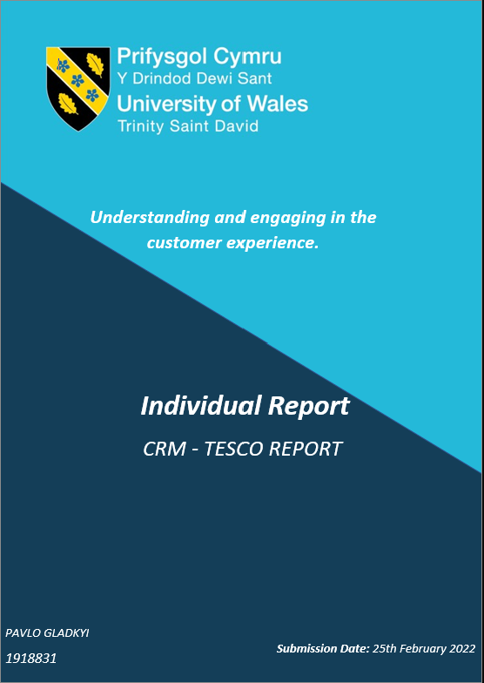

Developing Workplace Cri tical Thinking
Critical Analysis of Frederic Tayor Scientific Management & Edwards Deming 14-Point Philosophy.
Their practical implementation on the example of Amazon.
Report
Submition Date: 10th December 2021
Pavlo Gladkyi
1918831

Executive Summary

The report examined TESCO's Customer Relationship Management system and revealed that the company uses advanced technologies to collect its customers' data.
However, it was also concluded that TESCO has a problem with its cyber security as various hacker attacks led to confirmed personal data leaks. Moreover, in some cases, due to negligence, the company lost the valuable data of its employees.

Additionally, the report author scrutinised TESCO's business ethics and sustainability projects. As a result, it was confirmed that the company could not effectively control the ethical practices of its suppliers and, alias had to deal with consequences.

All in all, TESCO can still keep a trustful relationship with the customers and have a quick and efficient reaction to any internal or external threats.

As a recommendation, the report author would suggest TESCO invest in its data protection system, monitor its suppliers' ethical practices, and accelerate its sustainability initiatives.

Table of Contents

Table of Contents 1
List of Figures 2
1.0 Introduction 3
2.0 Findings 4
2.1.1 TESCO's background 4
2.1.2 TESCO and CRM 5
2.2 Ethics and Sustainability 8
2.3 Segmentation and the Loyalty Ladder 10
3.0. Conclusion 11
4.0. Recommendations 12
Reference List. 13

List of Figures

1. Figure 1: Twenty-one years of the U.K. grocery market share…………………………………………….. 5

2. Figure 2: E-commerce net sales of tesco.com from 2014 to 2022………………………………………… 6

3. Figure 3: TESCO's number of stores worldwide from 2008 to 2021…………………………………….. 7

4. Figure 4: The U.K.'s favourite supermarkets (ranked by customers satisfaction in 2020)…….. 8

1.0 Introduction

This individual report was created on 22/02/2022 at the request of the Chief Executive Officer of Marketing Week, an online journal produced by Tesco.
The marketing assistant for the TESCO Journal, Pavlo Gladkyi, will submit the completed report to a TESCO management team on 25/02/2022.

The report seeks to provide the outcome of the conducted research on TESCO's customer relationships management practices that are based on its ethical and sustainability policies and procedures. Moreover, the report's creator will discuss how the company engages with the segmentation of its customers, uses the loyalty ladder to improve customers relationship management and how external environment context could affect its development vector.

Furthermore, the author will analyse TESCO customers' experience and critically evaluate the benefits and challenges of developing and maintaining positive customer relationships to improve customer service, business adaptivity and profitability.

This report was compiled using various credible research materials. The range of sources comprised websites, books, blogs, articles, news articles and organisational documents.

2.0 Findings

2.1.1 TESCO's background

According to Ryle (2013), the U.K. retail giant TESCO's history commenced in 1919 in a tiny stall located in the East End of London when Jack Cohen launched the business by selling groceries and making the first profit. However, later on in 1924, Cohen utilised the positive retail experience by buying a shipment of tea from T. E. Stockwell and branded his new business under the name TESCO – a combination of their two initials. And subsequently, in 1929, he did introduce to East London his first TESCO store located in Burnt Oak with a straightforward marketing strategy to target mainly the low-income customers' segment providing a wide range of affordable dry goods.

Clark and Chan (2014) describe a decade of TESCO's business expansion from 1950 till 1960. As a result, the company acquired over 300 rival stores, increased its retailer market presence, and significantly amplified business profitability.
Furthermore, Forsey (2020) contended that the first TESCO supermarket opening in 1968 allowed TESCO to concentrate on diversification and provide for its customers' non-food merchandise, enlarge its presence on the market, and create a unique market niche to attract more clients. Additionally, Cohen's market strategy was highly effective as it was an amalgamation of affordable food for everyone and the American approach where products were selling in bulk for a lower price. However, the author stated that while concentrating on his primary objectives, Cohen missed some critical market trends – customers prefer merchandise quality over quantity.

As a response, in 1970, TESCO management initiated significant market repositioning actions and closed unprofitable stores. Moreover, the company enhance customers' perception of the brand by improving its exterior appearance and fulfilling customers' wants with high-quality merchandise.
The '80s were marked by TESCO market shares confrontation with Sainsbury's. As a result, the company has to review its price politic to win customers' loyalty. Additionally, TESCO made a long-range strategy move to fulfil market needs and provided additional services for its customers, such as banking, gas stations, and baby-care facilities, to improve its customers' experience.
In contrast, some TESCO superstore expansion projects did not resonate with local authorities and had considerable pushback - it was deemed a threat to existing small local merchants and shopping centres (Marketline, 2022).
According to Datamonitor (2004), in 1985, TESCO became the largest independent gasoline retailer in the U.K. and achieved a food retailer leader status with a dominant market position.
Hence in 1993, TESCO started its international expansion by purchasing French grocery chain Catteau S.A. for £175 million. However, after five years of struggle to compete with local discounters and larger chains, TESCO decided to sell Catteau S.A. and exit the French market.
Nevertheless, Payerle (2020) declares that after unsuccessful experience in France, TESCO still acquired 57 stores in Scotland, and Northern England, purchased a 51% stake in 43 Hungarian Stores chain, 31 stores in Poland, 13 stores in the Chech Republic and Slovakia.
Although TESCO did suffer from collateral development costs and operating losses, the company still managed to gain a leading market share position in the Republic of Ireland and Northern Ireland with 99 stores all together.
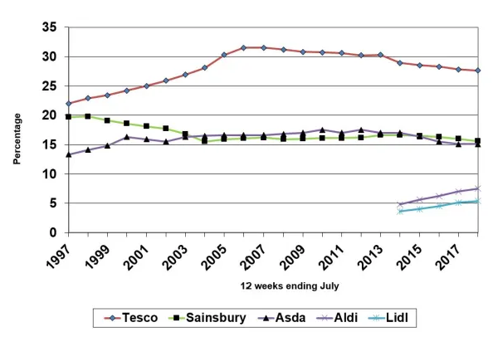

Figure 1: Twenty-one years of the U.K. grocery market share (Sparks, 2018).

2.1.2 TESCO and CRM

In the middle of the '90s, TESCO's experiments with different stores formats and innovative services resulted in TESCO Clubcard's introduction in 1995. As a result, the company became the first U.K. retailer with a loyalty card. Moreover, TESCO strengthened customer service and brought a wide range of new financial services, namely, TESCO Visa Card, TESCO Travel Money and Insurance and TESCO Clubcard Plus – an amalgamation of the banking account and loyalty card. Furthermore, with the new marketing strategy, TESCO aimed to continue improving its financial services, make a sustainable profit from central European branches and execute its opportunities on the Asian market (Tesco, 2022a).
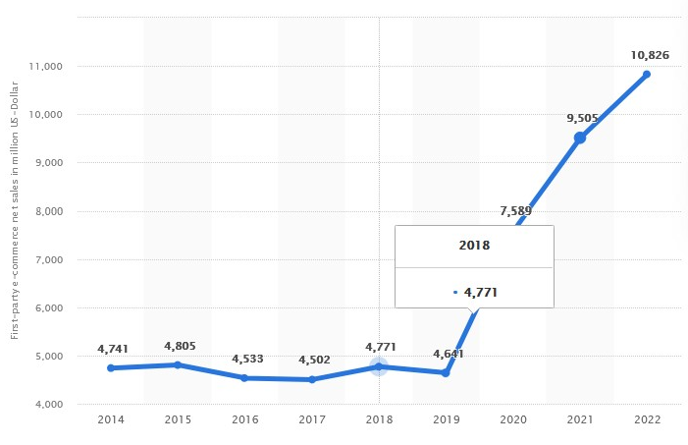
At the beginning of the 21st century, The Fourth Industrial Revolution pushed TESCO to establish its online presence (Taşkan and Kubat, 2020). Furthermore, due to inevitable digitalisation and a competitive market environment, TESCO invested in e-commerce services by fulfiling its customers' needs resulting in a positive financial response alongside Clubcard's success (Peters, 2021).
For instance, in 2011, contemporary technologies allowed Tesco to demonstrate incredible agility to the local market in South Korea, where after local market trends research, the company elaborated utterly digital solution. The company experimented with the first virtual grocery store and, after successful implementation, brought this concept to Europe (ContactPigeon, 2019).
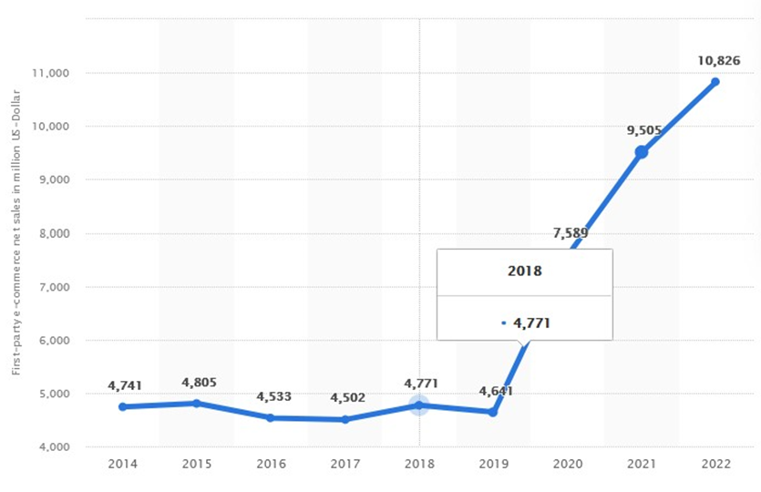

Figure 2: E-commerce net sales of tesco.com from 2014 to 2022 (Peters, 2021).

Indeed, the Clubcard was a total game-changer and vastly helped TESCO's Customer Relationship Management (CRM) operate with customers' touchpoints by direct and unobtrusive collecting (Hegarty, 2021). Moreover, collaboration with Dunnhumby enabled TESCO to study Customers Data Information (CDI) such as customer address, name, e-mail, product preferences and bank account details. Ultimately, TESCO can construct an effective promotions campaign with a personalised approach while targeting its customers (Dunnhumby, 2022).
For instance, Rollason (2014) contended that TESCO also uses social media platforms like Facebook and Twitter to engage with customers by providing them with products and services updates.

Furthermore, Taylor (2021) declares that TESCO currently has over 20 million Clubcard users who share their shopping data with the company. The company monitor any shopping trends fluctuation and adjusts its marketing strategy to satisfy its customers and maximise its profit. In addition, the CDI collected by TESCO improves its market segmentation and segregates and organises personal data for further strategic planning and product market positioning. Based on collected data, TESCO segregates customers into four broad categories depending on their solvency and product preferences (Dudovskiy, 2016).
The research shows that TESCO's target customer segment was always cost-conscious people interested in product line variety and price-quality balance. Hence the company has to pay attention to its competitors like Lidl because its strategy also focuses on cost-effectiveness. Therefore, it will be attractive to some of TESCO's customers who can prioritise low price instead of quality, especially during the current global COVID-19 pandemic, where the payability of the population tangibly declined (Accenture, 2020).
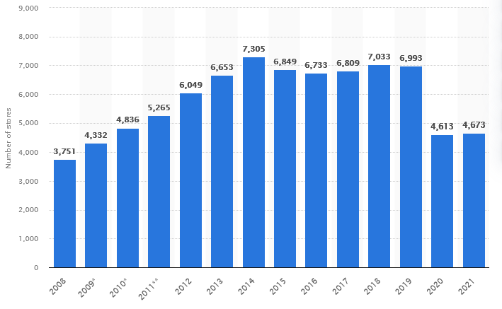
Moreover, Kopilevych (2019) states that there is a direct correlation between customer retention and customer satisfaction. That is why TESCO continuously keeps abreast of the CRM key drivers – customers satisfaction, clear feedback communication chain, constant market trends research.

Figure 3: TESCO's number of stores worldwide from 2008 to 2021 (Coppola, 2020).

Interestingly, some authors strongly disagree with the cost-effectiveness of CRM systems and have a sceptical view of its benefits. In particular, Richards (2016) stated that implementing a CRM system has several drawbacks: cost, low adaptation rate, loss of time, and insufficient data accuracy.
However, the latest information about TESCO's performance shows that the company increased its profit by 16.6% compared to the previous year. Moreover, despite the detrimental impact of the COVID-19 pandemic on business in general, TESCO shares were up 4.4%, taking 2021 gains to 14.3% (Davey, 2021).

2.2 Ethics and Sustainability

Zgheib (2015) describes business ethics as a moral duty of any organisation throughout its policies, procedures, and activities to support customers' best interest in any aspects of their interaction with the company. Ethical business practices directly correlate with corporate culture and its values and beliefs. Undoubtedly, a lack of ethics harms employees' performance (Zeiger, 2019). Additionally, ethics-related scandals negatively impact brand credibility and trust and could lead to legal ramifications.
SLD (2020) states that it will be hard to overcome the brand's association with unethical practice due to the increased attention on corporate social responsibility, fair labour practices, sustainability and discrimination. The author contends that building a positive brand image is an expensive process. However, the losses from rebuilding a positive reputation could be humongous, as there is a greater likelihood of customer outflow.

The author's research on the U.K. supermarkets' code of ethics revealed that the companies do not always follow their own declared values and policies, and TESCO is not an exemption. Additionally, 93% of the U.K. food retail market is dominated by eight supermarkets, where the leading three players are TESCO, Sainsbury's and ASDA, with nearly 42% respectively (Bedford, 2022).

Moreover, Carter (2018) assumes that this dominating position allows them often use unethical ways of running their business, which would affect their customers and companies' kudos. Intrinsically, the companies negatively impact people and the environment by cutting the price of their products and maximising profit (Putnam, 2021). Furthermore, the dominating position allows supermarket chains to control the food sector and decide on the food production processes and price politics.
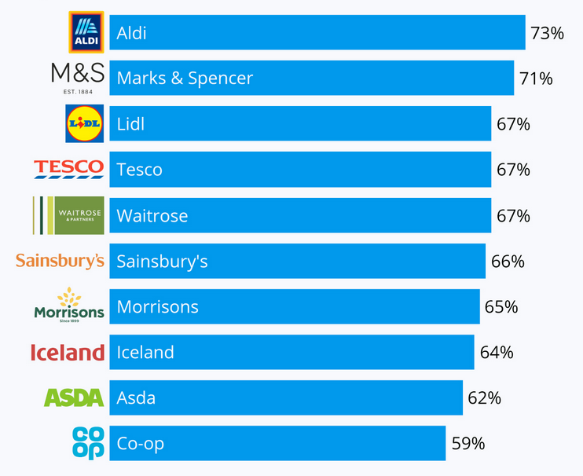

Figure 4: The U.K.'s favourite supermarkets (Armstrong, 2021).
TESCO's code of ethics currently has eleven policies, from Human rights to Anty-Bribery policy (Tesco, 2022b). However, even though TESCO declares its values and beliefs through its policies and tries to contain its positive public image, scandals arround the company are unavoidable. For instance, after the company declaration on a human rights approach, it was discovered that TESCO's suppliers from third world countries were used their employees in an unethical way that could be classified as slave labour (Lee, 2020). Furthermore, TESCO and other supermarkets like Sainsbury's, Asda, Mark & Spencer and Waitrose were involved in another ethical scandal where their farm products suppliers used gangs to control their employees' labour (Arbuthnott and Coussins, 2019).

Moreover, in our day's digitalisation, TESCO sometimes demonstrates its inability to secure the personal data of the employees and customers (BBC, 2016). As a result of miscellaneous hackers' attacks and the simple tort of negligence, TESCO risks losing internal and external customers' loyalty and considerably reducing the brand value (Kollewe, 2021).

It is useful to consider that an excellent example of TESCO's normative ethics is presented in the companies code of business conduct (Tesco, 2015).

In terms of sustainability, TESCO, similarly to its direct competitors in the retail industry, has glaringly apparent problems with its carbon footprint and ungreen products and practices (Chegut, 2020). For instance, Vitali (2020) states that TESCOs' suppliers from Brasil are actively involved in Amazon deforestation. Therefore, the company should pay attention to it instead of declaring its cooperation with Greenpeace on this subject.

Indeed, modern green trends, social pressure and governmental rules and regulations force retailers like TESCO to look for sustainable solutions to substitute existing products and practices (GOV.UK, 2021). In response, TESCO declared total decarbonisation within the U.K. till 2035 and cooperates with World Wide Fund for Nature to fight the global food system – the most significant cause of wildlife loss (WWF, 2018). Additionally, TESCO's economic and social impact report demonstrates an understanding and complex approach regarding sustainability and the company's remedial actions to mitigate or eliminate its impact on the natural environment (TESCO Plc, 2021).
For instance, the company has already invested over £200 000 in energy efficiency measures to install the LED light in the U.K. stores. Moreover, TESCO completed seventy-five green energy projects across the U.K., including solar, wind and bio generators powering 2% of its local operational needs.
Furthermore, TESCO Plc (2021) declares that they have a moral responsibility to help people eat healthily and, since 2018, removed 50 billion calories from its products. Additionally, to decrease the environmental impact, TESCO plans to power every store with 100% renewable energy, recycle or redistribute 82% of unsold food, replace all 5500 delivery vans with electric solutions by 2028 and provide electric vehicles charge stations near their supermarkets.

However, although to TESCO's perfect sustainability plan, Chapman (2017) reminds that TESCO must closely monitor its F&F clothes fashion line to avoid baned in U.S. and E.U. toxic chemicals components to ensure they follow up their ethical and sustainable commitments in front of their customers.

In terms of Corporate Social Responsibility (CSR), TESCO takes the view of Archie Carrol (Carroll, 2016). Moreover, using The six pillars model, the report's author concluded that the most potent of TESCO's sustainability drivers are ecological (Tesco plc, 2019).

2.3 Segmentation and the Loyalty Ladder

As it was aforementioned, the application of the CRM system could have certain aspects that companies should pay attention to and make sure the revenue from the customers and cost of application of the CRM system is well balanced. As a result, companies could be more effective in the decision-making process regarding their target strategy based on the revenue the customers bring and the company's effort to retain them.

Moreover, a well-established CRM system allows monitoring customers' retention rate and relationship history and, more importantly, seeing the opportunities for further relationship improvements by sending needed incentives to increase customer involvement and engagement.

Consequently, TESCO can monitor and identify the trends fluctuation in customers' interest in their products and services through its CRM system. Moreover, by using a Relationship Ladder, the company could streamline its market targeting process to categorise its customers depending on their payability and engagement level with the company.

Like any other company, TESCO is interested in capturing prospects from some competitors' market shares. However, TESCO's prospects cannot be targeted directly, as the company does not have any data on them yet, but is highly interested in attracting them.
For instance, TESCO uses its brand image for advertisements on television, newspaper and media to target prospects indirectly (Faull, 2021). Moreover, according to Statista (2021), in 2020, TESCO invested 81,5 million pounds in advertising in the U.K. Additionally, TESCO uses its website to attract new customers through online shopping, home delivery options, and integrated Club card rewards from any purchases (Tesco, 2021).

Regarding segmentation, the report author concluded that TESCO significantly expanded its products and services range since its creation. Today this list includes electronics, apparel, sport and beauty products, books, decoration, telecommunication, banking, insurance and much more. Hence the company covers various market segments to fulfil customers' needs (Shastri, 2022).

It is noteworthy that TESCO uses a multi-segment positioning to target several segments simultaneously; this allows the company to monitor and evaluate its competitors' segmentation strategies, continuously collecting, analysing and reacting to any changes.

However, even though TESCO's multi-segmentation strategy is apparent, it is still possible to distinguish its two core strategies – Cost Leadership and Differentiation (Dess and Davis, 1984). Therefore, these two strategies demonstrate how the company attempts to achieve aspects of RAVE. Additionally, the obtained feedback from the data segments and customers on the loyalty ladder allow TESCO to identify PECA action areas.

3.0. Conclusion

To recapitulate. The derived data revealed that TESCO currently has an effective customer relationship management system that allows the company to use various touchpoints to collect and utilise customers' personal data, enabling target marketing, product line and logistics adjustment, continuously monitoring fluctuations of market trends and retaining and attracting customers.
Moreover, a Deep Dive on the TESCO case study reveals that the company's CRM system is continuously evolving. Additionally, the company's reaction to the internal and external context is quick and sufficient, as the company reacts to public criticism promptly by keeping its ethical ground supported with declared values and beliefs.
However, the research also confirmed that TESCO still cannot guarantee consistent customer experiences with their online services and mobile application despite its current domination of the ambient merchandise segment. Moreover, TESCO should look for a feasible solution to improve its cyber security to avoid risks of losing clients' trust due to personal data security issues.

4.0. Recommendations

The report's author will recommend that TESCO pay attention to its cyber security and monitor its suppliers' chain to ensure compliance with its policies and ethical standards in the operating countries. Moreover, the company should continue executing its sustainability plan and meet its objectives within stipulated deadlines.
Additionally, the company should continue eliminating plastic from all process stages. Moreover, to be more competitive in the local market, TESCO should increase its investments in green technologies and make sure electric delivery vans and charging stations are in circulation before 2028, as sustainability will be a significant driver that attracts more customers.

Reference List.

Accenture (2020). 10 ways COVID-19 is impacting payments. [online] https://www.accenture.com, pp.2–28. Available at: https://www.accenture.com/_acnmedia/pdf-123/accenture-10-ways-covid-19-impacting-payments.pdf [Accessed 2 Feb. 2022].
Arbuthnott, G. and Coussins, J. (2019). Britain's biggest slavery gang "supplied supermarkets with veg." [online] BirminghamLive. Available at: https://www.birminghammail.co.uk/black-country/britains-biggest-slavery-gang-supplied-16547284 [Accessed 7 Feb. 2022].
Armstrong, M. (2021). Infographic: The U.K.'s favourite supermarkets. [online] Statista Infographics. Available at: https://www.statista.com/chart/17117/uk-favourite-supermarkets/ [Accessed 19 Feb. 2022].
BBC (2016). Tesco call centre worker fined over customer data breach. BBC News. [online] 20 May. Available at: https://www.bbc.co.uk/news/uk-scotland-tayside-central-36343849 [Accessed 26 Jan. 2022].
Bedford, E. (2022). Great Britain: Grocery Market Share 2015-2019 | U.K. Statistics. [online] Statista. Available at: https://www.statista.com/statistics/280208/grocery-market-share-in-the-united-kingdom-uk/ [Accessed 7 Feb. 2022].
Carroll, A.B. (2016). Carroll's Pyramid of CSR: Taking Another Look. International Journal of Corporate Social Responsibility, [online] 1(3). Available at: https://jcsr.springeropen.com/articles/10.1186/s40991-016-0004-6 [Accessed 21 Feb. 2022].
‌Carter, A. (2018). Supermarkets | Ethical Consumer. [online] Ethical Consumer. Available at: https://www.ethicalconsumer.org/retailers/shopping-guide/supermarkets [Accessed 7 Feb. 2022].
Chapman, B. (2017). Tesco crack down on chemicals that can cause serious health problems found in clothing line. [online] The Independent. Available at: https://www.independent.co.uk/news/business/news/tesco-hazardous-chemicals-f-and-f-clothing-range-pledges-to-remove-11-substances-greenpeace-detox-campaign-a7840956.html [Accessed 7 Feb. 2022].
Chegut, A. (2020). Retail Carbon Footprints: Measuring Impacts from Real Estate and Technology. [online] Available at: https://realestateinnovationlab.mit.edu/wp-content/uploads/2021/01/FINAL_Retail-carbon-footprints-report_011221.pdf [Accessed 7 Feb. 2022].
Clark, T. and Chan, S.P. (2014). A history of Tesco: The rise of Britain's biggest supermarket. The Telegraph. [online] 4 Oct. Available at: https://www.telegraph.co.uk/business/0/history-tesco-rise-britains-biggest-supermarket/ [Accessed 28 Jan. 2022].
ContactPigeon (2019). Tesco Case Study: How an Online Grocery Goliath Was Born. [online] ContactPigeon | Blog. Available at: https://blog.contactpigeon.com/tesco-case-study/#history [Accessed 1 Feb. 2022].
Coppola, D. (2020). Tesco's Global Number of Stores 2018 | Statistic. [online] Statista. Available at: https://www.statista.com/statistics/238667/tesco-plc-number-of-outlets-worldwide/ [Accessed 19 Feb. 2022].
Datamonitor (2004). Tesco PLC Company Profile. [online] Available at: https://people.exeter.ac.uk/wl203/BEAM011/Materials/Lecture%204/TESCO%20Company%20Profile.pdf [Accessed 8 Feb. 2022].
Davey, J. (2021). Tesco defies supply chain challenges to lift profit outlook. Reuters. [online] 6 Oct. Available at: https://www.reuters.com/business/retail-consumer/tesco-raises-full-year-outlook-after-strong-first-half-2021-10-06/ [Accessed 21 Feb. 2022].
‌Dess, G.G. and Davis, P.S. (1984). Porter's (1980) Generic Strategies as Determinants of Strategic Group Membership and Organizational Performance. Academy of Management Journal, [online] 27(3), pp.467–488. Available at: https://www.jstor.org/stable/256040?seq=1#metadata_info_tab_contents [Accessed 8 Feb. 2022].
Dudovskiy, J. (2016). Tesco Segmentation, Targeting and Positioning - Research-Methodology. [online] Research-Methodology. Available at: https://research-methodology.net/tesco-segmentation-targeting-and-positioning-2/ [Accessed 2 Feb. 2022].
Dunnhumby (2022). dunnhumby - Helping retailers, brands perfect the shopping science. [online] dunnhumby. Available at: https://www.dunnhumby.com/ [Accessed 1 Feb. 2022].
Faull, J. (2021). Tesco has a major new media offering for advertisers: here's what you need to know. [online] The Drum. Available at: https://www.thedrum.com/news/2021/11/30/tesco-has-major-new-media-offering-advertisers-heres-what-you-need-know [Accessed 8 Feb. 2022].
Forsey, Z. (2020). Why Tesco is called Tesco - and how first ever product changed everything. [online] mirror. Available at: https://www.mirror.co.uk/news/weird-news/tesco-called-tesco-how-its-21978016 [Accessed 28 Jan. 2022].
GOV.UK. (2021). Firms must commit to net zero to win major government contracts. [online] Available at: https://www.gov.uk/government/news/firms-must-commit-to-net-zero-to-win-major-government-contracts [Accessed 7 Feb. 2022].
Hegarty, R. (2021). Tesco reveals it is reaping rewards from revitalised Clubcard scheme. [online] The Grocer. Available at: https://www.thegrocer.co.uk/marketing/tesco-reveals-it-is-reaping-rewards-from-revitalised-clubcard-scheme/660621.article [Accessed 1 Feb. 2022].
Kollewe, J. (2021). Tesco website and app back online after hack attempt. [online] the Guardian. Available at: https://www.theguardian.com/business/2021/oct/25/tesco-website-app-back-online-hack-track-deliveries [Accessed 7 Feb. 2022].
Kopilevych, D. (2019). Customer Satisfaction and Retention: Is There a Correlation? [online] HelpCrunch blog. Available at: https://helpcrunch.com/blog/customer-satisfaction-and-retention/ [Accessed 19 Feb. 2022].
Lee, L. (2020). British grocer Tesco's slavery review reports abuses in Malaysia. Reuters. [online] 16 May. Available at: https://www.reuters.com/article/us-tesco-malaysia-workers-idUSKBN22S0GX [Accessed 7 Feb. 2022].
Marketline (2022). How Tesco Became the U.K.'s Largest Retailer. [online] Uwtsd.ac.uk. Available at: https://web-p-ebscohost-com.ezproxy.uwtsd.ac.uk/ehost/pdfviewer/pdfviewer?vid=4&sid=aa96c065-a9d5-4776-9e78-78f754a8fbf6%40redis [Accessed 30 Jan. 2022].
Payerle, Y. (2020). Why did Tesco fail in France? [online] Treehozz.com. Available at: https://treehozz.com/why-did-tesco-fail-in-france [Accessed 8 Feb. 2022].
Peters, L. (2021). E-Commerce net sales of tesco.com from 2014 to 2021. [online] Statista. Available at: https://www.statista.com/forecasts/1218318/tesco-revenue-development-ecommercedb [Accessed 1 Feb. 2022].
Putnam, H. (2021). Is Climate Change the Food Retail Industry's Biggest Opportunity? [online] Ratio Institute. Available at: https://ratioinstitute.org/is-climate-change-food-retails-achilles-heel-or-its-biggest-opportunity/ [Accessed 7 Feb. 2022].
Richards, G. (2016). 3 big problems with CRM (and how you can fix them) infographic. [online] Accent Technologies. Available at: https://accent-technologies.com/2016/02/19/3-big-problems-with-crm-infographic/ [Accessed 21 Feb. 2022].
‌Rollason, H. (2014). How Tesco Leads The Way in Social Customer Service. [online] Conversocial.com. Available at: https://www.conversocial.com/blog/how-tesco-leads-the-way-in-social-customer-service [Accessed 2 Feb. 2022].
Ryle, S. (2013). Making of tesco: a story of british shopping. Transworld Publishers Ltd, pp.10–15.
Shastri, A. (2022). Tesco Marketing Strategy Case Study | IIDE. [online] IIDE. Available at: https://iide.co/case-studies/tesco-marketing-strategy/ [Accessed 8 Feb. 2022].
SLD (2020). Strategies for Overcoming Negative Brand Perceptions. [online] SLD. Available at: https://www.sld.com/blog/brand-strategy/three-strategies-for-overcoming-negative-brand-perceptions/ [Accessed 7 Feb. 2022].
Sparks, L. (2018). Twenty One Years of U.K. Grocery Market Share. [online] Stirlingretail. Available at: https://stirlingretail.com/2018/08/13/twenty-one-years-of-uk-grocery-market-share/ [Accessed 19 Feb. 2022].
Statista (2021). Tesco’s UK ad spending 2012-2017 | Statista. [online] Statista. Available at: https://www.statista.com/statistics/549738/tesco-uk-ad-spending/ [Accessed 8 Feb. 2022].
Taşkan, B. and Kubat, C. (2020). Impacts of Industrial Revolutions on the Enterprise Performance Management: A Literature Review. Available at: https://www.researchgate.net/publication/339828441_Impacts_of_Industrial_Revolutions_on_the_Enterprise_Performance_Management_A_Literature_Review [Accessed 1 Feb. 2022].
Taylor, R. (2021). Why this shopping basket costs 45% more at Tesco without a Clubcard. [online] This is Money. Available at: https://www.thisismoney.co.uk/money/bills/article-10308957/Why-shopping-basket-costs-45-Tesco-without-Clubcard.html [Accessed 1 Feb. 2022].
Tesco (2015). Our COde Of Business COnduCt. [online] Available at: https://www.tescoplc.com/media/1143/code_of_business_conduct_2015.pdf [Accessed 21 Feb. 2022].
Tesco (2021). Tesco :: Online Groceries, Banking & Mobile Phones. [online] Tesco.com. Available at: https://www.tesco.com/ [Accessed 8 Feb. 2022].
Tesco (2022a). Clubcard Plus. [online] Available at: https://www.tesco.com/clubcard/clubcard-plus/bank-introducer?icid=CCPLUS_Stamp_BANK [Accessed 19 Feb. 2022].
Tesco (2022b). Ethics and Compliance policies. [online] Tesco PLC. Available at: https://www.tescoplc.com/about/how-we-do-business/ethics-and-compliance-policies/ [Accessed 7 Feb. 2022].
TESCO Plc (2021). Reports and Presentations. [online] Tesco PLC. Available at: https://www.tescoplc.com/sustainability/documents/reports-and-presentations/ [Accessed 8 Feb. 2022].
Tesco plc (2019). Sustainability. [online] Tesco PLC. Available at: https://www.tescoplc.com/sustainability/ [Accessed 22 Feb. 2022].
Vitali, C. (2020). Tesco's deforestation claims are misleading the public | Greenpeace UK. [online] Greenpeace U.K. Available at: https://www.greenpeace.org.uk/news/tesco-deforestation-meat-adverts/ [Accessed 5 Feb. 2022].
WWF (2018). Three ways we're fighting for your world with Tesco. [online] WWF. Available at: https://www.wwf.org.uk/updates/three-ways-were-fighting-your-world-tesco#main-content [Accessed 8 Feb. 2022].
Zeiger, S. (2019). Effects of a Lack of Ethics on a Business Environment. [online] Chron.com. Available at: https://smallbusiness.chron.com/effects-lack-ethics-business-environment-23332.html [Accessed 7 Feb. 2022].
Zgheib, P. (2015). Business ethics and diversity in the modern workplace. Hershey: Business Science Reference.

