[Date]
University of Wales Trinity Saint David
London campus
Moodle Name: Learning in the Digital Era
Moodle Code: ACCA 4025

Student Name: Avegielle Apolinar Ablang
Student ID: 2527361
Group Number: 1

Lecturer Name: Koushik Modak
Learning in the Digital Era
Assignment 1

Contents
Introduction 3
Main Body 3
Task 1: Essential Academic and Employment Skills for the future career Path 3
Task 1 (a): IEEE Referencing 3
Task 2: Collaborative Mind Map and Individual Poster 4
Mind Map (Collaborative) 4
Academic Poster (Individual) 4
Task 3: Virtual Collaboration and RefWorks 4
Automatic Referencing 4
Step-by-step process of using RefWorks with visuals 4
Task 4: E-Portfolio Creation and Evaluation 4
Task 4 (a): E-Portfolio Creation 4
Task 4 (b): Evaluation of e-Portfolio 4
Conclusion 4
References 4
Task 1 References: 4
Task 3 References: 5

Introduction

Main Body

Task 1: Essential Academic and Employment Skills for the future career Path

Task 1 (a): IEEE Referencing
When it comes to professional choices, educational skills are one of the most important factors. For example, most organisations prioritise academic knowledge and abilities. Having advanced abilities in the job you're applying for can help you because employers compete for each application. However, “Governments have become increasingly concerned with improving the employability of university graduates in recent years, but most existing studies of what graduate employers look for are limited by their reliance on self-reported preferences.” [2] This indicates that UK employers are recently changing their hiring practices to focus more on educational skills rather than limiting their own skills. For example, they may have a wealth of experience from their previous jobs.
Educational skills will support you throughout your career in the future as it will be the most important skills that organisations will need. Providing proof such as reference to the job description will help you secure the job you applied for as it shows your abilities to work. [3] For example, numerous employees from different countries have graduated from their respective countries. This means that most businesses prioritise graduate employment. However, certain employers rely on the skills. Examples include practical talents and theoretical skills. Because programming is difficult to learn, careers in information technology (IT) will be based on practical experience.
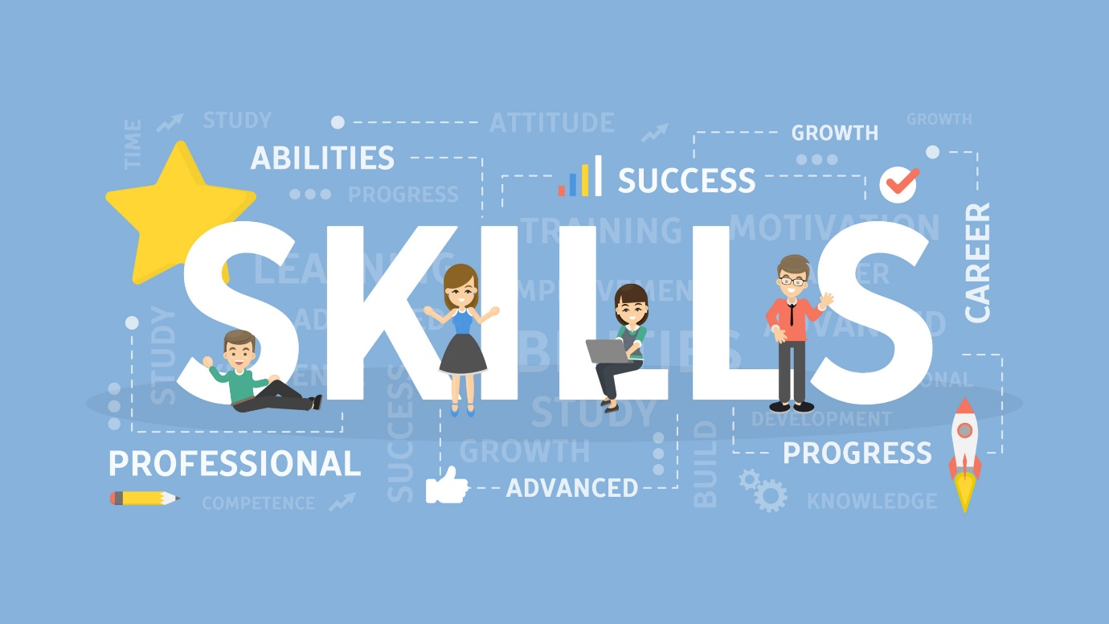
Figure 1 Educational Skills
The picture above depicts how educational skills can benefit you throughout your career. Having the skills to conduct such work as coding in information technology could benefit my career because technology is becoming increasingly important.
Task 1 (b): Evaluation of the Similarity report

Task 2: Collaborative Mind Map and Individual Poster

Mind Map (Collaborative)

Academic Poster (Individual)

Task 3: Virtual Collaboration and RefWorks

Automatic Referencing
Put your Chosen topic here

Step-by-step process of using RefWorks with visuals

Task 4: E-Portfolio Creation and Evaluation

Task 4 (a): E-Portfolio Creation

Task 4 (b): Evaluation of e-Portfolio

Conclusion

References
Task 1 References:

[1] | M. M. Rahman, “Impact of Practical Skills on Academic Performance: A Data-Driven Analysis,” 08 October 2021.
[2] | C. Byrne, “What determines perceived graduate employability?,” 29th of February 2020.
[3] | J.-B. R. Souppez, “Engineering employability skills: Students, academics, and industry professionals perception,” November 20, 2023.
[4] | C. Byrne, “What determines perceived graduate employability?,” 29 of February 2020.

Task 3 References:

