Analysis of the data
The survey questions were designed to investigate the perceptions of police officers (PO) regarding gender parity within the police force, and the strength of feeling of the officers perceptions in delivering gender parity in the South Wales Police force (SWP).
This chapter will discuss the quality of the data and analyse the data for trends and patterns, contrasting the survey responses to the interviews.
Interviews
Only 4 interviews were undertaken due to the significant time constraints. The interviews were set at 40 minutes, which is a little short, and this may have negatively affected the amount of relevant data that could be obtained, but it was necessary due to the time constraints. The interviews were audio recorded and transcribed manually by the researcher and not with any transcription software. The analysis of the interviews were also undertaken by the researcher without the aid of analysis software.
Whilst the researcher has significant experience of interviewing together with supporting skills, these are skills which are counter intuitive for interviewing as a researcher. As an officer, for example, whilst obtaining information from a victim, the officer is to support, sympathise and empathise. The officer would be doing a disservice to the victim and the police force by standing aloof to the fear and pain of a vicious robbery or rape. However, for the research interview, neutrality is important, otherwise the interview can become biased. This, being the first research interview conducted, could weaken the data.
Reliability in qualitative interviews is attained through a number of practical aspects of the process of interviewing, including the wording of the interview questions, establishing rapport with the interviewees, and considering the ‘power relationship,’ between the interviewer and the participant (Breakwell, 2000).
These practical elements are all heavily weighted towards the experience and attitude of the interviewer. The interviewer took great care when, asking the questions, to elicit their true feelings and knowledge about the research topic. Care was taken to ensure that the structured element of the interview was the same for each interviewee, however, they all could express their own personal reflections, and take different routes when completing the interview.
During the interview there was a good rapport, and interviewees were comfortable and relaxed. Their body language was open, and there was good eye contact. They were happy to give their opinions even if they thought it was not a common view, and if a specific numerical response was required, they were not embarrassed when they did not have the correct answer. It was a discussion and not merely a question and answer session. Regarding the power relationship between interviewer and interviewee, the interviewer, being aware of the impact of this, sort to diminish its affect. Lincoln and Guba state that what is particularly relevant when discussing qualitative studies is their validity, and the three common threats to validity in qualitative research is, researcher bias, re-activity and respondent bias (Lincoln and Guba, 1985).

Within this power relationship is the researcher bias being imposed on the interviewee, and the interviewer was conscious of avoiding this and facilitating re-activity from the interviewee during the interview. While reviewing the interviews after they had been recorded, care was taken to check for this affect in the interview. Assessing for re-activity of the interviewees was more difficult as it was not video recorded. And from the answers of the interviewees, respondent bias appeared to be low as their perceptions were frequently not necessarily what the establishment would like etc.
Thematic analysis and exploration was used (Braun and Clarke). According to them, thematic analysis is a method used for ‘identifying, analysing, and reporting patterns (themes) within the data (Braun and Clarke, 2006, p.79).
Interviewees understanding of GP
No interviewee, regardless of rank or sex, had an accurate understanding of GE and all had less of an understanding of GP. One of the male interviewees thought it a matter of terminology but said he understood the concept. None of the interviewees, regardless of rank or sex, knew what initiatives the SWP were undertaking to achieve GP. Only one male knew the correct percentage of male and female police officers in SWP.
All interviewees, regardless of rank or sex, thought that it was easier, in terms of the requirements to become a police officer, now than previously; with one female saying that people were entering the police force that should not be, as they are not best suited for the job. And one male officer saying that it would be harder for men ‘like him’ to get in now (that is white male).
Opinions/feelings
Despite their lack of understanding of GE and GP, and the actual correct, current statistics of GP in the police force, or what is being done to address GP by SWP, all felt capable of expressing their views and feelings on the subject. Both male and female interviewees thought the situation was unsatisfactory and the female interviewees had stronger feelings ‘appalled by’ the situation as they perceived it. The female interviewees also expressed a more despondent view of the future, predicting that it will not change or change quick enough, with one female officer effectively giving up and just accepting it is what it is. While none felt that they had been directly affected by GP per say, one female expressed negative experiences of treatment from her male colleagues. All the interviewees, regardless of rank or sex, thought that while it is easier to get into the police force now, the educational requirement imposed on the recruits is unnecessary and not required for the job.
Survey Analysis
Due to the significant cost and smaller sample numbers and completion rates, no sophisticated computer analyses were carried out. The analytic is percentage based, with some simple cross tabulating/filtering by the formal online survey proprietor. Some calculations were performed manually by the researcher.
Data Quality
Rules

1. Due to the significant time constraints and costs, the survey was left online for the ten days - everyone was made aware of this constraint when they were emailed. These ten days allowed a complete set of six days work and four days leave for all those who were emailed. Any survey responses outside of the ten days were not evaluated.

2. Some questions were “If” and “then” questions, and if the criteria for the ‘If” question was not met, then there would be no requirement to answer the rest of the question. Such unanswered questions were still taken as valid.
Data quality indicators
There were 103 eligible staff from the two stations that were randomly selected who received the emails. There were 56 responses. However, only 40 were received within the required time frame, and so only those 40 are analysed. However, even though we are not analysing all the 56 responses, their response nonetheless indicates a 54% response rate. Response rates to email surveys are usually 30-35%, without any follow up (Fincham, 2008).
With the 40 that were analysed, this represents a 39% response rate. This would suggest that there was significant interest in the purpose of the survey topic. The completion rate was 32%. The average completion rate for online surveys of 9-14 questions is approximately 56% (Survicate, 2021). This could suggest a low completion rate for the survey.
However, only 2 questionnaires had questions regarding their knowledge or opinions unanswered. The more significant number were the 5 questionnaires, where the individual did not supply their rank. This may be an oversight in their responses as the question asked for their sex and rank, and they all completed their sex, or it may indicate a reluctance to supply both data as an apprehension of possible identification. As it was particularly this question, it is less likely to indicate a frustrating or poor survey questionnaire. It will have however, a small impact, I believe on the completion, and therefore the accuracy of the data. The typical time to complete the survey was 3 minutes and 40 seconds, which would suggest it was a simple questionnaire to complete, which would support more accurate results.
Representative sample
The number of emails that were sent out as a sample population is quite small. There are 3174 police officers within the SWP (House of Commons, 2021). The random sample of the two stations were both in the same region of the SWP, therefore it will be less likely to represent the whole of the 4 regions in the SWP. While the stations were not the smaller stations, the number of staff in those stations was still only 103. Due to the reasons mentioned above, having only 33 totally complete surveys will reduce the quality of the data.
The number of male and female officers in the original 103 surveys sent were 66 male and 37 female this provides a population of 64% male and 36% female. The number of male and female officers in the response rate were 26 male and 14 female, this providing a sample of 65%men and 35% women. This is ratio is remarkably consistent from the total population to that of the respondents. This could suggest an equal importance of the survey topic to both men and women.
However, the number of male and female officers in the completion rate were 21 male and 11 female with an 80% completion rate for men and 85% for women. With the small numbers involved, the difference is probably not significant, but may indicate a greater level of interest from the women respondents. Only one question had a free text field, and only three completed it, all were female indicating a greater level of interest. The implications of these findings and results will be discussed in the next chapter.

1616
Bibliography.

Braun V. & Clarke V. (2006) ‘Using thematic analysis in psychology’, Qualitative Research in Psychology, 3(2), pp.77-101.
Available at: https://librarysearch.uwtsd.ac.uk/discovery/fulldisplay?docid=cdi_proquest_journals_223135521&context=PC&vid=44WHELF_UWTSD:44WHELF_UWTSD_VU1&lang=en&search_scope=Search_ELEC&adaptor=Primo%20Central&tab=Everything&query=any,contains,Braun%20V.%20%26%20Clarke%20V.,%202006.%20Using%20thematic%20analysis%20in%20psychology.&offset=0
(Accessed on: 28/9/2021)

Breakwell, G. M, Hammond, S. & Fife-Shaw, C (2000) Interviewing Methods in Psychology. 2nd Ed. London: Sage.

Fincham, J. (2008) ‘Response Rates and Responsiveness for Surveys, Standards, and the Journal’, United States: American Association of Colleges of Pharmacy, 72(2), pp. 43-43.
Availabe at: https://librarysearch.uwtsd.ac.uk/discovery/fulldisplay?docid=cdi_pubmedcentral_primary_oai_pubmedcentral_nih_gov_2384218&context=PC&vid=44WHELF_UWTSD:44WHELF_UWTSD_VU1&lang=en&search_scope=Search_ELEC&adaptor=Primo%20Central&tab=Everything&query=any,contains,Response%20Rates%20and%20Responsiveness%20for%20Surveys,%20Standards,%20and%20the%20Journal&offset=0
(Accessed on: 22/9/21)

House of Commons (2021) Police service strength.
Available at: https://researchbriefings.files.parliament.uk/documents/SN00634/SN00634.pdf (Accessed on: 25/9/21)

Lincoln, Y. S. and Guba, E. (1985) Naturalistic Inquiry. Newbury Park, CA: SAGE.
Available at: https://books.google.co.uk/books?hl=en&lr=&id=2oA9aWlNeooC&oi=fnd&pg=PA7&dq=Lincoln,+Y.+S.+%26+Guba,+E.+G.+(1985).+Naturalistic+Inquiry.+Newbury+Park,++CA:+SAGE.&ots=0umwR7O6Do&sig=UHWi5W991hKHX3_KU9uZj5ZTkiI#v=onepage&q&f=false
(Accessed on: 26/9/2021)

Survicate (2021) How to get survey completion rates of over 80%.
Available at: https://survicate.com/surveys/survey-completion-rate/
(Accessed on: 29/9/21)

Appendix

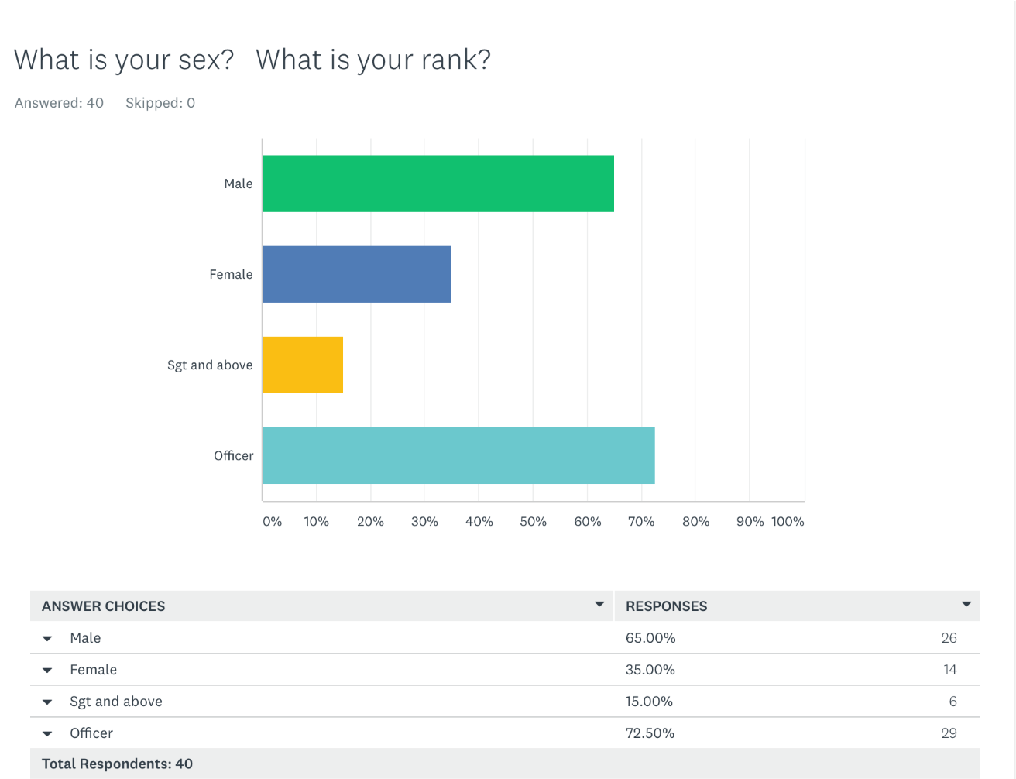
Fig 1
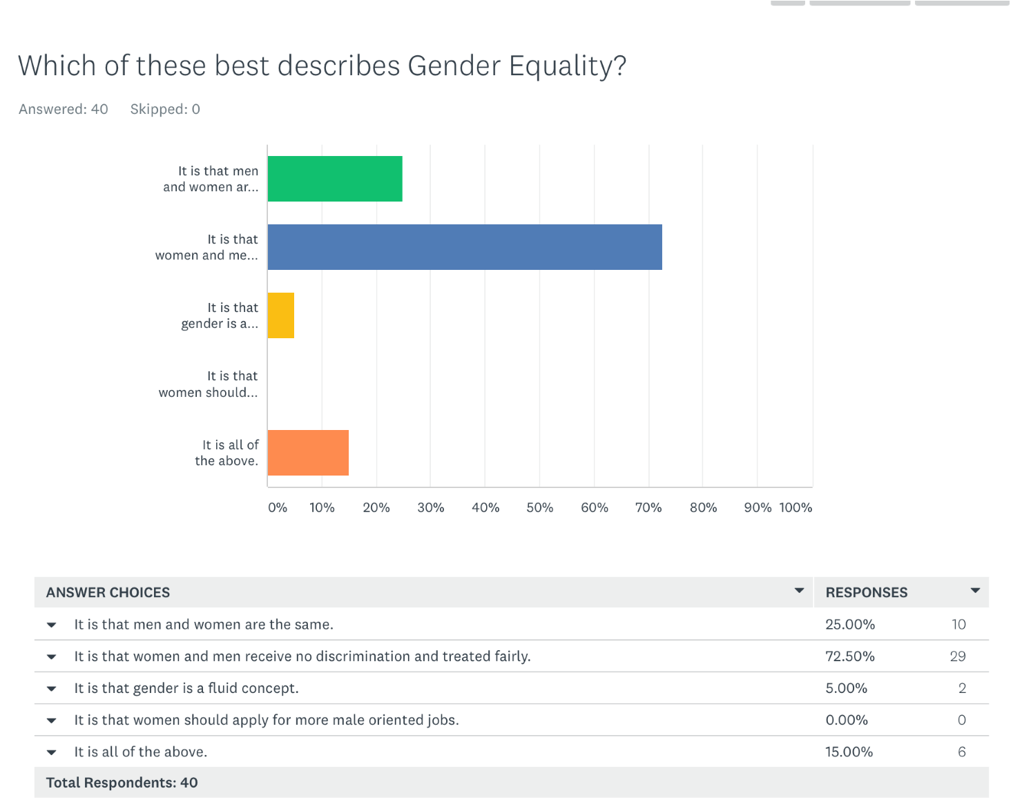
Fig 2

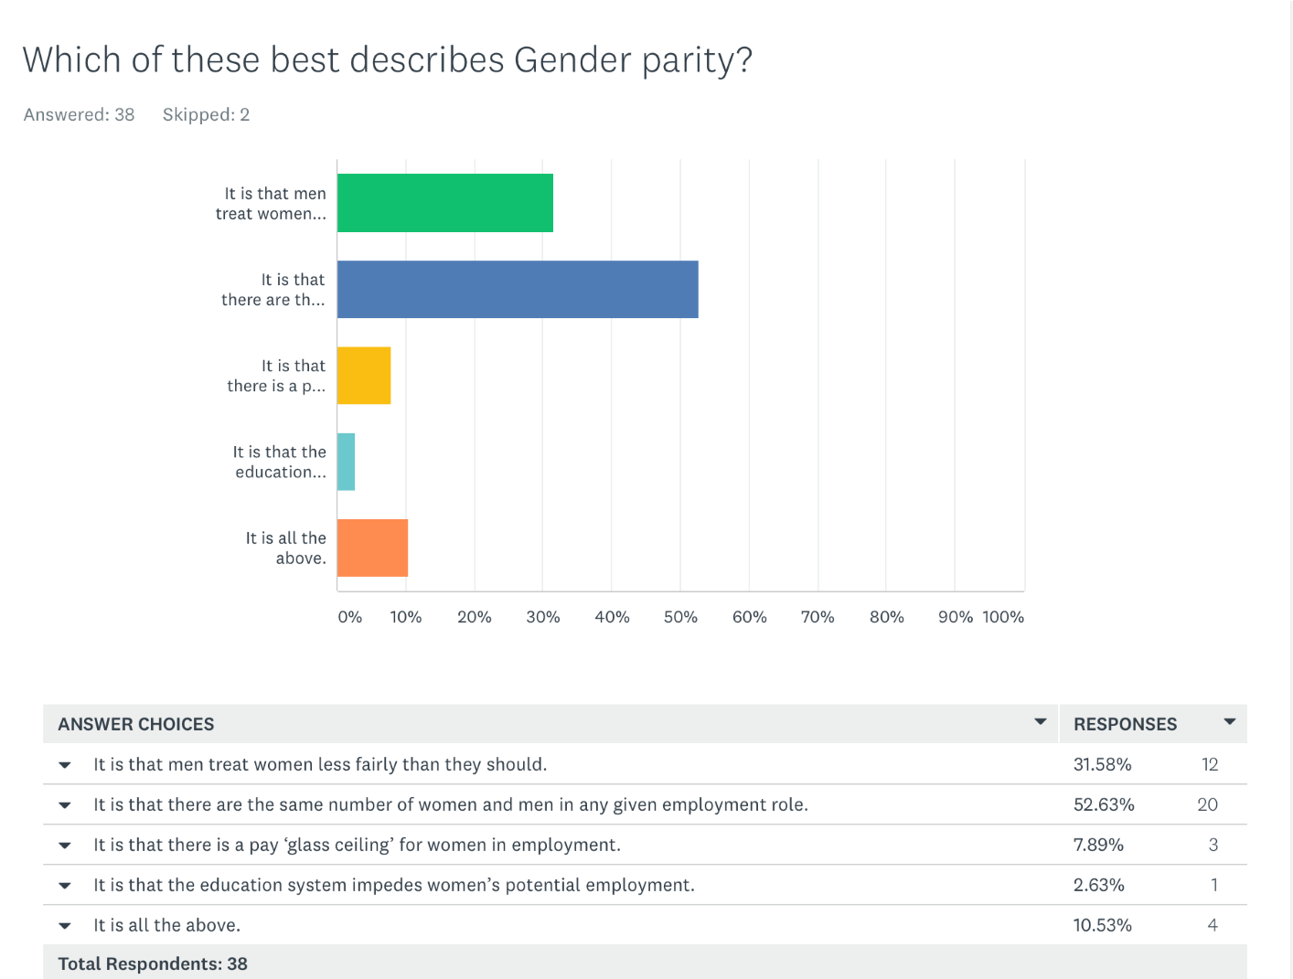
Fig 3
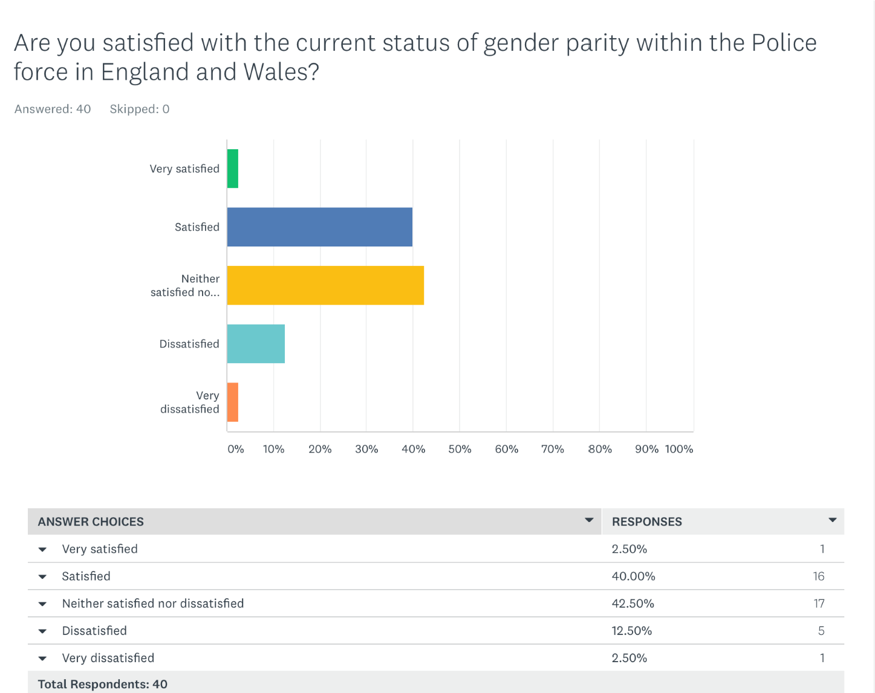
Fig 4

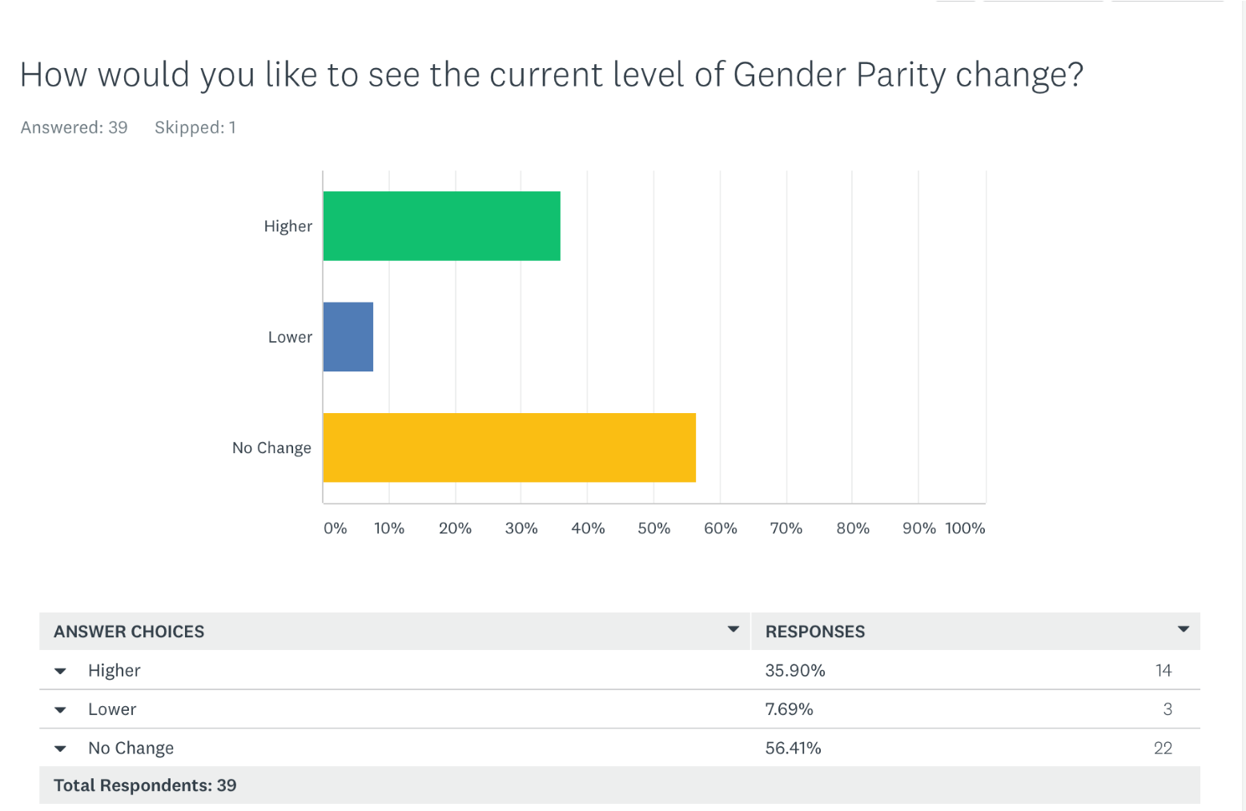
Fig 5
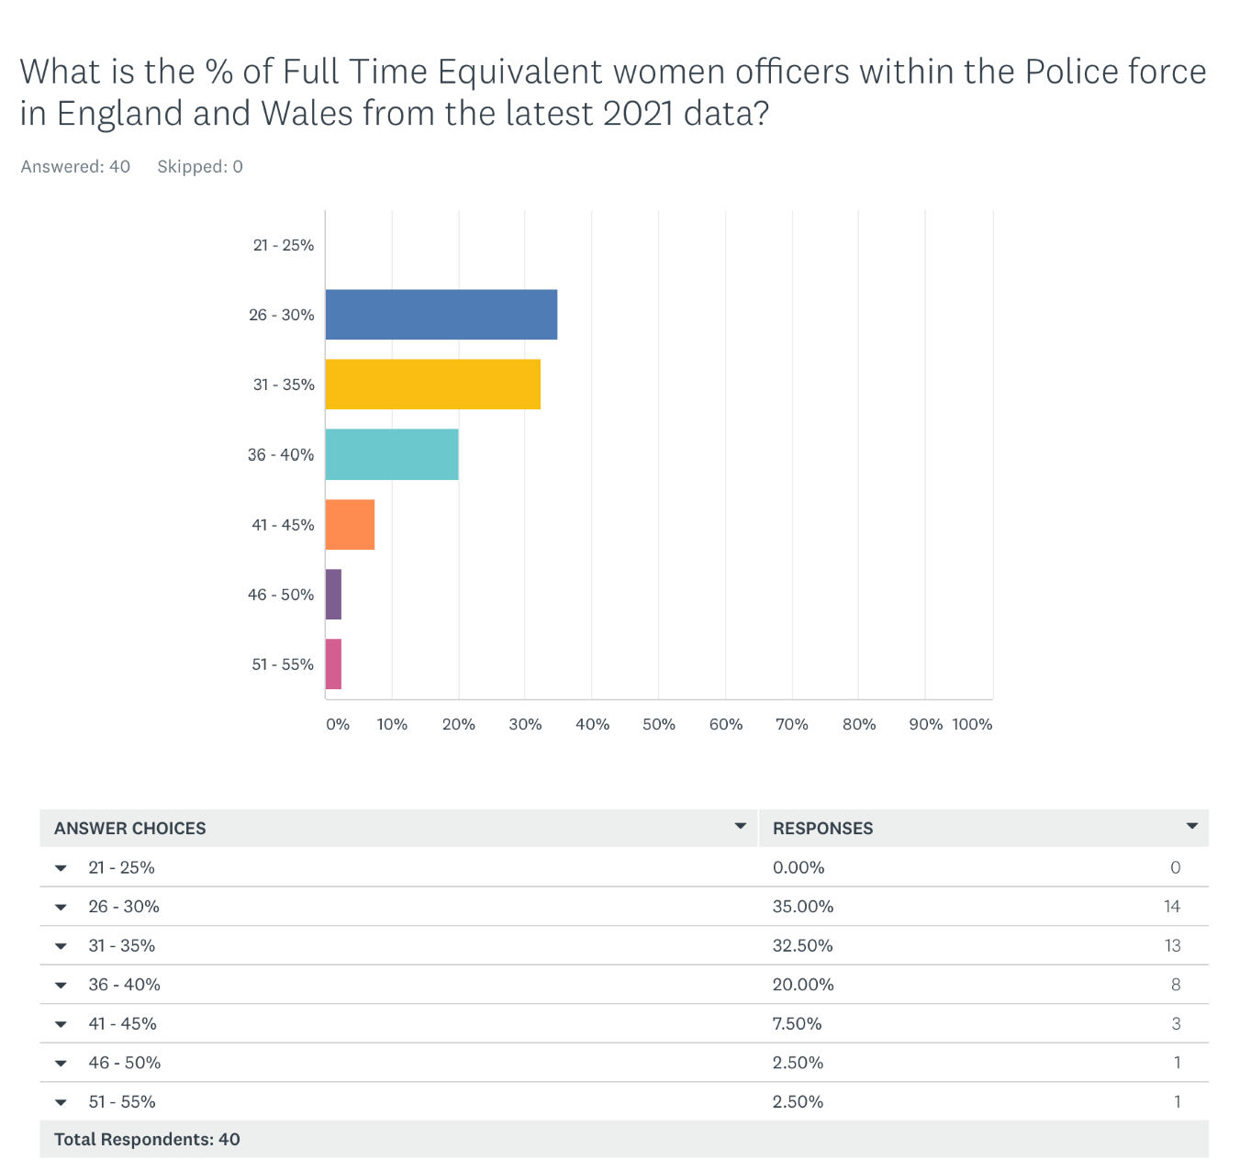
Fig 6

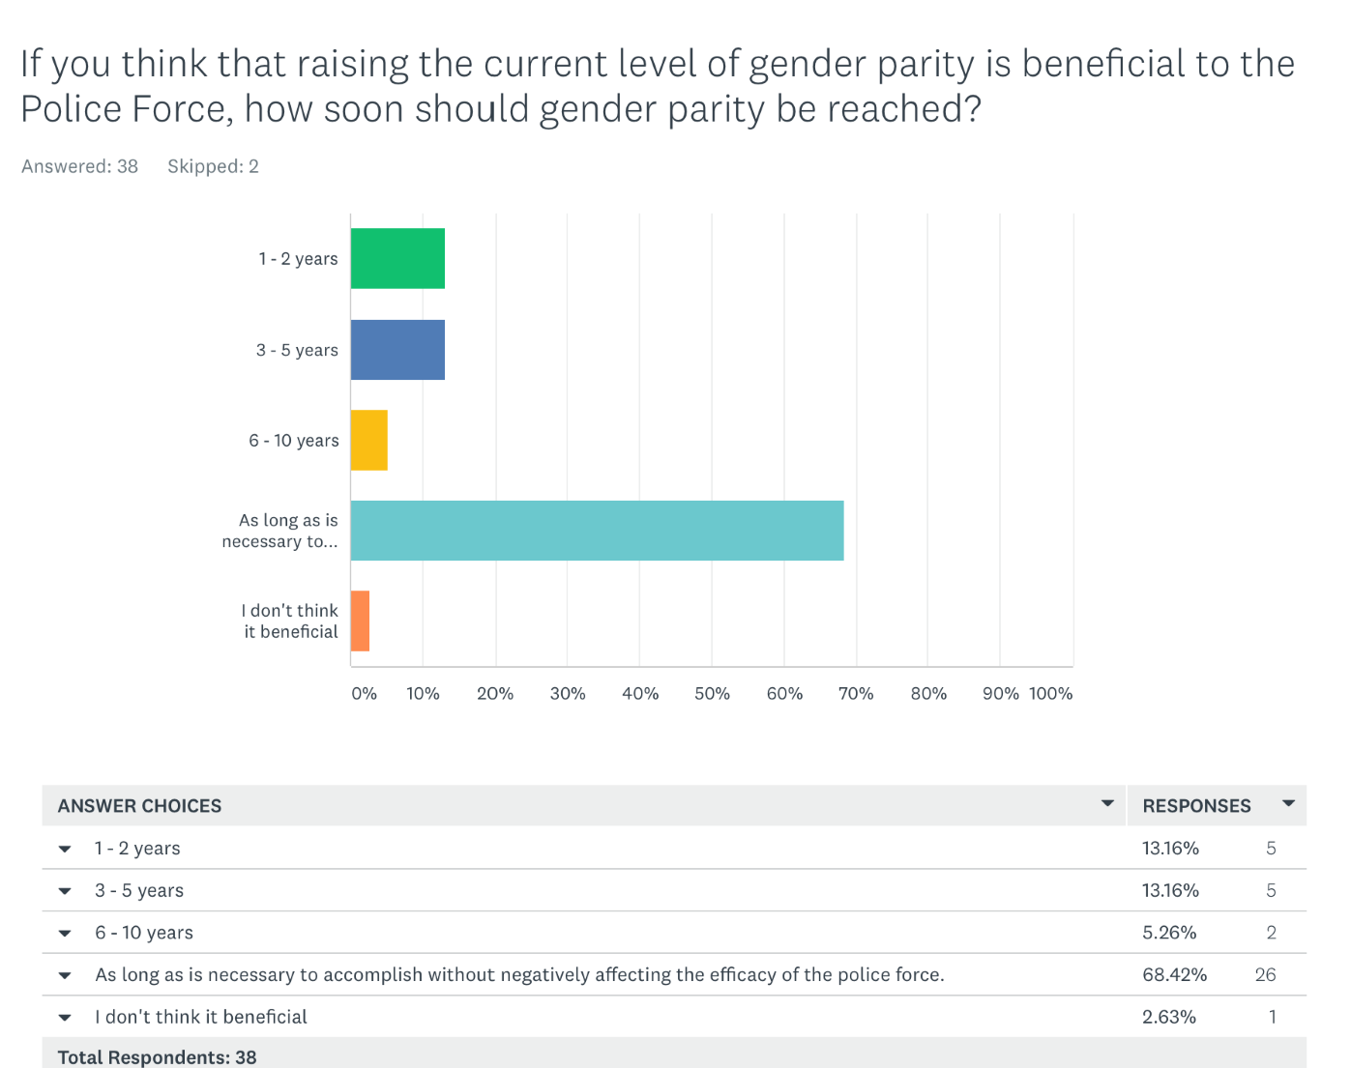

Fig 7

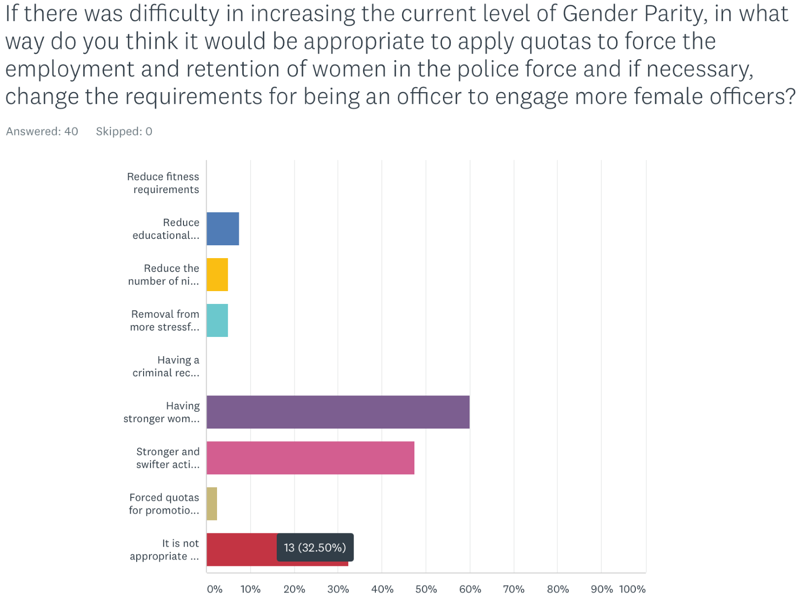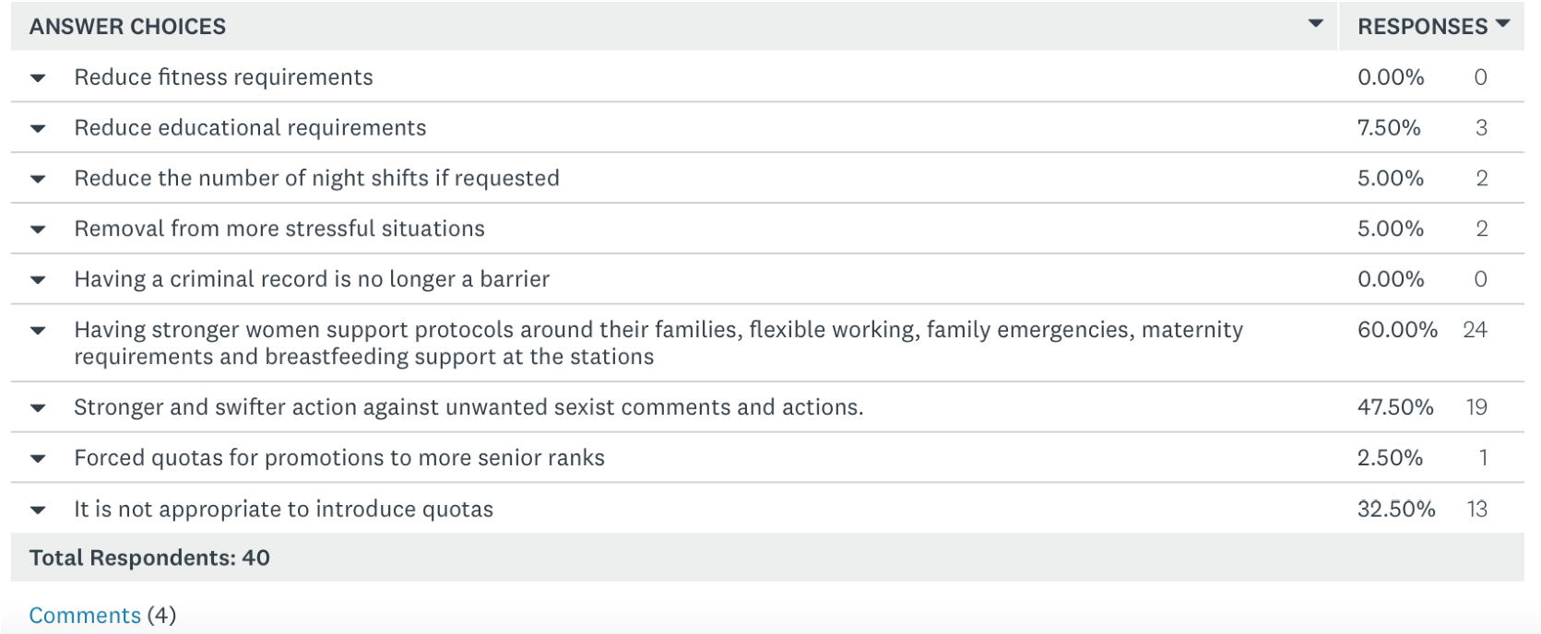
Caption
Fig 8
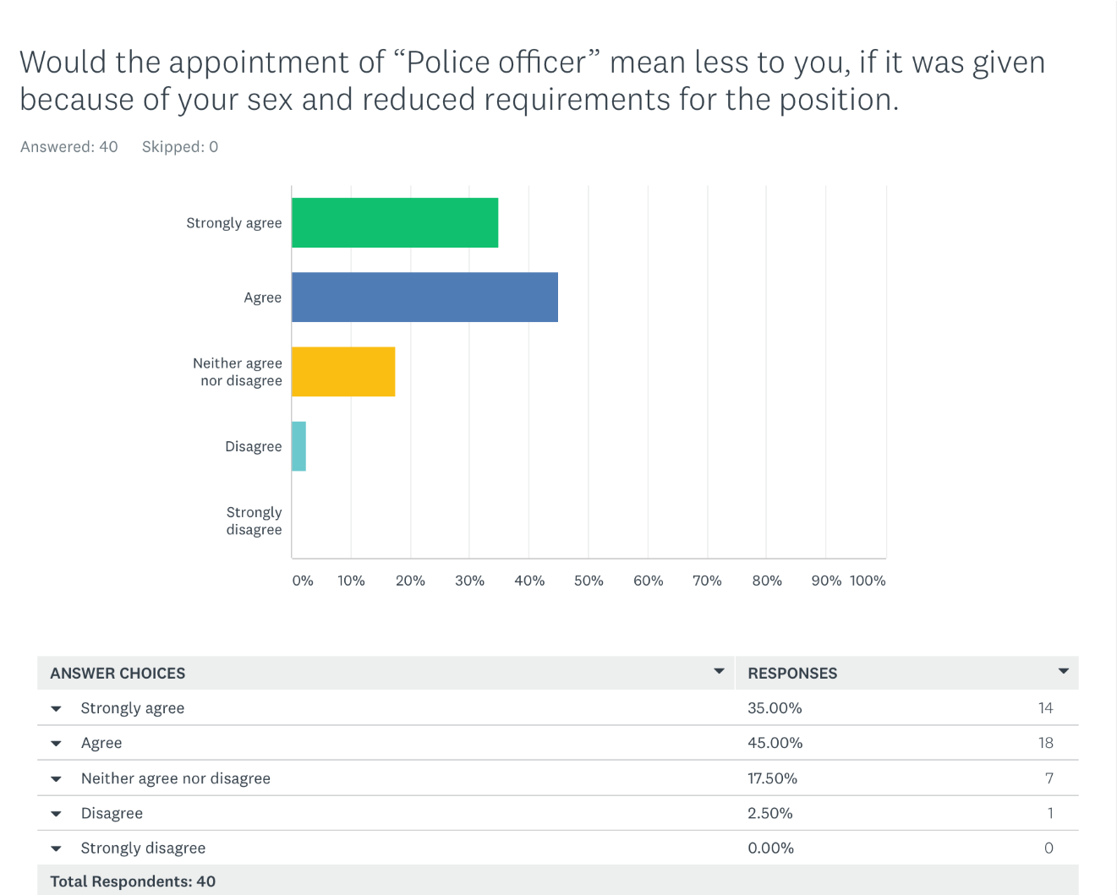

Fig 9
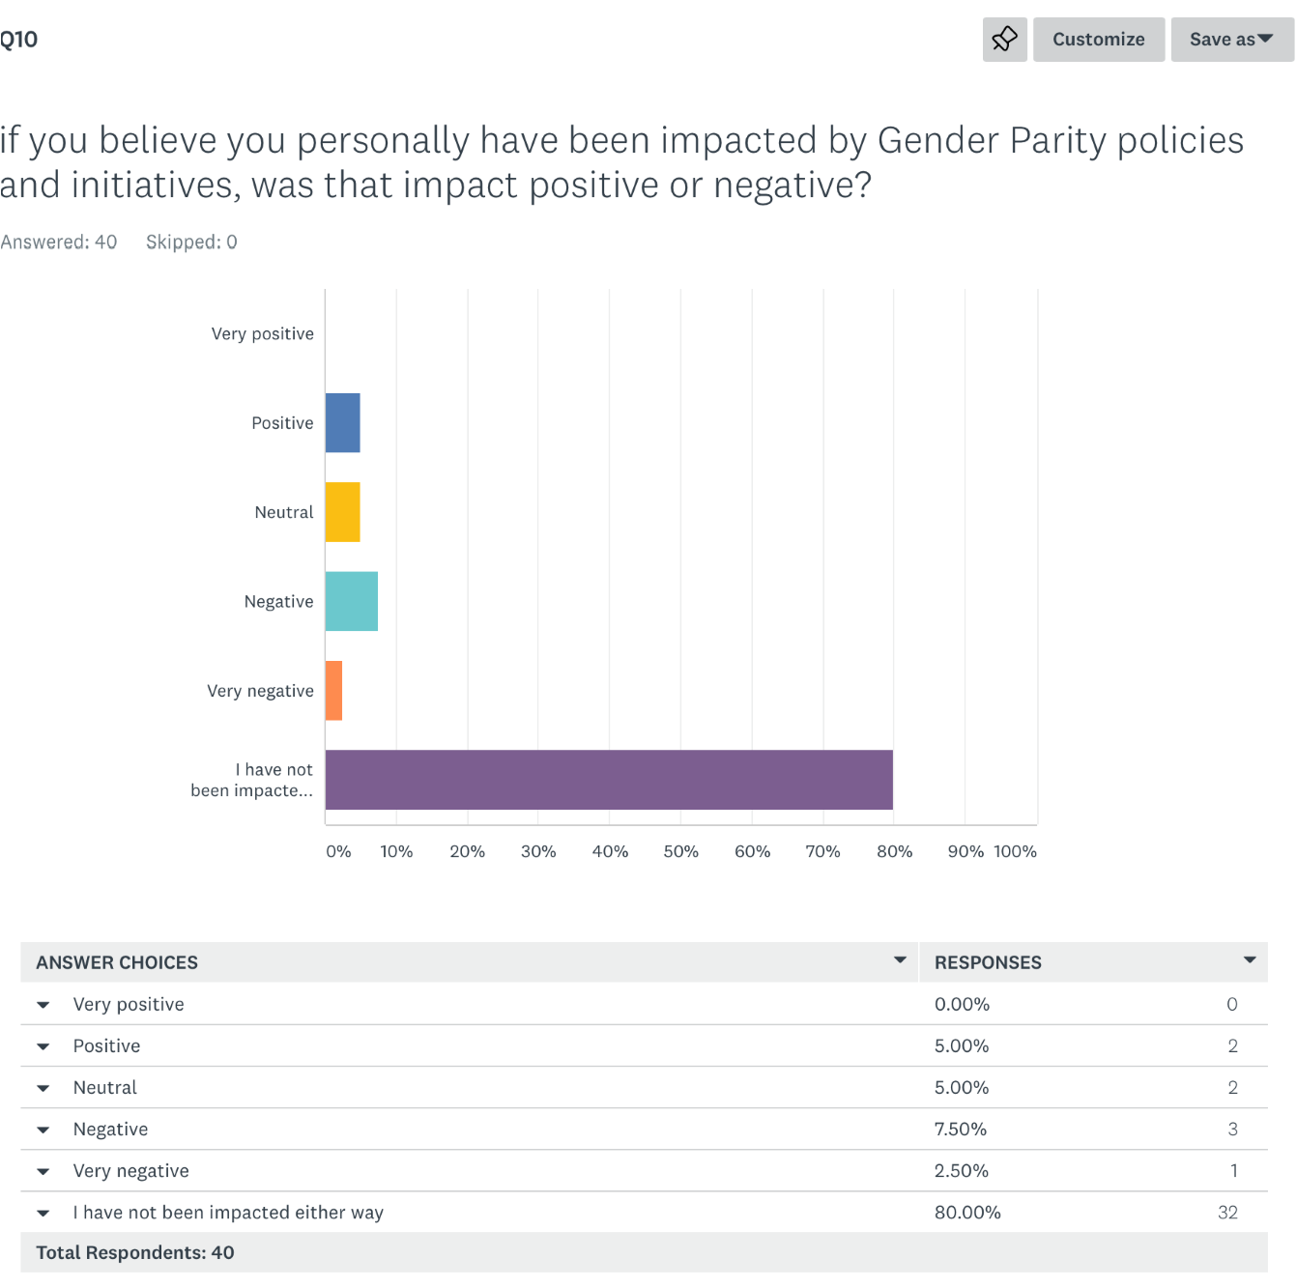

Fig 10
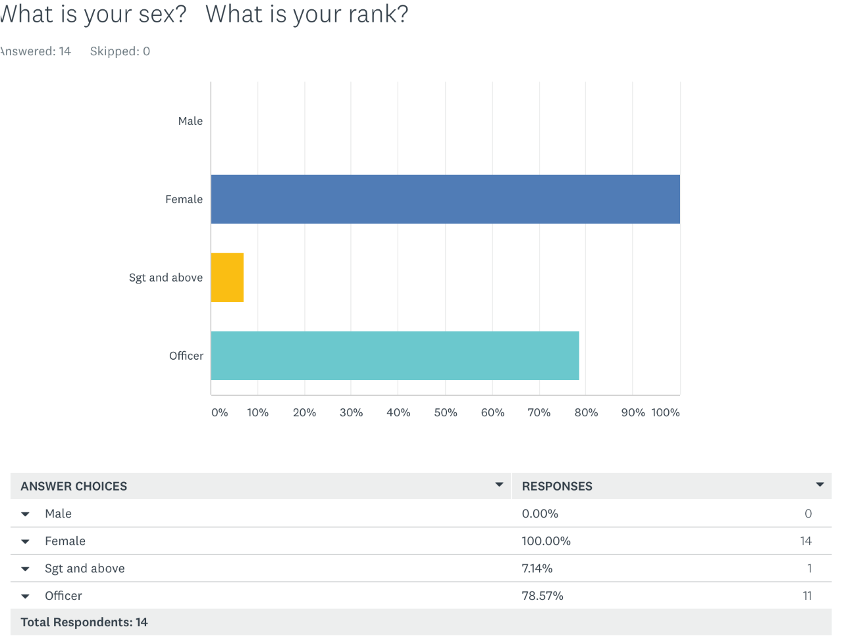

Fig 11
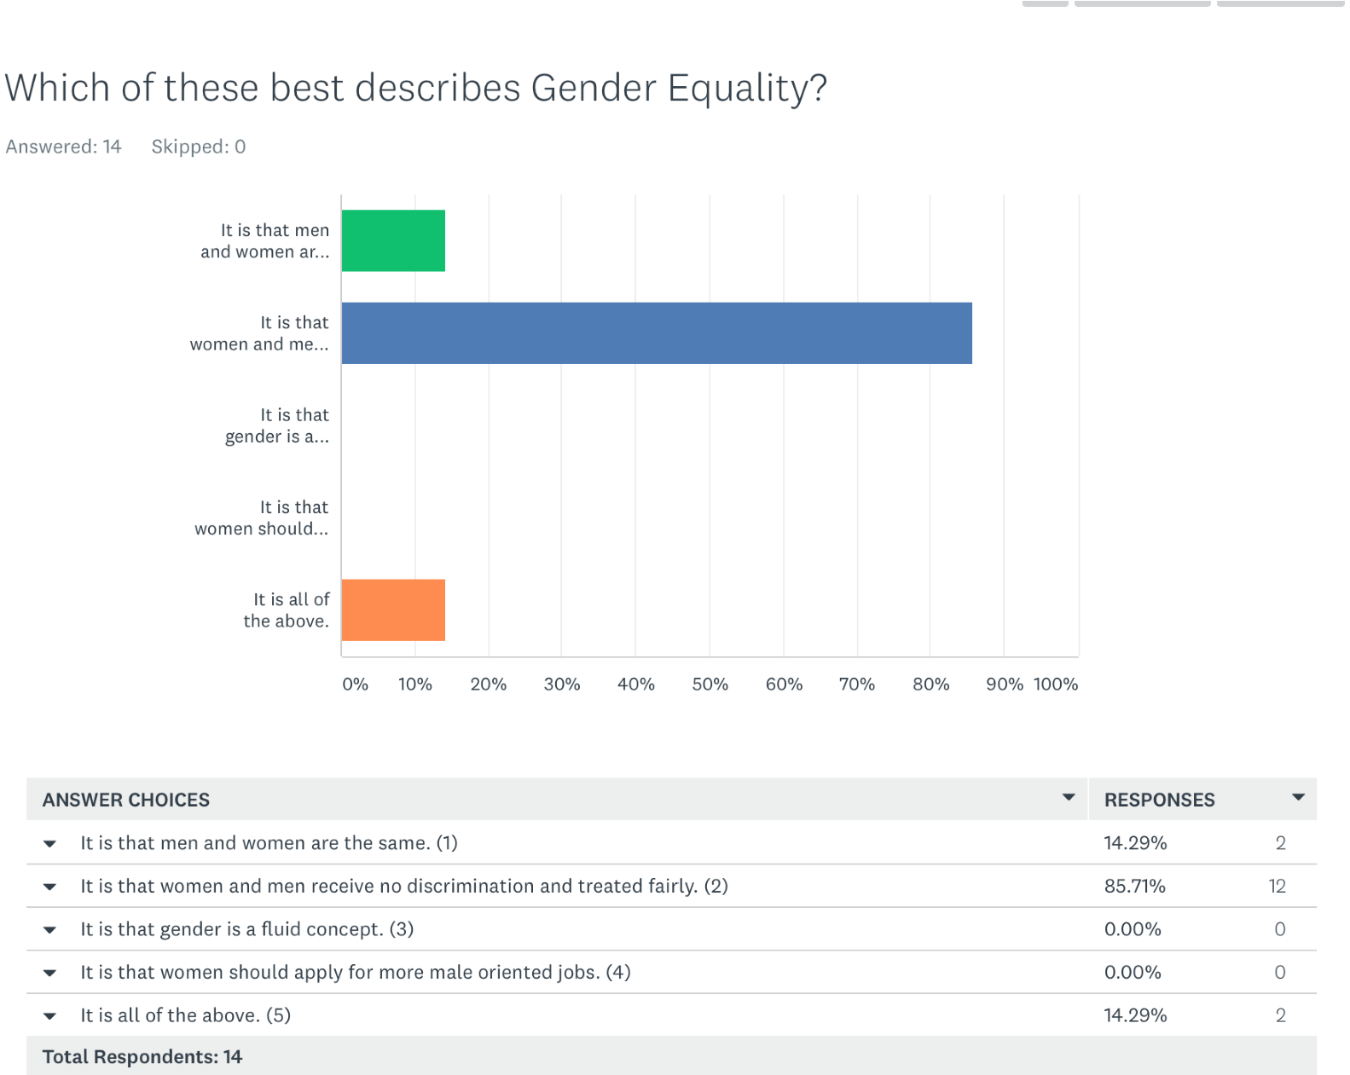

Fig 12
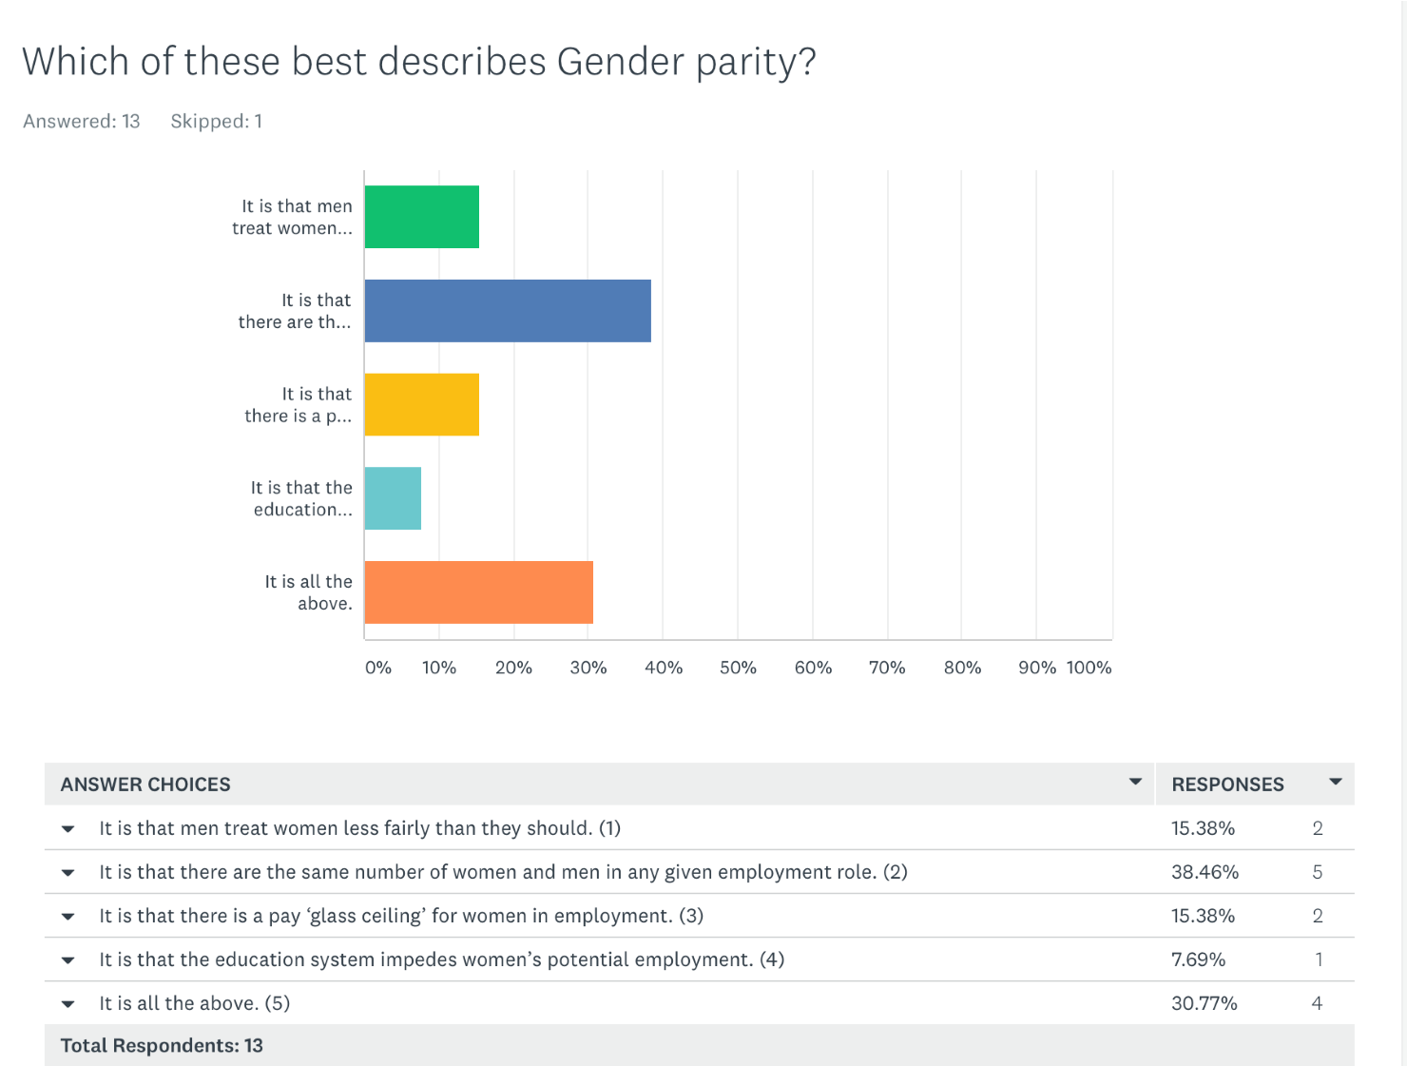

Fig 13
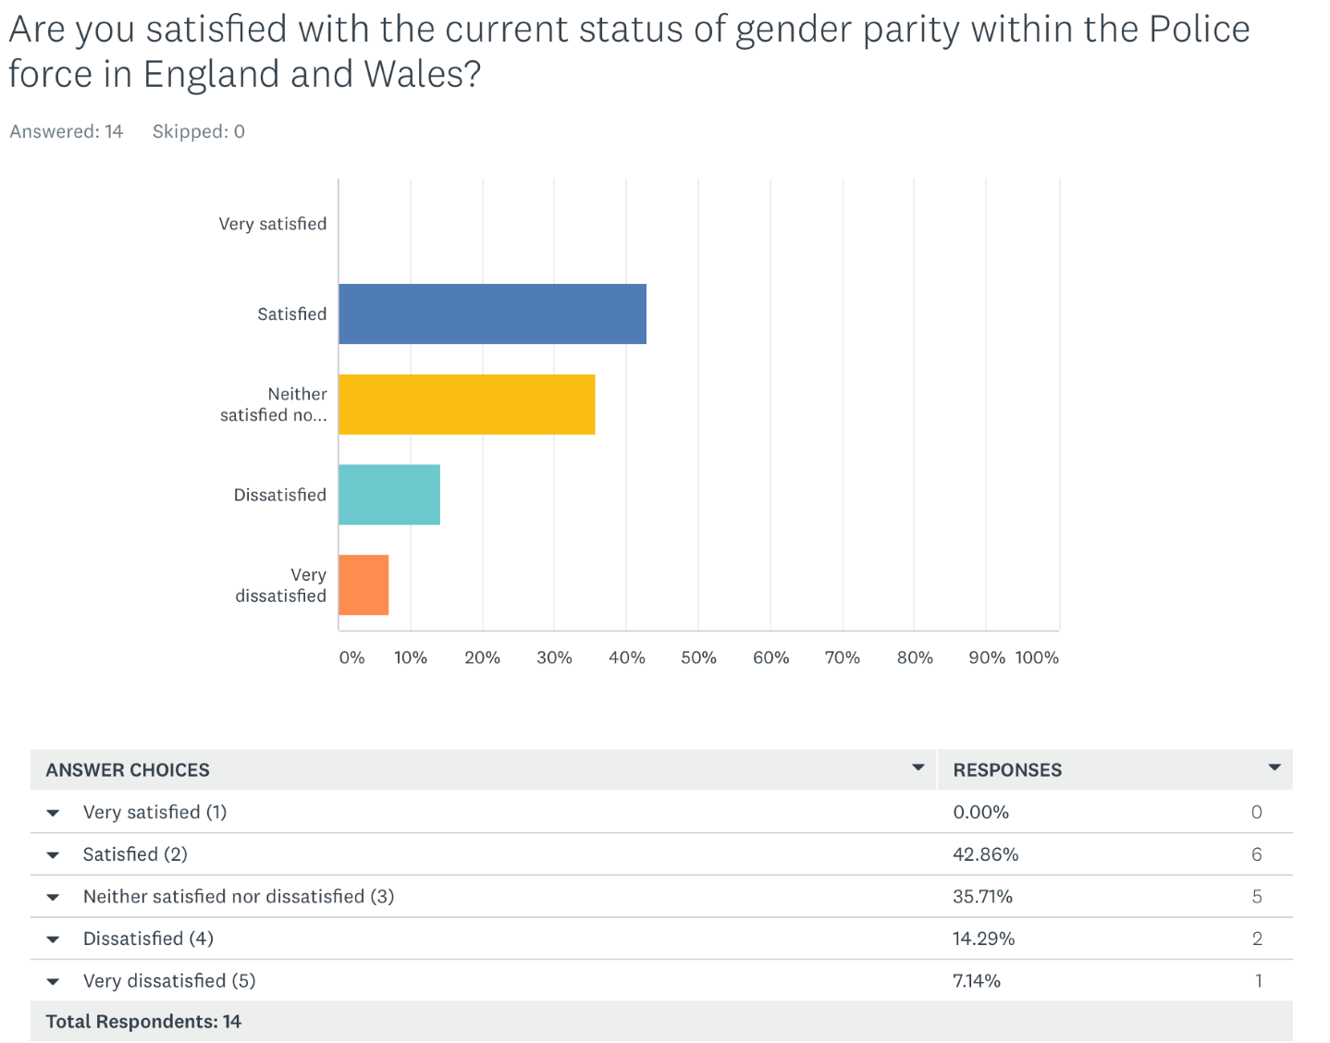

Fig 14

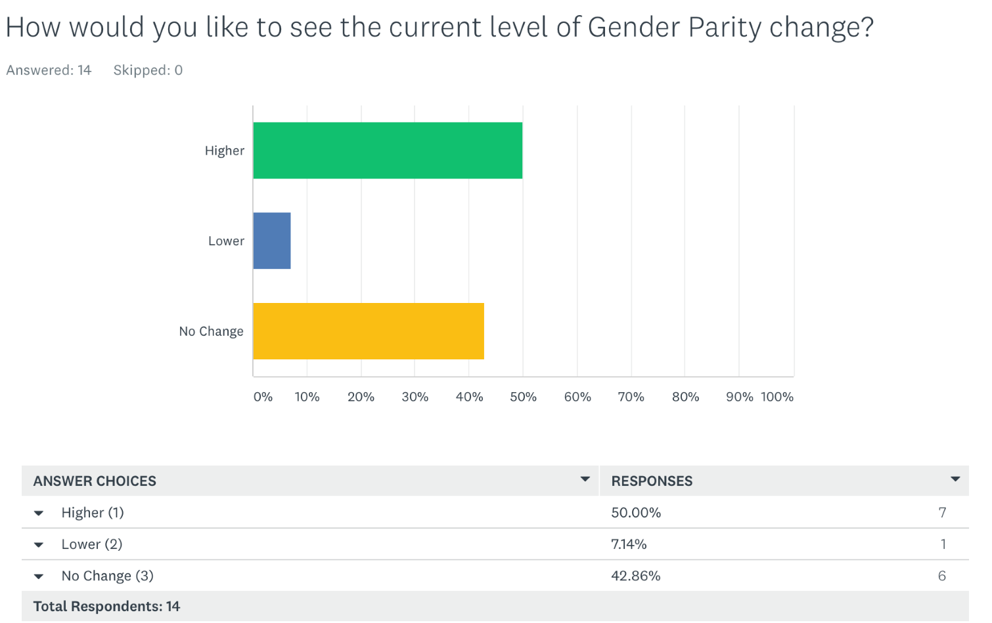
Fig 15
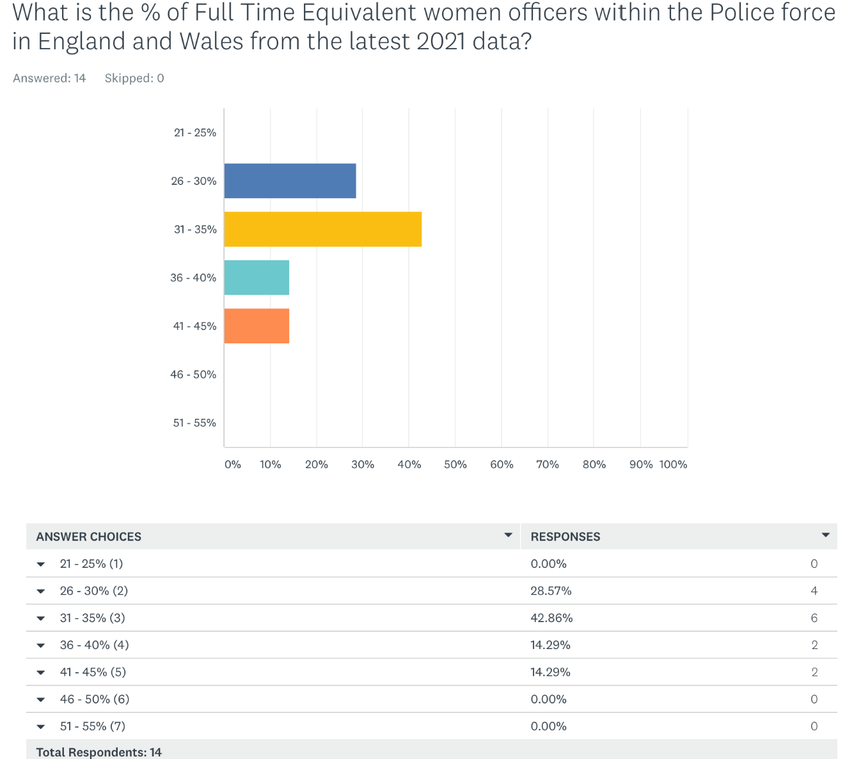
Fig 16
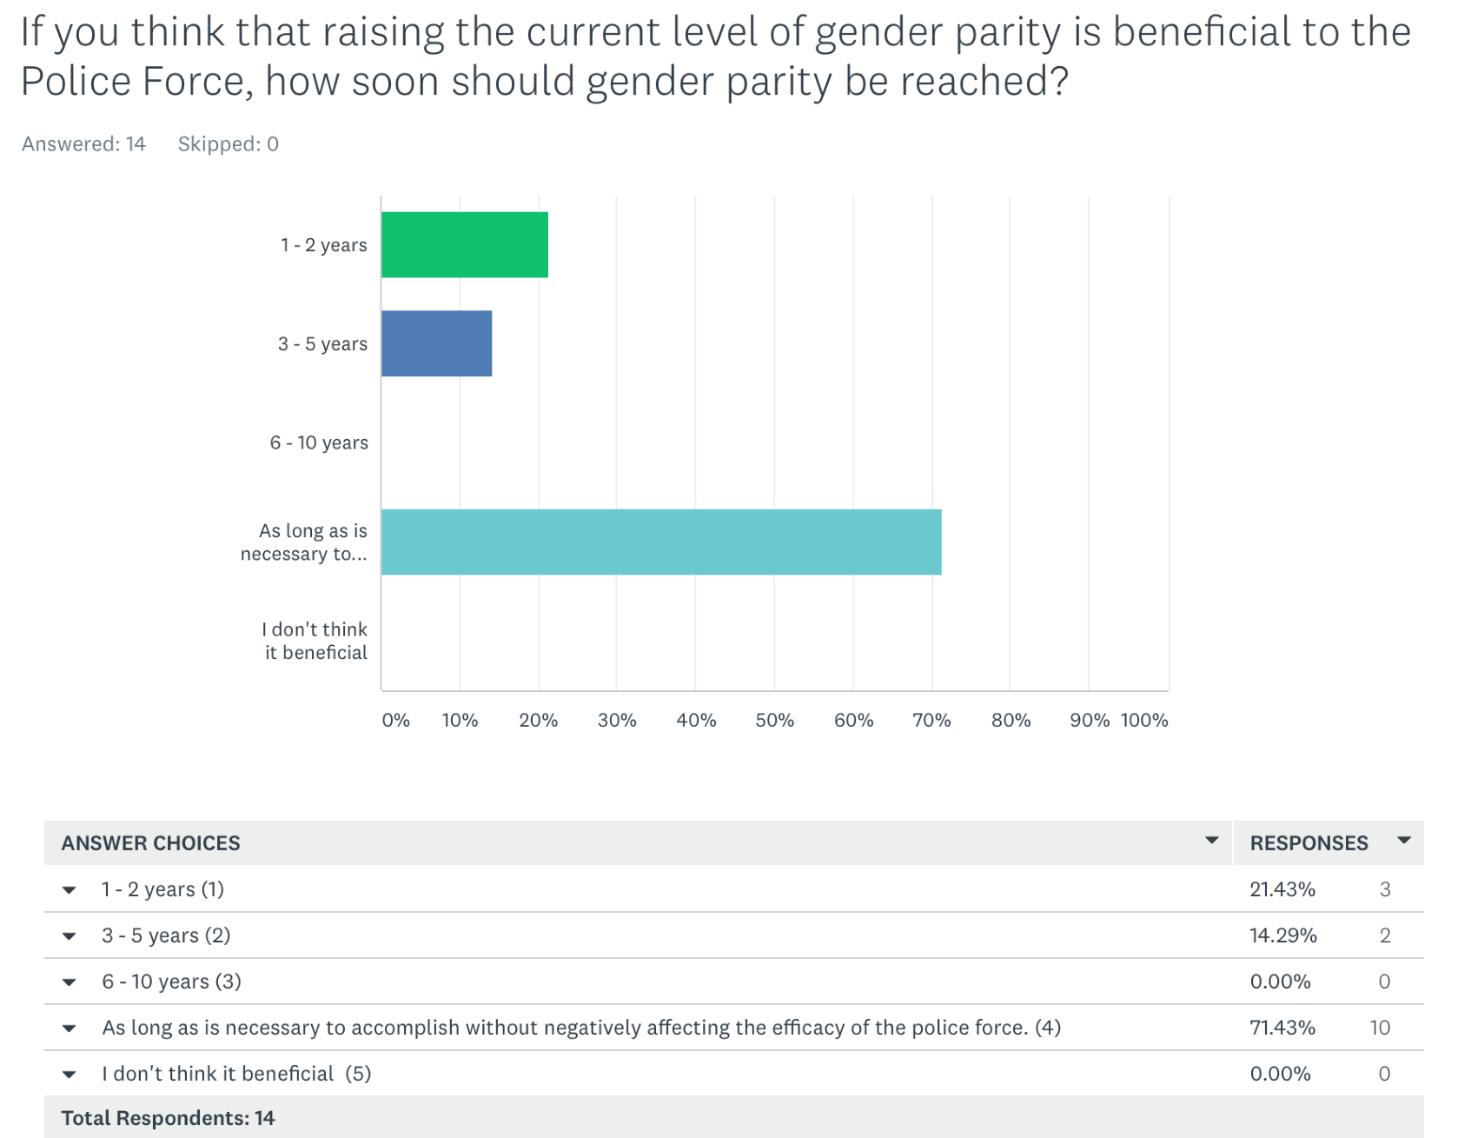

Fig 17
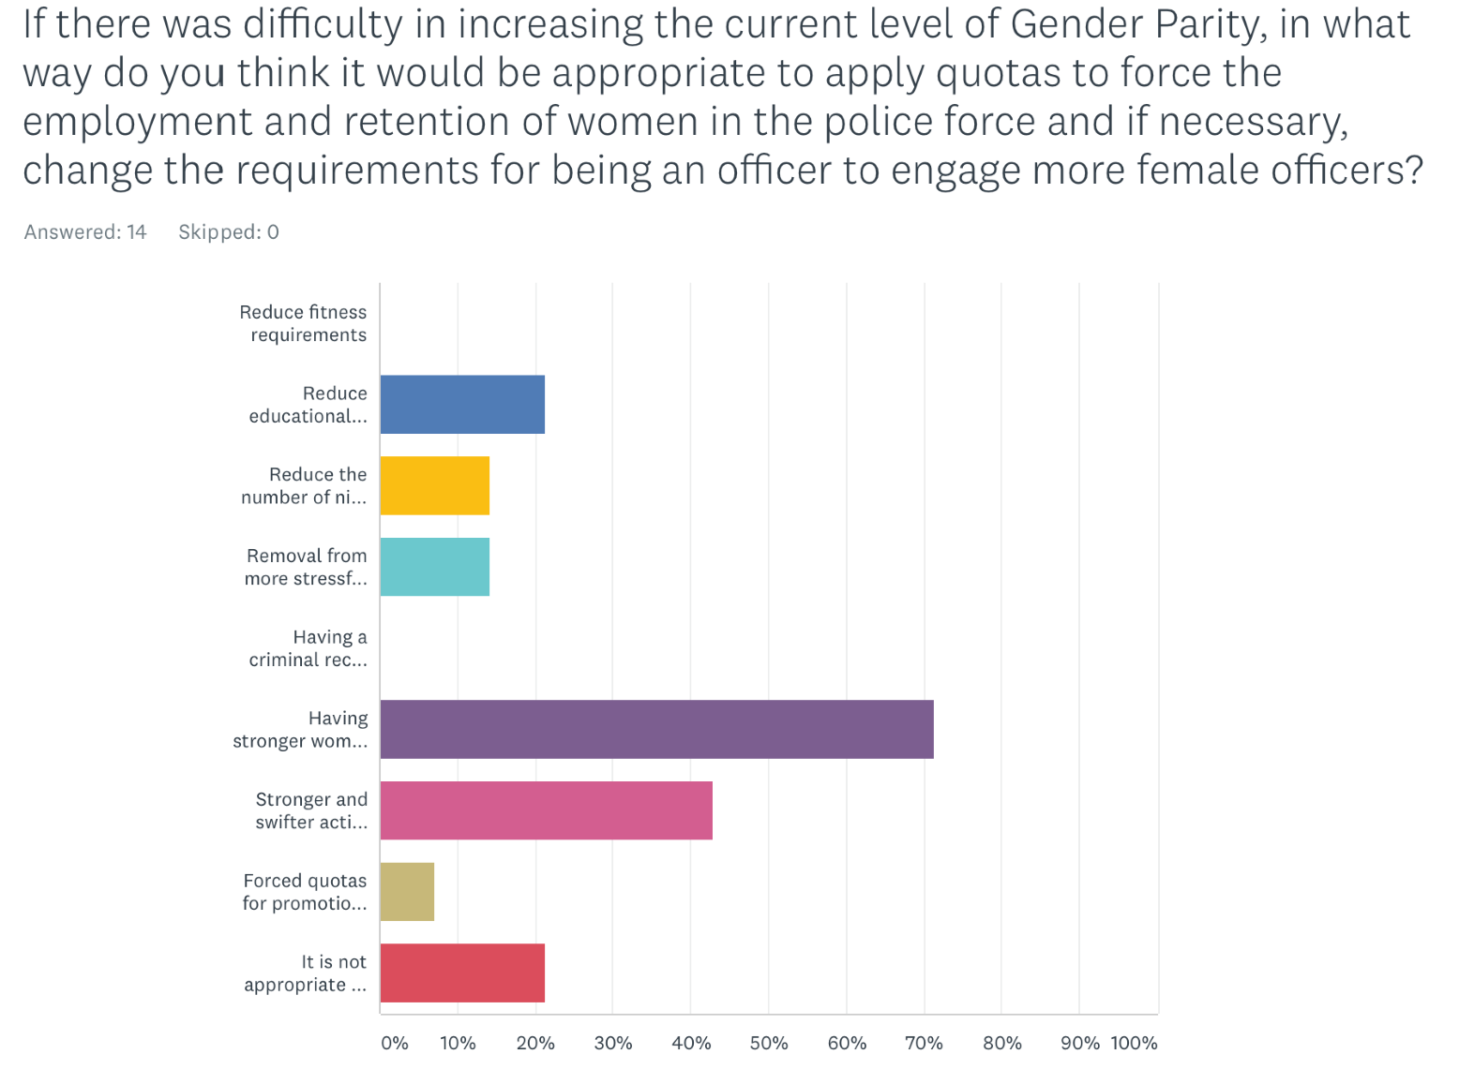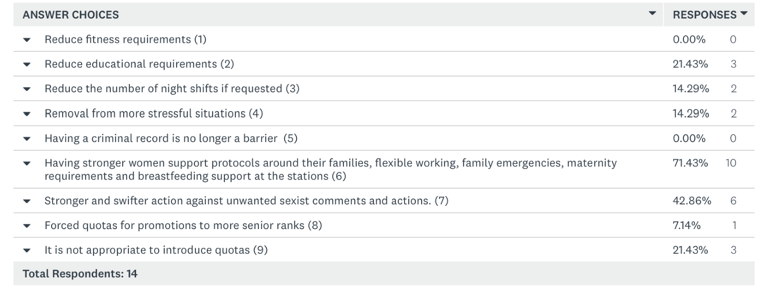
Caption
Fig 18

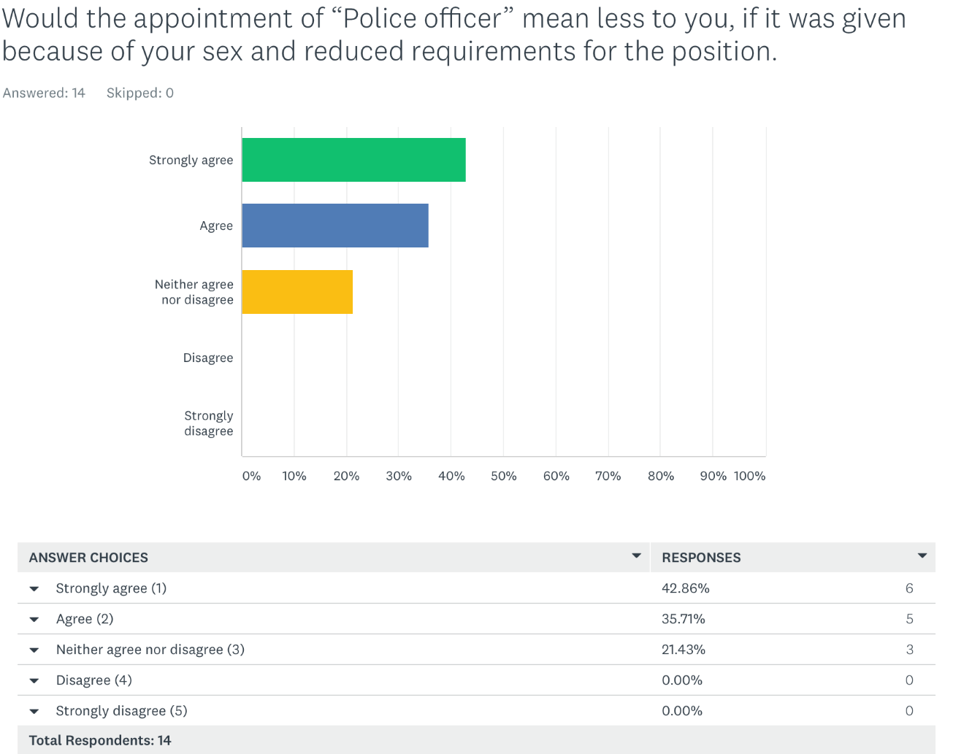
Fig 19
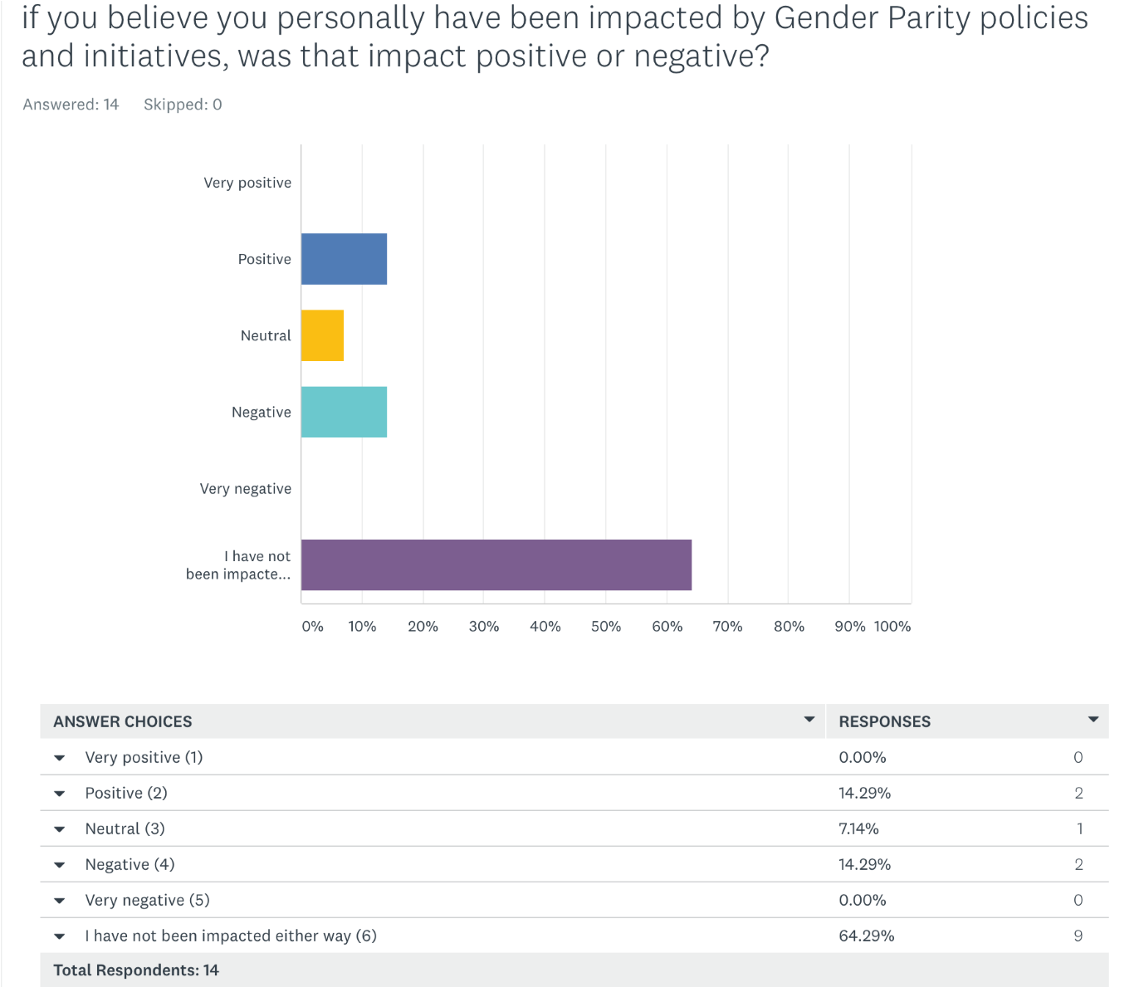
Fig 20

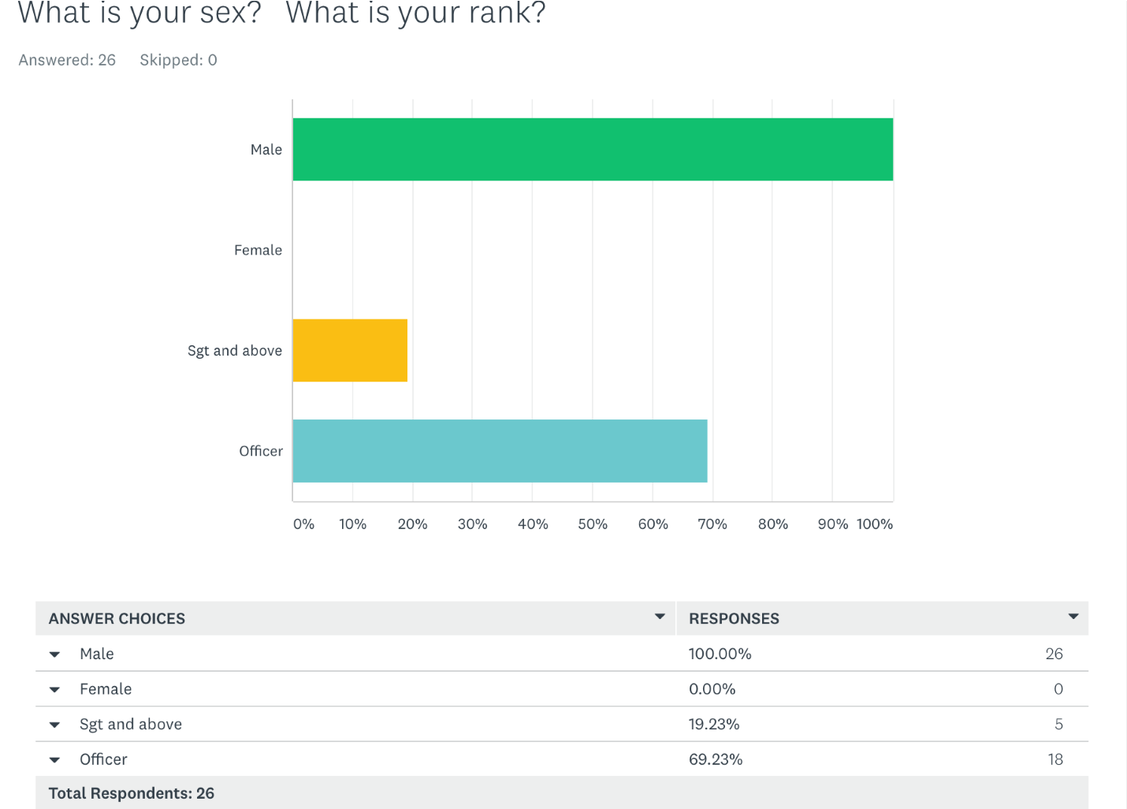
Fig 21
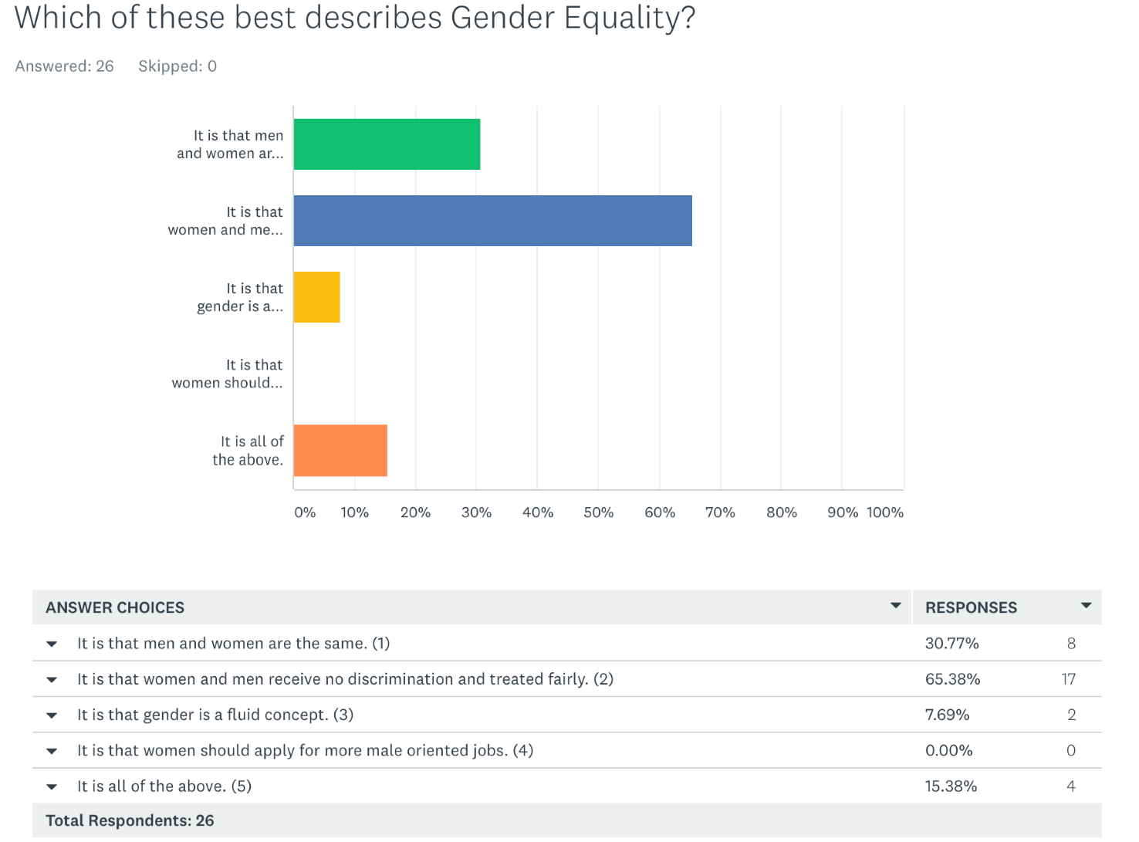
Fig 22

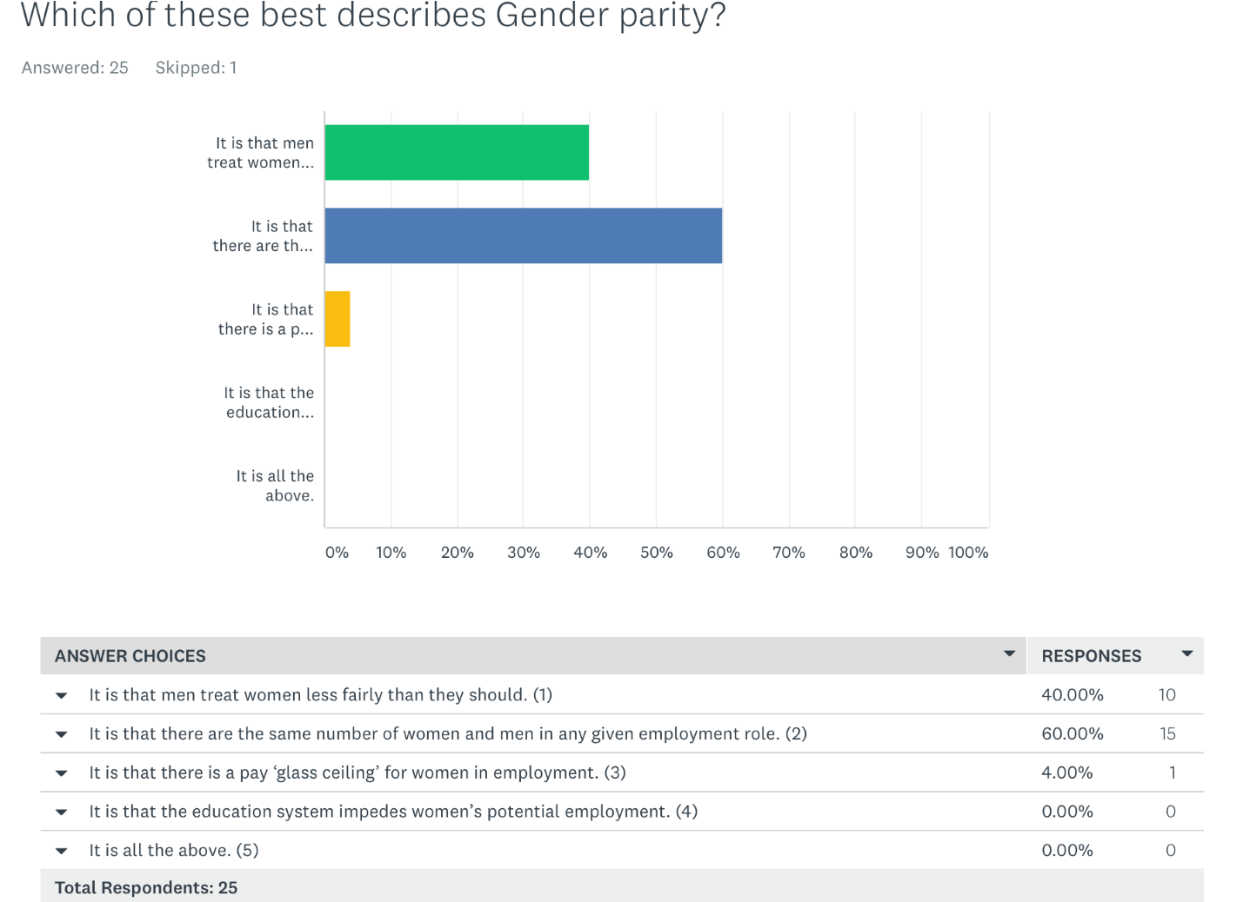
Fig 23
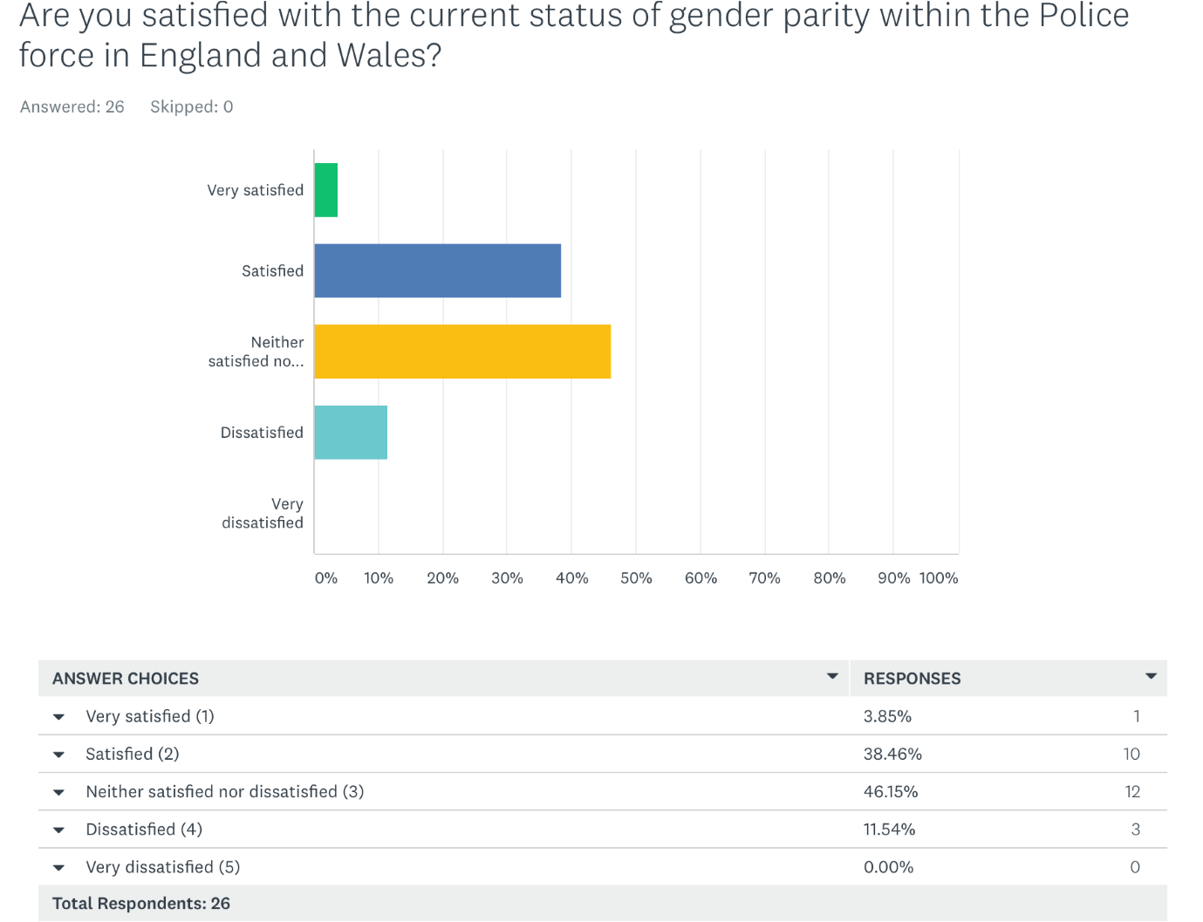
Fig 24

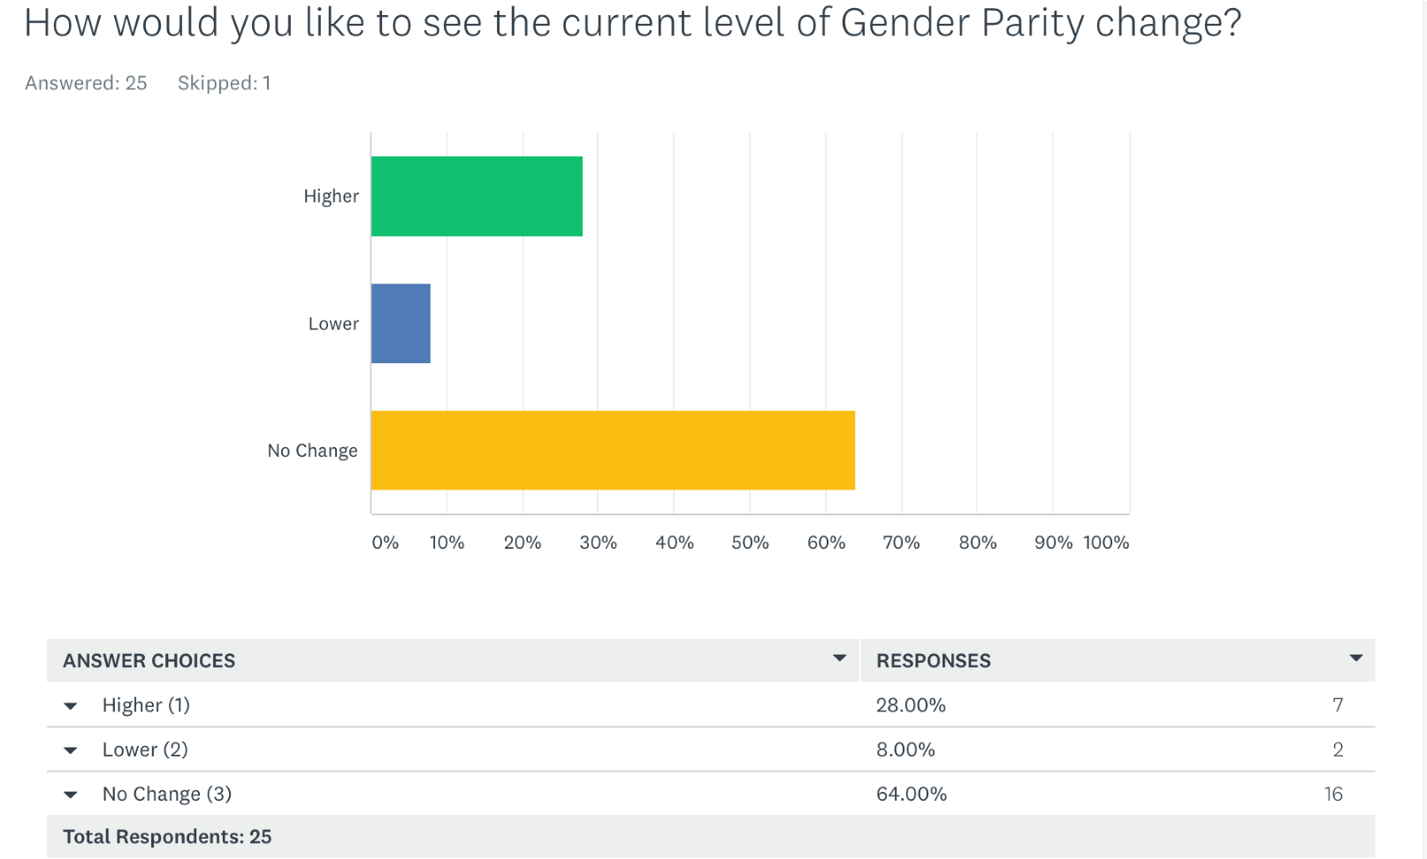
Fig 25
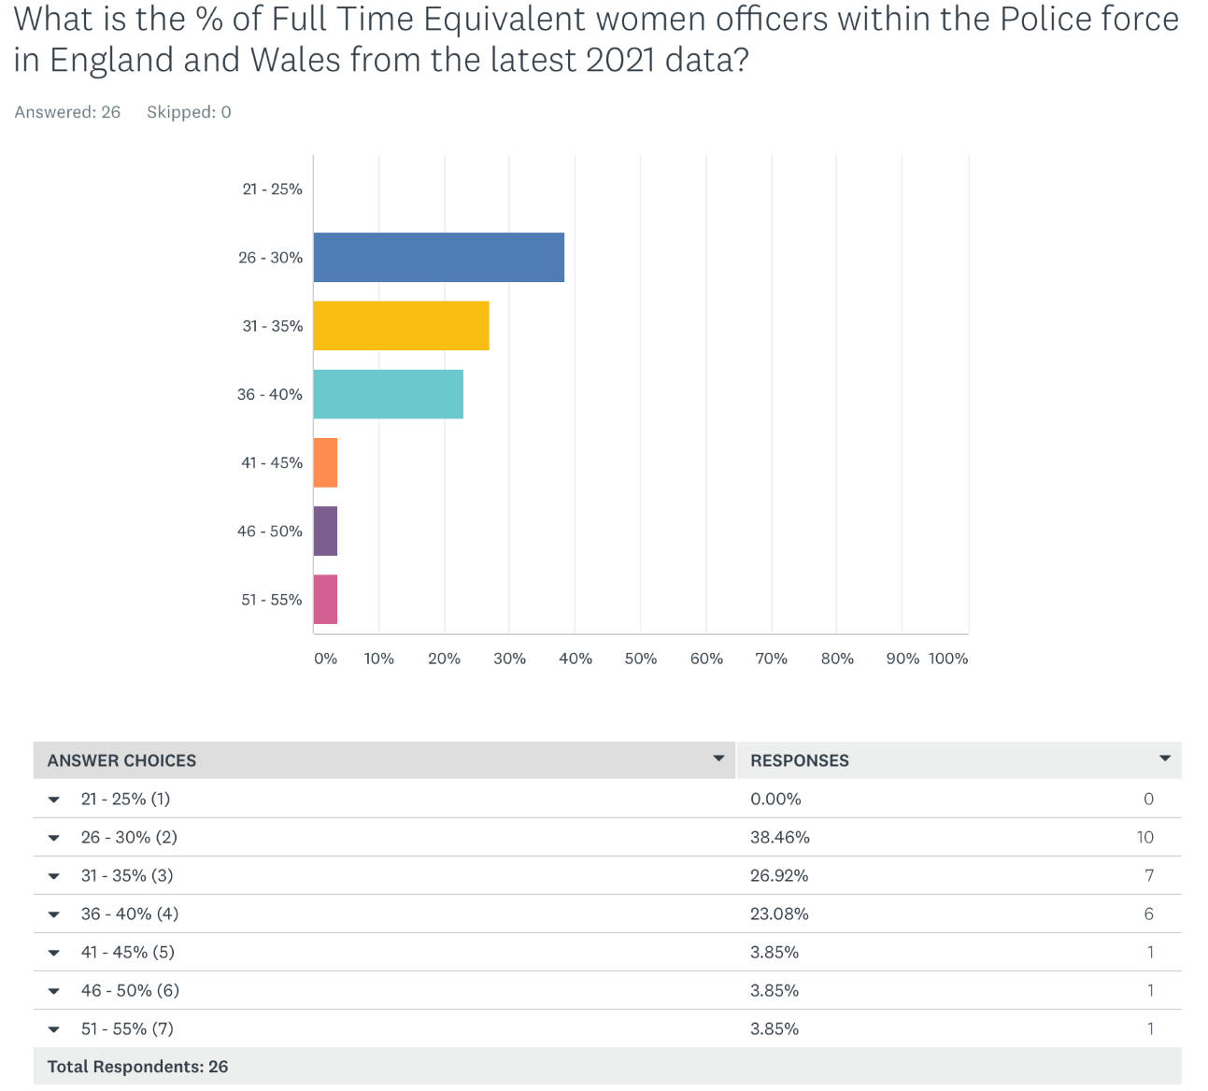
Fig 26

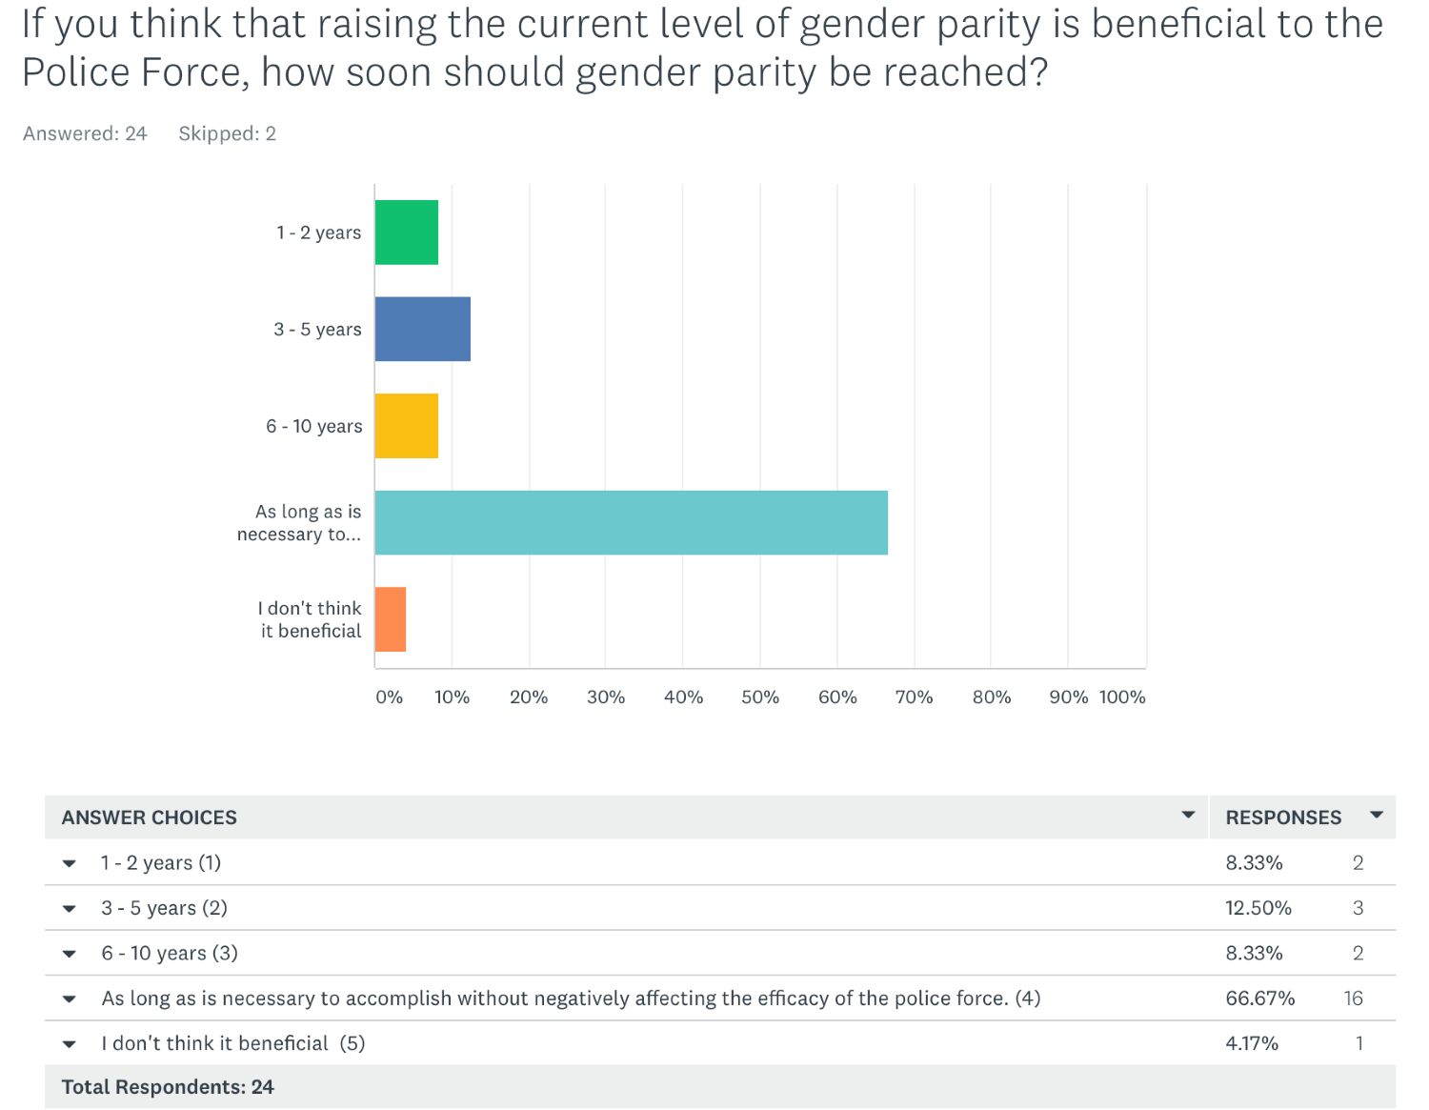
Fig 27
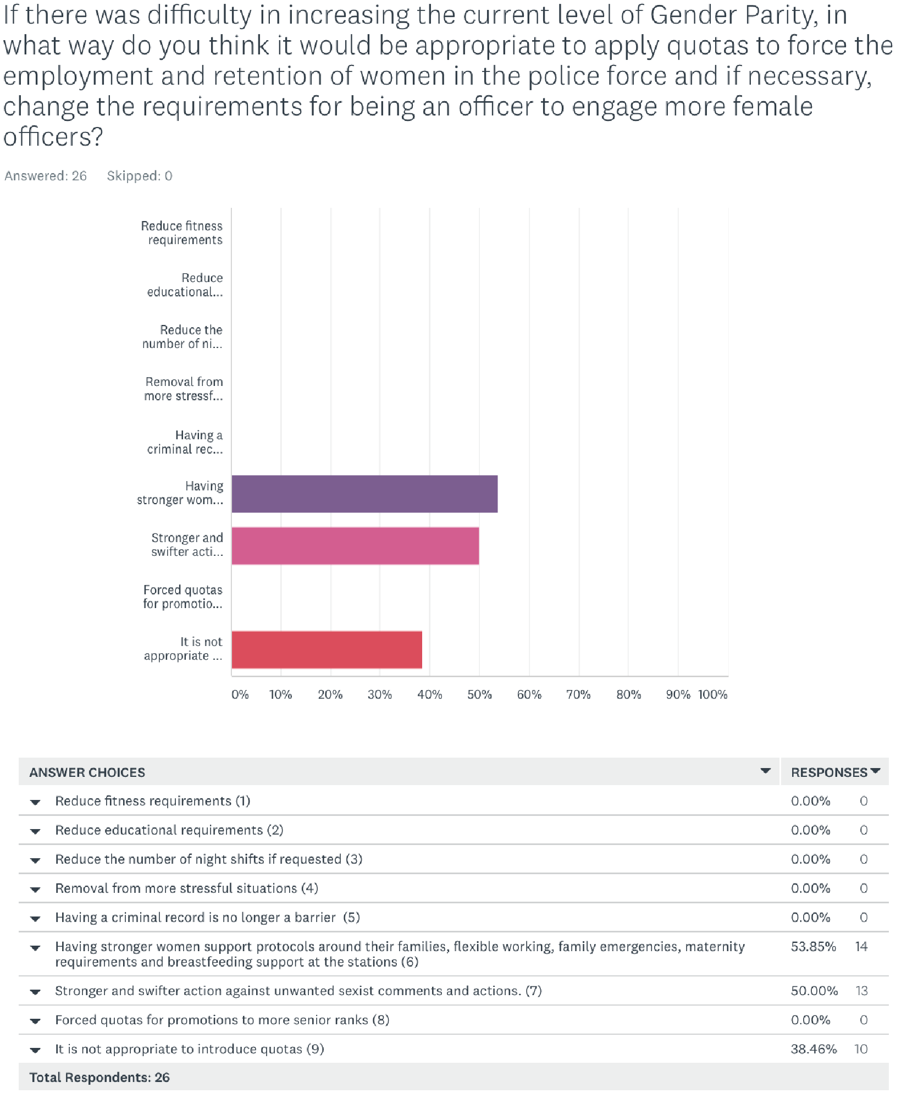

Fig 28

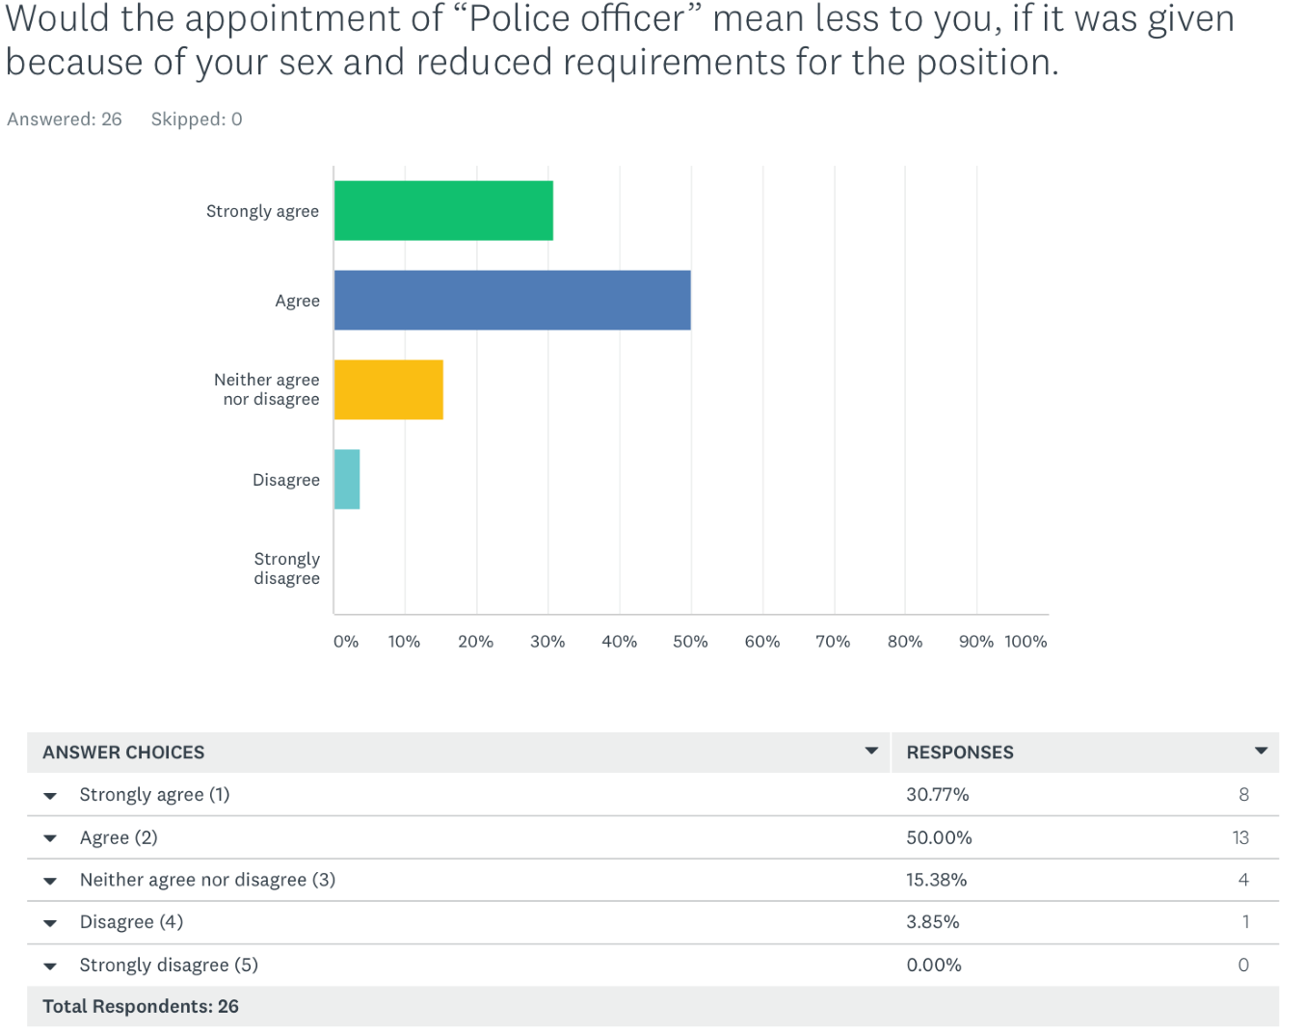
Fig 29
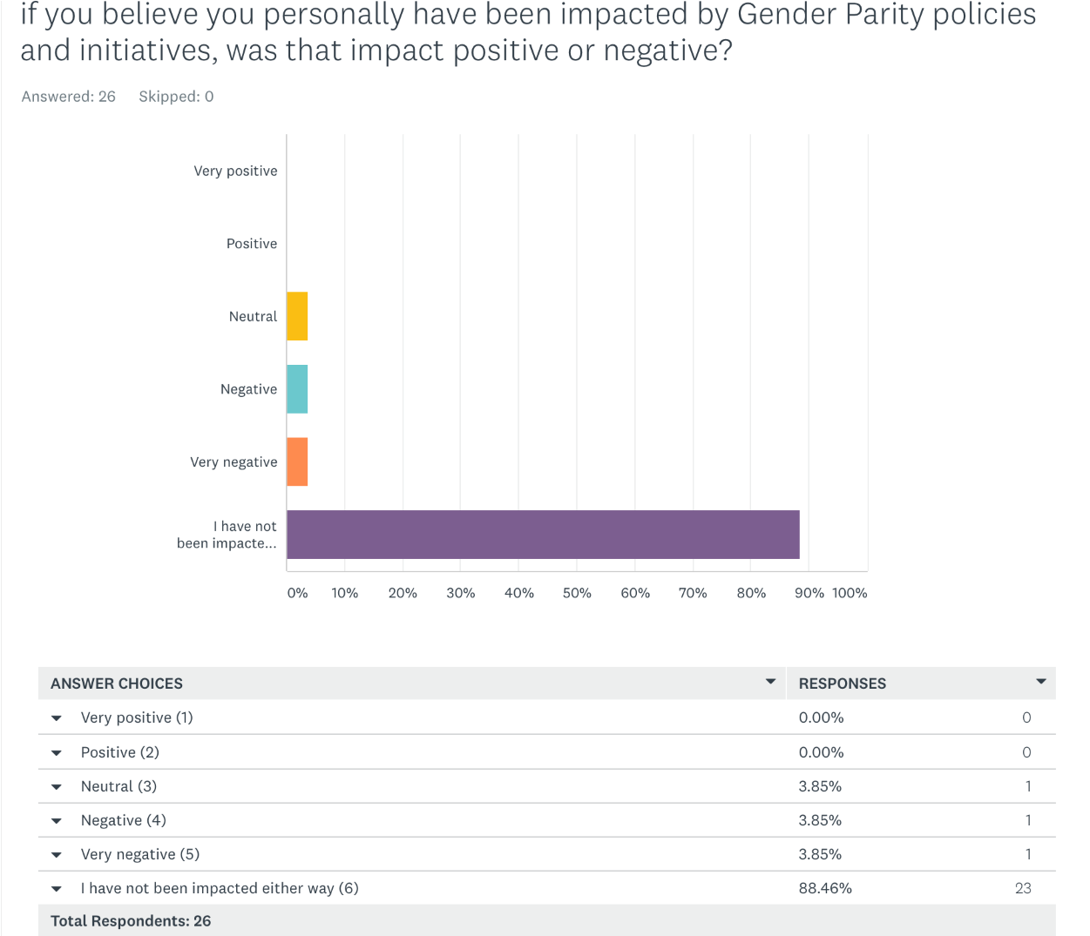
Fig 30

20

