
Software Engineering Design & Testing
Software Engineering Principles and Testing
Computing (Games Development)

William Foot (2405192)
Contents
1 Introduction 2
2 Literature Review 2
2.1 User Stories 2
2.2 CRC Cards 2
2.3 Class Diagrams 3
2.4 Sequence Diagrams 3
2.5 Software Testing 3
2.6 Unit Testing 4
3 Evaluation of Design 4
3.1 User Stories 5
3.2 CRC Cards 7
3.3 Class Diagrams 11
3.4 Sequence Diagrams 12
3.5 Software Testing 13
3.5.1 White-box vs Black-box 14
3.6 Unit Testing 15
4 Conclusion 16
5 References 17
6 Appendix 18

Introduction
Working as part of a group, we were tasked with creating a design specification for a web application version of the strategy board game, Battleship. The version of Battleship that we were to design would follow the same rules as the board game. This two-player game would feature a 10 x 10 grid, with each player placing their ships at the start of the game. Each player would then take turns guessing where the other player has placed their ships, and the grid would be marked with a hit if they are correct and a miss if they are not. The goal of the game is to guess the correct location of all the opponents’ ships before they can locate all of your ships [1].
This application expanded upon the traditional ruleset by allowing the player to use two once-per-game actions: a bomb and a counter manoeuvre. The bomb destroys an entire ship if it hits, and the counter manoeuvre allows a player to move their ship in response to a potential hit.
For the given scenario, techniques and tools such as user stories, Class Responsibility Collaborator (CRC) cards, and sequence diagrams have been used to design the application.

Literature Review

User Stories
“USQA: A User Story Quality Analyzer prototype for supporting software engineering students” [2] is a research paper that proposes a tool to support students in analysing user stories. The paper outlines factors for high-quality user stories and explains how the proposed prototype assesses them against these criteria. These criteria can be used to assess the user stories created for this project.
“User Stories and Natural Language Processing: A Systematic Literature Review” [3] discusses the drawbacks of using natural language when creating user stories. The paper then discusses the use of Natural Language Processing (NLP) techniques to improve the quality of use stories.
“On the impact of using different templates on creating and understanding user stories” [4] identifies 4 user story design templates, along with their benefits and drawbacks. They assess the speed of creation and its impact on understanding user stories.

CRC Cards
“CRC cards for product modelling” [5] describes the process of using CRC cards to build product models and highlights the importance of this modelling technique for creating well-structured, well-documented applications. It also defines an alternative CRC card layout for more advanced or complex applications, shown in Appendix 6.B.
“Teaching object-orientation with smartphones as digital CRC cards” [6] is a research paper proposing a tool to help students learn object-oriented design through digital CRC cards. The tool allowed students to navigate through their CRC card design to simulate scenarios. This allowed them to reflect on the design and the process a user would take through the application.
“Tree-Based Approach to Use CRC Cards Efficiently in Software Project Management” [7] proposes using an additional tree diagram to map the dependencies of the CRC cards to support project management during the design process. This method can be useful for rapid application development and scheduling when developing these classes.

Class Diagrams
“Evaluating the layout quality of UML class diagrams using machine learning” [8] analyses the layout quality of class diagrams and proposes a machine learning model to evaluate them. The algorithm's criteria can be applied to the class diagrams created for this project.
“Gamification of conceptual modeling education with UML class diagrams: an experimental analysis” [9] proposes a tool that uses gamification to support proper class diagram design. While the gamification aspect of this method is not relevant to this topic, the methods used to evaluate the creation of these diagrams can be applied to the diagrams created for this project.

Sequence Diagrams
“Required Behavior of Sequence Diagrams: Semantics and Conformance” [10] This article investigates the required behaviours of sequence diagrams and aims to establish a standardised conformance based on their semantics. This research will be useful when evaluating the sequence diagrams created for this project.
“SeDiTeC-testing based on sequence diagrams” [11] is a paper that investigates the use of sequence diagrams to create test cases for applications. Although the tool they propose is tailored to Java programs, the methodology behind it could be applied to the design produced for this project, allowing the sequence diagrams produced to aid in the creation of test specifications.

Software Testing
“A Comparative Study of White Box, Black Box and Grey Box Testing Techniques” [12] analyses and compares the three common testing techniques. It lists the advantages and disadvantages of each method, and using these, I can develop comprehensive tests for this application.
“Black And White-Box Unit Testing For Web Applications” [13] this paper analyses manual and automated testing, focusing on their application to web applications. It also reviews some common testing libraries for web applications, highlighting their benefits and drawbacks. Knowledge of these libraries could be beneficial when designing tests for this application.
“Literature Review: Advantages And Disadvantages Of Black Box And White Box Testing Methods” [14] reviews the advantages and disadvantages of both testing methods. It concludes that to ensure correct software functionality and comprehensive testing, both test methods must be used. This combination enables more robust error detection across the application's structural and functional aspects.

Unit Testing
“Unit Testing and Test Driven Development in Python”[15] It is a LinkedIn Learning course that covers unit tests, test-driven development (TDD), and best practices for TDD. While Python may not be relevant to this project, the overview of unit tests and TDD can still be applied.

Evaluation of Design
Per the product specifications, the design had to account for the fact that this was a web-based application. Online multiplayer was required, but we also proposed couch co-op so two players could play by passing a single device back and forth.
Our design process began with creating user stories for the application's features. These user stories were then ordered to show the journey a user would take while using this application. The user stories were then assigned priorities: must-have, should-have, could-have, and would-have. These priorities helped us to create a minimum viable product (MVP) that met the product specifications. While creating these user stories, we identified additional features we would like to build. However, some fell outside the scope of the MVP. After creating the user stories and identifying an MVP, we used them to create CRC cards. These identified the responsibilities of the proposed classes and any collaborators needed to perform them. Next, we created class diagrams that identified the methods for these classes. Specifying the types of data these classes would store and need to perform their operations. Finally, we created sequential diagrams to identify the actors and steps needed for specific scenarios.
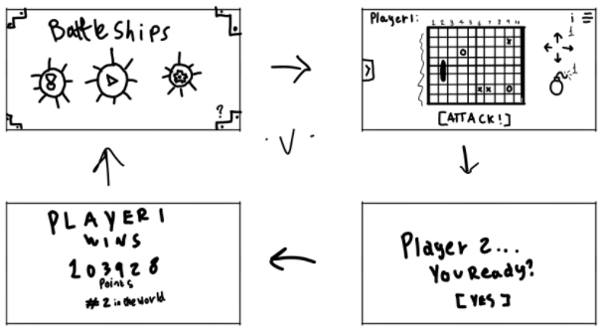
We also created a basic UI design to show how the user would navigate the application. This began with a rough sketch of the application's main screens, as shown in Figure 1.
Figure 1. Basic UI wireframe design

Figure 2 shows the expanded design, though it could have been expanded further to include more screens focused on the user-application interaction. A software tool more tailored to UI design, like Figma, could have been used to create a more interactive presentation. The design also lacked screens that highlighted key functionality, such as how a player should move their ship in response to an attack, the game-over screen, and the game log that shows the event history.
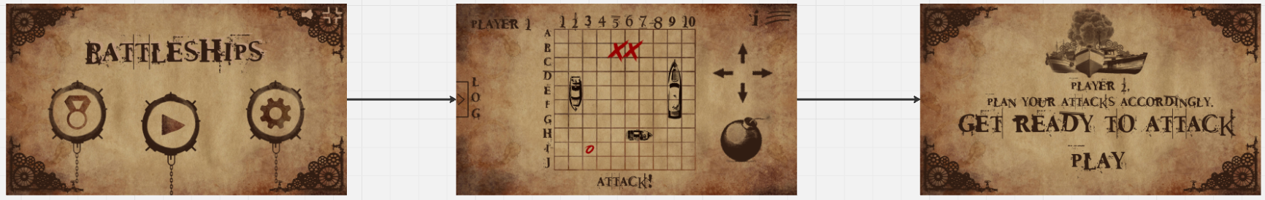
Figure 2. UI Design

User Stories
Many agile workflows begin by using user stories to map the software's behaviour in a way that is understandable to users and developers. These user stories follow a specific format [2], [3], [4]:
- The Who: As a User,
- The What: I want/need/would like to,
- The Why: so that,
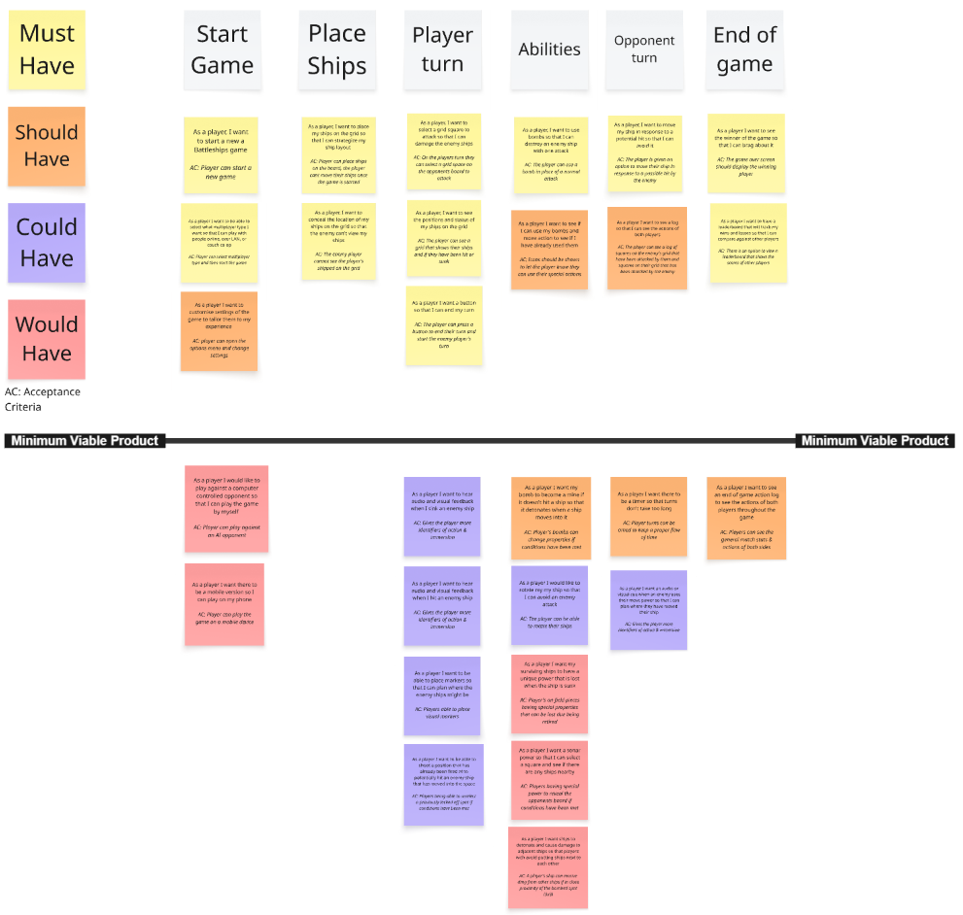
These three elements help developers assess who wants the functionality, what functionality they should provide, and why the software is needed. User stories are the basis for the project's design; poorly written user stories can affect the entire development process [2].
Figure 3. The user stories and MVP for the application design.
This figure shows the user stories created to identify the features to implement in the application. These user stories have all been assigned priorities, as highlighted on the left of the figure, and acceptance criteria. The top row of grey notes outlines the application's flow, beginning with “Start Game” and ending with “End of game”. Each column of notes represents features that apply to that stage of the application, such as the “Abilities” row representing the action of dropping a bomb on the player's turn. There is also a black line separating the MVP from extra features that can be added later or that do not meet the application specifications.
The user stories created identified only one type of user, the player. The proposed application design was relatively simple, and multiple user types were not required to meet the product specifications or the MVP. In the future, more roles could be added, for example, if players could make an account, then you would have two types of players: those with accounts and those without.
A framework exists to ensure the quality of these user stories. The Quality User Story (QUS) framework contains 14 elements for evaluating user stories [2]. Using this framework as a basis for evaluating the application's user stories, I have identified several areas that do not meet the framework's criteria.
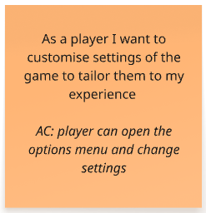
One user story was too broad and not well-defined. The idea behind the user story was to implement an options menu that lets the user adjust various settings, e.g., colour-blind mode, text size, and audio volume. However, I believe that by not listing any options that could be adjusted, this user story could lead to multiple interpretations of what could be in this options menu, thereby not meeting the “Unambiguous” criteria of the QUS framework [Appendix 6.A]. Splitting this user story into others that clearly list what options should be present would allow designers to prioritise which options to include in the MVP, and it would also help developers know which areas of the application need to be changed to accommodate these setting changes.
Figure 4. User story for a game options feature.
Other user story templates utilise a persona rather than a user; this persona has an identity, attitudes, and motivations. This extra information helps designers to understand what features a real user would want [4]. Using these personas in the user stories could improve their quality by adding more information about who this application is designed for. This could lead to more features that would help onboard newer players or retain the attention of avid gamers.

CRC Cards
The user stories previously created have been used to create CRC cards, each card represents a class of the application and gives a brief description of what it is responsible for and the other classes it needs to perform this responsibility [5], [7].
When reviewing these classes, I identified some areas that could be refined. First, the Rules class is redundant; its responsibilities could be moved into the Game class, so that only one class controls and validates player actions in accordance with the game rules.
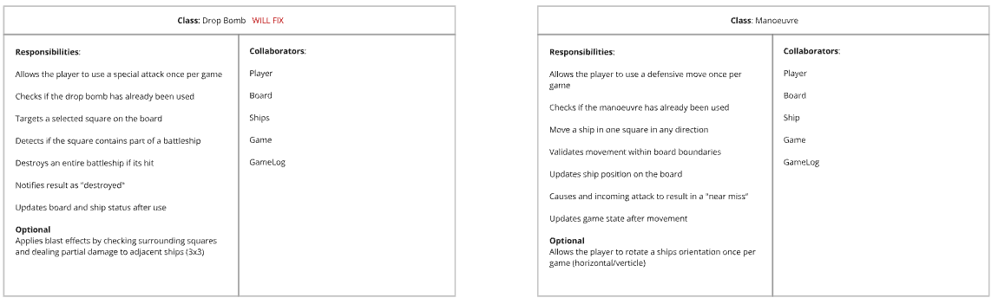
Secondly, I believe there should be an “Actions” class that controls the actions a player can take, such as attack, bomb, and manoeuvre. The attack and bomb actions have very similar functionality: the player selects a grid space on the board, the game checks whether an enemy ship is present there and then destroys that segment or the whole ship in the case of a bomb. This could reduce the risk of duplicate code when selecting a grid space and performing an action. This action class would work with the player to display available actions, and the board class to query the contents of grid spaces.
Figure 5. The Drop Bomb and Manoeuvre classes

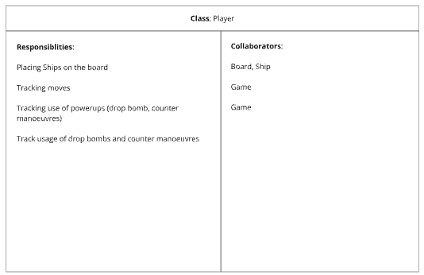
The player class could also have additional responsibilities, such as tracking the health of that player's ships. The board tracks when a ship is hit, and the game log records this and displays it to the player, but no class contains a list of these ships and their status.
Figure 6. The Player class
Overall, I feel that some of the CRC cards designed could be better defined, and there are some duplicate responsibilities. The board and game log classes both list recording hits, misses, and ships sunk as their responsibilities. I believe it should be the board's responsibility to detect the player input, resolve the event, and then send this data to the game log, which will then record the result and display it to the player. An additional “User” class could be added to represent the user before they start a game and become a “Player”. A menu class could also be added to start games and adjust game options. Likewise, a lobby class could also be added to manage a space where users could join and enable online matchmaking. As with the current CRC card design, no class is responsible for starting a game or for determining where the user goes when the game ends.
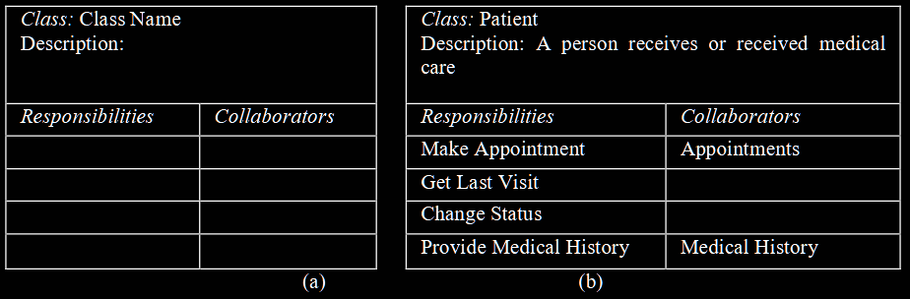
The template and example shown above uses an additional description field. This description could help us add an extra layer of definition to the proposed classes and reduce the risk of overlapping responsibilities.
Figure 7. (a) Format of a CRC Card and (b) CRC Card Example [7]
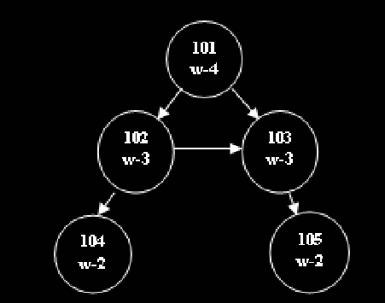
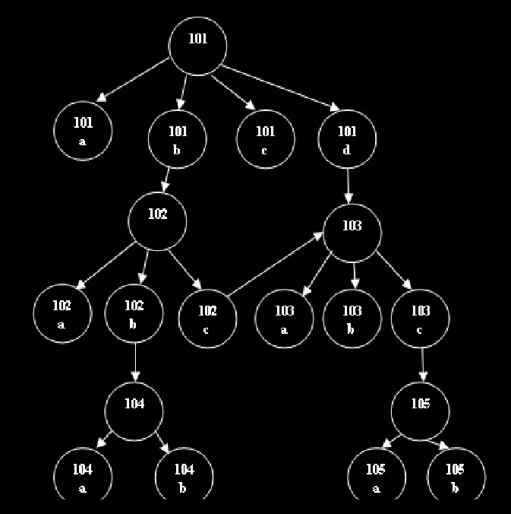
Vrushali Yogesh Karkare et al [7] proposes using a tree diagram to map each CRC card's responsibilities and collaborators. While this will add an extra step to the design process, I believe it would help during development, as each class has been mapped to its dependencies, enabling a better workflow when distributing the workload to developers.
Figure 8. Using node weight [7]
Figure 9. Tree diagram formed from CRC Cards [7]
Figure 9 shows how a graph can be constructed from CRC cards. Each node represents a CRC card, and it connects to each collaborator it needs to perform its responsibilities. The graph can then be simplified as shown in Figure 8. Each node is assigned a weight based on the number of responsibilities the class must perform.

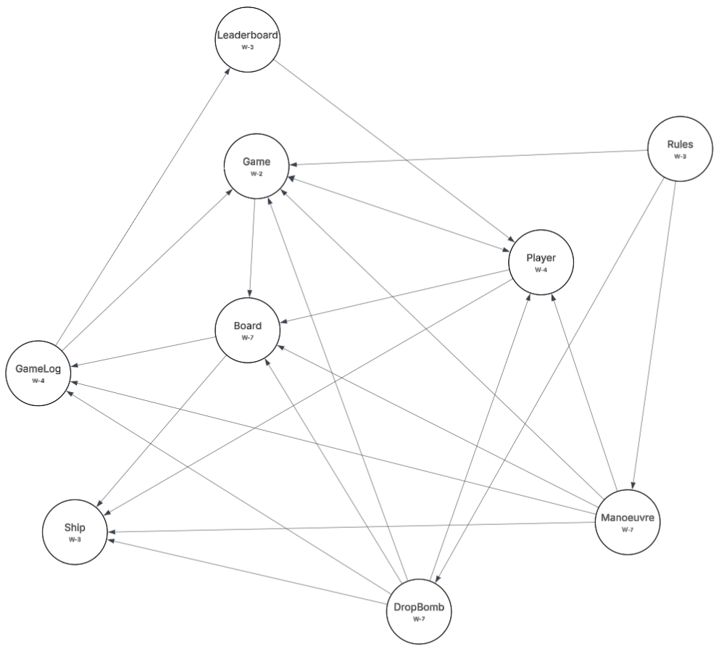
Using this method, I have created a tree diagram for the CRC cards.
Figure 10. Tree diagram of the created CRC cards
In Figure 10, there is no clear structure to the diagram, and many classes list multiple collaborators or are required as collaborators for multiple classes. There is no clear controlling class, and classes like the DropBomb and Manoeuvre list the same collaborators for very similar functions. To reduce this complexity, classes should be created to control similar functionality and reduce duplication [7]. Utilising this method during the creation of these cards could have helped to identify this issue earlier during the design process.
Rainer Lutz et al [6] uses a methodology in their CRC card design process that could have also improved the quality of the CRC cards produced. They use CRC cards to simulate application use, map user flow, and highlight design issues.

Lars Hvam et al use an expanded template for CRC cards as shown in Appendix 6.B [5]. This template changes a few things. Firstly, the responsibilities field is now a brief description of the class's role. The revised template also tracks inheritance hierarchies, which is very beneficial for designing complex systems with many classes that rely on similar functionality. The “knows” and “does” are also useful additions. The “does” field functions similarly to the responsibilities field in the CRC cards created for this design. The “knows” field contains attributes that are contained within the class and any collaborators that may rely on them. This template is a bridge between CRC cards and class diagrams; using it could have proved useful in this design for creating a more detailed CRC card without becoming too technical, as a class diagram would.

Class Diagrams
The next step in the design process is to use the CRC cards to create class diagrams that specify the functions a class may need to fulfil its responsibilities. These diagrams show the class name, attributes, methods, parameters, and return types. These resemble object-oriented programming classes and can be similar to the finished product [8], [9].
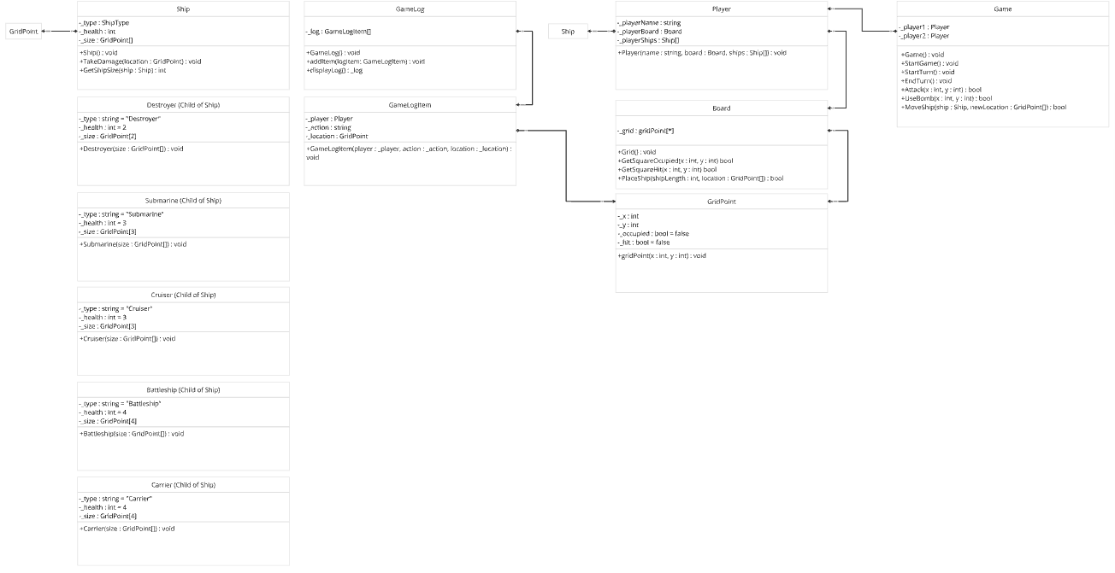
Appendix C lists the rules used by Giacomo Garaccione et al in the algorithm used to evaluate class diagrams [9]. I have used this criterion as a basis for evaluating the diagrams produced for this design. I found that class associations were unnamed; adding names to these associations could improve the design's clarity. Multiple classes also contained attributes outside the allowed types. This can be remedied by adding names to the associations and including getter functions in the classes rather than attributes.
Figure 11. Class Diagrams created for the application

The layout of the class diagrams is also an important factor to consider; the diagrams must be clear to read and follow. The elements should not overlap, bends in the lines connecting the classes should be minimised, and similar elements should be grouped together [8]. The class diagrams created meet these criteria, although the “Ship” class and its children could be moved closer to the “GridPoint” class to meet them better. The “Ship” class and its children could also be organised better to improve aesthetics and layout, and to reduce the amount of white space in the diagram.

Sequence Diagrams
Using the class diagrams, UML sequence diagrams can be created; these diagrams map interaction behaviours within a system [10]. One problem with these sequence diagrams is that the methods used are not documented properly on the diagram, and some are not present within the class diagrams. The sequence diagrams also reference classes that don’t exist, such as the lobby. To remedy this, each trigger should relate to a method within the class; if a class or method doesn’t exist, one should be created to ensure that the sequence diagrams and class diagrams reflect the same functionality. This also presents issues when using these diagrams to create test cases, as the classes, methods, parameters, and return values are not properly reflected in the sequence diagrams [11].
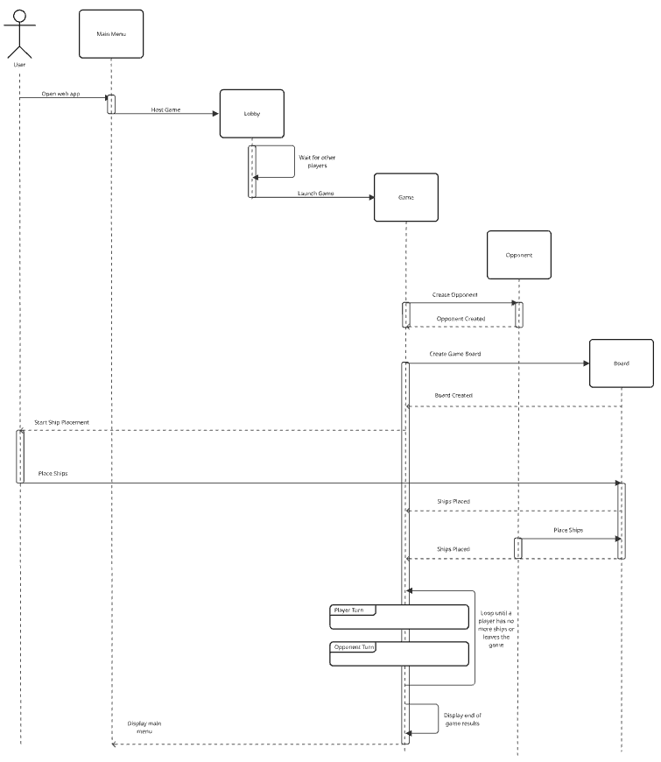
The main “Game Sequence” diagram could have been broken down further to aid test case creation and improve readability. As Figure 12 shows, this sequence covers many aspects of the game flow, including hosting a lobby, starting a game, placing ships, and the turn-based gameplay. These main sequences could have been broken into separate diagrams and included more details about the processes they should follow [11].
Figure 12. Game sequence diagram

Software Testing
Software testing is a crucial part of software development, as it identifies errors and flaws, validates functionality, and evaluates software performance. This is done to ensure that the software produced meets user requirements and that a high-quality product is delivered before being handed over to users or customers [12], [13], [14].
There are two main methods of software testing: black-box and white-box testing. Black-box testing assesses a system's functionality without examining its code. This is mostly used by non-technical specialists who test a system's functionality against the predicted outcome given by the design specification [13], [14]. On the other hand, white-box testing requires knowledge of the software’s code to test internal operations [12], [13]. Each method has its own strengths and weaknesses, and the choice of method should be guided by the project's requirements [14].

White-box vs Black-box
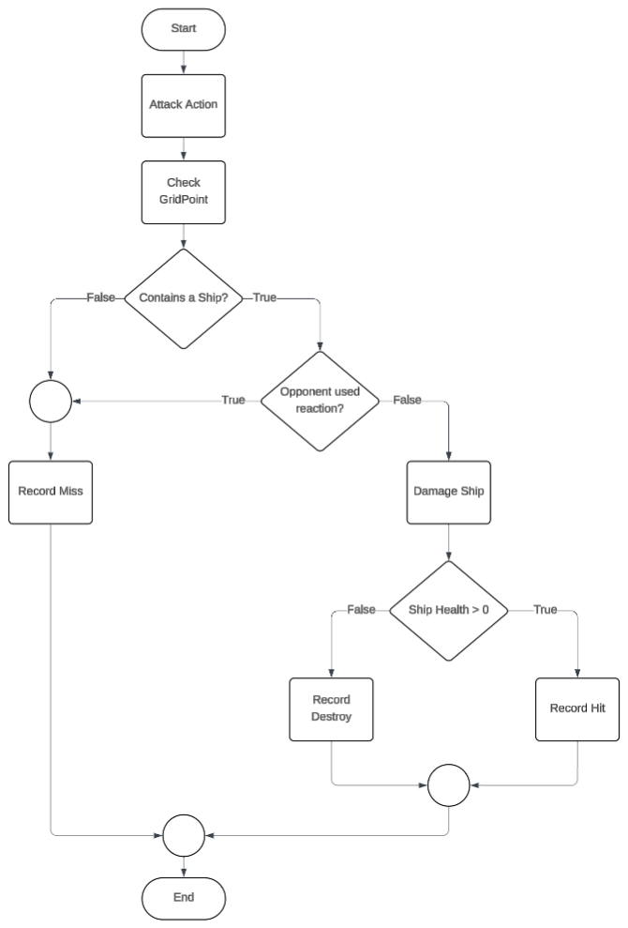
The main advantage of white-box testing is that it directly tests the application's source code, providing greater visibility into its inner workings and excelling at identifying internal logic errors [14]. This type of testing covers all execution paths of the internal code, including those that the end user rarely encounters [14]. However, because these tests require knowledge of the internal code, they can only be run by developers. If there are not enough people with this knowledge, the testing of the application can be impeded [12]. This type of testing is also very time-consuming, as all areas and execution paths of the application’s code must be tested [14]. Changes to the code will also mean that any previous tests will be invalidated and must be done again [14].
Figure 13. Path Testing Diagram
Figure 13 shows a diagram for the potential paths of the attack action. 4 different paths must be tested using branch testing. This tests the paths of every control statement to ensure that the code functions as expected [12].
Black-box testing is more effective at assessing the application's functionality. Testers interact with the user interface of the application and verify that the output produced meets the specification of the design [14]. This tests the application from the end user’s perspective and can identify any bugs they would encounter, such as issues with the interface, errors in the front-end functionality, and errors in inputs/outputs [14]. Test cases can be quickly developed, and larger code segments can be tested when compared to white-box testing [12]. This type of testing is very reliant on the software specification; if the specification is not clear or complete, the testing will not adequately assess the quality of the application [12], [14]. This type of testing can also be performed by potential users (user acceptance testing), allowing multiple perspectives of the application, not just those from the design and development teams [12].
As mentioned previously, the sequence diagrams produced can serve as a basis for some black-box testing of the application, as they highlight how the user interacts with the system [11]. Using these, I have created some example black-box tests as shown in Appendix 6.D. Each test includes an input, output, and result. The user must interact with the system, such as clicking the host game or end turn buttons. They are then expected to receive a specific output, an event, or a page redirect; if they do not, the test passes or fails.
Both methods complement each other: white-box focuses on proper code implementation, while black-box focuses on the application's overall functionality. Using one over the other can expose your application to security risks, reduced functionality, and a poor user experience [13], [14]. A combination of both methods must be used to maintain high code quality and to conduct more comprehensive testing of the application's functional and structural aspects [14].

Unit Testing
Unit tests are created to validate each function within the code; this isolates functions and removes their mutual dependencies [13], [15]. To create comprehensive unit tests, each function case should have its own unit test and execute only in the development environment. Unit tests can also be automated, so once they are created, they can be run whenever you like, as long as the code they are testing has not changed [15].
A unit test follows the following formula:
- A setup stage that creates a test variable.
- An action stage where the test variable is used within the production code.
- And then an Assert stage, where the action's result is checked.
Using the example shown in Figure 13, a unit test for the attack action could follow the following format. First, it would need to check the targeted grid point for the attack. The code would expect the function to return a valid GridPoint value.
Figure 14 shows a function that returns the value of a GridPoint whose x and y parameters match the given x and y parameters; if no matching point is found, it returns an empty GridPoint. The unit test then tests this function by creating a new board with a GridPoint, passing in the x and y coordinates of that GridPoint, and verifying that the function returns the GridPoint.
Figure 14. Sudo code of a function and unit test

Conclusion
While the artefacts created for this project outline a suitable design for a web application that meets the specification requirements, there is still room for improvement. The process started well, with strong collaboration when creating the user stories, leading to many ideas from different viewpoints and additional functionality we thought could improve the application. However, the process became somewhat fragmented as we moved through the design stages. The CRC cards did not adequately represent classes that should’ve been created from the user stories, and communication became strained. This meant not everyone understood the designs being created, leading to miscommunication when creating the next set of design diagrams.
This was especially apparent when moving from the CRC cards to the class diagrams, as not all CRC cards and methods were represented in a corresponding class diagram. This issue could be easily remedied, and having a clear design from start to finish will greatly support the development of the application.

References
[1] Hasbro, ‘Battleship Rules’. Dec. 02, 2012. Accessed: Apr. 23, 2026. [Online]. Available: https://web.archive.org/web/20121202084216/http://www.hasbro.com/common/instruct/battleship.pdf
[2] S. Jiménez, A. Alanis, C. Beltrán, R. Juárez-Ramírez, A. Ramírez-Noriega, and C. Tona, ‘USQA: A User Story Quality Analyzer prototype for supporting software engineering students’, Comput. Appl. Eng. Educ., vol. 31, no. 4, pp. 1014–1024, 2023, doi: 10.1002/cae.22620.
[3] I. K. Raharjana, D. Siahaan, and C. Fatichah, ‘User Stories and Natural Language Processing: A Systematic Literature Review’, IEEE Access, vol. 9, pp. 53811–53826, 2021, doi: 10.1109/ACCESS.2021.3070606.
[4] C. Gralha, R. Pereira, M. Goulão, and J. Araujo, ‘On the impact of using different templates on creating and understanding user stories’, in 2021 IEEE 29th International Requirements Engineering Conference (RE), Sep. 2021, pp. 209–220. doi: 10.1109/RE51729.2021.00026.
[5] L. Hvam, J. Riis, and B. L. Hansen, ‘CRC cards for product modelling’, Comput. Ind., vol. 50, no. 1, pp. 57–70, Jan. 2003, doi: 10.1016/S0166-3615(02)00143-4.
[6] R. Lutz, S. Schäfer, and S. Diehl, ‘Teaching object-orientation with smartphones as digital CRC cards’, in 2013 26th International Conference on Software Engineering Education and Training (CSEE&T), May 2013, pp. 89–98. doi: 10.1109/CSEET.2013.6595240.
[7] V. Y. Karkare and N. V. Thakur, ‘Tree Based Approach to Use CRC Cards Efficiently in Software Project Management’, Int. J. Adv. Res. Comput. Sci., vol. 3, no. 3, May 2012, Accessed: Apr. 29, 2026. [Online]. Available: https://www.proquest.com/docview/1443724773/abstract/F68A2A73D52D4AE5PQ/1
[8] G. Bergström et al., ‘Evaluating the layout quality of UML class diagrams using machine learning’, J. Syst. Softw., vol. 192, p. 111413, Oct. 2022, doi: 10.1016/j.jss.2022.111413.
[9] G. Garaccione, R. Coppola, L. Ardito, and M. Torchiano, ‘Gamification of conceptual modeling education with UML class diagrams: an experimental analysis’, Softw. Syst. Model., pp. 1–32, 2025.
[10] L. Lu and D.-K. Kim, ‘Required behavior of sequence diagrams: Semantics and conformance’, ACM Trans. Softw. Eng. Methodol., vol. 23, no. 2, pp. 1–28, Mar. 2014, doi: 10.1145/2523108.
[11] F. Fraikin and T. Leonhardt, ‘SeDiTeC-testing based on sequence diagrams’, in Proceedings 17th IEEE International Conference on Automated Software Engineering, Sep. 2002, pp. 261–266. doi: 10.1109/ASE.2002.1115026.
[12] M. Ehmer and F. Khan, ‘A Comparative Study of White Box, Black Box and Grey Box Testing Techniques’, Int. J. Adv. Comput. Sci. Appl., vol. 3, no. 6, 2012, doi: 10.14569/IJACSA.2012.030603.
[13] N. Golіan, V. Golіan, and I. Afanasieva, ‘BLACK AND WHITE-BOX UNIT TESTING FOR WEB APPLICATIONS’, Bull. Natl. Tech. Univ. KhPI Ser. Syst. Anal. Control Inf. Technol., no. 1 (7), pp. 79–83, Jul. 2022, doi: 10.20998/2079-0023.2022.01.13.
[14] A. Maspupah, ‘LITERATURE REVIEW: ADVANTAGES AND DISADVANTAGES OF BLACK BOX AND WHITE BOX TESTING METHODS’, J. Techno Nusa Mandiri, vol. 21, no. 2, pp. 151–162, 2024, doi: 10.33480/techno.v21i2.5776.
[15] ‘What is unit testing? | LinkedIn Learning’. Accessed: May 03, 2026. [Online]. Available: https://www.linkedin.com/learning/unit-testing-and-test-driven-development-in-python/what-is-unit-testing?autoSkip=true&resume=false&u=77966930

Appendix

Description of Critical Factors
USQA: A User Story Quality Analyzer prototype for supporting software engineering students – Description of critical factors [2]

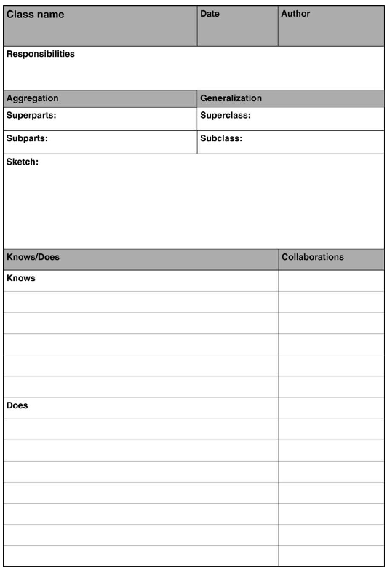
CRC cards for product modelling – CRC card diagram [5]
Figure 15. CRC card

Class Diagram Evaluation Criteria
Gamification of conceptual modeling education with UML class diagrams: an experimental analysis – Evaluation Criteria [9]

Syntax Rules

Class Constraints
- A class must have a non-empty name
- A class must have a unique name, two classes cannot have a duplicate name
- A class must have at least one valid attribute
- A class must have at least one valid association

Attribute Constraints
- An attribute must have a non-empty name
- An attribute must be expressed in an explicit format where its name is followed by a colon, and then by its type (name: type)
- An attribute cannot have a type that is not among the allowed ones (int, float, number, double, string, boolean, date, time, datetime, integer, latlong, currency, enum)
- An attribute cannot represent a foreign key of another class (e.g., the identifier of another class, or the name of another class in plural form)

Association constraints
- An association must have a non-empty name
- An association must have its multiplicity values specified on both ends
- An association cannot have as multiplicity values that are not numbers, or star to indicate multiple and unspecified values
- A recursive association must have its roles specified on both ends

Intermediate class constraints
- An intermediate class must have exactly two associations
- An intermediate class must have 1 as multiplicity values toward the two classes it connects
- An intermediate class must have its multiplicity values specified on both ends of both of its associations
- An intermediate class cannot have as multiplicity values from the two classes it connects values that are not numbers, or star to indicate multiple and unspecified values

Semantic Rules

Class constraints
- A reference class whose weight is STRONG must have a matching class in the diagram
- A diagram class cannot have a name that is not allowed

Attribute constraints
The following attribute constraints are verified if and only if there is a diagram class that match the diagram class that contains the specific attribute.
- An attribute in a reference class that has a matching diagram class must have a matching attribute in the same class
- An attribute in a diagram class that matches an attribute in the corresponding reference class must have a type that is among the allowed ones
- It is not possible to have a diagram class that matches an attribute of a reference class that cannot be represented as a class
- A diagram attribute cannot have a name that is not allowed

Association constraints
The following association constraints are verified if and only if there are diagram classes that match the source and destination classes of the reference association:
- A reference association must have a matching diagram association between two diagram classes that both have a STRONG weight
- A diagram association that matches a reference association must have its multiplicity values be among the allowed values in the reference association, for both source and destination
- The following association constraints are applied to all diagram associations that do not match a solution association:
- A diagram association cannot have a name that is not allowed
- A diagram association cannot connect two classes that are not allowed to have an association

Intermediate class constraints
- Both classes connected by a reference intermediate class must have a matching diagram class
- The diagram classes that match two classes connected by a reference intermediate class must be connected by an intermediate class
- Each diagram intermediate classes must match a reference intermediate class

Example Black-box tests
Pre-conditions | Input | Output | Result
Main Menu
 | User navigates to the webpage | Webpage displays the main menu. | Pass
 | User hosts a game | User is taken to the lobby page and waits for someone to join. | Pass
A game is being hosted by another player | User clicks the join game button | User is taken to the lobby page.  The start game button is now available. | Pass
Lobby
User in the lobby with another player | User clicks the start game button | The game starts. | Pass
User in the lobby by themself | User clicks the start game button | Output: error message.  The game does not start. | Fail if:  The message is not shown.  The game starts.
Lobby populated with a host and another user | Another user tries to enter the lobby | Output: error message.  The user cannot join. | Fail if:  The message is not shown.  The additional user can enter the lobby.
Lobby populated with a host and another user | User leaves the lobby | The user is taken to the main menu. | Pass
Lobby populated with a host and another user | User leaves the lobby | The host remains in the lobby.  The start button is unavailable.  Matchmaking restarts. | Pass
Lobby populated with a host and another user | The host leaves the lobby | Lobby closes, and both host and user are taken to the main menu. | Pass
Game
 | A player leaves the game or disconnects | Output: error message.  The game ends.  The remaining player returns to the main menu. | Fail if:  The Message is not shown.  The game continues.  The remaining player is not sent back to the main menu.
 | Beginning of the game | The player is taken to the ship placement screen | Pass
 | All ships have been placed | Player 1 starts their turn | Pass
 | A player has ended their turn | The other player starts their turn | Pass
 | A player has no ships left | The game ends.  Both players are taken to the main menu | Pass
Ship Placement
Valid game with two players | The player places their ship on an empty tile | The ship is placed | Pass
Valid game with two players | The player places their ship on another ship | Output: error message.  The ship is not placed. | Fail if:  The Message is not shown.  The ship is placed.
Valid game with two players.  The player has not placed all their ships. | The player clicks the start game button. | Output: error message.  The game does not start. | Fail if:  The message is not shown.  The game starts.
Valid game with two players.  The player has placed all their ships.  The opponent has placed all their ships. | The player clicks the start game button. | The game starts. | Pass
Valid game with two players.  The player has placed all their ships.  The opponent has not placed all their ships. | The player clicks the start game button. | Output: message waiting for opponent.  The game does not start. | Fail if:  The message is not shown.  The game starts.
Player Turn
A ship has been placed on the tile | The player uses the attack action on the tile | Output: message hit ship.  The ship is damaged. | Fail if:  The message is not shown.  The ship is not damaged.
 | The player uses the attack action on an empty tile | Output: message miss | Fail if:  The message is not shown.
 | The player clicks the end turn button | The player’s turn ends, and the opponent’s turn starts | Pass
The opponent has attacked a tile where the player has placed a ship.  The manoeuvre action pop-up has been displayed. | The player clicks no action. | The pop-up closes, and the opponents' turn continues. | Pass
The opponent has attacked a tile where the player has placed a ship.  The manoeuvre action pop-up has been displayed. | The player clicks the act button | The pop-up closes, and the player can now move the ship | Pass

