Section 5

Detailed Appendices.

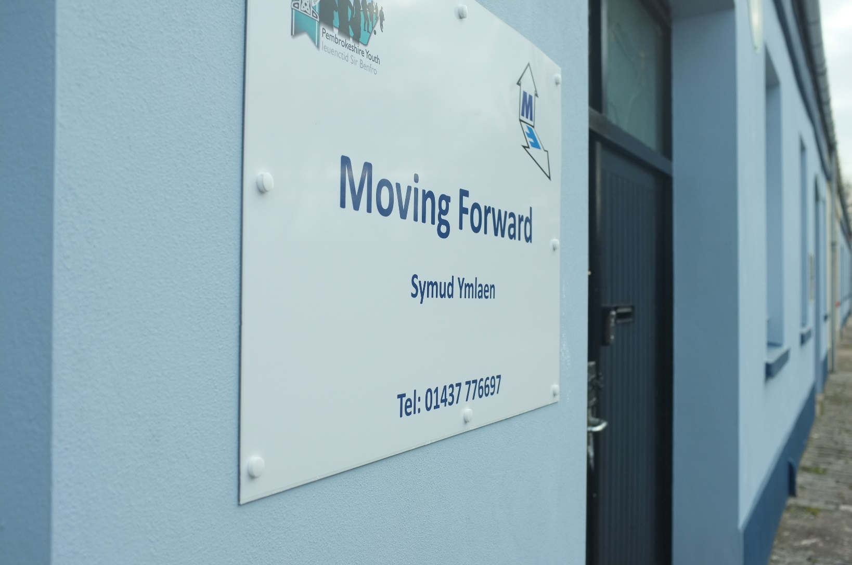

5.0: Content’s list

Detailed Appendices. 1
5.0: Content’s list 2
5.1: Seven reflective journals. 5
5.1.1: Reflection No. 1 5
5.1.2: Reflection No. 2 8
5.1.3: Reflection No. 3 12
5.1.4: Reflection No. 4 20
5.1.5: Reflection No. 5. 25
5.1.6: Reflection No. 6. 33
5.1.7: Reflection No. 7. 37
5.2: Records of the six supervision sessions. 41
5.2.1: Supervision No 1. 42
5.2.2: Supervision No 2. 45
5.2.3: Supervision No 3. 48
5.2.4: Supervision No 4. 53
5.2.5: Supervision No 5. 59
5.2.6: Supervision No 6. 64
5.2.7: Supervision contract. 68
5.3: Risk Assessment portfolio. 69
5.3.1: Risk assessment list. 70
5.3.2: Report to Pembrokeshire Youth on hazards found. 72
5.3.3: Safety Awareness. 73
5.4: records of 200 hours youth work 78
5.4.1: Record of youth work face-to-face hours. 78
5.4.2: Record of youth work non-face-to-face hours. 79
5.5: Own work for sessions. 81
5.5.1: - Moving In checklist No. 1 82
5.5.2: - Moving In checklist No. 2 85
5.5.3: - Moving In checklist No. 3 88
5.6: Material provided by young people. 88
5.7 Supporting evidence/emails. 90
5.8: Safeguarding Certificate. 92
5.9: Directed task. 93
5.10: NOS evidence matrix. 96

Section 5

5.1: Seven reflective journals.

5.1.1: Reflection No. 1
Online Tenancy Skills course.
Description (What happened)
I was invited to complete the Tenancy course, as required by young people to access the ‘Moving Forward’ project. With the objective to understand their experience in using this portal. After receiving the instructions to on how to join a “BigButton” session and a separate email with temporary password, I set aside some time for the course. On clicking on the website link, my screen informed me it was an unsecure site. This happened a couple of times even when trying different methods, so I accepted to override the safety feature.
The first action required was to set up a permanent password.
The location of the Tenancy Skills tile was straightforward to find, but the welcome video clip would not load. After a couple of attempts I moved forward to the next part followed by a short exercise filling in the blanks in a paragraph. I got a score of 7/10. I thought the wrong answers might be on the initial welcome video, so I attempted and succeeded in watching it, but it did not contain the answers I was looking for. I printed off the succeeding information slide and found the relevant answers.
I proceeded through two more sections, but due to being unable to watch the video clips, decided to stop and explore the website and find council tenancy agreement in additional support and information. I did not find and put it down to a poor internet connection.
After re-entering the course and finding that I could carry on from where I had previously left off, I exited the website.

Feelings (What were you thinking?)
I was pleased to have received the instructions and login details after sending in the registration form. I did feel unsure at the start as to: - how long the training would take to complete; how difficult it would be, and, due to problems experienced finding my way around other online forms and tests, did feel a little nervous as to whether it would be another negative experience.
My first knowledge questions were filling in the blanks. I scored 7/10, which left me feeling a little frustrated. The words I got wrong did not seem obvious, and it was the first blank too which I stumbled on. I went back over the previous slide and worked out the right answers, which were clearly mentioned.
I had a more positive outlook when I came back to finish the training, enjoying the experience When I completed the ‘find a word’ test, and found I had a score of 11/12, with only 11 words in the list, I laughed.

Evaluation (What was good and bad about the experience)
The tenancy skills course was very thoughtfully put together, and contained a lot of useful information, presented in an accessible way. I was pleasantly surprised at the relative ease on navigating the site. While I knew from an earlier conversation with Nick Hudd that the young people had only completed some individual sessions, I was unsure on the process of part finishing a section. There was an overall % progression score on the first tile, and a tick against each completed part within each separate training module, so it was easy to go back and complete it, although I was concerned how many I missed. The interview at the end with Kat was brilliant, and brough a reality to the course.
I did feel that the first test could have been simpler with a drag-and-drop ‘fill in the missing words’, as this would give the participant more confidence to proceed and complete the section.

Analysis (What sense can you make of the situation)
I approached the course with some negativity. I had previously applied for a Probation Officer degree internship and had to complete an online personality test. It was meant to be more fun by having a gaming feel to it. It caused me to be quite stressed at the end of it through not quite understanding how each section’s instructions, and getting caught up in an example loop, when I thought it was part of the exercise. When I found this course relatively straight forward it made me realise how previous experiences can strongly colour attitudes to new situations and environments. Having a poor internet connection did not help with the initial feelings.

Conclusion (What else could you have done?)
I had an unfounded negative expectation for this online course. My attitude was already negative due to the rapid changes with many services going online, exacerbated by previous bad experiences.
I need to acknowledge that this change is here to stay, and challenge internal negative thinking.

Action plan (If it arose again, what would you do)
Firstly, I could have found out how long the course would take to complete and question if the course needed to be completed in one session or in sections. My internet connection is not usually unreliable, but my daughter had been sent a text stating to expect interruptions, which I ignored. Next time I complete an online course I could check for any known issues and postpone the completion date as appropriate.
Word Count- 853

5.1.2: Reflection No. 2
Engaging with a Young Person as part of the ‘Moving forward’ project.
Reflective Journal using the Kolb experiential learning cycle (McLeod, S. A. 2017).
By Nicholas Sutton dated 3rd December 2020.
Concrete Experience.
My first encounter with the ‘Moving Forward’ project and a Young person (Miss. F), was with the delivery of some furniture at a private rented tenancy. I met Dan and Tim Ramsey outside the property, having arrived ten minutes late for the appointment. We had a brief introduction with the necessary safety questions regarding Covid and personal health, then we met Miss F. I took the furniture upstairs with Tim, having taken over from Dan. After Tim and Dan engaged Miss. F in conversation, she was asked to share her experiences of moving into her first house, recorded for the Voices section of the online tenancy training course. After leaving Miss F. Dan and Tim had a brief chat with me, before going home.
Reflective Observation
I arrived ten minutes late, due to missing a phone call and not checking my texts. I was out cycling when Tim phoned a second time. Understandably I was a bit flustered when I arrived, not having previously met Tim or Dan, and they were outside waiting for me, although I was quickly put at ease. The process of getting the furniture inside was a purely mechanical task, and I engaged in chit-chat with the Miss. F. The encounter became much more interesting when Tim and Dan engaged in conversation with Miss. F. She had a totally different background to me, moving into supported living accommodation when just sixteen, and living fully independent at nineteen, from a care environment. It reminded me of when my Son and daughter-in-law moved into social housing. I was shocked that there were no carpets. The Father-in-law and I clubbed together to purchase and fit the carpets. Miss F had to do it all without parental support and little preparation from social services. Her experiences were one of finding her own way by trial and error. Another person Miss. F. knew ended up in prison due to their mismanagement of the care leavers financial package.
Abstract Conceptualisation
My initial reaction was one of sadness that a teenager had to experience a major transition from a care environment to independent living with so little preparation and support. While financial support was available, parental, and the implied emotional support was non-existent, unlike that given to my son and daughter-in-law. The care system appeared to let down Miss F, although it is unrealistic to expect a system which may view Miss. F as a client, to function as surrogate parents. At the time of this first encounter with Miss. F. I did question in what ways the Youth Service could offer an alternative strategy. My initial thoughts were to respond to this situation the same as I did with my own Son, in that of handholding and protection from difficult situations.
Active Experimentation.
The following week, while attending the placement centre, I was asked my reactions to the meeting of Miss. F. Within this feedback, the values of youth work were explored. These values are found within the five pillars of youth Work (5 pillars) and the National Occupational standards of youth work (NOS).
From the five pillars of youth work, the values are Educative, Expressive, Participative, Inclusive and Empowering (Youth Work in Wales Review Group. (2018). From NOS the values are ‘participation and active involvement’, ‘equity, diversity and inclusion’, partnership with young people and others’, personal, social and political development’ CLD Standards Council Scotland. (2019).
I began to realise that the response to my son by fitting the carpet did not really involve him in any way, in addition it made him reliant on me, rather than being independent. So, he did not participate in fitting the carpet. Consequently, it did not strengthen his own belief in himself, and while he was supported in this transition to a new home and provided him and his family with a safe environment, it did not allow him to influence his surroundings or grant him learning opportunities to deal with further issues he encountered later. Rather than promote healthy interdependence, he became passively dependant on us as parents and on others.
This allowed me to reflect on some of the mistakes I had made on parenting, and the resilience developed by young people like Miss. F, withing an environment lacking so much of the love and support my son and his family had received.
A week or two later I had the opportunity to make a follow up call to Miss. F. to inform her that her story was live in the ‘Voices’ section of the online tenancy learning module. The act of recording her story and making it public met some of values found in the 5 pillars. Within Expressive, Miss. F. was able to tell her story to a wider audience, it gave her a voice, and a platform to influence others, to learn from her experiences. Through her participating in the Tenancy training and consequently accessing the furniture library, Miss. F became participative in receiving a bed and chest of drawers. So, she was part of the decision making and able to influence her environment with dignity.
The Social services did very little different to how I behaved to my son. They provided money and support in obtaining a safe flat but did not provide for the learning of skills needed to gain interdependence and ultimately independence, which is part of the Educative aspect found in the 5 pillars.
For me, this experience has revealed the efficacy of the values embedded in youth work. Moving forward, I will need to consciously examine my initial reactions to step in and take over when I perceive someone is in difficulty, by comparing them against these values, and then begin to change my actions accordingly. While this will seem initially to contradict compassion, it allows growth and learning for both the other person and I.
Word count – 961.
References
- McLeod, S. A. (2017). ‘Kolb - learning styles’. SimplyPsychology. (Pgs 1-8). Available at: https://www.simplypsychology.org/learning-kolb.html (Accessed 20th November 2020).

- Youth Work in Wales Review Group. (2018) Youth Work in Wales: Principles and Purposes, Cardiff: Youth Work in Wales Review Group.
- CLD Standards Council Scotland. (2019) Youth Work National Occupational Standards, Glasgow: CLD Standards Council Scotland.

5.1.3: Reflection No. 3
Gibbs Model of Reflection 1988
Reflection on encounters with a sick elderly neighbor M. L, his daughter Miss. E. and a follow-up phone call with my placement Learning Mentor. By Nicholas Sutton. 20/01/21
Description (What happened)
Our elderly neighbour Mr. L is quite poorly, we have known him for 10 years, and he feeds our guinea pigs in our house when we are away. As he was a bit gruff last time my wife popped round, we kept our distance, but knew he had cancer.
A couple of week ago, I saw his 24yr old daughter, Miss E. coming out of his house, and had a great chat about her dad. I had met and chatted briefly to her in the past. After asking Miss. E how we could help her dad, she said he would appreciate a visit, as he was totally reliant on her, and mentioned that she was looking for a neighbour to volunteer to go onto the telephone Lifeline system, which we willingly agreed to. Miss E also shared that she was struggling to care for her dad, as she was not getting any support.

I have since had a follow-on chat with Miss E. when she freely shared some personal information. She left university halfway through the second year, with various issues and moved back in with a previous childhood boyfriend feeling she had nowhere else to go. Her boyfriend is sharing a flat with his friend, whose dad owns the flat. The flat was in a poor way, is rent free, but as part of handshake agreement comes with a requirement to carpet and paint the flat. The boyfriend also left Uni part way through, is waiting for a medical diagnosis and apparently feels a bit of a failure. In addition, he feels he cannot leave the flat to find something better, believing he will be back charged for rent which he could not afford. He appears to be getting a basic job seekers allowance with minimal if any rent allowance.
I printed off some sample CV's for the boyfriend (I have not been in personal contact) as he was waiting for a friend to show him his and signposted him to seek support through Career Wales. I suggested to miss. E. to encourage the boyfriend to make an appointment with the Doctor explaining his concerns on waiting for a diagnosis and how this was affecting him. I also signposted him to seek support for housing by contacting the Universal credits dept.
Due to the Covid pandemic and the difficulty in gaining face-to face hours, I believed this encounter met some of the young people homelessness issues addressed through my placement withing the Pembrokeshire Youth Service and sought advice on how to proceed with some of my ideas first through contacting my college placement Lecturer, followed by my placement Learning Mentor and fieldwork Supervisor through emails. This was returned by a prompt phone call from my Learning Mentor, which has given me a brilliant opportunity to reflect on the above events.
Feelings (What were you thinking?)
At the time I felt that that were rich opportunities to explore youth work with Miss. E. when face-to face opportunities were severely limited. The opportunities, as I saw them, were:
- Meeting young people where they were at.
- Work within agreed limits with support through the Youth Service.
- Create social capital with Miss. E, through supporting the father, and looking to assist the boyfriend initially by seeking to help write a CV while seeking other opportunities through conversation either through a phone call or a video link.
- Through seeking support from my placement, be able to signpost the young people to additional support and services to perceived complex needs as they became apparent.
- See whether the boyfriend’s flat mate was approachable and explore if this young person could also be reached in some way.
- Explore the above opportunities from a youth work perspective using the five pillars of youth work (Youth Work in Wales Review Group 2018) and youth work NOS as a guide for practice and reflection and learn through reflective practice CLD Standards Council Scotland. (2019).
During the phone call from my Learning Mentor, some of the above points were discussed. I received some good advice and on how to signpost Miss. E. and her boyfriend to self-refer and register as homeless with the housing department. I explained that moving out was difficult due to the boyfriend believing he would be back charged for rent, and he did not have any finances to pay for that. The Learning Mentor (L.M) clearly explained that as no contract was signed then the boyfriend could not be charged for rent. I then asked that if they registered for housing, would the housing department refer them to the Youth Service, The LM said that while that was ideal, it was not currently in place.
From my previous conversation with Miss. E. I knew that she did not want to live alone, and by inference felt that she needed time to work out her true relationship with her boyfriend. She was also worried about being offered a house outside of Pembroke Dock where she is currently living. The ‘LM’ them offered to send me a Touching Base Registration Form and Bilingual Tenancy Form, which I received later that day. I have given Miss. E the Touching Base Registration form, which she has not yet submitted.
I then went to discuss the opportunities in contacting the boyfriend offering help to write a CV as a way in to see what developed. The ‘LM’ suggested that once they were registered with the Pembrokeshire Youth Service, they could be signposted to an internal CAMNESSA (?) group which were qualified to support in writing CV’s and finding jobs. The ‘LT’ went on to explain the Pembrokeshire youth service had support protocols to deal with various situations, and that I could be putting myself at risk in a safeguarding way if she brough a complaint against me.
I felt disappointed with myself, because I got agitated and spoke over the LM more than once when he was speaking, which I regret. The following day I sent a positive email thanking the LM for the forms and stating that the conversation had given me a lot to reflect on.
Evaluation (What was good and bad about the experience)
The good aspects of the telephone conversation were as follows:
- I learnt how to refer someone to social services for home help, housing and the Youth Work Services.
- I was able to signpost Miss. E. and her boyfriend to various services, including the Youth Service and the housing department.
- I was made aware of other support available to Young people within the Youth Service.
- The LM took the initiative to phone me up on receiving my first email to offer support and advice and forwarded me appropriate forms.
- The LM made me aware of the wider safeguarding issues in dealing with a single Young person, with various support protocols being in place.
- The LM made a point that it was both a privilege and responsibility when a Young Person opens up and shares personal information with a Youth Worker.
I sent the initial email first to my college placement Lecturer, followed by my placement Learning Mentor and fieldwork Supervisor, asking for support in reaching out to Miss. E. and her boyfriend with the idea of doing some meaningful youth work as part of my placement. Due to the various protocols in place this was not deemed possible or safe. It may have been helpful to have discussed alternative ways of meeting young people as part of the phone call, in addition to the big positive of signposting Miss E. and her boyfriend to professional services.
Analysis (What sense can you make of the situation)
I reached out to Miss. E. and her dad as part of my core values of having compassion and reaching out a helping hand to those in need. On reflection, I recognise the tensions this can cause. I am reminded of teaching my children to ride a bike, when the stabilisers are first taken off, and they fall off many times before they get the hang of it; the opposing emotions of not wanting my child to be hurt, against wishing them to be independent. I recognise that these core values and beliefs, which may be seen in one situation a strength, yet in another situation a weakness, through the eyes of other professionals.
Values and beliefs may not be static. These could be based on false assumptions and experiences. I need to be open for these to be challenged, kept if proved true and bat my corner, but to be ready to change them if not. I may also need at times be able to sensitively challenge others if the need arises.
When focusing on young people and their perceived needs and concerns, I need to recognise there are other stakeholders, with their beliefs, views, experience, and cultural background and allow for differences. It is not sufficient only focus on the young person or a situation but to recognise and value the diversity of other stakeholders with their perceptions and understanding. Trust in another leader’s abilities develops through spending time with them, creating meaningful relationships and exploring collaborative methods of teamwork.
There are further issues to explore. Can working within a youth Service with youth work policies and protocols cause a conflict with Youth Work core values and/or with one’s own values and beliefs? If so, how do individual people deal with that?
I found this quote helpful by Davies (2011, p 6).
Today, it is accepted, no one, no matter how well trained and supported, naturally skilled or charismatic, can be expected or should expect themselves to get it right the first time, every time. Even if they do get it more right than wrong, youth work is at it root a form of human action that, though part of an assigned role shaped by its own values and ethics and purposes, it carries within unpredictable human relationships. It is therefore always likely to contain imponderables and ambiguities: a missed opportunity, an only half-accurate interpretation of someone’s behavior, some limited understanding of what is going on in the immediate situation or in the wider policy context.
(Davies, 2011)
Conclusion (What else could you have done?)
Engaging with Miss. E. on a Youth Work basis came about through circumstances and not design. When it became apparent that this could become youth work, I referred it to various supervisors. Within another context, meeting a lone young person without any connections, would need to be treated in a different way, depending on their circumstances, and possibly consider walking away and not engaging.
I believe engaging with miss. E. had a least one element of youth work. Youth Work in Wales Review Group (2018, p 4) states, “The identification with young people outside formal or legal requirements is an important element in securing the voluntary engagement of young people.”
Through contacting various supervisors requesting advice through emails, I sought to meet the requirements of Youth Work in Wales Review Group. (2018 p.11) NOS ref YW04 (p. 11) which states, “Develop productive working relationships with colleagues and stakeholders to support youth work” and YW16 (p. 12) in “Enable young people to access information to make decisions”.
However, the ‘Line Manager’ implied YW20 9 (p. 12) which states, “Embed organisational policy for the protection and safeguarding of young people,” and within that my own protection. So now I only engage with Miss. E. If she is at Mr. L’s house when I am there making him a cup of tea or other minor chores.
Action plan (If it arose again, what would you do)
This engagement was not sought, although if it happened again, I would handle the second conversation with Miss. E. differently. This was the conversation where she shared personal information. It happened in front of her father. I did not pick up any hesitancy or reluctance in answering various questions. A couple of days later I asked was she OK talking in front of her Dad so openly. She indicated that she did not want her dad knowing so much about her, for which I appologised; she did add though she was grateful for what I was doing for her dad. I had previously asked Mr. L. how he felt about me talking to her daughter. He replied that he was grateful that someone was able to give advice when he felt unable to help her. At the time I did not see a problem, but now I would always ask if the person felt comfortable in the present environment or would like to go elsewhere more private.
I enjoy engaging with people and consider it normal for people to open- up to me. So, I can envisage similar situations happening again. Moving on with similar engagements to Miss. E. does need support from colleagues. Within a work environment, when you are on premises, the environment is more secure with protocols in place. Outside of that environment youth work can and possibly should happen. Developing reflective practice, having colleagues with good working relationships, and being self-aware of values and protocols can significantly reduce risks, as well as maintaining dynamic places of engagement.

Word count -2241.
References
- Davies, B, (2011) ‘Policy analysis: a first and vital skill of practice’, in Batsleer, & J Davies, B. (eds.) What is youth work? Exeter: Learning Matters.
- Youth Work in Wales Review Group. (2018) Youth Work in Wales: Principles and Purposes, Cardiff: Youth Work in Wales Review Group.
- CLD Standards Council Scotland. (2019) Youth Work National Occupational Standards, Glasgow: CLD Standards Council Scotland.

5.1.4: Reflection No. 4
Engaging with a Young Person as part of the ‘Moving forward’ project.
Reflective Journal using the Kolb experiential learning cycle (McLeod, S. A. 2017).
By Nicholas Sutton dated 6th February 2021.
Concrete Experience.
The Youth Work team within the Moving Forward project decided to individually create a checklist as an aid for young people to use when moving into their first independent home, using the idea of a traffic light system as found in section 5:1. ‘Red’ being the essential items on the first day, ‘Orange’ for the items needed to be considered within the first ten days, whilst ‘Green’ for those actions which may be considered several weeks later.
Everyone completed their lists enthusiastically and sent them to Nick Hudd my fieldwork supervisor for comparison. Nick then suggested, as part of good youth work practice, to include a young person in the enterprise. The young person approached was Miss F.; the same person focused on in reflection 2. Miss. F. is a Young Person representative on a Leaving Care panel and was willing to be involved.
Tim Ramsey, my placement mentor, set up the online session with Miss. F. and encouraged me to lead the conversation. It was agreed beforehand that Miss. F. would not be shown our own check lists. While this made Miss. F. task more difficult, it would ensure her contribution would be unbiased. While I took the lead, it was very much a joint effort, with Tim adding a complimentary input, allowing the session to flow freely and had some laughs over various experiences related to moving into a new home. One was when Miss. F. tried to get the central heating to switch on. After checking the Gas and electricity, she phoned her Grandad in despair who suggested checking the heating thermostat. After questioning what that was, and eventually finding it, the thermostat was located and found to be switched of. The conversation lasted approximately three quarters of an hour. At the end it we agreed to meet online again four days later, again with Miss. F., Tim, and Dan, the fourth member of the team. Afterwards Tim and I reflected on the discussion.
The second meeting went along the similar lines as the first, with Miss. F. sharing her list, and more importantly, her perceptions about injecting humour and demonstrated how the list could easily prevent a young person from engaging with it. We discussed including photographs of heating thermostats and other controls. Miss. F. felt that if a young person saw a photo of an item and it was different to the one in their house, it may cause confusion or concern that something was wrong. I shared a couple of my son’s experiences of moving into some houses. One was where I turned up to help him move in and could not believe the carpet had been ripped out. The other occasion happened when my son turned on the electric cooker for the first time to make some toast. The previous occupant had stuffed a wooden spoon into the grill, which promptly caught fire.
After Miss. F. had left the session, Tim and I had a short reflection. We discussed how at times Tim had added a comment or led the discussion. I suggested it was like a piece of Jaz improvisation where at times different instruments would have a solo piece. This made the whole conversation natural and balanced. It was left for Miss. F to send her list to Tim, and then forward it to me. I sent my original PowerPoint list to Tim to forward it to Miss. F. I had a new idea for a list and agreed to produce a draft piece for everyone to pull apart, including Miss. F, to then be developed together. When I have received Miss. F. list and produced a new list from it, we would arrange for another online meeting.
Reflective Observation
When Nick suggested that a young person should be involved, I thought initially that it was the right thing to be seen to be doing. My thinking and response were to do it as an exercise, and as an opportunity to add something to my portfolio, killing two birds with one stone.
I appreciated having the opportunity to lead the online meeting and prepared in advance to help it flow. Both sessions went well, and Miss. F. appeared to fully engage and hopefully enjoyed the experience. Tim and I had an opportunity to chit-chat about our hobbies and views afterwards, which was a good teambuilding experience.
In the first session I feel that Miss. F. felt a little under pressure over what she produced would disappoint us, or not be to the standard we were looking for. As a means of self-reassurance, she pushed to see our lists first. Tim and I managed to encourage her to understand that whatever she produced would be great, and while we were being unfair by not letting her see our lists first, what she produced would be authentic.
An important observation by Miss. F. were that my ideas, put together on a PowerPoint, may be associated with compulsory learning in school, along with possible negative emotions, causing the young person to disengage and not participate with the checklist. Another comment was to inject some fun element into the list with advice to include some emotion, for example: have a break; eat some comfort food; make the bed first so you can crash out when you have had enough. The introduction of these ideas by a young person, outside the original concept of the checklist, demonstrated that involving a young person in the process, is not just a minor technical detail. Miss. F. input moved the concept from being a functional list into one where other young person may engage with it. The insight into how a PowerPoint can cause a young person to potentially switch off through negative association proved this point, while advising the list should be fun to do, demonstrates that by elevating the input of the Young person to equal value of the youth worker, can enable the youth worker to learn from the experience.
Abstract Conceptualisation
The initial brief to the four leaders was to create one list using the traffic light system, Red being most urgent. After completing my PowerPoint presentation, I began to wonder if ‘Red’ may be stop rather than a task which was required to be completed urgently. This concern was also highlighted by Tim.
Miss. F. surprised us by producing two lists. One for selecting the house and planning to move in, with the second list detailing the essentials of moving into the home.
One idea I have is to design two checklists, and with Tim’s advice, design it in Publisher, including a tick box, a brief description of the task, using Miss. F’s words and emphasis (another suggestion from Tim) and using speech bubbles to inject humorous comments. To make this a comic book type of list is however beyond my capabilities. I am waiting on Miss. F. list via Tim to make a start.
Active Experimentation.
This encounter demonstrates the validity of engaging with young people in decision making. Young people can articulate their opinions, which allows for learning to take place from their experiences and demonstrates their perceptions of the world around them may be different to an older person. The awareness that negative experiences through mediums like PowerPoint, and through different methods of teaching, for example curriculum-based learning, can promote a negativity to learning, and not promote it is needed. Being aware of young people’s preferences through engaging them in conversation and reflecting on their experiences, would form part of informal learning and education, a cornerstone of youth work. Discussing with young people of their perception on how they learn best as individuals, and more importantly what switches them off, would be good issues to raise with a variety of young people. PowerPoint presentations are a viable tool for learning, and negative values could be explored and recognised, so this type of reaction can be self-recognised by the young person and addressed.
The question remains as to what Miss. F. is learning from her participating in assisting in writing out a checklist, in a further session I need to ask her opinion.
As part of the Youth Work in Wales Review Group. (2018 p. 4) one aspect of youth work is to include the young people to ‘Participate’ in activities with the “principles of equality and inclusion;” while another is for them be challenged. This challenging aspect was introduced by Miss. F. having to complete a list without first seeing ours. It put some pressure on her with the possibility of what she produced not meeting the Youth Leaders expectations and a possible fear of rejection. While this fear possibly remained, Miss. F. was encouraged, and her positive contribution praised. Miss. F. felt empowered to take her adapted list when it is produced and inviting other people’s opinion and input.
For Miss. F. this process was also ‘Expressive’ and ‘Educative’ as it allowed her to input some of her values and ideas into various Young People’s groups and communities’ and through these ideas affecting other people’s lives for the better. Finally, it was ‘Inclusive’ because Miss. F. became a valued member of the project and her views were respected (Youth Work in Wales Review Group, 2018 p. 5 & 6).
Word Count: 1542.
References
- Youth Work in Wales Review Group. (2018) Youth Work in Wales: Principles and Purposes, Cardiff: Youth Work in Wales Review Group.
- McLeod, S. A. (2017, Oct 24). ‘Kolb - learning styles’. SimplyPsychology. (Pgs 1-8). Available at: https://www.simplypsychology.org/learning-kolb.html (Accessed 20th November 2020)

5.1.5: Reflection No. 5.
Engaging with Youth Workers and aspects of safeguarding.
By Nicholas Sutton dated 11th February 2021.
The purpose of this reflection is to seek understanding of the apparent negative reactions by three youth leaders within the youth service regarding two separate naturally occurring engagements (conversations) with young people, one of which happened while on placement within the youth service but separate from it. The reaction was at variance with that expected by the author, which was some sort of encouragement to explore the encounters further within a supported structure. The two conversations are outlined below followed by further reading around the topic of Child Sexual Abuse (CSA) within the Dutch school and pre-school environment, risk taking and attitudes to young people from a professional youth work culture to put in context to the author’s perceived experience. This reading includes some reported cases of CSA within the Scout movement, previously considered an institution with high safeguarding standard, demonstrating the negative impact on an organisation’s reputation when these issues arise. The summary concludes this reflection. This reflection is not written as a criticism of the youth service or the manner I was treated, which was one of respectful concern, but rather as an explanation for the reason for the research which followed and an attempt to make sense of the challenges faced within the youth service at large regarding safeguarding and CSA. It needs to be stated that the author is a level four student where the expectation is to initially be an observer within the youth Work placement.
The author first met a group of three young people at ten pm at the local marina, while taking the dog for a walk in September 2020, while the second happened through engaging with a twenty-four-year-old young person, the daughter of a sick elderly neighbour, in January 2021. These encounters are explained more fully below. Due to the covid pandemic, the face-to-face contact through my placement had dried up, so these outside contacts were considered a good opportunity to engage in and reflect on youth work practice.
The second encounter involved engaging with a twenty-four-year-old primarily to find out how our neighbour was, but this then developed into the young person sharing about herself, including the fact she was sofa surfing, and therefore technically homeless. The response the author received on seeking advice to engage with the young person for their homeless situation in a professional manner with the support of the mentor was a firm negative. The mentor indicated their department only engage with a young person if they were enrolled onto their system, further, the young person may possibly make a safeguarding allegation against the author, while lone working was not permissible. This reaction was also discussed in a supervisory session, where safeguarding was brought up; protocols of the service were in place to keep the youth workers safe from sexual allegations, which could lead to dismissal and being struck off the register. It was acknowledged that there was a certain amount of red tape regarding this issue.
At University, an assignment was given regarding groupwork. Again, due to the lack of available face-to-face contact within the placement due to covid, the author reflected on the first encounter with three young people in September. The author had sent several emails to different youth workers within the youth service requesting support with any face-to-face hours to supplement those available with my placement. The replies were negative, but one reply mentioned they were a Community youth worker. The author felt that due to the apparent negative and cautious response of engaging with an individual young person, it would be interesting to investigate how unattached youth work was safely conducted within the youth service. This led to a third senior youth worker to request a joint meeting including my placement mentor on the 5^{th of} February 2021.
The online meeting took place on Friday the fifth of February 2021. Safeguarding was the main issue, with the author informed not to talk to young people alone from now on. When the author informed the youth worker that the conversation was an ordinary spontaneous chat with young people aged between nineteen and twenty-one, the youth worker stated that this was not relevant. The meeting was amicable, and the author shared his experiences of health and safety on an oil refinery. The author did leave the meeting slightly bewildered as to whether he could not approach and talk with any person aged under twenty-five alone, or in the context of being a trainee youth worker when in placement with the youth service. The author now understands the requirement to meet young people in the context of youth work requires two youth workers to be involved, a risk assessment made, sanction from a senior youth worker, while the importance of complying with other organisational protocols is recognised.
This section is written based on background reading.
- The first journal is called: “Guidelines for preventing child sexual abuse and wrongful allegations against staff at Danish childcare facilities,” written by Buch, Pallesgaard, and Lindso, (2019, p 1-22).
- The second journal is called “No fear- growing up in a risk adverse society” by Gill (2007).
- The third to gaining a contrasting view based on CSA Allegations within the UK Scouting movement in an Independent newspaper article by Jeffcott (2015).
- The fourth, called “The state of youth work in austerity England – reclaiming the ability to care” by Hughes, Cooper, Gormally & Rippingale (2014). “
- The purpose of Buch et al. (2019 p.1) journal was “to investigate how this widespread fear of CSA has influenced practices of the teacher-child relationships at childcare institutions.” This fear is not just affecting Denmark but is an international phenomenon. The problem with being accused of a CSA allegation is the great difficulty into clearing one’s name if falsely accused, and the prohibitive costs associated with the proceedings. The original cause was attributed to moral panics due to high media cases of child sexual cases leaving a mark on teaching institutions. The authors stated that it was essential to have a low tolerance to abuse to young people with robust systems to avoid it, but the consequences needed exploring. For many of the Dutch institutions, the guidelines put in place were more often aimed at protecting staff, with the unintended consequences of causing male teachers in particular to be stigmatised, while working practices with children were radically altered, for example: toilet doors left open, reducing the privacy of children; teachers forbidden from having children sat on their laps, especially with male teachers; teachers maintaining a greater distance from the children and two teachers being required for certain tasks. A perceived problem in Great Britain for male employment is that men may perpetrate CSA in childcare settings. One way to counter this was sturdy relationships and good leadership (Buch et al. 2019 p.1-9).
Buch et al. (2019 p.3) wrote this:
The survey indicated a nightmare of surveillance and a micro regulation of professional behaviours at British preschools and schools….and the fear of wrongful allegations have impoverished practice and relationships for children and staff.
For the years “between 2008 – 2015 three childcare teachers were convicted of CSA” (Buch et al. 2019 p.3), with data supplied from one Danish Union, while another union recorded two people convicted for the years between 2012 and 2015, While this list may not be exhaustive, it did demonstrate the low numbers involved (Buch et al. 2019 p.3).
The final quote portrays a very sad picture,
we wish to emphasize that in the culture of fear, children not only pay a price, but also themselves represent a risk to adults. In our survey, the childcare staff were faced with the dilemma of whether to care for the children or to protect themselves, because the children represented a potential risk of wrongful allegations. There was a tendency for children too to be met with distrust. Children have become dangerous, and we argue that this development is dangerous to children.
(Buch et al. 2019 p.17).
- The Safeguarding Vulnerable Groups Act 2006 resulted from the Soham murders in 2002. This act defines adults needing to be vetted based on criteria of regulated activities with children and young people to prevent CSA. putting a particular slant on this by suggesting “in effect the Act places around nine million adults technically under suspicion of abuse” (Gill, 2007, p. 50). While in a National Society for the Prevention of Cruelty to Children (NSPCC) survey for 18–24-year-olds found “sexual abuse by people who fit the categories of abuser newly covered by the Act hardly registered” (Gill 2007 p. 55). The downside to overregulating the contact between adults and children are the reduction of volunteers into the sector and an erosion of trusting environments for children. The primary aim of the 2006 Act was to protect children, and abusers are known to be addicted to this nauseating behaviour, but there are many negative consequences to the law too Gill (2007 p. 57).
Gill (2007 p. 55) writes “the vast majority of adults do not intend to harm children they do not know, so strangers are a largely dependable source of help if things go wrong”, but then goes on to say that there are many recorded cases where adults did not intervene in helping young children in the possibility that they were accused of having deviant intentions.
- Jeffcott, (2015) points out that the Scouting movement had historically been viewed as a safe place for children to attend, with high regard for their safeguarding systems, however during the 2014 over 150 claims had been received which had spanned decades, with many more expected to be received. The Scouting movement in attempting to shore up their previously enviable reputation, claimed that since their conception in 1907, ‘only’ forty-eight claims had ever been made previously. Some of those abused stated that the allegations were reported at the time of occurrence, some decades before, to the Movement, but these claims were not investigated or passed onto the Police. Other victims had not come forward previously either because of shame; because they felt they were the only one, or they would not be believed Jeffcott (2015) argues that “this leads to the unattractive conclusion that they (the Scout Movement) have done all they can and are still unable to control their servants or protect the children they are entrusted to look after”.
- Hughes et.al. (2014 p.1) in their opening statement explains that “The article contends that community and youth workers navigate a system which portrays young people as problematic”. Their article deals with a different fear to that of CSA. This is the fear of speaking out for the values of good youth work practice and appropriate risk taking and against the perceived growth performance indicators and measured outcomes within a deficit model of youth work. They recommend creating a safe place for discourse to happen to discuss alternative ways of youth work “positively transforming young people’s lives and imagines new ways of working” Hughes et.al. (2014 p.12).
The articles and journals outlined above create a maze of conflicting ideas and concerns. Within Buch et al. (2019) journal, a high level of fear has been generated over the concern of being falsely accused of CSA with its associated problems, while the actual level of convicted cases of childcare workers in Danish schools was minimal. This potential low level of prosecutions appears out of proportion to fear it has created. From the authors previous experience on safety, the severity of risk is compared with the likelihood of that event happening, then precautions are put in place to minimise that risk to an acceptable limit. While the risks to being falsely accused of CSA is very high, the question needs to be asked ‘what is the likely hood of being accused, with reasonable procedures put in place to minimise the risk and should it warrant the fear being generated?’ Within the authors previous experience from another industry, the very high-risk jobs, (with the risk of dying or causing an explosion) were mitigated by a high level of risk management, PPE, and planning, then the job got done in a safe manner. The policies put in place to counter the public backlash against CSA has generated a fear within teachers, apparently labelling children as potentially hazardous, while inadvertently the children become seen as toxic. The journal advised this fear is pandemic within Britain and across Europe. This fear damages the child-adult relationships, fosters distrust, and causes adults to become emotionally distant from children, having a detrimental effect in society. While the journal is based on Dutch schools, Welsh schools do have youth worker support (Buch et al. (2019).
Not only do children become a hazard, but adults also come under suspicion with the Safeguarding Vulnerable Groups Act 2006. Gill (2007) shows again that the recorded incidents of harm by adult strangers towards children as covered by the act are very small, yet the impact is that less people volunteer to work with children again from fear of being falsely accused of CSA. This again negatively impacts the provision of support and care to young people. Hughes et.al. (2014) introduce a different fear withing the Youth workers. That fear of challenging practices of starting from a deficit mode of youth work, due to financing based on goal setting.
The case of the CSA allegations within the Scouts movement is a sobering reminder to the impact not only onto an individual but the credibility of a respected organisation when abuse is uncovered and found not to have been dealt with in an effective manner. The dangers are real and the systems to protect the child and the adult do need to be in place and maintained.
When the author reflects again on the perceived negativity towards him due to having conversations alone with young people after reading these articles, the response does become understandable. However, the author feels that with innocence lost, both towards the young person possibly becoming toxic, or “dangerous” as quoted by Buch et al. (2019 p.17); the adult potentially hazardous; the youth work organisations fearful of their reputation; then youth work praxis, if these aspects are true, appear to have been diminished.
Word count- 2368.
References

- Buch, L. E-M., Pallesgaard, M.K., and Lindso, L. P. (2019) ‘Guidelines for preventing child sexual abuse and wrongful allegations against staff at Danish childcare facilities’ Societies (Basel, Switzerland), 2019-05-24, Vol.9 (2) (P. 1-22) DOI: 10.3390/soc9020042.
- Gill, T. (2007). No fear- growing up in a risk adverse society. London: Calouste Gulbenkian Foundation. Available at: https://timrgill.files.wordpress.com/2010/10/no-fear-19-12-07.pdf (Accessed 9th February 2021).
- Jeffcott, O. (2015) ‘Over 150 cases of child abuse in the Scouts have now been reported — and it’s only likely to get worse’. The Independent. 04 January 2015. Available at www.independent.co.uk/voices/comment/over-150-cases-child-abuse-scouts-have-now-been-reported-and-it-s-only-likely-get-worse-9956535.html (Accessed :13th February 2021).
- Hughes, G., Cooper, C. Gormally, S., & Rippingale, J. (2014). ‘The state of youth work in austerity England – reclaiming the ability to care’. Youth & Policy, Issue No. 113. (P 1-14.) Available at: https://www.youthandpolicy.org/wp-content/uploads/2017/06/hughes-youth-work-in-austerity.pdf (Accessed 9th February 2021).

5.1.6: Reflection No. 6.
Effects of the COVID pandemic on Young People and good referrals.
Reflective Journal using the Kolb experiential learning cycle (McLeod, S. A. 2017).
By Nicholas Sutton dated 6th February 2021.
Personal experience.
Within the Moving Forward project and when working with various youth workers on detached youth work, aspects of specialism and referrals of young people between departments and to third sector organisations for the most appropriate help was discussed. One conversation discussed the quality of help a third sector organisations could give, plus the quality of relationships between the youth workers and their people within the third sector organisations. The youth worker, as part of this discussion, mentioned that the individuals often changed frequently for any given job role, and the service the organisations gave was not always known. Some movement had been made to have joint meetings, but this may not be policy and probably on an ad-hock arrangement. The question is – how effective is it from the young person’s perspective is being referred to another agency?
Personal reflection
One of the purposes of the furniture library is as a tool to reach out to young people. Due to COVID, the many benefits and possibilities of engaging with young people has been severely limited. The conversations with young people and the informal learning as a result around using the facility in Pier road, cooking, washing up, making a house into a home, alongside the development of the taster flat has been curtailed, together with the lost opportunities to experience and be part of building relationships with young people. What will be discussed is conjecture and may have happened without COVID curtailing engagement with young people. Yet COVID has happened, with adverse consequences to many young people, at a time when services have been reduced (Danese and Smith, 2020, p. 169). My concern is that young people may be passed to other departments and third sector organisations, for various perceived needs outside the capability of a department, for the right reasons, but the services which the young people may be referred to, through advice of youth workers, may not be responsive to their needs, through either not having the resources, training or not operating on the same youth work values.
Some research revealed that due to Covid, nearly a third of young people were suffering from loneliness compared to nine percent before, with other stressors being home schooling, schoolwork and problems sleeping (McRoberts, 2020), while loneliness is shown to often lead to mental illness and poor health in young people (Eccles and Qualter, 2021 p. 17). Young people who have mental health problems are often referred to the NHS’s Child and Adolescent Mental Health Services (CAMHS). A statement regarding the waiting times for CAMHS referrals is quoted below:
New FOI data from HSJ shows that in 2017-18, more than 500 children needing Tier 3 Child and Adolescent Mental Health Services have waited over a year to start their treatment. Half of the 11,482 children needing treatment waited more than 18 weeks following their initial assessment. Only 14% began treatment within four weeks.
(Young Minds, 2018).
The article went on to state that young people experienced many difficulties in accessing the service (Young Minds, 2018), while COVID is only expected to increase the numbers of young people with mental health problems. This is at a time when “chronic underfunding has decimated CAMHS and needs to be urgently addressed to enable the services to cope with rising demand” (Danese et al. 2020 .170).
Personal meaning.
In making one example of referring young people to another organisation, I question how effective is it and what controls are in place to guide a young person through what could be a maze? Are there alternatives? Are organisations too quick to move young people along, even for all the right reasons?
CAHMS are conceived as the experts, but there appears little research carried out on loneliness in young people, which is a contributor to poor mental health, quote “with the exception of one review, all reviews focus on loneliness among adults, particularly those in the oldest age” (Eccles, et.al 2021, p. 170), while CAHMS “have swiftly and widely adopted remote working through telepsychiatry” (Eccles, et.al 2021, p170). Many of the youth workers and other students are reporting a sense of “ZOOM fatigue” (Sklar, 2020) where young people are failing to engage with youth workers on video calling platforms due to fatigue, which leads to the question is video calling of young people a valid response to mental illness, while Eccles et.al (2021, p. 29) advises against video calls for treating loneliness as it “reinforces the experience”.
Personal action.
Hart (2017, p 248/9.) wrote this “research is showing that relationships with trusted adults outside the home are a key indicator to a successful transition into adulthood”, while a little later “a healthy relationship with a youth worker is argued to create spaces for reflection, growth, increase in wellbeing, and flourishing”.
My take on this research and reflection is that good youth work practice in the right environment and setting may be more effective than referring young people to other organisations, while appreciating no-one person would have all the skills available. In future I will seek to find out whether traditional or at first seemingly natural courses of referral are in fact in the young person’s best interests, through seeking to understand what the other organisations and their workers can offer. Aso to question if a certain route is viable, to consider maintaining some level of contact while the young person is on their journey.
References
McLeod, S. A. (2017, Oct 24). ‘Kolb - learning styles’. SimplyPsychology. (Pgs. 1-8). Available at: https://www.simplypsychology.org/learning-kolb.html (Accessed 20th November 2020).
- Danese, A and Smith, P. (2020) ‘Debate: Recognising and responding to the mental health needs of young people in the era of COVID-19’ Child and Adolescent Mental Health. Issue 25, No. 3. Pp. 169-170. DOI: 10.1111/camh.12414.
- McRoberts, K. (2020) ‘Young people report lockdown loneliness’, The Buchanie; Peterhead, 18th Aug. No p. No. Available at: https://search-proquest-com.ezproxy.uwtsd.ac.uk/docview/2434944812?accountid=130472&pq-origsite=primo (Accessed: 6th March 2021).
- Eccles, A. M. and Qualter, P. (2021) ‘Review: Alleviating loneliness in young people – a meta-analysis of interventions.’ Child and Adolescent Mental Health. Issue 26, No. 1. Pp 17-33. DOI: 10.1111/camh.12389.Young Minds (2018) New Figures on CAMHS Waiting Times. Available at: https://youngminds.org.uk/blog/new-figures-on-camhs-waiting-times/ (Accessed 8th March2021).
- J. Sklar. J, (2020) ‘ZOOM fatigue’ is taxing the brain, here is why it is happening. National Geographic. 24th April. Available at: https://www.nationalgeographic.com/science/article/coronavirus-zoom-fatigue-is-taxing-the-brain-here-is-why-that-happens ‘(Accessed: 6th March 2021).

5.1.7: Reflection No. 7.
Reflective Journal using the Kolb experiential learning cycle.
By Nicholas Sutton dated 20/03/21
McLeod, S. A. (2017). ‘Kolb - learning styles.’
Concrete Experience.
The question arising from number five supervision session was whether a professional youth worker was needed to do effective youth work? This stems from past experiences in churches where small groups of young people were generally led by adult volunteers. These young people are often the children of attending parents while young people groups can be run to attract and keep families. Often, the churches do not attract those young people to the main activities/services when they have outgrown the group.
My initial reflection is to consider working alongside these volunteers, possibly spanning a small group of local churches, to develop this area of church life, while asking the question is this a viable and professional youth work route.
Reflective Observation
On wider reading this view is challenged by various aspects.
- Would these hypothetical churches/ volunteers want a qualified youth worker overseeing them?
- Would the youth worker get the full support of each church, or could they back off and let the so called ‘expert’ do it for them?
- Would the churches accept young people without their parents attending the church youth group?
- Would there be ownership by the leadership and congregations, in the commitment and possible changes which could accompany this? For example, advocacy of young people’s rights and potential opportunities for leadership within the church, and a vision for the work by the members?
- Would the churches be prepared to finance and resource the youth work to a good standard and partner the work over several years?
- Would the young people want to be involved with a professional youth worker; would they have a say; would the church be happy for a voluntary engagement by the young people?
- If the young people groups are small, are there good contacts with local schools or uniformed groups, to encourage new membership? (Thrive youth ministries).
These questions appear to overshadow the original reflection and would need to be considered, alongside what effective boundaries need to be in place to protect the youth worker from being put on.
Does some of the work with young people in churches constitute youth work, For example Sunday schools? Using youth work skills in these settings would benefit the young people, in much the same way as using counselling skills would help, but this would not add up to youth work or counselling.
To come alongside volunteers who may have limits on their involvement – i.e., see themselves as a spare pair of hands, who may not want to invest their time or resources to run the group to a professional standard, or may not see a reason to change their way of doing things, especially if there was a scarcity of local resources for young people in the area.
An aspect of concern which the placement supervisor brought up was the possibility of dealing with disclosures properly, in a volunteer setting. Churches I have been involved with did appear to take safeguarding seriously, with some training frequently being taught. Although I do note, most people were relieved when some nominated person came forward, often from some caring profession with additional training, to be accessed if something did crop up. On reflection, disclosure withing a church setting from a young person whose parents came to and were potentially funding the church, possibly highly respected or in a leadership position, or affect the reputation of the church, would create a conflict of interest in reporting issues to Social Services.
The other issue is accountability of the youth worker, who could have good intentions, may lead an enthusiastic volunteer group on a moral crusade, or could start well but get burnt out, or even abuse the system /young people in a variety of ways (Sercombe, 2004, pp.20-24).
Active Experimentation.
Being a qualified youth worker would have many benefits. Using NOS guidelines and training would allow a group to function to a high standard. If pressure was brought to bear due to conflicting visions or expectations, then it would be a protection for the youth worker who could demonstrate certain actions were either unethical or did not support the JNC qualification. The youth worker would be subject to supervision, giving an opening for ethical issues and outside support to name a few. Youth work would need be a joint effort, with commitment needed from the church leadership and congregation.
There are disadvantages to engage with youth work in a church setting. Due to the time required to do it well, payment would ideally need to be made. Many churches are often poorly financed, or do not see the need to employ a youth worker. Some of the values of youth work may not fit into a church’s vision, with various conflicts of interest. Volunteers may not want to change or commit to training, and the leadership may leave the youth worker isolated, through leaving it down to the ‘expert’. The church may not make room for the young people to flourish withing the seemingly ‘main’ activities of the church. Some adults may see the youth club solely for their children, and not for apparent outsiders who are not financially committed to the church coffers.
Churches could have a big part to play in facilitating good youth work, but this would need investment, vision, and support, while being challenged to revisit their strategy to include young people, for example in Hart’s ladder of participation (Sapin 201, p.142).
This reflection has digressed from the author’s starting point, but has highlighted some important aspects, which has challenging his initial thinking to consider a much broader landscape.

References
- McLeod, S. A. (2017, Oct 24). ‘Kolb - learning styles’. SimplyPsychology. (Pgs. 1-8). Available at:https://www.simplypsychology.org/learning-kolb.html (Accessed 20th November 2020).

- Thrive youth Ministries. So you want to employ a youth worker. Really. Available at: https://www.thriveym.org.uk/want-employ-youth-worker-really/ (Accessed 20 March 2021).

- Sapin, K. (2013) Enhancing young people’s participation’ in Curran, S., Harrison, R. and Mackinnon, D.(eds) Working with young people. 2nd edn. London: Sage Publications Ltd.

- Sercombe, H. (2004) ‘Youth work: the professionalisation dilemma’. Youth Studies Australia. v.23, n.4. Pp. 20-25. Available at: https://web-a-ebscohost-com.ezproxy.uwtsd.ac.uk/ehost/pdfviewer/pdfviewer?vid=1&sid=9e1057a6-9431-41b3-a88c-808ac3b4761b%40sessionmgr4007

5.2: Records of the six supervision sessions.

5.2.1: Supervision No 1.
SUPERVISION RECORDING No 1
DATE: 30th October 2020
TIME: 15:30 – 17:30
PEOPLE PRESENT: Nick Hudd and Nic Sutton (Face to Face)
DURATION OF THE MEETING: 2 hrs
AGENDA/ DISCUSSION POINTS
1. My reflection on my experience completing the online tenancy training.
2. A vent!
3. A discussion on my review of your document "Blended learning not blended teaching."
4. Discuss my Personal development plan,
5. Any other Business.
Attached documents
- A review of Nick’s document entitled ‘‘Blended Learning’ not ‘Blended Teaching’.
- A reflection of my experiences on completing the project’s online ‘Tenancy Training Course’.
- A draft copy of my Professional development Plan.
PROBLEMS ENCOUNTERED
None
REFLECTION ANALYSIS AND LEARNING Links between theory and practice can be made here and referenced in the usual way. Also, reflection on effectiveness of supervision.
The first item on the agenda was my opportunity to have a ‘vent’ or a moan and I had ten minutes for this. I felt uncomfortable with this, as I had found it best to keep your own thoughts and feelings to yourself, especially at work, where criticising aspects of work were always discouraged, and had a habit of causing trouble. However, I talked about how it had felt completing the online tenancy training course; which was the project’s access vehicle for allowing voluntary engagement of young people with the furniture library; against a backdrop of previous negative online experiences. Going into a new experience with past negative baggage was bound to cause unnecessary tensions.
Nick went onto explain about the ‘chimp’ paradox, or as he calls it the ‘monkey talk’. He explained that the thinking part of the brain can be thought of having two sides. The automatic part, which he termed as like various pre-recorded discs, and the thinking part of the brain, like a computer, acting as a sponge. The discs were like pre-recorded records which were automatically selected depended on the circumstances, which were there to keep us safe. He also mentioned that our thinking can have blind spots, like a scotoma. He went on to compare that paradox with my reaction to accessing online content causing me to react if it was difficult, and my brain was trying to protect me. On the other hand, if I had a new experience, then the automatic part would not have a suitable disc, and it would let the computer part of the brain take over and work out what to do, and possibly enjoy the experience. He went onto explain that when we realise what is happening, we can learn to train our brain to switch to the computer side. To prove this point Nick sat opposite me about four meters away and went to throw a small ball at me but did not let go. I went to catch the ball several times, until I realised, he was not going to let go of it. He went onto discuss my negative reactions to my online experiences, when navigating new websites while expecting it to be a difficult process. I found this a little disturbing, going to catch the non-existent ball, but it made the right impression and a learning experience.
Nick explained how to reference the learning outcomes for each unit at university as a brief to answer the assignments to get good grades. He suggested for any view I may wish to take find an opposing view to challenge any supposition. To make the best of an assignment use an author’s view/ take instead of your own, although, in presenting two views its ok to put one’s own opinion across. Another point Nick made was to find out who may have commissioned an article, because it could be biased. If an important article was written several decades prior, have regard for how the situation may be different in the prevailing climate. He introduced me to the ‘Carmarthen rule’! Which was not to sound to academic and put arguments in layman’s terms.
Nick discussed what social capital was. It is the benefit of being in a group where give and take are the norm. Building social capital can be made by investing in a person’s life, overtime they may be able to give something back, either in return or forwarded to other people, this builds up the idea of community. Jeffs and Smith (2005, p.54) suggest “there are considerable benefits in terms of health, educational achievement and economic activity linked to these communities where there is a strong tradition of associational activity” When working with young people he stated it was important to keep your promises, and to be genuine.
The Personal development plan was not discussed due to time restraints, and the review of Nick Hudd’s document "Blended learning not blended teaching," was only mentioned in passing.
Post evaluation
On reflecting on the supervision session afterwards I had mixed emotions. The talk on the ‘Chimp Paradox’ or the ‘Monkey Talk’ as he called it, was a very powerful idea. Basically, if I could understand when the automatic part or the ‘disc’ was playing, I may be able to see that there were alternative options available and change my thinking or behaviour.
The idea of evaluating and sharing feelings was not a novel idea, but doing it brought up a mixture of emotions. I had previously been in an important job, working alone for four years and never being asked once how I was getting on, even when occasionally my work was discussed in meetings. I only knew that I was doing at least an acceptable job because I had not upset anyone too much, because I would then be told. To talk about how I felt, how I was getting on, to even be encouraged to have a moan and potentially be able to criticise others in a safe place was daunting.
References
- Jeffs, T. & Smith, M. (2005) Informal education: conversation, democracy and learning. 3rd edn. Nottingham: Educational Heretics Press.

QUESTIONS ARISING
NONE

DATE OF NEXT MEETING: 8th December 2020
SIGNED: 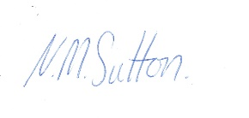
STUDENT. N. M. Sutton
SUPERVISOR – PP. Nick Hudd

5.2.2: Supervision No 2.
SUPERVISION RECORDING No. 2
DATE: 8th December 2020
TIME: 10:00 – 13:00
PEOPLE PRESENT: Nick Hudd and Nic Sutton
DURATION OF THE MEETING: 2 hrs.
AGENDA/ DISCUSSION POINTS
- 1. My reflection on Youth Work with the Moving On project and an encounter with Miss. F.
- 2. A vent!
- 3. Any other business.

Attached documents
- 1. A reflection of my experiences on completing the project’s online ‘Tenancy Training Course”

PROBLEMS ENCOUNTERED
None.

REFLECTION ANALYSIS AND LEARNING Links between theory and practice can be made here and referenced in the usual way. Also reflection on effectiveness of supervision.
In the ‘vent’ session I shared how I felt disappointed with the lack of face-to-face time due to the Covid restrictions.
As part of my reflections on Miss. F, we discussed at length how I had felt about a young person coming out of the care system and fending for herself, through renting a house and living alone from seventeen years old onwards.
I got stuck in my thinking on how I would react as a parent to my children in that situation, while Nick Hudd was pointing out the youth work approach, he brought up that the youth service did not bring love into the equation. This was quite a sticking point for me, and my thinking, compared to Nick’s. I felt it was unfair to deal with a young person at what appeared to be an arm’s length approach and dwelt on my experiences of my son and wife moving into a council property for the first time without any carpets. I and my son’s father-in-law put down self-levelling compound to repair the concrete floor where the previous carpet had been ripped up damaging the floor. I purchased and fitted one carpet and the father-in-law supplied and fitted the bedroom carpets. Between the two sets of parents, we found furniture and white goods and transported them to the new home.
Nick shared some insights that the Youth Service nor Social Services provided parental support to young people or care leavers. He mentioned that I had vision like the scotoma, which was a sort of programming in my thinking, which he had mentioned in the previous supervision. He suggested that I could view myself from the context of Johari’s window, examining all aspects of my thinking in relation to how I perceived other people. I felt this a personal challenge to my belief in reaching out to help people out of empathy and kindness. I felt that this ideal was being wrongly challenged and seen as a weakness with Nick and his team. This made me feel defensive and judged and I began to question if the placement was a threatening and judgmental environment. (This was how I felt at the time and have reflected on this since and have come to a different understanding.)
Nick discussed that how he and other members of the team projected an image when dealing with young people, alluding to the idea of an avatar, presenting an acceptable image possibly jokey and light-hearted. I understand that if a leader is having a bad day or has problems at home then displaying those feelings with potentially emotional young people, them altering our demeanour is good practice and to be self-aware. On reflection how we are perceived by young people as youth workers could have a profound impact on the environment, of youth club etc.), especially when some young people learn to respond and pick up their ques according to how others, especially their care givers, behave. Presenting a fun and happy side, whatever is happening within, and whatever has happened in the previous week’s club, appears to be an important aspect of youth work. I suppose this cannot be at the expense of being genuine or being a phony.
Another aspect discussed was being able to have your own political or religious views. As youth workers, one is in contact with people from all spectrums of society who may often hold contrary opinions and views or behave in ways which we may not agree with. In dealing with young people though, our views should not interfere with our relationship with the young person, and the young person may not know, and does not need to know our own preferences or dislikes, and we need to ensure we engage the young person through their perspective and not ours.
If there are tensions within a group to do with any sort of discrimination; and this could be generational; for example, we hate Polish people, because the Poles take our jobs. On way to counteract this is through informal learning. One suggestion was to have a national theme week, exploring the customs of the Poles or Greeks etc. where the past is challenged through the process of having a cultural night. The outcome for the young person participating in the event is not specified, but through the process of learning allows for a shift in thinking.
QUESTIONS ARISING
None

DATE OF NEXT MEETING: 25th January 2021
SIGNED: 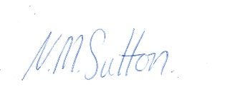
STUDENT Nicholas Sutton
SUPERVISOR PP. Nick Hudd.

5.2.3: Supervision No 3.
SUPERVISION RECORDING No. 3
DATE: 25th January 2021.
TIME: 15:00 – 17:30
PEOPLE PRESENT: Nick Hudd and Nic Sutton (Online with Teams)
DURATION OF THE MEETING: 2 ½ hours
AGENDA/ DISCUSSION POINTS
1. My reflection on Reflection on encounters with a sick elderly neighbor M. L, his daughter Miss. E. and a follow-up phone call with my placement Learning Mentor.
2. A vent!
3. Any other business.6.
Attached Documents
1. My reflection on encounters with a sick elderly neighbour M. L, his daughter Miss. E. and a follow-up phone call with my placement Learning Mentor.
PROBLEMS ENCOUNTERED
None

REFLECTION ANALYSIS AND LEARNING Links between theory and practice can be made here and referenced in the usual way. Also, reflection on effectiveness of supervision.
Over the previous two weeks I had been reflecting on my conversations with Miss. E. and the follow up conversation with my Mentor, Tim. I shared that I had felt angry and frustrated with the phone call partly because the mentor did not feel able to support any contact with Miss. E. due to internal protocols and safeguarding issues within the Pembrokeshire Youth Service, and partly because of my perceived putdown, of not being able to write a CV as a way of engaging with Miss. E’s boyfriend.
These aspects were discussed with Nick Hudd, who acknowledged there was a certain amount of red tape involved. Part of this red tape was the requirement of a Young Person to be referred or self-refer and fill in a short form, before being engaged by the youth service. I described the time when my two children, aged about fourteen and ten, took an internal flight to Scotland on their own. I wanted to walk them to the Customs desk, to ensure there were no problems and to support them in a new experience. One guard was very gruff and told me I could not walk round the screen When I insisted another guard asked, “what was the problem”, I explained that I did not want my children to get stressed, all I wanted to do was to see them through Customs, which he let me do. The comparison with access to the Youth Service was similar, the young person on self-referring did not know what the youth Service were likely to provide or what reception they would get. In my thinking of Youth Work was engaging them where they were and walking alongside through the checkpoint. Nick reflected that when you went to college or School, people did know what to expect, and the Youth Service were not so good at advertising their services. I feel that this is a blind spot within the youth Service.
Wylie (2013, p. 64) records this “
It requires workers who can seize encounters on the wing, not just in structured programs. Who will stick by troubled young people who may have few continuing, supportive relationships with adults?” … “Such tasks, and assessment, curriculum design and evaluation in non-formal settings have always demanded a high level of skill from youth workers”.

While I was angry, over several days I began to use the ‘Chimp Paradox’ to evaluate my emotions. Why did I feel so angry, why did it affect me so much what someone else said, or did not say? I began to see that the problem was with me and not my mentor. I realised that I was stuck somewhere in my own thinking. My thinking changed. I realised that I was focusing on miss. E. and here perceived needs and did not consider what my Mentor was seeing, his background and his take on the situation. This was a bit of revelation. Building up relationships with other stakeholders is as important as the presenting problem. I was assuming that the issues and needs of Miss. E. were obvious, and naturally my Mentor would want to respond in the same way. Miss. E. may be a contact in my life for a few weeks, Tim and Nick could be my colleagues or have some working relationship for ten years. The realisation that Tim had pushed a lot of my buttons was invaluable. I believe that Tim was in error on several counts even now, but my response was in greater error by a higher magnitude. Also, the needs of miss. E. were in some ways separate to this ‘crisis’ with Tim.
I was not responsible for Miss. E’s issues. Yes, I could support her in visiting her dad daily. But I knew very little about Tim and had not spent much time with him on placement due to COVID-19. Also, Tim knew very little about me. I realised that I had to lower my drawbridge, as I was creating a confrontational situation. I also realised that instead of just focusing on the presenting issues of a young person, or a more general crisis, it was important, critical even, to seek a consensus with other stakeholders where possible, due to other’s beliefs, background, and experiences, which are valuable resources.
(Own thoughts after the Supervision session: These may reduce one’s own blind spots, act as a safety check or balance out impulsive actions and bring in additional experience and knowledge. It is also necessary to sift other people’s perspectives though, as these may be founded on their own negative experiences resulting in being risk adverse. It is, I feel, a positive trait to be prepared to take risks, to believe in one-self, even to go against other’s inbuilt safety mechanisms, if the action is considered and based on an understanding of own abilities, within a framework of values, ethics, and appropriate boundaries, while wisdom may dictate taking another less confrontational route to maintain relationships. A fine balance! It is OK to challenge an adverse to risk taking recognise people have their own inbuilt safety mechanisms.)
Nick countered my views by asking me, as a qualified electrician, how I would feel if someone I knew who an apprentice was, asked me for advice on electrically testing a building. I replied that would be cautious, stating that they would need to be insured, that they were taking on a legal responsibility for the building, and was he/she aware of all the risks. He then went on to explain that my actions with Miss. E. Elicited the same response as mine in this situation. He said that the supervision sessions were meant to rip ideas and actions apart, to focus on issues and you felt, evaluate how to manage conflict. Feelings were important in the process, an explore antecedents. Within Miss. E. encounters there were potential safeguarding issues. He likened it to an ambulance crew’s response to an emergency “D.R.A.B.C”. Danger, Response, Airways, Breathing, Circulation. The first response is always regarding one’s own safety – Danger! Is the area safe. This is the same in working with Young people. Nick touched on the book edited by Sarah Banks – Ethical Issues in Youth Work. (Which I have started to read since)
Nick introduced the SKIP method of dealing with conflict (I did not write down what each letter stood for). He encouraged me to label the emotions, “I was angry because….;” to empathise, to re-assure and to re-direct the feelings, and to self-learn from the experience.
References
- Wylie, T. 2013. ‘Youth work in a cold climate’. Curran, S. Harrison, R. Mackinnon, D. (eds.) Working with Young People 2nd Edn. Milton Keynes: SAGE.
QUESTIONS ARISING
None

DATE OF NEXT MEETING: 26th February 2021
SIGNED: 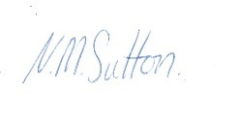
STUDENT Nicholas Sutton
SUPERVISOR- PP- Nick Hudd.

5.2.4: Supervision No 4.
SUPERVISION RECORDING No 4
DATE: 26th February 2021
TIME: 13:30 -16:00
PEOPLE PRESENT: Nick Hudd, Nic Sutton. (On TEAMS)
DURATION OF THE MEETING: 2 /2 Hours
AGENDA/ DISCUSSION POINTS
1. A vent!
2. Reflection No.4 - Engaging with a Young Person as part of the ‘Moving forward’ project.
3. Moving Into a tenancy Brochure – adapted from a list by a young person.
4. Child Safety allegations (CSA) and reflection No. 5 called “Engaging with Youth Workers and
aspects of safeguarding” – mentioned but not shown to Nick Hudd.

NOTES/ ACTION OF EACH ITEM
- No issues of concern to really talk about, although perceptions of meeting several youth workers from different departments belonging to the Pembrokeshire youth service, while on several days detached youth work over 15th -1st February was discussed at length.
2. Discussed opinions and learning from engagement with Miss. F. who was asked to produce a . list of items to consider when moving into a new tenancy.
3. The Moving in Brochure developed from the above engagement which I had adapted.
4. Trusted adults.
5. Other topics as they arise.

PROBLEMS ENCOUNTERED
Nick Hudd works from home. When the request was sent to Nick to firm up the date for supervision session No. 4, the moving date came through. Due to the unavoidable upheaval this caused and the wait for the internet connection to be re-established, a delay of two weeks occurred. This delay has impacted the next two supervision sessions, with the last one potentially on the 26^{th of} March, the submission date for the placement portfolio. And email has since been sent to Alana Enoch advising her of the delay and the potential problems. There is now a short period of grace if needed.
REFLECTION ANALYSIS AND LEARNING Links between theory and practice can be made here and referenced in the usual way. Also, reflection on effectiveness of supervision.
Nick and I discussed my online engagement with Miss. F. and y line mentor who was asked to produce a list of items to consider when moving into a new tenancy, which would then be reviewed and combined with a list produced independently by four youth workers, including myself. This list would then be produced as a brochure and distributed to young people in the future as a guide.
I considered this task originally as tokenistic, for Miss. F to be involved as part of the youth work project. Miss F. list would then be absorbed within a master lit, and be rubber stamped as part contributed by young people.
Miss F. perception of moving in was very illuminating. Not only did she create three lists, but she had injected feeling into it, while stating it needed to be fun for other young people to engage with the list.
These aspects made for a good discussion. Ideas of formal learning were explored where the youth leaders had understanding /experience while the young people were being taught, to avoid anticipated problems., and as Jeffs and Smith (2005, p.18)” we may have a detailed idea about what we are trying to achieve”, which is based on formal education.
Nick discussed some aspects of youth work were formal. In ‘the back office’ learning outcomes are discussed, direction of travel for the project, and what constitutes success, and what measurables can be recorded to demonstrate the project are effective. However, when interacting with young people, there is conversation and dialogue. For me in this process I learnt more than the young person did. Our collective moving in lists, while still holding value, have been side-lined to Miss F. list. Generally, because the list is combined with emotion and fun, and written from a young person’s experiences is more effective. This new list needs a format and developing, which I am in the process of working on, but the wording remains the same. The emotion is “make your bed first” so when you are tired it will be waiting for you, together with advice for the moving day, to buy something nice to eat for lunch. The fun element will be part of the finished brochure.
I shared with Nick how from this experience and understanding, I used fun and put feeling into a recent presentation. I have changed from seeing engagement with young people as potentially tokenistic to learning from the experience and applying it to aspects of my life.
Nick suggested that Youth workers have their perspective and opinions while the young people have theirs, together we meet somewhere between the two, this aspect was explored next.
First it can be difficult for a youth worker to adapt their good and well thought out plans to bend and change after input from young people. Nick gave an example of a previous colleague.
Nick shared that youth clubs previously offered a snooker tables as the main attraction, but with home entertainment, young people found something more enjoyable, so asked why to come to youth club. So, to keep abreast of young people’s wants and needs I is essential to have the young persons’ input and perspective, and then Nick stated that youth work would still lag in this fluid space. Nick put it in this perspective, Miss. F was a beneficiary of the furniture library, but had moved to a facilitator by significantly contributing to the moving brochure. Belton (2010, p. 20) suggests that change is “one of the important pillars of youth work education” which needs to be anticipated and prepared for.
I broached that I had completed No. 5 reflection and shared the outline of a research project on C.S.A. I mentioned that I had moved on from the original conclusion to which Nick suggested that I add to the document as a postscript, with my amended thoughts to demonstrate a progression of thinking and good reflective practice. This topic developed into a discussion on safety and safeguarding.
Safeguarding has a few sides. Nick gave an example when a young person shared a safeguarding concern, when faced with it being escalated, the person went on to deny it. It was only because proper safeguarding procedures were in place in the youth club, another youth worker in the background had heard the testimony and could corroborate the story. So good safety procedures protected a young person from further harm, in the same way an accusation against a youth worker could also be overheard, also giving protection. Another aspect of safety procedure gives youth workers the confidence to do their job. An example was given of using a mask in training when in a gas filled room. When on the mask protect, but the exercise means taking off the mask momentarily. This demonstrated the effectiveness of using the mask in that environment increases a person’s confidence to work in a gas fille room with the appropriate PPE. Good procedure enables a youth worker to be protected from CSA allegations and prevents grooming of young people by youth workers. One safety rule was within the project was always to have one team member by the door, so the issue did not arise where a young person could block egress out of the building.
Nick discussed trusted adults from an encounter by a youth leader with a known young person when working on a detached youth work team during the previous week. A group of young people from Ireland in another club were asked who they trusted, leaders within their home church had lost trust due to general CSA allegations. Trust is an important aspect of youth work.

Various other issues were raised. I had noted when working with another detached youth worker, that they took young people away from their familiar surroundings when working with them. This led me to find out that this was good practice. Batsleer (2013, p. 105) made this observation.
The paradox here is that safe- enough spaces are essential and yet learning can sometimes happen fastest and most significantly when there is a shifting and a riskiness that occurs when boundaries are challenged or breached.
For me this demonstrated one aspect of theory worked out in practice, or praxis.
Nick suggested in reflections and portfolios etc. to demonstrate thinking has developed over a period to show progress. State where I started from, and then show where I had moved to, and demonstrate the why.
We then discussed the process of supervision. I had started by being defensive, not trusting the process due to unfamiliarity I tried to over analyse everything. Nick advised to open myself up to scrutiny, which would allow me to know myself better, and it was not a means to critcise me, he mentioned aspects of the Johari window. Reflections on situations and thoughts would also challenge myself.
Nick also said that young people may also not trust the youth worker when issues are being raised, and to reflect on that experience from their perspective too. Our experiences are not wrong, but the perspectives need challenging, together with our belief systems. Supervision is a critique of behaviours and views; it is not judging the person.
References
- Jeffs, T. and Smith, M. K. (2005) Informal education: conversation, democracy and learning. Nottingham: Educational Heretics Press.
- Belton, B (2010) Radical youth work: Developing critical perspectives and professional judgement. Dorset: Russell House Publishing.
- Batsleer, J. (2013) ‘Informal Learning in Youth Work: Times, People and Places’, in Curran, S., Harrison, R. and Mackinnon, D. (eds.) Working with young people. 2nd edn. Milton Keynes: The Open University.

QUESTIONS ARISING
NONE

DATE OF NEXT MEETING: W/C 15th March 2021.
SIGNED:
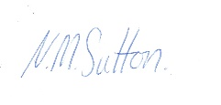
STUDENT Nicholas Sutton
SUPERVISOR PP. Nick Hudd.

5.2.5: Supervision No 5.
SUPERVISION RECORDING No. 5
DATE: 12th March 2021
TIME: 15:00 – 17:00
PEOPLE PRESENT: Nick Hudd &Nicholas Sutton
DURATION OF THE MEETING: 2 hours
AGENDA/ DISCUSSION POINTS
1. Rant!
2. Reflection No. 6. Effects of the COVID pandemic on Young People and good referrals.

3. General discussion

Preparation notes for meeting.
I have been thinking about a range of issues regarding the effects of the Covid pandemic. My above reflection on COVID and the implications on referrals to other services needed further reflection, this included: -
- The importance of being with people, friends’, and acquaintances.
- Fears and anxieties of people in the communities.
- Reflecting on Nick Hudd’s article called “Blended teaching, not blended learning” (Ref section 5.9)
especially on this extract when considering the merits of video conferencing: -
the lack of physical resources and social interaction opportunities, the ability for the educator to engage learners in conversation, debate, responding spontaneously to questions, are all diminished. Providing the space, means and culture that enables them to express themselves, feel empowered, be truly participative in their own learning, feel included are all compromised.
Discussing youth related issues in the abstract brings more questions, as good youth work practice needs to be seen and experienced, while words alone fail in conveying understanding and the consequential learning lost.
Nick’s article discusses the online learning platforms being a paradigm shift being offered as a new pedagogical approach. This approach may work to a point with formal, curriculum-based education, but its’ benefits to informal education, where conversation is a key element, appears less clear. One point to consider is the inability to choose the environment, or the safe space, as others, i.e., parents/ siblings, may be able to listen in to the private conversations.
However, it is hard to consider video conferencing replacing a youth worker’s interaction for crime, break-down in family relationships, depression, loneliness, and mental health issues, when “being about” in the locality or “being there” (Jeffs and Smith. 2005, p. 110-111) for a crisis, cannot happen. The thinking to find a paradigm shift in these issues may not have begun, partly due to the start-stop nature of COVID caused by firebreaks and lockdowns, while the long-term effects of young people needing services may not have been counted or costed. These services include Social workers, CAMHS, housing and other specialists, which already appear overloaded.
My reflection came out of a jumble of these thoughts, which need to be explored through this placement which is pushing the boundaries of traditional practice.
References
- Jeffs, T. and Smith, M. (2005) Informal education: conversation, democracy and learning. 3rd edn. Nottingham: Educational Heretic Press.
- Hudd, N. (2020) ‘'Blended learning', not 'blended teaching'’. Educational Workforce Council. Available at: https://www.ewc.wales/site/index.php/en/about/blog-archive/1624-nick-hudd-blended-learning-not-blended-teaching.html?highlight=WyJuaWNrIiwiaHVkZCIsIm5pY2sgaHVkZCJd. (Accessed 8th March 2021).
PROBLEMS ENCOUNTERED
The COVID pandemic preventing brilliant learning and experience through what this placement has to offer.

REFLECTION ANALYSIS AND LEARNING Links between theory and practice can be made here and referenced in the usual way. Also, reflection on effectiveness of supervision.
During the supervision session referrals to other agencies was discussed in length. There are various issues to consider.
- Do new youth workers have adequate counselling skills to use? Are they equipped to deal with Tier 1 needs?
- Due to the funding and measurement of targeted youth work, could the time taken to work with unrelated, but important issues, be discouraged, hence more referrals made, while controlling how and what interventions were made (Davies 2011, p. 12).
- Could these early intervention referrals further de-skill the youth worker?
An example was made regarding teachers. In the past teachers had to learn to deal with disruptive pupils. Today, in many schools, a person can be called to take a disruptive young person out of the classroom at the first sign of trouble.
Nick gave an example of the youth work pound. It was previously considered that there were invisible cost benefits to the government for investing in the youth service. In a youth work café if an elderly resident did not turn up who regularly came, they would phone up to check up on them. This could save a visit and expense from another service, but this would not be measured as part of the key performance indicators (KPI) for the café. This benefit can be multiplied many times over across the various youth work projects but could be discouraged due to these important aspects of youth work not meeting the funding bodies criteria.
Youth work is strongly connected to community “based on trust, respect and mutual understanding” (Gilchrist, 2009, p. 222). On another scheme, young people volunteering was given vouches to a certain value, which could be redeemed in a local shop. One butcher would charge the council £17.50 for a £20 voucher. The butcher did this because young people did not shop at the butchers, and it increased the foot fall, further, they may gain a new lifelong customer. The butcher also began to see the young person as a customer rather than a threat, which met NOS ref YW03, “Engage with communities to promote the interests and contributions of young people” (CLD Standards Council Scotland. 2019). When a young person leaves the remit of the youth service at twenty-five years old, then it is the wider community which needs to support them, so building self-efficacy and inter-dependence is vital.
References
- Davie, B. (2011) ‘Policy analysis: first and vital skill of practice’ in Batsleer, J. and Davies, B. (Eds.) What is youth work? Exeter; Learning Matters Ltd.
- Gilchrest, A. (2009) ‘Linking partnerships and networks’ in Harrison, R., Benjamin, C., Curran, S., and Hunter, R. (eds.) Leading work with young people. 2nd edn. Milton Keynes: The Open University.
- CLD Standards Council Scotland. (2019) Youth Work National Occupational Standards, Glasgow: CLD Standards Council Scotland.

QUESTIONS ARISING
The author felt that volunteers could take up the slack in the shortage of qualified youth workers, with one idea put forward training up the Christian denominations to re-engage with youth work; while Nick put forward the view that there were many aspects of youth work which required professionalism and proper training to operate effectively.
The question arising -Is the professionalisation of youth work essential? Wylie (2011, p. 65) suggests this “one looks forward to the day when a Secretary of State, or shadow, will announce a commitment to increase the numbers of youth workers, not police officers”.
This idea requires further research by the author.
References
- Wylie, T. (2013) ‘Youth work in a cold climate’ in Harrison, R., Benjamin, C., Curran, S., and Hunter, R. (eds.) Leading work with young people.2nd edn. Milton Keynes: The Open University.
DATE OF NEXT MEETING: Friday 26th March. 2021
SIGNED: 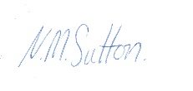
STUDENT Nicholas Sutton
SUPERVISOR

5.2.6: Supervision No 6.
SUPERVISION RECORDING No. 6
DATE: 26/03/21
TIME: 15:00 – 17:00
PEOPLE PRESENT: Nick Hudd and Nic Sutton
DURATION OF THE MEETING: 2 hrs.
AGENDA/ DISCUSSION POINTS
1. Feedback on Reflection No. 7.
2. discussing issues of labelling young people as NEETs or care leavers etc. as per point from supervisor’s final report.
3. Advice regarding level 5 placement.

NOTES/ ACTION OF EACH ITEM
1. Supervisor could see a shift in the author’s understanding of youth work values between the beginning of the supervision process till today, through the author challenging his own beliefs and understanding of some work with young people in a Christian faith setting not being youth work.
2. The author did not understand the depth of feeling on why the supervisor and mentor were so adamant on calling a young person, a young person, and not a NEET or care leaver etc.
3. It was discussed about broadening ones understanding of youth work through having diverse placements to be able to compare and contrast different philosophies and attitudes.
PROBLEMS ENCOUNTERED
This last supervision was scheduled after college submission date, due the supervisor moving to a new house and did not have an internet connection for a couple of weeks.
REFLECTION ANALYSIS AND LEARNING Links between theory and practice can be made here and referenced in the usual way. Also, reflection on effectiveness of supervision.
This last supervision was very beneficial. We discussed the joined-up nature of youth work in wales, from the interim board taking on board ideas from youth work organisations and making cohesive Wales wide policy in shaping youth work. Discussed were various organisations such as CWVYS, (the Council for Wales of Voluntary Youth Services) the independent representative body for the voluntary youth work sector in Wales and the Principal Youth Officers for each county in Wales. This gave the author a much bigger picture of how youth work was joined up over different sectors and led to a discussion of whether there were specific problems within the community of young people which the government were interested in tackling. This led to the supervisor sharing he was on two board, one called people are thriving and the other called Digital strategy board. These looked at two areas, the social problem and economic problem, both of which add financial burden onto the economy.
The next topic was the role of youth work when working with groups with very strong values, i.e., Jews or Moslems were marrying outside of the group can bring quite serious consequences to the individual or where a youth worker may fall foul of giving sexual health advice, say to a Gypsy community, where it is a matriarch’s job. These need to be worked around with understanding but the youth workers role is to educate and inform, possibly discussing outcomes to various decisions, and explain where we/ a young person has come from, their heritage and what this may mean for the future, possibly asking doe the values serve the young person or does the young person serve the values. It is not the role to tell a young person what to do.
The author raised the question about the professionalisation of youth workers, when it becomes a statutory position, does it become an extension of the social services, if a youth worker was to report a young person to the police for having drugs, then where is the trust and relationship?
The youth worker, social worker and police do all fall under the same umbrella, providing support and safety to the community/ society, but do have distinctive features. For example, the youth worker regarding drugs, may provide new needles and filters in a kit, to reduce harm reduction. The police would not be interested in prosecuting a user carrying a small amount of drugs, as they want to catch the suppliers. The Supervisor went on to explain that all citizens are part of this umbrella, where a possible child abuse case is noticed the next-door neighbour would phone the police/social services out of concern, he also went on to note that the Samaritans do not have a requirement to inform the police if they get a suicide call. The youth worker role is to ensure the young person is safe and needs to act accordingly.
The next discussion was on how to engage in youth work that was authentic, after the supervisor had suggested that when dealing with youth work, he wore a kind of mask. The result of the discussion lead to a youth worker needing to have a genuine purpose in forming relationships and educating young people, while the mask is relating to the young person relevant to their culture, values and interests, using attitudes, demeanour, dress sense, language etc, to be able to engage effectively with that young person. At home, with close friends, our guard may be down, and we may share different elements of ourselves.
He last point of discussion was around the subject on how people can label young people, for example, NEETs, Care leavers, ex-offenders etc., and how the youth worker addresses other people when asked what their job is.
Young people can be charaterised by these labels. The youth worker should always see them as young people – period. This was not understood by the author – So I may comfortably have said “I work with ex- offender young people”.
The supervisor asked, at what point does a young person lose that label? Care leaver, ex-con, drug addict etc. The youth worker’s purpose is to work with young people where they are at, thinking of a person as a label, can lead to the youth worker treating that label, and not working with the young person holistically.

QUESTIONS ARISING
COVID, limited face to face time, there may be opportunities with other departments for further young people contact.

DATE OF NEXT MEETING: None
SIGNED: 26/03/25
STUDENT 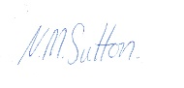
SUPERVISOR PP Nick Hudd.

5.2.7: Supervision contract.
Contract for Supervision
Between Nick Hudd and Nic Sutton dated 29/10/20
This is my understanding of the discussion on boundaries for the ongoing supervision sessions between Nick Hudd and Nic Sutton, which forms a binding supervision contract.
The supervision sessions are to be a safe space to explore aspects of my placement on the Moving Forward project, run by Pembrokeshire Youth.
- It shall be a safe space to express ideas and thoughts.
- What is said inside the supervision sessions are confidential, not withstanding any safeguarding issues will be taken outside the session to relevant bodies.
- The supervisory sessions will initially be upwards of an hour.
- There will be 10 minutes initially for “venting”, which is freedom to unbottle frustrations and feelings. The time for this will be open for review.
- Nic will present an agenda before the scheduled meeting, which will include at least one reflection piece to discuss.
- One of the aims is to link theory, with practice, and to connect what is being learnt at college with the placement.
- There will be a minimum of six supervision sessions. Additional sessions may be made by agreement.
- The dates of the sessions will be flexible, but adequate notice must be provided, and agreed with Nick Hudd in advance.
More generally, Nick Hudd emphasised the necessity for confidentiality within and after the placement, by not to discuss names or conversations to other parties. In addition, If I had contact or knowledge of people using the project, I was to declare it to the leaders, as this may have an impact on a person’s participation.
My conduct is to be appropriate for the setting.
This contract has been entered into voluntarily.
Nicholas Sutton
Date – 30/10/20

5.3: Risk Assessment portfolio.

5.3.1: Risk assessment list.
Risk assessment of Moving Forward project, Unit 3 pier Road, Pembroke Dock, on 17th December 2020.
Ref | Hazard/Task/Activity  Area of concern | Persons at  Risk | Existing  Controls | Describe any further controls/ actions needed | Actions  by  whom | Actions  by  when
1 | Unauthorised entry to premises | Staff and guests | Locked front door and CCTV. | Ensure back door is locked at end of day | Staff | Daily
2 | Visitor is infected with Covid | Staff and guests | Everyone asked if they have covid symptoms, contact with an infected person | None | Staff and guests. | When entering premises.
3 | Covid contact tracing. | Everyone. | Enter name, email address and phone number in register. | None | Staff and guests. | When entering premises.
4 | Catching/ spreading covid within centre | Everyone. | Regular use of hand sanitiser by front door | None | Staff and guests. | When on premises
5 | Reduce contact with Covid. | Everyone. | Use one way system when moving through venue | None | Staff and guests. | When on premises
6 | Ensure Fire exits are clear | Everyone. | Walkways clearly defined | Boxes obstructing main area fire door | Youth worker and I | Immediately. 17/12/20
7 | Potential Hot cooker surfaces, remaining hot after use. Others may touch hot surface and get burnt | Everyone | Assumed common sense. | Hot surface hazard label required, as visible warning | Nic Sutton. Label now purchased | Next visit to centre.
8 | Risk of falling downstairs | Stair users | Stairs in good condition | Handrail requires fitting as per building regs | Building maintenance team | Email sent 0912/20. Within a reasonable period.
9 | In furniture store, Keep walkways clear. | Everyone. | Building users ensure walkways are clear as part of normal housekeeping. | Ensure walkways clear due to constant moving of furniture | Youth workers. | Daily
10 | Causing injury due to lifting furniture or white goods. | Youth Workers | Specialist sack trucks | Get assistance when lifting large, heavy, or awkward items | Youth workers. | When moving items, within unit or delivering items.
11 | Safeguarding issues – Accusation of CSA | Youth Workers and volunteers, young people, Pembrokeshire youth (reputation/  liability) | Two youth workers to be visible and able to always listen when young people are being engaged with. | None | Youth Workers and volunteers | When engaging with young people on and off the premises.
12 | Safeguarding issues – Young person blocking building exit | Youth Workers and volunteers, young people, | One youth worker always to be between young person and door exit. | None | Youth workers | When engaging with young people on and off the premises.

5.3.2: Report to Pembrokeshire Youth on hazards found.
Moving Forward Project,
Unit 3 Pier Road
Hobbs point.
Pembroke Dock.
09/12/20
To Nick Hudd.
As part of my placement assignment with your ‘Moving Forward’ project, I need to carry out a risk assessment.
I have found two areas which may need further action.
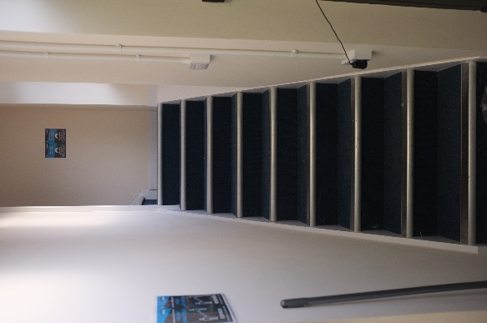
- Firstly, I noticed the stairs to the first-floor offices did not have a handrail fitted. On further investigating I found a document ‘building Regulations 2010, Part K’ as attached. Withing section K 1.34, page 14, it indicates handrails should be fitted to stairs. This may require further investigation. (Document attached to email)

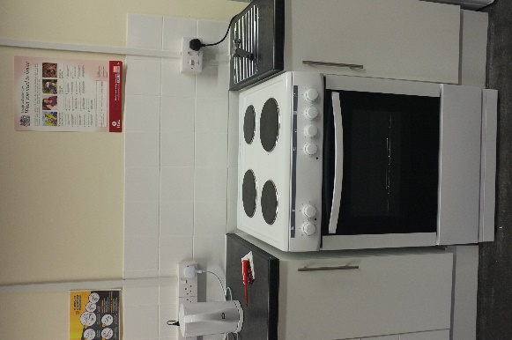

- Secondly, from past experiences of electric cookers, I have found that the top rings do not change colour when hot. I have taken the liberty of ordering a self-adhesive sign to highlight this issue (For a nominal sum of £1.36) which I should have by next Tuesday.

Trust this is ok.
Yours sincerely
Nicholas Sutton
(University Trinity St. David.)

5.3.3: Safety Awareness.
Some thoughts by Nic Sutton 07/10/20
Introduction.
Kate Sapin (2013, p. 32) penned this:
Policies that are designed to protect the organisation against litigation and disciplinary action can have a detrimental effect on practice. Contact with young people may be curtailed by extensive risk management or requirements for data entry. Key aspects of work such as flexibility spontaneity or informality may be undermined by exaggerated emphasis on procedures and could devalue the contribution of professionals who often make decisions based on their understanding of a particular situation. Informal work with young people often thrives on being able to make exceptions to the rules, rather than imposing regulations based on general rather than individual circumstances. However, the individual needs to be aware of the organisations policies and their implications to know when support may be withdrawn.....”
Comment: Health and Safety at Work is enshrined in Law. It is not there to stop us having fun, it’s there to keep us and others we have responsibility for ‘Safe’.
Consequences of having an accident at your project.
When we think about the consequences of having an accident, our first thoughts can be “was anyone hurt”?
But a loss can be seen in other ways too: -
- A loss of income - to the injured person being unable to work.
- A loss of income to a project / organisation due to a loss of reputation.
- Loss of possessions or equipment.
- Damage to property.
- Environmental impact.

Assessing the risk.
A short video ( 2 ½ min) on Assessing risk – by the Health and Safety Executive or H.S.E.
To open press on your “Ctrl” key and left click with mouse on the link – it will open up in your web browser

https://youtu.be/xyANahuhGs0

This video and other useful info can be found at https://www.hse.gov.uk/simple-health-safety/risk/index.htm
Trips, Slips and Falls.
The following statistics are taken from an interesting poster from the HSE website.
HSE “
Slips and trips are the most common cause of injury at work. On average, they cause 40 per cent of all reported major injuries and can also lead to other types of serious accidents, for example falls from height. Slips and trips are also the most reported injury to members of the public. https://www.hse.gov.uk/pubns/indg225.pdf )
Also by the HSE- Listen to this!
https://www.hse.gov.uk/slips/adverts/office.mp3

An informative video on Slips, trips and falls

https://youtu.be/KXFrU-vrwTY

Origin – SafeWorkManitoba

Hazard and Risk

A couple of videos explaining the difference between a Hazard and a Risk.

https://youtu.be/ToaVW4nSdBA by Holmeglen

https://youtu.be/y3dQj1mYlOw by Ally Safety

5 steps to risk assessment

Quote from Diana Smith “
This is a short video clip to assist you with structuring your Risk Assessment. Whilst there are many ways to develop a risk assessment, this simple process is aimed at those who are not used to developing formal risk assessments. It follows the Health and Safety Executives (HSE) in the UK process to risk assessment.

https://youtu.be/DV48730ypn0 by D.R Safety,

Risk Assessments

For me, (Nic) there are a couple of ways thinking about risk assessments.
- A walk around assessment. By this I mean going round a venue, looking for hazards. So an electric lead across a walkway, a damaged chair, a wet floor. This is something the videos have shown.

- The other is task specific. So an outing, dying someone’s hair, assembling a flat pack, moving furniture, demonstrating cooking.
These tasks often have several hazards identified in the task.
So I break the tasks into steps, and identify the hazards for each step. Then I would control each hazard. This could be in lifting – Get someone to help; or read instructions and follow advice – test chemical on a small patch of skin/ material first; or Wear PPE – Use disposable gloves- a respirator- an apron, etc.

Hair colouring gone wrong.


A mum was left scarred after having her hair dyed at a salon. She suffered a severe allergic reaction, which left her with swollen eyes and burns covering her face. It took doctors six months to find out why. 26-year-old Georgina Carter, from Cambridgeshire, United Kingdom, had enjoyed getting her hair dyed or eyebrows tinted ever since she was at school. She loved changing up her hair colour and had gone black, brunette, blonde, pink, purple and red over the years. She had never experienced a reaction to dye.

Read more: https://metro.co.uk/2018/12/07/woman-who-had-severe-reaction-to-hair-dye-can-never-colour-her-hair-again-8211179/?ito=cbshare
Twitter: https://twitter.com/MetroUK | Facebook: https://www.facebook.com/MetroUK/

Manual handling
You will enjoy this – they have a toddler doing the demonstrations!
A video called “Childs play” by Michael BAGNALL of SES
https://youtu.be/B4dK_BoPEKg

A Safety Moment.
Consider having a “Safety Chat with the young people. We are all very good about diving into a task, to ‘get in there’, but just pause for a moment and chat with the young people and make them aware of the hazards. At the start of the club a few rush over to the pool table, but there are some chairs a metre away. What happens when they are walking backwards with the cue in their hand, not paying attention? Could they move the chairs first to a “safe” distance first? Or a small group are eagerly chatting, but blocking the main entrance, could they have a chat in a “safer” place.
Be aware that circumstances may change from when you did a risk assessment. You are out on a hill walk, and the fog closes in, or the path by a river has been washed away. It’s hard but be prepared to abandon the activity. It’s not nice, and you won’t be thanked for it at the time.
In closing.
I trust you have enjoyed these thoughts and videos. A lot of the ideas and some of the content have been drilled into me on an Oil refinery over a number of years, which had a good safety record. I have got it wrong a few times, and I still do not like filling in the forms.
Let me know what you think – good or constructive criticism!
Cheers - Nic

References
- All online content accessed 2nd October 2020.
- Sapin, K. (2013) Essential skills for youth work practice. (2nd Edn.) London: Sage Publications.

5.4: records of 200 hours youth work

5.4.1: Record of youth work face-to-face hours.
Date | What did I do | Time Taken
10/11/20 | Met Tim Ramsey @ Neyland. Dropped off furniture. Tim interviewed 23 yr. old tenant | 1 hr.
17/11/20 | At Centre, met two Y.P and reviewed progress | 1 ½ hr.
24/11/20 | At centre, made phone call to Y.P met on 10/11 follow up and reviewed various cases | 3 ½ hr.
25/11/20 | At centre part of phone calls to young people who were part way through VLE training | 1 ½ hr.
02/01/21 | Chat with Miss. E. About sick Father | 1 Hr.
08/01/21 | Chat with Miss. E about her personal circumstances, signposted to various organisations | 1 Hr.
13/01/21 | Chat with Miss. E. about accommodation | ¼ Hr.
15/01/21 | Chat with Miss. E about plans for moving forward and gave form for self-referral to Pembrokeshire Youth provided by line Mentor | ¾ Hr.
29/01/21 | Online chat with Miss. F with Line Mentor, regarding checklist ideas for young people moving into own home. | 1 hr.
05/02/21 | Online chat with Miss. F with line Mentor, regarding checklist ideas for young people moving into own home. | ¾ hr.
15/02/21 | 16 young people contacted in 4-hour period from 14:00-18:00 as part of a half term Pembrokeshire Youth Service detached youth work scheme with Mia and Dan | 4 hr.
16/02/21 | Detached youth work from 15:00- 17:45 in Milford Haven with Sarah and Steph Main | 2 ¾ hr.
17/02/21 | Detached youth work from 14:00 – 15:45. With Dan | 1 ¾ hr.
18/02/21 | 16 young people contacted in 3-hour period from 14:00-16:00 as part of a half term Pembrokeshire Youth Service detached youth work scheme With Jo Rogers and Joe | 2 hr.
19/02/21 | Detached youth work from 14:00 – 15:30. Finished early due to bad weather. Dave Barnes & Alex Hanco | 1 ½ hr.
20/02/21 | Day cancelled due to rain. | 0
21/02/21 | Detached youth work from 14:00 – 17:45  In Milford Haven with Jimmy Wilson. Good contacts with 10 young people. | 3 ¾ hr.
12/03/21 | Online chat with Miss. F with Line Mentor, regarding ongoing checklist ideas for young people moving into own home. | 1 hr.
 | Total to date | 29 hr.

5.4.2: Record of youth work non-face-to-face hours.
Date | What did I do | Time Taken
22-23/09/20 | Phone call, Emails in initiating own placement up to initial chat with Nick Hudd and David Walker of Pembrokeshire Youth Service. | 3 hr.
2/10/20 | Initial Placement chat/interview with Nick Hudd and David Walker (both Senior Youth Work Practitioners in Pembrokeshire Youth Service) in person at Moving Forward homeless prevention youth project. | 2 ½ hr.
08/10/20 | Online Safeguarding Training & Test. | 2 hr.
06/10/20 | Online Tenancy training course for placement  (Part of, only due to internet problems). This is the online access training for Young People to access the ‘Furniture Library. One of the main portals for accessing the project. | 1 ½ hr.
09/10/20 | Continuation of Online Tenancy training course for placement. | 2 hr.
6-26/10/20 | Emails setting up online 3-Way meeting with Huw Williams (Tutor UWTSD) and Nick Hudd | 1 hr.
19/10/20 | Wrote No. 1 reflection based on online tenancy training course. | 3 hr.
20/10/20 | 3 way start up meeting on TEAMS with Huw Williams, Nick Hudd held online. | 1 ½ hr
22/10/20 | Reviewed N. Hudd’s ‘Blended Learning not Blended Teaching’ essay and I wrote critique + set up 1st supervision session via a series of emails. | 3 hrs
29/10/20 | Skype meeting with Nick Hudd discussing and arranging Supervision Contract (Located in Appendix 5:2) | 2 hrs
30/10/20 | No. 1 Supervision session with Nick Hudd, face to face. + prep time. | 2 +1 hr.
31/10/20 | Wrote up minutes of supervision No. 1 | ¾ hr.
17-19/11/20 | At Centre introduced myself to staff and took photos of Building. Wrote up risk assessment. Found Handrail on stairs missing, found relevant regulations, ordered hot surface hazard sticker for electric cooker. Sent email to Nick Hudd outlining issues and copy of building regulations. | 6 hr
24/11/20 | A meeting with Youth Work Team. Discussed Young People’s needs and worked in furniture store. Location taking delivery of beds and clearing space. Location- project building. | 4 hr
25/11/20 | Prep: Helped PAT test equipment for Young people, fridges and washing machines at Project building. | 2 hr
02/12/20 | Day cancelled- Young person cancelled appointment | 0
03/12/20 | Reflection No. 2. Meeting Miss. F. | 2 hr.
08/12/20 | Supervision Session 2 with Nick Hudd face to face. Location – project building. | 3 hr.
08/12/20 | Planning for visit by Young person from Silverdale emergency accommodation and discussed making a brochure, signposting Young People to external resources. | 3 hr.
10/12/20 | Writing up minutes for Supervision No. 2 | 3/4 hr.
15/12/20 | Session cancelled due to COVID – No face-face | 0
18/12/20 | End of year Homeless review held online. Discussed progress so far with project and developments for 2021. Present David Walker, Nick Hudd and James Risley. (All with the Pembrokeshire Youth Service) | 1 ¾ hr
09-11/01/21 | Emails to Alana Enoch, Nick Hudd & Tim Ramsey, regarding perceived opportunity to do some quality youth Work with Miss. E, and Boyfriend due to conversation about homelessness and other issues | ½ hr.
11/01/21 | Phone call with placement mentor regarding Miss. E. and how Pembrokeshire Youth Service operate. | ½ hr
11-24/01/21 | Reflection No. 3 and writing up of encounter with Miss. E, and phone call with Line Mentor. | 10 hr
25/01/21 | Online meeting with Alana Enoch (UWSD) to discuss placement and face to face hours. Discussed various options for working with different departments in Pembrokeshire Youth and external organisations. | 3/4 hr.
26/01/21 | Supervision Session No.3 with Nick Hudd online + preparation | 2 ½ + 1 hr
26/01/21 | Online meeting with Nick Hudd and Moving Forward team. Discussing check lists for Young People moving into new tenancy. Discussed problems facing a Young Person in detail | 1 ½ hrs
26/01/21 | Follow on online meeting from actions arising from earlier meeting. | 1 ½ hrs.
26/01/21 | Task from meeting, designing Power Point slides of essential list for Young Person moving into first tenancy | 2 hr
26-30/01/21 | Sent emails to three youth workers in Pembrokeshire Youth requesting opportunities for engaging in young people face-to-face within their groups. Phoned Riskin Mill residential home for Young people with mental health (Clunderwin, Pembrokeshire) enquiring R.E. volunteering to gain face-to-face hours. | 1 hr
28/01/21 | Wrote up minutes for supervision No. 3 | ½ hr.
29/01/21 | Online Project Team Meeting, Discussing individual Team member’s check lists. Idea growing into larger project. Some information to go onto online learning platform. Discussed meeting Miss. F. to get young person’s views on a priority list for moving into new tenancy. | 1 ½ hr.
01/02/21 | Preparation for taking lead with Miss. F. plus discussion with Mentor online prior and post online meeting with Young Person. | 1 ¼ hr.
02/02/21 | Mini reflection on reply to Nick Hudd’s email asking how I was finding supervision sessions were going. | ½ hr.
05/02/21 | Teams meeting with Liz Griffith & Tim Ramsey regarding safeguarding issues of talking to young people alone in September 2020 | 1 hr.
06/02/21 | Reflection No 4 on two online meetings with Miss. F & Mentor on producing a check list to help young people on moving into their first independent home | 3 ½ hr.
11/02/21 | Reflection No. 5 Researching and writing “Engaging with youth workers and aspects of safeguarding” | 6 hr
26/02/21 | Supervision No 4. 13:30 – 16:00 with Nick Hudd on Teams | 2 ½ hr.
01/03/21 | Writing up minutes for supervision No. 4 and sent to Nick Hudd with minutes from No.3 | 1 ¼ hr.
02/03/21 | Revised Moving in Check list & added clip art. | 1 ½ hr.
08/03/21 | Reflection No. 6. Researched and wrote up “Effects of the COVID pandemic on Young People and good referrals.” | 5 hrs.
12/03/21 | Preparation for video call to Miss. F. | ½ hr.
12/03/21 | Preparation and supervision session No. 5 with Nick Hudd. | 2 ½ hr.
15/03/21 | Wrote up minutes for supervision session No. 5 | 1 hr.
22/03/21 | Reflection No. 7 | 4 hr.
25/03/21 | Final 3-way meeting with Huw Williams, Tim Ramsey | ¾ hr.
26/03/21 | Supervision No. 6 with Nick Hudd on Teams | 2 hr.
26/03/21 | Write up No 6 Supervision minutes | 1 ½ hr.
 | Total hours | 106 hrs.

5.5: Own work for sessions.

5.5.1: - Moving In checklist No. 1
From my Personal Development Plan (PDP) in section 4.4 of this portfolio, under part 2, ‘Facilitate the personal, social, and educational development of young people’ I wrote this: -
Engaging with a young person from their first encounter with the project through to a self-realised outcome. This would be through understanding their needs and allowing them to articulate how their need/s could be met through either the Project or supporting/ external agencies. Then creating a space to support them in arriving at a hopefully positive outcome (The outcome in relation to the 5 pillars.) As well as their perceived needs.
(Nicholas Sutton – PDP.)
This engagement with a young person is still ongoing and has been reflected on in reflection 2 and 4 (section 5.1.2 & 5.1.4). Miss F was initial met as a first encounter meeting her perceived need for a bed and chest of drawers. Next, I set up and led a one-hour video call to outline a request for Miss. F. to produce her own checklist. Checklist ref 5.5.1 was my own version, while Miss. F. version can be found in section 5.6, produced as a result from me leading this video-call.
My line mentor then requested by to develop the young person’s checklist into something which could potentially be produced. These two versions are in section 5.5.2 & 3. These aspects meant that I completed that part of my PDP. The NOS elements were discussed in the two relevant reflections. Due to covid, crocheting or netmaking was not possible due to lack of face-face opportunities with COVID pandemic.


Authors own work in creating a checklist for young people when they move into a new tenancy. The aim was to offer learning to make the move as smooth as possible.
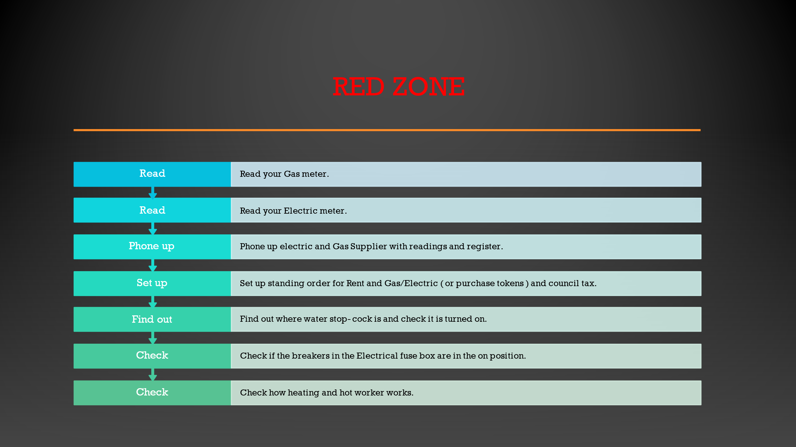
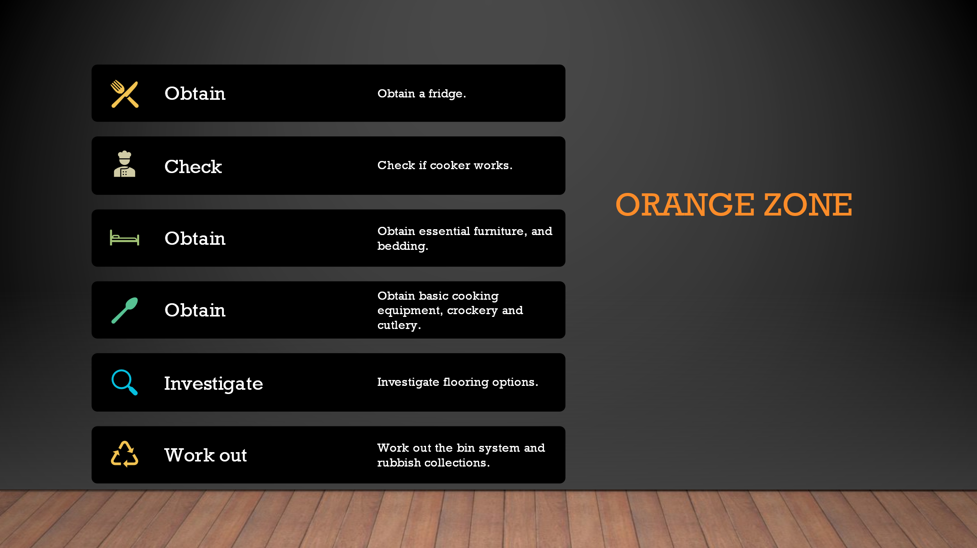
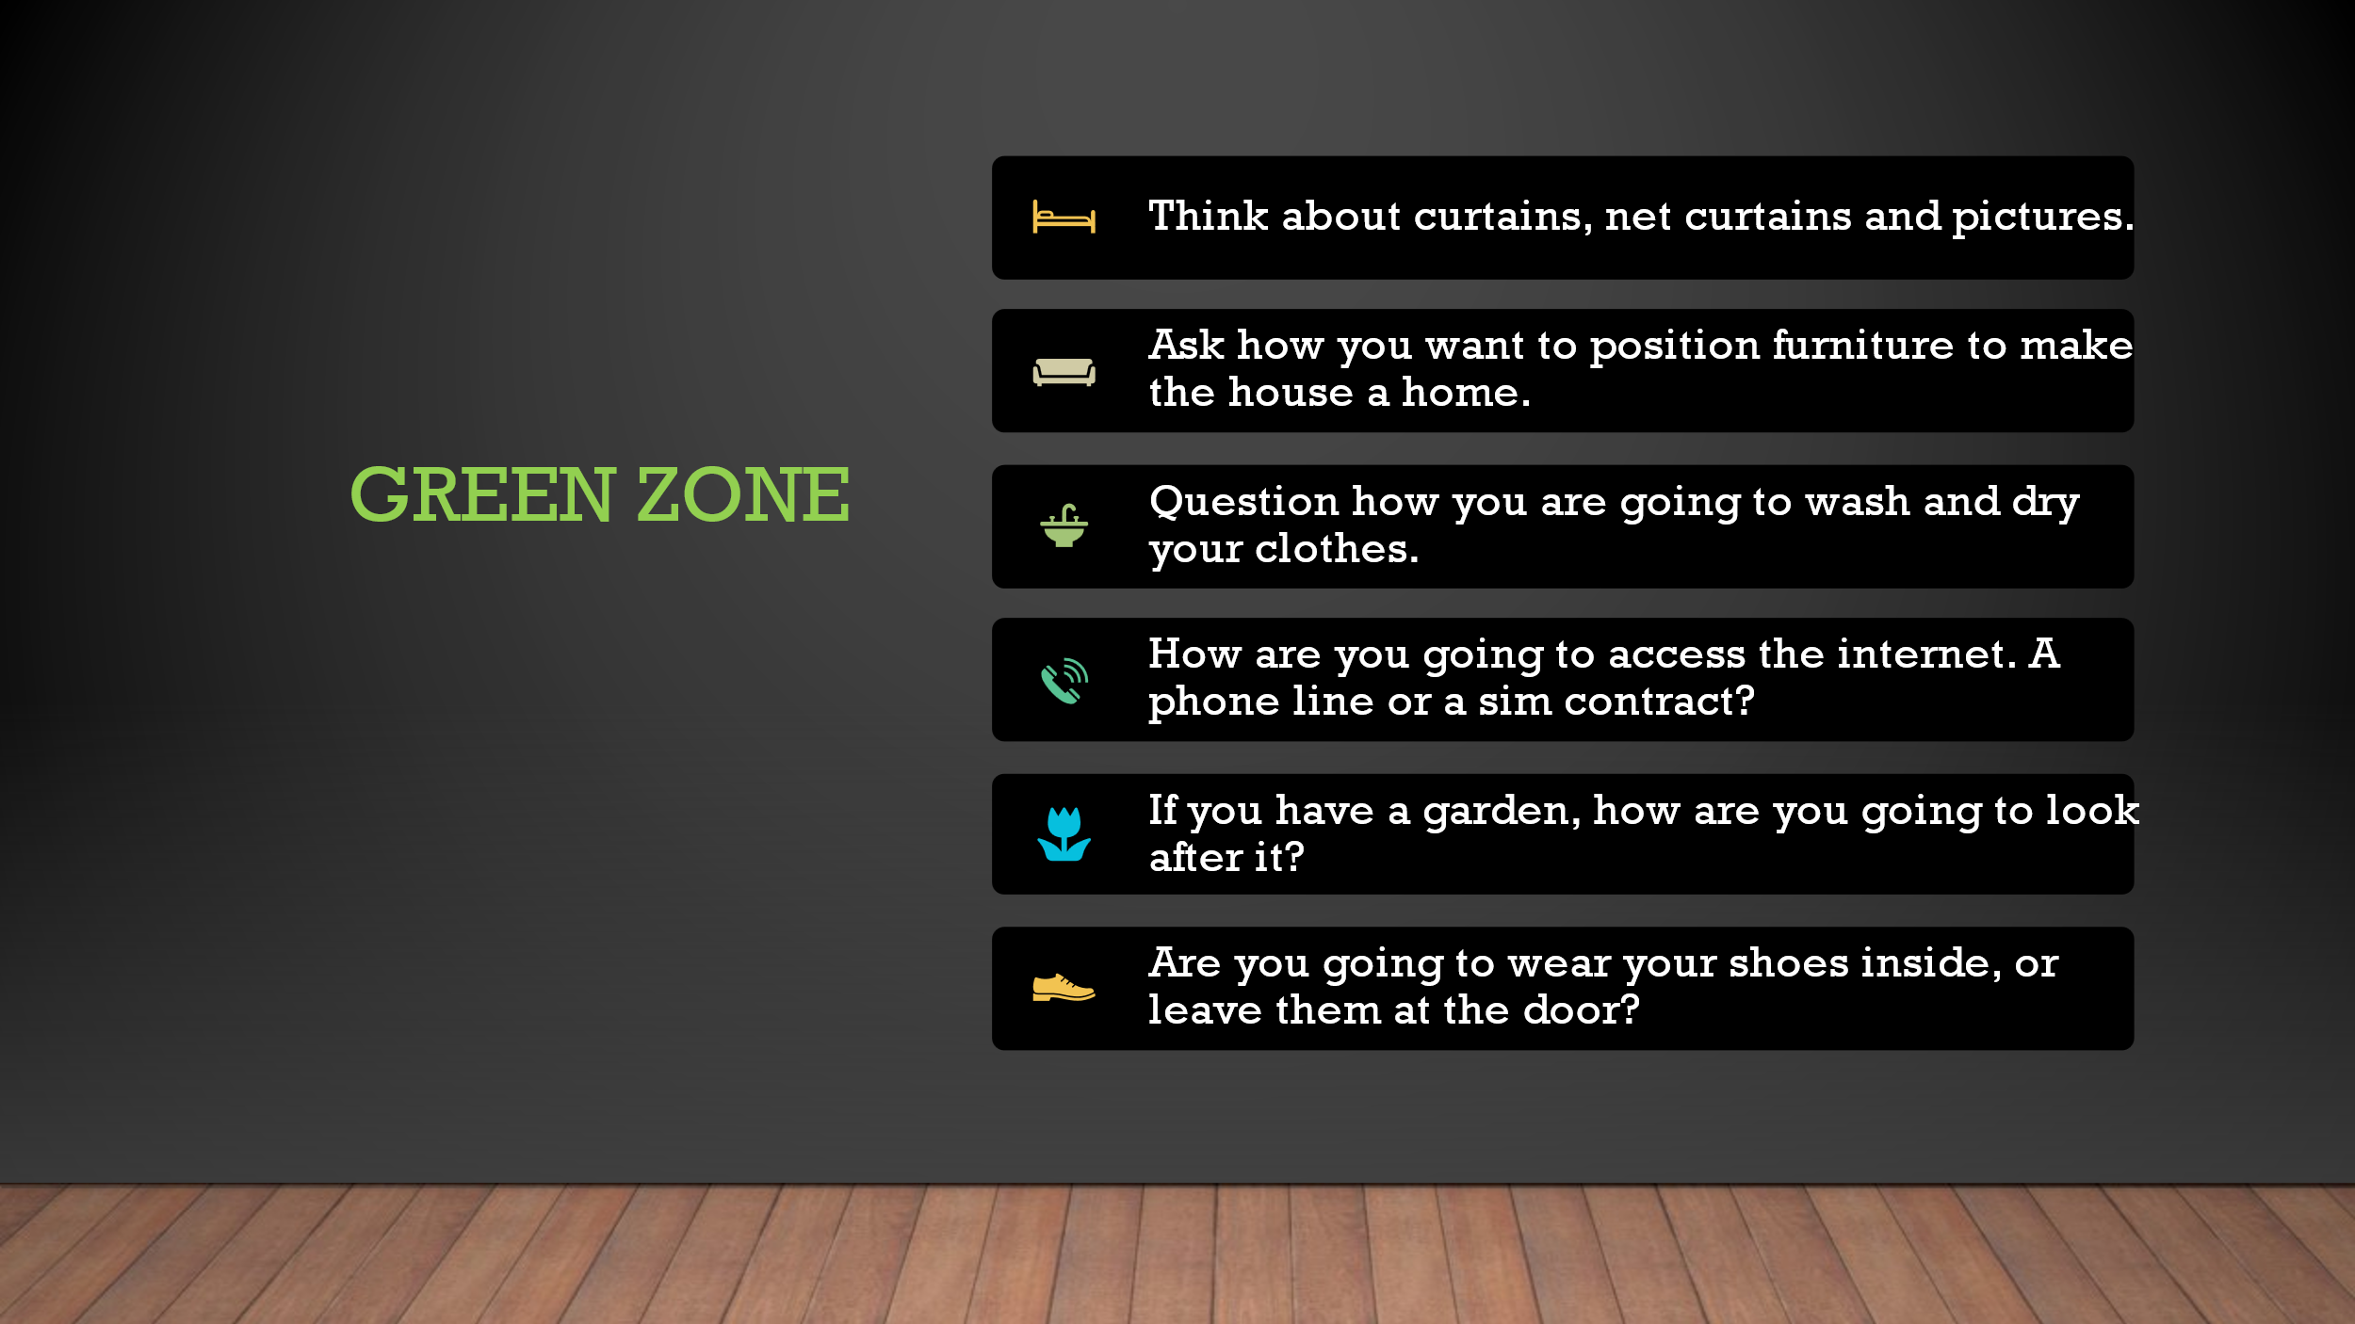
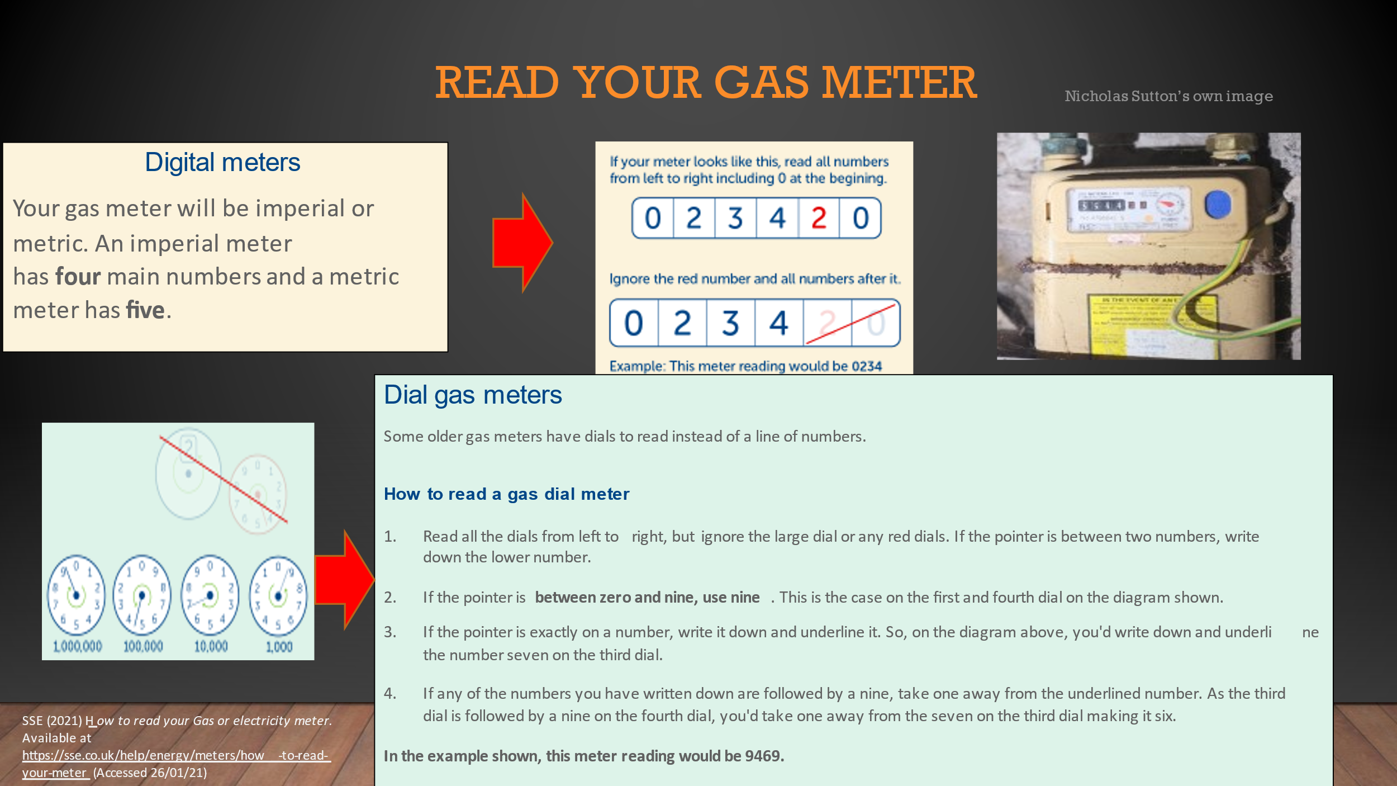
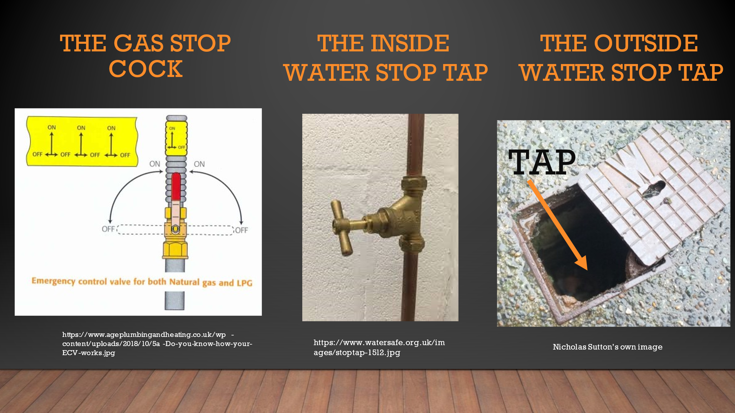
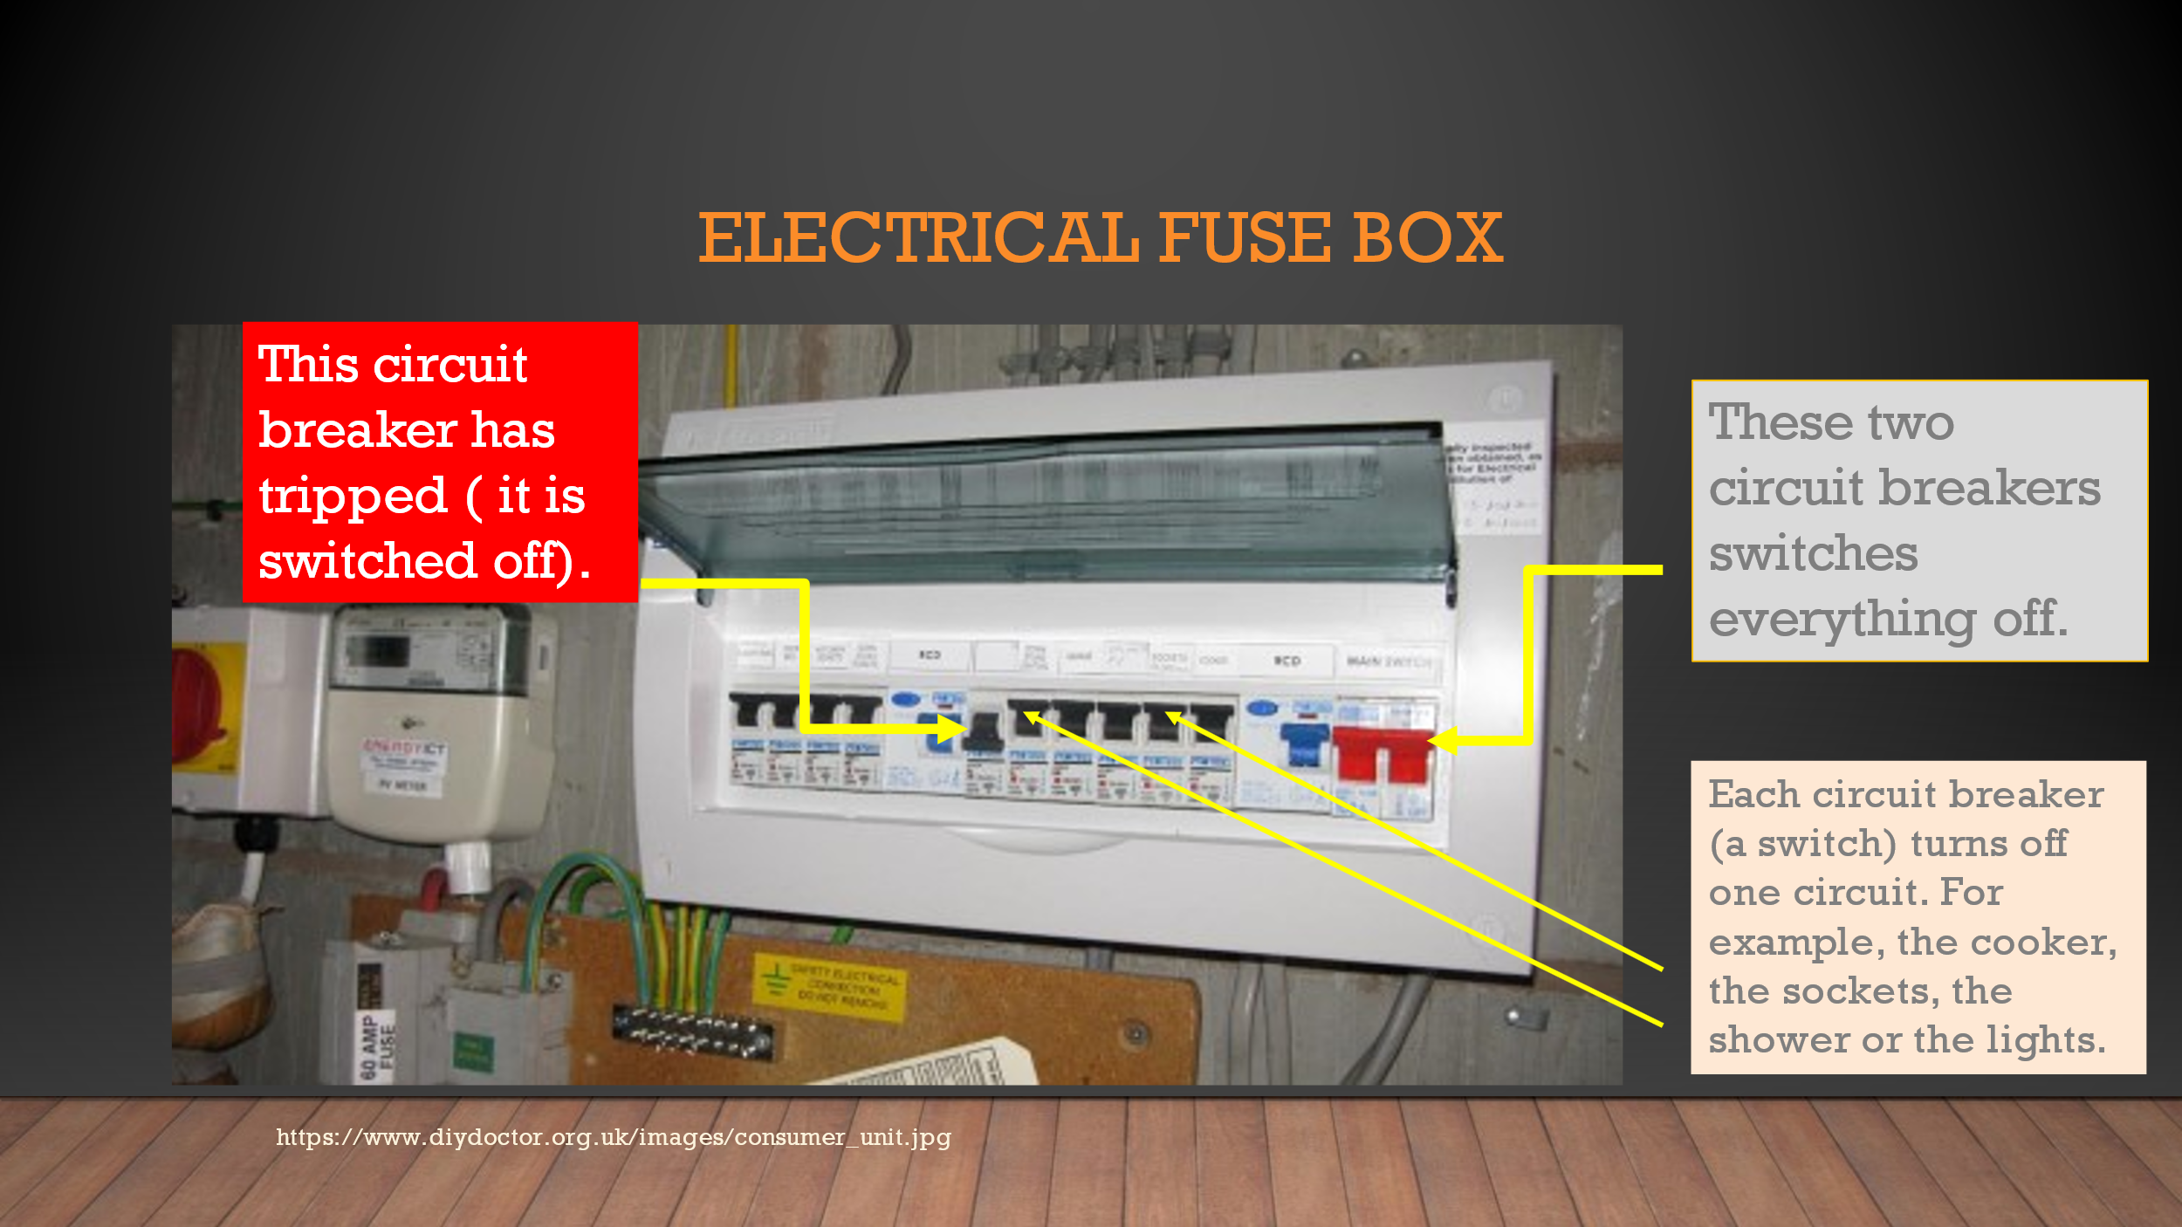

5.5.2: - Moving In checklist No. 2
The word for this checklist were provided by Miss. F. I put the titles together with my own drawings, with the idea of injecting some humour and emotion. This was the first draught list in this form. There are three parts, 1- before moving home; 2- The day of moving in; 3- After moving in.
Section 5.5.3 is the same list, but with clip art and photos mainly from the web replacing the drawings, as the second version to begin to professionalise the information sheet also the fonts were changed for easier reading. Please double click the embedded word doc. It could not be cut and pasted without losing the features. All clip art was properly referenced. The photo of the house is my own image.

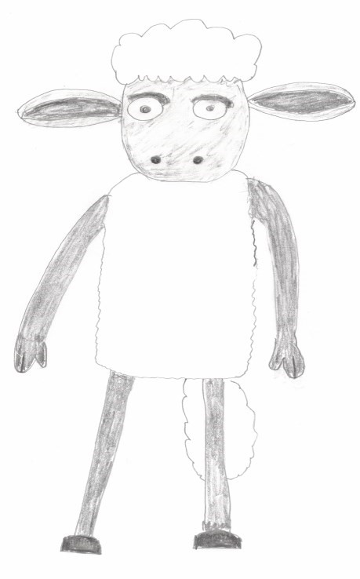
Step 1— Before moving in to do list
Here to help
…

How much dough?
Make sure you have budgeted and know how much you can afford to be spending on rent and bills for the property you have been offered or you are looking at.
Do I really want to live here?
When accepting a property, you need to be mindful of the location of the property and if it fits your needs, i.e. if it’s too far away from your work and you have little to no transport. or May have disabilities and need a washroom. Etc.
Is this place really good enough for me?
Check the property for any damages or problems that may need fixing before moving in, such as damp, all windows and door locks work, boiler, heating, and hot water all work correctly, make sure all plug sockets, light switches and light are all working correctly and are not damaged, check to make sure each radiator is working, the shower and all the fire alarms, also check the attic and all rooms/storage areas are empty.
What stuff do I need to live here?
Check the property for any essentials you may need to get for the property, such as cookers, flooring, washing machine, toilet seat and shower curtains etc.
It’s all about the money!
Start to save and get furniture/kitchen items you will need to move in with, such as bed, sofa, cooker, utensils, and a couple of pans, washing machine, storage units, etc. Do not forget bedding and a couple of bath/dish towels. Also, you may want to do a little shop beforehand with some bits like washing up liquid, toilet roll, tea and coffee, and some chocolate to treat yourself with at the end of the day.
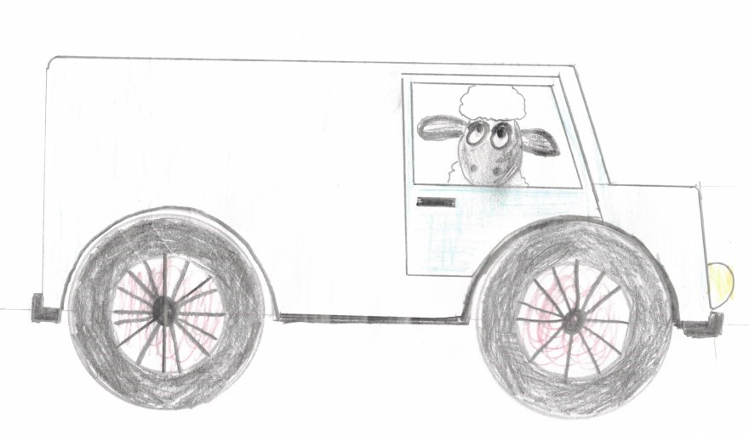
How’s it happening?
Get things in place for moving in, whether it be a van to help you move all your belongings or just having someone with you for support, plan as much as you can beforehand so that you can move as stress free as possible.

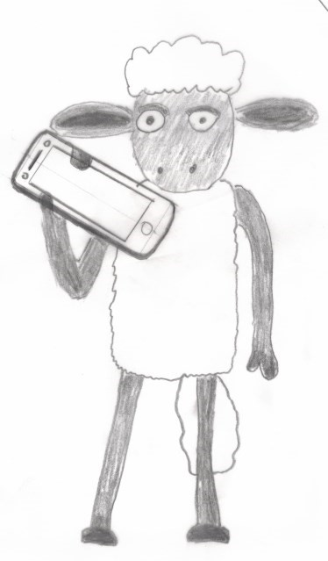
Step 2— Day of Moving in To Do List
Get talking– yes, it’s time to splash the cash.
Speak with your landlord and work out what day and how payment will be made, whether it’s direct debit or cash payment with receipt for proof of payment each time. The best day to set payment would be for the day you get paid if its monthly, or if weekly the day you think is best for you to have the money set aside every week for a certain day of the month.
Do you really want splinters in your feet?
If possible and its needed have flooring laid first day you get your key so that can be sorted straight away before you bring in furniture, if not whenever possible. Rugs are a good, homely compromise until you are in a situation to get flooring.
Something tedious— but please don’t miss this.
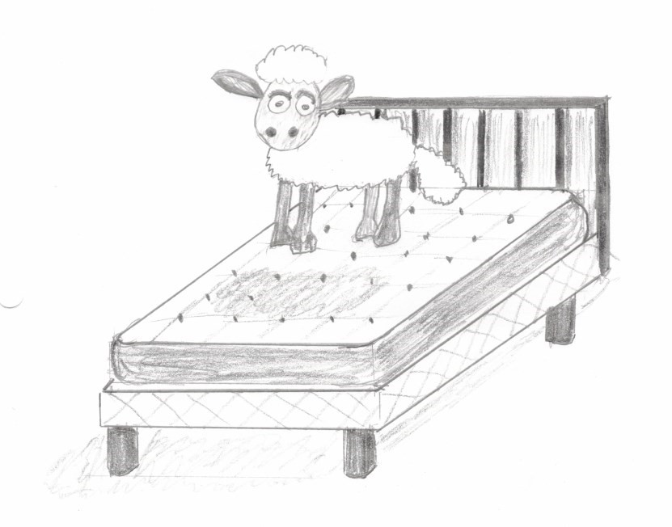
Write down your meter readings as soon as you move in, you do not want to be paying any more then what you are using. As long as you write you meter reading down and have no problems with gas or electric, you have a day or two before you need to phone your supplier to register your readings and set an account up with your details. We all know no one needs to be spending possibly hours on hold on the day you move when it can be done tomorrow.
Get down on it!
Put together and make your bed. The last thing you need to be doing after moving in all day and getting sorted is having to sort and make your bed. Having it there waiting for you when you have finished your day makes the thought of tomorrow a little easier.
How do you fancy the North Pole ?
Don’t forget to take 5 minutes for yourself, get yourself something to eat and ...chill.
Step 3— After Moving in To Do List


Ring
-
Ring….Ring
-
Ring...

Phone all necessary companies that you may need to register with for the property you have just moved into and new bins/recycling bags if these are missing. Ph0ne all the companies that you may need to change your address with.
.

Picture perfect.
Start to make you house feel like a home, put some pictures up, paint it colours you like, be proud of your house and what you are achieving.
Just suck it up.
Save to buy non-essential items you might not have been able to afford straightaway, like a toaster and kettle (or even a microwave), a vacuum (you can probably make do with a dustpan and brush at first).
Know your mates.

Be cautious when it comes to who you let in your house (not everyone is your friend). Remember that it is your house, who you have in there and when is in your control, and when it is in your control, and don’t let anyone run what you are building in life.

5.5.3: - Moving In checklist No. 3
Please double click the embedded word document to open the brochure.

5.6: Material provided by young people.
The following write-up was provided by a young person by Miss. F. which is referred to in section 5.1.4: Reflection No. 4. The Author and two other youth workers created their own lists, while a list was produced by Miss. F. This list was used as a basis for the lists produced in section 5.5.2.& 3.
Before Moving In To Do List
- Make sure you have budgeted and know how much you can afford to be spending on rent and bills for the property you have been offered or you are looking at.
- When accepting a property, you need to be mindful of the location of the property and if it fits your needs, ie if it’s too far away from your work and you have little to no transport. or May have disabilities and need a wash room. ect
- Check the property for any damages or problems that may need fixing before moving in, such as damp, all windows and door locks work, boiler, heating and hot water all work correctly, make sure all plug sockets, light switches and light are all working correctly and are not damaged, check to make sure each radiator is working, the shower and all the fire alarms, also check the attic and all rooms/storage areas are empty.
- Check the property for any essentials you may need to get for the property, such as cookers, flooring, washing machine, toilet seat and shower curtains ect.
- Start to save and get furniture/kitchen items you will need to move in with, such as bed, sofa, cooker, utensils and a couple of pans, washing machine, storage units, etc. Don’t forget bedding and a couple of bath/dish towels. Also if you can you may want to do a little shop beforehand with some bits like washing up liquid, toilet roll, tea and coffee, and some chocolate to treat yourself with at the end of the day.
- Get things in place for moving in, whether it be a van to help you move all your belongings or just having someone with you for support, plan as much as you can beforehand so that you can move as stress free as possible.
Day of Moving in To Do List
- Speak with your landlord and work out what day and how payment will be made, whether it’s direct debit or cash payment with receipt for proof of payment each time. The best day to set payment would be for the day you get paid if its monthly, or if weekly the day you think is best for you to have the money set aside every week for a certain day of the month.
- If possible and needed have flooring laid first day you get your key so that can be sorted straight away before you bring in furniture, if not whenever possible. Rugs are a good homely compromise until you are in a situation to get flooring.
- Write down your meter readings as soon as you move in, you don’t want to be paying any more then what you are using. As long as you write you meter reading down and have no problems with gas or electric, you have a day or two before you need to phone your supplier to register your readings and set an account up with your details. We all know no one needs to be spending possibly hours on hold on the day you move when it can be done tomorrow.
- Put together and make your bed. The last thing you need to be doing after moving in all day and getting sorted is having to sort and make your bed. Having it there waiting for you when you’ve finished your day makes the thought of tomorrow a little easier.
- Don’t forget to take 5 minutes for yourself, get yourself something to eat and chill.
- If you like, ask a friend or someone you trust to help you move or even just have a cup of coffee with you while you unpack so you’re not alone and you have emotional support if you need it during the day.

After Moving in To Do List

- Phone all necessary companies that you may need to register with for the property you have just moved into (gas, electric, water, bank, council for council tax and a new bins/recycling bags if these are missing), and all the companies that you may need to change your address with (ie DVLA if you have a driving licence).
- Start to make you house feel like a home, put some pictures up, paint it colours you like, be proud of your house and what you are achieving.
- Save to buy non-essential items you might not have been able to afford straightaway, like a toaster and kettle (or even a microwave), a vacuum (you can probably make do with a dustpan and brush at first).
- Be cautious when it comes to who you let in your house (not everyone is your friend).
- Remember that it is your house, who you have in there and when is in your control, and don’t let anyone ruin what you are building in life.

5.7 Supporting evidence/emails.
 | This is an email trail for the author finding his own placement from initial contact with Pembrokeshire County Council’s switchboard, to 3-way meeting. The email entry is given a unique number, which links into the copy of the actual emails in the embedded word document below.
Date of | Record of Emails leading to initial chat 02/10/20 with Nick Hudd and | Assigned
emails | David Walker regarding a placement on their youth homeless project | Number
22/09/2020 | From Pembrokeshire council confirming from my phone call/CC recruitment | 3.3/1
22/09/2020 | From Recruitment asking me to contact Steve.Davis@pembrokeshire.gov.uk | 3.3/2
22/09/2020 | Reply to recruitment giving a further brief of what I was loong for | 3.3/3
22/09/2020 | From recruitment - a query | 3.3/4
22/09/2020 | To Recruitment -Unsure of Steve Davies position in Pemb.Council | 3.3/5
23/09/2020 | From Recruitment advising Steve Davies was manager of Youth Service | 3.3/6
23/09/2020 | From Recruitment (Lynda) final acknowledgement | 3.3/7
22/09/2020 | To Steve Davies Pembrokeshire Council - introducing myself | 3.3/8
23/09/2020 | From Steve Davies stating forwarding my email to David Walker | 3.3/9
23/09/2020 | From David Walker asking me to contact Nick Hudd | 3.3/10
23/09/2020 | To David Walker, confirming I would contact Nick Hudd | 3.3/11
23/09/2020 | To Nick Hudd, Introducing myself. | 3.3/12
23/09/2020 | From Nick Hudd arranging 1st face -face chat on 2nd October | 3.3/13
23/09/2020 | To Nick Hudd confirming invitation with David Walker in attendance | 3.3/14
23/09/2020 | From Nick Hudd confirming time of meeting and Venue | 3.3/15
23/09/2020 | To Nick Hudd acknowledging time/location | 3.3/16
05/10/2020 | To Nick & David Walker thanking them for placement offer | 3.3/17
06/10/2020 | From David Walker, acknowledgement. | 3.3/18
06/10/2020 | From Nick Hudd, requesting I set up 3-way meeting | 3.3/19
07/10/2020 | To UWTSD Registry Admissions Concern R.E. DBS cert -No Adults Barred | 3.3/20
09/10/2020 | To Nick Hudd advising possible problem with my DBS. | 3.3/21
12/10/2020 | From Registry Admissions, (Carol Davies) Confirming I have correct DBS cert | 3.3/22
13/10/2020 | To Carol Davies, Thanking her | 3.3/23
13/10/2020 | To Nick Hudd, requesting setting up 3-way meeting | 3.3/24
13/10/2020 | From Nick Hudd, giving alternative dates for 3-way meeting | 3.3/25
13/10/2020 | To Nick Hudd, informing I would contact Huw Williams | 3.3/26
13/10/2020 | To Huw Williams. Introducing myself, and setting up 3-way meeting | 3.3/27
14/10/2020 | From Huw Williams CC Alana Enoch. Confirming which dates are suitable. | 3.3/28
14/10/2020 | To Huw Williams. Advising best date | 3.3/29
14/10/2020 | To Nick Hudd suggesting meeting date. | 3.3/30
14/10/2020 | From Nick Hudd, CC David Walker. Confirmation | 3.3/31
14/10/2020 | To Nick Hudd. Confirm Time and Venue | 3.3/32
14/10/2020 | To Huw Williams. Confirm Time and Venue. | 3.3/33
15/10/2020 | From Huw Williams. Can confirm date, but meeting to be on Zoom/ Teams | 3.3/34
15/10/2020 | To Nick Hudd. Request meeting be on Teams | 3.3/35
15/10/2020 | To Huw Williams. Apologised for misunderstanding of venue. | 3.3/36
15/10/2020 | From Huw Williams, acknowledgement. | 3.3/37
15/10/2020 | To Huw Williams. Confirming TEAMS meeting had been set up. | 3.3/38
15/10/2020 | To Huw Williams. Sent Copy of Draft: - agenda, placement contract & PDP. | 3.3/39
18/10/2020 | From Huw Williams. Acknowledgement | 3.3/40
19/10/2020 | Screenshot of TEAMS calendar r.e.3-way meeting | 3.3/41
20/10/2020 | To Nick Hudd. Thanking for meeting and requesting various policies | 3.3/42
19/10/2020 | From Nick Hudd. Sending various docs + procedures | 3.3/43
28/10/2020 | To Huw Williams. Belated thank-you for hosting 3-way meeting. | 3.3/44

This embedded word documents contains a copy of all emails pertaining to the above list.

5.8: Safeguarding Certificate.
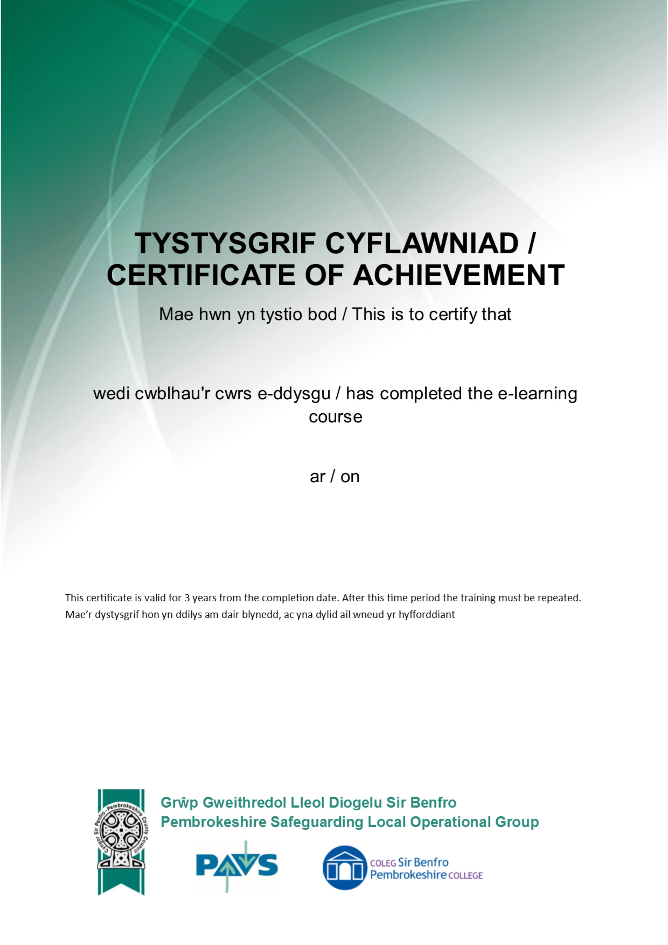
Nicholas Sutton
Safeguarding Children, Young People & Adults
8
th October
2020
9
NVJ5 - GQK9F - 816H8 - DC1F
9

5.9: Directed task.
Nick Hudd (the placement supervisor) requested the author to comment on an article he had written called ‘Blended Learning’ not ‘Blended Teaching’ (Hudd, 2020).
To Nick,
I read with interest your article ‘Blended Learning’ not ‘Blended Teaching’.
After learning some new words namely: - antecedent, vicariously, and pedagogical, I settled into the twists and turns of your piece.
I totally agree with your thoughts from the second half of the second paragraph, quote
This is a major shift in an educational paradigm, which the use of such simplistic terminology fails to convey; the lack of physical resources and social interaction opportunities, the ability for the educator to engage learners in conversation, debate, responding spontaneously to questions, are all diminished.” And continues “Whilst not entirely absent from a digital offer, the lack of these elements undoubtedly impedes learning.
(Hudd, 2020)
The part that made me stop to think was your last sentence in paragraph Three. To quote “Arguably the bastions I referred to early have become gate keepers of, rather than gateways to learning” (Hudd, 2020)
The inference that I take from the idea of ‘gatekeepers’; as compared to ‘gateways’; is one of learning being ‘metered out’ compared to ‘free guided access.’
If this reflects your thinking, then this idea possesses some tensions. The bastions; schools, colleges and universities; as you describe in paragraph one, must by their very nature exist to act as an ongoing storehouse of knowledge which society relies on. This storehouse is constantly being sieved and upgraded as new science, technology and thought are found to be pertinent.
The tension I find in your statement is this; -what viable alternative models are there of learning this knowledge, housed by the afore mentioned bastions of knowledge and learning?
Arguably there is free guided learning found online, through platforms like YouTube and many other open sites. But what other models could these institutions adopt to meter out knowledge? If in ‘gateways’ of free guided learning meant that everyone could learn what they wanted when they wanted, then surely the very foundations of those same bastions may be eroded?
The bastions need to be maintained through financial upkeep. Maybe one aspect of opening the gates could be by removing the barrier of university tuition fees? This then becomes primarily a political issue and not an educators’ or social problem. Mainstream schools and colleges generally have free learning access, thus potentially fall into your category of ‘gateways,’ even though I appreciate it is still a curriculum delivery?
The twists and turns I referred to in my opening paragraph are revealed in paragraph 4, where you say: “For those who are experiencing trepidation now, expecting to read an argument relating to the merits of these approaches outweighing those of a formal education system; sorry to disappoint” (Hudd, 2020).
You start with the start with the target audience’s understanding of who are educators, and then include the validity of the Youth Worker’s informal learning approach as one of inclusivity with other models, not one of exception. Starting with where people are at is a fundamental aspect of youth Work.
Your message and conclusion in these unprecedented times is a challenge for the hierarchy in delivery systems of knowledge to review and broaden their interpretation of blended learning (Hudd, 2020).
References
Hudd, N. (2020) 'Blended learning', not 'blended teaching' Education Workforce Council. Available at: https://www.ewc.wales/site/index.php/en/about/blog-archive/1624-nick-hudd-blended-learning-not-blended-teaching.html?highlight=WyJuaWNrIiwiaHVkZCIsIm5pY2sgaHVkZCJd (Accessed in October 2020).

5.10: NOS evidence matrix.



Youth and Community Work Programme
National Occupational Standards for Youth Work (LSIS, 2012) Checklist
Name: Nicholas Sutton
Date: 15th March 2021Placement: Moving Forward Project.
Description of the group: A homeless young person project
Line manager: Nick Hudd
Supervisor: Tim Ramsey
Visiting tutor: Huw Williams
This document is a checklist to be used by students when compiling evidence for assessment. The line manager is required to sign the final page to confirm that each standard has been met. It is the responsibility of the student to ensure that each standard has been met and that the evidence for that is included within the portfolio. This evidence will be checked during observations and at the final assessment.
This checklist must be printed out, completed and included at the front of the portfolio of evidence.

Key Area A: Work with young people and others |  | Tick, if the evidence is available, whether the standard was achieved | Page No. or location in portfolio
YW01 | Initiate, build and maintain purposeful relationships with young people | Yes | 5.1.2
YW02 | Assist young people to express and to realise their goals | Yes | 5.1.3
YW03 | Engage with communities to promote the interests and contributions of young people | Yes | 5.1.2
YW04 | Develop productive working relationships with colleagues and stakeholders to support youth work | Yes | 5.1.5
No. 32 | Lead and motivate volunteers (SFT MV D2) | No

Key Area B: Facilitate the personal, social and educational development of young people |  | Tick, if the evidence is available, whether the standard was achieved | Page No. or location in portfolio
YW05 | Enable young people to use their learning to enhance their future development | Yes | 5.1.4
YW06 | Enable young people to work in groups | Yes | 5.4.1  (17/11/20)
YW07 | Encourage young people to broaden their horizons to be effective citizens | Yes | 5.1.4
YW08 | Support young people to identify and achieve aims | Yes | 5.4.1  (15/01/21)
YW09 | Support young people in their understanding of risk and challenge | Yes | 5.1.3
YW10 | Facilitate young people’s empowerment through their active involvement in youth work | Yes | 5.1.4
YW11 | Plan, prepare and facilitate activities with young people | Yes | 5.5
YW12 | Work with young people to manage resources for youth work activities | Yes | 5.4.1  (10/11/20)
YW13 | Support young people in evaluating the impact of youth work activities | Yes | 5.1.3
YW14 | Facilitate young people’s exploration of their values and beliefs | Yes | 5.1.3
YW15 | Advocate on behalf of young people and enable them to represent themselves to others | Yes | 5.16
YW16 | Enable young people to access information to make decisions | Yes | 5.4.1  (24/11/20)

Key Area C: Promote inclusion, equity and young people’s interests and wellbeing |  |  | Tick, if the evidence is available, whether the standard was achieved |  | Page No. or location in portfolio
YW17 |  | Work with young people in promoting their rights | Yes |  | 5.4.1  (18/02/21)
YW18 |  | Explore with young people their wellbeing | Yes |  | 5.4.1  (21/02/21)
YW19 |  | Work with young people to safeguard their own welfare | Yes |  | 5.4.1  (08/01/21)
YW20 |  | Embed organisational policy for the protection and safeguarding of young people | Yes |  | 5.4.2  (05/02/21)
No. 33 |  | Promote equality of opportunity and diversity and inclusion in your area of  responsibility (Management and leadership NOS B11)
YW21 |  | Develop a culture and systems that promote inclusion and value diversity | Yes |  | 5.1.1
YW22 |  | Ensure that youth work activities comply with legal, regulatory and ethical requirements | Yes |  | 5.3.2
FUNCTIONAL AREA D: Develop Youth Work Strategy and Practice |  |  | Tick, if the evidence is available, whether the standard was achieved | Page No. or location in portfolio
YW23 | Investigate the needs of young people and the community in relation to youth work |  | Yes | 4.2
YW24 | Evaluate and prioritise organisational requirements for youth work activities |  | Yes | 5.8
YW25 | Influence and develop youth work strategies |  | Yes | 5.2.5
YW26 | Identify and secure funding and resources for youth work |  | Yes | 5.3.2
YW27 | Facilitate and engage young people in the strategic development and delivery of youth work |  | Yes | 5.4.1  (29/01/21)
YW28 | Work in partnership with agencies to improve opportunities for young people |  | Yes | 5.4.1  (16/02/21)
No. 34 | Develop structures, systems and procedures to support volunteering  (Managing Volunteers NOS A3) |  | No
YW29 | Monitor and evaluate the quality of youth work activities |  | Yes | 3.1

FUNCTIONAL AREA E: Develop, lead and manage self and others |  | Tick, if the evidence is available, whether the standard was achieved | Page No. or location in portfolio
YW30 | Work as an effective and reflective youth work practitioner | Yes | 5.1.5
YW31 | Provide youth work support to other workers | Yes | 5.4.1  (1502/21)
No. 32 | Involve, motivate and support volunteers (Managing Volunteers UKWH B2) | No
No. 33 | Promote equality of opportunity and diversity in your area of responsibility (Management and leadership NOS B11) | Yes | 5.1.6
No. 34 | Develop structures, systems and procedures to support volunteering (Managing Volunteers A3) | Yes | 5.3.3
No. 35 | Manage your own resources and professional development (Management and leadership A2) | Yes | 5.4.2  (22-23/09/20)
No. 36 | Provide leadership for your team (Management and leadership B5) | Yes | 5.1.6
No. 37 | Allocate and check work in your team (Management and leadership D5) | Yes | 5.4.2  (22-23/09/20)
No. 38 | Recruit, select and keep colleagues (Management and leadership D3) | No
No. 39 | Provide learning opportunities for colleagues (Management and leadership D7) | Yes | 5.3.3
No. 40 | Make sure your own actions reduce risks to health and safety (Health and Safety HSS1) | Yes | 5.3.1
No. 41 | Ensure health and safety requirements are met in your area of responsibility (Management and  leadership E6) | Yes | 4.5

SIGNED STUDENT 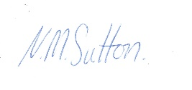 DATE- 19/03/21

