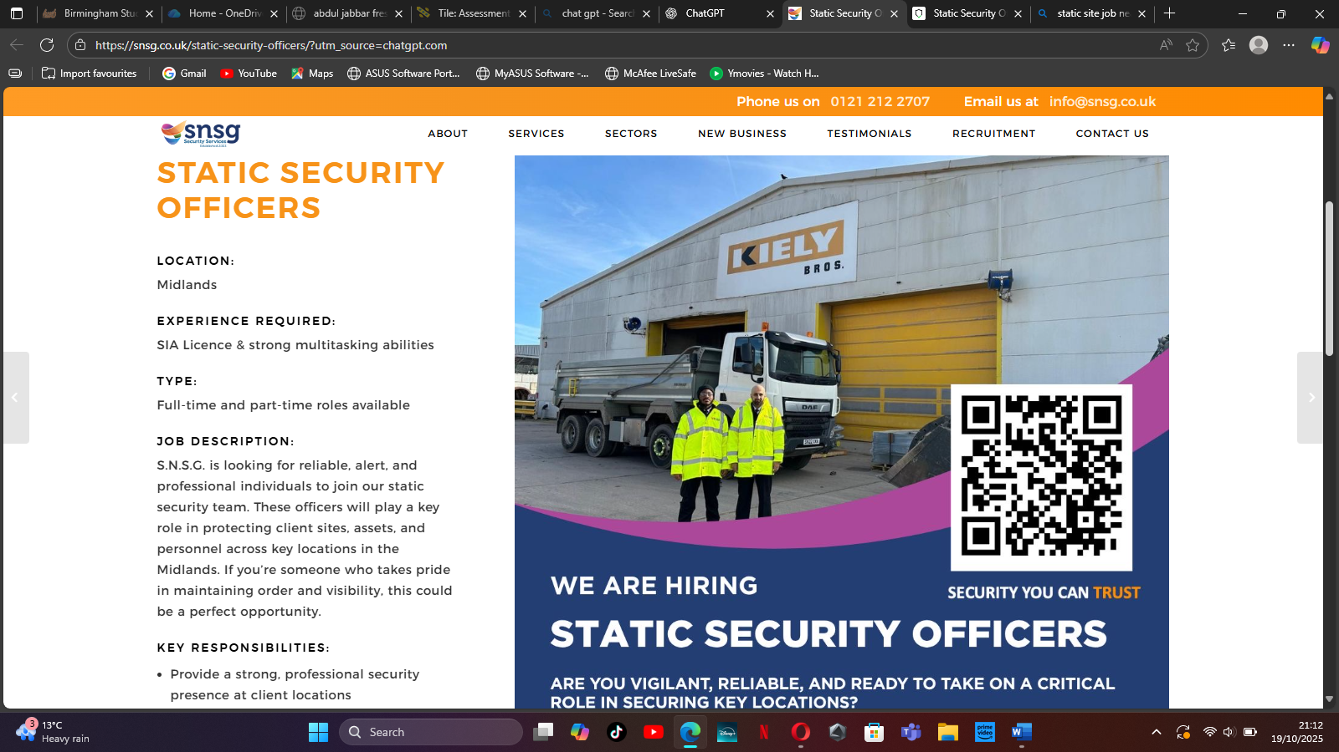
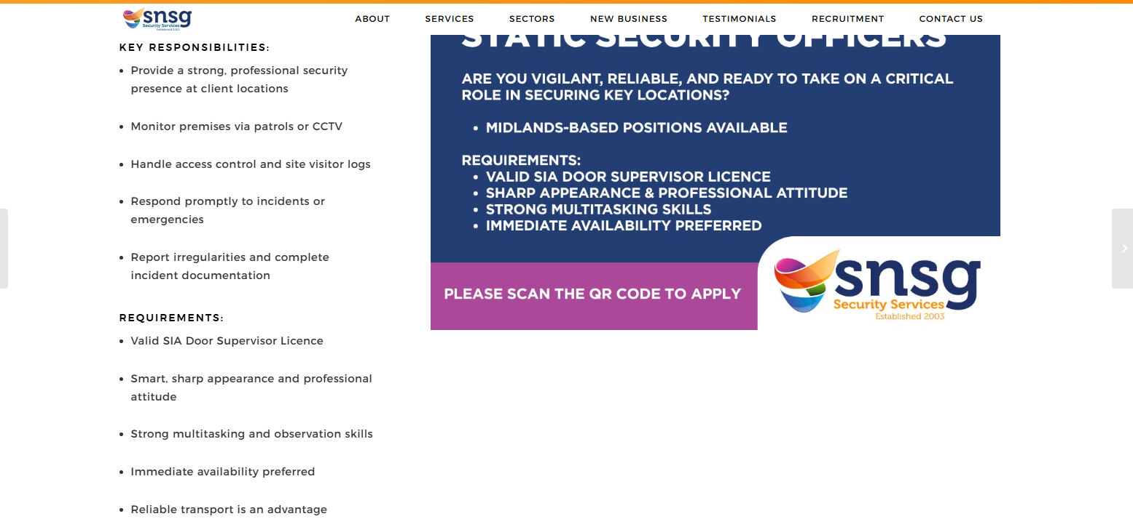

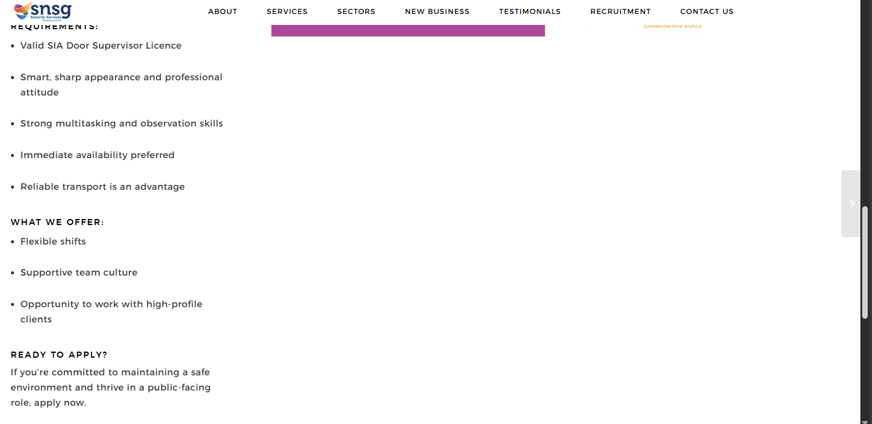
Abdul Jabbar
25/02/2000
448 Rednal Road
Birmingham
West midlands
B38 8HX
Mobile: 07510 953 846. Email: yojabbar123@gmail.com

Personal Profile:
I am a very ambitious person who has developed a mature and responsible approach to any task that I undertake, or situations that I am presented with. I have good interpersonal skills professionally. I have a very mature outlook, excellent communication skills and enjoy working with public. I always like to get the task I have been given done in a professional and efficient manner.
Key skills:
- Professional and polite telephone manner.
- Good communication skills.
- Good time keeping.
- Ability to multi task.
- Willing to learn and take on new skills.
- Reliable and professional.
- Great face to face skills.
- Quick at learning new skills.
- Capable of working independently or as a member of a group.
- Familiar with programs such as Microsoft Office, PowerPoint, Outlook and Internet.
__________________________________________________________________________________________________________
Employment History:
Work Experience
Security Officer
Kingdom Security-Redditch, Worcestershire
September 2022 to Present
• External patrol around site
• Walk around building checking if everything is good
• Opening and closing barriers
• Always being alerted
• Using radios to communicate
• Filling in book daily hour
• Clocking in and clocking out work
_______________________________________________________________________________________
Security Guard
Cava Security Services Ltd-Redditch, Worcestershire
December 2021 to Present
• Providing visual deterrent and securing all aspects
• Restrict access to only those that have been confirmed
• Keeping an eye on the front gate
• Check calls every hour
• Clock in and clock out
• Doing patrols every hour
• Opening and closing gate
• Filling up the generator with fuel
• Signing in manually on the job sheet
_______________________________________________________________________________________________________
Amazon delivery driver
Skywalker-Birmingham, West Midlands
October 2021 to Present
• Driving a ford transit
• Delivering over 250 parcels
• Loading and unloading parcels
• Matching bag numbers for which bag is first
• Having over 10 bags of delivery’s
• Dropping parcels of to customers
• Multi drops
• Sorting out the parcel smallest to biggest
_____________________________________________________________________________________________________
Security Officer
GMS Security-Redditch, Worcestershire
July 2021 to Present
1. Watching cctv cameras
2. Opening and closing barriers
3. Walking around premises
4. Closing windows if shut
5. Check points
6. Letting deliveries into the site
7. Booking in every hour
___________________________________________________________________________________________________
Ocado
Ocado warehouse-Tamworth
December 2019 to February 2020
1. Opening boxes
2. Scanning item
3. Putting items into bags
4. Checking quality on screen
5. Working in different areas meaning cold and warm place
________________________________________________________________________________________________
Amazon flex
Amazon Flex-Birmingham, West Midlands
March 2019 to January 2020
1. Delivering parcel
2. Scanning parcel
3. Sorting them in order
4. Delivering them to customers
Warehouse Operative
XPO Logistics-Tamworth, Staffordshire
October 2018 to December 2018
• Using ppt to collect items
• Scanning items barcode using a watch scanner
• Putting item on pallet
• Moving ppt all around the warehouse
_______________________________________________________________________________
Amazon Warehouse Operative
Amazon Fulfillment Associates-Coventry, West Midlands
June 2018 to September 2018
• Placing items onto a line
• Scanning the item
• Counting the item and checking the right quality
• Sending item to outbound
• Sorting the item into the correct totes
______________________________________________________________________________________________
Restaurant Waiter
Nando's-Birmingham, West Midlands
August 2015 to September 2015
• You Good face to face skills.
• Ability to multi task.
• Skilled communicator.
• High levels of organisation skills.
• Effective team leader and key team player
______________________________________________________________________________________________
Retail Shop Assistant
Store Twenty One-Birmingham, West Midlands
February 2014 to February 2014
• Customer service.
• Product display and keeping the shop tidy.
• Responding promptly and effectively to telephone enquiries.
• Updating supplier and product records

Education
University of Wales trinity saint David- certifcate of higher education business skills for the workplace
January 2025 to January 2026

Rockwood Academy 2011/2016
GCSEs:
English Business

Mathematics R.E
Science ICT

Certification/license

- Sia Door supervisor license (exp: December 2023)
- Emergency First Aid level 3 at work
- Full UK driving license

​​Abdul Jabbar
448 Rednal Road
Birmingham
B38 8HX
07510953846
activejabbar@gmail.com

Ref:
Dear sir/madam,
I am writing to apply for the above vacancy which is advertised on your website. I am enclosing my resume for your review. I have experience in this area and feel that I would make an ideal candidate. I am privileged to have skills and experience which include:
- Professional and polite telephone manner.
- Good communication skills.
- Good time keeping.
- Ability to multitask.
- Reliable and professional.
- Great face to face skills.
- Quick at learning new skills.
- Excellent customer Service skills.
I would be more than happy to schedule an interview to discuss the contributions that I can make to your team and can be contacted on the above details.
Thank you for your consideration.
Yours Sincerely,
Abdul Jabbar

