‘Ritual anthropophagy; contextualising and evaluating archaeological evidence, with the study of materiality and assemblages at Goyet’s Cavern and Gough’s Cave’
Ritual anthropophagy or anthropogenic cannibalism, (Cole, 2016, pp. 2) has been regarded with a variety of understandings and interpretations in the archaeological record, often fluctuating depending on the who, where, and when it was (re)-discovered. This leads to a plethora of contexts created to try explaining the historical purpose and application for ritual cannibalism in pre-history making it a ‘contentious issue’ (Cole, 2016, pp. 4). These contexts will be supplemented and critiqued with additional research into the materiality and analysis of taphonomy in ssemblages found in both; Goyet Cavern (Mozet, Belgium) and Gough’s Cave (Somerset, UK). Furthermore, this essay aims to provide an alternative interpretation, in which ritual cannibalism provided not just nutritional benefits but also social and cultural, and even a ‘religious agency’ (Norgon, 2013, pp. 4) and communal consolidation. The modification of bone assemblages at both sites, in addition to others could be indicative of a ‘bodily resocialization’ (Traphagan, 2008, pp.1), in which the body of kin is consumed and altered to then be reintroduced to the living community. Mortuary evidence is particularly valuable as Goring notes it represents the ‘direct and purposeful culmination of conscious behaviour rather than its incidental residue’ (Goring, 1989, pp. 95).
Goyet Cavern (Rougier et al, 2017) and Gough’s Cave (Bello et al, 2014) display a rich material culture of processed assemblages. Gough’s Cave specifically displays a unique use of ‘products carved out of the contextually situated materials and resources’ (Patnaik, 1995, pp. 59). The evidence and manufacturer of this materiality (bone) can be applied in part to suggest the social morphology (Agarwal, 2016, pp. 131) these communities may have lived in. In Gough’s cave, we see a recurring motif of LUP (Late Upper Palaeolithic) Magdalenian human bone fragmentation mixed with occupational detritus. The bone assemblages of Gough’s cave; have been subject to taphonomy speculation in which cranial and post cranial remains display anthropogenic modification (Lucas, 2018 pp. 5534); ranging from: disarticulation, de-fleshing, tooth indentations, percussion blows, cutting, and longitudinal splitting to extract marrow (Bello et al. 2015, pp. 171).
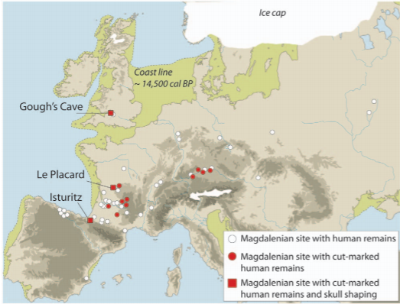
Fig. 1 (Above) – (Bello et al, 2011, pp. 2) Depicting the locale of Gough’s Cave in addition to the variability in Magdalenian sites in the processing of human remains and cannibalism. Suggesting a cultural and perhaps shared interpretation of cannibalism as way of ritual, supplemented nutrition, and cultural (re)-incorporation of the deceased.
The processing of bone marrow extraction displays the utilization of bodily resources and which parts were being consumed, which independently may have suggested endo-cannibalism; internal to the kin group (Harvey, 2002, pp. 255) for survival. However, the discovery of ‘Skull-cups’ which share similarities to additional Magdalenian sites in central and western Europe’ (Bello et al, 2015, pp. 170), suggesting a customary cannibalism, in which the human body, and its bone assemblages could have been involved in a ritual mortuary practice in unison with rigorous processing and consumption of bodies, allowing bodily re-socializing individuals after death, back into the kin group.
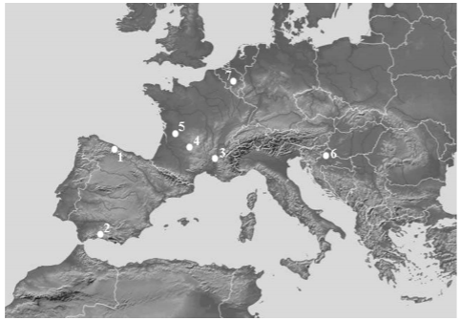
Fig. 2 (Above) – (Yustos & Yravedra, 2015, pp. 35) Displaying Goyet Cave location (7), in addition to other Neanderthal sites with evidence of cannibalism: (1) El Sidron; (2) Boquete de Zaffaraya; (3) Mouala-Guerey; (4) Combe-Grenal; (5) Les Pradelles; (6) Krapina;
Goyet’s Cavern archaeological narrative differs to that of Gough’s cave, notably so for its variation in archaeological assemblages through sedimentary levels displaying Middle Palaeolithic, Aurignacian, Gravettian, and Magdalenian (Toussiant, 2004, pp. 133). Additionally, the elusive contexts of Neandertal funerary practices, in situ endo-cannibalism was practiced (Rougier et al, 2016, pp.6) with signs of butchery, cut marks, teeth indentations and extracted marrow (Rougier et al, 2016, pp.1). Goyet Cavern yields evidence displaying unambiguously; Neanderthal cannibalism in Northern-Europe. Discovered in the cavern was the use of four bone assemblages to modify and retouch stone tools, perhaps suggesting a requirement and utility to their cannibalism, with ritual being harder to identify due to substantial diversity in ‘mortuary behaviour among the regions late Neanderthal population’ (Rougier et al, 2016, pp. 2). Furthermore, while H. neanderthalensis are of the same genus as H. sapiens (Genus; Homo), their behaviour cannot always be compared, due to lack of context on how neanderthal society and culture functioned (Stinger, 2014).
Despite this apparent incomparability, Pettitt’s (2000) archaeological analysis of Neanderthal remains emphasises ‘considerable and habitual stresses placed upon extremely muscular (Neanderthal) bodies from a young age, which extent towards the physical use of the body as a power tool’ (Pettitt, 2000, pp. 352). Cannibalism from this perspective may have constituted as a valuable (or desperate) resource and function to the relatively short, violent, and energy expensive lives of Neanderthal (Pettitt, 2000, pp. 359) at Goyet Cavern. Perhaps the Neanderthal of Goyet cave viewed the physicality and materiality of the body as more of a tool to be processed and used. Comparatively differing to the ritualistic anthropogenic processing of cranial bones (Rapport & Overing, 2000 pp. 14) and ritual carvings (Bello et al, 2015, pp. 174) at Gough’s Cave and other Magdalenian sites. However, due to the circumstantial presence and context of assemblages this does not mean ritual did not take place at Goyet cave.
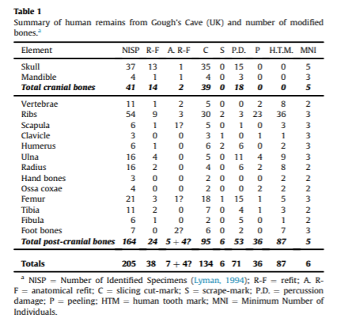
Fig. 3 (above) - (Bello et al, 2015, pp. 172) Displays the variety and patterns found amongst human bones at Gough’s Cave. Notably the heavy anthropogenic modification, especially to cranial bones, bearing 39 cut marks on 41 identified specimens, with the skull bearing abnormal amount of percussion blows. These cutmarks had formally been interpretated in earlier excavations (Cook, 1986 pp. 183) as natural environmental damage, produced by trampling. This however is a limited interpretation which as Andrews & Fernadez-Javlo (2003) developed that cut-marks are significant in evidencing cannibalism, but still fail to expand on recognising ritual cannibalism as taking place and suggest it was motivated by nutritional cannibalism, due to the similarity of ‘butchery techniques on human and non-human bones’ (Andrews & Fernadez-Jalvo, 2003, pp.81). The bones do show signs of nutritional cannibalism evidenced through processing and teeth indentations upon every post-cranial bone identified. However, the modifications to the cranial bones are suggestive of ritual, due to the inherent lower calorific value of the brain possessing (in combination with spinal cord and nerve trunks) ‘2706.00’ (Cole, 2016, pp. 3) nutritional calories, which when compared to other parts of the body we see a huge calorific variety with the thighs possessing ‘13354.88’ (Cole, 2016, pp.3) calories. The low nutritional nature of the brain and cranial bones in addition to deliberate cutting, suggests skulls were processed to produce ritual skull cups.
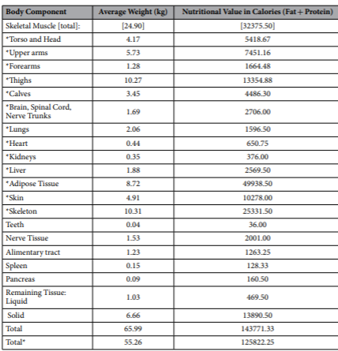
Fig 4. (Above) – (Cole, 2016, pp. 4), Displaying nutritional information on the human body, including the calorific intake of different parts of the body. Despite the heavily processed skulls, the brain does not possess a large calorific content unlike thighs, upper arms or even calves. It should be noted that while this applies to Homo sapiens nutritional content, neanderthal due to their more robust (Galway-Witham, 2019) frames may have had greater calorific quantities of fat and protein and thus different nutritional requirements.
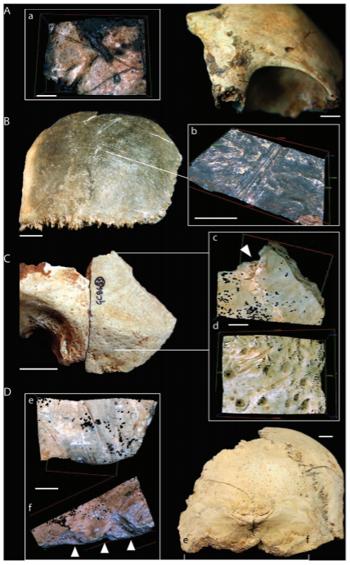
Fig. 5 (Above) – (Bello et al, 2011, pp. 4), (A) Displays the cut-marked frontal bone; (B) Cut marks upon the parietal; (C) Cut-marked and percussion impact on temporal bone; (D) Demonstrating additional cut marks and percussion impact on the occipital bone.

Gough’s Cave demonstrates anatomically skilled and purposeful post-mortem modification of human remains. The frequent distribution of cut-marks and percussion impacts suggest the cranial bones and skull were methodically cleaned of soft tissues perimortem, altered to remove the facial region, possibly to create more uniform shape to the edges of the cranial bones in producing skull-cups (Bello et al, 2011, pp. 2). These skull-cup’s using Ullrich model of manipulation in Palaeolithic bodies (Ullrich, 2005, pp. 3); could represent a part of a multi-stage burial (Bello et al, 2017) ritual which initiated with ritual de-fleshing of the body noted by high frequency of cut marks, to extract flesh and making the body easier to dismember for disarticulation, followed by percussion impacts to extract marrow. The processing and cleaning of bone can then begin which would identify specific pieces for scraping. In the case of Gough’s Cave skull cups, we see ritualistic cleaning of the cranial remains possessing 15 and 3 scrape-marks on the skull and mandible, respectively. Which displays processing beyond just nutritional consumption. The processing of the cranial bones and brain could be suggestive of a transitional mortuary process for the dead and living, and the reintroduction of the dead through skull cups into the world of the living (Hillard, 1990, pp. 1086). Perhaps it could be suggested that a form of ancestor worship took place, in which ritual would ‘emphasize the idea of continuity’ (Whitley, 2001, pp. 122), reinforcing cultural and social ties internal to the collective group. Furthermore, the inclusion of both men, women and children in skull-cups could support an embodied ritual (Stutz 2003) that focused on the ‘handling, modelling and care of skulls’ (Bonogofsky, 2004, pp. 119).
Contextually it is hard to draw any definite assumptions on the exact use of Skull cups, however; Brück notes the fragmentation and in this case disarticulation of the body ‘at the end of their lifecycles was a way of drawing attention to the social impact of death’ (Brück, 2006, pp. 297). Supporting the notion that ritual-processing was part of a social, (spiritual), and cultural event. Deliberate breakage was not just symbolic but acted to facilitate transformation of one state to another, or from the individual to the collective. Assuming these skull-cups saw practical or even ceremonial use, could infer a ‘reflection of social values’ (Steel, 2016, pp.81), in which Magdalenian’s at Gough’s cave viewed the human body as a resource (reflecting the notion of the body as a ‘power tool’ at Goyet Cavern), but also to be venerated and remembered through communal ritual, aforementioned by consistent modification and intentional scraping and softening of the cranial region.
Gough’s cave has a profusion of assemblages, ranging from cut marked ribs, percussion marked femur, and focally; an engraved human radius, displaying hallmark signs of cannibalism (cut, percussion, tooth; marks) while also displaying an unusual zig-zagging incision on the lateral part of the diaphysis where there is a lack of both meat and muscular material (Bello et al, 2017). Bello et al affirms these anthropogenic modifications are the result of deliberate engraving, fitting within the Magdalenian manufacturing patterns. Contrary to what Andrews and Fernadez-Javlo (2003) suggested was filleting marks creating during butchery. This essay will further explore Bello et al’s interpretation following micro/macro-morphometric analysis which can be likened to the materiality and physicality of additional Magdalenian assemblages.
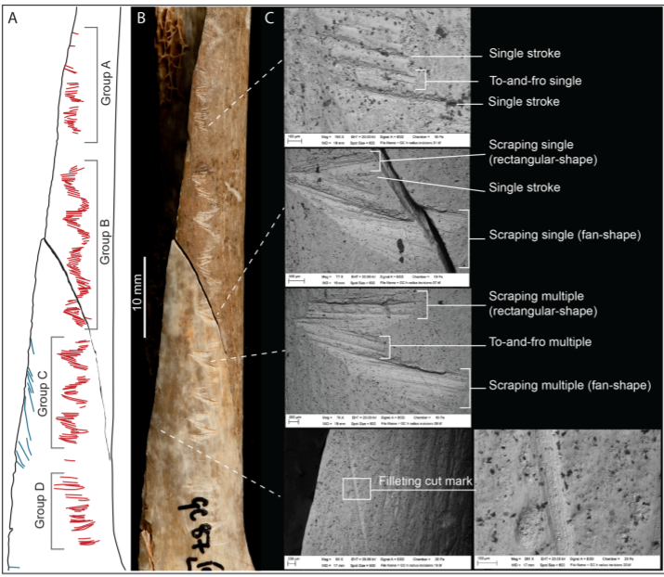
Fig. 6 (Above) – (Bello et al, 2017, pp. 6) Detailing the alterations of the engraved human radius M54074. It bears fractures and partial longitudinal break, with evidence of scraping suggesting the removing of flesh in preparation for the carving to be done. The entire engraving is composed of 87 incisions of which: 33 single-stroke, 32 ‘to-and-fro’ sawing, 13 large singular incisions, 19 multiple internal sub-incisions, and 22 scrape mark incisions (Bello et al, 2017, pp. 7). The unusual ‘zig-zag’ while not unique for this period, could be suggestive of cultural or ritual involving geometrical forms, representing rare evidence of socio-cultural and ritual expression in the upper palaeolithic (Bello et al, 2020, pp. 1).
The chronology of manipulations as Bello et al, also suggests were part of a ‘multi-stage cannibalistic ritual’. The marks and carvings must have held symbolic meaning, perhaps as a way of remembering events, reconciling the loss of the dead, or perhaps as written memory, that interacted and possessed greater meaning to complex social groups, allowing them to dispose and utilize the resources of the body. In addition, to further consolidate bonds by imbibing then processing the flesh and bones perhaps acting as a ‘symbolic glue’ for kin (Bello et al, 2017, pp. 13). McCrea counters this interpretation; suggesting, it is more than just an inter-social ritual between humans. Instead, the inhabitants of Gough’s cave saw their personhood (Fowler, 2004, pp. 5) as part of the natural world and by extension a strong relationship between hunters and prey (McCrea 2018). Furthermore, engraved bones may represent more than just anthropophagy, but suggest ‘Palaeolithic humanity’s awareness of the non-human society they inhabited’ (McCrea, 2018) and the ability to display cognizance through ritual art. Additionally, the presence of many engraved animal bones (see fig. 6) and the singular human radius may imply a context in which the animal world was transforming slowly towards a human-centric world. Moreover, Hill identifies that a more inclusive interpretation of pre-historic human-animal relations ‘recognizes the contingent nature of our engagement with animals’ and would allow for greater interpretive ability of human and animal personhood (Hill, 2013, pp, 127). Proposing the possibility these cannibalistic rituals may have taken place, in replication of animal butchery, to honour the dead (Conklin, 1995, pp. 75) and (re) join them to more than just the group collective but as a collective of the natural world.

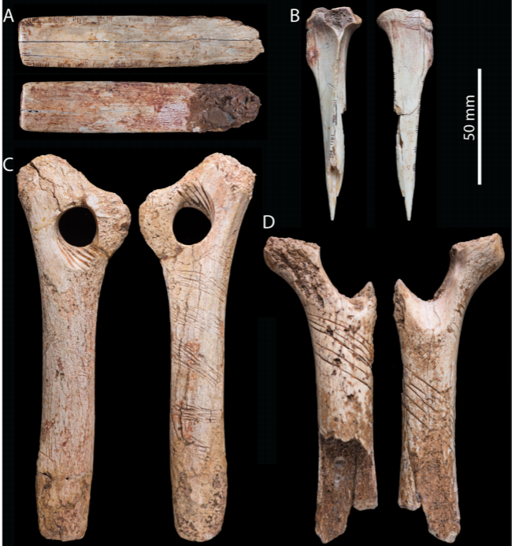

Fig. 7 (Above) – (Bello et al, 2017, pp. 5) Representing animal assemblages found alongside human remains bearing anthropogenic modification and display macro resemblance to the engravings on the human radius. (A) Displaying: engraved equine rib. (B) engraved Lepus timidus (Hare) tibia. (C&D) ‘Baton perce’ made from reindeer antler. The similarity is remarkable, but there is also a disparity between the human radius and the animal bones, with scraping marks never being observed on other engraved Magdalenian assemblages (Bello et al, 2011). Implying this was designed with a specific and intended purpose, most likely for a complex mortuary ritual, that held culturall and social significance.
Ritual cannibalism in Goyet Cavern amongst Neanderthal is much harder to suggest compared to the comparatively rich assemblages of Gough’s Cave. Gough’s cave has already demonstrated the limited range of labels such as ‘ritual’ and ‘nutritional’ cannibalism (Cole, 2016, pp. 3), in which both can be argued to have taken place, but authors still contrast as to which was motivated first. Understandably then, Goyet’s cave represents equal if not greater difficulty in contextualising their motivation for cannibalism. There is growing evidence that Neanderthal may have been ‘socially complex’ (Peeters & Zwart, 2020) and varied on exo- and inter-group levels as with archaic homo sapiens. Applying this interpretation could suggest what variables were important to social lives of Neanderthal, and thus may have been mirrored in ritual, mortuary customs and resulting cannibalism. However, it is hard to substantiate and expand upon with the current archaeological record. Pettitt (2000) advocates two factors in Neanderthal social organisation as ‘maturation’ (or lifecycle) and ‘transformation’ (or trauma, injury, and stress) – (Pettitt, 2000, pp. 360). This concept of a lifecycle and transformation of the body in the organisation of Neanderthal, may inflect the violent and often short lives they lived (Hendry, 2020, pp. 4). Making the need for food and resources essential, and thus cannibalism practical; nutritionally rewarding with a low energy expenditure.
Supporting this proposal of a ‘practicality’ to cannibalism is Rougier et al’s (2016) investigation (see fig. 8) into the taphonomy of the bones discovered at Goyet’s cavern. In which endo-cannibalism most likely took place, we see the highly processed areas being those of the high nutritional availability. Approximately the: thigh; with 13354.88 calories and calves with; 4486.30 calories (Cole, 2016, pp.4), with additional evidence of marrow extraction through percussion marks and retoucher traces. Pettitt’s and Rougier’s interpretation would suggest a wholly practical functionality to Neanderthal cannibalism over a ritualistic context, however this is still uncertain due to incomplete remains found at Goyet.
Fig. 8 (Below) – (Rougier et al, 2016, pp. 5). Summary of the anthropogenic modifications distinguished on Neanderthal remains at Goyet Cavern. Displaying a variety of cutmarks, percussion blows and pits, as well rare sight of multiple retoucher traces.
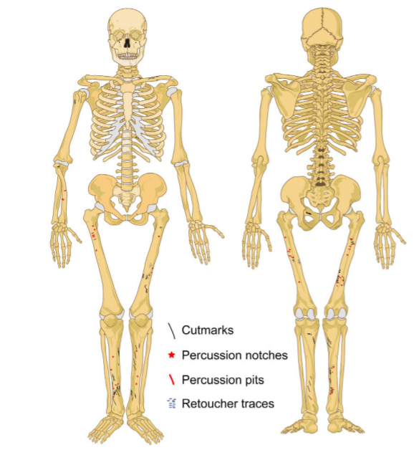
The scholarly dichotomy remains in Goyet Cavern and Gough’s Cave, in both ritual anthropophagy took place to varying degrees. Gough’s Cave displays a multi-faceted ritual in which bodies were ritually excarnated, for nutritional consumption, but also to produce bone assemblages such as skull-cups and the engraved radius which would aid and function in a mortuary ritual. These assemblages held connotations and imbedded contexts for the wider Magdalenian world, in addition to kin specific consolidation and exchange of agency from the living to dead, then to reincorporation into a social practice. Furthermore, the possibility of personhood being influenced by the butchery of animals around them suggests perhaps more could be learn about ritual cannibalism from the (ritual) butchery of animals. Anthropogenic modification and processing of cranial bones could infer a mortuary ritual due to the careful scraping and cut marks, in unison with deliberate percussion blows. Goyet Cavern displays a different narrative; in which the violent and stressful lives of Neanderthal required the utilization of available resources. Which was the body of other Neanderthal, de-fleshed and perhaps eaten from nutritionally rich areas. Goyet is harder to define as ritual due to the requirement for more evidence and greater analysis of current evidence (as would help with Gough’s cave too). However, from Pettitt’s suggestion of social principles based on interactions with the world around them, we can conclude these Neanderthal would have been no strangers to cannibalism, but the insufficient evidence requires hesitance in claiming they did or not practice ritual cannibalism.
Despite, these engagements with academic debate, only with greater future analysis and discoveries will we develop an archaeological framework to understand and provide greater contextual understanding to ritual anthropophagy in Goyet cave and Gough’s Cavern.

References:
Agarwal, S.C. (2016), Bone morphologies and histories: Life course approaches in bioarchaeology, American Journal of Physical Anthropology, Vol. 159, Issue: S61, pp. 130-149, Published by: Wiley, Url: https://onlinelibrary.wiley.com/doi/full/10.1002/ajpa.22905, Accessed online: 30/04/21
Andrews, P. Fernadez-Jalvo, Y. (2003), Cannibalism in Britain: Taphonomy of the Creswellian (Pleistocene) faunal and human remains from Gough’s Cave (Somerset, England), Bulletin of the Natural History Museum Geology, Issue 58, pp. 59-81, Published by: ResearchGate, Url: https://www.researchgate.net/publication/231880922_Cannibalism_in_Britain_Taphonomy_of_the_Creswellian_Pleistocene_faunal_and_human_remains_from_Gough's_Cave_Somerset_England, accessed online: 15/04/21
Bahn, P.G. (2011), Religion and Ritual in the Upper Palaeolithic, The Oxford Handbook of the Archaeology of Ritual and Religion, Published by: Oxford handbook, url: https://www.oxfordhandbooks.com/view/10.1093/oxfordhb/9780199232444.001.0001/oxfordhb-9780199232444-e-23#oxfordhb-9780199232444-bibliography-23, accessed online: 01/05/21
Bello, S.M. Blinkhorn, E. Needham, A. Bates, M. Duffy, S. Little, A. Pope, M. Scott, B. Shaw, A. Welch, M.D. Kinnaird, T. Millar, L. Robison, R. Conneller, C. (2020), Artists on the edge of the world: An integrated approach to the study of Magdalenian engraved stone plaquettes from Jersey (Channel Islands), PloS ONE, Vol. 15, No. 8, pp. pp. 1-40, Published by: PloS ONE, Url: https://journals.plos.org/plosone/article?id=10.1371/journal.pone.0236875, Accessed online: 01/05/21
Bello, S.M. Parfitt, S.A, Stringer, C.B. (2011), Earliest Directly-Dated Human Skull-Cups, PloS ONE, Vol. 6, Issue 2, pp. 1-12, Published by: PloS ONE, Url: https://journals.plos.org/plosone/article?id=10.1371/journal.pone.0017026, Accessed online: 30/04/21
Bello, S.M. Saladie, P. Caceres, I. Rodriguez-Hidalgo, A. Parafitt, S.A. (2015), Upper Palaeolithic ritualistic cannibalism at Gough's Cave (Somerset, UK): The human remains from head to toe, Journal of Human Evolution, Published by: Elsevier, pp. 171-189, Vol 82, url: https://reader.elsevier.com/reader/sd/pii/S0047248415000494?token=5F9https://www.nature.com/articles/srep44707BECF81327C1722AD152770BB3F3A66BB0A3EFA3F60B4247E57F0DC2CFBB5DE38A04E7B276911B0E0C93FAC2362C16&originRegion=eu-west-1&originCreation=20210415163339, accessed online: 30/04/21
Bello, S.M. Wallduck, R. Parfitt, S.A. (2017), An Upper Palaeolithic engraved human bone associated with ritualistic cannibalism, Research article, Vol 12, Issue: 8, Published by: PLoS ONE, Url: https://doi.org/10.1371/journal.pone.0182127, Accessed online: 30/04/21
Bonogofsky, M. (2004), Including Women and Children: Neolithic Modeled Skulls from Jordan, Israel, Syria and Turkey, Vol. 67, No. 2, pp. 118-119, Published by: The American Schools of Oriental Research, Url: http://www.jstor.org/stable/4132367 ,Accessed online: 30/04/21
Brück, J. (2006), Fragmentation, Personhood and the Social Construction of Technology in Middle and Late Bronze Age Britain, Vol. 16, pp. 297-315, Published by: Cambridge Archaeological Journal, url: https://www.cambridge.org/core/journals/cambridge-archaeological-journal/article/fragmentation-personhood-and-the-social-construction-of-technology-in-middle-and-late-bronze-age-britain/73AB3DAD6E13F2F57A16331ADB43876D, Accessed online: 26/10/20Accessed online: 01/05/21
Cobb, H. Jones, A.G. (2018), Being Mesolithic in Life and Death, Journal of World Prehistory, Vol. 31, pp. 367-383, Published by: Springer, Url: https://link.springer.com/article/10.1007/s10963-018-9123-1, Accessed online: 30/04/21
Cole, J. (2006), Consuming Passions: Reviewing the Evidence for Cannibalism within the Prehistoric Archaeological Record, Assemblage – the Sheffield graduate journal of archaeology, Issue 8, Vol 1, Published by: Research School of Archaeology and Archaeological Sciences University of Sheffield, Url: https://archaeologydataservice.ac.uk/archives/view/assemblage/html/9/cole.html, Accessed online: 30/04/21
Cole, J. (2016), Assessing the calorific significance of episodes of human cannibalism in the Palaeolithic, Scientific reports, Vol. 7, pp. 1-12, Published by: Scientific reports, Url: https://www.nature.com/articles/srep44707, Accessed online: 30/04/21
Conklin, B.A. (1995), "Thus Are Our Bodies, Thus Was Our Custom": Mortuary Cannibalism in an Amazonian Society, Vol. 22, No. 1, pp. 75-101, Published by: Wiley / American Anthropological Association, Url: https://www-jstor-org.ezproxy.uwtsd.ac.uk/stable/pdf/646047.pdf?refreqid=excelsior%3A505ebf478ad867a7e858ed1a4abe509a, Accessed online 01/05/21
Cook, J. (1991), PRELIMINARY REPORT ON MARKED HUMAN BONES FROM THE 1986-1987 EXCAVATIONS AT GOUGH'S CAVE, SOMERSET, ENGLAND, Vol. 29, No. 3, pp. 181-187, Published by: Moravian Museum, Url: https://www.jstor.org/stable/26295568?seq=1, Date accessed: 01/05/21
Dole, G. (1962), DIVISION OF ANTHROPOLOGY: ENDOCANNIBALISM AMONG THE AMAHUACA INDIANS*, Transactions of the New York Academy of Sciences, Vol 24, Issue 5, Series 2, pp. 567-573, Published by: Columbia University, url: https://nyaspubs.onlinelibrary.wiley.com/doi/abs/10.1111/j.2164-0947.1962.tb01432.x, accessed online: 30/04/21
Fowler, C. (2004), The Archaeology of Personhood, An anthropological approach, themes in archaeology, Vol. 1, No. 1, Published by: Taylor and Francis, pp. 1-111, Url: http://ndl.ethernet.edu.et/bitstream/123456789/53454/1/58.Chris%20Fowler.pdf, Accessed online: 01/05/21
Galway-Witham, J. Cole, J. Stringer, C. (2019), Aspects of human physical and behavioural evolution during the last 1 million years, Journal of Quaternary Science, Vol. 34, Issue 6, pp. 355-378, Published by: Wiley, Url: https://onlinelibrary.wiley.com/doi/full/10.1002/jqs.3137w, Accessed online: 30/04/21
Goring, E. (1989) Early Society in Cyprus: Death in everyday life: aspects of burial practice in the Late Bronze Age, pp. 94-105 Published by: Edinburgh University press, Url: https://www.maidenvoyagebooksellers.com/pages/books/72019/edgar-peltenburg/early-society-in-cyprus,
Harvey, G. (2004), Endo-Cannibalism in the making of a recent British Ancestor, Mortality Promoting the interdisciplinary study of death, and dying, Vol. 9 pp. 225-267, url: https://www.tandfonline.com/doi/abs/10.1080/13576270412331272866?journalCode=cmrt20, accessed online: 30/04/21
Hendry, L. (2020), Human Evolution: Who were the Neanderthals, Article, published by: Natural History Museum, Url: https://www.nhm.ac.uk/discover/who-were-the-neanderthals.html, accessed online: 01/05/21
Hilliard, R.F. (1990), Clarissa and Ritual, Modern Language Association PLMA, Vol. 105, No.5, pp. 1083-1097, Published by: Modern language association, url: https://www-jstor-org.ezproxy.uwtsd.ac.uk/stable/pdf/462736.pdf?refreqid=excelsior%3A369359e3c0ba6ed9cbdd1f5ba6db5802, accessed online: 01/05/21
Jacewicz, N. (2016) Neanderthal Dinner: Reindeer with A Side of Cannibalism, Article, published by: NPR, url: https://text.npr.org/485682145, Accessed online: 30/04/21
Knappet, C. (2014) Materiality in Archaeological Theory, Encylclopedia of Global Archaeology, pp. 1-8015, Published by: Springer-Verlag, Url: https://www.springer.com/gb/book/9781441904652?utm_campaign=bookpage_about_buyonpublisherssite&utm_medium=referral&utm_source=springerlink#aboutBook, Accessed online: 30/04/21
Lucas, C. Galway-Witham, J. Stringer, C.B. Bello, S.M. (2019), Investigating the use of Paleolithic perforated batons: new evidence from Gough’s Cave (Somerset, UK), Archaeol-Anthropol Sci, Vol. 11 pp. 5231-5255, Published: Stringer, Url: https://link.springer.com/content/pdf/10.1007/s12520-019-00847-y.pdf, Accessed online: 01/05/21
McCrea, J.T (2018), Anthropophagic Engravings: Evoking the Natural World Through Cannibalism in Gough’s Cave, Article, The Post Hole, published by: University of York, url: https://www.theposthole.org/read/article/387, Accessed online: 30/04/21
Norgon, K. (2013), IDENTIFYING MORTUARY RITUAL AND ANCESTOR VENERATION: A SPATIAL ANALYSIS OF THE TOMBS AT HUALCAYÁN, Journal of Undergraduate Research XVI, pp. 1- 20, Published by: UW-L, Url: https://www.uwlax.edu/globalassets/offices-services/urc/jur-online/pdf/2013/norgon.kate.archaeology.pdf, accessed online: 30/04/21
Patnaik, S.M. (1995), Material Culture and Archaeology, Indian Anthropologist, Vol. 25, No. 2, pp. 59-64, Published by: Indian Anthropological Association, url: https://www-jstor-org.ezproxy.uwtsd.ac.uk/stable/41919780?seq=1#metadata_info_tab_contents, Accessed online: 30/04/21
Peeters, S. Zwart, H. (2020), Neanderthals as familiar strangers and the human spark: How the ‘golden years’ of Neanderthal research reopen the question of human uniqueness, History and Philosophy of the Life Sciences Vol. 42, No. 33, pp. 1-26, Published by: Springer, url: https://link.springer.com/content/pdf/10.1007/s40656-020-00327-w.pdf, Accessed online: 01/05/21
Pettitt, P.B. (2000), Neanderthal lifecycles: developmental and social phases in the lives of the last archaics, World Archaeology Published by: Taylor and Francis, Vol. 31, Issue: 3, pp. 351-366, url: https://www.tandfonline.com/doi/pdf/10.1080/00438240009696926?needAccess=true, Accessed online: 30/04/21
Rapport, N. Overing, J. (2000), Social and Cultural Anthropology The Key Concepts, pp. 1-447, url: http://pustaka.unp.ac.id/file/abstrak_kki/EBOOKS/Nigel%20Rapport,%20Joanna%20Overing%20Social%20and%20Cultural%20Anthropology%20The%20Key%20Concepts%20%20%202000.pdf, accessed online: 30/04/21
Rougier, H. Crevecouer, I. Beauval, C. Posth, C. Flas, D. Wißing, C. Furtwangler, A. Gremonpre, M. Gomez-Olivencia, A. Semal, P. Plicht, J.V.D. Bocherens, H. Krause, J. (2016), Neandertal cannibalism and Neandertal bones used as tools in Northern Europe, Scientific reports, pp. 1-11, Issue 6, Published by: University of Groningen, url: https://doi.org/10.1038/srep29005, Accessed online: 30/04/21
Russell, M.D. (1987), Mortuary practices at the Krapina Neandertal site, American Journal of Physical Anthropology Volume 72, Issue 3 p. 381-397, Publshed by: Wiley, Url: https://onlinelibrary.wiley.com/doi/abs/10.1002/ajpa.1330720311, Accessed online: 30/04/21
Saladie, P. Rodriguez-Hidalgo, A. (2016), Archaeological Evidence for Cannibalism in Prehistoric Western Europe: from Homo antecessor to the Bronze Age, Journal of Archaeological Method and Theory, pp. 1034-1071, Vol. 24, Published by: Springer, Url: https://link.springer.com/article/10.1007/s10816-016-9306-y#:~:text=Archaeological%20sites%20identified%20with%20cannibalism,that%20accompany%20interpretations%20of%20cannibalism., Accessed online: 30/04/21
Steel, L. (2016), Kitchenalia in Bronze Age Cyprus, Gastronomica, Vol. 16, No. 3, pp. 79-90. Published by: University of California Press, Url: https://www-jstor-org.ezproxy.uwtsd.ac.uk/stable/26362375?seq=1#metadata_info_tab_contents Accessed online: 01/05/21
Stinger, C. (2014), Natural History Museum, Human Evolution – Are Neanderthals the same species as us? Article, Published by: Natural History Museum, Url: https://www.nhm.ac.uk/discover/are-neanderthals-same-species-as-us.html, Accessed online: 30/04/21
Toussaint, M. (2004), 1997-2005 Research in the caves of Goyet (Gesves, Province of Namur, Belgium) Tongeren Neandertal symposium excursion, 19 September 2004, Conference: Proceedings of the International Conference held in the Gallo-Romain Museum in Tongeren, Neandertal symposium, 17-19 september 2004 Volume: Etudes et Recherches archéologiques de l'Université de Liège, 117. Atuatuca 2, Published by: ResearchGate, pp. 115-134, Url: https://www.researchgate.net/publication/234849310_1997-2005_Research_in_the_cave_of_Goyet_Gesves_province_of_Namur_Belgium, accessed online: 30/04/21
Traphagan, J.W. (2008), Embodiment, Ritual Incorporation, and Cannibalism Among the Iroquoians after 1300 C.E. Jounral of Ritual Studies, Vol. 22, Issue: 2, pp. 1-12, Published by: Palmela J. Stewart and Andrew J. Strathern, url: https://www.jstor.org/stable/44368787?seq=1, Accessed online: 30/04/21
Ullrich, H. (2005), CANNIBALISTIC RITES WITHIN MORTUARY PRACTICES FROM THE PALEOLITHIC TO MIDDLE AGES IN EUROPE, Vol. 43, No. 2/3, pp. 249-261, Published by: Moravian Museum, Url: https://www-jstor-org.ezproxy.uwtsd.ac.uk/stable/pdf/26292739.pdf?refreqid=excelsior%3A67281ff03b54e000444116b1dc230c31, Accessed online: 01/05/21
Whitley, J. (2001), Too many ancestors, School of History and Archaeology Anthropologie (1962-), Vol. 76, No. 291, pp. 119-126, Published by: Cambridge University Press, Url: https://doi.org/10.1017/S0003598X00089870, Accessed online: 01/05/21

Image Reference
Fig 1. Bello, S.M. Saladie, P. Caceres, I. Rodriguez-Hidalgo, A. Parafitt, S.A. (2015), Upper Palaeolithic ritualistic cannibalism at Gough's Cave (Somerset, UK): The human remains from head to toe, Journal of Human Evolution, Published by: Elsevier, pp. 171-189, Vol 82, url: https://reader.elsevier.com/reader/sd/pii/S0047248415000494?token=5F9https://www.nature.com/articles/srep44707BECF81327C1722AD152770BB3F3A66BB0A3EFA3F60B4247E57F0DC2CFBB5DE38A04E7B276911B0E0C93FAC2362C16&originRegion=eu-west-1&originCreation=20210415163339, accessed online: 01/05/21
Fig 2. Yravedra, J.Yustos, M. (2015), Cannibalism in the Neanderthal World: An Exhaustive Revision, Prometheus Press/Palaeontological Network Foundation Journal of Taphonomy, Vol. 13, Issue 1, pp. 33-52, Published by: ResearchGate , Url: https://www.researchgate.net/publication/316915426_Cannibalism_in_the_Neanderthal_World_An_Exhaustive_Revision, Accessed online: 01/05/21
Fig 3. Bello, S.M. Saladie, P. Caceres, I. Rodriguez-Hidalgo, A. Parafitt, S.A. (2015), Upper Palaeolithic ritualistic cannibalism at Gough's Cave (Somerset, UK): The human remains from head to toe, Journal of Human Evolution, Published by: Elsevier, pp. 171-189, Vol 82, url: https://reader.elsevier.com/reader/sd/pii/S0047248415000494?token=5F9https://www.nature.com/articles/srep44707BECF81327C1722AD152770BB3F3A66BB0A3EFA3F60B4247E57F0DC2CFBB5DE38A04E7B276911B0E0C93FAC2362C16&originRegion=eu-west-1&originCreation=20210415163339, accessed online: 01/05/21
Fig 4. Cole, J. (2016), Assessing the calorific significance of episodes of human cannibalism in the Palaeolithic, Scientific reports, Vol. 7, pp. 1-12, Published by: Scientific reports, Url: https://www.nature.com/articles/srep44707, Accessed online: 01/05/21
Fig 5. Bello, S.M. Parfitt, S.A, Stringer, C.B. (2011), Earliest Directly-Dated Human Skull-Cups, PloS ONE, Vol. 6, Issue 2, pp. 1-12, Published by: PloS ONE, Url: https://journals.plos.org/plosone/article?id=10.1371/journal.pone.0017026, Accessed online: 01/05/21
Fig 6. Bello, S.M. Wallduck, R. Parfitt, S.A. (2017), An Upper Palaeolithic engraved human bone associated with ritualistic cannibalism, Research article, Vol 12, Issue: 8, Published by: PLoS ONE, Url: https://doi.org/10.1371/journal.pone.0182127, Accessed online: 01/05/21
Fig 7. Bello, S.M. Wallduck, R. Parfitt, S.A. (2017), An Upper Palaeolithic engraved human bone associated with ritualistic cannibalism, Research article, Vol 12, Issue: 8, Published by: PLoS ONE, Url: https://doi.org/10.1371/journal.pone.0182127, Accessed online: 30/04/21
Fig 8. Rougier, H. Crevecouer, I. Beauval, C. Posth, C. Flas, D. Wißing, C. Furtwangler, A. Gremonpre, M. Gomez-Olivencia, A. Semal, P. Plicht, J.V.D. Bocherens, H. Krause, J. (2016), Neandertal cannibalism and Neandertal bones used as tools in Northern Europe, Scientific reports, pp. 1-11, Issue 6, Published by: University of Groningen, url: https://doi.org/10.1038/srep29005, Accessed online: 30/04/21

