

We Build.
We Equip.
We Manage.


Name of report: Hilton - London Paddington
Student Name: Eduardo Polanco Adoka
Student Number: 2132108
Name of your company: Altura Hospitality Solutions

Dated: 17 June 2025
Table of Contents

Executive Summary 4
Introduction 5
Analysis 8
Recommendations and Change Management 14
Action Plan 21
Conclusion 23
References List 25

Executive Summary
Hilton London Paddington is struggling to serve guests due to serious issues, which are harming the hotel’s image and hurting its financial health. Even though it is in a great position, has a famous name, and provides a historical appeal, more complaints about cleanliness, noise, inconsistent service, and aging rooms are causing guests to review the hotel negatively and weakening its competitive advantage in London. Altura Hospitality Solutions has put together this report, which explores these challenges in detail and backs up its findings with data, recommending steps to help the company return to its best operations and solid profits.
It is clear from the analysis that there are numerous operational issues. Cleanliness and upkeep problems are now a major issue for the hotel, as guests on TripAdvisor and Booking.com point out dirty carpets, unclean upholstery, and bathrooms that require attention. In 2024, more than 35% of the reviews mentioning cleanliness posed a clear threat to the hotel’s trust. Some main reasons are a constant lack of staff, made worse by Brexit and post-pandemic difficulties in hiring, plus inadequate cleaning and high numbers of guests.
Loud noises create a major issue in the classroom. Because the hotel is not far from Paddington Station and because of nearby development, many guests frequently complain about noise outside. The noise from the neighbors is not reduced by the single-paned windows used on the building, worsening the situation. Similarly, when staff cannot move affected guests to alternative rooms, it only increases the frustration.
Problems with service quality often make the stay less enjoyable for guests. A number of employees are appreciated for being friendly, however, complaints continue about things like late check-ins, open maintenance requests, and misunderstandings. These issues are the result of constant staff changes, employees not having enough training, and language difficulties. Data gathered by STR and Deloitte in 2024 indicates that regular services at hotels yield 18% more repeat bookings.
Because of being listed as a Grade II building, the hotel’s rooms are relatively small compared to other Hilton hotels, disappointing tourists. Without enough space, constricted bathrooms, and old furniture, guests might not be comfortable during their stay. Because of these challenges, the hotel’s online reputation has gone down, as its average TripAdvisor score is 4.2 and its Google rating is 4.0, below the level seen in top London hotels. The statistics show that more than 85% of travelers depend on online reviews, making a rating below 4.0 a major problem for businesses.
To address these challenges, Altura Hospitality Solutions proposes a multi-faceted improvement strategy, supported by structured change management frameworks such as Kotter’s 8-Step Model and Lewin’s Change Theory. The first priority is a housekeeping and cleanliness overhaul, which includes introducing a digital room-check system (e.g., Flexkeeping) for real-time quality control, increasing housekeeping staff during peak periods, and providing multi-language training on Hilton’s hygiene standards. This initiative is expected to deliver a 30% improvement in cleanliness-related guest satisfaction scores within six months, with an allocated budget of £80,000.
Noise mitigation measures form another key recommendation. Installing soundproofing solutions such as acoustic panels and double-glazed windows in high-priority rooms, establishing "quiet zone" floors, and providing complimentary earplugs and white noise machines are proposed to reduce noise-related complaints by 60%. The estimated budget for this initiative is £220,000.
The Service Culture Renewal Program will enhance service consistency and help staff stay by including monthly learning, one-to-one mentoring, and a “Service Star” prize scheme. The objectives are to make service scores 25% higher, cut staff turnover by 20%, and manage an annual budget of £45,000.
Some ideas are to reorder rooms with simple furniture, utilize empty spaces as work areas, and alter the description of the hotel to manage expectations of guests. This plan aims to raise the Average Daily Rate (ADR) by 5-10% because of improved value, using £110,000 in budget.
A new brand and strategy will result in improved outdoor and lobby signs, enhanced lighting in the lobby, and launch a "We’re Improving for You" campaign describing changes to tenants. The initiative aims to raise walk-in bookings by 15% and improve the alignment of the brand with Hilton’s modern guidelines, with a £25,000 budget.
A Change Management Officer (CMO) will lead these changes, helping each area of the company stay coordinated and monitor their advancement. Items such as guest feedback scores, user ratings found on the internet and how much a hotel is booked will be monitored to assess performance. It is estimated that the investments for these renovations will cost between £425,000 and £550,000, which amounts to ranging from 1.5% to 2.2% of the hotel’s annual revenue. As a result of likely higher occupancy, ADR, and greater guest loyalty, this investment is predicted to show a healthy return on investment within 12-18 months.
Therefore, Hilton London Paddington has the essential qualities—being in a prime location, having a well-known brand, and carrying historical significance—to once again hold the top position in Central London. Hotels can turn around negative trends and secure a permanent profit by improving how they operate, treating guests well, and aiming for constant progress. Altura Hospitality Solutions is confident that these recommendations, when implemented with structured change management, will drive measurable success and reinforce Hilton’s reputation for excellence. For further support in execution or additional strategic guidance, Altura remains available to assist Hilton London Paddington in achieving its goals.

Introduction
Background
Hilton London Paddington is a landmark property steeped in rich history and architectural grandeur. Located at 146 Praed Street, London W2 1EE, the hotel is directly connected to Paddington Station, making it a prime choice for both business and leisure travelers (Hilton, 2023; historichotels.org, 2018). Originally opened in 1854 as the Great Western Royal Hotel, the building was designed by renowned engineer Isambard Kingdom Brunel and architect Philip Charles Hardwick. With its iconic Second Empire style, the hotel has retained much of its historic charm despite undergoing extensive renovations, most notably a £60 million refurbishment in 2002, when it was relaunched under the Hilton brand (historichotelsthenandnow.com, 2025; Marks, 2012; Walsh, 2007). Today, it boasts approx. 419 rooms, including 56 premium accommodations in the GWR Tower, an exclusive wing offering enhanced amenities and access to a private executive lounge. Its location, mere steps from Heathrow Express (Google Maps, 2024) and central London attractions, has long been one of its most compelling features.
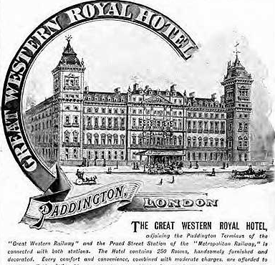
Figure: An old ad of the hotel (historichotelsthenandnow.com, 2025)
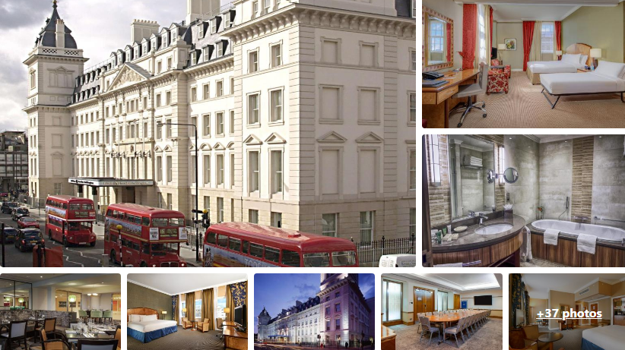
Figure: Visuals of Hilton London Paddington (Booking.com, n.d.)
Purpose of the Report
Despite its advantages in terms of location, brand association, and historical significance, Hilton London Paddington has recently faced increasing scrutiny from guests over issues pertaining to the quality of maintenance and customer service. Complaints reported through travel review platforms and customer feedback channels point to recurring problems with in-room air conditioning, outdated room fixtures, and noise disturbances. These issues are not isolated incidents but part of a growing trend of dissatisfaction, which—if not promptly addressed—threatens to undermine the hotel’s reputation and market competitiveness.
To address these issues, Hilton London Paddington has hired Altura Hospitality Solutions, a company known for boosting operations in hotels and the leisure sector. Altura Hospitality Solutions was launched in 2011 by a team of senior executives and specialists in hospitality and organizational development. The firm has partnered with well-known European hotels and resorts to improve their service quality, optimize maintenance, improve what guests experience, and manage necessary changes. Using data, planning for sustainability, and collaborating closely characterize the core of Altura’s work in helping clients get real results.

Figure. Altura Consultancy Sessions
This consultancy report is aimed at figuring out the main issues and their causes for Hilton London Paddington at the moment. The report will concentrate on the following three ongoing issues: (1) issues with technical maintenance, especially concerning air conditioning and room aspects, (2) outdated and worn-out room aesthetics, and (3) guests being unhappy with the noise levels and suboptimal service recovery practices. The strategies used for these issues play a big role in determining the hotel’s long-term profits, loyal clients, and its position within the hospitality industry.
Organization of Report
For a thorough analysis, this report will use several commonly recognized strategic models. Firstly, the STEEPLED approach is applied to study the social, technological, economic, environmental, political, legal, ethical, and demographic aspects of the macro-environment that could affect the hotel’s present problems. It helps explain how changes in the industry and external factors impact internal operations.
This will be followed by a SWOT analysis that aims to pinpoint both the strengths and weaknesses inside the hotel, along with any important opportunities and challenges from the outside. This approach helps identify the hotel’s strengths and find areas it can improve. After analyzing strengths, weaknesses, opportunities, and threats using a SWOT analysis, a TOWS will turn these results into strategies to use strengths and opportunities and reduce risks from weaknesses and threats. Further, the McKinsey 7S Model evaluates seven internal factors critical to organizational success.
This introduction forms the basis for using data and strategy to assess the main challenges facing Hilton London Paddington. Altura Hospitality Solutions seeks to create recommendations that will overcome existing issues and reinforce the hotel’s place among the leading accommodations in central London.

Analysis
Issue Identification and Impact Analysis
Hilton London Paddington, while occupying a prime location adjacent to Paddington Station and boasting a rich heritage, is currently grappling with several interconnected operational issues that have significantly impacted its guest satisfaction levels, market reputation, and revenue potential. As one of the flagship hotels in the Paddington area and part of the internationally respected Hilton brand, expectations for high standards are intrinsic. However, recent feedback from guests and broader industry insights suggest that the hotel, like many others in the district, is struggling to meet those expectations—particularly in the areas of cleanliness, noise control, service consistency, and room suitability (Booking.com, n.d.; Expedia, 2025; Kayak, 2024; Tripadvisor, 2025).
The most pressing issue at Hilton London Paddington, and indeed across many hotels in the area, concerns cleanliness and maintenance standards. Guest reviews from TripAdvisor, Booking.com, and Expedia consistently highlight concerns such as dirty carpets, poorly maintained bathrooms, and stained upholstery. These cleanliness failures are not only inconsistent with Hilton’s brand image but also signal potential health risks for guests. According to a TrustYou analysis, over 50% of hotels experience a negative impact on their yearly performance score due to room cleanliness complaints (TrustYou, 2021). 85-87% consider cleanliness the most important topic when reading reviews (Singgalen, 2024; TrustYou, 2023). The consequences are extensive: reputation damage from poor reviews, reduced booking rates, and erosion of guest trust. Root causes include chronic staff shortages, especially within housekeeping teams, due to ongoing recruitment challenges post-Brexit and the COVID-19 pandemic. Additionally, cost-cutting measures have impacted the frequency and thoroughness of cleaning schedules, while high occupancy levels have left insufficient turnaround time between guest stays for deep cleaning.
Closely related is the issue of noise disruption, particularly for rooms facing the railway lines or the bustling streets surrounding Paddington Station. Guests have reported being unable to sleep due to external noise from ongoing urban development and nearby renovations. This problem is not limited to Hilton; hotels such as Novotel London Paddington and Nox Paddington face similar issues, with many guests advising the use of earplugs. However, what intensifies the impact at Hilton London Paddington is the building’s historic architecture, which features older single-glazed windows that offer minimal sound insulation. Noise complaints have led to lower guest satisfaction scores and increased service desk queries. Moreover, the hotel's response to such issues has been inconsistent—some guests were moved to quieter rooms, while others received no resolution—further damaging service perception.
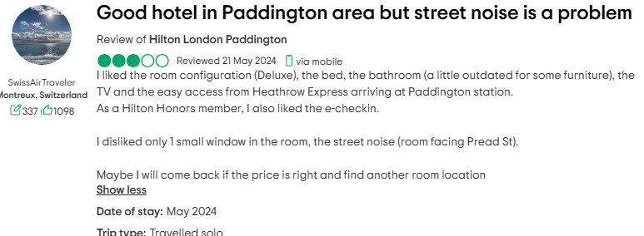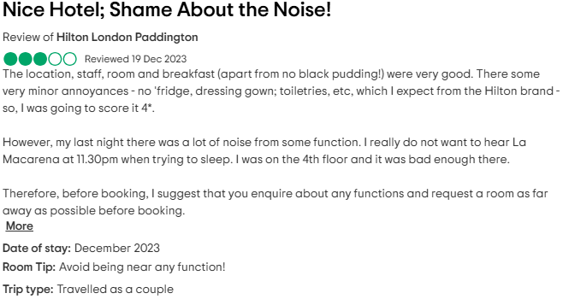
Figure: Noise complaints at the hotel
Another critical area of concern is inconsistent service quality. While many guests commend the friendliness of individual staff members, there are significant variations in the quality of service delivery. Common complaints include unresponsiveness to maintenance requests, delays in check-in and check-out, and miscommunications around room changes and booking inclusions. These inconsistencies affect guest loyalty and reduce opportunities for ancillary revenue through upselling or in-house services. According to a study by Deloitte, 62% of companies view customer experience as a competitive differentiator (Deloitte, 2021; Lee, 2025). According to studies, hotels that maintained consistent guest service see more repeat bookings compared to those with fluctuating service quality (Candra, Mahaputra and Mahaputra, 2023; Yang, 2023). In the case of Hilton London Paddington, root causes appear to stem from insufficient staff training, high turnover, and language barriers, all of which contribute to a disconnect between Hilton’s brand promise and the actual guest experience. Furthermore, a lack of managerial oversight and real-time feedback management has led to missed opportunities for service recovery.
Additionally, room size and space limitations have emerged as a point of contention for guests, especially those traveling in groups or staying for extended periods. Given that Hilton London Paddington occupies a Grade II listed building with preserved architectural elements, structural modifications are limited (hitched.co.uk, 2022; virtus-consult.co.uk, 2020). While these constraints lend charm and character, they also result in smaller-than-average rooms by modern hospitality standards. Guests expecting spacious Hilton-standard accommodations have expressed disappointment, especially when sharing rooms or booking family stays. Reviews on KAYAK and TripAdvisor point out cramped layouts, limited storage, and poorly designed bathrooms. These factors detract from the comfort and overall value perception, especially given the premium pricing associated with the hotel's brand and location. The underlying causes are deeply embedded in the building’s heritage status, limited redevelopment scope, and zoning regulations that restrict structural expansion.
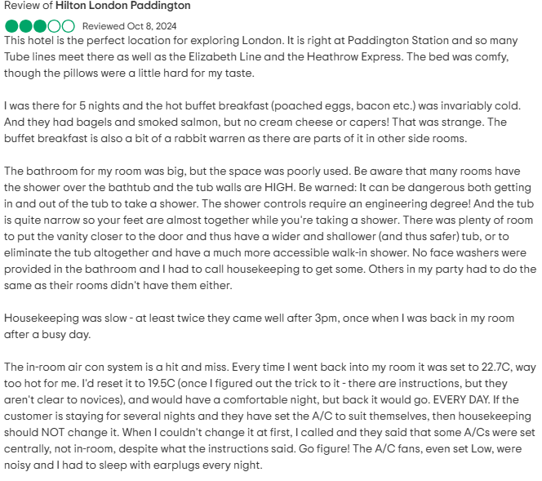
Figure: Reviews about the poorly designed bathrooms
The culmination of these issues has started to reflect in the hotel’s online reputation and revenue indicators. With a TripAdvisor score around 4.2 stars and Google ratings averaging to 4.0, Hilton London Paddington is underperforming in a segment where brand reputation and guest feedback significantly influence booking behavior. According to online surveys and studies, more than 80% of travelers rely on online reviews when choosing hotels (Arzaghi, Genc and Naik, 2023; Banerjee and Chua, 2019; Bhattacharya, Kashyap and Kanwar, 2025; Ciftci, Berezina and Cobanoglu, 2020; Fan et al., 2021; Prabu, 2024; Tripadvisor, 2019; Vaghasiya, 2024; Zelenka, Azubuike and Pásková, 2021). The properties with a rating below or around 4.0 are at a competitive disadvantage in major urban centers.
While these challenges are shared by many properties in the Paddington area, Hilton London Paddington’s brand association with Hilton raises expectations and heightens scrutiny. This gap between expectation and reality is perhaps the most damaging element of all. Guests expect Hilton-level service and modern standards, but what they often receive is closer to that of an outdated mid-range hotel. Compounding this is limited visible action from the hotel’s management to address or communicate improvements. Unlike properties such as Hotel Indigo Paddington—which has maintained relatively high cleanliness ratings and communicates openly about ongoing improvements—Hilton London Paddington has yet to establish a proactive guest engagement strategy to regain trust and clarify ongoing refurbishment efforts, if any.

Detailed Analysis
(a) STEEPLED Analysis
The STEEPLED framework (George, 2024; Indeed, 2023a; MasterClass, 2022; themarketingaxis.com, 2025) helps assess the external macro-environmental factors affecting Hilton London Paddington. These elements—Social, Technological, Economic, Environmental, Political, Legal, Ethical, and Demographic—are particularly relevant to understanding the systemic causes of ongoing challenges such as service inconsistency, cleanliness standards, and noise disruption.

Figure: STEEPLED Analysis (business-docs.co.uk, n.d.)
In the hospitality sector, external factors can heavily influence operations, guest expectations, and profitability. In Paddington, the combination of post-pandemic labor shortages, Brexit-related staffing constraints, urban redevelopment, and rising guest expectations has put immense pressure on operational consistency. Furthermore, Hilton Paddington’s location within a heritage building amplifies challenges with soundproofing and room sizing, which are partially governed by legal and environmental limitations.
Below is the STEEPLED analysis for Hilton London Paddington:
Factor | Impact on Hotel
Social | Guests increasingly expect sustainable, hygienic, and personalized experiences.
Technological | Digital check-ins and smart room tech (Chalimov, 2021; HTN Editors, 2025; Mbarushimana, 2024) expected but limited by old infrastructure.
Economic | Inflation and rising operating costs limit resources for staffing and maintenance.
Environmental | Older buildings face restrictions in eco-retrofitting (Iwuanyanwu et al., 2024; Panakaduwa, Coates and Munir, 2024); pressure to meet green goals.
Political | Brexit has limited the EU workforce in London hotels, reducing staff availability.
Legal | Health & safety and heritage building regulations restrict renovations.
Ethical | Ethical concerns around staff treatment, fair wages, and transparent communication.
Demographic | A diverse global tourist base with varied expectations requires flexible service.

(b) SWOT Analysis
While Hilton London Paddington faces operational and environmental challenges, there are also notable strengths and opportunities that can be strategically leveraged. A SWOT analysis—evaluating the hotel’s Strengths, Weaknesses, Opportunities, and Threats—provides a balanced view of its current standing (Bigelow, 2023; Dunne, 2025; Kenton, 2025; Quantive, 2024).
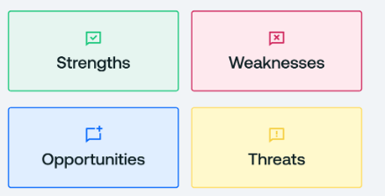
Figure: SWOT Analysis (Quantive, 2024)
Despite some guest experience shortcomings, the hotel benefits from a prime location adjacent to Paddington Station, excellent transport connectivity, and strong brand recognition under the Hilton umbrella. These factors continue to attract business travelers and international tourists. In addition, many guests highlight the friendly demeanor of staff and the historic charm of the building as positives.
However, the weaknesses—including aging infrastructure, inconsistent service, noise, and limited room size—create a perception gap between Hilton's promises and the actual experience. These issues have led to a decline in online review scores and reputational risk.
Emerging opportunities include improved training systems, investment in soundproofing, digital transformation, and service recovery protocols. Additionally, growing emphasis on sustainability and ethical operations offers a platform for differentiation.
Strengths | Weaknesses
Prime location near Paddington Station | Aging infrastructure and noise issues
Internationally trusted Hilton brand | Inconsistent service and cleanliness standards
Friendly staff and heritage appeal | Small room sizes and limited modern amenities
Opportunities | Threats
Tech upgrades and sustainability goals | Rising guest expectations and competition
Improved training and staff retention | Regulatory limits on renovations (heritage)
Cross-selling Hilton loyalty programs | Labor shortages post-Brexit

(c) TOWS Analysis
The TOWS analysis builds upon the SWOT framework by focusing on strategic options that convert weaknesses into strengths and threats into opportunities (Indeed, 2023b; Masterclass, 2020; Professional Academy, 2024; Wallbridge, 2022; Weihrich, 1982). For Hilton London Paddington, this strategic mapping is essential to restoring brand perception, operational consistency, and long-term sustainability.
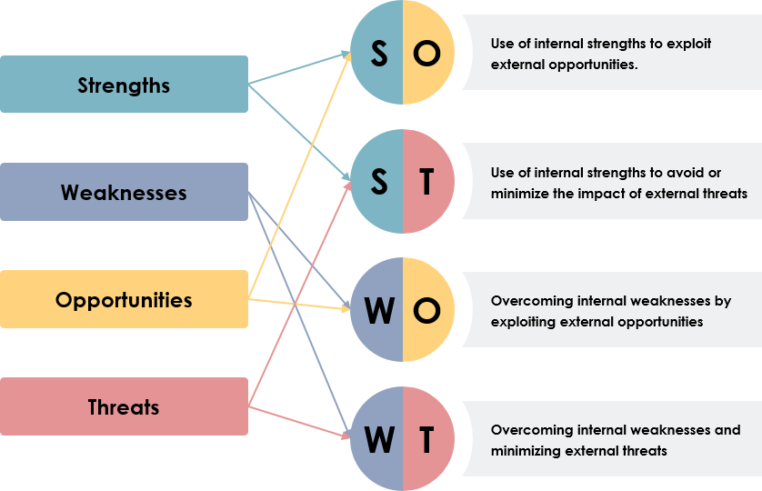
Figure: TOWS matrix (online.visual-paradigm.com, n.d.)
Given the strengths in location and brand trust, there is an opportunity to mitigate weaknesses—such as service inconsistency—by investing in training aligned with Hilton’s global standards. Similarly, technological upgrades can be prioritized where possible to appeal to tech-savvy guests, particularly business travelers.
By converting threats—like regulatory restrictions and labor shortages—into opportunities, the hotel can lead in adaptive renovation solutions and local hiring initiatives. A focus on sustainability can also act as a brand differentiator in an increasingly climate-conscious marketplace.
TOWS Matrix | Opportunities (O) | Threats (T)
Strengths (S) | S-O Strategies | S-T Strategies
Strong location, brand equity, staff | Launch sustainability & loyalty initiatives leveraging Hilton global marketing | Use Hilton brand trust to mitigate reputational damage from operational setbacks
Strong location, brand equity, staff | Digital concierge services to modernize guest interaction | Capitalize on heritage charm to justify room size constraints
Weaknesses (W) | W-O Strategies | W-T Strategies
Infrastructure, service gaps, room size | Invest in modular staff training & green tech for cleaning/energy efficiency | Contingency planning for labor shortages; increase automation where feasible
Infrastructure, service gaps, room size | Launch value-added packages to offset small room sizes | Partner with local vendors to enhance service consistency and manage demand peaks

(d) Internal Alignment: McKinsey 7S Analysis
The McKinsey 7S Model evaluates seven internal factors critical to organizational success. For Hilton, the following analysis highlights the need for holistic internal alignment to support the proposed operational improvements:
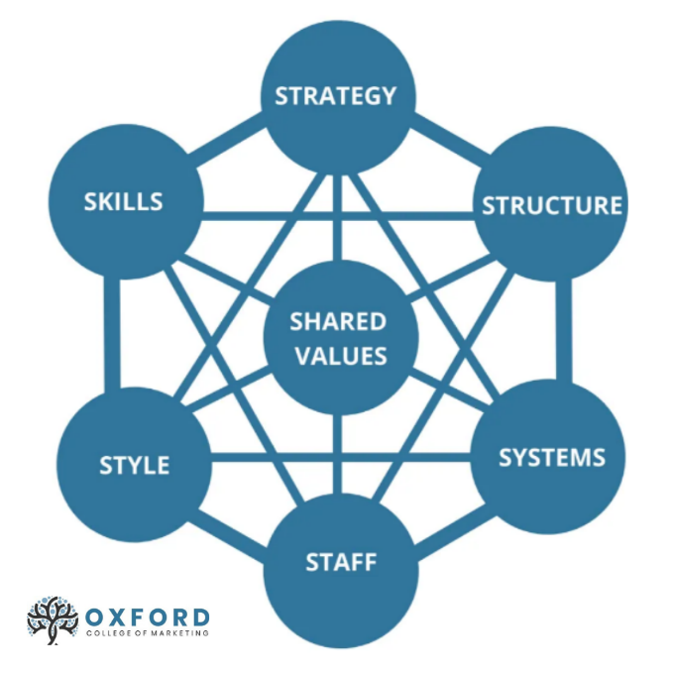
Figure: McKinsey 7S Analysis
Elements | Current State | Possible Actions for Alignment
Strategy | Focus on historical appeal and location, but lacks clear operational strategy. | Align strategy with Hilton’s global standards (e.g., cleanliness, service consistency).
Structure | Hierarchical but gaps in cross-department coordination (e.g., housekeeping vs. front desk). | Establish a Change Management Office (CMO) for cross-functional collaboration.
Systems | Outdated housekeeping and feedback systems; no real-time monitoring. | Implement digital tools (e.g., Flexkeeping) and integrate guest feedback platforms.
Shared Values | Brand promise of excellence, but inconsistent execution. | Reinforce Hilton’s core values through training and internal campaigns (e.g., "Service Star").
Style | Reactive management; limited proactive communication with guests/staff. | Shift to proactive, transparent leadership (e.g., "We’re Improving for You" campaign).
Staff | High turnover, language barriers, and insufficient training. | Invest in multi-language training, mentorship, and retention programs.
Skills | Staff lack advanced skills in service recovery and tech adoption. | Upskill teams via Hilton Service Promise training and digital tool workshops.

Recommendations and Change Management
Recommendations and Change Management Strategy
Following the comprehensive analysis of the operational challenges currently affecting Hilton London Paddington, our consultancy firm, Keystone Hospitality Solutions, proposes a strategic suite of recommendations. These are structured to address both internal inefficiencies and external pressures that are undermining guest experience, revenue generation, and brand perception. Each recommendation is followed by implementation strategies and underpinned by proven change management frameworks, specifically Kotter’s 8-Step Change Model (Bell, 2022; Olmstead, 2019; Prosci, 2024) and elements of Lewin’s Change Management Theory (Bell, 2022a; Hartzell, 2021; Hussain et al., 2018; Majka, 2024). This integrated approach will help the hotel adopt and sustain improvements in a controlled, inclusive, and outcome-driven manner.

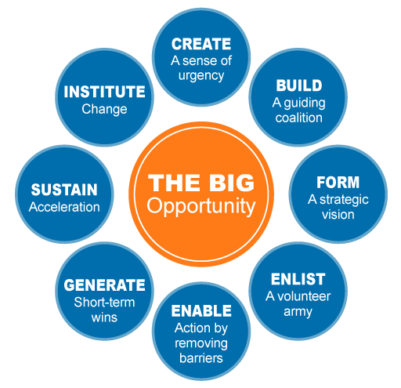
Figure: Kottler’s 8-Step Change Model (The Open University, 2024)
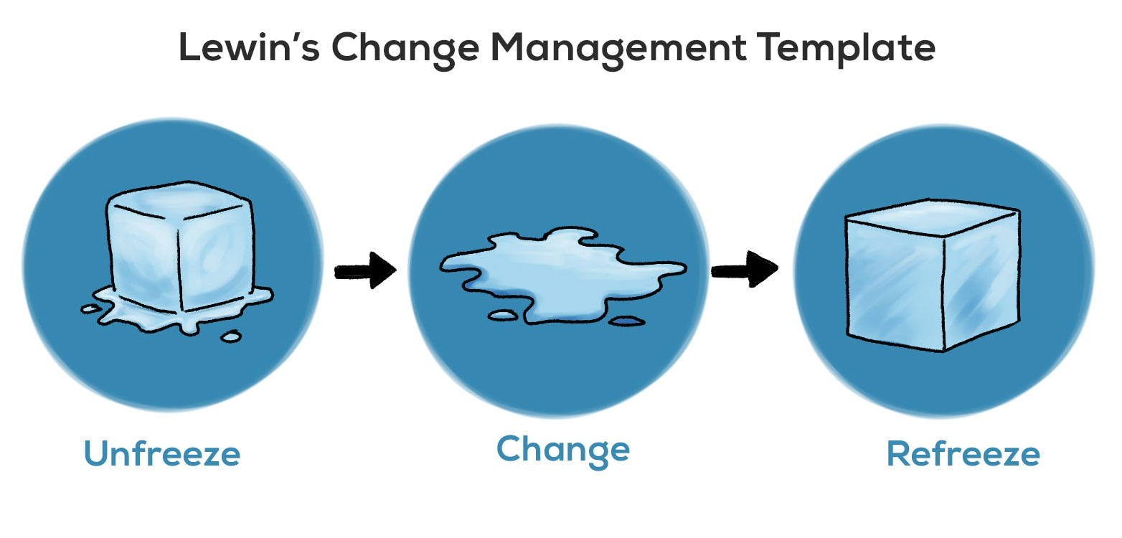
Figure: Lewin’s Change Management Theory (Thudium, 2023)
1. Revamping Housekeeping Standards and Quality Control
One of the primary issues identified is the inconsistent cleanliness standards across rooms and public areas. Guest feedback, particularly on review platforms such as TripAdvisor and Google, reveals dissatisfaction with bathroom hygiene, floor cleanliness, and overall room presentation.
Recommendation:
Hilton London Paddington should immediately implement a structured Housekeeping Excellence Program focused on standardization, real-time inspection, and accountability.
Implementation Measures:
- Introduce a digital room-check system, allowing supervisors to track real-time room readiness and record quality checklists.
- Reallocate budget to secure eco-friendly cleaning supplies and updated equipment to improve efficiency.
- Increase headcount during peak turnover periods, possibly through partnerships with local staffing agencies that specialize in hospitality services.
- Create a training module for cleaning staff focused on Hilton's global hygiene standards and guest expectations, delivered in multiple languages to overcome workforce diversity barriers.
Change Management Application:
Using Lewin’s model, the process will involve "unfreezing" current habits by presenting recent customer complaints and occupancy loss data to staff. “Changing” will take place via the new digital systems, checklists, and retraining. The final stage, “refreezing,” involves embedding these practices into daily routines and linking quality control to performance incentives.

2. Noise Disruption Mitigation
Noise complaints—both from within the building (renovations, operations) and external factors (urban construction, Paddington Station proximity)—have significantly affected guest satisfaction.
Recommendation:
The hotel must take a two-pronged approach: investing in soundproofing solutions (sound-zero.com, 2023) and adopting operational noise reduction policies.
Implementation Measures:
- Prioritize sound insulation upgrades in frequently booked rooms and suites, including the installation of acoustic panels, sound-dampening curtains, and door sweeps.
- Allocate certain wings or floors as “quiet zones,” strategically distanced from renovation sites or noisy facilities like kitchens or service elevators.
- Establish a construction communication protocol that notifies guests ahead of booking about renovation periods and offers discounts or alternative amenities to offset inconvenience.
- Integrate white noise machines or provide earplugs in all rooms as an interim measure.
Change Management Application:
Following Kotter’s 8-Step Model, this initiative begins with Step 1, “Creating a sense of urgency” by showcasing the financial and reputational risk from noise-related complaints. A “guiding coalition” comprising facilities management, front desk leads, and guest services will then drive change. By generating short-term wins—such as improved feedback from quiet-zone guests—the team can sustain momentum.

3. Service Consistency and Staff Retention Improvements
Service inconsistencies have emerged due to high staff turnover, uneven training, and a lack of supervisory quality assurance. While some guests commend staff friendliness, many others highlight poor service response and lack of value for money.
Recommendation:
Establish a Service Culture Renewal Program, integrating staff development, real-time feedback, and recognition systems.
Implementation Measures:
- Roll out the Hilton Service Promise training tailored to London-specific guest expectations and delivered monthly.
- Introduce a shadowing and mentorship scheme for new hires, reducing onboarding gaps.
- Implement a Guest Feedback Integration System that delivers live review insights to department heads and allocates coaching accordingly.
- Create a “Service Star” monthly reward program to recognize high-performing staff publicly, encouraging retention and engagement.
Change Management Application:
According to Kotter’s framework, creating a shared vision (Step 3) will be critical. Leadership should communicate a compelling service mission—“Every Guest, Every Time”—supported by testimonials and positive guest stories. Regular town halls and one-on-one feedback loops will institutionalize a feedback-positive culture. Resistance can be reduced through transparent communication about how these changes benefit both staff and guests.

4. Room Size and Space Utilization Strategy
Because the building is historic and limited by its structure, the rooms are often confined and small. As a result, only families, groups, and business travelers on long trips may find Hilton London Paddington to be appealing.
Recommendation:
Redesign under-utilized common areas and room layouts for space efficiency and experiential value enhancement.
Implementation Measures:
- Consider converting underused spaces (e.g., large corridors, storage rooms) into guest lounges, mini business centers, or flexible meeting pods.
- Redesign furniture in small rooms—fold-out desks, under-bed storage, wall-mounted amenities—to optimize usable space.
- Reposition marketing around “boutique charm” and smart design, shifting expectations from space to experience.
- Bundle value-adds like breakfast, flexible checkout, or free transport passes to counterbalance room size limitations.
Change Management Application:
Through “unfreezing” via market data showing market trends and guest feedback, hotel leaders can work with staff and others on the hotel’s new positioning. By doing this, firms are able to transform guests’ opinions just like they update the look of their establishments, using design, language, and conversation.

5. Integrated Change Management Office (CMO)
To manage these multifaceted changes holistically, it is recommended that Hilton London Paddington establish an internal CMO for a period of 12–18 months.
Implementation Measures:
- Assign cross-functional CMO members from operations, HR, guest services, facilities, and marketing.
- Use project dashboards and Key Performance Indicator (KPI)-based progress tracking (e.g., reduction in complaints, occupancy growth, TripAdvisor rating improvements).
- Implement quarterly review cycles for all change initiatives, using feedback from staff and guests to fine-tune strategies.
- Partner with external trainers and technology vendors to bring best practices and innovation into hotel operations.
Change Management Application:
A CMO formalizes and institutionalizes the change journey. Using Kotter’s final step—“anchoring new approaches in the culture”—the office will ensure that changes are not one-off projects, but ongoing transformations aligned with Hilton’s global brand ethos and local market dynamics.

6. Communication Strategy for Transparency and Guest Trust
It is important to be honest with guests and staff during the process of implementing any changes. Issues that could have been solved quickly with good communication are often turned into serious damage to a company’s reputation.
Recommendation:
Launch a Guest Engagement and Internal Transparency Campaign to align expectations and reinforce brand commitment.
Implementation Measures:
- Introduce “We’re Improving for You” visual signage and digital messages, informing guests about ongoing upgrades with timelines and benefits.
- Publish quarterly service updates on the hotel website and social media.
- Train front-of-house staff to confidently explain improvements underway and offer compensatory gestures when necessary.
- Conduct regular internal newsletters and team huddles to update staff on progress and gather feedback.
Change Management Application:
In Step 4, Kotter highlights that effective communication is essential to sharing the vision. Everyone on staff should become a role model for change, and guests ought to be part of what is being achieved. With regular reminders, guests are more knowledgeable, feel involved, and tend to trust more—needed most when there are renovations or new changes in services.

Measuring Impact, Assessing Success, and Evaluating Cost-Benefit Outcomes
Ensuring future success and sustainability of the planned changes requires Hilton London Paddington to measure the results and track changes. It is important to measure success to make sure desired outcomes are achieved and to give confidence to senior management, frontline staff, and customers. It is also important to weigh the expenses with the potential profits to ensure the hotel gets the best Return on Investment (ROI).
Adopting a proper KPI dashboard will help the hotel keep track of whether the strategies introduced are successful, especially regarding cleanliness, noise, service, and space. The dashboard will combine different indicators taken from daily activities, customer opinions, figures from the balance sheet, and staff involvement.
- Guest Satisfaction Scores (GSS): The Hilton group already utilizes the SALT (Satisfaction and Loyalty Tracking) system, and this should continue to be a central tool (Hilton, n.d.; Elphick, 2025). Improvements in areas like room cleanliness, noise control, and service consistency will be reflected in higher SALT scores. A minimum 10% improvement in GSS across cleanliness and service areas should be targeted within the first 6 months of implementation.
- Online Review Ratings: Platforms such as TripAdvisor, Google Reviews, and Booking.com offer publicly visible guest feedback. By tracking average review scores and analyzing sentiment (e.g., percentage of negative comments about noise or hygiene), the hotel can measure perception shifts. Software tools like ReviewPro or Revinate can automate this process and provide visual dashboards.
- Operational Efficiency: Housekeeping turnaround times, room inspection pass rates, and service resolution times (e.g., average minutes to resolve a complaint) are internal metrics that can be monitored. These should be tracked weekly and benchmarked against pre-intervention data.
- Employee Engagement and Retention Rates: Success in service quality improvement depends heavily on staff morale. Conducting quarterly staff surveys and tracking turnover rates will provide insight into internal culture shifts. A target of reducing turnover by 15% within a year is recommended.

Expected Benefits of Implementation
The benefits of the recommended changes are both tangible and intangible, and they span operational, financial, and reputational domains.
- Enhanced Guest Experience: With consistent cleanliness, quieter rooms, and improved service standards, guest satisfaction will improve significantly. Therefore, people are likely to return and make repeat bookings, especially vital for the business-focused area of Paddington.
- Reputation Recovery and Strengthened Online Presence: Keeping rooms spotless and noise-free will noticeably reflect on guests’ online reviews. With a greater number of stars, hotels can earn income from high-paying guests and start using less discount vouchers or offers from booking websites.
- Staff Productivity and Retention: If staff are given better training and are more satisfied, they are less likely to leave soon, which cuts the costs associated with finding replacements. When staff are engaged, they provide better guest service, which helps create a good cycle of reactions.
- Competitive Advantage: Small spaces in rooms can be turned into a cozy and economical place for guests to stay. This strategy will help Hilton London Paddington stand out from its budget neighbors and could enable the hotel to charge more for guests who want a great experience.

Cost Estimations and Investment Justification
Hilton London Paddington is a large, high-capacity property with over 400 rooms. Located in one of London’s busiest transport hubs, it is well positioned to generate significant revenue, with average daily rates (ADR) ranging between £150 and £300 depending on seasonality. Based on public financial data from comparable Hilton properties, annual gross revenue is estimated to be in the range of £25–35 million.
- Cleanliness Improvements: Digital housekeeping platforms and new cleaning equipment are estimated to cost £50,000–£75,000 in upfront investment, with annual maintenance and training costs of around £15,000. This cost is justified by potential revenue protection from improved occupancy and reduced refund requests.
- Noise Control Measures: Retrofitting rooms with soundproofing (doors, curtains, insulation panels) across high-priority rooms (estimated 150 rooms) would cost approximately £1,000–£1,500 per room, totaling £150,000–£225,000. Additional minor investments (white noise devices, earplug provision) would cost £5,000–£10,000 annually.
- Staff Training and Retention: Developing and running ongoing training programs—including service standards, communication skills, and cultural competence—would cost around £40,000 annually. The return on investment would come from increased upselling, better reviews, and reduced churn.
- Room Optimization Projects: Modifying furniture and repurposing communal areas would require a capex of roughly £100,000. However, enhanced guest perception and better space utility may allow the hotel to market these rooms at higher price tiers, increasing average room revenue.
- Change Management Office: Running a cross-departmental CMO over 12–18 months would cost approximately £80,000 in staffing, training, and communication tools. However, its value in managing risk and ensuring cohesive transformation far outweighs this expenditure.
Total Estimated Investment: The full transformation plan would cost between £425,000 and £550,000 over the first 12–18 months. This represents roughly 1.5%–2.2% of the hotel’s estimated annual revenue, a highly reasonable proportion considering the scale of improvements expected.

Action Plan
The following action plan clearly maps out the major issues at Hilton London Paddington, matching each with a tailored solution, cost estimate, and targeted improvement metric.
No. | Problem | Solution | Desired Outcome | 7S Element Addressed | Time Scale | Completion Date | Planned Budget
1 | Inconsistent Cleanliness and Maintenance | Increase housekeeping staff; implement digital housekeeping management tools; conduct monthly training for quality control. | Improve guest satisfaction ratings related to cleanliness by 30%; reduce negative online cleanliness reviews by 50% within six months. | Systems, Staff, Skills | 6 months | 31/12/2025 | £80,000
2 | Noise Disruptions from Renovations | Install double-glazed windows in 120 rooms; provide high-grade earplugs and in-room white noise devices; schedule renovation work outside peak hours. | Reduce noise-related complaints by 60%; improve sleep quality ratings and overall guest comfort. | Systems, Structure | 6 months | 28/02/2026 | £220,000
3 | Service Quality Inconsistencies | Launch customer service and communication training program; introduce a staff incentive and recognition system to boost engagement and consistency. | Increase service satisfaction scores by 25%; reduce staff turnover by 20%; improve brand review scores across platforms (Tripadvisor, Booking.com). | Staff, Skills, Shared Values | 9 months | 30/04/2026 | £45,000 (annual)
4 | Small Room Size and Layout Constraints | Redesign furniture layouts in compact rooms; install modular furniture; repurpose unused spaces into lounges/co-working areas for guest flexibility. | Increase room usability scores; enhance appeal to business travellers and families; raise average daily rate (ADR) by 5–10%. | Structure, Strategy | 9 months | 31/05/2026 | £110,000
5 | Outdated External Signage & Brand Image | Refresh signage and logo while keeping core brand identity; improve lighting and visual impact of hotel entrance. | Rebuild customer perception of modernity; improve walk-in conversion rates by 15%; align hotel with Hilton's brand standards. | Style, Shared Values | 3 months | 15/12/2025 | £25,000

Conclusion
This consultancy report has provided a detailed exploration of the core operational challenges currently faced by Hilton London Paddington, with strategic recommendations and a structured action plan tailored to support the hotel's continued growth and excellence in guest experience. Through a comprehensive analysis, it is evident that the hotel is experiencing persistent issues in several critical areas, including cleanliness and maintenance standards, noise disruptions, inconsistent service quality, room size limitations, and a dated external brand image. Each of these issues has had a direct impact on customer satisfaction, brand reputation, booking rates, and ultimately the hotel's revenue generation.
Based on our research and feedback from Tripadvisor, Kayak, and Booking.com, being understaffed in housekeeping is one of the major factors affecting guest experience. Meanwhile, noise from city growth and insufficient soundproofing is reducing guests’ comfort, especially by affecting their ability to sleep and their commitment to the brand. Still, even though the staff is friendly at times, having uneven service regularly impacts the way people see the Hilton brand promise. Being in a historic London central location makes room space limits a big challenge for our business compared to newer places.
In spite of these obstacles, the hotel remains strong thanks to its great location close to Paddington Station, the warm welcome it provides, and its repeated accolades for clean rooms. These two analyses helped us connect our strengths and opportunities to manage the weaknesses and threats well. We suggest strategies aimed at overcoming current issues and guaranteeing a successful future, loyalty among guests, and continued competitiveness. By strengthening training, using digital tools for cleaning, and reorganizing, Hilton London Paddington is expected to improve its service and build happier guests.
Guest satisfaction results, improvements to review scores, how full the hotel is, and the number of repeat guests are among the KPIs recommended. Every initiative has a carefully planned budget to ensure enough funds are available and every action taken leads to positive results. Our analysis of costs is still based on the hotel’s size, meeting its capacity and goals while making implementations manageable.
We are truly grateful to have done this consultancy engagement with Hilton London Paddington. It has been an honor to work in collaboration with your management team in studying, identifying, and solving essential issues in your company’s operations. Being open to critiques and requesting advice shows that you are dedicated to overall excellence at Hilton.
Should assistance be needed with staff training, greater efficiency, being more sustainable, or rebranding, our team from Altura Hospitality Solutions is happy to provide support. We hope that the insights and recommendations offered in this report serve as a strong foundation for positive transformation and future success.

References List
Arzaghi, M., Genc, I.H. and Naik, S. (2023). Rating vs. Reviews: Does official rating capture what is important to customers? Heliyon, 9(5), pp.e16337–e16337. doi:https://doi.org/10.1016/j.heliyon.2023.e16337.
Banerjee, S. and Chua, A.Y.K. (2019). Trust in online hotel reviews across review polarity and hotel category. Computers in Human Behavior, 90, pp.265–275. doi:https://doi.org/10.1016/j.chb.2018.09.010.
Bell, M. (2022a). Lewin’s Change Management Model. [online] Mind Tools. Available at: https://www.mindtools.com/ajm9l1e/lewins-change-management-model.
Bell, S. (2022b). Kotter’s 8-Step Change Model. [online] Mindtools. Available at: https://www.mindtools.com/a8nu5v5/kotters-8-step-change-model.
Bhattacharya, S., Kashyap, S. and Kanwar, R. (2025). The effect of online reviews on hotel bookings and tourism choices. International Journal of Tourism and Hotel Management, 7(1), pp.122–130. doi:https://doi.org/10.22271/27069583.2025.v7.i1b.132.
Bigelow, S.J. (2023). What Is a SWOT Analysis? [online] TechTarget. Available at: https://www.techtarget.com/searchcio/definition/SWOT-analysis-strengths-weaknesses-opportunities-and-threats-analysis.
Booking.com (n.d.). ★★★★ Hilton London Paddington, London, UK. [online] Booking.com. Available at: https://www.booking.com/hotel/gb/hilton-london-paddington.en-gb.html.
business-docs.co.uk (n.d.). What is STEEPLED Analysis and how do I do it? - Business Best Practice. [online] Business Documents UK. Available at: https://business-docs.co.uk/scenario/what-is-steepled-analysis-and-how-do-i-do-it/.
Candra, P., Mahaputra, M.R. and Mahaputra, M.R. (2023). Service Quality and Customer Satisfaction Have an Impact on Increasing Hotel Room Occupancy Ratio: Literature Review Study. Greenation International Journal of Tourism and Management, [online] 1(4), pp.400–412. doi:https://doi.org/10.38035/gijtm.v1i4.127.
Chalimov, A. (2021). Contactless Hospitality: How Technology Is Changing the Hotel Industry. [online] Eastern Peak - Technology Consulting & Development Company. Available at: https://easternpeak.com/blog/contactless-technology-solutions-hospitality/.
Ciftci, O., Berezina, K. and Cobanoglu, C. (2020). WINNING THE BATTLE: THE IMPORTANCE OF PRICE AND ONLINE REVIEWS FOR HOTEL SELECTION Muhittin CAVUSOGLU. [online] doi:https://doi.org/10.30519/ahtr.
Deloitte (2021). Global Customer Experience Benchmarking Report. [online] Available at: https://www.millennium1solutions.com/wp-content/uploads/2022/01/2021-Global-Customer-Experience-Benchmarking-Report.pdf.
Dunne, K. (2025). SWOT Analysis. [online] Mindtools. Available at: https://www.mindtools.com/amtbj63/swot-analysis.
Elphick, D. (2025). Guest satisfaction: Full guide for small properties | Little Hotelier. [online] Little Hotelier. Available at: https://www.littlehotelier.com/blog/running-your-property/guest-satisfaction [Accessed 9 Jun. 2025].
Expedia (2025). Hilton London Paddington Reviews, Deals & Photos 2025 - Expedia. [online] Expedia.com. Available at: https://www.expedia.com/London-Hotels-Hilton-London-Paddington.h598182.Hotel-Information [Accessed 9 Jun. 2025].
Fan, W., Liu, Y., Li, H., Tuunainen, V.K. and Lin, Y. (2021). Quantifying the effects of online review content structures on hotel review helpfulness. Internet Research, ahead-of-print(ahead-of-print). doi:https://doi.org/10.1108/intr-11-2019-0452.
George, C. (2024). What is a STEEPLE Analysis? Understanding its Elements and How to Create One. [online] Creately. Available at: https://creately.com/guides/steeple-analysis/.
Google Maps (2024). Google Maps - Hilton Hotel Paddington to Heathrow Express. [online] App.goo.gl. Available at: https://maps.app.goo.gl/nzgwF4TQPpK2fWSA6 [Accessed 9 Jun. 2025].
Hartzell, S. (2021). Lewin’s 3-Stage Model of Change: Unfreezing, Changing & Refreezing - Video & Lesson Transcript | Study.com. [online] Study.com. Available at: https://study.com/academy/lesson/lewins-3-stage-model-of-change-unfreezing-changing-refreezing.html.
Hilton (2023). Hilton London Paddington. [online] Hilton.com. Available at: https://www.hilton.com/en/hotels/lonpdhi-hilton-london-paddington/.
Hilton (n.d.). Hilton’s Satisfaction and Loyalty Tracking (SALT). [online] Available at: https://esg.hilton.com/wp-content/uploads/sites/4/2024/06/SALT-Guest-Metrics-2023.pdf.
historichotels.org (2018). Hilton London Paddington | Hotels In London England. [online] Historic Hotels Worldwide. Available at: https://www.historichotels.org/hotels-resorts/hilton-london-paddington/ [Accessed 9 Jun. 2025].
historichotelsthenandnow.com (2025). Hilton London Paddington (1854), London | Historic Hotels of the World-Then&Now. [online] Historichotelsthenandnow.com. Available at: https://www.historichotelsthenandnow.com/paddingtonlondon.html [Accessed 9 Jun. 2025].
hitched.co.uk (2022). Hilton London Paddington. [online] Hitched.co.uk. Available at: https://www.hitched.co.uk/wedding-venues/hilton-paddington_8301.htm [Accessed 9 Jun. 2025].
HTN Editors (2025). How Technology Can Power Smart Hotels from Check-In to Check-Out |. [online] Hoteltechnologynews.com. Available at: https://hoteltechnologynews.com/2025/04/how-technology-can-power-smart-hotels-from-check-in-to-check-out/.
Hussain, S.T., Lei, S., Akram, T., Haider, M.J., Hussain, S.H. and Ali, M. (2018). Kurt Lewin’s Change model: a Critical Review of the Role of Leadership and Employee Involvement in Organizational Change. Journal of Innovation & Knowledge, [online] 3(3), pp.123–127. doi:https://doi.org/10.1016/j.jik.2016.07.002.
Indeed (2023a). What Is a STEEPLE Analysis? (With Factors and Uses). [online] Indeed Career Guide. Available at: https://ca.indeed.com/career-advice/career-development/what-is-steeple-analysis.
Indeed (2023b). What is a TOWS analysis? (Definition and how to conduct it). [online] Indeed Career Guide. Available at: https://uk.indeed.com/career-advice/career-development/what-is-tows-analysis.
Iwuanyanwu, O., Gil-Ozoudeh, I., Okwandu, A. and Somadina Ike, C. (2024). Retrofitting existing buildings for sustainability: Challenges and innovations. Engineering Science & Technology Journal, [online] 5(8), pp.2616–2631. doi:https://doi.org/10.51594/estj.v5i8.1515.
Kayak (2024). Hilton London Paddington. [online] KAYAK. Available at: https://www.kayak.com/London-Hotels-Hilton-London-Paddington.55073.ksp#navbar-item-reviews [Accessed 9 Jun. 2025].
Kenton, W. (2025). How to perform a SWOT analysis. [online] Investopedia. Available at: https://www.investopedia.com/terms/s/swot.asp.
Lee, S. (2025). Optimizing Customer Experience in Hospitality and Tourism. [online] Numberanalytics.com. Available at: https://www.numberanalytics.com/blog/customer-experience-optimization-hospitality-tourism-impact [Accessed 9 Jun. 2025].
Majka, M. (2024). Navigating Change with Precision: Unpacking Lewin’s Change Management Model. [online] Available at: https://www.researchgate.net/publication/381280925_Navigating_Change_with_Precision_Unpacking_Lewin%27s_Change_Management_Model.
Marks, S. (2012). £60m facelift for Hilton Paddington | London Evening Standard. [online] The Standard. Available at: https://www.standard.co.uk/hp/front/ps60m-facelift-for-hilton-paddington-6306826.html [Accessed 9 Jun. 2025].
MasterClass (2022). STEEPLE Analysis: How to Conduct a STEEPLE Analysis - 2024 - MasterClass. [online] MasterClass. Available at: https://www.masterclass.com/articles/steeple-analysis.
Masterclass (2020). TOWS Analysis: Using a TOWS Matrix for Strategic Planning - 2024 - MasterClass. [online] MasterClass. Available at: https://www.masterclass.com/articles/tows-analysis.
Mbarushimana, S. (2024). The Impact of Smart Room Technology on Guest Satisfaction and Operational Efficiency. Journal of Modern Hospitality, 3(2), pp.1–13. doi:https://doi.org/10.47941/jmh.1956.
Olmstead, L. (2019). Applying the enhanced kotter’s 8 step change model. [online] Whatfix Digital Adoption Blog. Available at: https://whatfix.com/blog/kotters-8-step-change-model/.
online.visual-paradigm.com (n.d.). TOWS Analysis: A Comprehensive Guide. [online] online.visual-paradigm.com. Available at: https://online.visual-paradigm.com/knowledge/strategic-analysis/tows-analysis-guide/.
Panakaduwa, C., Coates, P. and Munir, M. (2024). Identifying sustainable retrofit challenges of historical Buildings: A systematic review. Energy and buildings, 313, pp.114226–114226. doi:https://doi.org/10.1016/j.enbuild.2024.114226.
Prabu, K. (2024). Vast majority of TripAdvisor users read at least 6-12 reviews before choosing hotel | PhocusWire. [online] www.phocuswire.com. Available at: https://www.phocuswire.com/Vast-majority-of-TripAdvisor-users-read-at-least-6-12-reviews-before-choosing-hotel.
Professional Academy (2024). An Introduction to the TOWS matrix: Putting SWOT into Action. [online] www.professionalacademy.com. Available at: https://www.professionalacademy.com/blogs/an-introduction-to-the-tows-matrix-putting-swot-into-action/.
Prosci (2024). Kotter’s Change Management Theory Explanation and Applications. Kotter’s Change Management Theory Explanation and Applications. [online] Available at: https://www.prosci.com/es/blog/recursos-humanos-clave-implementar-gestion-cambio-empresa.
Quantive (2024). SWOT Analysis: Definition, 8 Steps, Uses, & Examples. [online] Quantive.com. Available at: https://quantive.com/resources/articles/swot-analysis.
Singgalen, Y.A. (2024). Hotel Customer Satisfaction: A Comprehensive Analysis of Perceived Cleanliness, Location, Service, and Value. Journal of Business and Economics Research (JBE), [online] 5(3), pp.352–369. doi:https://doi.org/10.47065/jbe.v5i3.6016.
sound-zero.com (2023). How to Soundproof a Hotel Room: Crucial Investments. [online] Available at: https://sound-zero.com/how-to-soundproof-a-hotel-room/.
The Open University (2024). Hybrid working: change management. [online] Open Learning. Available at: https://www.open.edu/openlearn/money-business/hybrid-working-change-management/content-section-9.3.
themarketingaxis.com (2025). STEEPLE Analysis Definition with Real-World Examples. [online] The Marketing Axis. Available at: https://themarketingaxis.com/steeple-analysis-definition/.
Thudium, T. (2023). Lewin’s change theory. [online] Practical Psychology. Available at: https://practicalpie.com/lewins-change-theory/.
Tripadvisor (2019). Online Reviews Remain a Trusted Source of Information When Booking Trips, Reveals New Research | Tripadvisor. [online] ir.tripadvisor.com. Available at: https://ir.tripadvisor.com/news-releases/news-release-details/online-reviews-remain-trusted-source-information-when-booking.
Tripadvisor (2025). Tripadvisor. [online] Tripadvisor. Available at: https://www.tripadvisor.com/Hotel_Review-g186338-d1139866-Reviews-Hotel_Indigo_London_Paddington_an_IHG_Hotel-London_England.html#REVIEWS [Accessed 9 Jun. 2025].
TrustYou (2023). What Your Guests Are Saying About Hotel Cleanliness. [online] TrustYou. Available at: https://www.trustyou.com/what-your-guests-are-saying-about-hotel-cleanliness/ [Accessed 9 Jun. 2025].
TrustYou (2021). A Clean Sweep: Cleanliness is Negatively Impacting Hotel Scores Across the Board. [online] TrustYou. Available at: https://www.trustyou.com/a-clean-sweep-cleanliness-is-negatively-impacting-hotel-scores-across-the-board/ [Accessed 9 Jun. 2025].
Vaghasiya, K. (2024). 80+ Online Review Statistics (2019-2024 Collection). [online] Best Social Proof & FOMO app for your website | WiserNotify. Available at: https://wisernotify.com/blog/online-review-stats/.
virtus-consult.co.uk (2020). Hilton London Paddington - Virtus Consult. [online] Virtus Consult. Available at: https://www.virtus-consult.co.uk/expertise/hotels-leisure/hilton-london-paddington/ [Accessed 9 Jun. 2025].
Wallbridge, A. (2022). The TOWS Matrix – A Guide For Leaders And Managers. [online] TSW Training. Available at: https://www.tsw.co.uk/blog/leadership-and-management/the-tows-matrix/.
Walsh, D. (2007). Gulshan Bhatia poised to take control of Waldorf Hilton. [online] Thetimes.com. Available at: https://www.thetimes.com/travel/destinations/uk-travel/scotland-travel/gulshan-bhatia-poised-to-take-control-of-waldorf-hilton-xn9tlqnrvhh [Accessed 9 Jun. 2025].
Weihrich, H. (1982). The TOWS matrix - a tool for situational analysis. Long Range Planning, 15(2), pp.54–66. doi:https://doi.org/10.1016/0024-6301(82)90120-0.
Yang, C.-C. (2023). Hotel Service Quality. Springer eBooks, pp.3203–3207. doi:https://doi.org/10.1007/978-3-031-17299-1_4097.
Zelenka, J., Azubuike, T. and Pásková, M. (2021). Trust Model for Online Reviews of Tourism Services and Evaluation of Destinations. Administrative Sciences, [online] 11(2), p.34. doi:https://doi.org/10.3390/admsci11020034.

