

Cover Page
Student number: 2334466
Name: kate igbinigie
Programme: BSc Health and social care
Module: creativity and value creation
Module code: BMHP5014

Task 1 – Concept Map
Create a concept map that outlines the relationship between creativity, value creation, and health and social care improvement. Within the concept map explains how these concepts interact in a health and social care context (250 words).
Please refer to week 1 content

[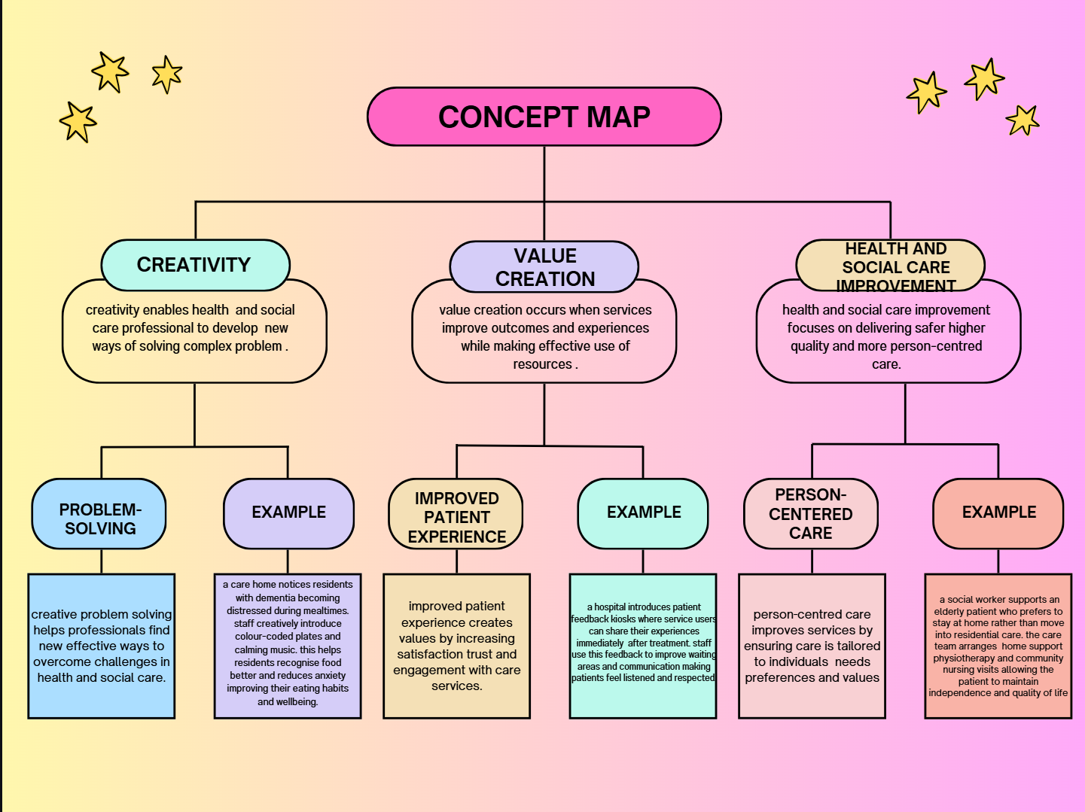
In health and social care, creativity, value creation, and improvement are intricately connected and operate as part of an ongoing cycle. Creativity is the starting point, as it involves innovative thinking, problem solving, and challenging traditional ways of working. Health and social care professionals often work in complex environments with limited resources and diverse service user needs. Creative approaches allow practitioners to develop flexible, person-centered solutions that respond effectively to these challenges.
Creativity enables value creation by transforming ideas into practices that improve outcomes and experiences for service users. In this context, value extends beyond financial efficiency and includes quality of care, patient safety, equity, dignity, and long-term wellbeing. For example, creatively redesigning care pathways or improving collaboration between services can reduce duplication, enhance continuity of care, and make better use of resources. This ensures that care is not only effective but also ethical and sustainable.
Value creation directly drives health and social care improvement. When services deliver high value, improvements are seen in care quality, access to services, and reduced health inequalities. These improvements benefit service users, families, and communities while also supporting workforce wellbeing and organizational sustainability. Importantly, improvement is supported by evaluation and learning. Reflection, audit, and feedback from service users and staff help organizations understand what works well and what needs to change.
This learning feeds back into creativity, encouraging further innovation and adaptation. Together, creativity, value creation, and improvement form a continuous cycle that supports high quality, responsive, and sustainable health and social care delivery.

Task 2 Self Reflection of Group Activity
Complete a self-Reflection on the Convergent/Divergent paperclip class activity using a reflective model (250 words, 1 source)
Please refer to Week 2 content.

In this activity I will be doing self-reflection by using Moodle. In this activity we had a group of 3 from my class we did the activity together we did the brainstorm.
- Hold papers together.
- Bookmark
- Reset button tool (phones, routers)
- Zip pulls replacement.
- Key ring
- SIM card ejector
- Money clip
- Hook for hanging decoration.
- Jewelry (ring, bracelet, earrings)
- Lock pick (theoretical/emergency context)
- Paperclip chain for crafts.
- Earing back
- Emergency zipper repair
SWOT Analysis of task two
The convergent and divergent paperclip activity provided a practical opportunity to reflect on how creative thinking develops within a structured task. Initially, my thinking was largely convergent, as I focused on familiar and obvious uses of the paperclip. This reflected a degree of functional fixedness, which limited idea generation at the early stage of the activity. As the task progressed, divergent thinking became more prominent, particularly through listening to others’ contributions and building on shared ideas. This shift increased my confidence and engagement, highlighting how creativity can be stimulated through collaboration and a supportive environment.
The activity was effective in demonstrating that creativity is a process rather than an innate ability. Generating a wide range of ideas encouraged flexibility and openness, while the convergent phase required evaluating and refining ideas to identify those that were most practical. This balance mirrors professional practice in health and social care, where practitioners must first explore multiple solutions and then select those that are safe, effective, and appropriate for service users. Time pressure helped maintain focus but also limited deeper exploration of some ideas, suggesting that creative potential can be influenced by contextual constraints.
Reflecting on the experience, I recognised the importance of psychological safety in encouraging participation. As the group became more comfortable, contributions increased in both quantity and originality. This supports the view that reflective practice enhances learning by allowing individuals to evaluate experiences and apply insights to future situations (Gibbs, 1988). Overall, the activity strengthened my understanding of how divergent and convergent thinking work together to support creativity and effective problem-solving.

Task 3 Case Study of a UK innovation
Write a concise case study analysis of an innovative project or initiative within the NHS or UK social care. Focus on how creativity was used to drive change and the value it created for patients or service users (400 words, 2 sources).
Please refer to Week 3 content
This case study explores the NHS Social Prescribing initiative, introduced to respond to the growing recognition that many health problems are linked to social factors such as loneliness, isolation, and poor mental wellbeing. The initiative sought to reduce pressure on GP services by connecting patients with community-based support, involving patients, GPs, link workers, voluntary organizations, and NHS system leaders (NHS England, 2019).
Creativity serves as the essential spark that ignites innovation, driving the transition from imaginative ideas to real world solutions. At its core, creativity involves seeing beyond existing assumptions and imagining alternatives that others might overlook. According to research, creative thinking generates innovative ideas that are both original and useful, laying the groundwork for innovation by providing raw material that can be developed into new products, services, or practices.
Creative approaches often involve leveraging new technologies, reimagining how services are delivered, and forming collaborative partnerships that combine diverse perspectives. For example, design thinking and crowdsourcing methods bring together multidisciplinary teams to brainstorm and prototype solutions, blending technological tools with human insight to overcome complex challenges. These techniques help break down rigid thought patterns and encourage experimentation with ideas that would not emerge through conventional processes.
This creativity transforms existing services by enabling organizations to rethink outdated models and adopt creative strategies. For instance, digital platforms that integrate service user feedback in real time can radically change how services are tailored and delivered, fostering responsiveness and personalization that were previously impossible. Creative thinking also helps organizations overcome barriers such as risk aversion and structural inertia by encouraging flexible mindsets and iterative testing of ideas.
Creative thinking does not just only solve problems, it reshapes practices, enabling sustained innovation that meets evolving to higher needs and drives competitive advantage.
The innovation created both tangible and intangible value for patients and the healthcare system. Tangibly, it improved accessibility by enabling remote consultations through digital platforms, reducing travel time and associated costs for patients. Health outcomes were enhanced through personalized care plans informed by real time data, leading to faster diagnosis and more effective treatments. Intangibly, patient satisfaction and engagement increased, as individuals felt more involved in their care and experienced a smoother, more responsive service. Overall, the innovation optimized resources, reduced strain on healthcare facilities, and fostered a more patient centered, efficient system.

Task 4 Research Task
Identify a current issue in health and social care (e.g., e.g., mental health stigma, access to care for vulnerable populations). Find two pieces of academic research (journal articles) that explain the reason for this problem. Paraphrase the findings of each article (300 words, 2 sources).
Please refer to week 4 content.
I am going to focus on mental health stigmas.
Mental health stigma continues to be a serious challenge in health and social care, preventing many people from seeking the support they need. Stigma often appears as negative stereotypes, prejudice, and discrimination, and it can make people feel ashamed or afraid to talk about their experiences. For those struggling with mental health conditions, this can lead to isolation, delayed treatment, and worsening symptoms, making recovery even harder.
Research shows that stigma is not just a personal issue, it is deeply embedded in society. Negative beliefs about mental illness, such as the idea that people with mental health conditions are dangerous, weak, or responsible for their struggles, are widespread. These beliefs not only shape public attitudes but can also become internalized, causing individuals to feel ashamed or hesitant to seek help. This internalized stigma can reduce confidence, limit engagement with healthcare services, and affect quality of life. (Corrigan and Watson, 2002)
Cultural and societal factors also play a key role. A study in Singapore found that misunderstandings about mental illness, social expectations, and fear of judgment reinforce stigma. People often hide their symptoms or avoid treatment because they worry about being judged by family, friends, or colleagues. Lack of mental health education and awareness contributes to these misconceptions, creating a cycle where stigma persists and access to care remains limited. (Chong et al., 2020)
Together, these findings highlight that mental health stigma is a complex problem rooted in societal attitudes and cultural beliefs. Reducing stigma requires more than just individual effort; it calls for public education, open conversations, and supportive environments that empower people to seek help without fear of judgment. Addressing stigma is essential for improving mental health outcomes and creating a more inclusive, compassionate healthcare system
Task 5 Podcast
Record a two minute Podcast introducing your idea for component 2 using https://www.rev.com/onlinevoicerecorder The MP3 audio must be downloaded and embedded as a file (see guidance video on how to do this here: https://www.youtube.com/watch?v=D21isId0agw) or an accessible OneDrive link if using a Chromebook (make accessibility – anybody) before inserting into your portfolio. Check the accessibility of the link before submitting.
Please refer to week 4 & 6 content.

C:\Users\igbin\Downloads\0b5ed9d7-df92-4e82-8b03-d2f7a469dff5.mp3

Task 6 NHS Leadership Framework Analysis
Write a short summary (200 words) explaining the key components of the NHS Leadership Framework. Then, choose one component and describe (150 words) how a leader might use it to encourage creativity and improve care in the NHS (2 sources).
Please refer to week 7’s content.
NHS leadership framework
The NHS Leadership Framework, formally referred to as the NHS Healthcare Leadership Model, sets out the key behaviours and capabilities required for effective leadership across the NHS. It is based on the principle that leadership is a shared responsibility and can be demonstrated by individuals at all levels, not only those in senior management roles. The framework consists of nine interconnected dimensions, including inspiring shared purpose, leading with care, engaging the team, evaluating information, and developing capability (NHS Leadership Academy, 2013).
Central to the framework is a strong emphasis on compassionate and inclusive leadership. Leaders are expected to place patients and service users at the heart of decision-making while also recognising the importance of staff wellbeing, engagement, and development. The model encourages leaders to work collaboratively across professional and organisational boundaries and to use evidence and reflection to inform decision-making. By promoting these behaviours, the framework aims to improve patient outcomes, enhance staff experience, and support continuous service improvement. Overall, the NHS Leadership Framework provides a practical and values-based approach to leadership that reflects the complex and people-centred nature of healthcare delivery (West et al., 2017).

Engaging the team
The “engaging the team” dimension of the NHS Leadership Framework focuses on building positive working environments where staff feel respected, supported, and motivated. Leaders who engage their teams effectively can encourage creativity by creating psychological safety, allowing staff to share ideas and challenge existing practices without fear of criticism. This is particularly important in the NHS, where frontline staff often have valuable insights into patient needs and service pressures.
By involving staff in discussions and decision-making, leaders can draw on a range of perspectives to develop creative and practical solutions to improve care. For example, encouraging multidisciplinary teamwork can lead to innovative approaches that enhance patient experience and efficiency. Engaged teams are more likely to feel valued and committed, which supports both staff wellbeing and high-quality care. Compassionate leadership has been shown to strengthen innovation, morale, and patient outcomes, highlighting its importance within NHS practice (West et al., 2017).

Task 7 Self Reflection Journal Entry
Write a short journal entry about what you learned in this module. Focus on how your understanding of creativity and value creation withing H&SC has changed and how it has informed your professional practice (200 words).
Please refer to week 9 content.
Throughout this module, my understanding of creativity and value creation within health and social care has developed significantly. At the beginning, I viewed creativity mainly as artistic expression or new ideas. However, I now recognise that creativity in health and social care is about problem-solving, innovation, and improving services in practical and meaningful ways. It involves rethinking systems, listening to service users, and finding more effective approaches to complex challenges.
I have also gained a deeper understanding of value creation. Previously, I associated value mainly with cost-effectiveness. Through this module, I learned that value in health and social care includes both tangible outcomes, such as improved efficiency and reduced waiting times, and intangible outcomes, such as dignity, compassion, and patient experience. I now appreciate how creativity directly contributes to value by enhancing quality of care and promoting person-centred practice.
This learning has influenced my professional practice by encouraging me to think more critically and proactively about improvement. I am now more aware of the importance of collaboration, co-design, and compassionate leadership in driving innovation. Overall, this module has strengthened my ability to see challenges as opportunities for creative improvement that can positively impact service users and healthcare systems.

Reference List
Amabile, T.M. (1996) Creativity in context. Boulder, CO: Westview Press.
Baines, S., et al. (2025) ‘The use of personas to involve consumers in healthcare co-design’, BMC Health Services Research.
Brown, T. (2015) ‘A design thinking framework for healthcare management and innovation’, PubMed.
Chong, S.A., Abdin, E., Vaingankar, J.A., Heng, D., Sagayadevan, V., Jeyagurunathan, A. and Subramaniam, M. (2020) ‘Determinants of public stigma towards people with mental illness in Singapore’, BMC Psychiatry, 20, p.207.
Corrigan, P.W. (2000) ‘Mental health stigma as social attribution: Implications for research methods and attitude change’, Clinical Psychology: Science and Practice, 7(1), p.48. Available at: https://psycnet.apa.org/fulltext/2000-13942-004.html (Accessed: 10 February 2026).
Corrigan, P.W. and Watson, A.C. (2002) ‘Understanding the impact of stigma on people with mental illness’, World Psychiatry, 1(1), pp.16–20.
Crisp, A.H., Gelder, M.G., Rix, S., Meltzer, H.I. and Rowlands, O.J. (2000) ‘Stigmatisation of people with mental illnesses’, The British Journal of Psychiatry, 177(1), pp.4–7.
Guilford, J.P. (1967) The nature of human intelligence. New York: McGraw Hill.
Henderson, C., Noblett, J., Parke, H., Clement, S., Caffrey, A., Gale-Grant, O., … Thornicroft, G. (2014) ‘Mental health-related stigma in health care and mental health-care settings: literature review’, The British Journal of Psychiatry, 204(3), pp.145–152.
Lee, Y.S.H., et al. (2023) ‘Leveraging patients’ creative ideas for innovation in health care’, PubMed.
Mental Health Foundation (2022) Stigma and discrimination. Available at: https://www.mentalhealth.org.uk/a-to-z/s/stigma-and-discrimination (Accessed: 10 February 2026).
NHS (2021) Innovation and improvement in health and care. London: NHS England.
NHS (2023) Artificial Intelligence. [online] NHS Transformation Directorate. Available at: https://transform.england.nhs.uk/information-governance/guidance/artificial-intelligence/#:~:text=Examples%20of%20AI%20which%20are (Accessed: 27 February 2024).
NHS Leadership Academy (2013) The NHS healthcare leadership model. London: NHS Leadership Academy.
Porter, M.E. (2010) ‘What is value in health care?’, New England Journal of Medicine, 363(26), pp.2477–2481.
Reavley, N.J. and Jorm, A.F. (2011) ‘Stigmatizing attitudes towards people with mental disorders: findings from an Australian national survey of mental health literacy and stigma’, Psychiatry Research, 189(3), pp.419–425.
Runco, M.A. and Jaeger, G.J. (2012) ‘The standard definition of creativity’, Creativity Research Journal, 24(1), pp.92–96.
West, M., Eckert, R., Collins, B. and Chowla, R. (2017) Caring to change: How compassionate leadership can stimulate innovation in health care. London: The King’s Fund.
World Health Organization (WHO) (2020) Global strategy on digital health 2020–2025. Geneva: WHO.
Brown, T. (2015) ‘A design thinking framework for healthcare management and innovation’, PubMed.
Guilford, J.P. (1967) The nature of human intelligence. New York: McGraw Hill.
Lee, Y.S.H., et al. (2023) ‘Leveraging patients’ creative ideas for innovation in health care’, PubMed.
National Health Service (NHS) (2021) Innovation and improvement in health and care. London: NHS England.
World Health Organization (WHO) (2020) Global strategy on digital health 2020–2025. Geneva: WHO.

