University of Wales Trinity Saint David
Wales Institute of Science & Art

2D Transient Heat Equation Solved With
Explicit Finite Difference Method (Report)
Computational Methods (ACMA6012)

Ryan lewis
2318511
February 2026

Table of Contents
List of Tables and Figures 3
Chapter 1: Introduction 4
Chapter 2: Governing Equation 4
2.1 Background of the Heat Equation 4
2.1.1 Importance of Numerical Methods for PDEs 4
2.2 Mathematical Formulation 5
2.3 Physical Assumptions 6
Chapter 3: Finite Difference Method 6
3.1 Introduction to Finite Difference Approximations 6
3.1.1 Taylor Series Expansions for Derivatives 6
3.2 Finite Difference Schemes: Forward, Backward, and Central Approximations 7
3.3 Truncation Error in Finite Difference Approximations 8
3.4 Discretisation of Spatial and Temporal Domains 8
3.4.1 Uniform Grid Spacing: h=x=y 8
3.4.2 Time Stepping: t 9
3.4.3 Nomenclature: Ti, jn 9
The notation Ti, jn represents the temperature at grid point (i,j) at time level n, corresponding to time t=n.t (LeVeque, 2007). 9
3.5 Formulation of the Explicit Finite Difference Method 10
3.5.1 Forward Time Central Space (FTCS) Scheme 10
3.5.2 Discretised Equation 10
3.5.3 Temporal Derivative (Forward Difference) 10
3.5.4 Spatial Derivatives (Central Difference) 11
3.6 Fourier Number and Stability Criterion 11
Chapter 4: Initial Condition, Boundary Conditions and Analytical Solution 12
4.1 Initial and Boundary Conditions 12
4.2 Analytical Solution 13
Chapter 5: Codes’ Details and Explanations 14
5.1 MATLAB Script Overview 14
5.2 Section-by-Section Explanation 14
Chapter 6: Validation of the Model 19
6.1 Visual Comparison 19
6.2 Quantitative Error Analysis 19
6.3 Discussion of Agreement 20
Chapter 7: Sensitivity Analysis of Key Numerical Parameters 21
7.1 Parameter Variation Strategy 21
7.2 Results Presentation 21
7.2.1 Effect of Grid Spacing on Equilibrium Time 21
7.2.2 Influence of Time Step (Δt) 23
7.2.3 Influence of Convergence Tolerance (CC) 25
Chapter 8: Limitations of the Numerical Model 26
Chapter 9: Suggested Improvements and Future Developments 27
Chapter 10: Conclusion 28
Chapter 11: References 29
Appendix 33

List of Tables and Figures
Tables
Table 1: Table of control parameters and variable grid spacing.
Table 2: Table of control parameters and variable time step
Table 3: Table of control parameters and variable tolerances.

Figures
Figure 1: 2D transient heat equation
Figure 2: Compact 2D transient heat equation
Figure 3: Taylor series expansion formula
Figure 4: The Maclaurin series equation
Figure 5: Forward, backward and central difference equations
Figure 6: Image of the nodes for discretisation of 2D heat equation
Figure 7: Forward and central differences substituted into the original heat equation
Figure 8: The discretised equation for EFD scheme for the 2D heat equation
Figure 9: The first order forward difference scheme
Figure 10: Spatial derivatives for the central difference scheme
Figure 11 Fourier number equation
Figure 12: Initial domain conditions
Figure 13: The set boundary conditions with Dirichlet on all edges
Figure 14: Analytical equation for the temperature field at thermal equilibrium
Figure 15: Heat maps of numerical and analytical time to reach thermal equilibrium and the maximum errors.
Figure 16: Screenshot of the outputs from the Matlab simulation
Figure 17: Calculations for relative accuracy of the maximum absolute error and RMS error.
Figure 18: Thermal equilibrium time (s) vs. Grid spacing
Figure 19: Thermal equilibrium time (s) vs. Time step
Figure 20: Thermal equilibrium time (s) vs. Tolerance

Chapter 1: Introduction
This report shows and analyses a numerical model for solving the transient heat conduction equation in two dimensions. The explicit Finite Difference Method (FDM) shows heat transfer across a rectangular aluminium plate using the Forward Time Central Space (FTCS) scheme. A complete MATLAB script includes material properties, discretisation, and boundary conditions. A traditional analytical solution compares steady-state outputs to verify the model's accuracy. A sensitivity analysis examines how numerical parameters like grid spacing, time step, and convergence tolerance affect solution stability and computational efficiency. Practical application, validation, and limitations of a fundamental computational method for solving parabolic partial differential equations are shown in this work.

Chapter 2: Governing Equation

2.1 Background of the Heat Equation
Fourier’s heat conduction equation, formulated in the early 19th century, fundamentally changed the understanding of heat transfer in solids. Despite initial controversy, it became a versatile model for diffusion processes driven by gradients, directly influencing Darcy’s law for groundwater, Fick’s laws for chemical diffusion, and Ohm’s law for electrical current (Narasimhan, 1999). Today, it serves as a common mathematical language across disciplines—from geophysics to materials science—linking the transport of heat, mass, and charge in physical and engineered systems (Narasimhan, 1999).

2.1.1 Importance of Numerical Methods for PDEs
Numerical methods become essential for solving PDEs under complex conditions, such as irregular geometries, transient behaviours, or multiple dimensions, where analytical solutions are unavailable. They offer strong computational frameworks for simulating physical phenomena like transient heat transfer, facilitating practical engineering analysis and design (Ferziger & Perić, 2002).

2.2 Mathematical Formulation
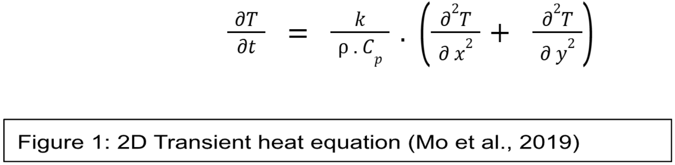
In practice, numerical methods are used to solve two-dimensional, transient heat conduction equations. This equation comes from an energy balance on a differential element. As shown in Chapter 5 of Two-Dimensional and Transient Heat Conduction (Mo et al. 2019), the finite difference method is often used to change the governing equation into a form that can be solved by a computer.

Definition of terms:
- T (temperature ℃),
- t (time seconds),
- k (Thermal conductivity W/m·°C (or W/m·K),
- p (density kg/m³),
- Cp (Specific heat capacity (J/kg·°C or J/kg·K))
- x,y (spatial coordinates).
The governing equation for transient heat conduction is often expressed in the compact form:

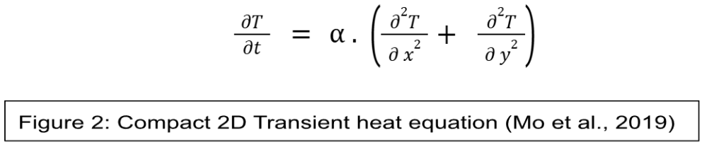

In this equation, $α$ is the thermal diffusivity, a key material property defined as the ratio of thermal conductivity where $α=\frac{k}{ρ . C_{p}}$. Thermal diffusivity, α, gauges how quickly a material responds to heat flow by comparing its ability to conduct heat to its ability to store it. In essence, while thermal conductivity indicates how much heat is transferred, α determines how fast the temperature changes (Bergman et al., 2011; Mo et al., 2019).

2.3 Physical Assumptions
Some assumptions were made during this experiment. These being that there were:
- Uniform material properties
- No internal heat generation
Although using these will give excellent repeatability and allow the experiment to be more easily solvable, it also limits the accuracy of real-world results.

Chapter 3: Finite Difference Method

3.1 Introduction to Finite Difference Approximations
Finite difference approximations provide a foundational technique for solving differential equations numerically by replacing derivatives with difference expressions at discrete points (Burden et al., 2016). The approach is built upon Taylor series expansions, which allow a function to be expressed as an infinite sum of its derivatives at a given point.

3.1.1 Taylor Series Expansions for Derivatives
The Taylor series for a function T(x) about a point x is
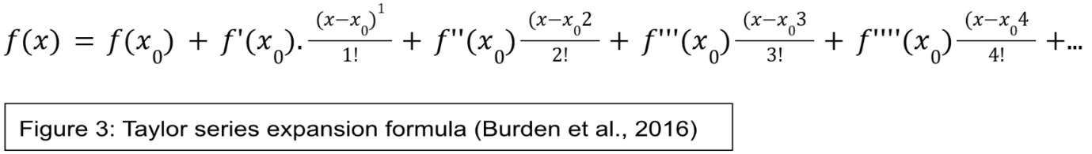
When expanded around zero, this becomes a Maclaurin series, simplifying the polynomial while preserving accuracy (Jacquemin et al., 2020).
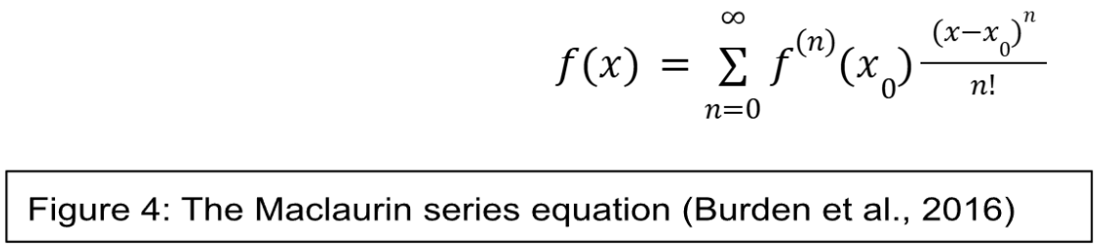

These expansions enable the estimation of first and second derivatives, forming the basis for discretising partial differential equations such as the heat equation.

3.2 Finite Difference Schemes: Forward, Backward, and Central Approximations
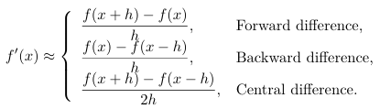
Continuous derivatives are approximated using values at neighbouring grid points through three primary schemes:

Figure 5: Forward, backward and central difference equations (Kvaerno, 2020)
- Forward difference: uses the current and next node.
- Backward difference: uses the current and previous nodes.
- Central difference: uses points on both sides, achieving higher accuracy.
Both forward and backward differences are first-order accurate, while the central difference is second-order accurate (Suárez-Carreño & Rosales-Romero, 2021). For diffusion problems like the heat equation, the central difference is often preferred due to its improved accuracy.

3.3 Truncation Error in Finite Difference Approximations
Truncation error arises when continuous differential operators are replaced with discrete approximations, which truncates the Taylor series (Jacquemin et al., 2020). The order of accuracy determines the error scaling:
- Forward/backward differences have truncation error $O(h)$ (first-order)
- Central difference has truncation error $O(h^{2})$(second-order) (Kvaerno, 2020)
This error accumulates in time-dependent simulations, making scheme selection a balance between accuracy, stability, and computational efficiency (Suárez-Carreño & Rosales-Romero, 2021).

3.4 Discretisation of Spatial and Temporal Domains

3.4.1 Uniform Grid Spacing: $h=Δx=Δy$
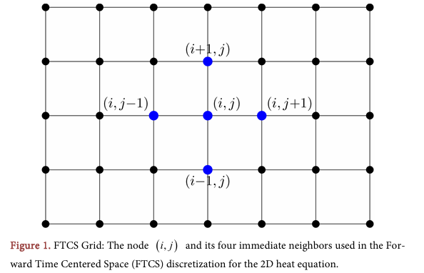
A uniform computational grid covers the plate’s continuous spatial domain (Langtangen, 2016). The physical location is given by $x=i.h$ and $y=j.h$, where i and j are integer indices.

Figure 6: Node (i, j) and four neighbours used for discretionisation for the 2D heat equation. (Haque et al. 2025)

The temperature at each grid point (i, j) depends on its four immediate neighbours—above, below, left, and right. Using the central difference method, spatial derivatives are estimated (Haque et al., 2025).

3.4.2 Time Stepping: $Δt$
Time is divided into discrete, uniform steps to track temperature evolution (HackMD, 2025). The time step Δt must be small enough to capture the solution’s behaviour while maintaining stability.

3.4.3 Nomenclature: $T_{i, j}^{n}$

The notation $T_{i, j}^{n}$ represents the temperature at grid point (i,j) at time level n, corresponding to time $t=n.Δt$ (LeVeque, 2007).

3.5 Formulation of the Explicit Finite Difference Method

3.5.1 Forward Time Central Space (FTCS) Scheme
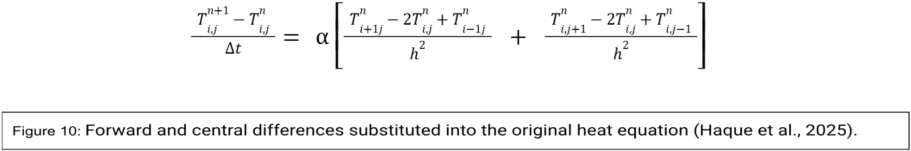
In the FTCS method, the time derivative is approximated with a forward difference,
Figure 7: Forward and central differences substituted into the original heat equation (Haque et al. 2025)

and spatial derivatives with a central difference.
This leads to an explicit update formula that computes future values directly from current ones (Flyriver, 2020).

3.5.2 Discretised Equation
In the FTCS discretisation, the time derivative is replaced with a forward difference scheme, while the spatial derivatives are approximated using central differences (Imperial College, London, 2020). This is shown as:
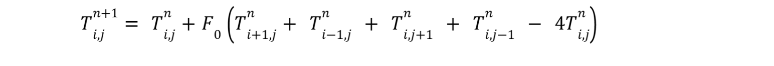
Figure 8: The discretised equation for EFD scheme for the 2D heat equation
Where $F_{o}$ is the Fourier number.

3.5.3 Temporal Derivative (Forward Difference)
The temporal derivative is approximated using a first-order forward difference:
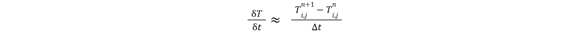
This approximation has a truncation error of $O(h)$ (Haque et al., 2025).
Figure 9: The first order forward difference scheme (Haque et al. 2025)

3.5.4 Spatial Derivatives (Central Difference)
The spatial derivatives are approximated using second-order central differences:
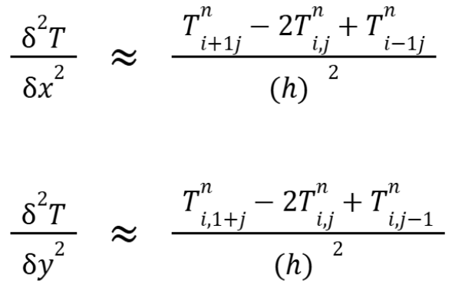
Figure 10:: Spatial derivatives for the central difference scheme (Haque et al. 2025)
These approximations have truncation errors of $O (h^{2})$ (Haque et al., 2025).
The forward and central differences can then be substituted into the original heat equation to provide the following explicit finite difference equation:

3.6 Fourier Number and Stability Criterion
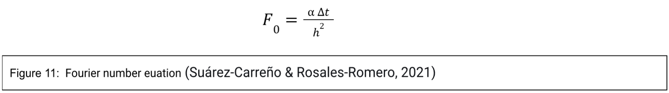
The Fourier number $F_{o}$ is an important dimensionless parameter that controls the balance between time and space discretisation, defined as:
For stability in the explicit scheme, the condition $F_{o}≤0.25$ must be satisfied (Suárez-Carreño & Rosales-Romero, 2021). This ensures that numerical errors do not amplify, maintaining a physically meaningful solution and avoiding oscillations or divergence.
Von Neumann stability analysis examines numerical scheme error spread (Lam & Yeung, 2002). Once it is found from material properties (e.g., aluminium $α≈6.42x10^{-5}m^{2}/s$), the time step must be small enough compared to the grid spacing h to keep $F_{0}$ within this limit.
When you introduce the Fourier number and rearrange the heat equation above, you get the discretised equation.

Chapter 4: Initial Condition, Boundary Conditions and Analytical Solution

4.1 Initial and Boundary Conditions
To obtain a well-posed solution to the 2D transient heat equation, specific initial and boundary conditions must be defined (Sabitov, 2015). The following conditions were implemented, consistent with the coursework specification.
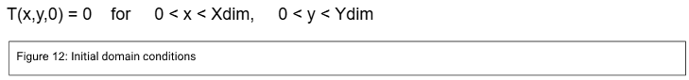
Initial Condition:
A uniform temperature of 0°C is prescribed across the entire aluminium plate at t=0,
This is implemented in the code by initialising the temperature matrix to zero.
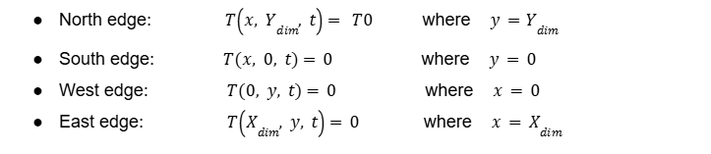
Boundary Conditions (Dirichlet on all edges):
Figure 13: The set boundary conditions with Drichlet on all edges

Where ${ T}_{0}$ is a defined constant temperature set to 50℃. These are enforced in the code by allocating the respective values to the temperature matrix's rows and columns at each time step.
These Dirichlet conditions were chosen because they work well for a classical heat conduction problem with a closed-form steady-state solution that uses the separation of variables method (Ozışık, 2013; Press et al., 2007). A clear standard for checking the numerical results of the Explicit Finite Difference Method (EFDM). This makes it possible to compare the numerical and analytical results, which is great for validating the code.

4.2 Analytical Solution
The following infinite Fourier series solution provides the steady-state temperature distribution at thermal equilibrium for the boundary conditions given in Section 4.1, which is used to validate the numerical model (Ozışık, 2013; Press et al., 2007):
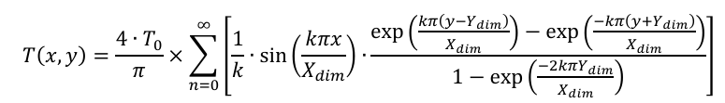
Figure 14: Analytical equation for the temperature field at thermal equilibrium (Ozışık, 2013; Press et al., 2007)
where k=2n+1.
Within the MATLAB script, this series is approximated by truncating the sum after a sufficiently large number of terms (NTerms=10,000) to ensure convergence to within machine precision across the entire grid. This analytical result serves as the critical benchmark for validating the numerical model's output in Chapter 6.

Chapter 5: Codes’ Details and Explanations

5.1 MATLAB Script Overview
This script provides a complete implementation for simulating 2D transient heat conduction. It follows a linear workflow: it configures the problem, executes the explicit finite-difference solver, calculates an exact solution for validation, and finally compares and visualises the results.

5.2 Section-by-Section Explanation
1: Workspace Management: This clears the command window, closes old figures, and removes any variables that were set in previous runs.
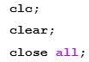
2: Material Property Definition: The constant thermal properties of aluminium are used to determine thermal diffusivity.
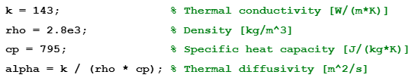
3: Geometry and Spatial Discretisation Input: This section defines the uniform grid spacing (h) and physical plate dimensions (X_dim, Y_dim). This requires direct input of values when running the simulation. The code checks that h is positive, divides equally into dimensions, and is smaller than dimensions.
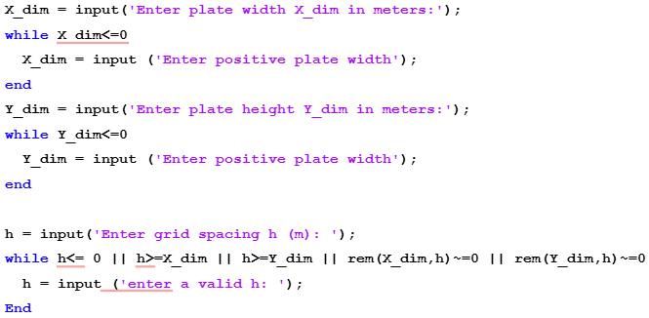
4. Grid construction: The computational grid's rows (NR) and columns (NC) depend on plate size and spacing (h). The size of the temperature matrices is determined. The North edge boundary temperature (T0) will require a value when the simulation is run.
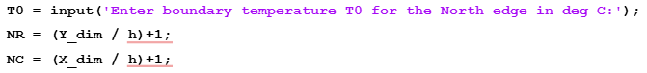
5: Initial Condition and Boundary Application: Zeroing the temperature matrix T1 meets the first condition. To satisfy the Dirichlet condition on the North edge, every node in the first row of T1 is assigned T0, except for the corners.
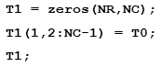
6: Temporal Discretisation Input : The maximum stable time step (dtMAX) is calculated in this section to prevent simulation instability.
7: Solver Matrix Initialisation: The time step (dt) must be positive and less than (dtMAX).
In addition, T2 = T1 means T1 is copied to create T2. The current time step values are in T1, and the next step values are in T2.
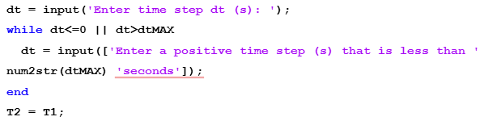
8: Convergence Criterion Setup : Set a convergence tolerance (CC, 0.01 °C). MaxDiff is set above CC to ensure the solver loop runs at least once.
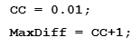
9: Explicit Solver Loop: This is the simulation's main part. The (while) loop runs until the plate's maximum temperature change meets the convergence condition (MaxDiff > CC). Each iteration passes through all plate interior grid points in two nested (for) loops. The new temperature at each point is calculated from the four surrounding temperatures. The code searches for the grid's largest temperature change after updating all inside points. The temperature matrix is updated, and the process repeats until the maximum change is less than the convergence criterion in Section 8. Thermal equilibrium has been reached.
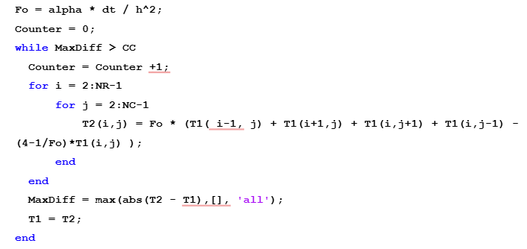
10: Analytical solution computation: For numerical model verification, the steady-state analytical solution is a matrix TA. Truncated sums (N_terms = 10,000) in a triple-nested "for" loop verify infinite series solutions at each grid point.
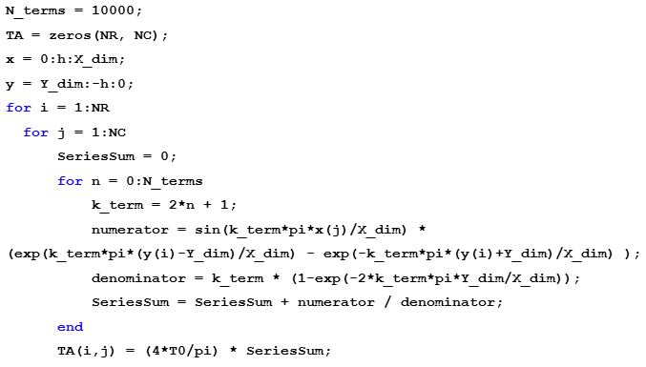
11: Validation and Error Analysis: The analytical (TA) and numerical (T2) solutions are compared. This calculates an absolute error matrix. The RMSE and maximum absolute error are calculated and shown.
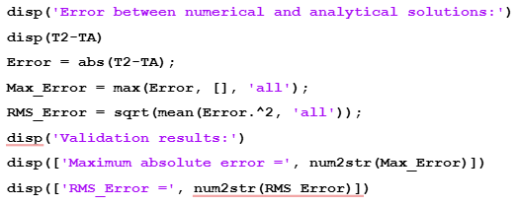
12: Results and Output Visualisation: Total equilibrium time is calculated and shown in correct units. The spatial error distribution, analytical solution, and numerical solution filled contours are shown in one figure by the script [Appendix 2].
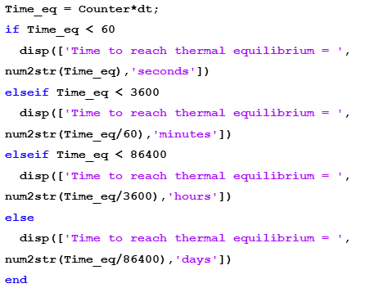

.

Chapter 6: Validation of the Model

6.1 Visual Comparison
The steady-state temperature field obtained from the EFDM is visually compared with the analytical benchmark (Ozışık, 2013; Press et al., 2007) in Figure 14. Both contour plots exhibit nearly identical heat diffusion patterns from the heated North edge, indicating strong qualitative agreement.
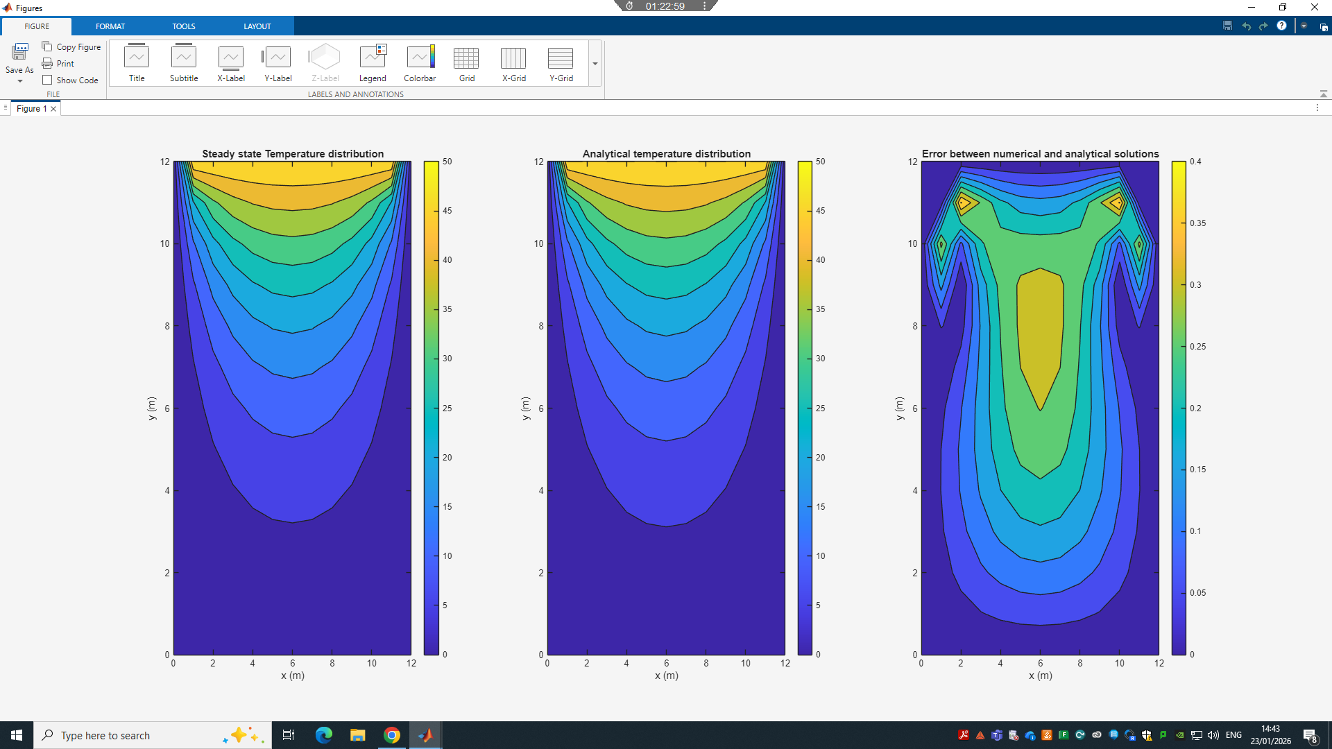
The spatial distribution of the absolute error between the two solutions (Figure 15, right subplot) shows deviations spread uniformly across the domain without concentration in specific regions. This pattern indicates no signs of numerical instability or systematic error, affirming the model's stability in line with established validation practices (Simões et al., 2012).
Figure 15: Heat maps of numerical and analytical time to reach thermal equilibrium and of the maximum eros.

6.2 Quantitative Error Analysis
Two standard metrics, which can be seen in Figure [15], are calculated directly from the code's output to quantify the agreement.
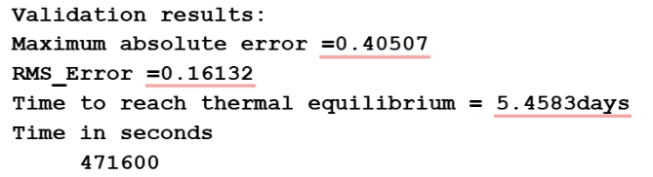

Figure 16: Screenshot of the outputs from the Matlab simulation

Two standard error metrics taken directly from the code output are used to measure the difference between the numerical and analytical solutions:
- Maximum Absolute Error: 0.40507°C
- Root Mean Square Error (RMSE): 0.16132°C
Relative to the 50°C boundary condition and the resulting temperature range across the plate, these errors correspond to relative accuracies of 99.2% (maximum) and 99.7% (RMS), confirming a high degree of numerical precision.
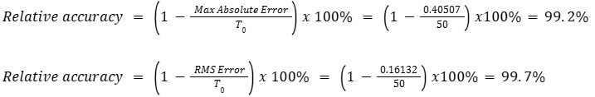
Figure 17: Calculations for relative accuracy of the maximum absolute error and RMS error

6.3 Discussion of Agreement
The close match between numerical and analytical results confirms the solver's reliability. Code verification typically involves this type of comparison against an exact solution (Burden et al., 2016). The methodology is consistent with validation techniques employed in other quantitative research, including the independent replication and error analysis conducted by Mitchell (2018). The steady-state heat equation with Dirichlet conditions is the standard here. The strong match shows that the code is correct and the discretisation scheme is reliable, both of which are important for building trust in the model's accuracy.

Chapter 7: Sensitivity Analysis of Key Numerical Parameters

7.1 Parameter Variation Strategy
The model was tested for robustness and reliability using a systematic local sensitivity analysis. A reliable numerical model should respond predictably and understandably to control parameter changes (Saltelli et al., 2008. pp 1-10). This analysis focused on three user-defined parameters that affect solution accuracy, stability, and computational cost:
- Grid Spacing (h).
- Time Step (Δt).
- Convergence Tolerance (CC).
A series of simulations were run on a 12 m × 12 m aluminium plate, varying one parameter while maintaining the other two constants as per the assignment brief. Thermal equilibrium time (in seconds) was the main output, which indicates computational cost and depends on scheme accuracy and stability.

7.2 Results Presentation

7.2.1 Effect of Grid Spacing on Equilibrium Time
The predicted equilibrium time decreased as the grid was refined from 4.0 m to 3.0 m, as shown in Table 1. Although further refinement increased the number of computational points, the equilibrium time stabilised at 373,500 seconds beyond 2.0m despite further refinements.

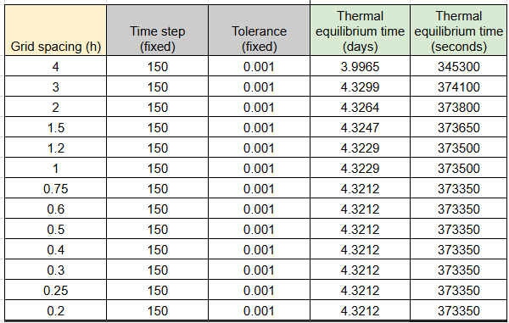
Table 1: Table of control parameters and the output of thermal equilibrium time (s) with variable grid spacing.

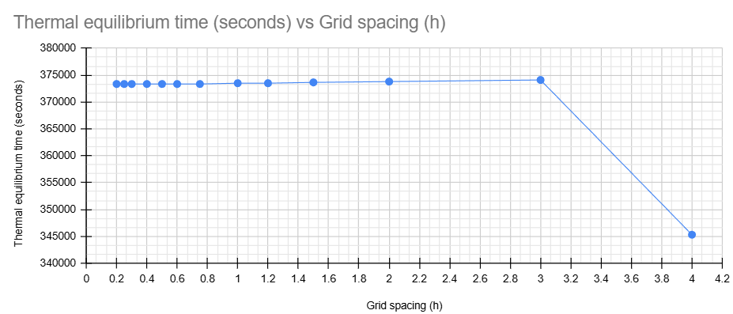
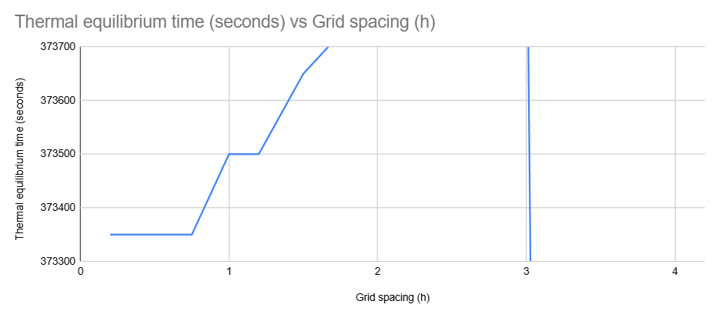
Figure 18: Thermal equilibrium time (s) vs Grid spacing (h), and a closer image of the chart to show the steps.
The findings demonstrate grid independence, an essential principle in numerical analysis. Coarse grids lead to notable spatial truncation errors, resulting in the model rapidly converging to an incorrect steady state. (Burden et al., 2016). This causes the model to rapidly reach an incorrect steady state. Refining the grid beyond a certain threshold effectively reduces the truncation error, but further refinement yields diminishing returns, increasing computational expenses without enhancing accuracy (Jacquemin et al., 2020). The approach of adjusting the grid to achieve a stable and efficient solution is fundamental to verifying solutions (Babuska & Oden, 2004; Chowdhury et al., 2021). The optimal grid spacing for this problem lies between 1.0 m and 2.0 m, striking the right balance between accuracy and speed.

7.2.2 Influence of Time Step (Δt)
A larger time step (Δt) results in a longer predicted time to reach thermal equilibrium. For example, the equilibrium time was reduced by almost 75% when Δt was decreased from 2000 s to 25 s.
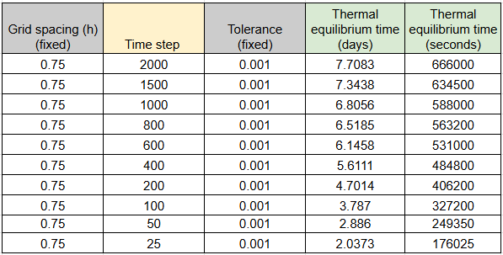
Table 2: Table of control parameters and the output of thermal equilibrium time (s) with variable Time step

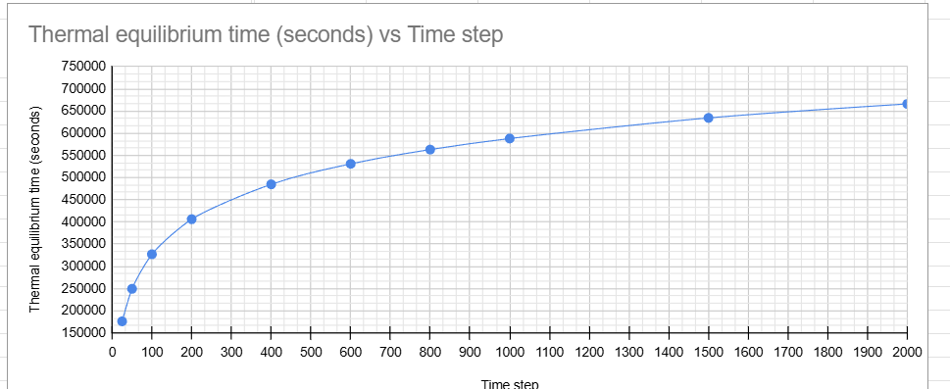
Figure 19: Thermal equilibrium time (s) vs Time step

Understanding the two main numerical error sources explains this trend. The truncation error from forward-difference time discretisation increases with step size, specifically O(Δt) (Burden et al., 2016). A high Δt causes numerical solutions to drift and oscillate around the steady state due to increased error at each step. Ferziger and Perić (2002) found that numerical diffusion delays convergence even when the stability criterion is met.
Lower time steps reduce this truncation error and improve per-step accuracy, but they take many more steps to reach physical time. This increases the potential for accumulated roundoff error, but in this simulation it was minor compared to truncation error (Burden et al., 2016).

7.2.3 Influence of Convergence Tolerance (CC)
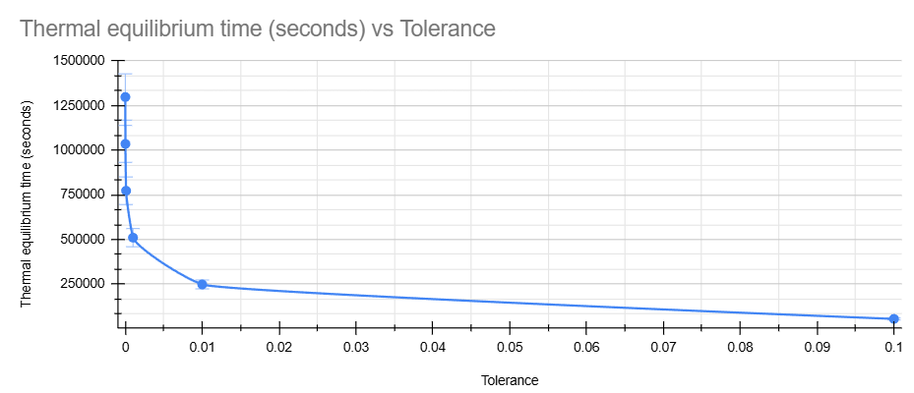
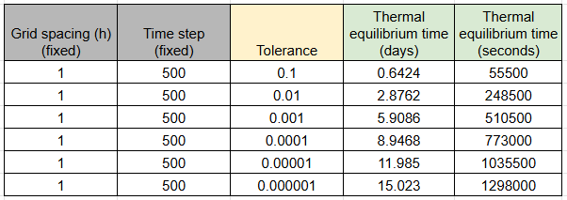
Convergence tolerance (CC) significantly impacts the computational time. When the tolerance is reduced, simulation time increases dramatically. Tolerance relaxation from 0.001 to 0.1 decreased equilibrium time from 510,500 to 55,500 s, while tightening it to 1×10⁻⁶ increased it to nearly 1.3 million seconds.
Figure 20: Thermal equilibrium time (s) vs Tolerance
Table 3: Table of control parameters and the output of thermal equilibrium time (s) with variable Tolerance
This result comes from code equilibrium detection. A standard convergence-checking approach (Ferziger & Perić, 2002) is used to run the simulation until the maximum temperature change across the grid between iterations falls below the tolerance.
A loose tolerance stops the simulation quickly, but the steady state may be far off. A strict tolerance requires the calculation to continue until the numbers barely change, wasting large amounts of computational power for little gain. It also takes too much computing time to get the final accuracy.

Chapter 8: Limitations of the Numerical Model
The practical insights from the sensitivity analysis in Chapter 7 make it clear what the main problems are with our EFDM model. The method has built-in trade-offs between speed, accuracy, and usefulness.
To begin with, truncation error is a major problem with the model. The study of grid spacing shows that coarse grids (like h=4.0m) give a quick but inaccurate equilibrium time (about 345,300 seconds). On the other hand, refining the mesh makes the time more accurate but takes longer. After a certain point (h ≤ 2.0m), the result stabilises, showing the law of diminishing returns: more refinement only adds cost, not accuracy. This behaviour reflects the second-order spatial accuracy of the central difference scheme, where truncation error scales as O(h²) and is an example of the classic trade-off between accuracy and efficiency in numerical analysis (Babuska & Oden, 2004).
The Fourier criterion (Fo ≤ 0.25) enforces a stricter condition called conditional stability. This makes the time step tiny, which slows down the simulation. Even with this limit, the analysis of Δt shows that using larger time steps leads to numerical diffusion (Ferziger & Perić, 2002), which alters the heat flow and, surprisingly, makes the simulation take longer to finish (for example, 666,000 seconds for Δt=200). Round-off error is another inherent limitation, particularly when very small time steps or tight convergence tolerances are used. In the present model, the sensitivity analysis indicates that round-off error remains secondary to truncation error, as reducing Δt continued to improve convergence without introducing numerical noise. However, for extremely strict tolerances (CC ≤ 10⁻⁶), the large number of iterations increases the potential for floating-point accumulation, making further accuracy gains unlikely (Burden et al., 2016).
Furthermore, our code’s equilibrium detection—checking against a set tolerance (CC)—is a practical but non-physical interim solution. The tolerance analysis makes it very clear that this criterion is arbitrary: a strict value (1×10⁻⁶) needs a lot of computation (about 1.3 million seconds) for very little gain, while a loose one (0.1) could stop too soon (55,500 s). As a result, numerical convergence (defined by CC) is not equivalent to physical steady state but merely a user-defined stopping condition (Ferziger & Perić, 2002). It is limited to simple geometries. The present model’s rectangular domain avoids this issue, but the method would struggle to represent curved boundaries or irregular features without severe step errors, which would introduce additional spatial discretisation error (Jacquemin et al., 2020).
Finally, the model's simple shape and materials make it hard to use in real life. It can only work with basic rectangular domains that have the same properties and simple boundaries. In the real world, dealing with complicated shapes, internal heat sources, or materials that change their properties would require a more advanced method (Jacquemin et al., 2020). This shows that this model is a useful but limited way to learn.

Chapter 9: Suggested Improvements and Future Developments
The model's problems, like the conditional stability constraint and simple geometry, make it clear where improvements can be made. The strict stability requirement $F_{o}≤0.25$ could be relaxed by adopting implicit methods like Crank-Nicolson, which offers unconditional stability. This method is always stable and gets second-order accuracy in both time and space, which makes it more accurate and faster. This is a big step forward because implicit methods like Crank-Nicolson get second-order temporal accuracy, while explicit methods (FTCS) usually only get first-order accuracy in time. This makes a big difference in how quickly they converge and how much error they build up (Suárez-Carreño & Rosales-Romero, 2021; Haque et al., 2025). The Alternating Direction Implicit (ADI) method, which breaks each time step down into simpler 1D solves, is a powerful alternative for even more efficient computation in 2D/3D problems (Ferziger & Perić, 2002).
To solve real-world engineering problems that involve complicated shapes or different types of materials, you need to go beyond the Finite Difference Method (FDM). The Finite Volume Method (FVM) is often the better choice because it naturally retains quantities like energy and mass the same, which makes the results more accurate and stable. This is especially true on coarser grids where FDM can fail (Liu et al., 2013). The Finite Element Method (FEM) is the most flexible way to model complex shapes or coupled physics, such as thermal stress in a casting. It works with unstructured meshes and supports multi-physics analysis directly (Si et al., 2003). Alternatively, for problems with infinite boundaries, the Boundary Element Method (BEM) can reduce computational costs by only discretising the surface (Shefrin, 2025). It depends on the geometry, how the material behaves, and the balance between speed and accuracy.
Finally, we could physically strengthen the model's ability to find equilibrium based on an arbitrary temperature tolerance. A more advanced method is to use entropy production as a way to validate the results. Studies show that a stable entropy production profile is strongly linked to an accurate, physically consistent steady-state solution. This is a more fundamental criterion than just a change threshold (Brohi et al., 2017). Adding a physics-based check like this would make the model much more reliable for complicated situations.

Chapter 10: Conclusion
This report has effectively demonstrated the application of the EFDM to solve the 2D transient heat equation. The MATLAB model used gave reliable results that were backed up by a strong agreement with a classical analytical solution. Sensitivity analysis was very helpful because it showed how important it is to find the right balance between computational cost, accuracy, and stability, which can be affected by things like grid spacing and time step. The model's limitations stem from its simplicity and conditional stability; nevertheless, it offers a solid basis for comprehending fundamental numerical principles. The study demonstrates that in computational engineering, achieving a dependable simulation necessitates a meticulous equilibrium between theoretical approaches and practical considerations of speed and precision.

Chapter 11: References
Babuska, I. and Oden, J.T. (2004). Verification and validation in computational engineering and science: basic concepts. Computer Methods in Applied Mechanics and Engineering, 193(36-38), pp.4057–4066. doi:https://doi.org/10.1016/j.cma.2004.03.002. [Accessed 20 Jan. 2026].
Bergman, T.L., Lavine, A.S., Incropera, F.P. and DeWitt, D.P. (2011). Fundamentals of Heat and Mass Transfer. 7th ed. [Online]. Hoboken, NJ: John Wiley & Sons. Available at:https://www.google.co.uk/books/edition/Fundamentals_of_Heat_and_Mass_Transfer/vvyIoXEywMoC?hl=en&gbpv=1&dq=Bergman [Accessed 28 Jan. 2026].
Brohi, A., Zhang, H., Kossi Min-Dianey, Rafique, M., Hassan, M. and Farooqi, S. (2017). Validation of accuracy and stability of numerical simulation for 2-D heat transfer system by an entropy production approach. Thermal Science, 21(suppl. 1), pp.97–104. doi:https://doi.org/10.2298/tsci17s1097b. [Accessed 28 Jan. 2026].
Burden, R.L., Faires, J.D. and Burden, A.M. (2016) Numerical Analysis. 10th ed. Boston, MA: Cengage Learning.
Chowdhury, T.A., Islam, T., Mujahid, A.A. and Ahmed, Md.B. (2021). The Periodicity of the Accuracy of Numerical Integration Methods for the Solution of Different Engineering Problems. Journal of Engineering Advancements. doi:https://doi.org/10.38032/jea.2021.04.006. [Accessed 18 Jan. 2026].
Croft, D.R. and Lilley, D.G. (1977). Heat Transfer Calculations using the Finite Difference Equations. London: Applied Science Publishers Ltd.
Ferziger, J.H. and Perić, M. (2002). Computational Methods for Fluid Dynamics. 3rd rev. ed. Berlin: Springer. Available at: [Accessed 23 Jan. 2026].
Flyriver (2020). Article about Forward Time Central Space Ftcs. [Online]. Available at: https://www.flyriver.com/g/forward-time-central-space-ftcs [Accessed 22 Jan. 2026].
HackMD (2025). Finite Difference Methods for SPDEs with code snippets | ViaDean - HackMD. [Online]. Available at: https://hackmd.io/@Cross-Field/code_fdm_spdes [Accessed 22 Jan. 2026].
Haque, M.N., Akter, R. and Mojumder, M.S.H. (2025). An Efficient Explicit Scheme for Solving the 2D Heat Equation with Stability and Convergence Analysis. Journal of Applied Mathematics and Physics, 13(07), pp.2234–2244. doi:https://doi.org/10.4236/jamp.2025.137127. [Accessed 25 Jan. 2026].
Imperial College London (2020). FTCS scheme — ESE Jupyter Material. [Online]. Available at: https://primer-computational-mathematics.github.io/book/c_mathematics/numerical_methods/7_FTCS.html [Accessed 25 Jan. 2026].
Jacquemin, T., Tomar, S., Agathos, K., Mohseni-Mofidi, S. and Bordas, S.P.A. (2020). Taylor-series expansion based numerical methods: a primer, performance benchmarking and new approaches for problems with non-smooth solutions. Archives of Computational Methods in Engineering, 27(5), pp.1465–1513. doi:https://doi.org/10.1007/s11831-019-09357-5. [Accessed 25 Jan. 2026].
Kvaernø, A. (2020). Lecture notes for TMA4125/4130/4135 Mathematics 4N/D Partial differential equations and finite difference methods. [Online]. Available at: https://wiki.math.ntnu.no/_media/tma4130/2020h/pde.pdf [Accessed 24 Jan. 2026].
Lam, T.T. and Yeung, W.K. (2002). A NUMERICAL SCHEME FOR NON-FOURIER HEAT CONDUCTION, PART II: TWO-DIMENSIONAL PROBLEM FORMULATION AND VERIFICATION. Numerical Heat Transfer, Part B: Fundamentals, 41(6), pp.543–564. doi:https://doi.org/10.1080/10407790190053770. [Accessed 24 Jan. 2026].
Langtangen, H.P. and Linge, S. (2017). Finite Difference Computing with PDEs. [Online]. Cham: Springer International Publishing. doi:https://doi.org/10.1007/978-3-319-55456-3. [Accessed 23 Jan. 2026].
LeVeque, R.J. (2007). Finite Difference Methods for Ordinary and Partial Differential Equations: Steady-State and Time-Dependent Problems. [Online]. Philadelphia, PA: Society for Industrial and Applied Mathematics (SIAM). Available at: https://www.tevza.org/home/course/modelling-II_2016/books/Leveque%20-%20Finite%20Difference%20Methods.pdf. [Accessed 22 Jan. 2026].
Liao, K. and Hu, C. (2012). A coupled FDM–FEM method for free surface flow interaction with thin elastic plate. Journal of Marine Science and Technology, 18(1), pp.1–11. doi:https://doi.org/10.1007/s00773-012-0191-0. [Accessed 25 Jan. 2026].
Liu, R., Wang, D., Zhang, X., Li, W. and Yu, B. (2013). Comparison Study on the Performances of Finite Volume Method and Finite Difference Method. Journal of Applied Mathematics, 2013, pp.1–10. doi:https://doi.org/10.1155/2013/596218. [Accessed 20 Jan. 2026].
Mitchell, C.L. (2018). Validation and Analysis of Numerical Methods for Solving Fractional-Order Differential Equations. [Online]. Available at: https://www.mctml.biomechanicalenvironments.com/wp-content/uploads/2018/05/Mitchell_Connor_MS_Thesis.pdf [Accessed 26 Jan. 2026].
Mo, J.P.T., Cheung, S.C.P. and Das, R. (2019). Demystifying Numerical Models: Step-by Step Modeling of Engineering Systems. [Online]. Oxford: Butterworth-Heinemann. Available at: https://books.google.co.uk/books?id=rqNPDwAAQBAJ [Accessed 20 Jan. 2026].
Narasimhan, T.N. (1999). Fourier's heat conduction equation: History, influence, and connections. Reviews of Geophysics, 37(1), pp.151–172. doi:https://doi.org/10.1029/1998rg900006. [Accessed 20 Jan. 2026].
Özışık, M.N. (2013). Boundary Value Problem of Heat Conduction. Mineola, NY: Dover Publications.
Press, W.H., Teukolsky, S.A., Vetterling, W.T. and Flannery, B.P. (2007). Numerical Recipes: The Art of Scientific Computing. 3rd ed. Cambridge: Cambridge University Press.
Sabitov, K.B. (2015). The Dirichlet problem for higher-order partial differential equations. Mathematical Notes, 97(1-2), pp.255–267. doi:https://doi.org/10.1134/s0001434615010277. [Accessed 28 Jan. 2026].
Saltelli, A., Ratto, M., Andres, T., Campolongo, F., Cariboni, J., Gatelli, D., Saisana, M. and Tarantola, S. (2008). Global Sensitivity Analysis: The Primer. [Online]. Chichester: John Wiley & Sons. Available at: https://www.andreasaltelli.eu/file/repository/Primer_Corrected_2022.pdf. [Accessed 26 Jan. 2026].
Shefrin, H. (2025). Finite Element Method vs Boundary Element Method in Engineering - Key Differences and Applications. [Online]. Available at: https://calledges.com/engineering/finite-element-method-vs-boundary-element-method [Accessed 28 Jan. 2026].
Si, H.-M., Cho, C. and Kwahk, S.-Y. (2003). A hybrid method for casting process simulation by combining FDM and FEM with an efficient data conversion algorithm. Journal of Materials Processing Technology, 133(3), pp.311–321. doi:https://doi.org/10.1016/S0924-0136(02)01008-7. [Accessed 28 Jan. 2026].
Simões, I., Simões, N., Tadeu, A., Reis, M., Vasconcellos, C.A.B. and Mansur, W.J. (2012). Experimental validation of a frequency domain BEM model to study 2D and 3D heat transfer by conduction. Engineering Analysis with Boundary Elements, 36(11), pp.1686–1698. doi:https://doi.org/10.1016/j.enganabound.2012.05.007. [Accessed 26 Jan. 2026].
Suárez-Carreño, F. and Rosales-Romero, L. (2021). Convergency and Stability of Explicit and Implicit Schemes in the Simulation of the Heat Equation. Applied Sciences, 11(10), p.4468. doi:https://doi.org/10.3390/app11104468. [Accessed 23 Jan. 2026].

Appendix
Appendix 1: Code
%Slide 1: Management commands
clc;
clear;
close all;

%Slide 2: Define material properties
% Physical properties of Aluminium
k = 143; % Thermal conductivity [W/(m*K)]
rho = 2.8e3; % Density [kg/m^3]
cp = 795; % Specific heat capacity [J/(kg*K)]
alpha = k / (rho * cp); % Thermal diffusivity [m^2/s]

%Slide 3: User inputs for spatial considerations
% Get plate dimensions
X_dim = input('Enter plate width X_dim in meters:'); % Width in meters
while X_dim<=0
X_dim = input ('Enter positive plate width');
end
Y_dim = input('Enter plate height Y_dim in meters:'); % Height in meters
while Y_dim<=0
Y_dim = input ('Enter positive plate width');
end
% Grid spacing
h = input('Enter grid spacing h (m): ');
while h<= 0 || h>=X_dim || h>=Y_dim || rem(X_dim,h)~=0 || rem(Y_dim,h)~=0
h = input ('enter a valid h: ');
End

%Slide 4: Compute number of rows and columns
% Get boundary temperature
T0 = input('Enter boundary temperature T0 for the North edge in deg C:'); % North boundary temperature in degrees C (only boundary which was not given a value of 0
% Number of rows and columns.
NR = (Y_dim / h)+1;
NC = (X_dim / h)+1;

%Slide 5: Temperature matrix T1
% Temperature matrix
T1 = zeros(NR,NC);
T1(1,2:NC-1) = T0;
T1;

%Slide 6: User input for temporal consideration
% calculate dtMAX
dtMAX = h^2 / (4 * alpha); % dtMAX is from changing Fo = alpha dt / h^2 < 1/4 to dt < h^2/4 alpha makes dtMAX = h^2 / (4 alpha)

%Slide 7: Initialise temperature matrix T2
% Get time step
dt = input('Enter time step dt (s): ');
while dt<=0 || dt>dtMAX
dt = input(['Enter a positive time step (s) that is less than ' num2str(dtMAX) 'seconds']);
end
T2 = T1; %T2 is to retain consistency along the boundaries.

%Slide 8: Convergence criterion threshold
% Define convergence criterion
CC = 0.01;
MaxDiff = CC+1;

%Slide 9: Calculating T2, part 1
% Calculate T2 until convergence criterion is met
Fo = alpha * dt / h^2; % Fourier number how fast heat spreads
Counter = 0;
while MaxDiff > CC %CC is your convergence criterion 0.01 deg C
Counter = Counter +1;
for i = 2:NR-1 %This only updates the inside points and skips the edges
for j = 2:NC-1
T2(i,j) = Fo * (T1( i-1, j) + T1(i+1,j) + T1(i,j+1) + T1(i,j-1) - (4-1/Fo)*T1(i,j) ); %These are the formulas for the heat spreading. This calculates the new temperature at 1 point
end
end
% Check convergence
MaxDiff = max(abs(T2 - T1),[], 'all'); %This works out what the biggest temperature change is per a particular step.
% Update T1 for next iteration
T1 = T2; %Updates the temperature, you now start from the new temperature.
end
disp('Numerical temperature matrix distribution to thermal equilibrium:')
disp(T2)
%Plot temperature distribution T2
x = 0:h:X_dim;
y = Y_dim:-h:0;
subplot(1,3,1)
contourf(x, y, T2)
xlabel('x (m)')
ylabel('y (m)')
zlabel('Temperature (deg C)')
title('Steady state Temperature distribution')
colorbar
shading interp

%Slide 10: Analytical solution
N_terms = 10000; %How much sin/cosine waves are used to make the pattern of the chart.
TA = zeros(NR, NC); %this initially sets the temp matrix to a blank canvass, all zeros.
x = 0:h:X_dim; %coordinate vecotrs
y = Y_dim:-h:0;
for i = 1:NR
for j = 1:NC
SeriesSum = 0;
for n = 0:N_terms
k_term = 2*n + 1;
numerator = sin(k_term*pi*x(j)/X_dim) * (exp(k_term*pi*(y(i)-Y_dim)/X_dim) - exp(-k_term*pi*(y(i)+Y_dim)/X_dim) );
denominator = k_term * (1-exp(-2*k_term*pi*Y_dim/X_dim));
SeriesSum = SeriesSum + numerator / denominator;
end
TA(i,j) = (4*T0/pi) * SeriesSum;
end
end
disp('Analytical temperature distribution to thermal equilibrium:')
disp(TA)
%Create a second plot for the analytical solutions
subplot(1,3,2)
contourf(x, y, TA)
xlabel('x (m)')
ylabel('y (m)')
zlabel('Temperature (deg C)')
title('Analytical temperature distribution')
colorbar
shading interp

%Section 11: Code validation
disp('Error between numerical and analytical solutions:')
disp(T2-TA)
Error = abs(T2-TA); %this shows the absolute error between numerical and analytical solutions at every grid point
Max_Error = max(Error, [], 'all'); %this shows the maximum absolute error. Largest error anywhere on the plate
RMS_Error = sqrt(mean(Error.^2, 'all')); %This shows the root mean square error. The average measure fo error
disp('Validation results:') %-
disp(['Maximum absolute error =', num2str(Max_Error)]) %The disp prints results to show how accurate the model is.
disp(['RMS_Error =', num2str(RMS_Error)]) %-
%Create a seperate plot for the errors
subplot(1,3,3)
contourf(x, y, Error)
% surf(x, y, Error)
xlabel('x (m)')
ylabel('y (m)')
zlabel('Temperature error (deg C)')
title('Error between numerical and analytical solutions')
colorbar
shading interp

%Section 12: Time to thermal equilibrium
Time_eq = Counter*dt; %The total time to reach equilibrium in seconds
if Time_eq < 60
disp(['Time to reach thermal equilibrium = ', num2str(Time_eq),'seconds'])
elseif Time_eq < 3600
disp(['Time to reach thermal equilibrium = ', num2str(Time_eq/60),'minutes'])
elseif Time_eq < 86400 %This will display the time in the appropriate units
disp(['Time to reach thermal equilibrium = ', num2str(Time_eq/3600),'hours'])
else
disp(['Time to reach thermal equilibrium = ', num2str(Time_eq/86400),'days'])
End

disp('Time in seconds')
disp(Time_eq)

Appendix 2: Outputs
Variables:

Enter plate width X_dim in meters:12
Enter plate height Y_dim in meters:12
Enter grid spacing h (m): 1
Enter boundary temperature T0 for the North edge in deg C:50
Enter time step dt (s): 3600
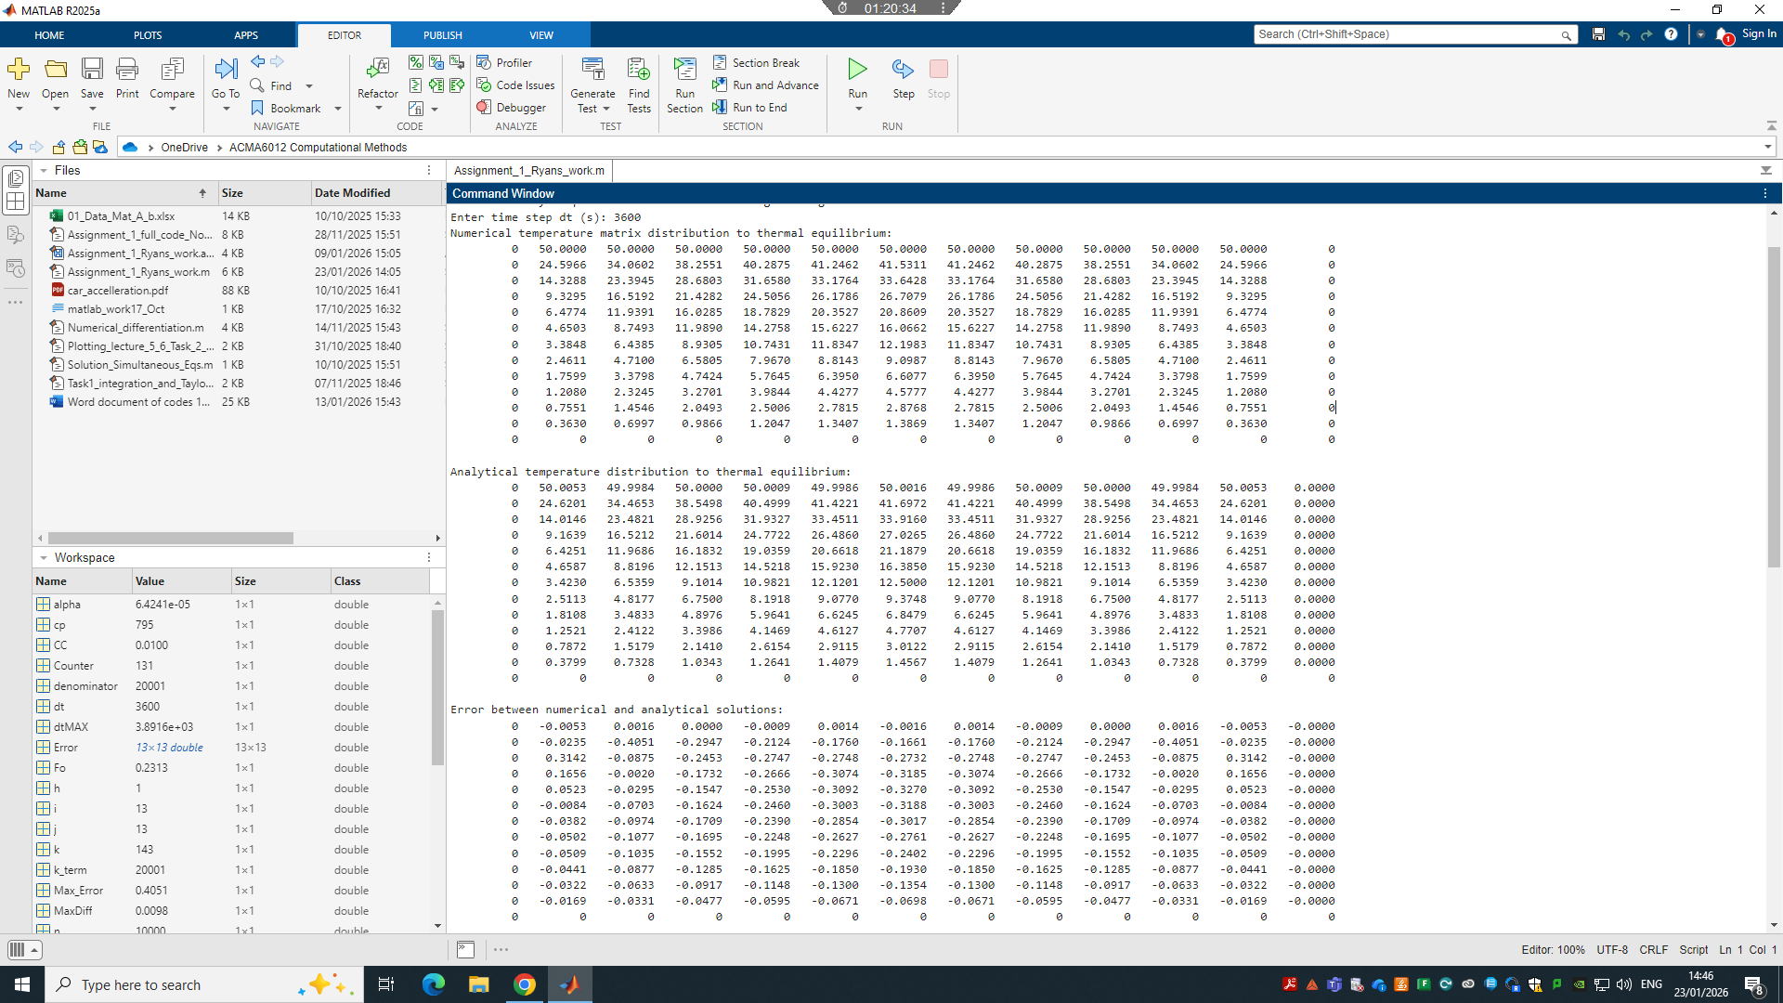
Validation results:
Maximum absolute error =0.40507
RMS_Error =0.16132
Time to reach thermal equilibrium = 5.4583days
Time in seconds
471600
Appendix 3: heat maps of 12x12 grid (contourf and surf)

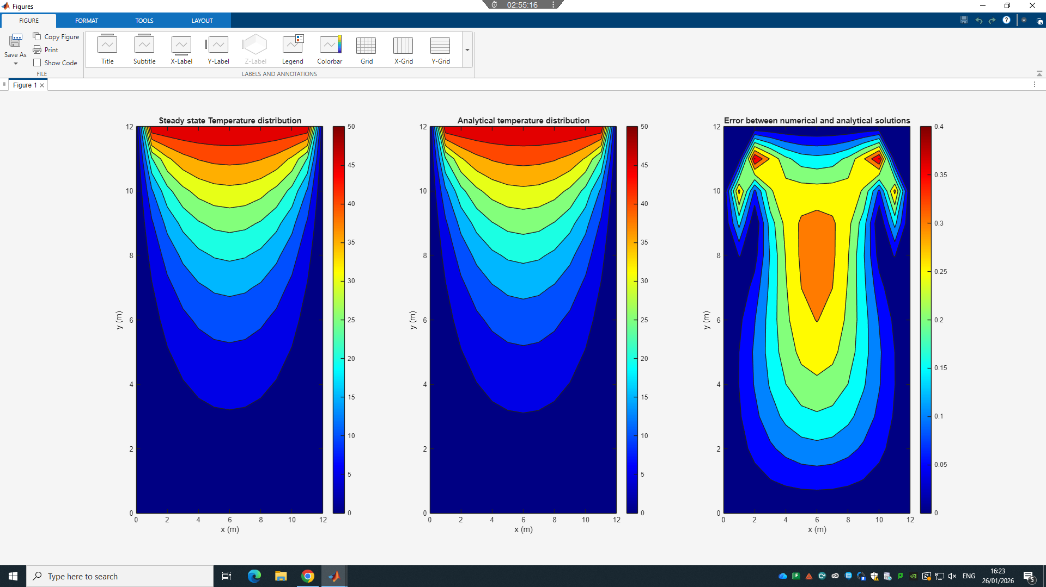
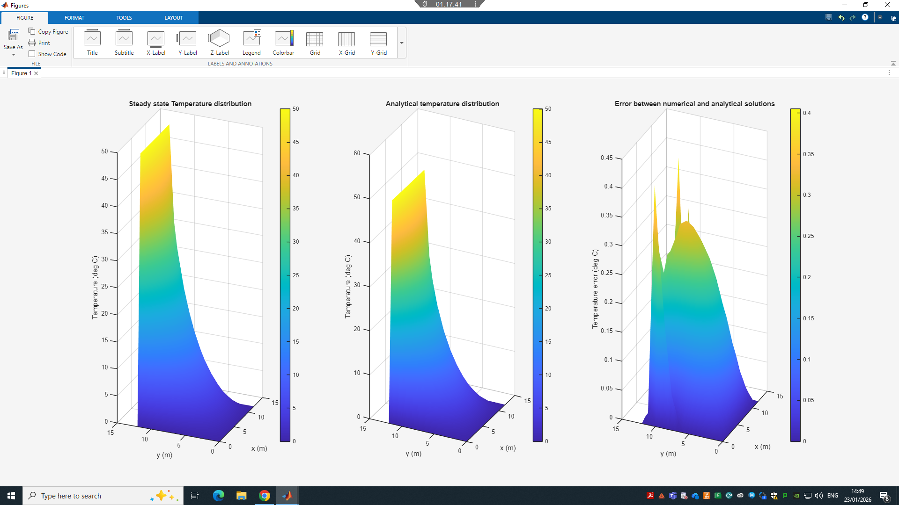
Appendx 4: Heat map plots for the rest
h = 4 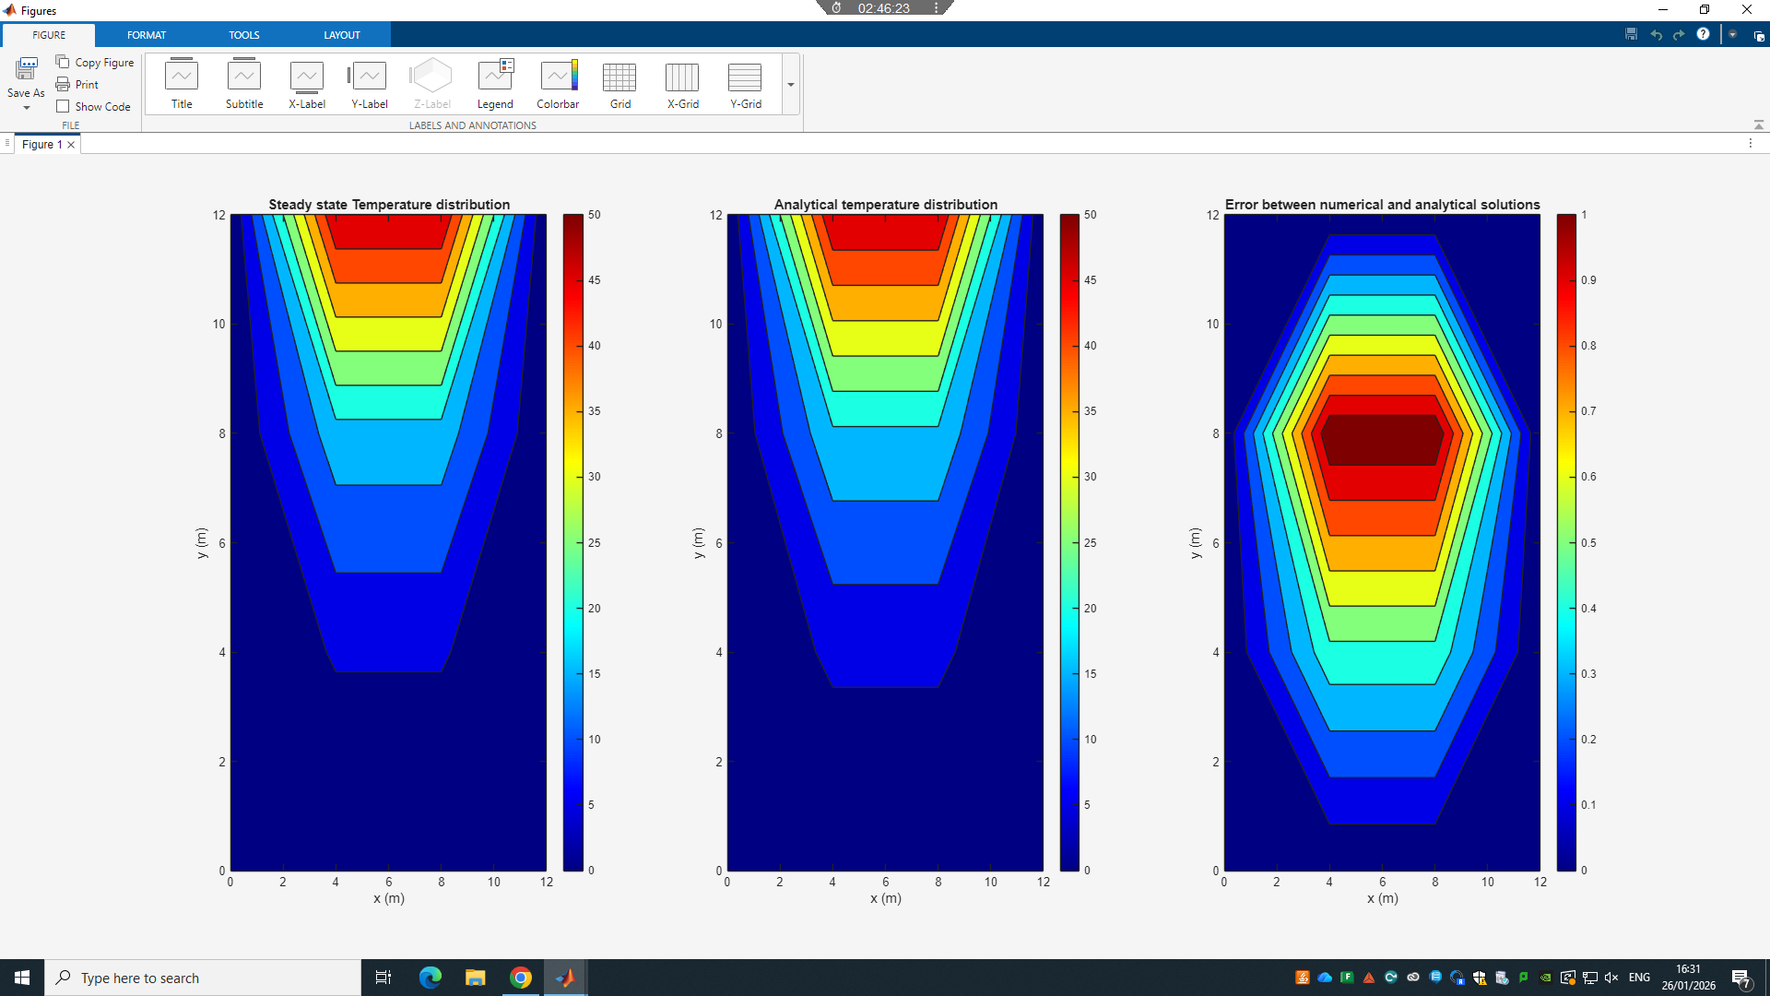
h = 3 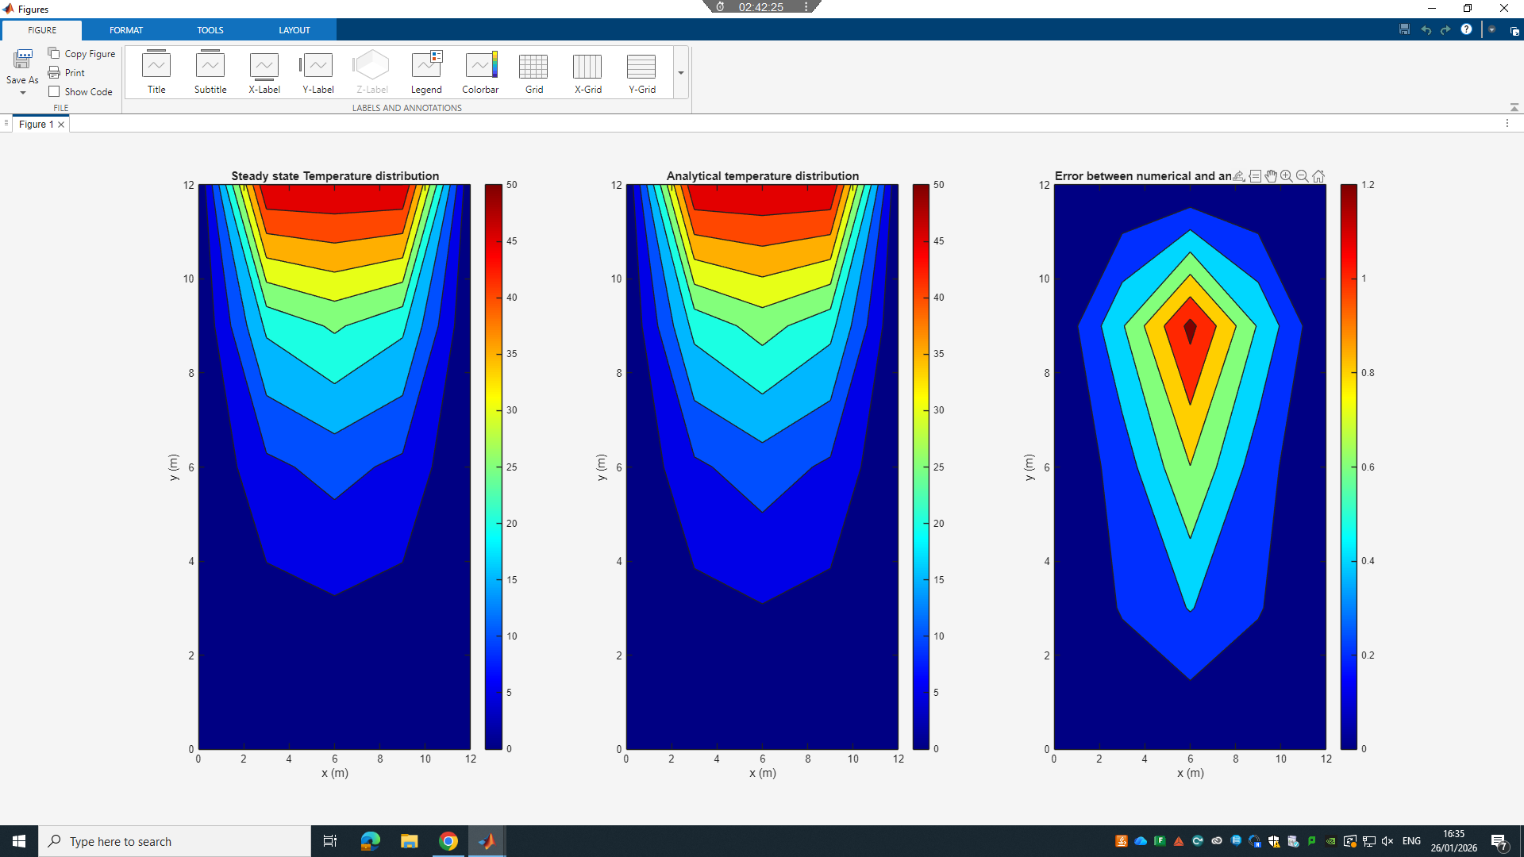
h = 2 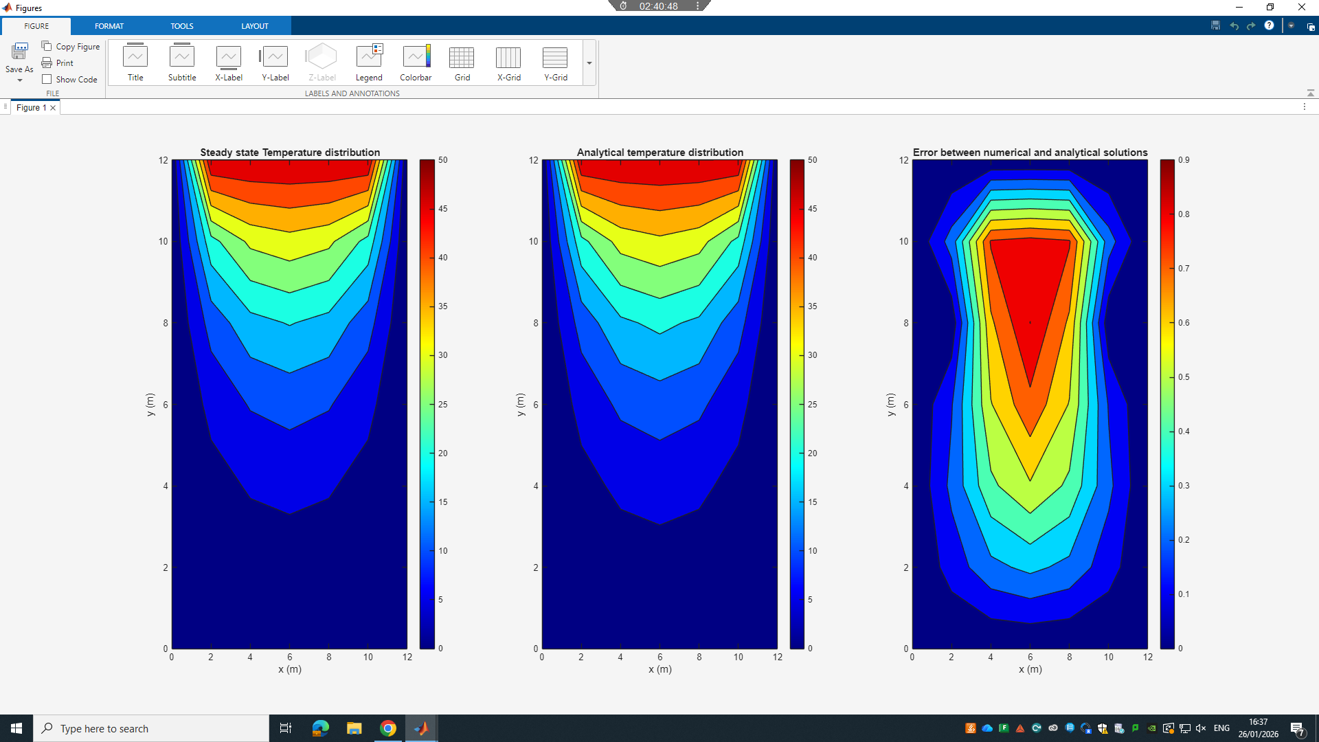
h = 1.5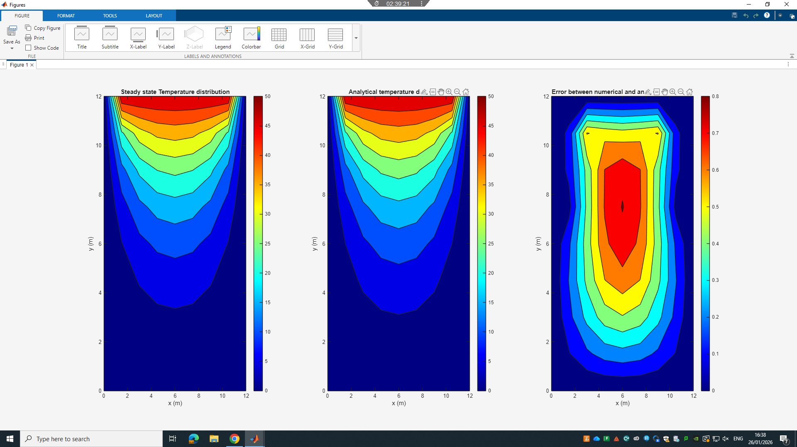h = 1.2 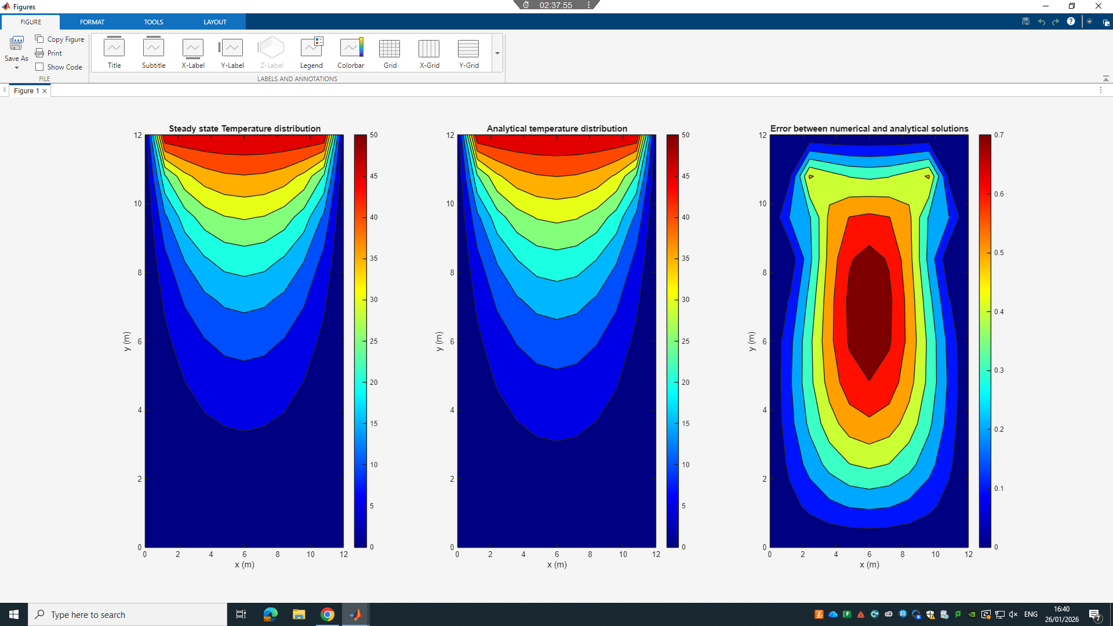
h = 1 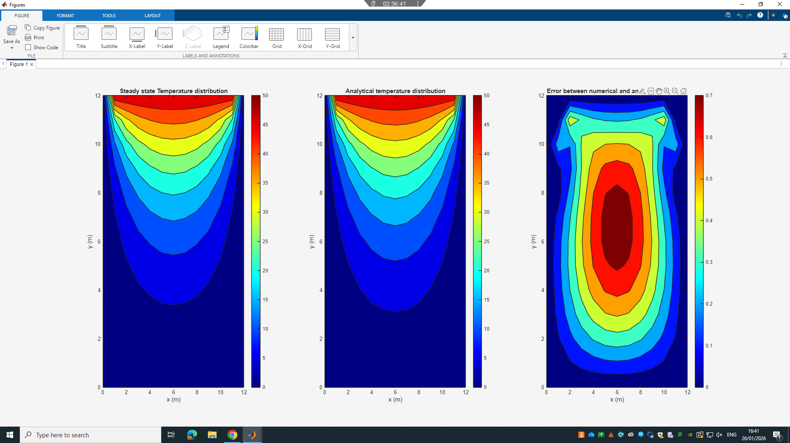
h = 0.75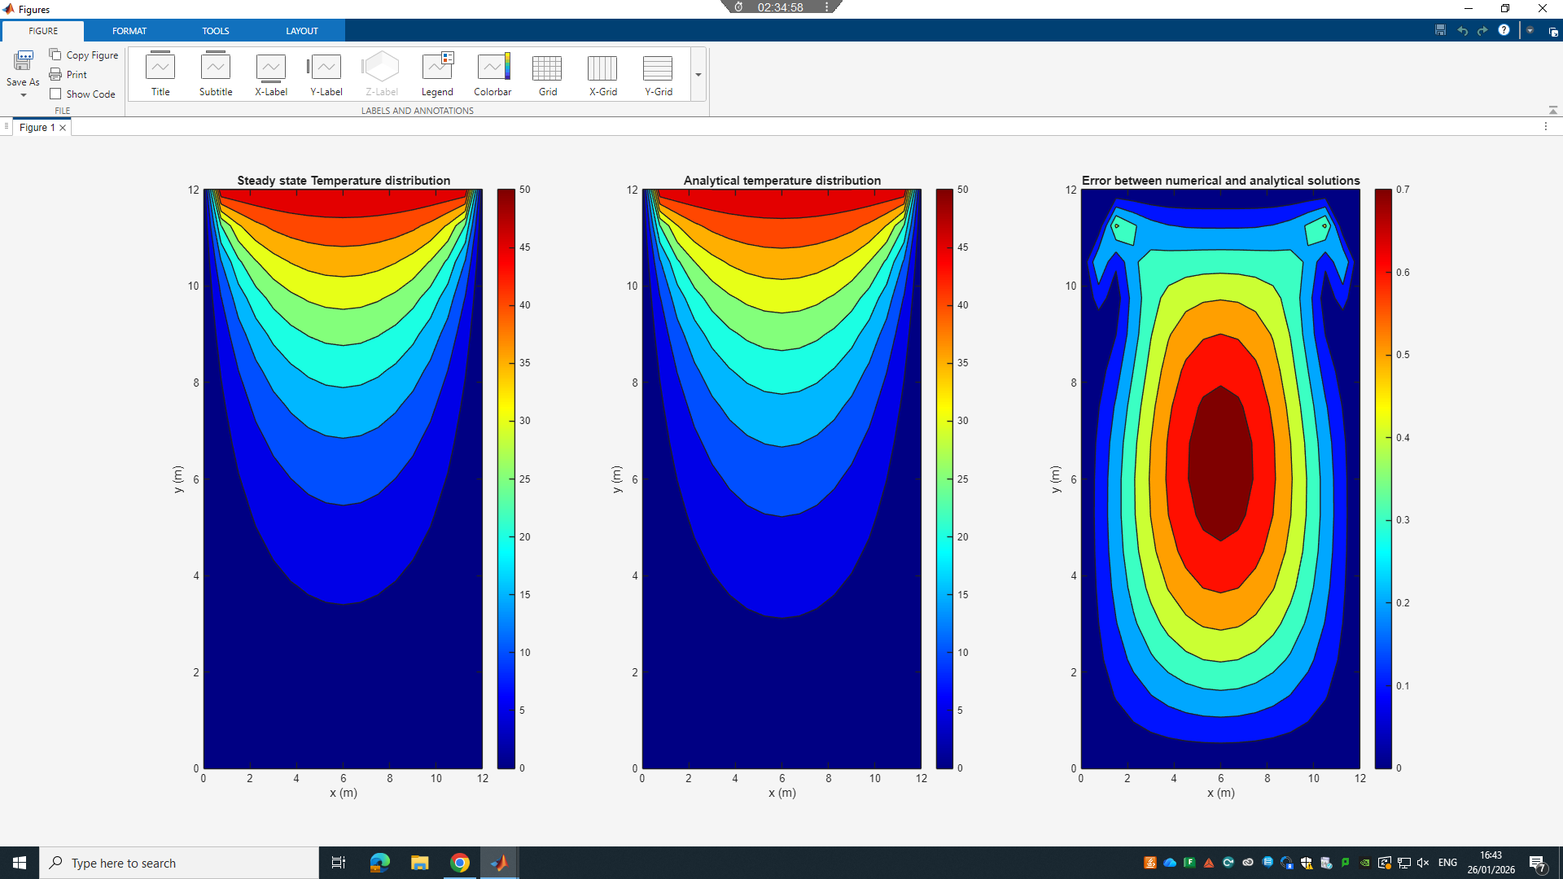
h = 0.6 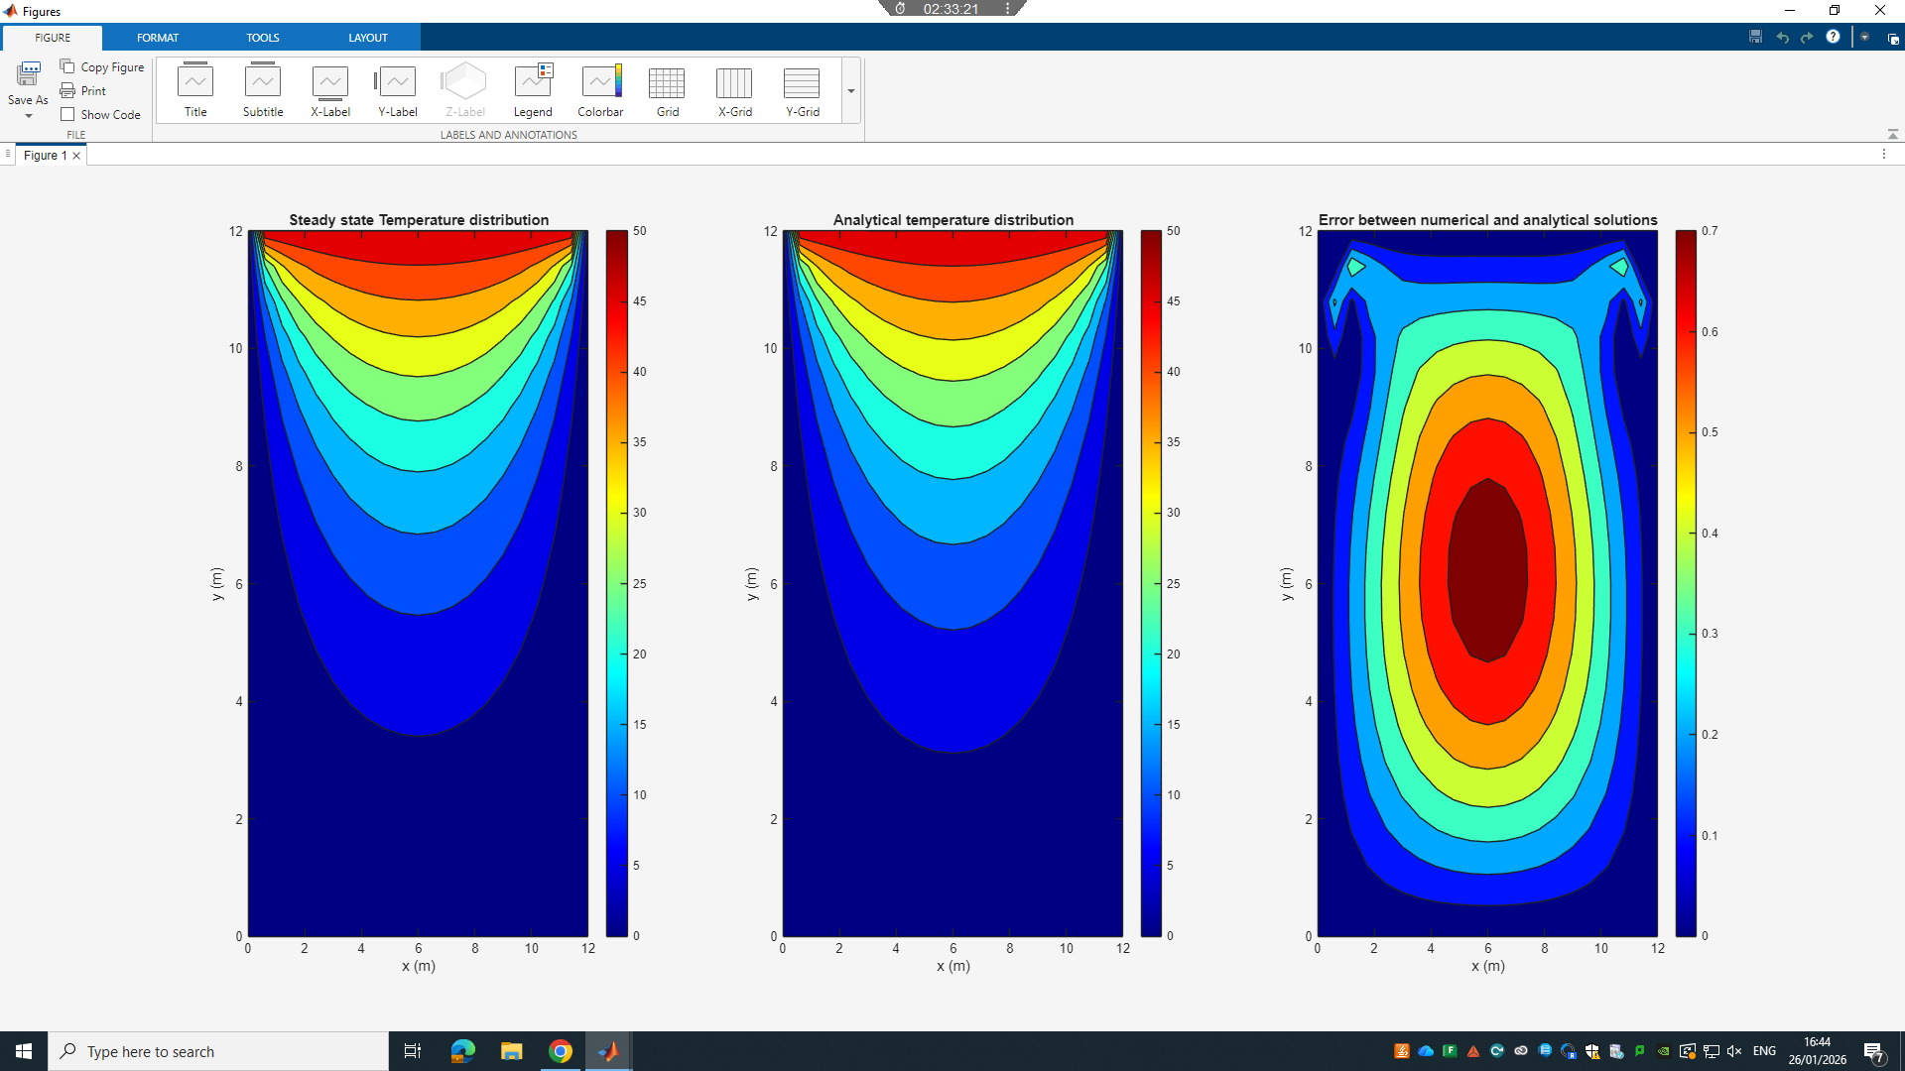
h = 0.5 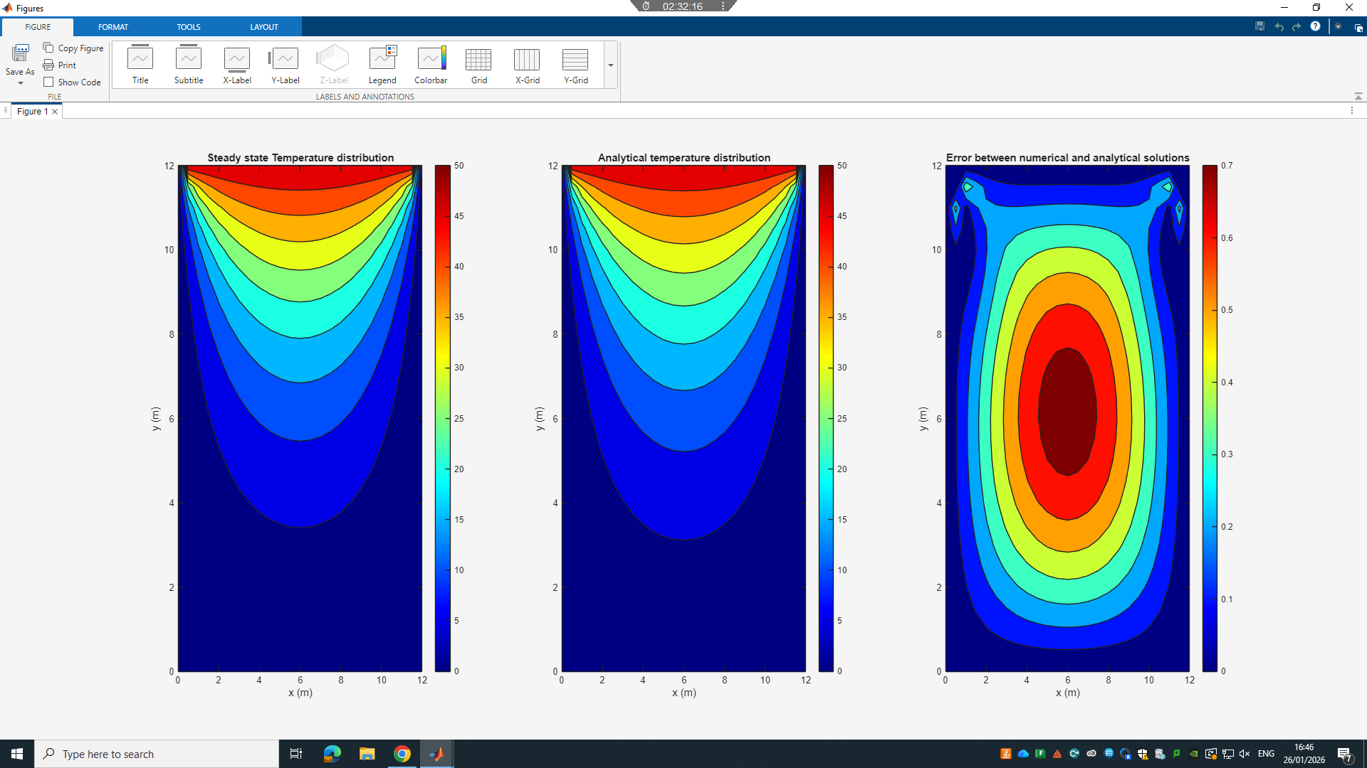
h = 0.4 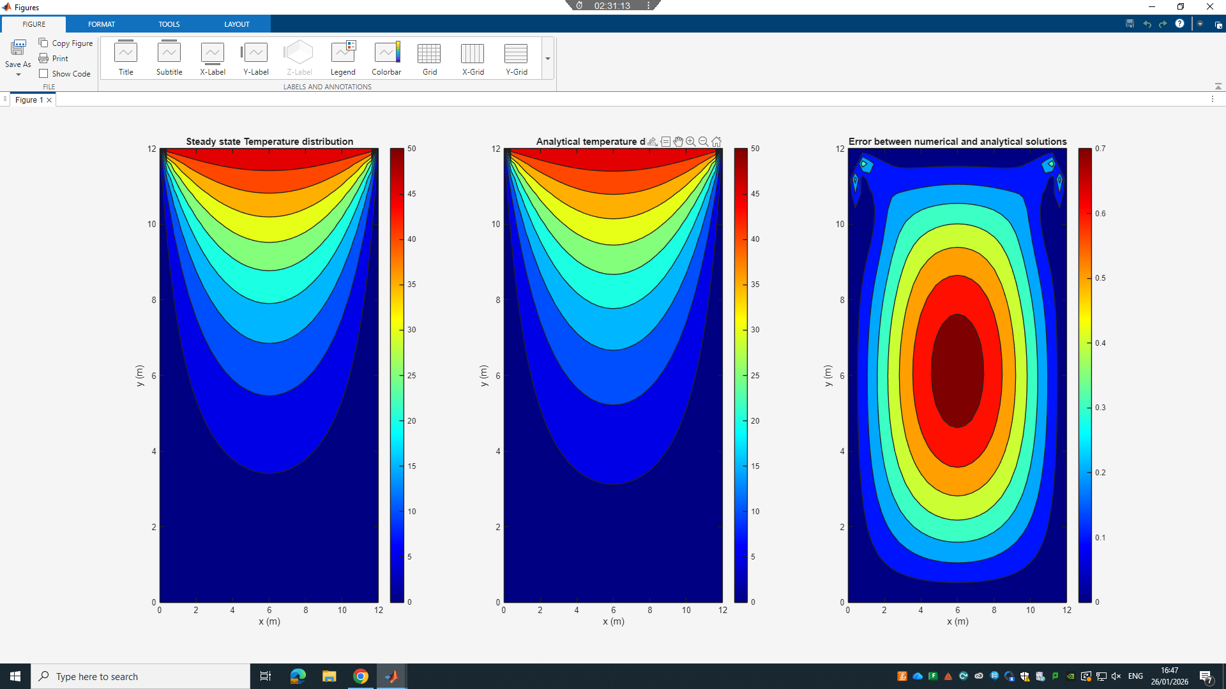
h = 0.3 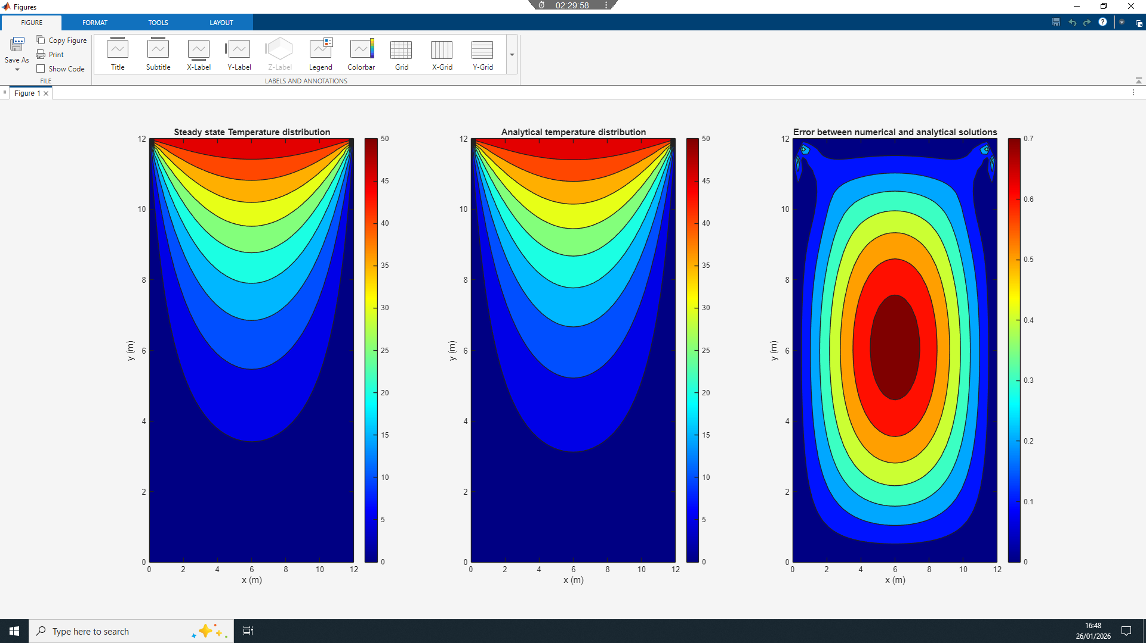
h = 0.25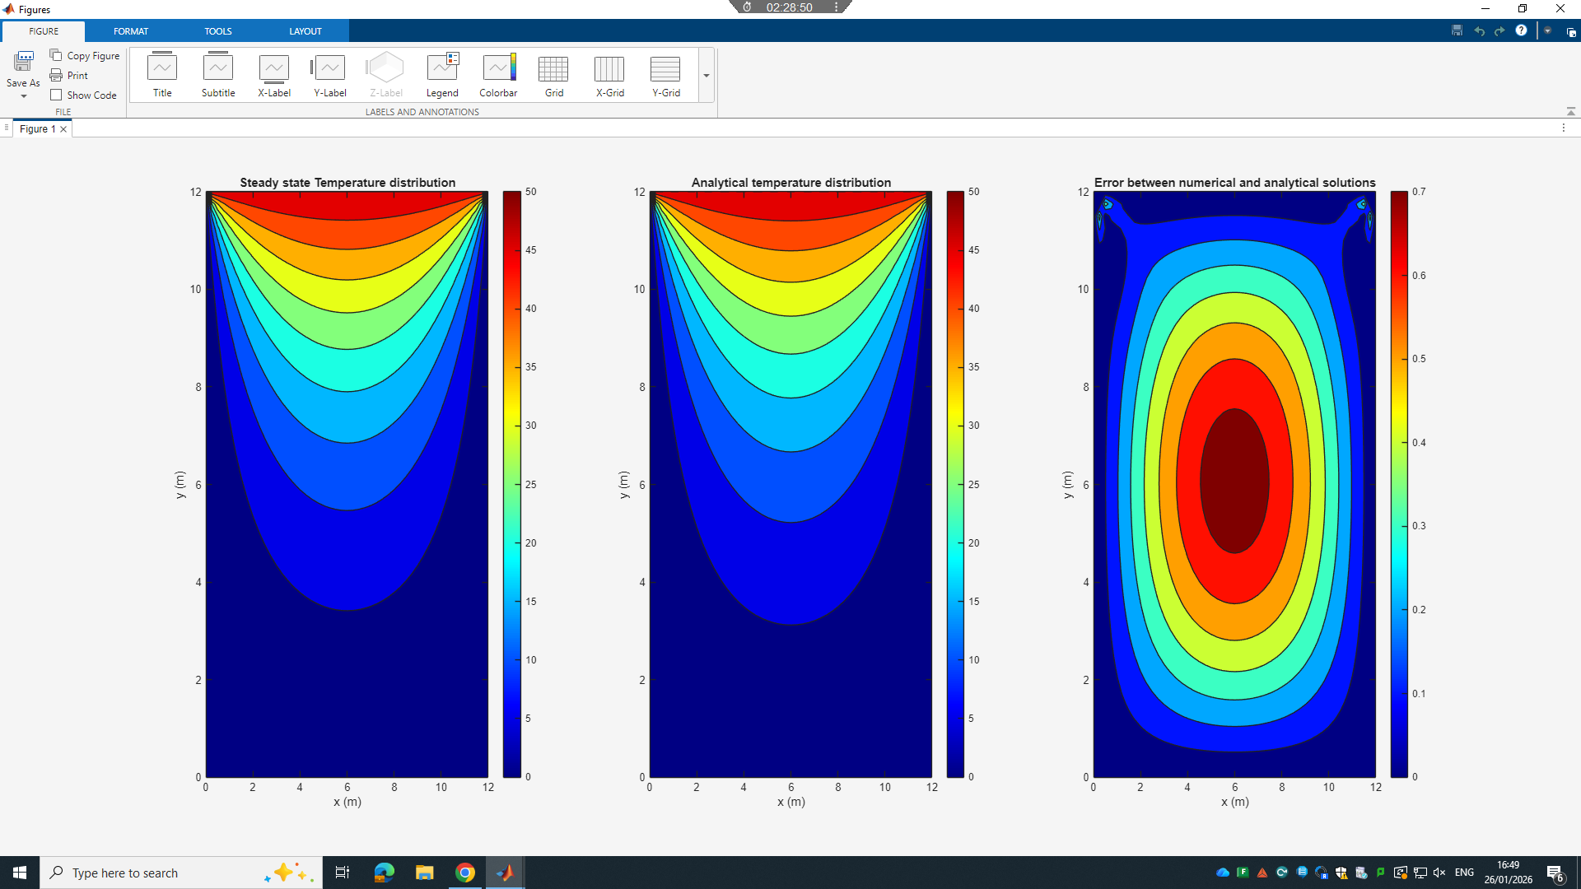
h = 0.2 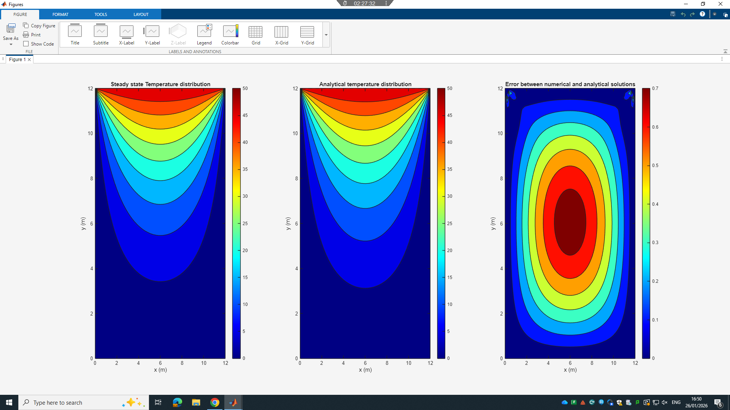
‌Δt = 2000 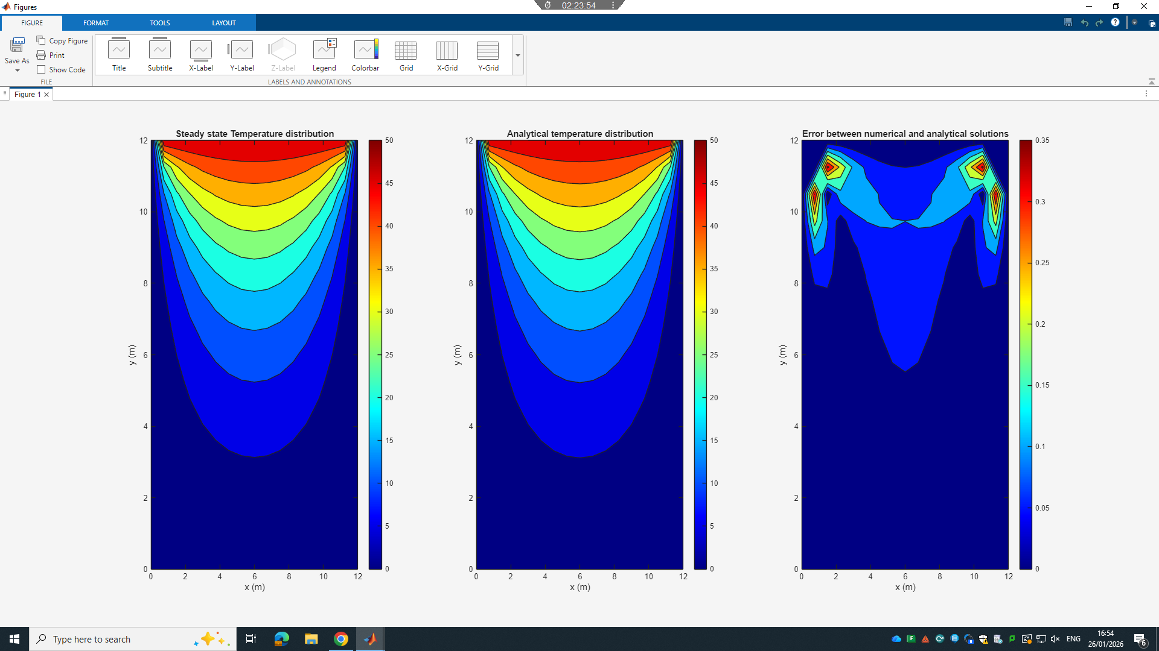
Δt = 1500 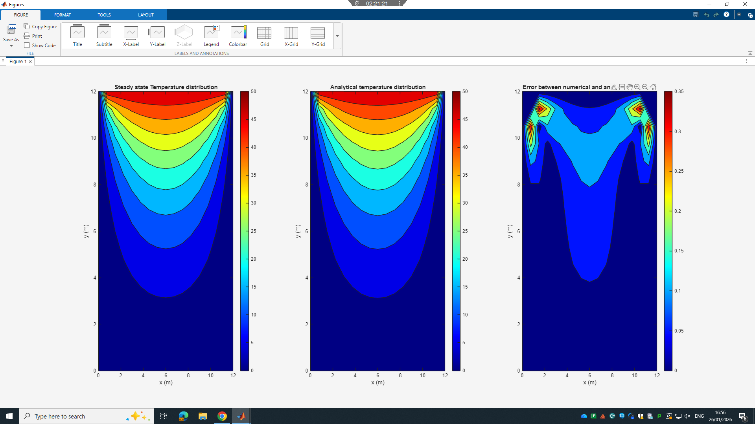
Δt = 1000 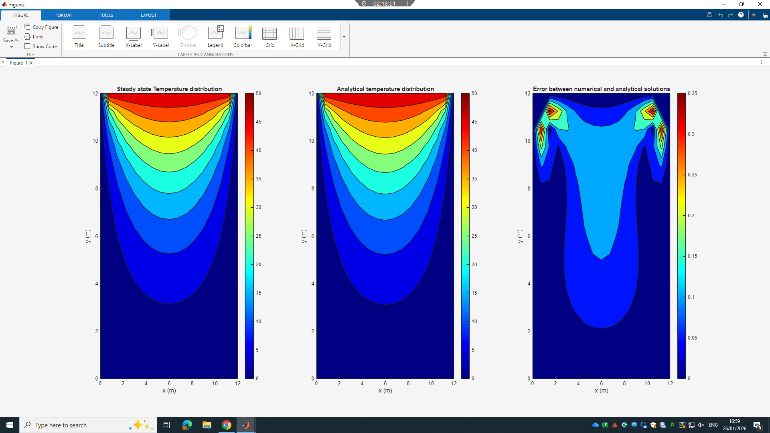
Δt = 800 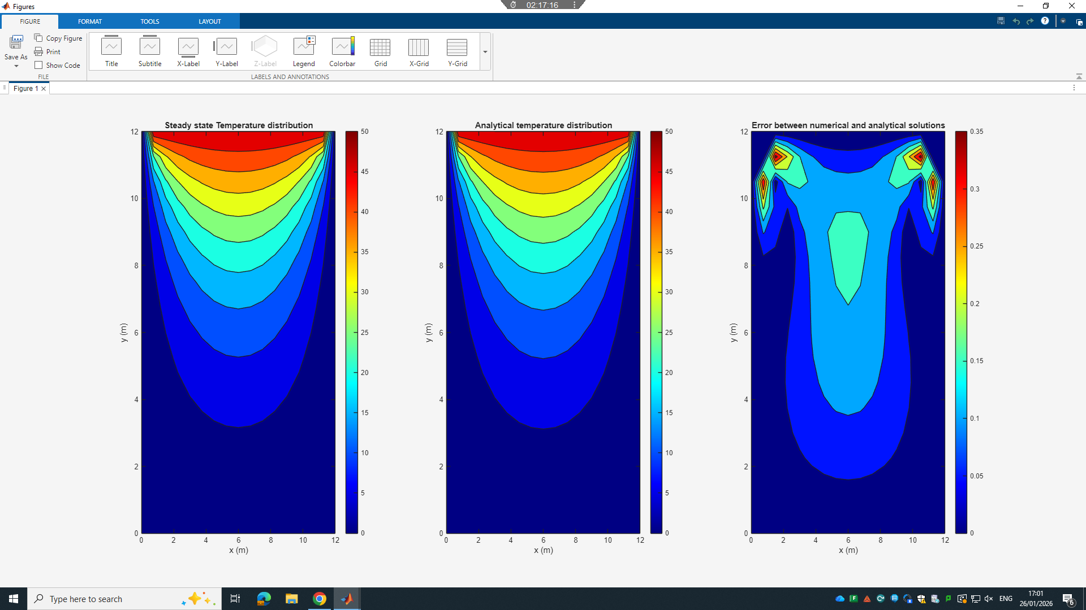
Δt = 600 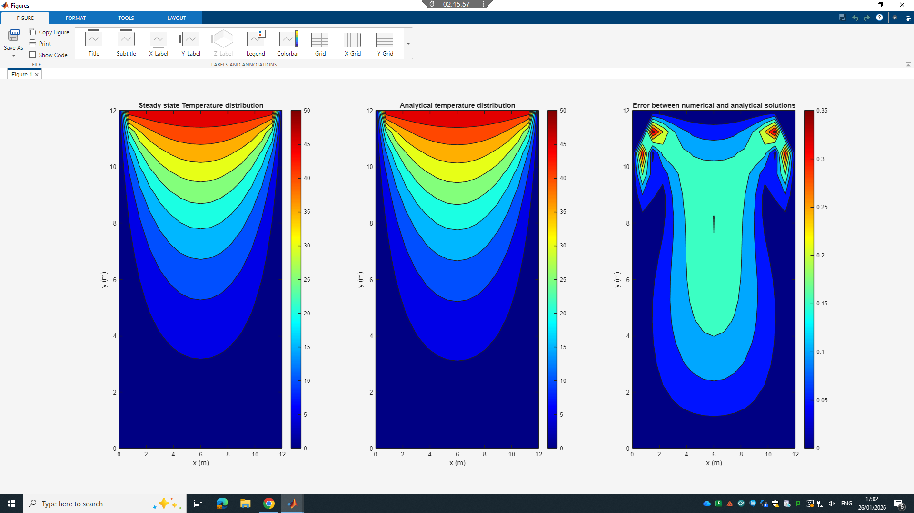
Δt = 400 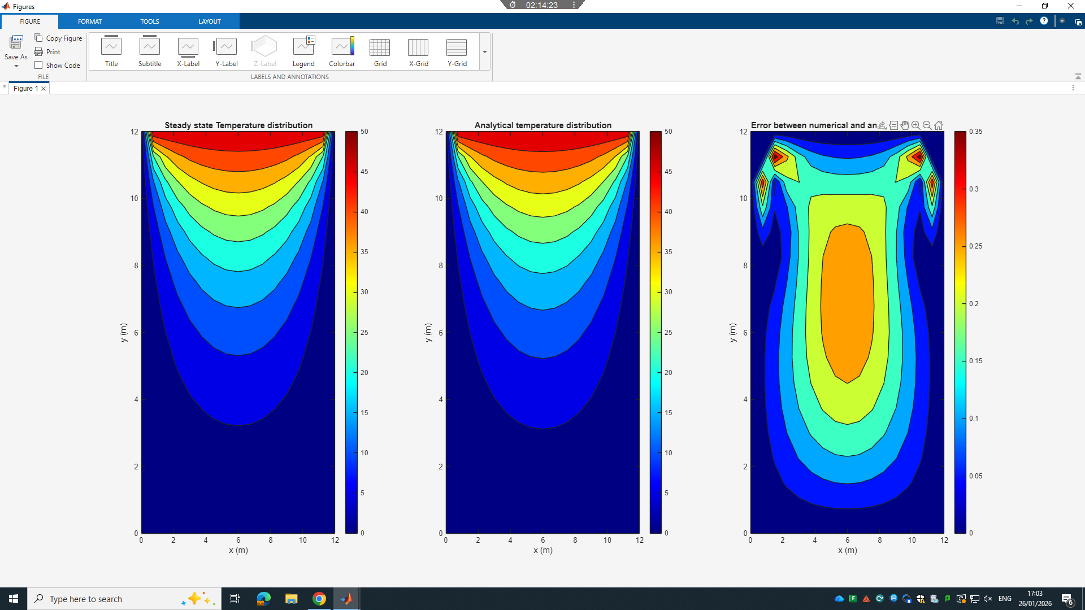
Δt = 200 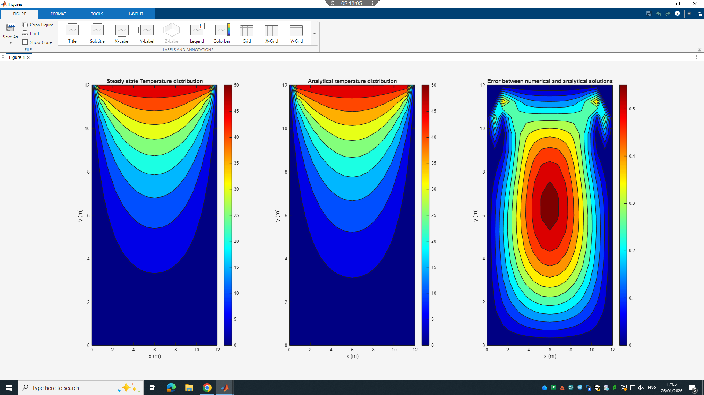
Δt = 100 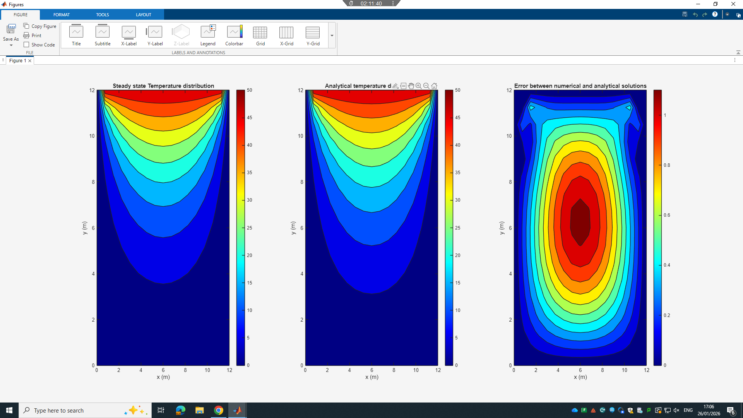
Δt = 50 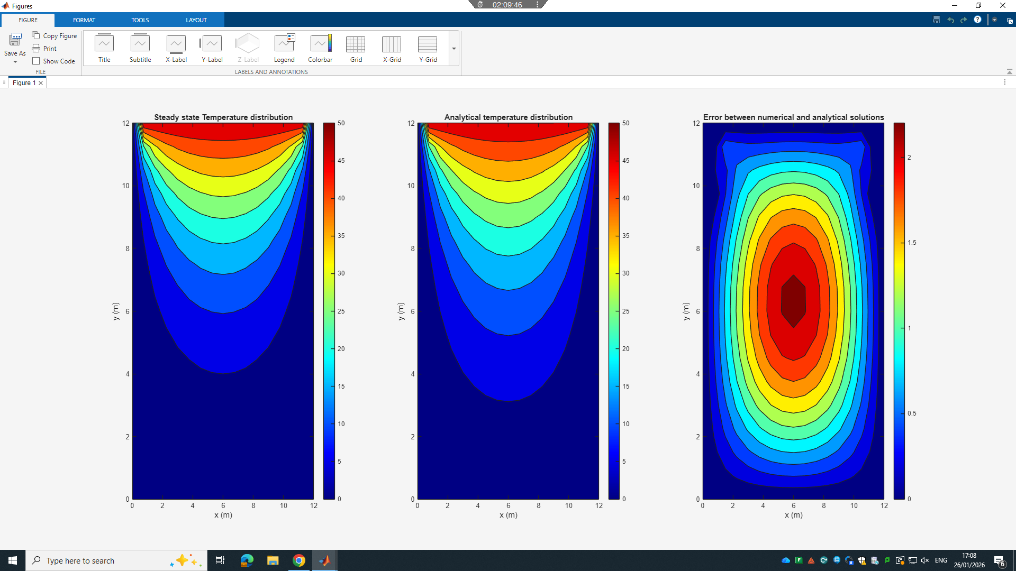
Δt = 25 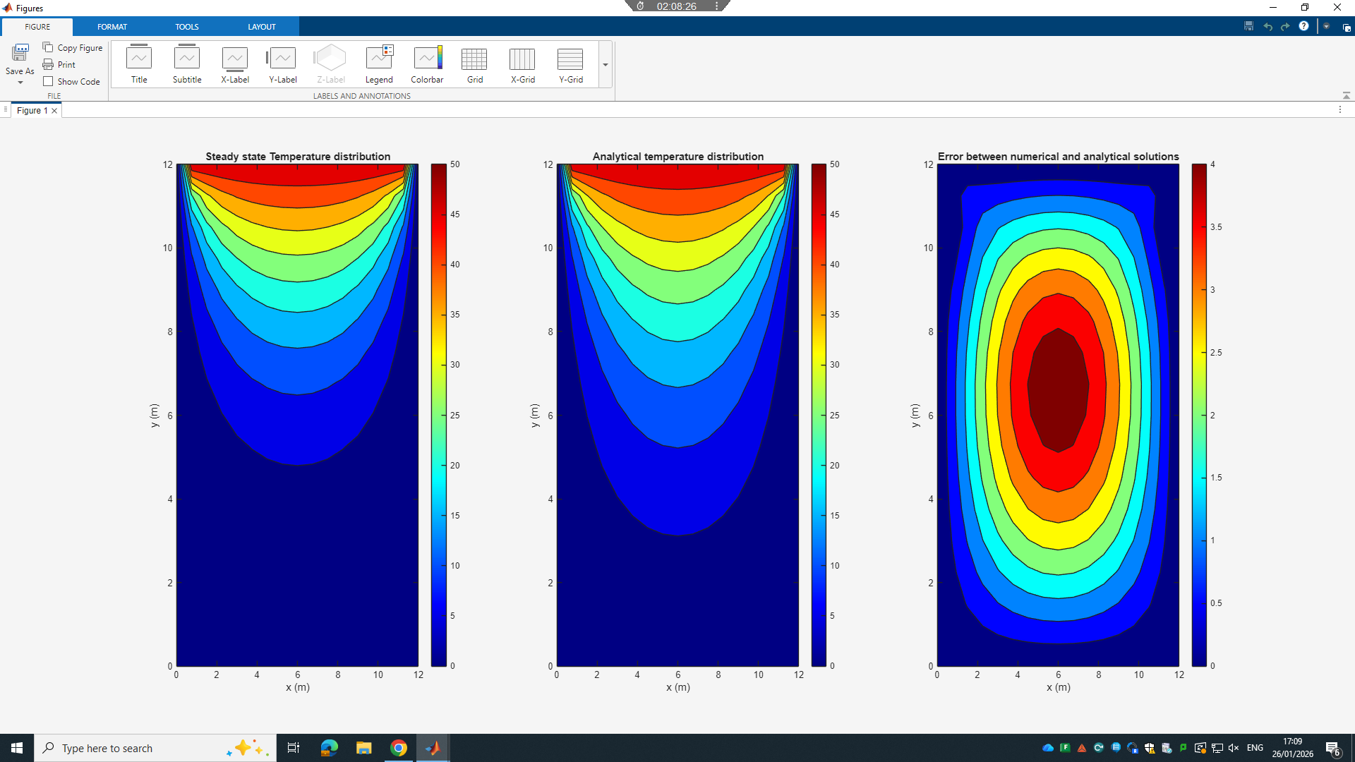

Change tolerance
CC = 0.1 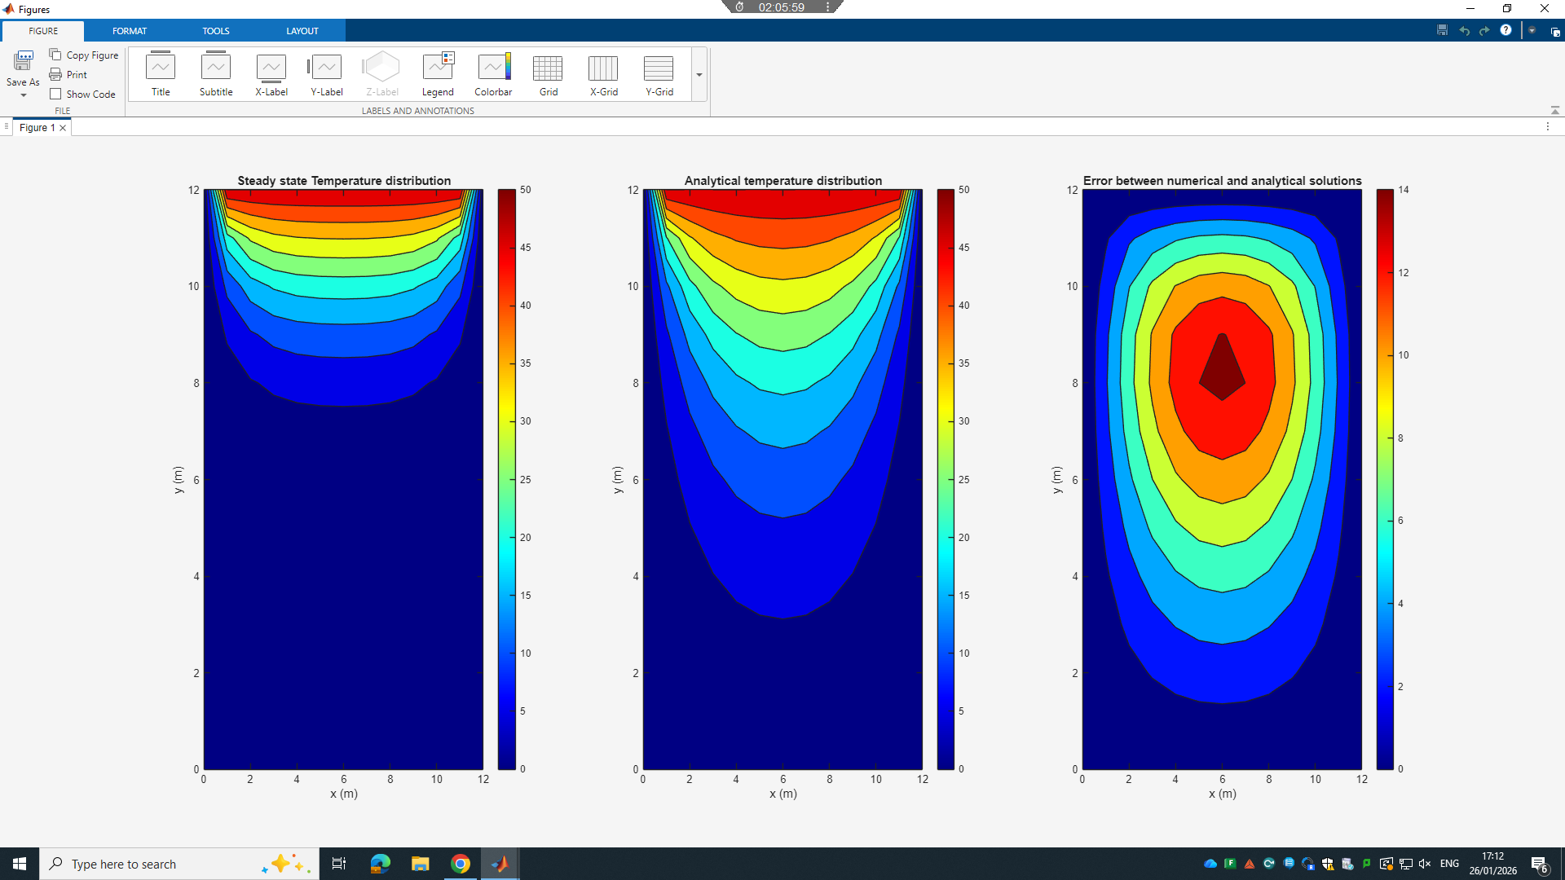
CC = 0.01 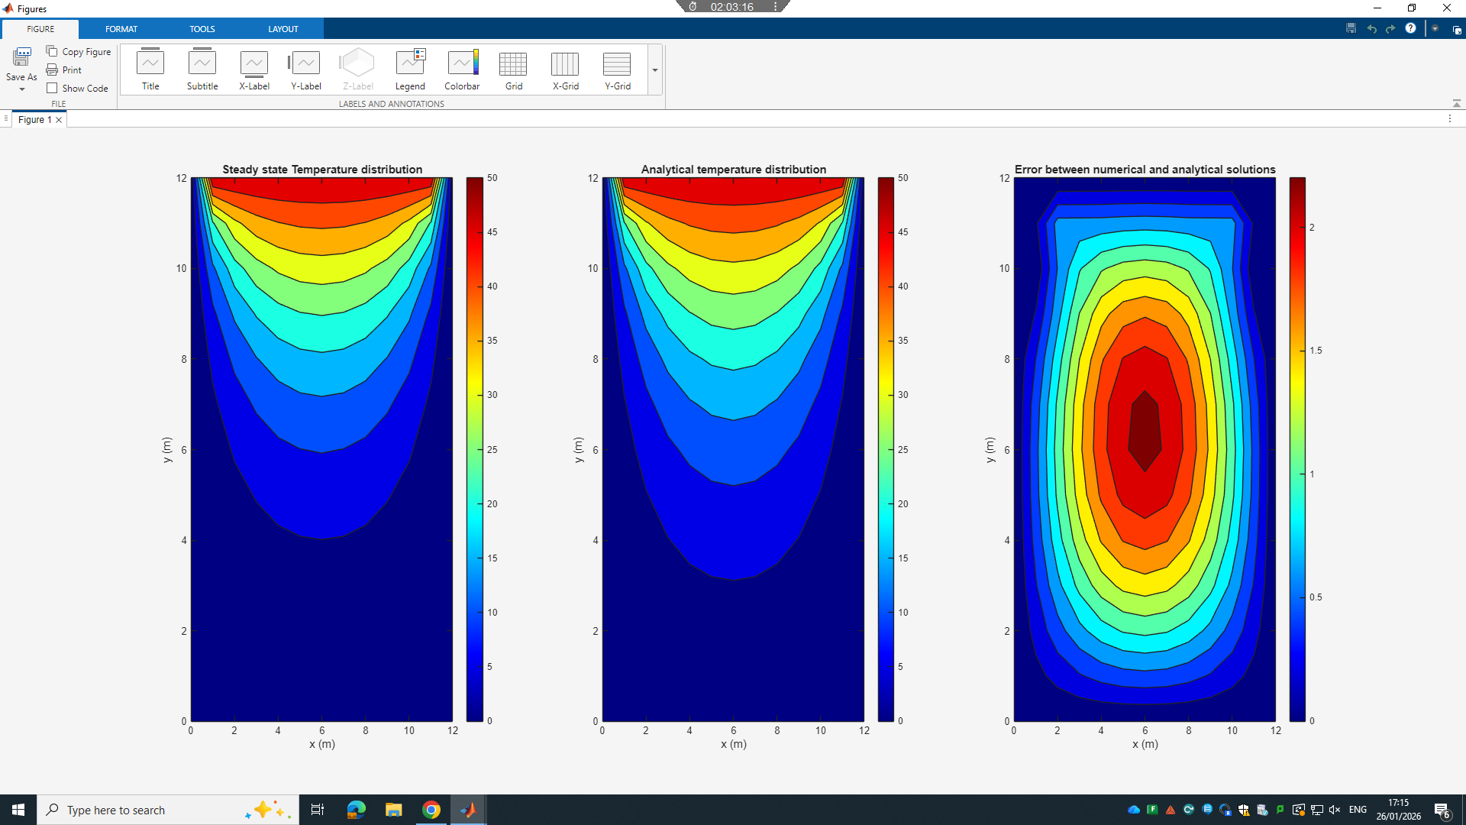
CC = 0.001 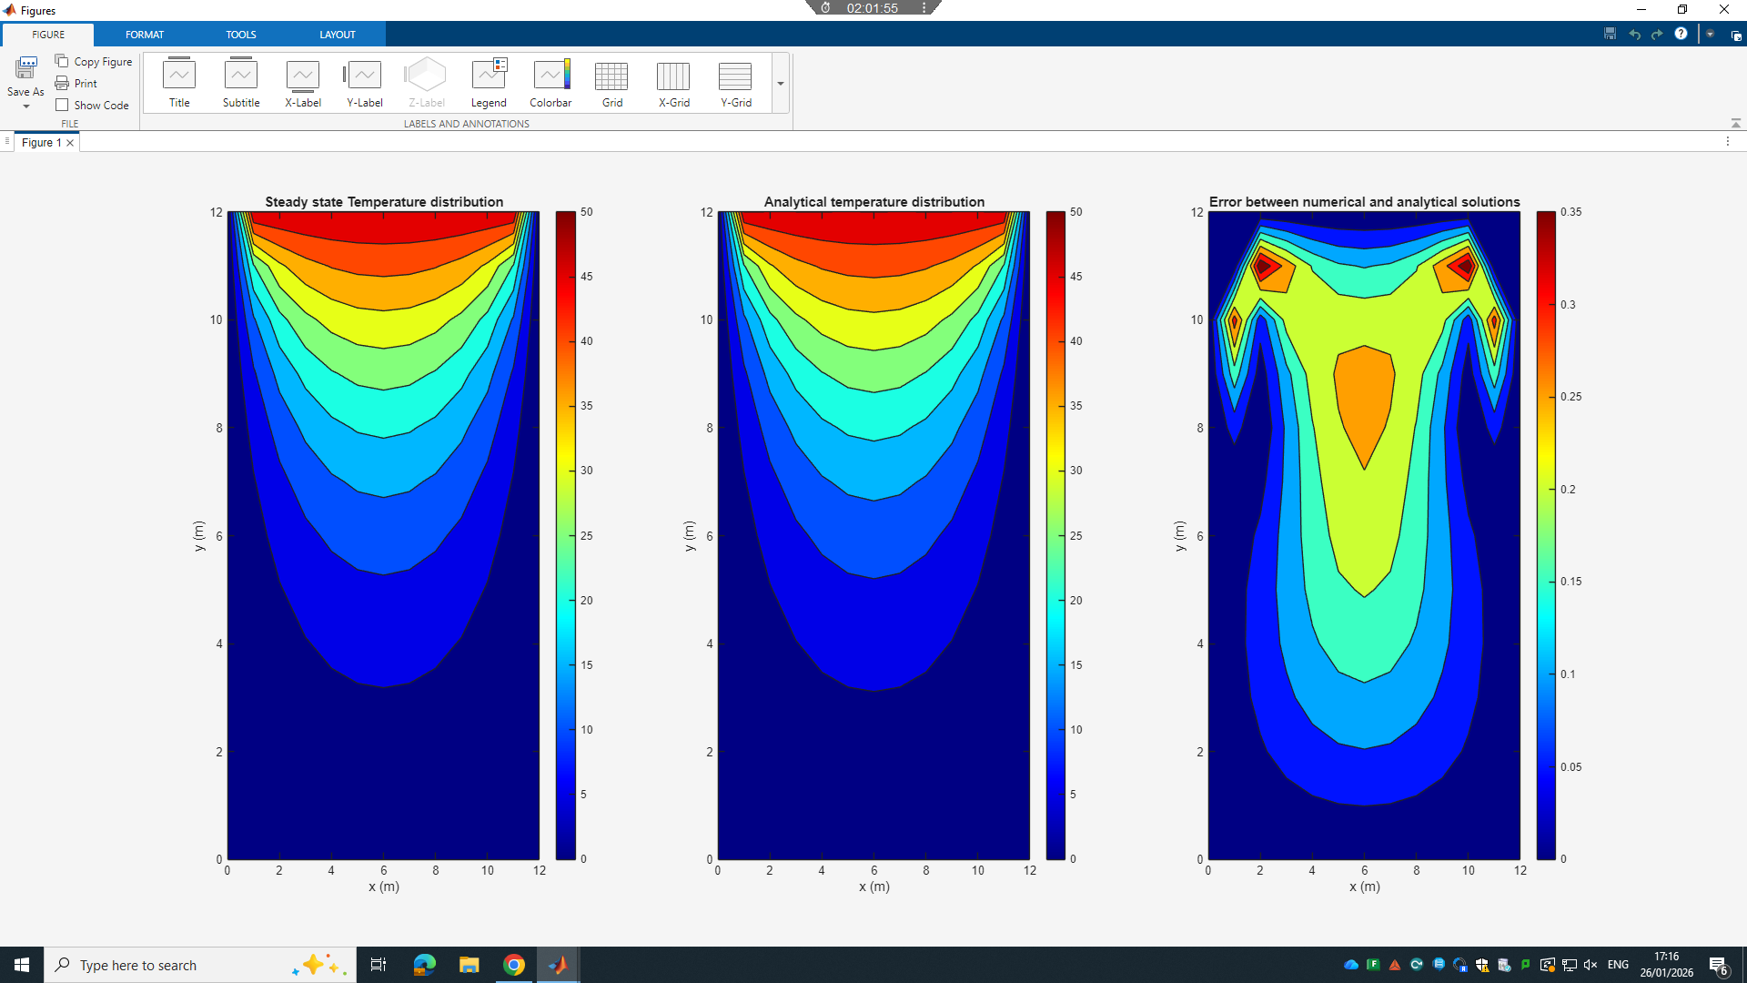
CC = 0.0001 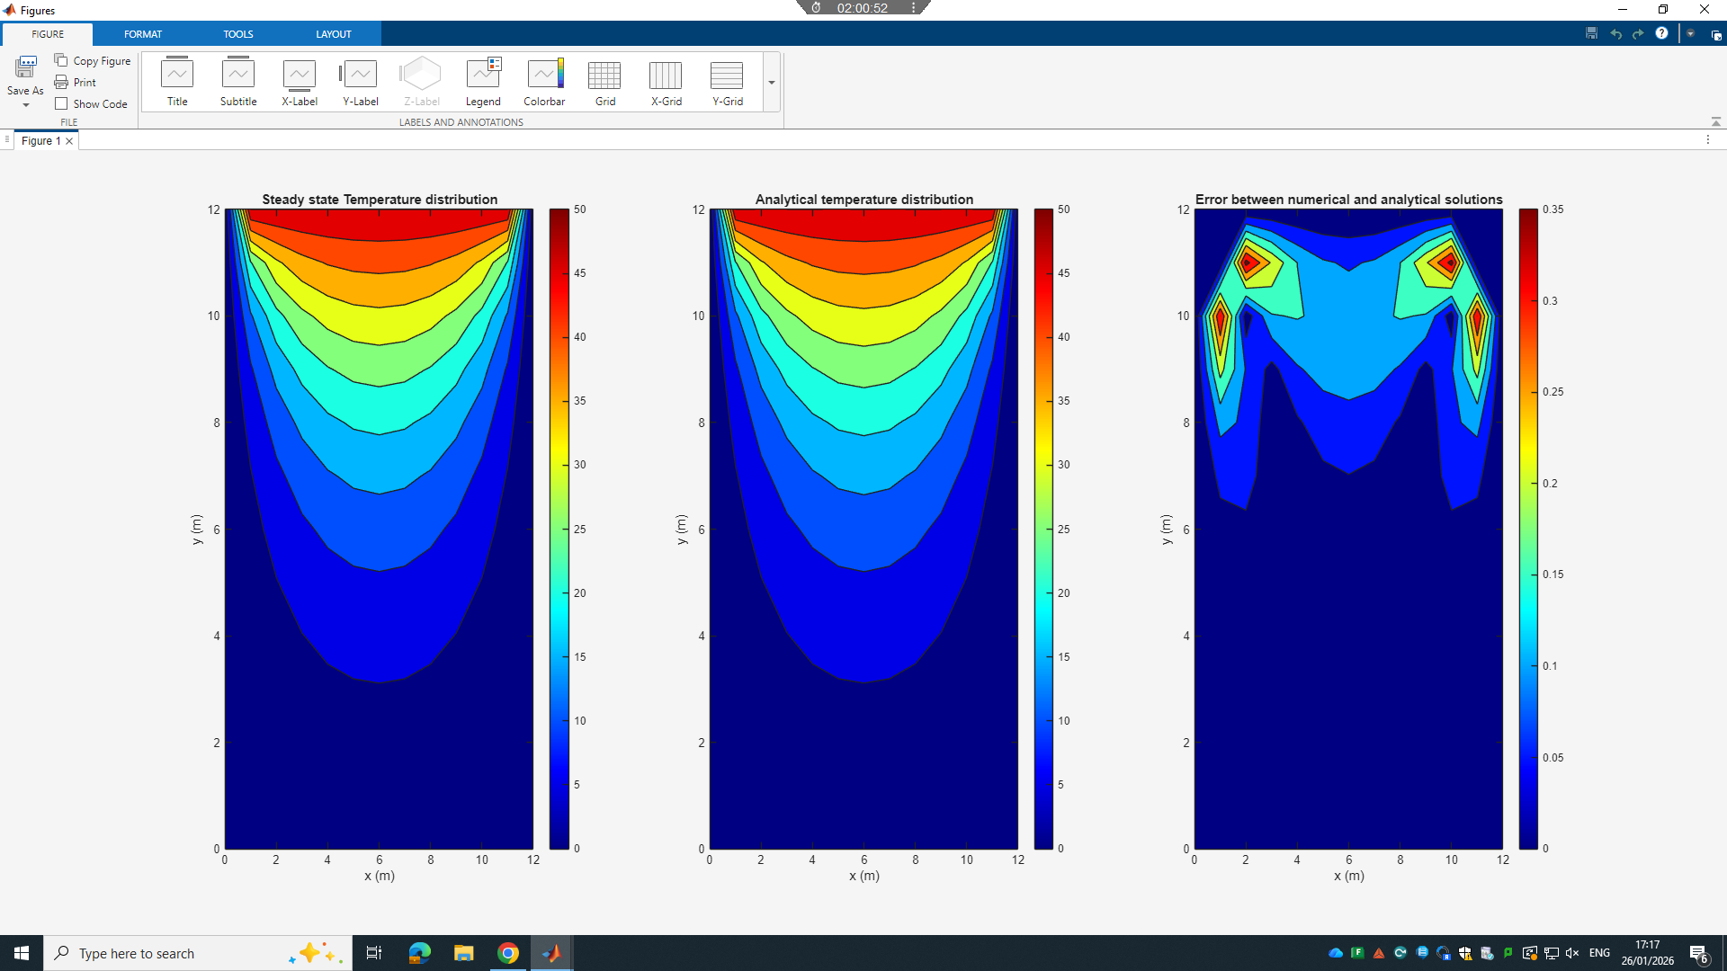
CC = 0.0001 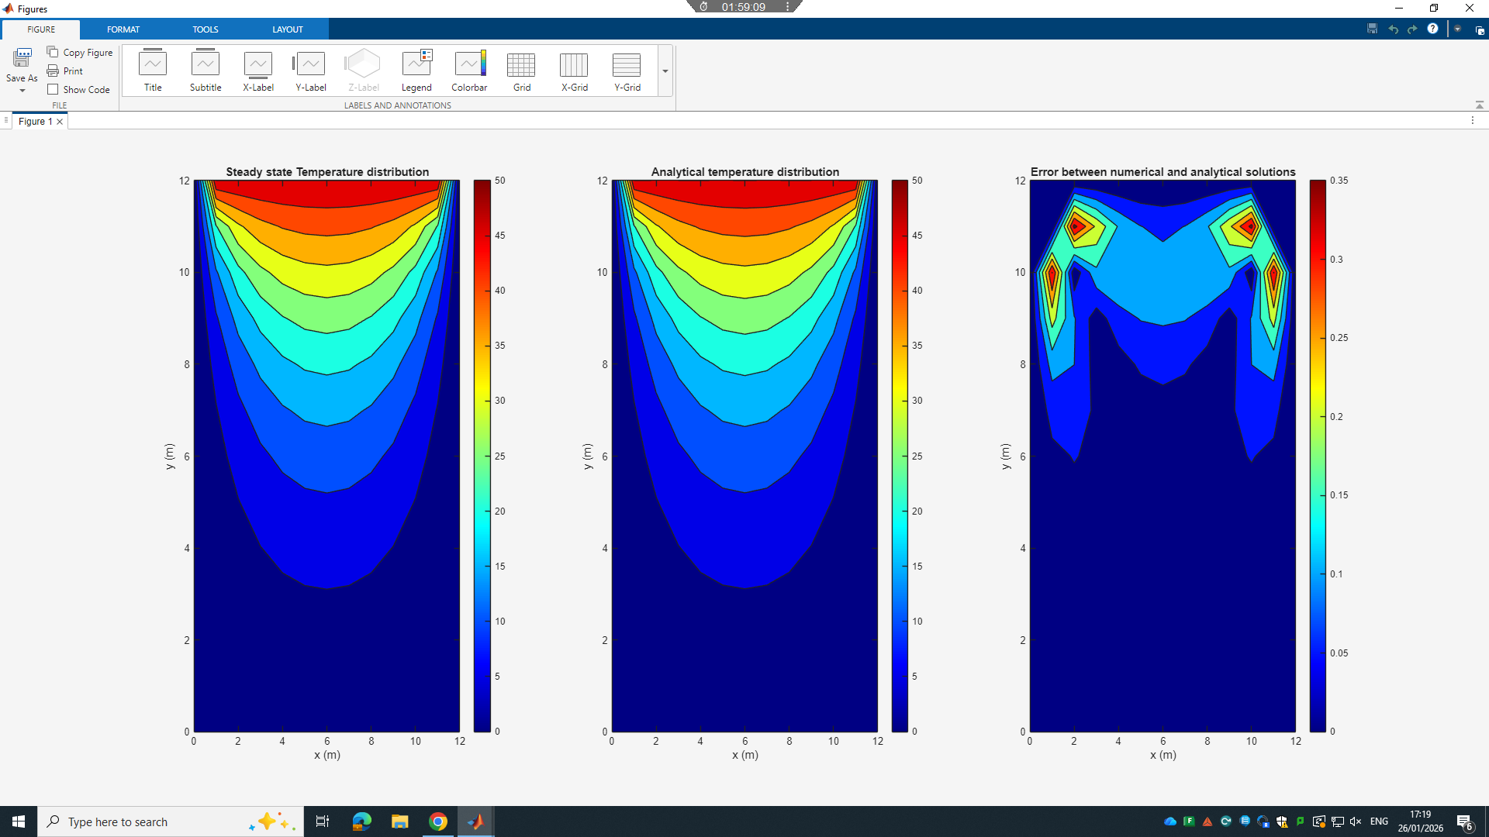
CC = 0.000001 


