NAME: Xinyu Shi

The Power of Myth …and movie-making
A Study of the Divergent Nature of Vermilion Bird
Student Number:2121915
Lecturer：Phil Organ

Summary
This study takes “Vermilion Bird”, one of the four mythical beasts in ancient Chinese mythology, as the object of research, and explores its artistic performance and historical support in the fantasy movie BEYOND THE VEIL. Firstly, we give an overview of the film's setting, and then we systematically analyze the cultural connotation of the Vermilion Bird in the traditional Chinese mythological system. Through the cross-cultural comparative research method, it is analyzed with the ancient Egyptian Benu bird and the Greek Immortal Bird, revealing the commonalities and characteristics of the mythological images of firebirds in different civilizations. Subsequently, an in-depth study of the characters is carried out. At the level of character design, based on ancient records such as the Classic of Mountains and Seas, and combined with modern digital media technology. We constructed the image of the Vermilion Bird with both traditional aesthetic features and contemporary visual expression and reconstructed the visual design of the transformation of its “human and god” forms. At the technical realization level, a VFX solution based on UE5, Blender and MAYA are proposed for key technical difficulties such as flame effects and feather dynamics. Finally, the elements of the Vermilion Bird in different periods are compared and analyzed through the analytical method of semiotics. Academic support is established for the characterization of the Vermilion Bird in the film. This study integrates traditional Chinese mythological elements into the contemporary film production process. It puts forward a set of “mythological IP modernization” thinking with academic support, which provides a theoretical framework and technical path for the creation of film and television works of similar themes. At the same time, it is also of practical significance to enhance the international expression of fantasy films.

Keywords: Vermilion Bird; Myth; Visual Effects; Cross-cultural comparisons
CONTENT
- Introduction 1
- Proposals 1
  - Movie Settings 1
  - Visual Concepts 3
- Research 4
  - The Mythological Traceability and Symbolism of the Vermilion Bird 4
    - Physical Expressions of the Star Cults 4
    - Symbolism of the Vermilion Bird 5
  - Cross-Cultural Comparison: Vermilion Bird, Benu Bird and Immortal Bird 5
  - Character Design 7
  - VFX/CGI Technology Needs Analysis 10
- Mythological Text Analysis and Visual Symbol Extraction 11
  - Analysis of Mythological Texts 11
  - Visual Symbol Extraction 11
- Conclusion 12
References 14

1. Introduction
This study takes the “Vermilion Bird”, a sacred animal in Chinese traditional culture, as the core object of research, and explores its visual representation in the movie BEYOND THE VEIL. The Vermilion Bird, as the symbol of the south in the Chinese astronomical system (Feng Shi, 2001), is related to the myths of the firebird, such as the ancient Egyptian Benu bird and the Greek Immortal Bird. This cross-cultural comparison maintains cultural specificity and provides a cognitive basis for international audiences. At the level of visual expression, the unique feather characteristics and flame-like dynamic effects of the Vermilion Bird provide rich creative space for the movie special effects industry. It includes key technical realization paths such as feather dynamic simulation and fluid particle effects. This study adopts a multifaceted methodology that combines historical and cultural theories and visual theories. It explores the modern adaptation and reconstruction of ancient myths while maintaining anthropological credibility. Provides a new research perspective for cross-cultural narratives in fantasy films.

2. Proposals
2.1Movie Settings
The time setting is divided into two parts, ancient and modern, and there will be connections between the two eras. In ancient times, the Vermilion Bird sheltered the royal families of the Xia, Shang and Zhou dynasties. The permanent residence of the Vermilion Bird is located on the bronze sacred tree at Sanxingdui. The Bronze Divine Tree also symbolizes the Path to Heaven. In modern times, the Vermilion Bird takes the form of Zhu Xuan, an antique dealer, who hides in a small building with green tiles and white walls in a Shanghai alley. At the same time, he can send messages through the bronze.

Background
Lin Xia, a restorer of cultural relics, stumbles upon a mysterious antique store called Zhu's Antiques in a Shanghai alley. When the store owner Zhu Xuan (the embodiment of the Vermilion Bird) meets her for the first time, he gives her a Sanxingdui bronze to restore. When Lin Xia's blood accidentally seeps into the grain, she sees a vision of a priest from the Shang and Zhou dynasties lighting a flame on a bronze sacred tree. Continuing to see visions thereafter, Lin Xia realized that her blood could activate more bronzes. These bronzes display the fragmented message: “When the sacred tree of Sanxingdui is rekindled, the veil will be broken.”

It is then that Blackwater, the multinational artifact-smuggling conglomerate that has been pursuing the bronzes, begins to track her down. Its leader, Tartuffe (a descendant of Western alchemists), wields a Shang Dynasty Taotie bronze goblet that can consume the flames of the Vermilion Bird.

Dating back to ancient times. In 1046 BC, the priest Red Feather foresaw that King Zhou would burn down the sacred tree, so he sealed both the Vermilion Bird and Taotie's essence in the bronzes, only to have them torn apart by the Taotie's essence.

At this point, the scene returns to the modern era, where the “New Divine Tree” excavated by a modern archaeological team under Pit No. 2 of the Sanxingdui Ruins is a trap disguised by Taotie. Taotie tries to use Lin Xia's blood to restart the evil fire. On their way to Sichuan with the bronze artefact, Zhu Xuan and Lin Xia stumbled upon a store where they discovered that the bronze artifact turned out to be a miniature projection of the Bronze God Tree. But by this time Zhu Xuan's life was coming to an end, with lava-like cracks appearing under his skin. At the site of the ruins, Tartuffe used a bronze goblet to drain the energy of the bronze vessel with the Zhu Xuan motif, and the pseudo-god tree began to materialize. Lin Xia cuts his palm and applies the blood to the bronze vessel: the blood flows in the reverse direction, forming the “Red Wen Dan Shu” recorded in the Classic of Mountains and Rivers, and the real God Tree rises from the ground. Zhu Xuan's divine seal illuminates, taking the form of a Vermilion Bird, and battles Tao tie. Lin Xia placed the bronze vessel into the position of the divine tree, completing the unfinished sacrifice of three thousand years ago. Tao tie was resealed, but the divine tree dissipated along with Zhu Xuan.
Three months later, Lin Xia rebuilt the “Zhu's Curio”. The camera pulls away as a red meteor across the Shanghai night sky.

2.2Visual Concepts
The movie is divided into scenes from the ancient period and scenes from the modern period because of the narrative structure. In the overall design, similar drawing styles are chosen but contrasted to deepen the connection between the two time periods. In the ancient period scenes, the art style of the movie refers to Big Fish & Begonia. Drawing on its colorful but not traditional style of scene color scheme. Every scene of the movie is filled with strong classical Chinese aesthetics. At the same time, to more closely match the style of the Xia, Shang and Zhou Dynasties, the design of bronze ornaments is skillfully integrated into the scene design. These decorations not only beautify the details of the movie but also give the scenes a strong historical and cultural heritage. This allows the audience to feel the unique charm of the period as if they were there. In the modern scene, the movie refers to the style of the old Shanghai lanes and alleys. Small buildings with green tiles and white walls, staggered paths made of green stone slabs, and gurgling rivers. Together, these elements build a picture of old Shanghai full of nostalgia and questioning. Here, the antique store in the guise of the Vermilion Bird is also skillfully hidden in this alleyway, to guard the ancient secrets. This tranquil atmosphere contrasts sharply with the tense atmosphere of the transnational artefact smuggling syndicate at a later stage. It also adds a touch of suspense and excitement to the film.

3. Research
The Vermilion Bird epitomizes the ancient Chinese idea of “unity of heaven and man”. Its symbolic system has always been centered around the “fire life order”. In contemporary times, the Vermilion Bird completes the modern transformation of its cultural genes through digital media and urban space, becoming a bridge between tradition and modernity. At the same time, its cross-cultural comparison with the mythological images of the ancient Egyptian Benu bird and the Western bird of immortality reveals the common pursuit of human civilization for the theme of eternal life.

3.1 The Mythological Traceability and Symbolism of the Vermilion Bird
3.1.1 Physical Expressions of the Star Cults
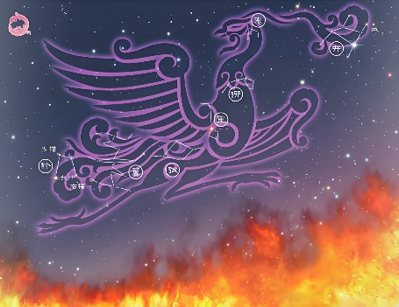
Archaeological discoveries have shown that the origin of the Vermilion Bird can be traced back to the “Vermilion Bird” recorded in the oracle bone inscriptions of the Yin and Shang dynasties. For the first time, a lacquer box from Zenghouyi's tomb in Suixian County shows the correspondence between the 28 constellations and the four elephants. The lines of the seven southern constellations (Jing, Ghost, Willow, Star, Zhang, Wing, and Square) (Figure 1) resemble birds spreading their wings. This astronomical system combines astronomical observation with animated totems, building an early prototype of the idea of “celestial and human interaction”. It embodied the wisdom of the ancients in interpreting the laws of nature by dividing space through the stars. With the migration of time, during the pre-Qin period, the Vermilion Bird was given the identity of “God of the South”. It corresponds to summer, the color red and the fire attribute of the five elements, symbolizing the flourishing of life force. The orientation and seasonal attributes of the Vermilion Bird were also recorded in Huainanzi Tianwenxun (Liu An, Western Han Dynasty).
Figure 1-The Seven Stars of the South, a map of the seven constellations

3.1.2 Symbolism of the Vermilion Bird
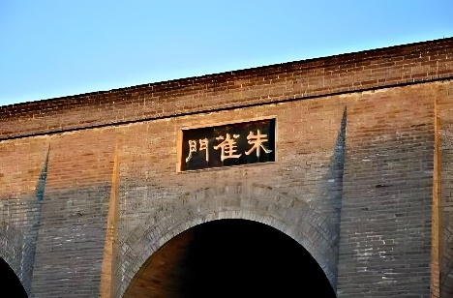
In ancient times, the Vermilion Bird was used almost as a political symbol of power and auspiciousness. In the imperial political system, the Vermilion Bird was regarded as an important symbol of the divine right of kings. At the same time, the Vermilion Bird was also given special political significance in the palace architecture and ceremonial system. For example, the Vermilion Bird Gate of Chang'an City in the Han Dynasty (Figure 2) and the Vermilion Bird Street of Daming Palace in the Tang Dynasty reflect the political symbolism of the Vermilion Bird as the god of the south. Furthermore, the Han Dynasty's Shangshu Zhonghou, which states that “the red bird carries the book of dan, and the king of the kingdom of literature is commanded”, links the Vermilion Bird to the political prophecy of the transfer of heaven's order. Even in the Ming and Qing Dynasties, the Vermilion Bird was still believed to be an important auspiciousness. In modern society, because of the “Vermilion Bird” in feng shui, requires the south to be open to the auspicious energy. Therefore, in modern furniture arrangements, many people will choose the Vermilion Bird ornaments placed in the south to promote career luck.
Figure 2-Vermilion Bird Gate of Chang'an City

3.2 Cross-Cultural Comparison: Vermilion Bird, Benu Bird and Immortal Bird
By comparing and analyzing the systematic nature of firebird myths around the globe, it can be found that there is a remarkable commonality between the Chinese Vermilion Bird, the Ancient Egyptian Benu Bird, and the Greek Immortal Bird. Even though these three mythological creatures arose from different civilization systems.
In terms of symbolism, all three mythological creatures are associated with the element of fire. The Vermilion Bird, as the god of the south, also represents the element of fire, symbolizing not only life and eternal flame but also rebirth by fire. The ancient Egyptian bird of Benu served as the soul of the sun god Ra. According to the hieroglyphics next to the frescoes in Tomb TT359 in Luxor, the Benu bird created itself from the flames of a sacred tree burning in the sanctuary of the temple of the sun god Ra. The Greek bird of immortality is recorded in the Metamorphoses as drawing fire and rebuilding a new bird from the ashes (Ovid 1984).

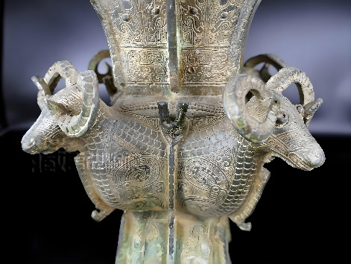
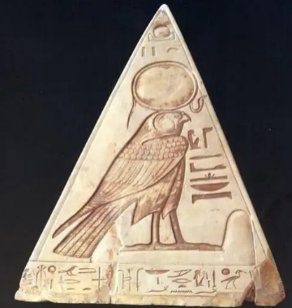
In terms of visual expression, the three sacred birds, though having certain differences in appearance, all hold an irreplaceable place in their cultural systems. The Chinese Vermilion Bird blends the flamboyant feathers of a chick with the stern form of a raptor. It shows the splendour of nature and, at the same time, alludes to the philosophical idea of “five colors for five directions” in the theory of yin-yang and five elements. This visual image not only meets the needs of astronomical observation at that time but also carries the ancient people's knowledge of the order of the universe. Moreover, traces of the Vermilion Bird can be found in many of the surviving bronze ritual objects. For example, the Vermilion Bird in the bronze Vermilion Bird Pattern Four-goat Square Zun (Figure 3) reflects the status of the Vermilion Bird in people's hearts at that time in society. Analyze while the Benu bird is modelled after the heron. In the artworks of the New Kingdom period, the Benu bird is often depicted as a heron with a long beak and a double-feathered crown, which is in line with the habits of herons that are widely distributed in the Nile Valley in reality. In the excavated Ancient Egyptian artefacts, the “Benben stone” (Figure 4), there are similar decorations. The two-feathered crown worn by the Benu bird not only reflects its divinity as the “spirit of the sun god” but also suggests its cultural connection with creation and resurrection. Finally, the Greek bird of immortality resembles a giant eagle. The feathers were partly golden and partly scarlet. This is documented in the Histories (Herodotus 443 B.C.). The process by which the bird burns itself and is reborn from the ashes also illustrates the cycle of life, giving it a metaphor of “divine prerogative”. At the same time, the Romans regarded the bird as a “symbol of eternal dominion” and engraved its image on coins, and the Roman Emperor Elagabalus even attempted to consume the bird to live forever. This is a direct reflection of the association of immortality with divinity. Even though these three sacred birds have different appearances, their connection with “divinity” is inextricably linked. At the same time, it also reflects the different aesthetic expressions of each civilization for “divinity”.
Figure 3-Bronze Vermilion Bird with Four Sheep Square
Figure 4 - Ancient Egyptian Artifacts “Pentel”
Through a systematic study of the Vermilion Bird, the Benu Bird, and the Immortal Bird, it can be concluded that global myths share a deep structure, but at the same time maintain cultural individuality. As Joseph Campbell argues in The Hero with a Thousand Faces. Although myths indicate great differences, their deep structures reflect common human psychological needs and spiritual dilemmas. (Joseph Campbell 1949)

3.3Character Design
Characterization
Because the character Beijing setting has a mix of present and ancient times, the character design will have two forms.

Animal Form
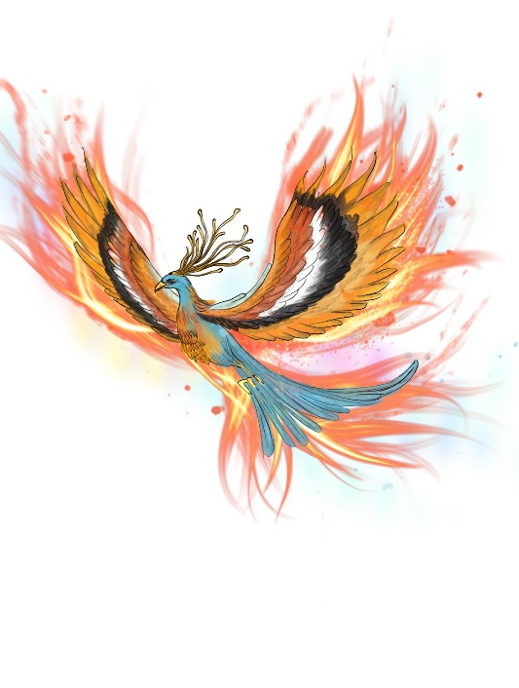
In the Classic of Mountains and Seas, it is written that the Vermilion Bird is a giant red bird clad in five-colored feathers, symbolizing the power of fire in the south. In order to combine the legend with modern aesthetics, CGI technology will be used to create feathers that have a flame-like flowing effect and emit a reddish glow throughout the body. The main form is based on the shape of an eagle, a peacock, and a crane. As a guardian deity, it needs to have a certain degree of divinity, and at the same time, it has the characteristics of robustness, nobility, and elegance. The feathers are interwoven with the five colors of the traditional Vermilion Bird: green, red, white, black and yellow. The pupils are designed in a flame-like red color, and the corresponding CGI technology will also be used to reveal the spirit and mystery. The red-colored pupils and the human form are also echoed here. The foot is designed as a three-toed golden claw. Sharp and tough, it also highlights the majesty and power of the Vermilion Bird. (Figure 5)
Figure 5 - Vermilion Bird in Animal Form

Human Form
When the Vermilion Bird assumes human form, its external features still retain its unique marks as a guardian deity. For example, the red-colored pupils, and the flaming divine seal on its forehead and all over its body. This is not only a symbol of identity, but also a manifestation of its power. These divine seal tattoos will emit a shimmering light under certain circumstances, which also adds to the character's sense of mystery. (Figure 6)

1. Top of the Head
The design of the top of the head is based on the Vermilion Bird motif on the Wadang.

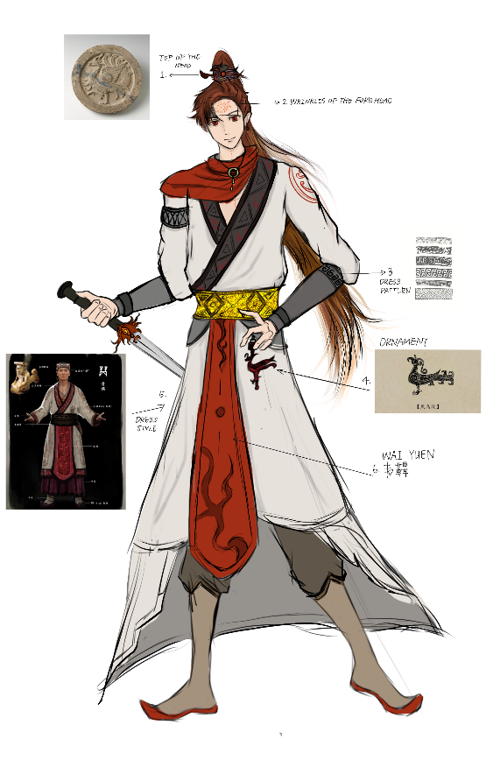
2. Wrinkles of the Forehead
Figure 6 - Design of the human form of the Vermilion Bird
The divine marks on the forehead, including those on the body, appear during the Vermilion Bird's appearances and battles, and special effects are used to make them glow with a faint shimmering light. This is to emphasize the character's divinity.
3. Dress Pattern
Because the character is in the Xia, Shang and Zhou periods, references to many Xia, Shang and Zhou period dress patterns, as dress embellishment. The dress pattern of the Xia, Shang and Zhou periods is mainly characterized by geometric patterns, such as straight lines, chevrons, back patterns, and so on. These motifs can also reflect the phenomenon of celestial worship at that time, and the “ten” motif symbolizes the four directions of heaven and earth in the Shang Dynasty.

4. Ornament
The ornament of the waist piece is designed according to the phoenix and bird pattern. The phoenix and bird pattern is one of the ancient bronze ornaments. The Xia, Shang and Zhou Dynasties were also the heyday of bronzes. (Huang Qing Sui 2021)

5. Dress Style
The overall dress style is based on the men's dress of the Shang and Zhou Dynasties. During the Shang and Zhou Dynasties, men's dress was based on the basic pattern of “top coat and bottom garment”. The nobles of the Shang and Zhou Dynasties wore belts to secure their dresses, and also wore a knee covering to symbolize their status. This is also a recognition of the status of the Vermilion Bird in the current era.

3.4 VFX/CGI Technology Needs Analysis
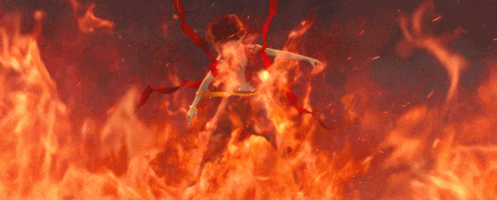
First of all, in the production of the flame feather effect, it is planned to use Houdini particle simulation technology. Because Houdini has a powerful particle system. This allows the team to make precise control of the movement trajectory and shape changes of each feather, and even the interaction with the surrounding scene. Furthermore, the red-colored pupils and the seal of God are like flames. Using fluid-driven particles, the eyeballs and the seal of the god emit energy particles, adding disturbances, turbulence, wind fields, and other settings. The main references are the flame effects in Ne Zha 2 (Figure 7) and the eyeballs emitting energy effects in The Island of Siliang.
Figure 7 - Ne Zha 2

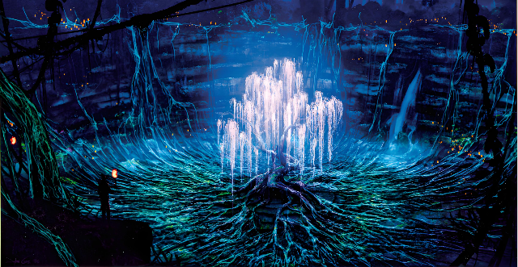
For the animation of the growth of the sacred tree, which was the habitat of the Vermilion Bird in ancient times, we will combine the modelling of MAYA and ZBrush with the animation of Blender. MAYA and ZBrush are used to construct the model of the sacred tree and clarify its overall shape and structure. Subsequently, in Blender, through keyframe animation, bone binding and other techniques. Realize the growth process of the sacred tree from seed sprouting, and branch stretching to branching. Refer to the tree of souls in Avatar (Figure 8), and refer to the rhythm in the production of its plant growth animation.
Figure 8 - Avatar

4. Mythological Text Analysis and Visual Symbol Extraction
4.1 Analysis of Mythological Texts
The Vermilion Bird occupies a pivotal position in the ancient Chinese mythological system. In ancient texts such as Mozi, the Vermilion Bird is always given the status of a priest or guardian deity. It represents sanctity and purity. In this movie, the character of the Vermilion Bird is positioned as a guardian god, also as a kind of inheritance of ancient mythology. As a guardian god, the Vermilion Bird guards the peace and order of human society with its power. Meanwhile, in the ancient period of the movie, the Vermilion Bird is not only the guardian god of human beings but also bears the heavy responsibility of guarding the royal family and the country.

  - Visual Symbol Extraction
In terms of visual symbol extraction, the study of the Qin-Han period Vermilion Bird Pattern and Sanxingdui Bronze Ware Pattern can further provide logical historical support for the design of the movie.

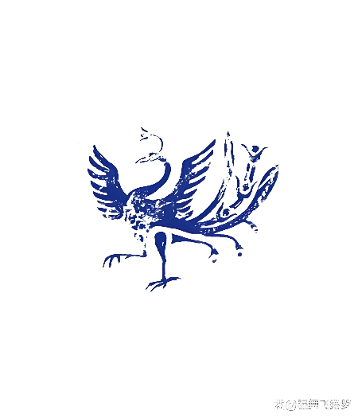
The Qin-Han period was one of the golden periods in the development of ancient Chinese art, and the Vermilion Bird pattern was also a popular decorative pattern at that time. It was widely used on bronzes, jades, potteries, wadang (Huaijun Liu 2002) and other artefacts. Vermilion Bird motifs of this period usually show the artistic characteristics of simplicity, clarity and smooth lines. The image of the Vermilion Bird is more lifelike and the feathers are more layered (Figure 9). The Sanxingdui culture also serves as one of the important parts of ancient Chinese civilization. On the bronzes of Sanxingdui culture, the element of the Vermilion Bird is worth studying and analyzing. The image of the Vermilion Bird on the bronzes of Sanxingdui often shows an exaggerated and deformed artistic style. At the same time, the element of Vermilion Bird is often combined with other symbols or patterns. Through the comparative study of the Qin-Han vermilion bird motifs and the vermilion bird elements on the Sanxingdui bronzes, it can be found that there is an obvious difference between the two in terms of artistic style. This difference also reflects people's different understanding and aesthetic pursuit of the image of the Vermilion Bird in different historical periods. Although there are obvious differences in artistic styles, the elements of the Vermilion Bird in different periods reflect that the Vermilion Bird was in a high cultural status at that time. This also lays a certain historical foundation and academic support for the Vermilion Bird as the guardian god of the country in the movie.
Figure 9-Vermilion Bird Patterns of the Qin and Han Dynasties

5. Conclusion
This study takes the “Vermilion Bird” as the central point of discussion in a diffuse manner. Through individual studies, the deep cultural connotation of the Vermilion Bird in the traditional Chinese mythological system is revealed. At the same time, in the cross-cultural comparative study, there is a certain connection with the image of the firebird in other cultures. It enhances the cultural universality of the character in the international arena and also promotes the exchange and integration of Eastern and Western cultures. At the level of character design, combining ancient texts and modern digital media technology, we successfully constructed the image of the Vermilion Bird with both traditional aesthetics and modern visual style. On the technical level, different production solutions are proposed for the animation of the flame feather and the growth of the sacred tree, which improve the efficiency of the film in post-production and provide technical ideas for future film and television works with similar themes. Finally, the mythological text analysis and visual symbol extraction provide stronger historical support for the characters. In summary, this study effectively provides a research program for the film, which can better support the post-production development of the film. It also opens up new research perspectives and creative ideas for the cultural narrative of fantasy films.

References
Anonymous. (2015). Classic of Mountains and Rivers. Beijing United Publishing Co. Beijing.
An Liu. (Western Han). Huainanzi - Tianwen zhun (淮南子-天文训)
Feng shi. (2007). Chinese Astro-Archaeology. China Social Science Publishing House. Beijing
Huaijun Liu. (2002). Qin-Han Treasures: Catalogue of Qin-Han Tile Dangs in Meixian County. Sanqin Publishing House. Xian.
Jingyun Guo. (2013). Xia, Shang and Zhou: from myth to historical fact. Shanghai Ancient Books Publishing House. Shanghai.
Publius Ovidius Naso. (1 A.D. to 8 A.D.). Metamorphoses. People's Literature Publishing House. Beijing.
Sheng Fu. (pre-Qin, Chinese history up to the foundation of the Qin imperial dynasty in 221 BC). The Book of History. Shanghai Ancient Books Publishing House. Shanghai.
Qingsui Huang. (2021). Classical Chinese Tattoos. People's Posts and Telecommunications Publishing House. Beijing.

