
DECLARATION
A usability study of mobile applications
By Leah Cahill

Supervisor: Kemi Ademoye
Second Marker: Michael Dacey
Project submitted as part of the requirements of the award of BSc (Hons) Web Development.
April 2018

I, Leah Cahill declare that I am the sole author of this Project; that all references cited have been consulted; that I have conducted all work of which this is a record, and that the finished work lies within the prescribed word limits.

This work has not previously been accepted as part of any other degree submission.

Signed: Leah Cahill

Date: 24th April 2018

FORM OF CONSENT

I, Leah Cahill hereby consent that my Project, submitted in candidature for the B.Sc.(Hons) Web Development degree, if successful, may be made available for inter-library loan or photocopying (subject to the law of copyright), and that the title and abstract may be made available to outside organisations.

Signed: Leah Cahill

Date: 24th April 2018

Abstract
The aim of this project is to evaluate usability of an existing app and to create a mobile application based upon feedback on how users find the usability. By using the feedback; it can be determined if there is anything on the app that can improve regarding usability.
An objective of this project is to research and fully understand how the designers design with usability in mind, thinking of design guidelines for websites for example or looking at user-centred design approaches.
A second objective is to be successful in implementing an application using a hybrid mobile application framework.
A third objective of this project is to receive feedback by questionnaires and ensure that the feedback is analysed and considered before development and whilst writing an evaluation.
The app has been developed using the Ionic 2 framework which enabled the researcher to create a hybrid mobile application. The design of the app was decided based upon experimental design strategies to how it could be designed with a good standard of usability.
A questionnaire was carried out on the Ionic app and the feedback showed that it showed slight improvements by rating higher than the original app in the feedback.
An overall conclusion of this project is that an understanding of usability was achieved, usability principles and guidelines that were identified in the literature research were applied in the design stage of the app. However, the overall usability of the app has areas that could be improved.

Contents
Abstract 2
List of figures 5
Introduction to project 8
Introduction to the Literature Review 9
What is usability? 9
Design Patterns 10
User Interface Design Patterns 10
Interaction Design patterns 10
Layout Patterns 11
Implementing Usability in Web Design 13
Core principles of usability in website design. 13
Core principles of usability for small-screen devices 15
User Experience (UX) 16
UX and Psychology 16
Usability Evaluation methods 18
Eye Tracking Method 18
Observational Method 19
Benchmark Method 20
Heuristic Evaluation 20
Research Methods 22
Research Philosophy 22
Research Approaches 22
Research Strategies 23
Time Horizons 24
Usability Questionnaire 25
Usability questionnaire results 26
Analysing the scores for each statement 27
A reflection of the questionnaire results 32
Introduction to Design section 33
User Requirements 33
User Scenarios 34
Use Case Diagrams 35
Initial Wireframes 36
Experimenting with Ionic CSS components 38
The Card Layout 38
Improving initial designs and ideas 40
Focusing on the content on the Recipe Pages 41
Considering the content for small screen devices 42
Designing the Newsfeed 43
Introduction to Development Section 44
Storyboards of the interfaces created 45
Continued. 46
Homepage 47
Explore Page 48
Considering the content for smaller screen devices alongside development 49
Discussing the Navigation of app 50
NavPush Navigation 51
Discussion of general Ionic features 52
Alerts 52
Tap, Date Time picker and Form 53
Ionic slides layout 54
Search feature 55
Search and Follower Pages using HTTP request 56
Camera Component 57
Viewing the app on different devices 58
Debugging on Android device 59
Evaluation of results 60
System Usability Scale (SUS) Score 60
Evaluation of project 63
Conclusion and Recommendations 65
Suggestions for further work. 66
Reflection 66
References 68
Recipe and Image References for App 73
Appendix- Section A: Exploring existing mobile applications 76
First App – ‘SORTEDfood’ 76
Second App – ‘Kitchen Bowl’ 77
Third app – ‘Foodsaurus’ 78
Section B: Questionnaire Feedback. 79
Background of study 84
Section C- Design and Development background - Research into Hybrid Mobile Applications 86
Progressive vs. Native vs. Hybrid 86
Hybrid mobile app development 87
Section D: User Requirements expanded 88
Section E: Second questionnaire results 89
List of figures
Figure 1 The Gutenberg diagram. [9] 11
Figure 2-Z Pattern Layout [9] 11
Figure 3 Heat map of the eye tracking data on a usability test on Holiday Auto's Website [31] 18
Figure 4 Holiday Autos new design [31]. 19
Figure 5 26
Figure 6 27
Figure 7 27
Figure 8 28
Figure 9 28
Figure 10 29
Figure 11 29
Figure 12 30
Figure 13 30
Figure 14 31
Figure 15 31
Figure 16 32
Figure 17 38
Figure 18 38
Figure 19 38
Figure 20 39
Figure 21 39
Figure 22 39
Figure 23 40
Figure 24 40
Figure 25 40
Figure 26 41
Figure 27 41
Figure 28 42
Figure 29 42
Figure 30 42
Figure 31 42
Figure 32 43
Figure 33 43
Figure 34 43
Figure 35 44
Figure 36 - Suggested Content Segment 45
Figure 37- Recipe #3 45
Figure 38- Recipe #1 45
Figure 39- Recipe Segment 45
Figure 40- Explore page 45
Figure 41- Homepage 45
Figure 42- Search Segment 45
Figure 43- Recipe #2 45
Figure 44- Page of suggested users 45
Figure 45- Share page 46
Figure 46 - Collections page 46
Figure 47- Homepage 46
Figure 48- Ingredient search page 46
Figure 49- User Profile 46
Figure 50- Settings 46
Figure 51 47
Figure 52 47
Figure 53 47
Figure 54 47
Figure 55 48
Figure 56 48
Figure 57 48
Figure 58 48
Figure 59- First Draft 49
Figure 60- Recipe Page unformatted 49
Figure 61- After breaking up the sections 49
Figure 62- After formatting content 49
Figure 63- Demonstrating the main navigation 50
Figure 64- App.Component 50
Figure 65 51
Figure 66 51
Figure 67 51
Figure 68 52
Figure 69 52
Figure 70 52
Figure 71 53
Figure 72 53
Figure 73 53
Figure 74 54
Figure 75 54
Figure 76 54
Figure 77 55
Figure 78 55
Figure 79 56
Figure 80 56
Figure 81 56
Figure 82 57
Figure 83 57
Figure 84- iPhone 6 Action sheet controller component 58
Figure 85- Android Action sheet controller component 58
Figure 86-Size of iPhone 6 58
Figure 87- Size of iPhone 5 58
Figure 88 59
Figure 89 59
Figure 90 60
Figure 91 61
Figure 92 61
Figure 93 62
Figure 94 63
Figure 95 76
Figure 96 76
Figure 102 77
Figure 103 77
Figure 104 78
Figure 105 78

Introduction to project
This project focuses on evaluating the usability of mobile applications and how areas of the apps may be improved by evaluation.
The researcher will initially evaluate an existing app and then develop one themselves, the usability of the new app will be evaluated using the same questionnaire as the initial app. The researcher will compare the results and evaluate the statements with lower scores and discuss how the app could be improved upon future development.
The overall aim of this project is to evaluate usability of an existing app and to create a mobile application based upon feedback on how users find the usability, using the feedback; it can be determined if there is anything on the app that can improve regarding usability.
An objective of this project is to research and fully understand how the designers design with usability in mind, thinking of design guidelines for websites for example or looking at user-centred design approaches.
A second objective is to be successful in implementing an application using a hybrid mobile application framework.
A third objective of this project is to receive feedback by questionnaires and ensure that the feedback is analysed and considered before development and whilst writing an evaluation.
This project begins with the following section which is a literature review researching usability. As usability is such a broad term, the literature review is split into sections such as discussing usability in web design, user experience (UX) and researching different usability evaluation methods.
The rest of the chapters consists of discussing the research methodology, a discussion of the questionnaire and the results, followed by a section containing the design and implementation of an app and then this project ends with a project evaluation and a personal reflection.

Introduction to the Literature Review
This section of the report contains a review of the literature and research papers that focus on usability and the user experience regarding websites and smaller screen devices.

What is usability?
Good usability is typically where the system is not lacking a feature or certain steps to perform a task, so the user has an efficient, effective and satisfying experience when using the product. It is also where the information presented is relevant, so the user finds it useful. If the user struggles to perform certain tasks on a piece of software that assumes the user will know exactly what to do, then the usability should be reviewed and improved upon so future users will have a better experience [1].
Systems designed with good usability are typically easier for the user to learn how to use it, as the user can follow the navigation and complete the tasks feeling stress free and without error (or minimal errors created) [2]. Jakob Nielsen [3] has identified the following heuristic principles regarding usability.
Heuristic principles for UI Design [3]
- Visibility of system status - Users should be informed what is going on with the system and receive this feedback within a reasonable timeframe.
- Match between system and the real world - The system should follow real-world conventions, it should use phrases and concepts that the user would relate to and understand rather than system-oriented terms.
- User control and freedom – System should support redo and undo options, so a user knows how to exit if they make a mistake.
- Help users recognize, diagnose, and recover from errors – Error messages should display clearly and indicate what the problem is to the user. The error message should also suggest a solution to fix the issue.
- Consistency and standards – The system should follow platform conventions and design standards, so users have a clear understanding what situations and what any actions mean.
- Error prevention – Check for error-prone conditions in the design so problems do not occur.
- Recognition rather than recall – users should be able to retrieve instructions when they require them rather than having to remember the instructions by memory.
- Flexibility and efficiency of use - Relevant and frequently accessed actions can be tailored by users so the interaction is accelerated.
- Aesthetic and minimalist design – The dialogues on the system should only contain information that is relevant and necessary.
- Help and documentation – Help and documentation should be available to guide a user with any issues that they have using the system. The documentation should be easy to search and easy to understand [4].

Design Patterns
This section contains information and research about design patterns that contribute towards the usability within the user interface of websites. Some researchers recognise User Interface Design Patterns as the same category as Interaction Design Patterns, here they are both going to be discussed in the same section.

User Interface Design Patterns
UI design patterns are there when a usability problem keeps occurring. The patterns will be reusable for other designers to overcome the same problem (if they encounter it). They are particularly useful in supporting some of Nielsen’s principles for UI design as they provide standard design patterns to commonly occurring problems, which then provides and ensures familiarity for the user.
The elements that the patterns are created upon are [5] [6]:
- Problem (and identifying context of problem): Investigating and discovering the initial problem that the user is facing and identify the problems context of use.
- Principle: what design principle that the design pattern is based upon.
- Solution: a solution to the problem.
- Document: analyse why and how the applied pattern works.
- Examples: Research existing solutions to the problem, some real-life system may have had the same problem but have found a solution to it.
- Implement: It is important to show how the applied pattern works in the system so that another user facing the same problem will be able to recreate it [5].

Interaction Design patterns
These patterns are flexible for the designers. They are guidelines, not rules that are set in stone; the designer can change them as they wish.
Visual Patterns
Visual design patterns are there to help the designer with the UI, this usually relates to the colour and the elements of the design. Focusing on a set of principles, there are the Gestalt principles in visual design [7], which are:
- Proximity
- Symmetry
- Common Regions
- Continuity
- Focus
- Closure
- Isomorphic correspondence
- Good form
- Simplicity
- Similarity
- Unity/harmony
- Connectedness
Although the Gestalt principles were developed in the 1920s, a case study in 2002 [8] tested these principles to see if they were still considered useful in helping with visual design. The study consisted of redesigning an existing website that teaches nursing students, and the new design created was from following the eleven Gestalt principles (listed above). The new design received extremely positive feedback when it came to asking users to evaluate it and it was [8] concluded that the Gestalt laws are still relevant, beneficial for visual design and effective for those who are learning.

Layout Patterns
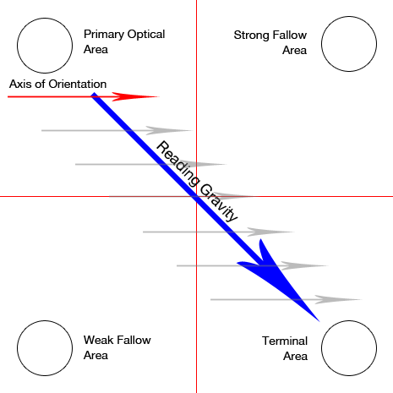
Layout design patterns are there for the designer to consider the layout and structure of the content on the web page. There are several patterns available depending on what content the designer needs to include, two examples being:
The Gutenberg diagram.
The Gutenberg pattern is where the page is broken up into four sections. This pattern is based upon on the natural reading path where the users read from left to right. The diagram suggests the eye movements and points out the main sections of content that the users are more likely to read naturally so this is where the most important elements should be on the page.
This layout pattern usually suits the page when there is a lot of text. [9]
Z-pattern Layout
Figure 1 The Gutenberg diagram. [9]
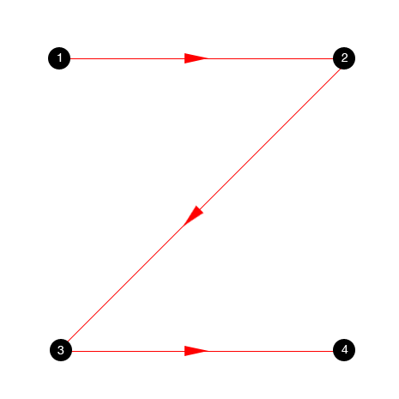
The Z-pattern is useful for pages with minimal content. The top line is the first part of the content that views will scan across, so it is here where the main text or information goes that you want users to focus on straight away.
The centre of the Z-pattern path is usually containing a large image or type of graphic that the user is unlikely to pause and focus on before moving on and scanning their eyes to the bottom right part of the page.
The structure to creating this pattern is important; the content should not distract users by including anything that is not in the Z-pattern path [10].
Figure 2-Z Pattern Layout [9]
The purpose of what brings a user to the page is an important factor that affects the layout of the website and what pattern to choose. The main use of the webpage must be clear to allow the user to perform the task that they intend, and the layout should include a visual pattern that will help attract their attention to the task. A study by Goncalves et al. [11] aimed to show that the visual patterns created by the user were different depending on the task performed and not where the task is located on the website.
The users completed tasks such as buying one product from Amazon and finding a Blog site of Expresso website and gaze maps displayed the eye tracking data. The study [11] concluded that there were clear differences in the statistical analysis of the eye tracker data on visual patterns of web pages and that each task has different visual patterns. The interpretation of this could be; that the type of tasks that are going to be performed could decide what visual layout pattern to implement.

Implementing Usability in Web Design
This section focuses on discussing some of the considered key elements when implementing usability principles in website design.
Core principles of usability in website design.
When it comes to website design and usability, there are design principles that are there for the developer to use alongside development as a guideline. These principles allow them to focus on how to make the website’s usability to a high-quality standard and it is not just, about how attractive the website looks.
User requirements.
As a starting point, the developer could focus on the user requirements of their website. This could enable the developer to design appropriately for the audience; they should ask questions such as:
- Who is the target audience for this?
- What is the target age group?
- Consider the size of the screen the users will view the data on; is it a small laptop with a 10.1-inch screen? Alternatively, a large desktop?
- The developer should consider the content of the website and ask themselves questions such as “What is the main purpose of this website?”, “Will users be able to find the information that they are searching for with ease?” and there is taking into consideration the language spoken/read by the users. [12]
Structure and content

When designing the usability of a website, it is important to consider the age group to focus the website content on. Websites will also need to consider the fact that they may have a wide range of age groups as part of their target audience. As such, the usability needs to ensure the website is accessible to all user age groups. Patsoule and Koutsabasis [9] demonstrate the importance of this in a study to redesign a touristic web portal to meet the accessibility needs of people from older age groups.
The original website had issues identified such as; the homepage “look” was not consistent with the aim and purpose of the website, there was too much text that overloaded users with information, and it needed to restructure the whole layout of the page so that it was clear and organised.
The study consisted of twelve older users participating by evaluating the two websites through interviews and questionnaires. The result was that the new redesigned website’s usability had greatly improved as they had resolved major usability issues within the original website and older users will have a more satisfying and easier experience using this website to view and book holidays through.
Still taking age and usability into consideration, there have been a similar study, but this time the study focuses on the usability of the web guidelines for teens [13]. The website evaluated was “BAM! Meeting the Challenge” which allows teens with asthma to use and let them live their lives normally. The guidelines were to ensure that the users could use the website with ease, have an overall satisfying experience, and engage in the usability and consider whether there was aesthetic appeal within the site. This study differs to Patsoule and Koutsabasis’ [14] study as this is about assessing that the website meets the usability guidelines rather than identify usability issues and redesign the website so it is an improved version, however both studies focus on particular audiences of age.
The overall conclusion of this study [13] was that the usability was consistent with the guidelines that they had focused on prior to testing. Bailey and Seals [13] hope that the design of usable websites for this age group will continue to improve as many users search the internet for health-related problems, so it is always going to be helpful towards those users if they are able to access reliable and usable websites for information.
Accessible design
Accessibility is important so that everyone has equal access to information online and can view it in a way that suits the individual. There are many factors aside from the design that could contribute to making the usability poor and it could relate to the accessibility of the product. The Web Content Accessibility Guidelines (WCAG) is one of the core standards in place to ensure that developers create a website that is accessible to everyone and it ensures that the website conforms to the current standards of the web and is compatible with browsers. There is also the Web Accessibility Initiative (WAI), which produced the initial version of the WCAG. WAI is set in place to improve the accessibility within the World Wide Web for disabled people. [15].
Rømen and Svanæs, carried out a research study to evaluate the usefulness of the WAI website accessibility guidelines mentioned above [16]. The study tests the usability of websites by asking disabled users to test them. The main purpose of the study was to conclude whether they felt that the WCAG was sufficient to guarantee website usability or not. The results from the study indicated that the guidelines were not sufficient and could be validated or improved upon in the future.
In a similar earlier study [17] , Petrie and Kheir investigated the relationship between accessibility and usability of websites getting users to complete a set of tasks on a website. This study differs from the study by Rømen Svanæs [17], as it focuses on whether there was a relationship between accessibility and usability rather than if the accessibility guidelines are sufficient to ensure the accessibility. It is, however, interesting to see how the accessibility of the websites in both studies is tested through usability testing and asking the users to complete the same tasks and in the same order, both studies also asked their participants to “think aloud” whilst performing the tasks.
Seven disabled participants and six controls who were non-disabled took part of the study evaluating the WAI guidelines [16]. In the other study by Petri and Kheir’s study [17] consisted of all the disabled participants being blind. It is important to note what disability each participant had, as not all disabilities are to do with visual impairments and the subject of accessibility for disabilities is broad and is open to different interpretations.
The previous two studies looked at usability and accessibility on websites. In [18], Navarette and Lujan-Mora present an Open Education Resource (OER) website designed to enhance the user experience for learners with disabilities. The paper looks at how a website can be made customisable to a learner with a certain disability, and how the profile and language bars can be changed to the user, so it is personalised for their individual use and may improve the experience of the user overall. It mentions how searching the website is an important usability issue, as it may otherwise become a time-consuming process for the user. As such, they have tried to resolve this by highlighting the most popular fields that users search, as it may be relevant and cut down on time searching for content.
For websites to support special software to an adequate standard then they must build them to support accessibility and WCAG and WAI provide guidelines for developers to follow to ensure this.

Core principles of usability for small-screen devices
Websites are no longer a standard size. There is a huge variety of devices available that range in size from small-screen devices, such as smart phones, to very large smart TVs, so it is important to consider how the design will look on different formats. Smaller-screens cannot hold near as much content as larger screens can, so the developer should consider the design to maximise the usability standard and ensure that users have a satisfying experience when using devices such as mobile phones.
There are factors to consider when designing for a small device such as:
- Screen size or screen resolution.
- Choice of device
- The operating System on the device.
- Choice of browser and what version [19]
It is important to consider these factors, so the designs can meet the web standards and are compatible to run on the specific browsers and that the content fits the device screen size.
Developers can create the layouts to be responsive, this ensures that the content designed is fluid and dynamically fits the screen of devices of different sizes such as tablets. The content changes and becomes responsive by setting different breakpoints throughout the code; extra content is set to hide when the screen size decreases or even shown when the screen is larger.
The practice is to ensure that the users do not have to be the ones trying to zoom in to view small writing to make it readable. This is where the typography comes into it and the units are not specified in fixed-size pixels but written as em units as the text is then in relation to the size of the content and automatically resizes. The responsive layout tends to contain less content and the navigation should be simple, so it does not take up too much of the page. Single column layout are a good choice for users rather than trying to zoom in on the screen on a certain side column, they are able to scroll down and view all the content with ease [20] [21] [22].

User Experience (UX)

User Experience (UX) focuses on the behavioural/emotional interaction between the end-user and the system created. The developer should consider how what is being created will meet the customers’ needs and create a good user experience overall for them. This is typically important for the company, as they want to have a good emotional response from the user and ensure that the customer uses the system regularly [23].
UX is an important part of usability as it is essential to consider how customers react to a product in a certain way that could influence improvements if they were to update it. UX could ensure that the system is easy to use, or enough instructions provided for the users to learn how to use the system. The less errors or time completed to carry out tasks then the better the experience of the user; if the system is frustrating to the user then they are less likely to use it again.
How is UX different from usability?
UX considers the end user’s behaviour when it comes to the usability of the product. Usability is also about the end user but not so focused on the emotional side and more about what users do to complete the tasks or how they navigate certain systems. Just because something is designed with the intention to be easy to use does not mean that it equals a good user experience [24].
UX thinks about the emotional side of the human interaction side of usability so it is important for the companies to really go out of their way and research their product from the perspective of real life potential customers. As each user is going to be different and have different opinions on the product, it is also important to receive feedback from more than one person [25]. When it comes to the user-friendly side of the product then the developer should ask themselves questions such as “What does the user expect when they click this button?” and “Does the system assume that they know how to do something without instruction?” If the developer considers the end user’s feelings and behaviour, then it could contribute to developing a system that the user can use without having to learn anything or complete tasks with minimal errors.

UX and Psychology
As UX focuses on emotions, applying psychology in aspects such as the design and colours can play a role in how the end-users feel towards the product. Notifications are another example of using psychology in UX. Knowing what notifications that the users would prefer to receive is always an advantage to the company, as they know that notifications help users keep up to date with the website or app. If the users allow the notifications, then this usually means that they are going to be regular users. However, notifications can become a disadvantage to the company if they send too many and the alerts become irritating to the users.
The psychology can affect the design, for example on a website, the developer could consider how to display the content and think about how the user’s eyes will follow the page and think about how they will view the headers etc. The page title text should always be the largest on the page so that it draws the users towards it immediately, so they know what the webpage is going to be about or include. It would create a negative user experience if they were to find themselves on a webpage and not fully understand what the main content is.
Emotions.
It is important to understand how to interpret a user’s emotional response in an effective way for it to contribute to recording useful feedback. Petrie and Precious [26] aimed to learn how to measure the UX by looking how the user reacts emotionally and they set out to do this by asking participants to use two techniques on two websites. The first technique was using the “think aloud” protocol and the other technique of using an Emotion Word Prompt list, which contained 16 emotion words for the participants to choose which they felt described their experience.
The conclusion of this study [26] was that the techniques used to measure the user experience were effective and allowed them to capture the user’s emotions successfully. However, the prompt list did not make a difference when it came to the number of emotive words chosen but was considered helpful in guiding users towards the right emotive word that they might have not thought of in the first place.
In a related case study on capturing and measuring emotions in UX. [27], the researchers explored if self-reporting was effective in comparison to other emotion capturing methods. Self-reporting is where the users are asked directly to explain how they felt about the tasks that they were told to complete and describe their user experience personally.
The study began with paper-based prototypes for the users to self-report and select what emotion they were feeling from a specific emotional scale category. The final study was a digitised version named Emotrak, implemented as an app and displayed upon on a tablet device. The conclusion of this study was that self-reporting enabled users to report accurately about how they feel and that the data recorded from the self-reporting was easy to interpret and understand, however the Emotrak is not yet finished and there is still future research to carry out.
Colour
Colour can have an impact on a user’s feelings towards a website. People associate different colours to specific feelings, but it is not always a general agreement on what emotion suits what colour, as this can be individual to each person depending on factors such as their culture. A case study [28] specifically focuses how colour influences navigation in a nonlinear narrative.
The study split 24 people into three groups of eight and asked the users to interact with the prototype where they had an option of three buttons associated to three emotional responses. These responses were recorded by the users thinking aloud, eye tracking, observation of the users’ body language and video recording. The conclusion of this study [28] was that colour does influence the emotional response in navigation and designers should consider these findings when developing interactive systems.

Usability Evaluation methods
This section focuses on the methods that are available to evaluate the usability within a website and discusses relevant research papers that include the evaluation method.

Eye Tracking Method
Eye tracking is a method used in usability evaluations. Software and devices are available to track the user’s behaviour and then the data is analysed based upon how the user reacts to the product or website. Eye tracking is especially useful as a method of testing when the navigation or the information architecture/menu is the focus of the usability test. Eye tracking can discover what certain parts of the webpage can attract the user’s attention immediately or if certain features capture the interest over other parts of the webpage [29].
Eye tracking data can discover if moving items around on the page affects the time taken to find them. For example, the study in [30] analyses eye-tracking data to discover if the location of items on a website’s navigation affects how quickly the user locates the tasks and if it takes them longer to find if the items location is further from the centre.
The study consisted of 147 participants on 15 unique navigation menus. Three menus included were vertical and the rest were horizontal. The study, however, concluded that the orientation of the menu had no effect on the time taken for users to locate a specific item on the menu. The overall conclusion of the study [30] was that there was no established relationship between the location of the menu item and the time taken that the users took to find them.
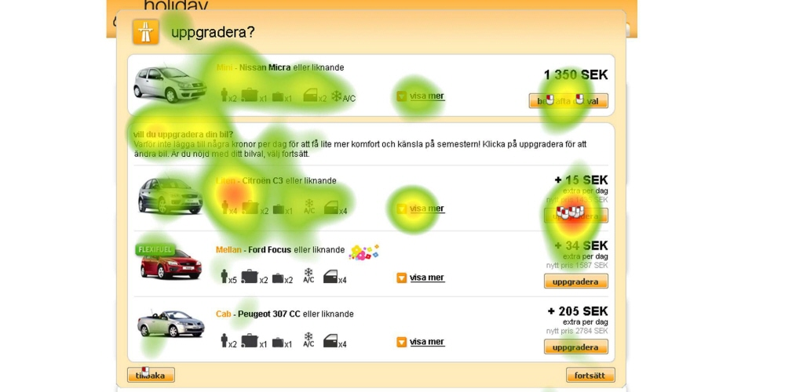
Figure 3 Heat map of the eye tracking data on a usability test on Holiday Auto's Website [31]
Eye tracking allows companies to improve their websites, such as Holiday Autos website (above) [31]. The booking process on their website was the focus of the usability test where the method of testing was eye tracking. It showed there were a few issues as some participants in the study did not even complete the order as they found it confusing to use.
The heat map created from the eye tracking data allowed the company to understand where they were going wrong on the design and improved it by removing unnecessary text, reducing the overall text in the ordering process and showing a process box on the users order so they know that their order have been processed.
The company used eye tracking again on the new and improved design of the website to ensure the quality in the validation of the test. Below is the heat map of the new design of the ordering process page [31], the new design received a positive response.
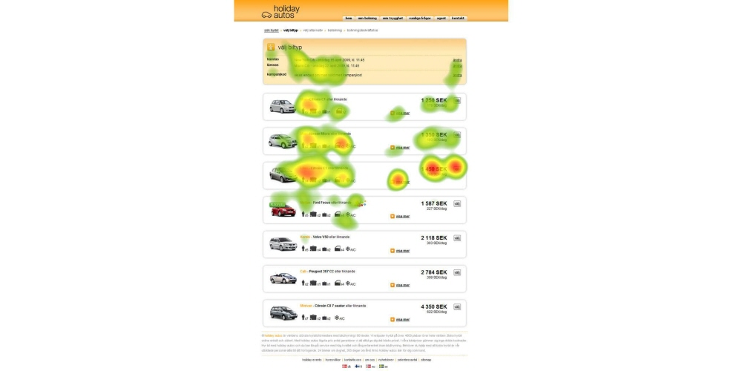
Figure 4 Holiday Autos new design [31].

Observational Method
There is the method of observing users when testing a system. It is useful to record users via video or audio so that their behaviour can be analysed later once the study has finished. However, it is important to make the setting of the recording natural, so participants’ behaviour and reactions are natural, and no reactions are forced. The behaviour of a user is up for interpretation; one person may show that they struggle with certain tasks by stopping and pausing for a few seconds, and this behaviour can compare to the behaviour of another user completing tasks quickly with no hesitation. [32]
Like the observational method, users can have their behaviour recorded by audio or video; but this time they will be recorded whilst they use the “Think aloud method”. The think aloud method asks users to express how they are feeling whilst carrying out certain tasks, they can express themselves in a negative or positive way, it is just important that they are being honest and not saying what they think that the researchers want to hear.
By changing the classic think-aloud method slightly, it may improve capturing a better emotional response from users. Here, a case study [33] considers using a different style of the think-aloud method; the style being relaxed and focusing on the participant’s utterances with interactions and then using the usual classic think-aloud style to compare it to. The researchers made interactions such as reminding and prompting the users to keep talking when they had fallen silent for a certain number of seconds or asking the users for their opinions directly.
The conclusion was that the interactive approach prompted users to make more comments out loud but was not found to be higher when the comments were analysed and considered relative to the study in comparison to the classic think-aloud style. The study [33] also concluded that interaction with the user’s thoughts might be distracting when they are trying to focus on completing tasks.

Benchmark Method
Benchmark testing is another evaluation method that is effective when it comes to usability testing, this is where a user completes certain tasks and their performance is measured. Comparisons are made between the scores of users’ performances which can determine what the average time taken to complete a task was or the data can be analysed to discover a pattern where many users may have hesitated which could indicate they misunderstood what to do straightaway. At the end of the usability test, the users give their opinions on the tasks that provides the researchers with subjective feedback.
Benchmarks in usability testing by identify the performances that the researchers wish to track and compare for their study. However, sometimes the existing benchmarks are not effective enough. This was the focus point in a study regarding motion-tracking systems [34] where they felt that there are not enough benchmarks, which measure the quality of motion-tracking systems.
The study [34] went on to develop six general requirements for their own designs and developed two benchmarks from this that they went on to test with their games. The study concluded that the general requirements that they developed provided an improvement to measuring the performance but there is still a lot of future work to do and more benchmarks need to be developed.

Heuristic Evaluation
Users who wish to inspect the usability can carry out a heuristic evaluation, which will identify usability problems within the UI design of a website.
The use of heuristic evaluation to find usability problems have been demonstrated in many research studies [35] [36] [37]. In a study by Nielsen [36], it reported that several factors might influence the probability of finding usability problems when using heuristic evaluations. For example, the expertise of the evaluators, which was further influenced by their familiarity of the type of interface being evaluated, the severity of the usability problems that exists and if the evaluation was done on a live system or paper prototype. [36]
Surveys
Participants can be asked to complete tasks on websites and then fill in a survey at the end, the survey can contain open-ended questions such as “What did you like the most about this website?” or close-ended questions such as “Did you like this colour scheme?” with answers for the users to rank being as simple as “Yes” or “No”.
An example of a usability study, which is the chosen study for this project, is the System Usability Scale (SUS). This is where a user answers a questionnaire by answering with their opinion of “strongly agreeing” or “strongly disagreeing”; the SUS have templates online and is customisable to have the questions directly relate to the website that the questionnaire focuses on.
The tester can measure user feedback by converting the scores and using 68 as the benchmark to consider the feedback average.
Regarding a usability study [38] on three travel websites, the participants took part in a pre-test survey and a post-test survey. The pre-test survey collected information about the participants such as their background and experience with the websites and internet. The post-test survey asked questions such as “what can be improved?” and “What was your least favourite feature?” The participants answered some close-ended questions with “Like” or “Dislike” regarding their opinions on the layouts, colours and fonts.
The study [38] concluded that the post-test surveys were effective in data collection and enabled the researchers to learn about the improvements that they could make by the participant’s recommendations. Future research will continue of the study, the research will include the participants completing more and complex tasks on each of the websites and discover any weaknesses within the usability.
Summary
To summarise the research upon usability testing, there are several ways to test the usability of websites and it is always important to consider which methods would be best to collect the necessary data/feedback. The size of the audience is always a good factor to consider, for example, a user may choose to carry out surveys if they know that their sample size is going to be small; this way they are still able to collect reliable and substantial feedback.
Another factor that could change the decision of what usability testing methods to choose could be the time constraint upon the project. An example of the timeframe becoming an issue could be asking fifty users to come in to the lab and use the eye tracking method on five different websites all in two hours. This will take a considerable amount of time and shows how the sample size and method chosen should fit the timeframe of the project. However, the whole project does not depend upon the usability testing; there is research, analysing feedback and evaluating to consider within the timeframe as well.
It is usual for teams to select more than one method of usability testing to ensure there is a variety of feedback and data to analyse. An example of choosing two different methods could be, choosing a heuristic evaluation to give objective data and then using the observational method to give the tester subjective data to consider.

Research Methods
This section contains and explains the research methods and approaches applied to this project.

Research Philosophy
There are several research philosophies that exist for a project depending upon the context, examples of different research philosophies are realism, positivism and phenomenology. It is felt that the positivist approach is the right philosophy for this project, as this project is going to be about conducting an experimental study to verify the usability of a mobile application.

Defining positivistic approach as:

“Positivism is a philosophical system deeply rooted in science and mathematics. It’s based on the view that whatever exists can be verified through experiments, observation, and mathematical/logical proof. Everything else is non-existent. In addition, positivists usually believe that scientific progress will eradicate, or at least sharply reduce, the problems facing mankind [39].”

The data collection methods of this approach are structured, and the research collected is valid and reliable. This project relates to this approach as it includes a structured questionnaire. This method allows the researcher to discover trends and make comparisons within the statistical data; the main data collection approach for the study is based on objective data via a structured questionnaire with standardised responses that map to numerical values, which can be easily interpreted and analysed. The study will also include some additional subjective data for further discussion [40].
Those who are creating a quantitative study in comparison to a qualitative study usually prefer positivism. This is because it focuses on the scientific methods and experiments rather than focus on the humanistic side of things.

Research Approaches

The approach to a research project can be inductive or deductive. This project is going to adopt the deductive approach as it is testing a hypothesis that the improvement of usability is possible upon evaluation of an existing system.
This approach involves initial hypotheses, whereas the inductive approach does not, the deductive approach is explained as “reasoning from the general to the particular” [41].
The deductive approach follows the following stages:
- Theory
- Hypothesis
- Test
- Evaluating
The application will be developed and evaluated to see if the researcher has fulfilled what they said they were going to do and have met the objectives of this study, which focuses on usability.

Research Strategies
The aim of this project is to evaluate usability of an existing app and to create a mobile application based upon feedback on how users find the usability, using the feedback; it can be determined if there is anything on the app that can improve regarding usability.
An objective of this project is to research and fully understand how the designers design with usability in mind, thinking of design guidelines for websites for example or looking at user-centred design approaches.
A second objective is to be successful in implementing an application using a hybrid mobile application framework.
A third objective of this project is to receive feedback by questionnaires and ensure that the feedback is analysed and considered before development and whilst writing an evaluation.
There is a limited budget available to the researcher, however this should not be a problem as Microsoft visual studio is going to be the software to develop the app and this is available in all the labs at the university. Microsoft visual studio is used because it is free, and the developer is familiar with it. This is an advantage as they should feel comfortable and confident working with this software for this project.

The researcher is going to use their knowledge of HTML/CSS and basic knowledge of JavaScript to implement the app. They will learn about the hybrid application framework to help develop when they have selected a framework.
The research strategy is going to be experimental design and it will be a test-retest design experiment. The participants will test out an existing app, which is a food blog; this app is available on the Apple app store and downloaded onto the researcher’s iPhone SE.
The questionnaire is a customised version of the System Usability Scale (SUS) [42] and the participants complete several tasks beforehand. They will answer ten following statements regarding how easy they felt completing the tasks, how they feel about the app overall and the content, at the end they are able to voice their opinions on the negative and positive aspects of the app.
The answers from the questionnaire range from one to five; you calculate the score by subtracting one from the score for every odd numbered question, subtracting the value from five for every even numbered question and multiplying the new values by 2.5, which gives a score out of one hundred. Sixty-eight is the average and each score from the participant can compare their score against the average and the other participants’ scores. [43]
A new app is going to be designed after the first questionnaire and the app will be relevant to the app that the questionnaire is based on. The new app will try to display some improvements regarding the usability that the questionnaire picked upon, the participants will test the new app with the same questionnaire as before and a discussion and comparison of the scores will be made.
The participants are able to voice their opinions of the app that they feel are relevant, although this part of the feedback is subjective so it is hard to compare emotions than it is to compare numerical data. This subjective feedback will still be useful and considered alongside their questionnaire responses to gain a clear understanding of how each participant feels but it is not as important to the conclusion as their questionnaire scores will be.

Time Horizons

This study has a relatively short time span, so it is going to be a cross-sectional study. There are only several months to complete all stages of the study, and the design and development may take longer to implement and finish in comparison to writing the literature review. The timing schedule will allow the development stage to be considerably longer than other stages of the study.
Data Collection Methods
As mentioned in the research strategies, a questionnaire is the chosen data collection method in this project. There is the initial questionnaire during the research stage of the project and then another after the development stage where the participants will fill in the questionnaire and give their feedback of the usability.

The questions will be pre-defined and direct, the data from the participants scores will be analysed to discover if there are any patterns emerging within the opinions on any tasks that the user were asked to complete.
The questionnaires created are with an unbiased approach, the numerical data allows the feedback to be analysed easily rather than asking users for their thoughts and feelings, as that would then be hard to put into data and interpret it. However, the brief points that the users make are going to be recorded to back up their questionnaire results.
It is going to be a summative evaluation as it focuses on the user’s opinions at the end of completing the tasks and how they found the app overall.

Usability Questionnaire

The usability questionnaire will be a summative evaluation. The test runs on the completed and live application called ‘Kitchen Bowl’, the app chosen was the favourite out of the three downloaded, shown in the appendix, section A.
The participants are using the downloaded app to conduct the test; this is ran on the researchers’ iPhone SE. All the participants for this questionnaire regularly use a mobile phone and have many apps downloaded, this ensures that they are familiar with the interfaces of apps so should feel confident in their opinions of liking or disliking certain parts of the app such as the layout or flow.
This questionnaire is specific on the usability of the app; it is not about the participants opinions of the actual written content and images. The questionnaire selected will be a customized version based on the System Usability Scale (SUS) Test; the questions in the customised SUS will directly focus on the Kitchen Bowl apps specific features.
This questionnaire allows the collection of feedback within a short time frame as it will not take long for the participants to use the app and then give their opinions.
SUS Customised questionnaire
These are set tasks for the user to perform to gain an initial understanding and feel of the app -
- Like a photo on the homepage.
- Upload a photo (from camera roll).
- Follow a new creator.
- Create new recipe.
- Find recipe on a cake.
- Create a collection
User opinions on each statement. The answers from strongly agree to strongly disagree –
- I think the layout is simple and easy to follow
- All content on the app is relevant
- I found the recipes page with ease and the steps of the recipes are easy to follow
- I felt that the app is easy to understand and there is no learning required on how to use it
- The layout and theme of the app is consistent throughout
- I feel like there is adequate content on the page at once when viewing recipes
- There is an adequate amount of content on the newsfeed
- I found uploading an image was straightforward
- I found creating and posting a recipe was straightforward
- I understand what a ‘collection’ on the app was and how to create one

The participants have the opportunity at the end to list any negative or positive points that they feel are relevant to the study.

Usability questionnaire results

Figure 5

Figure 5 shows the SUS scores from the participants. The average score in this questionnaire was 54, which scores as “OK/Fair” usability within the app, anything below 68/100 is below average and implies that improvements could be made based upon the feedback.
In the following section, each score from the statements will be analysed to discover what the usability issues within the app are.

Analysing the scores for each statement

Figure 6
Question: I think the layout is simple and easy to follow
Statement one scored highly among all participants which shows that they all agreed and felt that the layout was simple and easy to follow. Participant D and participant E both stated after the questionnaire that the positive of the app was that it was easy to follow and easy to use so their scores reflect their opinions.

Figure 7
Question: All content on the app is Relevant
Statement two scored well but not as high as it could have been. Participant E stated that they did not fully understand the “featured” section on the newsfeed and a score of a three reflects this. This indicates a usability problem of the user fully understanding the content on the app.

Figure 8
Question: I found the recipes page with ease and the steps of the recipes are easy to follow
Statement three scored well between all five participants. Participant D stated that the layout was easy to follow and both participants B and C stated that finding recipes was easy, the high scores of fours and a five reflect their opinions. This indicates that there are no usability issues here regarding the steps of recipes and finding them.

Figure 9
Question: I felt that the app is easy to understand and there is no learning required on how to use it
Statement four did not score consistently. Participant D stated that creating a collection was easy to do once you understood what was meant by “Klip it” but participant A saw this as a negative point, stating that they only clicked on “Klip it” randomly and then discovered what it was meant by “Collection”. This suggests that the usability with the users identifying the custom buttons is an area for improvement.

Question: The layout and theme of the app is consistent throughout
Figure 10
Statement five did not score as well as it could have with scoring three from participants A, B and E. Participants C and D, however, stated that they liked the layouts which is reflected in their scores of five. These scores indicate that the consistency of the layout and design could be reconsidered and investigated in depth to why three users scored it a neutral score.

Figure 11
Question: I feel like there is adequate content on the page at once when viewing the recipes
The scores for statement six shows that the way the content is displayed, could be improved as it only scored a three from participants C and E. Participant A stated that the recipes page has a lot going on in every section with a lot of content, this feedback suggests that the layout could be simplified so that it is not overwhelming with text.

Question: There is an adequate amount of content on the newsfeed
Figure 12
Figure 12 shows that the scores indicate that improvements can be made here. The feedback given from participant C for statement seven was that they disliked how there is a featured section on the newsfeed. This suggests that any suggested content from the app should be in its own section, so the users can have the newsfeed exclusively to view their followers’ posts.
Figure 13
Question: I found uploading an image was straightforward
Statement eight was the highest scoring statement in the questionnaire. Nobody rated it lower than a five so that is a great indication that there are no usability issues regarding uploading their own image.

Figure 14
Question: I found creating and posting a recipe was straightforward
The scores are inconsistent for statement nine. Participants A and D both scored it four which indicates that they agreed that creating a recipe was straightforward, however, participant C scored it a two, meaning that they disagreed with the statement. The usability issue of posting a recipe is an area to investigate to discover more.

Figure 15
Question: I understand what a collection on the app was and how to create one
Statement ten was the lowest scoring on the questionnaire. This means that the participants mainly disagreed strongly and did not understand what a collection was and how to create one. This gives a good overall conclusion to see the trend how nobody scored it higher than a two so there must be an issue regarding usability here.

Figure 16 shows the average score of each statement in the questionnaire. This provides us with an overview of how the app scored overall.
Figure 16

A reflection of the questionnaire results

This app scored well in areas regarding the navigation, most participants felt that the app was easy to use and easy to follow. Participant C pointed out that finding recipes was straightforward and participant D agreed that the layout was easy to follow, this is a good indication that if there are any usability issues within the app, then they do not lie within the navigation and the flow of the app.
The general opinion of the negative points was that it was not initially understood that ‘Klip’ creates the collections in the app and that the ‘featured’ content interrupted the actual content that the user wants to view and who they follow.
This feedback shows that possible improvements can focus upon the specific features of the app such as adding content to a collection; if the app includes customised icons then they should be clear to avoid confusion. The verbal feedback received matches with the scores of the questionnaire as statement 10 scored the lowest consistently, which was “I understand what a ‘collection’ on the app was and how to create one”.

Introduction to Design section

This section is going to include user scenarios, use case diagrams, the initial wireframes and designs created in visual studios. The design methodology stated for this project was that it was going to follow experimental design strategies and the designs will be decided by testing and retesting them against the usability guidelines identified in the literature review.
The app that is going to be developed is aiming to achieve good usability regarding the sense that the users will understand the actions and have a satisfying experience on the app. The newsfeed on KitchenBowl included sections that were of suggested content of “Featured Recipes” and this scored negatively among the users as they rather view their followers content and keep the suggested content to the explore page.
The app also lost marks for usability when it came to their customised button “KlipIt” that created a collection within the app. This was not made clear initially and it is where some users got confused.
The app is going to be developed using the Ionic 2 framework, this was decided after the developer researched the different available frameworks and considered their benefits (Shown in appendix, section C).

User Requirements

The user requirements help the developer prioritise features when developing the app. Also asking questions relating to usability could help alongside the designing stage, these questions could be the following [44]:
- Does anything on the app seem out of place?
- Does the design match the purpose?
- Does the navigation make sense?
- Does it require learning?
- Are there any steps that may frustrate a user?

Requirements (Expanded in Appendix – Section D):

- The interface must be implemented using Ionic 2.

- The standard of usability should be considered when design decisions are being made.

- The app must include relevant information on recipes and posts on food.

- The app must include navigation and interactions that the users will understand easily.

User Scenarios
A User scenario could be useful in thinking about the events and inputs that the user would go through and interact with on the app.
Person A.
Name: Alice.
Description: Keen baker.
Objectives: Interested in learning new recipes.
Scenario: Alice will use the Explore section and view the suggested recipe categories.
Person B
Name: Bella.
Description: Home baker.
Objectives: Wants to personalise her profile.
Scenario: Bella will use the settings page to set details such as gender and country.
Person C
Name: Kate.
Description: Keen cook.
Objectives: Wants to post a photo of her bake.
Scenario: Kate wishes to share her own photos of what she has cooked lately. She will do this by going onto the Share section and take a photo from the camera.
Person D
Name: Tim.
Description: Chef.
Objectives: Interested in what his followers post.
Scenario: Tim will use the newsfeed to scroll and read what the people he is following post.
MoSCoW criteria
The Personas must have [45]:
- An interest in recipes/food
- Have a phone to use the app
- Distinguishing scenarios from one another
Should have
- A familiarity with mobile apps and the general flow of them
Could have
- Multiple scenarios.
Won't have
- The personas do not have to be from a certain area to use the app.
- They do not have to be a certain age.

Use Case Diagrams
Taking the user case scenarios above into consideration, use case diagrams are useful when it comes to individually looking at the sequences and tasks of a system that the user will engage in and consider how they interact with it [46].

Initial Wireframes
The app that is going to be developed is going to a food blog kind of app where users can share content and view their follower’s images and recipes. These wireframes are created using www.Balsamiq.cloud.

Homepage –
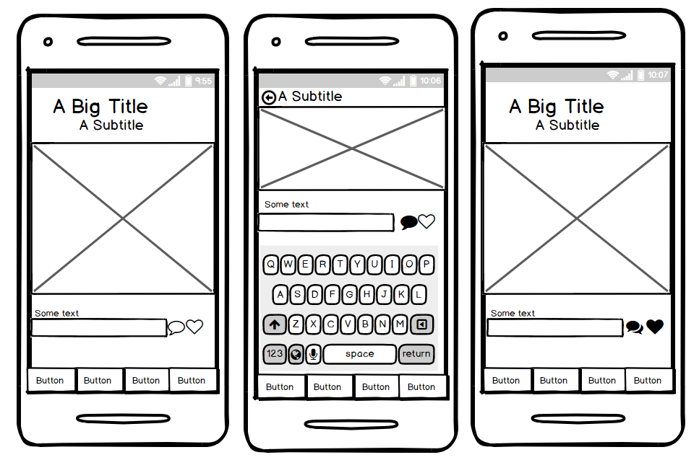
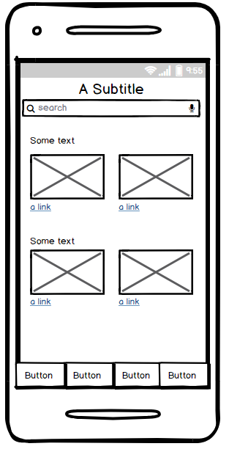
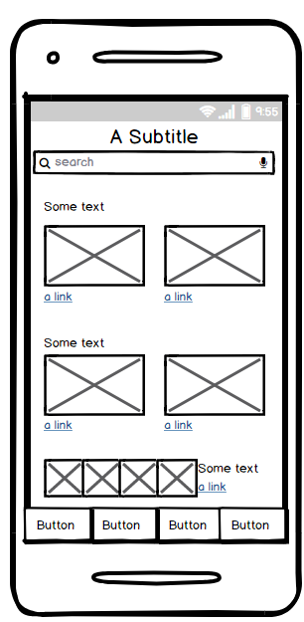
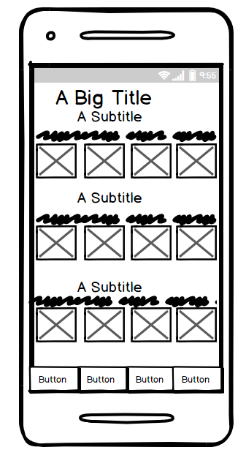
Explore Page-
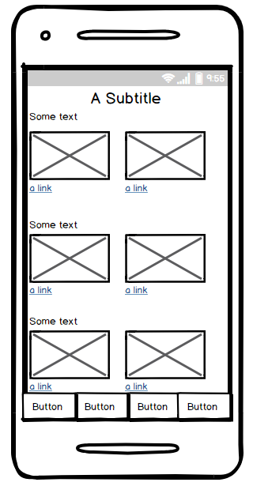
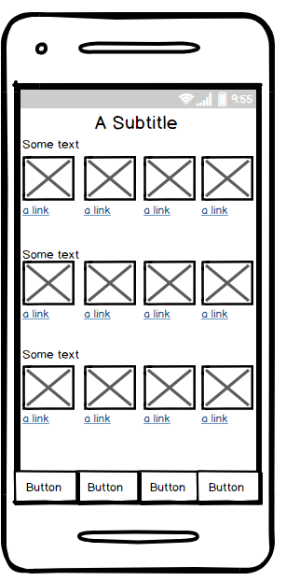

Experimenting with Ionic CSS components
This section will include designs created on visual studio using Ionic, Apache Cordova and AngularJS. This page includes experimenting with different features that are created with Ionic CSS components and are screenshots of the app running in the simulation window; the app is displayed on an Android phone.
The designs at this stage are experimental. Each design will involve an evaluation of the relevant usability guidelines.

The Card Layout
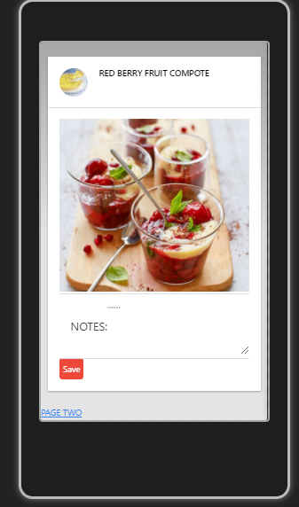
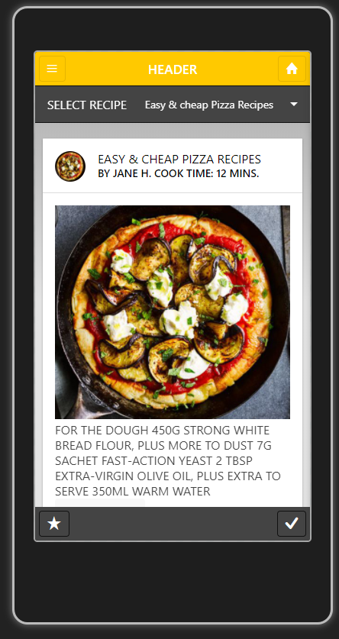
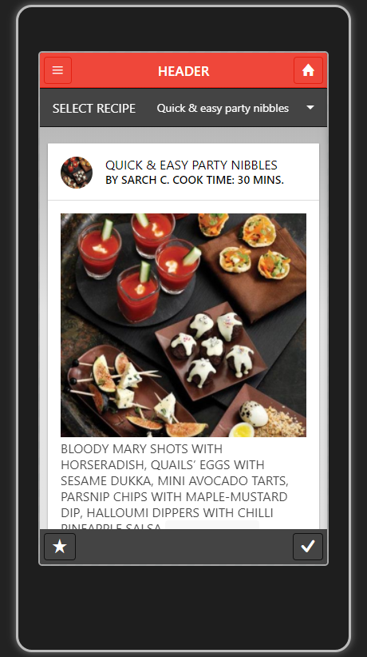
Figure 17
Figure 18
Figure 19
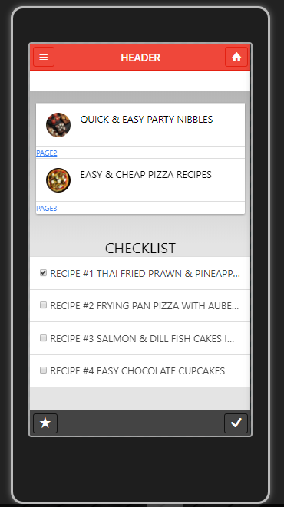
The heuristic principle “Flexibility and efficiency of use [3]” applies here. The home icon in figures 17 and 19 in the navigation bar is a shortcut that accelerates the users to a page that they visit frequently, by adding a shortcut, the app requires less effort from the user.
The Ionic card layout is the main layout component in these designs. The card layout organises the images, text and headers efficiently. Figures 17, 18 and 19 tries to follow the heuristic principle of “aesthetic and minimalistic design [3]”, however, figures 17 and 19 currently have too much text in the main content but it can always change so in future the text will have some structure and format.
Consistency and continuity [7] is a principle that figures 17 and 19 follow by demonstrating the type of navigation that the app will include (a button in the header) and how the headers should remain consistent throughout so the user becomes familiar with the app. Figure 18 lacks any header and footer so this design will not continue.
Checklist, Toggle and Select features
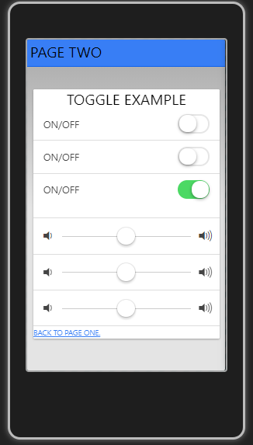

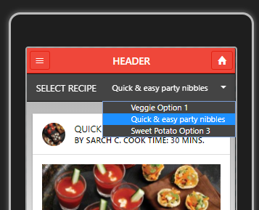
Figure 20
Figure 21
Figure 22
The structure for figure 20s design is going to change when making further improvements. The checklist section was implemented to test whether the page worked if it was split into two different sections, but as the design is for a small screen device, it is better to focus on a consistent minimal layout rather than end up looking untidy and have the users’ eyes scan the page in confusion. Less text in the checklist section would be better suited for this size of screen [22].
Figure 21 was an example of the ionic toggle features that could be included in the app rather than the design of an actual page.
Figure 22 was an example of applying the select and drop-down feature of ionic onto a page, it is unsure yet whether this feature will be included in the actual app, but it was interesting to explore this option nonetheless and see how it appears.
The problem with implementing a drop-down box like this could be that the option buttons may be too small for some users’ finger size and it may not be easy for them to select the option they want. The size of any buttons or actions implemented needs to be an appropriate size so that the user can press it comfortably.

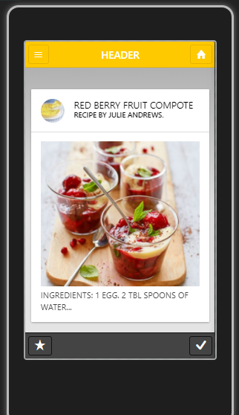
Improving initial designs and ideas
Figure 23
Figure 24
Figure 25
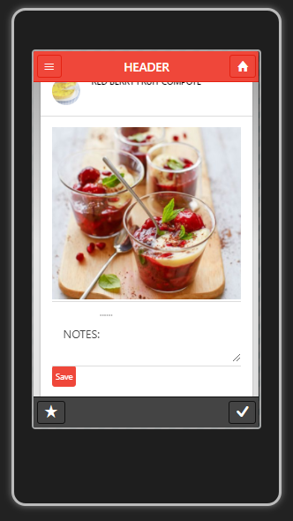
Figure 23 is an improvement of figure 24, which now includes a header that would be the source of navigation for the user and a consistent factor in all designs.
This brings us to the middle design; it shows the problem with smaller screen devices when it comes to the content fitting on the screen as the header is overlapping the title of the recipe. The amended design, shown in figure 25. The colour of the header was changed but this is just part of experimenting with the design, the yellow does not really work with the grey background or dark footer. However, even though the design has improved slightly, it could be better.
These designs follow the Gestalt principles of simplicity [7] in visual design, and there will be an element of similarity on each of the recipe pages to help the user feel familiar and confident using the app. The heuristic principle of “aesthetic and minimalist [3]” design have also been followed here.

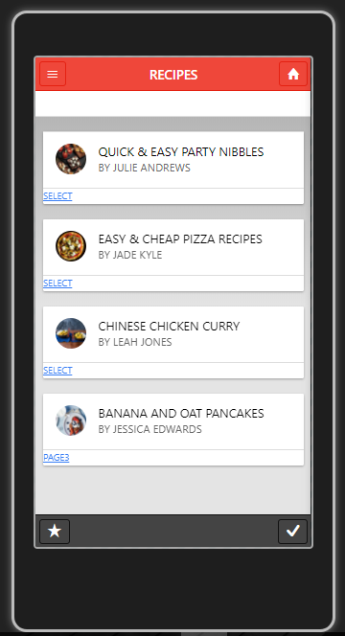
Focusing on the content on the Recipe Pages
Figure 26
Figure 27
This page demonstrates how considering the usability of the layout improves the design.
The design above in Figure 27 is a little unorganised. Figure 26 is an improvement, as the checklist does not fit that page. Figure 26 is more pleasing on the eye than figure 27 as the structure of the recipe content is consistent and symmetrical along the whole page.
‘Common regions’ is also mentioned in the Gestalt principles [7] shows the connection between elements, and this principle has been applied here by using the card layout to enclose each element (image, title and user) and grouping them to show the distinct recipes along the page. This layout is organised for the user to understand what they are viewing.

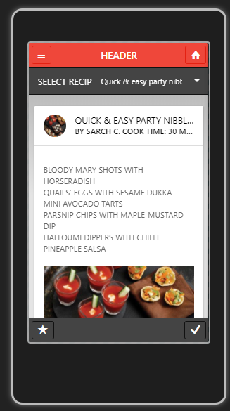
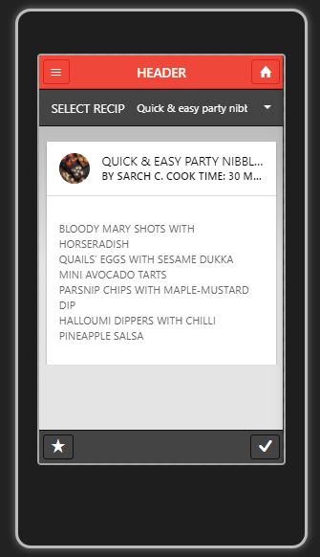
Considering the content for small screen devices
Figure 28
Figure 29
Figure 30
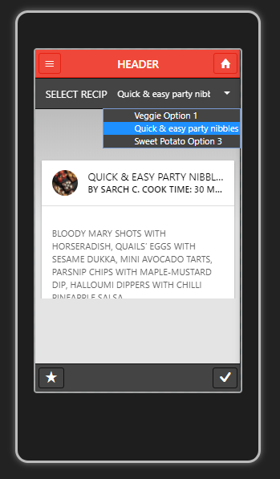
These page layouts show how important it is to consider the text and the content. The text in figure 28 is unformatted, which is difficult to read.
Figure 31
The text has been broken up in figure 29 and an image is included under the text in figure 30, however these pages still have room for improvements such as formatting the text further by adding bullet points or styling the lists to show the user clearly that they are different ingredients.
The colour scheme is not going to stay the same in the developed app as these colours do not work well overall and are too dark. The colours are not too important right now in this designing for usability stage; the colours will just help with the overall look of the pages at the end.

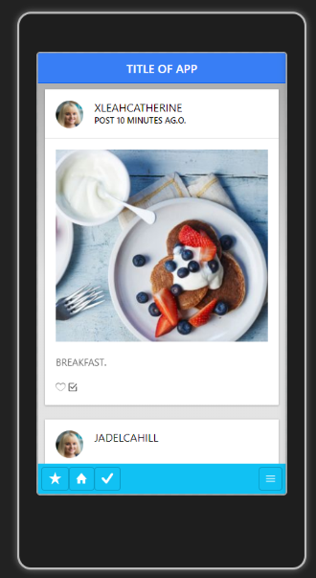
Designing the Newsfeed

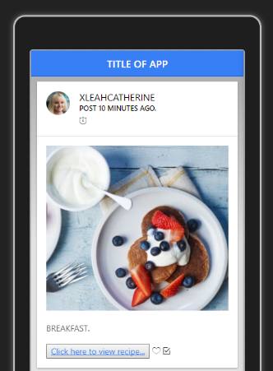

Figure 32
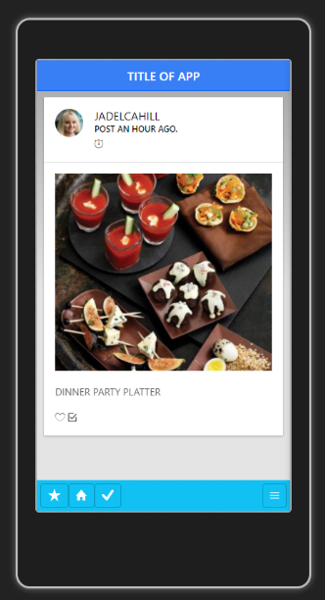
Figure 33

This is the homepage of the app, which is going to be a newsfeed style. This page is going to include relevant content that the user would expect when looking at viewing their friends’ posts.
This type of newsfeed layout could relate to the Z-pattern layout where there is minimal content, text at the top, a large image in the centre of the “Z” where the users’ eyes scan and then text at the bottom [9].

Figure 34

Introduction to Development Section
This development section shows how a combination of development methods have been used in this project such as feature driven development, demonstrated by using a MoSCoW list (shown below in Figure 35) to prioritise the development features implemented. This section also shows how an iterative design approach have been used for the UI.
The chosen framework for this development project was Ionic 2, therefore the interface for this project have been created with Ionic components. The Ionic framework is built upon Angular and Cordova and can be used to develop a cross platform mobile app using HTML, CSS and Typescript/JavaScript.
The pages follow the same structure throughout the project. The ionic pages are created and stored in their own folder within the “src” and “pages” folder which includes their corresponding SCSS file, HTML file and typescript file. The typescript file is where you implement the functional behaviour. It uses dependency injection, which requires importing the ionic-angular components relevant to the functional behaviour and inject them via the constructor method into the classes.
Ionic and Cordova provide a set of plugins which provide access to native device functionality. These plugins enable the app to use the native functionality of the device such as the camera. Required plugins are added to the plugins folder and imported into the pages that need to use them.
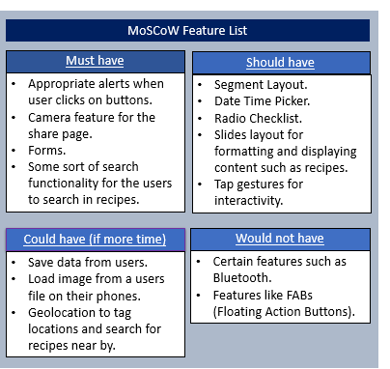
There are many Ionic 2 built in components that have been implemented in this project and these are discussed in the following pages. The next section displays the storyboard and navigation, followed by a discussion of the main interfaces, and a discussion of the general features.
Figure 35

Storyboards of the interfaces created
This section shows the flow of the navigation and each interface created in the implemented app.

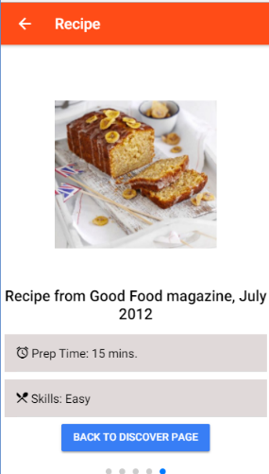
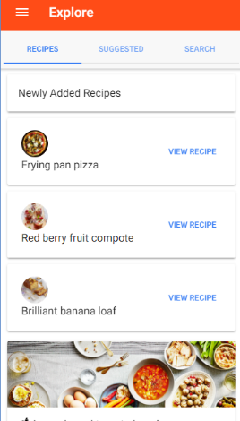
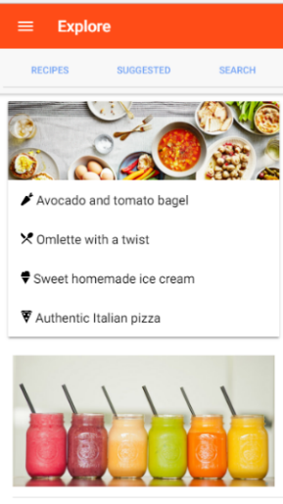
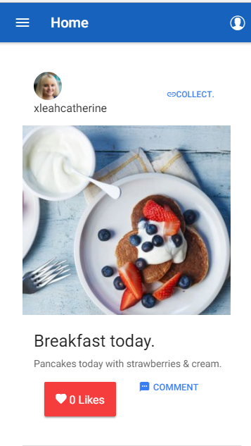
Figure 36 - Suggested Content Segment
Figure 37- Recipe #3
Figure 38- Recipe #1
Figure 39- Recipe Segment
Figure 40- Explore page
Figure 41- Homepage

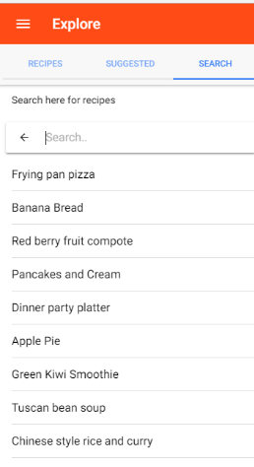
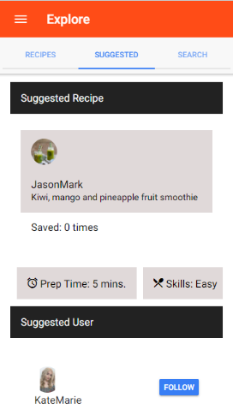

Figure 42- Search Segment

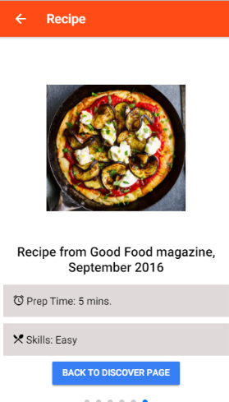
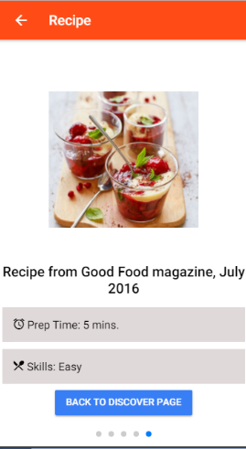

Figure 43- Recipe #2

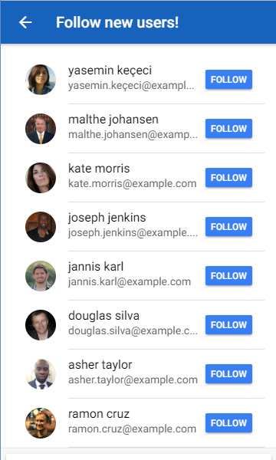

Figure 44- Page of suggested users

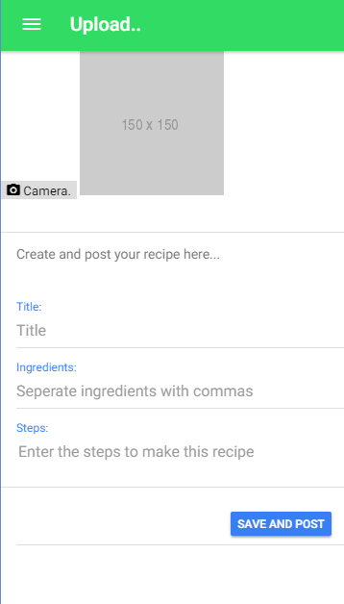
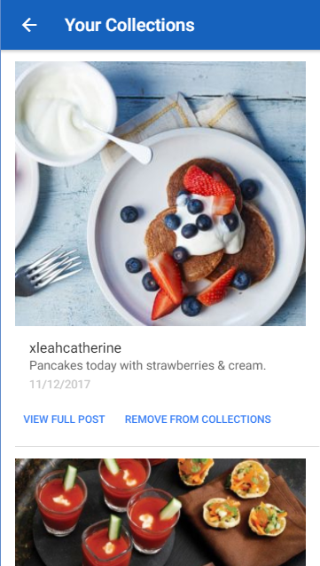
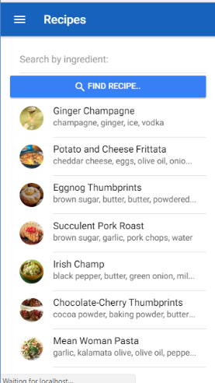
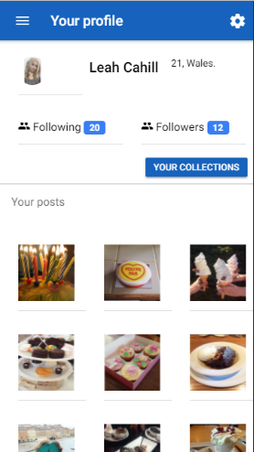
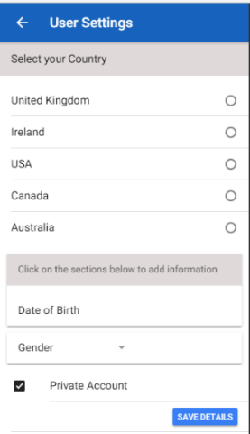
Continued.

cv
cv
cv
Figure 45- Share page
Figure 46 - Collections page
Figure 47- Homepage
Figure 48- Ingredient search page
Figure 49- User Profile
Figure 50- Settings
Discussion of main interfaces

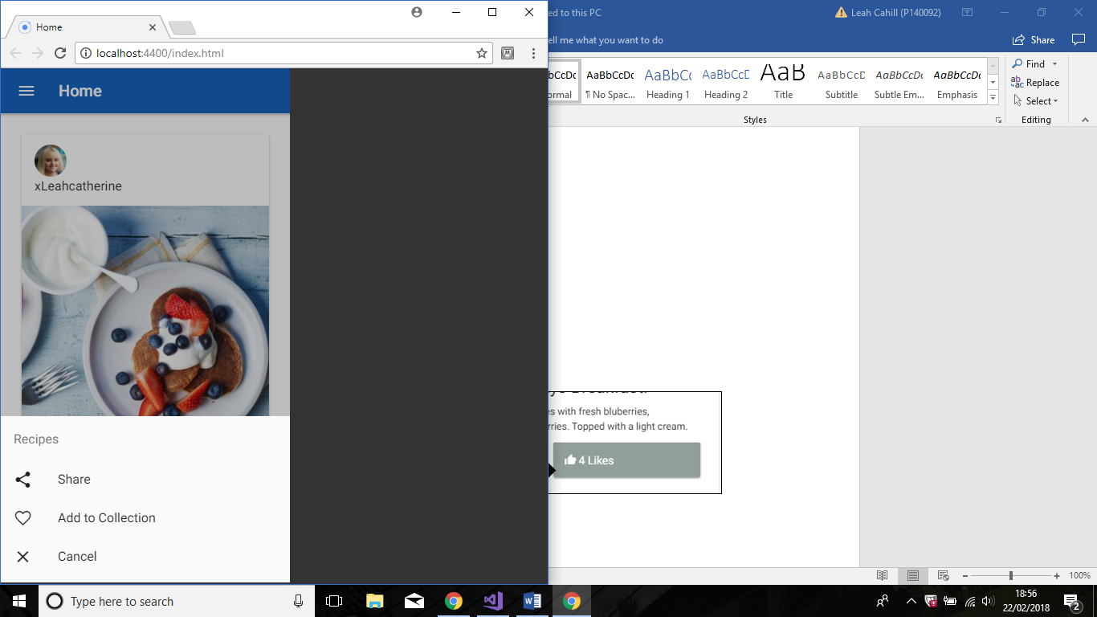
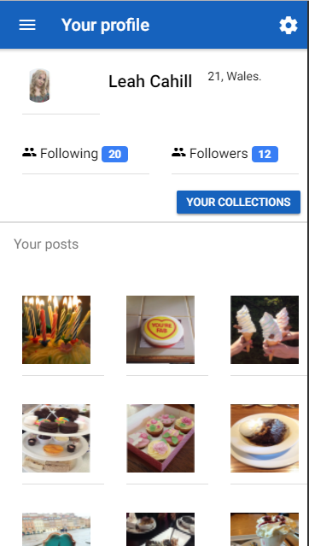
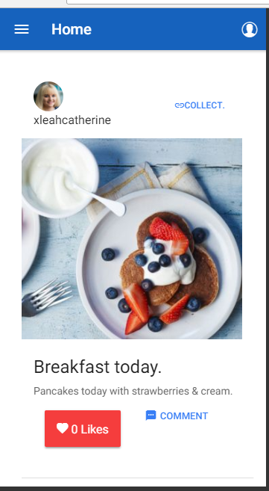
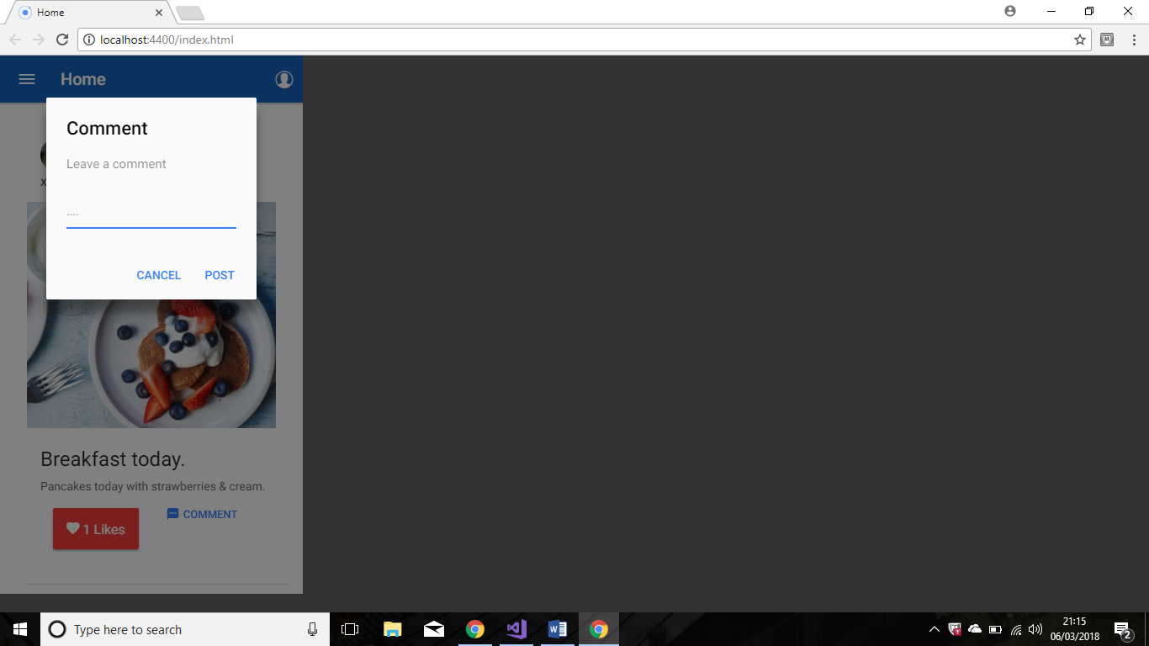
Homepage
Figure 51
Figure 52
Figure 53
Figure 54

The simplicity of the Ionic card layout used to create the newsfeed is effective in achieving the heuristic principle [3] of “Aesthetic and minimalistic design”. It is structured and organised in an appealing layout that does not distract the user with other content that they may feel is unnecessary, the feedback regarding the Kitchen Bowl apps newsfeed indicated that there was too much going on and a participant commented that they did not like the “Suggested Content” section. Here, there has been an improvement as the user focused on the main aspects you would expect in a newsfeed and the participants commented on this, saying how they liked the flow and layout of the page.
By creating a short cut to the profile with the icon in the top hand corner, it requires less effort from the user and achieves the heuristic principle [3] of “flexibility and efficiency of use”. The shortcut provides faster access to a frequently accessed page.
The interactions of the user are limited to certain inputs on this page. There are a couple of buttons, so this leaves little room for the user to be able to make an error on the page. This identifies with the heuristic principle [3] of “error prevention”.
An aim of this app was to make it easy and clear for users to create collections of posts. An alert has been added on the top right of every post, allowing the user to click and select “Add to Collection”, it is felt that this is clearer than the “KlipIt” on the app that was evaluated. The “KlipIt” button was originally to the bottom right of posts on the newsfeed or the top right on recipes and did not show on all posts. It was important to include the Collect button (Figure 53 and Figure 51) as it was a main feature on the Kitchen Bowl app, it allows the users to “Collect” their favourite posts and view them later without having to scroll through the newsfeed or their friend’s profiles to find it.

Explore Page
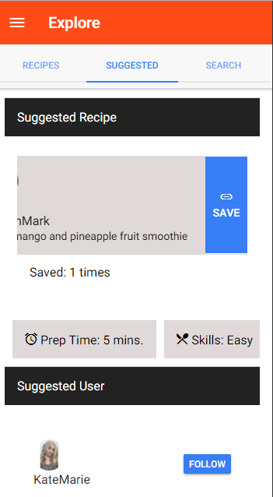
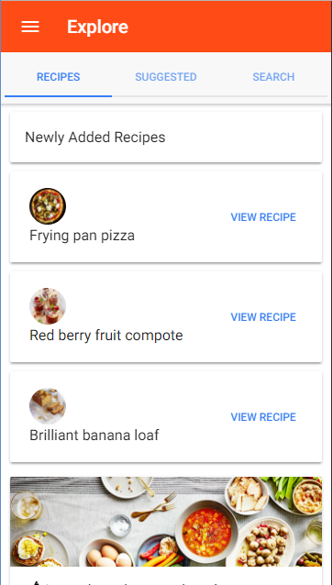
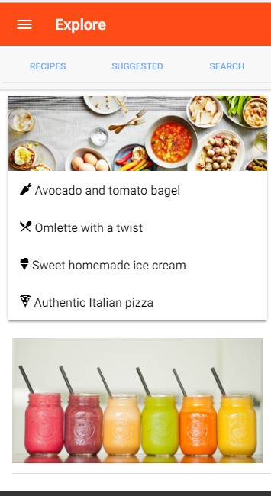
Figure 55
Figure 56
Figure 57
Figure 58

This part of the app contains a lot of different content. Here, it was important to consider the design for smaller devices, if all the content was on the same page the user would have to scroll down for a few minutes to view it all. Scrolling to view a lot of content is not ideal as it is would be uninteresting to the user and parts of the app may go unnoticed if it is right at the bottom.
The Ionic segment layout seemed appropriate to apply in this situation, it allows organisation of grouped items and the content on each segment is limited yet relevant, this enables the Explore page to have some structure to it.
It is felt that this page follows the heuristic [3] principle of “Consistency and standards”, by following platform conventions and design standards. The actions are clearly labelled for the user to understand what each part means and the segment they are viewing is underlined to avoid any confusion of what part they are viewing.
It also follows the principle [3] of “Efficiency of use”; this page and its contents are completely relevant to the purpose of the app.

Considering the content for smaller screen devices alongside development

Before (First Iteration)
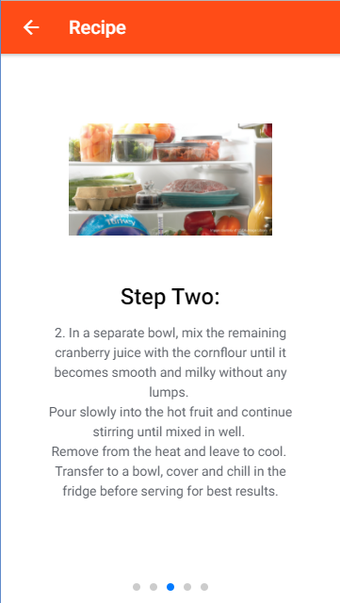
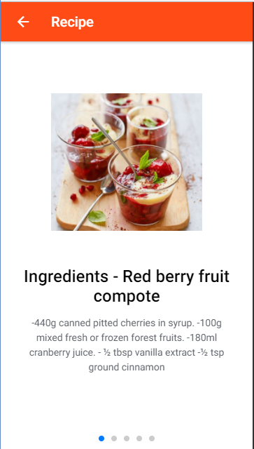
This page is from the recipe segment and allows the user to slide across to view each step.
Figures 59 and 60 demonstrate the problem where the content must be included and deleting any to fit the page was not an option. The Ionic slides layout helps break down the content problem as the user is now able to view the text in different parts and not all at once.
However, the result was not as organised as expected (shown in Figure 59) as it was just a big block of text.
Figure 59- First Draft
Figure 60- Recipe Page unformatted
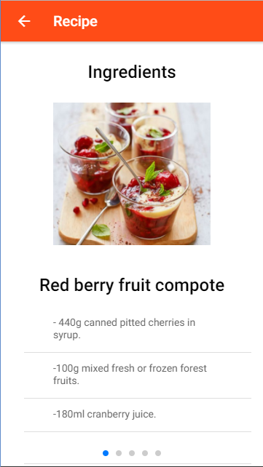
After (Final Iteration)
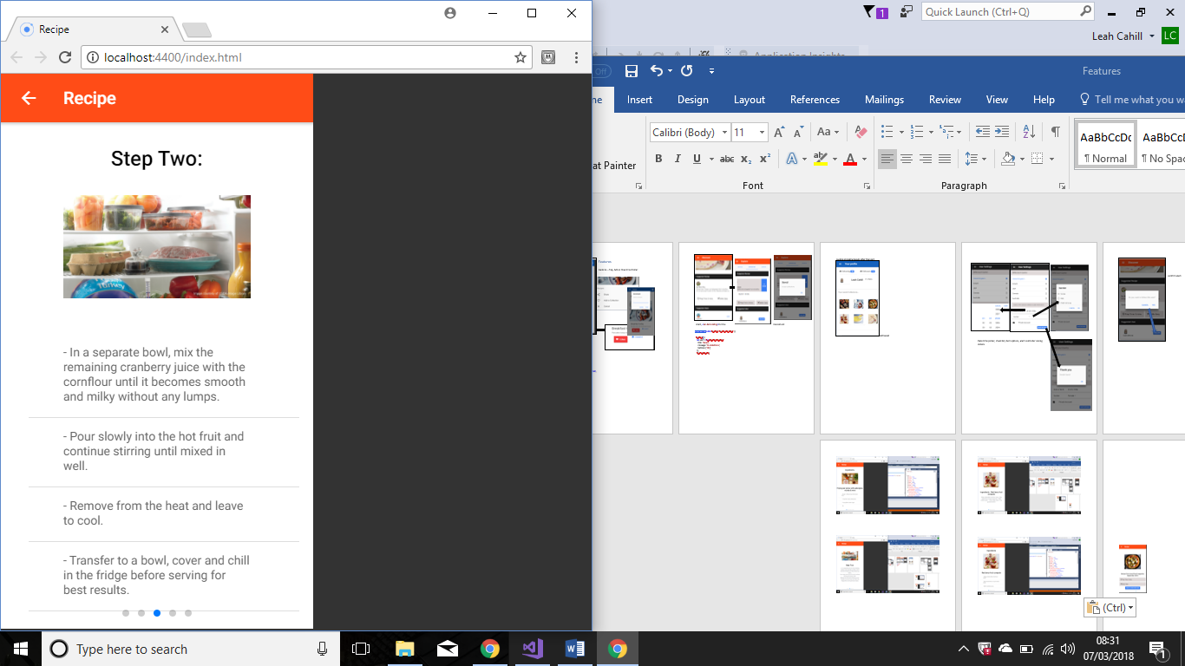
Figures 62 and 61 shows how the layout has slightly changed so the headers are now above the images and the text below has been broken up into sections. Each item has the “Text-wrap” element on it as the content overlapped otherwise.
Figure 61- After breaking up the sections
Figure 62- After formatting content
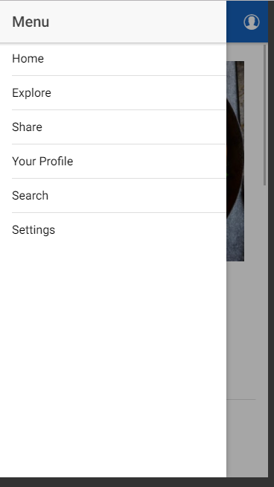
Discussing the Navigation of app
Figure 63- Demonstrating the main navigation

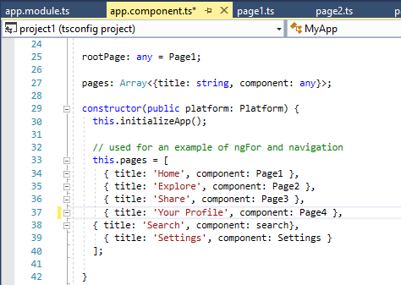
Figure 64- App.Component

The main navigation is through a toggle menu in the top left-hand corner that expands upon a user click. This navigation allows the menu to hide and the user access it when necessary, therefore enabling more space on the screen for other content.
The developer implemented the navigation by creating a folder (for example) named “Pageone”, which includes a typescript, HTML and SCSS file. The next step is importing the pages into the app.module and the app.component and declaring each page.
To set up the final part of the navigation, the user adds the pages into the constructor shown in figure 64. Figure 63 shows how the code in this constructor displays the pages into the main menu. If any pages are not included in the constructor, then another type of navigation accesses those pages.

NavPush Navigation
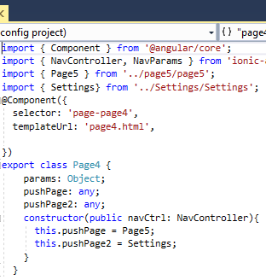
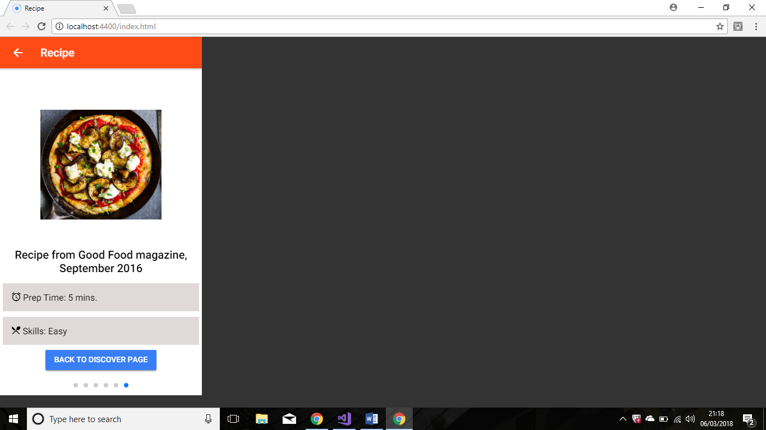
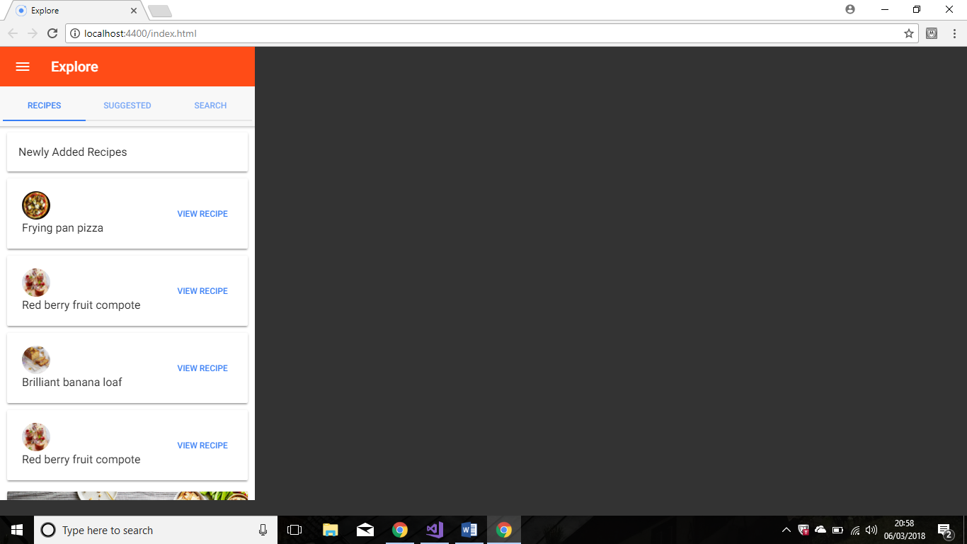
Figure 65
Figure 66

This is an example of how the pages link together in this app when they are not included in the main menu. The pages exist after already declaring them in the app.component and app.module upon creation.
Figure 67
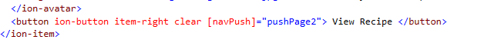
The developer imports the pages into the specific typescript files, and then uses pushPage to link them together. Figure 65 shows the code importing a specific page and linking it to pushPage.
The navPush is included in the HTML file through a button (shown in figure 67) and this binds the navigation together.
Figure 67

Discussion of general Ionic features
Ionic components have been implemented in this app to create the user interface. This following section discusses these features briefly, accompanied with screenshots from the app running in the browser on an LG simulator.

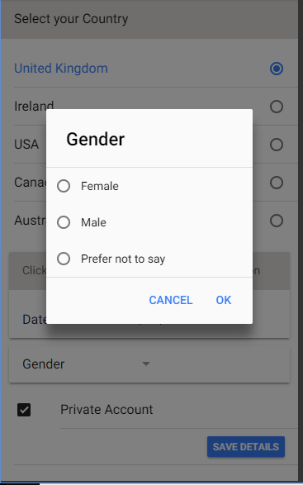
Alerts
Figure 68

Figure 69
Figure 70
Figure 69 demonstrates a showPrompt alert in the app when a user taps on the comment button. The alert controller component is imported from Ionic-Angular into the pages typescript file.
Figure 70 illustrates the use of an action sheet. Similarity to the alert, the developer imports the action sheet controller from Ionic-angular and into the files typescript file.
Figure 68 shows the radio checklist when the user taps on Gender, they are given the options of “Female”, “male” or “Prefer not to say”.

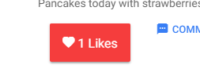
Tap, Date Time picker and Form
Figure 71
Figure 72
Figure 73
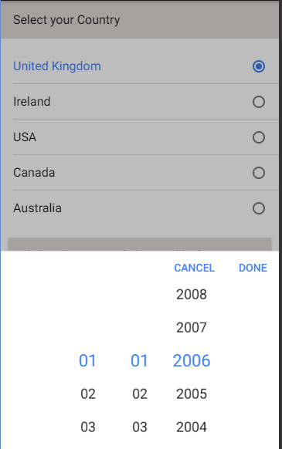
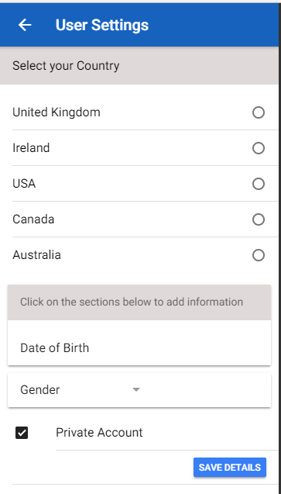

Figure 73 shows a button that have been implemented with Ionic gestures so that the user can tap and see the count going up with each tap. The developer implemented this by binding the HTML to a tap event in the pages typescript file.
Figure 72 demonstrates the implementation of the Ionic Date Time picker component. This allows the user to tap and select their date of birth by scrolling down to find the values.
Figure 71 displays a form within the Settings page which enables the user to select their home country.
Ionic slides layout
Figure 74

Figure 75

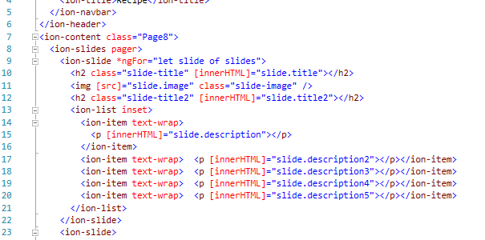
Figure 74 and 75 shows the use of the Ionic slides components. Slides allow the user to slide through the recipe steps without moving to a new HTML page. The developer implemented this by setting the HTML (shown in figure 76) to call the JSON data that is stored in the pages typescript file by *ngFor=”let slide of slides”.
Figure 76

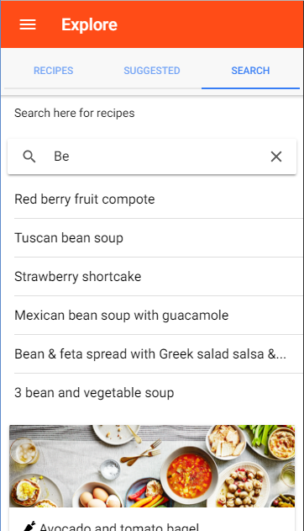
Search feature
Figure 77
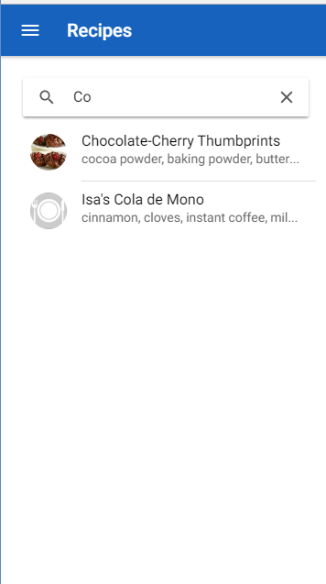
Figure 78
This app includes two pages where the user can search for recipes, shown in figures 78 and 77. The screenshot shows the user typing into a search and the results changing so it finds what they are searching. The developer implemented this in the pages typescript files, so the value entered in the search, compares against the values that are stored as JSON data and shows if it matches the input.

Search and Follower Pages using HTTP request
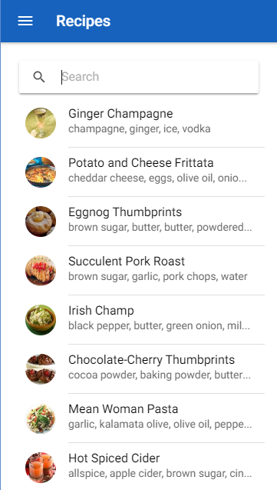
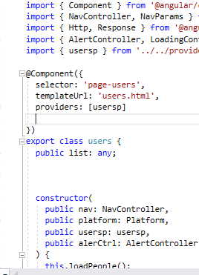
Figure 79
Figure 80
Figure 81

The app uses JSON data from a Web Service provided by Recipe Puppy. The required pages make HTTP requests to two APIs to display the JSON data in this app. The implementation of these pages was slightly more complex. Provider pages with injectable classes had to be created to call the services. These injectable classes enable the importing and injecting of the class into the corresponding pages @component decorator and then create a method to display the JSON data there.
The provider class contains the Angular HTTP component to request the data from https://randomuser.me/api/ for the followers’ page, shown in figure 80, and http://www.recipepuppy.com/api/ for the search page, shown in figure 79. The load() method is used in the classes to load the data from the provider and then it is displayed in a list on the following HTML page using Angular’s ngFor attribute.

Camera Component
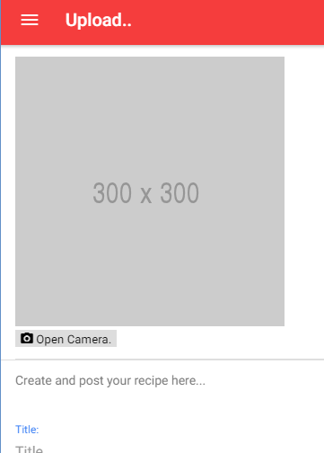
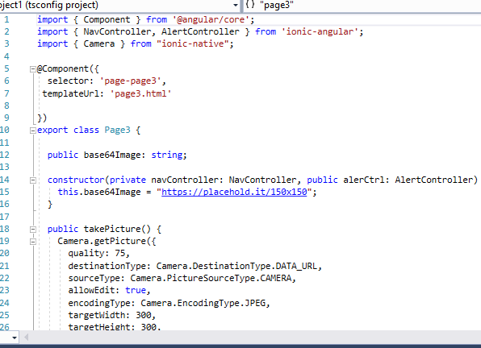
Figure 82
Figure 83
Figures 83 and 82 shows how you can create a hybrid mobile app using the native components of the phone. Here, the share page uses the camera. The developer imports the camera component from Ionic-native and adds it into the constructor.
The getPicture() method have been accessed from the camera component and implemented on the corresponding HTML page with a button to allow the user to access the camera and take their own photo.

Viewing the app on different devices
As this app is a hybrid application developed using the Ionic framework, it can run on multiple devices. All the screenshots up to this page have been run on an Android simulation, below are a couple screenshots to demonstrate the different device sizes and the differences between IOS and Android.
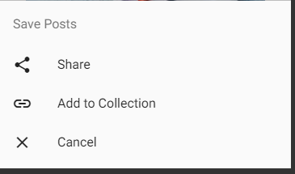
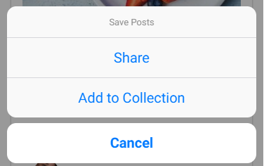
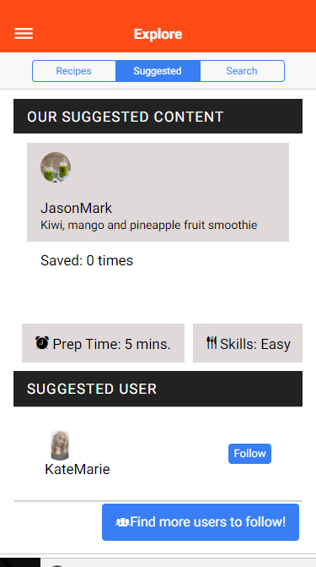
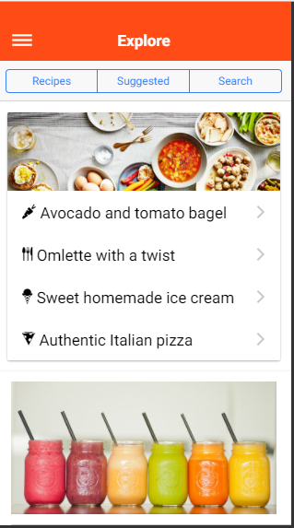
Figure 84- iPhone 6 Action sheet controller component
Figure 85- Android Action sheet controller component
Figure 86-Size of iPhone 6
Figure 87- Size of iPhone 5

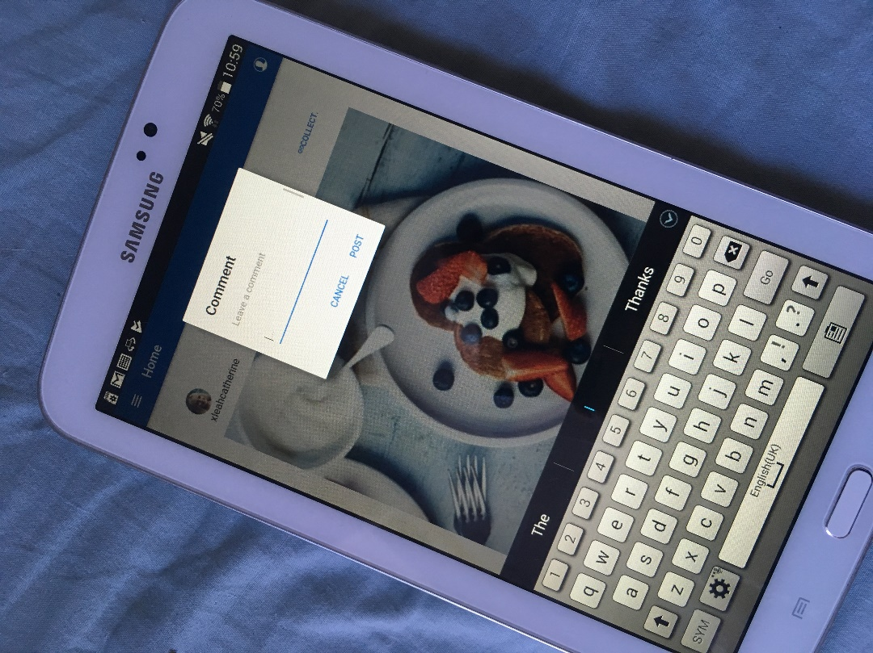
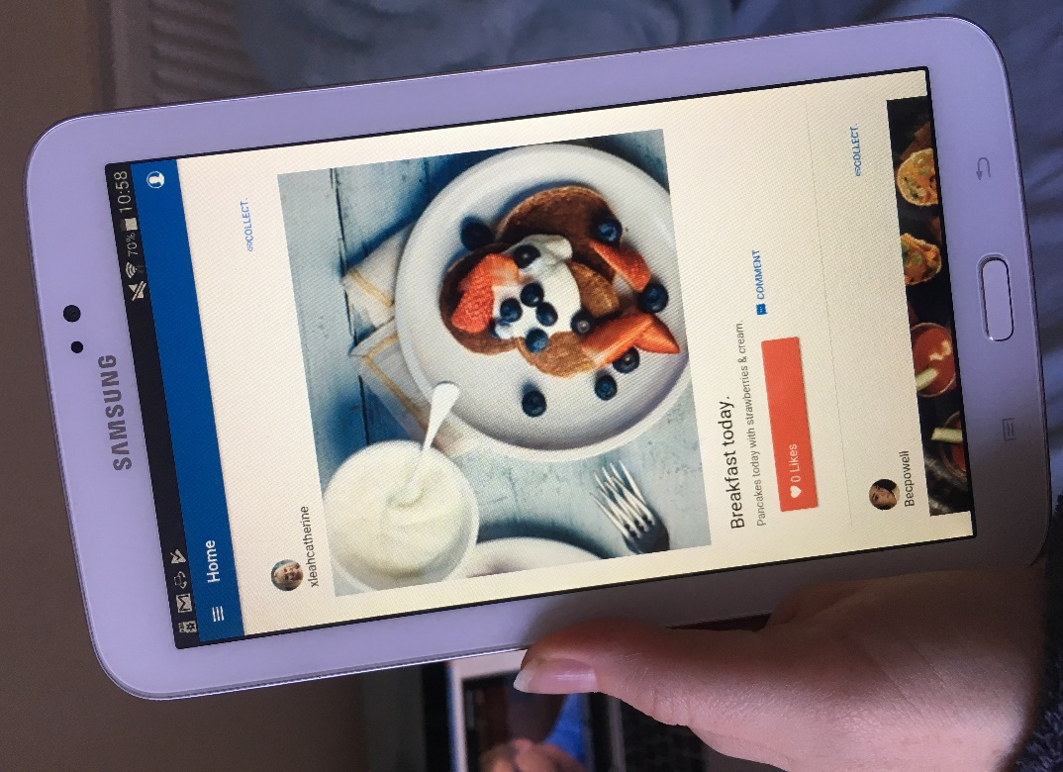
Debugging on Android device
Figure 88
Figure 89

Figures 89 and 88 are photos of debugging the app on a real device, this enables the user to gain a real understanding of the ‘look’ and ‘feel’ of the app and test that all the navigation works as expected. Debugging the app on a real device gives the user the advantage of being able to test the components such as the camera.

Evaluation of results
The development ended by asking five participants the same statements as the initial questionnaire but this time, they were answering based upon their opinion of the new app. For the usability tests, the app was loaded and run on a Samsung tablet.
The tasks that they were asked to do beforehand to get used to the app were only slightly different from the initial study, such as search for a cocoa recipe instead of cake, but there were no differences between the statements. The questionnaire followed the same format as the initial study and the participants expressed a negative and a positive opinion at the end.

System Usability Scale (SUS) Score
Figure 90 shows the average of the SUS scores from the participants.
Discussing the results of the questionnaire, the average score is 58. This score suggests that there is room for improvement as the desired score is above 68; however, it has still scored higher than the initial app, which scored 54.
Figure 90
One of the primary aims set out for the developed app was to improve the usability, especially focusing on the “Collections” part of the app so the users would understand customised buttons. This part of the app is where it scored the lowest initially; however, it has scored higher on the second questionnaire on statement 10 “I understand what a ‘collection’ on the app was and how to create one” so it is no longer the lowest scoring statement.
Regarding the implemented app, the user was able to click the button “Add to collection” and they were able to “View collections”. However, there is no functionality that enables them to add to a collection, but they were able to gain an understanding of the way it works with the buttons and interactions.
The participants were asked to identify the positive and negative of the implemented app to give an overall understanding of their scores. Participant A suggested that the “share” page would be more effective if the image upload and listing the ingredients were separate. They mentioned that it was clear to understand but it would be an improvement to separate it.
The scores relating to the share page are shown in figures 91 and 92. These were not the lowest scoring statements but a section that the participants commented negatively on, as participant B stated that they did not understand the layout. This section would have to be investigated to make improvements to the usability.

Figure 91

Figure 92
Figure 93: An overview of the average score of each statement.
Figure 93
Discussing the statements that scored the highest, the implemented app rated high when it came to the layout and navigation, for statement one: “I think the layout is simple and easy to follow”. The participants felt that the navigation was easy to follow throughout, and they liked the newsfeed, shown by the scores in Figure 93 where everyone rated it a 5.
Again, relating to the layout and navigation, statement 3 “I found the recipes page with ease and the steps of the recipes are easy to follow” scored high, where all participants gave it a score of 5. Participants A commented that the navigation was easy to follow.
The Kitchen Bowl app received comments in the initial questionnaire of how the users did not like the suggested content on the newsfeed. The implemented app kept the newsfeed simple, only showing posts and the users liked this, Participant A commented how they liked the newsfeed. This was reflected in the results for statement 7: “There’s an adequate amount of content on the newsfeed”.

Figure 94
Figure 94 shows the lowest scoring statement. This was “I feel like there is adequate content on the page at once when viewing recipes”, this may be reflected as the loaded app had issues displaying the images on the recipe slides. However, participant D commented that the content seemed small compared to the size of the tablet device. Participant A said that more content overall on the pages would have looked better. This is an area that will be looked upon in future for improvements.
The app itself had some slight usability issues that were identified straight away such as not being able to view the suggested followers and search the recipes when the device has no internet connection. Future improvements may mean looking at creating a page that will load data when offline.
The scores from the SUS measure so that 51 and below means that the app fails the usability test [43]. If the app scores around 68 then it means that it is OK but it is still average and there is room for improvements and anything above 80.3 means it is doing very good. The implemented app scored below average with 58, but it did not fail.
To conclude, the usability is better in the second app when comparing its score to the score from the first app. However, there is room for improvement considering the average score was 58 and 68 would be the preferred minimum score. The questionnaire showed that the areas that can be improved are the recipe pages and the share page.

Evaluation of project
Overall, the answers from the questionnaire are as expected. It is understood that it will take a couple of questionnaires and studies to improve the app and gain a usability score that suggests that the app has near-perfect usability. The concept of testing and retesting designs alongside the user feedback is vital to understanding how future work can focus on certain areas to ensure the app improves.
The project went according to the Gantt chart that was created at the initial stage, this ensured that the different stages of the project were finished and evaluated to the time plan so nothing would over run and be incomplete by the deadline.
The method of collecting feedback through a questionnaire proved to collect useful opinions regarding the usability of both apps. The answers to the statements were backed up by verbal opinions which helped when analysing the data. Upon reflection, more attention should have been focused on the verbal opinions and the participants should have been able to expand as these points were clear and helpful in understanding where the usability issues were.
Discussing the aims and objectives; the aim of this project was “to evaluate the usability of an existing app and to create a mobile application based upon feedback on how users find the usability, using the feedback; it can be determined if there is anything on the app that can improve regarding usability.”
This project meets the aim by using the initial questionnaire to discover any usability issues within the existing app and identifying areas for improvement by focusing on which statements scored the lowest.
It is felt that the objective to “research and fully understand how the designers design with usability in mind, thinking of design guidelines for websites” have been met, as usability in websites and smaller screen devices was researched in depth, alongside exploring the user experience (UX) of website design and researching different usability evaluation methods.
Additionally, the objective of understanding usability have been achieved by identifying principles through research, such as the Jakob Nielson heuristic principles and the Gestalt visual design principles. These principles/ guidelines were subsequently applied when designing the interfaces for the app as following them enabled the developer to focus on creating the app with usability in mind.
The second objective set out was “to be successful in implementing an application using a hybrid mobile application framework.” It is felt that this objective was achieved as the app was successfully developed, creating the user interface with the Ionic 2 framework.
The third objective set for this project was “to receive feedback by questionnaires and ensure that the feedback is analysed and considered before development and whilst writing an evaluation.” The developer achieved this as they analysed each score from the questionnaire by creating a graph of each statement and then briefly discussing what usability problem that a lower score could indicate.
If given the opportunity to do it again, the developer would design the app differently with changes to the share page and explore page. The share page would be broken into sections and enable the user to select multiple photos to write about and upload, as currently, they can only take one photo.
The second change they would make would be to the design of the explore page. The layout would be a tabs view with the sections “Suggested followers” and “suggested recipes” instead of the current segment layout with three sections; this part would be redesigned as there is currently a segment to search recipes and an individual search page, having two parts within the app to search seems unnecessary upon reflection.
Regarding the initial app, it is felt that the developer focused on the usability issues and tried to improve them. The participants in the initial study did not like that suggested content was shown on the newsfeed so the Ionic app newsfeed was kept simple and only showed posts from people that they follow. The Ionic app also tried to simplify the whole “Collections” by adding a little “Collect” button next to the posts and a clear “View collections” button on the profile so the users could understand what it was.

Conclusion and Recommendations
For the literature review, relevant journals, websites and books were researched to gain a valuable understanding of how developers implement usability in websites and other devices. This helped meet the objective “research and fully understand how the designers design with usability in mind, thinking of design guidelines for websites for example or looking at user-centred design approaches”.
The research from the literature review resulted in some key findings such as usability guidelines, principles and different evaluation methods which was important for the other stages of the project.
The second objective was “to be successful in implementing an application using a hybrid mobile application framework.” This objective was achieved by spending a lot of time experimenting with the different ionic components that are online and deciding which ones were suitable for the app.
Discussing the research methodology, an experimental design approach was chosen to decide the final designs of the implemented app. An experimental design approach ensured that the focus was constantly on designing for usability and this was done by creating designs that follow certain usability principles and guidelines, and changing them if the original designs did not work.
Regarding the data collection method, the SUS questionnaire enabled the collection of reliable and valid results that were easy to analyse after converting the scores. The SUS questionnaire used in this project was a customised version of the original, this enabled the statements to be changed to directly focus on the apps in the study rather than use generalised statements. These direct statements helped focus on certain areas of where the usability issues may be.
However, a limitation of this evaluation method is that it was tested on a small sample of participants and only one iteration of the questionnaire was carried out. For future work, the app could be improved and another iteration of the questionnaire would prove valuable in order to see if the changes are reflected positively in the participant’s scores.
Upon reflection, it is felt that another type of usability evaluation method could have been used alongside the questionnaire so that there would have been more verbal feedback to work with whilst implementing the app. The verbal feedback from the questionnaires helped support the usability scores but was limiting, by using another method such as observation and the “think aloud” method, it may have been more effective in understanding the usability issues.
Another method that could have been applied is benchmarking. The participants could have been asked to follow certain tasks and the times could have been recorded and compared. By recording and comparing the rate that the participants completed tasks may give an indication of any issues in stages where there has been any hesitation or any tasks where they did not complete them.
Discussing the implementation, the Ionic 2 framework was effective in creating a quick hybrid mobile app. This framework was effective in creating an app that demonstrates a good standard of usability as the UI components are clear and give a smooth “native like” feel. The components were easy enough to customise and move around according to the design which made it very flexible to work with.
An overall conclusion of this project is that an understanding of usability in websites and smaller screen devices was achieved and although the usability of the implemented app is not perfect, there are obvious areas that could be improved in the future and changed so that the usability would score higher in the questionnaire.
Suggestions for further work.
It all comes down to the project timeline, there are features that could have been implemented if there was more time to work on this app.
One feature that would be included in future development would be a file transfer option, the user could have the option to upload a file from their device rather than only having the option to take an image from the camera. This would improve the user experience of the app by encouraging them to share at times that are good for them, rather than when they only can take a photo. Another feature that may improve the users experience of the app could be using the GPS plugin and allowing users to search for recipes posted nearby or looking at where they have been tagged.
Further work regarding usability would begin by focusing on the lowest scoring statement, which related to the recipe page. It did not help that the images had issues loading on the device for the questionnaire. However, the sharing a recipe/image page had negative feedback so that would be a focus area as well. The redesigning stage would consider why the initial design did not work for the participants and experiment with different layouts to how it could be improved. This is a situation where it would need to be tested and retested to continue improvement.
The “View Collections” page have some usability issues such as having to scroll down if looking for an old post, this layout should be reconsidered to think of how to look back through old posts without making it a time-consuming task.
Regarding the app and its functionality, further work could focus on implementing more functionality within the app such as manipulating data. The app such could save users data from a form or asking for a username and password and then saving that data. However, the security would be an issue that would have to be considered if it were asking for personal information and storing passwords.
Reflection
Overall, I enjoyed working on this project and I feel that I have learnt many skills whilst doing so. I was drawn to the topic of usability just out of interest and I feel like it is an important topic regarding mobile apps and websites as it is a major factor in gaining regular users.
During the development stage, I learnt to understand the structure of an Ionic 2 project and how to implement different components. However, at first I found it confusing and got frustrated at times when I could not understand why a feature was not working, an example being when I tried to implement navPush navigation. I looked the issue up online and discovered I was not importing the right page into the typescript file, so this is why it is vital to understand the structure and components of the project.
An initial problem was misunderstanding the difference between versions Ionic 1 and Ionic 2. There is a lot of documentation online and sometimes it was unclear which version it was. The development began with this confusion as the ionic card layout was implemented using Ionic 1 code instead of Ionic 2, this was resolved by looking online to understand the differences.
Regarding help online, I followed tutorials to add features such as the camera. Although not all blogs were helpful and some were directed towards the other existing versions of Ionic, this was something I had to look out for before trying to add it into my project.
I felt it was important to constantly look back upon the key findings from my literature review to remind myself to focus on the usability and not just how good a feature may look. Writing the literature review enabled me to learn about the relevant research that is available and expand my knowledge on usability in general and how it is implemented in websites. Writing the report helped me improve my writing skills by drafting and redrafting to ensure that my sentences were structured and readable, as sometimes I would write sentences that were too long and the paragraphs did not flow smoothly when read back.
I feel that given the time frame that I could not have done better as I invested a lot of time and effort into this project and I worked hard to gain an understanding of everything I was doing. Maybe, if there were more time then I could improve the app by focusing on the areas of usability on the statements that scored the lowest in the questionnaire and seeing how I could fix and improve them.
However, I think that if I had more time, I would also like to work on the apps functionality and learn how to incorporate the server-side technologies into my app by interactions such as saving a user’s name into a database.
Overall, completing this project have helped me with understanding the flow of project work in general, regarding planning and keeping to the time scale. I was unconfident at first using the Ionic 2 framework so I planned that the development would take a lot longer than it actually did. I also planned the development time so that I had time just in case there was a code in the error that would have taken longer than usual to fix.

References

[1] | D. C. J. S. Jeffrey Rubin, Handbook of Usability Testing, how to plan, design and conduct effective tests, Indianapolis, IN: Wiley Publishing, Inc., 2008.
[2] | A. N. Schulze, “User-Centered Design for Information Professionals,” Journal of Education for Library and Information Science, vol. 42, no. 2, pp. 116-122, 2001.
[3] | J. Nielsen, “10 Usability Heuristics for User Interface Design,” Nielsen Norman Group, 1 January 1995. [Online]. Available: https://www.nngroup.com/articles/ten-usability-heuristics/. [Accessed 13 November 2017].
[4] | J. Nielsen, Designing Web Usability: The Practice of Simplicity, CA, USA: New Riders Publishing Thousand Oaks, 1999.
[5] | “User Interface (UI) Design Patterns,” Interaction Design Foundation, [Online]. Available: https://www.interaction-design.org/literature/topics/ui-design-patterns. [Accessed 16 November 2017].
[6] | J. Borchers, A pattern approach to interaction design, the University of Michigan: Wiley, 2001.
[7] | S. Bradley, “Design Principles: Visual Perception And The Principles Of Gestalt,” Smashing Magazine, 28 March 2014. [Online]. Available: https://www.smashingmagazine.com/2014/03/design-principles-visual-perception-and-the-principles-of-gestalt/. [Accessed 15 November 2017].
[8] | L. D. J. E. T. Dempsey Change, “Gestalt theory in visual screen desgin: a new look at an old subject,” CRPIT '02 Proceedings of the Seventh world conference on computers in education conference on Computers in education: Australian topics - Volume 8, vol. 8, pp. 5-12, 2002.
[9] | S. Bradley, “3 Design Layouts: Gutenberg Diagram, Z-Pattern, And F-Pattern,” Vanseo Design, 7 February 2011. [Online]. Available: http://vanseodesign.com/web-design/3-design-layouts/. [Accessed 15 11 November].
[10] | C. B. Staff, “Design jargon explained: the Z-Pattern,” Creative Bloq, 15 July 2015. [Online]. Available: http://www.creativebloq.com/web-design/design-jargon-explained-z-pattern-71515717. [Accessed 15 November 2017].
[11] | T. R. L. M. E. P. M. B. A. C. Martinho Goncalves, “Identifying different visual patterns in web users behaviour,” SCCG '11 Proceedings of the 27th Spring Conference on Computer Graphics, pp. 65-70, 2011.
[12] | “Design guidelines for the Web,” Usability Net, [Online]. Available: http://www.usabilitynet.org/tools/webdesign.htm. [Accessed 18 October 2017].
[13] | C. S. C. M. Bailey, “Evaluation of Web usability Guidelines for Teens,” ACM SE '17 Proceedings of the SouthEast Conference, pp. 50-54, 2017.
[14] | P. K. Evelina Patsoule, “Redesigning web sites for older adults,” PETRA '12 Proceedings of the 5th International Conference on PErvasive Technologies Related to Assistive Environments , no. 13, 2012.
[15] | S. L. Henry, “Introduction to Web Accessibility,” W3C, September 2005. [Online]. Available: https://www.w3.org/WAI/intro/accessibility.php. [Accessed 6 November 2017].
[16] | D. S. Dagfinn Rømen, “Evaluating web site accessibility: validating the WAI guidelines through usability testing with disabled users,” NordiCHI '08 Proceedings of the 5th Nordic conference on Human-computer interaction: building bridges , pp. 535-538 , 2008.
[17] | O. K. Helen Petrie, “The relationship between accessibility and usability of websites,” CHI '07 Proceedings of the SIGCHI Conference on Human Factors in Computing Systems, pp. 397-406 , 2007.
[18] | S. L.-M. Rosa Navarrete, “Improving OER websites for learners with disabilities,” W4A '16 Proceedings of the 13th Web for All Conference, no. 16, 2016.
[19] | “Designing for different browsers and devices,” Gov.uk, 3 October 2017. [Online]. Available: https://www.gov.uk/service-manual/technology/designing-for-different-browsers-and-devices. [Accessed 25 October 2017].
[20] | B. S. Gardner, “Responsive Web Design: Enriching the User Experience,” Sigma: Inside the digital ecosystem, vol. 11, no. 1, pp. 13-19, 2011.
[21] | B. Frain, Responsive Web Design with HTML5 and CSS3, Packt Publishing Ltd., 2012.
[22] | A. Warsi, “7 usability guidelines for websites on mobile devices,” Webcredible, 10 March 2011. [Online]. Available: https://www.webcredible.com/blog/7-usability-guidelines-websites-mobile-devices/. [Accessed 25 October 2017].
[23] | E. Laprecht, “The Difference Between UX and UI Design - A Layman’s Guide,” CareerFoundry, 25 April 2017. [Online]. Available: https://careerfoundry.com/en/blog/ux-design/the-difference-between-ux-and-ui-design-a-laymans-guide/. [Accessed 25 October 2017].
[24] | Domain7, “Usability vs. User Experience: What's the difference?,” Slideshare, 27 February 2014. [Online]. Available: https://www.slideshare.net/domain7/ux-vs-usability. [Accessed 5 November 2017].
[25] | S. Magazine, User Experience Design, Smashing Magazine, 2012.
[26] | J. P. Helen Petrie, “Measuring user experience of websites: think aloud protocols and an emotion word prompt list,” CHI EA '10 CHI '10 Extended Abstracts on Human Factors in Computing Systems, pp. 3673-3678 , 2010.
[27] | L. M. H. Sarah E. Garcia, “Capturing & Measuring Emotions in UX,” CHI EA '16 Proceedings of the 2016 CHI Conference Extended Abstracts on Human Factors in Computing Systems, pp. 777-785, 2016.
[28] | C. G. S. C. Victor Socas, “Emotional Navigation in nonlinear narratives: a case study on the influence of color,” Interacción '14 Proceedings of the XV International Conference on Human Computer Interaction , no. 18, 2014.
[29] | A. M. W. Joseph H. Goldberg, “Eye Tracking in Usability Evaluation: A Practitioner's Guide,” The Mind's Eyes: Cognitive and Applied Aspects of Eye Movements, 2002.
[30] | A. J. DeWitt, “Examining the Order Effect of Website Navigation Menus With Eye Tracking,” Journal of Usability Studies, vol. 6, no. 1, pp. 39-47, 2010.
[31] | “Eye tracking eases web ordering process,” tobiipro, [Online]. Available: https://www.tobiipro.com/fields-of-use/user-experience-interaction/customer-cases/holiday-autos/. [Accessed 27 November 2017].
[32] | “User observation/field studies,” Usability Net, [Online]. Available: http://www.usabilitynet.org/tools/userobservation.htm. [Accessed 14 November 2017].
[33] | S. M. Tingtin Zhao, “Keep talking: an analysis of participant utterances gathered using two concurrent think-aloud methods,” NordiCHI '10 Proceedings of the 6th Nordic Conference on Human-Computer Interaction: Extending Boundaries, pp. 581-590, 2010.
[34] | D. W. M. E. L. A. S. Jean-Luc Lugrin, “Usability benchmarks for motion tracking systems,” VRST '13 Proceedings of the 19th ACM Symposium on Virtual Reality Software and Technology, pp. 49-58, 2013.
[35] | D. L. K. E. D. M. M. G. L. E. N. Gustavo F. Tondello, “CHI PLAY Companion '16 Proceedings of the 2016 Annual Symposium on Computer-Human Interaction in Play Companion Extended Abstracts,” Heuristic Evaluation for Gameful Design, pp. 315-323, 2016.
[36] | J. Nielsen, “Finding usability problems through heuristic evaluations,” CHI '92 Proceedings of the SIGCHI Conference on Human Factors in Computing Systems, pp. 373-380, 1992.
[37] | M. E. Atwood, “Novice heuristic evaluations of a complex interface,” CHI EA '99 CHI '99 Extended Abstracts on Human Factors in Computing Systems, pp. 304-305, 1999.
[38] | P. P. Deborah Sater Carstens, “Usability study of travel websites,” Journal of Usability Studies, vol. 1, no. 1, pp. 47-61, 2005.
[39] | “Positivism,” Philosophy Terms, [Online]. Available: http://philosophyterms.com/positivism/. [Accessed 20 November 2017].
[40] | J. W. Creswell, Research Design, SAGE publications, 2014.
[41] | R. Pellissier, Business Research Made Easy, Juta and Company, 2008.
[42] | “System Usability Scale (SUS),” Usability.gov, [Online]. Available: http://www.usabilitynet.org/trump/documents/Suschapt.doc. [Accessed 25 October 2017].
[43] | N. Thomas, “How To Use The System Usability Scale (SUS) To Evaluate The Usability Of Your Website,” Usability Geek, 13 July 2015. [Online]. Available: https://usabilitygeek.com/how-to-use-the-system-usability-scale-sus-to-evaluate-the-usability-of-your-website/. [Accessed 20 November 2017].
[44] | J. DeRome, “31 Questions Every Designer Should Ask When Testing Prototypes,” User Testing Blog, 13 May 2015. [Online]. Available: https://www.usertesting.com/blog/2015/05/13/31-questions-every-designer-should-ask-when-testing-prototypes/. [Accessed 2018 February 19].
[45] | K. Goodwin, Designing for the Digital Age: How to Create Human-Centered Products and Services, John Wiley & Sons, 2011.
[46] | M. Rouse, “use case diagram (UML use case diagram),” Whatis?, [Online]. Available: http://whatis.techtarget.com/definition/use-case-diagram. [Accessed 14 February 2018].
[47] | E. O. Mario Korf, “"Native, HTML5, or Hybrid: Understanding Your Mobile Application Development Options",” Sales Force Developers, June 2016. [Online]. Available: Native. [Accessed 18 October 2017].
[48] | M. Rajput, “Which One to Choose: Native Apps or Progressive Web Apps?,” Mind Inventory, 16 August 2017. [Online]. Available: http://www.mindinventory.com/blog/native-apps-vs-progressive-web-apps/. [Accessed 25 October 2017].
[49] | A. P. Avinash Shrivas, “To Study and Design a Cross-Platform Mobile Application for Student Information System using PhoneGap Framework,” International Journal of Emerging Technology and Advanced Engingeering, vol. 3, no. 9, pp. 390-395, 2013.
[50] | P. Saccomani, “Native, Web or Hybrid Apps? What's the difference?,” MobiLoud, [Online]. Available: https://www.mobiloud.com/blog/web-hybrid-native-apps/. [Accessed 25 October 2011].
[51] | A. Zolciak, “Progressive Web Applications: The Thing to Consider When Short on Resources,” InsaneLab, 1 January 2017. [Online]. Available: https://insanelab.com/blog/web-development/progressive-web-apps-pwa-vs-native/. [Accessed 25 October 2017].
[52] | F. Mastropasqua, “Hybrid vs Native Mobile App vs Progressive Web App,” Clearly Agile, 13 March 2017. [Online]. Available: Hybrid vs Native Mobile App vs Progressive Web App. [Accessed 25 October 2017].
[53] | B. L. Andre Charland, “Mobile application development: web vs. native,” Communications of the ACM, vol. 54, no. 5, pp. 49-54, 2011.
[54] | S. Gordiyenko, “Hybrid Mobile App Development: Getting a Native Experience,” XB Software Blog, 29 January 2016. [Online]. Available: https://xbsoftware.com/blog/hybrid-mobile-applications-development-native-experience/. [Accessed 31 October 2017].
[55] | P. Bala, “The advantages and disadvantages of using Ionic framework, compared to native apps,” LinkedIn, 18 November 2015. [Online]. Available: https://www.linkedin.com/pulse/advantages-disadvantages-using-ionic-framework-compared-pritam-bala. [Accessed 25 October 2017].
[56] | Jscrambler, “10 Frameworks for Mobile Hybrid Apps,” Jscrambler, 18 April 2017. [Online]. Available: https://blog.jscrambler.com/10-frameworks-for-mobile-hybrid-apps/. [Accessed 31 October 2017].
[57] | Y. P. Rohit Ghatol, Beginning PhoneGap: Mobile Web Framework for JavaScript and HTML5, Appress, 2012.
[58] | “The Good and The Bad of Xamarin Mobile Development,” AltexSoft, 26 June 2017. [Online]. Available: https://www.altexsoft.com/blog/mobile/the-good-and-the-bad-of-xamarin-mobile-development/. [Accessed 31 October 2017].
[59] | A. Ahtinen, “Wellness applications -- ui design to support long-term usage motivation,” Proceeding CHI EA '08 Extended Abstracts on Human Factors in Computing Systems, pp. 2669-2672, 2008.

Recipe and Image References for App
[1] | A. Chikhi, La commande floue directe du couple, Presses Académiques Francophones, 2014.
[2] | "Reinvented Menus," Delta Airlines, [Online]. Available: https://www.delta.com/content/www/en_US/traveling-with-us/onboard-services/food-and-beverage.html. [Accessed 15 March 2018].
[3] | Nami, "Tofu Pizza," Just One Cook book, 22 February 2015. [Online]. Available: https://www.justonecookbook.com/tofu-pizza/. [Accessed 14 March 2018].
[4] | K. Nixon, "Chocolate Pasta with Chocolate Hazelnut Cream Sauce, White Chocolate Shavings and Fresh Berries," Food Network, [Online]. Available: https://www.foodnetwork.com/recipes/chocolate-pasta-with-chocolate-hazelnut-cream-sauce-white-chocolate-shavings-and-fresh-berries-2042101. [Accessed 11 March 2018].
[5] | P. Dean, "Cinnamon Rolls," Food network, [Online]. Available: https://www.foodnetwork.com/recipes/paula-deen/cinnamon-rolls-recipe-1946030. [Accessed 11 March 2018].
[6] | Rachel, "Spiced Cranberry Sauce," The Kitchen Holiday, Tuesday November 2013. [Online]. Available: http://www.thekitchenholiday.com/2013/11/spiced-cranberry-sauce.html. [Accessed 10 March 2018].
[7] | Angela, "How to make homemade pizza dough," Oh She Glows, 2 August 2011. [Online]. Available: http://ohsheglows.com/2011/08/02/how-to-make-homemade-pizza-dough/. [Accessed 9 March 2018].
[8] | GoodFood, "Brilliant banana loaf recipe," BBC good food, [Online]. Available: https://www.bbcgoodfood.com/recipes/2249656/brilliant-banana-loaf. [Accessed 8 March 2018].
[9] | D. GRITZER, "Cooking With Olive Oil: Should You Fry and Sear in It or Not?," Serious Eats, [Online]. Available: https://www.seriouseats.com/2015/03/cooking-with-olive-oil-faq-safety-flavor.html. [Accessed 13 March 2018].
[10] | "Banana Bread," Feral Kitchen, [Online]. Available: http://feralkitchen.com/tag/banana-bread/. [Accessed 2 March 2018].
[11] | "Refrigerator and freezer storage," UNL Food, [Online]. Available: https://food.unl.edu/refrigerator-and-freezer-storage. [Accessed 4 March 2018].
[12] | admin, "Sauce," Pizza Recipe Guide, 22 June 2017. [Online]. Available: https://pizzarecipeguide.com/sauce/. [Accessed 5 March 2018].
[13] | "Fruit and Vegetable smoothies," the local lift, [Online]. Available: http://thelocallift.com/drinks/smoothies/. [Accessed 8 March 2018].
[14] | C. Best, "Frying pan pizza with aubergine, ricotta & mint," BBC Good Food, [Online]. Available: https://www.bbcgoodfood.com/recipes/frying-pan-pizza-aubergine-ricotta-mint. [Accessed 4 March 2018].
[15] | S. Cook, "Quick & easy party nibbles," BBC Good Food, [Online]. Available: https://www.bbcgoodfood.com/recipes/69613/quick-and-easy-party-nibbles. [Accessed 2 March 2018].
[16] | "Red berry fruit compote (German rote grütze)," BBC Good Food, [Online]. Available: https://www.bbcgoodfood.com/recipes/red-berry-fruit-compote-german-rote-grutze. [Accessed 2 March 2018].
[17] | "Ultimate quiche Lorraine," BBC Good Food, [Online]. Available: https://www.bbcgoodfoodme.com/recipes/ultimate-quiche-lorraine. [Accessed 2 March 2018].
[18] | L. Grimes, "Chinese Chicken curry," BBC Good Food, [Online]. Available: https://www.bbcgoodfood.com/recipes/chinese-chicken-curry. [Accessed 2 March 2018].
[19] | L. Grimes, "Banana & Oat Pancakes," BBC Good Food, [Online]. Available: https://www.bbcgoodfood.com/recipes/banana-oat-pancakes. [Accessed 3 March 2018].
[20] | "Soup," Tim Hortons, [Online]. Available: https://www.timhortons.com/us/en/promos/soup.php. [Accessed 2 March 2018].
[21] | "White Chocolate Desserts," Best Friends For Frosting, 4 June 2013. [Online]. Available: https://bestfriendsforfrosting.com/white-chocolate-desserts/. [Accessed 3 March 2018].
[22] | "THE KEYS TO PREPARE A HEALTHY BREAKFAST FOR CHILDREN AND TEENAGERS," BETIS, [Online]. Available: https://www.torresyribelles.com/en/keys-healthy-breakfast-children-teenagers/. [Accessed 8 March 2018].
[23] | "user, Business, woman, profile, Avatar, people, Girl icon," shareIcon, [Online]. Available: https://www.shareicon.net/user-business-woman-profile-avatar-people-girl-771202. [Accessed 1 March 2018].
[24] | G. Food, "Kale and Avocado Smoothie," BBC Good Food, [Online]. Available: https://www.bbcgoodfood.com/recipes/bone-builder-smoothie. [Accessed 4 March 2018].
[25] | J. Sear, "Healthier veggie carbonara," BBC Good Food, [Online]. Available: https://www.bbcgoodfood.com/recipes/healthier-veggie-carbonara. [Accessed 3 March 2018].
[26] | R. Behan, "Lentil & Sweet Potato curry," BBC Good Food, [Online]. Available: https://www.bbcgoodfood.com/recipes/lentil-sweet-potato-curry. [Accessed 4 March 2018].
[27] | C. Collins, "Carrot & Ginger immune-boosting soup," BBC Good food, [Online]. Available: https://www.bbcgoodfood.com/recipes/carrot-ginger-immune-boosting-soup. [Accessed 1 March 2018].
[28] | M. Nice, "Kiwi Fruit Smoothie," BBC Good Food, [Online]. Available: https://www.bbcgoodfood.com/recipes/kiwi-fruit-smoothie. [Accessed 5 March 2018].

Appendix-
Section A: Exploring existing mobile applications

This section contains screenshots of apps that are from the App store onto an IPhone SE (on 11th October 2017). The researcher downloaded multiple apps to gain an understanding on general factors, such as layouts and the different ways the user can interact with each app.
This section is important as the researcher will choose one of the apps to evaluate the usability through a questionnaire.

First App – ‘SORTEDfood’

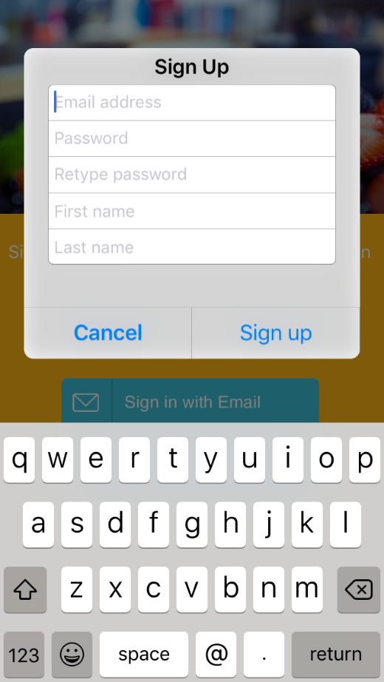
The first one downloaded was an application called 'SORTEDfood’, it is an app that is created to share recipes and videos. Unfortunately, the experience of the app cut short when the user could not even get past the ‘Create Username’ page (shown in figure 95), as it would not respond to any touch. This app is not a contender for the questionnaire due to this.
Figure 95
Figure 96

Figure 97

Figure 98

Figure 99Figure 100

Figure 101

Second App – ‘Kitchen Bowl’

The second app downloaded is ‘Kitchen Bowl’. This app has sections for users to share photos, view tags, creators and recipes.
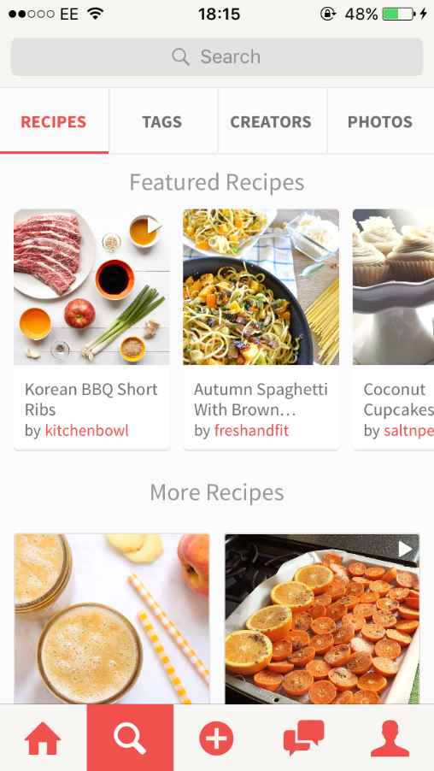
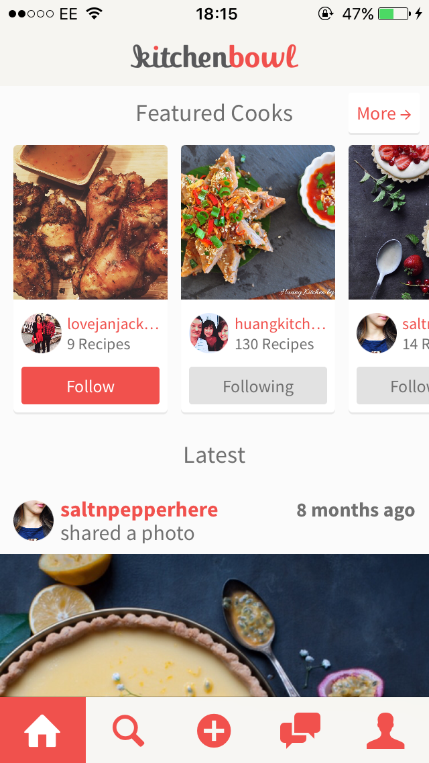
The content on this app is organised very well and it is felt like it is a good app overall with relevant content and sections for the users to explore. This app is going to be a contender for the questionnaire as it provides a lot of interactivity with the user and tasks for them to follow and determine how they feel aboutthe usability.

Figure 102
Figure 103

Third app – ‘Foodsaurus’
This app is very different to the previous and is a list that shows which foods are vegan. You search for a specific ingredient and you can click and expand to see why it is or is not vegan.
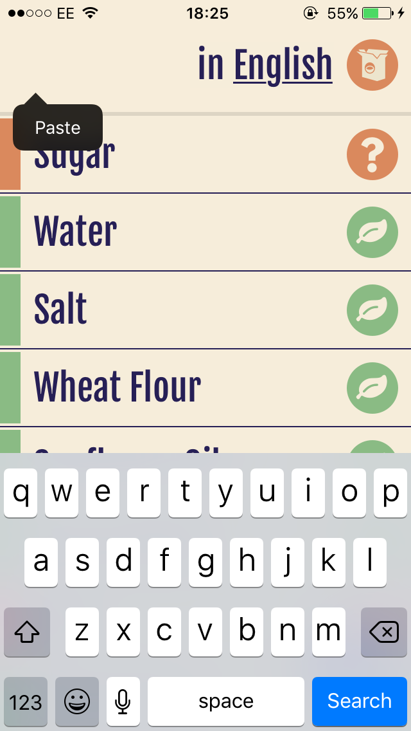
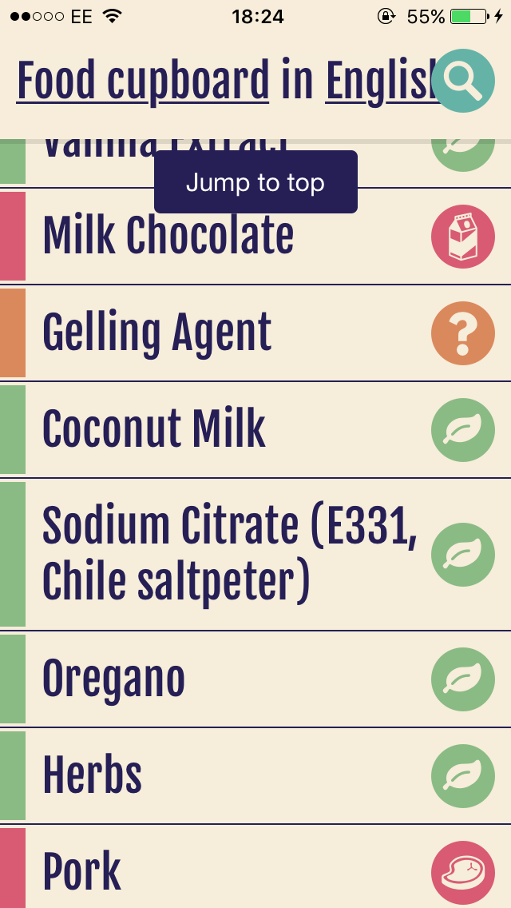
There are obvious usability issues such as not being able to find an ingredient within alphabetical order, as you would expect. However, this app is slightly too simple to consider using it for the questionnaire.
Figure 104

Figure 105

 | Strongly Disagree |  |  |  | Strongly agree
 | 1 | 2 | 3 | 4 | 5
I think the layout is simple and easy to follow |  |  |  |  | X
All content on the app is relevant |  |  |  | X
I found the recipes page with ease and the steps of the recipes are easy to follow |  |  |  | X
I felt that the app is easy to understand and there is no learning required on how to use it |  |  | X
The layout and theme of the app is consistent throughout |  |  | X
I feel like there is adequate content on the page at once when viewing recipes |  |  |  | X
There’s an adequate amount of content on the newsfeed |  |  |  | X
I found uploading an image was straightforward |  |  |  |  | X
I found creating and posting a recipe was straightforward |  |  | X
I understand what a ‘collection’ on the app was and how to create one | X
Section B: Questionnaire Feedback. Participant A, age: 21. SUS Score: 55/100.

 | Strongly Disagree |  |  |  | Strongly agree
 | 1 | 2 | 3 | 4 | 5
I think the layout is simple and easy to follow |  |  |  | X
All content on the app is relevant |  |  |  |  | X
I found the recipes page with ease and the steps of the recipes are easy to follow |  |  |  | X
I felt that the app is easy to understand and there is no learning required on how to use it |  | X
The layout and theme of the app is consistent throughout |  |  | X
I feel like there is adequate content on the page at once when viewing recipes |  |  |  |  | X
There’s an adequate amount of content on the newsfeed |  |  |  |  | X
I found uploading an image was straightforward |  |  |  |  | X
I found creating and posting a recipe was straightforward |  |  | X
I understand what a ‘collection’ on the app was and how to create one | X
Participant B, age: 20. SUS Score: 52.5/100.

Participant C, age: 25. SUS Score: 52.5/100.
 | Strongly Disagree |  |  |  | Strongly agree
 | 1 | 2 | 3 | 4 | 5
I think the layout is simple and easy to follow |  |  |  |  | X
All content on the app is relevant |  |  |  | X
I found the recipes page with ease and the steps of the recipes are easy to follow |  |  |  | X
I felt that the app is easy to understand and there is no learning required on how to use it |  |  |  | X
The layout and theme of the app is consistent throughout |  |  |  |  | X
I feel like there is adequate content on the page at once when viewing recipes |  |  |  | X
There’s an adequate amount of content on the newsfeed |  |  | X
I found uploading an image was straightforward |  |  |  |  | X
I found creating and posting a recipe was straightforward |  | X
I understand what a ‘collection’ on the app was and how to create one | X

 | Strongly Disagree |  |  |  | Strongly agree
 | 1 | 2 | 3 | 4 | 5
I think the layout is simple and easy to follow |  |  |  |  | X
All content on the app is relevant |  |  |  | X
I found the recipes page with ease and the steps of the recipes are easy to follow |  |  |  |  | X
I felt that the app is easy to understand and there is no learning required on how to use it |  |  |  |  | X
The layout and theme of the app is consistent throughout |  |  |  |  | X
I feel like there is adequate content on the page at once when viewing recipes |  |  |  | X
There’s an adequate amount of content on the newsfeed |  |  | X
I found uploading an image was straightforward |  |  |  |  | X
I found creating and posting a recipe was straightforward |  |  |  | X
I understand what a ‘collection’ on the app was and how to create one |  | X
Participant D, age: 23. SUS Score: 55/100.

 | Strongly Disagree |  |  |  | Strongly agree
 | 1 | 2 | 3 | 4 | 5
I think the layout is simple and easy to follow |  |  |  |  | X
All content on the app is relevant |  |  | X
I found the recipes page with ease and the steps of the recipes are easy to follow |  |  |  | X
I felt that the app is easy to understand and there is no learning required on how to use it |  |  |  |  | X
The layout and theme of the app is consistent throughout |  |  | X
I feel like there is adequate content on the page at once when viewing recipes |  |  | X
There’s an adequate amount of content on the newsfeed |  |  |  | X
I found uploading an image was straightforward |  |  |  |  | X
I found creating and posting a recipe was straightforward |  |  | X
I understand what a ‘collection’ on the app was and how to create one | X
Participant E, age: 20. SUS Score: 55/100.

Background of study
All participants own a smart phone, four own an iPhone and one owns an android, so they are all used to using several apps daily.
Comments from the users after completing the tasks and questionnaire.
Participant A
Positive: Easy to understand the purpose of app.
Negative: Did not understand how to create a collection and only discovered how to create one when I clicked on the ‘Klip’ button randomly to figure out what it was.
Participant B
Positive: I like the layout of the newsfeed, easy to find relevant recipes under categories.
Negative: Did not create a collection because I did not know how. The recipes page has a lot going on with every section of the screen containing content.
Participant C
Positive: Finding recipes was straightforward, all content is relevant.
Negative: Featured cooks section on newsfeed interrupts viewing the direct content that you have chosen to follow and view.
Participant D
Positive: Layout of app is easy to follow, creating a recipe is fun and easy to do.
Negative: didn’t understand the ‘Klip’ button first but creating a collection was easy enough to do once it was understood it was created by ‘klipping’ the recipes you wanted.
Participant E
Positive: Easy to use the app.
Negative: The recipe page could include categories rather than what’s featured – unsure what it means by ‘featured’, where?

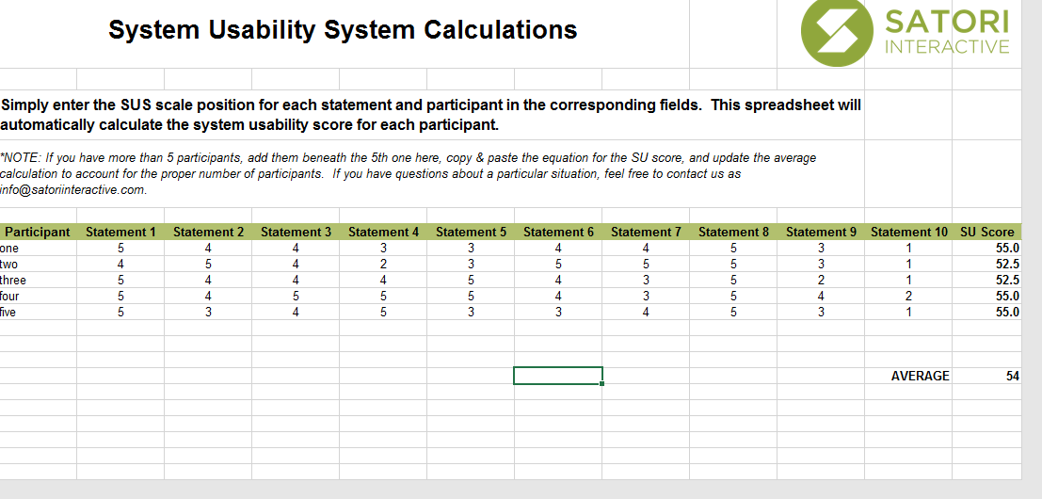
Working out the SUS scores using satoriinteractive.com/wp-content/uploads/2015/09/Satori-SUS-Calculator.xls

Section C- Design and Development background - Research into Hybrid Mobile Applications
The focus of this project is evaluating the usability of an app; this section will provide an overview of hybrid applications and the different frameworks available.
A hybrid mobile app is an application developed using a combination of native and web applications. A native app is an app for a specific mobile operating system, such as Swift for IOS. Hybrid apps are implemented using a combination of technologies and are hosted inside a mobile platform’s Web View, which is in the native container.
The researcher has investigated frameworks to determine which one would be best to develop an app with for this project [47].

Progressive vs. Native vs. Hybrid
There are many ways to build mobile interfaces; developers have the options of developing native apps, hybrid apps or progressive web apps. A progressive app is displayed as a website, which is within the users’ browser and provides functionality from there. A progressive web app is developed with popular technologies such as JavaScript, CSS and HTML5.
One of the benefits of creating a progressive web app is that it is easily accessible, as it does not require the user to download them from any app store. The progressive web app is available in the browser of the device and is accessible offline. In contrast, hybrid apps and native apps are downloaded from an app store.
Developing a progressive web app could potentially be quicker than developing a native app, because if a user were to develop the same app but as a native app for both IOS and android, they would have to develop one in the Swift language for IOS and then another app in Java for Android. This would mean that the cost of developing a native app would be a lot higher than developing a progressive web app. If a developer is looking to develop an app whilst sticking to a tight budget then it would be better to choose to create a progressive web app [48] [49].
Hybrid apps, like progressive web apps, also make use of web developers’ existing knowledge so they can develop hybrid apps quickly without having to learn any new languages. Another advantage is that both native and progressive web apps can use features such as push notifications, this ensures that users are likely to return and become regular users of the apps [50].
A disadvantage of a progressive app is that it cannot use the functionality of the device’s hardware and are unable to install plugins. In contrast, native apps can use the functionality of the devices (which includes features such as using the Bluetooth or the camera) [51] [48]. Hybrid applications are also able to access the device’s hardware and they do this with plugins, however if a plugin does not exist then the developer will either must create one to work with their app or consider a different design [52] [53].

Hybrid mobile app development
There are frameworks available that help with the development of a hybrid mobile application and this report will discuss four of them to consider them as a framework to use in the development of the app for this project. Hybrid mobile application frameworks are useful to develop an application if the developer has little experience when it comes to developing apps [54].
Ionic is popular among developers, it is an open-source mobile application framework which enables the developer to write one app which works across multiple platforms. It makes use of JavaScript, HTML, Sass and CSS, which is a positive for web developers who are confident using these web technologies [55].
Sencha Touch is another framework option. It includes native packaging, which is an advantage and allows responsive touch features within their applications and it includes templates for the developer to use. Unlike Ionic, Sencha Touch’s products are not free to use and can be expensive to purchase but the apps can be worth it as they provide a native look and feel for all the popular platforms [56].
Phonegap is a HTML5 framework based on the open source Apache Cordova and it is popular with developers. Apps created with Phonegap can extend with plugins, which then enables the use of the hardware’s functionality [57].
Xamarin is another framework owned by Microsoft. It uses C# to create applications for multiple platforms. Xamarin comes complete with a development toolset so no integration of other applications is required to build a Xamarin application, although you can integrate third party resources but there may be an issue with compatibility. The disadvantage for some web developers using Xamarin, however, is that they would need a basic understanding of the native languages rather than use their existing knowledge of CSS, HTML and JavaScript to create the app as the app requires a layer of code that is platform specific. [58]
Chosen framework
The chosen framework for this project is Ionic. After researching, it is felt that this is the right choice of framework to build a new application with; there is plenty of documentation online with ready-made components for the UI, which gives a “native-like” feel and will help create the app to how the developer envisions it.

Section D: User Requirements expanded

These requirements have been added to help the developer alongside design decisions whilst working on this app.
The platform for which the app will be built towards is not discussed as part of the design section, as the app is going to be a hybrid app, so it will support multiple platforms.
Questions to consider regarding the interface:
- How will the users understand this action?
- Is this button placed where the users would expect it to be?
- Is this interaction unnecessary? Or is it distracting?

The user requirements built from the questions above:
- The buttons implemented must be positioned clearly to the user regarding the size and colour. However, they must not be distracting.
- The buttons will link the user to pages that they expect from clicking on this action
- The flow of the navigation must be considerably easy to learn/understand.

Questions to consider regarding the app in general:
- Is this image/text/section relevant?
- What features will this app need?
The user requirements built from the questions above:
- The app is based upon viewing recipes, cooking and food in general so it is important to stick to this theme and make the pages revolve and relate to it.
- This app should include the following important pages; newsfeed, explore page, share page and profile page.

 | Strongly Disagree |  |  |  | Strongly agree
 | 1 | 2 | 3 | 4 | 5
I think the layout is simple and easy to follow |  |  |  |  | X
All content on the app is relevant |  |  |  | X
I found the recipes page with ease and the steps of the recipes are easy to follow |  |  |  |  | X
I felt that the app is easy to understand and there is no learning required on how to use it |  |  |  | X
The layout and theme of the app is consistent throughout |  |  |  | X
I feel like there is adequate content on the page at once when viewing recipes |  |  | X
There’s an adequate amount of content on the newsfeed |  |  |  |  | X
I found uploading an image was straightforward |  |  | x
I found creating and posting a recipe was straightforward |  |  | X
I understand what a ‘collection’ on the app was and how to create one |  |  |  | x
Section E: Second questionnaire results
Participant A score:
(background: age 52)

 | Strongly Disagree |  |  |  | Strongly agree
 | 1 | 2 | 3 | 4 | 5
I think the layout is simple and easy to follow |  |  |  |  | X
All content on the app is relevant |  |  |  |  | X
I found the recipes page with ease and the steps of the recipes are easy to follow |  |  |  |  | x
I felt that the app is easy to understand and there is no learning required on how to use it |  |  |  | X
The layout and theme of the app is consistent throughout |  |  |  |  | X
I feel like there is adequate content on the page at once when viewing recipes |  |  |  | x
There’s an adequate amount of content on the newsfeed |  |  |  |  | x
I found uploading an image was straightforward |  |  | X
I found creating and posting a recipe was straightforward |  |  | x
I understand what a ‘collection’ on the app was and how to create one |  |  |  | x
Participant B – Age 21:

 | Strongly Disagree |  |  |  | Strongly agree
 | 1 | 2 | 3 | 4 | 5
I think the layout is simple and easy to follow |  |  |  |  | X
All content on the app is relevant |  |  |  |  | x
I found the recipes page with ease and the steps of the recipes are easy to follow |  |  |  |  | X
I felt that the app is easy to understand and there is no learning required on how to use it |  |  |  |  | X
The layout and theme of the app is consistent throughout |  |  |  |  | X
I feel like there is adequate content on the page at once when viewing recipes |  |  |  | x
There’s an adequate amount of content on the newsfeed |  |  |  |  | X
I found uploading an image was straightforward |  |  |  |  | X
I found creating and posting a recipe was straightforward |  |  |  |  | x
I understand what a ‘collection’ on the app was and how to create one |  |  |  | x
Participant C: Age 22-

 | Strongly Disagree |  |  |  | Strongly agree
 | 1 | 2 | 3 | 4 | 5
I think the layout is simple and easy to follow |  |  |  |  | X
All content on the app is relevant |  |  |  | X
I found the recipes page with ease and the steps of the recipes are easy to follow |  |  |  |  | x
I felt that the app is easy to understand and there is no learning required on how to use it |  |  |  |  | X
The layout and theme of the app is consistent throughout |  |  |  | X
I feel like there is adequate content on the page at once when viewing recipes |  |  | X
There’s an adequate amount of content on the newsfeed |  |  |  |  | X
I found uploading an image was straightforward |  |  |  | x
I found creating and posting a recipe was straightforward |  |  |  | x
I understand what a ‘collection’ on the app was and how to create one |  |  |  | x
Participant D: age 22:

 | Strongly Disagree |  |  |  | Strongly agree
 | 1 | 2 | 3 | 4 | 5
I think the layout is simple and easy to follow |  |  |  |  | X
All content on the app is relevant |  |  |  | X
I found the recipes page with ease and the steps of the recipes are easy to follow |  |  |  |  | X
I felt that the app is easy to understand and there is no learning required on how to use it |  |  |  | X
The layout and theme of the app is consistent throughout |  |  |  |  | X
I feel like there is adequate content on the page at once when viewing recipes |  |  |  | X
There’s an adequate amount of content on the newsfeed |  |  |  |  | x
I found uploading an image was straightforward |  |  |  |  | X
I found creating and posting a recipe was straightforward |  |  |  |  | x
I understand what a ‘collection’ on the app was and how to create one |  |  |  | x
Participant E: age 23-
Comments from the users after completing the tasks and questionnaire.
Participant A
Positive: I like how simple the newsfeed is and the navigation throughout is easy to follow.
Negative: The pages where they show the steps of the recipes would look better with slightly more content on it.
Participant B
Positive: I like the layout of the explore page and I like the search for recipes page.
Negative: I did not understand at first that the “share page” included both the image upload and to create a recipe under it. Also, the search for recipes page only works when connected to internet.
Participant C
Positive: The app is easy to use, and all content is relevant.
Negative: The “Follow new user” button may appear hidden to some people as it is at the bottom of the newsfeed and under the suggested user on the explore page. Maybe if the position of the button was moved then it’d be more obvious straightaway.
Participant D
Positive: I liked the explore page and how there were different sections of content.
Negative: There was a slight problem with the recipe pages where the images did not load. The content looked small compared to the size of the tablet.
Participant E
Positive: This app was easy to use, and I like the newsfeed.
Negative: I found the creating a new recipe easy as it is through the share page, so I rated it high, however, I feel that the page would be more effective if the recipe was separate to the photo upload?

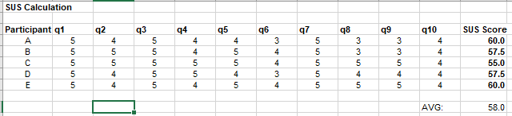
Working out the SUS score

