STUDY TRACK
Design and Development of a Web-Based Task and Deadline Management System for Students
Student Name | Sanobia Nosheen Ahmed
Student ID | 2314145
Module | Independent Project II ACCA6020
Lecturer | Renuga Jayakumar
Submission Date | 10th Aug 2026
Report Type | Level 6 Technical Project Report

DECLARATION FORM AND FORM OF CONSENT
Declaration of Originality

I, Sanobia Nosheen Ahmed, declare that I am the sole author of this Project; that all references cited have been consulted; that I have conducted all work of which this is a record, and that the finished work lies within the prescribed word limits.

This work has not previously been accepted as part of any other degree submission.

Signed: Sanobia N Ahmed

Date: 10th August 2026

FORM OF CONSENT

I, Sanobia Nosheen Ahmed, hereby consent that my Project, submitted in candidature for the B.Sc. (Hons) Computer Networks degree, if successful, may be made available for inter-library loan or photocopying (subject to the law of copyright), and that the title and abstract may be made available to outside organisations.

Signed: Sanobia N Ahmed

Date: 10th August 2026

Copyright Acknowledgement

I acknowledge that the copyright of this project report, and any product developed as part of the project, belongs to the University of Wales Trinity Saint David, London.

Academic Declaration and Scope Note
This report explains the design, development and evaluation of the Study Track web application. It is based on the project documents, diagrams and source-code files supplied for this assignment. IEEE numbered citations are used throughout the report. The work is written in clear academic language and does not claim that features were tested when there is no evidence to support that claim.
No questionnaire, interview, focus group, observation or experiment was carried out with real students. The feedback pages are part of the prototype and may be used in a future approved study. They are not treated as real research results in this report. The research section uses published books, journal articles, conference papers, standards and official technical guidance only.

Abstract
Study Track is a web-based task and deadline management system for university students. It brings assignments, examinations, reading, development work and personal tasks into one place. The prototype uses PHP, MySQL, HTML, CSS and JavaScript. Its main features include secure registration and login, module and task management, study-hour recording, calendar views, urgent warnings, a smart-priority score, charts, dark mode, PDF export and administrator pages. The project is linked to self-regulated learning because it helps students plan work, monitor progress and review completed tasks. The report uses secondary research and reviews the supplied documents and code. It finds that the project has a clear purpose and a useful design, but some parts need correction before final submission. The database names are not fully consistent across the documents and code, some administrator actions need stronger security, and the full application could not be independently run from the supplied files. No real student data was collected. The project is therefore presented as an academic prototype rather than a finished university service. The report recommends one final database structure, safer POST actions with CSRF protection, better form labels, clearer test evidence and a future usability study only after ethical approval.

Contents
DECLARATION FORM AND FORM OF CONSENT 2
Academic Declaration and Scope Note 3
Abstract 3
1. Introduction 6
1.1 Background and problem context 6
1.2 Aim and objectives 6
1.3 Scope and report structure 7
2. Critical Literature Review 7
2.1 Search focus and evidence boundaries 7
2.2 Time management and academic study 7
2.3 Self-regulated learning as the conceptual foundation 8
2.4 Learning analytics dashboards and actionable feedback 8
2.5 Usability, accessibility and interface design 9
2.6 Software quality and secure web development 9
3. Methodology 10
3.1 Research and development approach 10
3.2 Secondary data collection 10
3.3 Artefact inspection and evaluation method 11
3.4 Data storage and research ethics 11
4. Requirements Analysis 11
4.1 Stakeholders and user roles 11
4.2 Assumptions and constraints 12
5. System Design 13
5.1 Architectural design 13
5.2 Database and information model 14
5.3 Object and interaction design 16
5.4 Workflow, navigation and interface design 18
5.5 Smart-priority design 20
6. Implementation 21
6.1 Technology stack and local environment 21
6.2 Registration and authentication 21
6.3 Calendar and task presentation 22
6.4 Administrator and feedback functions 22
6.5 Front-end implementation and responsive design 23
6.6 Implementation consistency and maintainability 23
6.7 Project interface screenshots 24
7. Testing and Evaluation 30
7.1 Testing strategy 30
7.2 Additional boundary and negative tests 31
7.3 Quality evaluation 31
7.4 Limitations of the evaluation 32
8. Security, Privacy, Ethics, Accessibility and Sustainability 32
8.1 Security and privacy 32
8.2 Research ethics 33
8.3 Accessibility and inclusive design 33
8.4 Sustainability and professional practice 33
9. Project Management and Resources 33
9.1 Weekly plan 33
9.2 Resources and risks 34
10. Discussion 34
10.1 Achievement of the project aim 34
10.2 Relationship to literature 35
10.3 Critical weaknesses and technical debt 35
10.4 Recommended development roadmap 36
11. Conclusion 36
References 37
Appendix A. Supplied Artefact Evidence 40
Appendix B. Suggested Extended Test Evidence Template 40
Appendix C. Installation and Demonstration Checklist 40

1. Introduction

1.1 Background and problem context
University students often need to manage several modules, assignment deadlines, examinations, reading tasks and personal responsibilities at the same time. The problem is not only remembering a date. Students also need to judge how much work a task needs, decide what should be done first and check whether progress is being made. Information may be spread across notebooks, calendars, emails, messages and learning platforms. This can make planning difficult and can lead to missed deadlines or rushed work. Study Track was designed to place this information in one simple system.
The educational idea behind the project is self-regulated learning. This means that students set goals, choose study methods, monitor their own progress and reflect on the result instead of relying only on instructions from other people [1] [2]. A digital planner cannot make a student learn, but it can support the planning and monitoring parts of this process. Study Track supports this by allowing users to enter tasks, deadlines, priority levels, estimated hours and study records.
The supplied documents describe Study Track as a PHP and MySQL prototype that runs locally through XAMPP, WAMP or MAMP. The planned functions include registration and login, task management, module organisation, study-hour recording, a calendar, dashboard charts, reminders, PDF export, feedback and an administrator area. The source-code files show several of these functions, including authentication, calendar filtering, administrator reports, responsive CSS and dark-mode storage. Some pages and the final SQL file were not available in the supplied package, so the report clearly separates confirmed code features from planned features.

1.2 Aim and objectives
The aim is to design, build and evaluate a secure web-based system that helps students plan tasks, notice deadlines and monitor study activity. The system is not designed to predict grades or replace support from lecturers. Its purpose is to give students a clear personal view of their workload and progress.
Table 1. Project aim, objectives and evidence
ID | Objective | Evidence in project
O1 | Provide secure student and administrator registration/login. | Signup and login pages; password hashing; role checks.
O2 | Allow tasks to be created, categorised, prioritised and monitored. | Task entity, categories, priorities, status and admin task list.
O3 | Organise tasks by module and personal category. | Module entity and optional module foreign key.
O4 | Track study time and show meaningful totals. | Study-session entity and documented dashboard statistics.
O5 | Improve deadline awareness through calendar and urgency information. | Monthly calendar, reminder design and smart-priority concept.
O6 | Provide accessible and responsive interface features. | Arial interface, responsive CSS grid, dark mode and mobile navigation.
O7 | Evaluate the artefact without using unauthorised human participants. | Functional tests, code review, heuristic inspection and synthetic data.

1.3 Scope and report structure
The project is a local web prototype, not a live university service. It stores account and planning information in a relational database and shows the main journey from login to dashboard, tasks, calendar, study records and administrator pages. The report covers literature, method, requirements, design, implementation, testing, security, privacy, accessibility, sustainability, project planning, discussion and conclusion. The supplied diagrams and project files are used as evidence throughout.

2. Critical Literature Review

2.1 Search focus and evidence boundaries
The literature review focuses on five connected topics: student time management, self-regulated learning, learning analytics dashboards, web-system quality and secure development. Recent peer-reviewed research was used where possible. Important older studies were also included when they explain the main theory. Books and official standards were used for software engineering, usability, accessibility and security.
The search terms included combinations of student time management, self-regulated learning, study dashboards, learning analytics, task priority, web usability, secure PHP, software quality and student planning. Sources were selected because they were relevant to the project and came from recognised publishers, journals, conference proceedings, standards organisations or official technical documentation. The review is not presented as a full systematic review because it does not claim to search every database or include every available study. PRISMA and software-engineering review guidance were used to keep the search and reporting process clear [3] [4].

2.2 Time management and academic study
Time management includes planning, setting priorities, monitoring work and using time carefully. These skills matter in higher education because students manage several deadlines and much independent study. Research reports a link between time management and academic achievement, although self-reported data has limits [5]. Online-learning research also links self-regulated learning strategies with academic achievement [6]. Study Track supports these behaviours by showing completed tasks, recorded hours, overdue work and status changes.
A digital planner can reduce the effort of remembering many commitments, but a complicated form can create extra work. Study Track should collect only useful details: title, deadline, category, module, priority, estimated hours and status. Notes and study sessions can remain optional. This balance supports effectiveness, efficiency and satisfaction in the user’s own context [7].
Priority is more complex than sorting only by date. A small task may be due tomorrow, while a larger task due next week may need many hours. Study Track combines deadlines, chosen priority and estimated effort in one score. The method is easy to understand, but the input may be inaccurate. The score should guide the student, not make the final decision. For example, a high-priority task should be done in two days. Normally, a low-priority task appears due in two weeks. Estimated hours add useful context because a large assignment needs an earlier start. The system should display the reason for the score, such as ‘due soon’ or ‘high effort’, so the student can understand it. Users should also be able to change priority when new information becomes available

2.3 Self-regulated learning as the conceptual foundation
Zimmerman describes self-regulated learning as a repeating process involving forethought, performance and self-reflection [1]. Panadero’s review similarly shows that established models include goal setting, strategic planning, self-monitoring, feedback and adaptation [2]. These phases can be mapped directly to Study Track. Creating a task and estimating hours represent forethought; recording study sessions and changing task status represent performance monitoring; reviewing charts and completed work supports reflection. The mapping gives the interface an educational rationale rather than treating it as a general to-do list.
Digital systems can support self-regulation, but the results are not always strong. Reviews show that learning-analytics tools support different stages of regulation, while research quality and evaluation are sometimes limited [8]. Too many prompts may also create dependence [9]. Digital learning brings benefits, but distraction, unequal access and weak digital skills remain challenges [10].
Study Track should inform people rather than control the user. An urgent warning should explain that the deadline is close and show the expected workload. The student should still decide what to do. Charts should compare the learner with their own plans and past activity, not rank students against one another.
Study quality is not the same as the number of recorded hours. The prototype records hours and notes, but it cannot measure concentration, understanding or learning outcomes. Hours should therefore be treated as a planning measure, not proof of learning. Optional reflection notes could record what was achieved, what remains difficult and the next action. Digital activity data can support research, but it must be interpreted carefully [11].

2.4 Learning analytics dashboards and actionable feedback
Learning analytics dashboards show information about learning activity. Research warns that many dashboards are not strongly linked to learning theory and may not support useful study strategies [8]. Later work supports participatory design, clearer theory and better human decision-making [12] [13]. Personalised learning may also benefit when dashboard information is clear and linked to action [14]. Study Track should therefore use charts that help the student make a practical decision.
The Study Track dashboard shows task totals, urgent warnings, module progress, recent tasks and charts. It answers simple questions about what is due, what remains unfinished and how much study time is recorded. Charts should support, not replace, a clear task list. Text values, labels, keyboard access and accessible tables are needed under WCAG 2.2 [15]. Students may react differently to the same graph when it shows different data, so the design should be tested [16].
Warnings can help, but too many alerts may be ignored. Users should control reminder timing and frequency, and completed tasks should not trigger messages. The sequence diagram shows a reminder script, database check and email, but the working reminder code was not supplied. The report can review the idea but cannot confirm email delivery, rate control or message privacy.
The administrator dashboard shows users, tasks, study hours and feedback. These totals may help with technical monitoring, but personal planning data can be sensitive. A live system should give administrators only the access needed for maintenance and should use grouped or anonymous data for research. This report treats the dashboard as a local prototype and does not analyse real students.

2.5 Usability, accessibility and interface design
HCI research recommends consistent design, clear system status, error prevention and useful feedback [17] . Study Track uses repeated card layouts, familiar buttons, status badges, a calendar and dark mode. The wireframes separate the homepage, dashboard, task page and administrator page. The site map also keeps the main functions close to the dashboard.
A consistent appearance is not enough. Forms need clear labels, useful error messages and a way to recover from mistakes. The signup page validates data, but placeholders should not be the only labels because they disappear during typing. Delete actions need clear confirmation and server-side protection. Colour should never be the only way to show status.
Students may use the system on laptops, tablets or phones. The CSS changes multi-column layouts to a single column and uses a mobile menu on smaller screens. This follows responsive-design guidance [18]. Testing is still needed at different zoom levels, screen sizes and orientations. A mobile agenda view may be clearer than a full calendar grid. Mobile tools can support self-regulated learning when they are simple and linked to clear goals [19].

2.6 Software quality and secure web development
Software engineering guidance supports a clear path from requirements to design, development, testing and maintenance [20] [21]. ISO/IEC 25010 lists product-quality areas such as functionality, efficiency, reliability, security and maintainability [22]. ISO 9241-11 adds effectiveness, efficiency and satisfaction [7], while ISO/IEC 25019 covers quality in use [23]. These models provide a more robust evaluation than simply checking whether a page opens.
Study Track stores names, emails, passwords and information about user activity, so security is important. NIST recommends security throughout development [24], and OWASP lists common risks such as broken access control, injection and insecure design [25]. The supplied code uses password hashing, password verification and PDO prepared statements. PHP guidance explains how these methods protect passwords and reduce SQL-injection risk [26], [27].
The code review also found risks. Some administrator changes use GET links without a visible CSRF token, and demo credentials appear on the login page. The supplied files do not show secure cookie settings, session renewal, rate limits, password reset or complete audit logging. These controls may exist in missing files, but they cannot be confirmed. The prototype should not be described as production-ready.
Table 2. Literature themes and implications for Study Track
Theme | Main finding | Implication
Self-regulated learning | Planning, monitoring and reflection are cyclical. | Map tasks, study logs and progress review to the cycle.
Time management | Behavioural evidence is stronger than perception alone. | Use deadlines, status and hours; do not rely only on satisfaction.
Dashboards | Visualisations must support action and be theory-informed. | Prioritise urgent work and text summaries over decorative charts.
Usability | Effectiveness, efficiency and satisfaction depend on context. | Test realistic task scenarios on desktop and mobile.
Accessibility | Content must remain perceivable and operable. | Use labels, keyboard support, contrast and text alternatives.
Security | Controls must be integrated throughout the lifecycle. | Use secure sessions, CSRF controls, least privilege and validation.

3. Methodology

3.1 Research and development approach
The project uses a design-and-development method. A working computing system is created and then reviewed against the requirements and published research. The work follows a repeated cycle: defining the requirements, designing the database and pages, building the functions, testing them and using the findings to improve the system. This method suits the project because the result is both a written report and a web prototype. Short development cycles also follow the inspect-and-improve approach used in Scrum [28].
The evidence comes from three sources: the supplied project documents, the available PHP/CSS/JavaScript files and published academic or technical guidance. Differences between the documents and code are reported instead of being hidden. For example, the documents use study hours, while one administrator query uses study logs. The final database and code must use one name.

3.2 Secondary data collection
The research part uses secondary data only. Information was collected from peer-reviewed journal articles, academic books, conference papers, technical standards and official documentation. The topics included student planning, self-regulated learning, dashboard design, accessibility, PHP security, databases and software quality. Notes recorded the source, year, purpose, method, main findings, limits and relevance to Study Track. Recent sources were preferred, while older key theory was used where needed.
No primary data was collected from real students. No questionnaire was distributed, no interview was completed, and no user was observed. The feedback form and administrator feedback chart are only prototype features. Synthetic test records may be entered on a local computer to check that forms and charts work, but they must not be described as real opinions. Any future user study would need a new research plan, participant information, consent, a data-management plan and ethical approval before data collection starts.

3.3 Artefact inspection and evaluation method
The system was reviewed by reading the documents, checking the available code, linking requirements to features and following common user tasks step by step. The code review checked input validation, password handling, database queries, role checks, output escaping, navigation and front-end behaviour. The walkthrough covered account creation, login, dashboard use, tasks, calendar use, administrator pages and prototype feedback. The full system and database were not available for independent running. For this reason, the Pass results in the supplied test plan are reported as documented results and not as repeated tests for this report.
The quality discussion uses ISO/IEC 25010 categories and ISO 9241-11 usability concepts. Security findings are compared with NIST SSDF and OWASP guidance. Accessibility is reviewed against WCAG 2.2 at a design level. This method supports a balanced conclusion: it can identify strengths and visible weaknesses, but it cannot prove reliability in a live system, scalability, resistance to security attacks or effect on student learning. This method is suitable for the available evidence because it does not invent test results. It checks whether the planned functions match the code that can be seen and whether the design follows recognised guidance. The method also records uncertainty. A missing file is reported as missing rather than treated as a failed feature. This makes the evaluation fair, repeatable and easier for an assessor to follow.

3.4 Data storage and research ethics
Research notes, downloaded publications, diagrams, code copies and the report are stored on a password-protected laptop in a separate project folder. No participant data is stored. The files will be kept until the assessment, and any academic review period is complete. Unneeded drafts and duplicated copies can then be securely deleted. Published articles are cited and are not redistributed. This keeps the amount of stored data low and limits access to the project files.

4. Requirements Analysis

4.1 Stakeholders and user roles
The primary user is a student who wants a personal view of modules, deadlines and study progress. The secondary role is an administrator responsible for user accounts, technical oversight and controlled review of system records. A third stakeholder is the project assessor, who requires evidence that the system was planned, implemented, tested and carefully evaluated. In future institutional deployment, additional stakeholders would include lecturers, accessibility specialists, data-protection staff and IT support; but these roles are outside the current prototype.
The use-case design correctly separates student and administrator actions. Students register or log in, manage tasks, view the calendar, track study hours, view charts, export information, receive reminders and access the feedback form. Administrators view users, tasks, usage statistics and feedback information. The separation supports role-based access control, but it also creates a requirement that every administrator page must enforce the role server-side. Hiding a navigation link would not be sufficient.
Table 3. Functional requirements
ID | Function | Acceptance description | MoSCoW
FR1 | Registration | Create a student account using name, email and password. | Must
FR2 | Authentication | Verify credentials and start a protected session. | Must
FR3 | Task CRUD | Create, view, edit, complete and delete tasks. | Must
FR4 | Classification | Assign category, module, priority, deadline and status. | Must
FR5 | Calendar | Display user tasks in a selected monthly view. | Must
FR6 | Study logging | Record date, hours, optional module/task and notes. | Should
FR7 | Priority support | Calculate and display an understandable urgency score. | Should
FR8 | Dashboard | Show counts, urgent work, progress and recent tasks. | Should
FR9 | Reminder | Check upcoming deadlines and avoid duplicate alerts. | Could
FR10 | Export | Produce a personal task report for offline planning. | Could
FR11 | Administration | Manage users and review tasks using protected pages. | Must
FR12 | Feedback module | Store synthetic/demo feedback; real use requires ethics approval. | Could

Table 4. Non-functional requirements
ID | Quality area | Requirement
NFR1 | Security | Hashed passwords, prepared queries, protected routes, CSRF controls and secure sessions.
NFR2 | Usability | Core task creation should be understandable without training and recoverable after errors.
NFR3 | Accessibility | Keyboard operation, visible labels, focus indication, sufficient contrast and text alternatives.
NFR4 | Performance | Dashboard and calendar should respond promptly with normal student data volumes.
NFR5 | Reliability | Updates should preserve referential integrity and avoid duplicate or orphaned records.
NFR6 | Maintainability | Consistent naming, reusable includes, documented configuration and modular functions.
NFR7 | Portability | Local deployment through common PHP/MySQL packages and standards-based browser output.
NFR8 | Privacy | Collect only necessary account/planning data and restrict administrator visibility.

4.2 Assumptions and constraints
The prototype assumes that a student has access to a modern browser and is willing to enter task information manually. It also assumes that deadlines and estimated hours are entered accurately. Local XAMPP deployment reduces hosting complexity but does not show internet security, multi-user load or email delivery. The current dataset is expected to be small, so performance testing at university scale is outside scope. The most important ethical constraint is that no real student research may be carried out under the current approval position.

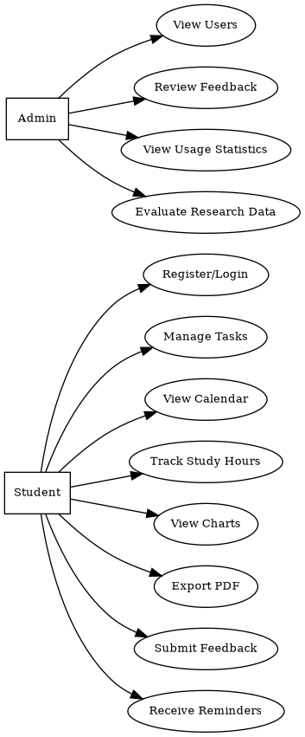
Figure 1. Study Track students and administrators use cases (source: supplied project documentation).

5. System Design

5.1 Architectural design
Study Track follows a standard server-rendered web design. The browser presents HTML forms, navigation, tables, cards, calendars and charts. PHP controllers process requests, apply authentication or administrator checks and communicate with MySQL through PDO. The database stores user records, modules, tasks, study sessions, reminders and feedback. JavaScript provides lightweight client-side interactions such as menu expansion, dark-mode persistence and deletion confirmation. This separation is suitable for a student project because the technologies are widely documented, can be deployed locally and do not require a separate API framework.
The design also has limits. Several PHP files mix page layout, validation and database work, which can make later changes difficult. A larger version should separate routing, validation, business rules, database queries and templates. Shared functions for escaping, authentication, priority scores and CSRF checks would reduce repeated code.

5.2 Database and information model
The entity-relationship design contains six main entities. A user owns modules, tasks, study sessions and feedback. A task may belong to a module, and study sessions may be linked to a module or task. Reminders are linked to tasks. This design supports personal data separation because most operational tables contain a user foreign key. Optional modules and task references allow personal activities and general study sessions to be recorded without forcing an academic module relationship.
Database normalisation reduces repeated data. User details are stored once, modules are separate from tasks, and reminders are separate from task records. Foreign keys help keep related records consistent [29]. The project should define what happens when a task or user is deleted and add indexes to common search fields such as user_id, module_id and deadline.
The main database problem is naming. The documents use user_id, task_id and study hours, while the code often uses id, and one query uses study logs. One final naming method must be used in the SQL file, code, diagrams and data dictionary. Otherwise, installation may fail even when each file looks correct.
Table 5. Core database entities
Entity | Purpose | Relationship/constraint
Users | Account identity, email, password hash, role and creation time. | One user owns many modules, tasks, logs and feedback records.
Modules | Student-defined module code and module name. | Belongs to one user; referenced optionally by tasks/logs.
Tasks | Title, category, priority, deadline, estimated hours, status and score. | Belongs to one user and optionally one module.
study hours/ study logs | Date, hours, notes and optional task/module links. | Belongs to one user; supports monitoring over time.
Reminders | Task reminder date, send status and timestamp. | Belongs to one task; should prevent duplicate sends.
Feedback | Ease, satisfaction, efficiency, comments and date. | Prototype evaluation data; real collection requires approval.

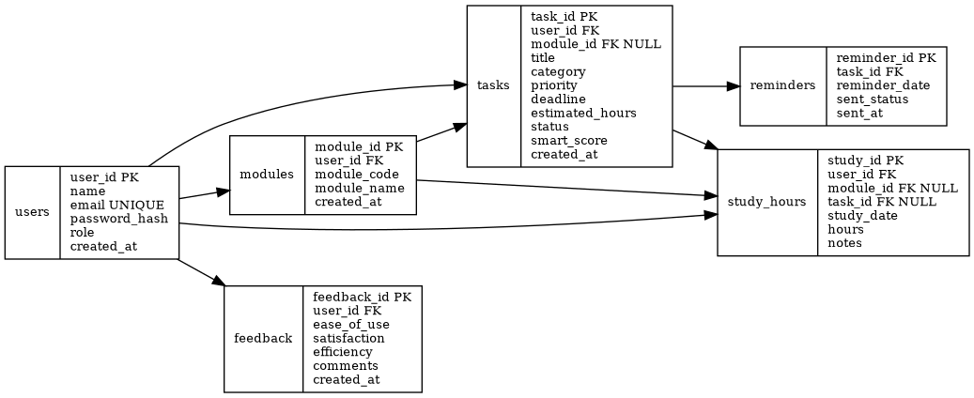
Figure 2. Study Track entity-relationship design (source: supplied project documentation).

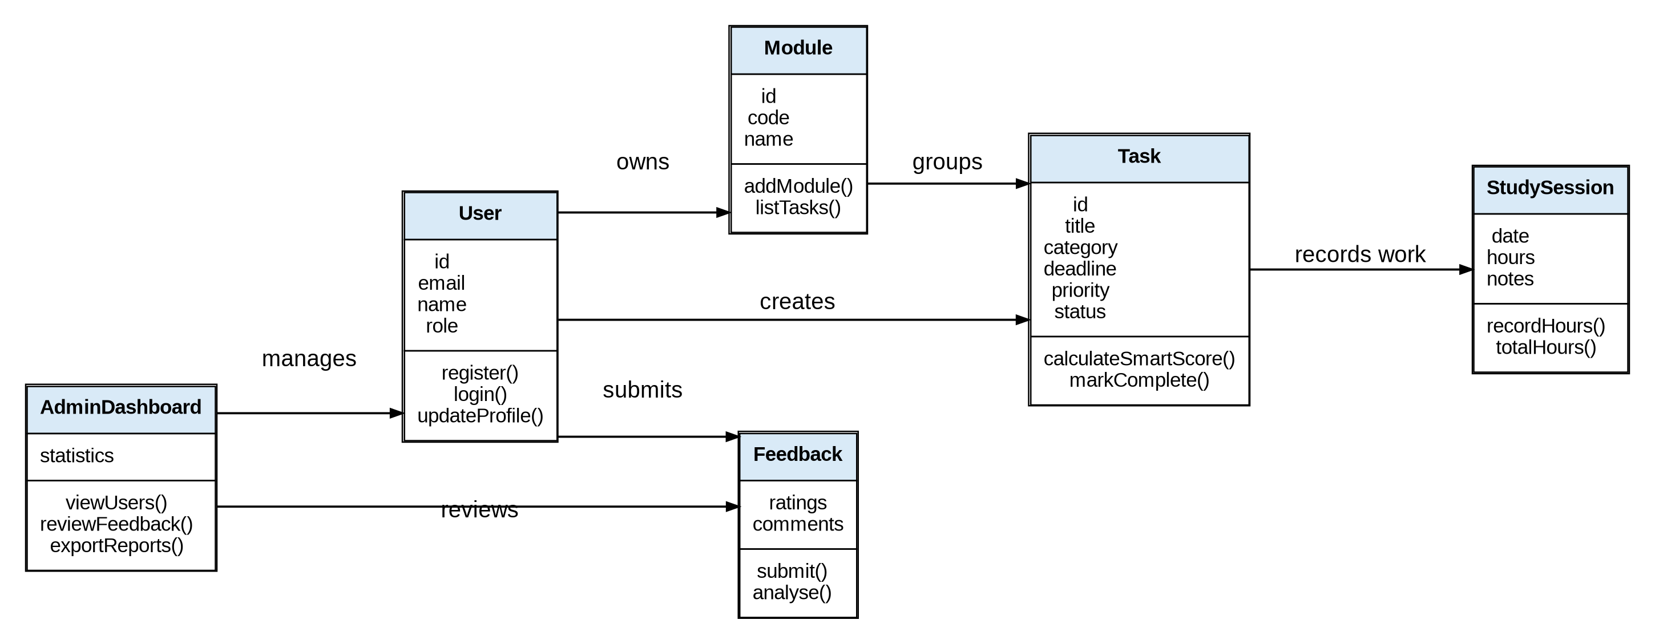
Figure 3. Study Track conceptual class diagram (source: supplied project documentation).

5.3 Object and interaction design
The class diagram identifies User, Module, Task, Study Session, Feedback and Admin Dashboard concepts. It is useful as a conceptual model, although the PHP implementation is procedural rather than a direct object-oriented translation. Methods such as register (), login (), add Module (), mark Complete () and record Hours () describe responsibilities that should exist even if they are implemented as functions or request handlers. The diagram could be improved by adding visibility, data types, multiplicities and a dedicated Reminder class. It should also show that administrative actions depend on an authenticated user with the administrator role.
The reminder sequence describes a student creating a task through the browser, PHP calculating priority, the task and reminder being stored, and a reminder script checking due records before sending an email. The sequence is plausible, but a reliable implementation must include transaction boundaries, error states, idempotency and delivery logging. If task insertion succeeds but reminder insertion fails, the system should either retry or roll back as appropriate. The reminder process should mark a record as sent only after successful dispatch and should avoid placing sensitive task notes in an unencrypted email.

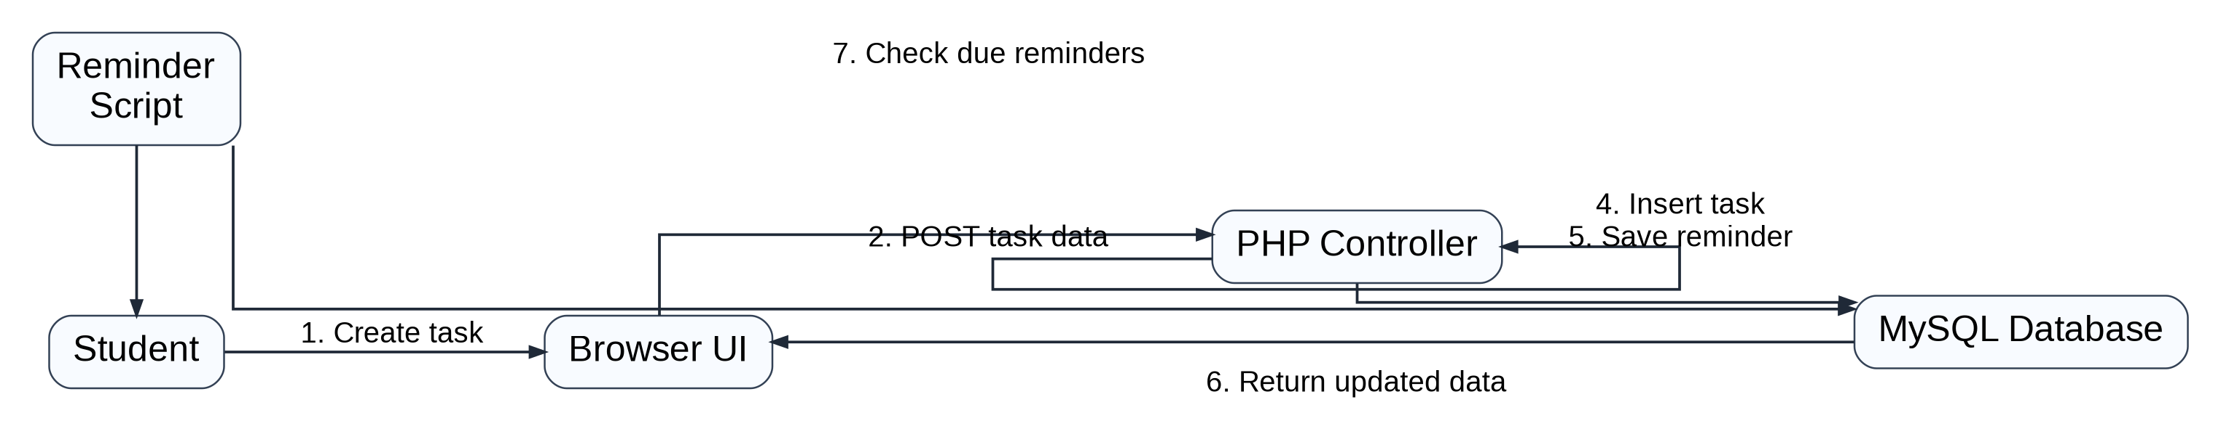
Figure 4. Task reminder sequence (source: supplied project documentation).

5.4 Workflow, navigation and interface design
The student workflow begins with registration or login and continues to the dashboard, data entry, priority calculation, warnings, calendar and chart review, progress updates and optional feedback. The flow is understandable but should not force every user through the same sequence. A returning student may need to add a task directly, while another user may only check the calendar. The dashboard therefore acts as a navigation hub rather than a mandatory step in every operation.
The site map separates the public home, login and signup pages from authenticated student and administrator areas. Student navigation includes tasks, calendar, modules, study hours, feedback and PDF export. The administrator area includes users, tasks and feedback. This shallow structure is appropriate for the prototype. Breadcrumbs are not essential at this scale, but the active navigation item and page title should always indicate location.
The wireframes show a homepage with a concise value statement and call to action, a dashboard with statistics and alerts, a task page with form, filters and smart labels, and an administrator page with tables. Their strongest feature is priority planning of core content. Their limitation is that they do not specify error messages, empty states, confirmation messages, keyboard order or responsive behaviour. These details need to be included in later design specifications because they strongly affect usability.

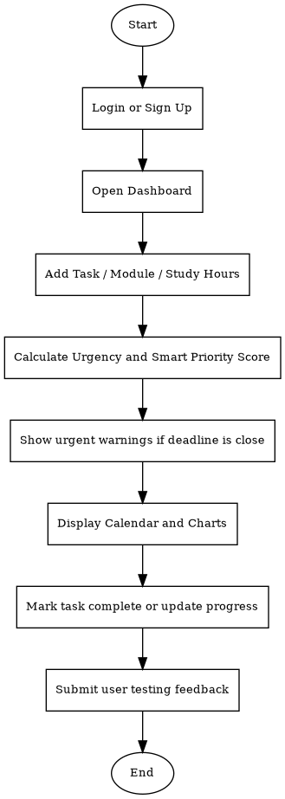
Figure 5. Student workflow flowchart (source: supplied project documentation).

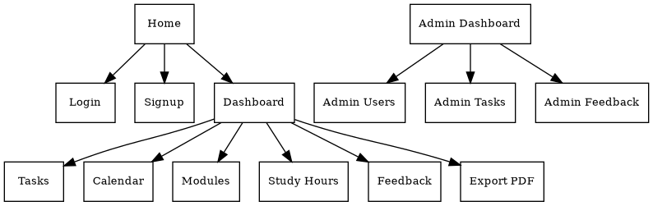
Figure 6. Site map and navigation structure (source: supplied project documentation).

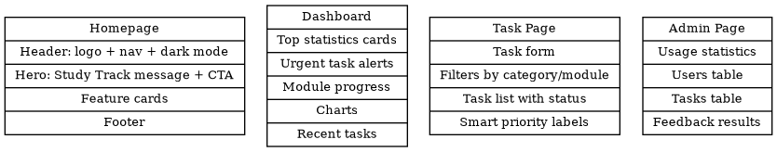
Figure 7. Low-fidelity interface wireframes (source: supplied project documentation).

5.5 Smart-priority design
The documentation defines the priority concept as a combination of how close the deadline is, selected priority and estimated hours. A clear formula is:
Smart Score = Deadline Weight + Priority Weight + Effort Weight
Completed tasks are excluded from urgent warnings. The exact numerical weights should be documented and tested for boundary cases, such as overdue tasks, deadlines later today, zero estimated hours and changed status. The score should be recalculated from current values rather than stored permanently unless the application also updates it whenever a relevant field changes. Storing a stale score would create inconsistent rankings.
Table 6. Smart-priority factors
Factor | Design rule | Control required
Deadline | Highest when overdue or due today; reduced as remaining days increase. | Use exact time zone and define inclusive boundaries.
Priority | High contributes more than Medium; Medium more than Low. | Explain that priority is selected by the student.
Estimated hours | Greater remaining effort increases the need to start earlier. | Prevent negative values and cap unrealistic inputs.
Status | Completed tasks are removed from warning lists. | Reopening the operation should restore calculation.

Table 7. Requirements traceability matrix
Requirement | Design component | Evidence | Assessment
FR1-FR2 | Authentication pages | login.php, signup.php | Documented and code-visible
FR3-FR4 | Task model and task administration | tasks.php and data dictionary | Partly visible; student CRUD pages absent
FR5 | Calendar | calendar.php | Code-visible
FR6 | Study time | ER model and admin totals | Documented; implementation files incomplete
FR7-FR8 | Priority and dashboard | smart_priority_score() call; project report | Helper/dashboard not fully supplied
FR9 | Reminder | Sequence diagram and reminders entity | Design only in supplied set
FR10 | PDF export | Site map and test plan | Documented; code not supplied
FR11 | Administration | index.php, users.php, tasks.php, feedback.php | Code-visible
FR12 | Feedback | feedback.php and documentation | Code-visible; real participant uses not permitted

6. Implementation

6.1 Technology stack and local environment
The system uses PHP for server-side work, MySQL for the database, HTML for page structure, CSS for layout and JavaScript for small interactive features. This technology stack is suitable for a university prototype because it can run locally in XAMPP and can be checked without a complex build process. PHP pages are created on the server, which keeps the browser code simple. The main risk is that security, routing and validation must be applied in the same way across every script.
The documents tell the user to create the Study Track database, import an SQL file, update the connection details, start Apache and MySQL and open the local website. These are clear basic steps. But the package used for this report did not include the final SQL dump or every required file. A complete submission should contain one project folder, the final database script, a sample environment file and a README showing the exact PHP and MySQL versions.

6.2 Registration and authentication
The signup code trims the name and email, validates the email format, checks that the password has at least six characters and inserts the user through a prepared PDO statement. The password is transformed using a password hash with PASSWORD_DEFAULT before storage. This is a strong implementation decision because PHP’s password API stores an adaptive hash rather than a recoverable password [29]. The database column should allow at least 255 characters so future algorithm changes do not truncate hashes.
The login code retrieves the account by email through a prepared statement and checks the submitted password with password verify. On success, it stores the user ID, name, email and role in the session and redirects to the dashboard. Prepared statements reduce injection risk when used correctly [29]. The use of escaping helpers when values are written into HTML is also visible in the templates.
Before deployment, password and session controls should be stronger. Passwords should be longer than six characters and checked against known weak passwords. The session ID should change after login. Login attempts should be limited, and cookies should use Secure, HTTP Only and Same Site settings. Demo credentials should be removed, and error messages should not reveal whether an email exists.
Code extract 1. Simplified authentication logic based on the supplied login file.
$stmt = $pdo->prepare('SELECT * FROM users WHERE email=?');
$stmt->execute([$_POST['email']]);
$user = $stmt->fetch();
if ($user && password_verify($_POST['password'], $user['password'])) {
$_SESSION['user'] = [
'id' => $user['id'],
'name' => $user['name'],
'email' => $user['email'],
'role' => $user['role']
];
}

6.3 Calendar and task presentation
The calendar page requires authentication, accepts a selected month, queries only tasks belonging to the current user and groups them by day. This is an important access-control pattern because the user identifier comes from the authenticated session rather than from an editable URL. The output includes escaped task titles and formatted times. The monthly grid supports deadline scanning, while the responsive stylesheet converts the calendar to one column on narrow screens.
The administrator task page shows users, modules, deadlines and priority scores. This confirms that these fields are part of the working model. However, deletion uses a GET parameter. Changes to data should be made using POST, including a CSRF token, checking permissions again and showing a clear result. Database rules must also protect linked reminders and study logs.
The full student task-creation and editing pages were not supplied. The report therefore cannot verify validation of deadline format, estimated hours, category enumeration, task ownership or mass-assignment controls. These checks should be performed server-side even when the form uses HTML input types, because client-side restrictions can be bypassed.

6.4 Administrator and feedback functions
The administrator dashboard calculates total users, tasks, feedback records and study hours, then lists recent feedback. Separate pages display all tasks, manage users and calculate average feedback ratings. The administrator pages call required (), indicating a central role check. This is positive, but the implementation of that helper is unavailable and must be tested directly in the complete system.
Changing roles or deleting users is risky. The system should protect the last administrator, use CSRF-protected POST forms, record who made each change and consider asking the administrator to log in again. The current code stops an administrator from deleting their own account, but wider rules are still needed.
The feedback page calculates average scores for ease of use, satisfaction and efficiency and displays them in a bar chart. This shows database calculations and chart creation. For the research, the page must not be presented as evidence from students because no real students were approved or recruited. It can be checked with clearly labelled synthetic test data. A future approved study should collect only necessary information, separate consent from responses and control who can read comments.

6.5 Front-end implementation and responsive design
The stylesheet defines a reusable visual system based on CSS variables for background, card, text, muted text, primary, warning and danger states. Cards, grids, tables, badges and buttons are consistent across pages. Dark mode changes the variables rather than duplicating every rule, and JavaScript saves the preference in local Storage. This is a maintainable implementation for a small project and shows separation between presentation and server logic. The browser Web Storage API is used only to save the non-sensitive dark-mode preference [30].
Below 850 pixels, the layout changes to one column, the heading becomes smaller, the navigation uses a menu button, and the calendar becomes a list. The menu needs an accessible name, keyboard support and an area-expanded state. Local Storage is suitable for a theme setting, but not for login data or private tasks. Dark mode colours also need contrast and focus testing.
Several forms use placeholders instead of proper labels. This can confuse users after they start typing and can reduce screen-reader support. The next version should add linked labels, field help, clear error summaries and visible focus. Tables need header cells, and chart values should also be available as text or a table.

6.6 Implementation consistency and maintainability
The database, documents and code must use the same names. Three differences need to be fixed before submission: password hash in the data dictionary but password in the code, study hours in the documents but study logs in one query, and clear key names such as user-id in the diagrams but id in the code. These differences may come from different versions of the project. The safest method is to make the final SQL schema the main source, then update the data dictionary, diagrams and queries to match it. A short change log should explain the corrections.
The project needs consistent names, shared validation, central error handling and separate setup settings. Database passwords must not be stored in a public repository. Users should see a simple error message, while technical details go to a protected log. Version-control commits should link changes to requirements or defects.

6.7 Project interface screenshots
Figures 8 to 14 show the main Study Track interfaces produced from the supplied PHP, CSS and JavaScript project files. Synthetic demonstration records were used because no real student data or ethically approved user testing was available. The screenshots therefore show the intended prototype design and functions; they are not presented as research findings.
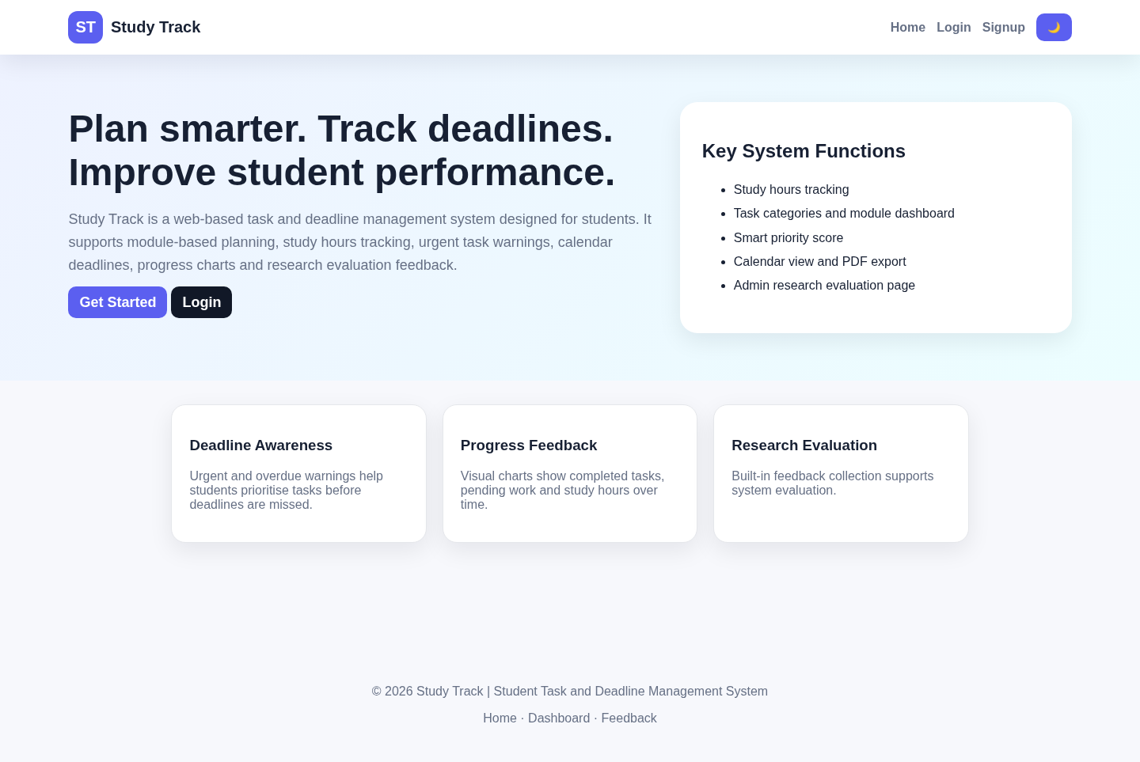
Figure 8. Study Track homepage interface (source: rendered from the supplied project source files using synthetic demonstration data).

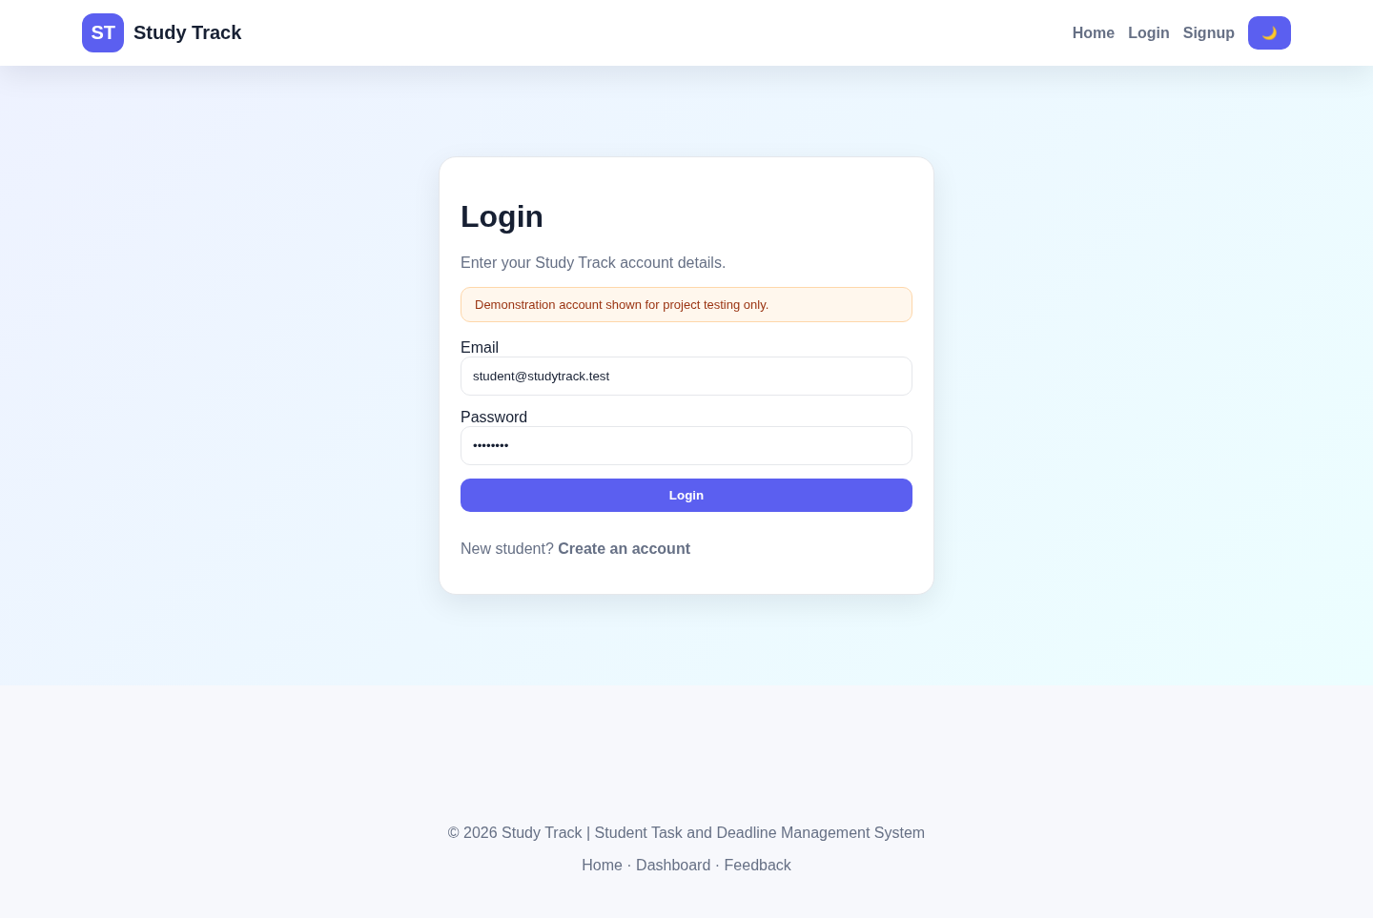
Figure 9. Study Track login interface (source: rendered from the supplied project source files using synthetic demonstration data).

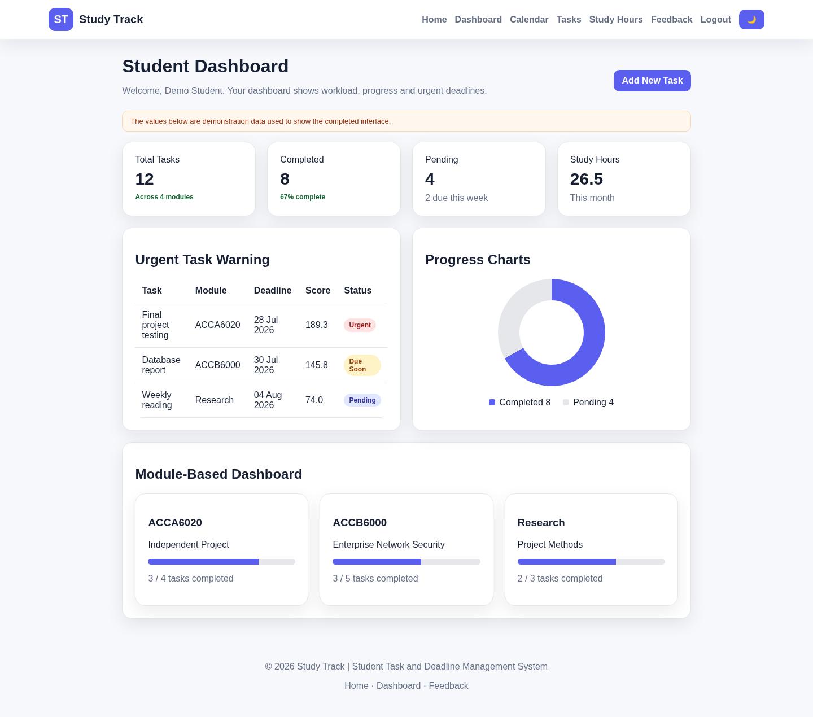
Figure 10. Study Track student dashboard (source: rendered from the supplied project source files using synthetic demonstration data).

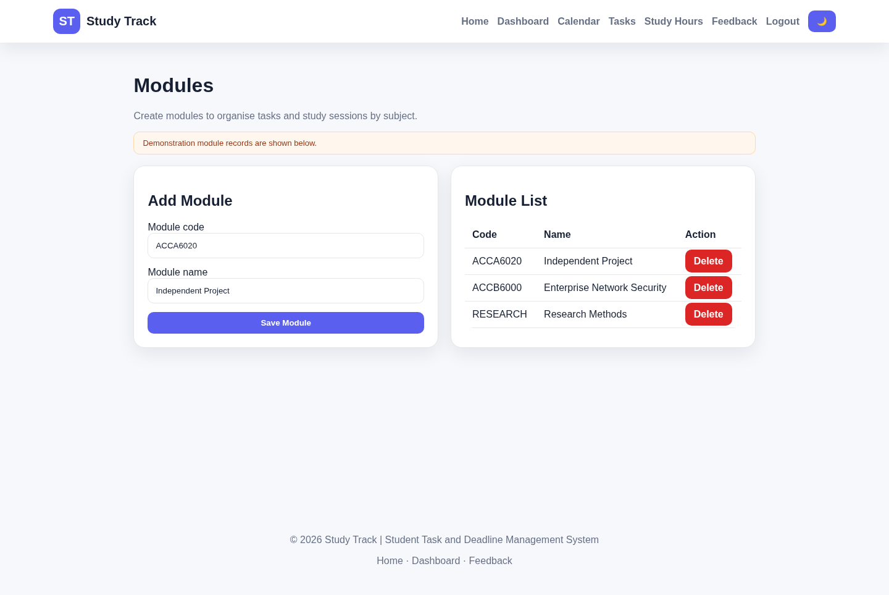
Figure 11. Study Track module-management interface (source: rendered from the supplied project source files using synthetic demonstration data).

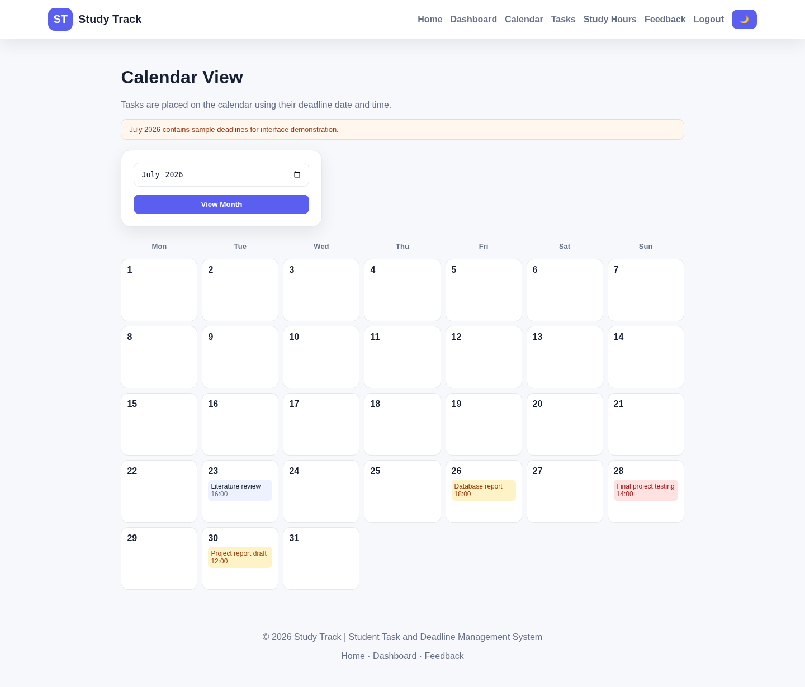
Figure 12. Study Track calendar interface (source: rendered from the supplied project source files using synthetic demonstration data).

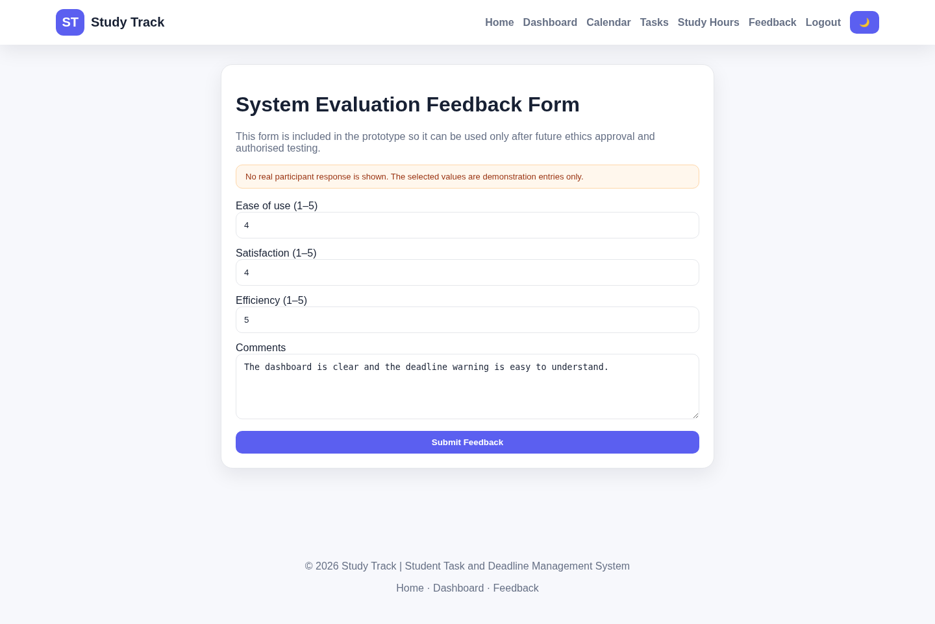
Figure 13. Study Track evaluation feedback interface (source: rendered from the supplied project source files using synthetic demonstration data).

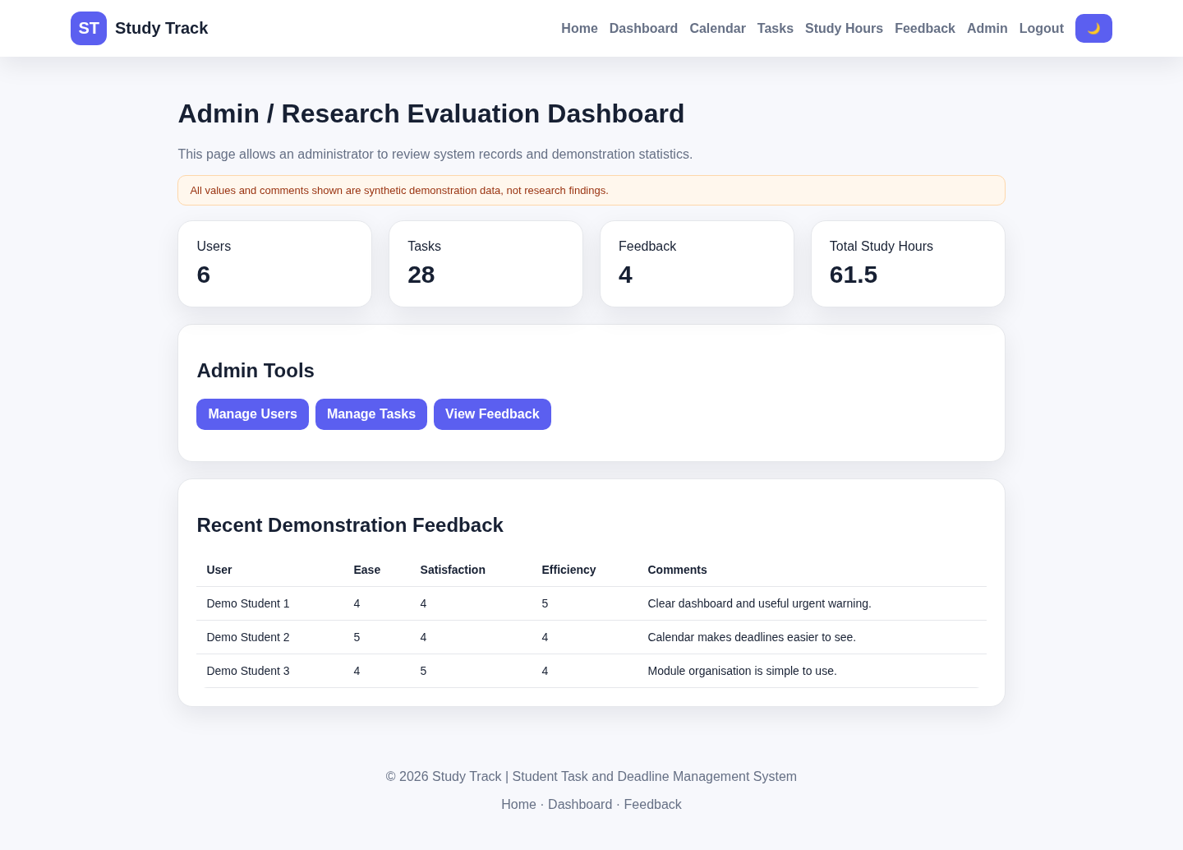
Figure 14. Study Track administrator evaluation dashboard (source: rendered from the supplied project source files using synthetic demonstration data).

7. Testing and Evaluation

7.1 Testing strategy
Testing should cover validation rules, PHP and MySQL connections, user roles, complete user journeys, responsive pages, accessibility and security. The supplied documents list twelve functional tests and mark them as Pass. These tests cover signup, login, task management, categories, calendar use, study hours, urgent warnings, charts, dark mode, PDF export, feedback and administrator access.
The complete runnable system and database were not supplied for this report, so the recorded Pass results could not be checked again. The report therefore separates a documented pass from evidence that can be seen directly in the code. For example, registration and login logic are visible, while some task and study-hour pages are not available. The final submission should include screenshots, actual results, dates and the software version used for every test.
Table 8. Documented functional test matrix
Test | Feature | Expected result | Evidence status
T01 | Signup | Valid account created; duplicate/invalid details rejected. | Pass in documentation; code supports validation.
T02 | Login | Valid user enters dashboard; invalid credentials rejected. | Pass in documentation; code-visible.
T03 | Task management | Add, edit, complete and delete update database. | Pass documented; full student pages absent.
T04 | Categories | All stated categories are stored and displayed. | Pass documented; entity/design evidence.
T05 | Calendar | Task appears on correct date for logged-in user. | Pass documented; calendar code-visible.
T06 | Study hours | Logged hours update totals. | Pass documented; input code absent.
T07 | Urgent warning | Due-soon task appears in warning area. | Pass documented; helper/dashboard absent.
T08 | Charts | Task and study data appear in charts. | Pass documented; feedback chart visible.
T09 | Dark mode | Theme changes and preference persist. | Pass documented; CSS/JS code visible.
T10 | PDF export | Personal task report is generated. | Pass documented; export code absent.
T11 | Feedback | Synthetic rating/comment is stored and listed. | Pass documented; admin view visible.
T12 | Admin | Administrator views protected users/tasks/feedback. | Pass documented; pages call role check.

7.2 Additional boundary and negative tests
Negative and boundary tests are also needed. Registration should test blank, duplicate, invalid and very long data. Login should test repeated failures, logout, expired sessions and direct access to protected pages. Task tests should include past deadlines, invalid hours, unauthorised IDs and linked records. Calendar tests should include leap years, empty months and time-zone changes.
Security tests should check escaping, prepared queries, role protection, CSRF tokens and secure cookies. Accessibility tests should cover keyboard use, focus, zoom, screen-reader labels, contrast and clear errors. Automated tools are useful, but manual review is still needed because a tool cannot decide whether the whole journey is understandable. Web-security research also supports using more than one testing method [31].

7.3 Quality evaluation
Table 9. Quality evaluation against ISO/IEC 25010
ISO/IEC 25010 area | Evaluation | Current level | Priority action
Functional suitability | Core planning model is coherent; some functions are only documented. | Medium-High | Supply full source and rerun end-to-end tests.
Performance efficiency | Simple server-rendered pages suit small local datasets. | Medium | Add query indexes and measure realistic response times.
Compatibility | Standard-based stack should work in modern browsers. | Medium | Test Chrome, Edge, Firefox, Safari and mobile.
Interaction capability | Clear cards, tables and calendar; form labelling is limited. | Medium | Add labels, errors, empty states and usability scenarios.
Reliability | Relational model supports consistency; recovery not evidenced. | Medium-Low | Add transactions, backups, error handling and restore tests.
Security | Hashing and prepared statements visible; CSRF/session gaps remain. | Medium-Low | Implement secure POST actions, session hardening and logging.
Maintainability | Shared includes and CSS variables help; schema names conflict. | Medium | Consolidate schema, add coding standard and automated tests.
Flexibility | Optional module/task links support different study patterns. | Medium-High | Allow configurable categories and reminder preferences.

The review shows that the prototype is strongest in its main idea and its clear information layout. The weaker areas are the parts where evidence is missing, especially reliability, full security checks, accessibility testing and real usability results. This does not mean that the project has failed. It means that the final report must describe the current level honestly and show a clear improvement plan. Functional suitability is supported by the planned task, module, calendar and study-hour features. Usability is supported by simple navigation and repeated page layout. Maintainability is helped by shared header, footer and setup files. At the same time, reliability needs full installation evidence, security needs stronger testing and accessibility needs checks with assistive technology. The quality model therefore helps show both achievement and remaining work.

7.4 Limitations of the evaluation
The evaluation has four main limits. First, no real students took part, so the results cannot be applied to all students. Second, the source package is incomplete, so not every function could be run. Third, static code review can find visible weaknesses but cannot replace penetration testing or long-term use. Fourth, the project does not measure grades or learning quality, so it cannot prove that Study Track improves academic performance.

8. Security, Privacy, Ethics, Accessibility and Sustainability

8.1 Security and privacy
Study Track stores account details and personal planning records. Even task titles may reveal health, work or study problems. The system should collect only needed data, explain why it is collected, set a retention period and allow correction or deletion where appropriate. These controls follow the UK GDPR principles explained by the Information Commissioner’s Office [32].
Every query must enforce access control. Students should only see rows linked to their own account. Administrators’ access should be limited and recorded. Passwords and backups must be protected. A live system also needs HTTPS, secure cookies, CSRF tokens, server-side validation, output encoding and regular security updates. These controls follow NIST and OWASP guidance [24], [25].
The supplied code already uses prepared statements and password hashing. The next security tasks are to replace GET-based changes, remove demo credentials, renew sessions after login, add rate limits, check secure cookies and test the administrator guard. The project must also decide what happens to tasks and study logs when an account is deleted.
Table 10. Security and privacy risk register
Risk | Impact | Likelihood | Treatment
Unauthorised record access | High | Medium | Filter every query by authenticated user; test object IDs and admin routes.
CSRF on delete/role change | High | High in supplied code | Use POST, unpredictable CSRF tokens and server-side confirmation.
Credential exposure | High | Medium | Remove demo details; enforce HTTPS and secure sessions.
SQL injection | High | Low-Medium | Continue prepared statements; inspect every dynamic query.
Stored XSS in task/comments | High | Medium | Validate input and escape output in every context.
Schema inconsistency/data loss | Medium | High | Align names, add migrations, constraints and backups.
Excess administrator visibility | Medium | Medium | Apply least privilege, aggregation and audit logs.
Unauthorised research use | High | Low if controls followed | Do not recruit participants without new ethical approval.

8.2 Research ethics
The original prototype contains a feedback form and administrator research dashboard, but this report does not use them to collect evidence from real students. This avoids recruitment, consent and confidentiality problems under the current restriction. Synthetic records used for software demonstration must be clearly labelled and removed before any future study. No statement such as “students found the system easy to use” should appear unless it is supported by an approved method and actual data.
A future usability study would need clear participant information, voluntary consent, a withdrawal method, fair recruitment and a data-retention plan. Participation must not affect grades. Test scenarios should use invented tasks instead of real coursework or personal commitments. Results should be grouped, and any quotations should be anonymous.

8.3 Accessibility and inclusive design
Accessibility is a quality requirement and a professional duty. WCAG 2.2 requires content to be perceivable, operable, understandable and robust [15]. Study Track needs semantic headings, linked labels, keyboard navigation, visible focus, strong contrast, clear errors and text alternatives for charts. Colour alone must not show status, and dark mode must expose its current state.
Responsive pages are a good start, but responsiveness is not the same as accessibility. Testing should include zoom, reflow, screen readers, keyboard and voice input. Calendar tasks should also appear in a simple date list, and chart values should be shown in a table. These changes help users with small screens, older devices or temporary impairments.

8.4 Sustainability and professional practice
The system uses a simple server-rendered design and can run on an ordinary laptop. This limits client processing and keeps development manageable. Sustainable software also means code that is clear, testable and easy to update, so it can remain useful for longer. Current research treats sustainability as environmental, technical, social and economic, not only as energy use [33].
Sustainability improvements include fewer database queries, smaller assets, limited reminder traffic, clear dependency records and supported PHP versions. Social sustainability means supporting disabilities, slow connections and older devices. Long-term use also needs a maintenance owner, backups and a process for security updates. These remain recommendations for this academic prototype.

9. Project Management and Resources

9.1 Weekly plan
A week-to-week plan is suitable because the project combines research, design, coding and documentation. The plan below uses an iterative sequence with time reserved for correction and evidence collection. Activities can overlap, but each week should produce a visible output such as an updated diagram, implemented page, test record or report section.
Table 11. Weekly project plan
Week | Main activity | Output
1 | Confirm problem, scope, ethics boundary and success criteria. | Approved proposal and objectives.
2 | Review literature and record IEEE references. | Literature matrix and review outline.
3 | Define users, functional and non-functional requirements. | Requirements specification.
4 | Design ER model, data dictionary and system architecture. | Database/design diagrams.
5 | Create wireframes, site map and responsive style system. | Interface prototype.
6 | Implement registration, login and session protection. | Authentication pages and tests.
7 | Implement modules, tasks and smart-priority logic. | Task workflow and database records.
8 | Implement study logs, calendar, dashboard and charts. | Student monitoring functions.
9 | Implement admin, reminder/export prototypes and error handling. | Administration and support functions.
10 | Run functional, boundary, security and accessibility tests. | Completed evidence matrix.
11 | Evaluate literature and quality standards. | Evaluation and recommendations.
12 | Finalise report, references, appendices and demonstration. | Submission package and backup.

9.2 Resources and risks
The project needs a laptop that can run Apache, PHP, MySQL and a modern browser. Software includes XAMPP, a code editor, phpMyAdmin, browser developer tools, diagram software and version control. The student developer is the main person responsible, with guidance from the tutor. No participant recruitment is needed for secondary research.
Main schedule risks are underestimating integration, adding too many features and leaving testing too late. Technical risks include database-name differences, missing files and local-server problems. The project can reduce these risks by finishing Must requirements first, keeping a working version, making regular backups and stopping non-essential changes before final testing. A weekly review should check completed work, remaining risks and evidence still needed for the report. Each week should end with a working version of the system, not only unfinished code. Important decisions should be made in a short project log, including the reason for changing the database field, page layout or security control. This record can support the final discussion and show how problems were solved. It also reduces the risk of forgetting why a change was made when the report is written later.

10. Discussion

10.1 Achievement of the project aim
Study Track deals with a real student problem: seeing deadlines, workload and progress in one place. It is more useful than a basic to-do list because it links tasks with modules, estimated hours, study sessions, calendar dates, warnings and charts. The design also connects with self-regulated learning. Task creation and time estimates support planning, status and study logs support monitoring, and totals and charts support reflection. The connection is sensible, but the system would need approved user research before claiming that it improves learning.
The project also shows a suitable range of Level 6 computing skills. It includes requirements analysis, relational database design, use cases, workflow and sequence diagrams, front-end design, PHP programming, database access, authentication, role management and testing. Prepared statements and password hashing show awareness of secure coding. Reusable CSS cards, tables and responsive grids show practical interface design. The work also develops transferable skills needed in computing employment. These include planning work over several weeks, reading technical sources, making design decisions, checking code, recording risks and explaining results to technical and non-technical readers. The project requires personal responsibility because the developer must decide which features are essential, correct problems and present honest evidence. These skills are useful for junior web development, software support, and database roles.
The wide range of features also creates a risk. Some functions appear in diagrams or test plans but do not have complete implementation evidence in the supplied files. A reliable end-to-end workflow is more valuable than a long feature list that cannot be shown. The final submission should clearly mark each function as implemented, partly implemented or planned.

10.2 Relationship to literature
Research supports planning, monitoring and reflection in self-regulated learning [1]. Dashboard studies also show that visual information works best when it is linked to theory and a clear action [16]. Study Track follows this approach by linking warnings and charts to tasks that the user can update. Its clear priority score is easier to explain than a hidden prediction model.
The research also gives warnings. Recorded activity does not prove learning, and a completed task does not prove a good academic result. Too many dashboard measures may create pressure or distraction. Study Track should keep the page simple, allow users to control reminders, and test whether users can complete tasks accurately before asking broad satisfaction questions.
The system correctly focuses on personal progress rather than ranking students. Students have different modules, responsibilities and assessment conditions, so direct comparison may be unfair. Comparing current work with personal plans and past activity is more useful and creates fewer privacy and ethical concerns.

10.3 Critical weaknesses and technical debt
The first technical problem is the discrepancy between the database names used in the documents and those used in the code. These differences can stop installation and can reduce confidence in the project. One final schema, an updated data dictionary and an installation check should be completed before adding more features. The second problem is the security of administrator actions. Delete and role-change functions should use CSRF-protected POST requests instead of GET links. The third problem is incomplete test evidence. Each test should show the input, expected result, actual result, screenshot and retest information.
Accessibility also needs more work. The pages use responsive layouts and clear colours, but several forms depend on placeholders, and the charts do not show a clear text alternative. These issues can be corrected by adding proper labels, keyboard focus, error summaries and accessible data tables. The project also has no ethically approved usability results. The report therefore uses secondary research and synthetic testing only.

10.4 Recommended development roadmap
Table 12. Recommended improvement of roadmap
Priority | Action | Expected benefit
1 - Essential | Consolidate SQL schema, table/column names and complete installation package. | Reproducible build and reduced data-loss risk.
2 - Essential | Replace state-changing GET actions; add CSRF and session hardening. | Improved protection of accounts and records.
3 - Essential | Complete server-side validation and ownership check for all task/log actions. | Prevents invalid or unauthorised changes.
4 - High | Add automated unit/integration tests and evidence for every requirement. | Repeatable quality assurance.
5 - High | Improve labels, keyboard support, focus, contrast and chart alternatives. | Progress toward WCAG 2.2 conformance.
6 - High | Implement reminder preferences, duplicate prevention and delivery logging. | More reliable, less intrusive notifications.
7 - Medium | Add account recovery, audit logs, backups and controlled deployment configuration. | Operational readiness.
8 - Future | Conduct ethics-approved usability testing with realistic but non-sensitive tasks. | Evidence of effectiveness, efficiency and satisfaction.

The improvement plan places reliability and security before extra visual features. After the core system is stable, future versions could add recurring tasks, user reminder settings, data import and export and optional reflection notes. A connection to a university learning platform should only be considered after identity, data sharing and governance requirements are agreed.

11. Conclusion
Study Track is a useful web project that combines task management, calendar planning, study-hour recording and a clear priority method. The documents show a connected design, and the supplied code shows important functions such as registration, login, calendar filtering, administrator reports, responsive pages and dark-mode storage. The project also uses password hashing, prepared statements and output escaping in the available code.
The report also identifies clear limits. The complete system could not be run from the supplied files; some database names do not match, administrator actions need safer CSRF-protected forms, and no real student feedback can be used under the current ethical restriction. Study Track should therefore be described as a working academic prototype, not as a finished university service or a proven learning tool.
The project aim is mostly achieved at the design and prototype stage. The next steps are to correct the database and source package, improve security, add stronger accessibility features and record repeatable test evidence. A real usability study should only be completed after obtaining ethical approval. With these changes, Study Track could become a stronger personal planning tool while keeping student data private and giving users control over their own information.

References

[1] | B. J. Zimmerman, "becoming a self-regulated learner: An overview," Theory into practice, vol. 41, no. 2, pp. 64-70, 2002.
[2] | E. Panadero, "“A review of self-regulated learning: Six models and four directions for research," Frontiers in Psychology, vol. 8, 2017.
[3] | J. P. et al. M, "“The PRISMA 2020 statement: An updated guideline for reporting systematic reviews”," BMJ, vol. 372, p. n71, 2021.
[4] | B. Kitchenham and S. Charters, "Guidelines for performing Systematic Literature Reviews in software Engineering," 2007.
[5] | M. Romero, C. Casadevante and J. Santacreu, "Time management, fluid intelligence and academic achievement," Psychological Studies, vol. 69, no. 1, pp. 59-68, 2024.
[6] | J. Broadbent and W. L. Poon, "Self-regulated learning strategies and academic achievement in online higher education learning environment: A systemic review," The Internet and Higher Education, vol. 27, pp. 1-13, 2015.
[7] | ISO, "Ergonomics of Human-System Interaction-Part 11: Usability: Definitions and Concept," International Organisation for Standardisation, Geneva, Switzerland, 2018.
[8] | C. Lang, G.Siemens, A.F. Wise, D. Gasevic and A. Merceron, Eds,, The Handbook of Learning Analytics, Vancouver, BC, Canada: Society for Learning Analytics Research, 2022.
[9] | R. C. Clark and R. E. Mayer, e-Learning and the Science of Instruction: Proven Guidelines for Consumers and Designers of Multimedia Learning, Hoboken, NJ, USA: Wiley, 2016.
[10] | N. Selwyn, Education and Technology: Key Issues and Debates, London, UK: Bloomsbury Academic, 2022.
[11] | I. Molenaar, S. de Mooij, R. Azevedo, M. Bannert, S. Järvelä and D. Gašević, "Measuring self-regulated learning and the role of AI: Five years of research using multimodal multichannel data," Computer in Human Behaviour, vol. 139, 2022.
[12] | J. A. Larusson and B. White, Learning Analytics: From Research to Practice, York, NY, USA: Springer, 2014.
[13] | Y. Rogers, H. Sharp, and J. Preece, Interaction Design: Beyond Human-Computer Interaction, Hoboken, NJ, USA: Wiley, 2023.
[14] | E. T. Khor and K. Mutthulakshmi, "A systematic review of the role of learning analytics in supporting personalised learning," Education Sciences, vol. 14, 2024.
[15] | W. W. W. Consortium, Web Content Accessibility Guidelines (WCAG) 2.2, 2023. [Online].
[16] | P. Galvao de Barba, E. A. Oliveira and X. Hu, "Same graph, different data: A usability study of a student-facing dashboard based on self-regulated learning theory," in Proc. ASCILITE 2022, 2022.
[17] | D. Benyon, Designing User Experience: A Guide to HCI, UX and Interaction Design, 4th ed., Harlow, UK: Pearson, 2019.
[18] | a. k. a. M. Mozilla Developer Network, "MDN Web Docs," [Online]. Available: https://developer.mozilla.org/en-US/docs/Learn_web_development/Core/CSS_layout/Responsive_Design. [Accessed 26 Jul 2026].
[19] | I. Nyirenda and C. Simuja, "The use of M-learning to foster the development of self-regulated learning in university students: A systematic review," The Independent Journal of Teaching and Learning, vol. 18, pp. 78-92, 2023.
[20] | I. Sommerville, Software Engineering, Harlow, UK: Pearson, 2016.
[21] | R. S. Pressman and B. R. Maxim, Software Engineering: A Practitioner’s Approach, 9th ed., New York, NY, USA: McGraw-Hill, 2020.
[22] | ISO/IEC, "Systems and Software Engineering—Systems and Software Quality Requirements and Evaluation (SQuaRE)—Product Quality Model," Geneva, Switzerland, 2023.
[23] | I. 25019:2023, "Systems and Software Engineering—Systems and Software Quality Requirements and Evaluation (SQuaRE)—Quality-in-Use Model," ISO, Geneva, Switzerland, 2023.
[24] | M. Souppaya, K. Scarfone and D. Dodson, "Secure Software Development Framework (SSDF) Version 1.1: Recommendations for Mitigating the Risk of Software Vulnerabilities," NIST — National Institute of Standards and Technology, Gaithersburg, MD, USA, 2022.
[25] | O. Foundation, "OWASP Top 10: The Ten Most Critical Web Application Security Risks," 2021. [Online]. Available: https://owasp.org/Top10/.
[26] | P. D. Group, "password_hash—Creates a password hash," [Online]. Available: https://www.php.net/manual/en/function.password-hash.php.
[27] | P. D. Group, "PDO::prepare—Prepares a statement for execution," [Online]. Available: https://www.php.net/manual/en/pdo.prepare.php.
[28] | K. Schwaber and J. Sutherland, "The Scrum Guide: The Definitive Guide to Scrum," 2020. [Online]. Available: https://scrumguides.org/scrum-guide.html.
[29] | Oracle, "FOREIGN KEY constraints," [Online]. Available: https://dev.mysql.com/doc/refman/8.4/en/create-table-foreign-keys.html.
[30] | M. D. Network, "Web Storage AP," MDN Web Docs, [Online]. Available: https://developer.mozilla.org/en-US/docs/Web/API/Web_Storage_API.
[31] | M. Aydos, A. Aldan, E. Coşkun and A. Soydan, "Security testing of web applications: A systematic mapping of the literature," Journal of King Saud University—Computer and Information Sciences, vol. 34, no. 9, pp. 6775-6792, 2022.
[32] | I. Information Commissioner’s Office, "A guide to the data protection principles," [Online]. Available: https://ico.org.uk/for-organisations/uk-gdpr-guidance-and-resources/data-protection-principles/.
[33] | G. A. García-Mireles, M. Á. Moraga, F. García and C. Calero, "Sustainability in the field of software engineering: A tertiary study," ACM Transactions on Software Engineering and Methodology, vol. 35, no. 5, 2026.

Appendix A. Supplied Artefact Evidence
The report was prepared from the supplied project documentation, seven diagram images and the available PHP, CSS and JavaScript source files. The documentation contains the stated scope, requirements, data dictionary, diagrams, test plan, user manual, installation guide and evaluation plan. The source-code sample contains administrator pages, authentication pages, a calendar page, a shared stylesheet and JavaScript utilities. The complete database script and several application pages were not included in the supplied set; therefore, the report clearly identifies features that are documented but not independently visible in code.
Appendix Table A1. Supplied files reviewed
Evidence item | Use in evaluation
Study_Track_Assignment_Documentation | Scope, requirements, design, test plan, installation and evaluation.
login.php / signup.php / logout.php | Authentication, password hashing, session creation and logout.
calendar.php | Monthly task query filtered by authenticated user.
admin/index.php | Usage counts, administrator tools and recent feedback.
admin/users.php | User listing, deletion and role switching.
admin/tasks.php | Task listing, deadline order and priority-score display.
admin/feedback.php | Feedback table and average-score bar chart.
style.css / main.js | Responsive interface, dark mode, menu and delete confirmation.

Appendix B. Suggested Extended Test Evidence Template
For the final demonstration, each test should include the following fields: test ID, requirement ID, environment, precondition, test data, numbered steps, expected result, actual result, status, screenshot or log reference, defect ID and retest date. Test data should be synthetic and must not contain real student information.
Appendix Table B1. Test evidence structure
Field | Example
Test ID / requirement | T05 / FR5 Calendar
Environment | Windows 11, XAMPP, PHP version, MySQL version, Chrome version
Precondition | Logged in as test student; one task due 15 October at 14:00
Steps | Open Calendar; select October; locate day 15.
Expected | Task title and time appear only for the authenticated user.
Actual | Record exact observed result.
Evidence | Screenshot filename and database query/log reference.
Result | Pass / Fail / Blocked and retest date.

Appendix C. Installation and Demonstration Checklist
- Install a supported local PHP/MySQL package and confirm Apache and MySQL start without port conflicts.
- Create the final database and import the verified schema or migrations.
- Configure database credentials through a protected local configuration file.
- Create synthetic student and administrator accounts; remove public demo credentials before deployment.
- Run registration, login, task, calendar, study-log and administrator tests.
- Confirm that student accounts cannot open administrator pages or another user’s records.
- Test responsive layout, keyboard navigation, zoom, contrast and chart alternatives.
- Export the final database structure, screenshots, test evidence and source-code version used for submission.

