FUTURE DEVELOPMENTS IN THE FIELD OF MARKETING
Darren Emanuel
Student No. 1402731
Marketing Management -BMMB7012
TESLA
Corporate Social Responsibility

Table of Contents
2. List of Figures - 3 -
3. List of Acronyms - 4 -
4. Executive summary - 5 -
4.1 Further information : - 5 -
5. Introduction - 6 -
5.1 Define Topic / Challenge - 6 -
5.2 Organisational introduction - 6 -
5.3 Environmental Scan - 7 -
5.4 Corporate Social Responsibility Definition (CSR) - 7 -
5.5 What is Tesla’s current approach to CSR? - 8 -
6. Analysis - 9 -
6.1 The Marketing Concept - 9 -
6.1.1 Tesla Resource analysis - 9 -
6.1.2 Marketing Concept at Tesla - 10 -
7. The Micro & Macro Environment - 11 -
7.1 The Micro Environment - 11 -
7.1.1 SWOT - 11 -
7.2 Porter’s 5 forces - 12 -
7.3 The Macro environment - 13 -
7.4 PESTEL Analysis - 13 -
8. The Target Market - 14 -
8.1 Segmentation, Targeting and Positioning - 14 -
9. Marketing mix - 15 -
10. Marketing media - 16 -
11. Conclusions - 17 -
12. Recommendations - 18 -
13. References - 20 -
14. Appendices - 24 -
14.1 Appendix 7 – Segmentation, Targeting & Positioning (STP) Analysis - 24 -
14.2 Appendix 1 - 5 Forces analysis - 25 -
14.3 Appendix 2 - PESTEL Analysis Infographic - 26 -
14.4 Appendix 3 - PESTEL Analysis - 27 -
14.5 Appendix 4 - SWOT Analysis - 28 -
14.6 Appendix 5 - Recommendations - 29 -
14.7 Appendix 6 – Competitor analysis - 30 -
14.8 Appendix 7 – Segmentation, Targeting & Positioning (STP) Analysis - 31 -

List of Figures

Figure 1 : Tesla Inc logo Source : (Tesla , 2022) - 7 -
Figure 2: CSR Approaches. Source: (Crane, et al., 2014) - 8 -
Figure 3 : 3 conditions of the marketing concept. Source : (Fahy & Jobber, 2012) - 9 -
Figure 4: Elkington's Triple Bottom Line Source : (Taylor, 2020) - 10 -
Figure 5 : Conceptional car brand map - 14 -
Figure 6: USA Population percentage per socioeconomic class. Data Sourced from (Meggitt, 2019) - 14 -
Figure 7 : 7P's analysis of Tesla currently - 15 -
Figure 8 : Proposed 7P's for Tesla - 15 -
Figure 9 : SOSTAC Model of recommendations - 18 -
Figure 10 : 5 Forces analysis - 25 -
Figure 11 : PESTEL Analysis Infographic - 26 -
Figure 12 : PESTEL Analysis - 27 -
Figure 13 : SWOT Analysis - 28 -
Figure 14 : Recommendations - 29 -
Figure 15: Table showing total vehicle registrations since 2014 in descending order. - Data sourced from (Department for Transport, 2022) - 30 -
Figure 16: Table showing total vehicle registrations in 2021 in descending order. - Data sourced from (Department for Transport, 2022) - 30 -
Figure 17: STP Analysis on Tesla - 31 -

List of Acronyms

CSR – Corporate Social Responsibility
EV – Electric Vehicle
IP – Intellectual Property
R&D – Research and Development
ROI – Return on Investment
SEO – Search Engine Optimisation
STP - Segmentation, Targeting and Positioning
SWOT – Strengths, weaknesses, opportunities and threats
UK – United Kingdom

Executive summary

An investigative report of Tesla and their marketing management strategy with a view to improving the strategy to combat the negative media surrounding CSR and the use of unethically sourced cobalt.

The author utilises a range of analytical models to identify Tesla’s current position in the market place and the threats to its current position. A number micro & macro factors are identified and analysed with use of theoretical models to identify what needs to be considered before proposing an alternative marketing strategy.

A review of Tesla’s current marketing activity has been undertaken with further investigative analysis on how Tesla evaluate whether their current marketing activity is successful.

Throughout the analysis, the author was able to identify that whilst Tesla are a successful company, especially given its age, there is no marketing budget, with the company’s success owed to the fame of its high-profile CEO Elon Musk.

A list of proposed recommendations was identified and a SOSTAC model utilised to create the proposed strategy going forward to improve Tesla’s brand image, improve public opinion and to distance itself from unethical suppliers and practices.

Further information :

Total word count: 5209
Applicable word count: 3300

Pages: 30

Introduction

Define Topic / Challenge

The topic being analysed within this report is how an improved Marketing Management Strategy could benefit Tesla Inc to combat the negative press narrative surrounding Tesla’s use of cobalt in their batteries. More specifically, the negative media narrative surrounds the source of the cobalt itself and the use of child labour in the mining of cobalt in the Dominican Republic of Congo which has resulted in a lawsuit being filed against Tesla in 2019 by 14 Congolese families due to child miners being buried alive or suffering from injuries after tunnel collapse. (BBC, 2019).

This presence of negative media narrative is the catalyst for the Author to analyse the marketing management strategies within Tesla and identify whether there are areas that can be improved.

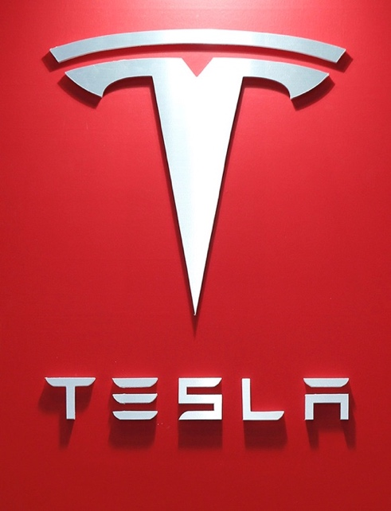
Organisational introduction

Tesla Motors (named after Nikola Tesla) was founded in 2003 by 2 engineers ( Martin Eberhard and Marc Tarpenning ) with a vision to create fully electric vehicles combining automotive engineering with technology to create cars that were “better, quicker and more fun to drive” than the fossil fuel equivalents (Tesla , 2022).

In 2017 Tesla Motors shortened its name to Tesla, Inc and currently employs 99,000+ persons and produced 930,000+ vehicles in 2021 with over 100,000 of these in Europe alone, with Tesla accounting for 11% of all car sales in the UK. The Tesla Model 3 was the 10th best-selling car on the planet in 2021 and is tipped to be in the top 5 of 2022 (Auto News, 2022) which shows the scale of tesla and the impact they have had on the automotive industry as a whole and not just in the EV space.
Figure 1 : Tesla Inc logo Source : (Tesla , 2022)

Environmental Scan

As a result of the environmental scan completed previously, it was identified that Tesla is subject to negative media narrative as a result of a lawsuit from 14 Congolese families as a result of child labour being injured whilst mining cobalt for use in Panasonic batteries which are supplied to Tesla for use in their products.

A SWOT analysis has been undertaken which can be seen in appendix 4 of this report, which identified that the supply and demand of cobalt is also a threat to the business as reported by (Emir, 2022).

As a result of the environmental scan, recommendations for improvement were identified as can be seen in appendix 5. The 3 recommendations all focus on addressing the negative media narrative surrounding cobalt and corporate social responsibility (CSR).

The recommendation chosen to address is no1, ‘Tesla should not associate themselves with suppliers who are known exploiters of child labour’, however, the changes in the marketing strategy will address all recommendations by the nature of their similarity.

Corporate Social Responsibility (CSR)

CSR is defined by the Department for Business, Innovation & Skills as “ the responsibility of an organisation for the impacts of its decisions on society and the environment above and beyond its legal obligations, through transparent and ethical behaviour.”
The two approaches to CSR are shown in the figure below.

Figure 2: CSR Approaches. Source: (Crane, et al., 2014)

Tesla’s approach to CSR

As a result of the environmental scan, the author believes that Tesla has adopted the traditional approach to CSR when compared to the table above. Tesla is concerned about the risk to its brand image and public opinion. Tesla does not consider CSR as an impacting factor on their bottom line and takes a defensive responsiveness to CSR challenges. Tesla’s motto is that corporate social responsibility is a bolt-on and does not form part of their business strategy.

Analysis

The Marketing Concept

(Fahy & Jobber, 2012) define the marketing concept to be “the achievement of corporate goals through meeting and exceeding customer needs better than the competition” and further explain that 3 conditions must be met before the marketing concept can be applied, which can be seen in the figure below.

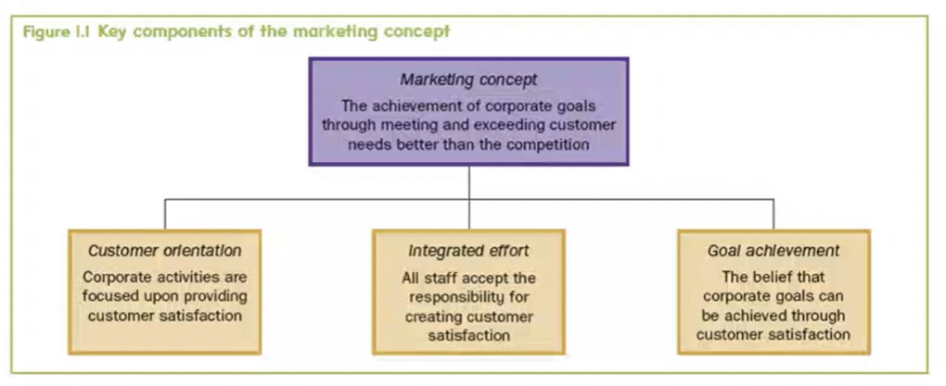
Figure 3 : 3 conditions of the marketing concept. Source : (Fahy & Jobber, 2012)

Tesla Resource analysis

Human resource
The business is well resourced in terms of personnel with 99,000+ persons employed. However, there is a non-existent marketing budget and therefore, marketing staff will exist in the form of a skeleton structure, with staff focused on customer experience by collating data and demonstration days with staff in-store worldwide. There is good communication between departments which can be seen in the efficiency of how the business operates. It is unlikely that a relatively young business would become so successful if collaborative working across departments was not present.

Physical
Tesla physical stores exist in many locations worldwide including the UK where prospective customers can visit and see the physical product itself whilst Tesla marketing staff are on hand to assist with any queries. Tesla operates from several Gigafactory’s worldwide with their HQ located at the Texas Gigafactory. As the HQ is located in one large building, the author believes that physical human cooperative working will be present to achieve the same goals.

Technological
Tesla vehicles themselves use technology to provide feedback to Tesla on vehicle usage and customer satisfaction or faults. As a technology company, their marketing focus is online and purchases are via their e-commerce website which is available in most countries on all technology platforms. The marketing teams will have no difficulty in connecting to other departments digitally.

Financial resource
Tesla has significant revenue each year ($53.82 Billion in 2021 with Profits of $8.51 Billion equating to a 16% profit margin) and reports expenditure of $992 million on selling, general and administrative costs (Tesla Inc, 2022). However, it is reported that Tesla’s marketing budget is $0 (Shastri, 2022). Whilst the marketing budget may be non-existent, Tesla’s marketing strategy is still well-considered and uses alternative means to attract customers discussed later in this report.

From the analysis above, we can see that Tesla invests considerable resources in following the marketing concept model as all 3 pillars are evident within the business.
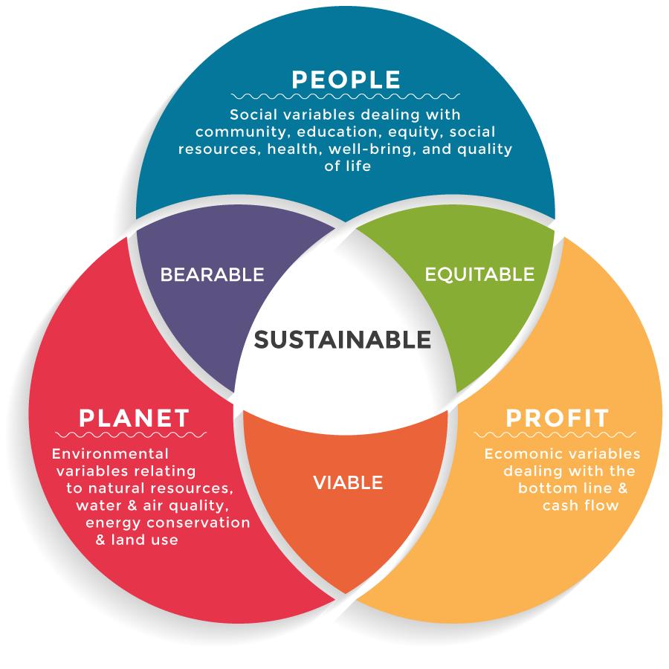

Marketing Concept at Tesla

We can utilise the resource analysis above to analyse against Elkington’s Triple Bottom Line (1997) model.

Profit – Tesla is financially successful with profits of $8.51billion in 2021 which can be reinvested to create a marketing budget. (People and planet).

People – Tesla’s focus is on improving the environment, reducing the usage of fossil fuels and bringing renewable energy innovations to people’s day-to-day lives. Tesla doesn’t just focus on the EV element but also combines this with autonomous driving and a plethora of safety features.

Planet – Tesla produces products that convert the consumers of fossil fuels to a greener and more sustainable alternative which protects our planet and reduces air, sound and waste pollution.
Figure 4: Elkington's Triple Bottom Line Source : (Taylor, 2020)

The Micro & Macro Environment

In this section, an analysis will be undertaken on the micro & macro environments using common analysis tools which will inform the proposed strategy going forward.

The Micro Environment

SWOT

A thorough SWOT analysis of Tesla has been performed as can be seen in appendix 4 of this report.

Tesla SWOT summary

Strengths
Tesla was first to mass-produce a fully electric vehicle (Tesla , 2022) and produce the most reliable electric vehicle also with the greatest range (Moses, 2020) which results in a range of strengths that the marketing department can utilise to great advantage by associating these key trigger words with Tesla itself by use of advertising campaigns.

Tesla invests considerable sums in R&D which allows for future EV innovation (Gibson, 2019) and subsequently owning the IP and Patents accordingly, continuing the monopoly already held by the company which is a marketing strategy in its own right.

Weaknesses
The worldwide shortage of electronic chipsets (BBC, 2022) and other electronic components combined with limited manufacturing space (BBC, 2022) and child labour claims (Posner, 2020) are the greatest weaknesses for Tesla currently. Tesla's marketing team can address these claims to fend off negative public opinion subject to Tesla creating ethically and morally correct supply chains.

Elon Musk is the sole face of the brand (Ferris, 2016) and drives the sales of Tesla through his appearances and controversies. This is a weakness as whilst Elon is an obsessively hard worker, he is also erratic and a serial entrepreneur and there is the risk of him leaving to pursue a new venture leaving Tesla faceless and brandless.

Furthermore, due to Elon’s obsessive work ethic, Elon regularly causes controversy amongst high-level staff and therefore, Tesla is known for its high turnover of executive staff as reported by (Matousek, 2019). This forms a key marketing strategy point; the marketing department could start to create a faceless brand image removing the reliance on Elon himself.

Opportunities
The main opportunity here to address negative media narrative is for Tesla to manufacture batteries without the use of Cobalt which also removes any links with child labour. Currently, Tesla relies on Panasonic to supply all battery products although Smith 2021 reports that Tesla is currently looking to develop their batteries that last 5x longer and cost half of the current battery (Smith, 2021).

By Tesla developing these opportunities, this will provide a great marketing advantage in terms of distancing Tesla from unethical suppliers and improving public opinion. If developed, there is also an opportunity for Tesla to sell their Cobalt-free batteries to other manufacturers capitalising on the opportunity and securing greater control over the EV market space.

Threats
(Porter, 1979) states that competition is always a threat. Tesla has dominated the EV market over recent years although, as can be seen in the competitor analysis in appendix 6.
As discussed in the weaknesses above, Elon Musk can cause controversy and tension within Tesla as reported by (Collins, 2018)

Negative media narrative around child labour being used for cobalt mining could cause negative public opinion and with an increase in EV competition developing Cobalt-free batteries, this could have detrimental impacts on Tesla.

Porter’s 5 forces

A thorough 5 forces analysis has been undertaken as can be seen in appendix 1 of this report which provides a great insight and lessons that can be learnt by analysing the market.

Rivian has been identified as a new entrant threat in the EV space with the company being backed by Amazon as a major stakeholder (Kalupski, 2021). Rivian has a brand image solely focused on sustainability and reducing carbon footprint to protect the environment for generations to come, marketing the benefits to children, a soft spot in the hearts of most consumers.

Rivian operates a contemporary CSR approach whilst Tesla’s approach is a traditional approach with a brand image that portrays an image of performance, speed and convenience not capitalising on environmental benefits.

Tesla can adopt the marketing strategy of Rivian as the rival company's marketing aligns with the demographic of environmentally conscious buyers which is the target market of Tesla.

Tesla’s segment of choice is in the environmentally friendly fully electric and luxury vehicle space which attracts high cost and appeals to high socioeconomic classes. Since their inception, Tesla has dominated this space due to it being the only company offering a product in this segment (Hadi, 2021).

Tesla’s 5 forces analysis will change over the next several years as they have pledged to develop a Cobalt-free battery (Perkins, 2021)which will change their position in the market and will move ahead of the competitive rivalry in this quickly developing segment. The construction of several Tesla Gigafactory’s worldwide will also allow Tesla to produce significantly higher vehicle numbers helping to negate shortages of raw materials and chipsets due to their purchasing power with economies at scale.

The Macro environment

PESTEL Analysis

A full PESTEL analysis has been undertaken as can be seen in appendix 3.

Political and Legal
(Fleisher, 2016) reports that Tesla raised the price of their vehicles by 5% in the UK immediately after the Brexit vote which makes marketing Tesla vehicles more challenging. Furthermore, the lack of any agreed trade deals since Brexit adds to the difficulty in Tesla capitalising on the UK market.

Economic
(The World Bank, 2020) report that Covid-19 “Covid-19 to plunge global economy into worst recession since world war 2” which will result in significantly fewer people purchasing vehicles. Furthermore, (BBC, 2021) reports that Covid-19 has caused a global chip shortage disrupting vehicle manufacturing with Tesla themselves identifying the increase in operating expenses, rising raw material, commodity, logistics and expedite costs as a risk (Tesla Inc, 2022).

Social and Environmental
(Department for Transport, 2019) report that the Government are investing in the push for E-Bikes to be used for commuting in an attempt to tackle congestion. This investment impacts Tesla as whilst electric cars address air pollution, this does not tackle congestion and the lack of space (parking etc) which is becoming the new focus.

Technological
As addressed by Porters 5 forces section above, threat of new entrants like Rivian is high and, in an attempt, to combat this, (pressman, 2021) reports that Tesla spent $1.491 billion on R&D to remain ahead of the competition and to innovate allowing for ownership over critical IP’s and Patents. The marketing team can capitalise on this innovation.

The Target Market

A comprehensive STP analysis has been undertaken and can be seen in appendix 7

Segmentation, Targeting and Positioning

Tesla segment the market by predominantly focusing on the psychographic and lifestyle headings, targeting those that are environmentally conscious and looking for sustainable transport. They further segment the market by benefits sought focusing on those that are seeking the benefits of luxury and environmentally friendly purchases.

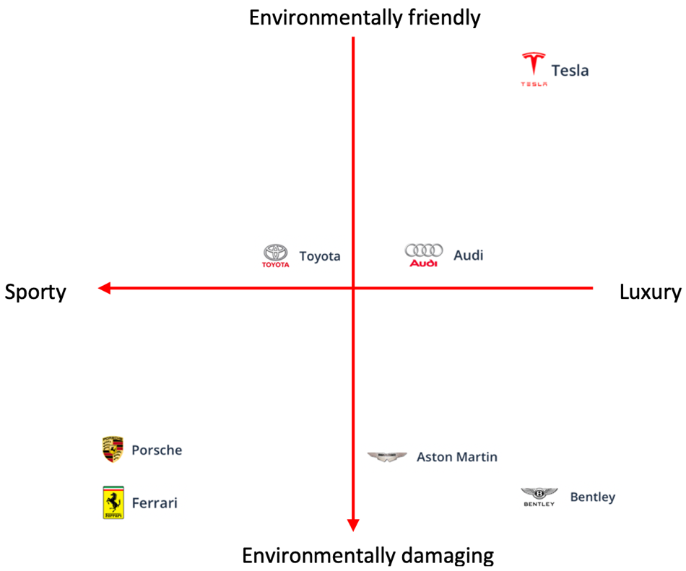
Moving on to selecting a segment to target, Tesla does not necessarily target a certain demographic as their vehicles appeal to all demographic categories but instead, they target the benefits sought segment where they can appeal to individuals seeking a luxury and environmentally friendly purchase or those individuals looking to minimise their carbon impact on the environment.

When we look at where Tesla position their product in the segment, Tesla offers their product as a zero-emission vehicle with the longest range supported by a plethora of safety features including near-autonomous driving.

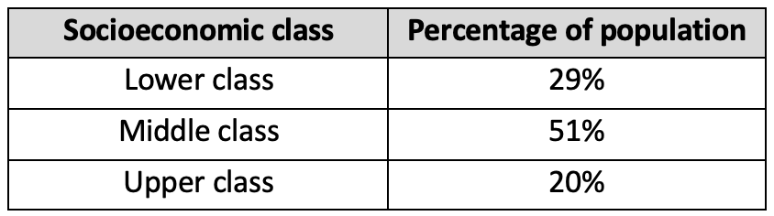
In summary of the STP analysis, we can see in figure 5: conceptional map alongside, that Tesla is positioned in the luxury and environmentally friendly quadrant allowing Tesla to capitalise and charge higher values due to their demographic being upper-class individuals with a greater disposable income. However, this strategy does limit the potential customer numbers as can be seen in the table in figure 6, where the upper class is the smallest portion of the population.
Figure 5 : Conceptional car brand map
Figure 6 : USA Population percentage per socioeconomic class. Data Sourced from : (Meggitt, 2019)

Marketing mix

7P’s analysis
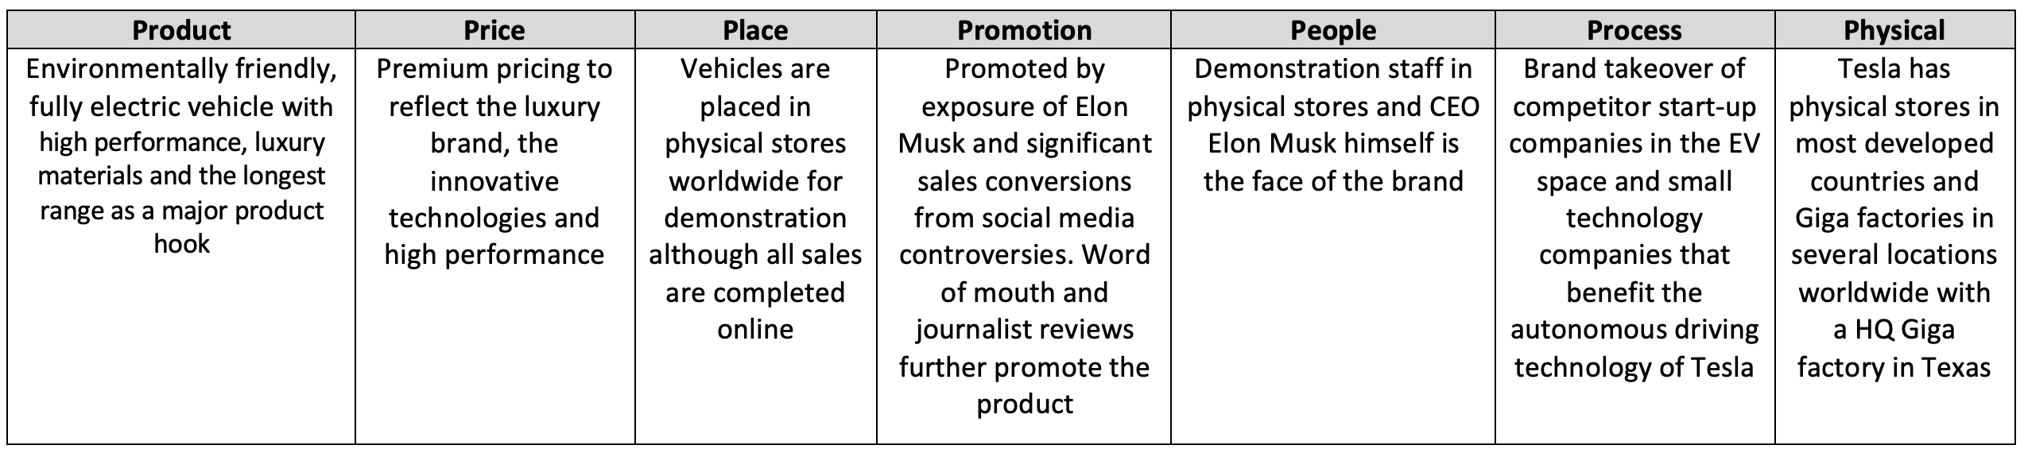
Figure 7 : 7P's analysis of Tesla currently
Tesla has capitalised on the fame of the exuberant Elon Musk himself and use a clever marketing strategy by utilising viral social media posts and placing secret features in their vehicles software, this prompts influencers to ‘find’ the feature and share the information via social media, causing Tesla to be viral on social media.

Whilst Tesla does own physical stores, these are for demonstration purposes and all transactions are completed via their e-commerce website. As Tesla’s marketing and purchasing process is online, Tesla can maximise their exposure and track consumer behaviour via the use of SEO and analytics providing real-time analysis of their trending status. Online purchasing only has proved successful which has been further accelerated since Covid-19

Tesla “sells a fraction of the cars of other automakers, but has the largest combined following on social media channels like YouTube, Reddit and Twitter” as reported by (McFarland, 2021) which provides Tesla with data on brand awareness and is a forum for instant feedback to any Tesla’s announcements or direction changes allowing Tesla to respond immediately.

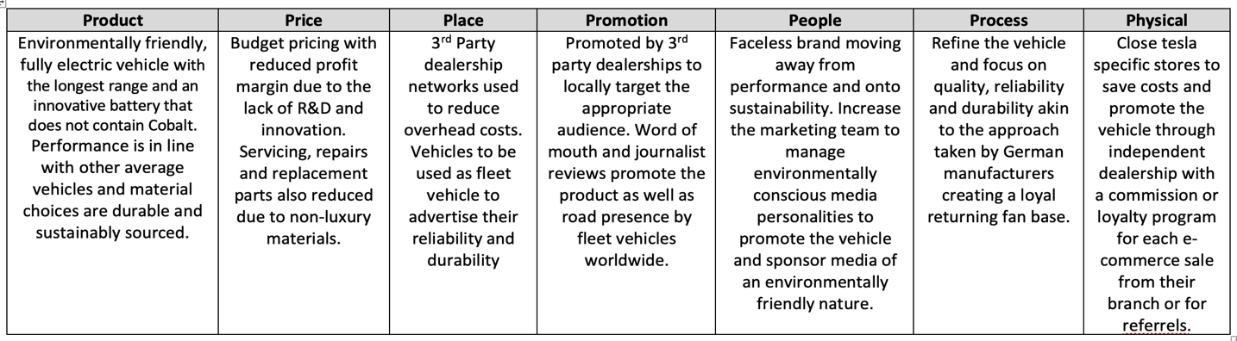
To address the recommendation to improve CSR within Tesla, the author feels that going forward, the 7P’s analysis should reflect the table below.
Figure 8 : Proposed 7P's for Tesla
As we can see from the Marketing concept analysis above, Tesla has a marketing budget of $0 and operate direct-to-consumer sales removing the middleman and has developed a good customer relationship management system to monitor their referral scheme of $1000 of credit for each referral.

Marketing media

As we can see from the table in the 7P’s section of this report, any promotional activity conducted from Tesla’s inception through to current day has been via social media predominantly utilising well-known CEO Tesla Musk as a catalyst to controversy which puts Tesla in the limelight indirectly.

Whilst this is an unorthodox method of promotional activity, Tesla has gone from a start-up to one of the most valuable car manufacturers on the planet and turning over $50+ billion per year in less than 20 years which in real terms, is a truly incredible feat of business development when the marketing budget is $0.

Furthermore, Tesla commonly code hidden features into their vehicles software which attracts attention from a younger demographic predominantly ‘influencers’ who then create content of the hidden feature which reaches a large audience digitally which is in-direct free marketing which subsequently improves the brand image amongst the younger demographic.

In terms of measuring success, (Assis, 2016) reports that Tesla achieved “biggest one-week launch of any product ever” “without any paid advertising” which confirms that Tesla’s marketing strategy for selling vehicles is successful.

However, (Smith, 2021) reports that competitive vehicle manufacturers will also be expanding their marketing activity online expecting to secure a large amount of Tesla’s potential customers and without paid mass marketing, Tesla’s potential customer base will diminish.

As a result of the information above, the author concludes that any indirect marketing or promotion through social media, influencers and mainstream media has been incredibly effective and capitalising on this free marketing has paid dividends to the company. Going forward, Tesla may wish to explore diversifying its marketing approach to have more than one source of customers.

Conclusions

In conclusion to the analysis undertaken above, it is clear that Tesla have built a positive brand image, sales and growth, although competitors are starting to enter the space dominated by Tesla since its inception. The monopoly held by Tesla is coming to an end, and what has worked to-date will not suffice going forward if Tesla wishes to stay ahead of the competition and continue to dominate the market.

Public opinion is changing as more and more reports linking Tesla to unethical practices are unearthed and released. Tesla need to act quickly to retain their luxury brand image and ensure this is not quickly replaced with a public opinion of a company that is unethical, not morally conscious and driven by profits and greed. This appears to be a knife-edge period in Tesla’s journey where a conscious CSR approach is needed more than ever.

Tesla’s marketing mix and segment of choice is a limited space which combined with ever-increasing living costs and reduced expendable income places a glass ceiling on Tesla’s sales numbers unless they target other market segments.

In terms of marketing strategy, Tesla have been incredibly successful with a marketing budget of $0 by capitalising on Elon Musk, his controversies and the viral social media activity that follows. However, there has been no attempt by Tesla to market its mission statement and advertise how they operate as an ethically correct and sustainable company and are instead relying on its momentum.

Recommendations

These recommendations aim to address negative media narrative and public opinion and further distance themselves from the unethical supply of Cobalt and the linked exploitation of child Labour.

Recommendations listed within the SOSTAC action plan below
Figure 9 : SOSTAC Model of recommendations

References
Assis, C., 2016. Tesla: Model 3 had ‘biggest one-week launch of any product ever’. [Online]
Available at: https://www.marketwatch.com/story/tesla-picks-up-325000-reservations-for-model-3-2016-04-07
[Accessed 29 June 2022].
Auto News, 2022. Tesla Model 3 Was 10th Best-Selling Car Globally In 2021, Could Go Top 5 In 2022. [Online]
Available at: https://autonews.cc/tesla-model-3-was-10th-best-selling-car-globally-in-2021-could-go-top-5-in-2022/
[Accessed 24 June 2022].
Baumann-Pauly, D. & Cremer, S., 2020. How New Business Models Can Address Human Rights Risks in the Cobalt Supply Chain. [Online]
Available at: https://papers.ssrn.com/sol3/papers.cfm?abstract_id=3679885
[Accessed 26 June 2022].
BBC, 2019. Top tech firms sued over DR Congo cobalt mining deaths. [Online]
Available at: https://www.bbc.co.uk/news/world-africa-50812616
BBC, 2021. Chip shortage could last into 2023, says car boss. [Online]
Available at: https://www.bbc.co.uk/news/business-58465954
[Accessed 29 June 2022].
BBC, 2022. Tesla expects 50% growth despite supply chain woes. [Online]
Available at: https://www.bbc.co.uk/news/business-60149374
[Accessed 27 June 2022].
Booms, B. H. & Bitner, M. J., 1981. Marketing strategies and organisation structure for service firms. American Marketing Association, 1(1), pp. 46 - 51.
Collins, J., 2018. Elon Musk's Increasingly Erratic Behavior Comes At A Price For Tesla Shareholders. [Online]
Available at: https://www.forbes.com/sites/jimcollins/2018/09/05/elon-musks-increasingly-erratic-behavior-comes-at-a-price-for-tesla-shareholders/
[Accessed 27 June 2022].
Crane, A., Matten, D. & Spence, L., 2014. Corporate Social Responsibility: Readings and Cases in a Global Context. 1 ed. London: Routledge.
CTECHI, 2021. Nissan plans to use cobalt-free batteries on the car. [Online]
Available at: https://www.ctechigroup.com/nissan-plans-to-use-cobalt-free-batteries-on-the-car
[Accessed 25 May 2022].
Department for Transport, 2019. Government ushers in new era of green commutes with e-bike Cycle to Work scheme. [Online]
Available at: https://www.gov.uk/government/news/government-ushers-in-new-era-of-green-commutes-with-e-bike-cycle-to-work-scheme
[Accessed 29 June 2022].
Department for Transport, 2022. Vehicle licensing statistics data tables. [Online]
Available at: https://assets.publishing.service.gov.uk/government/uploads/system/uploads/attachment_data/file/1077492/veh0181.ods
[Accessed 25 May 2022].
Emir, C., 2022. New battery technologies and recycling won’t save you from cobalt shortage. [Online]
Available at: https://interestingengineering.com/new-battery-technologies-and-recycling-wont-save-you-from-cobalt-shortage
[Accessed 26 June 2022].
Fahy, J. & Jobber, D., 2012. Foundations of Marketing. 4th ed. London: McGraw-Hill Higher Education.
Ferris, R., 2016. Musk is Tesla's greatest stregnth and weakness says valuation expert. [Online]
Available at: https://www.cnbc.com/2016/07/13/musk-is-teslas-greatest-strength-and-weakness-says-valuation-expert.html
[Accessed 27 June 2022].
Fleisher, L., 2016. Tesla Raises U.K. Prices After Brexit Vote. [Online]
Available at: https://www.industryweek.com/the-economy/public-policy/article/21993450/tesla-raises-uk-prices-after-brexit-vote
[Accessed 29 June 2022].
Gibson, R., 2019. How Tesla became one of the worlds greatest innovators.. [Online]
Available at: http://www.4lenses.it/en/2016-07-19-how-tesla-became-one-of-the-world-great-innovators.html
[Accessed 27 June 2022].
Griffiths, H., 2018. Is cobalt the electric car’s dirty secret?. [Online]
Available at: https://www.autoexpress.co.uk/car-news/105573/is-cobalt-the-electric-car-s-dirty-secret
[Accessed 25 May 2022].
Hadi, L., 2021. tesla porters five forces industry and competition analysis. [Online]
Available at: https://www.hivelr.com/2021/12/tesla-porters-five-forces-industry-and-competition-analysis/
[Accessed 19 June 2022].
Hadi, L., 2021. Tesla: Porter’s Five Forces Industry and Competition Analysis. [Online]
Available at: https://www.hivelr.com/2021/12/tesla-porters-five-forces-industry-and-competition-analysis/
[Accessed 29 June 2022].
Kalupski, K., 2021. How can Rivian Build Trust Through Sustainability?. [Online]
Available at: https://www.investisdigital.com/blog/corporate-communications/how-can-rivian-build-trust-though-sustainability
[Accessed 27 June 2022].
Makinson, R., 2021. Elon Musk: The Inspirational Success Story Of Tesla’s CEO. [Online]
Available at: https://www.ceotodaymagazine.com/2021/10/elon-musk-the-inspirational-success-story-of-teslas-ceo/
[Accessed 19 May 2022].
Matousek, M., 2019. Tesla is bleeding executives and it could create problems for the company, experts say. [Online]
Available at: https://www.businessinsider.in/tesla-is-bleeding-executives-and-it-could-create-problems-for-the-company-experts-say/articleshow/68087993.cms
[Accessed 27 June 2022].
McCarthy, E. J., 1960. Basic Marketing: A Managerial Approach. 1 ed. Homewood, Illinois: R D Irwin.
McFarland, M., 2021. Tesla's superfans have made it a social media star. There's a catch.. [Online]
Available at: https://edition.cnn.com/2021/02/02/cars/tesla-social-media/index.html
[Accessed 29 June 2022].
McWilliams, A., Siegel, D. S. & Wright, P. M., 2006. Corporate Social Responsibility. Journal of Management Studies, 43(1), pp. 1-16.
Meggitt, J., 2019. Lower, Middle and Upper Class Income Levels. [Online]
Available at: https://finance.zacks.com/lower-middle-upper-class-income-levels-9877.html
[Accessed 29 June 2022].
Moses, M., 2020. Electric cars with the longest range. [Online]
Available at: https://www.edfenergy.com/for-home/energywise/electric-cars-longest-range
[Accessed 27 June 2022].
Perkins, T., 2021. Will Rivian’s electric vehicles end Detroit’s reign over the US auto industry?. [Online]
Available at: https://www.theguardian.com/environment/2021/nov/26/will-rivians-electric-vehicles-end-detroits-reign-over-the-us-auto-industry
[Accessed 29 June 2022].
Porter, M. E., 1979. How Competitive Forces Shape Strategy. Harvard Business Review, 57(2 (March - April 1979)), pp. 137-145.
Porter, M. E., 1980. competitive strategy: creating and sustaining superior performance. 1st ed. New york: New York Free Press.
Posner, M., 2020. How Tesla Should Combat Child Labor In The Democratic Republic Of The Congo. [Online]
Available at: https://www.forbes.com/sites/michaelposner/2020/10/07/how-tesla-should-combat-child-labor-in-the-democratic-republic-of-the-congo/
[Accessed 26 June 2022].
pressman, M., 2021. CULTURE OF INNOVATION: TESLA HAS TRIPLE THE R&D OF TRADITIONAL AUTOMAKERS - UPDATED. [Online]
Available at: https://evannex.com/blogs/news/innovation-culture-tesla-r-d-spending-versus-other-automakers
[Accessed 29 June 2022].
Reed , E., 2020. History of Tesla: Timeline and Facts. [Online]
Available at: https://www.thestreet.com/technology/history-of-tesla-15088992
[Accessed 19 May 2022].
Shastri, A., 2022. A Complete Analysis on Tesla Marketing Strategy – 360 Degree Analysis. [Online]
Available at: https://iide.co/case-studies/tesla-marketing-strategy/
[Accessed 26 June 2022].
Smith, A., 2021. Panasonic’s new Tesla battery lasts five times longer and costs half as much. [Online]
Available at: https://www.independent.co.uk/tech/panasonic-tesla-battery-electric-car-b1958785.html
[Accessed 27 June 2022].
Smith, K., 2021. Can Tesla continue to grow without mass marketing?. [Online]
Available at: https://www.nielsen.com/us/en/insights/article/2021/can-tesla-continue-to-grow-without-mass-marketing/
[Accessed 29 June 2022].
Taylor, G., 2020. Triple Bottom Line: measuring social and environmental KPIs. [Online]
Available at: https://blog.chainpoint.com/blog/triple-bottom-line-measuring-social-and-environmental-kpis
[Accessed 28 June 2022].
Tesla , 2022. About Tesla. [Online]
Available at: https://www.tesla.com/about
[Accessed 19 May 2022].
Tesla Inc, 2022. TSLA Q1 2022 Update. [Online]
Available at: https://tesla-cdn.thron.com/static/IOSHZZ_TSLA_Q1_2022_Update_G9MOZE.pdf?xseo=&response-content-disposition=inline%3Bfilename%3D%22TSLA-Q1-2022-Update.pdf%22
[Accessed 25 June 2022].
Tesla, 2022. Exiting the Fossil Fuel Era. [Online]
Available at: https://www.tesla.com/impact
The World Bank, 2020. COVID-19 to Plunge Global Economy into Worst Recession since World War II. [Online]
Available at: https://www.worldbank.org/en/news/press-release/2020/06/08/covid-19-to-plunge-global-economy-into-worst-recession-since-world-war-ii
[Accessed 29 June 2022].

Appendices

Index of appendices

Appendix 1 - 5 Forces analysis

Appendix 2 - PESTEL Analysis Infographic

Appendix 3 - PESTEL Analysis

Appendix 4 - SWOT Analysis

Appendix 5 – Recommendations

Appendix 6 – Competitor analysis

Appendix 7 – Segmentation, Targeting & Positioning (STP) Analysis

Appendix 1 - 5 Forces analysis

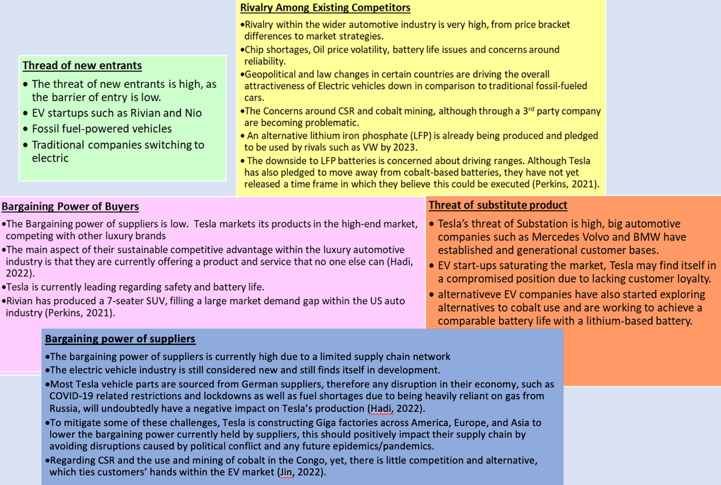
Figure 10 : 5 Forces analysis

Appendix 2 - PESTEL Analysis Infographic
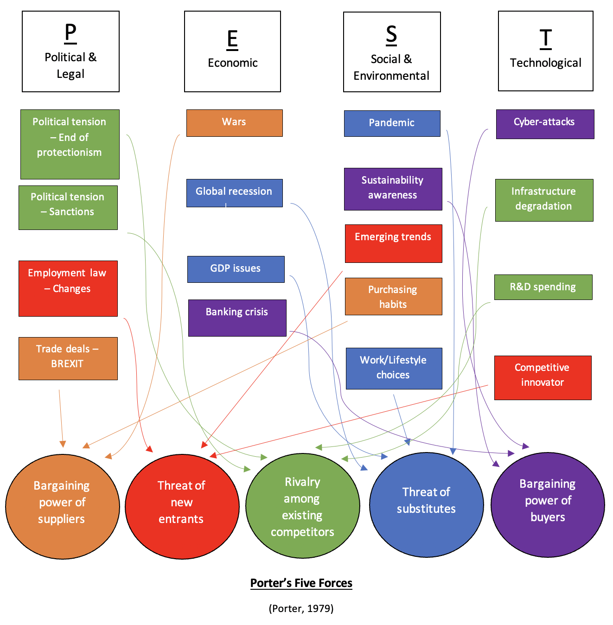
Figure 11 : PESTEL Analysis Infographic

Appendix 3 - PESTEL Analysis

Figure 12 : PESTEL Analysis

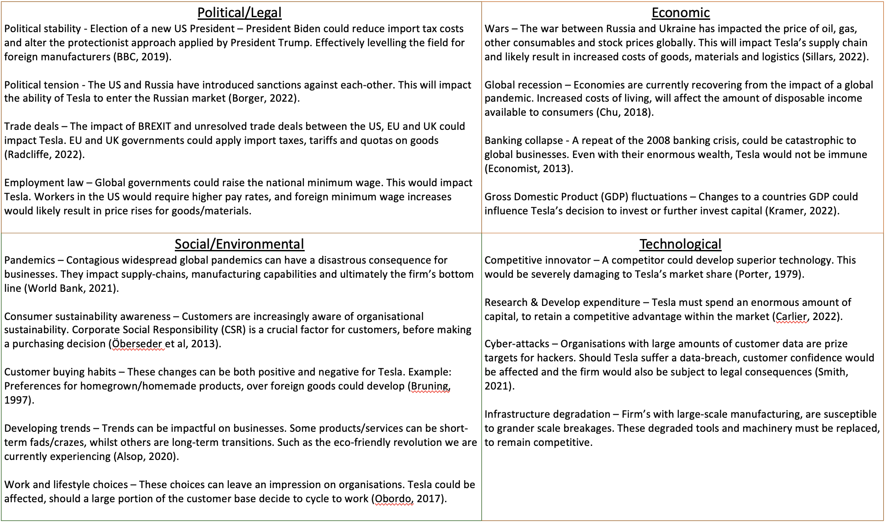

Appendix 4 - SWOT Analysis

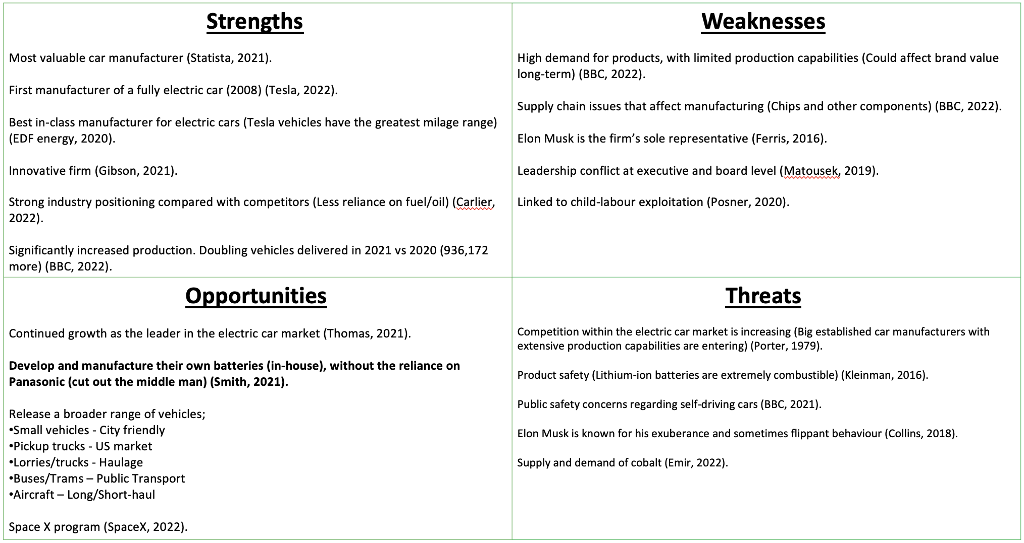
Figure 13 : SWOT Analysis

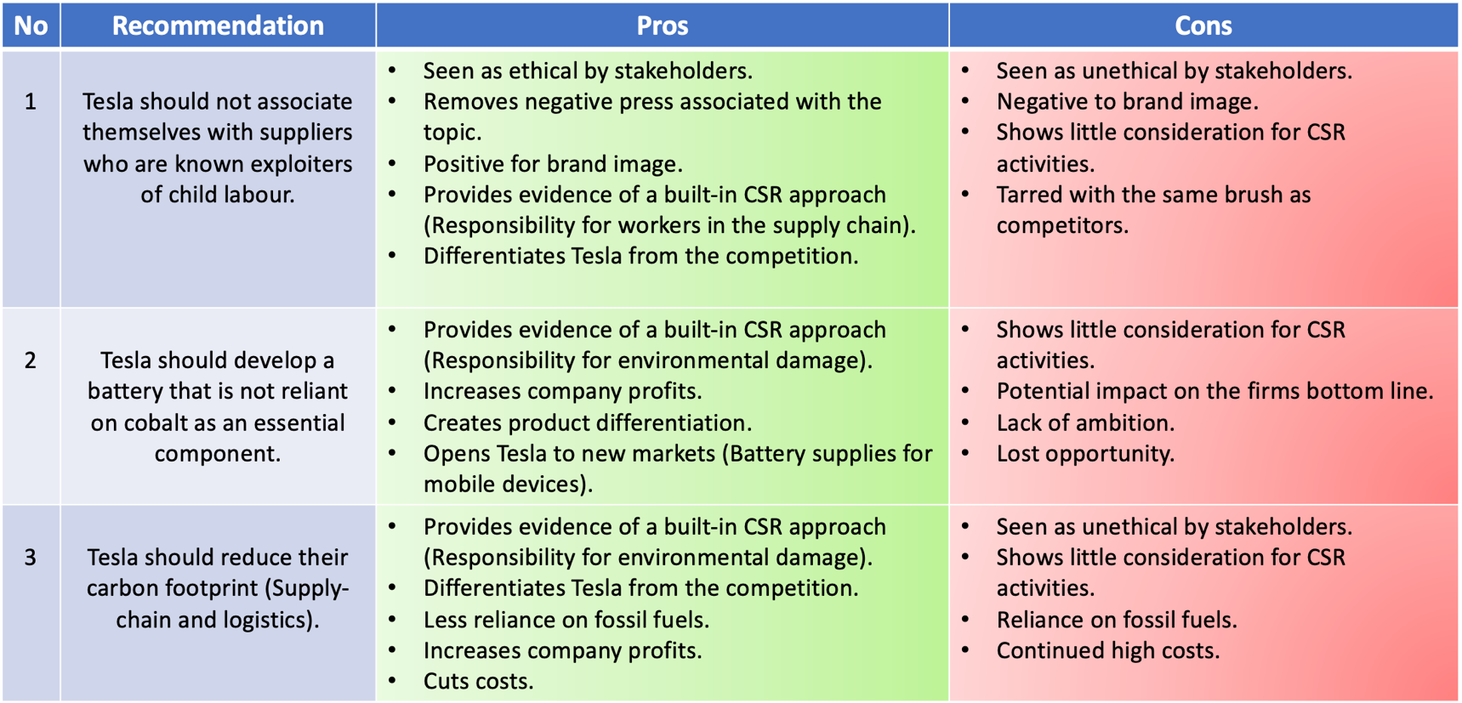
Appendix 5 - Recommendations
Figure 14 : Recommendations

Appendix 6 – Competitor analysis

As can been seen in figure 1, Department for transport statistics show that the number 1 selling electric vehicle in the UK since 2014 is the Tesla Model 3 closely followed by the Nissan Leaf and Renault Zoe. Overall, when reviewing the top ten number of registrations, we can identify that Tesla’s main competitors since 2014, in descending order are :
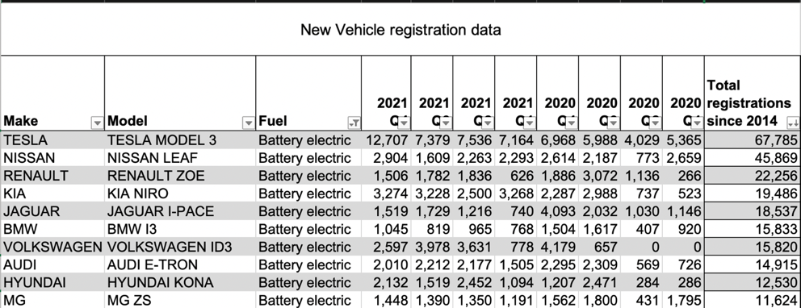
- Nissan
- Renault
- Kia
- Jaguar
- BMW
- Volkswagen
- Audi
- Hyundai
- MG
Figure 15: Table showing total vehicle registrations since 2014 in descending order. - Data sourced from (Department for Transport, 2022)
However, the EV space is changing daily and when reviewing the 2021 statistics, the competitor positioning has changed resulting in the current top 10 competitors in descending order are :
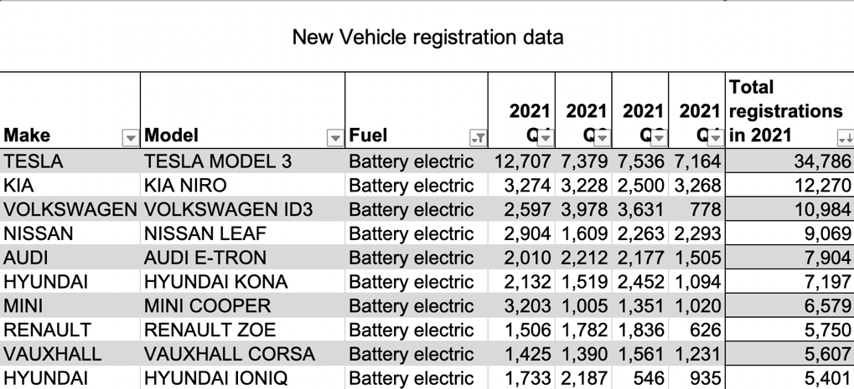
- Kia
- Volkswagon
- Nissan
- Audi
- Hyundai *
- Mini
- Renault
- Vauxhall
- Hyundai *

Figure 16: Table showing total vehicle registrations in 2021 in descending order. - Data sourced from (Department for Transport, 2022)

*Note : When both Hyundai models are added, total sales for 2021 are 12,598, placing Hyundai in first position as the biggest competitor to Tesla currently in Electric vehicle sales market.

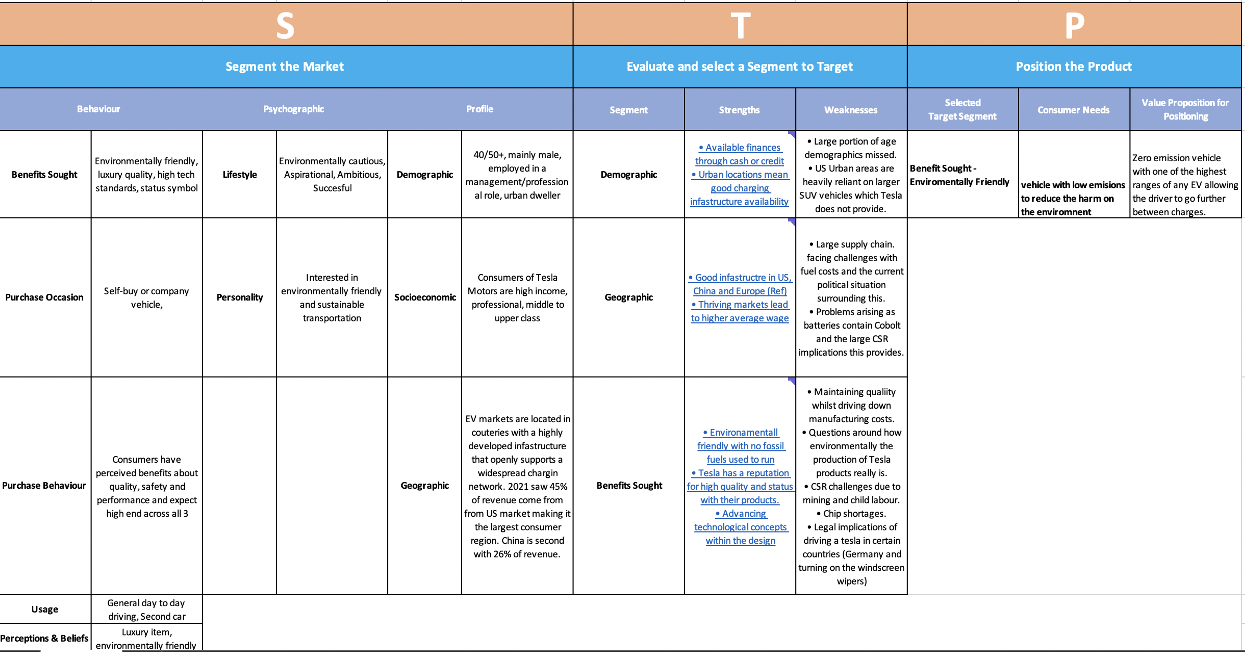
Appendix 7 – Segmentation, Targeting & Positioning (STP) Analysis
Figure 17 : STP Analysis on Tesla

