REPORT
Name of the Student: christalina margarita pereira
Name of the University: university of wales Trinity Saint David London
Student Id-2028771
Lecturer- saqib shamim

Table of Contents
Introduction 2
Discussion 2
Three models of communication: transmission, interaction, and transaction model 2
Analyzing the communication skills 5
The Advantages and Disadvantages of Communication Technology 8
Conclusion 11
References 13

Introduction
The process of communication consists of transferring ideas or feelings to another person. Ideas have no physical substance, and thus cannot be handed directly to the recipient. Consequently, they must be exchanged through symbols that represent other things. These symbols constitute language, the system of symbols used to exchange ideas and feelings.

Discussion
Students taking an Introduction to communication course will learn how to analyze the various types of communication and how they are used in various contexts. This course will cover print, electronic, and new information technologies, as well as communication theory. In addition, they will learn about economic, political, and social institutions that shape communication (D’Agostino et al. 2017). This class will teach students how communication is a way of life in advanced post-industrial societies. Students should also learn how to apply the concepts they learn in the classroom to improve their own communication skills.
Whether students are taking an Introduction to Communication course as a prerequisite for a major or minor in communications, they will have an understanding of the fundamental principles of speech communication and how to apply them to different contexts. Topics covered will include public, interpersonal, and intercultural communication. They will also learn about the ethical issues that arise in communication. The course also covers the theories and concepts of communication, including the development of language, the use of written and spoken language, and the role of symbols.

Three models of communication: transmission, interaction, and transaction model
Types of model
Various types of models have emerged over time to describe how information is exchanged. Shannon and Weaver's original model includes five key elements: an information source, a sender, a receiver, and an interference-filtering device. A message is sent from the sender to the receiver, and the latter decodes the message to decipher its content. This model is based on human communication, but also relies on information technology.
The classical model for communication has many shortcomings, including a lack of social aspects, such as inter-personal relationships, and less flexibility than modern models. Nevertheless, the core idea of an individual communication code is interesting (Biglu et al. 2017). It also suggests that other levels play a role in the transmission of messages, such as subconsciously including and receiving content. As with any other model, the sender-receiver model provides an interface to these other levels.
Transmission model with example
The transmission model is a common misrepresentation of communication. While it may be appropriate for everyday use, its misuse is a dangerously misleading misrepresentation of communication. This article will examine the transmission model with an example, and explain how its use affects the effectiveness of communications (Rohid and Rusmawati 2019). The following discussion includes an example of communication that is reliable, and a discussion of how its reliability is affected by noise and context.
The original transmission model involves five elements: the source of the information, the sender, and the receiver. Each element is important to understanding the process. The sender stores the information, the receiver decodes the message, and the message reaches its destination. Unlike human communication, this model assumes that information is transmitted in a mono-dimensional, or uni-dimensional, form. During the transmission process, noise and interference can disrupt the message, reducing its quality.
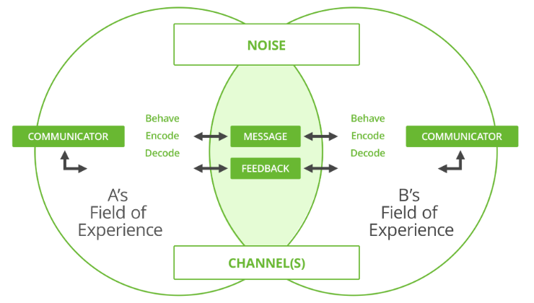
Interaction model with example
An interaction model is a conceptual framework that combines user knowledge, real-world metaphors, and a product's features. These models are useful for any product that reacts to the user's actions and aims to increase a user's interaction and enjoyment. While an interaction model isn't a part of the design process per se, it is a crucial foundation to any design project (Kumar et al. 2021)
The interaction model describes how different elements of a system interact with each other. It shows the different types of interactions, based on categories, such as channels, contexts, and acting entities. The interactive behavior of the system is modeled through an interaction diagram. Although it may be difficult to visualize this dynamic behavior, it's the best way to understand and predict how a game will interact with its users.
Transaction model with example
In a transaction model, the communication process between two individuals is influenced by various environmental noises and barriers. These factors may be physical, physiological or psychological. The transaction model relates these factors to social reality and relational situations. It considers these factors as important in determining the communication pattern. In this model, the overpowering factors are social systems, cultural systems and relational situations. Physical contexts can either enhance or inhibit communication (Moss 2019).
In a transactional model, the communicators are interdependent. In other words, they create meaning in the moment. The same goes for the recipients of the communication. The transactional model of communication is also called a "multi-agent" model. It focuses on the interdependence of communicators, rather than their independence. This makes it easier for individuals to interact with each other (Syamsuddin, Mustafa and Rofiki 2021). However, the transactional model of communication is not as universal as it sounds.

Analyzing the communication skills
Having excellent communication skills is an important aspect of a successful career. Having good communication skills will not only help to land an interview, but also make it easier to get through a selection process. Having good human relations skills and the ability to articulate effectively will give a significant advantage over other applicants (Beardsley 2019). Effective communication involves requesting information, discussing problems, and interacting with others.
In the Introduction to Communication Skills course, will learn about soft and hard communication, the differences between spoken and non-verbal communication, and how to communicate effectively in the workplace and in personal life. The course also addresses barriers to effective communication and the role of culture and context in communication.
The first session of the course will include an introduction to communication. In the introduction, should define what communication is and how it can be defined as verbal, nonverbal, or paraverbal. If possible, one can introduce a short discussion of active listening strategies and ask participants to brainstorm them. Give them ten minutes to do this.
Analysis
The analysis of communication skills in HR practice has been largely focused on identifying specific behaviors that employees display, but it is clear that there is more to this process. There are also five broad categories of communication behaviours that HR practitioners engage in, such as gesturing, grumbling, listening, and interacting (Malik et al. 2018). Although each communication behaviour is important, focusing on any one of them is unhelpful, as the skills can be more effectively described as instances of practice.
These factors are often elaborated and supported by data to identify specific types of behaviour. For example, observations focused on understanding which communication skills were exhibited, while interviews provided personal and contextual background information (Kee et al. 2018). The analysis of communication skills enactment requires this decontextualization, and the analysis of each type of behaviour has revealed that some behaviours are more common than others.
Different types
A person's communication skills are the key to his/her success in a business. The various styles of communication vary, but are crucial to the success of any business. In a professional setting, people use several modes of communication to convey their ideas, opinions, and concepts. A person's communication style does not depend on the form of communication, but on the manner in which they communicate with others.
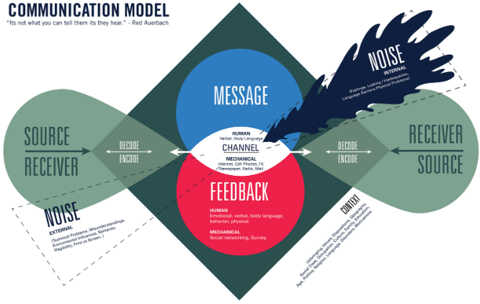
The most common type of communication is verbal, which involves face-to-face conversation with others, as well as written messages. Oral communication can occur through video, radio, television, or voice over the internet (Wagner-Menghin, de Bruin and van Merriënboer 2016). Examples of verbal communication are conversations, counseling colleagues, meetings, and conferences. Verbal communication is important for delivering a message effectively and receiving clear directions from colleagues. It also boosts morale and productivity. One will need good verbal communication skills to achieve these goals in business.

The Advantages and Disadvantages of Communication Technology
The Internet has greatly influenced our lives, and communication technology is no exception. While the internet can connect people from all over the world, many of us don't have the luxury of carrying around separate communication devices (Dumford and Miller 2018). In the past, one often had to invest in separate devices to communicate. Thanks to the internet, one can now communicate with others from the comfort of homes.
This course examines the fundamental principles and processes that have led to the development of the Internet and the emergence of new forms of communication. Students will gain insight into the impact that these technologies have on society, relational relationships, and even the psychology of the people who use them. This course is an essential prerequisite for any Communications major.
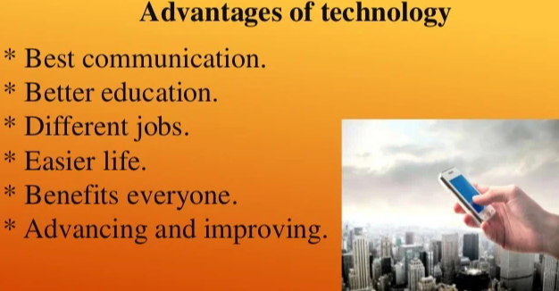
This course is a foundational course for students in the Communication and Information Technology major. The course materials provide guidance in what to study and where to focus. Various learning objectives, key terms, and assignments provide students with the tools they need to integrate and apply their newfound knowledge. Self-mastery exercises and assignments help students build their technical skills. The course material is organized into two parts: the applied part and the general component (Han et al. 2022). For students interested in the field of communication, a lab component is included that emphasizes script writing and script reading.
Advantages
The advantages of communication technology extend well beyond just its speed. Organizations can share information more easily. Information is organized in one central location and can be accessed by all employees. Electronic mail, for example, enables even the lowest-level employees to communicate directly with their managers (Sadeghi 2019). Instead of holding meetings, information flows freely from bottom to top. In addition, companies can offer their products and services online and even conduct international business. These are just a few of the benefits of communication technology.
One of the most obvious advantages of communication technology is that it can help us communicate with people all over the world. Not only does it allow us to reach out to our friends and family in more places, but it also makes it possible to conduct business around the world. With these benefits, it is no wonder that people are increasingly embracing this technology (Aslantürk 2018). While its many downsides are still unavoidable, the benefits far outweigh its potential drawbacks.
Disadvantages
While many of the advances in ICT have improved communication and the globalization process, some of the downsides have been a drawback for older generations. In particular, technology has made it easier for people to communicate with one another, while reducing personal contact. Another disadvantage of communication technology is the possibility for cyber-bullying and cyber-skyping (Bruce and Hogan 2019). These technologies are also difficult to use in some instances. However, despite the downsides, the benefits are far outweigh these negatives.
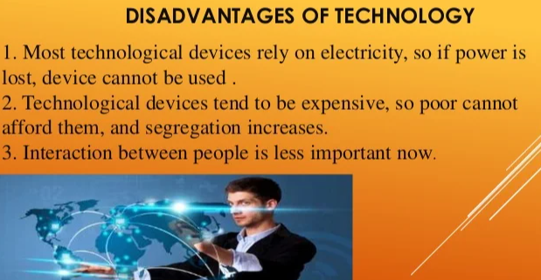
Communication technology has also paved the way for a more global market. With online services, organizations can build strong customer bases and boost their profitability. As a result, communication technology has revolutionized organizational departments and increased productivity levels. It has also resulted in the creation of unusual jobs, such as those that require extensive use of technology (Martelli et al. 2016). However, it is important to note that technology is not a permanent solution to the world's problems. Therefore, data backup is essential to protect business data from severe loss.

Conclusion
Effective communication is one of the foundational skills of leadership. Effective communication is crucial for a business to maximize its production, link remote branches, and publicize products and services. Having good communication skills also helps in minimizing rumors and ensuring the smooth functioning of the organization. Make sure to use transition words in conclusion. It should have at least three sentences. In the conclusion, restate thesis and sum up the main supporting ideas.
Communication skills improve professional relationships. In professional life, it helps to build rapport with coworkers and clients. Besides, good communication skills build teamwork. Consider oneself as a brand: way of talking to others can affect professional image. A good communication skills improves the overall image of a brand and improves employer-employee relationships. Good communication skills make stand out from competitors. One can earn more money, have more clients, and enjoy a better quality of life. Today, communication technology is available for everyone to use. However, some people abuse it for their own benefit and inadvertently affect other people. This is a problem rooted in a lack of education and knowledge about the dangers of this technology. It also examines the potential for addiction and misuse. Throughout history, communication technology has been used to improve the lives of many people in many areas, from business to academics.
The main advancement in the world of technology is communication technology. With the help of the internet, millions of people can connect with each other around the world without leaving their homes. This opens up numerous opportunities for globalization, but it also damages social environments. While allowing millions of people to communicate with each other without leaving their homes and affecting the lives of millions, this technology has also led to a decrease in the joys of face-to-face communication, which is an important part of human life.

References
Aslantürk, Ö.S., 2018. In vitro cytotoxicity and cell viability assays: principles, advantages, and disadvantages. Genotoxicity-A predictable risk to our actual world, 2, pp.64-80.
Beardsley, R., 2019. Communication skills in pharmacy practice. Lippincott Williams & Wilkins.
Biglu, M.H., Nateq, F., Ghojazadeh, M. and Asgharzadeh, A., 2017. Communication skills of physicians and patients’ satisfaction. Materia socio-medica, 29(3), p.192.
Bruce, B.C. and Hogan, M.P., 2019. The disappearance of technology: Toward an ecological model of literacy. In Writing in a Technological World (pp. 191-207). Routledge.
D’Agostino, T.A., Atkinson, T.M., Latella, L.E., Rogers, M., Morrissey, D., DeRosa, A.P. and Parker, P.A., 2017. Promoting patient participation in healthcare interactions through communication skills training: a systematic review. Patient education and counseling, 100(7), pp.1247-1257.
Dumford, A.D. and Miller, A.L., 2018. Online learning in higher education: exploring advantages and disadvantages for engagement. Journal of Computing in Higher Education, 30(3), pp.452-465.
Han, H., Hingle, S.T., Koschmann, T., Papireddy, M.R. and Ferguson, J., 2022. Analyzing Expert Criteria for Authentic Resident Communication Skills. Teaching and Learning in Medicine, 34(1), pp.33-42.
Kee, J.W., Khoo, H.S., Lim, I. and Koh, M.Y., 2018. Communication skills in patient-doctor interactions: learning from patient complaints. Health Professions Education, 4(2), pp.97-106.
Kumar, T., Malabar, S., Benyo, A. and Amal, B.K., 2021. Analyzing multimedia tools and language teaching. Linguistics and Culture Review, 5(S1), pp.331-341.
Malik, A., Setiawan, A., Suhandi, A., Permanasari, A., Dirgantara, Y., Yuniarti, H., Sapriadil, S. and Hermita, N., 2018. Enhancing communication skills of pre-service physics teacher through hot lab related to electric circuit. In Journal of Physics: Conference Series (Vol. 953, No. 1, p. 012017). IOP Publishing.
Martelli, N., Serrano, C., van den Brink, H., Pineau, J., Prognon, P., Borget, I. and El Batti, S., 2016. Advantages and disadvantages of 3-dimensional printing in surgery: a systematic review. Surgery, 159(6), pp.1485-1500.
Moss, T., 2019. Analyzing Communication Center Training through the Lens of Foucault. Communication Center Journal, 5(1), pp.175-177.
Rohid, N. and Rusmawati, R.D., 2019. Students' Mathematical Communication Skills (MCS) in Solving Mathematics Problems: A Case in Indonesian Context. Anatolian Journal of Education, 4(2), pp.19-30.
Sadeghi, M., 2019. A shift from classroom to distance learning: Advantages and limitations. International Journal of Research in English Education, 4(1), pp.80-88.
Syamsuddin, A., Mustafa, S. and Rofiki, I., 2021. Analyzing Written Communication Skill in the Form of Scientific Article of Prospective Teachers of Elementary School through Reflective Journal. Ilkogretim Online, 20(1), pp.768-776.
Wagner-Menghin, M., de Bruin, A. and van Merriënboer, J.J., 2016. Monitoring communication with patients: analyzing judgments of satisfaction (JOS). Advances in Health Sciences Education, 21(3), pp.523-540.

