An analysis of industrial and craft activity in the Roman and Ptolemaic Eastern Desert

The purpose of this paper is to explore the industrial and craft activities in the Eastern Desert of Egypt in the Roman and Ptolemaic period, particularly pertaining to the extraction of materials and surrounding activities. Following this consideration will be given to how important the Eastern Desert was compared to other regions of Egypt or the Empire. The vast amount of useful stone, ores and gemstones found within the Eastern Desert has long been recognised, particularly Beryl, ‘marble’ and Gold, but many other kinds of materials were extracted and worked from the pre-dynastic to the Roman period that had both many local uses, as well as export value. Egypt as a whole may have been “blessed with great geological wealth” but the Eastern Desert forms an important part of this. Furthermore, it would be easy to see the Eastern Desert’s industrial activity as primarily that of extraction, however, this paper will argue that much work had to be done in the region to prepare the materials for travel. In addition, the support and logistics for the region, from food to fuel, must be considered as part of this industrial activity. However, the economic importance of the Eastern Desert lies not just in its industry, but also as an important hub of trade with regions further south and the Indian Ocean, constantly importing and exporting goods across the desert, the Red Sea and the Nile. The paper will first list the various resources and industries found in the Eastern Desert, giving examples of certain sites and an overview of that sectors activity, be it Gold mining or stone quarrying. Secondly, this paper will attempt to analyse the importance of such activity to the Ptolemaic house or the Roman Empire through the number of workings, variety thereof, and the scarcity of the extracted materials, and the distances such goods travelled. Thirdly, the region must briefly be compared to other industrial regions of the Roman Empire, or Ptolemaic Egypt, or else any analysis stands alone without the context in which to place the evidence.
This first section will discuss the stone that was extracted from the region and the economic activity surrounding them. The rocks include: Diorite, Gabbro, Tonalite Gneisas and other similar rocks, Haematite, Malachite, ‘marbles’, Serpentine, Porphyrys, Siltstone, Greywacke and Conglomerate, Soapstone, Tavertine, Tuff and Tuffaceous Limestone. These stones could be used to make objects big or small, complex or simple. Paving stones prove a common usage for these stones, as is the creation of beautiful and colourful vessels, but the most famous examples are columns (which could range massively in size) such as for the Pantheon, as well as sarcophagi. Many of these objects are found in Italy, adorning the finest public and private architecture, and the importance of the quarrying activities in the Eastern Desert can be most keenly seen through these artefacts. This is because of the sheer difficulties of extraction, processing and transportation of rock from the Eastern Desert to Italy. The first process was extraction, these sites were logistically complex and the work was not merely a matter of hewing at the rock, but of breaking apart the right sections of rock to then be moulded into the right shape, likely, but not certainly, leaving all but the finest of work to be done at the final destination. The level of skill, organisation and craftsmanship must have been immense at these sites. The archaeology of these sites, and the Eastern Desert in general, paints a picture of a well-fortified, at least by the Roman period, and well connected region, and these quarries and their supporting settlements were centres of life as well as work. Although the status of the workers is debatable, perhaps free, or slaves, the pay of the free labour seems to have been rather good, again showing the value of the operations if high pay was feasible. Once the stone was worked from the rock face it was shaped and then had to be transported across the desert to the Nile. This necessitated a series of way stations to provide water, protection and shelter from the harsh climate and potential banditry. Many of the objects must then have gone by land, then by river and by sea, and then by land again in order to get to their destination, a massive effort to be sure, involving people from all walks of life and many of which must have required payment. The extraction of stone also requires tools that must have been made, repaired, and maintained, on or near the sites of extraction (or else brought to the site), and fuel for furnaces (for metal mines), forges and fires, as well as other materials must have needed to be brought to the locations.
The scale of stone extraction was also very large in size not just in variety, with something in the region of eighteen quarries known, if we compare this on a map, for the comparative size of the Eastern Desert its resources are numerous and dense. The picture that emerges from the evidence for stone quarrying in the Roman period is that of a major centre of exploitation within the Empire, but, it must be said, it is hardly unique in its scale, but that does not remove from its importance. The sizes of some of the removed blocks is also very impressive, we also luckily have some unfinished (and finished) stone at Mons Claudianus and Mons Pohpyrites. The level of finish is reasonably high, some tubs, columns and bases look as if most of the work for them had been done before they left the site, clearly not only quarrying took place at these sites and it was more convenient to do much of the work before transport. Stone was then likely cut and shaped largely ‘on demand’ so the right sections could be removed and shaped, and one must imagine a lively and busy community around these quarries, of interlinking needs and skills. However, even when the objects had been shaped, or at least cut free, from the stone, they then had to be dragged down the mountainside with wooden support ramps built up the mountain at some sites. Neither are all these sites barren barracks of slaves and overlords, but vibrant communities with all the cultural and industrial activity that entails. Mons Pophyrites ‘temple to Serapis’ has many examples of finely carved stone and inscriptions, surely from the locally sourced stones, which not only further illustrates the level of skill of the population, but also the level of industrial activity required to build such sites. Perhaps a good comparison might be the mining towns of Britain and America, sometimes vibrant communities that surround, and often live and die, by the wealth of the earth.
Semi-precious and Precious stones, as well as Crystals, were also extracted in great variety with Amethysts, Beryls (particularly Emeralds), Chalcedony (Ard and Cornelian), Jasper, Garnets, Fluorspar, Peridot (off the Red Sea Coast), and Smoky Quartz, all being mined in the region. Of most interest are the Beryls as the only source of Emeralds within the Roman Empire in antiquity comes from the Eastern Desert, even if their colour lacks the deep green hue of later Indian subcontinent imports. The most obvious usage for such gemstones is in jewellery such as earrings and necklaces, however, the finest craftwork might be on signet rings, where the gemstone is set in a precious metal ring and carved to resemble a figure, sometimes in exquisite detail. Some items of jewellery utilise a large range of stones that may have come from the Eastern Desert, as well as precious metals. The scale of workings is as impressive as the stone quarrying, with approximately twenty known sites that were worked. We are fortunate that our literary evidence covers such luxury items and Pliny at least, and likely much of the Roman world, saw them as highly valuable.
“So great is the value that men attach to the multiplied varieties of these gems, their numerous colours, their constituent parts, and their singular beauty, that, in the case of some of them, it is looked upon as no less than sacrilege to engrave them, for signets even, the very purpose for which, in reality, they were made. Others, again, are regarded as beyond all price, and could not be valued at any known amount of human wealth; so much so that, in the case of many, it is quite sufficient to have some single gem or other before the eyes, there to behold the supreme and absolute perfection of Nature's work.”
Other than for jewellery, some crystals were prized for their supposed medicinal qualities, for Malachite, or ‘Molochitis’, Livy tells us “It is highly esteemed for making seals, and it is endowed by Nature with medicinal properties which render it a preservative for infants against certain dangers which menace them.” Pliny goes on to describe many other supposed health benefits of various stones and materials, but also that crystal may make goblets or basins and presumably other objects. Finally, pieces called cameos, some reasonably large in size, could be made from various materials that were found in the Eastern Desert, such as Amethyst and Chalcedony.
The next issue is the extent of processing and refinement, how much work was done to these stones before many of them were exported? Transporting entire geodes and large unprocessed pieces would surely have been less efficient than doing at least some of the processing in situ, however, such stones and minerals can be fragile, we probably, much like the stone, do not have cases of completed works being shipped, more likely they were worked into some form that was easier to transport, yet is not as fragile as a finished piece.
As well as this, many ores for metals can be found, such as Copper and of course Gold (often mixed in with varying quantities of Silver), indeed “The most important and consistently sought-after natural resource available in the Eastern Desert throughout antiquity was Gold”. Gold from the Eastern Desert has long been extracted but our literary evidence for it becomes more detailed in the Ptolemaic period, with Diodorus describing the process in some detail. The extraction of Gold is highly laborious as it occurs within other rocks at varying levels,
“Mineralogically, Gold-bearing veins are composed of milky white, dense quartz. Barren, Gold-free quartz commonly can be found in the vicinity of mines. Gold is unevenly disseminated in auriferous veins, and is intimately interwoven with other minerals, notably Pyrite, Chalcopyrite (Cufes2), Pyrrhotite, Sphalerite, and Galena.”
Then a large process of grinding and purification must take place before presumably smelting it into bullion for ease of transportation. This smelting may well have happened on or near the site of the Quartz excavation and refinement, or perhaps as far away as the Nile, or in other centres of Industry within the Eastern Desert. It is most probable however that some sort of processing and smelting was occurring in the Eastern Desert, as transporting ore, or Gold dust, would increase the likelihood of losing Gold in travel or of being prohibitively heavy to transport, bullion can be easily stacked and importantly weighed out, so when the convoy reaches the Nile all can be checked. All of this requires large populations of workers and some moderately complex facilities, such as washing tables, grinding stones and furnaces. The logistical problems are much the same as the stone quarries, one may need to house workers and certainly many supplies need to be imported and those import routes secured. Furthermore the number of ancient Gold mines is higher than the number of stone quarries, which supports the view that this was the most important industry in the Eastern Desert, it certainly is the most consistent throughout vast stretches of time. These metals had varied uses, not just for coinage but also for jewellery and luxury items, as well as more mundane artefacts.
With these industries there is an infrastructure of townships, forts and ports that existed in large part to support the extraction activities in the Eastern Desert, but, not only that, these industries helped support each other. A fascinating case study for the industry surrounding the Gold mining in the region is Abu Gerida, as no Gold mining occurred on the site so far as we can tell, but it clearly was a central hub to other mines including those for Iron and Copper, it also produced tools and smelted ores. Not only was Gold mining a major industry, but it seems to have created and necessitated other industries in the region. Indeed the quarrying of stone is crucial to the processing of Gold ore, after all, one needs hard stones to break apart the Quartz on, and this stone must have come from the Eastern Desert. So one industry can feed into another, in the same vein, the support structures aid not just one industry, but all.
Now the different activities and the evidence which pertains to them has been discussed, we must attempt to gauge how important and far reaching the industrial activity in the region was. For some easily recognisable stones and Emeralds that is fairly easy, we can trace the source directly back to the Eastern Desert, and can show just how far these objects travelled. However, for many other precious, semi-precious and more common stones, being able to exactly trace an item to an exact quarry or mine is all but impossible without chemical analysis. Vast quantities of such items exist in Ptolemaic Egypt and the Roman Empire, sometimes whole hordes of such stones have been found at bath houses around the empire, as far north as Britannia. Some such items must surely have come from the Eastern Desert. The other issue is the relative importance of the Eastern Desert to the overall industrial activities of the Ptolemaic Kingdom and the Roman Empire, at least so far as mining, quarrying and supporting activities are concerned. The simplest method would be to examine the stones and ores found in the Eastern Desert, and see if any of them are particularly important or unique, and on the basis of that information, judge the Eastern Deserts relative importance. A complete analysis of mining and quarrying output in the Roman Empire as a whole being out of scope here, such a cursory methodology will have to suffice.
For Gold, we know that “while Egypt was an important source of Gold for the Romans, other regions of their empire including Wales, Spain, and Dacia (modern Romania) also supplied the imperial government with this precious metal.” However, to calculate the relative importance of the Gold mines to the Roman Empire we would need to be able to calculate the output of not only the Eastern Desert mines, but also those all across the Empire. So far as the Eastern Desert is concerned, there are two possible approaches to this, firstly, the examination of waste materials, the mine shafts, and ratios of the occurrences of Gold within the Quartz, to then try to estimate the amount of removed material. If highly detailed archaeological work could be done and the dates of extraction somehow divined then we could produce production figures. The second methodology, is that of comparative studies. If we know that in similar circumstances using similar techniques each worker would generate between one and fifteen grams of Gold per day, if we can have an estimate of the working population of such sites, we could produce an estimate of the daily output. Unfortunately population figures are a particularly difficult issue for the ancient world and we have no way of knowing what proportion of the population of, for example, one of the supporting sites was directly involved in the industry, nor how many days of the year the seams were worked, nor how many lived in temporary structures. Further complicating the issue is that different kinds of workings might allow smaller or larger amounts of people to work a site, a deep tunnel is more limited than a more open mine. At Bir Umm Fawakhir the population may have been around a thousand, assuming that five hundred of them are at work at the Quartz veins each day would yield according to our comparison between 500 and 7500 grams of Gold per day from the surrounding mines. However, eleven tons of Gold for all of Egypt has been estimated to be produced during the Ptolemaic and Arab periods, if we take a middling estimate of 3500 grams of Gold per day this produces around a ton in a single year, far too high an estimate to join the two estimations. Producing an accurate estimate for Gold output for the Eastern Desert during a specific period of time may be impossible, as may be an accurate estimate for the entire Empire to compare it to, a full evaluation of estimates is beyond the scope of this paper, however, we should expect the output to not be low relative to other regions considering the number of mines.
How does the Eastern Desert compare to other major industrial regions of Egypt? Obviously there is the lack of large scale agriculture and large scale cities, nothing as large as Alexandria exists within the Eastern Desert (although accounting for tented populations is problematic), but on the grounds of raw materials a more direct comparison is possible. To begin with stone quarries, the Eastern Desert is far from unique in terms of being a great source of stone, but is likely as important as other regions. Many sites around the Nile and further afield provide limestone and many other types of stone, although, as has been said before, certain varieties are unique to the Eastern Desert. In terms of gemstones and semi-precious stones the Eastern Desert is the only major area that produces such items within Ptolemaic Egypt. There are a handful of gemstone mines not in the Eastern Desert, and so, to the Ptolemies, this region must have been important for that reason. Lastly metal ores, primarily Silver (from Electrum), Iron, Copper, and most importantly Gold occur in the Eastern Desert, undoubtedly the Eastern Desert was a font of wealth, but not all of these are unique to this one region of Egypt. The Importance of the Eastern Desert’s Gold is the easiest of the raw resources to analyse in terms of importance as most other Gold working sites in Ptolemaic Egypt ceased to be worked. Therefore the only new source of Gold for the Ptolemies, apart from booty, became the Eastern Desert, and so, on a Ptolemaic scale, the Gold makes the Eastern Desert alone important. Copper and Iron are less clearly cut issues, although sources exist in the Eastern Desert they also exist in the Sinai, Turquoise was also found in the same area as the Copper in the Sinai. Weighing the relative importance of Copper yields from the Sinai and the Eastern Desert is highly problematic due to methods involved or lack of complete survey. However, seven mines are known in the Sinai and ten in the Eastern Desert and it would be no stretch to assume a larger yield from the Eastern Desert, but it seems impossible to assume the Sinai’s Copper or the Eastern Deserts was vastly more important than the other to the Ptolemies. Overall then the Eastern Desert must have been one of the key Industrial areas of the Ptolemaic Kingdom by virtue of its diverse, plentiful, and sometimes unique resources.
A wider and more complex issue is the relative importance of the Eastern Desert to the Roman Empire in terms of its industry, was it a backwater in terms of Industry, the region’s main importance being its connection to the Indian ocean, or was it similar to or greater in importance to industries in regions of Spain, Britain or Italy? This comparison must focus on the three major groupings of resources, hard and soft stones, metals, and semiprecious and precious stones. None of these resources only source is from the Eastern Desert, with the exception of Emeralds and specific varieties of stone, which although notable, does not automatically make the Eastern Desert particularly important.
The Roman Empire (at least at its height) was blessed with several sources of Gold, notably but not exclusively in Spain, Dacia, Gaul (albeit possibly at reduced output), and even as far flung as Wales in Britannia. Nor is the Eastern Desert the only region of the Empire in which a large variety of valuable metals can be found. Spain, for example, has Roman mines for Gold, Silver, Lead, Copper, Tin, Iron, Mercury, and Zinc and has been considered to be the source of ores “par excellence” for the Roman Empire. Spain indeed has all the crucial metals of the Roman Empire, nor are the mines of Spain diverse but insignificant, many mines were exploited. Britain and Gaul were also a source of varied mineralogical wealth, with metals such as Lead, Silver, Iron, Tin and Copper to match the Gold. Greece and the Aegean islands such as Thasos, as well as Asia Minor also boast significant Gold and Silver, along with other minerals. Even Italy and Sicily also provided no small amount of valuable workings. Overall the Roman Empire at its height held within it vast and varied metallurgical deposits. In this respect Egypt, and more specifically the Eastern Desert, stands as one region among many which provided the Roman Empire with the metals it needed to survive.
The Roman Empire was equally blessed with a vast array of quarries, with examples dotted around almost the entirety of the Empire, in Italy, Spain, Britain, and Gaul, as well as further east. The Eastern Desert, in terms of number of quarries and their geographical concentration is approximately as important as any other region of the Empire in which quarries are to be found, with areas such as North Africa, Greece, and the Near East being similar in those terms. What makes the Eastern Desert’s important in these terms is the unique stones it had to offer, not that it had granite or limestone, but its beautiful Porphyry and other stones, and, as has been discussed previously, the fact that these travelled far and wide. The Eastern Desert then is not massively important to the Roman stone industry as a whole, but, much like its gemstones, does provide some unique additions.
The Eastern Deserts plethora of precious and semi-precious stones in such a, relatively, confined geographical region is clearly of note, it is not the only source of gemstones, crystal or other kinds of minerals within the Roman Empire. Indeed beyond internal mining many such materials could be imported, such as Plinys Murrhine, from the trade with the Indian Ocean or via the more problematic Parthia. One example that Pliny also gives us is crystal mining in the Alps, however notable other sources of stones include Spain and Britain. But nowhere provides the variety of the Eastern Desert in a comparable region.
In terms of large scale supporting industries and networks of logistics, the Eastern Desert stands out mostly for the difficulties of its location, rather than the scale of such efforts. The Roman military fortifications and logistics at Hadrian’s Wall for example are highly impressive and required many smiths and other craft activities to sustain it, and no doubt created many industries as the soldiers’ pay trickled into the local economic community, much as the Eastern Desert miners must have done. The economic life of the towns and settlements of the Eastern Desert are difficult to reconstruct but none of the settlements is a metropolis, even if some may be more important than others. The potters, weavers, warehouses, bakers, artisans, carpenters and masons must all have had a part to play in the Eastern Desert, after all, much construction and many people were required, but the settlements are just not of a large enough size to compare to many other places in the empire in importance in these terms. However, on a regional scale clearly these sites must have been crucial to the successful exploitation of the regions wealth, and a seat for further economic activity. Although the expected and actual lifestyle of those living at these numerous sites in the Eastern Desert will forever remain hazy to us, we can be sure that these sites were not all devoid of luxury, as specialists and well paid workers must have sought to take advantage of their pay, and any notable infrastructure must have helped attract such workers.
In conclusion the Eastern Desert was not devoid of resources, industry, skills or life, but its importance should not be overestimated nor ignored. It can come as no surprise that the Eastern Desert was likely significantly more important to the Ptolemies than to the Roman Empire, since it could provide many unique and important resources, as compared to the Roman Empire which often had other sources for the precious materials found in the region. Rather than being the most varied and major area of resource extraction as it was for the Ptolemies, it becomes one of several important areas of industry, albeit with a few unique and some very important resources. In terms of the supporting and surrounding industries we can be sure that many must have existed, the mines were not simply supplied with labour in awful conditions, but communities and all that entails sprung up in the Eastern Desert, although not on a particularly large scale. However, in the weighing of the importance of such activates it is important to remember that the industry of the Eastern Desert is only one important part of the economic activity of the region, trade, elephant hunting and transportation, as well as any other factors should also be considered when evaluating its overall importance to larger power structures of a kingdom or an empire. In terms of the mining and quarrying industry then, the Eastern Desert was clearly the most important region of Egypt by the Ptolemaic period and continued to be so in the Roman period. The fruits of this region spread far and wide and created communities in its shadow whose ruins still stand testament to thousands of years of strenuous and difficult labour in the pursuit of the regions great wealth.

Bibliography
Ancient
Diodorus, Library of History. Oldfather, C.H. (Trans.). 1989. William: London
Herodotus, The Histories. Aubery de Selincourt (Trans.). 1954. Penguin Books: Bungay
Pliny, Natural History. Healey, J. (Trans.). 1991. Penguin: London
Polybius, Histories. Waterfield, R. (Trans.). 2010. Oxford University Press: Oxford
Strabo, Geography. Jones, H.L. (Trans.). 1989. Loeb: London
Vergil, Georgics. Greenough, J.B. (Trans.). 1900. Ginn and co: Boston
Xenophon, Hellenica. Warner, R. (Trans.). 1966. Penguin Classics: London

Modern
Aston, B. Harrell, J. and Shaw, I. 2009. ‘Stone’ in Nicholson, P.T and Shaw, I. (eds.), Ancient Egyptian Materials and Technology. Cambridge University Press: Cambridge 5-77
Burnham, B.C. and Burnham, H. 2004. Dolaucothi-Pumsaint: Survey and Excavations at a Roman Gold-mining Complex, 1987-1999. Oxbow: Oxford
Cobb, M. 2015. ‘Balancing the Trade: Roman Cargo Shipments to India’. Oxford Journal of Archaeology, Vol.34, 2, 185-203
Cunliffe, B. 1995. Roman Bath. Bath Press: Bath
Davies, O. 1935. Roman Mines in Europe. Oxford University Press: Oxford
Domergue, C. R. 1990. Les mines de la péninsule ibérique dans l'antiquité. École Française de Rome: Rome
Domergue, C. Serneels, V. Cauuet, B. Pailler, J.-M. Orzechowski, S. 2006. ‘Mines et Métallurgies en Gauleà la fin de l’âge du Fer et à l’époque Romaine’ dans Celtes et Gaulois. L’archeologie face a l’historie. La Romanisation et la question de L’heritage celtique, Paris 131-162
El-Rahman, Y, A. Surour, A, A. El Manawi, A, H, W. Rifai, M. Motelib, A, A. Ali, W, K. and El-Dougdoug, A, M. 2013. ‘Ancient Mining and Smelting Activities in the Wadi Abu Gerida Area, Central Eastern Desert, Egypt: Preliminary Results’ in Archaeometry, Vol. 55, 6, 1067–1087.
Gale, N.H. and Stos-Gale, Z.A. 1981. ‘Ancient Egyptian Silver.’ The Journal of Egyptian Archaeology, Vol. 67, 103-115
Grant, M. 1995. Art in the Roman Empire. Routledge: London
Harrell, J and Storemyr, P. 2009. ‘Ancient Egyptian quarries - an illustrated overview.’ QuarryScapes: Ancient Stone Quarry Landscapes in the Eastern Mediterranean. Vol. 12. 7-50.
Healy, J. F. 1978. Mining and Metallurgy in the Greek and Roman World. Thames and Hudson: London
Hingley, R. 2012. Hadrian's Wall: A Life. Oxford University Press: Oxford
Klemm and Klemm and Marr. 2001. ‘Gold of the Pharaohs – 6000 years of gold mining in Egypt and Nubia’. African Earth Sciences, Vol. 33, 643–659
Klemm, R. and Klemm, D.2013. Gold and Gold Mining in Ancient Egypt and Nubia Geoarchaeology of the Ancient Gold Mining Sites in the Egyptian and Sudanese Eastern Deserts. Springer: Berlin
Lucas, A. 1927. ‘Copper in Ancient Egypt.’ The Journal of Egyptian Archaeology. Vol. 13, 3/4, 162-170
Lucas, A. and Harris, J. 2012. Ancient Egyptian Materials and Industries. Dover: New York
Meyer, C. Earl, B. Omar, M. and Smither, R.K. 2003. ‘Ancient Gold Mining at Bir Umm Fawakhir Ancient Gold Extraction at Bir Umm Fawakhir’, Journal of the American Research Centre in Egypt, Vol. 40. 13-53
Ogdan, J. 2009. ‘Metals’ in Nicholson, P.T and Shaw, I. (eds.), Ancient Egyptian Materials and Technology. Cambridge University Press: Cambridge 148-176
Parkins, H. and Smith, C. 2005. Trade, Traders and the Ancient City. Routledge: London
Rapp, G. 2009. Archaeomineralogy. Springer: New York
Sidebotham, S. E., Hense, M. and Nouwens, H. M. 2008. The Red Land: The Illustrated Archaeology of Egypt’s Eastern Desert. The American University in Cairo Press: Cairo

Images
One: Egyptian Quarries. Aston, Harrell, and Shaw. 2009: 8-9
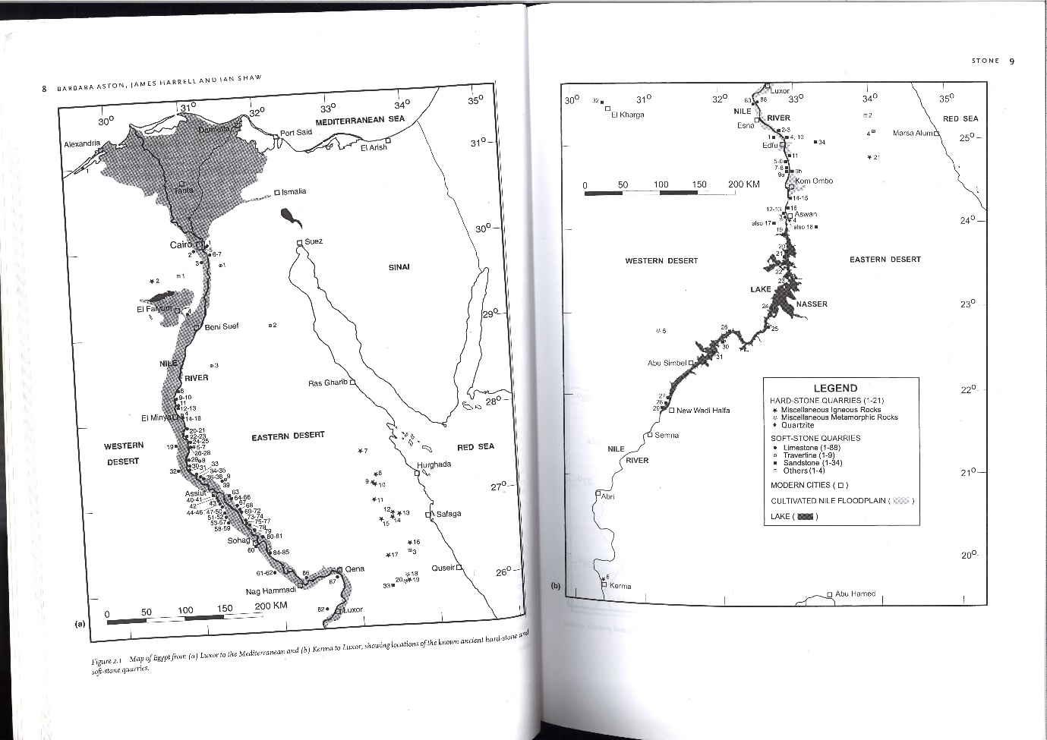

Two: Egyptian Gemstone Mines. Aston, Harrell, and Shaw. 2009: 10-11
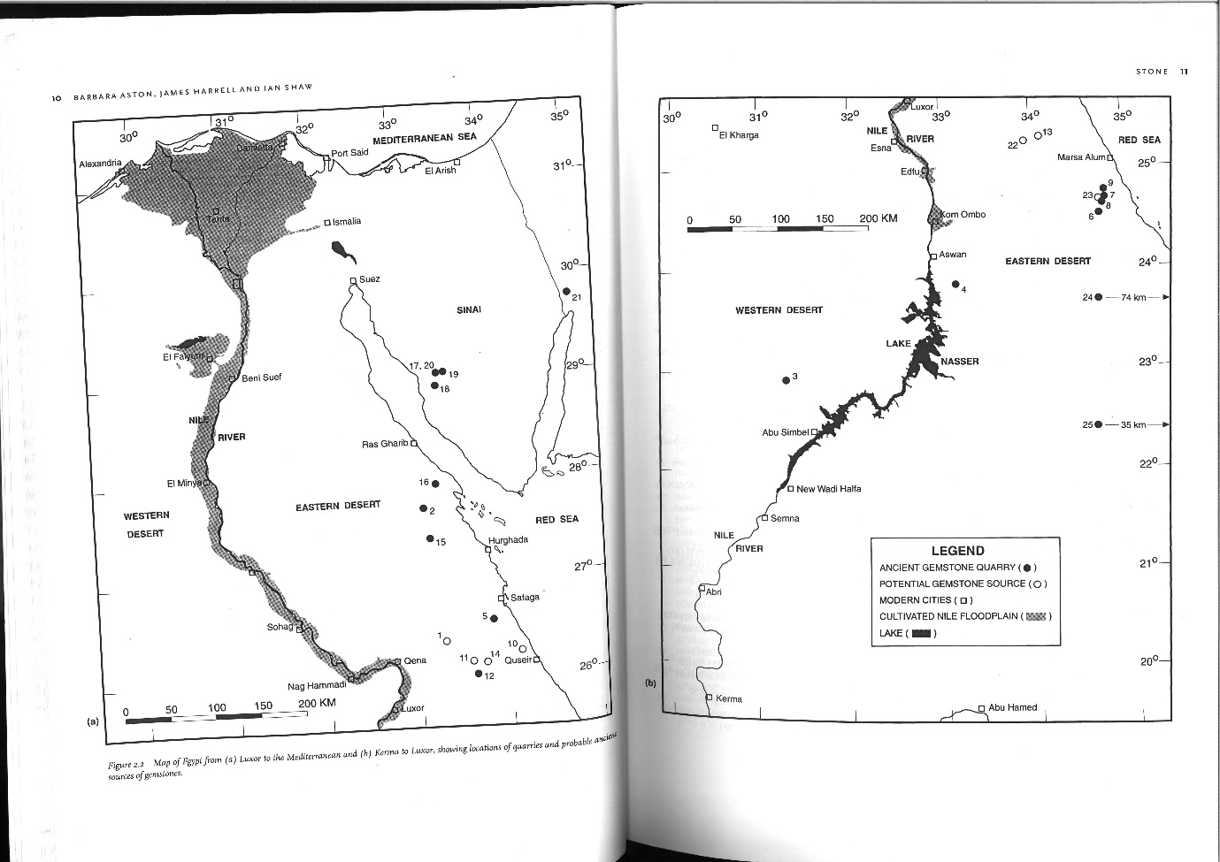

Three: Eastern Desert Gold Mines. Klemm, Klemm and Murr. 2001: 650
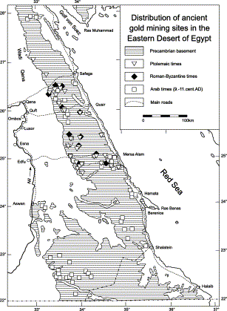
Four: Quarries in the Roman Empire. Russel. 2013: 1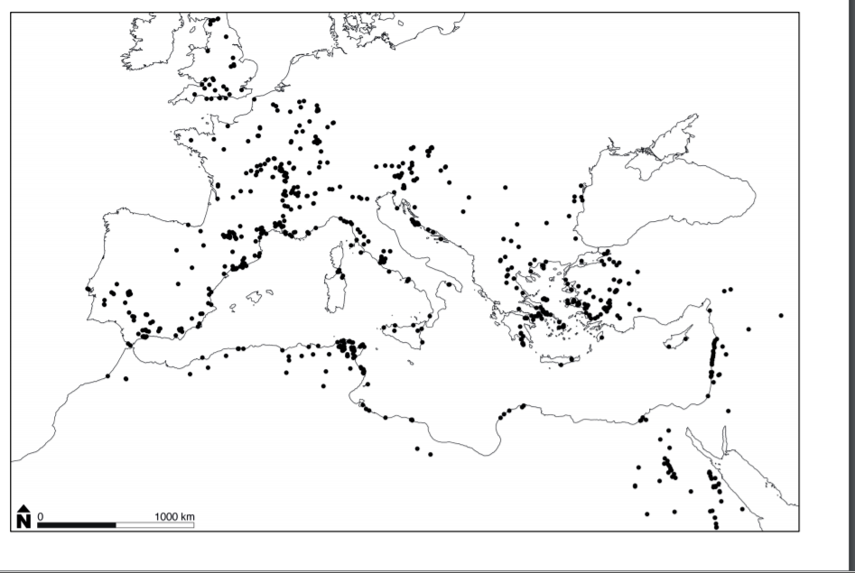

Five: Mining areas and sites in Britain, France, Spain and the western Mediterranean. Healy 1978: 50-1
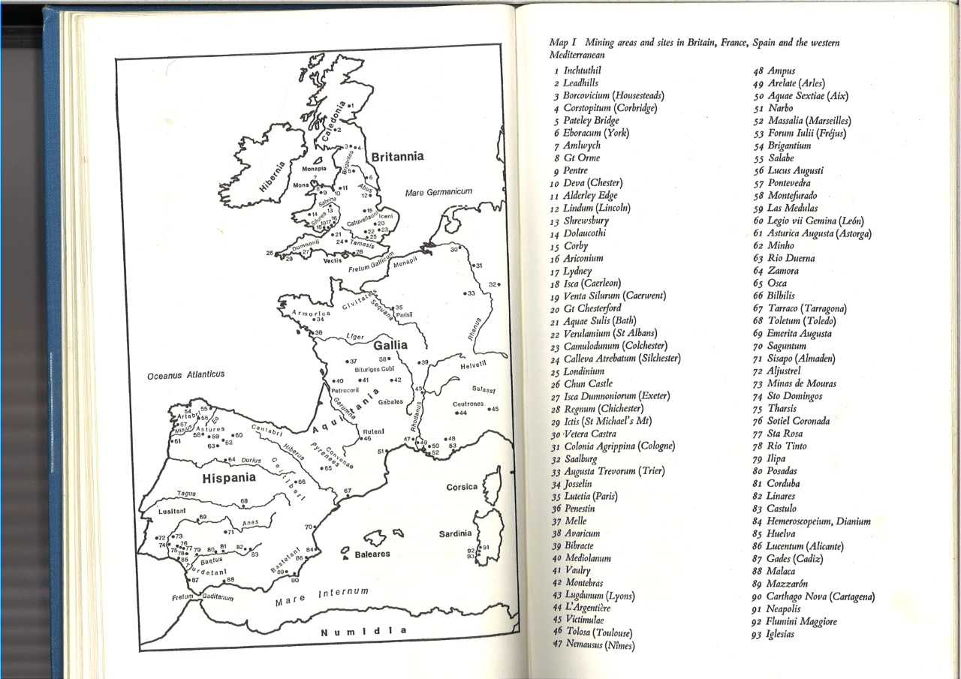

Six: Mining areas and sites in the central and eastern Mediterranean. Healy 1978: 54-5
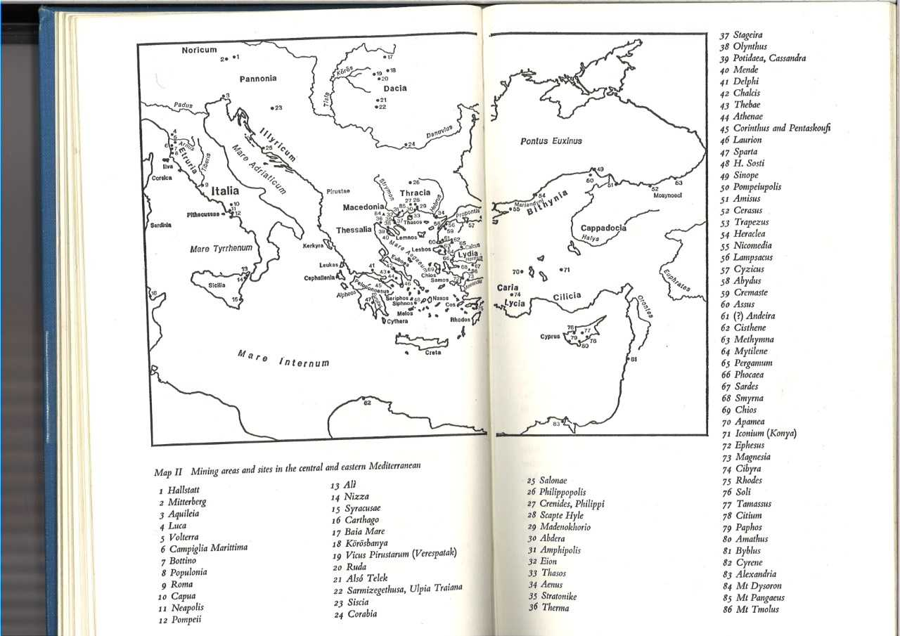

Websites
- Russel, B. ‘Gazetteer of Stone Quarries in the Roman World’ 2013. http://oxrep.classics.ox.ac.uk. http://oxrep.classics.ox.ac.uk/docs/Stone_Quarries_Database.pdf [Accessed 30/12/2017]
- ‘Exhibition and Artefacts’. https://museum.wales. https://museum.wales/roman/exhibitions-and-artefacts/ [Accessed 01/01/2018]

Sidebotham 2008: 57-8, 239, 317
Sidebotham 2008: 58; Aston, Harrell and Shaw 2009: 15, 24-5, 34, 44
Sidebotham 2008: 317
Sidebotham 2008: 58; Cobb 2013: 140, 147, 152; Cobb 2015: 187-9
Aston, Harrell and Shaw 2009: 26-61
Aston, Harrell and Shaw 2009: 34
Grant 1995: 25-7; Sidebotham 2009: 69
Aston, Harrell and Shaw 2009: 15; Sidebotham 2008: 227
Ogdan 2009: 148; Sidebotham 2008: 36, 52, 69; Meyer, Earl, Omar, Smither 2003: 15
Sidebotham 2008: 88; Ogdan 2009: 162
Sidebotham 2008: 88, 92
Sidebotham 2008: 27-8
Sidebotham 2008: 24, 27, 29, 48, 171
Sidebotham 2008: 17, 58
Sidebotham 2008: 244
Image One
Image Four, Website 1
Sidebotham 2008: 69, 76-9; Lucas and Harris 2012: 59
Sidebotham 2008: 67, 94; Plin. Nat. 36.9; Lucas, Harris 2012: 73-4
Sidebotham 2008: 87
Sidebotham 2008: 21, 24-6, 29-32, 50-1, 88
Sidebotham 2008: 77
Aston, Harrell and Shaw 2009: 47
Aston, Harrell and Shaw 2009: 24; Lucas and Harris 2012: 389
Sidebotham 2008: 67, 317-9, 336; Grant 1995: 114
Plin. Nat. 37.1
Sidebotham 2008: 239
Image two
Plin. Nat. 37.1
Plin. Nat. 37.36
Plin.Nat.37.10
Grant 1995: 112
Klemm and Klemm 2013: 41; Gale and Stos-Gale 1981: 113
Sidebotham 2008: 239
Diod. 3.12ff
Carol Meyer, Bryan Earl, Mohamed Omar and Robert K. Smither: 19
Ogdan 2009: 162
Ogdan 2009: 162; Klemm and Klemm 2013: 2
Kelmm and Klemm 2013: 17-8; Ogdan 2009: 162; Sidebotham 2008: 143
Sidebotham 2008: 242
Image Three
Grant 1995: 114-8
Sidebotham 2008: 248-9; Klemm and Klemm 2013: 109-10; El-Rahman, Surour, Manawi, Rifai, Motelib, Ali and Dougdoug 2013: 1067
Sidebotham 2008: 249
Sidebotham 2008: 58, 69-70, 89
Klemm and Klemm 2013: 43
Website 2; Cunliffe 1995: 52, 106
Sidebotham 2008: 281
Carol Meyer, Bryan Earl, Mohamed Omar and Robert K. Smither: 32 Klemm and Klemm 2013: 23-4
Klemm and Klemm 2013: 27
Sidebotham 2008: 260, 280
Klemm and Klemm 2013: 10
Sidebotham 2008: 247
Klemm and Klemm and Murr 2001: 658
Sidebotham 2008: 66
Image One, Harrell and Storemyr 2009: 7
Klemm and Klemm 2013: 12
Aston, Harrell and Shaw 2009: 32, 52
Klemm and Klemm 2013: 1ff; Ogdan 2009: 149, 166-7
Aston, Harrell and Shaw 2009: 38, 43
Lucas 1927: 162
Lucas 1927: 166
Davies 1935: 63, 140, 198-9, 226; Domergue 1990: 5; Burnham and Burnham 2004; Diod. 5. 27, 36-8; Strab. 4.2.1-2; Domergue, Serneels, Cauuet, Pailler, Orzechowski 2006: 132
Domergue 1990: 7-12; Plb. 3.57
Domergue 1990: 3
Healy 1978: 45; Plin. Nat. 3.4
Domergue 1990: 324, 519
Davies 1935: 140ff; Domergue, Serneels, Cauuet, Pailler, Orzechowski 2006: 132ff
Parkins and Smith 2005: 62-3; Hdt. 3.57, 6.46, 7.144; Xen. Hell. 4.8.37; Strab. 12.3
Diod. 5.10; Strab. 6.4.1; Plb. 6.17; Verg. G. 2.136
Healy 1978: 45-67; Image Five and Six
Healy 1978: 237-53
Image 4; Strab. 6.4.1
Plin. Nat. 37.7
Plin.Nat 37.10
Plin.Nat. 37.11, 43; Rapp 2009: 101, 105, 113, 118, 216
Hingley, R. 2012: 14, 30
Sidebotham 2008: 247, 253, 258-9

