Material science and building servicess

  - Jac Beynon –2116579 Email – 2116579@student.uwtsd.ac.uk

Contents Page
- Page 2 – Contents Page
- Page 3 – Introduction
- Page 4,5 – Calculations of Room index and Utilisation Fact
- Page 6 – Lighting layout (S max figure)
- Page 7,8 – Sound Reduction index
- Page 9 – Reference list

Introduction
In this report I will be using my mathematical skills, my knowledge in the construction industry and what I have learned in my lectures over the last months to calculate room index, utilisation factors with full workings out, I will also calculate how many lamps are needed for a room though using the data I will find out, I will also design a layout for all the lamps on a sketch or on a drawing software. In the second part of the assignment I will be working out the sound reduction index of a brick wall with one opening.
In this work I will demonstrate my understanding of building regulations in relation to the data and calculations I will be working out. By doing this I hope I will learn more about the related topics which will help me explain them and build my knowledge of the industry even further. I will be using written and visual presentation to show my work as I think some data is best shown in an image rather than in a paragraph.
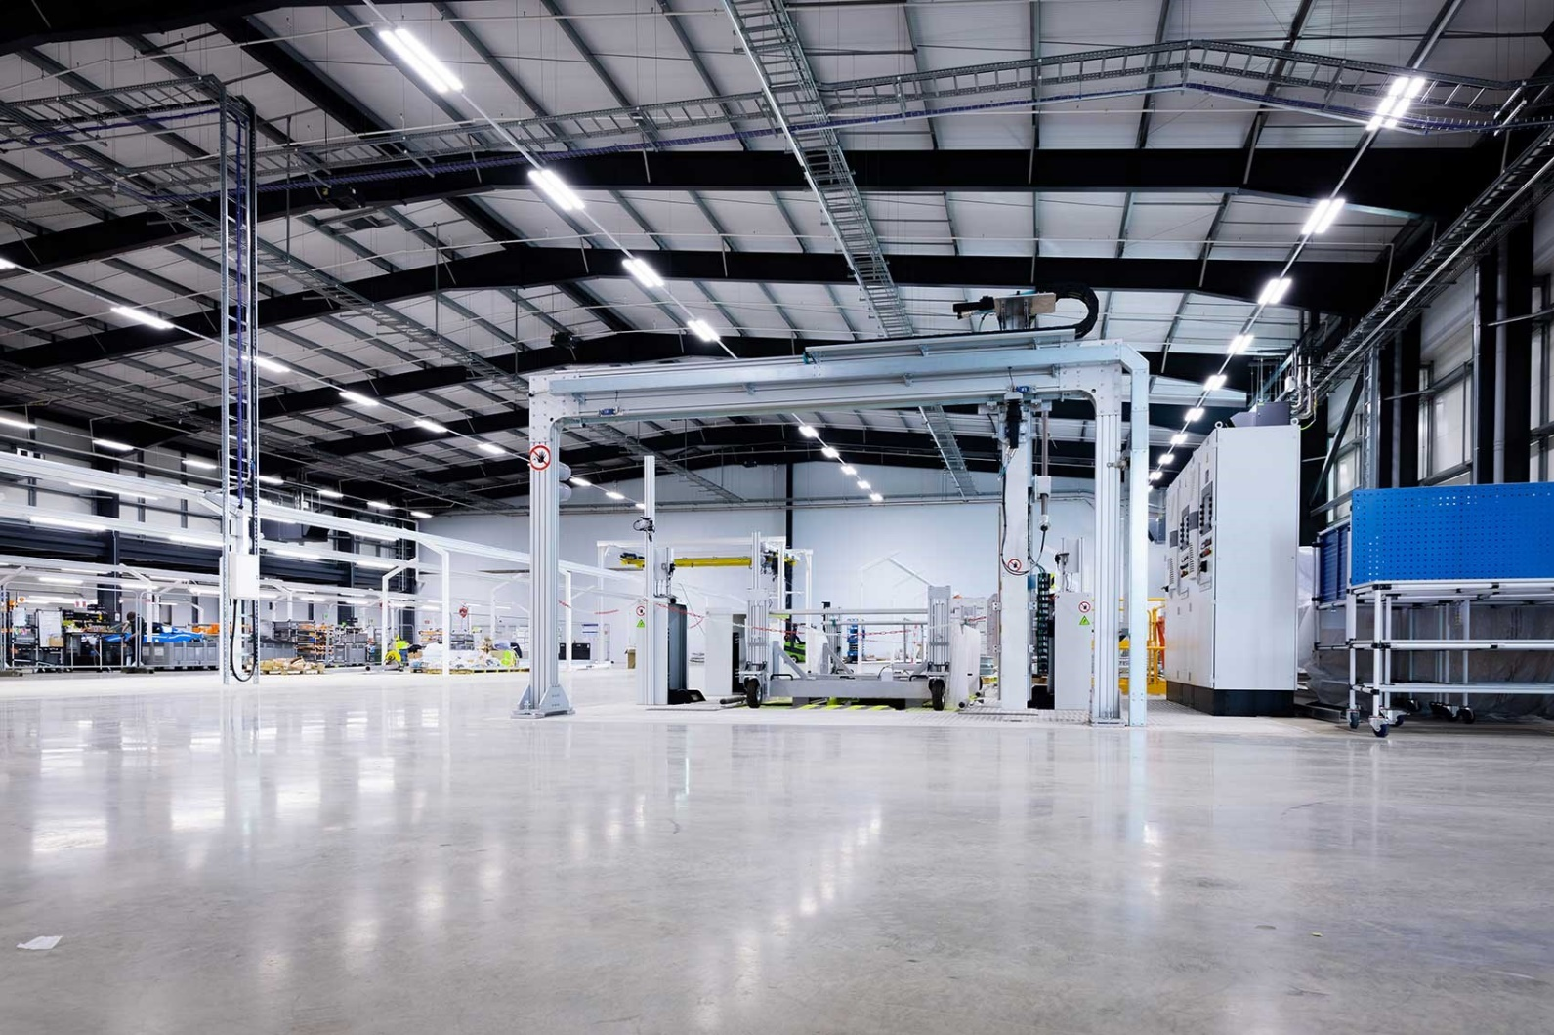
Whilst completing this report I will be referencing to any data I have found and also putting a reference page so any data can be easily found and understood.
(Mcnamara, 2021)

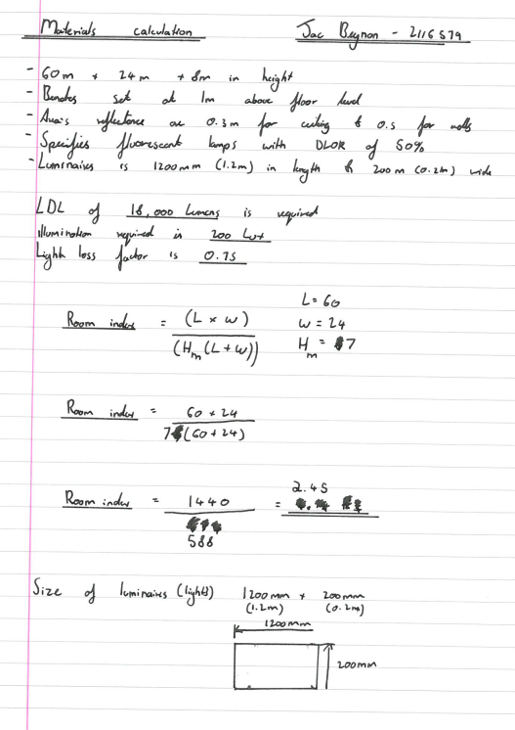
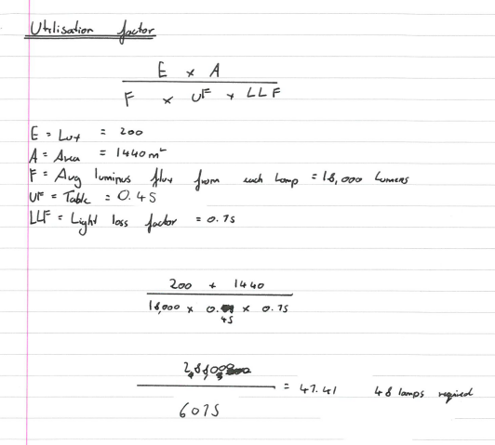

Above you can see both calculations for the room index and the utilisation factor, I chose to do these on paper as I would struggle to do it correctly on the computer but they were both easy enough to complete with help from my notes and knowledge that I have doing these calculations in my lectures.
.

Lighting Layout
As we have found the utilisation factor which is 47.41 but as we round up to the nearest even number the number of lamps required would be 48, this number of lamps will be used to be to light an area of 60m by 24m, and as the lights are 1.2m by 0.2m I think this amount of light would be sufficient enough for the area of the factor.
To work out the layout of the lighting I will need to find out the S max figure which will help me determine the maximum distance I can leave between each fluorescent bulb. The equation for this will be 1.0x H_{m,} the H_{m} figure is the height from the working plane to the top of the room which in this case the H_{m} figure is 7m.
Due to building regulations low energy light fittings must have a luminous efficiency greater than 45lm/W, this matters as 75% of all light fittings in the main space of a building should be low energy (Evangelidis, 2022). There for if this law applies here then we should have 36 energy saving lamps here.

S max equation
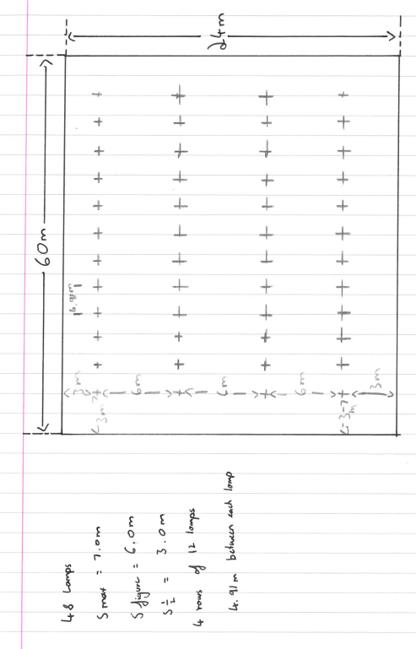
S max = 1.0 x H_{m}
S max = 1.0 x 7.0
S max = 7.0
We know that we need 48 lamps to fill the area of the factory which is 60m by 24m and that the lamps cannot be more than 7.0 meters apart from each other. The ideal spacing would be 4 rows of 12 lamps.

Sound Reduction Index
The sound reduction index is the measure of the insulation against the direct transmission of airborne sound.

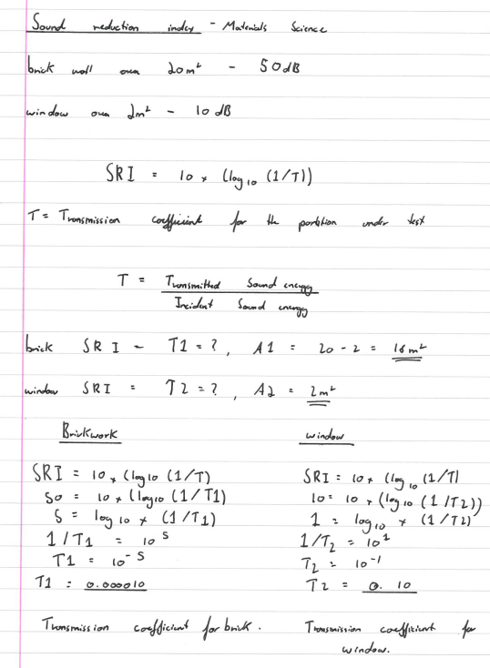

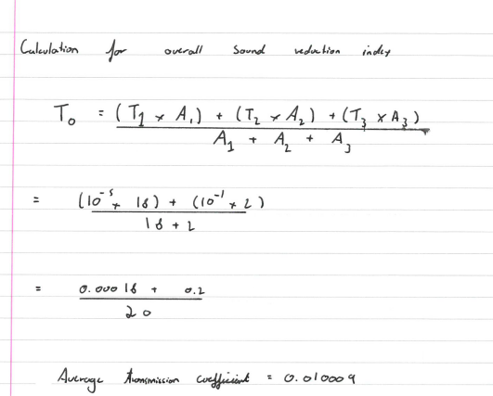

Implications of frequency and wavelength in building materials/ construction
Sound can be measured in frequency by measuring the number of sound vibrations per second (Healthy Hearing, n.d), but sound itself is measured in decibels, this can affect certain construction elements such as insulation. If proper insulation is not used then noise will be transferred through wales but if recommended insulation is used such as fiberglass insulation which can trap and absorb sound waves (Better Soundproofing, 2019) which would keep sound inside and noise which is outside would not be heard inside.
Along with this a properly built partition wall would help dampen sound, there are 2 options steel and wood and as wood would influence greater sound conditioning over steel (Lyons, 2021) then a wood stud wall would have a better affect on blocking and not allowing sound through it along with proper insulation. As having in proper partition wall construction and insulation would allow waves of sound to be transmitted through the wall which would mean not a better wall and insulation is needed to make sure this does not happen.

Reference list
- Better Soundproofing. (2019). Best Soundproofing Insulation for Noise Reduction. [online] Available at: https://bettersoundproofing.com/best-soundproofing-insulation/#:~:text=Fiberglass%20Insulation.
- Evangelidis, A. (2022). Part L Building Regulations: LENI introduced – April 6th 2014 – Lyco. [online] lyco.co.uk. Available at: https://www.lyco.co.uk/advice/part-l-building-regs-leni-update/.
- Healthy Hearing. (n.d.). What is a decibel and what does it measure? [online] Available at: https://www.healthyhearing.com/report/52514-What-is-a-decibel#:~:text=Decibels%20measure%20sound%20intensity%20(amplitude)&text=Frequency%2C%20reported%20in%20Hertz%20(Hz [Accessed 3 May 2022].
- McNamara, P. (2021). New Lotus sports car factory: the first tour. CAR Magazine. [online] 16 Apr. Available at: https://www.carmagazine.co.uk/car-news/industry-news/lotus/inside-new-lotus-factories/ [Accessed 18 Apr. 2021].

