
APPENDIX GA36a

LEVEL 4 ASSESSMENT SPECIFICATION

Student name: | Daniel Smith | Student ID number: | 144455
Programme: | HNC Process Operations Engineering
Module: | Industrial Process Operations and Control
Module code: | PCPO4004 | Contribution to Overall Module Assessment (%): | 50%
Lecturer: | Adam Jenkins | Internal Verifier: | Lance Rutherford
Assignment Title: | Process Automation | Word count (or equivalent): | 2000
Submission deadline: | 06/05/2020 | Return date of provisional marks & written feedback: | 27/05/2020
Submission method: | All written assessments, where practical and possible, must be submitted via Turnitin unless otherwise instructed by the Lecturer. (Please DO NOT put this assessment specification into Turnitin or it will match many similarities with other students’ submissions.)  Alternative submission method (if applicable):  Late submission of the assessment will result in a late penalty mark. Penalties for late submission: Up to one week late, maximum mark of 40%. Over one week late, 0%. Only the Extenuating Circumstances Panel may approve a change to submission dates.
Academic honesty / referencing: | Academic honesty is required. In the main body of your submission you must give credit to authors on whose research and ideas your work is based. Append to your submission a reference list that indicates the books, articles, etc. that you have used, cited or quoted in order to complete this assessment.

Module Learning Outcomes
(from module syllabus)
LO1, LO2, LO3.

TASK DESCRIPTION

Assignment Brief

The aim of this assignment is to investigate process automation techniques and apply this knowledge to a range of practical exercises. The exercises will use virtual process environments in simulation software including LabView, TSC simulation, Automation Studio and the virtual control room (VCR). You will also be asked to investigate the application of SCADA systems.

Introduction

In manufacturing industry today programs such as LabView, TSC simulation and Automation Studio are used to design, construct and test control systems in a safe virtual environment. For this assignment you are required to complete a series of observed practical assessments using these virtual development and simulation environments.

These assessments will include:

- The safe start-up of process systems using written procedures
- Controlling product manufacturing to meet operational specifications
- Alarm handling and emergency shutdown (ESD)
- Development, design and implementation of control systems and strategies

The assignment practical exercise will include:

Exercise 1. Duty / standby pumping operation (TSC Simulation and VCR).
Exercise 2. Steam generation plant operation (LabView)
Exercise 3. Bottle filling plant (Automation Studio).

Task 1.

Exercise 1. Pumping Operation (SIM290 Basic Pump Operations).

The pump operation model (see figure 1) consists of a tank with a single feed line and a single exit line that has two pumps installed in parallel. A flow controller controls the flow rate through the pumps and in the event of low flow condition the controller opens a recycle back to the tank. A level controller and second flow controller (which controls the flow leaving the system) are used in cascade to control the level in the tank. The system is designed to protect the pumps should the supply feed fail.

Familiarise yourself with the operation of the storage tank pumping system. Write a standard operating procedure (SOP) for the manual changeover of the pumping system from P_101A to P_101B. Include information on the operation of valves, flow control and alarms. In addition, include an emergency shutdown procedure for the pumping system.

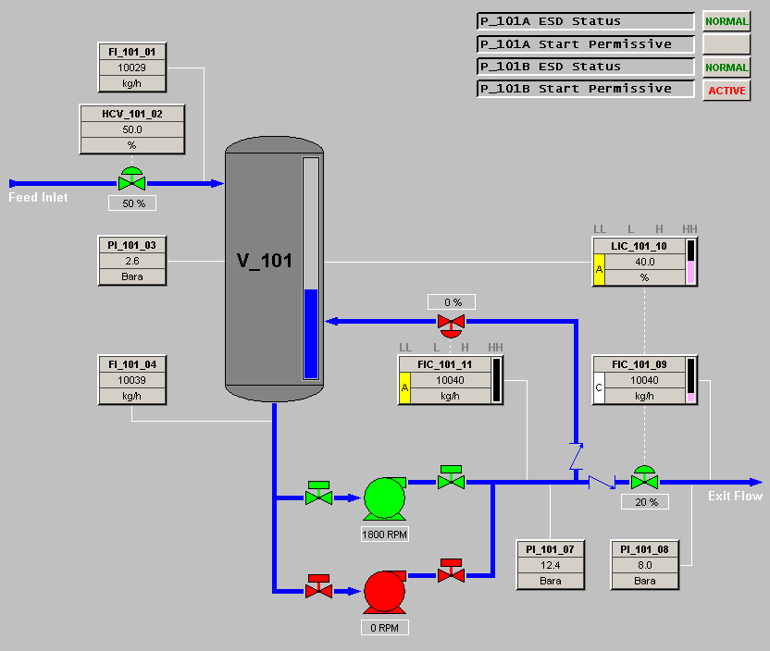

Figure 1. V101 system pumping operation.

Exercise 2. Steam generation plant operation.

Familiarise yourself with the steam generation system virtual simulator (see figure 2). The simulator consists of a boiler, FD fan, water feed pump, valves, instrumentation and control panels. The boiler and associated equipment can be operated from BO101control panel.
To support the safe operation of the boiler the system check panel should be used to confirm progression of the start-up process. The level alarm panel will indicate the boiler drum level and level alarms. The trend window can be used to monitor the boiler drum water level.

For this exercise you are required to start up the boiler to the point where steam is being generated and from your knowledge of the system develop the following in a report format:
- An explanation of the general operation of the process identifying specific equipment and a review of the instrumentation.
- A detailed standard operating procedure (SOP) to ensure safe and consistent start-up and operation of the boiler (ensure the SOP clearly states the operational steps)
- A timing diagram for the systems check process
- An alarm and interlock matrix table
- A fault finding guide should the system lock out operate.

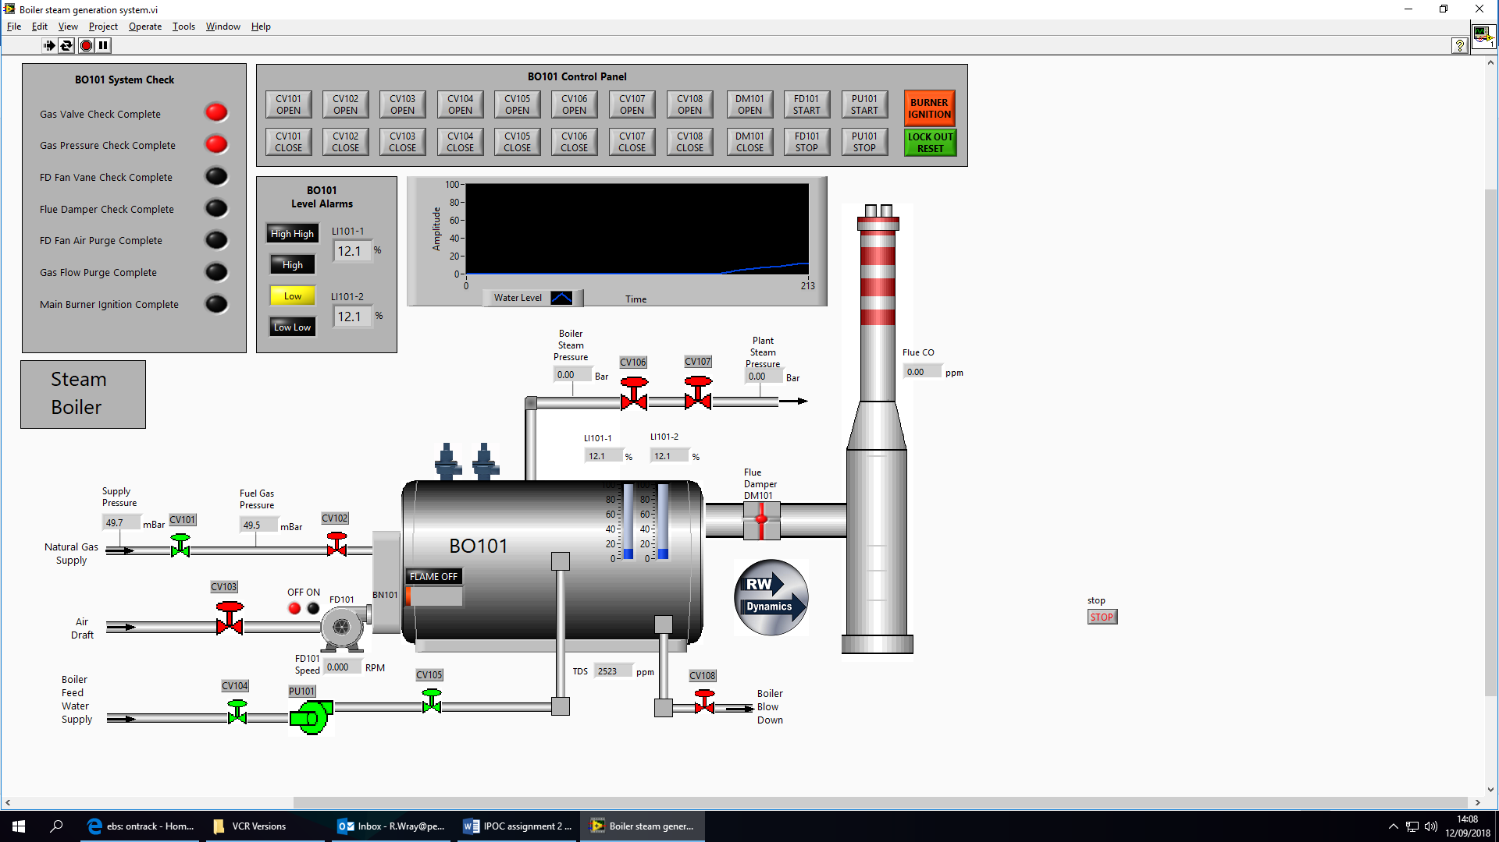
Figure 2. Steam generation process.

Exercise 3. Bottling Plant Operation

This production process (see figure 3) places bottles onto the conveyor where they are moved to the filling and capping stations in turn. The operation of the bottle filling system is currently under manual control through the use of various buttons on the control panel. The process is to be fully automated and requires a sequential control strategy to be developed.
Familiarise yourself with the process and through your knowledge of these systems construct a flow diagram for all the sequential control operations. Included in your flow diagram all consecutive and concurrent processes to ensure bottles will be filled and capped in a continuous process. Briefly discuss the process and the application of the sequential control system.

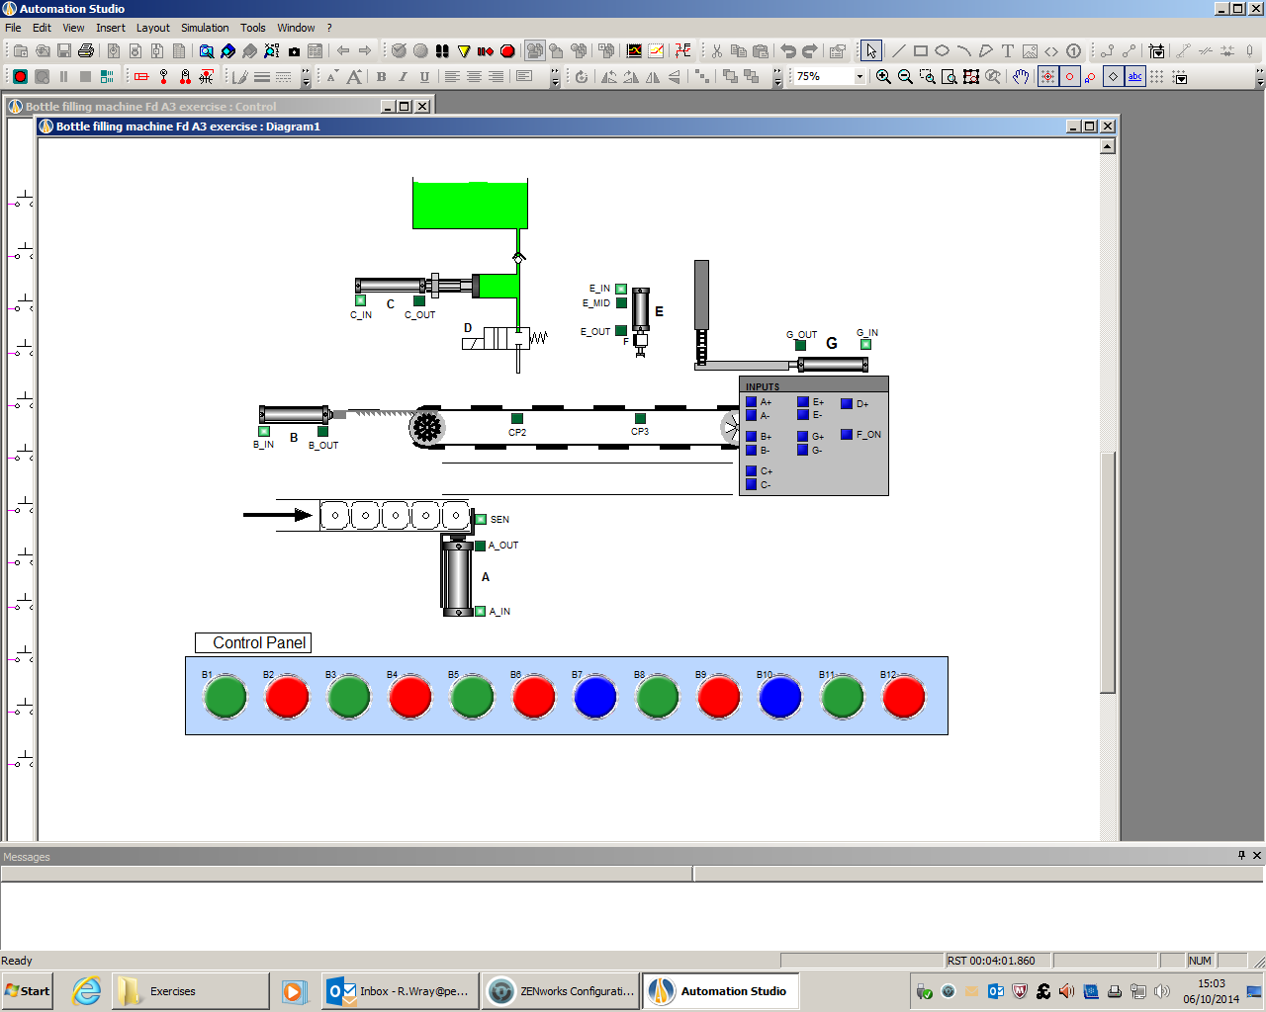
Figure 3. Bottle filling process.

Task 2. SCADA (Supervisory Control and Data Acquisition)

SCADA systems are now used in multiple engineering industries like Valero and First Milk where they are an essential part of the industrial plant operation.

Produce a report discussing the key features of SCADA systems and how HMI and PLCs are integrated into them and, where possible, include industrial examples from your workplace.

GUIDANCE FOR Students IN THE COMPLETION OF TASKS

NOTE: The guidance offered below is linked to the five generic assessment criteria overleaf.

- Engagement with Literature Skills
Your work must be informed and supported by scholarly material that is relevant to and focused on the task(s) set. You should provide evidence that you have accessed an appropriate range of sources, which may be academic, governmental and industrial; these sources may include academic journal articles, textbooks, current news articles, organisational documents, and websites. You should consider the credibility of your sources; academic journals are normally highly credible sources while websites require careful consideration/selection and should be used sparingly. Any sources you use should be current and up-to-date, mostly published within the last five years or so, though seminal/important works in the field may be older. You must provide evidence of your research/own reading throughout your work, using a suitable referencing system, including in-text citations in the main body of your work and a reference list at the end of your work.

Guidance specific to this assessment: You must provide evidence of individual research with respect to the area of study and provide relevant referencing.

- Knowledge and Understanding Skills
At level 4, you should be able to demonstrate knowledge of the underlying concepts and principles associated with your area(s) of study. Knowledge relates to the facts, information and skills you have acquired through your learning. You demonstrate your understanding by interpreting the meaning of the facts and information (knowledge). This means that you need to select and include in your work the concepts, techniques, models, theories, etc. appropriate to the task(s) set. You should be able to explain the theories, concepts, etc. to show your understanding. Your mark/grade will also depend upon the extent to which you demonstrate your knowledge and understanding.

Guidance specific to this assessment: Your report should show you gained knowledge of the subject area.

- Cognitive and Intellectual Skills
You should be able to present, evaluate and interpret qualitative and quantitative data, in order to develop lines of argument and make sound judgements in accordance with basic theories and concepts of your subject(s) of study. You should be able to evaluate the appropriateness of different approaches to solving problems related to your area(s) of study and/or work. Your work must contain evidence of logical, analytical thinking. For example, to examine and break information down into parts, make inferences, compile, compare and contrast information. This means not just describing what! But also justifying: Why? How? When? Who? Where? At what cost? You should provide justification for your arguments and judgements using evidence that you have reflected upon the ideas of others within the subject area and that you are able to make sound judgements and arguments using data and concepts. Where relevant, alternative solutions and recommendations may be proposed.

Guidance specific to this assessment: The report should show analysis of the research and practical exercises.

- Practical Skills
At level 4, you should be able to apply the basic underlying concepts and principles to evaluate and interpret these within the context of your area of study. You should be able to demonstrate how the subject-related concepts and ideas relate to real world situations and/or a particular context. How do they work in practice? You will deploy models, methods, techniques, and/or theories, in that context, to assess current situations, perhaps to formulate plans or solutions to solve problems, or to create artefacts. This is likely to involve, for instance, the use of real world artefacts, examples and cases, the application of a model within an organisation and/or benchmarking one theory or organisation against others based on stated criteria.

Guidance specific to this assessment: Completion of the practical tasks with clear evidence of meeting the exercises specifications.

- Transferable Skills for Life and Professional Practice
Your work must provide evidence of the qualities and transferable skills necessary for employment requiring the exercise of some personal responsibility. This includes demonstrating: that you can communicate the results of your study/work accurately and reliably, and with structured and coherent arguments; that you can initiate and complete tasks and procedures, whether individually and/or collaboratively; fluency of expression; clarity and effectiveness in presentation and organisation. Work should be coherent and well-structured in presentation and organisation.

Guidance specific to this assessment: Your work should be well organised and presented in a professional manner.

Student FEEDBACK FORM

This section details the extent to which the assessment criteria are demonstrated by you, which in turn determines your mark. The marks available for each category of skill are shown. Lecturers will use the space provided to comment on the achievement of the task(s), including those areas in which you have performed well and areas that would benefit from development/improvement.

Generic Assessment Criteria | Marks available | Marks  awarded
1. Engagement with Literature Skills
.
 | 10
2. Knowledge and Understanding Skills

 | 20
3. Cognitive and Intellectual Skills

 | 30
4. Practical Application Skills

 | 30
5. Transferable Skills for Life and Professional Practice

 | 10

Assessment Mark (Assessment marks are subject to ratification at the Exam Board. These comments and marks are to give feedback on module work and are for guidance only until they are confirmed. ) | Late Submission Penalties (tick if appropriate) |  | %
 | Up to 1 week late (40% Max) |  | %
 | Over 1 week late (0%) |  | %

GENERIC ASSESSMENT CRITERIA

Level 4
In accordance with the Framework for Higher Education Qualifications, at the end of Level 4 students will be expected to have demonstrated knowledge of the basic underlying concepts and principles of a subject, and an ability to evaluate and interpret these within the context of that area of study. They should be able to present, evaluate and interpret qualitative and quantitative data in order to develop lines of argument and make sound judgements in accordance with basic theories and concepts of their subject(s) of study. They will have learned how to evaluate different approaches to solving problems, and will be able to communicate the results of their study/work accurately and reliably, and with structured and coherent arguments. They will be able to undertake further training and develop new skills within a structured and managed environment and will have the qualities and transferable skills necessary for employment requiring the exercise of some personal responsibility.

Level 4 | FAIL | MARGINAL FAIL | SATISFACTORY  (3rd / Pass) | GOOD  (2.2 / Pass) | VERY GOOD  (2.1 / Merit) | EXCELLENT  (1st / Distinction) | EXCEPTIONAL  (1st / Distinction)
Category | 0-29% | 30-39% | 40-49% | 50-59% | 60-69% | 70-84% | 85-100%
Engagement with literature (including reading, referencing,  academic conventions and  academic honesty) | Little or no evidence of reading and/or reliance on inappropriate sources.  Views and findings mostly unsupported and non-authoritative.  Referencing conventions used incoherently or largely absent. | Poor engagement with essential reading. No evidence of wider reading. Reliance on inappropriate sources, and/or indiscriminate use of sources. Heavily reliant on information gained through class contact. Inconsistent and weak use of referencing. | Engagement with a limited range of mostly relevant and credible sources but with some reliance on information gained through class contact. Some omissions and minor errors.  Referencing conventions evident though not always applied accurately or consistently. | Engagement with an appropriate range of literature, including sources retrieved independently. Some over-reliance on texts rather than other sources. Referencing may show minor inaccuracies or inconsistencies. | Engagement with a wide range of literature, including sources retrieved independently.  Selection of relevant and credible sources. Generally sound referencing, with no/very few inaccuracies or inconsistencies. | Engagement with an extensive range of relevant and credible literature. Consistently accurate application of referencing. | Exceptional engagement with an extensive range of relevant and credible literature. High-level referencing skills consistently applied.
Knowledge and understanding (Knowledge of the basic underlying concepts and principles of a subject.) | Major gaps in knowledge and understanding of the basic underlying concepts and principles of the subject matter. Inclusion of irrelevant material. Substantial inaccuracies. | Gaps in knowledge of the basic underlying concepts and principles, with flawed or superficial understanding. Some significant inaccuracies and/or irrelevant material. | Limited knowledge and understanding of the basic underlying concepts and principles within the subject area. Some elements may be missing. | Knowledge of the basic underlying concepts and principles is accurate with a good understanding of the field of study but lacks depth and/or breadth. | Competent knowledge of the basic underlying concepts and principles. Exhibits very good understanding. | Excellent knowledge and understanding of the basic underlying concepts and principles of the subject. | Exceptional, detailed knowledge and understanding of the basic underlying concepts and principles
Cognitive and intellectual skills  (Evaluate underlying concepts and principles of a subject and interpret qualitative and quantitative data in order to develop lines of argument and make sound judgements.) | Wholly or almost wholly descriptive work. Little or no evaluation of the underlying concepts and principles.  Failure to develop arguments, leading to illogical or invalid judgements. Minimal or no use of  evidence to back up views. | Largely descriptive work, with superficial evaluation of the underlying concepts and principles. Weak interpretation of data, flawed development of arguments and judgements. Information accepted uncritically, uses generalised statements made with scant evidence and unsubstantiated opinions. Ideas sometimes illogical and contradictory. | Limited attempt at evaluation of the underlying concepts and principles, tending towards description.  Can interpret qualitative and quantitative data but with some errors. Some evidence to support emerging arguments and judgements but these may be underdeveloped or with a little inconsistency / mis-interpretation. | Good evaluation of the underlying concepts and principles. Can interpret qualitative and quantitative data, with minor errors.  An emerging ability to use evidence to support the argument.  Mostly valid arguments and logical judgements. | Sound evaluation of the underlying concepts and principles. Can interpret qualitative and quantitative data accurately. Ability to devise arguments using evidence to make mostly appropriate and valid judgements. | Excellent evaluation of the underlying concepts and principles. Can interpret qualitative and quantitative data accurately and with some insight. Excellent ability to devise arguments using evidence and make appropriate and valid judgements. | Exceptional evaluation of the underlying concepts and principles based evidence. Outstanding interpretation of qualitative and quantitative data.  Exceptional ability to devise arguments using evidence and make wholly appropriate and valid judgements.
Practical skills  (Different approaches to solving problems in particular contexts.) | Limited or no use of taught, basic methods, materials, tools and/or techniques.  Little or no appreciation of the context of the application.  Very weak evidence of different approaches to problem-solving in particular contexts. | Rudimentary application of taught, basic methods, materials, tools and/or techniques but without consideration and competence. Flawed appreciation of the context of the application.  Weak evidence of different approaches to problem-solving in particular contexts. | An adequate awareness and mostly appropriate application of basic methods, materials, tools and/or techniques.  Basic appreciation of the context of the application.  Can identify problems in particular contexts and propose basic alternative approaches or solutions though there may be errors. | A good and appropriate application of basic methods, materials, tools and/or techniques.  Clear appreciation of the context of the application.  Good evidence of different approaches to problem-solving in particular contexts and proposes mostly appropriate solutions. | A very good application of a range of basic methods, materials, tools and/or techniques.  Very good consideration of the context of the application. Very good evidence of different approaches to problem-solving in particular contexts and proposes appropriate solutions. | An advanced application of a range of taught, basic methods, materials, tools and/or techniques.  The context of the application is well considered, and insightful.  Excellent evidence of different approaches to problem-solving in particular contexts and proposes appropriate solutions. | Exceptional levels of application and deployment skills in particular practical contexts. Outstanding identification of problems in particular contexts and formulation of wholly appropriate, thoughtful solutions / different approaches.
Transferable skills for life and professional practice  (Communicate the results of their study/work accurately and reliably, and with structured and coherent arguments; the qualities needed for employment requiring the exercise of some personal responsibility within a structured and managed environment.) | Work is poorly structured, disorganised, inaccurate and/or confusingly expressed. Very weak use of language and/or very inappropriate style. Failure to work effectively individual or as part of a group. Little or no evidence of the skills for employment requiring the exercise of some personal responsibility. | Work is poorly presented in a disjointed manner. It is loosely, and at times incoherently, structured, with information and ideas often poorly expressed. Weak use of language and/or inappropriate style. Flawed approach to individual or group work, meeting only partial obligations to others. Limited evidence of the skills for employment requiring the exercise of some personal responsibility. | Mostly ordered presentation and structure in which relevant ideas / concepts are reasonably expressed. Work may lack coherence and/or accuracy in places. Can work as part of a group, meeting most obligations to others but perhaps with limited involvement in group activities.  Demonstrates the basic skills for employment requiring the exercise of some personal responsibility, with some areas of minor weakness. | Mostly coherent, organised and accurate work, in a suitable structure and is for the most part clearly expressed. Can work effectively independently and/or as part of a team, with clear contribution to group activities.  Demonstrates the skills for employment requiring the exercise of some personal responsibility, with some areas of strength and some of minor weakness. | Work is accurate, coherent, fluent, well-structured and organised.  Can work effectively independently and/or as part of a team, with very good contribution to group activities. Demonstrates very good skills for employment requiring the exercise of some personal responsibility, with just occasional minor weakness. | Work is coherent, very fluent and is presented professionally. Can work effectively independently and/or as part of a team, with an excellent contribution to group activities. Demonstrates excellent skills for employment requiring the exercise of some personal responsibility with an appetite for further development. | Work is accurate, exceptionally coherent, very fluent and presented well. Can work effectively independently and/or as part of a team, with an exceptional contribution to group activities. Demonstrates exceptional skills for employment requiring the exercise of some personal responsibility with an appetite for further development.

THIS DOCUMENT IS ALSO AVAILABLE IN WELSH


Industrial Process Operations and Control

Contents Page

Task 1 Page 17 – 19.

Task 2 Page 20 – 26.

Task 3 Page 27 – 28.

Task 4 Page 29 - 31.
Task 1 – Pumping Operation
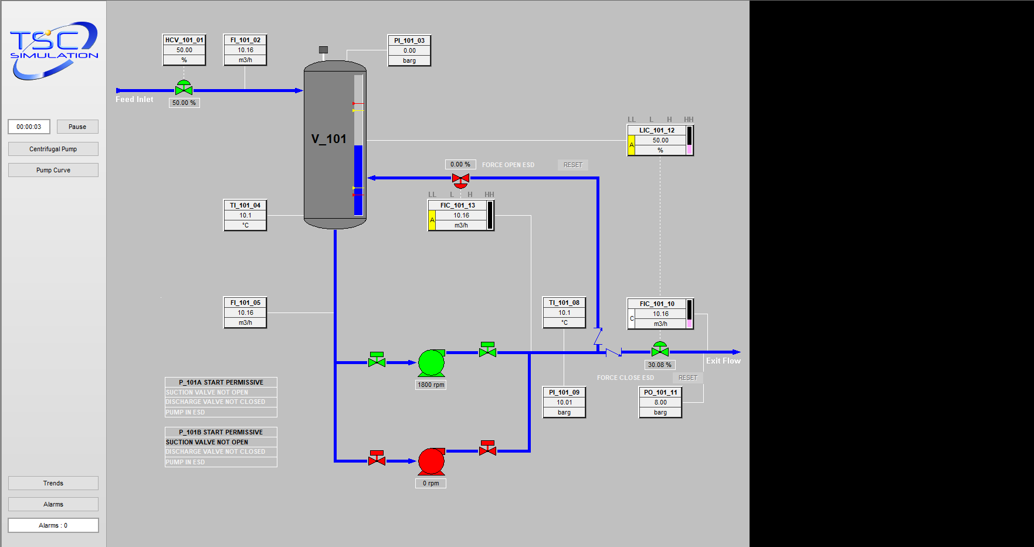

 | Standard Pump Switch Operation
Step | Activity
1. | Open globe valve XV_101B_06.
2. | Run up P_101B pump.
3. | Allow P_101B to run up to max speed.
4. | Ensure no system alarms are set off from vibes readings, temperature or flow readings.
5. | Open globe valve XV_101B_07 slowly to gradually introduce more flow.
6. | Ensure no alarms are set off by the increased level of flow through flow sensor.
7. | Close control valve XV_101A_07.
8. | Allow time for system to settle.
9. | Turn off pump P_101A.
10. | Close control valve XV_101A_06.
11. | Leave pump P_101B run and check the flow rate of pump to ensure no abnormalities.

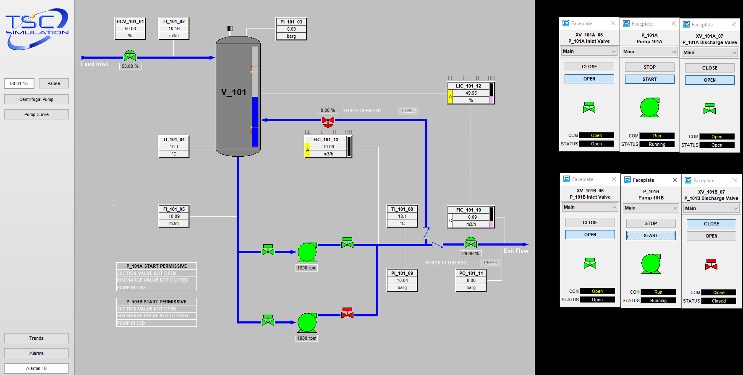
Steps 1-4.
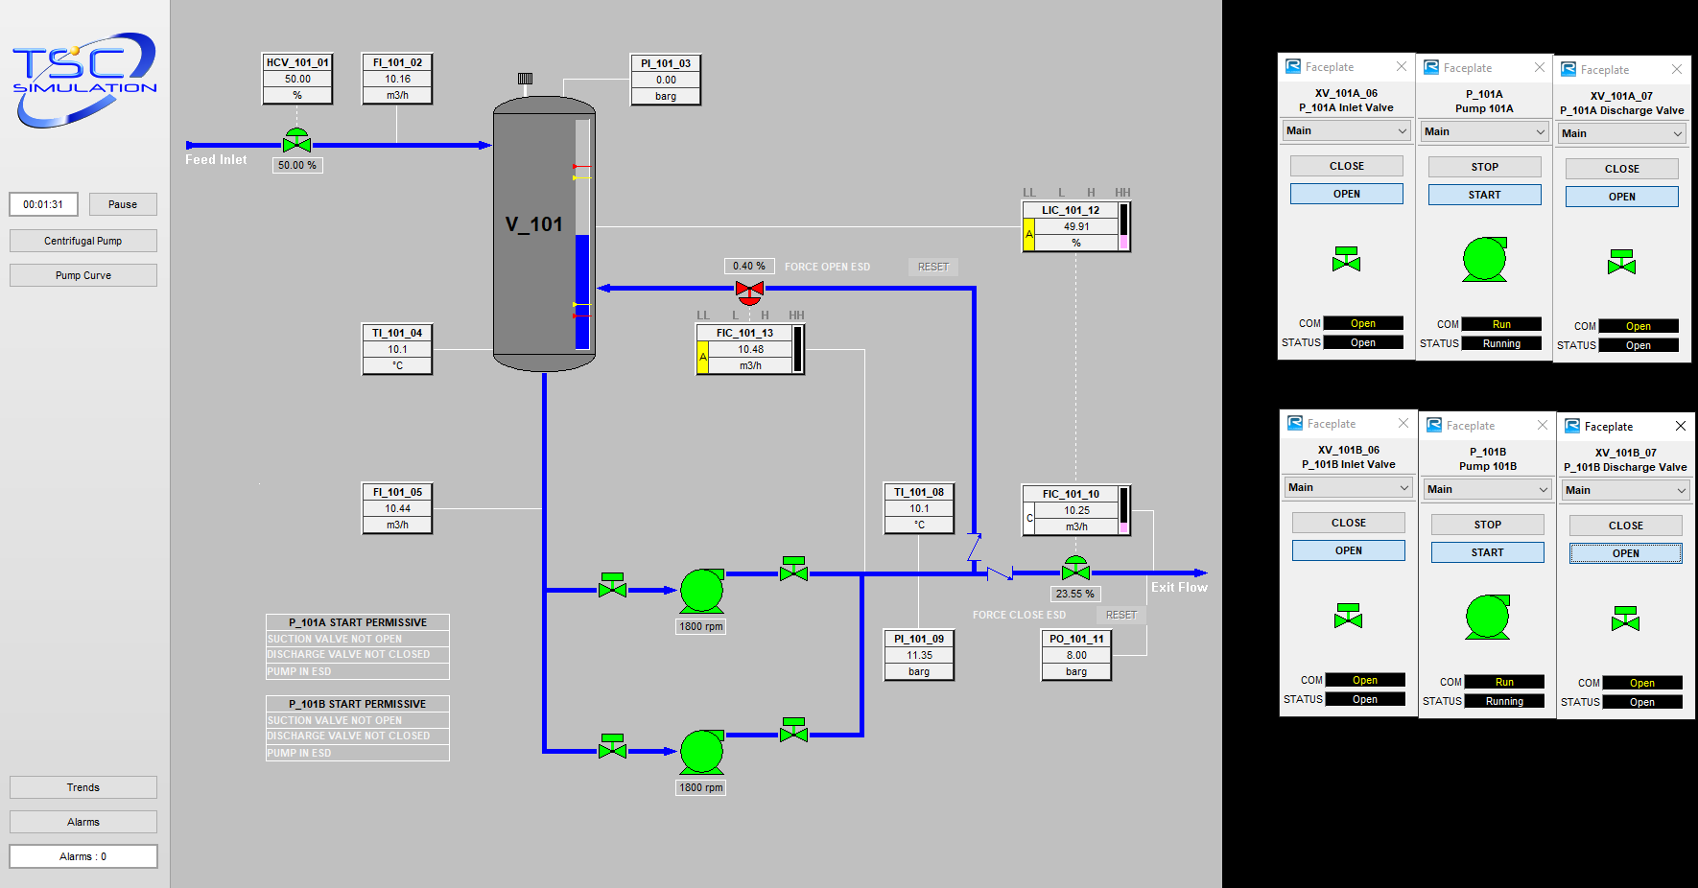
Steps 5-6.
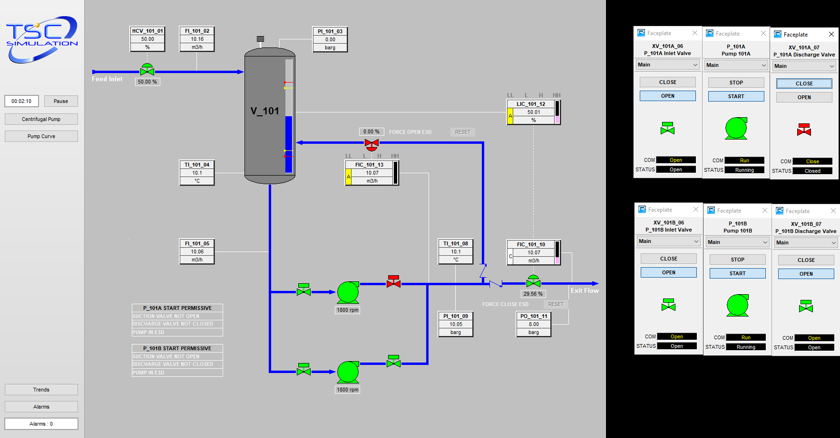
Steps 7-8.
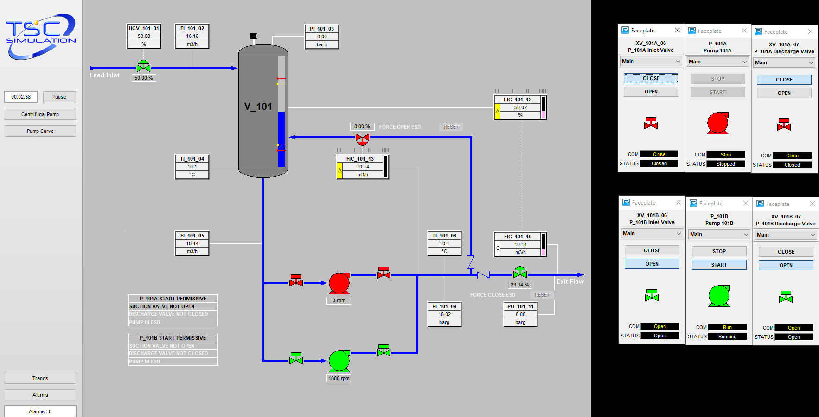
Steps 9-11.

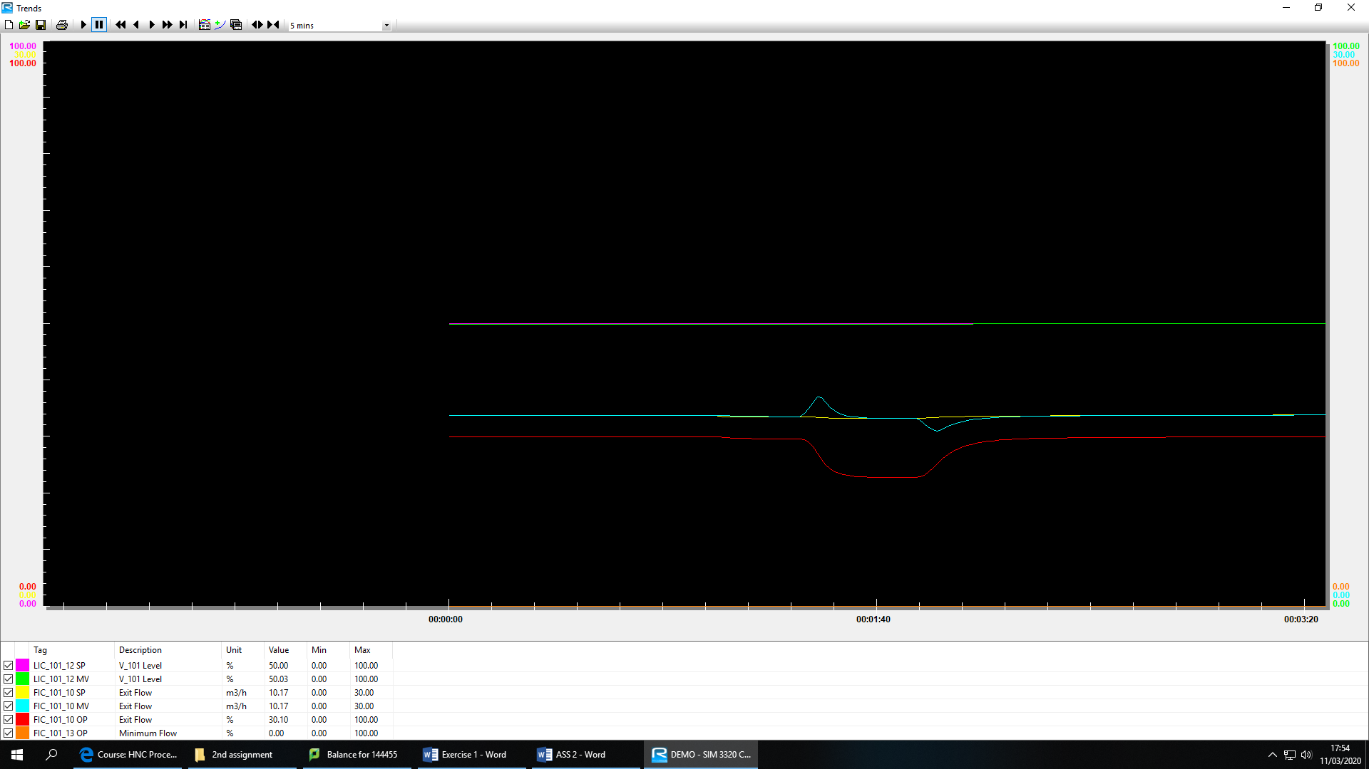
Trends throughout the pump switch operation.

 | Emergency Shutdown Procedure
Steps | Activity
1. | Close discharge valve of operating pump.
2. | Shutdown operating pump.
3. | Close suction valve.
4. | Block in valve providing product to pumps from vessel.
5. | Direct flow from vessel when high alarm sounds.

Task 2
A fire tube steam boiler operates through a combustion reaction between fuel gas and air to cause a flame, these ignite into tubes which are submerged in water throughout a vessel. Boiler feed water is added to the vessel where the flames are produced, the heat is then transferred from the tubes which run inside of the water. After time the water is boiled and evaporated into steam, the steam is then taken via pipes to be removed from the boiler, this is then outputted around the site to be used to power equipment such as turbines or to be used for cleaning. Once the hot gasses have been put through the boiler the gasses are removed via the stack which is controlled by a damper. Within the boiler there is sensors which control the vessel, such as level transmitters these control the amount of boiler feed water being put into the vessel. It also has temperature sensors; these ensure that the temperature outputted from the furnace is consistent to keep the amount of steam outputted constant.
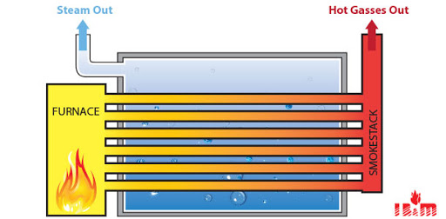
IB&M (2019)

 | Standard Boiler Operation
Steps | Activity
1. | Open Valve CV101.
2. | Wait for pressure to build in the line and allow the sensor to register the check.
3. | Open CV103.
4. | Open flue damper DM101.
5. | Start force draft fan and allow the fan to run to speed.
6. | Open CV104 and CV105.
7. | Start pump PU101 and begin filling tank to around 30%.
8. | Open CV106 and CV107.
9. | Wait for water level to be above low alarm level.
10. | Lockout reset.
11. | Open CV102.
12. | Ignite burner.
13. | When level is around 50-60%.
14. | Close feed water inlet valve and turn off PU101.
15. | Control boiler level via boiler blowdown valve CV108 and by turning PU101 on and adding feed water if needed.

 | System Check Timing Diagram
Check | Duration
Gas valve check. | Instant.
Gas pressure check. | Around a minute.
Flue damper check. | Instant.
FD fan vane check. | Instant.
FD fan air purge. | 45-50 seconds.
Gas flow purge. | Instant.
Main Burner Ignition. | Instant.

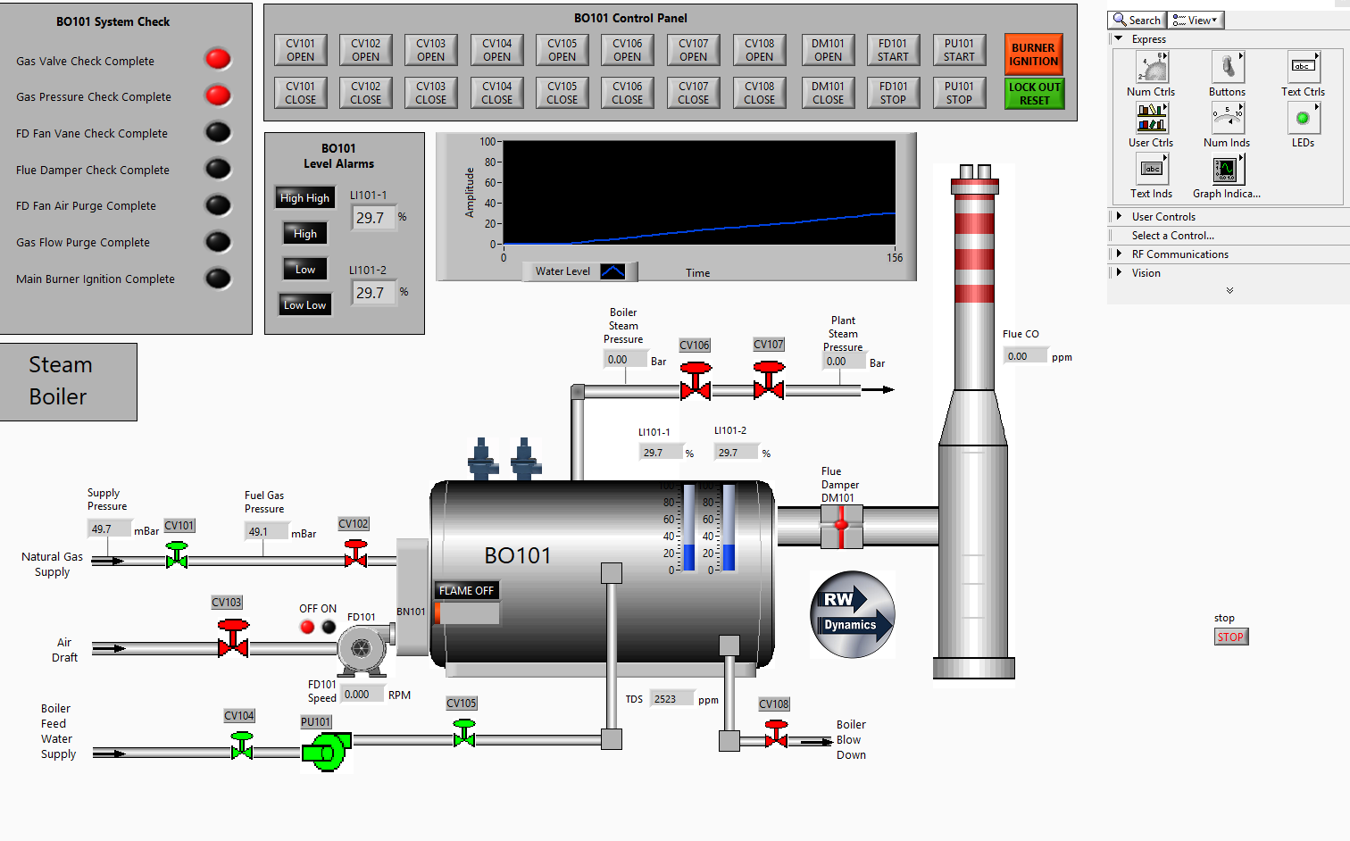
Boiler before start-up procedure.

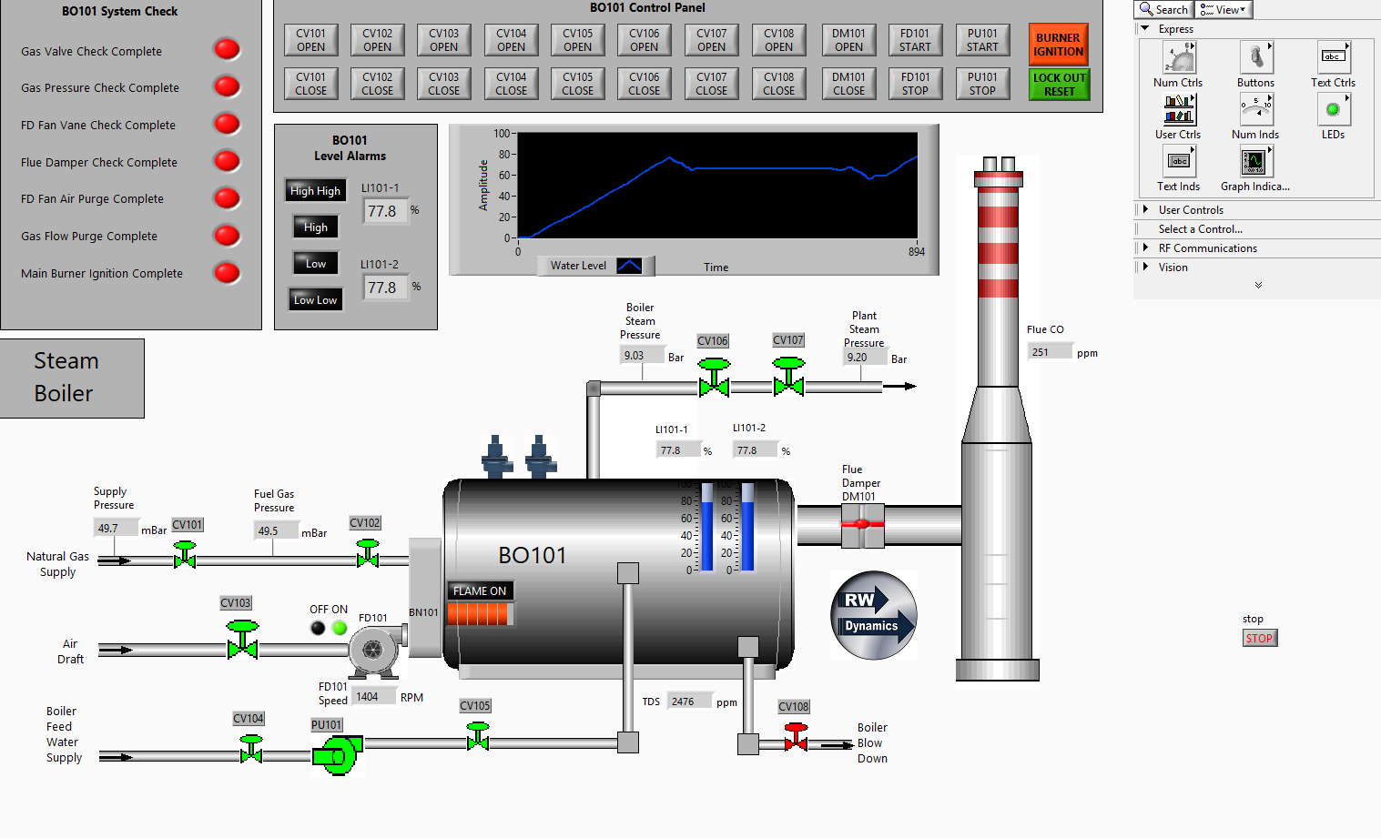
Boiler when fully operational.
 | CV101 | CV102 | CV103 | CV104 | CV105 | CV106 | CV107 | CV108 | DM101 | FD101 | PU101
Gas Valve Check |  | X
Gas Pressure Check |  | X | X
FD Fan Vane  Check |  |  | X
Flue Damper Check |  | X | X |  |  |  |  |  |  | X | X
FD Fan Air Purge |  | X |  |  |  |  |  |  |  | X
Gas Flow Purge |  | X
PU101 |  |  |  | X | X |  |  |  |  |  | -
High Alarm |  | X
High High Alarm |  | X |  |  |  |  |  |  |  |  | X
Low Alarm |  | X
Low Low Alarm |  | X
Lock Out Reset |  | X

Fault Finding Guide for Boiler Operation

CV103 Trip –
If CV103 will not open firstly check for any alarms via the alarm panel, if the gas pressure check alarm is not on then check to see if valve CV102 is open, if not open this and check to see if the alarm is cleared. If this is still not fixed, then check to make sure that the flue damper check alarm is not active, if it is then ensure CV102 is open. If the error is still not fixed then check to ensure that the force draft fan is operational, to do this follow the steps to switch on FD fan and let run to speed, check to see if the alarm was silenced. If the alarm is still active, then check to see if PU101 is running.

Damper Trip –
If Damper will not open, then ensure the steps taken on the previous fault finding have been carried out. Also ensure CV103 is open.

High High Alarm –
If high high alarm is sounded ensure CV105 is closed and PU101 is turned off. Ensure CV108 is opened for boiler blowdown, this will drain boiler feed water level and should remove high high alarm. If high high alarm is still present, check CV102 is not open.

PU101 Alarm –
Ensure High High alarm not active as this can trip PU101, if this happens ensure CV104 is open and start the pump, then open CV105 and allow pump to run to speed. To run this pump both valves need to be open constantly.

Task 3
Sequential control is a control system which uses individual steps to create a step by step system, each one of these steps must be accomplished before the next step begins. This sort of control system can also be time dependant, each point may have to be working for a certain period of time and then the next step can begin, by doing this it ensures that the whole process is at the highest speed it can be at. Another benefit of using this type of control is that if one of the individual steps are not completed it will be noticed and the step will go back and ensure that the step is completed in the correct order.

To create a sequential control system, we need to carry out a flow diagram this allows the system to carry out the step by step strategy. The first step of the flow diagram is to check that the bottle is on the conveyor, if this is not it must go back and retract piston B2 and then move piston B1 forward, this will then make sure the bottle is on the conveyor belt. Then it moves to the second step, it checks to ensure the piston B2 is completely extended, then checks if piston C is retracted and again has a workaround in place in case the piston is not retracted, if it is not then the system will active B6 and it will operate the piston. This then allows the system to move to the filling stage where it ensures that B7 is held down for a time period to ensure that the bottle is filled, it then moves to the next step where it checks that the bottle is filled. If the bottle is not filled then the previous step is carried out again and then moved to the next step where it retracts the conveyor piston by pressing B4 and moves the bottle forward by pressing B3, the next step is to check that the bottle is underneath the piston if not it will go back to the previous steps and carry them out. Then it ensures piston G has a bottle cap on and then moves by pressing B11, this then continues to screw the bottlecap onto the bottle and if the bottlecap is not recognised to be screwed onto the bottle then it will repeat previous steps to ensure it is. It will then continue to move the bottle off of the production line and will repeat the process again.
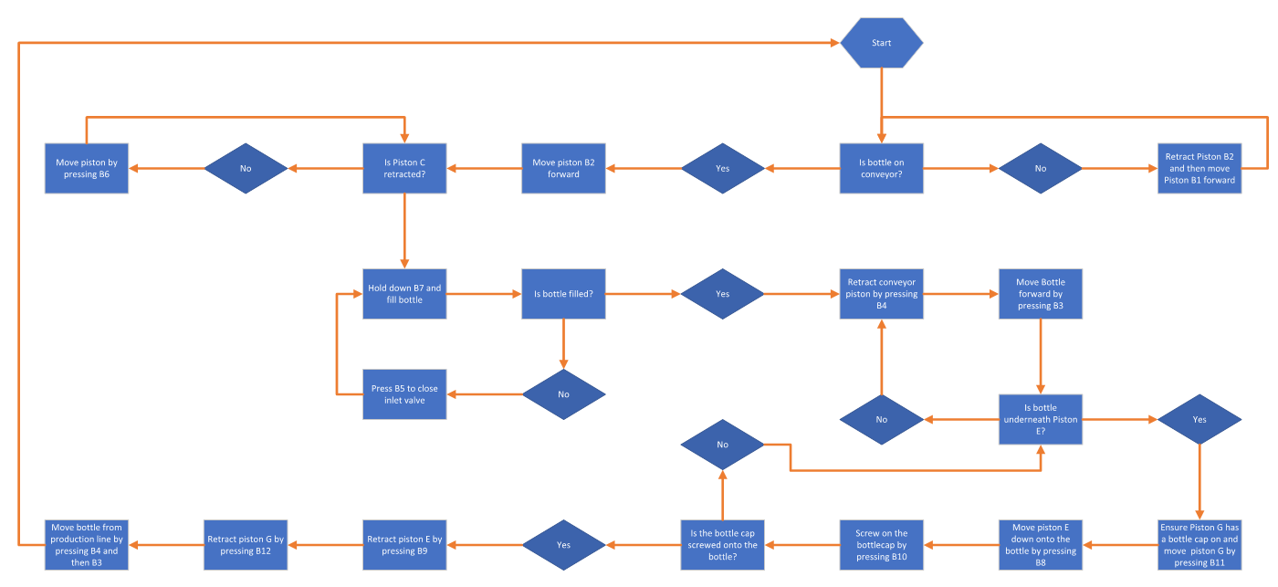

Task 4 – SCADA

SCADA (Supervisory Control and Data Acquisition) systems are commonly used within modern industry to monitor a large process operation that would combine multiple instruments and pieces of equipment. The SCADA system helps to maintain efficiency as every part of the plant is communicating to the operator and is monitoring all parameters so that the operator can see if anything in the plant differs. This will allow them to make data driven decisions from the control room by using HMI’s (Human Machine Interface) which use data recorded by sensors and instruments which are sent to a PLC (Programmable Logic Controller) which then allows the HMI to read the data and turn it into readable data at a control panel.
SCADA systems are usually used within private sector companies as they can be expensive to set up around a site, they are very beneficial to big companies as they can be setup to run an entire complex or can be setup to just monitor a few pieces of equipment. It also is a benefit as they can be used to monitor equipment on the opposite side of a plant to where the control room is so can pick up errors before any operator could even tell that the equipment is having problems, this makes monitoring for errors a lot quicker and easier for plant operators.
The information which is monitored and sent to the operators are recorded on plant by instruments and sensors such as speed sensors, temperature transmitters and vibration sensors, however all of this data that is recorded is not readable without being converted from an analogue data source into a readable data source that the operator can understand. To do this it must be ran through either a PLC unit or an RTU (Remote Terminal Unit) these do roughly the same thing, they take a input such as a vibration unit and turn it into an output, from the PLC or RTU the data is then sent to a HMI, this can then be read by an operator in the control room and they will be able to see the data from the vibration sensor on a pump that could be miles away instantly.
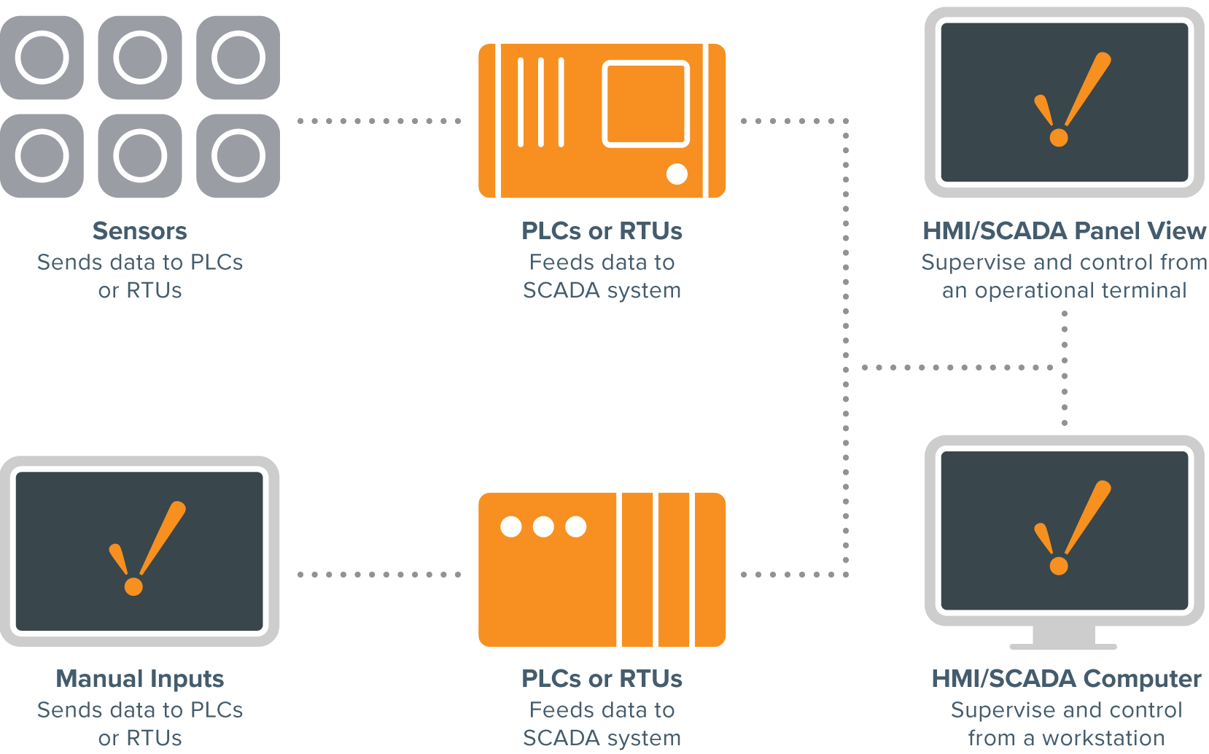
Inductive Automation (2018)
Examples of using this sort of SCADA system on site in Valero can be seen within most of the important equipment that are used on site. An example of this is the crude column (1-C-1) overhead pressure control scheme, as shown below.
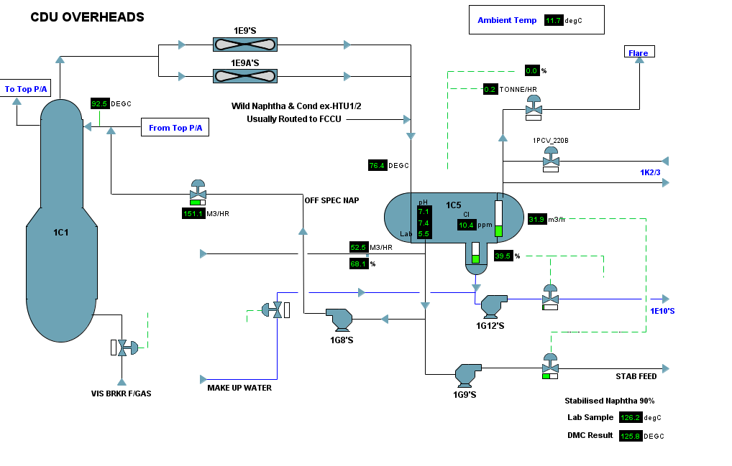
Valero Indx Screenshot (2020)
The overhead system of 1-C-1 is designed to condense and separate hydrocarbon and water vapours that pass overhead through cooling and condensing equipment. This system comprises of;
- Overhead accumulator (1-C-5).
- Fin fan coolers (1-E-9’s).
- Off-gas knockout facilities (1-C-12).
- Off-gas compressors (1-K-2 and 1-K-3).
Overhead Pressure Control
The 1-C-1 pressure is controlled by pressure transmitters,1-PT-220A and 1-PT-220B, controlling two valves which are 1-PC-220A and 1-PC-220B. Pressure recycle is controlled by valve 1-PC-220B, increasing the valve output opens the recycle flow and increases the pressure on 1-C-5 and therefore 1-C-1 pressure rises. A vent path to flare is provided by valve 1-PC-220A which will open once the pressure reaches its set point. 1-PT-220A has a set point above 1-PT-220B set point, therefore, preventing excess flaring from occurring. In operation as 1-C-1 pressure rises with ambient temperatures or feed stock changes 1-PC-220B recycle valve will close to control the pressure and reduce the recycle gas from the compressor discharge valve. This reduction in recycle loads up the compressors and boosts pressure going forward out of the 1-C-1 pressure system, thus lowering 1-C-1 pressure.
Additional control of pressure is achieved by the operator starting and stopping 1-E-9 fin fan condensers as required to keep the column operation at an optimum pressure of 1.3 – 1.4 Kg/cm² and the pressure control valves within the valves output control band. Operating at a lower pressure improves crude fractionation due to increased vaporisation and reduced heater fuel costs.

Word Count : 1918 words.

References
IB&M. (2019) Firetube Boilers [Accessed on 21/04/2020] Available at: http://www.industrialboiler.com/Boilers/Firetube-Boilers

Inductive Automation (2018) What is SCADA? [Accessed on 25/04/2020] Available at: https://inductiveautomation.com/resources/article/what-is-scada

Valero Indx. (2020) CDU control [Accessed 28/04/2020] Available at: Valero Indx monitoring system

