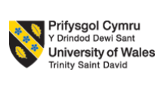
Programme Name: Master of Business Administration
Module Title: Human Capital Management
THE IMPACT OF NATIONAL AND INTERNATIONAL LABOUR MARKETS ON HRM AND IHRM POLICIES
Module code: LCMB7023
Module Leader: Dr. Gladius Kulothugan
Summative Assessment 1: Report
Student ID: 2436053
Student Name: Taranjot Randev
Word Count: 2522
Date of Submission: 14th November 2025

Executive Summary
The following report is a critical analysis of the evolving relationship between technology and demographic trends and strategy in human resource management (HRM) in a globalized economy. It explores how automation, artificial intelligence and online space are changing the labour markets, not only with displacement of jobs, but also of job skills. This is also explained about demographic and geopolitical issues such as the effects of ageing, migration trends, and political turmoil, which have a bearing on mobility of labour force and workforce management initiative in global perspective. In addition to that, the report discusses the long-standing issue of skills gaps and evaluates strategic HR strategies like the build, buy, borrow, and bind strategies of such business sectors as the technology, healthcare, and hospitality. Finally, it involves reflective self-evaluation through professional development, adaptability to technology, and future career expansion through the Gibbs Reflective Cycle. Combined with the analyses, the necessity of the current HR professionals to integrate technological fluency with cross-cultural intelligence and lifelong learning is evident and the need to remain competitive in the rapidly evolving labour markets.

Table of Contents
Introduction 3
Critical Analysis of Cause-and-Effect Between HR Strategy and Technology 3
The Transforming Labour Market 3
Implications for HRM and IHRM Strategies 4
Macro-Environmental Influences and Their Implications for Human Resource Management 4
Major Demographic Factors 4
Major Geopolitical Drivers 5
Concerns and Challenges of the HR Professionals 5
From the Problem of Skills Gaps to Strategic HRM Solutions 6
Understanding the Root Causes of Skills Gaps 6
Strategic HRM Solutions: Build, Buy, Borrow, and Bind Approaches 6
Sector-Specific Applications 7
Authentic Self-Reflection and Forward-Looking Development Plan 7
Self-Assessment 7
Development Plan 9
Conclusion 9
Reference List 10
Appendix 12

Introduction
The world of business everywhere is undergoing a transformational shift because of the impact of technology and demographic shifts and geopolitical shifts. The implications of these developments are far reaching human resource management (HRM) practices and in regard to labour markets. It is now up to organizations to bargain using the paradigms of automation, artificial intelligence, and digital working arrangement without losing strategic nimbleness and workforce inclusivity. In this transformation, this report will, in a critical discussion, endeavor to communicate four aspects that are related to the transformation. First, it is concerned with formal nexus of causes and effects of the HR approach and technological advances. Second, it addresses demographic and geopolitical factors which alter international HR practices. Third, it appraises the chronic issue of skills gap and makes strategic HRM plans to overcome the gaps. Lastly, it also offers critical critique of the personal competencies required to be successful in the current HR leadership. All these discussions demonstrate that new generation HRM requires the ability to balance between digital revolution and the adaptability of humans, moral control and lifelong learning.

Critical Analysis of Cause-and-Effect Between HR Strategy and Technology

The Transforming Labour Market
Automation and artificial intelligence (AI) are two technology-based domains that have tremendously changed the labour market in the labour market. It has not only automated not only repetitive and routine work but has also brought about such new jobs as AI ethicists, automation specialists, and data scientists (Zhukovska et al., 2021). It is this two-fold tendency; displacing jobs and creating jobs that puts focus on the intersectional dynamic between the human resources strategy and technology. As the work of machines grows, human employees are increasingly demanded to work creatively and analytically and interpersonally, which makes a new higher digital competence and flexibility more necessary (Purwanto & Siagian, 2025). Meanwhile, the change in the pattern of work was the result of the gig economy that facilitates the adoption of such digital platforms as Uber, Fiverr, and Upwork. It has made the possibilities of finding employment more flexible, but it has also raised concern about employment security, categorization of employees, and social protection (Amorim et al., 2022). As the speed of automation increased, the half-life of skills decreased significantly, five-year mark or even less became standard, which in turn provokes the self-propelling demand of digital skills and competences in the domicile of STEM (Colombo and Marcato, 2023).
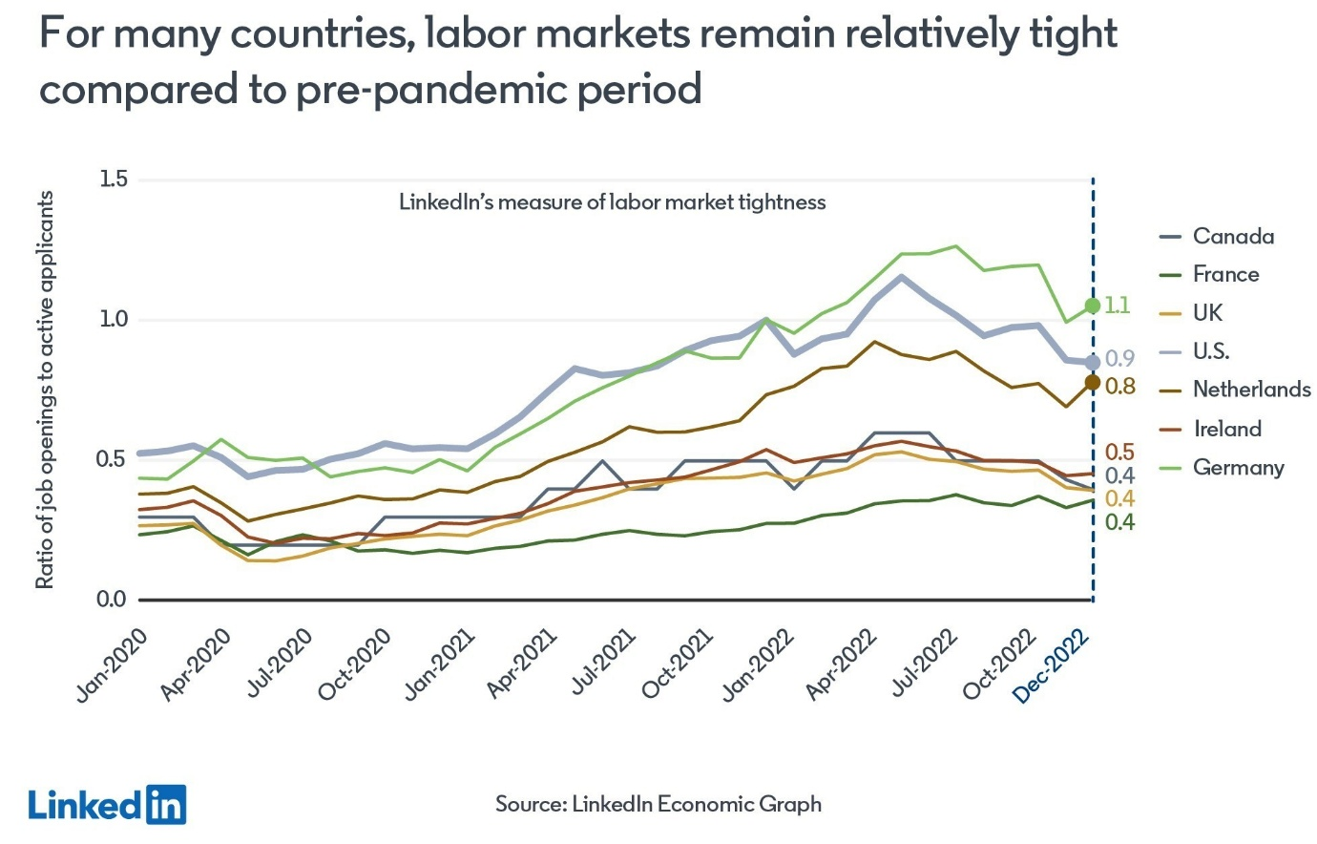
Figure 1: Global Labour Market
(Source: Blue, 2023)

Implications for HRM and IHRM Strategies
Talent Acquisition: AI has been used to innovate the recruitment process through AI-based sourcing, screening, and predictive analytics, which are more efficient but, without ethical control, may cause bias in an algorithm (Bozkurt et al., 2024). To this end, the HR professionals will need to supplement human judgment with technological assistance and applicants that possess the characteristics of learning agility and adaptability (major characteristics of success in digital department stores) should be considered (Patrick et al., 2023).
Learning and Development (L&D): With all the changes in the technological sphere still being at high rates, microlearning modules, digital badges, and AI-based training paths are the ones that help the principle of lifelong learning become increasingly important in organizations (Utama and Samaad, 2025). Such programs not only focus on the gaps in the existing skills they also entail offering the staff a higher degree of participation through the personalized learning process.
Strategic HR Planning: The emerging skills requirement requires such predictions by HR to be fact based, due to technological disruption. Through the introduction of the notion of workforce analytics, the leaders of HR units will have the potential to create responsive policies that will regulate blended workforces of gig, part-time, and remote workers (Darwish et al., 2024).
IHRM Implications: To the international environment, it relates to the problems of data protection, international legislation like GDPR, and how to address numerous regulations of the gig economy in terms of a workforce that is technologically empowered and borderless (Khassawneh and Abaker, 2022). International companies have no choice but to align the synthesis of technologies with the multinational HR policies that ensure fairness, transparency, and welfare of the staff members (Dickmann, 2021).

Macro-Environmental Influences and Their Implications for Human Resource Management

Major Demographic Factors
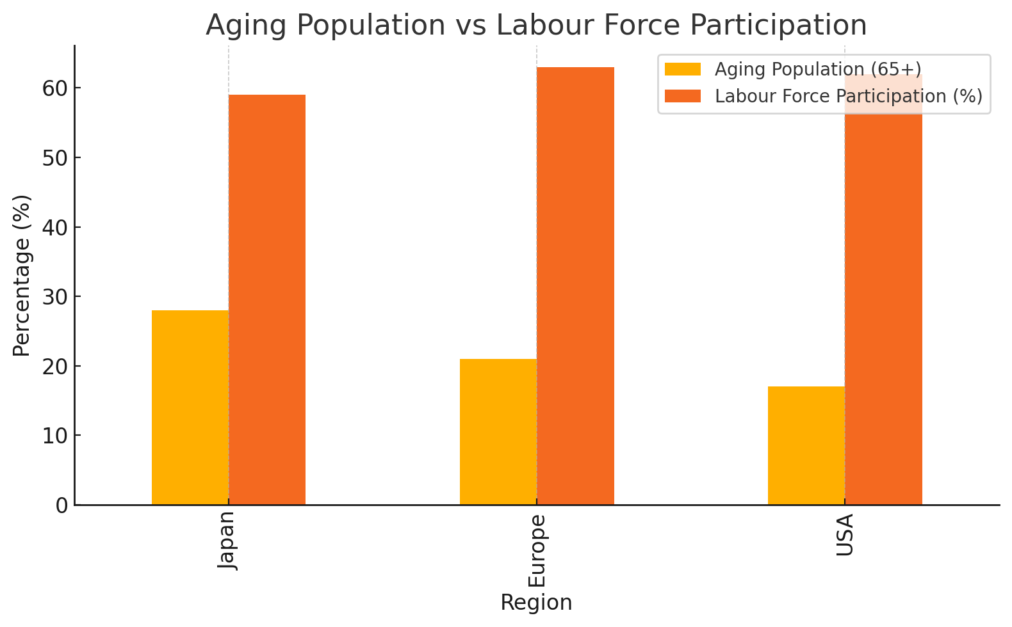
Figure 2: Aging Population vs Labour Force Participation
(Source: Created by Author)
The entire world is experiencing demographic changes that are incredibly drastic and in the context of the labour markets, organisations are forced to reconsider their human resource policies. The fact that populations are growing old is one of the most significant circumstances in the developed economies such as Japan or the entire Europe. The decrease in the number of people engaged in the labor force and the increase in dependency ratio have contributed to the incentive to implement multi-generational workforce solutions (Dickmann, 2021). HR managers are thereby developing programs that would facilitate the transfer of knowledge between older and younger employees through mentorship and reverse mentoring programs (Amorim et al., 2021). The other crucial demographic dimension is migration. The flux of migration has generated two phenomena which are brain drain and brain gain. Nations that are increasingly developing might lack expertise among the professionals who are transported to other countries to find the superior offer as well as the receiving countries enjoying the inflow of different and skilled professionals (Tran et al., 2024). This unrestricted movement of talent worldwide exposes HR departments to the aspects of strategic provision consisting of skill gaps through global recruitment of talent.

Major Geopolitical Drivers
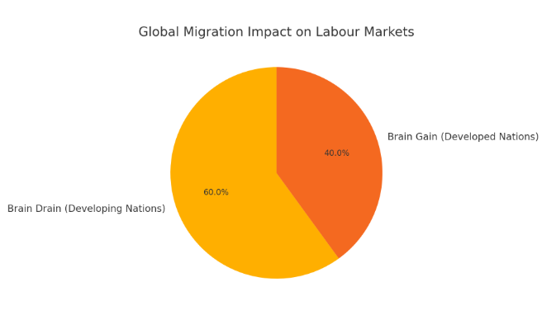
Figure 3: Global Migration Impact on Labour Markets
(Source: Created by Author)
The employment environment and HR practices in the world are influenced significantly by the changing geopolitical situations. The heightened trade wars and protectionist actions have had effects globally on the supply chains and transformed the geographies of organizational recruitment (Basahal, Forde & MacKenzie, 2023). The highly unstable international business is also threatening companies by putting them at a risk of talent acquisition because of the threat of globalization and, as a result, the company is moving towards so-called glocal HRM solutions that strike a balance between international orientation and local sensitivity (Patrick, Jha & Sharma, 2023). International assignments are also hard due to the sanctions and political instability. The HR departments will have to safeguard expatriates by hardening risk evaluation processes, crisis management, and contingency planning (Darwish et al., 2024). COVID-19 as explained by Amorim et al. (2022) became the continuation of the tendency of remote working and exposed the instability of the mobility systems in the world.
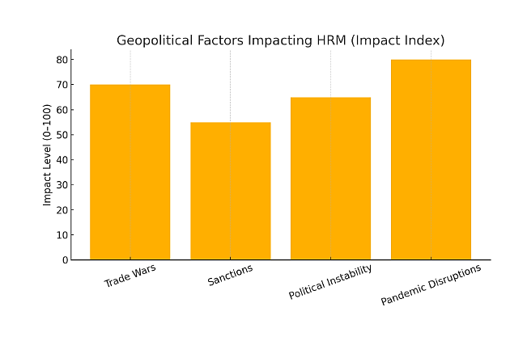
Figure 4: Geopolitical Factors Impacting HRM (Impact Index)
(Source: Created by Author)

Concerns and Challenges of the HR Professionals
The hectic global environment which confronts contemporary HR professionals with multilateral problems. The free movement of talent has already become restricted in terms of complicated visa regulations and the fluctuating pattern of immigration legislation, and the movement of the employees between the frontiers has been more bureaucratically challenging (Horwitz et al., 2023). Furthermore, the threat management mandate has also been magnified, and HR leaders must come up with robust practices of duty of care that would protect international expatriates working in non-friendly nations (Bozkurt et al., 2024). Even compliance has turned into a strategic practice; organisations must be driven by an eclectic mosaic structure of national labour laws and data protection regulations and the form of employment and particularly in the gig economy (Khassawneh and Abaker, 2022). It is however also associated with the problem of cultural orientation, compliance with immigration rules and acculturation of immigrant staff in the organizations of host states (Horwitz et al., 2023).

From the Problem of Skills Gaps to Strategic HRM Solutions

Understanding the Root Causes of Skills Gaps
The problem of skills disparities can be considered one of the gravest in the modern labour markets with the rate of technological, demographic, and structural change being always significantly greater than the adaptation rate of the workforce. First, due to the ever-growing rate of automation, artificial intelligence (AI), and digital transformation, not only has many obsolete, traditional skills become unnecessary, but it also has created new prospects in the digital, analysis, and adaptability skills (Purwanto and Siagian, 2025). The inability to match the industry requirements into the educational systems has intensified the gap where in most cases the universities are falling behind the reality on the ground, with regards to updating the curriculum based on the business and technological reality (Colombo and Marcato, 2023). In addition, the deficiency of organizations (especially small and medium-sized enterprises) that invest on continuous learning and development (L&D) has kept depressing the workforce with under-skill (Utama & Samaad, 2025).

Strategic HRM Solutions: Build, Buy, Borrow, and Bind Approaches
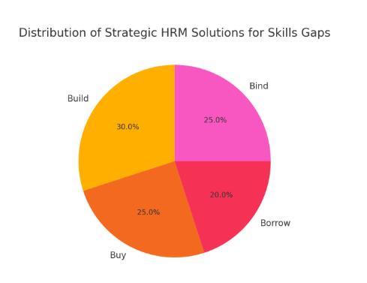
Figure 5: Distribution of Strategic HRM Solutions for Skills Gaps
(Source: Created by Author)
The modern strategic HRM considers the skills gaps with the multi-pronged approach of build, buy, borrow and bind strategy:
- Build Strategies: They involve the acquisition of talent within the organization, and they come in form of corporate academies, apprenticeships and planned learning programs. In this case, the one that can be used to help an employee acquire capabilities in an efficient manner, and hence be relevant in the future, is the integration of personal microlearning modules with AI-based learning systems (Darwish et al., 2024).
- Buy Strategies: There is need to externally purchase talent in a situation where an organization cannot develop the required skills at a given time. Through strategic recruitment, HR leaders can identify a source of talent in other regions of the world where data analytics can be used to guess the future demand (Khassawneh and Abaker, 2022).
- Borrow Strategies: There is a growing number of organizations that are borrowing talent externally in such form as consultant, freelance and contract workers to meet short-term demands. The gig economy assists in acquiring specific skills within a short amount of time without obligatory employment commitments (Basahal, Forde & MacKenzie, 2023).
- Strategies for Binding: Retention - or the bind strategy - is very important in enabling investment in talent to yield maximum payback. Effective retention involves the presence of good career paths, offering of mentoring programs and job rotation which makes employees have the desire to remain but reduce the rate of turnover (Horwitz, Ronnie & Kamoche, 2023).

Sector-Specific Applications
Sector-specific applications are:
- Technology Sector: Build Technology is referred to as the build strategy and in-house code schools and AI literacy classes are some examples in this category. Meanwhile, the mechanism of deploying freelance data scientists and software engineers on project-based basis is executed through the tactics of borrowing (Purwanto & Siagian, 2025).
- Healthcare Sector: Due to the continuous nursing and other specialists’ shortage, healthcare organizations are forced to employ buy tactics, such as the recruitment of specialists within the cross-border mode, namely the developing countries (Tran, Muenjohn & Montague, 2024).
- Hospitality Industry: HR managers at hospitals worry about the build approaches; management apprentice program and pipeline training designs. The sustainability and inclusive campaigns enable employers to enhance brand awareness and attract and acquire talent in the competitive markets (Aldossari and Chaudhry, 2024).

Authentic Self-Reflection and Forward-Looking Development Plan

Self-Assessment
My self-assessment is as follows:
- Technology: My technological knowledge has increased a lot in this MBA programme. I managed to learn to apply the collaboration tool, MS Teams, the HR measurement data analysis tools, which rely on the cloud, and the AI, including the ChatGPT, to the implementation of research synthesis and report writing. I began to develop a growing confidence that I can handle the digital resources and use technology to complete group tasks. This goes in accordance with the rise in HR trend in the exploitation of AI and analytics to enhance the decision-making process (Patrick, Jha & Sharma, 2023).
- Communication: This communication turned out to be one of the strengths. The assessments given by other group members showed I was also successful as a team communicator, i.e. report good understanding of conveying ideas based on cross-cultural sensitivity. Communication with the members of the team of various nationalities played as a mirror to the realities of the international HRM environments (Khassawneh and Abaker, 2022).
- Teamwork: Through such projects, I was able to construct teamwork and conflict resolution skills through teamwork. I would also be eager to make compromises and act as a mediator to resolve the differences, be accommodative and friendly to each other, and this is in line with the intercultural management factors (Horwitz, Ronnie & Kamoche, 2023). Distribution of tasks scales and the encouragement of other students to take part in the process also made me understand the group dynamics better and realize the value of psychological safety.
- Leadership: Informally, I was a self-starter even though I had no official leadership role. The examples include the fact that I was assigned the duty of summarizing difficult literature reviews and supporting my classmates that could not cope with the technical aspects of the assignments. These cases were exhibited in the form of distributed leadership, whereby the influence is achieved through contribution and not through hierarchy (Darwish et al., 2024).
- Self-Directed Learning: I have also been very active as a learner by scheduling and studying weekly, being present and attending organizational optional webinars, and expounding outside core reading. I took a short distance online course in HR analytics so that I could enhance my skills in data interpretation. It is a notable aspect of lifelong employability in an unstable international work environment (Amorim et al., 2022).

Development Plan
I will also gain certification of self-directed learning on HR analytics and AI-driven HR system to enhance my employability to work in technologically advanced organizations (Utama & Samaad, 2025). To overcome my flaws in cross-cultural teams’ management, I will offer myself as the leader of the next cross-cultural group project and get my colleague’s feedback. In line with this, I will also be undertaking an online course in Coursera titled Managing Global Teams by April 2026, and it is correlated with my goals to work in global HRM roles. Having merged the ongoing learning and the practical experience in the field of leadership, I would like to become a globally competent HR expert capable of integrating technology and management that need people. This pattern of the development is also concordant with the global HRM systems in some of the works by Dickmann (2021) and Patrick et al. (2023), which note the flexibility, inclusivity, and ethical leadership as the successful drivers of the international environments.

Conclusion
Finally, all three, technological innovation, labour market transformation, and strategic human resource management are interdependent in a way that is not conclusive but rather interactive. The use of automation, artificial intelligence, and digital platforms force HR professionals to be more progressive in thinking and orient them to lifetime learning, flexibility, and responsible technology use. In tandem with this, demographic changes, immigration trends, and political unrest in the world are motivating organizations to be globally competent, accommodative and powerful. The sole remedy to this need is to be competitive in the various industries by improving the skills gaps in a balanced manner of both internal development, strategic recruitment, and talent retention. Finally, the reflective component adds to the concept that HR professionals need to be self-aware, culturally intelligent and seek proactive professionals’ growth. Integrating knowledge based on data and human oriented leadership developing a workforce capable of prospering in the realm of rapid digital and social transformation have become the future of HR.

Reference List
Aldossari, M. and Chaudhry, S., 2024. Gendered precarity in Saudi Arabia: Examining the state policies and patriarchal culture in the labor market. Gender, Work & Organization, 31(6), pp.2698-2716.
Amorim, W.A.C.D., Cruz, M.V.G.D., Sarsur, A.M. and Fischer, A.L., 2021. HRM in Brazil: an institutional approach. Revista de Gestão, 28(1), pp.84-99.
Amorim, W.A.C.D., Cruz, M.V.G.D., Sarsur, A.M., Fischer, A.L., Lima, A.Z. and Bafti, A., 2022. The intricate systemic relationships between the labor market, labor relations, and human resources management in a pandemic context. Revista de Administração de Empresas, 63, pp.e2021-0669.
Basahal, A., Forde, C. and MacKenzie, R., 2023. Labour market localisation policies and organizational responses: an analysis of the aims and effects of the Saudi Nitaqat reforms. International Journal of Organizational Analysis, 31(4), pp.1024-1036.
Blue, A. (2023) ‘The outlook for 2023 is uncertain, but here’s what we know about the global labour market’, World Economic Forum, 18 Jan. Available at: https://www.weforum.org/stories/2023/01/the-outlook-for-2023-is-uncertain-but-here-s-what-we-know-about-the-global-labour-market-davos23/ (Accessed: 12 November 2025).
Bozkurt, Ö., Chung, C., Kawai, N. and Honda-Howard, M., 2024. Multinational firms as emissaries of decent work: worker responses to progressive HRM in a foreign retailer in Japan. Critical Perspectives on International Business, 20(2), pp.225-245.
Colombo, E. and Marcato, A., 2023. Skill demand and labour market concentration: evidence from Italian vacancies. International Journal of Manpower, 44(9), pp.156-198.
Darwish, T.K., Khassawneh, O., Melhem, M. and Singh, S., 2024. HR directors in India: Navigating institutional incoherence for HRM stability and change. Employee Relations: The International Journal, 46(4), pp.776-794.
Dickmann, M., 2021. International Human Resource Management-Historical Developments, Models, Policies and Practices in MNCs. Contemporary Human Resource, 225.
Horwitz, F.M., Ronnie, L. and Kamoche, K., 2023. The role, nature and contribution of Indian emerging market multinational companies in African countries. South Asian Journal of Human Resources Management, 10(2), pp.184-203.
Khassawneh, O. and Abaker, M.O.S.M., 2022. Human resource management in the United Arab Emirates: Towards a better understanding. In HRM in the Global South: A critical perspective (pp. 103-128). Cham: Springer International Publishing.
Patrick, W.S., Jha, J.K. and Sharma, K.G., 2023. Strategic international human resource management (SIHRM) framework: an integrated review and directions for future research. Journal of global mobility: The home of expatriate management research, 11(2), pp.274-294.
Purwanto, S. and Siagian, F., 2025. Strategic human resources management in the global era: Navigating opportunities and challenges. Centurion MSPD Journal, 1(1).
Tran, T.T., Muenjohn, N. and Montague, A., 2024. Negotiating entry to the professional labour market among Vietnamese skilled migrants in Australia: The impact of cultural distance. International Journal of Intercultural Relations, 100, p.101977.
Utama, Z.M. and Samaad, A.W., 2025. Modernizing HRM for Global Small and Medium-Sized Businesses. Journal of Center for Energy Policy and Human Resources Capacity Development, 1(1), pp.45-60.
Zhukovska, V., Piatnytska, G., Raksha, N., Lukashova, L. and Salimon, O., 2021. HR-manager: Prospects for Employment in the Labor Markets. In SHS Web of Conferences (Vol. 111, p. 01011). EDP Sciences.

Appendix
Strengths | Weaknesses | Opportunities | Threats
Strong written and verbal communication skills demonstrated through presentations and reports. | Limited hands-on experience managing multicultural or remote teams. | Growing demand for HR professionals skilled in AI, analytics, and global workforce management. | Rapid technological change leading to potential skill obsolescence.
High self-directed learning ability and adaptability to new technologies and digital tools. | Limited exposure to strategic HR decision-making and policy formulation. | Expansion of online learning and certification platforms for professional development. | Increasing competition for international HRM and HR analytics roles.
Effective teamwork, collaboration, and conflict-resolution skills developed through group projects. | Occasional overreliance on structured guidance rather than spontaneous leadership. | Rising organizational emphasis on inclusion, sustainability, and employee well-being. | Economic and geopolitical volatility impacting global job mobility and stability.
Strong research, analytical, and problem-solving capabilities enabling evidence-based HR decisions. | Moderate confidence in presenting data-driven insights to senior management. | Opportunities to gain leadership experience through volunteering or cross-functional projects. | Risk of burnout from balancing work, continuous learning, and career advancement.

