University of Trinity St David

Gangs and how they rise within local communities and how it is prevented

Written by: Ronan McCoach
Student Number: 1901575
Supervisor: Mike Durke

Abstract
This dissertation focuses on topics relating to gang growth and police counter strategy and also analyses how the general public perceives these topics using a questionnaire.
Acknowledgments
Finally, the researcher would like to extend their personal gratitude to the supervisors for all the assistance that was provided during this research as without the assistance this would have been a significantly harder and would likely not have been possible.

Declaration
This work has not previously been accepted in substance for any degree and is not being concurrently submitted in candidature for any degree.
STATEMENT 1
This dissertation is being submitted in partial fulfilment of the requirements for the degree of BA/BSc.
STATEMENT 2
This dissertation is the result of my own independent work/investigation, except where otherwise stated.
Other sources are acknowledged in the Reference Section.
STATEMENT 3
I hereby give consent for my dissertation, if accepted, to be available for photocopying and for interlibrary loan, and for the title and summary to be made available to outside organisations.
STATEMENT 4
I hereby give consent for my dissertation, if accepted, to be available on the university’s IT system to those who have consent to use the system.

Student’s Name: Ronan McCoach

Signed: Ronan McCoach

Date:06/05/2022

Contents
Introduction…………………………………………………………………………………….5-9
Objectives………………………………………………………………………………………9-17
How gangs grow their numbers and profits 9-13
How the police prevent gang related activities and their methods of recruitment. 13-17
Research Methods ……………………………………………………………………………………....17
Research Onion 18
Approach and Strategy 19
Choice 19
Time Horizon 19
Limitations 20
The types of questions that will be asked on the questionnaire 21
Ethics and considerations when creating the survey 21
Importance of the questionnaire 22
Research Conclusion 22-23
Survey finding………………………………………………………………………………………24
Question 1: 25
Question 2: 26
Question 3: 27
Question 4: 28
Question 5: 29
Question 6: 30
Question7: 31
Question 8: 32
Question 9: 33
Question 10: 34
Survey Conclusion………………………………………………………………………..35
Conclusion………………………………………………………………………………….35-37
References…………………………………………………………………………………38-58
Appendices………………………………………………………………………………59-60

Introduction
There are many forms of crime within society, some more damaging than others. These crimes may cause damage to entire communities and local households. One such example of this is burglary, which involves an offender entering a premises with the intention of committing a crime. This form of crime often leaves the victim feeling vulnerable and helpless (Victim Support 2022). An example of this is, that there were 4581 cases of burglary in London in 2021. Leaving a number of people with damaged property, as well as their possessions being stolen never being recovered (Crime Rate London 2022). By comparison, January had a much high case of Burglary with confirmed cases coming in at 4738. January also has an overall higher crime rate of 82,799, whilst December has a lower crime rate ranging at 80,992 (UK Crime Stats 2022). Despite this crime has increased for the past few years for multiple reasons relating to poverty as well as covid. Most of the reasons for these crime increases, relate to desperation as opposed to desiring a life of crime meaning that most offenders require financial support if their crimes are to be prevented (Thompson 2021). The reason that covid 19 has had an effect on crime, is due to covid 19 having a major effect on the economy as well as local business, leaving many people without jobs therefor leaving many people without a way to make money, this can lead some people to commit crimes like burglary and robbery or in worse cases extreme domestic abuse (Stripe 2021). This is due to crimes like robbery, burglary and gangs can provide financial support to their lives despite the risk of going to prison or being gravely injured. Lastly gangs are not a rare option for people lacking money. As gangs provide funds for people who join, making the option appealing for those in need of financial stability Trust for London 2022).
Anti-social behaviour is quite common within society, and mostly refers to people acting in a manner that causes people distress and is mostly committed by children and teenagers. The reason that children and teens are more likely to commit Anti-social Behaviour, can depend on the child/ teen’s current situation. One example of this can be parental abuse (Department for Levelling up, Housing & Communities 2021). The reason that parents can cause children to commit anti-social behaviour, is due to negative reinforming, meaning that abuse and other negative parenting can cause a child to behave negatively when in school and when in local communities (National Library of Medicine 2019). One example of anti-social behaviour is graffiti, where a person causes property damage by painting on houses, and other forms of property (University of Pennsylvania 2018). Anti-social behaviour is not just committed by children but can also be committed by adults. One such example could be drinking alcohol in public, which is often committed by people who are already Intoxicated. The main problem with people who are Intoxicated in public, is the potential for violence, as people who are intoxicated have the potential to start a fight with people in the streets (Cheshire East Council 2022). Lastly anti-social behaviour can also include being loud in public areas, as well as being verbally aggressive around people which has the potential to turn into assault, as people can become agitated as a result of the disturbing behaviour this, is also covered by the public order act 1986 (Crown Prosecution Service 2019).
Murder is also a major problem within society, despite being one of the less common crimes. The reason this is a major crime is due to the fact that murder, causes many people to become victims, as a person’s death has the potential to distress within a family and friend group, potentially leading to either suicide or murder out of revenge (Moroz 2019). The reason that murder is somewhat of a rare crime, is due to the fact that it is usually not planned but is done when a person is in a highly stressed-out state. Leading to the actions being more rash and more irresponsible. To add to this murder is most common in domestic and organised criminal activity an example of domestic homicide had an overall count of 362 over a 3-year period from 2018 up to 2021(Office for National Statistics 2021). the reason that murders are more common in domestic situations, is due to the nature behind domestic violence that being a stressful relationship that does not become resolved over a prolonged period of time. This often means that during a specific argument, one of the individuals may use physical violence that may kill the other person involved in the domestic. It should also be mentioned that domestic homicides reports, had a slight increase during the covid lockdown but remained mostly stable similar prior to the covid lockdown (National Police Chiefs Council 2021). Lastly the reason that murder is common in organised crime is due to organised criminals often trying to kill rivals for profit and control over illegal markets as well as gangs often killing when performing illegal actions due to the stress built up in the moment (HM Government 2011).
Organised crime is a major problem within society especially the United Kingdom as organised crime involves a group of people coming together to commit criminal related activities on a larger and more cohesive scale (Crown Prosecution Service 2017). This form of criminal activity is especially dangerous, as gangs will attempt to control large areas as a means to generate profit through illegal distribution of narcotics and weapons. To add to this organised gangs will also attempt to control and manipulate vulnerable people as means to gain cheap labour otherwise known as county lines (Crown Prosecution Service 2022). Unfortunately, county lines are a major problem within the United Kingdom as it has led a lot of families to fear that their children may fall victim to this manipulation or worse that their children may already be apart of the system leading a lot of parents into intense paranoia and fear (The Children’s Society 2022). Gangs are very dangerous within the UK but infamous as majority of gangs in London are rivals and have illegal use very dangerous weapons that are hard to get in the country e.g., guns which means that they have the ability to kill/ gravely injure people in a short space of time, to add for this gangs are also responsible for over half of all of London’s crimes from minor crimes to serious offenses (London Assembly 2018). Lastly gangs will in most cases burgle people’s homes and steal their possessions. This can also relate to pets and the reason that is done, is because gangs will sell items and rare animal breed later for a quick profit. Stealing pets is mostly recent but has left victims traumatized not knowing where their pets are and if they are safe leaving them vulnerable (Department for environment, Food and Rural affairs 2021).

It is important that as a society we understand the dangers of organised crime, and that current standards of policing work effectively. That is why we will be critically analysing how Gangs grow within communities, and how they gain massive profits through their illegal methods. Whilst by contrast how the police counteract these methods and seeing if the current methods employed are at all effective at counteracting gang related activity within the United Kingdom. The reason that understanding if the police are effective at counteracting gang related activity, is that it allows society to understand how it can improve on its methods of prevention allowing for a more cohesive community.

How gangs grow their numbers and profits
In the United Kingdom there are many criminal gangs, who are responsible for a series of crimes that go on within local communities. These crimes can range from hostile takeovers of rival gangs to local drugs being distributed within their gang territories (CPS 2021). The reason that these gangs pose a threat within society, is their social influence on youths and adults. This is because this influence is what keeps gangs alive as people who are influenced by gangs are more likely to cooperate with their requirements/demands (Youth.GOV 2022), these influences can involve fear or envy and both have similar effects in the short and long term as if a person fears gangs in their community they will be less likely to work with local authorities (Mann 2021) much the same involving those who are envious or loyal to gangs, this also has the added negative of the three parties being more likely to fulfil the demands of the gangs such as county lines which within itself is similar to indentured servitude (National Crime Agency No date), this is because gangs will have people do illegal drug runs on their behalf in exchange for petty payments e.g. small amounts of addictive narcotics. Gangs use this tactic within their communities as the victims of this servitude are very unlikely to find a way out of this dangerous lifestyle and also because the gangs that employ the tactic are nearly at no risk of being found out as if the victim is caught, they will have no real information pertaining to the gangs’ activities (Local Government Association 2021). Gangs also use these county lines as form sexual exploitation meaning that their victim will become reliant in some form to the gang member they know or live with. This means that the gang member will provide an ultimatum to the victim that being that they will provide sexual services to paying people in exchange for drugs from the gang (NSPCC 2021).

Gangs can grow through celebrities; This is because some celebrities actually once being part of gangs, and in some cases maintain regular contact. This can have an effect on young people as they may see what the celebrities’ previous activities as a motivator or an aspiration making them more likely to attempt to follow their past choices one such one such example of this would chief Keef who is a rapper and gang member of the Black Disciples (Austen 2013). Children may find this information out from friends or the celebrity themselves through podcasts and other medias creating a possible chance for a child to see gangs in a positive way which also applies to drugs like marijuana An example of this would be Danny Trejo although not actually a part of a gang himself and advising people to stay away from such activities did in fact grow up surrounded by Mafia members and is also known for negotiating with a Mafia head when directing a movie (Trejo 2021). Now despite Mr Trejo being against people joining gangs, people may still find aspirations through his life story. Finding few positives leading to potential gang opinionated biases. Celebrities are not the only reason people may join gangs, as there are other forms of media that can include people. And example of this being video games which tend to over glorify all forms of crime two such examples of this can be Grand Theft Auto and the Mafia Trilogy (Fournis 2014). The reason that these games influence people is, due to the games telling primary positive stories relating to their criminal activities (Pers 2015). These games often find themselves played by children, which can once again influence their perception on criminal gangs (Albanese 2016). Lastly a game like the Mafia trilogy has an impact on people’s perception as the game tells a story that attempts to make the gang members likable, as well as relatable. Making people see the gangster lifestyle look rewarding and outright beneficial (Crown Prosecution Service 2022).

Gangs also cause further issues within society that being their violent and this violence can come in different forms for example, gangs are likely to rob or burgle people for their property. This is because most gangs are opportunistic meaning that if robbing or burgling a location is possible with a good amount of success on their side, they will be quite likely to perform the crime (Metropolitan Police 2022). This is a significant issue as most gangs rise up from poorer communities of which are unlikely able to afford appropriate house protection e.g., strong locks or burglar alarms meaning that gangs are fairly likely to commit these crimes within their communities (London Assembly 2019). This is done as it allows them to sell off any valuables that were stolen for a profit. This further bolster their numbers through profit as gangs may recruit more members if their able to afford to pay their members (Burges 2013). Too add to this gangs will have rivals within their communities, in most cases these gangs will react with violence towards each other with little to no discrimination between gangs’ members and civilians (Lewisham Council 2014). This means that many civilians within the community, are likely to be injured during a gang through the violent means (HM Government 2016). Gang wars also cause immense property damage due to the violence caused, gang wars as a means to destroy their competition on the drug market and in some cases to cease their criminal assets e.g., drugs and personnel (Crown Prosecution Service 2021). An example of this would be in London where gangs fight wars using knives, and in some cases, old Webley IV revolvers illegally shipped from France and used in order kill rival gangs or threaten/ rob victims (Home Office 2015). Some gangs are also known to use police intelligence, when committing crimes, the reason for this is that it allows a gang to find strategies that can be used to counter what the police are trying to prevent (HM Government 2016). An example of this would be if the police knew about drugs being sold in a specific area, then the gang could use this information to move their drugs to another location where the police are not prioritising their search (Gunnell 2016).
Lastly gangs have many ways of storing their illegal items as a method of keeping them hidden from law enforcement as well as rival gangs and potential thieves. One such way is through county lines. Similarly, to how county lines are used for distribution they may also be used as a method to have the victim hide and conceal drugs and weapons within their own home (NCA 2016). This is done as it keeps any illegal items away from the gang meaning if the police were to conduct a search on a gang member home any illegal items may not be in their house but instead the county lines victim this may often be done to a child as a child is less likely to tell their parents or the police due to the potential fear or loyalty they may feel towards to person they are helping (NCA 2018). Storage may also be done to their girlfriend or boyfriend scaring them into hiding the drugs for them this is most often done through manipulation e.g., telling them that they are just as guilty as them and that they will be put in jail if the offender is caught (NCA 2017). Gangs may not always use county lines as a method of storage but instead may have a specific gang member hold onto any illegal items. This gang member can be described as a head of coordination, as they will be responsible for taking inventory and ensuring any and all items are moved if the building is believed to be attacked by rival gangs or raided by the police (Thurrock 2022) Gang members may also seek to hide drugs in peoples back gardens, this is done as the police will be very unlikely to suspect a person who is not known to be a drug dealer or for that matter a drug user this can be seen in a news report in 2018 reporting that gangs are using vulnerable people to store drugs and storing drugs in peoples back gardens (March 2018). Lastly in some cases, gangs may just outright sell their illegal items at a significantly lower price than what is usually sold on the illegal market. The reason that this is done, is to combat rival gangs in terms of profits as if people see that certain dealers are selling at cheaper prices, they may instead by from them devaluing rival gangs. This can also be done as a gang may be catching to much attention and will try to get rid of their stock quickly as a means to avoid being caught with the items (Leong 2021).

How the police prevent gang related activities and their methods of recruitment
The police are always looking for methods that could both prevent and stop gang related crimes within local communities. This can be quite difficult as gangs employ very deceptive methods when it comes to most of their activities. One such method of prevention would be informants or undercover officers (National Crime Agency 2022). This is effective as this allows the police to gain information on a gangs related activity allowing the police to potentially prevent any organised related plans (Home Office 2018). This also helps as this allows the police to gain evidence relating to the leaders within the gangs and to what crimes they are responsible for, allowing for a justifiable arrest. To add to this the police may also use such information to raid any illegal workplaces that a gang has set up e.g., drug labs and weapons stashes (Dorset Police 2022). This is important as these items allow a gang to gain their profits as well as power within their communities and without these items, they will potentially become less effective. The only issue with this strategy is that it rarely slows the flow of drugs in a local community for more than a few hours. (Competition & Market Authority 2014).

The police also use more minor methods against gangs that being education as this method allows the police to educator the young generation about the danger of getting involved with a gang (Youth & Policing EDUCATION HUB 2018). This also has the added benefit of preventing people from becoming interested in gang culture as this can be dangerous as young people are more likely to see gangs in a more glamorised fashion (Home Office 2015). This method is effective as young people gain a significant insight into gangs and will understand that what gangs present to them is not a well-off lifestyle but instead a dangerous lifestyle with little reward and with a high chance to of dying when being a part of a gang (Children’s commissioner 2021) This method is also effective as ex-gang members can volunteer to attend such event providing a more mild-mannered story for the young individual and once again providing significant insight into the dangers faced by people involved with gangs (Home Office 2014).

The police may also investigate a gang through interrogation. This is an effective method as it allows the police to conduct many interviews with an offender who is affiliated with a criminal gang this information can pertain to who their leader is all the way up to specific operations that the gang is currently involved in e.g., who the gangs are working with and their drug distribution (Home Office 2020). This information is good for prevention/stopping a gang as it allows the police to build a case possibly leading to the gangs’ members being arrested however, the only negative to this strategy is that it relies on the interviewee answering the questions and if they refuse then evidence will not be gathered from the interrogation (Stephensons 2020). The suspect/ offender may also wish to use solicitor which can in fact complicate an interview as solicitors guid the interviewee on question that they should not answer. (Noble Solicitors 2021).

The police prevent illegal shipments into the UK through monitoring shipments that enter the United Kingdom using scanners as well as working with trade partners as this allows the police to better regulate what comes into the United Kingdom (National Crime Agency No Date). This somewhat prevents the flow of guns being supplied to gangs as most items will be found by police upon arrival however, most weapons being supplied are done through the dark web which makes it more difficult to monitor what is being brough into the UK as the Dark Web is not very well tracked (Metropolitan Police 2020). This strategy is also used for drugs as some gangs will cooperate with criminal elements overseas being directly supplied from other countries (Interpol 2018). This method helps curb this in much the same way as it slows the illegal distribution of drugs in the county (Townsend 2021). The difficulty the police often have when it comes to preventing shipments into the United Kingdom is that gangs often use all manners of transportation e.g. light aircraft and yachts to add to this difficulty county lines have also become apart of overseas trading further creating difficulty as county lines victims often have no information that they can provide about the criminal gang (Home Office (2018).

The police must also try to counter gang leadership which can pose difficulty when attempting to deal with an operation. One such example of this would be gang hierarchy, as gangs are highly likely to use children and teens as a form distributor as they are the least likely to be targeted by the police (. Kids who are involved with a gang, are also labelled as tennies whilst teens are labelled as runners (Thurrock No Date). The police will attempt to educate parents about the signs of a child potentially being involved from a gang. This can range from the child being caught with illegal items, such as drugs and weapons as well as their behaviour changing e.g., being more prone to violence or severe mood swings. The reason that the police do this is that it allows the parents to find a way for to prevent their child from getting involved with the gang any further (NSPCC No Date). The police also work with other agencies who specialise in helping children who have been involved with gangs. This allows the police to provide further assistance in terms of preventing children from being further exploited by gangs (Home Office 2010). Lastly and example of the police stopping a gang was when the police had shut down a drug gang and arrested its leader giving the leader a 20-year sentence (NCA 2022)
The police service also combats organised crime by the use of heat cameras and electric reading. The reason for this is to grow certain drugs e.g., marijuana will require conditions similar to an arid environment. Heat cameras have the ability to see if the temperature of a home is hotter temperature than it should be, and if a home is found to have an extremely elevated temperature that could warrant a search as a means to find out if marijuana or other drugs are in fact being grown (Complex 2013). The same applies to electricity as to increase the heat a gang may employ many electrical heating appliances to increase the room temperature which will increase the electrical voltage being used in the house. If this voltage is high at a near consistent rate, then this could also be used as a justification for a search (Parks 2020). as this is out of the ordinary for your average house resident. This is a strong method as the average home will use the average amount of heat and electricity compared to a home that is growing marijuana allowing the police to investigate to see why the home is using so much energy (NCA 2022). Lastly the police also counteract drug raids on gang hideouts as a means to decrease the amount of drug distribution within a local area this of course is a strong strategy at preventing drug activity as well as how much funds a gang will receive from their sales however, this is not the strongest strategy that the police can employ the reason for this being is due to the fact that it only stops the drug trade for little more than an hour as another gang will often continue distribution abusing the empty market that the police helped clean out (South Wales 2022). Lastly the police may also find drug producers using phones this is done by extracting information from an offender’s phone and searching their message history allowing the police to gain evidence on those who could be creating illegal drugs or weapons (College of Policing 2021)

Research Methods
The point of this topic is to gain an understanding into the research methods, that will be applied to this topic, and why they are important and more importantly effective. This topic will also be discussing the relevance of the research onion when preparing to research a specific topic. This topic will also aim to understand why the researcher has chosen to pursue specific approaches to their research questionnaire and why they feel it will be more effective using specific methods.

Research Onion
The research onion is a model that labels out what types of decisions, which will have to be made when researching a specific topic. These labels are shown, within the layers of an onion. Each layer representing what should be used in a methodology the start, of which being the outer layer. This helps ensure, that a researcher creates the most reliable and efficient research possible, by following steps that are contained within the research onion (Phair and Warren 2021). The stages of the research onion will cover all aspects of a reliable piece of research material consisting of Philosophy, research approach, Research Strategies. Research choice and Research Time Horizon (Stainton 2021)


(15 writers No Date)

Approach and Strategy
The way this research will be conducted is by using a questionnaire, the reason for this is that questionnaires can provide a quantitative amount of information allowing the user to find the highest percentage of an answer as well as the lowest and find a consensus between how the majority of people think and feel about a particular subject. The questionnaire will also be done using qualitive research, as this method allows the researcher to gain a large number of volunteers to answer the questionnaire providing the research with a more reliable amount of numerical data. This will also allow the researcher to provide a basic survey consisting of yes, no, and unsure answers but also containing questions that will be thought provoking and reliable (National Library of Medicine 2013).
Choice
The choice in research approach is an especially crucial step in any piece of critical research, the reason for this is because it lays out how the researcher will analyse their findings and how they will choose to discuss the importance of what has been Discovered. The research approach that will be used is deductive research (Soiferman 2010). The reason that deductive research will be used is because the information that has been gathered by the researched can then be used to compare results with what is currently evident within society allowing the research to see if the answers received match up with other statistics taken by other research and analyse the difference and similarities. This research method will also provide the researcher with flexibility when comparing information gathered with other statistics as this information can be compared with media sites as well as official government-based information allowing the researcher to develop a more reliable comparison between information that has already been gathered.
Time Horizon
The time horizon is used to ensure that the researcher prepares their research to meet a specific time standard when researching a topic and then using that research to provide a reliable conclusion. The best method for this would be mixed method simple as this would allow the researcher to provide a questionnaire that relies on questions that are high in number and simple to answer whilst also providing qualitive questions that would be in depth whilst also be easy to answer (UK Health and Security Agency).

Limitations
There are not too many limitations for this research other than the fact that the researcher must find willing participants to take part in the survey, which should not prove to be of great difficulty due to the survey being done through the internet (Debois 2022). To add to this the dissertation objectives must be completed on time which is a long process which can of course requires much fact checking as well as ensuring that the number of people answering the questions is at least 80 can also make this a longer process. The other limitation that related to this research was finding an adequate site to create a questioner as many questionnaires site can simply be cheated on that is why the researcher chose to use survey monkey as this does not allow a person who has already taken to survey to try again ensuring that all answers are final preventing results that could be considered disingenuous. Lastly the major limitation is that the researcher must find one hundred people who would be willing to do the survey which can be difficult and take a lot of time.

The types of questions that will be asked in the questionnaire
The questions will mostly relate to how people perceive organised crime within the United Kingdom as well as if they have ever been victims of organised crime to add to this, the questionnaire will also have questions relating to people’s knowledge of organised crime in local communities. The reason that the researcher feels that this is important is because it will show if people within the community see organised crime as a danger as well as peoples general understanding into how gangs operate. It is also important to understand if most people become victims of gang related activity.

Ethics and considerations when creating the survey
When the researcher is creating the questionnaire, they must ensure not to ask any questions that would cause any distress or offence which could be quite difficult since the questionnaire relates to violent organised crime it could lead to some people becoming quite stressed about the topic however, if the questions are asked appropriately and do not have anything considered graphic it can be avoided. Lastly considering the topic it would also be important to avoid anyone who participates in an organised criminal organisation as this could pose a danger to the researcher due to the nature of the topic.

The Importance of the questionnaire
The questionnaire will be an especially important aspect of the researcher’s dissertation the reason for this is that it will allow the researcher to gain an understanding in to how the average person think when it comes organised crime as well as how it is prevented. This will also allow the researcher to gain an understanding into the public’s opinion into the police this meaning if the police are considered effective when dealing with organised criminals. Lastly the researcher wishes to see if the public understand certain gang related strategies e.g., whether the public understand what county lines are.

Research conclusion
To conclude, the researcher will be using quantities research alongside deduction with mixed methods. This will be done as it will allow the researcher to compare and contrast all information gained from the questionnaire, with current standing information from government statistics. The researcher will also be asking questions relating to how people think about gangs as well as their experience with organised criminals. Lastly it will be especially important to consider the types of questions that are asked as they could cause the volunteer stress or fear if the questions are not written for their consideration (National Library of Medicine 2006). This information must also be safely secured, once completed this will be done by saving the information on the researcher’s computer which is password protected ensuring that no information is lost through deletion. The information will also be safely secured on a memory card as a precision in case any files become corrupted (Office for Health improvement & Disparities 2022). Lastly this information will also be guarded by anti-virus as this will protect all files stored on the computer from being stolen and linked (National Cyber Security centre 2019).

Survey Findings
The survey consisted of 108 participants and had a surprisingly diverse response to add to this the survey mostly subverted the researchers’ expectations due to the opinions of the general public as well as their knowledge of some criminal strategies e.g., county lines.

Question 1: what is your gender?
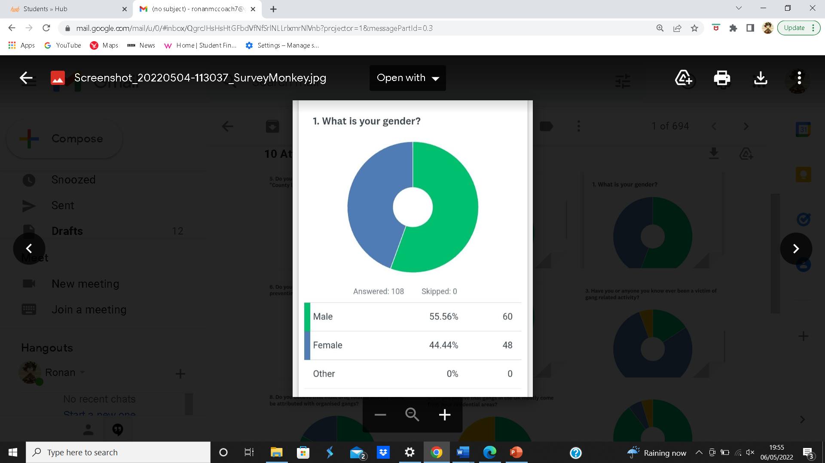
The first question that was asked on the survey was people’s gender, consisting of male, female and other. This part of the questionnaire was mostly equal between male and female with sixty participants being male while forty-eight were female however, there were zero individuals identifying as other on the survey. Lastly it should be stated that one participant skipped a few of the questions during this survey leaving some questions with an odd number of results.

Question 2: Do you know what organise crime is?
The second question on the survey was whether people understood what organised crime was, which resulted in ninety-four people answering that they understood what organised crime was and fourteen answering that they do not know. this was mostly not a surprising result as the average person would be aware of organised crime, either through media or learning it at an early age. However, the fourteen people who were not aware, is not a major problem as they may simply not be aware of gangs being considered a form of organised crime but instead just refer to them as gang members.
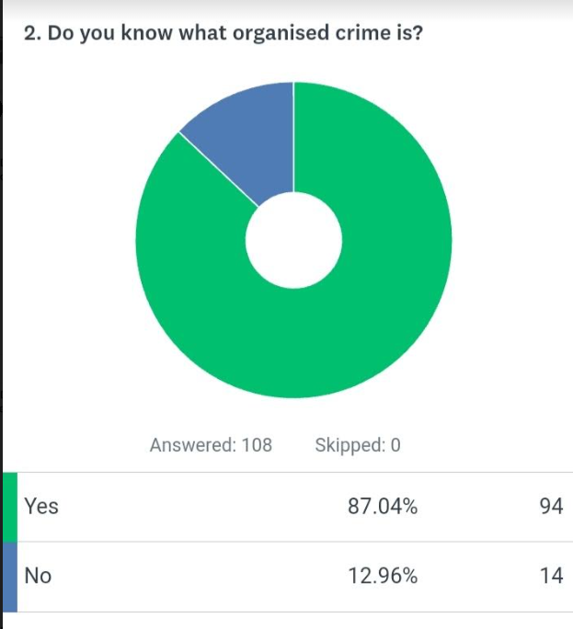

Question 3: Have you or anyone you know ever been a victim of gang related activity?
The third question in the survey was, whether the participant had ever been a victim of organised crime. Which resulted in seven-teen participants answering, that they knew that they were attacked by people who were apart of an organised criminal group. Whilst eighty-five had answered that they have never been a victim of organised crime however, 6 people answered that they were not sure meaning that they may have been victims of violent crime but were not sure if it was from an organised criminal group. The survey shows that 15.74% were victims of organised crime whilst 5.56% were unsure this in contrast with a survey created by the Office of National Statistics in 2021 showed that in 2020 at least 1.6% of people in England and Wales were victimized from violent crime showing that organised criminal organisations can be considered to be somewhat responsible for a high portion of victimization in England and Wales (Stripe 2021). Of gangs were to be responsible for the majority of violent crime in the England and Wales it would be important to focus on preventing people from joining organised criminal organisations. Lastly the fact that the overwhelming majority answered that they had not being victims of organised crime is a positive showing that most communities within England and Wales are not dangerous.
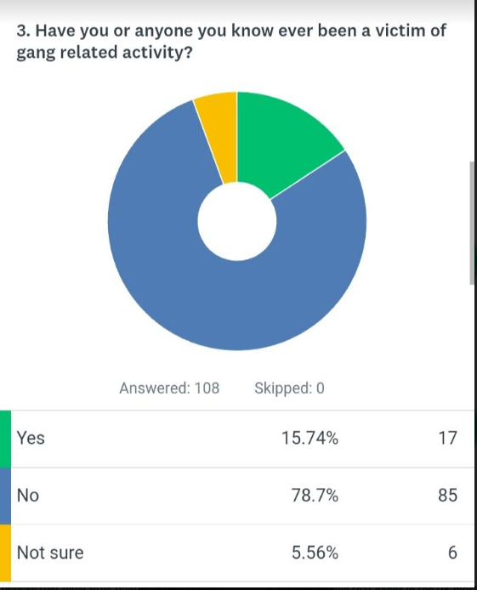

Question 4: Do you believe that gang in the UK mostly come from poor residential area?
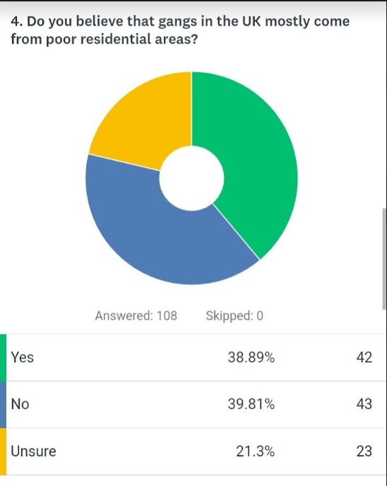
The fourth question had the most surprising results as this question asked if people believed that organised gangs mostly came from poorer communities or they if were mostly from all social economic classes. The results showed that the participants are mostly equal in terms of for and against. These results have shown that forty-three believe that organised criminal gangs mostly come from poor communities, whilst forty-two also believe that they come from all economic classes and the remaining twenty-three were unsure if organised gangs mainly come from poorer communities or if they were mostly from all economic classes. This information does not line up with the researchers main point as research has shown that most organised gangs come from poorer community this is due to the difficulties that are faced when there is not enough money to afford basic necessities leading some people into crime as a method to afford basic necessities however, is still possible for all walks of life to join gangs for different reasons (Family Lives 2022). Lastly the researcher believes that the participants who answered that no to on the questionnaire believe that people join gangs as a method of making quick money as this is a common belief by some households across the world.

Question 5: Do you know the criminal strategy known as “county lines”
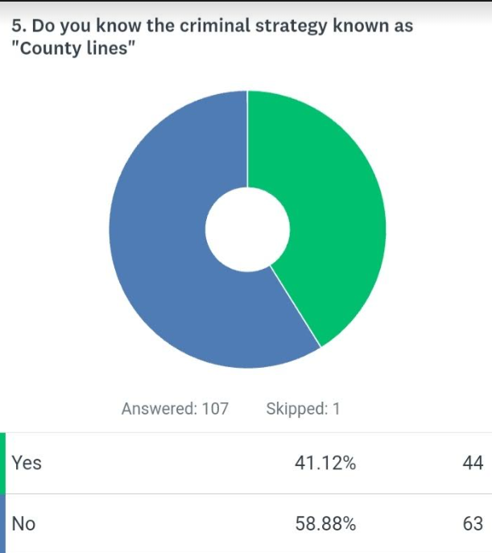
The fifth question revolved around whether the general public understood what county lines were. The reason that this question was asked is, because the general public may not actually understand the more complex strategies that gangs employ in order to gain money as well as potential members. The results primarily surprised the researcher, with forty-four answering that they had an understanding of what county lines were whilst the remaining sixty-three answered that they did not know what county lines were. The reason that this result had surprised the researcher, is because the term county lines not often stated by the general public nor the media, but this result has some positives, as it means that people understand the dangers that gangs can pose onto the vulnerable people within society and how they can be exploited for criminal gains. Despite the fact that the majority do not understand the term “County Lines” this does not mean that they do not understand the dangers gangs pose on their children or vulnerable members of society as most members of society are educated about the potential dangers of being manipulated by gang and other criminal elements this just simply shows that some members of the general public may not understand the complexity of this strategy or have simply never heard to strategies official name (Home Office 2018).

Question 6: Do you believe that the police are effective at both preventing and stopping gang related activity?
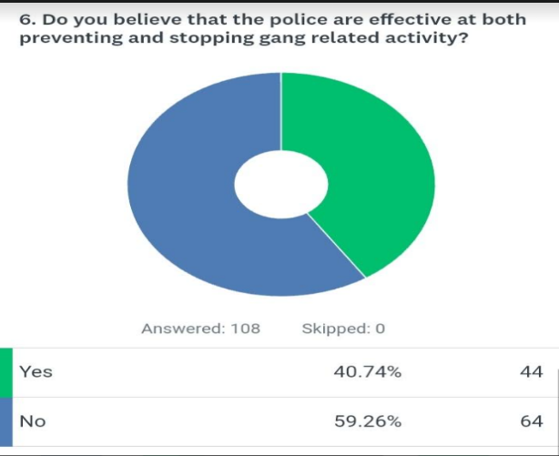
The sixth question revolved around the public’s perception of the police and whether they were effective at countering gang related activity within their communities. The results primarily showed that the community does not think that the police are effective at countering gang related activity with sixty-four of the participants answering that they did not believe that the police were effective at counteracting gang related activity within local communities however, forty-four participants do believe that the police are effective at countering gang related activity within local communities. This result shows the majority of participants believe that the police simply are not effective when it comes to preventing and stopping organised criminals within their communities. This also means that people may not feel safe within their communities and may want their local authorities to take organised crime more seriously. Lastly the results did show that a substantial portion of participants do feel that the police are effective at stopping organised gangs within their community. This shows that some participants may not experience any gang related activity or may never hear about it on the media this could also mean that the participants who answered this question feel safe within their communities and attribute this safety to the police officers in their local area however, a government pole from 2020 does show that 70% of participants felt safe within their communities showing that the participants from the researchers survey may actually feel safe but do not believe that the police are currently effective (Welsh Government 2020)

Question 7: Do you believe that the police could be doing more within your local community?
The participants of this question had an overwhelming majority all agreeing that the police could be doing more for their community with the result showing that one hundred participants agreeing that the police do not do enough within their local communities. The remaining eight believe that the police are doing a satisfactory job within their community which is significantly less when compared to the opposing side as the vast majority of people believe that the police don’t to enough within their local communities. These answers show that the majority of participants do not believe that the police do a good enough job when it comes to preventing which is a major negative as this means that as the majority of people do not have faith in the current standards the police use when it comes to keeping the community safe. The reason that the community could believe this is the lack of a police presence in some parts of the UK e.g., Gwent which has been seeing significant resignations due to budget cuts and loss of benefits (Malthouse 2021). Lastly this could be due to anti-social behaviour people face within their community which some members of the public sometimes blame on their local police service (Hales 2018).
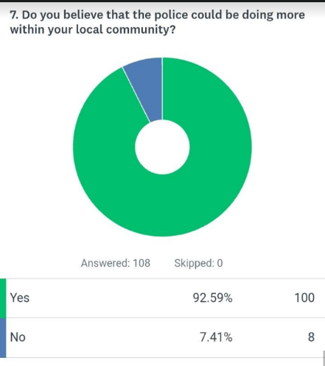

Question 8: Do you believe that most drug related activity, could be attributed with organised gangs?
The vast majority of participants believe that most drug related activity can be attributed towards organised crime with the results showing that eighty-nine of the participants believing this to be true whilst eighteen believing this to be false. This result is not a major surprise as organised gangs are infamous for their drug related activity across the United Kingdom as well as across the world an example of this being the years of 2020/2021 where there were over forty-nine thousand recorded drug offences in London alone which of course would reach the media providing many participants the knowledge of gang-based drug offences (Statista 2022). A major example of the media reporting this is in 2019 when the BBC reported on drug gangs stating that there were over four thousand people in London who were in a drug gang and working on the county lines. The media of course could be mostly responsible for the statistics a of the researcher’s survey however, drug related crime is indeed mostly associated with organised gangs as gangs often have entire groups of people working on selling and buying illegal narcotics (BBC 2019). Lastly, the people who disagreed may not understand how much drug related crime is associated with organised crime or may believe that the majority of drug related crime is associated with local dealers who create their own illegal drugs and then sell them (Public Health England 2015).
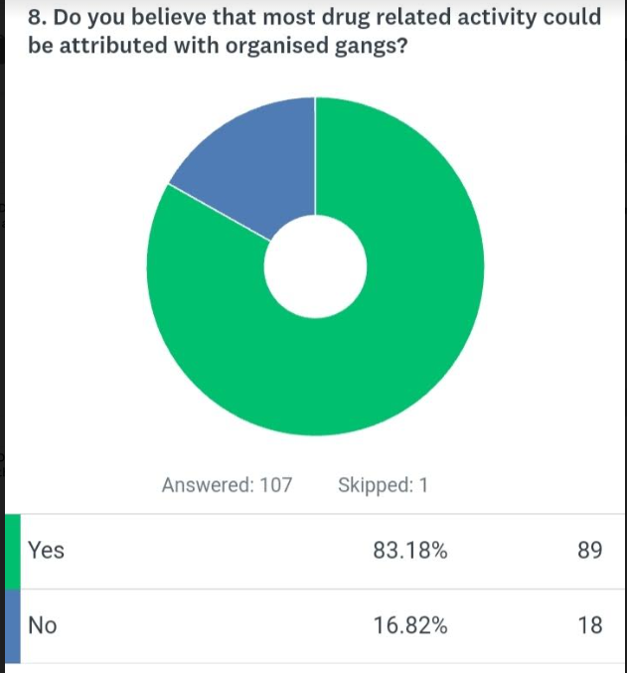

Question 9: Do you believe that gang distribution of drugs and weapons is becoming weapons is becoming a serious problem in the United Kingdom?
The majority of participants do believe that the distribution of drugs and weapons, is becoming a serious problem within the United Kingdom, with ninety-seven participants believing that this is a serious issue, whilst six do not believe that this is a major issue and five not being aware if it is an issue. This statistic shows that the participants are aware, that many gangs in the United Kingdom are becoming more efficient, at selling both weapons and drugs which is currently a major issue within the UK as many gangs have become more effective and both importing and exporting both of these illegal items. This can be seen by the increase in drug distribution by London gangs, as many gangs within the UK have began exporting narcotics and weapons by using civilians’ ships e.g., yacht. This can be seen in the years of 2020 and 2021, as there were over 1281-gun related offences in London alone as well as drug offences being at 4900 in those same years (Statista 2022). Lastly in the years of 2019 and 2020 firearm offences against people saw a jump by 30% within the United Kingdom showing that the firearms trade has become an issue within the United Kingdom due to the increased use of them in active crimes (Allen and Hording 2021).
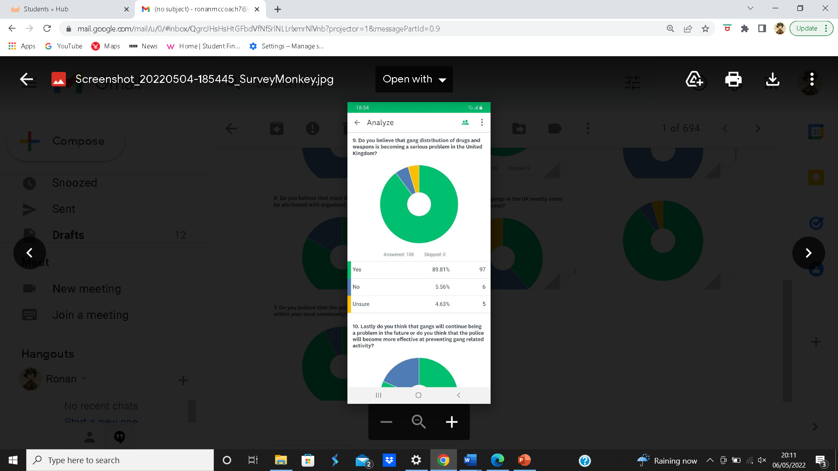

Question 10: Lastly do you believe that gangs will continue being a problem in the future or do you think that the police will become more effective at preventing gang related activity?
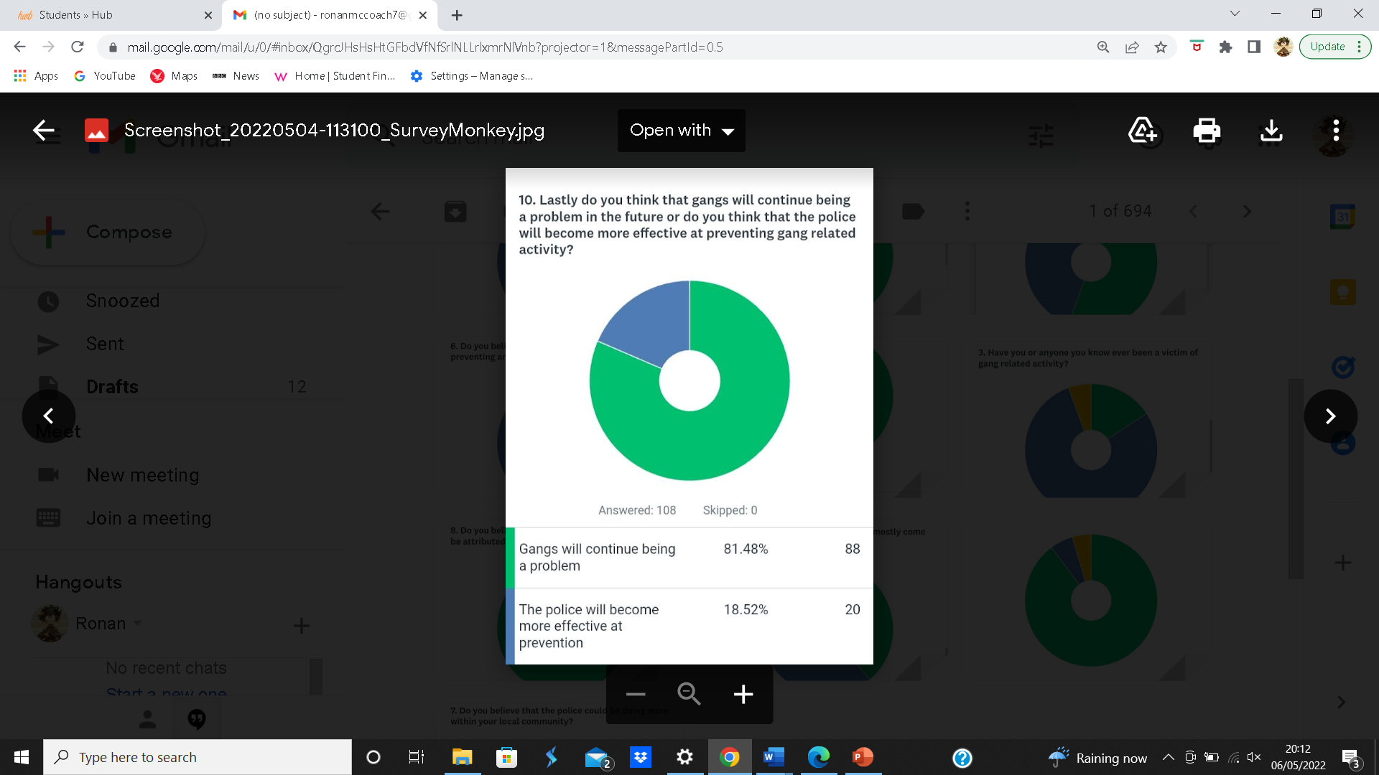
The overwhelming majority of participants do believe that gangs will continue being a problem in the future with eighty-eight participants believing this to be true while the remining twenty believing that the police will become more effective over time. This statistic is mostly based on opinion as it is impossible to say if the police will become more effective at countering the threats that gangs could potentially pose in the future however, this statistic does show how the participants think when it comes to how the police perform when it comes to countering crime as well as how gangs avoid the police. This statistic shows that the participants mostly believe that gangs will become more effective at countering the police as opposed to the police countering gangs this of course could be due to the fact that gangs have been on the rise in recent years especially in the city of London to add to this with some forces becoming short staffed many people could under the impression that the police simply haven’t the manpower nor the equipment to handle the shear amount of gangs within a city such as London. An example of this would be from Sky news in the year of 2021 when they reported on an interview with a gang member that there were over two hundred gangs in the City of London and that it was because the police simply did not care about people’s safety. Reports such as these can have a massive impact on the publics perception as they may begin to believe that the police simply do not focus on certain criminal activity as well as the public safety (Hughes 2021).

Survey Conclusion
To conclude this survey has found many much important information showing that the participants understand some aspects of organised criminal activity however, this survey has also found that the participants may feel some discontent with how the police currently perform their duties as the majority of participants believe that the police could be doing more to tackle crime within their own communities this is also shown through the last question as the majority of participants believe that the police will not become any more effective in the future but do have faith in their local police service which mostly align with other statistics created by the government (British Government 2021).

Conclusion
In conclusion this dissertation has looked into topics related to gangs and how they grow financially and recruit new members as well as how the police try to prevent these methods and how effective they are. This dissertation also covered how the general community feels about gangs across the United Kingdom as well as how the police counteract these strategies. These topics have mainly shown that gangs are very flexible with the strategies, they employ not fearing hurting others for their own gain as well as not having many considerations for those they manipulate. This can be seen through the county lines, which most gangs will use on vulnerable and helpless people as a way to generate cash at their expense. This can also be seen by the methods gangs use to exploit its members by using them to transport drugs within their local communities and not paying them with money but instead getting them addicted to narcotics such a marijuana and methamphetamines so that they will instead accept a small amount of drugs as payment leaving them in a state of work that fuels their addiction (Sommerset Police 2022). The dissertation also covered how the police counteracted gang related crime examples of this being how the police use informants within gangs as a way to develop evidence that can be used against gang members when developing a case. Too add to this it the strategies also included the prevention methods that the police use for example working with other agencies as a method to rehabilitate gang members as well as help them get off any drugs they may be addicted to. This information showed that gangs will likely continue being a problem as when a gang splits another gang will likely take its place this (Home Office 2017).
This dissertation also included a methodology the reason for this is that the researcher required three methods of research when preparing for the questionnaire which would be used to find out more information relating to the participants knowledge and opinions on the chosen topics. One of the research methods that was chosen for the survey was deduction the reason being that deduction would allow the researcher to compare their own research with those of a similar topic whether they be from the media or official government statistics. This method would also allow the researcher to ask questions relating to people’s opinion on a subject, which was important for a few questions in the survey. The survey would also employ the mixed research method simple as this would allow the researcher to ask simple yes and no questions whilst also ensuring that the research would be conclusive. The last method that would also be employed would be qualitive research, as this would allow the researcher to use questions that would allow for a better understanding of why the participant believes in what they answered. These topics would be gained from the research onion, which is used by researchers when creating a survey, and in a more professional manner.
her research methods as it is simple to understand and allows the researcher to consider their options Lastly the survey had surprising results for the researcher as the answers provided the researcher with the information that was required, to out how the public perceived crime and what they understood about it. The survey showed that the vast majority of the participants believed that the police could be doing better when it came to fighting organised crime this also correlated with how the police would handle organised crime in the future as the vast majority of people would also believe that the police would not improve when its comes to prevention showing that the public currently are not satisfied with how the police are currently performing in 2022 (Home Office 2016. The participants would also have a general understanding of organised criminal strategies, with just under half of the participants understanding the criminal strategy of county lines, and what they are used for, alongside the vast majority also being aware of what organised crime was and what it is often used for.

References

15 Writers (No Date) Understanding Research Onion. Accessed: https://15writers.com/research-onion/ Accessed: 26/04/2022

Albanese. G (2016) Violent video games create aggression, but do they kids to commit crimes. Available at: https://www.healthline.com/health-news/violent-video-games-create-aggression-but-they-do-cause-kids-to-commit-081415 Accessed: 04/04/2022

Allen G and Hording M (2021) Firearm statistics: England and Wales. Available at: https://commonslibrary.parliament.uk/research-briefings/cbp-7654/ Accessed: 03/05/2022

Austen, B (2013) Public Enemies: is Fuelling Gang Wars in Chicago. Available at: https://www.dcjs.virginia.gov/sites/dcjs.virginia.gov/files/training-events/3289/publicenemiessocialmediaisfuelinggangwarsinchicagounderwirewired.pdf Accessed: 04/04/2022

Crime Rate London (2022) City of London Crime overview. Available: https://crimerate.co.uk/london/city-of-london#:~:text=December%202021%20was%20also%20a,of%202.7%20per%201%2C000%20residents. Accessed: 02/11/2022

BBC (2019) County Lines: More than 4,000 Londoners identified in drugs gangs. Available at: https://www.bbc.co.uk/news/uk-england-london-49751780 Accessed: 29/04/2022

Burges, D (2013) Cargo theft gang. Available at: https://www.sciencedirect.com/topics/computer-science/cargo-theft-gang Accessed: 16/02/2022

British Government (2021) Confidence in the local police. Available at: https://www.ethnicity-facts-figures.service.gov.uk/crime-justice-and-the-law/policing/confidence-in-the-local-police/latest#:~:text=74%25%20of%20people%20had%20confidence,the%20year%20ending%20March%202020 Accessed: 04/05/2022

Crown Prosecution Service (2019) Summary: What offences may be committed if someone is shouted at or approached by another person in a street? Available at: https://www.cps.gov.uk/cps/news/summary-what-offences-may-be-committed-if-someone-shouted-or-approached-another-person Accessed: 06/03/2022

Crown Prosecution Service (2017) Organised Crim-Strategy. Available at: https://www.cps.gov.uk/organised-crime-strategy Accessed: 08/03/2022

Crown Prosecution Service (2022) County Lines Offending. Available at: https://www.cps.gov.uk/legal-guidance/county-lines-offending Accessed: 08/03/2022

Complex (2013) Get to know the technology authorities use to make drug bursts. Available at: https://www.complex.com/pop-culture/2013/12/technology-authorities-use-during-drug-busts/ Accessed: 27/03/2022

Cheshire East Council (2022) Council’s plan to crackdown on anti-social behaviour in boroughs major town. Available at: https://www.cheshireeast.gov.uk/council_and_democracy/council_information/media_hub/media_releases/4022022-chance-to-comment-on-council-plans-to-crack-down-on-towns-anti-social-behaviour.aspx Accessed: 06/03/2022

Children’s Commissioner (2021) Children will keep dying on our streets until there is a joined up public health response to gangs. Available at: https://www.childrenscommissioner.gov.uk/2021/02/06/children-will-keep-dying-on-our-streets-until-there-is-a-joined-up-public-health-response-to-gangs/ Accessed: 24/03/2022

College of Policing (2021) Obtaining information from digital devices-new guidance released. Available at: https://www.college.police.uk/article/extraction-material-digital-devices-app Accessed: 02/03/2022
Competition & Market Authority (2014) Rewards for information about cartels. Available at: https://www.gov.uk/government/publications/cartels-informant-rewards-policy/rewards-for-information-about-cartels Accessed: 17/02/2022

Crown Prosecution Service (2021) Criminal Damage. https://www.cps.gov.uk/legal-guidance/criminal-damage Accessed: 23/03/2022

CPS (2021) Gang related offences-Decision making in. Available at: https://www.cps.gov.uk/legal-guidance/gang-related-offences-decision-making Accessed: 15/02/2022

Department for environment, Food and Rural affairs (2021) Pet abduction to be made new criminal offence in crackdown on pet theft. Available at: https://www.gov.uk/government/news/pet-abduction-to-be-made-new-criminal-offence-in-crackdown-on-pet-theft Accessed: 08/03/2022

Debois S (2022) 10 Advantages And Disadvantages Of Questionnaires. Available at: https://surveyanyplace.com/blog/questionnaire-pros-and-cons/ Accessed: 24/04/2022

Department for levelling up, Housing & Communities. (2021) Help with Anti-social behaviour for social housing tenants. Available at: https://www.gov.uk/government/publications/help-with-anti-social-behaviour-for-social-housing-tenants/help-with-anti-social-behaviour-for-social-housing-tenants Accessed: 04/03/2022

Dorset Police (2022) Arrests in Dorset as part of crackdown on suspected drug gangs. Available at: https://www.dorset.police.uk/news-information/article/14415 Accessed: 15/03/2022

Gunnell D (2016) Social Network analysis of an urban street gang using police intelligence data. Available at: https://assets.publishing.service.gov.uk/government/uploads/system/uploads/attachment_data/file/491578/horr89.pdf Accessed: 20/03/2022

Family Lives (2022) Advice for parents and carers on gangs. Available at: https://www.familylives.org.uk/advice/teenagers/behaviour/gangs Accessed: 04/05/2022

Fournis G (2014) Violence, crime, and violent video games: is there a correlation. Available at: https://www.psychiatrictimes.com/view/violence-crime-and-violent-video-games-there-correlation Accessed: 15/04/2022

Home Office (2014) Advice to parents and carers on gangs. Available at: https://assets.publishing.service.gov.uk/government/uploads/system/uploads/attachment_data/file/345337/AdviceParentsCarersGangs14.pdf Accessed: 17/02/2022

Home Office (2018) Criminals Exploitation of children and vulnerable adults: County Lines guidance. Available at: https://assets.publishing.service.gov.uk/government/uploads/system/uploads/attachment_data/file/863323/HOCountyLinesGuidance_-_Sept2018.pdf Accessed: 04/05/2022

Hughes A (2021) ‘There’s no end to this because the police don’t care and we don’t care’; Inside London’s gang Hotspot. Available at: https://news.sky.com/story/theres-no-end-to-this-because-the-police-dont-care-and-we-dont-care-inside-londons-gang-hotspot-12472251#:~:text=There%20are%20about%20200%20identified,by%20how%20violent%20they%20are. Accessed: 04/05/2022

Home Office (2015) Preventing youth violence and gang involvement. Available at: https://assets.publishing.service.gov.uk/government/uploads/system/uploads/attachment_data/file/418131/Preventing_youth_violence_and_gang_involvement_v3_March2015.pdf Accessed: 17/02/2022

HM Government (2011) Ending Gang and Youth violence: A cross-Government report. Available at: https://assets.publishing.service.gov.uk/government/uploads/system/uploads/attachment_data/file/97861/gang-violence-summary.pdf Accessed: 07/03/2022

Home Office (2020) Interviewing suspects. Available at: https://assets.publishing.service.gov.uk/government/uploads/system/uploads/attachment_data/file/864940/interviewing-suspects-v7.0.pdf Accessed: 25/03/2022

Home Office (2015) 2010 to 2015 government policy: knife, gun and gang crime. Available at: https://www.gov.uk/government/publications/2010-to-2015-government-policy-knife-gun-and-gang-crime/2010-to-2015-government-policy-knife-gun-and-gang-crime Accessed: 23/03/2022

Home Office (2018) Covert Human Intelligence sources. Available at: https://www.nationalcrimeagency.gov.uk/what-we-do/crime-threats/drug-trafficking Accessed: 16/02/2022

HM Government (2016) Statutory guidance. Available at: https://assets.publishing.service.gov.uk/government/uploads/system/uploads/attachment_data/file/526379/Statutory_Guidance_-_Injunctions_to_Prevent_Gang-Related_Violence__web_.pdf Accessed: 03/10/2022

Home Office (2010) Safeguarding children and young people who may be affected by gang activity. Available at: https://assets.publishing.service.gov.uk/government/uploads/system/uploads/attachment_data/file/189392/DCSF-00064-2010.pdf.pdf Accessed: 04/04/2022

Hales G (2018) Crime is up-blame the police? Available at: https://www.police-foundation.org.uk/2018/03/crime-blame-police-crime-survey-england-wales-tells-us-police-crime-recording-practices-exposes-limitations/ Accessed: 29/04/2022

Harris D, Turner R, Garrett I, Atkinson S (2011) Understanding the Phycology of Gang violence: Implications for designing effective violence interventions. Available at: https://assets.publishing.service.gov.uk/government/uploads/system/uploads/attachment_data/file/217379/research-gang-violence.pdf Accessed: 25/03/2022

HM Government (2016) Ending gang violence and exploitation. Available at: https://assets.publishing.service.gov.uk/government/uploads/system/uploads/attachment_data/file/491699/Ending_gang_violence_and_Exploitation_FINAL.pdf Accessed: 23/03/2022

Home Office (2017) Government takes action on county line drug gangs. Available at: https://www.gov.uk/government/news/government-takes-action-on-county-line-drug-gangs Accessed: 04/05/2022

Home Office (2016) Ending gang violence and exploitation. Available at: https://www.gov.uk/government/publications/ending-gang-violence-and-exploitation Accessed: 04/05/2022

Interpol (2018) Our role to fight drug trafficking. Available at: https://www.interpol.int/en/Crimes/Drug-trafficking/Our-role-to-fight-drug-trafficking Accessed: 03/17/2022

Local Government Association (2021) LGA: More girls being recruited and horrifically abused by county lines and drug gangs. https://www.local.gov.uk/about/news/lga-more-girls-being-recruited-and-horrifically-abused-county-lines-drug-gangs#:~:text=Children%20aged%2015%20to%2017,a%20year%20in%20illegal%20profits. Accessed: 15/02/2022

London Assembly (2019) Revealed: Full Links between poverty and violent crime in London. Available at: https://www.london.gov.uk/press-releases/mayoral/full-links-between-poverty-and-violent-crime Accessed: 16/02/2022

Lewisham Council (2014) Safer Stronger Communities Select Committee. Available at: https://councilmeetings.lewisham.gov.uk/documents/s31856/Appendix%20D%20- Accessed 02/20/2022

Leong K (2021) Law Enforcement and Bargaining over illicit drug prices: Structural evidence from a gangs’ ledger. Available at: https://walshc.github.io/research/gang_bargaining.pdf Accessed: 14/03/2022

Mann B (2021) More Britons now unconfident than confident in the police to deal with crime locally. Available at: https://yougov.co.uk/topics/politics/articles-reports/2021/10/06/more-britons-now-unconfident-confident-police-dealV Accessed: 20/03/2022

Malthouse K (2021) Policing (England and Wales). Available at: https://hansard.parliament.uk/Commons/2021-02-10/debates/A2C2CDCF-15E1-4EA5-9B05-E8DA2551E644/Policing(EnglandAndWales) Accessed: 29/04/2022

Moroz A (2019) Living with Loss. Available at: https://www.victimsupport.org.uk/wp-content/uploads/documents/files/Living%20with%20loss-Summary.pdf Accessed: 07/03/2022

Marsh S (2018) UK gangs ‘using vulnerable peoples homes to stash drugs. Available at: https://www.theguardian.com/world/2018/aug/01/uk-gangs-using-vulnerable-peoples-homes-to-stash-drugs Accessed: 15/03/2022

Metropolitan Police (2020) Keeping London Safe. Available at: https://www.met.police.uk/SysSiteAssets/media/downloads/force-content/met/about-us/met-business-plan-2020-23.pdf Accessed: 17/02/2022

London Assembly (2018) Gun Crime in London. Available at: https://www.london.gov.uk/about-us/london-assembly/london-assembly-publications/gun-crime-london Accessed: 08/03/2022

Metropolitan Police (2022) Seven facts about residential burglary. Available at: https://www.met.police.uk/cp/crime-prevention/protect-home-crime/residential-burglary-facts/#:~:text=Burglars%20are%20often%20opportunistic%20thieves,will%20only%20spur%20them%20on. Accessed: 16/02/2022
NCA (2017) County Lines Violence, exploitation & Drug Supply 2017. Available at: https://www.nationalcrimeagency.gov.uk/who-we-are/publications/234-county-lines-violen-ce-exploitation-drug-supply-2017/file Accessed: 03/10/2022

National Cyber Security Centre (2019) What is antivirus product? Do I need one? Available at: https://www.ncsc.gov.uk/guidance/what-is-an-antivirus-product Accessed: 28/04/2022

NCA (2022) Arrested by the NCA-man suspected of running cannabis farm network. Available at: https://www.nationalcrimeagency.gov.uk/news/arrested-by-the-nca-man-suspected-of-running-cannabis-farm-network Accessed: 23/04/2022

NCA (2022) Operation Venetic: Available at: https://www.nationalcrimeagency.gov.uk/news/operation-venetic-drugs-supply-gang-leader-sentenced Accessed: 14/03/2022

NCA (2016) County Lines Violence, exploitation & Drug supply 2016. Available at: https://www.nationalcrimeagency.gov.uk/who-we-are/publications/15-county-lines-gang-violence-exploitation-and-drug-supply-2016/file Accessed: 03/20/2022

National Police Chiefs Council (2021) Domestic Homicides remain stable during lockdown but still enduring problem says new police report. Available at: https://news.npcc.police.uk/releases/domestic-homicides-show-no-significant-increase-during-lockdown-says-new-police-report Accessed: 07/03/2022

National Library of Medicine (2013) Qualitive Research. Available at: https://www.ncbi.nlm.nih.gov/pmc/articles/PMC3757586/ Accessed? 20/04/2022

NSPCC (No Date) Criminal Exploitation and Gangs. Available at: https://www.nspcc.org.uk/what-is-child-abuse/types-of-abuse/gangs-criminal-exploitation/ Accessed: 27/03/2022

National Crime Agency (2022) Protected Persons. Available at: https://www.nationalcrimeagency.gov.uk/what-we-do/how-we-work/providing-specialist-capabilities-for-law-enforcement/protected-persons Accessed: 25/03/2022

National Crime Agency (No Date) Illegal Firearms. Available at: https://www.nationalcrimeagency.gov.uk/what-we-do/crime-threats/firearms Accessed:17/02/2022

Noble Solicitors (2021) A guid to voluntary police interviews. Available at: https://www.noblesolicitors.co.uk/about/a-guide-to-voluntary-police-interview.html Accessed: 25/03/2022

National Library of Medicine (2006) Designing a questionnaire. Available at: https://www.ncbi.nlm.nih.gov/pmc/articles/PMC4797036/ Accessed: 27/04/2022

National Crime Agency (2022) Drug Trafficking. Available at: https://www.nationalcrimeagency.gov.uk/what-we-do/crime-threats/drug-trafficking Accessed: 16/02/2022

NCA (2018) County Lines Drugs Supply, Vulnerability and Harm 2018. Available at: https://www.nationalcrimeagency.gov.uk/who-we-are/publications/257-county-lines-drug-supply-vulnerability-and-harm-2018/file Accessed: 10/03/2022

National Crime Agency (No Date) County Lines. Available at: https://www.nationalcrimeagency.gov.uk/what-we-do/crime-threats/drug-trafficking/county-lines Accessed: 15/02/2022

National Library of Medicine (2019) Child maltreatment and the risk of antisocial behaviour: A Population-based cohort study spanning 50 years. Available at: https://pubmed.ncbi.nlm.nih.gov/31812893/ Accessed: 03/15/2022

Office for National Statistics (2021) Domestic abuse prevalence and Trends England and Wales: year ending March 2021) Available at: https://www.ons.gov.uk/peoplepopulationandcommunity/crimeandjustice/articles/domesticabuseprevalenceandtrendsenglandandwales/yearendingmarch2021 Accessed: 07/03/2022

Office for Health improvement & Disparities (2022) Methodology. Available at: https://www.gov.uk/government/publications/covid-19-mental-health-and-wellbeing-surveillance-report/methodology Accessed: 29/04/2022

Pers J (2015) A Longitudinal Study of Risk-Glorifying Video Game Behaviour Deviance. Available at: https://www.ncbi.nlm.nih.gov/pmc/articles/PMC4151190/ Accessed: 19/04/2022

Parkes T (2020) Cannabis gangs hunt out drug dens using hi-tech cameras. Available at: https://www.expressandstar.com/news/crime/2020/01/06/thermal-imaging-cameras-used-to-target-wolverhampton-homes/ Accessed: 14/03/2022

Public Health England (2015) The mental health needs of gang-affiliated young people. Available at: https://assets.publishing.service.gov.uk/government/uploads/system/uploads/attachment_data/file/771130/The_mental_health_needs_of_gang-affiliated_young_people_v3_23_01_1.pdf Accessed: 04/05/2022

Phair D and Warren K (2021) Peeling the Onion, Layer by layer (with examples) Available at: https://gradcoach.com/saunders-research-onion/#:~:text=At%20the%20simplest%20level%2C%20Saunders,any%20other%20formal%20research%20project. Accessed: 27/04/2022

Stephensons (2020) How long can the police hold you for questioning. Available at: https://www.stephensons.co.uk/site/blog/criminal-justice-blog/how-long-can-the-police-hold-you-for-questioning Accessed: 25/03/2022

Stripe N (2021) The nature of violent crime in England and Wales: Year ending March 2020. Available at https://www.ons.gov.uk/peoplepopulationandcommunity/crimeandjustice/articles/thenatureofviolentcrimeinenglandandwales/yearendingmarch2020 : 29/04/2022

Stainton H (2021) Research Onion. Available at: https://tourismteacher.com/research-onion-beginners/ Accessed: 27/04/2022

Statista (2022) Number of police recorded drug offences in London 2015/2016 to 2020/2021. Available at: https://www.statista.com/statistics/864747/drug-offences-in-london/ Accessed: 29/04/2022

Statista (2022) Number of Firearm offences in London 2015-2021. Available at: https://www.statista.com/statistics/865565/gun-crime-in-london/#:~:text=There%20were%201%2C281%20gun%20crime,by%20the%20COVID%2D19%20pandemic. Accessed: 02/05/2022

South Wales (2022) Nearly 70 drug dealers have been arrested as part of Operation Talon-A Class A drug Supply in Cardiff. Available at: https://www.south-wales.police.uk/news/south-wales/news/2022/chw-feb/nearly-70-drug-dealers-have-been-arrested-as-part-of-operation-talon--a-huge-crackdown-on-class-a-drug-supply-in-cardiff/ Accessed: 12/04/2022

Stripe N (2021) Understanding the impact of the pandemic on levels of crime in England and Wales. Available at: https://blog.ons.gov.uk/2021/11/04/understanding-the-impact-of-the-pandemic-on-levels-of-crime-in-england-and-wales/ Accessed: 04/03/2022

Soiferman K (2010) Compare and Contrast Inductive and Deductive. Available at: https://files.eric.ed.gov/fulltext/ED542066.pdf Accessed: 29/04/2022

Sommerset Police (2022) County lines drug dealers jailed for more than 20 years. Available at: https://www.avonandsomerset.police.uk/news/2022/03/county-lines-drug-dealers-jailed-for-more-than-20-years/ Accessed: 04/05/2022

Trust For London (2022) Crimes recorded by Neighbourhood income deprivation decile in London (March 2020-Febuary 2021. Available at: https://www.trustforlondon.org.uk/data/crime-and-income-deprivation/ Accessed: 04/03/2022

Thompson K (2021) Poverty is the main ‘cause’ of Youth Violent Crime in London…. Available at: https://revisesociology.com/2021/06/24/poverty-is-the-main-cause-of-youth-violent-crime-in-london/#:~:text=A%20recent%202019%20study%20into,Sociology%20Crime%20and%20Deviance%20module. Accessed: 03/04/2022

Trejo D (2021) When Danny Trejo Negotiated between Hollywood and Mexican prison gangs. Available at: https://www.gq.com/story/danny-trejo-prison-gangs Accessed: 18/03/2022

The Children’s Society (2022) What is County Lines? Available at: https://www.childrenssociety.org.uk/what-we-do/our-work/child-criminal-exploitation-and-county-lines/what-is-county-lines Accessed: 08/03/2022

Townsend M (2021) British gangs and international rivals join forces to increase cocaine sales. Available at: https://www.theguardian.com/world/2021/sep/19/british-gangs-and-international-rivals-join-forces-to-increase-cocaine-sales Accessed: 17/02/2022

Troubled Teens (2019) Gangs and Teens. Available at: https://troubledteens.com/teen-warning-signs/gangs-and-teens/ Accessed: 23/03/2022

Thurrock (2022) County Lines (drug trafficking) Available at: https://www.thurrock.gov.uk/gangs-and-gang-crime/county-lines-drug-trafficking Accessed: 15/03/2022

Thurrock Council (No Date) Gang related violence. Available at: https://democracy.thurrock.gov.uk/documents/s27618/Appendix%203%20-%20Gang%20Related%20Violence%20Booklet.pdf Accessed: 24/03/2022

Thurrock.gov.uk (No Date) Gang structure. Available at: https://www.thurrock.gov.uk/gangs-and-gang-crime/gang-structure Accessed: 16/02/2022

UK Crime Stats (2022) Crime in London. Available at: https://www.ukcrimestats.com/Subdivisions/GLA/2247/ Accessed: 03/03/2022

University of Pennsylvania (2018) How parenting affects antisocial behaviours in children. Available at https://www.sciencedaily.com/releases/2018/10/181011173131.htm Accessed: 05/03/2022

University of Leicester (2013) Gang Culture. Available at: https://www.le.ac.uk/ebulletin-archive/ebulletin/features/2000-2009/2006/08/nparticle.2006-08-03.html Accessed: 23/03/2022

UK Health and Security Agency (2020) Mixed methods study. Available at: https://www.gov.uk/guidance/mixed-methods-study#:~:text=A%20mixed%20methods%20study%20combines,with%20more%20in%2Ddepth%20findings. Accessed: 27/04/2022

Victim Support (2022) Burglary. Available: https://www.victimsupport.org.uk/crime-info/types-crime/burglary/ Accessed: 02/04/2022

Welsh Government (2020) What factos are linked to people feeling safe in their local area? Available at: https://gov.wales/sites/default/files/statistics-and-research/2020-03/what-factors-are-linked-to-people-feeling-safe-in-their-local-area.pdf Accessed: 04/05/2022

Youth.GOV (2022) Youth Involved in Gangs. Available at: https://youth.gov/youth-topics/preventing-gang-involvement/adverse-effects Accessed: 15/02/2022

Youth & Policing (EDUCATION HUB 2018) County Lines Lesson Package. Available at: https://www.youthandpolicing.co.uk/wp-content/uploads/2018/09/County-Lines-Lesson-Plan.pdf Accessed: 03/10/2022

Appendices

Organised crime

Organised crime
Top of Form

Question Title

1. What is your gender?
Male
Female
Other

Question Title

2. Do you know what organised crime is?
Yes
No

Question Title

3. Have you or anyone you know ever been a victim of gang related activity?
Yes
No
Not sure

Question Title

4. Do you believe that gangs in the UK mostly come from poor residential areas?
Yes
No
Unsure

Question Title

5. Do you know the criminal strategy known as "County lines"
Yes
No

Question Title

6. Do you believe that the police are effective at both preventing and stopping gang related activity?
Yes
No

Question Title

7. Do you believe that the police could be doing more within your local community?
Yes
No

Question Title

8. Do you believe that most drug related activity could be attributed with organised gangs?
Yes
No

Question Title

9. Do you believe that gang distribution of drugs and weapons is becoming a serious problem in the United Kingdom?
Yes
No
Unsure

Question Title

10. Lastly do you think that gangs will continue being a problem in the future or do you think that the police will become more effective at preventing gang related activity?
Gangs will continue being a problem
The police will become more effective at prevention
Done
Bottom of Form
Powered by

