Nicusor Mihai Enache (1912495)

Internet Engineering

Assignment 2 Resit/Rework

Universal Sports Database

Task 1 report

Design
I first started by deciding what design my database will use. I had to create a database for the three branches of Universal sports: Casual staff, Fitness instructors and Swimming pool attendants. The branches are then divided in two more sections: Personal data and Company data. The primary keys of Personal data and company data were Staff code and branch code. Staff code is the identification number of each employee and branch code is the identification number of the branch they employee currently works in. I have concluded that to create an efficient design I would have to separate the three different branches to make it easier to create the relationships. For example, the Casual staff branch is not related to the Fitness instructors branch because they are different branches with different workers and different tasks. Furthermore, after deciding how I will be approaching the situation, I have used StarUML to illustrate my design.
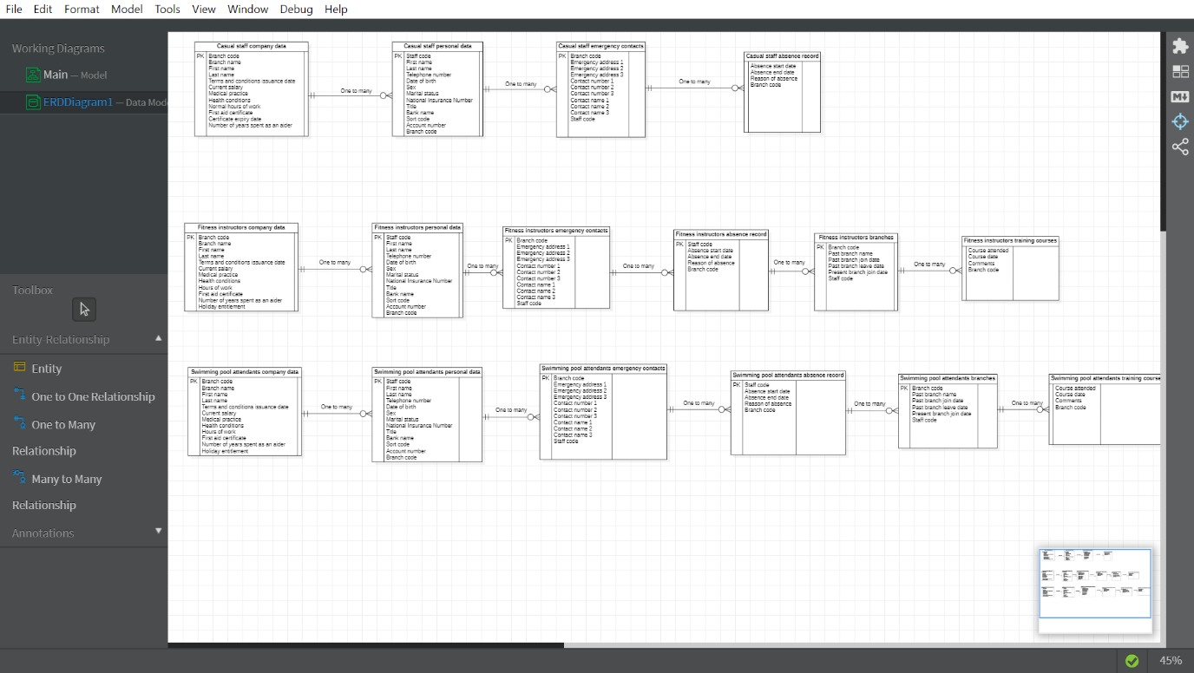
As we can see in the entity relationship diagram above, each branch of the company has its own tables where data is stored, none of the branches interacting with each other. Each table has at least a primary key or foreign key and the type of relation is one to many.

