

Course: Business management
Module name: Data Handling & Business Intelligence
Module code: LCBB5000
Lecturer: Dr Xavier Matieni
Title of report: Assignment 2
Student: Stanimira Nikolova Nikolova
ID Number: 2118452

TABLE OF CONTENT

1.Introduction…………………………………………………………………………page 3
2.What is business? …………………………………………………………………page 3
3. The definition of data warehouse………………………………………………...page 3
4.Definition of Business Intelligence………………………………………………page 4
5. Data mining and its definition……………………………………………………page 4
6.Microsoft Excel……………………………………………………………………...page 4
7.Part 1 ………….……………………………………………………………………page 6
8.Part 2………………………………………………………………………………page 15
9.Conclusion…………………………………………………………………………page 25
10.Reference list…………………………………………………………………...page 26

Introduction
Excel supports performance tracking, accounting, and customer intelligence with integrations like Microsoft SharePoint and Power Business Intelligence (BI), enabling data querying and analysis across Excel and BI tools. BI is crucial for organizations to understand data, improve decision-making, and analyse data. Excel, integrated with SharePoint and Power BI, offers data import, visualization, analysis, filtering, chart types, and Microsoft-provided reports and dashboards (Kaur.2023). This essay will analyse the importance of Business Intelligence using Excel and how this tool can help business to perform simple calculations, track information and sort data. In part 1 and part 2 of my assignment, I answered the questions that were provided by the university.
Maheshwari and Anil (2015), point out that business is the art of doing something productive and serving someone in need to improve the world. Business activities are recorded using electronic media or paper and after that these records become data. The industry has access to a wealth of client feedback data. Utilising methodologies and specialised tools, this data may be studied and mined to produce patterns and information that provide insight into how the business is operating. These concepts can be reintroduced into the firm to improve its effectiveness and efficiency so that as the cycle continues, it can adapt to better meet the requirements of its clients.
According to Maheshwari and Anil (2015, p.10), a data warehouse is a large store of data from various sources within a company used for management decisions. It is an adaptation of the operational database for decision-making and reporting. As more operational data becomes available, the warehouse accumulates and adds it, without updating the data values. For example, a data warehouse for movie sales data should track sales for making informed decisions. Maheshwari and Anil (2015, p.37) state that a data warehouse is functionally and physically separate from a transactional and operational database and creating a data warehouse for queries and analysis represents a significant investment in effort and time. It also must be continually kept up to date for it to be useful. Data warehouse offers the business a lot of technical benefits such as reporting and data mining activities. Thus, improving customer service and business efficiency. It also can present a competitive advantage by facilitating decision-making as well as supporting reform business processes. Data warehouse provides timely and better information and allows end users to perform extensive analysis (Maheshwari and Anil,2015, p.37)
Maheshwari and Anil (2015, p.3-4) state that Business Intelligence is a broad set of information technology (IT) and includes tools for analysing, reporting, and gathering information to the users about the performance of the organization and its environment and to help with decision-making in any industry. These IT solutions are the most important solutions for investment as it generates data about sales, expenses, and purchases from multiple locations as well as times. As analysing this data could help recognize regional selling items, fast-growing customer segments, fast-selling items, seasonal items, and so on. Ideas about what products sell together also can be generated, which products people tend to buy, and so on. This intelligence and insights can support the design of better promotion plans, store layouts, and product bundles, which lead to a better-performing business. For instance, the vice president of finance would be interested in tracking, expense, daily revenue, and cash flows by store as measuring the cost of capital, comparing them against the plan, and so on. Pattern recognition is also important as it can help dissipate a lot of anger and frustration, for example, the top twenty percent of customers lead to eighty percent of the business, or twenty percent of products generate eighty percent of the business. Data mining includes machine learning and statistical techniques to form decision-making models from raw data. Data mining techniques include decision trees, artificial neural networks, regression, cluster analysis, and more (Maheshwari and Anil,2015).
Witten (2011, p.8-9) states that the definition of data mining indicates the process of analysis and exploration of a dataset of an enormous size, to find regular patterns, to extract knowledge to obtain meaningful rules. It also involves methods at the intersection of machine learning. Serious applications of data mining involve thousands or even millions of individual cases. Corporate data is an asset, which value has increased enormously with the development of data mining techniques.
According to David et al (2021, p.1-13), Microsoft Excel is the most universally used spreadsheet package in businesses, universities, and colleges and it is used as the software package for statistical analysis. There are four primary tasks: Enter/Access Data, apply tools, enter functions and formulas and editing options, and apply Excel to help users focus on statistical methodology. Microsoft Excel is also one of the most important tools for marketing as such analysis often prove helpful in founding future marketing strategies for various product. It is also used to monitor the output of a production process, economics, and information system. Data are the facts collected, summarized, and analysed for interpretation and presentation and all data collected in a specific study are referred to as the data set for the study. By conducting an observational study or experiment data can be obtained from existing sources such as employees, customers, business operations, ages, salary, distribution costs, production quantities, customers, gender, sales volume, etc. Observational studies observe what is happening in a specific situation and conduct a statistical analysis of the resulting data. Statistical analysis of the data also may help managers to decide how factors such as gender and the length of the shopping of the customer affect the amount spent. Great care is important in recording and collecting data to ensure that errors are not made as it can result in misleading information and bad decisions. Thus, accurate data is vital as it can help ensure valuable and reliable decision-making information (David et al,2021, p.1-13).

Part 1:
1: University information has been used to find the average price (room reservation price) over the year ranging from 2017 to 2021 and Microsoft Excel is used.
Average reservation price is 103.4235 as can be seen as well in the picture.
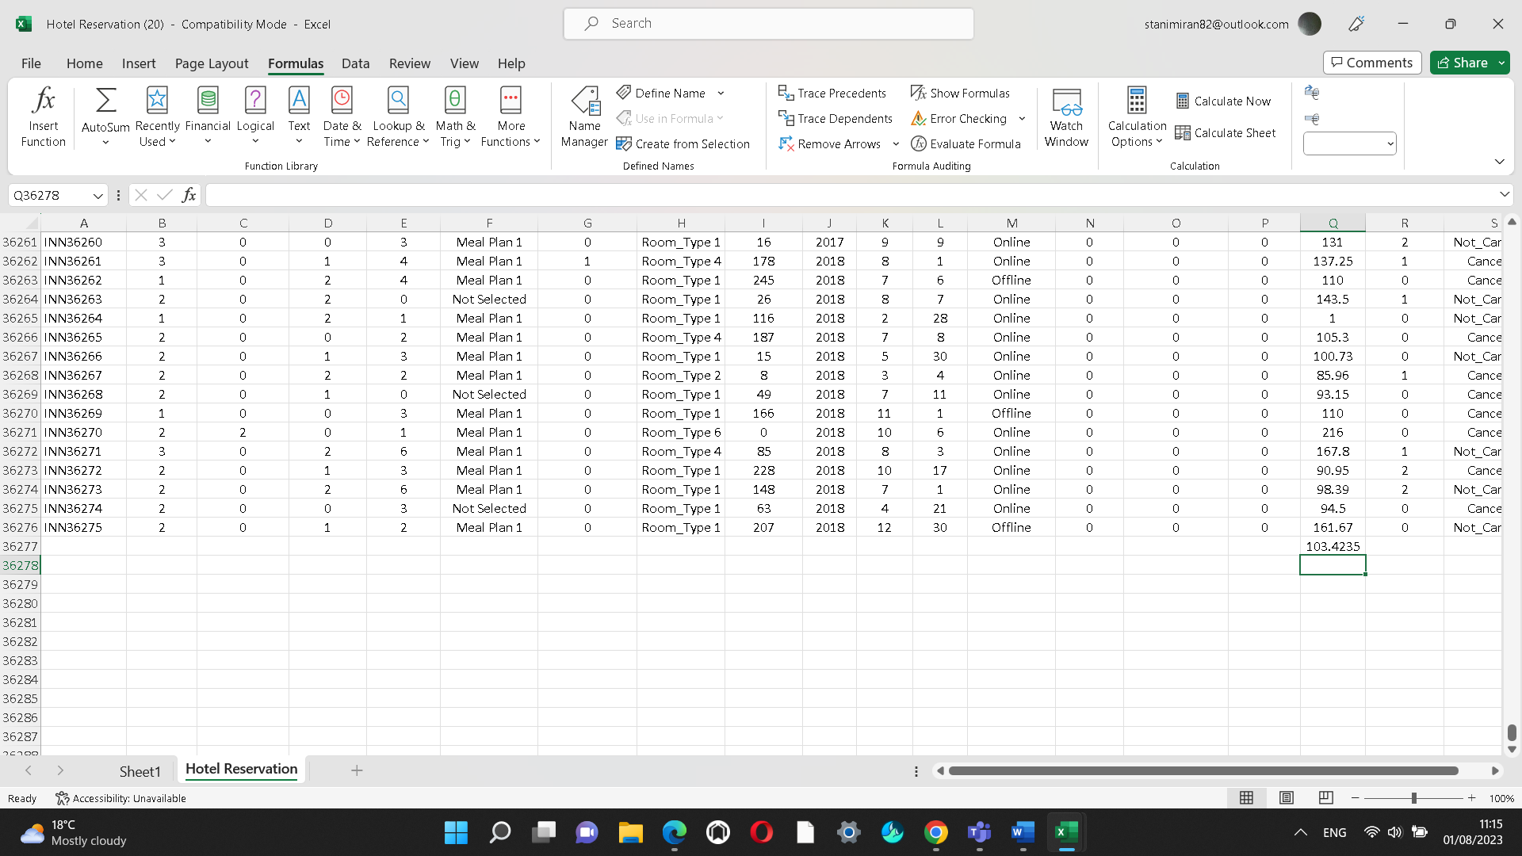

Microsoft Excel makes the visualisation of data a lot easier, as data can be found quickly and organised, which helps businesses better understand the structure and activities of their workforce.

2: The next part is to demonstrate how I can perform these tasks with the use of a minimum of 2 Microsoft Excel functions such as LOOKUP and PIVOT TABLES as an example. It is required to produce also appropriate and meaningful graphs/charts/diagrams based on my finding. PIVOT TABLES have been used here.

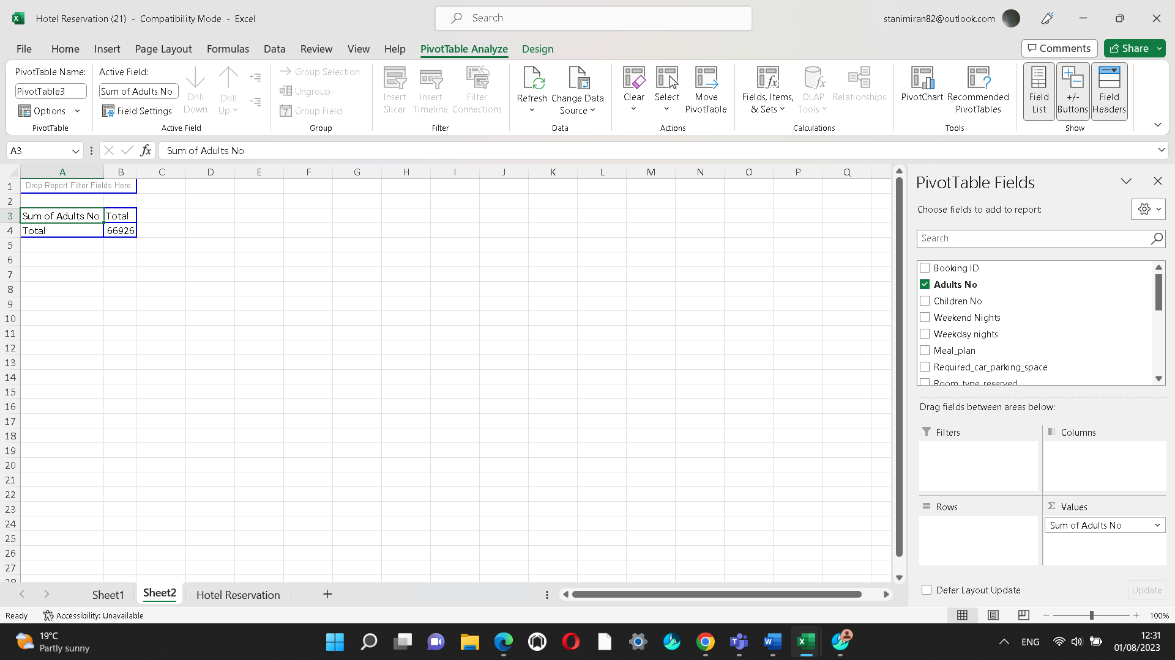

Based on finding the sum of the adult number in total is 66926 for the period 2017-2021

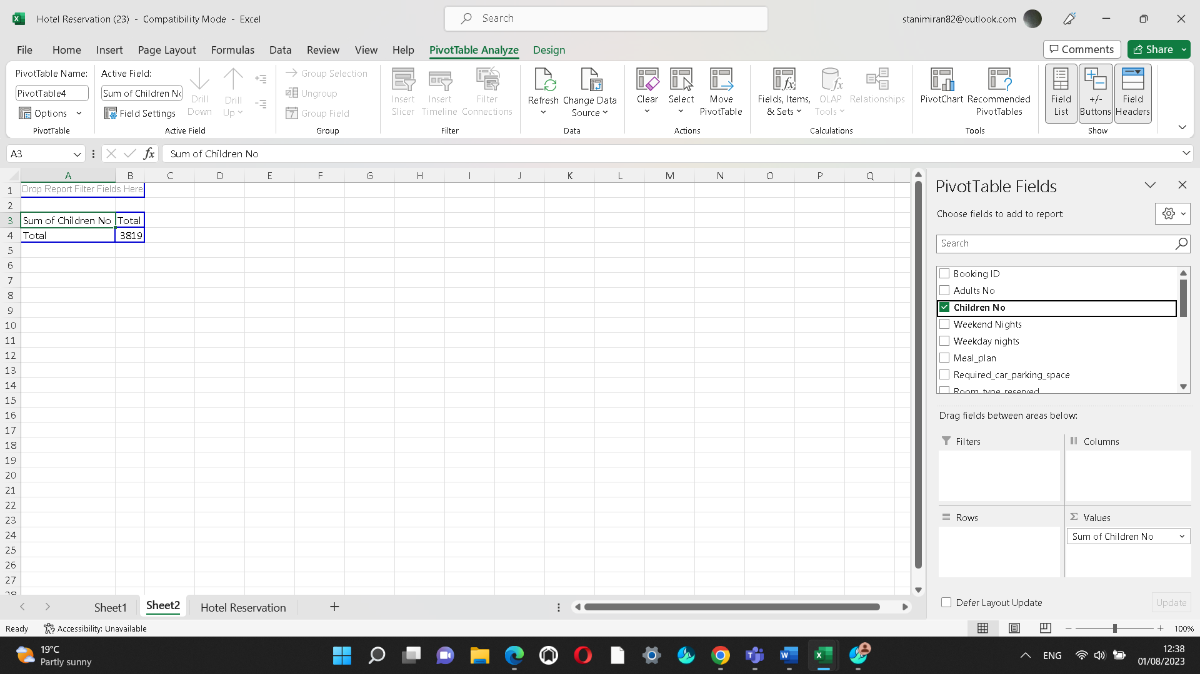

The sum of children number for the period between 2017-2021 is 3819.

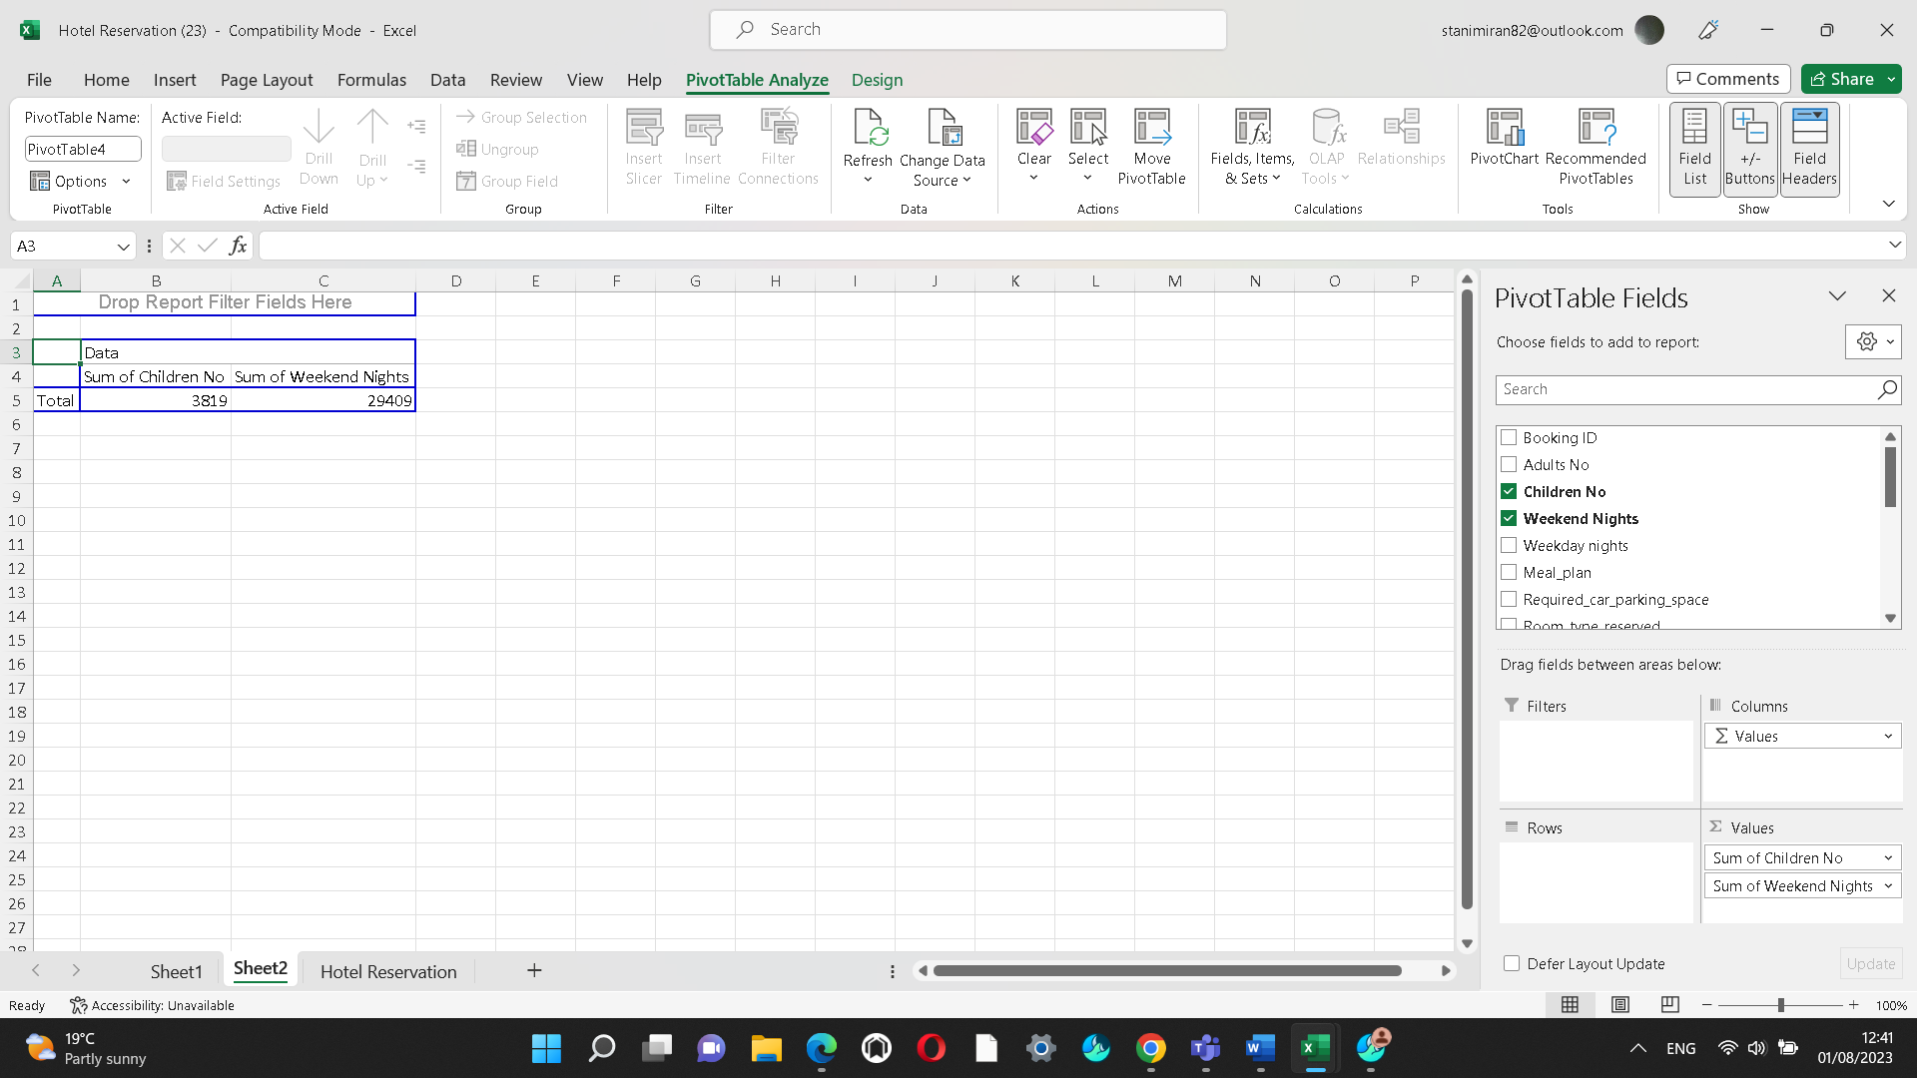
In this chart can be seen that the sum of the total children number is 3819 as well as the sum of the weekend nights is 29409.

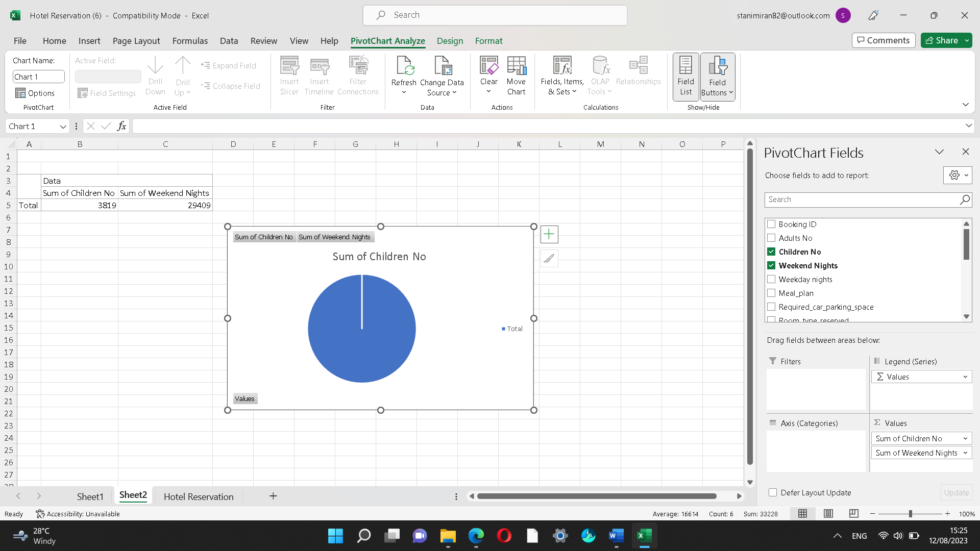
And Pivot chart is above.

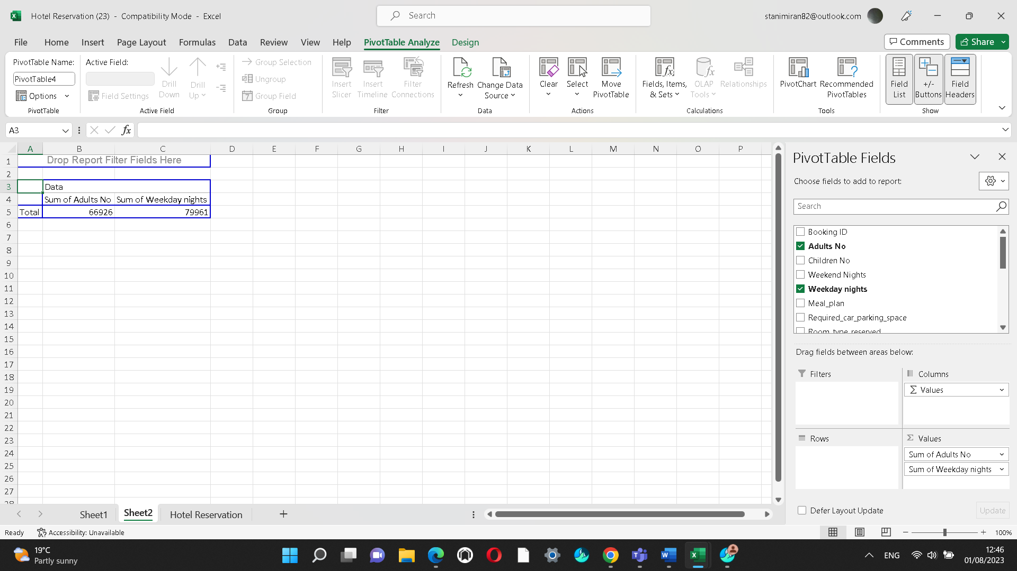
It is shown the sum of the adults' number in total for the period 2017-2021 which is 66926 and the sum of the weekday nights-79961 and Pivot Table is below.

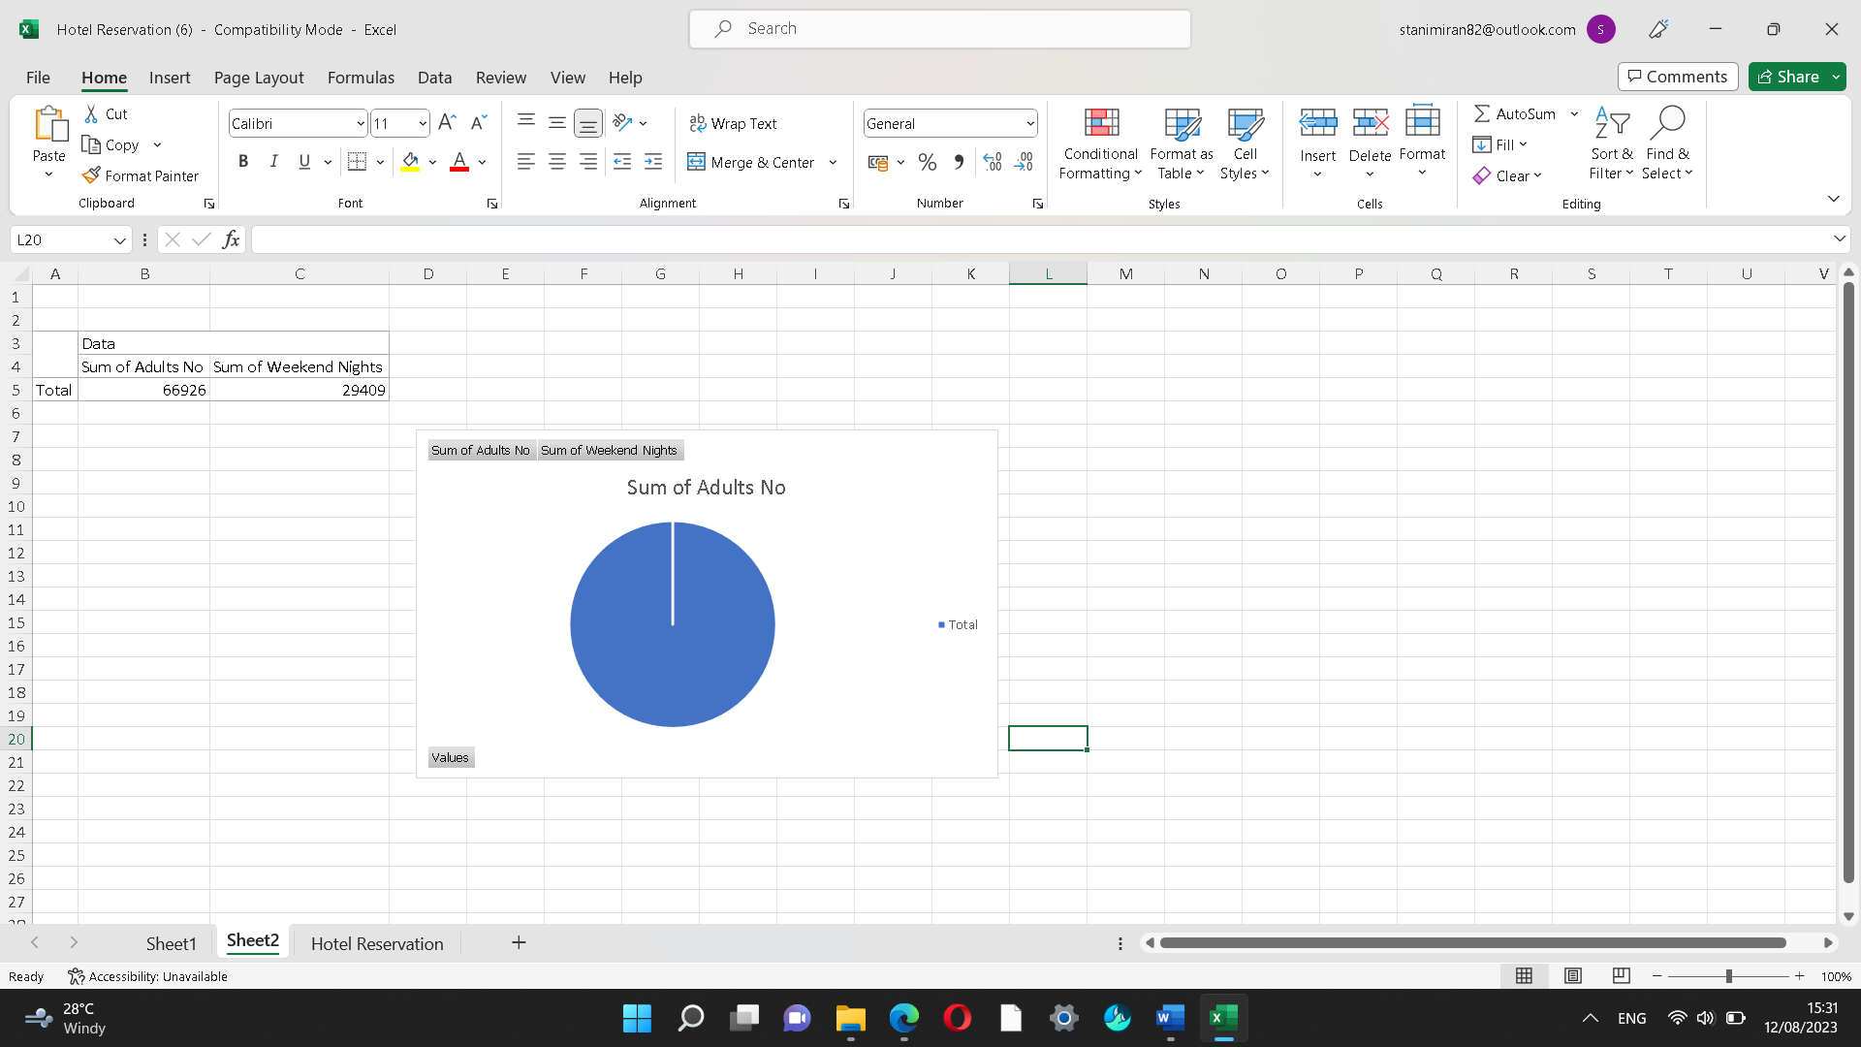

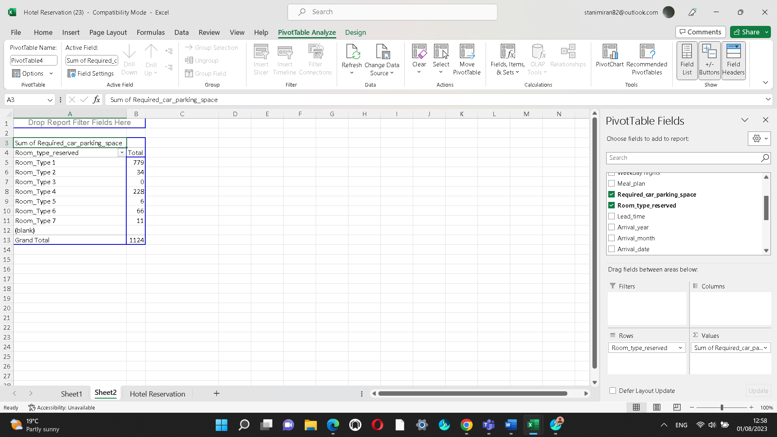

This chart shows the sum of the required car parking space for the period 2017-2021 which for type 1 in total is 779, for type 2 is 34, for type 6 is 66 and in Grand total is 1124. Pivot chars is below.

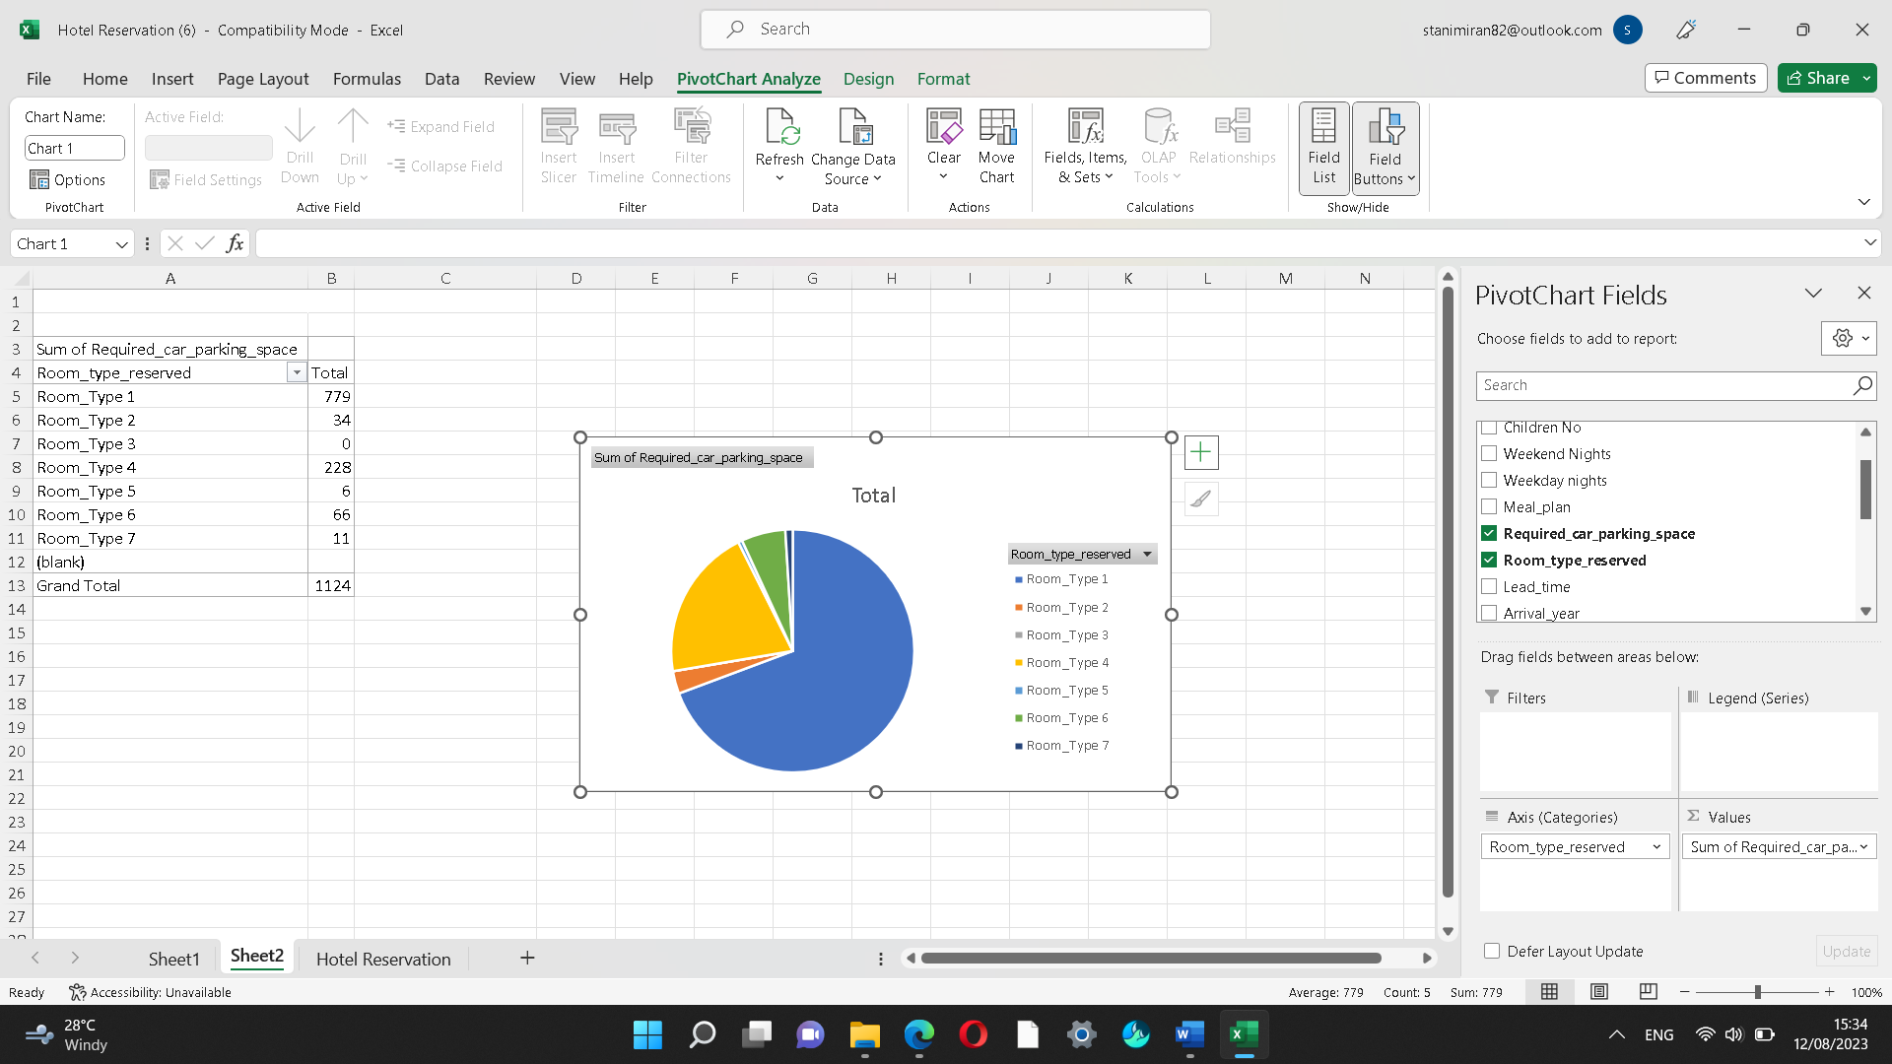

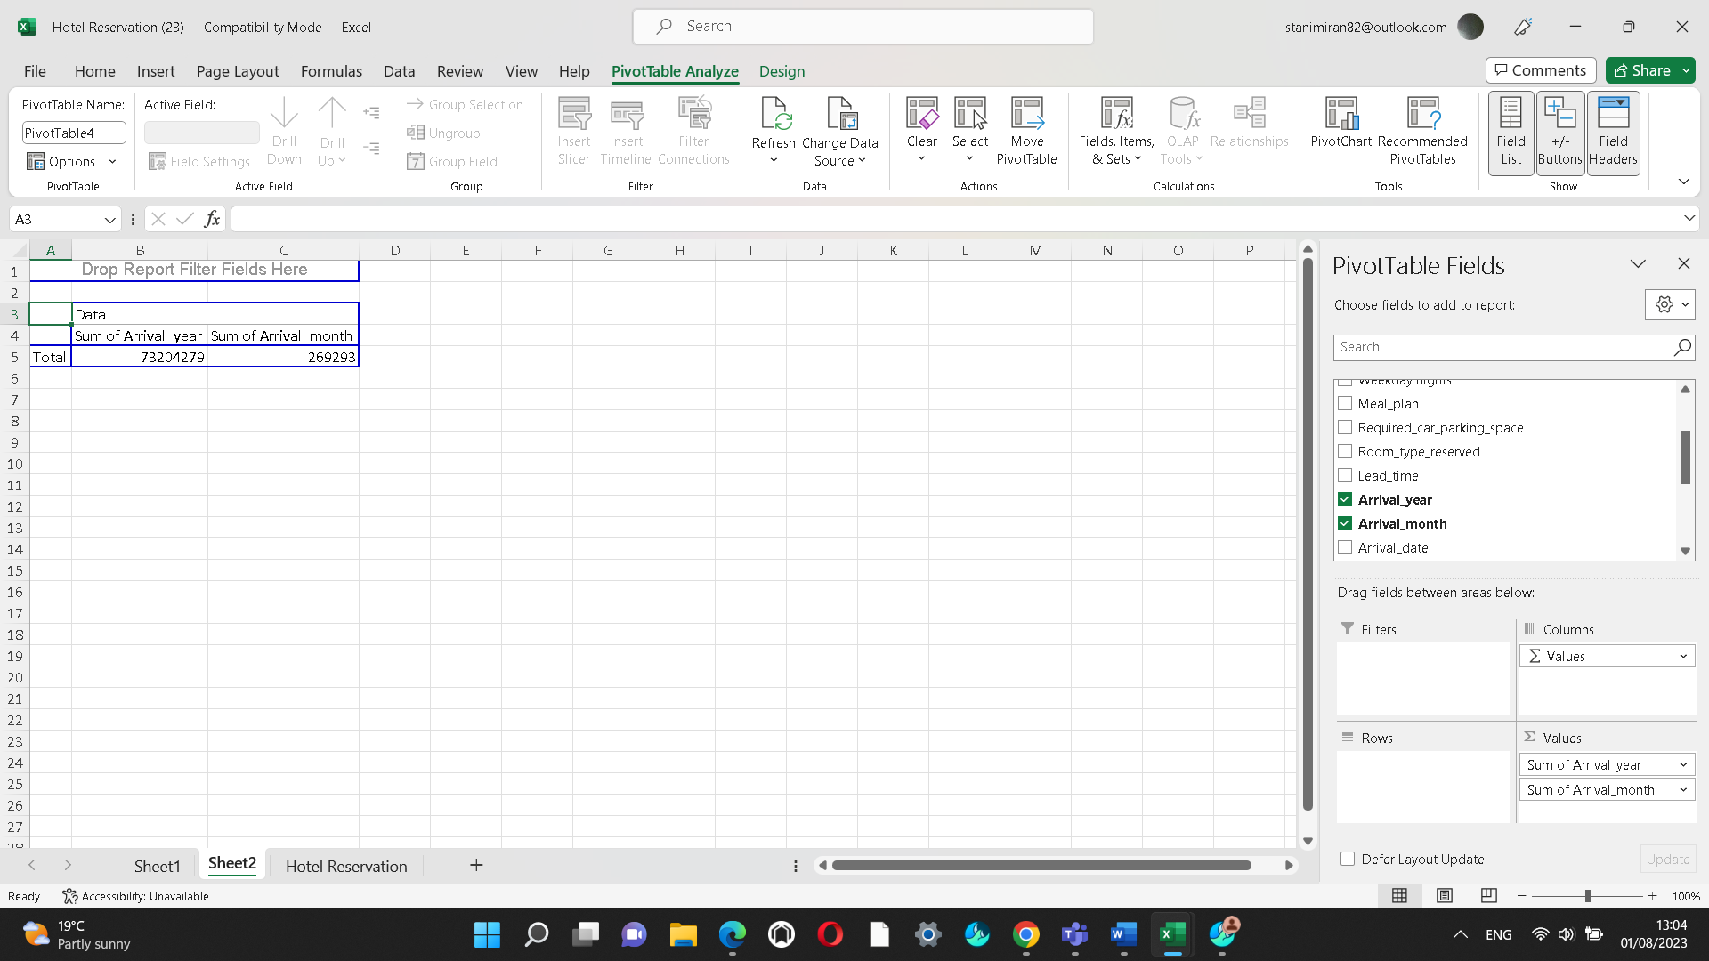
This chart shows the sum of the arrival year in total which is 73204279. Can also be seen the sum of the arrival for a month for the period of 2017-2021 is 269293. And Pivot chart is below.
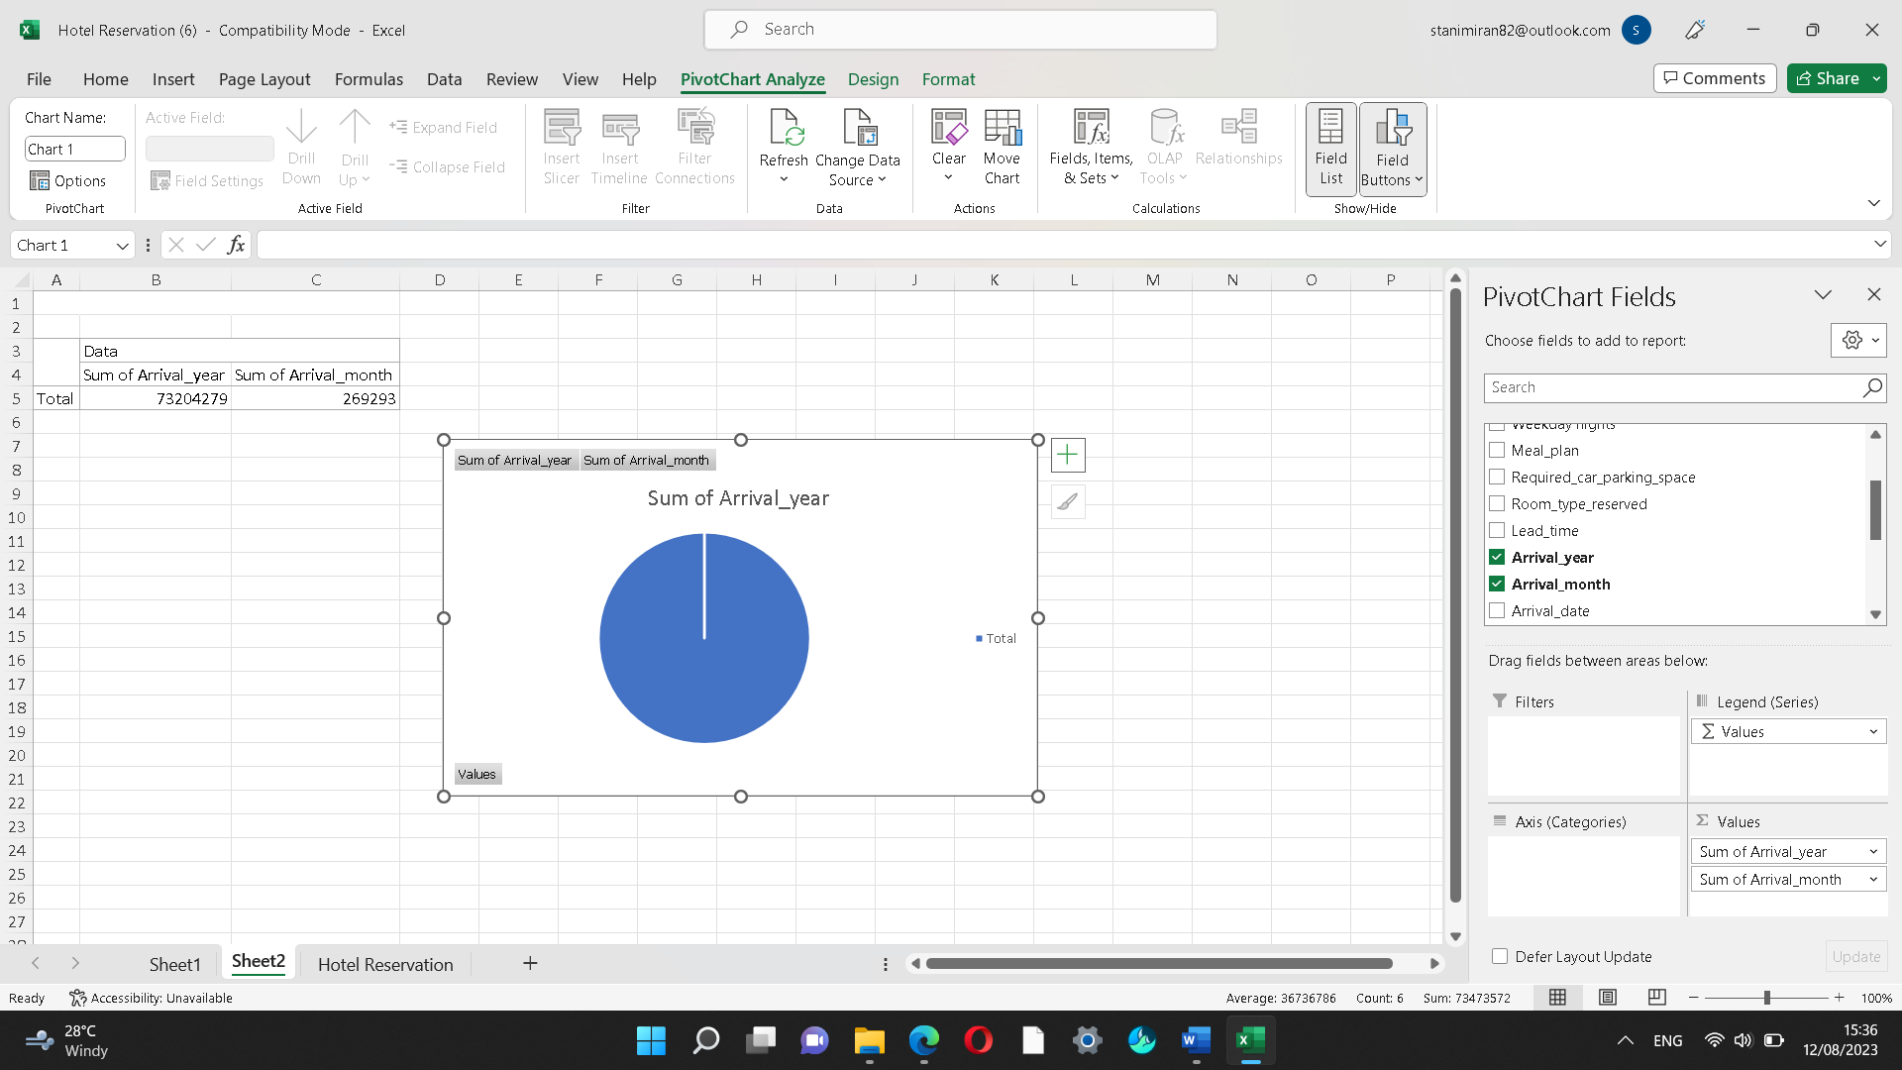

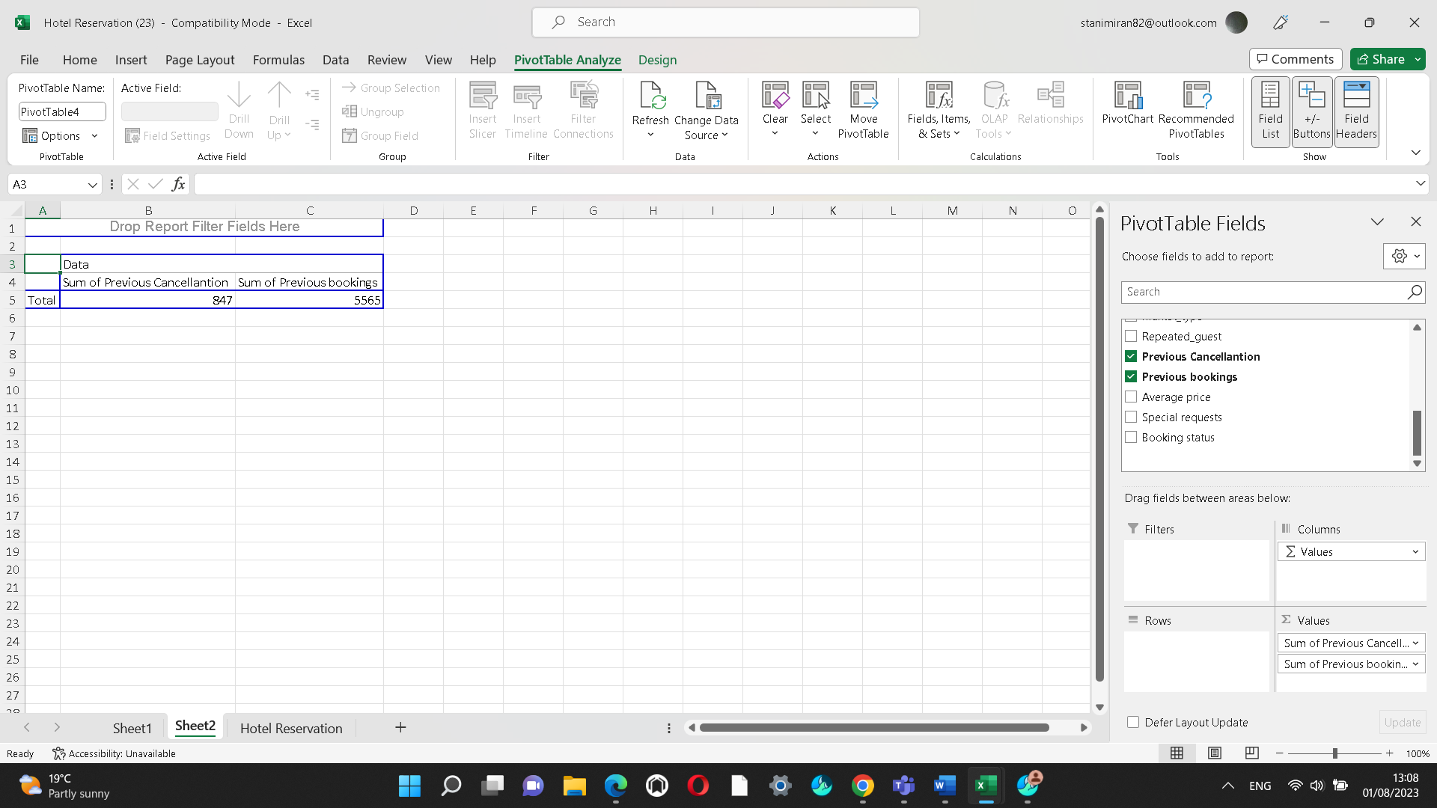

The sum of previous cancellations is shown above which in total is 847 as well as the sum of the previous bookings is 5565. Pivot chart is below.
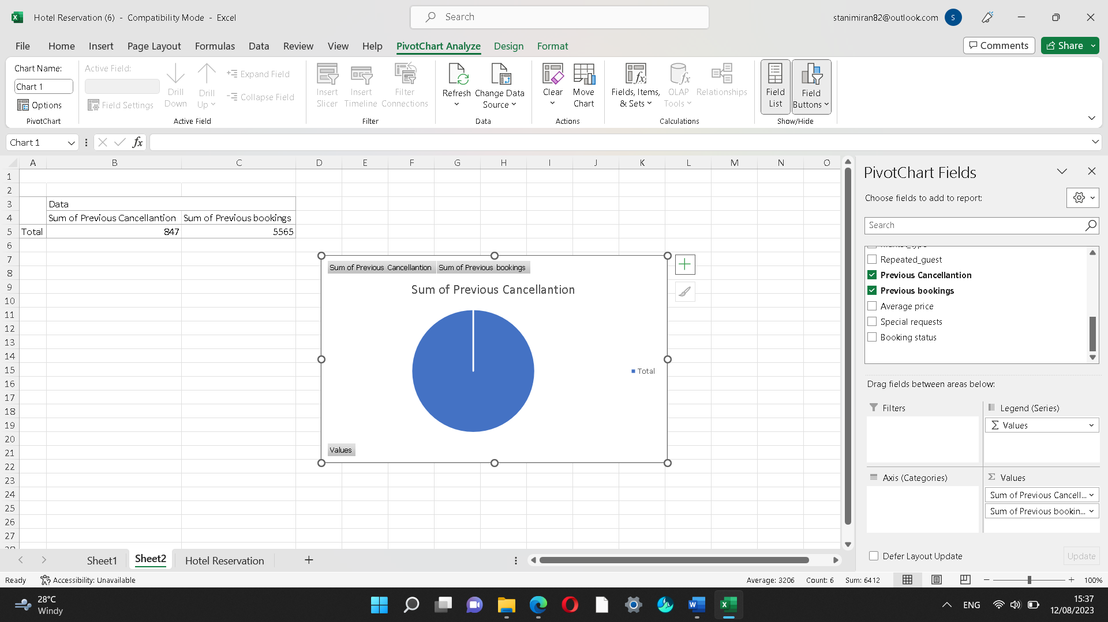
From the proof above can be seen that Excel is the best way to store data for example from the hotel reservation dataset providing an effortless way to data visualization with charts. Excel is a valuable tool as enables managers to plan each task accordingly.

3: IF Function is used to be seen if the student pass or fails the exam

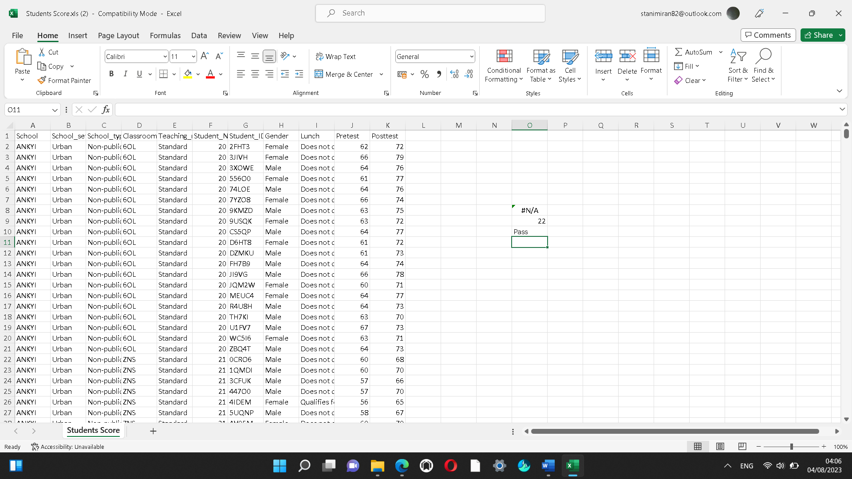
IF Function is used which shown that this student passed his exam.
This formula has been used =IF(C2>=60,” Pass”,” Fail”)

Part 2
1.How many students are male and female?

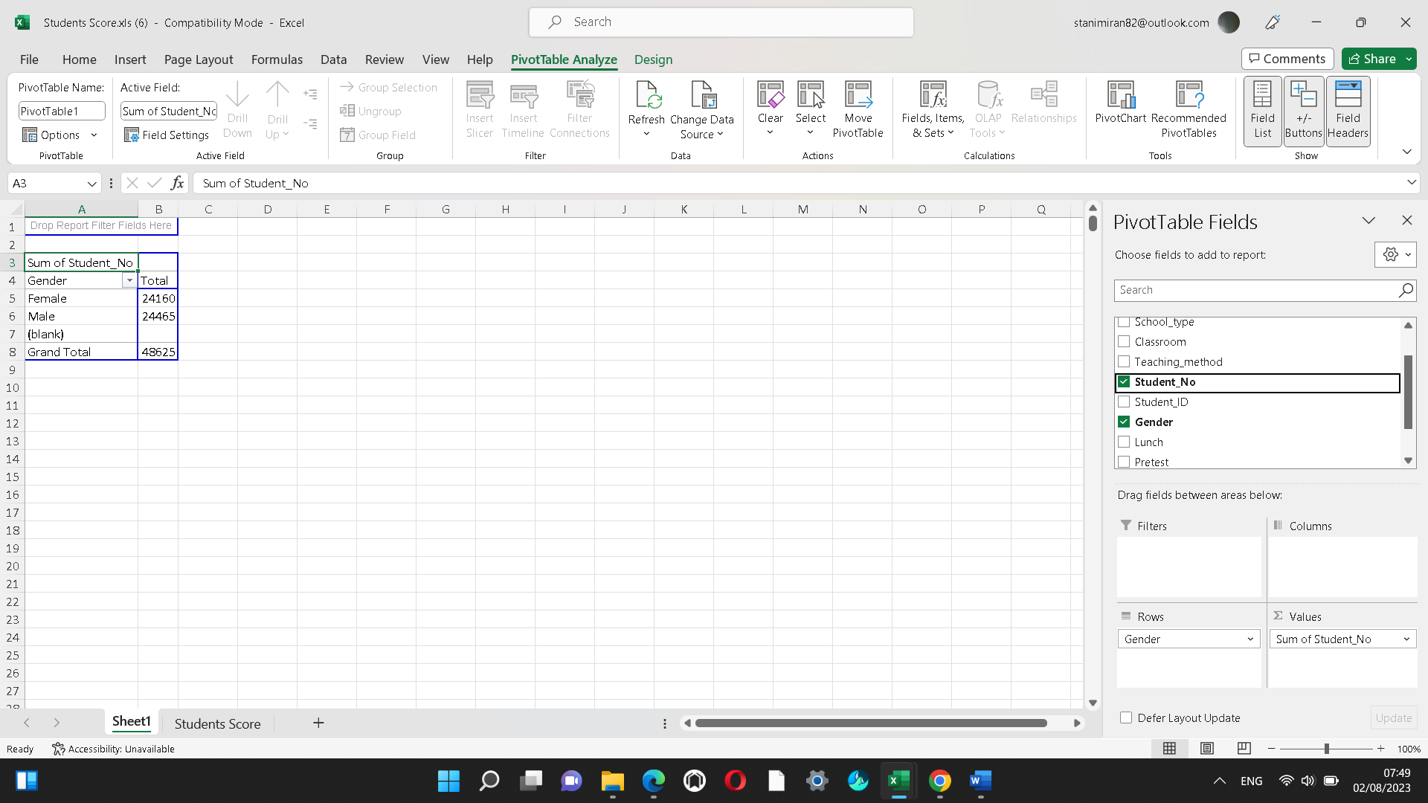
From the chart above it is shown that 24160 students are female, and 24465 students are male, or in grand total 48625 and Pivot chart is below.
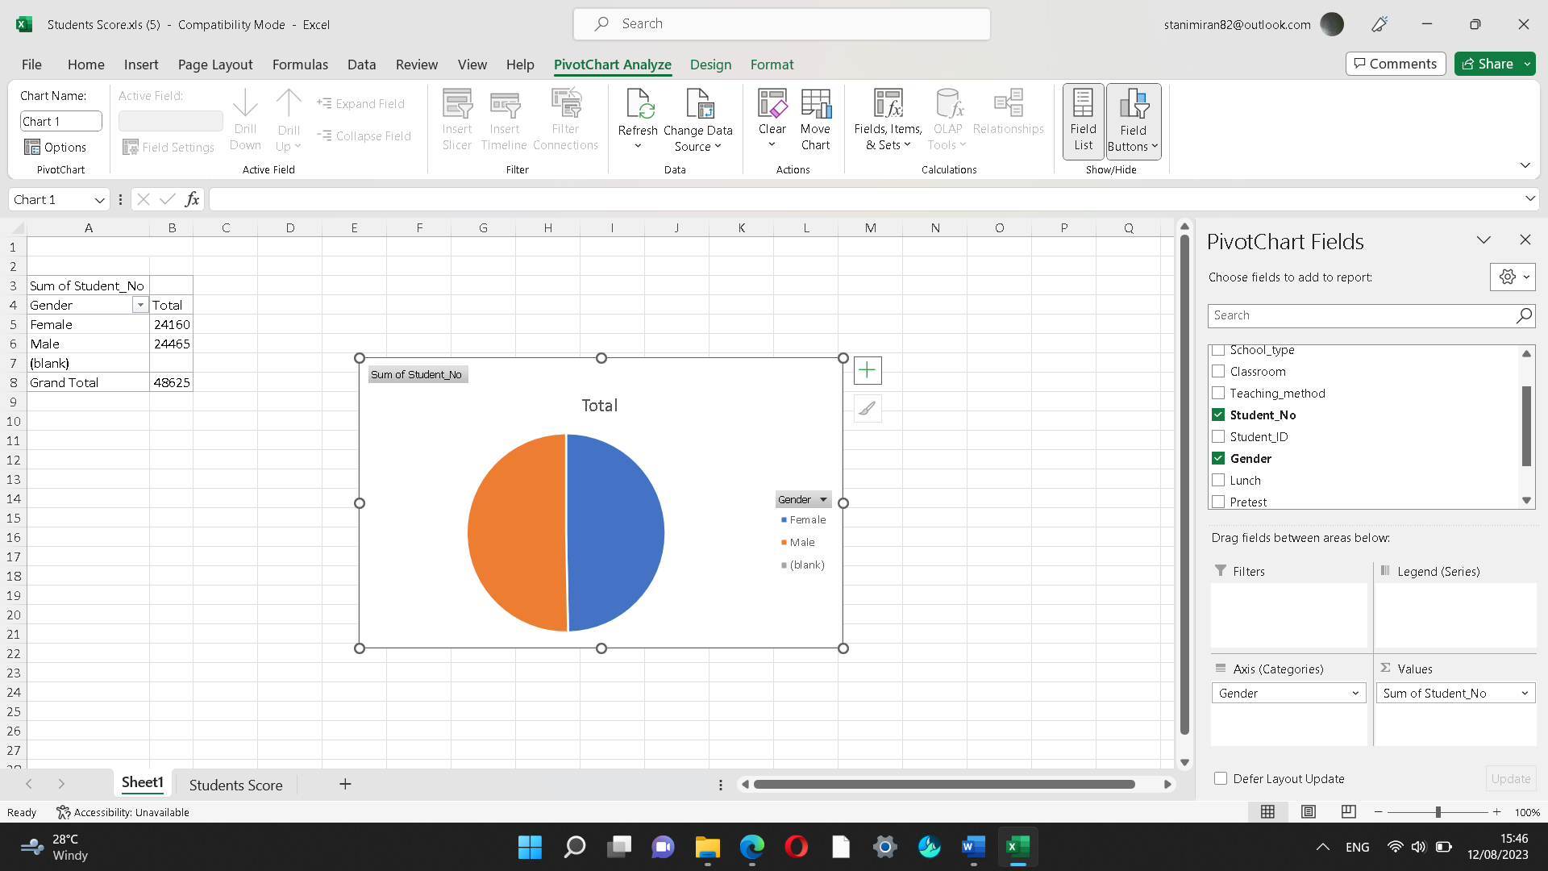

2. How many students qualified and do not qualify for reduced/free lunch?
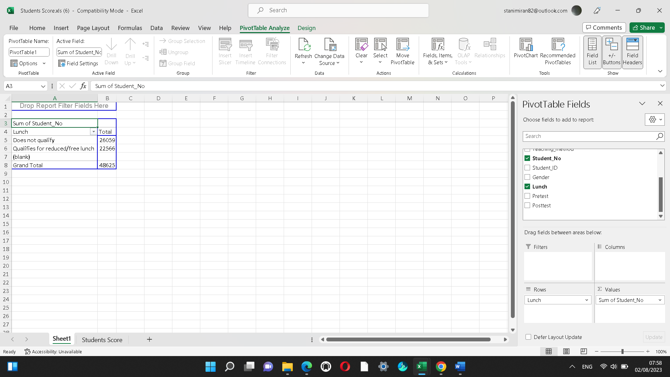
Based on the finding 26059 students does not qualify for reduced lunch while 22566 students are qualified for reduced/free lunch. Pivot chart is below.

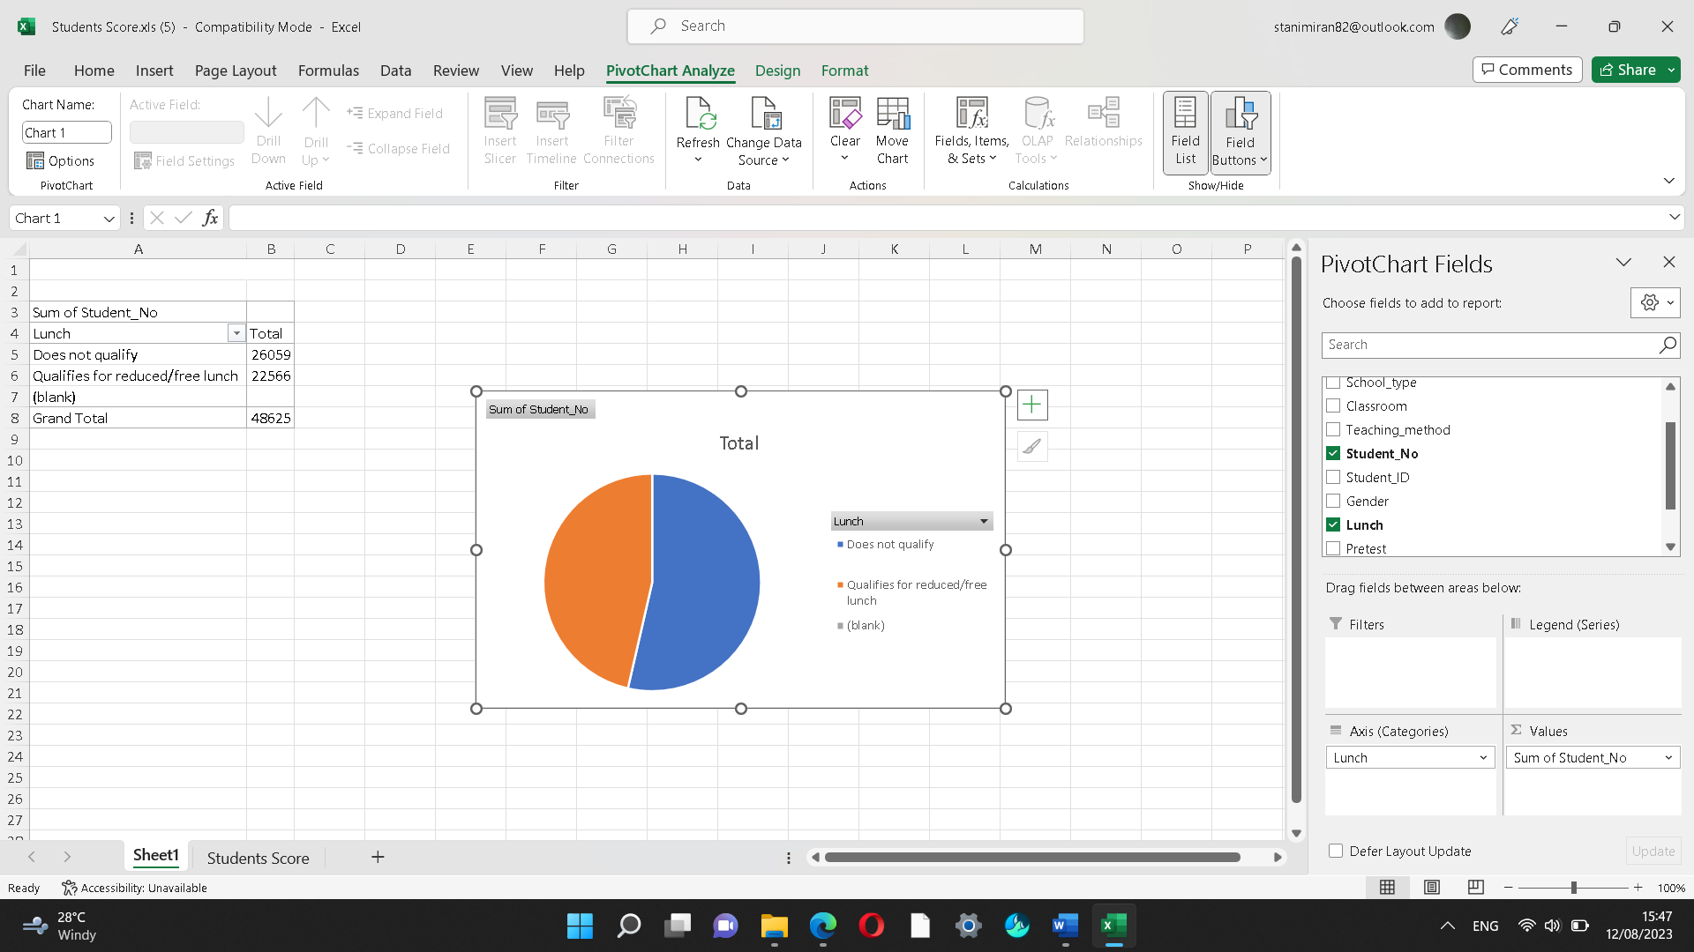

3. What are the mean(average) and median of students who qualify and do not qualify for reduced/free lunch?
3.1. 26059 students are does not qualify for reduced lunch
Mean - 2+6+0+5+9=22, 22:5=4,4
Median - 02569 = 5
3.2. 22566 students are qualified for reduced/free lunch
Mean - 2+2+5+6+6 =21, 21:5=4.2
Median- 22566 =5

4. What are the mean and median differences of student pre-test and post-test scores?
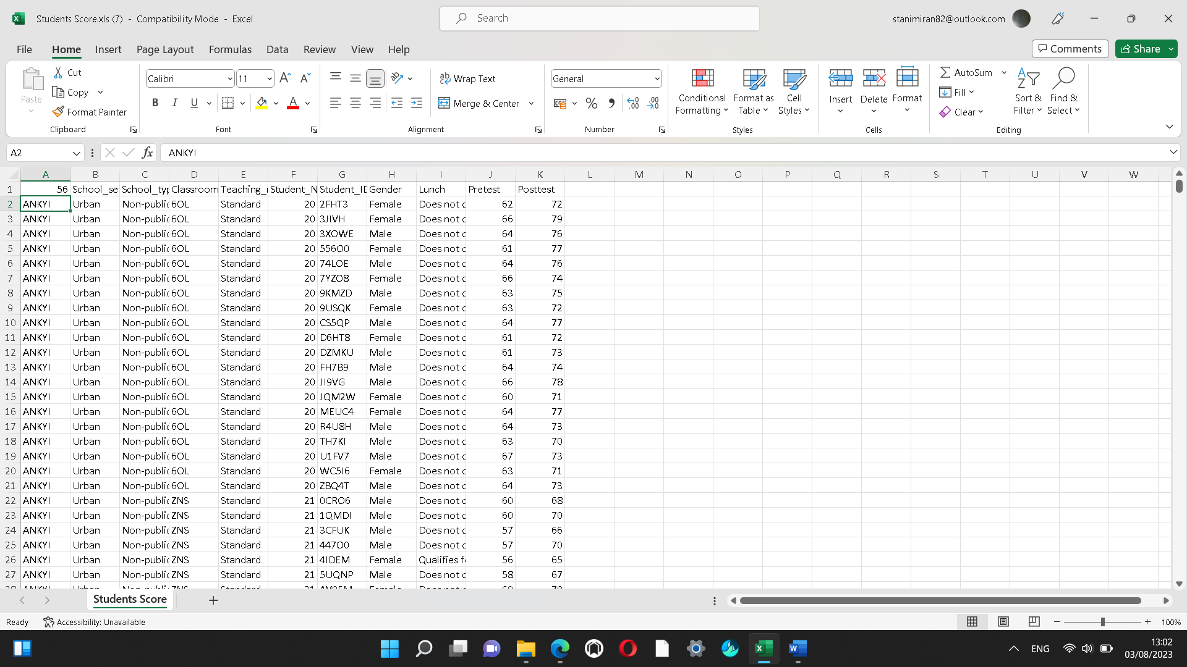
Median number of pretest scores is 56

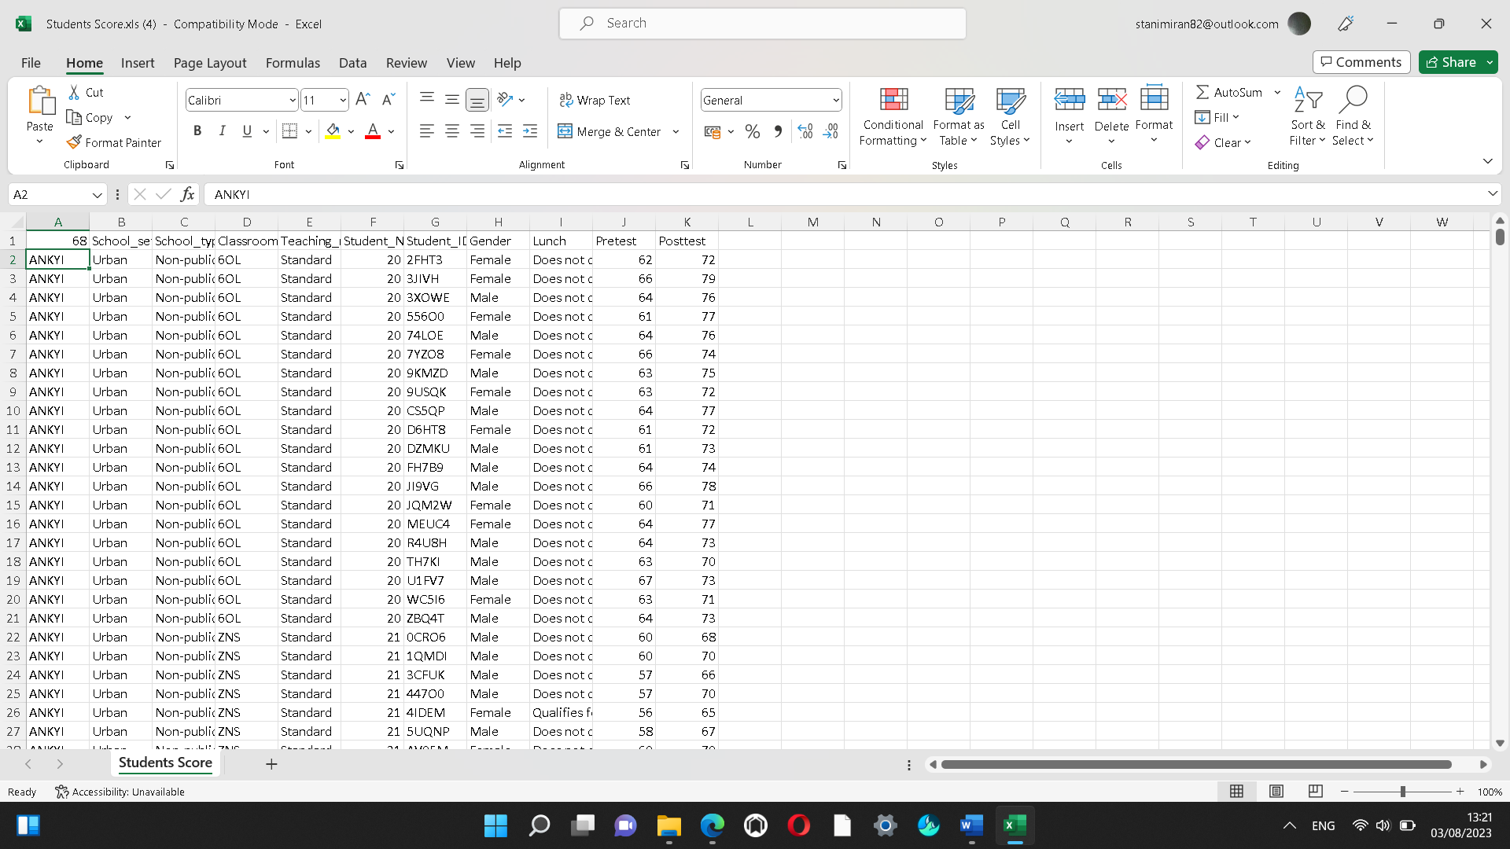
And median number of post-test scores is 68

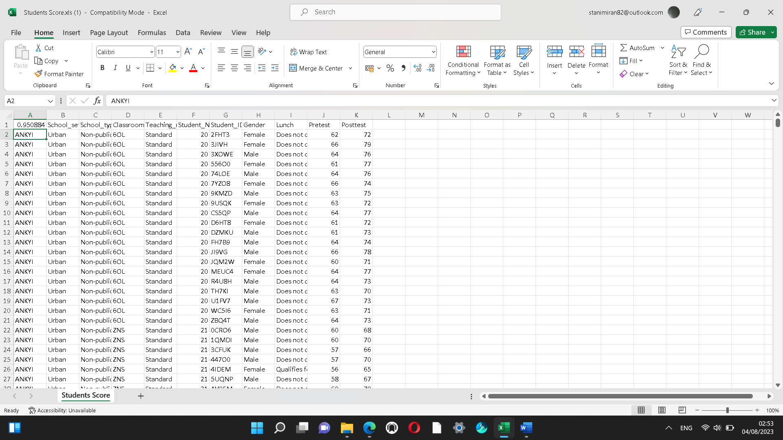
Correlations is 0,950884. Correlation coefficients range from -1 to +1, where -1 is a perfect negative correlation, +1 is a perfect positive correlation, and 0 is no correlation as can be seen in this case.

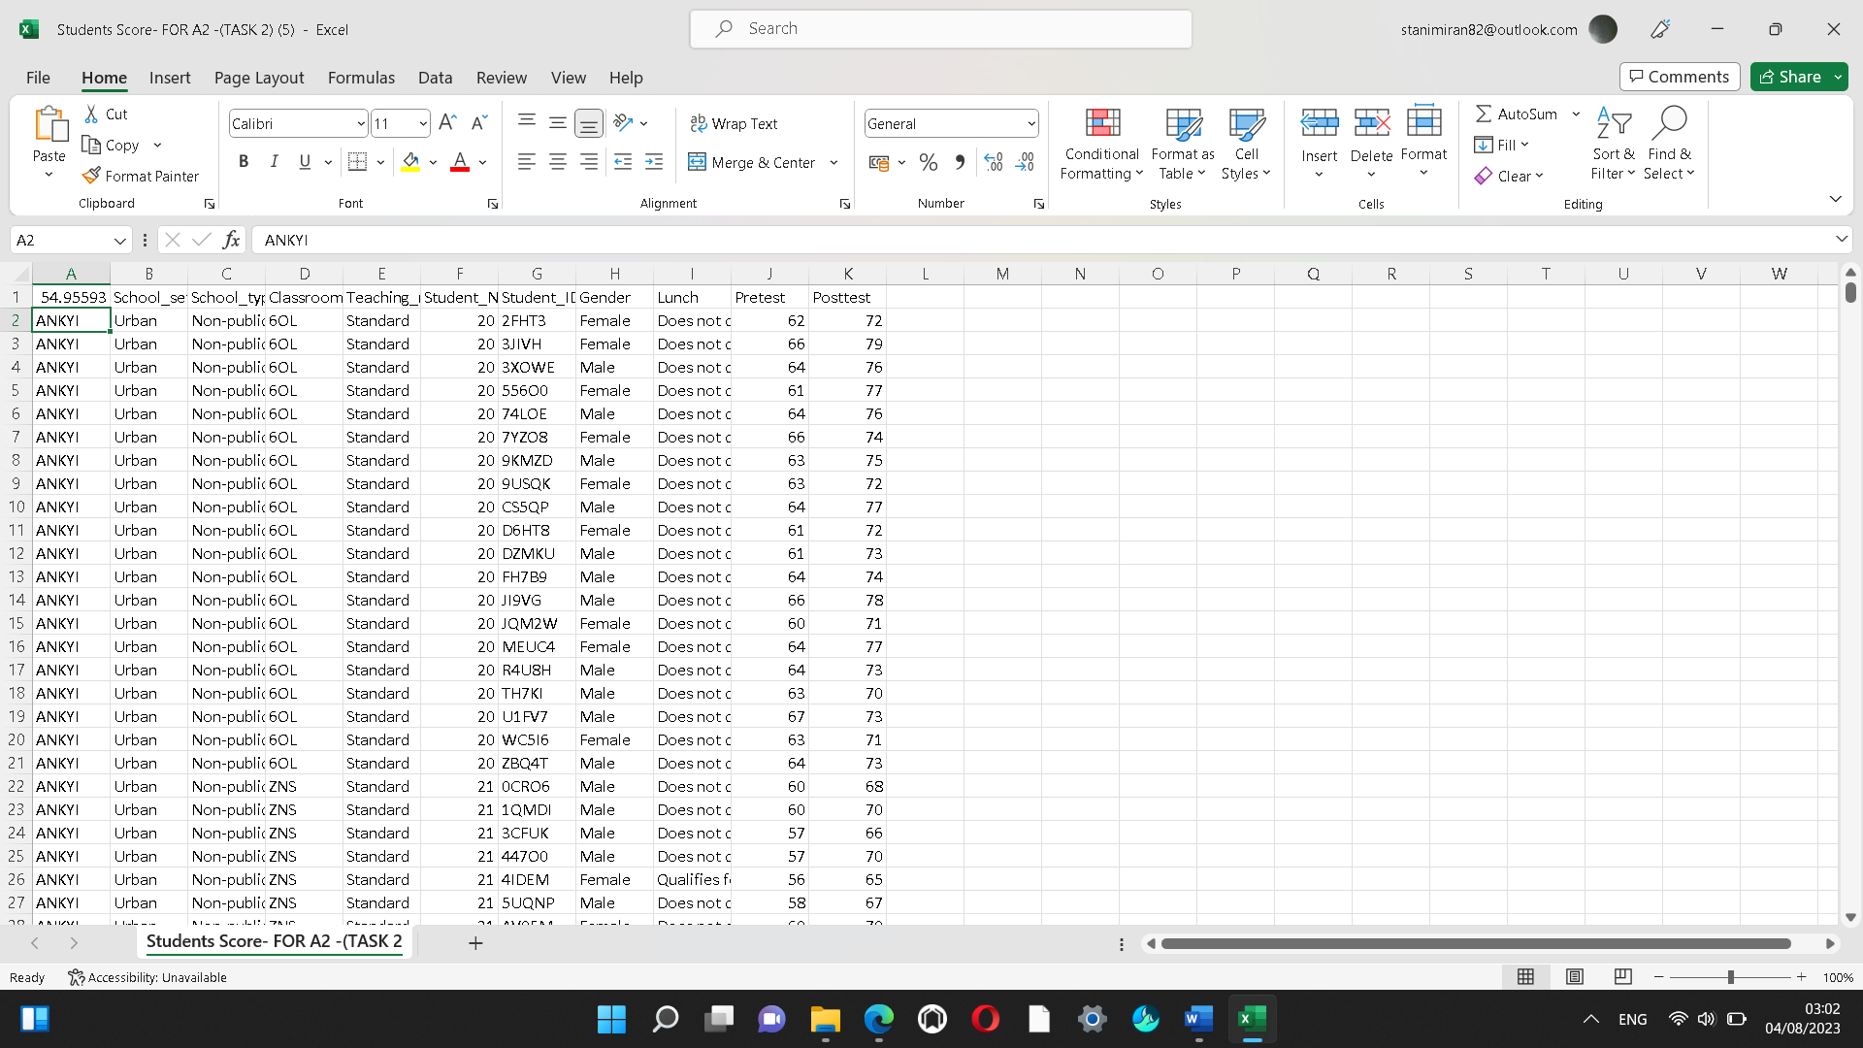
Mean(average) pre-test scores are 54.95593

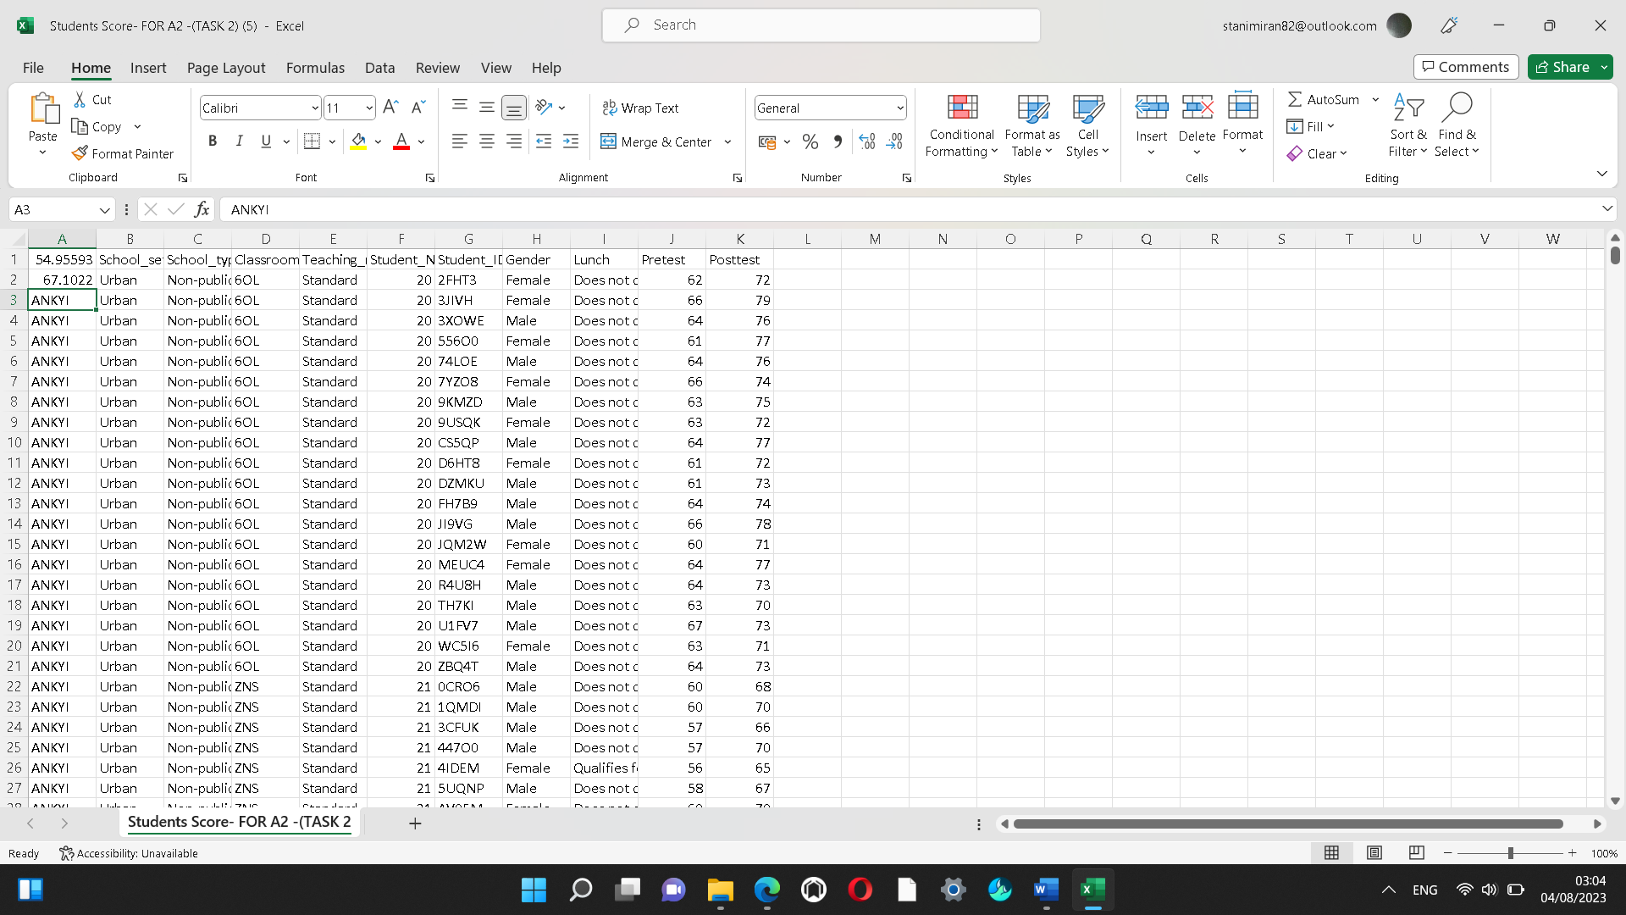
While mean(average) post-test scores are 67.1022.

5. Give a specific example of Clustering, show working with screenshots, and clearly explain the results as using the dataset Student_Score.csv provided in conjunction with SPSS (Statistical Package for Social Sciences)
According to Analytix Labs (2022), Clustering is an unsupervised learning method that groups entities based on similarities in unlabelled data. It is used for surface-level analysis of unstructured data and extracts patterns and inferences from data objects. Different clustering approaches are used in data mining, including connectivity-based, agglomerative, centroid-based, distribution-based, fuzzy, constraint-based, K-Means, Mean Shift Clustering, Gaussian Mixture Model (GMM), and DBSCAN. These algorithms are crucial for exploring data, anomaly detection, outlier detection, and pattern detection in unstructured, heterogeneous, and noisy data. They can be applied to various applications, such as market segmentation, customer segmentation, text topic retrieval, and image segmentation. Clustering is a powerful tool used in various fields to prepare data for machine learning processes.
Analytix Labs (2022) points out that it is applied in market segmentation, retail marketing, social network analysis, wireless network analysis, image compression, data processing, streaming services, tagging suggestions using co-occurrence, life science, and healthcare, and identifying good or bad content. Clustering helps businesses understand target audiences, retail marketing, social network analysis, wireless network analysis, network traffic classification, image compression, data processing, streaming services, and more. It also helps in regulating streaming services, understanding search behaviour, and detecting cancerous cells using medical image segmentation. Clustering also helps filter out fake news and detect fraud, spam, and rough content using attributes like source, keywords, and content. Clustering in data mining and machine learning segments datasets into similar groups, improving user behaviour predictions. Various algorithms create optimal data objects, offering infinite opportunities (Analytix Labs,2022)

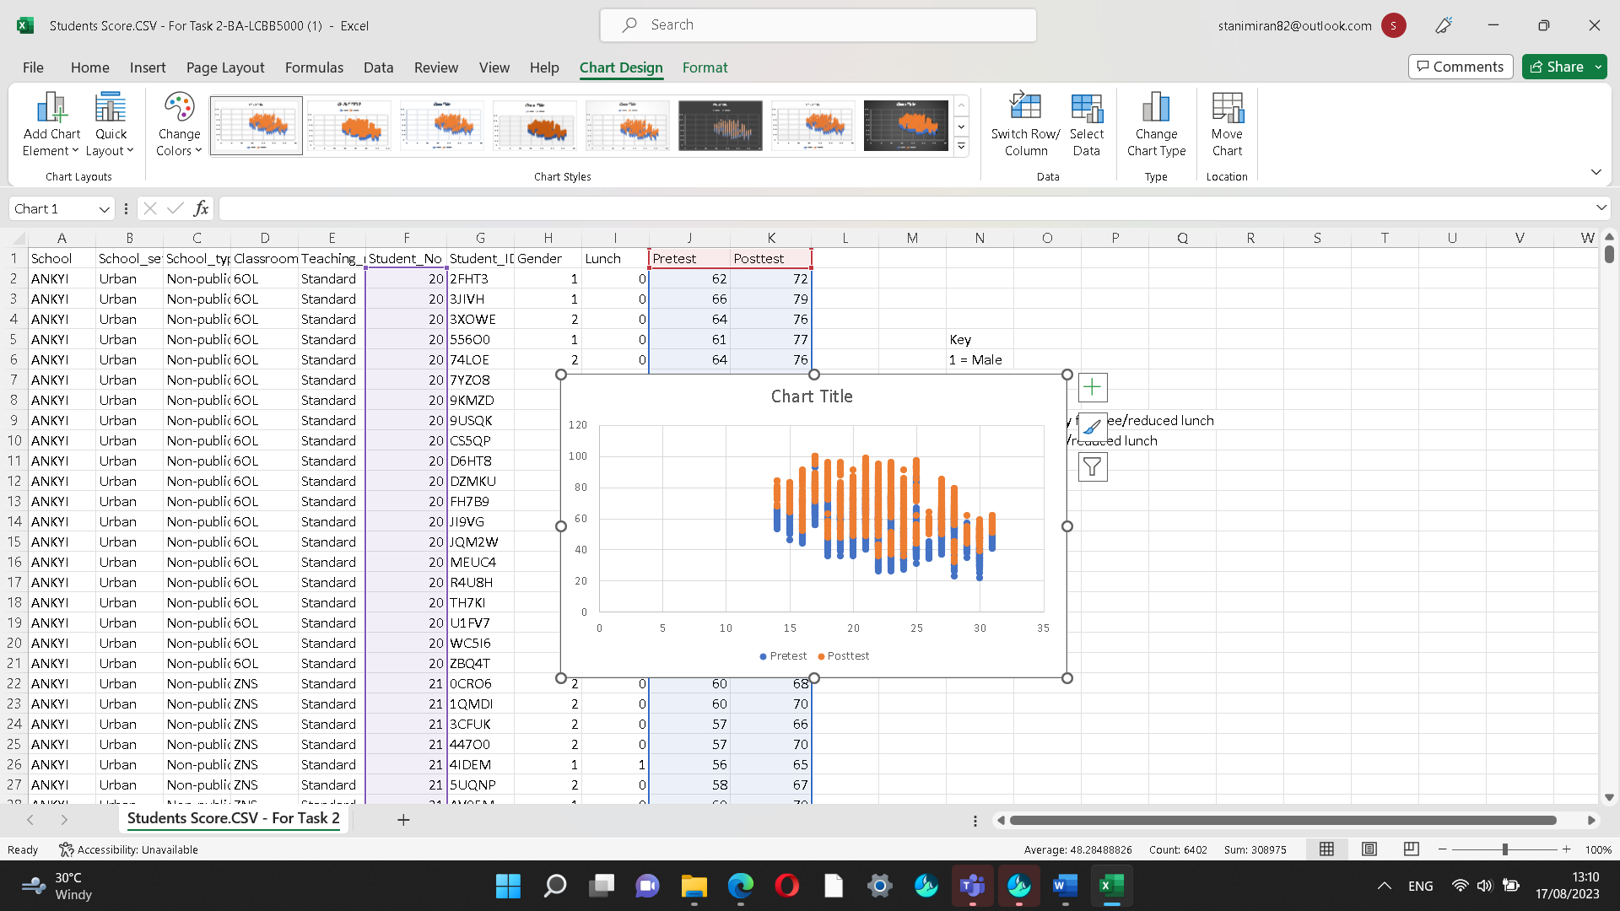

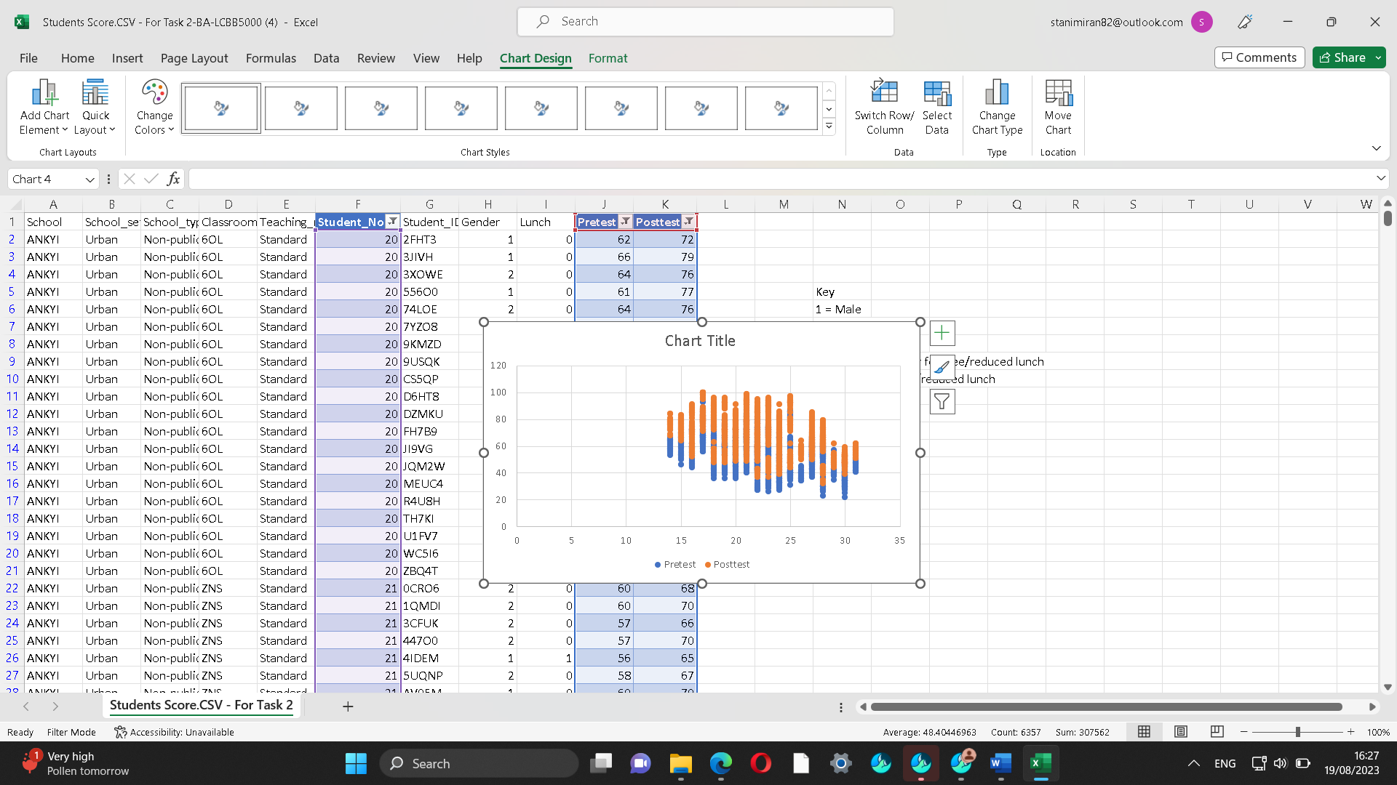
Therefore, from the research and proof above Clustering analysis can help with the decision of where to go as it is another group of data to identify groups of sales, transactions, customers or other types of things and behaviours. Pivot table is below.

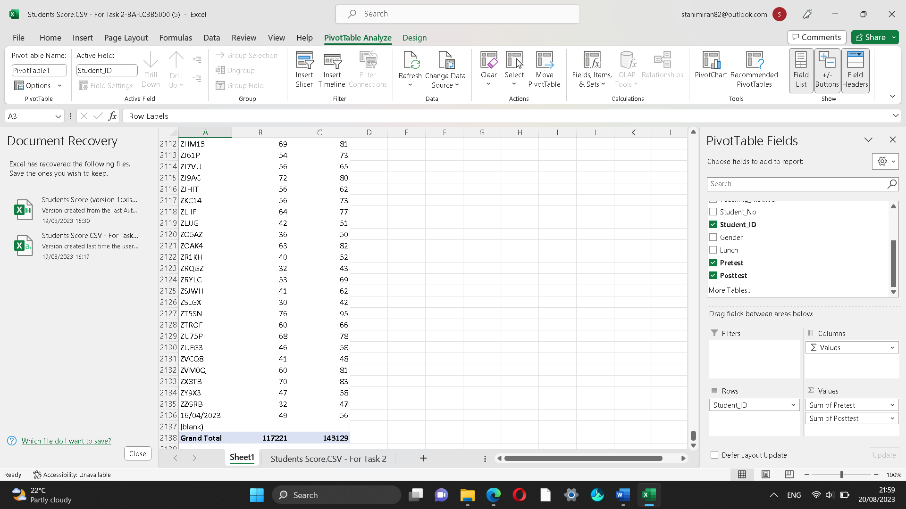
In the pivot table for student ID, the grand total for the sum of the pretest is 117221 and the sum of the post-test is 143129.
6. Give at least five examples of the most popular data mining and text mining techniques that can be applied to modern business.
Sharma (2021) states that Decision trees are a form of data mining approach that create a model for categorising data. The models are created in the shape of a tree structure and as a result, they fall under the category of supervised learning. In addition to classification models, decision trees are also employed in the construction of regression models that forecast class labels or values to assist in decision-making. A decision tree can use both numerical and categorical data, such as gender, age, etc. A decision tree is a supervised learning structure with a root node, branches, and leaf nodes. It splits a dataset into subsets based on its most significant attribute, using the "Greedy Approach" and a top-down method called "Tree pruning." The accuracy of a model is checked on a test set, with an accurate model defined by the percentage of classification test set tuples and classes. There are two types of decision trees: classification and regression. Classification involves building models describing important class labels, which are applied in machine learning and pattern recognition. Classification models are used for fraud detection and medical diagnosis. Regression models predict numerical attributes, which are continuous values. A decision tree algorithm, ID3, was developed by J. Ross Quinlan in 1980 and succeeded by other algorithms like C4.5. Both algorithms applied the greedy approach, with ID3 using a training dataset with class labels divided into smaller subsets (Sharma,2021)
Maheshwari & Anil (2015, p.53) state that Artificial Neural Networks (ANN) is a sophisticated data mining method from Artificial Intelligence. It also mimics the manner of human neural structure. With many data points the neural network can be prepared by deciding repeatedly. By adjusting its internal communication and computation parameters it will continue to learn based on feedback on its previous decisions. ANNs (Artificial Neural Networks) can begin to be seriously considered for arrangement in real situations and time as ANNs have been trained with a large amount of data over an extended period and have become more accurate than human experts. ANNs are popular as they can reach a high predictive accuracy and are simple to implement and do not have any issue with data quality. It also requires a lot of data to train to establish good predictive ability. The most widely used and straightforward statistical data mining method is regression. Its objective is to accurately fit a smooth, specified curve to the data. Energy use as a function of daily temperature can be predicted using regression analysis techniques. So, using this equation, one may predict how much energy will be used on any given day in the future (Maheshwari & Anil, 2015, p.53)
According to Hassan (2023), Cluster analysis is a data analysis method that groups objects strongly associated within a data set using independent machine learning algorithms. It also helps understand data patterns and detect patterns providing valuable insights in certain cases. Cluster analysis is beneficial in large and unstructured data sets, where manual labelling can be expensive and time-consuming. This analysis also can help detect outliers in data, which are rare events or observations that differ significantly from the mean. Cluster analysis has applications in various industries such as marketing, business operations, Earth observation, and data science, as it helps create pixel masks for objects in images and helps in marketing influences about data sets. Applications include optimization of processes and costs, customer segmentation, image segmentation, and predictive analytics (Hassan,2023). Maheshwari & Anil (2015, p.54) point out that Association Rules Mining is a well-known data mining method, especially where selling is involved in the business. Association rules are also known as market basket analysis as it helps in answering questions about cross-selling opportunities.

7. Using relevant real-world examples, discuss the benefits and disadvantages of using SPSS and Excel. Then, show your findings in a table.
Stat Analytica (2019) states that Excel is a powerful and user-friendly statistics software that stores data in tabular format and enables various data manipulations. It offers pivot tables for creating insights and importing and exporting data. Excel also allows for custom functions and external database analysis. Its graphical user interface and visualization techniques make it an excellent choice for data analysis and reporting. SPSS (Statistical Package for Social Sciences) is a widely used statistical tool in the data analytics and data science industry, offering faster and more reliable performance. It is used for statistics, real-time usage, and large-scale companies with sensitive data. Excel, on the other hand, is a subset of computer science and covers various methods and technologies. It is used for computation, data storage, and data formats, while Excel focuses on mathematics concepts like algebra, calculus, statistics, and advanced statistics. Both tools teach about data processes, memory management, and data storage, while Excel provides more formulated mathematical operations and analytics.
Stat Analytica (2019) point out that SPSS is a batch-processing statistical tool, while Excel is a data manipulation tool. Its primary purpose is to use data manipulation techniques to fetch satisfactory results while storing and safely handling data. Both tools are integrated into IBM and are constantly evolving, with both being constantly updated with new statistics algorithms. However, both tools still need improvement to become the best statistics software. SPSS and Excel are distinct statistical analysis software, with Excel being spreadsheet software and SPSS being statistical analysis software. Both offer built-in data manipulation tools and variable transformation, while Excel lacks built-in functions. However, both Excel and SPSS excel in their respective domains, serving their purpose exceptionally well. Both tools are the best statistical tools in their respective fields (Stat Analytica,2019) Vivian Education Management Private Limited (2023) states that data manipulation skills are important for example Pivoting data involves taking a table as well as turning it on its site to show a different perspective and focus on the important information as pivoting is also an effective tool. Data manipulation requires proper techniques to save time and avoid mistakes.
Excel is a crucial data manipulation tool for businesses, providing quick access to essential information and enabling customized detection of various data sets, enhancing their growth and adaptability. Therefore, SPSS is an analysis-focused statistical package, while Excel is a general spreadsheet program. Familiarity with both tools is beneficial for data-driven tasks.
Conclusion
Business Intelligence is crucial in today's competitive world, with different Microsoft Excel functions simplifying data visualisation and organisation and providing such analytical power. It helps businesses understand workforce structure and activities while recording and collecting data. Analyse Excel data gives users the ability to comprehend data through simple natural language queries and offers high-level visual summaries, patterns, and trends. Analysing trends in profitability can be done with Excel. With Excel skills in business being so crucial since they can lead to leadership chances and power an entire company, putting these steps into practice can assist in identifying areas for improvement and helping to make educated decisions that can increase your bottom line.

Reference list:
Analytix Labs (2022) What is Clustering in Machine Learning: Types and methods
[Online] Available at:
https://www.analytixlabs.co.in/blog/types-of-clustering-algorithms/ (Accessed: 16 August 2023)

Hassan, A (2023) What is Cluster Analysis? [Online] Available at:
https://builtin.com/data-science/cluster-analysis (Accessed: 31 July 2023)

David et al (2021) Modern Business statistics with Microsoft Excel, Ed.7, South-Western College Publishing [Online] Available at:
https://books.google.co.uk/books?hl=en&lr=&id=LwfFDwAAQBAJ&oi=fnd&pg=PP1&dq=microsoft+Excel+and+its+importance+in+business&ots=S5DP3pt5XM&sig=_2MKS_ae8Y-sK8glvING9SENUoU#v=onepage&q=microsoft%20Excel%20and%20its%20importance%20in%20business&f=false (Accessed:1 August 2023)

Maheshwari & Anil, K (2015) Business Intelligence and Data Mining. Business Express Press, LLC, New York

Kaur, R (2023) Excel for Business Intelligence: A comprehensive guide [Online]
Available at:
https://www.selecthub.com/business-intelligence/excel-for-bi-tool-using-replacing/
(Accessed:4 August 2023)

Sharma, R (2021) What is Decision Tree in Data mining? Types, Real world Examples& Applications [Online] Available at:
https://www.upgrad.com/blog/what-is-decision-tree-in-data-mining/ (Accessed: 13 July 2023)

Stat Analytica (2019) SPSS vs Excel: Which One is The Best Tool for Statistics [Online] Available at:
https://statanalytica.com/blog/spss-vs-excel/ (Accessed: 2August 2023)

Vivian Education Management Private Limited (2023) Excel Data Analysis 101: 9 Essential Data Manipulation Techniques [Online] Available at:
https://skillfine.com/excel-data-analysis-techniques/ (Accessed: 4 August 2023)

Witten (2011) Data mining [electronic resources]: practical machine learning tools and techniques,3rd Ed. Amsterdam: Elsevier/Morgan Kaufmann

