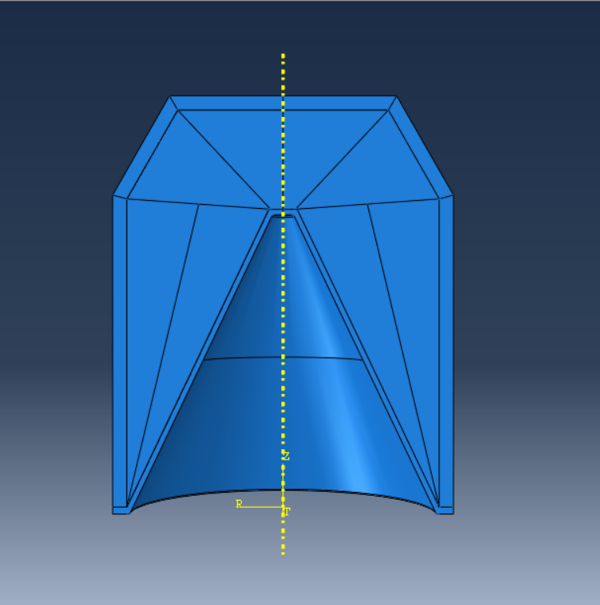
Cover Image 1: A 3D Model of A Shaped Charge in Abaqus

Finite Element Analysis of Shaped Charge Jet Formation
  - Advanced Physics of OME
Silas Blevins | OME Degree Apprenticeship | January 2024

Abstract
Shaped Charges are a common explosive article in military applications, used in demolition charges, High Explosive Anti-Tank (HEAT) warheads, and Landmines [1]. Shaped Charges work by the Munroe Effect, which states that when a hollow cavity is formed in one end of an explosive charge and a detonator is placed at the other, the energy of the detonation products is focused, resulting in an intense localized force which creates a deeper cavity when directed against a metal plate than an equivalent charge without such a cavity. When a liner is added to this cavity, it forms a high-velocity jet which further increases the penetration of the charge [2]. This report documents the use of the Abaqus software to carry out Finite Element Analysis of a notional shaped charge and assess the formation of the jet.

Table of Contents
Abstract i
Table of Figures iii
List of Tables iv
List of Equations v
1 Introduction 1
1.1 Shaped Charge Overview 1
1.2 The ABAQUS Software Package 1
2 Model Setup 2
2.1 Material Properties 2
2.2 Geometry 3
2.3 Model Parameters 3
2.4 Meshing 3
3 Results 4
3.1 2D Results – Velocity and Displacement 4
3.2 2D Results – Stress 4
3.3 3D Results – Velocity and Displacement 4
3.4 3D Results – Stress 4
4 Validation 5
4.1 Existing performance Data 5
4.2 Comparison to Experimental Results 5
5 Conclusions 6
6 References 7

Table of Figures
Cover Image 1: A 3D Model of A Shaped Charge in Abaqus i

Figure 1: A Sectioned High Explosive Anti-Tank (HEAT) Shell showing the components of a shaped charge [4] 1
Figure 2: The Case of the Charge Sketched in Abaqus. 4
Figure 3: The Liner of the Charge Sketched in Abaqus 5
Figure 4: The Fill of the Charge Sketched in Abaqus 5
Figure 5: The 3D Model Assembly in Abaqus, with colours indicating individual parts 6
Figure 6: The 2D Model Assembly in Abaqus, with colours representing individual parts 6
Figure 7: The 2D Model in Abaqus showing the XSYMM boundary condition 7
Figure 8: The 3D Model in Abaqus showing the ZSYMM boundary condition 7
Figure 9: The Case of the 2D Model meshed in Abaqus. Mesh is Tri-Type with an element size of 0.00001 to 0.0005m 8
Figure 10: The Fill of the 2D Model meshed in Abaqus, Mesh is Tri-Tye with an element size of 0.0005 to 0.002m 8
Figure 11: The liner of the 2D Model Meshed in Abaqus, Mesh is Tri-Type, Element size approximately 0.0002m 9
Figure 12: The Case of the 3D Model Meshed in Abaqus, Mesh is Tet-Type, Element Size approximately 0.0025m 9
Figure 13: The Fill of the 3D Model Meshed in Abaqus, Mesh is Tet-Type, Element Size approximately 0.003m 10
Figure 14: The Liner of the 3D Model Meshed in Abaqus, Mesh is Tet-Type, Element Size approximately 0.0015m 10
Figure 15: A Graph of Y Velocities against Time for 10 Nodes Extracted from the 2D Model 12
Figure 16: A Graph of the Average Y Velocity against time of 10 Nodes Against Time For the 2D Model 13
Figure 17: A Graph of the Y Displacements of 10 Nodes against Time For the 2D Model 13
Figure 18: A Graph of the Average Y Displacement against time of 10 Nodes for the 2D Model 14
Figure 19: A Graph of the Y Velocities of 10 Nodes against time for the Conventionally-Meshed 3D Model 14
Figure 20: A Graph of the average Y Velocity of 10 nodes against time for the Conventionally-Meshed 3D Model 15
Figure 21: A Graph of the Y Displacements against time for 10 Nodes from the Conventionally-Meshed 3D Model 16
Figure 22: A Graph of the Average Y Displacement of 10 Nodes against time from the Conventionally-Meshed 3D Model 16
Figure 23: A Graph of the Y Velocities against time of 10 nodes for the Adaptively-Meshed 3D Model 17
Figure 24: A Graph of the average Y Velocity of 10 Nodes against time for the Adaptively-Meshed 3D Model 17
Figure 25: A Graph of Y Displacement against Time of 10 Nodes for the Adaptively-Meshed 3D Model 18
Figure 26: A Graph of Average Y Displacement of 10 Nodes against time for the Adaptively-Meshed 3D Model 18
Figure 27: A Comparison of the average Y Velocities of the Jet Tips from all 3 models 19
Figure 28: A Comparison of the average Y Displacements of the Jet Tips from all 3 models 20

List of Tables
Table 1: Basic Material Properties of RDX, Steel 4340, and Copper as used in all models discussed in the report 2
Table 2: Johnson-Cook Plasticity Model Parameters for Steel 4340 and Copper 2
Table 3: Johnson-Cook Damage Model Parameters for Steel 4340 and Copper 2
Table 4: EOS Parameters for RDX 2
Table 5: EOS Parameters for Steel 4340 and Copper 2
Table 6: Comparisons of the Displacement and Velocity Outputs of all 3 models 20

Annex A Table 1: Velocities of the Jet Tip - 2D 27
Annex A Table 2: Jet Tip Displacement - 2D 30
Annex A Table 3: Jet Tip Velocities - 3D 32
Annex A Table 4: Jet Tip Displacements - 3D 35
Annex A Table 5: Jet Tip Velocities - 3D Adaptive 37
Annex A Table 6: Jet Tip Displacements – 3D Adaptive 40
Annex A Table 7: Displacement Comparisons 42
Annex A Table 8: Velocity Comparisons 44

1 Introduction

Shaped Charge Overview
Shaped charges are a common explosive article used for a range of applications in the military environment. The Munroe Effect, discovered by Charles E. Munroe in 1888 [3], describes how when a hollow cavity is formed in an explosive charge, the detonation energy is more focused than that of an equivalent solid charge, and as such the blast wave can deform and penetrate a metal plate more easily. [2] It later came to be understood that if the cavity was lined with metal, the penetrating power was further increased by the formation of a high-velocity jet of metal propelled by the detonation of the explosive. A typical shaped charge as used today in the anti-armour role consists of a main charge of high explosive with a conical metal liner, which forms the jet, with a detonator at the rear of the charge, all contained within a warhead casing, typically metal or plastic. Figure 1 below shows an example of a munition fitted with a shaped charge, with all major components visible.
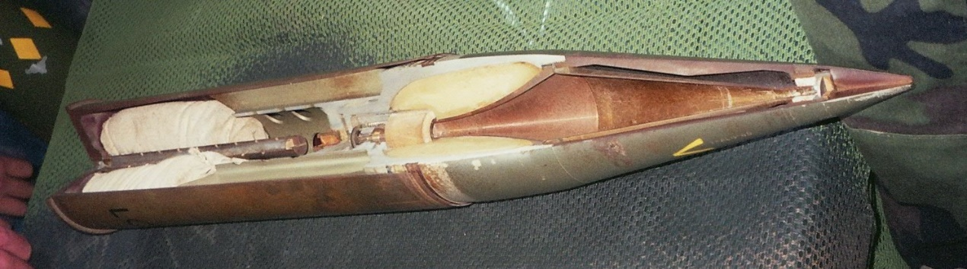
Figure 1: A Sectioned High Explosive Anti-Tank (HEAT) Shell showing the components of a shaped charge [4]

The ABAQUS Software Package
ABAQUS is a Finite Element Analysis software package published by Dassault Systemes. The software is capable of calculating the strains and velocities involved in detonations and was therefore an appropriate choice of software to carry out the analysis in this report. As ABAQUS does not include a database of material properties, all material properties were taken from academic sources and are referenced when appropriate.

Model Setup

Material Properties
For the shaped charge being modelled in this report the High Explosive chosen was RDX. Steel 4340 was chosen as the charge casing, and Copper was chosen as the liner. The basic properties of each material are given below.
Material | Density (kgm⁻³) | Young’s Modulus (GPa) | Poisson’s Ratio | Shear Modulus (GPa) | Melting Temperature (K)
RDX | 1806 [5] [6] | N/A | N/A | 13.82 [7] | N/A
Steel 4340 | 7830 [8] | 200 [9] | 0.29 [9] | 78 [9] | 1793 [8]
Copper | 8960 [10] | 110 [11] | 0.343 [11] | 47.7 [10] | 1790 [10]
Table 1: Basic Material Properties of RDX, Steel 4340, and Copper as used in all models discussed in the report
In addition to the basic material properties depicted above, it was necessary to include failure, damage and Equation of State (EOS) coefficients for the materials in order to accurately model their behaviour under the high strain rates associated with explosives. Both metals used the Johnson-Cook failure and damage, and both used the Us-Up EOS. The RDX used the JWL EOS and did not require a failure or damage model. Tables 2, 3, 4 and 5 below show these coefficients.
Material | A (MPa) | B (MPa) | n | m | Melting Temp (K) | Transition Temp (K)
Steel 4340 | 792 [8] | 510 [8] | 0.26 [8] | 0.26 [8] | 1793 [8] | 293.2 [8]
Copper | 120 [10] | 292 [10] | 0.31 [10] | 1.09 [10] | 1790 [10] | 293 [10]
Table 2: Johnson-Cook Plasticity Model Parameters for Steel 4340 and Copper
Material | d1 | d2 | d3 | d4 | d5
Steel 4340 | 0.05 [8] | 3.44 [8] | 2.12 [8] | 0.002 [8] | 0.61 [8]
Copper | 0.54 [12] | 4.89 [12] | -3.03 [12] | 0.014 [12] | 1.12 [12]
Table 3: Johnson-Cook Damage Model Parameters for Steel 4340 and Copper
Material | Detonation Speed ms⁻¹ | A (GPa) | B(GPa) | ω | R₁ | R₂ | Detonation Energy Density (kJ) | Pre-Detonation Bulk Modulus (GPa)
RDX | 8280.4 [5] | 611.3019 [5] | 10.65031 [5] | 0.32 [5] | 4.4 [5] | 1.2 [5] | 145.75 [5] | 11.68 [5]
Table 4: EOS Parameters for RDX
Material | C₀ | s | Γ₀
Steel 4340 | 0.4578 [8] | 1.33 [8] | 1.67 [8]
Copper | 3940 [10] | 1.489 [10] | 2.02 [10]
Table 5: EOS Parameters for Steel 4340 and Copper
During initial test runs of the model, the steel material used the full properties given above. However, model errors in the case lead to the decision to use a simplified steel model, using only Density, Young’s Modulus, and Poisson’s Ratio. This allowed the basic behaviour of the steel to be calculated without limiting the model’s runtime to a value too low to extract meaningful results.

Geometry
Whilst no specific shaped charge was used as a basis for the model, consideration was given to realistic sizing, and as such a charge diameter of 120mm was chosen. This number is close to the caliber of tank main guns used by both NATO (120mm) and China, Russia and other former soviet nations (125mm) and as such is approximately representative of a shaped charge that may be encountered in a modern battlefield environment.
The Case of the charge was drawn in the sketch screen with an external radius of 60mm, an internal radius of 59mm, and a length of 145mm.
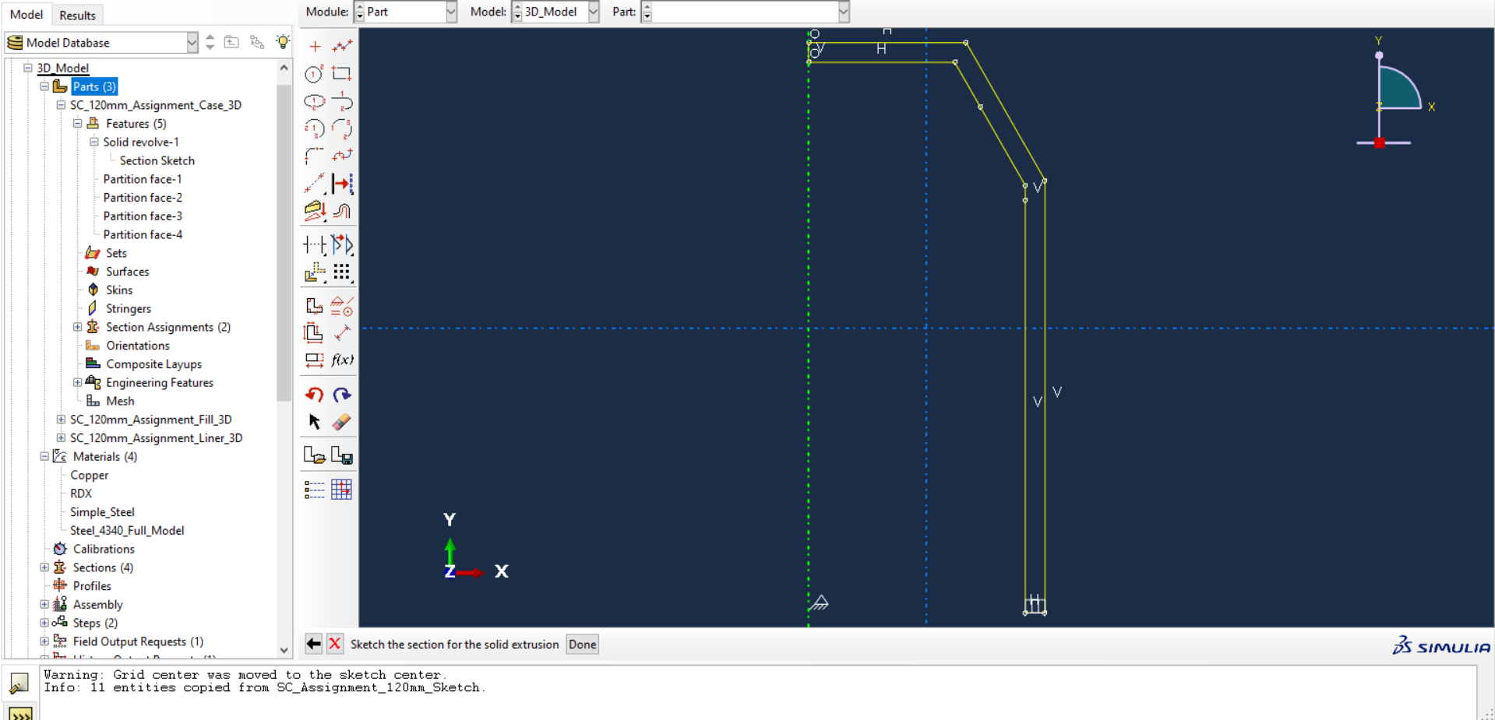
Figure 2: The Case of the Charge Sketched in Abaqus.
Only half of the case was drawn to allow revolution to form a 3D shape when carrying out the modelling in 3D. For the 2D model, symmetry was achieved using boundary conditions.
The Copper Liner was sketched with a radius of 59mm, a length of 105mm, and a half-angle of 25.46°. As with the case, half of the liner was sketched to allow for revolution.
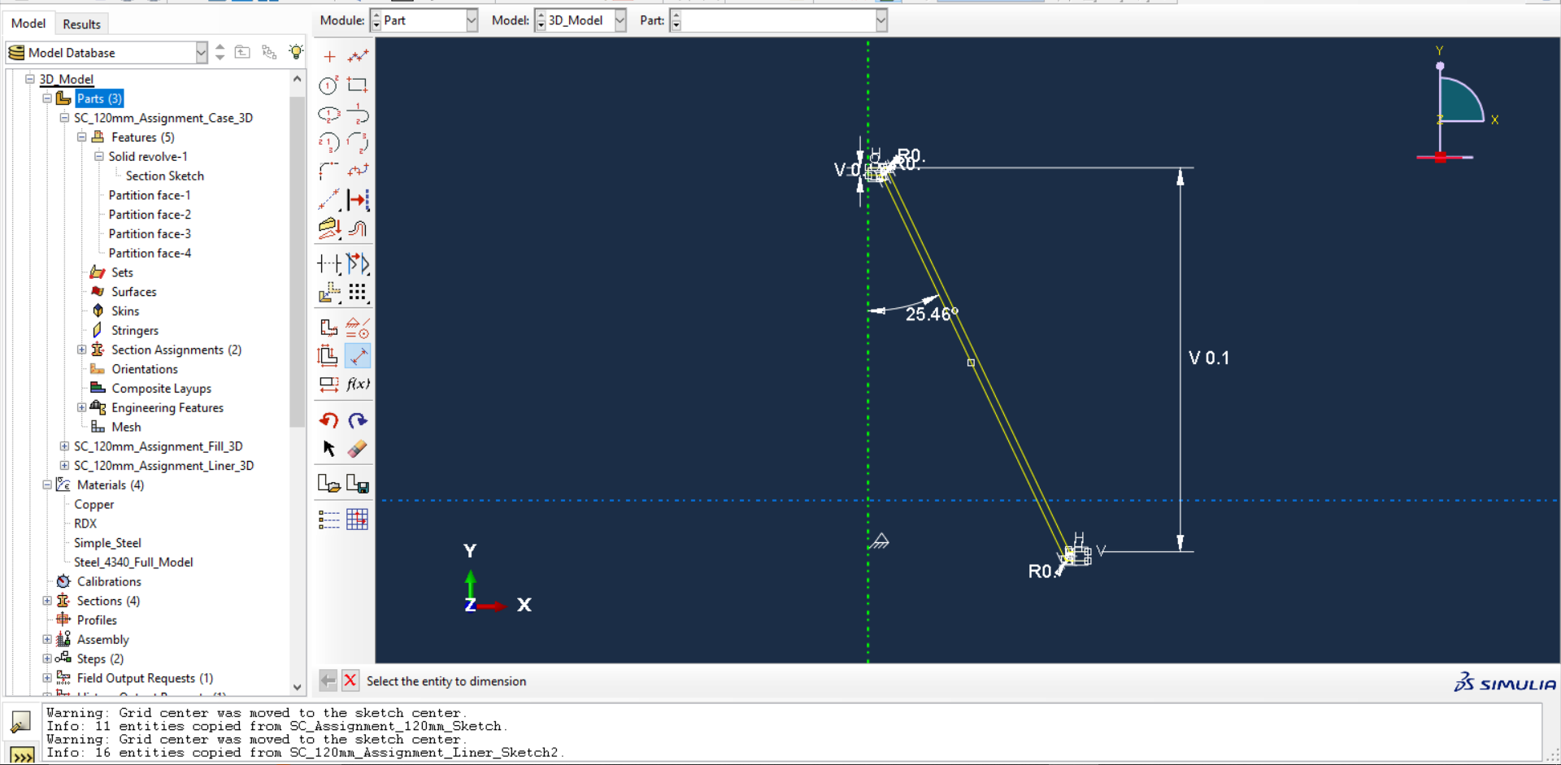
Figure 3: The Liner of the Charge Sketched in Abaqus
The Fill of the charge was sketched by overlaying the liner and case sketches and then removing the outer lines in order to create a shape with a diameter of 59mm, a height of 144mm, and a half-angle in the center of 25.46°.
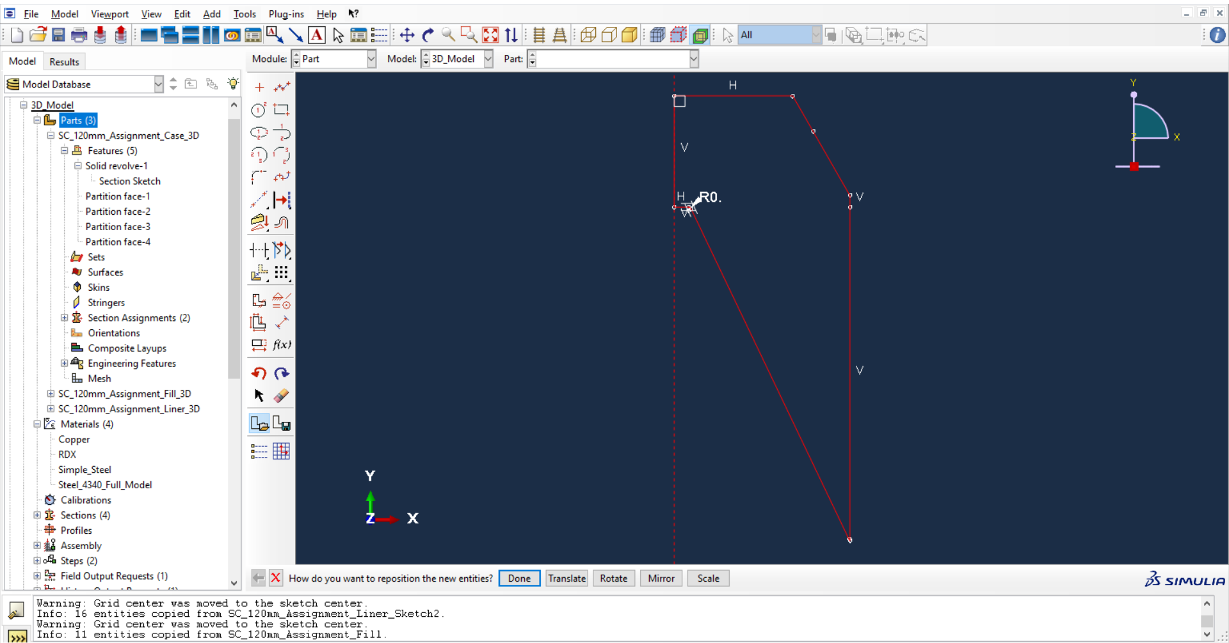Figure 4: The Fill of the Charge Sketched in Abaqus
After the sketches had been drawn, the parts were created from the sketches, using the revolution feature to create parts for the 3D Model. These parts were then combined into an Assembly and materials were assigned appropriately. 3D Parts were rotated through 180° and further symmetry was provided by boundary conditions.
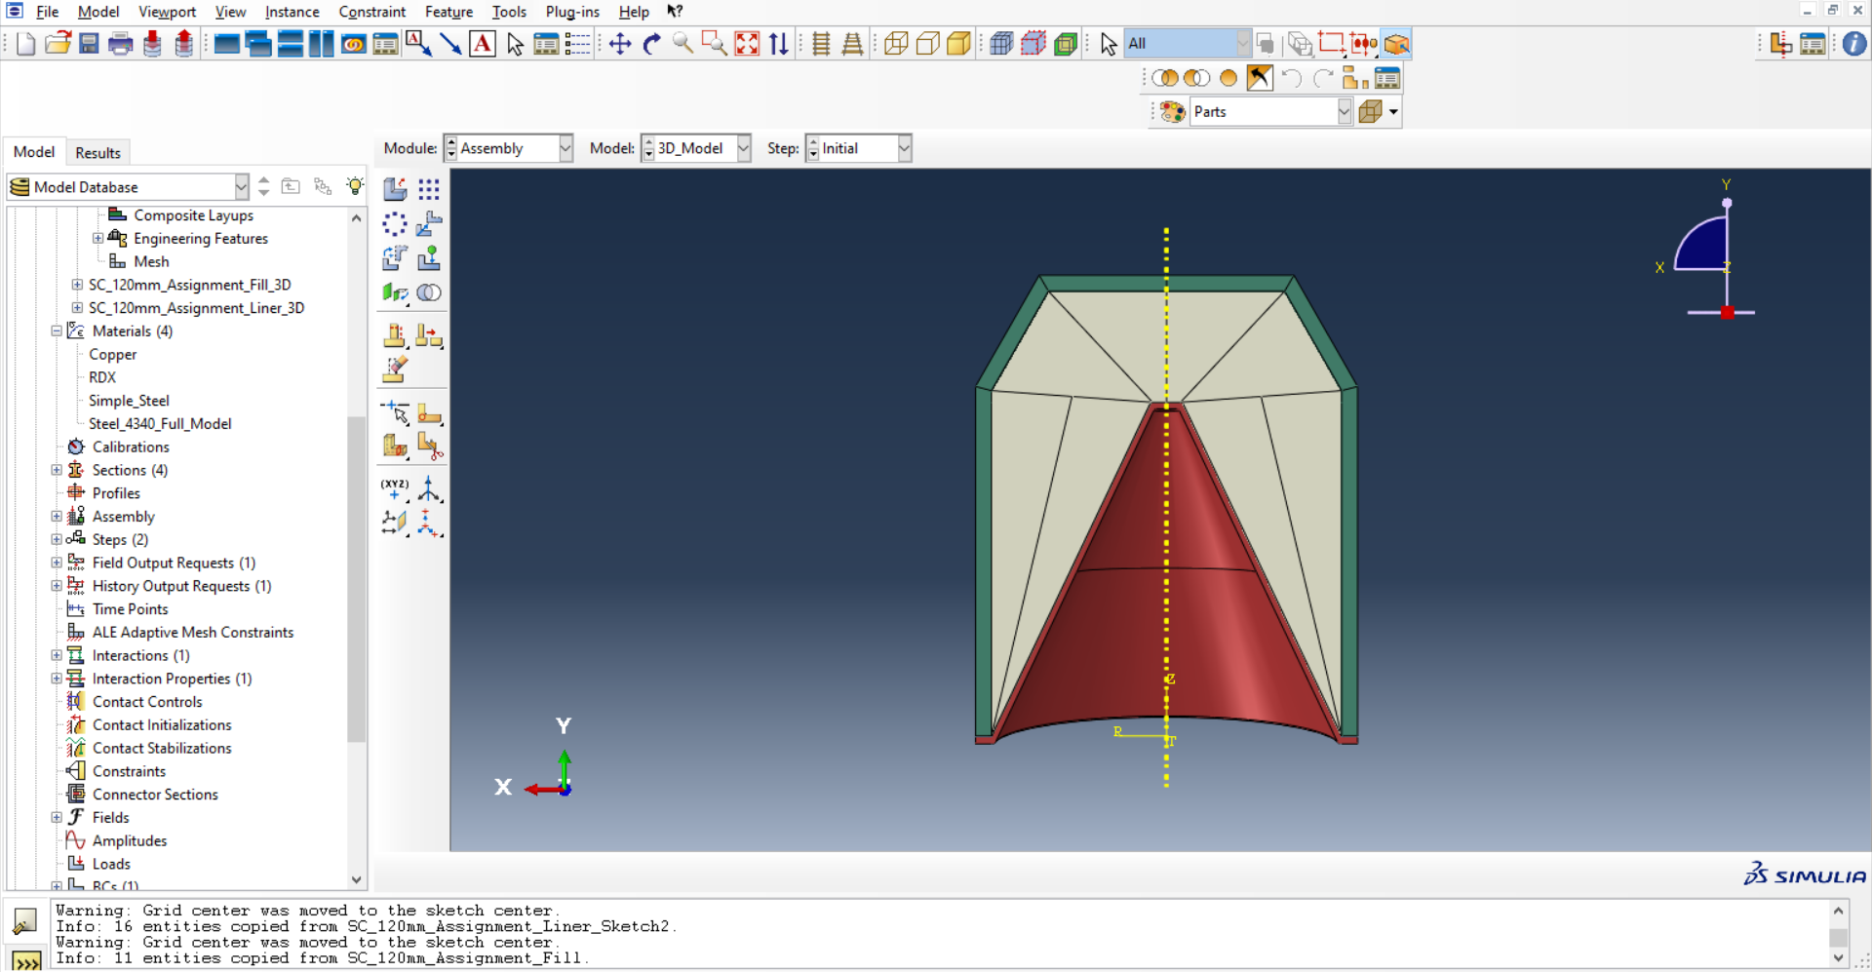Figure 5: The 3D Model Assembly in Abaqus, with colours indicating individual parts
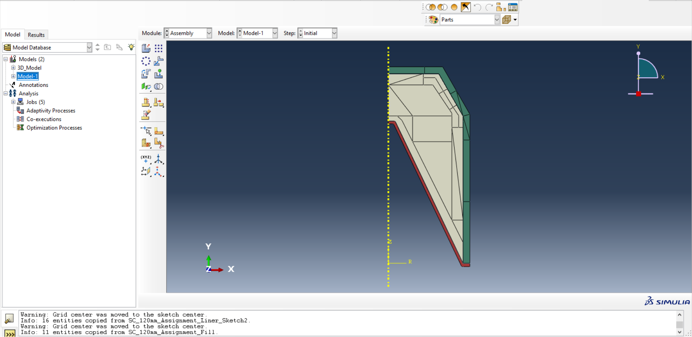Figure 6: The 2D Model Assembly in Abaqus, with colours representing individual parts

Model Parameters
In order to allow the parts to interact with one another, contact behaviour had to be specified. In the Interaction module of Abaqus, an Interaction Property labelled as ‘IntProp-1’ was created with frictionless tangential behaviour, ‘Hard’ Contact Pressure-Overclosure, and default Constraint Enforcement. This property was applied to Step-1 (see ‘Runtime and Outputs’ below) and the contact was set to All With Self, meaning that the parts of the model would be able to interact and exert forces on one another, allowing the jet formation to be appropriately simulated. Boundary conditions were applied to both the 2D and 3D models in the ‘Load’ module to simulate symmetry. In the 2D model, this was an XSYMM Boundary condition, meaning that the model was treated as symmetrical in the X Direction. Similarly, in the 3D Model, a ZSYMM boundary condition was applied, meaning that the model was treated as symmetrical in the Z direction.
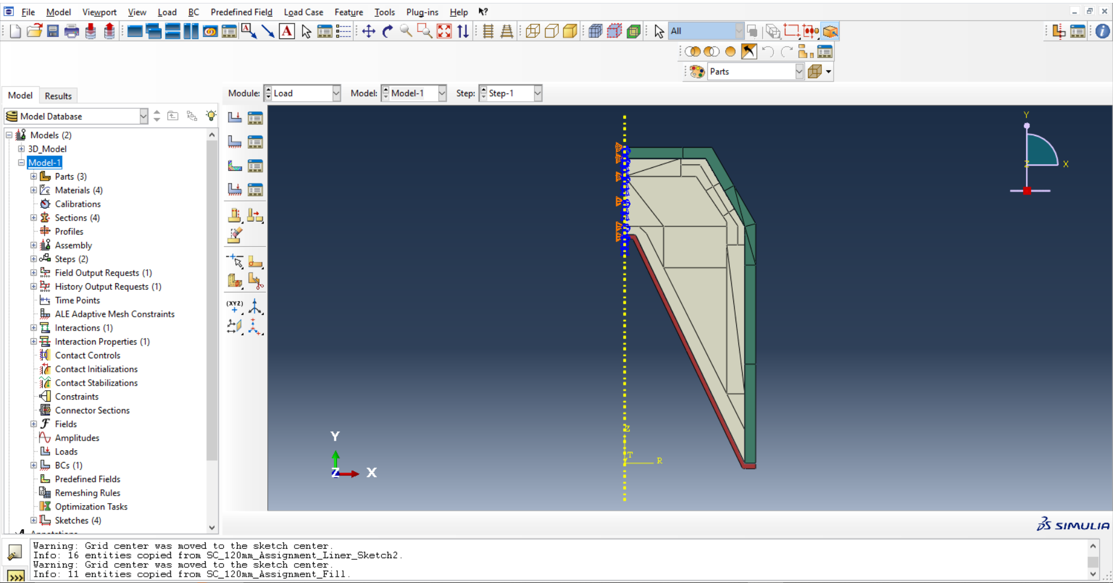Figure 7: The 2D Model in Abaqus showing the XSYMM boundary condition
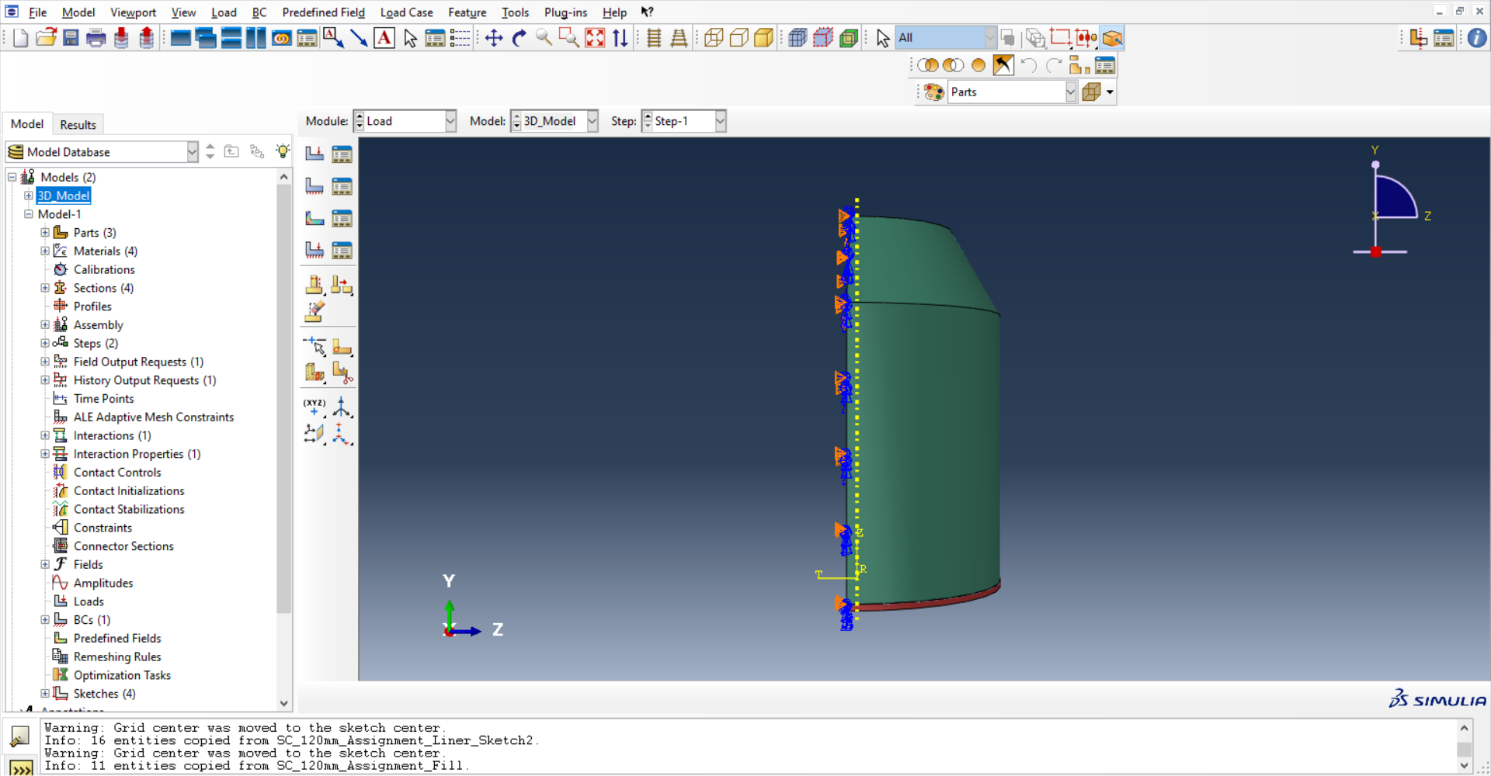
Figure 8: The 3D Model in Abaqus showing the ZSYMM boundary condition

Meshing
In all three models used in this report, sketches were partitioned, allowing the mesh to be proportioned differently in separate areas of the part. In the case of this simulation, this involved making the mesh denser towards the edges of the explosive filler where it met with the case and liner. Examples of all meshes are shown below.

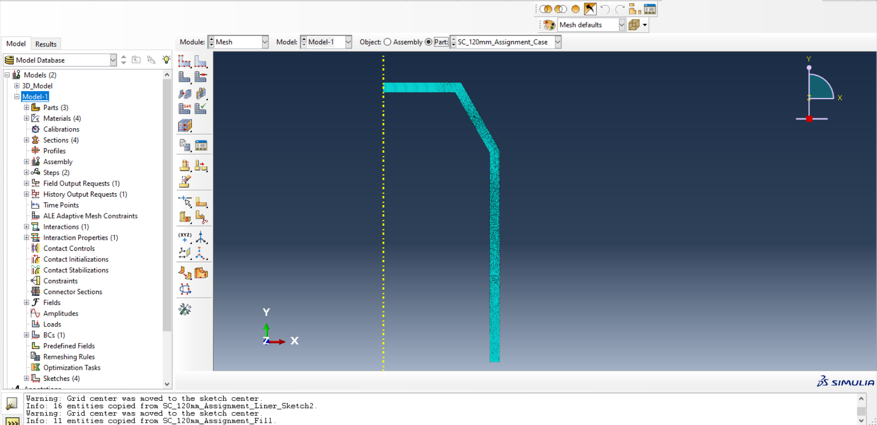
Figure 9: The Case of the 2D Model meshed in Abaqus. Mesh is Tri-Type with an element size of 0.00001 to 0.0005m
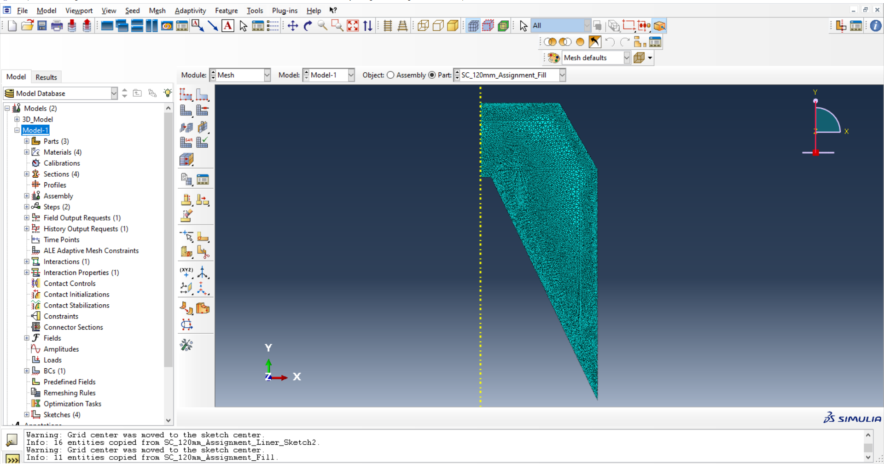Figure 10: The Fill of the 2D Model meshed in Abaqus, Mesh is Tri-Tye with an element size of 0.0005 to 0.002m
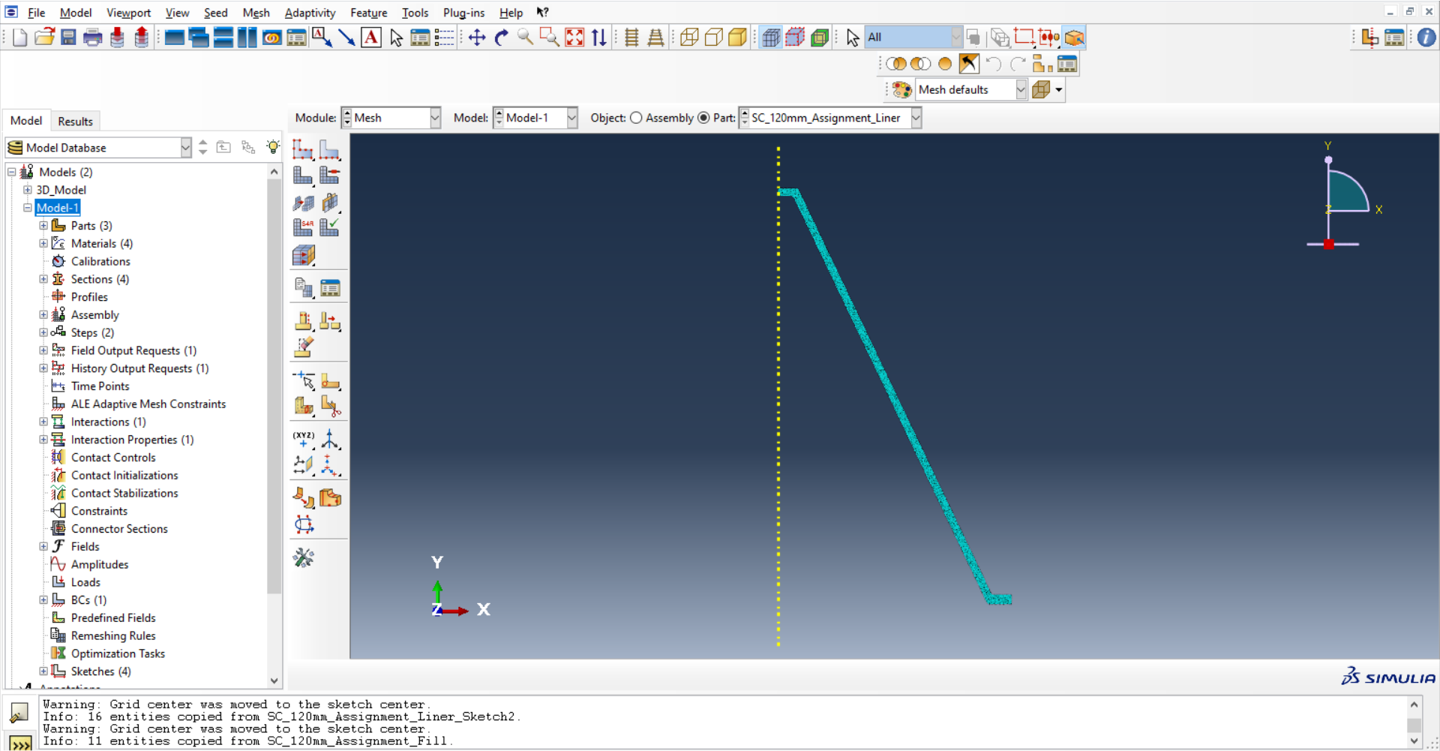Figure 11: The liner of the 2D Model Meshed in Abaqus, Mesh is Tri-Type, Element size approximately 0.0002m
Owing to the computational limitations of Abaqus, the 3D model necessitated a more coarse mesh. In addition, a second 3D model was run using the adaptive meshing algorithm to evaluate the differences in results between conventional meshing and adaptive meshing.
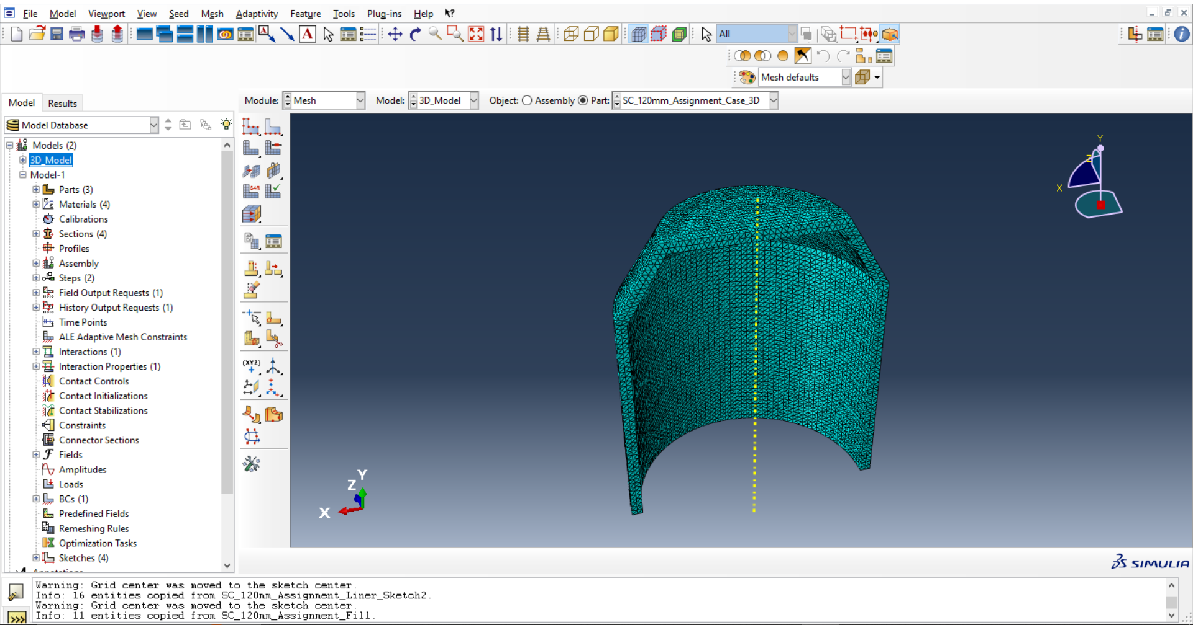Figure 12: The Case of the 3D Model Meshed in Abaqus, Mesh is Tet-Type, Element Size approximately 0.0025m
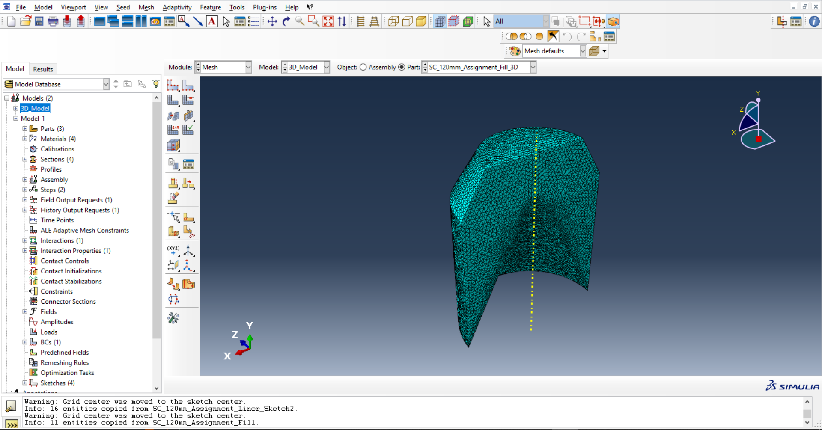Figure 13: The Fill of the 3D Model Meshed in Abaqus, Mesh is Tet-Type, Element Size approximately 0.003m
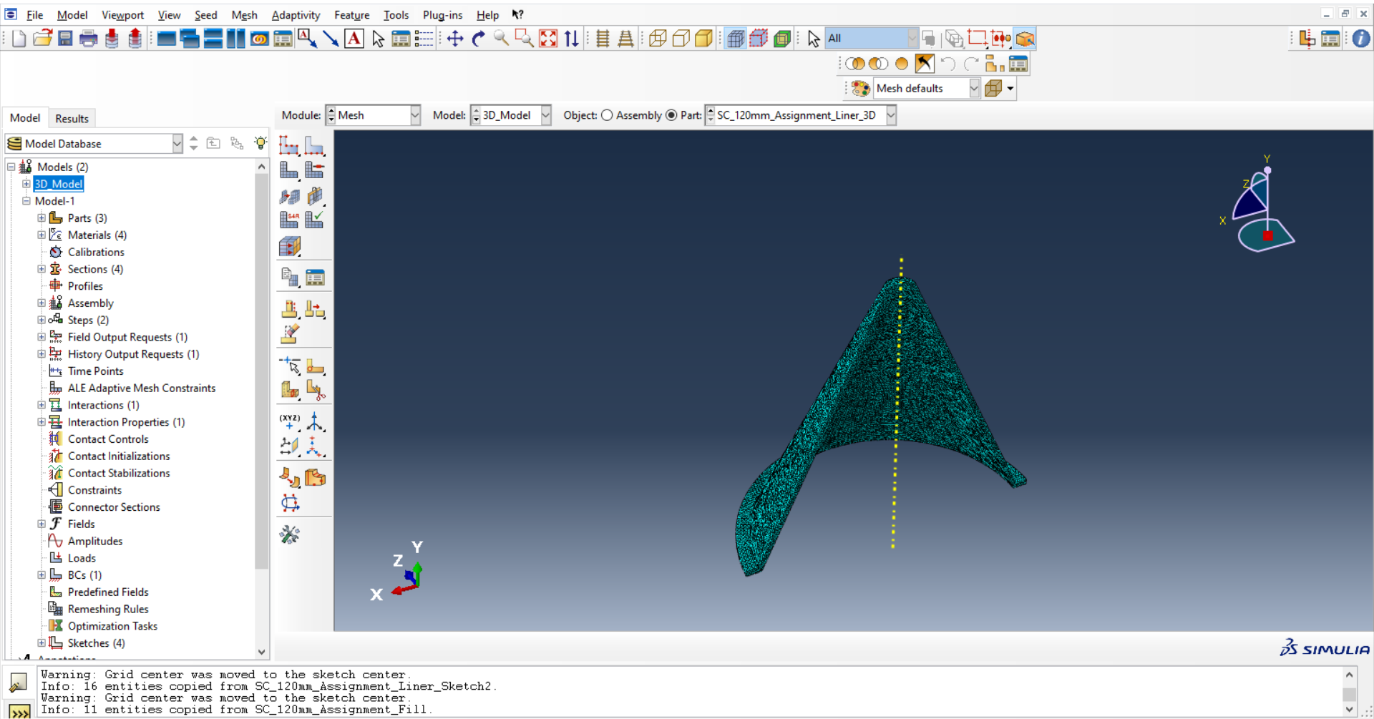
Figure 14: The Liner of the 3D Model Meshed in Abaqus, Mesh is Tet-Type, Element Size approximately 0.0015m

Runtime and Outputs
In both the 2D and 3D models (Without adaptive meshing) the model was set to run over a single step, named in the Step Module as Step-1. In both cases, Step-1 was set at 5x10⁻⁵s but neither model ran to completion owing to element distortion. The 2D model ran to an end time of 4.51x10⁻⁵s and the Non-Adaptively Meshed 3D model ran to an end time of 4.17x10⁻⁵s. In both cases this resulted in observable jet formation and was deemed to be suitable for interpretation of results. In the 3D Adaptive Model, an initial attempt was made to only start the adaptive meshing at t=2x10⁻⁵s, however the model crashed at the transition point, and so the decision was made to utilise adaptive meshing for the full duration of 5x10⁻⁵.

Results

2D Results – Velocity and Displacement
One of the defining aspects of shaped charge performance is the velocity of the jet produced. From the model, the velocities of 10 nodes at the tip of the jet were recorded. Since the jet was projected ‘downwards’ in the coordinate frame of the model, the ‘Y’ velocities were selected. Microsoft Excel was used to record the data and produce graphs. The velocities of the nodes assessed are shown below, and the full tables of results are shown in Annex A.

Figure 15: A Graph of Y Velocities against Time for 10 Nodes Extracted from the 2D Model
From the graph above, it can be seen that the nodes undergo rapid acceleration between t=0.00001s and t=0.00002s before reaching a velocity of approximately 8000ms⁻¹. Because the different meshes used for the 2D and 3D models prevented the exact same nodes from being selected, an average velocity was calculated to allow comparisons. This average is displayed in the graph below.

Figure 16: A Graph of the Average Y Velocity against time of 10 Nodes Against Time For the 2D Model
From this graph, and the tables in Annex A, it can be seen that the final average velocity of the nodes was approximately 8000ms⁻¹
In addition to the velocities, the displacement of the nodes was recorded. The data was collected from the same 10 nodes used for velocity, with the individual and average results shown in the graphs below.

Figure 17: A Graph of the Y Displacements of 10 Nodes against Time For the 2D Model

Figure 18: A Graph of the Average Y Displacement against time of 10 Nodes for the 2D Model
From these graphs, and the tables in Annex A, it can be seen that by the end of the simulation, the jet had travelled 23.375cm from its point of origin in 0.000045s, giving an overall average velocity of 5194.4ms⁻¹

3D Results – Velocity and Displacement
Velocity and displacement results were obtained for 10 nodes at the tip of the jet for both the Conventional and Adaptive meshing algorithms used for the 3D model. The graphs below show the velocity of the individual nodes over time, and the average velocity of the nodes for the conventional mesh.
Figure 19: A Graph of the Y Velocities of 10 Nodes against time for the Conventionally-Meshed 3D Model

Figure 20: A Graph of the average Y Velocity of 10 nodes against time for the Conventionally-Meshed 3D Model
This shows the jet undergoing a rapid acceleration between t=0.00001s and t=0.000025s, before reaching a final velocity of approximately 6000ms⁻¹.
As with the 2D Model, the displacement of the same nodes was recorded and averaged. This is shown in the graphs below.

Figure 21: A Graph of the Y Displacements against time for 10 Nodes from the Conventionally-Meshed 3D Model

Figure 22: A Graph of the Average Y Displacement of 10 Nodes against time from the Conventionally-Meshed 3D Model
From the displacement data above, and the results tables in Annex A, it can be seen that the jet had moved 12.825cm from its origin in 0.0000417s, giving an overall average velocity of 3705.5ms⁻¹.
Given that the adaptively meshed model produced different results, these are shown and discussed below.

Figure 23: A Graph of the Y Velocities against time of 10 nodes for the Adaptively-Meshed 3D Model

Figure 24: A Graph of the average Y Velocity of 10 Nodes against time for the Adaptively-Meshed 3D Model
From these graphs it can be seen that the liner undergoes a period of extreme acceleration between t=0.00001s and t=0.000025s, reaching a final velocity of approximately 6000ms⁻¹.
As with both the 2D and 3D-Conventional model, the displacements were also recorded. These are shown below.

Figure 25: A Graph of Y Displacement against Time of 10 Nodes for the Adaptively-Meshed 3D Model

Figure 26: A Graph of Average Y Displacement of 10 Nodes against time for the Adaptively-Meshed 3D Model
These graphs, and the tables in Annex A, show that the jet had been projected 9.615cm in 0.0000362s, giving an average overall velocity of 2656ms⁻¹

3.5 Comparisons
Since each of the 3 models ran until a different end time, it is necessary to make some normalization to allow the results to be compared. For the velocities, this entails comparing the average velocities over the timespan of the 2D Model as this model ran the longest before crashing. This graph is shown below.

Figure 27: A Comparison of the average Y Velocities of the Jet Tips from all 3 models
This graph shows that the 2D model demonstrates both an earlier acceleration and greater magnitude of final velocity compared to either of the 3D models, which both display similar acceleration and velocity characteristics. It is also seen both in the graph, and in the tables in Annex A, that the final time at which data is present for all three models is t=0.00036. This time will be used where necessary in this analysis to allow for direct comparisons. It can also be seen that for all three models, the velocity somewhat plateaus between t=0.000025 and t=0.000036. Taking the mean velocity from each model between these two points will give an approximation of the final jet velocity which can be used to compare results directly
Similarly to velocities, the average displacements from each model are displayed below.

Figure 28: A Comparison of the average Y Displacements of the Jet Tips from all 3 models
As with the Velocity graphs in (wait for final figure number) it can be seen that the two 3D models demonstrate very similar results, whereas the 2D model demonstrates an earlier start to its movement, and a higher final displacement.
Direct comparisons of the results are shown in the table below.
Model | Maximum Velocity | Average Velocity from t=0.00025s to t=0.000036s | Displacement at t=0.000036 | Overall Average Velocity up to 0.000036s
2D | 8021.532ms⁻¹ | 7944.2ms⁻¹ | 0.16205m | 4501.4ms⁻¹
3D | 6328.468ms⁻¹ | 6128.16ms⁻¹ | 0.09458m | 2627.2ms⁻¹
3D-Adaptive | 6087.11ms⁻¹ | 5850.59ms⁻¹ | 0.09508m | 2641.1ms⁻¹
Table 6: Comparisons of the Displacement and Velocity Outputs of all 3 models
This shows that the 3D models both demonstrate a jet velocity of approximately 6000ms⁻¹, whereas the 2D model demonstrates a jet velocity of approximately 8000ms⁻¹.

Conclusions

Comparisons to Existing Data
Various literature exists concerned with the performance of shaped charges, most noticeably on their penetration performance against targets, and their jet behaviour. Poole [13] describes the shaped charge jet as forming within ‘the order of 6μs’ and reaching speeds of ‘6-12kms⁻¹’. Similarly, Walters [2] gives the velocity of a shaped charge jet tip as ‘in excess of 10 km/s’. This shows that whilst it cannot be guaranteed that this model is a perfect representation of a real charge of the same dimensions and materials, it does perform consistently with existing data on shaped charge jet formation and speed.

Possible Causes of Disparity between 2D and 3D Models
It is clear from the results above that the results of the 2D and 3D models are noticeably different. However, as stated above, shaped charge jets can travel at speeds between 6 and 12kms⁻¹ [13]. Therefore, all three sets of results lie within the expected values of shaped charge performance. Owing to the computational limitations of Abaqus, the 2D model was able to use a much finer mesh than the 3D models, meaning that some calculations could be performed more accurately. The 3D Models, however, account for forces acting on the liner in the Z-Direction, not just the X and Y. This range of differences demonstrates that there are several contributing factors to the disparity and it is not possible to say which model more accurately represents the performance of a shaped charge.

Overall Conclusions and Further Investigation
Overall, this report has shown that Abaqus is a suitable modelling software for the simulation of the formation of shaped charge jets. The formation of a jet which behaves in accordance with predictions based on previous studies [2] [13] was demonstrated in both 2D and 3D models. To develop this research further, more detailed studies into the pressures and stresses involved in the jet formation could be carried out. In addition, it is noted that despite its overall suitability, Abaqus’ computational limitations restricted the mesh size and simulation runtimes, and further insight could be gained by comparing these results to those obtained in practical testing and using other modelling software.

References

[1] | R. Evans and B. Seddon, Explosive Ordnance Guide For Ukraine (Second Edition), Geneva: Geneva International Centre for Humane Demining, 2022.
[2] | W. P. Walters, “The Shaped Charge Concept, Part 1. Introduction,” Ballistic Research Laboratory, Aberdeen, 1990.
[3] | C. E. Munroe, “Effects of Detonation of Gun-Cotton,” The American Journal of Science, vol. XXXVI, no. 211, pp. 48-49, 1888.
[4] | David Monniaux, CC BY-SA 3.0, Obus 501556, 2006.
[5] | R. L. Hinrichsen, M. A. Moshier and A. G. Kurtz, “High Velocity Impacts of Man Portable Air Defense Systems,” American Institute of Aeronautics and Astronautics, Palm Springs, 2004.
[6] | Y. Wang, X. Li, S. Chen, X. Ma, Z. Yu, S. Jin, L. Li and Y. Chen, “Preparation and Characterization of Cyclotrimethylenetrinitramine (RDX) with Reduced Sensitivity,” Materials, vol. 10, no. Special Issue "Energetic Materials and Processes", 2017.
[7] | P. Pahari, A. D. P. Rao and W. M, “Molecular Dynamics Simulations of the Decomposition and Us–Up Relationship of RDX Molecular Crystal Subjected to High Velocity Impact,” Springer Journal of Molecular Modelling, vol. 29, no. 50, 2023.
[8] | Dassault Systemes, “Simulation of Ballistic Perforation of Aluminium Plates with Abaqus/Explicit,” 2012.
[9] | MatWeb, “AISI 4340 Steel, normalized, 25 mm round,” MatWeb, 2023. [Online]. Available: https://www.matweb.com/search/DataSheet.aspx?MatGUID=fd2df45bffa54018b54989bc14092d9f&ckck=1. [Accessed September 2023].
[10] | M. K. Mohd Nor, C. S. Ho, N. Ma'at and M. F. Kamarulzaman, “Modelling Shock Waves in Composite Materials using Generalised Orthotopic Pressure,” Continuum Mechanics and Thermodynamics, vol. 25, no. 5, 2020.
[11] | MatWeb, “Copper, Cu; Annealed,” MatWeb, 2023. [Online]. Available: https://www.matweb.com/search/datasheet.aspx?matguid=9aebe83845c04c1db5126fada6f76f7e. [Accessed September 2023].
[12] | H. Liu, J. Zhang, X. Xu, Y. Qui, Z. Liu and W. Zhao, “Effects of Dislocation Density Evolution on Mechanical Behaviour of OFHC Copper During High-Speed Machining,” Xi'an, 2019.
[13] | C. Poole, “Penetration of a Shaped Charge,” Corpus Christi College, Oxford, 2005.

Annex A: Results Tables

t | Node 1 | Node 2 | Node 3 | Node 4 | Node 5 | Node 6 | Node 7 | Node 8 | Node 9 | Node 10 | Average
0 | 0 | 0 | 0 | 0 | 0 | 0 | 0 | 0 | 0 | 0 | 0
1.00E-06 | 0 | 0 | -1.12E-23 | 0 | 0 | 0 | 0 | 0 | 0 | 0 | -1.1E-24
2.00E-06 | -5.80E-05 | 6.53E-05 | -9.23E-05 | -0.00065 | -0.00052 | 1.87E-05 | 0 | 0 | 0 | 0 | -0.00012
3.00E-06 | -4.67E-05 | 0.000882 | -0.00014 | -0.0007 | 0.000629 | 0.000382 | 3.74E-23 | 0 | 0 | 0 | 0.000101
4.00E-06 | -0.0057 | -0.0018 | 0.001628 | 0.003917 | 0.000207 | -0.00076 | -0.00131 | 6.64E-24 | 3.07E-07 | 8.37E-05 | -0.00037
5.00E-06 | -0.0048 | -0.00168 | 0.004151 | -0.0003 | -0.00167 | -0.00118 | 0.008034 | 4.31E-09 | 0.003553 | 0.002443 | 0.000855
6.00E-06 | -367.535 | -281.699 | -277.809 | -285.542 | -296.07 | -84.2187 | 0.000884 | 0.00325 | 0.001773 | -0.005 | -159.287
7.00E-06 | -492.638 | -521.767 | -498.98 | -489.994 | -492.175 | -512.219 | -0.00197 | 0.004255 | 0.003567 | 0.003067 | -300.776
8.00E-06 | -637.404 | -702.483 | -678.279 | -641.385 | -639.353 | -635.852 | -0.00433 | -0.00418 | -0.00212 | -0.00332 | -393.477
9.00E-06 | -774.595 | -935.35 | -870.365 | -789.827 | -783.575 | -762.434 | -258.049 | -0.00381 | -0.00336 | 0.005358 | -517.42
1.00E-05 | -909.232 | -2182.09 | -1369.56 | -960.229 | -936.925 | -879.332 | -492.417 | -288.518 | -268.474 | -363.694 | -865.047
1.10E-05 | -1170.69 | -5319.55 | -4729.29 | -1501.85 | -1295.64 | -1081.82 | -647.879 | -538.696 | -449.53 | -447.877 | -1718.28
1.20E-05 | -3509.43 | -6016.78 | -5943.08 | -5181.8 | -4318.15 | -2648.52 | -745.455 | -674.658 | -594.716 | -589.324 | -3022.19
1.30E-05 | -5876.21 | -6553.23 | -6302.04 | -5657.41 | -6037.74 | -5140.82 | -824.255 | -761.95 | -704.468 | -698.647 | -3855.68
1.40E-05 | -6129.79 | -6944.75 | -6681.47 | -5949.58 | -6432.1 | -5699.38 | -900.69 | -834.942 | -790.572 | -783.992 | -4114.73
1.50E-05 | -6331.78 | -7238.46 | -7101.19 | -6354.68 | -6683.23 | -6199.1 | -991.542 | -896.778 | -864.973 | -858.8 | -4352.05
1.60E-05 | -6503.14 | -7404.13 | -7287.42 | -6671.43 | -6886.17 | -6575.99 | -1090.63 | -964.46 | -935.608 | -927.531 | -4524.65
1.70E-05 | -6673.3 | -7443.02 | -7218.44 | -6860.89 | -7079.7 | -6819.92 | -1226.57 | -1047.99 | -1003.81 | -990.925 | -4636.46
1.80E-05 | -6814.58 | -7396.09 | -7174.46 | -6975.5 | -7234.08 | -6969.92 | -1544.68 | -1131.32 | -1068.35 | -1052.71 | -4736.17
1.90E-05 | -6934.17 | -7349.59 | -7135.42 | -7068.39 | -7369.28 | -7102.75 | -4398.33 | -1251.45 | -1155.46 | -1135.62 | -5090.05
2.00E-05 | -7015.08 | -7288.56 | -7081.68 | -7125.74 | -7456.74 | -7172.78 | -6615.59 | -1484.28 | -1272.87 | -1239.53 | -5375.29
2.10E-05 | -7020.38 | -7246.77 | -7063.38 | -7129.15 | -7455.86 | -7124.32 | -7482.59 | -2981.3 | -1555.4 | -1497.86 | -5655.7
2.20E-05 | -7092.29 | -7399.26 | -7241.86 | -7202.29 | -7533.07 | -7239.31 | -7959.63 | -6510.84 | -3253.79 | -2113.2 | -6354.55
2.30E-05 | -7185.15 | -7408.89 | -7190.98 | -7275.42 | -7643.89 | -7393.52 | -8318.99 | -8213.94 | -6940.92 | -6124.16 | -7369.59
2.40E-05 | -7212.94 | -7361.74 | -7134.27 | -7290.73 | -7674.05 | -7353.66 | -8631.54 | -8685.16 | -7648.84 | -8272.79 | -7726.57
2.50E-05 | -7211.33 | -7342.01 | -7125.52 | -7289.81 | -7674.41 | -7357.59 | -8847.2 | -8797.26 | -8015.81 | -8734.67 | -7839.56
2.60E-05 | -7215.61 | -7333.57 | -7125.44 | -7289.68 | -7676.38 | -7371.28 | -8862.16 | -8913.54 | -8406.35 | -8970.47 | -7916.45
2.70E-05 | -7231.82 | -7357.83 | -7142.86 | -7293.61 | -7694.05 | -7393.8 | -8741 | -9000.9 | -8737.21 | -9248.07 | -7984.12
2.80E-05 | -7241.94 | -7384.39 | -7163.51 | -7307.1 | -7707.99 | -7396.64 | -8586.54 | -8975.72 | -8985.38 | -9466.11 | -8021.53
2.90E-05 | -7232.32 | -7406.19 | -7181.64 | -7318.47 | -7699.9 | -7366.34 | -8560.9 | -8823.01 | -9059.53 | -9492.11 | -8014.04
3.00E-05 | -7210.12 | -7416.89 | -7196.82 | -7302.22 | -7678.06 | -7334.66 | -8570.81 | -8651.53 | -9060.08 | -9381.6 | -7980.28
3.10E-05 | -7179.89 | -7453.77 | -7227.31 | -7279.46 | -7645.74 | -7300.11 | -8562.67 | -8557.56 | -9037.46 | -9254.5 | -7949.85
3.20E-05 | -7166.2 | -7477.66 | -7247.55 | -7262.86 | -7628.77 | -7292.93 | -8522.98 | -8526.97 | -8964.77 | -9160.93 | -7925.16
3.30E-05 | -7169.47 | -7491.2 | -7255.78 | -7259.64 | -7636.22 | -7304.99 | -8489.31 | -8528.42 | -8869.75 | -9084.24 | -7908.9
3.40E-05 | -7181.65 | -7503.46 | -7265.79 | -7274.88 | -7647.72 | -7304.89 | -8427.42 | -8561.17 | -8776.92 | -9021.13 | -7896.5
3.50E-05 | -7187.23 | -7524.98 | -7282.26 | -7287.54 | -7660.6 | -7312.27 | -8358.88 | -8625.95 | -8700.59 | -8972.32 | -7891.26
3.60E-05 | -7198.7 | -7548.25 | -7305.31 | -7309.13 | -7667.73 | -7302.38 | -8342.83 | -8690.04 | -8666.34 | -8950.15 | -7898.09
3.70E-05 | -7168.46 | -7560.86 | -7316.51 | -7287.86 | -7637.4 | -7261.12 | -8336.67 | -8741.17 | -8661.27 | -8951.86 | -7892.32
3.80E-05 | -7128.65 | -7553.31 | -7308.13 | -7254.11 | -7598.52 | -7210.57 | -8318.57 | -8800.59 | -8685.11 | -8978.73 | -7883.63
3.90E-05 | -7102.13 | -7538.39 | -7291.11 | -7228.86 | -7567.7 | -7186.19 | -8311.78 | -8840.64 | -8719.2 | -9018.98 | -7880.5
4.00E-05 | -7074.24 | -7521.97 | -7274.6 | -7198.14 | -7540.17 | -7160.78 | -8301.69 | -8876.56 | -8759.59 | -9059.15 | -7876.69
4.10E-05 | -7054.32 | -7514.04 | -7265.05 | -7181 | -7519.67 | -7134.13 | -8309.9 | -8910.05 | -8785.97 | -9082.11 | -7875.62
4.20E-05 | -7032.93 | -7497.69 | -7250.82 | -7159.15 | -7496.75 | -7114.89 | -8337.16 | -8933.96 | -8789.3 | -9087.16 | -7869.98
4.30E-05 | -7017.03 | -7484.11 | -7230.85 | -7137.56 | -7473.58 | -7094.52 | -8362.83 | -8945.07 | -8788.93 | -9089.34 | -7862.38
4.40E-05 | -6995.8 | -7467.04 | -7218.38 | -7121.16 | -7457.15 | -7071.3 | -8377.72 | -8945.32 | -8792.04 | -9093.81 | -7853.97
4.50E-05 | -6975.85 | -7453.97 | -7206.3 | -7100.02 | -7435.98 | -7053.6 | -8396.89 | -8944.17 | -8799.53 | -9099 | -7846.53
4.51E-05 | -6973.14 | -7452.88 | -7204.75 | -7099.73 | -7433.53 | -7050.72 | -8399.69 | -9334.97 | -8798.41 | -9101.88 | -7884.97
Annex A Table 1: Velocities of the Jet Tip - 2D
t | Node 1 | Node 2 | Node 3 | Node 4 | Node 5 | Node 6 | Node 7 | Node 8 | Node 9 | Node 10 | Average
0 | 0 | 0 | 0 | 0 | 0 | 0 | 0 | 0 | 0 | 0 | 0
1.00E-06 | 0 | 0 | 0 | 0 | 0 | 0 | 0 | 0 | 0 | 0 | 0
2.00E-06 | -2.18E-11 | 3.09E-11 | -1.27E-11 | -9.46E-11 | -6.00E-11 | -2.91E-11 | 0 | 0 | 0 | 0 | -1.9E-11
3.00E-06 | -4.73E-10 | -4.40E-10 | -3.35E-10 | -4.04E-10 | -5.28E-10 | -2.87E-10 | 0 | 0 | 0 | 0 | -2.5E-10
4.00E-06 | -1.08E-09 | -3.93E-10 | -5.09E-10 | -5.68E-10 | -4.22E-10 | -1.92E-09 | 0 | 0 | 0 | 0 | -4.9E-10
5.00E-06 | -1.43E-09 | -3.93E-10 | -6.11E-10 | -1.02E-09 | -1.14E-09 | -2.94E-09 | -6.98E-10 | 0 | 2.04E-10 | 4.37E-11 | -8E-10
6.00E-06 | -2.54E-05 | -0.00018 | -0.00015 | -6.26E-05 | -4.96E-05 | -3.55E-06 | -1.05E-09 | 0 | -8.44E-10 | -1.69E-09 | -4.7E-05
7.00E-06 | -0.00037 | -0.00064 | -0.00058 | -0.00043 | -0.00041 | -0.00033 | -1.05E-09 | -1.46E-09 | -1.22E-09 | -2.39E-09 | -0.00027
8.00E-06 | -0.0009 | -0.00128 | -0.00119 | -0.00098 | -0.00095 | -0.00085 | -1.05E-09 | -2.10E-09 | -1.80E-09 | -1.75E-09 | -0.00062
9.00E-06 | -0.00159 | -0.00211 | -0.00197 | -0.00169 | -0.00165 | -0.00151 | -0.00016 | -4.77E-09 | -1.86E-09 | -1.75E-09 | -0.00107
1.00E-05 | -0.00241 | -0.00341 | -0.00302 | -0.00255 | -0.00249 | -0.00232 | -0.00057 | -0.00019 | -7.14E-05 | -3.18E-05 | -0.00171
1.10E-05 | -0.00343 | -0.00748 | -0.00581 | -0.00368 | -0.00356 | -0.00329 | -0.00116 | -0.00063 | -0.00042 | -0.00036 | -0.00298
1.20E-05 | -0.00548 | -0.01319 | -0.01141 | -0.00707 | -0.00617 | -0.00488 | -0.00186 | -0.00123 | -0.00096 | -0.00087 | -0.00531
1.30E-05 | -0.01044 | -0.01948 | -0.0175 | -0.01268 | -0.01163 | -0.00901 | -0.00265 | -0.00194 | -0.00162 | -0.00152 | -0.00885
1.40E-05 | -0.01652 | -0.02624 | -0.024 | -0.01847 | -0.01788 | -0.01444 | -0.00353 | -0.00273 | -0.00238 | -0.00227 | -0.01285
1.50E-05 | -0.02274 | -0.03334 | -0.03089 | -0.02462 | -0.02444 | -0.0204 | -0.00447 | -0.0036 | -0.00321 | -0.00309 | -0.01708
1.60E-05 | -0.02917 | -0.04068 | -0.03813 | -0.03115 | -0.03124 | -0.02681 | -0.00551 | -0.00454 | -0.00412 | -0.00398 | -0.02153
1.70E-05 | -0.03576 | -0.04812 | -0.04538 | -0.03792 | -0.03822 | -0.03351 | -0.00666 | -0.00554 | -0.00508 | -0.00493 | -0.02611
1.80E-05 | -0.04251 | -0.05554 | -0.05258 | -0.04485 | -0.04539 | -0.04042 | -0.00802 | -0.00663 | -0.00612 | -0.00596 | -0.0308
1.90E-05 | -0.04938 | -0.06291 | -0.05974 | -0.05187 | -0.05269 | -0.04745 | -0.01073 | -0.00782 | -0.00723 | -0.00705 | -0.03569
2.00E-05 | -0.05636 | -0.07023 | -0.06685 | -0.05897 | -0.0601 | -0.05459 | -0.0164 | -0.00917 | -0.00844 | -0.00823 | -0.04093
2.10E-05 | -0.06338 | -0.07748 | -0.07389 | -0.06611 | -0.06757 | -0.06176 | -0.02353 | -0.01107 | -0.00982 | -0.00957 | -0.04642
2.20E-05 | -0.07042 | -0.08479 | -0.08105 | -0.07326 | -0.07505 | -0.06892 | -0.03124 | -0.01617 | -0.01189 | -0.01131 | -0.05241
2.30E-05 | -0.07758 | -0.09222 | -0.08827 | -0.0805 | -0.08265 | -0.07625 | -0.0394 | -0.0237 | -0.01732 | -0.01525 | -0.05931
2.40E-05 | -0.08477 | -0.0996 | -0.09543 | -0.08779 | -0.09031 | -0.08362 | -0.04787 | -0.03221 | -0.02476 | -0.02271 | -0.06691
2.50E-05 | -0.09199 | -0.10695 | -0.10256 | -0.09508 | -0.09798 | -0.09097 | -0.05663 | -0.04096 | -0.03257 | -0.03126 | -0.07469
2.60E-05 | -0.09921 | -0.11429 | -0.10969 | -0.10237 | -0.10566 | -0.09834 | -0.06551 | -0.04982 | -0.04078 | -0.0401 | -0.08258
2.70E-05 | -0.10643 | -0.12163 | -0.11682 | -0.10966 | -0.11334 | -0.10572 | -0.0743 | -0.05878 | -0.04935 | -0.04919 | -0.09052
2.80E-05 | -0.11366 | -0.129 | -0.12398 | -0.11696 | -0.12105 | -0.11311 | -0.08297 | -0.06778 | -0.05823 | -0.05857 | -0.09853
2.90E-05 | -0.12091 | -0.1364 | -0.13115 | -0.12428 | -0.12876 | -0.12049 | -0.09153 | -0.07667 | -0.06726 | -0.06806 | -0.10655
3.00E-05 | -0.12813 | -0.14381 | -0.13834 | -0.13159 | -0.13644 | -0.12784 | -0.1001 | -0.08541 | -0.07632 | -0.07751 | -0.11455
3.10E-05 | -0.13532 | -0.15125 | -0.14555 | -0.13888 | -0.14411 | -0.13516 | -0.10867 | -0.094 | -0.08537 | -0.08682 | -0.12251
3.20E-05 | -0.14249 | -0.15872 | -0.15279 | -0.14615 | -0.15174 | -0.14245 | -0.11721 | -0.10255 | -0.09437 | -0.09603 | -0.13045
3.30E-05 | -0.14966 | -0.1662 | -0.16004 | -0.15341 | -0.15938 | -0.14975 | -0.12572 | -0.11107 | -0.10329 | -0.10515 | -0.13837
3.40E-05 | -0.15683 | -0.17369 | -0.1673 | -0.16068 | -0.16702 | -0.15706 | -0.13418 | -0.11961 | -0.11211 | -0.1142 | -0.14627
3.50E-05 | -0.16402 | -0.18121 | -0.17458 | -0.16796 | -0.17467 | -0.16437 | -0.14257 | -0.12821 | -0.12085 | -0.12319 | -0.15416
3.60E-05 | -0.17121 | -0.18874 | -0.18187 | -0.17526 | -0.18234 | -0.17168 | -0.15091 | -0.13686 | -0.12953 | -0.13215 | -0.16205
3.70E-05 | -0.17839 | -0.1963 | -0.18918 | -0.18256 | -0.18999 | -0.17896 | -0.15925 | -0.14558 | -0.13819 | -0.1411 | -0.16995
3.80E-05 | -0.18554 | -0.20386 | -0.19649 | -0.18983 | -0.19761 | -0.18619 | -0.16758 | -0.15436 | -0.14687 | -0.15006 | -0.17784
3.90E-05 | -0.19265 | -0.21141 | -0.20379 | -0.19707 | -0.20519 | -0.19339 | -0.1759 | -0.16318 | -0.15557 | -0.15906 | -0.18572
4.00E-05 | -0.19974 | -0.21894 | -0.21107 | -0.20428 | -0.21275 | -0.20056 | -0.1842 | -0.17204 | -0.16431 | -0.1681 | -0.1936
4.10E-05 | -0.2068 | -0.22645 | -0.21835 | -0.21147 | -0.22028 | -0.20771 | -0.1925 | -0.18093 | -0.17308 | -0.17717 | -0.20147
4.20E-05 | -0.21384 | -0.23395 | -0.2256 | -0.21863 | -0.22777 | -0.21483 | -0.20082 | -0.18984 | -0.18186 | -0.18625 | -0.20934
4.30E-05 | -0.22088 | -0.24144 | -0.23284 | -0.22578 | -0.23527 | -0.22195 | -0.20918 | -0.19879 | -0.19066 | -0.19535 | -0.21721
4.40E-05 | -0.22787 | -0.24893 | -0.24006 | -0.2329 | -0.24273 | -0.22903 | -0.21755 | -0.20773 | -0.19946 | -0.20443 | -0.22507
4.50E-05 | -0.23483 | -0.25638 | -0.24725 | -0.23999 | -0.25016 | -0.23607 | -0.22592 | -0.21664 | -0.20823 | -0.2135 | -0.2329
4.51E-05 | -0.23559 | -0.25719 | -0.24803 | -0.24076 | -0.25097 | -0.23683 | -0.22683 | -0.21761 | -0.20918 | -0.21449 | -0.23375
Annex A Table 2: Jet Tip Displacement - 2D
t | Node 1 | Node 2 | Node 3 | Node 4 | Node 5 | Node 6 | Node 7 | Node 8 | Node 9 | Node 10 | Average
0 | 0 | 0 | 0 | 0 | 0 | 0 | 0 | 0 | 0 | 0 | 0
1.02E-06 | 0 | 0 | 0 | 0 | 0 | 0 | 0 | 0 | 0 | 0 | 0
2.00E-06 | 0 | 0 | 0 | 0 | 0 | 0 | 0 | 0 | 0 | 0 | 0
3.02E-06 | 0 | 0 | 0 | 0 | 0 | 0 | 0 | 0 | 0 | 0 | 0
4.01E-06 | 0 | 0 | 0 | 0 | 0 | 0 | 0 | 0 | 0 | 0 | 0
5.01E-06 | 0 | 0 | 0 | 0 | 0 | 0 | 0 | 0 | 0 | 0 | 0
6.01E-06 | 0 | 0 | 0 | 0 | 0 | 0 | 0 | 0 | 0 | 0 | 0
7.00E-06 | 0 | 0 | 0 | 0 | 0 | 0 | -2.12E-24 | 0 | 0 | 0 | -2.1E-25
8.00E-06 | -5.11E-06 | 9.39E-07 | 1.34E-06 | -0.00011 | -2.46E-05 | -0.00021 | -0.00015 | 3.62E-05 | -9.44E-05 | 1.51E-05 | -5.4E-05
9.00E-06 | 4.05E-05 | 7.45E-06 | -2.70E-06 | 2.67E-05 | -4.54E-05 | -19.4433 | -280.698 | -0.00047 | -0.00013 | -0.00088 | -30.0143
1.00E-05 | -0.00024 | -158.384 | -0.07105 | -0.00046 | -1.65E-05 | -220.332 | -502.528 | -331.785 | -0.04526 | -343.535 | -155.668
1.10E-05 | -351.317 | -434.541 | -281.68 | -362.998 | -275.752 | -444.823 | -619.584 | -482.945 | -287.396 | -503.912 | -404.495
1.20E-05 | -460.93 | -603.887 | -403.759 | -522.234 | -451.289 | -649.449 | -695.119 | -599.124 | -455.239 | -630.922 | -547.195
1.30E-05 | -616.529 | -658.766 | -601.607 | -615.84 | -601.31 | -726.301 | -784.003 | -717.379 | -598.008 | -724.983 | -664.473
1.40E-05 | -716.8 | -751.383 | -715.321 | -730.105 | -699.81 | -865.27 | -894.668 | -793.727 | -749.172 | -774.604 | -769.086
1.50E-05 | -799.641 | -835.111 | -813.188 | -798.356 | -769.225 | -963.155 | -1022.19 | -847.965 | -824.999 | -843.946 | -851.778
1.60E-05 | -846.76 | -927.343 | -872.759 | -841.748 | -844.787 | -1011.04 | -1141.92 | -953.087 | -880.726 | -941.121 | -926.129
1.70E-05 | -930.928 | -1005.54 | -941.034 | -925.568 | -920.112 | -1153.83 | -1333.11 | -1027.94 | -934.305 | -1052.04 | -1022.44
1.80E-05 | -1012.13 | -1090.35 | -1014.24 | -1024.41 | -993.459 | -1283.58 | -1884.77 | -1121.71 | -1015.88 | -1126.98 | -1156.75
1.90E-05 | -1081.11 | -1220.51 | -1094.56 | -1085.52 | -1051.37 | -1787.09 | -2966.17 | -1270.87 | -1097.53 | -1261.64 | -1391.64
2.00E-05 | -1179.11 | -1396.34 | -1194.19 | -1195.13 | -1148.45 | -2953.14 | -4198.14 | -1570.24 | -1190.92 | -1536.82 | -1756.25
2.10E-05 | -1327.06 | -2069.3 | -1348.82 | -1341.12 | -1275.16 | -4153.6 | -5120.36 | -2567.18 | -1339.55 | -2524.96 | -2306.71
2.20E-05 | -1587.05 | -3453.51 | -1713.31 | -1649.62 | -1477.01 | -5059.12 | -5673.85 | -3929.89 | -1672.82 | -4061.99 | -3027.82
2.30E-05 | -2419.5 | -5076.81 | -2908.82 | -2665.1 | -2131.83 | -5513.42 | -5905.59 | -5218.72 | -2678.22 | -5248.11 | -3976.61
2.40E-05 | -4111.47 | -6008.71 | -4874.98 | -4460.12 | -3788.95 | -5864 | -5986.64 | -5855.98 | -4527.4 | -5970.13 | -5144.84
2.50E-05 | -5354.16 | -6417.47 | -6018.33 | -5756.89 | -5606.05 | -6059.61 | -5980.75 | -6157.08 | -5801.6 | -6227.68 | -5937.96
2.60E-05 | -5961.93 | -6428.76 | -6543.55 | -6456.23 | -6329.62 | -6086.92 | -5913.73 | -6325.98 | -6313.74 | -6355 | -6271.55
2.70E-05 | -6238.62 | -6404.17 | -6462.01 | -6900.81 | -6479.73 | -5948.12 | -5831.2 | -6344.41 | -6232.48 | -6443.13 | -6328.47
2.80E-05 | -6217.63 | -6287.38 | -6151.05 | -6952.2 | -6579.28 | -5910.32 | -5751.62 | -6278.82 | -6228.94 | -6437.85 | -6279.51
2.90E-05 | -6132.3 | -6200.51 | -6023.98 | -6835.86 | -6549.65 | -5896.8 | -5684.72 | -6226.04 | -6192.31 | -6375.49 | -6211.77
3.00E-05 | -6078.4 | -6138.48 | -6011.26 | -6703.53 | -6497.33 | -5886.92 | -5630.17 | -6192.98 | -6154.48 | -6303.5 | -6159.71
3.10E-05 | -6009.79 | -6081.83 | -6021.39 | -6627.23 | -6484.05 | -5855.23 | -5577.48 | -6161.55 | -6123.54 | -6247.19 | -6118.93
3.20E-05 | -5964.64 | -6051.28 | -6032.33 | -6598.77 | -6503 | -5821.92 | -5522.12 | -6125.23 | -6107.34 | -6193.67 | -6092.03
3.30E-05 | -5935.2 | -6038.8 | -6054.93 | -6574.45 | -6510.86 | -5785.85 | -5474.67 | -6080.09 | -6091.77 | -6140.6 | -6068.72
3.40E-05 | -5909.48 | -6004.67 | -6072.61 | -6552.46 | -6512.3 | -5757.92 | -5426.35 | -6032.47 | -6088.89 | -6091.43 | -6044.86
3.50E-05 | -5904.64 | -5958.23 | -6110.23 | -6534.4 | -6517.61 | -5733.46 | -5376.03 | -5991.01 | -6081.46 | -6052.76 | -6025.98
3.60E-05 | -5893.21 | -5922.67 | -6074.2 | -6512.06 | -6511.55 | -5705.72 | -5325.88 | -5952.2 | -6071.89 | -6014.9 | -5998.43
3.70E-05 | -5886.98 | -5894.87 | -6089.39 | -6493.9 | -6500.67 | -5672.04 | -5296.83 | -5915.17 | -6056.01 | -5993.71 | -5979.96
3.80E-05 | -5873.15 | -5862.76 | -6092.11 | -6472.53 | -6486.71 | -5642.17 | -5247.75 | -5882.76 | -6027.94 | -5951.14 | -5953.9
3.90E-05 | -5844.82 | -5862.97 | -6082.09 | -6463.27 | -6468.21 | -5622.18 | -5247.85 | -5829.75 | -6067.01 | -5890.23 | -5937.84
4.00E-05 | -5830.12 | -5831.47 | -6169.82 | -6459.84 | -6473.82 | -5586.04 | -5198.97 | -5796.26 | -6044.75 | -5856.35 | -5924.74
4.10E-05 | -5835.9 | -5735.6 | -6067.66 | -6482.27 | -6577.66 | -5537.23 | -5158 | -5784.98 | -6040.76 | -5816.4 | -5903.65
4.17E-05 | -5820.46 | -5607.93 | -5252.91 | -6577.33 | -6654.32 | -5503.42 | -5121.62 | -5750.95 | -5890.77 | -5764.73 | -5794.44
Annex A Table 3: Jet Tip Velocities - 3D
t | Node 1 | Node 2 | Node 3 | Node 4 | Node 5 | Node 6 | Node 7 | Node 8 | Node 9 | Node 10 | Average
0 | 0 | 0 | 0 | 0 | 0 | 0 | 0 | 0 | 0 | 0 | 0
1.02E-06 | 0 | 0 | 0 | 0 | 0 | 0 | 0 | 0 | 0 | 0 | 0
2.00E-06 | 0 | 0 | 0 | 0 | 0 | 0 | 0 | 0 | 0 | 0 | 0
3.02E-06 | 0 | 0 | 0 | 0 | 0 | 0 | 0 | 0 | 0 | 0 | 0
4.01E-06 | 0 | 0 | 0 | 0 | 0 | 0 | 0 | 0 | 0 | 0 | 0
5.01E-06 | 0 | 0 | 0 | 0 | 0 | 0 | 0 | 0 | 0 | 0 | 0
6.01E-06 | 0 | 0 | 0 | 0 | 0 | 0 | 0 | 0 | 0 | 0 | 0
7.00E-06 | 0 | 0 | 0 | 0 | 0 | 0 | -1.17E-31 | 0 | 0 | 0 | -1.2E-32
8.00E-06 | 0 | 0 | 0 | 0 | 0 | 0 | 0 | 0 | 0 | 0 | 0
9.00E-06 | 0 | 0 | 0 | 0 | 0 | -1.71E-06 | -5.37E-05 | 0 | 0 | -7.28E-12 | -5.5E-06
1.00E-05 | 0 | -1.99E-05 | -2.88E-09 | 0 | 0 | -0.00023 | -0.0004 | -7.94E-05 | -1.80E-09 | -7.27E-05 | -8.1E-05
1.10E-05 | -8.53E-05 | -0.00032 | -0.00013 | -8.31E-05 | -4.95E-05 | -0.00066 | -0.00093 | -0.00043 | -0.00013 | -0.00041 | -0.00032
1.20E-05 | -0.00043 | -0.00081 | -0.00051 | -0.00044 | -0.00038 | -0.00127 | -0.00158 | -0.00094 | -0.00049 | -0.00092 | -0.00078
1.30E-05 | -0.00095 | -0.00143 | -0.00106 | -0.00094 | -0.00087 | -0.00198 | -0.00234 | -0.00157 | -0.00102 | -0.00157 | -0.00137
1.40E-05 | -0.0016 | -0.00215 | -0.00172 | -0.00158 | -0.00151 | -0.00277 | -0.00319 | -0.00232 | -0.00168 | -0.0023 | -0.00208
1.50E-05 | -0.00234 | -0.00297 | -0.00249 | -0.00234 | -0.00225 | -0.00366 | -0.00414 | -0.00315 | -0.00244 | -0.00314 | -0.00289
1.60E-05 | -0.00317 | -0.00384 | -0.00333 | -0.00318 | -0.00307 | -0.00466 | -0.00521 | -0.00405 | -0.00329 | -0.00406 | -0.00379
1.70E-05 | -0.00406 | -0.0048 | -0.00424 | -0.00408 | -0.00396 | -0.00573 | -0.00644 | -0.00503 | -0.0042 | -0.00505 | -0.00476
1.80E-05 | -0.00503 | -0.00585 | -0.00522 | -0.00504 | -0.0049 | -0.00694 | -0.00798 | -0.00611 | -0.00518 | -0.00613 | -0.00584
1.90E-05 | -0.00607 | -0.007 | -0.00627 | -0.00609 | -0.00593 | -0.00843 | -0.01041 | -0.0073 | -0.00623 | -0.00732 | -0.00711
2.00E-05 | -0.00721 | -0.0083 | -0.00741 | -0.00724 | -0.00703 | -0.01072 | -0.01398 | -0.00869 | -0.00737 | -0.0087 | -0.00866
2.10E-05 | -0.00846 | -0.00996 | -0.00867 | -0.00849 | -0.00823 | -0.0143 | -0.0187 | -0.01069 | -0.00863 | -0.01063 | -0.01068
2.20E-05 | -0.00989 | -0.01268 | -0.01017 | -0.00996 | -0.0096 | -0.0189 | -0.02411 | -0.01393 | -0.01011 | -0.01394 | -0.01333
2.30E-05 | -0.01181 | -0.017 | -0.01238 | -0.01202 | -0.01133 | -0.02421 | -0.02992 | -0.01854 | -0.0122 | -0.01863 | -0.0168
2.40E-05 | -0.01504 | -0.02255 | -0.01626 | -0.01561 | -0.01425 | -0.02991 | -0.03587 | -0.02414 | -0.0158 | -0.02427 | -0.02137
2.50E-05 | -0.01985 | -0.02882 | -0.02178 | -0.02077 | -0.01902 | -0.03588 | -0.04185 | -0.03017 | -0.021 | -0.0304 | -0.02695
2.60E-05 | -0.02557 | -0.03522 | -0.02819 | -0.0269 | -0.02511 | -0.04199 | -0.04781 | -0.03642 | -0.02711 | -0.0367 | -0.0331
2.70E-05 | -0.03172 | -0.04165 | -0.03471 | -0.03359 | -0.03153 | -0.04801 | -0.05368 | -0.04276 | -0.03342 | -0.0431 | -0.03942
2.80E-05 | -0.03796 | -0.04799 | -0.04101 | -0.04054 | -0.03805 | -0.05393 | -0.05947 | -0.04907 | -0.03965 | -0.04955 | -0.04572
2.90E-05 | -0.04413 | -0.05422 | -0.04708 | -0.04743 | -0.04462 | -0.05983 | -0.06518 | -0.05532 | -0.04587 | -0.05596 | -0.05197
3.00E-05 | -0.05023 | -0.06039 | -0.05309 | -0.0542 | -0.05114 | -0.06573 | -0.07084 | -0.06153 | -0.05204 | -0.0623 | -0.05815
3.10E-05 | -0.05628 | -0.0665 | -0.05911 | -0.06086 | -0.05763 | -0.0716 | -0.07645 | -0.06771 | -0.05817 | -0.06858 | -0.06429
3.20E-05 | -0.06226 | -0.07257 | -0.06513 | -0.06747 | -0.06412 | -0.07744 | -0.082 | -0.07385 | -0.06429 | -0.0748 | -0.07039
3.30E-05 | -0.06821 | -0.07861 | -0.07117 | -0.07406 | -0.07063 | -0.08324 | -0.0875 | -0.07996 | -0.07038 | -0.08096 | -0.07647
3.40E-05 | -0.07413 | -0.08463 | -0.07724 | -0.08062 | -0.07714 | -0.08901 | -0.09295 | -0.08601 | -0.07647 | -0.08708 | -0.08253
3.50E-05 | -0.08004 | -0.09061 | -0.08332 | -0.08717 | -0.08365 | -0.09476 | -0.09835 | -0.09202 | -0.08256 | -0.09315 | -0.08856
3.60E-05 | -0.08594 | -0.09656 | -0.0894 | -0.09369 | -0.09017 | -0.10048 | -0.1037 | -0.09801 | -0.08864 | -0.09919 | -0.09458
3.70E-05 | -0.09183 | -0.10246 | -0.09548 | -0.10019 | -0.09667 | -0.10616 | -0.10901 | -0.10394 | -0.0947 | -0.10519 | -0.10056
3.80E-05 | -0.09771 | -0.10835 | -0.10157 | -0.10668 | -0.10316 | -0.11182 | -0.11427 | -0.10983 | -0.10075 | -0.11117 | -0.10653
3.90E-05 | -0.10357 | -0.11421 | -0.10765 | -0.11314 | -0.10964 | -0.11745 | -0.11952 | -0.11569 | -0.1068 | -0.11709 | -0.11248
4.00E-05 | -0.10941 | -0.12007 | -0.11379 | -0.1196 | -0.11611 | -0.12305 | -0.12475 | -0.1215 | -0.11284 | -0.12295 | -0.11841
4.10E-05 | -0.11524 | -0.12585 | -0.11991 | -0.12608 | -0.12262 | -0.12861 | -0.12993 | -0.12729 | -0.1189 | -0.12879 | -0.12432
4.17E-05 | -0.11914 | -0.12966 | -0.12396 | -0.13043 | -0.12698 | -0.13229 | -0.13336 | -0.13113 | -0.12292 | -0.13266 | -0.12825
Annex A Table 4: Jet Tip Displacements - 3D
t | Node 1 | Node 2 | Node 3 | Node 4 | Node 5 | Node 6 | Node 7 | Node 8 | Node 9 | Node 10 | Average
0 | 0 | 0 | 0 | 0 | 0 | 0 | 0 | 0 | 0 | 0 | 0
1.00E-06 | 0 | 0 | 0 | 0 | 0 | 0 | 0 | 0 | 0 | 0 | 0
2.01E-06 | 0 | 0 | 0 | 0 | 0 | 0 | 0 | 0 | 0 | 0 | 0
3.01E-06 | 0 | 0 | 0 | 0 | 0 | 0 | 0 | 0 | 0 | 0 | 0
4.00E-06 | 0 | 0 | 0 | 0 | 0 | 0 | 0 | 0 | 0 | 0 | 0
5.01E-06 | -2.47E-05 | -0.00142 | 0.000109 | -0.00026 | -0.0002 | -0.0004 | 3.53E-07 | -3.02E-05 | 3.44E-05 | -4.23E-05 | -0.00022
6.00E-06 | -1.98E-05 | -3.26E-05 | -6.09E-05 | 0.000657 | -0.00047 | 2.54E-05 | 4.46E-06 | -5.60E-06 | -0.00012 | 3.69E-06 | -2E-06
7.01E-06 | -0.00021 | -0.00059 | -0.00011 | -0.00044 | 0.000115 | 9.42E-05 | -1.67E-05 | 2.28E-05 | 3.80E-05 | -5.47E-05 | -0.00012
8.00E-06 | 1.79E-07 | -0.00119 | -0.00052 | -0.0841 | -0.00136 | -1.04E-05 | -5.21E-05 | -0.00051 | -8.25E-05 | -0.02981 | -0.01176
9.00E-06 | 0.000224 | -170.039 | -63.4141 | -266.324 | -186.961 | -0.00019 | -0.06884 | -4.97E-05 | -0.00018 | -251.989 | -93.8796
1.00E-05 | -0.00014 | -395.632 | -376.962 | -456.961 | -402.934 | -0.08244 | -253.277 | -1.6299 | -92.4883 | -463.649 | -244.362
1.10E-05 | -85.562 | -532.52 | -539.963 | -592.885 | -561.815 | -271.562 | -447.508 | -274.226 | -368.298 | -583.393 | -425.773
1.20E-05 | -374.122 | -661.91 | -651.406 | -699.073 | -679.036 | -459.12 | -576.328 | -473.565 | -538.452 | -690.7 | -580.371
1.30E-05 | -533.56 | -760.331 | -727.993 | -776.069 | -764.437 | -567.488 | -678.21 | -615.606 | -654.474 | -786.346 | -686.451
1.40E-05 | -650.495 | -824.398 | -819.902 | -857.058 | -833.758 | -684.377 | -767.284 | -706.693 | -741.08 | -871.747 | -775.679
1.50E-05 | -737.148 | -909.693 | -909.827 | -949.563 | -903.061 | -774.062 | -840.224 | -789.128 | -812.406 | -962.767 | -858.788
1.60E-05 | -808.171 | -1011.85 | -996.521 | -1063.12 | -1002.25 | -841.601 | -915.472 | -864.069 | -884.279 | -1073.23 | -946.056
1.70E-05 | -877.659 | -1154.53 | -1107.73 | -1239.47 | -1137.75 | -911.44 | -999.01 | -932.89 | -956.149 | -1240.71 | -1055.73
1.80E-05 | -950.819 | -1472.4 | -1270.02 | -1702.16 | -1420.87 | -984.534 | -1096.84 | -1008.51 | -1041.11 | -1678.8 | -1262.61
1.90E-05 | -1025.94 | -2404.72 | -1681.99 | -3028.42 | -2338.53 | -1073.78 | -1234.16 | -1099.19 | -1146.7 | -2680.98 | -1771.44
2.00E-05 | -1105.85 | -3674.31 | -2770.12 | -4311.95 | -3780.96 | -1179.16 | -1514.09 | -1210.97 | -1304.14 | -3783.27 | -2463.48
2.10E-05 | -1199.23 | -4523.17 | -4094.73 | -5096.13 | -4933.24 | -1308.72 | -2345.95 | -1365.55 | -1692.87 | -4743.93 | -3130.35
2.20E-05 | -1316.99 | -5201.64 | -5151.25 | -5627.69 | -5586.45 | -1554.06 | -3674.83 | -1675.93 | -2640.79 | -5419.98 | -3784.96
2.30E-05 | -1511.78 | -5660.75 | -5774.79 | -6013.18 | -5914.5 | -2352.19 | -4927.43 | -2715.92 | -4004.05 | -5740.03 | -4461.46
2.40E-05 | -2191.21 | -6024.64 | -6108 | -6186.7 | -6145.07 | -4043.53 | -5632.97 | -4459.95 | -5168.43 | -5870.6 | -5183.11
2.50E-05 | -3719.76 | -6091 | -6172.68 | -6200.13 | -6244.86 | -5411.96 | -5887.29 | -5763.56 | -5806.71 | -5828.73 | -5712.67
2.60E-05 | -5014.74 | -6002.21 | -6119.86 | -6091.27 | -6217.89 | -6147.93 | -6011.06 | -6610.4 | -6065.8 | -5705.46 | -5998.66
2.70E-05 | -5867.05 | -5860.86 | -6019.88 | -5947.69 | -6142.46 | -6456.01 | -6060.31 | -6834.36 | -6086.43 | -5596.05 | -6087.11
2.80E-05 | -6125.8 | -5700.92 | -5887.41 | -5761.9 | -6058.36 | -6556.04 | -6031.57 | -6848.75 | -6106.32 | -5530.5 | -6060.76
2.90E-05 | -6268.16 | -5529.36 | -5746.73 | -5601.22 | -5976.2 | -6521.04 | -5977.02 | -6826.08 | -6102.39 | -5463.59 | -6001.18
3.00E-05 | -6297.02 | -5413.57 | -5618.24 | -5479.81 | -5897.63 | -6402.47 | -5933.62 | -6759.38 | -6082.66 | -5399.69 | -5928.41
3.10E-05 | -6362.02 | -5294.64 | -5510.27 | -5356.19 | -5814.69 | -6293.53 | -5896.18 | -6693.64 | -6039.58 | -5345.83 | -5860.66
3.20E-05 | -6377.99 | -5212.83 | -5412.08 | -5266.42 | -5736.49 | -6238.54 | -5859.96 | -6645.04 | -5973.33 | -5303.02 | -5802.57
3.30E-05 | -6386.35 | -5128.71 | -5325.15 | -5176.75 | -5655.67 | -6218.84 | -5826.01 | -6614.92 | -5927.55 | -5265.67 | -5752.56
3.40E-05 | -6396.17 | -5059.66 | -5239.32 | -5094.98 | -5572.47 | -6200.69 | -5795.7 | -6595.44 | -5896.55 | -5234.77 | -5708.58
3.50E-05 | -6416.69 | -4981.32 | -5142.26 | -5026.36 | -5491.37 | -6188.28 | -5749.1 | -6584.96 | -5857.83 | -5187.21 | -5662.54
3.60E-05 | -6435.41 | -4939.61 | -5065.33 | -4969.8 | -5413.95 | -6182.71 | -5697.8 | -6606.73 | -5825.06 | -5178.09 | -5631.45
3.62E-05 | -6438.81 | -4932.91 | -5061.52 | -4973.88 | -5392.15 | -6178.9 | -5717.73 | -6620.58 | -5821.77 | -5289.56 | -5642.78
Annex A Table 5: Jet Tip Velocities - 3D Adaptive
t | Node 1 | Node 2 | Node 3 | Node 4 | Node 5 | Node 6 | Node 7 | Node 8 | Node 9 | Node 10 | Average
0 | 0 | 0 | 0 | 0 | 0 | 0 | 0 | 0 | 0 | 0 | 0
1.00E-06 | 0 | 0 | 0 | 0 | 0 | 0 | 0 | 0 | 0 | 0 | 0
2.01E-06 | 0 | 0 | 0 | 0 | 0 | 0 | 0 | 0 | 0 | 0 | 0
3.01E-06 | 0 | 0 | 0 | 0 | 0 | 0 | 0 | 0 | 0 | 0 | 0
4.00E-06 | 0 | 0 | 0 | 0 | 0 | 0 | 0 | 0 | 0 | 0 | 0
5.01E-06 | -2.27E-12 | -3.71E-10 | 6.23E-11 | -1.41E-10 | -1.10E-10 | -1.21E-10 | 0 | -1.64E-11 | 5.91E-12 | -9.09E-13 | -6.9E-11
6.00E-06 | -9.41E-11 | -9.65E-10 | -2.59E-11 | -1.33E-10 | -2.26E-10 | -1.12E-10 | 0 | -2.55E-11 | -2.14E-11 | -6.32E-11 | -1.7E-10
7.01E-06 | -8.73E-11 | -7.71E-10 | -7.35E-10 | -7.93E-10 | -5.38E-10 | -1.31E-10 | 0 | -2.91E-11 | -5.09E-11 | -7.28E-11 | -3.2E-10
8.00E-06 | -8.73E-11 | -1.10E-09 | -7.35E-10 | -6.18E-09 | -5.68E-10 | -1.31E-10 | 0 | -2.91E-11 | -5.09E-11 | -1.49E-09 | -1E-09
9.00E-06 | -8.73E-11 | -3.14E-05 | -7.15E-06 | -8.89E-05 | -3.63E-05 | -1.16E-10 | -3.39E-09 | -2.91E-11 | -4.37E-11 | -6.36E-05 | -2.3E-05
1.00E-05 | -8.73E-11 | -0.00032 | -0.00027 | -0.00044 | -0.00034 | -4.31E-09 | -8.36E-05 | -1.10E-07 | -1.25E-05 | -0.00042 | -0.00019
1.10E-05 | -1.10E-05 | -0.00079 | -0.00072 | -0.00097 | -0.00082 | -8.91E-05 | -0.00043 | -0.00013 | -0.00028 | -0.00094 | -0.00052
1.20E-05 | -0.00028 | -0.00138 | -0.00133 | -0.00162 | -0.00145 | -0.00045 | -0.00094 | -0.0005 | -0.00074 | -0.00158 | -0.00103
1.30E-05 | -0.00073 | -0.0021 | -0.00201 | -0.00235 | -0.00217 | -0.00095 | -0.00157 | -0.00105 | -0.00134 | -0.00231 | -0.00166
1.40E-05 | -0.00133 | -0.00289 | -0.00279 | -0.00317 | -0.00297 | -0.00158 | -0.00229 | -0.00171 | -0.00204 | -0.00314 | -0.00239
1.50E-05 | -0.00203 | -0.00376 | -0.00365 | -0.00407 | -0.00384 | -0.00231 | -0.0031 | -0.00246 | -0.00282 | -0.00406 | -0.00321
1.60E-05 | -0.0028 | -0.00472 | -0.0046 | -0.00508 | -0.00479 | -0.00312 | -0.00397 | -0.00329 | -0.00367 | -0.00508 | -0.00411
1.70E-05 | -0.00364 | -0.00579 | -0.00565 | -0.00622 | -0.00586 | -0.004 | -0.00493 | -0.00419 | -0.00459 | -0.00622 | -0.00511
1.80E-05 | -0.00455 | -0.00708 | -0.00684 | -0.00764 | -0.00711 | -0.00495 | -0.00598 | -0.00516 | -0.00558 | -0.00764 | -0.00625
1.90E-05 | -0.00554 | -0.00894 | -0.00827 | -0.00995 | -0.00892 | -0.00597 | -0.00714 | -0.00621 | -0.00667 | -0.00979 | -0.00774
2.00E-05 | -0.00661 | -0.01203 | -0.01044 | -0.01366 | -0.01196 | -0.0071 | -0.00849 | -0.00736 | -0.00789 | -0.01304 | -0.00986
2.10E-05 | -0.00776 | -0.01611 | -0.01389 | -0.0184 | -0.01635 | -0.00834 | -0.01035 | -0.00864 | -0.00935 | -0.0173 | -0.01265
2.20E-05 | -0.00901 | -0.02101 | -0.01853 | -0.02378 | -0.02164 | -0.00975 | -0.01335 | -0.01014 | -0.01148 | -0.02241 | -0.01611
2.30E-05 | -0.01042 | -0.02646 | -0.02402 | -0.02961 | -0.02739 | -0.01162 | -0.01769 | -0.01224 | -0.01479 | -0.02802 | -0.02022
2.40E-05 | -0.01219 | -0.03231 | -0.02999 | -0.03573 | -0.03343 | -0.01479 | -0.02305 | -0.01584 | -0.01941 | -0.03384 | -0.02506
2.50E-05 | -0.0151 | -0.03839 | -0.03614 | -0.04194 | -0.03964 | -0.01957 | -0.02883 | -0.02098 | -0.02494 | -0.0397 | -0.03052
2.60E-05 | -0.01951 | -0.04444 | -0.0423 | -0.04809 | -0.04587 | -0.02539 | -0.03479 | -0.02722 | -0.0309 | -0.04547 | -0.0364
2.70E-05 | -0.02506 | -0.05038 | -0.04837 | -0.05412 | -0.05205 | -0.0317 | -0.04083 | -0.03397 | -0.03699 | -0.05111 | -0.04246
2.80E-05 | -0.03105 | -0.05617 | -0.05432 | -0.05997 | -0.05815 | -0.03822 | -0.04688 | -0.04082 | -0.04308 | -0.05667 | -0.04853
2.90E-05 | -0.03727 | -0.06178 | -0.06014 | -0.06565 | -0.06417 | -0.04476 | -0.05288 | -0.04767 | -0.04919 | -0.06217 | -0.05457
3.00E-05 | -0.04354 | -0.06724 | -0.06582 | -0.07118 | -0.07011 | -0.05123 | -0.05883 | -0.05446 | -0.05528 | -0.0676 | -0.06053
3.10E-05 | -0.04988 | -0.07259 | -0.07138 | -0.0766 | -0.07596 | -0.05757 | -0.06475 | -0.06119 | -0.06135 | -0.07298 | -0.06642
3.20E-05 | -0.05624 | -0.07783 | -0.07684 | -0.08191 | -0.08174 | -0.06383 | -0.07062 | -0.06785 | -0.06735 | -0.0783 | -0.07225
3.30E-05 | -0.06263 | -0.083 | -0.08221 | -0.08713 | -0.08744 | -0.07005 | -0.07646 | -0.07448 | -0.0733 | -0.08358 | -0.07803
3.40E-05 | -0.06902 | -0.08809 | -0.08749 | -0.09226 | -0.09305 | -0.07626 | -0.08227 | -0.08108 | -0.07921 | -0.08884 | -0.08376
3.50E-05 | -0.07542 | -0.09311 | -0.09268 | -0.09732 | -0.09858 | -0.08245 | -0.08805 | -0.08767 | -0.08508 | -0.09405 | -0.08944
3.60E-05 | -0.08185 | -0.09806 | -0.09777 | -0.10231 | -0.10403 | -0.08864 | -0.09378 | -0.09426 | -0.09092 | -0.09922 | -0.09508
3.62E-05 | -0.08307 | -0.099 | -0.09873 | -0.10325 | -0.10505 | -0.08981 | -0.09485 | -0.09551 | -0.09202 | -0.1002 | -0.09615
Annex A Table 6: Jet Tip Displacements – 3D Adaptive
t | Average Displacement - 2D | Average Displacement - 3D | Average Displacement - 3D adaptive
0 | 0 | 0 | 0
1.00E-06 | 0 | 0 | 0
2.01E-06 | -1.87356E-11 | 0 | 0
3.01E-06 | -2.46655E-10 | 0 | 0
4.00E-06 | -4.88944E-10 | 0 | 0
5.01E-06 | -7.97445E-10 | 0 | -6.93945E-11
6.00E-06 | -4.66437E-05 | 0 | -1.66665E-10
7.01E-06 | -0.000274293 | -1.17007E-32 | -3.2087E-10
8.00E-06 | -0.000615828 | 0 | -1.03755E-09
9.00E-06 | -0.001068313 | -5.54628E-06 | -2.27259E-05
1.00E-05 | -0.001705784 | -8.0824E-05 | -0.00018746
1.10E-05 | -0.002982589 | -0.000322216 | -0.000516623
1.20E-05 | -0.005311903 | -0.000777153 | -0.001026053
1.30E-05 | -0.008848179 | -0.0013725 | -0.001659251
1.40E-05 | -0.012847117 | -0.002081457 | -0.002391729
1.50E-05 | -0.017081888 | -0.002890568 | -0.003209467
1.60E-05 | -0.021532219 | -0.003785025 | -0.004110954
1.70E-05 | -0.02611332 | -0.0047585 | -0.005108973
1.80E-05 | -0.030799205 | -0.005838838 | -0.006252583
1.90E-05 | -0.035686756 | -0.007105863 | -0.007740405
2.00E-05 | -0.040933639 | -0.008663248 | -0.009858158
2.10E-05 | -0.046417365 | -0.010677068 | -0.012648868
2.20E-05 | -0.05240955 | -0.013329192 | -0.016110835
2.30E-05 | -0.05931348 | -0.01680261 | -0.02022445
2.40E-05 | -0.06690719 | -0.02136951 | -0.02505818
2.50E-05 | -0.07469409 | -0.02695447 | -0.03052361
2.60E-05 | -0.08257623 | -0.03310046 | -0.03639725
2.70E-05 | -0.0905217 | -0.0394168 | -0.04245703
2.80E-05 | -0.09852989 | -0.04572223 | -0.04853458
2.90E-05 | -0.10655092 | -0.05196539 | -0.05456769
3.00E-05 | -0.1145482 | -0.05814961 | -0.06053094
3.10E-05 | -0.12251225 | -0.06428963 | -0.06642266
3.20E-05 | -0.13045068 | -0.07039318 | -0.07225116
3.30E-05 | -0.1383653 | -0.07647219 | -0.0780264
3.40E-05 | -0.1462683 | -0.0825281 | -0.08375622
3.50E-05 | -0.1541624 | -0.08856308 | -0.08944082
3.60E-05 | -0.1620544 | -0.09457582 | -0.09508399
3.62E-05 |  |  | -0.09615114
3.70E-05 | -0.16995 | -0.10056309
3.80E-05 | -0.1778388 | -0.10653003
3.90E-05 | -0.1857201 | -0.1124757
4.00E-05 | -0.1935993 | -0.1184068
4.10E-05 | -0.2014747 | -0.1243206
4.17E-05 |  | -0.1282523
4.20E-05 | -0.2093379
4.30E-05 | -0.2172132
4.40E-05 | -0.2250687
4.50E-05 | -0.2328965
4.51E-05 | -0.233748
Annex A Table 7: Displacement Comparisons
t | Average Velocity - 2D | Average Velocity - 3D | Average Velocity - 3D Adaptive
0 | 0 | 0 | 0
1.00E-06 | -1.12118E-24 | 0 | 0
2.01E-06 | -0.000124142 | 0 | 0
3.01E-06 | 0.00010121 | 0 | 0
4.00E-06 | -0.000373225 | 0 | 0
5.01E-06 | 0.000855291 | 0 | -0.000222597
6.00E-06 | -159.2872793 | 0 | -2.04544E-06
7.01E-06 | -300.7764082 | -2.12199E-25 | -0.000115081
8.00E-06 | -393.4769952 | -5.3871E-05 | -0.011764275
9.00E-06 | -517.4196812 | -30.01427592 | -93.8796128
1.00E-05 | -865.0471 | -155.6681026 | -244.3615786
1.10E-05 | -1718.2822 | -404.4948 | -425.7732
1.20E-05 | -3022.1913 | -547.1952 | -580.3712
1.30E-05 | -3855.677 | -664.4726 | -686.4514
1.40E-05 | -4114.7266 | -769.086 | -775.6792
1.50E-05 | -4352.0533 | -851.7776 | -858.7879
1.60E-05 | -4524.6509 | -926.1291 | -946.0563
1.70E-05 | -4636.4565 | -1022.4407 | -1055.7338
1.80E-05 | -4736.169 | -1156.7509 | -1262.6063
1.90E-05 | -5090.046 | -1391.637 | -1771.441
2.00E-05 | -5375.285 | -1756.248 | -2463.482
2.10E-05 | -5655.701 | -2306.711 | -3130.352
2.20E-05 | -6354.554 | -3027.817 | -3784.961
2.30E-05 | -7369.586 | -3976.612 | -4461.462
2.40E-05 | -7726.572 | -5144.838 | -5183.11
2.50E-05 | -7839.561 | -5937.962 | -5712.668
2.60E-05 | -7916.448 | -6271.546 | -5998.662
2.70E-05 | -7984.115 | -6328.468 | -6087.11
2.80E-05 | -8021.532 | -6279.509 | -6060.757
2.90E-05 | -8014.041 | -6211.766 | -6001.179
3.00E-05 | -7980.279 | -6159.705 | -5928.409
3.10E-05 | -7949.847 | -6118.928 | -5860.657
3.20E-05 | -7925.162 | -6092.03 | -5802.57
3.30E-05 | -7908.902 | -6068.722 | -5752.562
3.40E-05 | -7896.503 | -6044.858 | -5708.575
3.50E-05 | -7891.262 | -6025.983 | -5662.538
3.60E-05 | -7898.086 | -5998.428 | -5631.449
3.62E-05 |  |  | -5642.781
3.70E-05 | -7892.318 | -5979.957
3.80E-05 | -7883.629 | -5953.902
3.90E-05 | -7880.498 | -5937.838
4.00E-05 | -7876.689 | -5924.744
4.10E-05 | -7875.624 | -5903.646
4.17E-05 |  | -5794.444
4.20E-05 | -7869.981
4.30E-05 | -7862.382
4.40E-05 | -7853.972
4.50E-05 | -7846.531
4.51E-05 | -7884.97
Annex A Table 8: Velocity Comparisons

