HPHE5003 Heritage & Archaeology of Conflict John Jones

Assessment: Portfolio: Part 2: video review (1000 words)

Glacier Girl: The real story of a WW2 P-38 trapped in ice for 50 years.

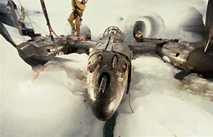
The cavern dug around the trapped P-38 under ice in Greenland glacier

This was an interesting film and I was drawn into it by the passion of the two main men, Richard Taylor and Pat Epps, both of whom were Americans from Atlanta. Taylor was an architect, but he had an obvious fervour for aircraft, and Pat Epps ran an aviation hangar, so planes were his life and work. The film has wide ranging appeal and I think it would be well received by anyone with an interest in people, adventure, aeroplanes, archaeology, geography or opportunities for investment. If the observer of the film had prior knowledge of the lost squadron of aircraft that Taylor and Epps pursued, or if perhaps the viewer was interested in aspects of military flying in the Second World War, then they could gain more from the film than the casual observer who just seeks an hour or so of entertainment; but prior knowledge is not essential as this film stands alone well and tells the story in an easily understood, casual way although it still packs every scene, conversation and report with fact.

The film explained how in 1942, as part of Operation Bolero, the Americans moved a squadron of eight planes up over Labrador, Greenland, Iceland and on to Prestwich in Scotland in preparation for the Second World War invasion to retake Europe from the Nazi Regime. While on route to Britain, the weather changed, their position was lost, and disaster struck. The planes were forced to make a crash landing on a glacier in Greenland and, nine days later, the aviators were lucky to be rescued off the ice cap.

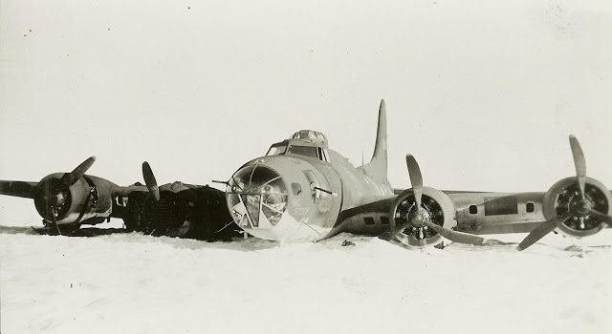
P-38 after landing on the Greenland icecap.

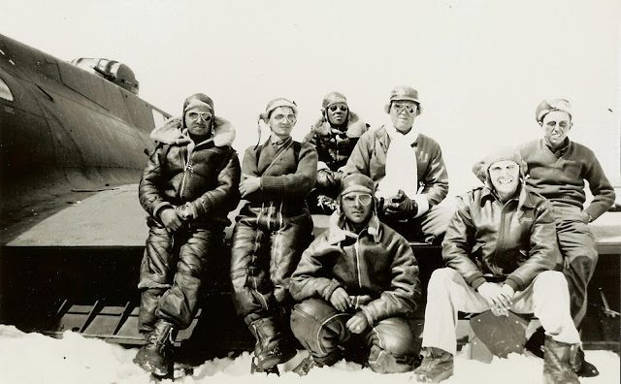
Aviators ready for rescue by the crashed P-38

The United Sates Airforce intended to rescue the planes at a later date but this was never done and the squadron comprising of six Lockheed P-38 Lightening fighter aircraft and two Boeing B-17 Flying Fortress were left to the unmerciful Greenland weather. Over the coming decades they were buried by ice and as the glacier itself was moving so the position also changed and this added to the difficulty of finding the site of the abandoned aircraft.

The mission to recover a plane started in 1981 but it was not until 1992 that The Greenland Expedition Society finally exhumed a P-38 from beneath two hundred and sixty-four feet of ice. The story of the disentombment is told in an almost folksy homely American way and one becomes as interested and sympathetic towards the aircraft, as to the people involved. As the film unfolded, it was sad to see how both Taylor and Epps in the prime of their lives lost everything they had while involved in the rescue of the plane: Fortune, marriage, family and career were lost due to what became an obsessive multi-million dollar drive to extract the plane from the ice. In the mainly all-male film we saw egos clash and there were many battles to take control of planning, finances, ownership and archaeology. At times the men were so frustrated that they walked away but they could not stay away, nor could they rest until this rare jewel of an aircraft was safely back home in America.

The film was in some ways filled with too many experts, it seemed everyone had ideas and at times they were unwilling to work together. Each man seemed determined that his way was the best and an example of this was when in about 1990 the Pitzgali Brothers were driving an Archimedes screw, an adapted silo unloader, in to the ice to cut through to the P-38 and at the same time Taylor and Brookes were using a steam probe mounted on an A-frame that they had invented, built and called a Goffer for the same purpose: This was one objective being tackled by two different teams, from two different angles and this brings in to question whether the recovery was a party for amateurs to play in or a serious encounter by dedicated professionals.
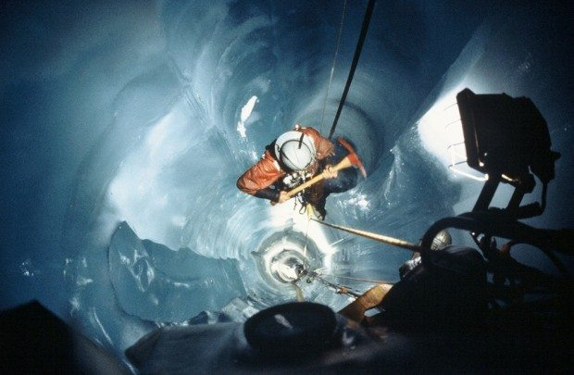 Rescuers descending to the P-38

In the film, it seemed at times that one hand did not know what the other was up to especially with the hair-brained fund-raising schemes and later involvement of people like the aviation treasure hunter, Russell Rajani. Rajani was only there to increase his own wealth and standing.

There are many aspects to this film which must have wide appeal because the tale of a treasure hunt is exciting, the landscape in which the filming took place was cold, wild and remote, the discovery of the plane was amazing and it was amazing to actually see a P-38 being brought to the surface in such good condition. The film showed how this was surprising to the diggers and I envisage it to be likewise for everyone who watches the film. Additional interested was raised by personal stories featured in the film, such as when in a blizzard, Lou Sapienza, the photographer had his tent blow away and he struggled to reach his colleagues and safety because the storm was so bad, the visibility was near nil and the snowfall was so dense and swirling that he could not see where he was going, it seems he was lucky to survive. This film tells many tales of great personal daring and well as showing the chronological events leading to the recovery of a P-38 aircraft. The soundtrack, with the wind howling and the ice crunching, really demonstrated the remoteness, the rapidly changing weather conditions and the freezing temperatures in which the work took place.

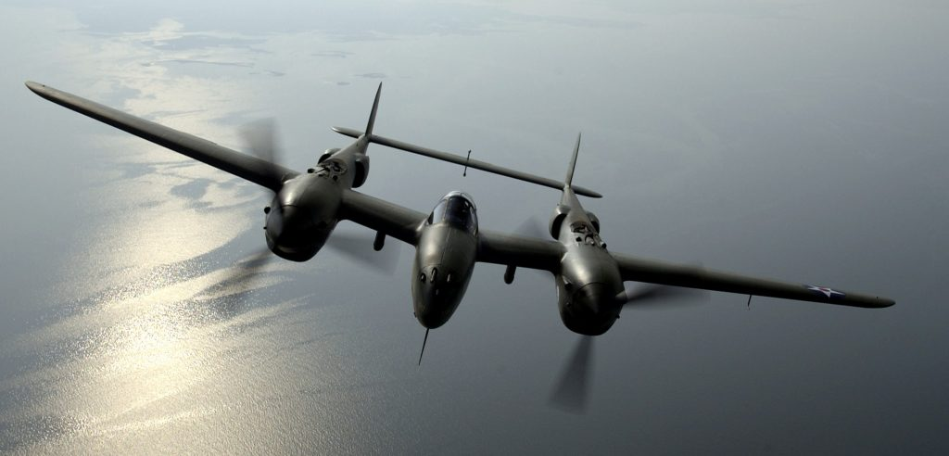
OVER VIRGINA — Steve Hinton flies “Glacier Girl,” a P-38 Lightning dug out from 268 feet of ice in eastern Greenland in 1992. The aircraft was part of a heritage flight during an air show at Langley Air Force Base, Va., on May 21. (U.S. Air Force photo by Tech. Sgt. Ben Bloker)

This film was action packed, the participants were crazed and passionate, they appeared totally gripped by the adventure and the find of the P-38. Although the aircraft was recovered, for the benefit of all aviation enthusiasts, it seemed sad that both Taylor and Epps lost so much and at the beginning of the film they were youthful and enthusiastic and at the end of the film they looked like old men, aged by the weather and the responsibility of their undertaking:

Pats Epps and Richard Taylor

The film was particularly clear in illustrating the process of aging as experienced by Taylor and Epps, it showed the changes to their physiques and faces as a natural progression that occurred alongside the narrative. For me this was a film well worth watching and, due to the amount of aviation history it reveals, I intend to re-watch it to further improve my knowledge of archaeology and the recovery of the P-38.

Bibliography

'"Glacier Girl": The Real Story of a WW2 P-38 Trapped in Ice for 50 Years, dir. by (MikeGoesBoom, 2017).

Taylor, Richard, Ready for Takeoff: Pat Epps and Richard Taylor Roll the Pole (2017) <http://readyfortakeoffpodcast.com/rft-129-aviation-adventurer-richard-taylor/> [accessed 1 March 2020].

Conde, Alex, The Plane That Returned to Flight After 67 Years in Glacier Ice (2018) <https://insh.world/tech/glacier-girl-the-story-of-the-impossible-plane/> [accessed 2 March 2020].

Alex Conde, The Plane That Returned to Flight After 67 Years in Glacier Ice (2018) <https://insh.world/tech/glacier-girl-the-story-of-the-impossible-plane/> [accessed 2 March 2020].
Alex Conde, The Plane That Returned to Flight
Alex Conde, The Plane That Returned to Flight
Alex Conde, The Plane That Returned to Flight
Alex Conde, The Plane That Returned to Flight
Richard Taylor, Ready for Takeoff: Pat Epps and Richard Taylor Roll the Pole (2017) <http://readyfortakeoffpodcast.com/rft-129-aviation-adventurer-richard-taylor/> [accessed 1 March 2020].

