LEVEL 6 ASSESSMENT SPECIFICATION

Student name: | Jake Mason | Student ID number:
Programme:
Module: | Data Warehousing and Data Mining
Module code: | ACCA6026 | Contribution to Overall Module Assessment (%): | 50%
Lecturer: | John Williams | Internal Verifier: | Bev Holland
Assignment Title: | Data Warehousing | Word count (or equivalent): | 3000
Submission deadline: | 28th January 2022 | Return date of provisional marks & written feedback: | 25th February 2022
Submission method: | All written assessments, where practical and possible, must be submitted via Turnitin unless otherwise instructed by the Lecturer. (Please DO NOT put this assessment specification into Turnitin or it will match many similarities with other students’ submissions.)  Alternative submission method (if applicable):  Late submission of the assessment will result in a late penalty mark. Penalties for late submission: Up to one week late, maximum mark of 40%. Over one week late, 0%. Only the Extenuating Circumstances Panel may approve a change to submission dates.
Academic honesty / referencing: | Academic honesty is required. In the main body of your submission you must give credit to authors on whose research and ideas your work is based. Append to your submission a reference list that indicates the books, articles, etc. that you have used, cited or quoted in order to complete this assessment.
Module Learning Outcomes (from module syllabus)
Upon the successful completion of this module, the student should be able to:
- Analyse critically the structure, capabilities and role of a data warehouse within a modern business environment.
- Select and perform appropriate data analysis and reporting on data within a data warehouse environment and critically evaluate the results
- Provide business intelligence through the creative application of appropriate data mining processes and the critical evaluation of their results.

STUDENT FEEDBACK FORM

This section details the extent to which the assessment criteria are demonstrated by you, which in turn determines your mark. The marks available for each category of skill are shown. Lecturers will use the space provided to comment on the achievement of the task(s), including those areas in which you have performed well and areas that would benefit from development/improvement.

Generic Assessment Criteria | Marks  available | Marks  awarded
1. Engagement with Literature Skills
.
Sections 1, 4  Engagement with a wide range of research informed literature, including sources retrieved independently. Selection of relevant and credible sources. Very good use of referencing, with no/very few inaccuracies or inconsistencies. | 10 | 7
2. Knowledge and Understanding Skills

Sections 2, 3  Knowledge is reasonably extensive coherent and detailed. Exhibits some understanding of the breadth and depth of established views, and the work is, at least in part, informed by current research and scholarship. | 15 | 10
3. Cognitive and Intellectual Skills

Sections 3.5  Sound critical thinking, analysis, synthesis and evaluation demonstrating critical thinking. Ability to devise and sustain persuasive arguments, and to review the reliability, validity and significance of evidence to make mostly appropriate and valid judgements. | 25 | 15
4. Practical Application Skills

Section 3, 4  Can identify complex problems and propose excellent solutions. Innovation and creativity evident. An application of a range of methods, materials, and techniques. The context of the application is well considered. | 35 | 23
5. Transferable Skills for Life and Professional Practice

Sections 5, 6  Can communicate well, confidently and consistently in a suitable format. Demonstrates very good graduate employment skills, with just occasional minor weakness. | 15 | 10

Assessment Mark (Assessment marks are subject to ratification at the Exam Board. These comments and marks are to give feedback on module work and are for guidance only until they are confirmed. ) | Late Submission Penalties (tick if appropriate) |  | 65%
 | Up to 1 week late (40% Max) |  | 65%
 | Over 1 week late (0%) |  | 65%


data Warehousing
256602 Jake Mason


Contents Page
- Contents Page, Page 1
- Data Mining, Page 2
- Dataset, Page 2 – Page 5
  - Attributes, Page 2 – Page 5
  - Number of instances, Page 5
  - Missing Values, Page 5
- Pre and Post Processing, Page 5 – Page 8
  - Noisy Data, Page 5 – Page 6
  - Data Reduction, Page 6 – Page 8
  - J48, Page 8
- Sample runs and results + Methods Chosen, Page 8 - 17
  - Naïve Bayes, Page 8 – Page 9
  - Regression, Page 9 – Page 12
  - Clustering, Page 12 – Page 16
  - Nearest Neighbour, Page 16 – 17
- Business Recommendations, Page 17 – Page 19
- Reflective Commentary, Page 19
- Bibliography, Page 20 to Page 21
2650 words.

Task 1
Data Mining: Purpose, Practice and Business Use
The purpose of data mining is to extract data using intelligent tools from a data set, so it can be transformed into an understandable format[1] [2]. Data mining is the automatic analysis of large quantities of data, done to extract previously unknown patterns, patterns can entail cluster analysis, anomaly detection and sequential pattern mining [3].
A target set of data must be formed before data mining begins. Pre-processing is done to analyse the data sets before data mining occurs, during which missing data and noise is removed [1].
Data mining involves six tasks: [3]
- Anomaly Detection. Identification of abnormal records, containing errors or uncanny data - warranting investigation
- Dependency modelling, or market analysis. Relationships between variables are searched, an example of this being commerce businesses keeping data on customer buying habits for marketing [5].
- Clustering. Discovery of groups among the data which may contain similarities, without already using data structures.
- Classification. Generalisations apply structures to fresh data, for example - in e-mail systems categorising incoming emails as spam or legitimate.
- Regression. Attempts to discover a function which can model the data with the least number of errors as possible to generate estimations on the relationships among data [5].
- Summary. A coherent display of the dataset is completed, using visualisation and report generation.
Data mining is being utilised by several industries for help in data analysis and business intelligence, with it proving useful from a business perspective [4]. Business intelligence can classify like-minded customers for a commerce company, leading to a system where specific items are recommending to certain customers, as a way to increase sales [5]. Data found through mining can be used to inspire customer retention, this is already done by businesses via loyalty point programs – which collect feedback from customers based on what they enjoy viewing in advertisements, where advertisements could be shown and for what reason – allowing more effective marketing and brand loyalty [6].
Dataset
Attributes
The attributes are listed below: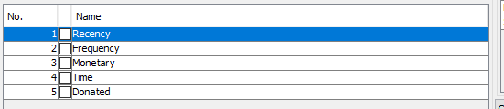
The recency attribute is for detailing when the last blood donation was made for that record, the unit shown is in months, Frequency details how often blood is donated, monetary refers to the total blood donated, time is the total amount of months since the first donation made, as opposed to the latest one.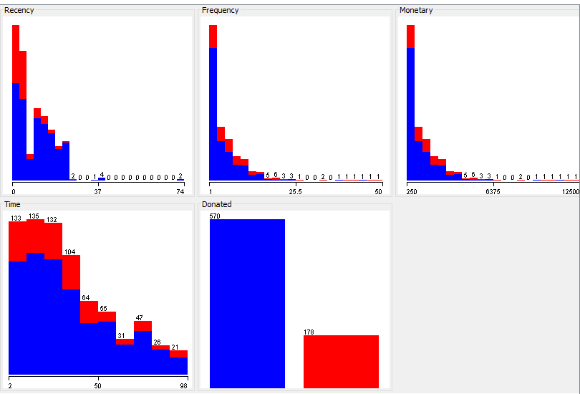
For relevancy the minimum value is “0” and the maximum is “74”, what can be derived from this is that there are some patients who have donated blood as recently as less than a month before this data was archived. 74 being the highest value tells us that records older than 6 years are kept. The mean is 9.507, suggesting the average donor of this clinic donates every 9-10 months. The standard deviation is 8.095, this standard deviation is relatively low when considering the highest possible value in this context is 74 – this low standard deviation implies that values are clustered close to the mean of 9.507. What can be seen from the graph below is that most donors are frequent donors, with results generally dissipating as you go along the X axis (which shows the recency).
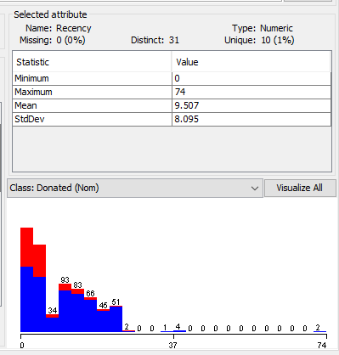
The highest frequency of blood donated is “50”. The mean average is “5.515”, significantly lower than the highest frequency, being nearly ten times lower, the standard deviation of “5.839” suggests that those who donate blood in abnormally large amounts are the vast minority, and that most donors donate less than 10 times. According to the below graph instances go down gradually as the frequency goes up, although this is not the case in every instance, most notably example is the 3rd unit shown on the X axis being significantly smaller than the 2 previous ones, and the 5 corresponding ones.
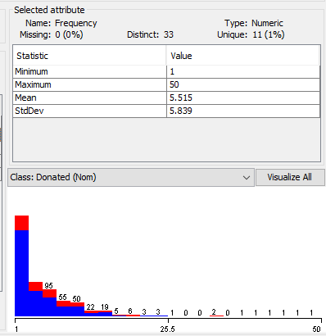
The minimum amount of blood donated according to the monetary data is “250”, the highest value being “12500”, the mean is “1378.676”, with a standard deviation of “1459.827”, the standard deviation is significantly higher than the mean, but not relative to the maximum value of 12500 – which is significantly larger than the minimum, mean and standard deviation. The suggestion from the standard deviation and displayed in the graph below is that most donors donate the minimum amount of blood, with it decreasing gradually from there, at a mostly consistent rate (with some negligible abnormalities).
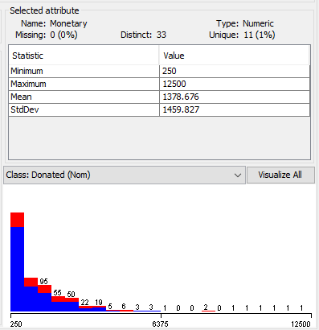
The time attribute here will show the age of certain records in the database, displaying how long they have been in there – in months. The minimum value is “2”, meaning the latest instances are 2 months old, the highest is “98”, showing the oldest records as being over 8 years old. The mean is “34.282”, meaning the average record is nearly 3 years old, by looking at just the mean value and the maximum value, it would appear as if blood donations at this clinic are the rise, because more records have been recently added – the standard deviation further backs up this conclusion as it is even lower than the mean (“24.377” months, a little over 2 years). 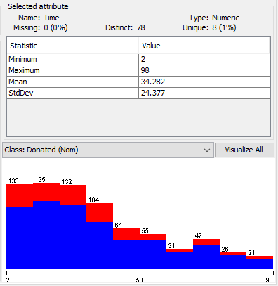
Number of instances
The data has 748 instances. Each instance represents a record of a person who has donated blood to this specific blood-transfusion-service, the 748 instances were selected from 748 random donors.
Missing Values
There appears to be no missing values. The data reads as cohesive and coherent – any inconsistencies or missing values would cause results to be messy.
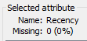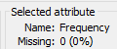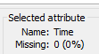
Pre and Post Processing
Noisy Data
To minimise noisy data appearing the data was opened on excel before weka – as to check if the data validation was correct for the attributes:
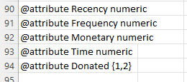 “@attribute” signalling the following as an attribute, the following phrase being said attribute and the final phrase being the data type. For line 90 “Recency” is the attribute and “numeric” is the data type.
Missing values were searched for in the data. No values were missing. Noisy data was then searched for, as noisy data cannot be read by computers[7].
An easy way to look for noisy data is to select to edit an attribute and look for inconsistent data:
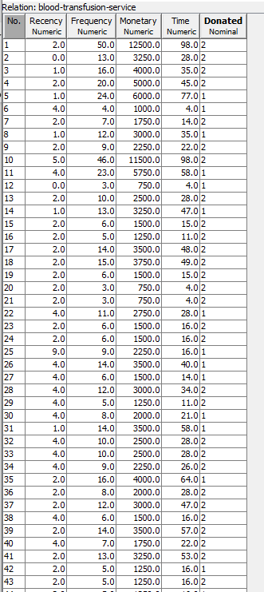Inconsistent data will usually reveal itself by not appearing to conform to the format of other values in its table, or by being impossible values such as percentages over 100, or less than 0. Upon analysis into each attribute, noisy data was not discovered.
To check if percentage predictions are correct, the dataset can be opened in notepad, values should then be copied and pasted, the clone prediction can be altered to have its donation value changed from a “1” or “2” to a “?”.
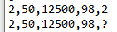Weka will then predict weather or not those instances donated or not – if the prediction is the same as the original, and the percentage is the same, then we know the percentage predictions or estimations from clusters and nearest neighbour are correct.
Data Reduction
Data reduction will be done as a lot of data is being handled, so to make analysis easier data reduction techniques are implemented to decrease data storage and analysis costs. This can be done using the ‘classify’ tab on Weka, selecting the J48 classifier in trees and doing a percentage split. 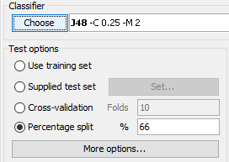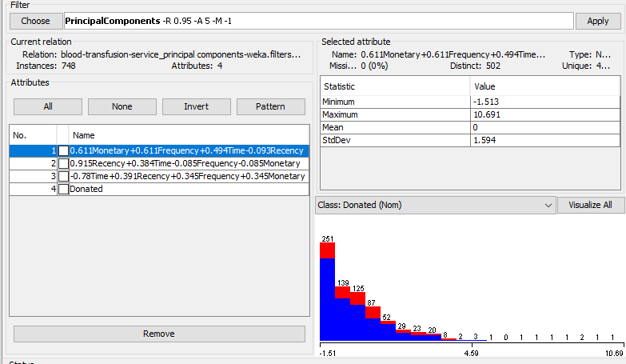 Adding the PrincipalComponents in conjunction to this will reduce dimensionality by accounting for variance in the original data through choosing enough eigenvectors to do so [8]. Upon running the another classifer (RandomForrest) with a new filter in effect, it was found the number of instances was reduced from 748 to 254. However there was reduced accuracy, with the accuracy of the classified instances only being a little over 75% now -. A cross validation finds slightly different results at an accuracy of “74.1974”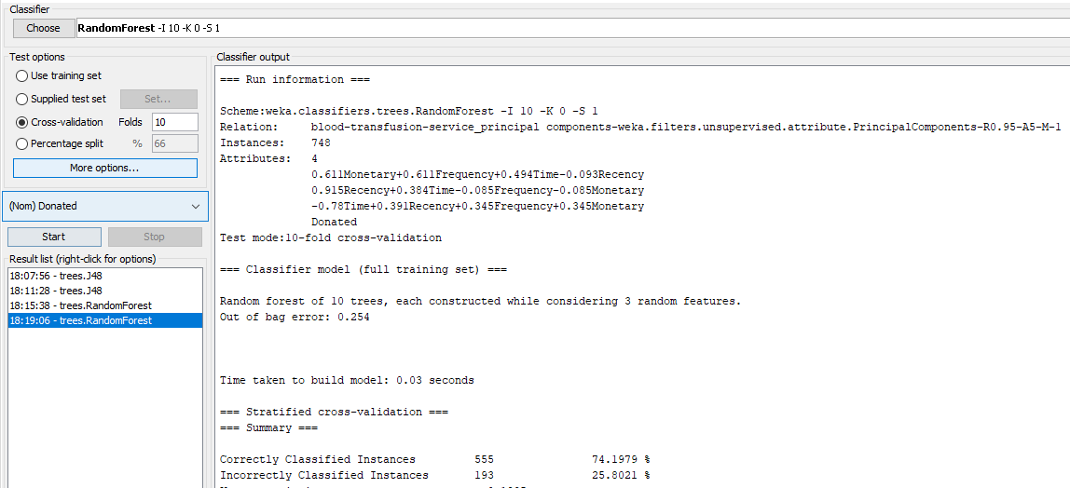Further options for data reduction can be selected by left-clicking on the filter chosen in pre-process.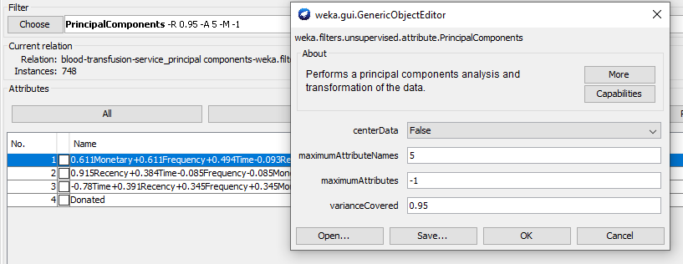
J48
The J48 algorithm is used for generating decision trees.
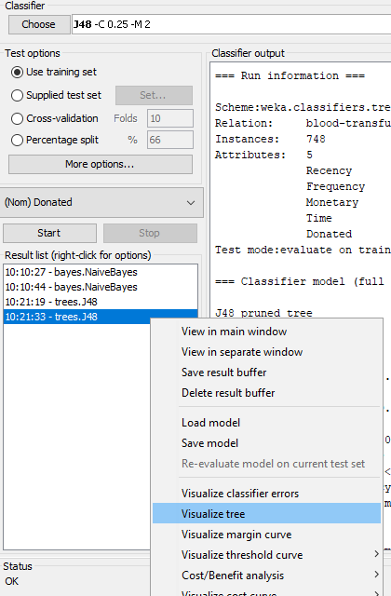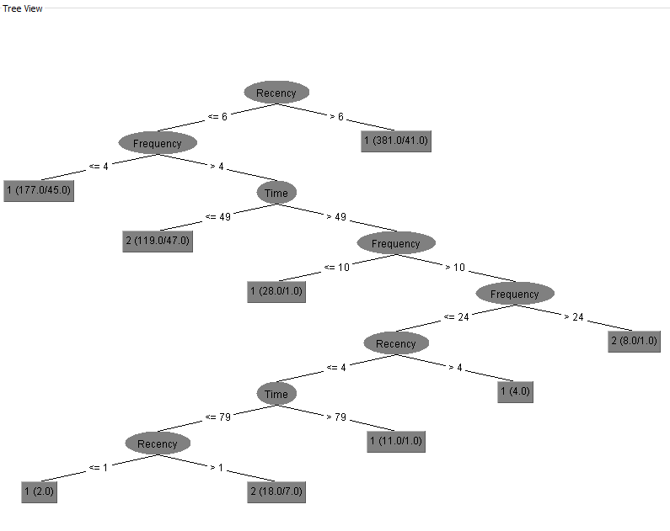The attribute on the top of the tree (recency) is the most important, the other attributes’ importance also being determined by their position from top to bottom of the tree. 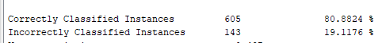 The accuracy rate is 80.8824%, which is reasonably high.
Sample runs and results + Methods Chosen
Naïve Bayes
Naïve Bayes is a classifier used to solve classification problems. It attempts to determine independence between attributes – Bayes’ theorem claims that the probability of an event can be changed as fresh data is introduced [12].
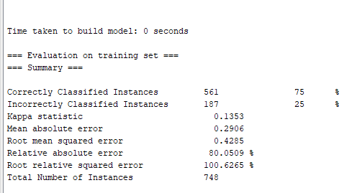 Upon performing this on the dataset, three quarters of the instances were correctly classified.
Regression
Linear regression can be used to show relationships between variables – the use of this method is for predictions [9]. Linear regression can be done by going to the classify tab and selecting the LinearRegression classifier.
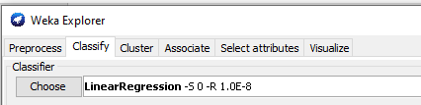
When regression is done on the Recency attribute, these are the results: 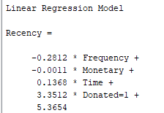
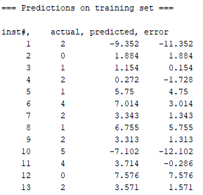
When frequency and monetary were measured, the errors made were minimal, this may be because of there being less attributes to take into consideration when making predictions.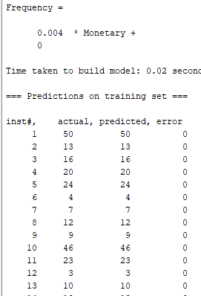
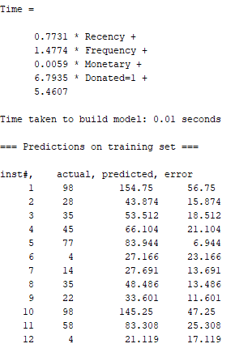
At the bottom of the output is the root squared error, the lower this is – the less errors there are. For recency this was the result:
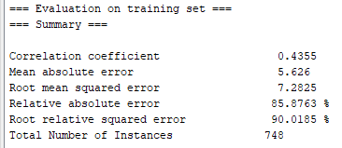
While for time this was the result:
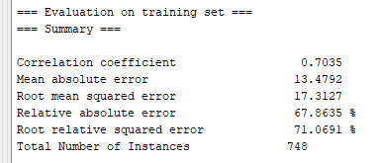
Monetary and frequency had the same result:
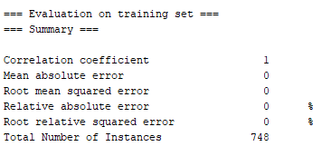
Clustering
Clustering is a tool used to group objects together for analysis, it can be done to the data through the cluster tab, by using the SimpleKMeans clusterer. 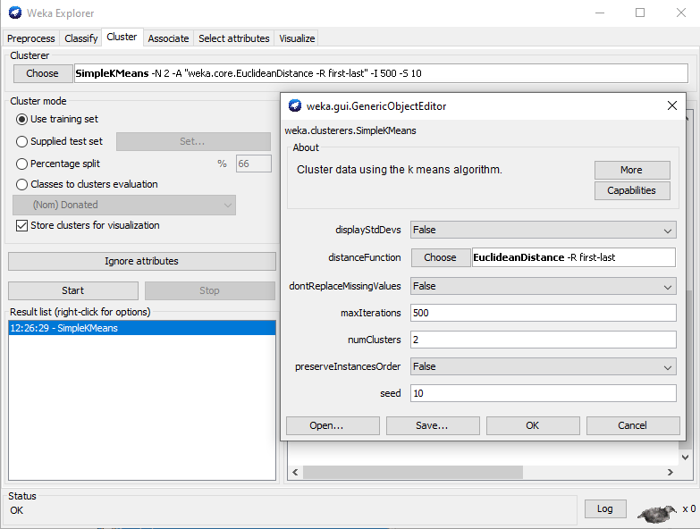
Ideally you want an equal spread of instances among the number of clusters selected, although this is not always possible. When splitting into 5 cluster groups, these are the results shown.
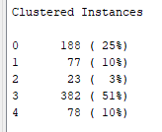Above the clustered instances are the cluster centroids, this is where analysis can begin. 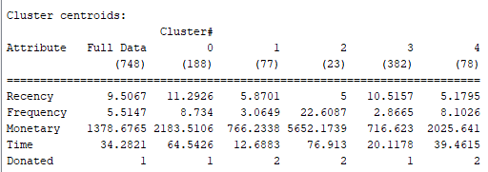Full Data refers to all the instances (748). The donated attribute details details whether every instance in that group would have donated blood, if the donated attribute says “1” it means not every person in that cluster has donated – while “2” says the inverse, where every person in the group has donated blood, we can determine that groups 1, 2 and 4 are more likely to donate blood, because of this.
Of the 3 groups where the entirety have donated, we can see that group 2 by far donates the most blood at “5652.1739”, which is more than groups 1 and 4 combined – they also have a lower recency, if ever so slightly – implying they donate blood more often. Their frequency is much higher, meaning they have donated blood more often than the other groups, time shows they are the oldest cluster group too.
The groups where not every peron has donated blood generally have a higher recency than the entirely-donor groups,, however group 0 has a higher frequency than group 1 and 4, meaning they’ve generally donated blood more often – the total blood they have donated is higher than groups 1 and 4, although still trailing behind 2; group 0 is the second oldest group however (behind 2), so their higher units in some attributes, despite not all members being donors, can be explained easily.
More information can be shown by visualising the cluster. 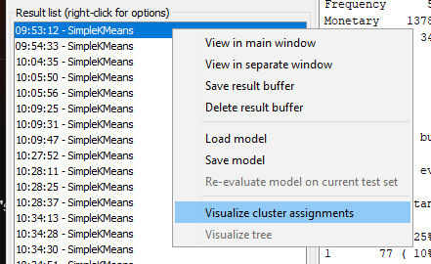
This visualisation was made showing time on the X axis and frequency on the Y axis – this combination can be used to display the frequency in which older/newer people in the databse donate blood, this is useful for determining if new or old donors are more likely to donate blood. 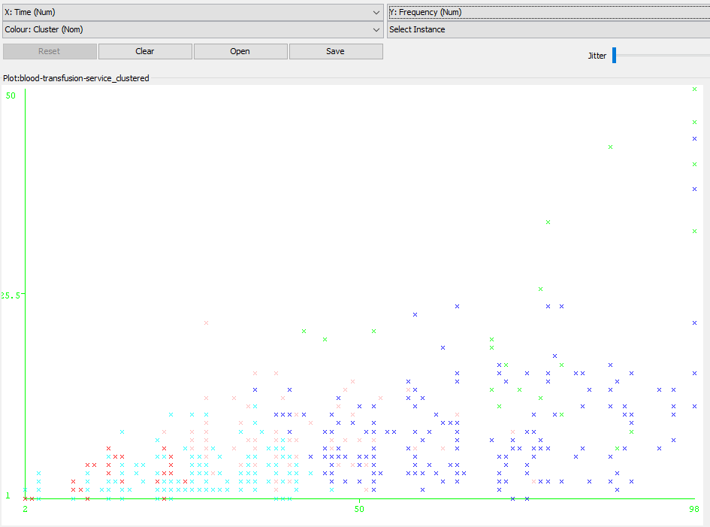Older records (which are further to the right on the X axis) have donated blood more to this clinic. 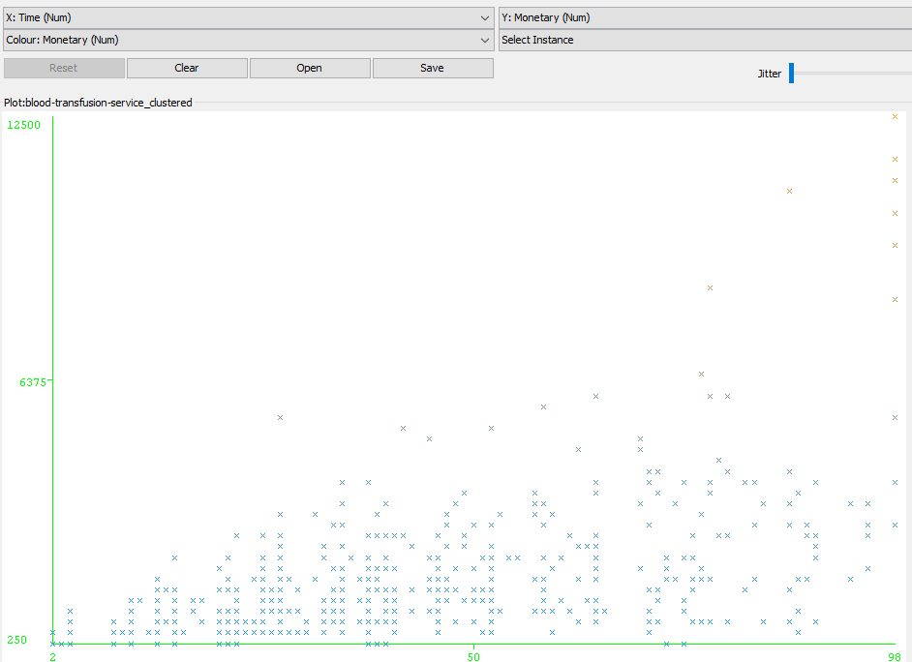
The colour of the cluster groups can be set as the key for the visualisations shown.
Nearest Neighbour
Nearest neighbour allows for past data instances to be used in predicting output values of fresh instances, this can be used to predict the blood donation frequency of new donors based on existing records.
Nearest neighbour can be performed on Weka by going to the classify tab and selecting IBk (from the lazy folder) as the classifier to use. 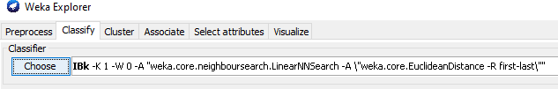When being run on the recency attribute, it was mostly correct predictions, although errors did appear.
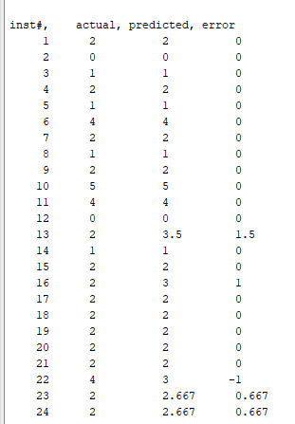These errors were generally far less glaring than those made during linear regression.
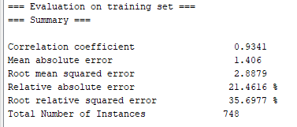
When looking at the donated attribute, there was a 93.1818% accuracy rate. 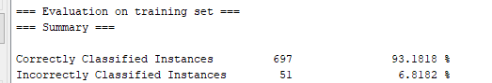
Upon changing the “K” option in the classifier to “5” instead of “1”, results get less accurate. 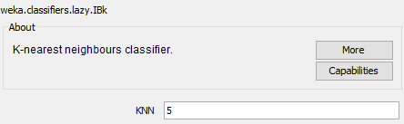 Going down by nearly 10%. When changed to 20 the accuracy goes down further. This is good as it shows the dataset is not noisy, with noisy datasets the accuracy will improve as K is increased – although this would still decrease if K was set to a data value close to the size of the entire dataset, closer to the baseline accuracy for the dataset. When K is set to 748 the result is a 76.2032% accuracy rate.
Using the ZeroR classifier, the baseline accuracy is the same as the IBk accuracy when K is set to 748. 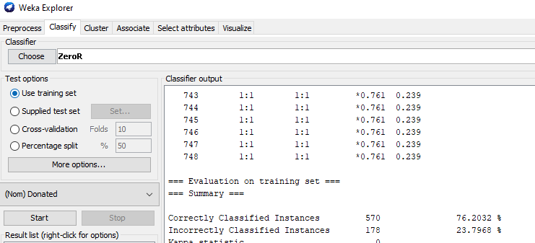
Business Recommendations
Conclusions from Pre-Processing
By looking at the immediate data made available by the attributes during pre-processing, it is obvious that most donors will only donate blood once, this is backed up by use of cluster visualisation. A conclusion that could be drawn from this is that the clinic should focus on incentivising one-time donors to donate more, this way less new instances will need to be created – saving on data storage – and more blood will be donated overall.
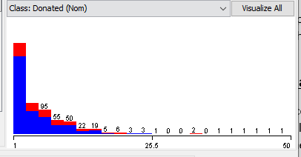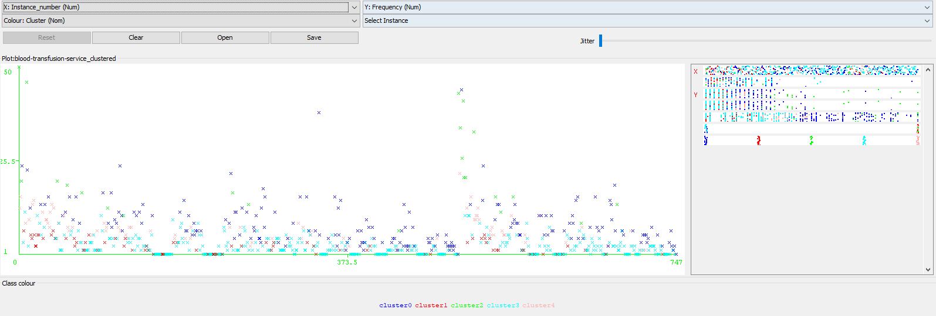
Predictions regarding the monetary and frequency attributes can be concluded perfectly using Linear Regression. This can provide assistance in resource and worker planning. Predicting the monetary attribute specifically can determine necessary amounts and sizes of blood bags, as well as storage – and other resources that may need to come with these, such as more space for the storage compartments and medical containers where the blood bags will need to be stored, as well as ACs to keep the storage rooms at the right tempreture. The frequency attribute being predicted perfectly can contribute to the resource planning that the monetary attribute assists in, but it will also allow for better planning for an appropriate workforce size, as it will indicate how often the blood bank may need to be open.
Clustering
From the data clustering, it can be seen that Group 1 is entirely full of donors, it’s average frequency of donations is more than half of the full data, despite being nearly 3 times newer. The monetary result of group 1 is more than half of the overall data, its recency is also significantly lower than that of the overall data. What can be concluded from there is potential high value in newer donors, backing up the notion promoted previously that getting new donors to stay can prove successful. 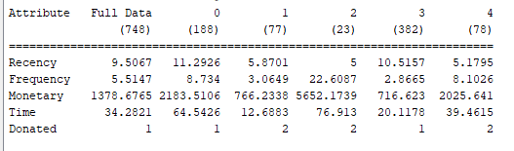
Group 2 is the oldest group in the cluster shown, its high recency and frequency rate displays the value in maintaing donors too. Group 2 has signifcantly less instances included than Group 3 and 4, but has a much higher monetary result.
Nearest Neighbour vs Linear Regression
Nearest neighbour presented an incredibly high accuracy with its predictions (93%), this was still noticeably high even when ‘k’ was set to 748.
Contrast this with Linear Regression which presented error rates that were higher, except for specific attributes. While each method has their own unique uses which makes them both essential, for areas where they may overlap – nearest neighbour is the method to go for, as it is a generally more reliable predictor of overall data than Linear Regression. Nearest Neighbour and Naïve Bayes are used for similar predictions, but Nearest Neighbour is more accurate, so again proves to be more useful for a data analyst.
An issue that may arise with nearest neighbour is that it assumes all attributes are just as valuable, if this is not so, then schemes which allow for selecting and weighting attributes based on their importance may be of more usefulness [10].
Reflective Commentary
As shown previously, Nearest Neighbour generates a prediction accuracy of 93.1818%, and the system itself has a baseline accuracy of 76.2032%. However Linear Regression provided mixed results in regard to its accuracy. The pre-processing tools available provide useful information such as the mean and standard deviation of the attributes available – on top of providing visualisations. Data in the attributes can be altered easily, if need be, and clustering is incredibly useful for visualising data, comparing information on different attributes and instances.
The methods used generated results all in less than a second, on top of the number of functions which are completed by default in the pre-processing tab such as standard deviation.
The filters necessary for completing certain analysis methods come with the software itself and are easy to use. There are inaccuracies in the predictions, while for the most part the predictions are accurate and this dataset has an overall high baseline accuracy, but inaccuracies still occur.
Some activities may be necessary to conduct on data before analysis can begin, however cannot be done using the pre-processing tab and thus will require altering data through third party apps, an example earlier of this included opening the dataset in notepad.
In conclusion it can be said that this is a good system for data analysis – predictions about which groups are more likely to donate blood could be made, and other useful anecdotes of information could be generated too via clustering, regression, and the readily available pre-processing.
Suggestions for improvement can be made for the analysis conducted. Testing of increasing the ‘k’ unit during use of the Nearest Neighbour method, to display how the amount the accuracy of results dropped while the k value increased would diminish slowly could have been done. Furthermore, more time could have been dedicated to possible post-processing measures.

Bibliography
- Chakrabarti S. et al Data Mining Curriculum: A Proposal (Version 1.0) [Internet]. https://kdd.org. 2006 [cited 15 January 2022]. Available from: https://kdd.org/exploration_files/CURMay06.pdf
- Haste et al The Elements of Statistical Learning: Data Mining, Inference, and Prediction [Internet]. 2009 [cited 15 January 2022]. Available from: https://web.archive.org/web/20091110212529/http://www-stat.stanford.edu/~tibs/ElemStatLearn/
- Fayyad U, Piatetsky-Shapiro G, Smith P. From Data Mining to Knowledge Discovery in Databases [Internet]. kdnuggets. 1996 [cited 15 January 2022]. Available from: https://www.kdnuggets.com/gpspubs/aimag-kdd-overview-1996-Fayyad.pdf
- Cao L, Philip SY, Zhang C, Zhang H. Data mining for business applications [Internet]. Springer Science & Business Media. 2008 [cited 15 January 2022]. Available from: https://citeseerx.ist.psu.edu/viewdoc/download?doi=10.1.1.467.6199&rep=rep1&type=pdf
- Linden G, Smith B, York J. Amazon.com recommendations: Item-to-item collaborative filtering [Internet]. IEEE Internet computing. 2003 [cited 15 January 2022]. Available from: https://cseweb.ucsd.edu//classes/fa17/cse291-b/reading/Amazon-Recommendations.pdf
- Coll S. Discipline and reward: The surveillance of consumers through loyalty cards [Internet]. Geschichte und Gesellschaft. 2016 [cited 15 January 2022]. Available from: https://www.vr-elibrary.de/doi/abs/10.13109/gege.2016.42.1.113
- Teng CM. Correcting Noisy Data.[Internet]. InICML. 1999 [Cited 19 January 2022]. Available from: http://citeseerx.ist.psu.edu/viewdoc/download?doi=10.1.1.663.2101&rep=rep1&type=pdf
- PrincipalComponents [Internet]. Weka.sourceforge.io. 2022 [cited 19 January 2022]. Available from: https://weka.sourceforge.io/doc.stable/weka/attributeSelection/PrincipalComponents.html
- Yan X, Gang Su X. Linear Regression Analysis [Internet]. Google Books. 2009 [cited 21 January 2022]. Available from: https://books.google.co.uk/books?id=MjNv6rGv8NIC&pg=PA1&redir_esc=y#v=onepage&q&f=false
- Altman N. An Introduction to Kernel and Nearest Neighbor Nonparametric Regression [Internet]. cornell.edu. 1992 [cited 21 January 2022]. Available from: https://ecommons.cornell.edu/bitstream/handle/1813/31637/BU-1065-MA.pdf;jsessionid=B027EB303AB44442CD1E223023882390?sequence=1
- McCallum A. Graphical Models Lecture 2: Bayesian Network Representaion [Internet]. People.cs.umass.edu. 2022 [cited 28 January 2022]. Available from: https://people.cs.umass.edu/~mccallum/courses/gm2011/02-bn-rep.pdf

