
Student Name: Uttam Devshibhai Vaghamashi

Student ID: 2520138

Module Name: Marketing Management

Module Code: LCMB7024

Lecturer’s Name: Laila Maazouz and Dian Mayasari

Work Count: 2661

Assessment Component 2 (all elements)

Contents
Introduction 2
Element 1: Brand Extension Poster (BYD Smart Home Energy Ecosystem) 2
References (Element 1 and Poster) 3
Element 2: STDP Analysis (Segmentation, Targeting, Differentiation, Positioning) 4
2.1 Market Segmentation 4
2.2 Targeting Strategy 5
2.3 Differentiation Strategy 6
2.4 Positioning Strategy 7
Critical Evaluation 8
References (Element 2) 9
Element 3: Marketing Mix (4Ps) – BYD Smart Home Energy Ecosystem 10
3.1 Product Strategy 10
3.2 Price Strategy 10
3.3 Place (Distribution) Strategy 11
3.4 Promotion Strategy 12
3.5 Critical Evaluation of Marketing Mix 12
References (Element 3) 14
Element 4: Reflection 15
References (Element 4) 17
Conclusion 18
Appendix 19

Introduction
This assignment develops a marketing strategy for BYD’s Smart Home Energy Ecosystem as a brand extension within the clean energy sector. Using STDP and the marketing mix, the analysis evaluates how BYD can leverage its technological capabilities to address growing demand for sustainable, integrated energy solutions in a rapidly evolving global market.

Element 1: Brand Extension Poster (BYD Smart Home Energy Ecosystem)
BYD is a rapidly expanding global clean energy and electric vehicle manufacturer, operating across more than 70 countries and delivering over 3 million EVs in 2023 (BYD, 2024). Building on its strong capabilities in battery technology and renewable energy systems, the proposed brand extension introduces the BYD Smart Home Energy Ecosystem. This system integrates solar panels, home battery storage, and EV charging into a unified platform designed to enhance household energy efficiency and sustainability (IEA, 2023).
The extension responds to accelerating global demand for clean energy solutions, with renewable energy capacity expected to increase by over 60% by 2030 and more than 40% of consumers considering solar adoption (IEA, 2023). Unlike standalone energy products, this ecosystem offers a holistic solution by enabling energy generation, storage, and consumption within a single network, strengthening BYD’s competitive positioning (Melnyk et al., 2024).
From a sustainability perspective, the system supports decarbonisation by reducing reliance on fossil fuels while promoting energy independence. Furthermore, AI-driven energy optimisation can reduce household energy costs by up to 20%, enhancing both economic and environmental value (McKinsey & Company, 2023). Overall, this brand extension aligns with market trends and presents a scalable, high-growth opportunity for both consumers and investors.

References (Element 1 and Poster)
Almughram, O., Ben Slama, S. and Zafar, B., 2022. Model for managing the integration of a vehicle-to-home unit into an intelligent home energy management system. Sensors, 22(21), p.8142.
Armiento, M., Lelli, M., Andrews, C., Idini, B. and Ruff, R., 2025. Analysing the global workforce dynamics of the energy transition: main findings from the World Energy Employment report 2023. Discover Sustainability, 6(1), p.35.
BYD (2024) Annual Report and Sustainability Overview. Available at: http://annualreports.ai/company/hong-kong/commerce-industry/byd-company/ (Accessed: 1 April 2026)
IEA (2023) Renewables 2023: Global Energy Market Report. Available at: https://www.iea.org/reports/renewables-2023 (Accessed: 1 April 2026)
McKinsey & Company (2023) The Future of Energy Systems and Electrification. Available at: https://www.mckinsey.com/industries/oil-and-gas/our-insights/global-energy-perspective-2023 (Accessed: 1 April 2026)
Melnyk, T., Demkiv, Y. and Salamatin, K., 2024. Specifics of Pricing Policy in the Global Energy Market in Context of Energy Transitions.
Schiffer, H.W., 2023. Forecasts and scenarios for global energy supply up to 2050-synopsis of the approaches and results of studies published in 2023. vgbe energy journal, 11.

Element 2: STDP Analysis (Segmentation, Targeting, Differentiation, Positioning)

2.1 Market Segmentation
Effective segmentation is essential for identifying high-value customer groups within the emerging smart energy ecosystem market. The global transition towards renewable energy and electrification has created diverse demand patterns shaped by economic, environmental, and technological factors (IEA, 2023). As shown in Table 1, segmentation for the BYD Smart Home Energy Ecosystem is structured across geographic, demographic, psychographic, and behavioural variables.
Table 1: Market Segmentation for BYD Smart Home Energy Ecosystem
Segmentation Type | Key Characteristics | Evidence / Data
Geographic | Developed & emerging markets (China, EU, USA) | These regions account for over 75% of global solar installations (IEA, 2023)
Demographic | Age 30–55, middle–high income homeowners | Households earning higher incomes are 2x more likely to adopt solar systems (Melnyk et al., 2024)
Psychographic | Environmentally conscious, tech-oriented consumers | Over 70% of consumers prioritise sustainability in energy decisions (Deloitte, 2023)
Behavioural | EV owners, early adopters of smart home tech | Global EV sales exceeded 14 million units in 2023, increasing demand for integrated systems (IEA, 2024)
As illustrated in Table 1, the most attractive segment consists of urban, high-income homeowners with strong environmental awareness and existing engagement with electric vehicles and smart technologies. This segment demonstrates both the financial capacity and behavioural readiness to adopt integrated energy solutions.

2.2 Targeting Strategy
Based on the segmentation analysis, the primary target market is:
Urban, middle-to-high income homeowners aged 30–50 who own or intend to purchase electric vehicles
This group is strategically significant due to its high purchasing power and increasing interest in energy independence. Research indicates that households with EV ownership are significantly more likely to invest in home energy systems, as they seek to reduce long-term electricity costs and reliance on external grids (McKinsey & Company, 2023). Additionally, rising electricity prices projected to increase by over 20% in many regions by 2030 further incentivise this segment to adopt self-sufficient energy solutions (IEA, 2023).
From a strategic perspective, BYD adopts a differentiated targeting approach, focusing on environmentally conscious consumers who value both cost efficiency and sustainability. This segment is particularly attractive as it aligns with long-term market growth, given that renewable energy adoption is expected to expand by over 60% globally by 2030 (IEA, 2023). Furthermore, targeting EV owners allows BYD to leverage its existing customer base, strengthening brand loyalty and cross-selling opportunities. As shown in Figure 1, the rapid growth in EV adoption supports the increasing demand for integrated home energy solutions among EV users.
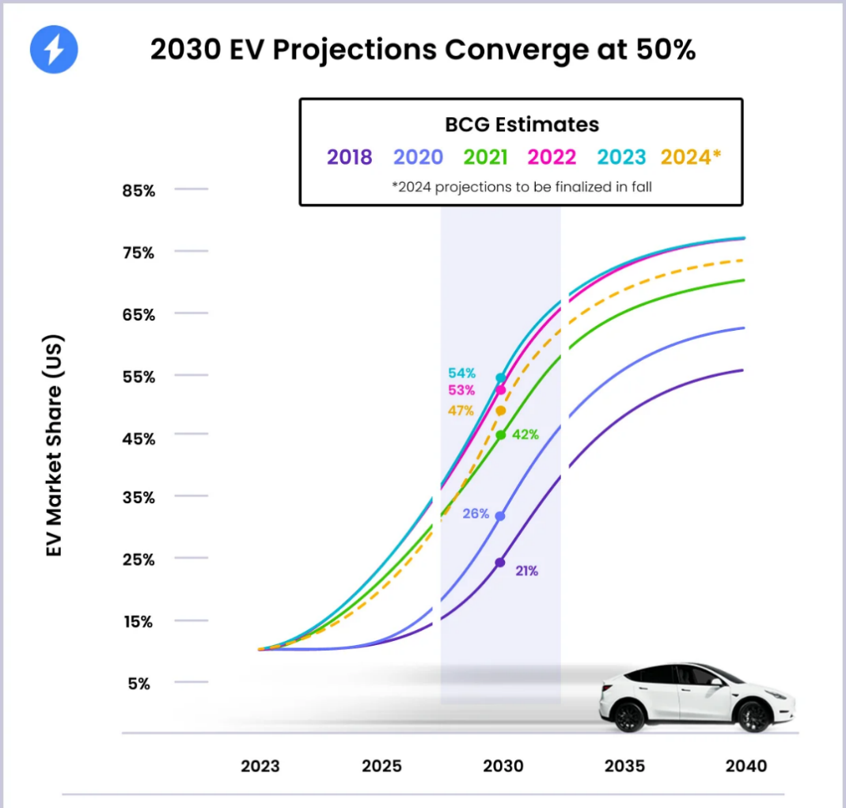
Figure 1: EV market share is projected to reach around 50% by 2030, indicating rapid global adoption of electric vehicles (Recurrent Auto, 2024).

2.3 Differentiation Strategy
The BYD Smart Home Energy Ecosystem differentiates itself through integration, cost efficiency, and sustainability leadership. Unlike competitors such as Tesla Energy, which primarily focus on battery storage and solar panels, BYD offers a fully integrated ecosystem combining EVs, batteries, and renewable energy systems within a single platform.
Key differentiation factors include:
- Vertical Integration: BYD produces its own batteries, EVs, and energy systems, reducing production costs by up to 15–20% compared to competitors (Di Maro, 2025). This enables competitive pricing without compromising quality.
- Ecosystem Synergy: The integration of EVs with home energy systems allows bi-directional energy flow (vehicle-to-home), improving energy efficiency and flexibility.
- Sustainability Focus: The system directly supports global decarbonisation goals, with residential solar solutions capable of reducing household emissions by up to 50% (IEA, 2023).
- AI-driven Optimisation: Advanced energy management systems can reduce household energy costs by approximately 20%, enhancing value for consumers (McKinsey & Company, 2023).
Critically, this differentiation reflects a cost leadership and sustainability hybrid strategy, allowing BYD to compete on both affordability and environmental performance. However, challenges remain, particularly in competing with established premium brands and overcoming consumer trust barriers in Western markets.

2.4 Positioning Strategy
The BYD Smart Home Energy Ecosystem is positioned as:
“An affordable, integrated clean energy solution enabling sustainable and self-sufficient living.”
This positioning differentiates BYD from premium competitors such as Tesla, which focus on high-end energy solutions. Instead, BYD targets a broader market by emphasising affordability, accessibility, and sustainability.
From a perceptual standpoint, the product occupies a space between cost-efficient solutions and advanced smart energy systems, offering both value and functionality. As shown in Table 1, this positioning aligns with the needs of environmentally conscious consumers seeking long-term cost savings and energy independence.
Furthermore, the global smart energy market is projected to exceed $1 trillion by 2030, driven by increasing electrification and renewable adoption (McKinsey & Company, 2023). This reinforces the strategic relevance of BYD’s positioning within a high-growth industry.

Critical Evaluation
The STDP strategy demonstrates strong alignment between market trends and BYD’s capabilities. The segmentation effectively identifies high-potential consumers, while the targeting strategy focuses on a financially viable and environmentally motivated segment. Differentiation through vertical integration and ecosystem synergy provides a clear competitive advantage.
However, limitations exist. Market adoption may be constrained by high initial installation costs and regulatory differences across regions. Additionally, strong competition from established brands such as Tesla Energy may challenge BYD’s positioning in premium markets. Despite these challenges, BYD’s cost advantage and sustainability focus provide a solid foundation for long-term growth.
On the other hand, positioning can be improved with a more distinct comparative market approach. Although BYD highlights its low cost and integrative nature, rival firms like Tesla use premium positioning based on innovation and brand prestige. Thus, BYD has the potential to create a position as a “value-innovation leader” in order to balance between expensive premium products and fragmented low-cost offerings (Di Maro, 2025). On the other hand, the chosen position may become a threat for BYD since customers tend to assume that cheaper products have low quality. Therefore, BYD should support its position with effective marketing efforts, including branding and customer experience management.

References (Element 2)
BYD (2024) Annual Report and Sustainability Overview. Available at: http://annualreports.ai/company/hong-kong/commerce-industry/byd-company/ (Accessed: 1 April 2026)
Deloitte (2023) Global Consumer Sustainability Trends Report. Available at: https://www.deloitte.com/content/dam/assets-shared/docs/industries/consumer/2023/gx-consumer-creating-value-from-sustainable-products-aoda.pdf (Accessed: 1 April 2026)
Di Maro, A., 2025. Business Model Innovation in the Renewable Energy Storage Market: An Empirical Analysis of Leading Global Battery Energy Storage System Companies (Doctoral dissertation, Politecnico di Torino).
IEA (2023) Renewables 2023: Global Energy Market Report. Available at: https://www.iea.org/reports/renewables-2023 (Accessed: 1 April 2026)
IEA (2024) Global EV Outlook 2024. Available at: https://www.iea.org/reports/global-ev-outlook-2024 (Accessed: 1 April 2026)
McKinsey & Company (2023) The Future of Energy Systems and Electrification. Available at: https://www.mckinsey.com/industries/oil-and-gas/our-insights/global-energy-perspective-2023 (Accessed: 1 April 2026)
Melnyk, T., Demkiv, Y. and Salamatin, K., 2024. Specifics of Pricing Policy in the Global Energy Market in Context of Energy Transitions.
Recurrent Auto (2024) EV adoption projection chart (based on BCG forecast) [image]. Available at: https://www.recurrentauto.com/research/ev-adoption-us (Accessed: 1 April 2026).

Element 3: Marketing Mix (4Ps) – BYD Smart Home Energy Ecosystem

3.1 Product Strategy
The BYD Smart Home Energy Ecosystem represents a comprehensive clean energy solution, integrating solar panels, home battery storage, and EV charging infrastructure into a unified platform. From a theoretical perspective, this aligns with Kotler’s three levels of product, where the core product is energy independence, the actual product is the integrated system, and the augmented product includes AI-based energy optimisation and after-sales services (Kotler and Keller, 2022).
The product directly responds to the rapid expansion of the global renewable energy market, which is projected to grow by over 60% by 2030 (IEA, 2023). Unlike fragmented solutions offered by competitors, BYD’s vertically integrated system enables seamless interaction between components, improving efficiency and reducing energy waste. For instance, vehicle-to-home (V2H) technology allows EV batteries to supply electricity back to households, enhancing energy resilience.
Strategically, BYD adopts a product system innovation approach, combining multiple technologies into one ecosystem. This creates higher customer value and switching costs, reinforcing long-term adoption. However, the complexity of installation and system integration may present barriers, particularly for first-time users.

3.2 Price Strategy
BYD is expected to implement a value-based pricing strategy, balancing affordability with long-term economic benefits. The average cost of residential solar systems ranges in $10,000–$25,000, while home battery systems can add an additional $5,000–$10,000 (IEA, 2023). However, these upfront costs are offset by long-term savings, with households potentially reducing energy bills by 15–25% annually (McKinsey & Company, 2023).

Table 2: Comparative Pricing in Smart Energy Market
Brand/System | Estimated Cost Range | Market Position
Tesla Powerwall + Solar | $15,000–$30,000 | Premium
LG Energy Solution | $10,000–$20,000 | Mid–Premium
BYD Smart Ecosystem (Proposed) | $12,000–$22,000 | Value–Premium
As shown in Table 2, BYD is positioned within a value-premium segment, offering competitive pricing compared to premium competitors such as Tesla. This strategy leverages BYD’s cost advantage through vertical integration, enabling it to reduce production costs by up to 15–20% (Di Maro, 2025).
Critically, while value-based pricing enhances accessibility, high initial investment remains a barrier for mass adoption. To address this, BYD may adopt financing options and government subsidy integration, particularly in regions promoting renewable energy adoption.
Strategically speaking, the pricing decision should take into account more than the short-term costs and focus on long-term considerations as well. The concept of Total Cost of Ownership assumes particular significance especially when customers are increasingly evaluating various options for energy provision from an economic and ecological standpoint. In this regard, it could be useful for BYD to present the Return on Investment that is possible with its solutions by presenting figures regarding savings on energy and the extent of independence from outside power sources (Deloitte, 2023). Another potential idea would be offering installment schemes or leases to increase the affordability of such systems.

3.3 Place (Distribution) Strategy
BYD employs a hybrid distribution strategy, combining direct sales, partnerships, and digital platforms. The ecosystem will be distributed through authorised dealers, energy solution providers, and online platforms across key markets such as China, Europe, and North America.
The global shift towards digital platforms is significant, with over 65% of consumers researching energy solutions online before purchase (Deloitte, 2023). This highlights the importance of integrating e-commerce with physical installation services. Additionally, partnerships with construction firms and smart home providers can enhance market penetration.
From a strategic perspective, BYD’s distribution aligns with an omnichannel approach, ensuring accessibility while maintaining control over brand experience. However, infrastructure limitations and regulatory differences across countries may impact distribution efficiency.

3.4 Promotion Strategy
BYD’s promotion strategy is centred on integrated marketing communications (IMC), combining digital engagement, sustainability messaging, and strategic partnerships. The global clean energy transition has increased consumer awareness, with over 70% of consumers considering sustainability in purchasing decisions (Deloitte, 2023).
Key promotional approaches include:
- Digital Marketing: Leveraging platforms such as YouTube, LinkedIn, and Google Ads to target environmentally conscious consumers. Digital channels influence over 60% of purchasing decisions in technology markets (Melnyk et al., 2024).
- Sustainability Campaigns: Emphasising carbon reduction and energy independence aligns with global net-zero goals, strengthening brand perception.
- Strategic Partnerships: Collaborations with governments and energy providers enhance credibility and support large-scale adoption.
BYD’s promotional strategy reflects a pull marketing approach, focusing on educating consumers rather than aggressive selling. However, compared to established global brands, BYD may need to invest more in brand awareness, particularly in Western markets.

3.5 Critical Evaluation of Marketing Mix
The 4Ps strategy demonstrates strong alignment with BYD’s brand extension objectives. The product strategy leverages innovation and integration, while pricing reflects a balance between affordability and value. Distribution ensures accessibility through multiple channels, and promotion effectively communicates sustainability benefits.
However, several challenges remain. High initial costs may limit adoption among lower-income consumers, while regulatory complexities can affect market entry. Additionally, strong competition from companies such as Tesla may require continuous differentiation.
Despite these limitations, BYD’s vertical integration, cost advantage, and sustainability positioning provide a sustainable competitive advantage. The marketing mix effectively supports the brand extension by aligning technological innovation with evolving consumer demands and global energy trends.

References (Element 3)
BYD (2024) Annual Report and Sustainability Overview. Available at: http://annualreports.ai/company/hong-kong/commerce-industry/byd-company/ (Accessed: 1 April 2026)
Deloitte (2023) Global Consumer Sustainability Trends Report. Available at: https://www.deloitte.com/content/dam/assets-shared/docs/industries/consumer/2023/gx-consumer-creating-value-from-sustainable-products-aoda.pdf (Accessed: 1 April 2026)
Di Maro, A., 2025. Business Model Innovation in the Renewable Energy Storage Market: An Empirical Analysis of Leading Global Battery Energy Storage System Companies (Doctoral dissertation, Politecnico di Torino).
IEA (2023) Renewables 2023: Global Energy Market Report. Available at: https://www.iea.org/reports/renewables-2023 (Accessed: 1 April 2026)
Kotler, P. and Keller, K.L. (2022) Marketing Management. 16th edn. Pearson. Available at: https://studylib.net/doc/27749324/kotler--keller---chernev---16th-ed-edits (Accessed: 1 April 2026)
McKinsey & Company (2023) The Future of Energy Systems and Electrification. Available at: https://www.mckinsey.com/industries/oil-and-gas/our-insights/global-energy-perspective-2023 (Accessed: 1 April 2026)
Melnyk, T., Demkiv, Y. and Salamatin, K., 2024. Specifics of Pricing Policy in the Global Energy Market in Context of Energy Transitions.

Element 4: Reflection
The development of the BYD Smart Home Energy Ecosystem provided a valuable opportunity to apply advanced marketing theories within a contemporary and highly dynamic industry context. This process significantly enhanced my understanding of how brand extension strategies can be used not only for business growth but also to address global challenges such as sustainability and energy transition. By integrating frameworks such as STDP and the marketing mix, I was able to move beyond descriptive analysis and engage in critical evaluation of how organisations align consumer needs with strategic capabilities (Kotler and Keller, 2022).
One of the key insights gained from this project is the importance of aligning brand extensions with core organisational competencies. BYD’s strength in battery technology and vertical integration enabled the development of a realistic and strategically coherent extension. This reflects academic arguments that successful brand extensions must leverage existing brand equity while simultaneously creating new value propositions (Aaker and Keller, 1990). Furthermore, the use of market data, such as renewable energy growth projections and EV adoption rates, reinforced the importance of evidence-based decision-making in strategic marketing (IEA, 2023). This strengthened my ability to critically evaluate market opportunities rather than relying on assumptions.
The process of designing the poster presentation further contributed to the development of my communication skills. Unlike traditional academic writing, the poster required concise and visually engaging content, encouraging me to prioritise clarity, relevance, and impact. This aligns with professional marketing practices, where complex ideas must often be communicated quickly and effectively to diverse stakeholders (Fill and Turnbull, 2019). The experience improved my ability to translate theoretical concepts into practical and accessible formats, which is essential in real-world business environments.
However, the project also highlighted areas for improvement. While the analysis incorporated relevant theories and data, greater depth could have been achieved by exploring potential risks such as regulatory barriers and consumer adoption challenges in different regions. Additionally, time management emerged as a limitation, particularly in balancing detailed research with the need for concise presentation. Future projects would benefit from a more structured planning approach, allowing sufficient time for both critical analysis and refinement of outputs.
Another aspect to consider in terms of personal development involves the ability to develop critical thinking and evaluate strategically. It was clear throughout the assignment that good marketing strategies go beyond simply using theoretical tools and require an ability to critically think about the situation and identify problems and solutions. In the case of the proposed brand extension, although its success seems quite obvious from the perspective of the theoretical model, there may be many barriers to successful implementation that need to be addressed. Such experience will allow me to become a better strategist in the future and be able to critically evaluate marketing plans.
Overall, this assignment has contributed significantly to my personal and professional development. It enhanced my analytical thinking, strategic planning, and ability to apply marketing theories to real-world scenarios. Moreover, it reinforced the importance of sustainability as a central consideration in modern business strategy. Moving forward, I aim to further develop my critical evaluation skills and incorporate a wider range of academic and industry sources to strengthen the robustness of my analysis. This will enable me to produce more comprehensive and impactful marketing strategies in future academic and professional contexts.

References (Element 4)
Aaker, D.A. and Keller, K.L., 1990. Consumer evaluations of brand extensions. Journal of marketing, 54(1), pp.27-41.
Fill, C. and Turnbull, S., 2019. Marketing communications. Pearson UK.
IEA (2023) Renewables 2023: Global Energy Market Report. Available at: https://www.iea.org/reports/renewables-2023 (Accessed: 1 April 2026)
Kotler, P. and Keller, K.L. (2022) Marketing Management. 16th edn. Pearson. Available at: https://studylib.net/doc/27749324/kotler--keller---chernev---16th-ed-edits (Accessed: 1 April 2026)

Conclusion
The analysis demonstrates that BYD’s Smart Home Energy Ecosystem offers strong strategic potential by aligning innovation with sustainability trends. However, high initial costs and competitive pressures remain key challenges. Long-term success will depend on effective execution, market adaptation, and continuous technological advancement to sustain competitive advantage in the global energy transition.

Appendix


