Student Name: Mohammed Bab Al Fazal  Student ID: 2118712  Module Title: Foreign Languages and Cultural Awareness  Module Code: BMIH5003  Lecturer: Heidi Prosser  Date: | 
ASSIGNMENT 1: PORTFOLIO
(4 Components)

Component 1: Professional Reflection (500 words +/- 10%)

Weighting: 25%
I overheard a waiter called Akihito and a Japanese customer having a cultural miscommunication, during my time as an industrial placement learner in hospitality management at the Conrad Hotel London’s breakfast restaurant. The visitor was having trouble ordering breakfast due to cultural variations in eating etiquette and the language barrier. Throughout the morning, I watched as Akihito, the duty manager, became more irritated and did nothing to make the visitor feel at ease. The significance of learning to avoid cultural misunderstandings in hotel F&B operations was driven home to me by this experience.
One must be able to recognise and effectively respond to a variety of cultural situations to be culturally intelligent (Demes and Geeraert, 2014). Japanese eating etiquette and communication standards were foreign to Akihito. For instance, he cut corners while taking orders, didn’t try to be more clear, and didn’t go into detail on how some of the menu items could have varied from what one would get at a typical Japanese morning meal. Using basic Japanese terms, using visuals to describe meals, asking open-ended questions to evaluate knowledge, and providing more extensive explanations of menu alternatives would have been a more culturally wise approach (Adam et al., 2023).
I am committed to developing the abilities necessary to prevent or mitigate future cultural service gaps, based on my observations and as I get ready for a career in hotel management. This starts with reading, attending cultural events, watching documentaries, and having interactions with people from varied backgrounds to increase one’s openness and respect for diverse cultures (Gewinner, 2020). To ensure that I am always challenging my own unconscious prejudices, I want to take part in more cross-cultural training programmes and mentorships within the hospitality industry. I will be better able to provide enjoyable multicultural eating encounters due to these endeavours.
This event reinforced my belief that Conrad’s food and beverage (F&B) departments need more uniform cultural intelligence training. Cultural norms, communication variances, and strategies for achieving mutual understanding with clients from diverse backgrounds should be part of every employee’s training. Even sign language or simple language abilities might help guests understand and be less frustrated (Fuentes-Moraleda et al., 2020). Another way to get workers ready is to have them role-play different cultural situations. My goal in launching these campaigns is to encourage a service culture that is attentive to and considerate of customers’ ethnic and linguistic backgrounds.
Considering the aforementioned circumstances, it can be said that this cultural misunderstanding highlighted the need for hospitality executives to consistently cultivate cultural intelligence in addition to staff training. This will help to minimise service dissatisfaction and promote genuine cross-cultural interactions. I want to set a good example in this area and also introduce organisational initiatives that provide staff with resources to help them prevent and address cultural service gaps, in my future role as hotel manager.
References:
Adam, I., Agyeiwaah, E. and Dayour, F., (2023). Migrant worker inclusion and psychological well-being: Insights from the hospitality and tourism workplace. Journal of Hospitality and Tourism Management, 55, pp.448-459.
Demes, K.A. and Geeraert, N., (2014). Measures matter: Scales for adaptation, cultural distance, and acculturation orientation revisited. Journal of cross-cultural psychology, 45(1), pp.91-109.
Fuentes-Moraleda, L., Díaz-Pérez, P., Orea-Giner, A., Muñoz-Mazón, A. and Villacé-Molinero, T., (2020). Interaction between hotel service robots and humans: A hotel-specific Service Robot Acceptance Model (sRAM). Tourism Management Perspectives, 36, p.100751.
Gewinner, I., (2020). Gendered and diversified? Leadership in global hospitality and tourism academia. International Journal of Contemporary Hospitality Management, 32(6), pp.2257-2282.
Component 2: Training Plan (500 words +/- 10%)

Weighting: 25%

Identified cultural misunderstanding (in a few words):
Due to language and cultural issues, the service at the hotel’s breakfast restaurant is frustrating for Japanese guests.
Training plan (Why/What//Who/Where/When):
Why?
Language obstacles and a lack of cultural knowledge on the part of hotel employees are major causes of cultural misunderstandings that manifest themselves in food and beverage service. I saw that this may be frustrating for both personnel and visitors during my industrial placement. They must get training, to ensure that staff members are prepared to help guests have enjoyable, culturally sensitive eating experiences.
What?
The aspects are demonstrated in the following:
- Comparing and contrasting Japanese and Western communication norms and styles.
- Playing the part of a Japanese host in a typical food and beverage service scenario.
- Advice for reaching a mutual understanding with Japanese visitors who are experiencing language difficulties.
- Japanese translations of commonly used “English phrases and questions”.
- An outline of the translation tools currently available to hotels and how to use them.
- Appointment of Japanese-speaking staff members to provide guidance.
Who?
It is needed by all individuals working in the food and beverage service industry at breakfast restaurants. Besides, it is recommended for all other food and beverage divisions, but not required. It is also dedicated to advanced training for food and beverage management teams, focusing on the finer points of building culturally competent teams.
Where?
The places are the main hotel conference room; breakout areas for smaller groups to test out scenarios. All of the food and beverage divisions have posters that provide visual translations and cues.
When?
The programme runs every year:
- The firm will have its introductory training, which happens to coincide with the usual flood of Japanese visitors, every year in January.
- Every four months, hotel analytics will inform “Cultural Intelligence Refreshers” that will cover a new priority culture.
- To determine lessons learned and areas for further training, post-service debriefs are conducted after any significant instances involving cultural misunderstanding.
The training programme also includes research-based suggestions on how to effectively cultivate cultural intelligence in the hospitality industry (Ersoy, 2014). Role plays and other experiential learning exercises help staff members prepare for and handle cross-cultural service interactions (Groves et al., 2015). It is also necessary for continuing exposure to build the talent for changing behaviour and attitudes across cultures (Madera et al., 2018). The quarterly refresher sessions also match this idea.
Besides, staff opinions will be gathered via pre- and post-training questionnaires, and monthly guest satisfaction statistics will be broken down by important ethnic groups to assess efficacy. In addition, staff focus groups will be organised every six months to pinpoint any ongoing service deficiencies caused by linguistic or cultural obstacles.
Regarding the budget, there is no extra venue hiring costs for the specialised conference room and breakout rooms. The main expenses consist of paying the Japanese-speaking staff members for their assistance and hiring outside experts to help with more sophisticated training sessions. The estimated annual training costs are:
- Fees for the External Facilitator: $2200
- Fluent in Japanese Working Time: $1,200
- Materials for Printing: $700
References:
Ersoy, A., (2014). The Role of Cultural Intelligence in Cross-Cultural Leadership Effectiveness: A Qualitative Study in the Hospitality Industry. Journal of Yasar University, 35(9).
Groves, K.S., Feyerherm, A. and Gu, M., (2015). Examining cultural intelligence and cross-cultural negotiation effectiveness. Journal of Management Education, 39(2), pp.209-243.
Madera, J.M., Kapoor, C.E. and Lee, L., (2018). Diversity training in the hospitality and tourism industry. Handbook of human resource management in the tourism and hospitality industries, pp.347-363.
Component 3: Student Self-Reflection (500 words +/- 10%)

Weighting: 25%
Description:
I had not given much thought to the significance of cultural understanding in the hotel business before beginning my management study. I had the unspoken but strong belief that foreign visitors to London should be acquainted with Western cultural conventions around eating and lodging, even if I prioritised giving excellent service. The problem with this approach became apparent during my internship at the Conrad Hotel when I overheard an employee called Akihito and a Japanese client having a cultural miscommunication. It became quite clear how much of an impact culture can have on a traveller’s expectations and experience when they saw the guest’s distress at having to deal with strange food, language obstacles, and service standards.
Feelings:
Then, I felt a mix of shame for my lack of prior proactive consideration of cultural viewpoints and defensiveness over my self-perception as someone open to ideas from across the world. My first reaction transformed into appreciation for the knowledge I had gained from this experience as I dug further into the topic via literature and discussions with my placement manager. I felt compelled to broaden my cultural consciousness via education and experience.
Evaluation:
The diversity competency model reveals that my initial level of cultural awareness was lower, at the “unconscious incompetence” level, where the idea of needing to attune myself to other cultures had not even occurred to me (Gallan et al., 2021). My “conscious incompetence” was brought to light during placement observation and reflection; I was still unable of some things, but I was beginning to see my limits in terms of offering inclusive experiences.
Analysis:
I uncritically assumed that Western culture was better in hospitality for several reasons. To begin, diversity education and cultural awareness were much less of a priority in my four years of university than technical service skills. Secondly, the company materials and training provided by the Conrad Hotel emphasised brand standards rather than discussing how to adapt to satisfy local demands. Thirdly, I didn’t always take into account visitors’ lived experiences since I grew up visiting London’s international milieu, which normalised intercultural encounters.
Conclusion:
Both my personal lack of cultural preparation as a young professional in the hospitality sector and the prevalent way in which training in this field treats cultural differences were highlighted by this event. The most important thing I’ve learned is that all guests bring their own cultural perspectives with them when they travel and that to make their travel experiences enjoyable, services should be adjusted to bridge cultural gaps instead of asking everyone to comply. Cultural awareness is not something one learns once and then forgets about; rather, it is something that needs constant, collaborative growth (Manoharan and Singal, 2017; Im and Chung, 2023)).
Action plan:
I have committed to some continuing initiatives to transform this area of weakness into a strength in cultural competence. Initially, I want to keep broadening my horizons culturally, which will include future travels to Asian and African nations with histories quite distinct from my own familiarity with London. Then, I am joining a worldwide network of hospitality professionals to share and learn from cultural service experiences that are specific to each of our locations. Thirdly, I still believe in the power of onboarding and continuous training to change organisational attitudes, and I’m fighting for this cause as my career develops.
References:
Gallan, A.S., Kabadayi, S., Ali, F., Helkkula, A., Wu, L. and Zhang, Y., (2021). Transformative hospitality services: A conceptualization and development of organizational dimensions. Journal of Business Research, 134, pp.171-183.
Im, J. and Chung, Y.K., (2023). Exploring diversity, equity, and inclusion in hospitality and tourism firms through the organizational justice and stakeholder theories. Tourism Management, 95, p.104662.
Manoharan, A. and Singal, M., (2017). A systematic literature review of research on diversity and diversity management in the hospitality literature. International Journal of Hospitality Management, 66, pp.77-91.
Component 4: Training Presentation (6 Slides)

Weighting: 25%
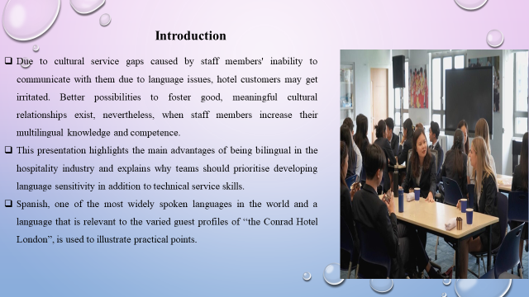
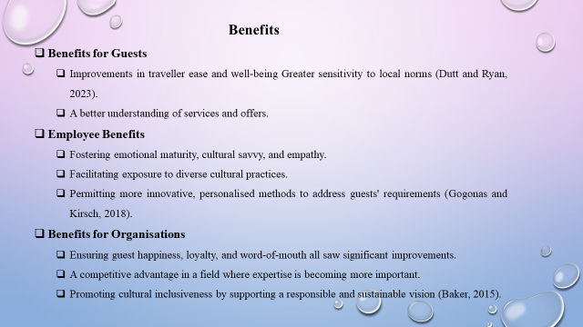
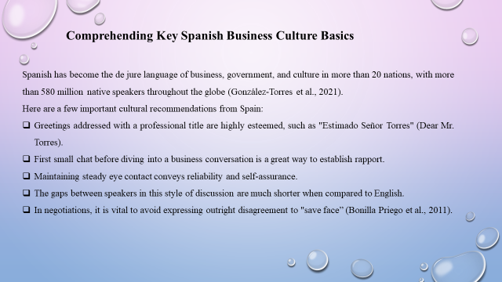
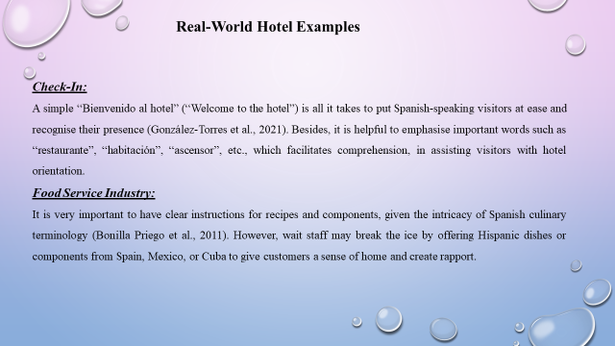
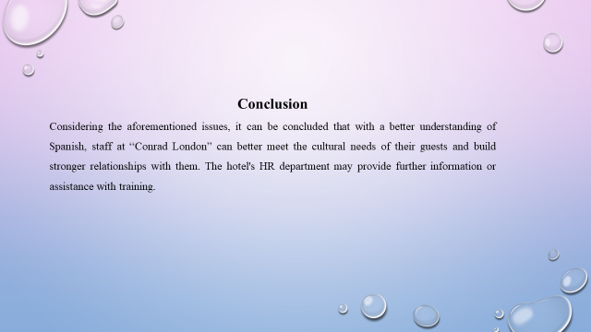
References (no screenshots):
Baker, W., (2015). Culture and identity through English as a lingua franca: Rethinking concepts and goals in intercultural communication (Vol. 8). Walter de Gruyter GmbH & Co KG.
Bonilla Priego, M.J., Najera, J.J. and Font, X., (2011). Environmental management decision-making in certified hotels. Journal of sustainable tourism, 19(3), pp.361-381.
Dutt, C.S. and Ryan, C., (2023). Hotel management schemes: liminal protean pathways derived from acting as lifeguards in Gulf luxury resorts. International Journal of Contemporary Hospitality Management.
Gogonas, N. and Kirsch, C., (2018). ‘In this country my children are learning two of the most important languages in Europe’: ideologies of language as a commodity among Greek migrant families in Luxembourg. International Journal of Bilingual Education and Bilingualism, 21(4), pp.426-438.
González-Torres, T., Rodríguez-Sánchez, J.L. and Pelechano-Barahona, E., (2021). Managing relationships in the Tourism Supply Chain to overcome epidemic outbreaks: The case of COVID-19 and the hospitality industry in Spain. International journal of hospitality management, 92, p.102733.

