Topic: The Impact of International Supply Chain Disruptions on UK SME Manufacturing Firms

Declaration
I, Amit, declare that this dissertation has been composed by myself, that the work contained herein is entirely my own except where explicitly stated otherwise in the text, and that this work has not been submitted for any other degree or qualification, in whole or in part, except as specified.

Signature: ………………………………............................

Date: ………………………………............................

Acknowledgement
I would like to take this opportunity to recognise the fact that I owe the University of Wales Trinity Saint David (UWTSD) my genuine gratitude, due to which this research would not have received the academic base that it has been given. I would like to extend my profoundest gratitude to my supervisor, [Supervisor Name], who has helped me work on this project, given me valuable feedback and guided me throughout the entire project. I also owe my Programme Manager, [Manager Name], some assistance with administrative matters. Last but not least, I would like to thank my family, who were patient, supportive, and believed in me. This study is an epitome of the support and direction of all these people.

Abstract
Aim: This study examines the impact of international supply chain disturbances on the operations and strategic choices of UK manufacturing SMEs. It will seek to determine the key causes of disruptions, evaluate their operational and financial consequences, and get insights into how firms cope with them.
Research Method: The research was based on a positivist philosophy and a deductive, quantitative approach. The data was gathered using a formal questionnaire, which was done online, among 150 SME manufacturing companies in the UK, chosen through purposive sampling. In SPSS, there were statistical tests based on frameworks like the Resource-Based View and Dynamic Capabilities Theory to test the relationships through correlation and regression tests, as well as descriptive statistics.
Findings: Geopolitical conflicts, trade law changes triggered by Brexit, increased logistics expenses, and dependence on foreign suppliers are the primary disrupting factors. They result in the delay of production, increased cost, and poor performance of a business. Supplier relationship diversification, nearshoring, and collaborative relationships with suppliers may be regarded as effective mitigation strategies that can significantly reduce the adverse effects of disruptions.
Contribution: The research can be considered UK-specific empirical data, confirmation of a composite theoretical framework of SME resilience, and a business-level hierarchy of strategies that managers and trade organisations, as well as policymakers, can use.
Limitations: The application of a single quantitative method, a cross-sectional design that cannot detect changes over time, and the target population of UK SMEs, which may be problematic in different settings.

Keywords: UK manufacturing SMEs, supply chain disruptions, supply chain resilience, operational performance, risk mitigation strategies, Brexit trade regulations, geopolitical conflicts, nearshoring, supplier diversification, Dynamic Capabilities Theory, Resource-Based View, SME vulnerability, production efficiency, cost management

List of Abbreviations
Abbreviation | Full Term
AI | Artificial Intelligence
ANOVA | Analysis of Variance
DCT | Dynamic Capabilities Theory
GEIS | Growth Enterprise Investment Scheme
RBV | Resource-Based View
R&D | Research and Development
SME | Small and Medium-sized Enterprise
SMEs | Small and Medium-sized Enterprises
SPSS | Statistical Package for the Social Sciences
SSAF | SME Strategic Adaptation Framework
UK | United Kingdom

Contents
Declaration 2
Acknowledgement 3
Abstract 4
List of Abbreviations 5
List of Figures 9
List of Tables 10
Chapter 1: Introduction 11
1.1 Introduction of Chapter 11
1.2 Background 11
1.3 Problem Statement 12
1.4 Research Questions: 13
1.5 Rationale of the Study 14
1.6 Structure of the dissertation 14
1.7 Summary 14
Chapter 2: Literature Review 16
2.1. Introduction 16
2.2. Conceptual and Contextual Foundations 16
2.2.1 The definition of International Supply Chain Disruptions. 16
2.2.2 Systemic Vulnerability and SMEs. 17
2.2.3 Interconnectedness on a Global Level and Risk Multiplication. 17
2.3. Theoretical Frameworks 18
2.3.1 Resource-Based View (RBV) 18
2.3.2 Dynamic Capabilities Theory (DCT). 18
2.3.4 Network Theory. 19
2.3.5 Integrative Framework 20
2.4. Empirical evidence from the world literature 21
2.4.1 The Economic/Cost Impact of Disruption on SMEs. 22
2.4.2 Institutional/Environmental Disruptions and Overall Performance of SMEs. 23
2.4.3 SME’s Strategic and Structural Responses to Global Supply Chain Disruptions 24
2.4.4 The Role of Knowledge Preparedness and Technological Capability of SME in dealing with disruptions 24
2.5. Conceptual Framework 25
2.6 Critical Analysis and Summary of Literature 27
Chapter 3: Research Methodology 29
3.1 Introduction 29
3.2 Research Philosophy 29
3.3 Research Approach 30
3.4 Research Strategy 31
3.5 Population, Sampling, and Sample Size 32
3.6 Data Collection Method 34
3.7 Data Analysis Method 34
3.8 Ethical Considerations 35
3.9 Chapter 3 Summary and Methodological Limitations 36
Chapter 4: Results and Findings 37
4.1 Chapter Introduction 37
4.2 Descriptive Statistics 37
4.3 Frequency Analysis 38
4.4 Correlation Analysis 56
4.5 Reliability Analysis 58
4.5.1 Reliability (Scale: Supply Chain Disruptions) 58
4.5.2 Reliability (Scale: Business Performance Impact) 58
4.5.3 Reliability (Scale: Business Performance Impact) 59
4.6 Regression Analysis 60
4.7 Chapter Summary 62
Chapter 5: Discussion 64
5.1 Chapter Introduction 64
5.2 Overall Findings of the study 64
5.3 Findings Comparison with Literature Review 65
5.4 Study contribution 67
5.5 Chapter Summary 68
Chapter 6: Conclusion 69
6.1 Chapter introduction 69
6.2 Findings for Each Objective 69
6.3 Theoretical Contribution 72
6.4 Practical Contribution 72
6.5 Limitations 72
6.7 Future Research Avenues 73

List of Figures
Figure 1 Integrative Theoretical Framework (Made by Author) 18
Figure 2 Conceptual Framework (Made by Author) 24
Figure 3 Size of the firm (number of employees) 37
Figure 4 Industry sub-sector 38
Figure 5 Years of operation of the firm 39
Figure 6 International geopolitical conflicts 40
Figure 7 Brexit-related trade regulations 41
Figure 8 Rising global transportation and logistics costs 42
Figure 9 Dependence on overseas suppliers 43
Figure 10 Limited visibility into international suppliers 44
Figure 11 Frequent production delays 45
Figure 12 Increased production costs 46
Figure 13 Raw material cost volatility 47
Figure 14 Reduced ability to meet customer demand 48
Figure 15 Decline in overall business performance 49
Figure 16 Supplier diversification 50
Figure 17 Nearshoring or local sourcing 51
Figure 18 Digital supply chain monitoring tools 52
Figure 19 Collaboration with suppliers 53
Figure 20 Government support schemes 54
Figure 21 Histogram of the dependent variable 59
Figure 22 Normal P-Plot of Regression Standardised Residual 60

List of Tables
Table 1 Inclusion and Exclusion Criteria 32
Table 2 Descriptive Statistics 37
Table 3 Demographic Question 1 37
Table 4 Demographic Question 2 38
Table 5 Demographic Question 3 39
Table 6 Response to Questionnaire Statement 1 40
Table 7 Response to Questionnaire Statement 2 41
Table 8 Response to Questionnaire Statement 3 42
Table 9 Response to Questionnaire Statement 4 43
Table 10 Response to Questionnaire Statement 5 44
Table 11 Response to Questionnaire Statement 6 45
Table 12 Response to Questionnaire Statement 7 46
Table 13 Response to Questionnaire Statement 8 47
Table 14 Response to Questionnaire Statement 9 48
Table 15 Response to Questionnaire Statement 10 49
Table 16 Response to Questionnaire Statement 11 50
Table 17 Response to Questionnaire Statement 12 51
Table 18 Response to Questionnaire Statement 13 52
Table 19 Response to Questionnaire Statement 14 53
Table 20 Response to Questionnaire Statement 15 54
Table 21 Reliability (Scale: Supply Chain Disruptions 57
Table 22 Reliability (Scale: Business Performance Impact) 58
Table 23 Reliability (Scale: Business Performance Impact) 58
Table 24 Model Summary 59
Table 25 ANOVA 59
Table 26 Coefficient Analysis 60

Chapter 1: Introduction

Introduction of the Chapter
Chapter 1 lays out the background of the research by providing background information about the UK manufacturing SMEs and the increasing vulnerability to international supply chain shocks. It provides the main issues posed by economic shocks worldwide and the strategic significance of the resilience of supply chains. The research aim, problem statement, objectives and research questions are clearly outlined in the chapter, but the chapter also provides the justification of the relevance of the study. On the whole, it helps to determine the magnitude and aim of the study and predetermines the course of the following chapters.

1.2 Background
In the United Kingdom, Small and Medium-sized Enterprises (SMEs) are the drivers of the economy, accounting for more than 99 per cent of all manufacturing companies and playing a significant role in the country's productivity and employment (Lin et al., 2022). These SMEs are essential to maintaining industrial production and innovation, as they account for about 250,000 active manufacturing enterprises (Gov.UK, 2023). Yet, by relying on global sourcing, they have become highly vulnerable to global shocks such as the COVID-19 pandemic, trade rifts during the Brexit period, and geopolitical conflicts.
The Manufacturing Growth Program (2020) also states that almost two-thirds of SMEs in the UK have experienced considerable challenges in their operations due to the global breakdown of their supply chains, compared with 40 per cent of larger firms. The pandemic disrupted the logistics system, the supply of raw materials, and consumer demand, exposing the weakness of the internationally dependent SME manufacturing system (Gurbuz et al., 2022). The textile and electronic industries were particularly severely affected because both have intensive, globally dispersed supply chains.
Many SMEs also felt liquidity crunches due to delayed shipments and order cancellations, putting working capital to the test. Such shocks highlighted the necessity for companies to focus on supply chain resilience strategies, such as supply diversification, regionalisation of manufacturing locations, and investment in digital monitoring systems (Alshahrani and Salam, 2022). On a national scale, Foroughi (2025) report that supply chain fragility is a significant obstacle to SME growth. Access to finance is also a challenge for almost 80 per cent of SME manufacturers, including those in early development stages, as they are unable to invest in technology and resilience. Moreover, a significant percentage of companies are unaware of available government assistance services, including the British Business Bank and the Business Growth Fund, which, combined, would increase manufacturing investment by 9.2 billion a year (Fouejieu, Ndoye and Sydorenko, 2020).
Policymakers have proposed measures such as a super-growth capital allowance (150%) and the Enhanced Growth Enterprise Scheme (GEIS) to trigger recapitalisation and scale-up opportunities (Tyrrell, 2025). Export barriers also escalate supply chain issues. Direct exports by manufacturers account for only 22% in the UK, and several manufacturers complain about the challenges posed by foreign regulations and red tape. This reliance on narrow markets exposes them to greater risk from foreign shocks (Ellis et al., 2022).
As a result, more SMEs are reorganising their supply chain models, resourcing, local sourcing, and digital transformation to strengthen control and flexibility. After all, the international supply chain unrest has not only tested the operational resilience of UK SME manufacturers but also triggered a structural shift toward a model of localised, technologically integrated, and sustainable production (Hsu et al., 2021). These changes underscore the pivotal nexus of policy support, financial accessibility, and strategic innovation, which will collectively determine whether UK manufacturing SMEs can convert post-crisis vulnerability into long-term competitive advantage (Setyadi, Pawirosumarto and Damaris, 2025).

1.3 Problem Statement
The UK manufacturing SMEs have become susceptible to frequent global supply chain interruptions, which have escalated in recent years, following overlapping global crises. Ivalua (2024) shows that almost half (47%) of the UK businesses were more disrupted over the last 12 months, where inflation (79%), energy price volatility (75%), and geopolitical tensions, e.g., the war in Ukraine (53%) and the Red Sea conflict (44%), are the key factors. These upheavals have caused delay in production, an increase in costs and intense strain on procurement networks, i.e. 60 per cent of companies believe their supply chains are weaker than ever before. In addition, 46 per cent of organisations do not have sufficient visibility of the vulnerabilities in their suppliers, and 43 per cent are unable to adapt easily to changing circumstances (Tao et al., 2025). Although awareness is increasing, financial and technological factors limit the adoption of resiliency-based strategies such as nearshoring, diversification, and AI-based monitoring systems by the majority of SMEs. This continuous instability highlights the necessity to study the impact of disruptions of international supply chains on operational performance and planning strategies of UK manufacturing companies.
1.4 Research Aim and objectives:
To investigate how international supply chain disruptions influence the operational performance and strategic decisions of UK manufacturing firms.
- To identify the key causes of international supply chain disruptions affecting UK manufacturing firms.
- To assess the impact of these disruptions on production efficiency, cost management, and overall business performance.
- To explore strategies and best practices adopted by UK manufacturing firms to mitigate supply chain risks.

1.4 Research Questions:
- What are the key causes of international supply chain disruptions affecting UK manufacturing firms?
- What is the impact of these disruptions on production efficiency, cost management, and overall business performance?
- What are the strategies and best practices adopted by UK manufacturing firms to mitigate supply chain risks?

1.5 Rationale of the Study
This research is necessary because UK manufacturing SMEs are still experiencing increased international supply chain shocks that are compromising their productivity, cost-effectiveness, and competitiveness. Though it is very vital to their participation in innovation and job creation, the firms are very vulnerable to all the uncertainties in the world, like inflation, war and logistic failures. Previous literature has noted the importance of resilience measures such as diversification and digital transformation. Still, there is little research on the specific effects of these disruptions on the operational and strategic aspects of manufacturing companies in the UK. This study will address a critical gap in the literature by dealing with the effects and the adaptive mechanisms of SMEs to endure continuous volatility. The results will be of great significance to policy makers and business executives as they will inform the future resilience structure, investment choices and policy intervention to increase supply chain resiliency and guarantee sustainable expansion in the UK manufacturing industry.

1.6 Structure of the dissertation
This thesis is divided into five chapters. Chapter 1 provides the background of the research, the problem statement, the objectives, and the justification for the research. Chapter 2 provides a critical literature review of international supply chain disruptions, SME resilience, and operational performance. Chapter 3 describes the methodology followed in the study, which is a primary quantitative research method. Structured questionnaires will be distributed to UK manufacturing SMEs, and statistical data will be analysed. Chapter 4 summarises and discusses the quantitative results, evaluating the difference of supply chain disruptions on operation and the strategic decision. Lastly, Chapter 5 contemplates the results in comparison with the current literature, inferences, practical and policy implications and the future research recommendations.

1.7 Summary
Chapter 1 provides an introduction to the importance of UK manufacturing SMEs, as they are the main drivers of the economy, but they are becoming more vulnerable to disruptions in international supply chains. The impact of COVID-19, trade barriers caused by Brexit, geopolitical disputes, inflation, and the volatility of energy have revealed the vulnerabilities of supply models that are globally dependent, which have resulted in delays in production, rising prices, and liquidity limitations. Although there is policy support, financial access and a lack of awareness limit SMEs from investing in resilience measures of diversification, localisation and digital transformation. The chapter provides the research aim, objectives, and questions that are oriented at studying the causes and effects of supply chain disruptions and mitigation strategies adopted.

Chapter 2: Literature Review

2.1. Introduction
The global supply chains are now very interconnected and susceptible to large-scale disruption, including pandemics, geopolitical conflicts, and natural disasters (Guo et al., 2024). The SMEs that make up more than 99% of all businesses in the world are a disproportionately impacted category because they have limited financial reserves, the flexibility to operate, and reliance on foreign suppliers (Gherghina et al., 2020). SMEs can also struggle to control the disruption of supplies since they do not have redundancy and digital infrastructure as big multinationals do (Hafeez, Shahzad and Silva, 2025). The explanation of the impact of such disruptions on the performance of SME manufacturers, their resilience, and strategic adjustment is crucial to sustainable competitiveness. Critically, the literature review identifies existing international evidence on the impacts of global supply chain disruptions on manufacturing SMEs, key theoretical lenses, cross-country empirical research, and implications and research gaps, as suggestions for the manufacturing context in the UK.

2.2. Conceptual and Contextual Foundations

2.2.1 The definition of International Supply Chain Disruptions.
Supply chain disruptions are the unanticipated occurrences which hinder the normal flow of goods, services, or information (Mishra, Gupta and Jha, 2024). Globalisation of production networks has exposed firms to a variety of external shocks, including the COVID-19 outbreak, trade friction associated with Brexit, port congestion and the Russia-Ukraine conflict. These have been disrupting logistics, limiting resources, and revealing the vulnerability of international trade systems. Orlando et al. (2021) categorise all these disruptions into two types: the supply shocks, such as shortages of raw materials, supplier failures, and transport limitations, and the demand shocks, such as cancellation of orders or an unexpected decline in consumer demand. These effects are further enhanced by the nature of modern supply chains, where failures in one node can cascade through the whole supply chain.

2.2.2 Systemic Vulnerability and SMEs.
The industry of SMEs is more susceptible to any global shocks due to its limited financial stability, reduced inventories, and lack of alternatives with suppliers (Gamage et al., 2020). According to Etemad (2020), disruptions are faster spreading among SMEs, as they rely on lean, highly integrated networks with little redundancy. This dependence exposes them to cascading failures as they have upstream or downstream partners that are derailed. Kanyepe et al. (2025) also prove that economic restrictions, lack of qualified labour and unreliability of suppliers increase the risk that directly impacts operational and financial performance. Since SMEs do not have excellent crisis handling systems or diversified sourcing systems, they are prone to severe liquidity problems and delays in production during international crises.

2.2.3 Interconnectedness on a Global Level and Risk Multiplication.
Global integration has given rise to supply efficiency and cost competitiveness, but at the same time, it has decreased resilience (Kot et al., 2020). According to Gurbuz et al. (2022), the outbreak of COVID-19 caused great operational paralysis in SMEs within the textile industry in Turkey, which demonstrates the far-reaching nature of disruptions through the supply chain of multi-tiers. To counter these shocks, larger companies used reserves and digital technologies, and SMEs experienced the problem of supplier defaults and cash flow deficits. These weaknesses highlight the structural asymmetry of global performance and the local strength of SME supply networks.
Manufacturing SMEs are the most impacted because they are dependent on just-in-time production and strict control over inventory (Onyeanuforo et al., 2024). These industries are very reliant on the foreign supply and logistics accuracy, and there is little space for interruption. Therefore, to be more resilient, several manufacturing SMEs have embraced multi-sourcing and supplier partnerships, as well as digital solutions, e.g., predictive analytics and supply chain monitoring. Despite the varying implementation capacity by countries, the global experience in diversification, cooperation, and digitalisation offers a golden opportunity to the UK manufacturing SMEs in trying to reduce the vulnerabilities in supply chains in the future.

2.3. Theoretical Frameworks

2.3.1 Resource-Based View (RBV)
Resource-Based View (RBV) assumes that competitive advantage is gained by firms by establishing and mobilising unique, valuable, and inimitable internal resources that include technology, skills, and knowledge (Barney, 2012). In the SME environment, this theory highlights the role of technology capability, innovation, and managerial expertise as the most central resources that lead to operational resilience in cases of disruptions. To reinforce this argument, Alquraish (2025) demonstrate that technological capability moderates the connection between supply chain risks and the performance of firms, and that innovation is a safeguarding resource. SMEs that use digital tools to monitor the supply chain, optimise inventory, and make predictions are more adaptable than those with limited resources. RBV, however, assumes that there is adequate resource and autonomy, which is, in most cases, not the case with SMEs, which are usually resource-constrained and are dependent on inter-firm cooperation (Kero and Bogale, 2023). Therefore, although RBV helps explain resilience in terms of internal strengths, it loses explanatory value for externally integrated SME supply networks.
Nonetheless, the emphasis of RBV on internal resources can be excessively high in that it downplays the role of external environmental factors, including market volatility, regulatory changes, and reliability of suppliers (Madhani, 2010). The presumption that resources can be efficiently mobilised also fails to take into account managerial capacity constraints and financial constraints prevalent in the SMEs (Lubis, 2022). As a result, although RBV offers internal strengths to be vital in resilience, it does not give much information on how SMEs can capitalise on external networks, collaboration, or institutional resources to maintain performance in the face of global supply chain shocks.

2.3.2 Dynamic Capabilities Theory (DCT).
Dynamic Capabilities Theory is an extension of the RBV, which explains how firms sense, seize, and reconfigure their resources in order to wade through turbulent environments (Teece and Pisano, 1994). With respect to international supply chain disruptions, DCT is a framework for understanding the adjustments of SMEs' strategies in the face of uncertainty. Kiessling et al. (2024) use this theory to show that SMEs that have effectively developed dynamic capabilities, i.e., have the capacity to restructure their export strategies and operations processes quickly, are more resilient and faster to internationalise. Their results indicate that supply relationships, which are more tightly controlled, allow direct exporters to respond more readily to disruption-related volatility than indirect exporters, who are dependent on intermediaries. DCT's competitive resilience is strong because it identifies learning, agility, and reconfiguration as major contributors to CEO-driven competitive resilience. However, it is not very helpful in emphasising institutional and financial constraints encountered by SMEs and presupposing that the firms have the foresight and capital to implement strategic change (Teece, Peteraf and Leih, 2016).
DCT is not as useful in environments where the SMEs experience severe financial, regulatory or institutional constraints, because it presupposes that firms possess foresight and resources which can be used to reconfigure the operation (Saeedikiya, Salunke and Kowalkiewicz, 2024). As an example, an SME in the UK experiencing trade barriers due to the impact of Brexit in a short time may be aware of the necessity to change suppliers or alter logistics, but cannot take any measures because of the insufficient funds or the absence of other partners (Bailey et al., 2023). This shows that though DCT provides a conceptual way of controlling strategic adaptability, it failed to recognise the real-life constraints that reduce the responsiveness of SMEs, which limits its explanatory value to be context-dependent.

2.3.4 Network Theory.
The Relational View and Network Theory are based on the assumption that inter-organisational relationships and collaborative networks are the key to long-term advantage and resilience (Dyer and Singh, 1998). Kot et al. (2020) believe that SMEs rely on relational capital, such as trust, cooperation and information exchange, to ease disruptions. This opinion is supported empirically by Gurbuz et al. (2022), who show that the more diversified and geographically distributed the supply networks of SMEs, the less disruption they had and the quicker they could resume operations during the COVID-19 pandemic. These relational networks promote resource sharing among them, co-solution of problems, and dynamism. Nonetheless, excessive reliance on such networks will lead to vulnerability where two or more partners encounter concurrent crises, as failures by one system will enhance the systemic risks.
Although the network theory implies the advantages of relational capital, trust, and collaboration to SME resilience, the assumption made is that partners are both competent and trustworthy (Do, Nguyen and Dao, 2025). As a matter of fact, companies that rely on the network extensively might be exposed to multiplied risks in case of simultaneous failure of several partners, like in times of endemic crises like the COVID-19 pandemic or geopolitical instability (Xu et al., 2020). In addition, excessive dependence on external networks can also curtail internal capability building, leaving SMEs vulnerable in the case of the lack of external assistance, a key constraint of the application of the theory to resource-constrained firms.

2.3.5 Integrative Framework
As seen in the figure below, the holistic view of SME resilience is created through a combination of RBV, DCT, and the Relational View. RBV describes how innovation and technology as internal resources make firms operationally stronger, DCT describes the adaptive processes of internal resource realignment, and the Relational View of operations maintenance by external cooperation.
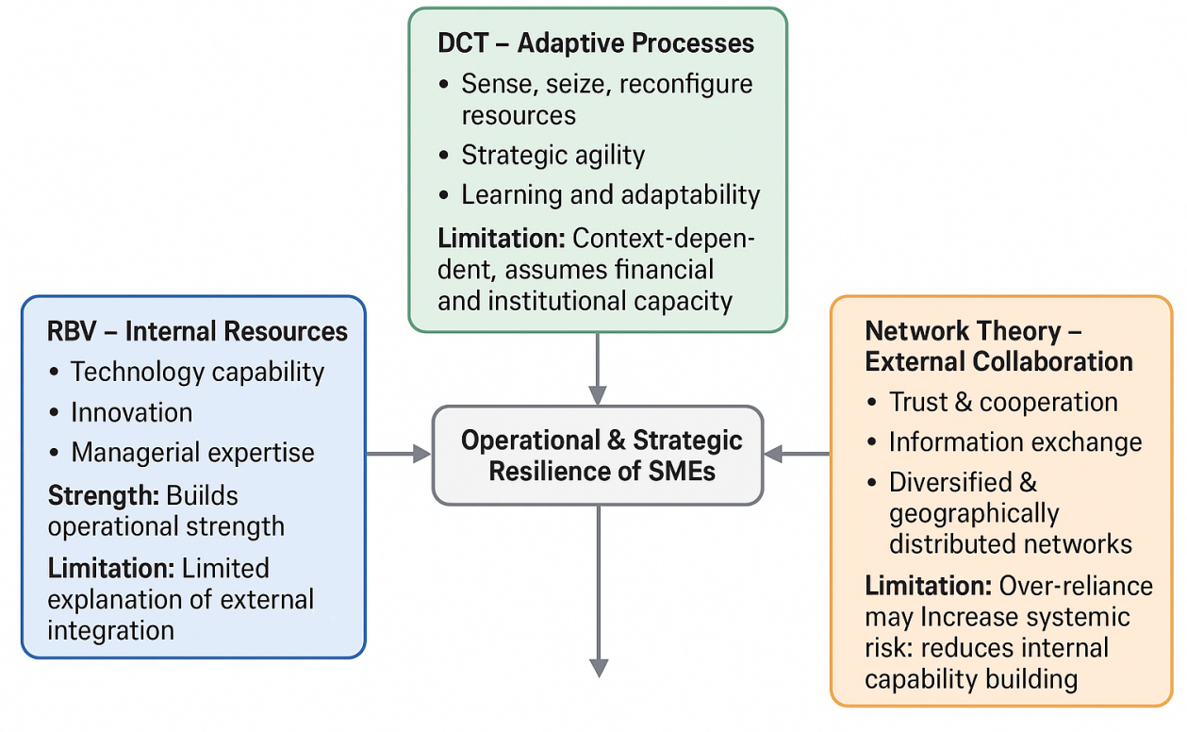
Figure 1 Integrative Theoretical Framework (Made by Author)

With manufacturing SMEs, and especially in the UK, resilience is created by the interplay between internal potentials (digitalisation, leadership agility) and external partnerships (regional diversification and collaborative sourcing). This unified model offers a holistic perspective that can be used to study how SMEs can endure, adjust, and recuperate from such international disruptions in the supply chains.

2.4. Empirical evidence from the world literature
The impact of Global Supply Chain Disruptions on production efficiency
The literature increasingly finds that supply chain disruption is a systemic shock that changes how effectively production operates. Nevertheless, the available literature tends to focus more on just describing types instead of measuring real results. An example is provided by Syamsyul et al. (2023), who conceptually map supply, demand and logistical disruptions, but their qualitative orientation prevents understanding of how they reduce measurable performance and the efficiency of production. Although the disruptions are demonstrated to slow down the inputs and stop the production processes, the lack of performance standards, such as the reduction in output or productivity, diminishes the explanatory capabilities of their results.
Bhat et al. (2025) offer a more well-analysed study by unveiling the ways in which disruptions incur indirect and hidden costs such as stockpiling supplies, rushed logistics and contractual inefficiencies, which the conventional cost accounting systems do not capture. More importantly, though, their synthesis reveals a structural weakness of the literature, which suggests that cost management is largely addressed as a reactive process, and not as a strategic power. This limited framing does not give enough focus on how long-term cost volatility weakens pricing power, compromises the budgeting process, and limits long-term capital allocation, especially where SMEs have limited resources.
These efficiency and cost pressures have performance implications that are also discussed in the context of supply chain resilience. Negi et al. (2025) state that the relationship between exposure to disruption and organisational effectiveness is mediated by resilience capabilities, which enable a quicker operational recovery and the stabilisation of short-term performance. However, this positive perception is challenged by their findings, which highlight that the investment in resiliency can be quite expensive in terms of finances and organisations. Consequently, resilience can maintain a continuity in operations and, at the same time, undermine financial performance, dispelling the notion that resilience has a homogenous positive impact on business performance.
This tension is especially visible in the study by Foli et al. (2022), which is SME-based, as the maturity of supply chain risk management is associated with innovation performance. Although proactive risk management helps to create an adaptive capacity during a disruption, the research has pointed out a significant trade-off: investments in disruption mitigation can displace innovation spending and hence restrict long-term competitive advantage. In turn, disruption response strategies can secure the short-term survival but not the long-term growth.

2.4.1 The Economic/Cost Impact of Disruption on SMEs.
International supply chain risks have created significant economic and operational impacts on SMEs in international settings. The most frequent ones are the rising costs, longer lead times, supplier default, and production stagnation, which endanger the existence of firms and their competitiveness (Gurtu and Johny, 2021). In their research on the Turkish manufacturing SMEs, Asgary et al. (2020) established that the global economic and geopolitical risks, including fiscal crises and trade wars, were identified as the most extreme risks. This shows that SMEs are very vulnerable to changes in the global markets since they are reliant on international suppliers and have a low ability to absorb shocks. However, Orlando et al. (2021) found that in 2020, the global trade had plummeted by about 9.2%, and SMEs had been affected more than the rest due to insufficient contingency planning and the absence of redundancy in their supply chains.
In various regions, the COVID-19 pandemic increased the weaknesses in the operations of SMEs. Companies whose operations were based on the just-in-time model were unable to sustain continuity when borders were shut down and the delivery time of suppliers took longer (Du, Razzaq and Waqas, 2022). The study conducted by Kanyepe et al. (2025) revealed that the supply chain risk has a direct negative effect on financial and operational performance in the manufacturing industry in Zimbabwe, which supports the applicability of the patterns to the rest of the globe. The logical effect of interruptions, in which a single failure disrupts the whole supply chain, became a true motif. Indicatively, the problems with the supply of raw materials caused downstream shortages, factory shutdowns, and a decrease in the income of SMEs around the world (Bateh, 2024). Therefore, when bigger companies cushioned the impact with capital buffers and multi-level sourcing, SMEs succumbed to stagnation of production, the loss of business, and the threat of bankruptcy.

2.4.2 Institutional/Environmental Disruptions and Overall Performance of SMEs.
The impacts of external institutional and environmental environments on SME to international supply chain disruptions have significant effects. Informal institutions mentioned by Kiessling et al. (2024) (social trust, corruption rates, and political stability) have an impact on the way SMEs handle relations with their exporters and adjust in extreme situations. SMEs have more negotiating, coordinating and recovering ability in the countries with stable institutional settings. On the other hand, the risk exposure is exaggerated by weak governmental frameworks or uncertainty about policies.
Asgary et al. (2020) also underline that the perceptions of SMEs towards world risks vary in terms of national context, since geopolitical instability, inefficiency in regulations, and lack of efficient crisis management structures can change the risk prioritisation. All these points point to the fact that, although the notion of supply chain resilience is commonly defined as an organisational capability, the macro-institutional environment relies on it as well. These global lessons make sense to UK manufacturing SMEs. The background of Brexit and the disturbances of global trade, as well as the volatility of energy prices, can be viewed as reflections of the cross-border limitations that can be seen elsewhere. With the UK redefining its trading relationships, the SMEs are faced with the challenge of balancing between sourcing internationally and sourcing locally and regionally (Siameh, 2023). The increased digital presence, government support systems, and institutional confidence would be critical in the translation of lessons of the best practices in the world to the locally viable models of resilience.

2.4.3 SME’s Strategic and Structural Responses to Global Supply Chain Disruptions
SMEs have implemented strategic and structural adaptation strategies in response to disruptions in the world setting in efforts to enhance flexibility and resilience. Onyeanuforo et al. (2024) discovered that SMEs in various countries had five primary adaptation strategies, including supplier diversification, nearshoring, digitalisation, financial hedging, and operational flexibility. These measures are proactive and reactionary measures aimed at reducing supply uncertainty. The authors created the SME Strategic Adaptation Framework (SSAF) and categorised firms into three types: resilience-based adapters (firms with a focus on survival and stabilisation), growth-based pivots (firms that use disruption to innovate and grow), and defensive consolidators (firms that downsize operations in order to minimise losses) (Pertheban et al., 2023).
The findings of Gurbuz et al. (2022) also indicated that the recovery rate of SMEs implementing multi-sourcing, collaboration, and diversifying customers was greater, and the intensity of disruption was lower. They analysed the Turkish textile companies and revealed that companies in the sector with a broader supplier base and greater product flexibility sustained their activities better as compared to those with centralised and narrow supplier chains. All these studies point to the key issue of collaboration, redundancy, and technological agility as the key elements of sustainable recovery. Active strategies like supply diversification, integrating the digital realm, have been established to be much more effective than the solely reactive strategies, such as cost-reduction or temporary closure. But its application is limited by financial resources; most SMEs are unable to reorganise or invest a lot in technology.

2.4.4 The Role of Knowledge Preparedness and Technological Capability of SME in dealing with disruptions
Hafeez et al. (2025) proposed the idea of knowledge preparedness, denoting the ability of firms to react to disruptions via the following knowledge, innovation, and information-sharing systems. Based on their findings, it appears that companies that invest in R&D, process innovation, and digital integration before crises have a higher level of resilience. It is worth noting that some of the European SMEs managed to overcome the impact of lockdowns with the help of innovations in inventory management, automation of logistics, and digital traceability. This position was further developed by Kanyepe et al. (2025), who demonstrated that technological capability serves as a moderating factor between supply chain risk and performance, such that companies with superior technological equipment, i.e. AI, predictive analytics, and blockchain, have a better ability to predict and respond to disruptions.
However, according to Faiz, Le and Masli (2024), digitalisation cannot be a universal solution. A lot of SMEs, particularly those in developing and emerging economies, have challenges with finances and expertise that are a barrier to effective adoption of technology. The digital divide implies that, when companies in prosperous economies have access to data analytics and distressed collaboration, other companies are relying on manual organisation and the lack of coverage in the market (Faiz, Le and Masli, 2024). This leads to innovation and preparedness to knowledge, being a lopsided benefit, strengthening inequality in the global supply chain resilience.

2.5. Conceptual Framework
The conceptual framework of this research is informed by the interaction of the internal resources, dynamic capabilities and external networks to gain insight into the effects of the interruption of the global supply chains on the manufacturing SMEs in the United Kingdom.
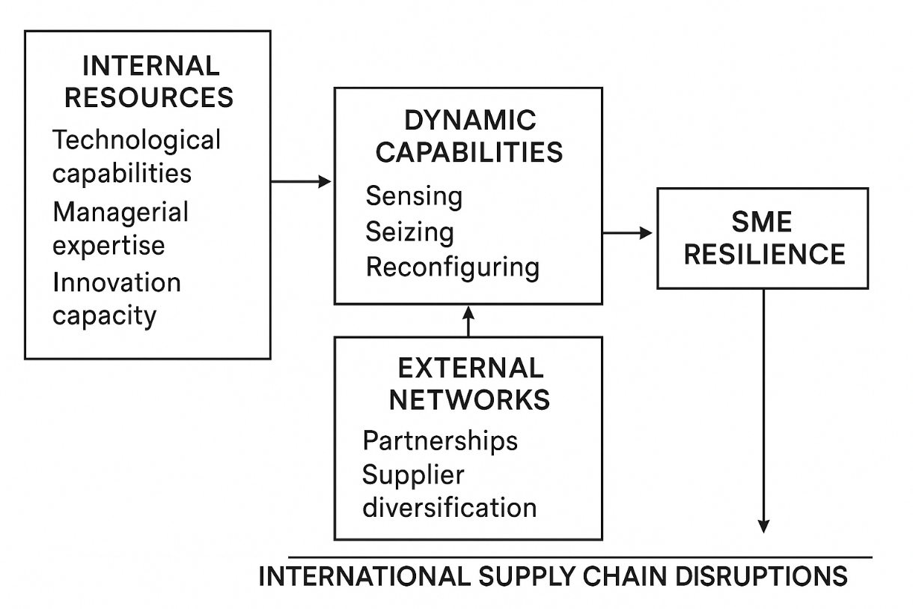
Figure 2 Conceptual Framework (Made by Author)
The framework, which is based on the Resource-Based View (RBV), acknowledges the fact that the technological capabilities, managerial skills, and innovation capability of SMEs are the key internal resources that allow the companies to become operationally resilient in the face of disruptions (Barney, 2012; Alquraish, 2025). But, due to the limited resources that SMEs usually possess, just internal strengths are not enough, and the Dynamic Capabilities Theory (DCT) should be included, which focuses on sensing, seizing, and reconfiguring resources as a response to uncertainty (Teece and Pisano, 1994; Kiessling et al., 2024). DCT identifies strategic agility, learning, and adaptability as the most important ways in which SMEs react to shocks in supply.
In addition to these internal orientations, the Relational View and Network Theory emphasise the use of external partnerships, supplier diversification, and collaboration to be more resilient (Dyer and Singh, 1998; Kot et al., 2020). This means that SMEs that are embedded in a robust relational network are able to share assets, solve issues together, and bounce back quicker in the face of global perturbation, but overreliance may escalate systemic risk (Xu et al., 2020; Do, Nguyen and Dao, 2025). The combined conceptual framework thus makes SME resilience a process of internal competencies, adaptive strategic processes, and network involvement. The empirical evidence indicates that the relationship between the supply chain disruptions and operational performance is mediated by technological preparedness, knowledge management, and multi-sourcing practices, which inform the strategies of UK SMEs to mitigate risks and remain competitive in global supply chain management (Hafeez et al., 2025; Kanyepe et al., 2025).

2.6 Critical Analysis and Summary of Literature
Existing literature on international supply chain disruptions provides a solid foundation for understanding how SMEs adapt to global volatility. The conceptual richness of the theoretical synthesis between the Resource-Based View, the Dynamic Capabilities Theory, and the Relational View is enhanced as it shows the relationship between internal resources, flexibility, and network cooperation to build resilience. Research of this kind can be demonstrated by cross-country studies like Gurbuz et al. (2022) and Kiessling et al. (2024), which contribute to the comprehension of multiple adaptation strategies in institutional settings. Practical implications of the SMEs are also provided because the empirical findings present practical explanations of strategic responses, including supplier diversification, digitalisation, and innovation. Nevertheless, the literature has a number of limitations that are critical. The excessive focus on COVID-19 reduces the scope of generalisability, and the focus on other forms of disruptions (geopolitical, environmental or energy crisis) is not properly covered. The majority of the research has been based on quantitative and cross-sectional surveys, which do not provide long-term adaptation and recovery processes, which are essential.
Resilience also has conceptual ambiguity, with researchers defining it as a process, a result, or a capacity. Besides, the effects of digitalisation are not uniform, as the positive effects of technological adoption seem to be dependent on firm size, resources, and country context. Without any doubt, the literature gives a piecemeal but informative image. The key gaps are the lack of research conducted in the UK and sector-specific research, especially in the manufacturing sector, and the lack of focus on the policy and institutional effects on SME resilience. Mixed-method/longitudinal research approaches should also be used in the future to reflect the dynamic resilience processes and determine the effects of contextual factors and digital innovation on SME survival following a global supply chain disruption.

Chapter 3: Research Methodology

3.1 Introduction
This chapter presents the research design used to examine how the UK manufacturing firms of SMEs are affected by the international supply chain disruption. The research leverages the Saunders Research Onion as a guide to designing the research (Saunders, Lewis and Thornhill, 2019). All the layers of the onion, such as philosophy, methods of data collection, etc., are evaluated critically, and decisions made regarding them are justified based on the goals of the study. The major selection criteria were a quantitative research strategy, which utilised structured questionnaires that were given to the UK SMEs and were analysed through the use of statistical methods. Strengths and limitations of each of the chosen methodological options are also assessed in the chapter so that the study results can be considered rigorous, replicable, and generalizable. It is dedicated to the quantification of the relationship between disruptions, operational performance, and strategic responses, without forgetting about the intrinsic methodological limitations.

3.2 Research Philosophy
The research philosophy used in this study is positivism, which focuses on observable, measurable phenomena and makes use of objective data as the means of determining patterns and causal relationships (Bryman and Bell, 2015; Saunders, Lewis and Thornhill, 2019). The positivist approach coincides with the quantitative aspects of this study, in which the variables described in this study, including the efficiency of production, cost management, adoption of technology, and supply chain mitigation strategy, can be operationalised and analysed statistically. One of the main advantages of positivism is that the results it produces can be generalised and replicated, which is crucial in the case of comparing various SMEs in different parts of the UK. This method also facilitates hypothesis testing with the help of such theoretical frameworks as the Resource-Based View (RBV), Dynamic Capabilities Theory (DCT), and Network Theory, which allow conducting systematic analysis of the relationships among internal resources, adaptive capabilities, and SME resilience (Teece, Pisano and Shuen, 1994; Lubis, 2022).
Positivism is not without its limits, though. It is more likely to simplify complex phenomena and may disregard subjective and context-specific variables like managerial decision-making, corporate culture, or informal supplier networks, which affect the reactions of SMEs to supply chain disruptions (Bryman and Bell, 2015). Positivism is also based on the assumption that the social reality exists without human understanding, which might not entirely reflect the peculiarities of SME activities (Saunders et al., 2019). Irrespective of these limitations, a positivist philosophy is relevant in this study since the main goal is to measure the relationships and evaluate patterns through structured, statistical means among the SMEs. The philosophy guarantees rigorous methodology, objectivity and reliability in the measurement of the effects of international supply chain disruptions.

3.3 Research Approach
The research method was a deductive one, which was in line with the positivist philosophy. Deduction involves generalisation of hypotheses based on theories which are known, and then they are tested empirically (Saunders, Lewis and Thornhill, 2019). In this paper, the Resource-Based View (RBV), Dynamic Capabilities Theory (DCT), and Network Theory were used to develop hypotheses to understand the idea of impacting internal resources, adaptive capabilities, and external networks on SME resilience to disruptions in international supply chains. The deductive approach offers a methodological design and clarity whereby operationalisation of variables like supplier diversification, adoption of digital, and managerial expertise can be accurately established. This will enable the statistical testing of the relationships between these factors and the operational performance so that the results are not only theoretically based but also reproducible (Barroga and Matanguihan, 2022).
Nevertheless, deductive reasoning may be limiting and can fail to see unexpected variables or emergent phenomena in highly dynamic places such as global supply chains (Behfar and Okhuysen, 2018). Although the survey contained few open-ended questions in order to get some context, the major emphasis was put on testing the hypothesis by means of quantification. The methodology is warranted by the fact that it provides a golden mean between theoretical rigour and empirical measurement that allows conducting a systematic evaluation of the SME operational responses to disruptions. It makes certain that the research measures the quantifiable effect of supply chain shocks, and it is also consistent with the theoretical constructs.

3.4 Research Strategy
The survey approach has been chosen in this study, which corresponds to the main quantitative focus, and the aim to conduct a structured collection of data with a large sample of UK SMEs (Bryman and Bell, 2015; Saunders, Lewis and Thornhill, 2019). This research is particularly appropriate when it comes to surveys since they ensure that data is collected in a standardised form, which is easy to compare, test statistically, and generalise the findings. The key constructs addressed by the strategy to be operationalised include production efficiency, product diversification in supply chains, and digital preparedness, which are the core focus in determining the impacts of international supply chain disruptions on the performance of SMEs (Ali et al., 2024). The primary advantage of the survey method is that it is scalable and cost-effective to enable the collection of data on SMEs in different regions with minimum logistical limitations. The surveys also generate structured information that can be rigorously analysed in terms of quantitative data, allowing hypothesis testing based upon theoretical models.
In addition, standardisation of surveys implies consistency in the measurement of the variables and thus minimises researcher bias in the collection of data. However, there are significant weaknesses in surveys. They are based on self-reports that are susceptible to respondent bias or poor reporting (Rosenman, Tennekoon and Hill, 2011). Surveys can also not address subtle, context-driven variables, including managerial judgment, organisational culture or informal supplier relationships, which can have a major impact on SME resilience. Also, the response rates might be low, and this may lead to non-response bias, which may compromise representativeness and generalisation. Irrespective of these issues, the strategy of the survey is warranted, since the research is oriented at quantifying the relations between the disruption of the supply chain and operational performance (Sterrantino, 2024). The survey has been pretested to minimise the possible weaknesses, and validation questions were added in order to decrease the measurement error. Statistical analysis (descriptive analysis, correlation, and regression) was used to offer a sound, objective assessment of the hypothesis and reveal patterns of systemic understanding of SME resilience in the UK.
3.5 Research Choices
The quantitative method used was a mono-method where structured questionnaires were used to collect the data. The studied option takes adherence to the positivist philosophy and deductive logic with a focus on observable, quantifiable variables and the possibility to test hypotheses statistically (Bryman and Bell, 2015). The methodology provides consistency and comparability among respondents, ease of analysis, with the help of software, such as SPSS, and enables systematic testing of the relationship between supply chain disruptions and SME performance indicators. Nevertheless, the technique has its flaws since it overlooks the qualitative aspects, including managerial logic, organisational culture, or informal interactions with suppliers and may exclude the variables that arise in an emergent manner and have an impact on SME resilience. Irrespective of these limitations, the mono-method approach is reasonable because of the major emphasis on measurable results and hypothesis-based analysis.
3.6 Time Horizon
The time horizon used was cross-sectional since data of SMEs was collected at one time. The structure works well as a method of investigating the immediate effect of international supply chain shocks and relating variables that could be measured in the most effective way (Saunders, Lewis and Thornhill, 2019). However, it is not able to trace dynamic changes, processes of long-term adaptation, or changing strategies of resilience, so it cannot reveal anything about the effects over time. It is valid that the cross-sectional method is applied in this research because of the lack of resources, the necessity to obtain quick data from numerous SMEs, and the focus on the statistical analysis of relations as opposed to trends.

3.5 Population, Sampling, and Sample Size
The population of the research will include SME manufacturing organisations in the UK, which are organisations with less than 250 employees and an annual turnover of not more than £50 million (Gov.UK, 2024). These companies are already vulnerable to the effects of international supply chain failures because of limited financial capabilities, just-in-time, and reliance on international suppliers, which makes them the best companies to explore the nature of operational resilience and strategic response.
The purposive sampling approach that was used was non-probability, which focuses on SMEs that have relevant experience in international supply chain management. This will lead to the collection of quality data, which meets the objective of the research since respondents will have personal experience of supply chain disruptions (Etikan, Musa and Alkassim, 2016). Nonetheless, purposive sampling leads to the possible selection bias and constriction of the generalizability of other samples, as the exclusion of firms not involved in international supply chains or manufacturing activities.
The statistical reliability and practical feasibility were met by choosing a target sample of 100 employees of SMEs. This is in accordance with the recommendations of Krejcie and Morgan (1970) for a finite population, which has adequate power for regression and correlation analysis. A pretest on 10 SMEs was performed to ensure that the questions were clear and relevant to the research, which in the process increased the reliability and minimised error in measurement.
Table 1 Inclusion and Exclusion Criteria
Criteria | Inclusion | Exclusion
Company Size | <250 employees | >250 employees
Annual Turnover | <£50 million | >£50 million
Industry Type | Manufacturing SMEs | Non-manufacturing firms
Supply Chain Scope | Involvement in international supply chains | Domestic-only operations
Operational Status | Active SMEs with ongoing production | Dormant or closed firms
Geographic Location | United Kingdom | Outside UK

This methodological system ensures that the firms that are most aligned with the research questions are selected so that the effects of global supply chain disruptions on the performance of SMEs can be accurately evaluated, and the constraints on the application of the findings to all populations can be considered.

3.6 Data Collection Method
Structured questionnaires were used to gather the data by being administered electronically to managers and supply chain officers of the UK SME manufacturing companies (Quaquebeke et al., 2022). The questionnaire was well structured in order to take into account appropriate quantitative data on four dimensions, namely: firm attributes, such as size, sector, and annual revenue; exposure to international supply chain disruptions, such as delays, shortages, and geopolitical influences; operational performance measures, such as production efficiency, cost management, and delivery times; and strategic and resilience measures, such as supplier diversification, the use of digital technologies, and the existence of collaborative partnerships. T
he formal nature of the questionnaire permits direct quantification of the responses, enables the systematic data cleaning, coding and statistical analysis, and permits comparability among the respondents where the same measurement scales are used (Singh, Neuert and Raykov, 2023). But this way is not always applicable, because it is possible that some answers are affected by the social desirability bias, and that intricate contextual problems are simplified by using closed-ended questions. In spite of these issues, the use of structured questionnaires was suitable in this study because of its effectiveness in gathering data among a geographically dispersed sample and because it corresponds to the philosophy of positivism and quantitative approach (Roxas and Lindsay, 2012). The pretesting of the questionnaire contributed to the increased clarity, reliability, and relevance of the questionnaire, and Likert scales facilitated standardisation of the subjective constructs of perceived resilience and the efficacy of mitigation strategies to contribute to the correlation and regression analysis.

3.7 Data Analysis Method
Data obtained was analysed by both descriptive and inferential statistical methods in order to give a rigorous analysis of the relationships between international supply chain disruptions and SME operational performance. The mean, median, and standard deviation were used as the descriptive statistics to describe firm characteristics, disruption experiences, and adoption of resilience strategies (Bryman and Bell, 2015). A correlation analysis was used in inferential analysis to identify strength and direction of relationships between supply chain disruptions and performance metrics, and multiple regression analysis to test the impact of independent variables, including internal resources, digitalization, and supplier diversification, on dependent variables, including production efficiency, cost management, and overall operational performance (Saunders, Lewis and Thornhill, 2019). The advantages of the method are that it is able to measure the relationship, the hypotheses that are tested through theoretical constructs include the Resource-Based View, Dynamic Capabilities Theory, and Network Theory, and detect the important predictors of resilience in SMEs (Creswell and Creswell, 2018).
Also, statistical analysis allows extrapolating the research to the broader population of UK SMEs under the constraints of the purposive sampling technique. Nevertheless, there are weaknesses, which include the inability to discover the causal processes behind the observed relations entirely through the use of statistical methods, and the results of regression analysis might be influenced by the sample size, outliers, or multicollinearity (Hair et al., 2022). Nevertheless, these weaknesses do not rule out the fact that the SPSS software is used to facilitate proper computation, replication, and incorporation of the robustness checks to limit the possible bias, and thus, statistical analysis is the most suitable option to assess the effects of international supply chain disruption on SME performance.

3.8 Ethical Considerations
The research process ensured that ethical standards were adhered to and, therefore, would keep the participants safe and the research findings credible. Every respondent agreed to the informed consent, guaranteed anonymity, and had the opportunity to withdraw without facing any consequences. Reporting was done in aggregate form, as identifying individual firms was unwanted, and participation of the ethical committee of the university research was obtained (Bryman and Bell, 2015; Saunders, Lewis and Thornhill, 2019). Ethical rigour establishes a trusting relationship with the respondents, which motivates them to provide true and correct answers, thereby increasing the general reliability of the data. Ethical considerations are also used to ensure that the institutional guidelines and legal requirements are met, especially when dealing with sensitive business information like operational performance and operating chain strategies (Creswell and Creswell, 2018). The scope of questioning can be restrained, though, by ethical considerations that might restrict the option of follow-up clarification and investigation of delicate practices. In spite of this weakness, ethical principle adherence is supported because it will protect the respondents, minimise the chances of non-response bias, and add to the validity and strength of the research results. Ethical diligence is hence inherent to the methodological integrity and practice of the study.

3.9 Chapter 3 Summary and Methodological Limitations
Chapter 3 summarises critically the research methodology employed to conduct the study on the effect of international supply chain disruption on the UK SME manufacturing companies. Using the Research Onion by Saunders, the study embraces the philosophy of positivism and a deductive approach that makes it possible to test a hypothesis based on Resource-Based View, Dynamic Capabilities Theory, and Network Theory (Bryman & Bell, 2015; Teece, Pisano and Shuen, 1994). A mono-method approach based on surveys gathered structured data on purposefully sampled SMEs, which could be statistically analysed to examine the efficiency of production, supplier diversity, and adoption of digital platforms in production using SPSS (Saunders, Lewis and Thornhill, 2019). Although it has such strengths as replicability, objectivity, and generalizability, the weaknesses are potential bias in self-reported survey data, simplification of complex organisational situations, a cross-sectional limitation, and reduced generalisability because of purposive sampling (Hair et al., 2022). Ethical controls guaranteed privacy but curtailed investigations into sensitive business procedures. All in all, the methodology is conducive to solid statistical analysis with admitted limitations.

Chapter 4: Results and Findings

4.1 Chapter Introduction
This chapter reports the findings and conclusions of the research on the international supply chain breakage within manufacturing companies in UK. It provides descriptive, frequency, correlation, reliability and regression analysis to answer the research questions. The chapter analyses major disruption determinants, their functional and financial consequences, and efficacy of the mitigation measures and presents facts to justify the purposes of the study.

4.2 Descriptive Statistics
The descriptive statistics are based on 150 valid answers according to the UK manufacturing firms, and there is no missing data, hence the reliability of the data. Background variables, such as the number of years of operation, industry sub-sector, and firm size, are important, as they assist in explaining the difference in exposure to international supply chain disruption. The mean scores of 3.7 to 4.0 and the median of 4 of items that are associated with geopolitical conflict, Brexit-related trade regulations, increasing cost of logistics and dependence on external suppliers suggest that participants strongly agree that these are the primary sources of international supply chain disruptions (RQ1). On the same note, a high consensus on questions concerning production delays, high production cost, fluctuation of raw material prices, decreased capacity to satisfy customer demand and decreasing business performance supports the adverse effects of disruptions in efficiency, cost management and overall performance (RQ2). Lastly, high mean scores for supplier diversification, nearshoring, digital monitoring tools, collaboration, and government support indicate the strategies implemented to reduce supply chain risks (RQ3).
Table 2 Descriptive Statistics
Statistics
 |  | Size of the firm | Industry sub-sector: | Years of operation of the firm: | Q1 | Q2 | Q3 | Q4 | Q5 | Q6 | Q7 | Q8 | Q9 | Q10 | Q11 | Q12 | Q13 | Q14 | Q15
N | Valid | 150 | 150 | 150 | 150 | 150 | 150 | 150 | 150 | 150 | 150 | 150 | 150 | 150 | 150 | 150 | 150 | 150 | 150
N | Missing | 0 | 0 | 0 | 0 | 0 | 0 | 0 | 0 | 0 | 0 | 0 | 0 | 0 | 0 | 0 | 0 | 0 | 0
Mean |  | 1.5933 | 2.2333 | 2.0067 | 3.9400 | 3.8400 | 4.0067 | 4.0467 | 3.8000 | 3.9667 | 3.7733 | 3.7267 | 3.7067 | 3.7867 | 3.7867 | 3.9400 | 3.8667 | 3.8333 | 3.8667
Median |  | 1.5000 | 2.0000 | 2.0000 | 4.0000 | 4.0000 | 4.0000 | 4.0000 | 4.0000 | 4.0000 | 4.0000 | 4.0000 | 4.0000 | 4.0000 | 4.0000 | 4.0000 | 4.0000 | 4.0000 | 4.0000
Std. Deviation |  | 0.65637 | 1.07701 | 0.96584 | 1.10660 | 1.01055 | 0.81510 | 1.04488 | 1.02976 | 0.97909 | 1.04366 | 0.95465 | 0.98680 | 0.92386 | 0.95949 | 0.94286 | 0.92444 | 0.88550 | 0.99439

4.3 Frequency Analysis
The sample includes 50 per cent micro-enterprises, 40.7 per cent small firms, and 9.3 per cent medium-sized firms. This distribution reveals that the majority of the firms are small-scale, which can affect their susceptibility to disruption in the supply chain because of the lack of resources. Smaller companies might be less effective in the face of production delays and cost control issues, which contribute to investigating RQ1 and RQ2 regarding the factors, causes, and effects of disruption on business performance.
Table 3 Demographic Question 1
Size of the firm (number of employees):
 |  | Frequency | Percent | Valid Percent | Cumulative Percent
Valid | Micro enterprise (1–9 employees) | 75 | 50.0 | 50.0 | 50.0
Valid | Small enterprise (10–49 employees) | 61 | 40.7 | 40.7 | 90.7
Valid | Medium enterprise (50–249 employees) | 14 | 9.3 | 9.3 | 100.0
Valid | Total | 150 | 100.0 | 100.0

The respondents are primarily in textile and apparel (36%) and food and beverage manufacturing (28.7%), and below are electronics (22%), and metal/machinery (10%). Supply chain risks unique to the industry may have different impacts on production efficiency and cost variability. Knowledge of sub-sector representation will assist in defining which sectors are most at risk of disruption (RQ1) and how strategies might vary (RQ3).
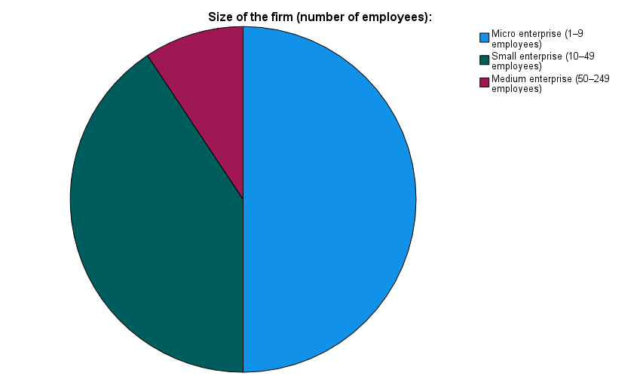
Figure 3 Size of the firm (number of employees)

Table 4 Demographic Question 2
Industry sub-sector:
 |  | Frequency | Percent | Valid Percent | Cumulative Percent
Valid | Food and beverage manufacturing | 43 | 28.7 | 28.7 | 28.7
Valid | Textile and apparel manufacturing | 54 | 36.0 | 36.0 | 64.7
Valid | Electronics and electrical equipment | 33 | 22.0 | 22.0 | 86.7
Valid | Metal and machinery manufacturing | 15 | 10.0 | 10.0 | 96.7
Valid | Other | 5 | 3.3 | 3.3 | 100.0
Valid | Total | 150 | 100.0 | 100.0

The ages of most firms are relatively young: 36% are less than 5 years old, 37.3% are between 5 and 10 years old, and only 10% are over 20 years old. About managing the international supply chain disruption, the younger firms might be less experienced, which can impact their resilience and decision-making. This is associated with RQ2 and RQ3 as it demonstrates the possibility of making mitigation strategies and operational efficiency dependent on firm maturity.
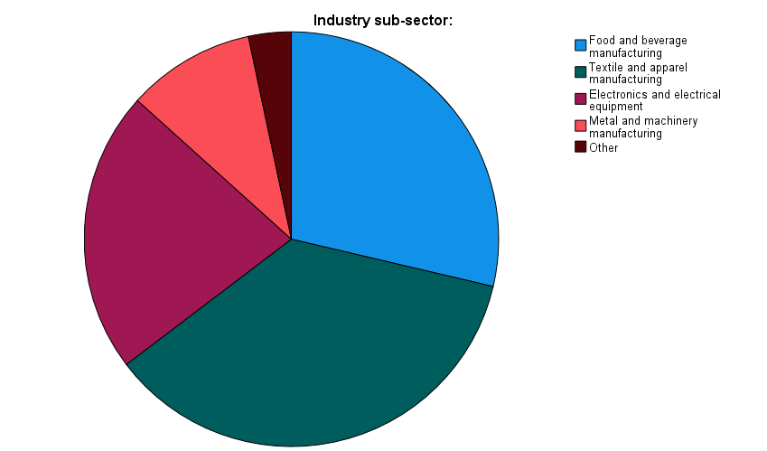
Figure 4 Industry sub-sector
Table 5 Demographic Question 3
Years of operation of the firm:
 |  | Frequency | Percent | Valid Percent | Cumulative Percent
Valid | Less than 5 years | 54 | 36.0 | 36.0 | 36.0
Valid | 5–10 years | 56 | 37.3 | 37.3 | 73.3
Valid | 11–20 years | 25 | 16.7 | 16.7 | 90.0
Valid | More than 20 years | 15 | 10.0 | 10.0 | 100.0
Valid | Total | 150 | 100.0 | 100.0

There is a combined 81.3 per cent agreement and strong agreement that geopolitical conflicts severely affect supply chains, with only 10.7 per cent of the respondents disagreeing. This shows that the influence of external politics is considered one of the key contributors to supply chain unpredictability by firms, and it directly answers RQ1 on the key causes of global disruptions. The high agreement reflects the significance of tracking events in the world as part of risk management planning (RQ3).
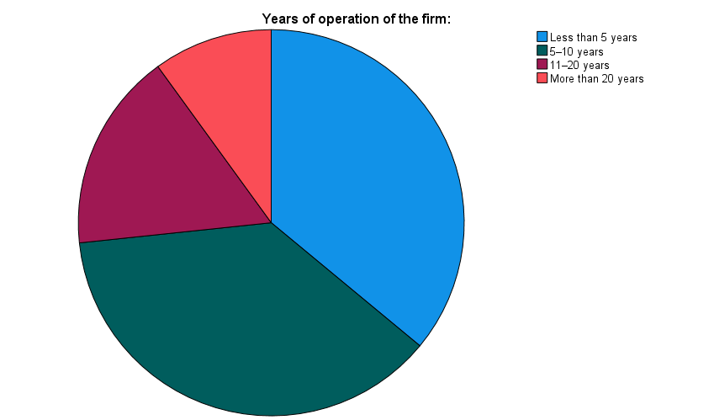
Figure 5 Years of operation of the firm
Table 6 Response to Questionnaire Statement 1
International geopolitical conflicts have significantly disrupted our supply chain operations.
 |  | Frequency | Percent | Valid Percent | Cumulative Percent
Valid | Strongly Disagree | 12 | 8.0 | 8.0 | 8.0
Valid | Disagree | 4 | 2.7 | 2.7 | 10.7
Valid | Neutral | 12 | 8.0 | 8.0 | 18.7
Valid | Agree | 75 | 50.0 | 50.0 | 68.7
Valid | Strongly Agree | 47 | 31.3 | 31.3 | 100.0
Valid | Total | 150 | 100.0 | 100.0

Three-quarters of the companies (75.3) say that the Brexit-related rules delay international sourcing, and 10.7% say they do not. This underlines regulatory disruptions as one of the critical influences on the supply chain reliability (RQ1). There is also a possibility that the delays will affect the production efficiency and cost management, which is a context of RQ2. To reduce these impacts, firms can either implement localised sourcing or diversification of suppliers (RQ3).
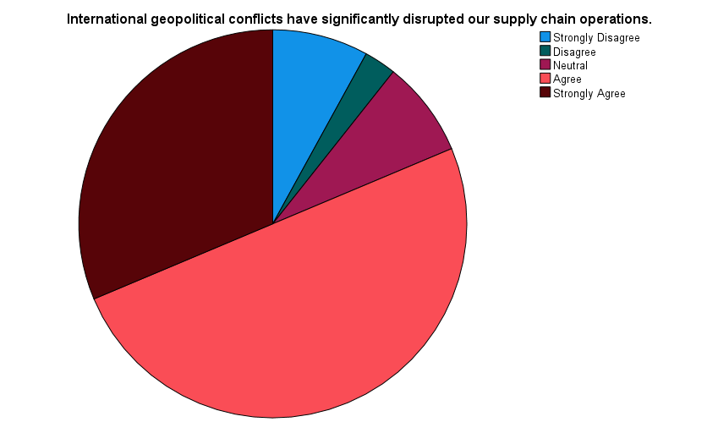
Figure 6 International geopolitical conflicts

Table 7 Response to Questionnaire Statement 2
Brexit-related trade regulations have caused delays in sourcing materials internationally.
 |  | Frequency | Percent | Valid Percent | Cumulative Percent
Valid | Strongly Disagree | 7 | 4.7 | 4.7 | 4.7
Valid | Disagree | 9 | 6.0 | 6.0 | 10.7
Valid | Neutral | 21 | 14.0 | 14.0 | 24.7
Valid | Agree | 77 | 51.3 | 51.3 | 76.0
Valid | Strongly Agree | 36 | 24.0 | 24.0 | 100.0
Valid | Total | 150 | 100.0 | 100.0

Three-quarters of the respondents (82 per cent) are in agreement or strongly agree that the increasing costs in transportation and logistics are a bad thing that impacts the reliability of supply, and those who do not agree are only 5.3 per cent. This implies that cost pressures are commonly understood as a factor that augments supply chain susceptibility (RQ1). These higher expenses will lower profit margins and pressure operational efficiency, which supports RQ2 regarding the financial and production impacts.
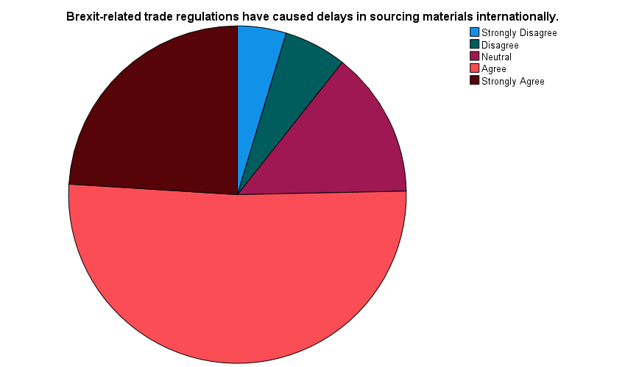
Figure 7 Brexit-related trade regulations
Table 8 Response to Questionnaire Statement 3
Rising global transportation and logistics costs have affected supply reliability.
 |  | Frequency | Percent | Valid Percent | Cumulative Percent
Valid | Strongly Disagree | 2 | 1.3 | 1.3 | 1.3
Valid | Disagree | 6 | 4.0 | 4.0 | 5.3
Valid | Neutral | 19 | 12.7 | 12.7 | 18.0
Valid | Agree | 85 | 56.7 | 56.7 | 74.7
Valid | Strongly Agree | 38 | 25.3 | 25.3 | 100.0
Valid | Total | 150 | 100.0 | 100.0

Sixty-eight point six per cent of those asked state that they agree or strongly agree that the dependence on foreign suppliers increases the risk of disruption, and this result demonstrates that the global dependency is one of the greatest weaknesses (RQ1). This dependency has the potential of increasing delays, cost unpredictability, and production efficiency, which is connected to RQ2. To reduce these risks, the firms can implement the suppliers diversification or nearshoring policy, which prompts RQ3.
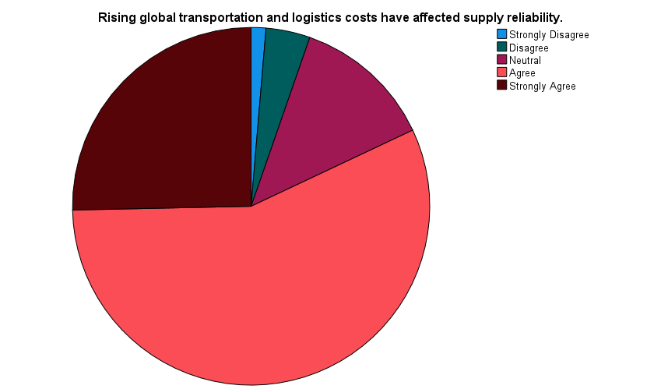
Figure 8 Rising global transportation and logistics costs
Table 9 Response to Questionnaire Statement 4
Dependence on overseas suppliers increases the risk of supply chain disruption.
 |  | Frequency | Percent | Valid Percent | Cumulative Percent
Valid | Strongly Disagree | 6 | 4.0 | 4.0 | 4.0
Valid | Disagree | 8 | 5.3 | 5.3 | 9.3
Valid | Neutral | 18 | 12.0 | 12.0 | 21.3
Valid | Agree | 59 | 39.3 | 39.3 | 60.7
Valid | Strongly Agree | 59 | 39.3 | 39.3 | 100.0
Valid | Total | 150 | 100.0 | 100.0

The majority (70.7% agree or strongly agree) believe that global supply chains face significant unseen risks, which may indicate a major operational problem due to a lack of visibility. Poor visibility may not allow timely identification of delays or quality problems to influence the cost and production schedules (RQ2). The digital monitoring tools are hence important mitigation strategies (RQ3).
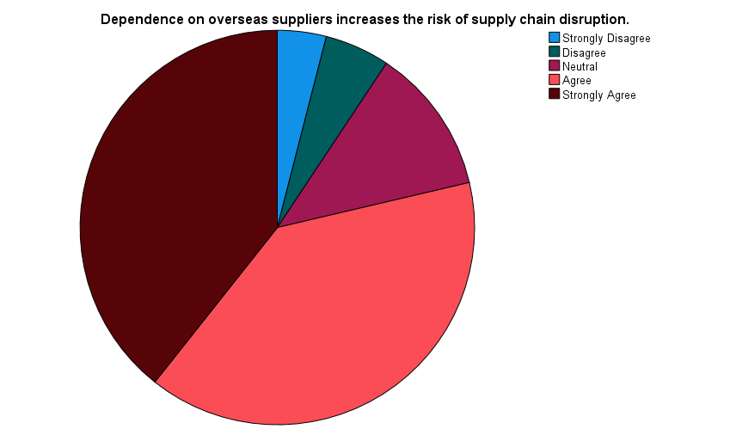
Figure 9 Dependence on overseas suppliers
Table 10 Response to Questionnaire Statement 5
Limited visibility into international suppliers contributes to unexpected disruptions.
 |  | Frequency | Percent | Valid Percent | Cumulative Percent
Valid | Strongly Disagree | 7 | 4.7 | 4.7 | 4.7
Valid | Disagree | 9 | 6.0 | 6.0 | 10.7
Valid | Neutral | 28 | 18.7 | 18.7 | 29.3
Valid | Agree | 69 | 46.0 | 46.0 | 75.3
Valid | Strongly Agree | 37 | 24.7 | 24.7 | 100.0
Valid | Total | 150 | 100.0 | 100.0

74.7 per cent of companies concur or even strongly agree that supply chain disruption often causes delays in the production timetable. This is a first-hand example of how operational interference can affect efficiency (RQ2), thereby influencing delivery punctuality and customer satisfaction. The finding implies the need for active measures, including working with suppliers and implementing technology-based monitoring systems to ensure the continuity of production (RQ3).
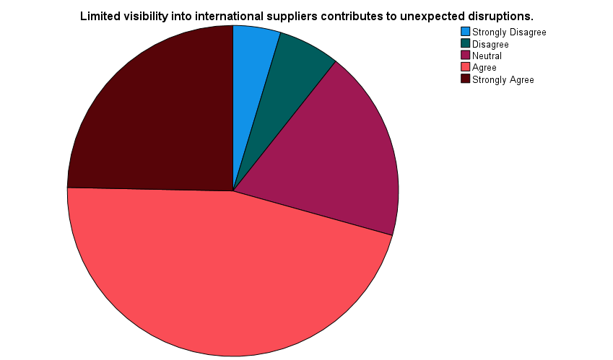
Figure 10 Limited visibility into international suppliers
Table 11 Response to Questionnaire Statement 6
Supply chain disruptions have caused frequent delays in production schedules.
 |  | Frequency | Percent | Valid Percent | Cumulative Percent
Valid | Strongly Disagree | 6 | 4.0 | 4.0 | 4.0
Valid | Disagree | 3 | 2.0 | 2.0 | 6.0
Valid | Neutral | 29 | 19.3 | 19.3 | 25.3
Valid | Agree | 64 | 42.7 | 42.7 | 68.0
Valid | Strongly Agree | 48 | 32.0 | 32.0 | 100.0
Valid | Total | 150 | 100.0 | 100.0

They have 64.6 per cent agreeableness, strongly agreeing that international disruptions add to the costs of production, with only 11.3 per cent saying that it does not. A direct financial effect of supply chain instability is associated with rising costs, which is connected to RQ2. Such cost pressures can affect pricing, profit margins, and overall competitiveness, and therefore firms seek mitigation strategies such as supplier diversification or nearshoring (RQ3).
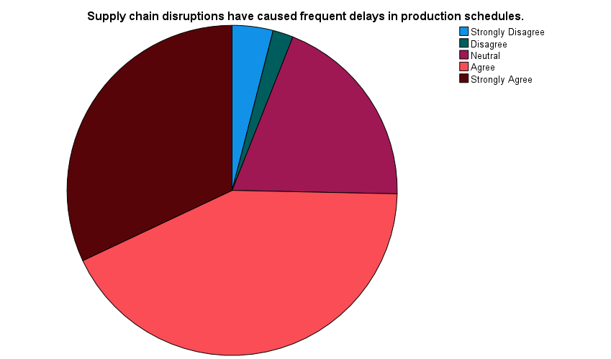
Figure 11 Frequent production delays
Table 12 Response to Questionnaire Statement 7
International supply disruptions have increased overall production costs.
 |  | Frequency | Percent | Valid Percent | Cumulative Percent
Valid | Strongly Disagree | 5 | 3.3 | 3.3 | 3.3
Valid | Disagree | 12 | 8.0 | 8.0 | 11.3
Valid | Neutral | 36 | 24.0 | 24.0 | 35.3
Valid | Agree | 56 | 37.3 | 37.3 | 72.7
Valid | Strongly Agree | 41 | 27.3 | 27.3 | 100.0
Valid | Total | 150 | 100.0 | 100.0

A majority of the respondents (62.6%) cite cost fluctuations in raw materials as one of the factors negatively impacting profit margins. It means that the implication of supply chain disruptions is financial, as it can affect the performance of businesses (RQ2). Firms can use hedging approaches or source locally to address volatility related to RQ3 on effective mitigation practices.
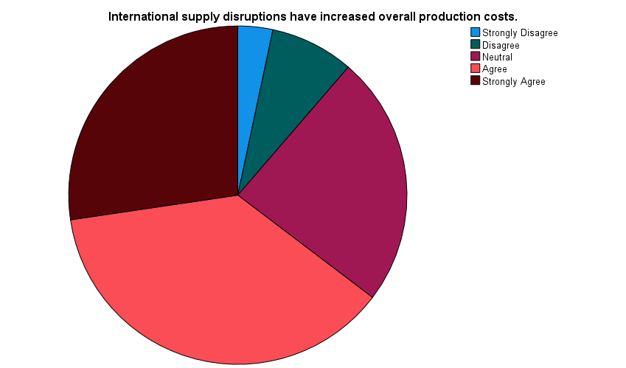
Figure 12 Increased production costs
Table 13 Response to Questionnaire Statement 8
Cost volatility in raw materials has negatively affected profit margins.
 |  | Frequency | Percent | Valid Percent | Cumulative Percent
Valid | Strongly Disagree | 4 | 2.7 | 2.7 | 2.7
Valid | Disagree | 9 | 6.0 | 6.0 | 8.7
Valid | Neutral | 43 | 28.7 | 28.7 | 37.3
Valid | Agree | 62 | 41.3 | 41.3 | 78.7
Valid | Strongly Agree | 32 | 21.3 | 21.3 | 100.0
Valid | Total | 150 | 100.0 | 100.0

Sixty-seven point three per cent of respondents agree or strongly agree that supply chain disruptions cause them to lose the capacity to deliver customer orders on time. This work emphasises efficiency and service-level issues (RQ2) and the need to focus on resilience mechanisms, including nearshoring, supplier partnership, or digital surveillance (RQ3).
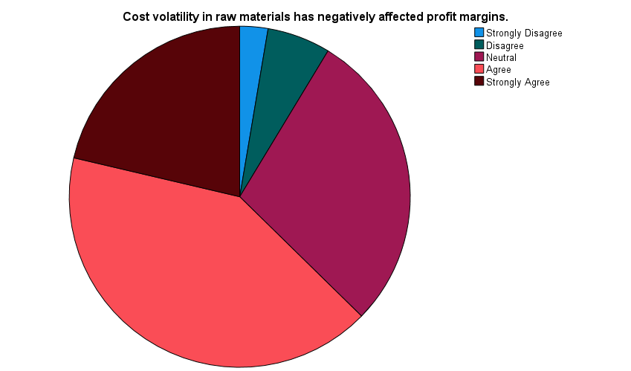
Figure 13 Raw material cost volatility
Table 14 Response to Questionnaire Statement 9
Supply chain disruptions have reduced our firm’s ability to meet customer demand on time.
 |  | Frequency | Percent | Valid Percent | Cumulative Percent
Valid | Strongly Disagree | 4 | 2.7 | 2.7 | 2.7
Valid | Disagree | 16 | 10.7 | 10.7 | 13.3
Valid | Neutral | 29 | 19.3 | 19.3 | 32.7
Valid | Agree | 72 | 48.0 | 48.0 | 80.7
Valid | Strongly Agree | 29 | 19.3 | 19.3 | 100.0
Valid | Total | 150 | 100.0 | 100.0

Sixty-seven point three per cent of respondents accept or strongly accept that international supply chain instability negatively impacts overall business performance. This is the combination of the operation and financial effects of disruptions, which is connected to RQ2. It highlights the necessity of sound risk mitigation measures, including diversification, technology adoption, and government assistance (RQ3).
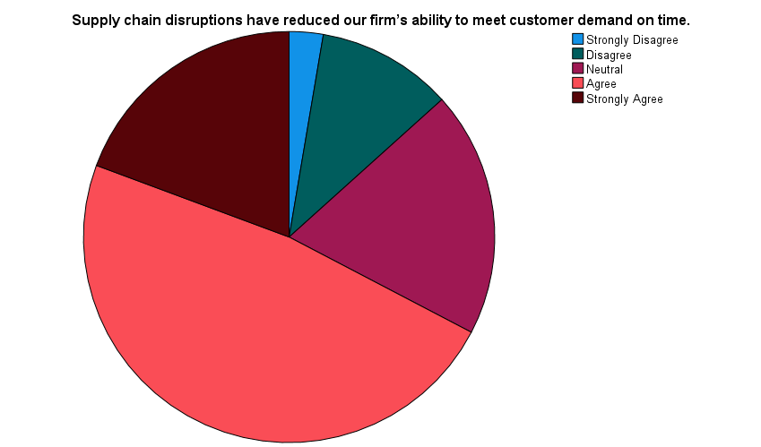
Figure 14 Reduced ability to meet customer demand
Table 15 Response to Questionnaire Statement 10
Overall business performance has declined due to international supply chain instability.
 |  | Frequency | Percent | Valid Percent | Cumulative Percent
Valid | Strongly Disagree | 4 | 2.7 | 2.7 | 2.7
Valid | Disagree | 7 | 4.7 | 4.7 | 7.3
Valid | Neutral | 38 | 25.3 | 25.3 | 32.7
Valid | Agree | 69 | 46.0 | 46.0 | 78.7
Valid | Strongly Agree | 32 | 21.3 | 21.3 | 100.0
Valid | Total | 150 | 100.0 | 100.0

67.3 per cent of firms report that diversifying suppliers reduces disruption, supporting a successful risk mitigation strategy (RQ3). The diversification will be beneficial in managing the dependence on certain suppliers, enhancing the continuation of production, and minimising the expenses or delivery risks, thereby indirectly contributing to the achievement of efficiency and business performance goals (RQ2).
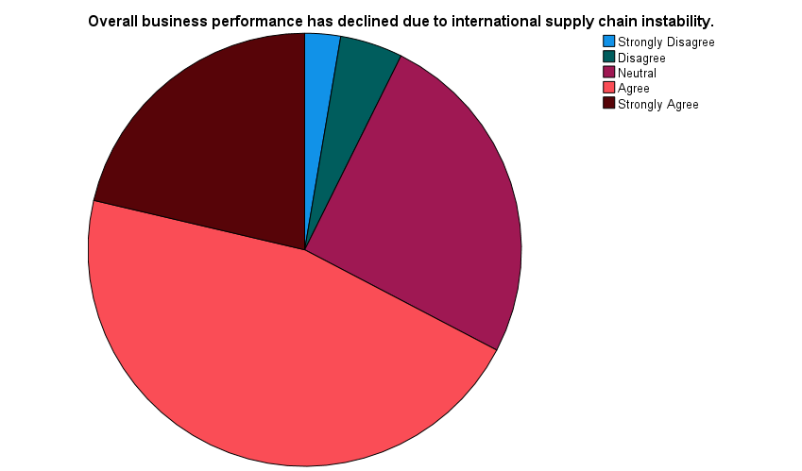
Figure 15 Decline in overall business performance
Table 16 Response to Questionnaire Statement 11
Supplier diversification has helped reduce the impact of supply chain disruptions.
 |  | Frequency | Percent | Valid Percent | Cumulative Percent
Valid | Strongly Disagree | 3 | 2.0 | 2.0 | 2.0
Valid | Disagree | 12 | 8.0 | 8.0 | 10.0
Valid | Neutral | 34 | 22.7 | 22.7 | 32.7
Valid | Agree | 66 | 44.0 | 44.0 | 76.7
Valid | Strongly Agree | 35 | 23.3 | 23.3 | 100.0
Valid | Total | 150 | 100.0 | 100.0

There is a 79.4 per cent agreement that nearshoring or local sourcing will increase the reliability of the supply chain. This is a mitigation measure that is closely applicable to RQ3 and demonstrates that decreasing reliance on remote vendors enhances efficiency in operations and minimises vulnerability to global shocks (RQ2).
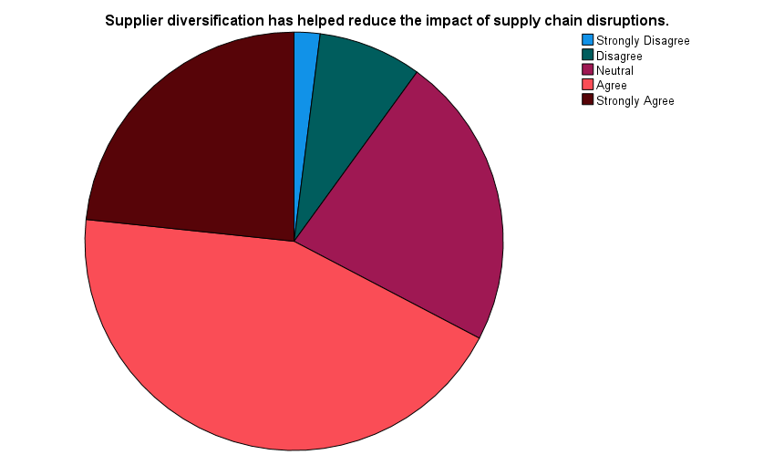
Figure 16 Supplier diversification
Table 17 Response to Questionnaire Statement 12
Nearshoring or local sourcing has improved supply chain reliability.
 |  | Frequency | Percent | Valid Percent | Cumulative Percent
Valid | Strongly Disagree | 4 | 2.7 | 2.7 | 2.7
Valid | Disagree | 10 | 6.7 | 6.7 | 9.3
Valid | Neutral | 17 | 11.3 | 11.3 | 20.7
Valid | Agree | 79 | 52.7 | 52.7 | 73.3
Valid | Strongly Agree | 40 | 26.7 | 26.7 | 100.0
Valid | Total | 150 | 100.0 | 100.0

Three-quarters (75.4) of companies believe that digital tools increase disruption readiness. The fact that it is highly adopted shows that technology has increasingly been used to manage supply chain risks (RQ3) and that monitoring enhances response time and minimises operational and financial effects (RQ2).
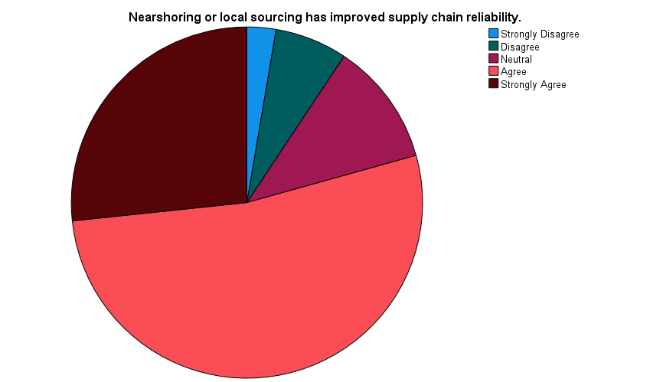
Figure 17 Nearshoring or local sourcing
Table 18 Response to Questionnaire Statement 13
Digital supply chain monitoring tools have enhanced disruption preparedness.
 |  | Frequency | Percent | Valid Percent | Cumulative Percent
Valid | Strongly Disagree | 4 | 2.7 | 2.7 | 2.7
Valid | Disagree | 9 | 6.0 | 6.0 | 8.7
Valid | Neutral | 24 | 16.0 | 16.0 | 24.7
Valid | Agree | 79 | 52.7 | 52.7 | 77.3
Valid | Strongly Agree | 34 | 22.7 | 22.7 | 100.0
Valid | Total | 150 | 100.0 | 100.0

70% of the participants say they agree or strongly agree that collaboration is a resilience enhancer. This emphasises the role of cooperative relationships in reducing supply chain risks (RQ3) and contributes to the continuity of operations through the implementation of improved coordination and contingency planning (RQ2).
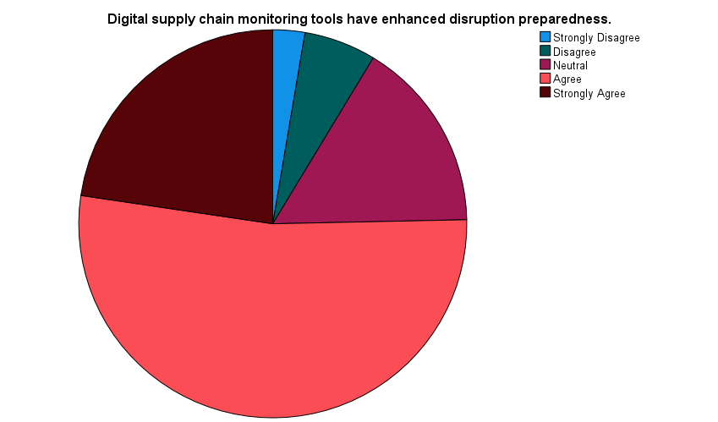
Figure 18 Digital supply chain monitoring tools
Table 19 Response to Questionnaire Statement 14
Collaboration with suppliers improves resilience during international disruptions.
 |  | Frequency | Percent | Valid Percent | Cumulative Percent
Valid | Strongly Disagree | 4 | 2.7 | 2.7 | 2.7
Valid | Disagree | 4 | 2.7 | 2.7 | 5.3
Valid | Neutral | 37 | 24.7 | 24.7 | 30.0
Valid | Agree | 73 | 48.7 | 48.7 | 78.7
Valid | Strongly Agree | 32 | 21.3 | 21.3 | 100.0
Valid | Total | 150 | 100.0 | 100.0

One out of every three (71.4) indicates that government support helps it in countering supply chain risks. It is an external intervention by which firms reduce the effects of operations and financial, which corroborates RQ3 on mitigation strategies. It also has an indirect effect of keeping the production efficiency and the general performance of the business (RQ2).
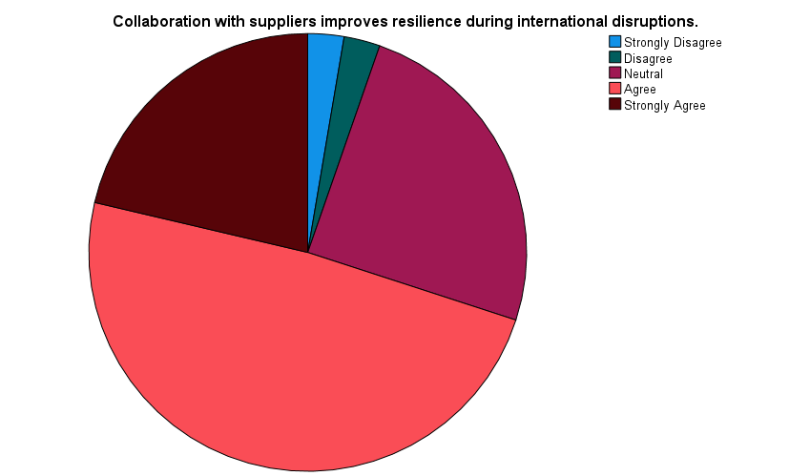
Figure 19 Collaboration with suppliers
Table 20 Response to Questionnaire Statement 15
Government support schemes have assisted in managing supply chain risks effectively.
 |  | Frequency | Percent | Valid Percent | Cumulative Percent
Valid | Strongly Disagree | 8 | 5.3 | 5.3 | 5.3
Valid | Disagree | 1 | 0.7 | 0.7 | 6.0
Valid | Neut  Ral | 34 | 22.7 | 22.7 | 28.7
Valid | Agree | 67 | 44.7 | 44.7 | 73.3
Valid | Strongly Agree | 40 | 26.7 | 26.7 | 100.0
Valid | Total | 150 | 100.0 | 100.0

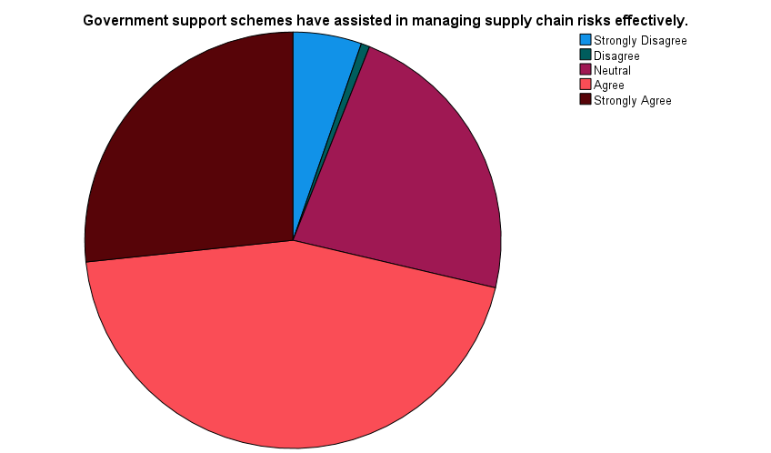
Figure 20 Government support schemes
This correlation should be change into same the up gargh as normal

4.4 Correlation Analysis
The correlation analysis indicates strong, significant positive relationships between supply chain disruption factors and their operational and strategic effects on UK manufacturing firms. Brexit-related trade delays are positively correlated with international geopolitical conflicts, with a very strong correlation (r = .790, p < 0.01), suggesting that multiple external factors jointly disrupt supply chains (RQ1). Increased logistics and reliance on foreign suppliers also have moderate to strong relationships with production delays, increased costs, and decreased customer responsiveness (r = 0.406-0.632, p < .01), as well as with the operational effects of these disruptions (RQ2). Low level of transparency towards international suppliers is strongly linked with low level of delivery performance (r = .655, p < 0.01), which underscores the importance of transparency in minimising risks.
Positively, the new use case of strategic mitigation measures, including supplier diversification, nearshoring, collaboration with suppliers, and government support, has a positive correlation with better operational results, with r ranging between.498 and 615 (p < 0.01), which justifies the fact that the improvement of operational outcomes is observed among firms using these strategies (RQ3). Digital supply chain monitoring reveals lesser yet significant correlations with disruption preparedness (r =.215 -.368, p < 0.01), though it does not fully negate greater scale strategic initiatives. All in all, the correlations indicate that external disruption factors are interconnected and that proactive approaches are essential to ensure efficiency, cost control, and business performance amid international supply chain pressures.
Correlations
 | Q1 | Q2 | Q3 | Q4 | Q5 | Q6 | Q7 | Q8 | Q9 | Q10 | Q11 | Q12 | Q13 | Q14 | Q15
Q1 | 1 | .790** | .558** | .542** | .567** | .475** | .424** | .562** | .592** | .473** | .449** | .582** | .215** | .551** | .499**
Q2 | .790** | 1 | .572** | .655** | .485** | .503** | .379** | .539** | .585** | .488** | .594** | .582** | .207* | .630** | .460**
Q3 | .558** | .572** | 1 | .606** | .441** | .581** | .507** | .356** | .587** | .510** | .439** | .455** | .224** | .504** | .440**
Q4 | .542** | .655** | .606** | 1 | .477** | .507** | .582** | .457** | .632** | .511** | .492** | .432** | .264** | .473** | .394**
Q5 | .567** | .485** | .441** | .477** | 1 | .446** | .432** | .483** | .655** | .576** | .391** | .630** | .254** | .478** | .577**
Q6 | .475** | .503** | .581** | .507** | .446** | 1 | .406** | .320** | .539** | .549** | .450** | .492** | .277** | .543** | .471**
Q7 | .424** | .379** | .507** | .582** | .432** | .406** | 1 | .463** | .469** | .548** | .441** | .293** | 0.101 | .366** | .482**
Q8 | .562** | .539** | .356** | .457** | .483** | .320** | .463** | 1 | .491** | .322** | .456** | .407** | 0.095 | .494** | .470**
Q9 | .592** | .585** | .587** | .632** | .655** | .539** | .469** | .491** | 1 | .564** | .465** | .580** | .295** | .466** | .596**
Q10 | .473** | .488** | .510** | .511** | .576** | .549** | .548** | .322** | .564** | 1 | .463** | .555** | .242** | .555** | .604**
Q11 | .449** | .594** | .439** | .492** | .391** | .450** | .441** | .456** | .465** | .463** | 1 | .498** | .180* | .535** | .378**
Q12 | .582** | .582** | .455** | .432** | .630** | .492** | .293** | .407** | .580** | .555** | .498** | 1 | .368** | .615** | .593**
Q13 | .215** | .207* | .224** | .264** | .254** | .277** | 0.101 | 0.095 | .295** | .242** | .180* | .368** | 1 | .284** | .243**
Q14 | .551** | .630** | .504** | .473** | .478** | .543** | .366** | .494** | .466** | .555** | .535** | .615** | .284** | 1 | .615**
Q15 | .499** | .460** | .440** | .394** | .577** | .471** | .482** | .470** | .596** | .604** | .378** | .593** | .243** | .615** | 1
**. Correlation is significant at the 0.01 level (2-tailed).
*. Correlation is significant at the 0.05 level (2-tailed).

4.5 Reliability Analysis

4.5.1 Reliability (Scale: Supply Chain Disruptions)
The scale of supply chain disruptions shows high internal consistency (Cronbach's alpha = 0.867, 0.869 with standardised items) using five items. This high score indicates that the items are always reliable measures of the construct of supply chain disruptions, as they capture different dimensions of factors such as geopolitical conflicts, logistical challenges, and supplier dependency. A good internal consistency guarantees that the results of the survey are consistent and reproducible, putting more confidence in the interpretation of the results. Measurement Disruptions are also essential in determining how they are affected and affected by the operational impact of production delays and increased costs, as well as determining the effectiveness of the mitigation strategies. Reliability can also be used to validate further analyses, such as correlations and regression, in answering RQ1 on the causes of disruption and RQ2 on the effect on business performance.
Table 21 Reliability (Scale: Supply Chain Disruptions
Reliability Statistics
Cronbach's Alpha | Cronbach's Alpha Based on Standardised Items | N of Items
0.867 | 0.869 | 5

4.5.2 Reliability (Scale: Business Performance Impact)
The score of Cronbach's alpha of the business performance impact scale is 0.814, which is a good internal consistency of the five items to assess operational and financial impacts of supply chain disruption. The high reliability confirms that the items (production efficiency, cost management, and overall business performance) are coherent in their indicators of the construct. Regular measurement will be necessary to assess the reliability of the analysis of supply chain disruption and mitigation measures in terms of performance outcomes, which will directly support RQ2 and RQ3. The reliability of the scale enhances confidence in the interpretation of statistical relationships, such as correlations and regression, and demonstrates that respondents' perceptions of the performance effects are consistent across the measured dimensions.
Table 22 Reliability (Scale: Business Performance Impact)
Reliability Statistics
Cronbach's Alpha | Cronbach's Alpha Based on Standardised Items | N of Items
0.814 | 0.814 | 5

4.5.3 Reliability (Scale: Business Performance Impact)
The impact of business performance measurement, measured second, has a Cronbach's alpha of 0.790 (0.791 standardised), an acceptable reliability for a five-item scale. This implies that the items are consistent enough to measure operational and financial performance outcomes caused by disruptions of supply chains. The consistency of measurements guarantees that the scale can be used later in further analyses, such as regression modelling, and that results linking disruptions and mitigation measures to business performance are sound. It gives the confidence that relationships observed are in reality relationships, as opposed to measurement error. This consistency also contributes to the overall validity of the study, as the responses are adequate to reflect the effects of supply chain concerns on UK manufacturing companies.
Table 23 Reliability (Scale: Business Performance Impact)
Reliability Statistics
Cronbach's Alpha | Cronbach's Alpha Based on Standardised Items | N of Items
0.790 | 0.791 | 5

4.6 Regression Analysis
The regression analysis ascertains the influence of supply chain disruption and mitigation approaches on the business performance of UK manufacturing companies. The model summary shows high positivity, with a positive relationship between the disruption and mitigation strategies. The R = 0.860 and R 2 = 0.739 values indicate that about 73.9 per cent of the influence on business performance is explained by the combination of disruption and mitigation strategies. The adjusted R 2 of 0.735 indicates the model's robustness, and the standard error of 0.38106 indicates low prediction error.
Table 24 Model Summary
Model Summary^{b}
Model | R | R Square | Adjusted R-Square | Std. Error of the Estimate | Change Statistics
 |  |  |  |  | R Square Change | F Change | df1 | df2 | Sig. F Change
1 | .860ª | 0.739 | 0.735 | 0.38106 | 0.739 | 207.998 | 2 | 147 | 0.000
a. Predictors: (Constant), Mitigation_Strategies, Supply_Chain_Disruptions
b. Dependent Variable: Business_Performance_Impact

The ANOVA findings indicate that the model is statistically significant (F = 207.998, p < 0.001), demonstrating that supply chain disruptions and mitigation strategies are reliable predictors of business performance.
Table 25 ANOVA
ANOVAª
Model |  | Sum of Squares | df | Mean Square | F | Sig.
1 | Regression | 60.405 | 2 | 30.203 | 207.998 | .000^{b}
1 | Residual | 21.345 | 147 | 0.145
1 | Total | 81.750 | 149
a. Dependent Variable: Business_Performance_Impact
b. Predictors: (Constant), Mitigation_Strategies, Supply_Chain_Disruptions

The coefficient analysis indicates a large positive influence (B = 0.549, β = 0.603, p < 0.001) when supply chain disruptions increase, supporting RQ2: as disruptions increase, the negative impacts on business performance increase. The impact of mitigation strategies is also positive (B = 0.330, 2 = 0.309, p < 0.001), indicating that the negative impact of the disruption can be mitigated through strategies such as supplier diversification, nearshoring, digital monitoring, and collaboration.
Table 26 Coefficient Analysis
Coefficientsª
Model |  | Unstandardized Coefficients |  | Standardized Coefficients | t | Sig.
 |  | B | Std. Error | Beta | t | Sig.
1 | (Constant) | 0.363 | 0.179 |  | 2.032 | 0.044
1 | Supply_Chain_Disruptions | 0.549 | 0.058 | 0.603 | 9.429 | 0.000
1 | Mitigation_Strategies | 0.330 | 0.068 | 0.309 | 4.835 | 0.000
a. Dependent Variable: Business_Performance_Impact

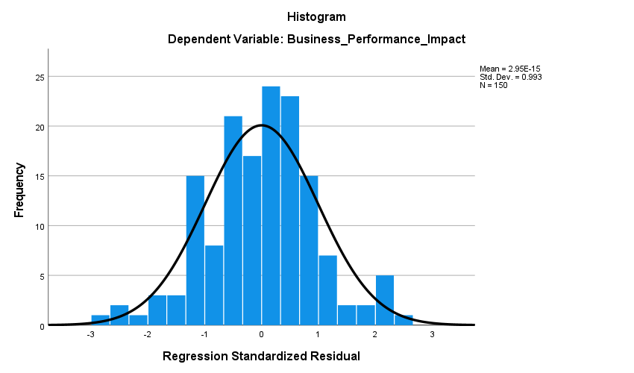
Figure 21 Histogram of the dependent variable

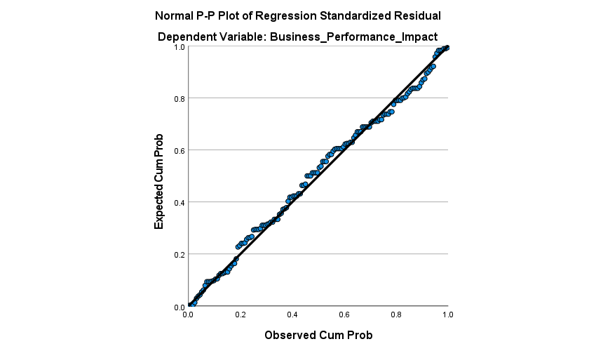
Figure 22 Normal P-Plot of Regression Standardised Residual

The overall outcome of the regression analysis indicates that although international supply chain disruptions have a major impact on production, costs, and overall performance, reactive mitigation measures can considerably soften these impacts, leading to operational stability and resilience for UK manufacturing companies
Till here and the both figure are same in the many student

4.7 Chapter Summary
Chapter 4 presents systematic analysis of 150 valid answers of UK manufacturing companies, which indicates high reliability and consistency of data. Descriptive statistics and frequency reports indicate that the most significant causes of supply chain disruption are geopolitical conflicts and the regulations related to Brexit, increasing logistics costs, and reliance on foreign suppliers, which negatively influences the productivity of production, its cost management, and the overall performance of the business. The results of correlation analysis reveal that there are strong positive correlations between disruption factors and operational effects, which demonstrates that the risks are interrelated. The reliability tests ensure high internal consistency of the measured constructs. Regression analysis reveals that there is a significant influence of supply chain disruptions on business performance ( = 0.603, p < 0.001) and mitigation strategies such as supplier diversification, nearshoring, digital monitoring, and collaboration moderately influence the effect ( = 0.309, p < 0.001). In general, the results highlight the importance of proactive mitigation measures in the context of building resilience, reducing operational and financial losses, and maintaining performance under international supply chain pressures.

Chapter 5: Discussion

5.1 Chapter Introduction
The chapter is a synthesis of the empirical data provided in Chapter 4 and puts it in the broader context of the research. It relates data analysis to the general discussion through a summary of the main results in the context of the research questions and compares them with the literature reviewed in Chapter 2. The practical, academic, and policy value of the study is also mentioned in the chapter and demonstrates how the study contributes to new knowledge specific to UK SME manufacturers. It is aimed at bringing together the evidence, showing the impacts of international supply chain disruptions on operations, costs and business performance and also seeking how SMEs cope with the challenges. The chapter has practical implications that can inform managers and policymakers on how to improve supply chain resiliency.

5.2 Overall Findings of the study
This research investigated the nature of, the impacts of, and remedies for supply chain disruption in UK manufacturing companies through the lens of 150 legitimate responses. According to Descriptive statistics (Table 2), the respondents have high levels of agreement that geopolitical conflicts, trade regulations associated with Brexit, increasing logistics costs, and dependence on foreign suppliers are the leading disruption factors, with mean scores of 3.7-4.0 and a median of 4. These values are high, which implies that there is a definite agreement between firms on the main causes of instability of the supply chain. Figure 6-9 also demonstrates that in more than 75 per cent of companies, these factors cause delays or cost increases, and that is apparent throughout the industry. Frequency analyses (Tables 35 and Figures 35) indicate that half of the firms are microenterprises, and fewer than 37% are less than 10 years old. This implies that smaller, younger organisations are especially susceptible to setbacks due to a lack of resources, experience, and operational strength. The sub-sector analysis shows that the sample is dominated by textile and apparel (36) and food and beverage manufacturing (28.7).
Figures 4 and 5 indicate that these industries face difficulties in their supply chain management, such as changing prices of raw materials and logistical delays, which correspond to the research questions on the causes (RQ1) and operational impacts (RQ2) of disruption. The correlation analysis (Table 1) shows strong positive correlations between disruption factors and operational impacts. For example, Brexit-related delays and geopolitical conflicts are strongly correlated (r = 0.790, p < 0.01), indicating that several external events together increase supply chain threats. Poor visibility of international suppliers, as indicated in Figure 10, and poor performance in delivery have a strong correlation, which underlines the significance of transparency in minimising operational risks. The mitigation measures, as illustrated in Figures 15 and 19 and Tables 16 and 20, are effective in reducing disruption.
Diversification of suppliers (67.3% agreement, Figure 15), nearshoring (79.4%, Figure 16), digital monitoring (75.4%, Figure 17), working with suppliers (70%, Figure 18), and government support (71.4, Figure 19) have a significant positive impact on the operational resilience. Regression analysis (Tables 24-26) indicates that disruptions negatively affect business performance ( = 0.603, p = 0.001), whereas mitigation strategies positively moderate this effect ( = 0.309, p = 0.001). In general, the analysis indicates that the effects of international supply chain disruptions are interdependent and powerful, influencing production efficiency, costs, and delivery reliability. Companies that use a mix of strategic and technological mitigation strategies have stronger resilience and performance. On balance, the figures and tables show that proactive risk management, transparency, and collaborative styles are critical to the continuity of operation and financial performance in UK manufacturing.

5.3 Findings Comparison with Literature Review
Findings of the study are consistent with and build on the existing literature, and give insights unique to the situation of the UK manufacturing. In line with global research, SMEs are at a disadvantage when it comes to supply chain disruptions. The principal disruptors were identified as geopolitical tensions, rising logistics costs, and reliance on foreign suppliers, consistent with the findings of Gurbuz et al. (2022) in Turkey and Asgary et al. (2020) worldwide. Nonetheless, this study points to trade regulations arising from Brexit as one of the factors that are singularly important in the UK, demonstrating that, even when localised, institutional change can be as disruptive as international shocks. This adds complexity to the literature by showing the compounded difficulties that UK SMEs face.
The operational and financial implications of disruptions are also gained through the findings. Although earlier research, including Syamsyul et al. (2023), focuses on conceptual categorisation of risks, the current research provides quantitative data on the actual effects of these risks on production efficiency, costs, and overall business performance in the UK. Speaking of mitigation strategies, nearshoring and supplier diversification proved the most useful, aligning with global models such as those of Onyeanuforo et al. (2024) and indicating that they are more strategically relevant in the UK due to Brexit. Conversely, digital monitoring tools were found to be less influential than anticipated, which concurs with warnings about the digital divide and resource scarcity in SMEs (Faiz et al., 2024), suggesting that basic network reorganisation must precede high-tech investment.
The theoretical perspectives are also reinforced and broadened by findings. The views of the Resource-Based View (RBV) (Barney, 2012) are affirmed, with internal resources being efficiently used in strategic adjustment. More to the point, the study provides strong evidence for the Dynamic Capabilities Theory (DCT) (Teece and Pisano, 1994), showing that SMEs perceive the risks of regulations and geopolitical factors, utilise nearshoring and diversification opportunities, and reorganise supply chains to sustain performance. Also, such a high dependence on partnership and collaboration has empirical support from the Relational View and Network Theory (Dyer and Singh, 1998), indicating that resilience is not constructed individually but is co-created through inter-firm networks, trust, and shared resources. On the whole, the research demonstrates that both internal factors and strategic external relationships condition resilience among SMEs. It fills gaps in the literature, offering UK-specific evidence, demonstrating the compounding effects of Brexit and global shocks, and highlighting the strategic prioritisation of physical and relational mitigation solutions over digital tools for resource-constrained SMEs.

5.4 Study contribution
This study presents significant scholarly, applied, and policy implications because it is a narrow, empirical study of supply chain disruptions in the UK manufacturing industry.
Academic Value: The article addresses a literature gap by providing a UK- and sector-specific, data-driven examination of the reasons, consequences, and solutions to supply chain disruptions. In contrast to most of the current research, which has put a lot of emphasis on COVID-19, this research paper takes into account a multi-crisis scenario, such as geopolitical tensions, Brexit, and increasing costs. It further evaluates theoretical constructs such as the Resource-Based View (RBV) (Barney, 2012) and the Dynamic Capabilities Theory (DCT) (Teece and Pisano, 1994) in a real-world, high-stress setting. These results indicate that although internal resource development is also noteworthy, network-based approaches, such as supplier diversification and networking, are even more critical when SMEs are responding to disruptions.
Practical contribution: The results can serve as practical advice for managers. By identifying the most critical disruptors and the most effective mitigation strategies, managers can prioritise interventions that enhance resilience and safeguard performance, including nearshoring, supplier diversification, and collaboration. The fact that the strategies have a quantifiable impact on mitigating the negative consequences of disruptions provides managers with a solid reason to implement costly strategic adjustments (Karanam et al., 2024). This assists the SMEs in making sound investment choices in resilience and operational continuity.
Policy Value: The study is also informative for policymakers, as it identifies key areas of pressure. The trade regulations associated with Brexit are the primary source of disruption, highlighting opportunities for trade facilitation. The fact that government support schemes are viewed positively indicates that these interventions are appreciated and working, and thus they should be continued and encouraged (Audretsch et al., 2025). Further, the role of the digital tools is limited, which implies that policies can prioritise incentives for technology implementation alongside the promotion of underlying resilience policies, including audits and grants to diversify suppliers.
Generally, the research provides vivid, evidence-based information that reinforces academic knowledge, informs managerial behaviour, and shapes policy formulations within the UK manufacturing industry.

5.5 Chapter Summary
This chapter introduces and discusses the main findings of empirical research on disruption in the international supply chains of manufacturing SMEs in the UK. According to the study, three primary disruptive factors have been identified: geopolitical strains, regulatory shifts, particularly Brexit-related regulations, and economic challenges, including rising logistics and material prices. All these act to reduce production efficiency, increase costs, and hurt the overall performance of the business. Notably, the research indicates feasible avenues to resiliency. Mitigation strategies, such as supplier diversification, near-shoring, and supplier collaboration, are highly effective at reducing the negative impact of disruptions. Although the results can be compared with the international body of knowledge on SME vulnerability, they provide valuable evidence for the UK, highlighting the importance of restructuring supply networks rather than relying solely on digital tools. The chapter highlights the practicality of the study to provide practical information to SME managers to reinforce operations and policymakers to reinforce the UK manufacturing industry in the unstable global market.

Chapter 6: Conclusion

6.1 Chapter introduction
The study analysed a critical issue to the UK economy, the impact of international supply chain shocks on manufacturing Small and Medium-sized Enterprises (SMEs). In the context of various crises, including the COVID-19 pandemic, Brexit, and geopolitical disputes, as well as increasing inflation rates, the purpose of the given study was to go beyond general vulnerability debates and to present an evidence-based analysis of the reasons, impacts, and mitigation mechanisms of SMEs. The present chapter is a conclusion of the key findings, based on the aims of the research, the practical and theoretical contributions to the study, limitations of the research, and recommendations for further research.

6.2 Findings for Each Objective
Objective 1: Identify the key causes of international supply chain disruptions affecting UK manufacturing firms
The study specifies a multifaceted combination of threats that UK manufacturing SMEs have to combat, showing that the disruption of the supply chain is hardly ever occasioned by a single element. The analysis of the survey revealed that the agreement on the number of causes was very high, as they were interrelated. More than 80% of respondents cited geopolitical issues, including the war in Ukraine and the Red Sea crisis, as the biggest disruptors, which shows that the high impact of global political instability on supply chain reliability is significant. In particular, trade regulations related to Brexit played a crucial role in the UK context, and 75.3% of companies emphasised long delays and the complexity of international sourcing. This observation shows that institutional or regulatory reforms can be disruptive, like macroeconomic shocks. Increased costs in global transportation and logistics were cited by 82 per cent of the respondents as one of the key causes of decreased reliability and profitability erosion, and it is still a structural issue facing SMEs.
The other major cause is associated with the business models of most SMEs, where they tend to be over-dependent on foreign suppliers. Three-quarters and eighty-six per cent of the respondents recognised that this reliance is a core risk, and this is further augmented by low visibility of supplier networks, which 70.7 per cent of the firms mentioned. Such a performance of non-transparency does not enable proactive management of risks and, in most cases, transforms any possible disruption into such an unforeseen crisis. All these reasons are not independent of each other but are in a synergistic manner. Geopolitical unrest and Brexit policies enhance volatility that escalates logistics expenses and reveal the dangers of relying on opaque supply chains. The results verify that UK SMEs are surrounded by a compounded disruption environment where global, regional, and structural vulnerability interplay with each other and increase their impact.
Objective 2: Assess the impact of these disruptions on production efficiency, cost management, and overall business performance
The above disruptions have obvious operational and financial implications for SMEs. Its most immediate operational effect is on the production schedules. Seventy-four point seven per cent of firms have indicated that they often experience production delays due to supply chain disruptions. This spills over into customer service, with 67.3% of respondents reporting lower on-time delivery performance. These observations are supported by correlation analysis, which indicates that there are strong correlations between the factors of disruption and the inefficiencies in operations. Economically, the impacts are also immense. Sixty-four point six per cent of the companies said that the international disruptions have raised the overall cost of production, and 62.6 per cent said that fluctuating prices of raw materials had an adverse effect on profit margins.
The effects were also quantified by means of the regression analysis, which indicated that an increase in the cost of logistics and the other effects of disruption is significantly linked to the increase in the costs of production. The operational delays, combined with the cost pressures, add to the degradation of the business performance. Sixty-seven per cent of the firms said that they have been adversely impacted by supply chain instability on their overall business performance. The outcomes of the regression analysis established a strong, positive relation between the perceived disruption severity and the negative performance outcomes. Essentially, this cause-and-effect chain can be traced: global shocks and structural vulnerability lead to operational failures, cost pressures, and loss of competitiveness, endangering the survival and expansion of UK manufacturing SMEs.
Objective 3: Explore strategies and best practices adopted by UK manufacturing firms to mitigate supply chain risks
The study also determines feasible solutions that are implemented by SMEs to deal with supply chain risk. The results indicate a portfolio of strategies, some of which are perceived to be more effective. The most approved strategies include reorganisation of the supply network itself. According to 79.4% of the firms, nearshoring or local sourcing has been reported to enhance supply reliability as a strategic change in order to lessen the geographic and international risk. Diversifying suppliers was also seen as important by 67.3 per cent of respondents as one way of diversifying risk among several suppliers, and developing a good working relationship with suppliers was an important aspect of resilience, as stated by 70 per cent. These results show that non-technological buffers to disruption include trust, communication, and information sharing.
One-third (75.4) of respondents recognised digital supply chain monitoring tools as being useful to enhance disruption preparedness. Nevertheless, they did not have a significant effect on the general business performance, which indicates that in the case of a resource-constrained SME, the digital tools may be regarded as an addition and not as an independent solution. Their performance is not effective without prior restructuring of supply networks and relationship-building. The 71.4% of firms also appreciated the use of external support, including government aid, to aid in coping with risk. The regression analysis was used to prove that a combination of these mitigation strategies has a strong positive moderating influence. This implies that companies that apply both network reorganisation, supplier diversification, collaborative, digital and external-support strategies are more equipped to minimise the adverse effects of disruptions on performance. The findings are empirical support of the significance of active risk management and strategic adjustment in ensuring SME competitiveness.

6.3 Theoretical Contribution
This research contributes significantly to the theory in the areas of SME resilience and supply chain management. It gives substantial empirical evidence on a compound framework involving the Resource-Based View, Dynamic Capabilities Theory, and Network Theory. Results indicate that resilience is not a result of a single perspective but a combination of these perspectives. Although the role of internal resources and technology is essential, dynamic capabilities, in particular, the possibility to foresee geopolitical and regulatory threats and redesign the supply chains with the help of nearshoring and diversification, are essential in turbulent systems. The Relational View and the Network Theory are also confirmed, as the study also supports the significance of collaboration and close relations with suppliers.

6.4 Practical Contribution
The research has direct implications for SME managers, industry organisations and policymakers. To managers, it is an evidence-based prioritisation guide that is clear to follow. The results emphasise that supplier diversification and nearshoring investments can be more efficient than sophisticated digital solutions for many SMEs and assist managers in making data-driven decisions to decrease the adverse effects of disruptions. To industry agencies and consultants, the study provides industry standards of typical problems and an appropriate reaction, instructing training, resilience audit, and best-practice manuals in line with UK manufacturing. The study defines regulations related to Brexit as one of the disruptors to policymakers, indicating the points of trade facilitation. The government schemes are appreciated, but interventions can be optimised to assist SMEs in making expensive strategic changes, including supplier diversification and inventory buffer, instead of generic prescriptions or grants to go digital. Lastly, the findings on trade-related disruptions can be used to underpin policy advocacy, which will support trade agreements and domestic support policy that is informed by the realities of trade operations by the UK manufacturing SMEs.

6.5 Limitations
This study is tightly designed; however, there are numerous limitations that inform its findings. The primary weakness has been the application of only one quantitative method, utilising structured questionnaires. Although useful in finding patterns and testing relationships, this methodology is incapable of getting a detailed qualitative experience of individual firms, managerial decision-making or the richness of supplier relations. A sample size of 150 (even though adequate to conduct statistical analysis) cannot provide a comprehensive insight into the sub-sectors and might not be representative of the heterogeneity of manufacturing SMEs in the UK. The research concentrates on the UK alone, and the results, particularly those that relate to Brexit, are in the context of the UK and may not be applicable in other nations directly. Moreover, the cross-sectional design offers a time-point view, which will not allow one to study the dynamics of resilience and strategies in the case of long-term disruptions. These restrictions do not weaken the study, but they point out the limitation in the scope of their applicability.

6.7 Future Research Avenues
Findings and limitations of the study indicate that there are a number of directions that future research can take. The next step that could be helpful would be a mixed-methods approach, i.e. a combination of quantitative surveys and extensive qualitative case studies or interviews. This may explain the causes of statistical trends, including the complexity of supplier diversification or the dynamics of effective cooperation. Long-term longitudinal studies of SMEs would be useful to determine the sustainability and the long-term effectiveness of resilience strategies. Comparative study of manufacturing sub-sectors, e.g. electronics and food and beverage, may assist in developing custom-made resilience models. It would help expand the study to the SMEs in the EU or North America to identify which supply chain issues are universal and the ones unique to the UK situation. These would develop a more detailed and practical concept of SME resilience in a fluctuating global economy.
Overall, this research shows that UK manufacturing SMEs are highly interconnected in a risk environment where geopolitical tensions, regulatory changes, and structural reliance interact to disrupt supply chains. Such disruptions can be quantified in terms of negative impacts on the efficiency of production, costs and the general performance of the business. Nevertheless, companies that adopt a proactive blend of mitigation measures, such as nearshoring, supplier diversification, collaborative relationships, digital tracking, and external support, can curb them to a large extent.

7.0 References
Ali, A., Abdallah, Alomair, A. and Naim, A. (2024). The Role of Digital Supply Chain on Inventory Management Effectiveness within Engineering Companies in Jordan. Sustainability, [online] 16(18), pp.8031–8031. doi:https://doi.org/10.3390/su16188031.
Alquraish, M. (2025). Digital Transformation, Supply Chain Resilience, and Sustainability: A Comprehensive Review with Implications for Saudi Arabian Manufacturing. Sustainability, [online] 17(10), p.4495. doi:https://doi.org/10.3390/su17104495.
Alshahrani, M.A. and Salam, M.A. (2022). The Role of Supply Chain Resilience on SMEs’ Performance: The Case of an Emerging Economy. Logistics, [online] 6(3), p.47. doi:https://doi.org/10.3390/logistics6030047.
Asgary, A., Ozdemir, A.I. and Özyürek, H. (2020). Small and Medium Enterprises and Global Risks: Evidence from Manufacturing SMEs in Turkey. International Journal of Disaster Risk Science, [online] 11(1), pp.59–73. doi:https://doi.org/10.1007/s13753-020-00247-0.
Audretsch, D.B., Aronica, M., Belitski, M., Caddemi, D. and Piacentino, D. (2025). The impact of government financial aid and digital tools on firm survival during the COVID-19 pandemic. Small Business Economics. doi: https://doi.org/10.1007/s11187-025-01014-5.
Bailey, D., De Propris, L., De Ruyter, A., Hearne, D. and Ortega-Argilés, R. (2023). Brexit, Trade and UK Advanced Manufacturing sectors: a Midlands’ Perspective. Contemporary Social Science, 18(2), pp.1–16.
Barroga, E. and Matanguihan, G.J. (2022). A Practical Guide to Writing Quantitative and Qualitative Research Questions and Hypotheses in Scholarly Articles. Journal of Korean Medical Science, 37(16). doi:https://doi.org/10.3346/jkms.2022.37.e121.
Bateh, D. (2024). Supply chain disruptions and their effect on suppliers and consumers in the marketplace. Forum for Economic and Financial Studies, [online] 2(1), pp.343–343. doi:https://doi.org/10.59400/fefs.v2i1.343.
Behfar, K. and Okhuysen, G.A. (2018). Perspective—Discovery Within Validation Logic: Deliberately Surfacing, Complementing, and Substituting Abductive Reasoning in Hypothetico-Deductive Inquiry. Organization Science, 29(2), pp.323–340. doi:https://doi.org/10.1287/orsc.2017.1193.
Bhat, M.A., Hurrah, F.A. and Sangmi, M. (2025). Supply chain cost management: An integrated systematic review and bibliometric analysis . International Journal of Foreign Trade and International Business, [online] 7(1). Available at: https://www.foreigntradejournal.com/article/view/152/7-1-21.
Bryman, A. and Bell, E. (2015). Business Research Methods. 5th ed. Oxford: Oxford University Press.
Creswell, J.W. and Creswell, J.D. (2018). Research design: qualitative, quantitative, and Mixed Methods Approaches. 5th ed. Thousand Oaks, California: SAGE Publications.
Do, H., Nguyen, B. and Dao, M. (2025). Social capital and SME innovations: the importance of knowledge combination and customer demands. Small Business Economics, [online] pp.1–38. doi:https://doi.org/10.1007/s11187-025-01105-3.
Du, L., Razzaq, A. and Waqas, M. (2022). The impact of COVID-19 on small- and medium-sized enterprises (SMEs): empirical evidence for green economic implications. Environmental Science and Pollution Research, 30(1). doi:https://doi.org/10.1007/s11356-022-22221-7.
Dyer, J.H. and Singh, H. (1998). The Relational View: Cooperative Strategy and Sources of Interorganizational Competitive Advantage. The Academy of Management Review, [online] 23(4), pp.660–679. doi:https://doi.org/10.2307/259056.
Ellis, N., Elsayed, H., Chivite-Matthews, N., Telford, P., Wright, N., Wong, T., Patev, B. and Gladstone, E. (2022). Barriers of exporting businesses and the role of export promotion in addressing them. [online] Available at: https://assets.publishing.service.gov.uk/media/6304e2ec8fa8f5536aea070b/barriers-of-exporting-businesses-and-the-role-of-export-promotion-in-addressing-them.pdf.
Etemad, H. (2020). Managing uncertain consequences of a global crisis: SMEs encountering adversities, losses, and new opportunities. Journal of International Entrepreneurship, 18(2), pp.125–144.
Etikan, I., Musa, S.A. and Alkassim, R.S. (2016). Comparison of convenience sampling and purposive sampling. American Journal of Theoretical and Applied Statistics, 5(1), pp.1–4. doi:https://doi.org/10.11648/j.ajtas.20160501.11.
Faiz, F., Le, V. and Masli, E.K. (2024). Determinants of digital technology adoption in innovative SMEs. Journal of Innovation & Knowledge, [online] 9(4), p.100610. doi:https://doi.org/10.1016/j.jik.2024.100610.
Foli, S., Durst, S. and Temel, S. (2022). The link between supply chain risk management and innovation performance in SMEs in turbulent times. Journal of Entrepreneurship in Emerging Economies. doi:https://doi.org/10.1108/jeee-03-2022-0084.
Foroughi, A. (2025). Challenges and Opportunities for SMEs in Supply Chain Digital Transformation. Archives of Business Research, 13(05), pp.01-23. doi:https://doi.org/10.14738/abr.1305.18667.
Fouejieu, A.P., Ndoye, A. and Sydorenko, T. (2020). Unlocking Access to Finance for SMEs: A Cross-Country Analysis. IMF Working Papers, [online] 2020(055). doi:https://doi.org/10.5089/9781513536156.001.A001.
Gamage, S.K.N., Ekanayake, E., Abeyrathne, G., Prasanna, R., Jayasundara, J. and Rajapakshe, P. (2020). A Review of Global Challenges and Survival Strategies of Small and Medium Enterprises (SMEs). Economies, 8(4), p.79.
Gherghina, S.C., Botezatu, M.A., Hosszu, A. and Simionescu, L.N. (2020). Small and Medium-Sized Enterprises (SMEs): The Engine of Economic Growth through Investments and Innovation. Sustainability, 12(1), p.347.
GOV.UK (2024). Business population estimates for the UK and regions 2024: statistical release. [online] GOV.UK. Available at: https://www.gov.uk/government/statistics/business-population-estimates-2024/business-population-estimates-for-the-uk-and-regions-2024-statistical-release.
Gov.UK (2023). BEIS Small and Medium Enterprises (SMEs) Action plan: 2022 to 2025 (accessible webpage). [online] GOV.UK. Available at: https://www.gov.uk/government/publications/beis-small-and-medium-enterprises-sme-action-plan-2022-to-2025/beis-small-and-medium-enterprises-smes-action-plan-2022-to-2025-accessible-webpage.
Guo, Y., Liu, F., Song, J.-S. and Wang, S. (2024). Supply Chain Resilience: a Review from the Inventory Management Perspective. Fundamental Research, [online] 5(2), pp.1–14. doi:https://doi.org/10.1016/j.fmre.2024.08.002.
Gurbuz, M.C., Yurt, O., Ozdemir, S., Sena, V. and Yu, W. (2022). Global supply chains risks and COVID-19: Supply chain structure as a mitigating strategy for small and medium-sized enterprises. Journal of Business Research, 155, p.113407. doi:https://doi.org/10.1016/j.jbusres.2022.113407.
Gurtu, A. and Johny, J. (2021). Supply chain risk management: Literature review. Risks, [online] 9(1), pp.1–16. doi:https://doi.org/10.3390/risks9010016.
Hafeez, S., Shahzad, K., Helo, P. and Mubarak, M.F. (2025). Knowledge Management and SMEs’ Digital transformation: a Systematic Literature Review and Future Research Agenda. Journal of Innovation & Knowledge, [online] 10(3), p.100728. doi:https://doi.org/10.1016/j.jik.2025.100728.
Hafeez, S., Shahzad, K. and Silva, M.D. (2025). Enhancing Digital Transformation in SMEs: The Dynamic Capabilities of Innovation Intermediaries within Ecosystems. Long Range Planning, pp.102525–102525. doi:https://doi.org/10.1016/j.lrp.2025.102525.
Hair, J., Anderson, R., Black, B. and Babin, B. (2022). Multivariate Data Analysis. 8th ed. Pearson Higher Ed.
Hsu, C.-H., Yu, R.-Y., Chang, A.-Y., Chung, W.-H. and Liu, W.-L. (2021). Resilience-Enhancing Solution to Mitigate Risk for Sustainable Supply Chain—An Empirical Study of Elevator Manufacturing. Processes, [online] 9(4), p.596. doi:https://doi.org/10.3390/pr9040596.
Ivalua (2024). UK Businesses in the Middle of a Chain Reaction, with Nearly Half Experiencing a Surge in Supply Chain Disruption | Ivalua. [online] Ivalua. Available at: https://www.ivalua.com/press-releases/uk-businesses-in-the-middle-of-a-chain-reaction-with-nearly-half-experiencing-a-surge-in-supply-chain-disruption/.
Kanyepe, J., Musasa, T. and Wilbert, M. (2025). Supply Chain Risk Factors, Technological Capabilities, and Firm Performance of Small to Medium Enterprises (SMEs). Journal of Small Business Strategy, 35(1). doi:https://doi.org/10.53703/001c.125910.
Karanam, R.K., Sachani, D.K., Natakam, V.M., Yarlagadda, V.K. and Varma, R. (2024). Resilient Supply Chains: Strategies for Managing Disruptions in a Globalized Economy. American Journal of Trade and Policy, 11(1), pp.7–16. doi: https://doi.org/10.18034/ajtp.v11i1.719.
Kero, C.A. and Bogale, A.T. (2023). A systematic review of resource-based view and dynamic capabilities of firms and future research avenues. International Journal of Sustainable Development and Planning, 18(10), pp.3137–3154. doi:https://doi.org/10.18280/ijsdp.181016.
Kiessling, T., Dabić, M., Sandep, Y., Huck, N. and Maley, J.F. (2024). Supply Chain Disruptions and Need for Resilience: SMEs Direct/Indirect Exporting and Rapid Internationalization. IEEE Transactions on Engineering Management, pp.1–43. doi:https://doi.org/10.1109/tem.2024.3514701.
Kot, S., Haque, A. and Baloch, A. (2020). Supply Chain Management in Smes: Global Perspective. Montenegrin Journal of Economics, 16(1), pp.87–104. doi:https://doi.org/10.14254/1800-5845/2020.16-1.6.
Krejcie, R.V. and Morgan, D.W. (1970). Determining Sample Size for Research Activities. Educational and Psychological Measurement, 30(3), pp.607–610. doi:https://doi.org/10.1177/001316447003000308.
Lin, D.-Y., Rayavarapu, S.N., Tadjeddine, K. and Yeoh, R. (2022). Helping small and medium-size enterprises thrive | McKinsey. [online] www.mckinsey.com. Available at: https://www.mckinsey.com/industries/public-sector/our-insights/beyond-financials-helping-small-and-medium-size-enterprises-thrive.
Lubis, N.W. (2022). Resource Based View (RBV) in Improving Company Strategic Capacity. Research Horizon, 2(6), pp.587–596. doi:https://doi.org/10.54518/rh.2.6.2022.587-596.
Madhani, P.M. (2010). The Resource-Based View (RBV): Issues and Perspectives. [online] ResearchGate. Available at: https://www.researchgate.net/publication/45072517_The_Resource-Based_View_RBV_Issues_and_Perspectives.
Mishra, A., Gupta, N. and Jha, G.K. (2024). Supply Chain Resilience: Adapting to Global Disruptions and Uncertainty. International Journal of Innovative Research in Engineering, 5(2), pp.189–196. doi:https://doi.org/10.59256/ijire.20240502025.
Negi, P., Jaiswal, A. and Rekunenko, I. (2025). Supply Chain Resilience, Organizational Effectiveness, and Firm Performance: A Systematic Review and Future Research Agenda. Sage Open, 15(4). doi:https://doi.org/10.1177/21582440251393994.
Onyeanuforo, U.L., Suotonye, B. and Alfa, C. (2024). The Impact of Global Supply Chain Disruptions on UK SMEs’ International Business Strategies: A Post-Pandemic Analysis. INTERNATIONAL JOURNAL OF SOCIAL SCIENCES AND MANAGEMENT RESEARCH, [online] Vol 10.(No. 11). doi:https://doi.org/10.56201/ijssmr.v10.no11.2024.pg.403.413.
Orlando, B., Tortora, D., Pezzi, A. and Bitbol-Saba, N. (2021). The disruption of the international supply chain: Firm resilience and knowledge preparedness to tackle the COVID-19 outbreak. Journal of International Management, 28(1), p.100876. doi:https://doi.org/10.1016/j.intman.2021.100876.
Pertheban, T.R., Thurasamy, R., Marimuthu, A., Venkatachalam, K.R., Annamalah, S., Paraman, P. and Hoo, W.C. (2023). The Impact of Proactive Resilience Strategies on Organizational Performance: Role of Ambidextrous and Dynamic Capabilities of SMEs in Manufacturing Sector. Sustainability, 15(16), p.12665. doi:https://doi.org/10.3390/su151612665.
Quaquebeke, N.V., Salem, M., van Dijke, M. and Wenzel, R. (2022). Conducting organizational survey and experimental research online: From convenient to ambitious in study designs, recruiting, and data quality. Organizational Psychology Review, 12(3), p.204138662210975.
Rosenman, R., Tennekoon, V. and Hill, L.G. (2011). Measuring Bias in self-reported Data. International Journal of Behavioural and Healthcare Research, 2(4), pp.320–332. doi:https://doi.org/10.1504/ijbhr.2011.043414.
Roxas, B. and Lindsay, V. (2012). Social Desirability Bias in Survey Research on Sustainable Development in Small Firms: an Exploratory Analysis of Survey Mode Effect. Business Strategy and the Environment, 21(4), pp.223–235. doi:https://doi.org/10.1002/bse.730.
Saeedikiya, M., Salunke, S. and Kowalkiewicz, M. (2024). Toward a dynamic capability perspective of digital transformation in SMEs: A study of the mobility sector. Journal of Cleaner Production, [online] 439, p.140718. doi:https://doi.org/10.1016/j.jclepro.2024.140718.
Saunders, M., Lewis, P. and Thornhill, A. (2019). Research Methods for Business students. 8th ed. Pearson.
Setyadi, A., Pawirosumarto, S. and Damaris, A. (2025). Toward a Resilient and Sustainable Supply Chain: Operational Responses to Global Disruptions in the Post-COVID-19 Era. Sustainability, 17(13), pp.6167–6167. doi:https://doi.org/10.3390/su17136167.
Siameh, C. (2023). Brexit, Trade in Intermediates, and Global Value Chains: Beyond the UK and the EU . [online] Available at: https://thedocs.worldbank.org/en/doc/3e5537ac17a795823a3e3c46b12c0351-0050022023/related/30-Brexit-Trade-in-Intermediates-and-Global-Value-Chains-Beyond-the-UK-and-the-EU.pdf.
Singh, R.K., Neuert, C.E. and Raykov, T. (2023). Assessing conceptual comparability of single-item survey instruments with a mixed-methods approach. Quality & Quantity. doi:https://doi.org/10.1007/s11135-023-01801-w.
Sterrantino, A.F. (2024). Observational studies: Practical tips for avoiding common statistical pitfalls. The Lancet Regional Health - Southeast Asia, [online] 25(100415), p.100415. doi:https://doi.org/10.1016/j.lansea.2024.100415.
Syamsyul, U., Joo Yun, W., Rasi, Z. and Suhana Ithnin, H. (2023). Supply Chain Disruptions: Challenges and Mitigation Strategies in Manufacturing Companies. International Journal of Business and Social Science, [online] 14(4). doi:https://doi.org/10.30845/ijbss.v14n4p4.
Tao, J., Aamir, M., Shoaib, M., Yasir, N. and Babar, M. (2025). Bridging the Gap Between Supply Chain Risk and Organizational Performance Conditioning to Demand Uncertainty. Sustainability, 17(6), p.2462. doi:https://doi.org/10.3390/su17062462.
Teece, D., Peteraf, M. and Leih, S. (2016). Dynamic capabilities and organizational agility: Risk, uncertainty, and strategy in the innovation economy. California Management Review, 58(4), pp.13–35. doi:https://doi.org/10.1525/cmr.2016.58.4.13.
Teece, D.J. and Pisano, G.P. (1994). The Dynamic Capabilities of Firms: An Introduction. [online] ResearchGate. Available at: https://www.researchgate.net/publication/235362985_The_Dynamic_Capabilities_of_Firms_An_Introduction.
The Manufacturing Growth Program (2020). Weaker supply chains are hitting SMEs looking to recover from Covid-19 | Manufacturing Growth Programme. [online] Manufacturinggrowthprogramme.co.uk. Available at: https://www.manufacturinggrowthprogramme.co.uk/weaker-supply-chains-are-hitting-smes-looking-to-recover-from-covid-19/.
Tyrrell, M. (2025). Make UK urges government to adopt Estonia-style business support. [online] @UKMFGNews. Available at: https://www.pesmedia.com/make-uk-urges-government-to-adopt-estonia-style-business-support [Accessed 3 Dec. 2025].
Xu, Z., Elomri, A., Kerbache, L. and El Omri, A. (2020). Impacts of COVID-19 on Global Supply Chains: Facts and Perspectives. IEEE Engineering Management Review, [online] 48(3), pp.153–166. doi:https://doi.org/10.1109/EMR.2020.3018420.

