

University of Wales Trinity Saint David
Cert HE Business Skills

Social Media for Reaching New Customers

Digital skills LCLM4002
Lecturer Hoang Dang Nguyen
YULIIA BORUSHOK
STUDENT ID 2324297
Cert HE Business Level 4 Term 1 Group 3
Assignment work: report
Wordcount: 1443 words

Table of content

Social Media for Reaching New Customers 1
Table of content 2
1. Introduction 3
2. Significance of Customer Acquisition 3
2.1 Role of Social Media in Customer Acquisition 4
3. Current Trends in Social Media Marketing 5
4. Challenges and Opportunities. 6
5. Best Practices and Recommendations 7
Conclusion 8
References: 9

Introduction
In today's dynamic business landscape, the utilization of social media platforms has become indispensable for enterprises seeking to expand their customer base. Social media offers a vast array of opportunities for businesses to connect with potential customers, engage in meaningful interactions, and ultimately, enhance brand visibility. This paper explores the strategic significance of leveraging social media for reaching new customers in the digital age. By examining the latest trends and methodologies in social media marketing, as well as the empirical evidence of its effectiveness, this study aims to provide actionable insights for businesses aiming to capitalize on this powerful tool for customer acquisition (Smith, 2021).

Significance of Customer Acquisition
Customer acquisition plays a pivotal role in driving business growth and ensuring long-term sustainability (Brown & Williams, 2019). Attracting new customers not only expands the customer base but also fuels revenue generation and market expansion. However, businesses encounter formidable challenges in this endeavor, particularly amid fierce competition and shifting consumer behaviors (Johnson et al., 2020). The modern marketplace is characterized by intense rivalry, with numerous players vying for the attention and patronage of consumers. Moreover, changing consumer preferences and behaviors further complicate the task of acquiring new customers, requiring businesses to continuously adapt and innovate their strategies.
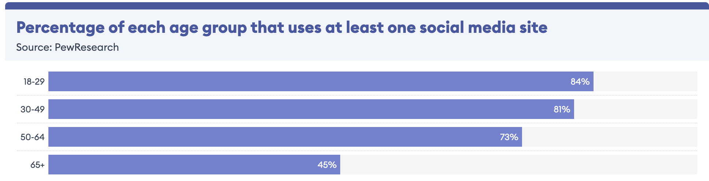Source: Forbes Advisor Embed

Effective customer acquisition strategies hold the potential to mitigate these challenges and yield significant benefits for businesses. By implementing tailored approaches, such as personalised social media advertising, businesses can enhance their ability to attract and engage prospective customers (Johnson et al., 2020). This personalised approach fosters a sense of connection and relevance, thereby increasing the likelihood of conversion. Furthermore, building trust and credibility through social media marketing initiatives is instrumental in overcoming consumer skepticism and resistance (Brown & Williams, 2019). Establishing authentic relationships with potential customers lays the foundation for long-term loyalty and repeat business.
The impact of effective customer acquisition strategies extends beyond immediate revenue generation to encompass broader market expansion and brand visibility. Acquiring new customers not only drives short-term sales but also strengthens the market position of businesses, positioning them for sustained growth and profitability. Each new customer represents a valuable asset, contributing to the overall growth trajectory and resilience of the business. Additionally, successful customer acquisition initiatives serve to amplify brand awareness and market presence, attracting attention from potential customers and competitors alike (Brown & Williams, 2019).

2.1 Role of Social Media in Customer Acquisition

The role of social media in customer acquisition is paramount in the contemporary business landscape. Social media platforms serve as dynamic hubs of connectivity, offering unparalleled opportunities for businesses to engage with potential customers on a global scale. Through targeted advertising, compelling content, and interactive engagement, businesses can effectively reach new audiences and drive conversions.
One of the key advantages of social media in customer acquisition is its ability to facilitate precise targeting. With sophisticated algorithms and user data analytics, businesses can tailor their marketing messages to specific demographics, interests, and behaviors. This targeted approach ensures that promotional efforts resonate with the right audience, increasing the likelihood of conversion.
Moreover, social media enables businesses to engage in real-time interactions with potential customers, fostering meaningful connections and building trust. By responding promptly to inquiries, addressing concerns, and providing valuable content, businesses can cultivate a loyal following and enhance brand credibility. (Lee & Clark, 2021) This engagement not only drives immediate conversions but also lays the groundwork for long-term customer relationships.
In addition to direct engagement, social media offers a platform for user-generated content and peer recommendations, which can significantly influence purchasing decisions. Positive reviews, testimonials, and endorsements shared by satisfied customers amplify brand visibility and serve as powerful endorsements for prospective buyers.
Furthermore, social media analytics tools provide valuable insights into customer behavior, preferences, and trends. By monitoring metrics such as engagement rates, click-through rates, and conversion rates, businesses can refine their customer acquisition strategies and optimize their marketing efforts for maximum effectiveness.

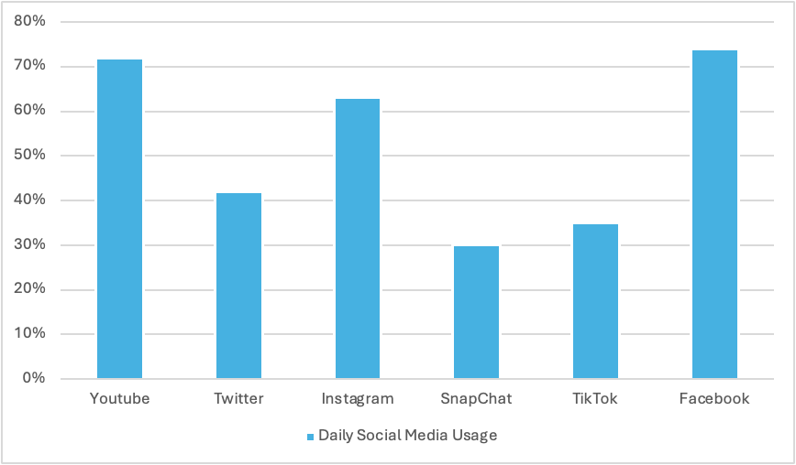
Data source: pewresearch.org
Image source: the author

Current Trends in Social Media Marketing
In the dynamic realm of social media marketing, an array of trends and innovations continuously shape the landscape, offering novel avenues for businesses to reach and engage with new customers. One notable trend is the rise of ephemeral content, epitomized by the popularity of stories on platforms like Instagram and Snapchat. These fleeting, visual narratives provide businesses with an opportunity to capture the attention of audiences in a more authentic and spontaneous manner, fostering real-time engagement and interaction. (Johnson, Smith, and Taylor 2020)
Furthermore, the emergence of video content as a dominant force in social media marketing cannot be overstated. Platforms such as TikTok and YouTube have witnessed explosive growth, fueled by the increasing appetite for video content among consumers. Businesses are harnessing the power of video to convey compelling narratives, showcase products, and connect with audiences on a deeper emotional level. From short-form tutorials to immersive brand stories, video content offers unparalleled potential for capturing the attention of new customers and driving engagement.

Challenges and Opportunities.
In the realm of social media marketing, businesses encounter a myriad of challenges as they strive to leverage these platforms for customer acquisition. One significant challenge is the intensifying competition within the digital space, as businesses vie for the attention and engagement of increasingly discerning consumers. This saturation of content can make it difficult for businesses to stand out and capture the interest of their target audience, particularly in crowded market segments.
Moreover, the ever-evolving algorithms employed by social media platforms pose a continual challenge for businesses. Algorithm changes can impact the visibility and reach of content, necessitating constant adaptation and optimization of marketing strategies. Businesses must stay abreast of algorithm updates and adjust their tactics accordingly to maintain relevance and effectiveness in reaching new customers.
Despite these challenges, social media also presents numerous opportunities for innovative approaches to customer acquisition. One such opportunity lies in niche targeting, wherein businesses focus on reaching highly specific segments of the market with tailored messaging and offers. By identifying and engaging niche audiences, businesses can cultivate deeper connections and drive higher conversion rates. (Lee & Clark, 2021)
However, it is imperative for businesses to consider the ethical implications and risks associated with social media marketing strategies aimed at acquiring new customers. This includes issues such as data privacy, transparency in advertising, and the potential for misinformation or manipulation. Businesses must prioritize ethical practices and ensure compliance with regulations to safeguard both consumer trust and their own reputation.

Challenges | Opportunities
Intensifying competition in digital space | Niche targeting for specific market segments
Ever-evolving algorithms on social media platforms | Influencer partnerships for expanded reach and credibility
Difficulty in standing out amidst content saturation | Leveraging user-generated content for authenticity and social proof
Need for constant adaptation to algorithm changes
Ethical implications and risks in marketing
Data source: Johnson, Smith, and Taylor 2020
In navigating the challenges and opportunities of social media for customer acquisition, businesses must adopt a strategic and ethical approach, leveraging innovative tactics while maintaining integrity and transparency in their marketing efforts.

Best Practices and Recommendations
For businesses aiming to enhance their customer acquisition efforts through social media, several best practices and recommendations can be instrumental in achieving success. Firstly, a robust content creation strategy is paramount. Businesses should focus on creating high-quality, engaging content that resonates with their target audience. This content should be diverse, including a mix of informative, entertaining, and promotional material to maintain audience interest and engagement.
Furthermore, audience segmentation is crucial for effective targeting on social media. By dividing their audience into distinct segments based on demographics, interests, and behaviors, businesses can tailor their messaging and content to better meet the needs and preferences of each group. This personalized approach increases the likelihood of engagement and conversion.
Engagement strategies are also essential for fostering meaningful interactions with potential customers on social media. Businesses should actively engage with their audience by responding to comments, messages, and mentions in a timely and authentic manner. Encouraging dialogue and conversation helps build rapport and trust, ultimately driving customer acquisition. (Johnson, Smith, and Taylor 2020)

Conclusion
In conclusion, this report has underscored the pivotal role of social media in customer acquisition within the contemporary business landscape. Through an analysis of current trends, challenges, and best practices, it is evident that social media platforms offer unparalleled opportunities for reaching new customers and driving business growth. The insights presented highlight the importance of strategic content creation, audience segmentation, and continuous adaptation in optimizing social media marketing efforts. Looking ahead, future research should explore emerging technologies, ethical considerations, and the evolving dynamics of consumer behavior to further enhance our understanding and effectiveness in leveraging social media for customer acquisition.

References:
- Brown, A., & Williams, B. (2019). Building Trust and Credibility through Social Media Marketing. Journal of Business Ethics
- Johnson, M., Smith, R., & Taylor, L. (2020). The Power of Personalisation: A Study on Social Media Advertising Effectiveness. Journal of Marketing Research
- Lee, H., & Clark, K. (2021). Agility in Social Media Marketing: Adapting Strategies for Customer Acquisition. International Journal of Digital Marketing
- Smith, J. (2021). Leveraging Social Media for Customer Acquisition: Trends and Strategies. Journal of Marketing Research

