Mohammed Abdul Farhan + Aidan Swan
Vito Construction Group Project
Civil Engineering Schedule of works
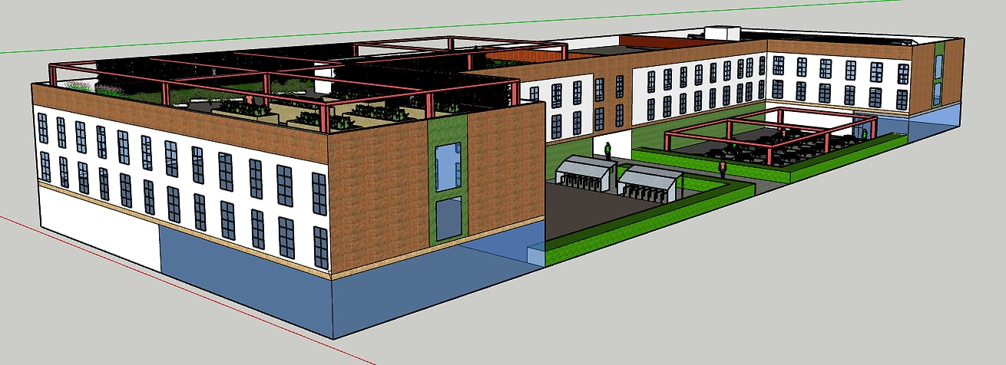

With every construction work and setting up build sites it is vital to take into consideration the list of work and the step by step guide to finish the work in a safe manner not only for the workers but the general public and the future use of the building. Schedule of work is without quantity data its presented more as an instructional list. For this build the following will give an indication of how we Vito Construction identify possible risks and how we will prevent major problems occurring.

PREPARATION INCUDES THE FOLLOWING:
- Assessing the climatic/environmental conditions.
- Access to and from the workplace.
- Notify neighbours should any of the hazards affect them.
- Specific instructions for employees.
- Plant and equipment is suitable for the intended use and inspected by a third party before use and is properly maintained.
- Personal Protective Equipment.
- Location of underground, above ground and overhead services are identified and clearly marked.
- Emergency and rescue procedures are setup in the event of an accident, injury or other emergency, including the means to protect any other persons in the vicinity.

SCHEDULE OF WORKS (BRIEF STEP BY STEP):

Foundation structures
- Soil sample testing to check if the soil is cohesive or non-cohesive. The risk of building on cohesive soil is the fact you may get substantial movement of the building before it sets and may not be solid, therefore removing majority of the cohesive soil or penetrating it to ensure it is safe for us to work on.
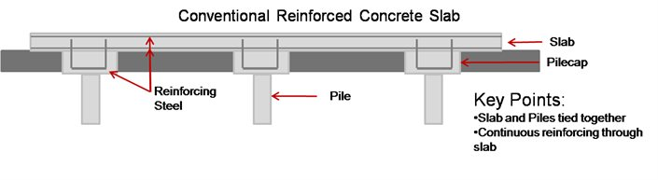
- Excavate the foundation to the required measurements for the building plan. The deep basement construction will require the work force to manually use the excavators and remove earth as safely as possible and ensuring safety is top priority. There could be nearby elderly walking past or even students therefore they are the highest priority to keep safe and away from any danger so the area will be locked off any of workers and construction site use only. Once excavation has been completed and has been satisfied with the construction manager, the foundation will be poured and laid down for the solid foundation which will be specified by the civil engineer.
- Once the pilling have been put in place, the concrete slabs will be put in accordance to the piles and around the required locations of the foundation and when this is done it keeps the slab and piles tied together. Pile supported slabs are considered as “deep foundations” and are introduced after geotechnical investigations have determined that the ground is inadequate for a ground supported slab.
Where pile-supported slabs are used, the sub-base is assumed to recede in the long-term, leaving the slab supported solely by the piles. However, the sub-base provides temporary support for the slab during construction until it has set enough to support itself. All piles are designed in accordance with Eurocode 7.
- Settlement is a very important consideration when designing ground-supported slabs. Uniform settlement across the area of the slab doesn’t usually cause any structural problems. However, differential settlement can cause a variety of problems:
- Damage to the slab – Because the slab support is effectively lowered in one area, the operational loads on the slab will cause it to experience bending moments for which it has not been designed.
- Loss of levelness – Even a relatively small loss of levelness can cause serious issues for very high racks and precise MHE.
- Loss of flatness – Cracks caused by any damage to the slab can affect its flatness. This can be problematic for some MHE.
- For concrete floor slabs, pile heads are very important additions to piles as they help to reduce the maximum bending moment experienced by the slab, by reducing the effective span. They also reduce the chance of the slab failing by punching shear from the pile.
- A well-constructed pile head should be level and have a smooth trowelled finish. According to TR34, the pile head’s level tolerance should be no greater than +0, -25mm with respect to the slab soffit and its slope should be no greater than 5mm over its width. Also, the head must not project above the sub-base.
- If a pile head is poorly constructed, it could cause restraint to the slab which is laid on top of it. This is to be avoided at all costs as piled supported slabs are usually steel fibre reinforced and ‘jointless’ so any cracks that propagate to the full depth of the slab could potentially have serious structural implications. To help minimise restraint on the slab from the pile head, an additional layer of slip membrane must be laid directly over, extending 300mm past the edge of the pile head in each direction.
Super-structure
The superstructure covers everything above the substructure, from walls to floors to roofing. The whole purpose of this superstructure is to enclose and divide space, as well as spread loads safely into the substructure. Within our building, you will find primary, secondary and finishing elements as well as the services. The primary elements are the main supporting, enclosing and protecting elements of the superstructure. There are 4 sections to this, walls, floors, roofs, stair well and lift.
- The external walls will be cavity walling with the use of brick. Cavity walling is simply using two brick walls built parallel to each other but does have a slight gap between acting as the cavity. The cavity walls acts as a barrier to weather and the outer leaf preventing rain and wind penetrating the inner leaf, the insulation inside the cavity is used to prevent heat loss and will be 150mm used according of course to the British standards and the planning portal.
- Once the concrete walls have been poured and in place and if needed with support to keep in place, workers are in a vulnerable position as the walls are heavy they will need to ensure it is safe to place it. The column’s will be put in the areas of the planning as it will be the best for support and for less loading stress and the bending moments.
- Internal walls are either load bearing, meaning they support any upper floors or roof and are in place to divide rooms into shapes and sizes. Solid block walls which is simple block work for the internal wall finish will be covered with plasterboard or plastered straight over to give a smooth finish to which then paint of wallpaper will be applied. The benefit of the solid block walls offer low thermal and sound insulation qualities but advances in technology and materials means that blocks such as thermalite blocks can give out better sound and heat insulation. Solid brick walling usually made with face brickwork as decorative finish.
- The main part of the building that carry a load are said to be in a constant state of stress. Tension pulls or stretches a material and can have a lengthening effect. Compression squeezes the material and can have a shortening effect. Shear occurs when one part of a component slips or slides over another causing a slicing effect.
- For this to happen, a component or member must be under a strain of a load, it can be either dead load, the weight of the building itself and the materials used to construct the building, covering components such as the floors and roofs.
- Imposed loads are any moveable loads like furniture as well as natural forces such as wind, rain and snow conditions.
In order to handle the loads for this building to withstand, there are load bearing structural members strategically placed throughout the building.
- The types of load bearing members are horizontal members which is a floor joist, which carries the load and transfers it back to its point of support. However, the horizontal member when under loading, can bend and be in all three types of stress, with the top in compression, the bottom in tension and the ends in shear. The bending moment can be contained by using correctly stress-graded materials or by adding a load bearing wall to support the floor. Vertical members are any walls or columns that are in place to transfer the loads from above (including horizontal members) right down to the substructure and foundations have vertical members, they are usually in a compression state.

Flooring
- Solid concrete floor are more durable and are constructed on a sub-base incorporating hardcore, damp proof membranes and insulation. The depth of the hardcore and concrete will depend on the m2 floor area and will be set by the building regulations and the local authority. Underfloor heating will also be incorporated into a solid concrete floor. Great care will be taken when finishing the floor to ensure it is even and level, by using various gauges, levels and other specialist equipment.
Technical installations
- Specialist for the plumbing for each room and the whole building will be contracted and done. It is essential that the plumbing is done correctly as if it is not it can lead to leakage, and walls and flooring can be damaged, not only that but also family’s, students living within residency can be at a potential risk, therefore ensuring the plumbing and electrical side of it is done to a high standard and then the certification of the installation will be inspected by the local authority and they will ensure safety and if there is any amendments needed they can be done.
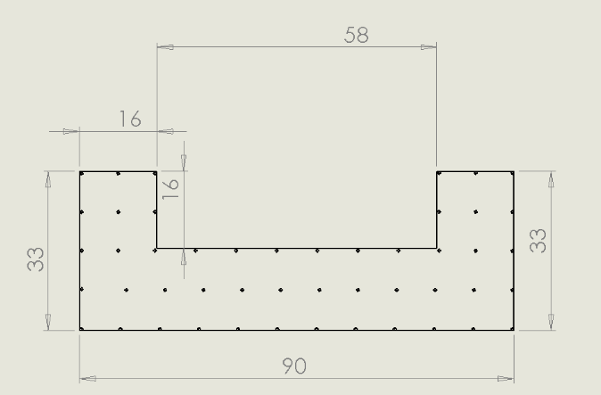
- The electrics will need to be installed by certified engineers and the installation would take place once the floor levels and completed and the super structure has been built in order for the electric wires and sockets to be put in where required, there is a risk which is the fact that the wire can blow if the voltage is not correct and this can leave a significant damage and harm to both the building and the workers.


