REWORK An ESSAY: A COMPARISON OF THE MARKETING METHODS OF TWO MULTINATIONAL HOTEL CHAINS.

(Hilton Hotel and Accor Hotel)
Module Name: Marketing Essentials
Module Code: BMIH4005 REWORK

Title: A Comparison of The Marketing Methods of Two Multinational Hotel Chains.
Student Name: Faruque Ahmed
Student Id: 2235171
Lecturer Name: Chris Wilkin
Word Count:1533
Marketing amendment 9
TABLE OF CONTENTS
Introduction 3
Main body 3
Market approach 3
Current market position 7
Marketing consideration (regarding sustainability/social/geopolitical/contemporary issues) 8
Conclusion 11
References 12

Introduction
The aim of the essay is to give an effective comparison of the marketing methods of two multinational hotel brands which is Hilton hotel and Accor hotel.
Hilton hotel
Hilton Hotels & Resorts that is Hilton's flagship is among most well-liked hotel brands globally. Conrad Hilton founded this hotel on May 31, 1919, and is presently the biggest hotel and resort bought by Hilton worldwide. The hotel has above 570 locations extended over 85 countries and sectors on 6 continents (Reidhead, 2020). Every of these founding are either bought by Hilton or reserved by independent industry proprietors.

Accor hotel
Accor hotel operates multiple markets such as higher range market, Luxury, mid-season and appropriate hotels that are component of the franchisees. The enterprise operates hotels below carious of brand names; contain Novotel Suites , Ibis Styles, Grand Mercure and several others (Damnjanović, 2020). The enterprise works about 5298 sites extend during 110 countries, involving in America, Asia, and Europe.

Market approach
The company’s marketing strategy’s most important objective is to attain its goals and also be the market leader (Chang, 2019). The marketing Mix and Strategy of Hilton are to build an analysis of its product, promotion, price, and place tactics:
Hilton Marketing Mix
Product
- Hilton offers products that are customized to meet the particular requirements of its consumers.
- Hilton Hotels provides a broad range of goods and outstanding customized service.
- The company commitment towards a unique and unforgettable experience for all customers (HOSAENA, 2020).
Place
- Hilton hotels are simply reachable through multiple media platforms for example, websites and travel booking websites.
- The company gives consumer care services to deal with any queries linked to bookings or services provided.
Price
- Hilton's goods and services are of elite quality and imitate optimistic characteristics.
- The company's costing strategy is depending on its consumers’ behaviours and preferences, mostly those from the upper-income class.
Promotion
- Hilton issues advertisements in certain areas and media.
- The company compete in many business exhibitions globally where consumer representatives advertise their items to possible buyers.
- Hilton is connected with airlines, trip, and travel organizations to more promote its products.
Recent changes in marketing approaches of the company
According to Nozdreva (2021), the marketing strategy of the company is to establish Hilton Hotels as the leaders in the hospitality business by providing exceptional service to the customers of the company. The strategy places an emphasis on forming and fostering close relationships with customers, with the end goal of generating brand loyalty among those customers.
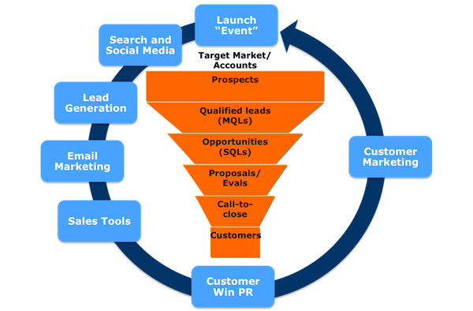
Figure 1 New Integrated Marketing Approach
(Source: brendanziolo, 2023)

Accor Hotels
According to Camelia, et al. (2019), the marketing mix of Accor Hotel is essential to the accomplishment of its marketing approach, which in turn enables the company to achieve success in the market-place. Despite this, the marketing plan for Accor Hotels helps the company engage effectively in the market and achieve the goals and objectives it has set for itself.

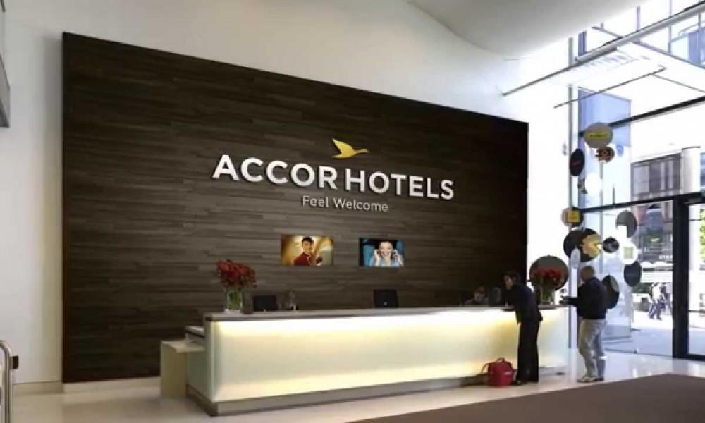
Figure 2 AccorHotels to Buy Luxury Hotel Group For $2.9 Billion
(Source: JACKIE REDDY, 2015)
The Accor hotels marketing Mix
Product
An Accor hotel gives a various luxury hotels and other facilities below many worldwide standard brands. The products involve:
- Luxury Hotels
- Midscale Hotel
- Economy Hotels
The company also has above 9,000 restaurants and bars which provide above 200 million consumers yearly.
Price
The pricing tactic of Accor Hotels concentrates on offering high-end luxury hotels with mid to less-priced hotels to participate with local competitors. The company places focus on quality and consumer fulfilment. Accor Hotels provides a variety of higher and luxury hotels which compete for industry.
Place
Accor Hotels began operations in France under the Novotel brand name and have since expanded their reach to more than one hundred countries across six continents (Nga, 2020). Paris, Bali, Shanghai, Dubai, Cairo, Mumbai, and Toronto are just some of the cities that are included on this list of its world-famous landmarks. Accor Hotels call both France and Switzerland their home countries.
Promotion
Le Club Accor Hotels is the brand’s reliability program which pursues a standard reliability scoring formation. Consumers receive points whenever they remain at hotels that could be saved for buying guest rooms and services at all of the group's amenities.
Recent changes in marketing approaches of the company
The organization plans to implement a program that will maximize productivity while also reducing waste. In addition to this, it is an applicant in the United Nations' Women Empowerment Council and has made a commitment to the United Nations' COP-21 Practices about climate change (Abellanet Miranda, 2019). The team has a strong internet presence thanks to geographically specific pages on YouTube, Twitter, and Instagram as well as a Facebook page with 1.8 million likes.

Current market position
Hilton hotels
Target market- the management of hotels’ serves to a broad range of consumers, involving business travellers, conference attendees, vacationers, actors, chiefs of state, and artists. With these groups are every measured as the organization’ target audiences.
Segmentation- Hilton Hotels utilizes geographic segmentation to make hotels in locations wherever the target market is effectively represented (Naumov, 2019). The organization’s main demographic segment contains middle-aged and older persons with superior incomes who stand for the uppermost social class, creating them Hilton’s possible consumer sector.
Positioning- Hilton Hotels is an international brand with hotels 572 and resorts in 85 sectors and countries over 6 continents. The organization has 10,000 owners, and 76 percent of them are replicate consumers, emphasizing the brand’s well-built positioning.
Marketing communication- Hilton Holdings Inc. mainly utilizes customary marketing interaction strategies to convey luxury to its customers. The organization’s marketing communication tactic involves a combine of print, sales advertising, publicity, media promotion, direct selling, and social events to express superiority to its customer groups.
Accor hotels
Target market- The organization targets’ travellers on company tours from premium, expensive, mid-market, and economy classes.
Segmentation- Accor Group operates in each of the targeted market groups and also employs a mixed segmentation approach. For instance, the Ibis hotels cater to the lower end of the market, while Sebel and Fairmont are luxury hotels with distinct clientele.
Positioning- Accor Group uses a market penetration approach to improve its goods and attract clients from existing markets (Cheng, 2019). The company is active in all significant market categories and also looks to launch new products.
Market communication- The Company has a well-designed webpage where it promotes all its brands under different price categories and reservation options. The webpage for each hotel and resort provides information about existing contracts and programs.

Marketing consideration (regarding sustainability/social/geopolitical/contemporary issues)
Hilton hotel
Sustainability issues - The hotel's waste management practices and pollution have a significant impact on its sustainability, resulting in devastating effects on biodiversity and the environment.
Social issues - Hilton Hotels has announced its CSR programs focused on improving its societal performance (Della Corte, 2020). The company provides 5 million hours of study and 2 million courses for university employees, and 14,000 managers have undergone integrity and anti-corruption education.
Geopolitical issues - Hilton Hotels' global presence attracts various international issues, and the company is working with host countries to overcome geopolitical challenges and provide the best results.
Contemporary issues - Hilton Hotels faces several contemporary issues, including human resources, increasing competition in the market, and updating technology.
Accor hotels
Sustainability issues - Carbon dioxide and trash emissions are the major sustainability concerns for Accor hotels, as they have a significant impact on climate change. The release of carbon dioxide from the hotel contributes to the worsening of the climate.
Social issues - Accor has launched Planet 21 as part of its corporate social responsibility, which is organized into four areas of society: employees, customers, partners, and local communities. The plan's primary focus is on providing food and beverages and building to all.
Geopolitical issues - Being an international brand, Accor has faced numerous geopolitical issues, including pandemics and wars (Lee, 2020). To overcome these challenges, the company aims to work with the situation and provide the best services to its customers.
Contemporary issues - Unskilled staff, operational issues, and changes in customer demand are some of the major factors that have a significant impact on the company.

Marketing amendment
Hilton hotel
The quality assurance teams of the hotel, which are spread out over the world, are working on formulating a plan to keep the operations they run to an exceptionally high standard (Unurlu, 2019). The purpose of the hotel's services is to offer its guests the highest possible level of comfort and to make them feel as though they are staying in their own homes.
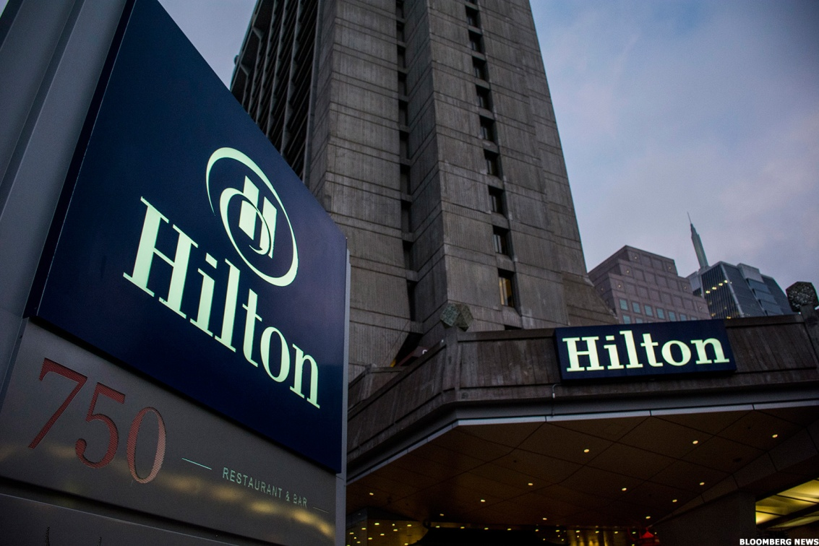
Figure 3 Hilton Worldwide and Spinoffs Are Good Investments Now or Later
(Source: IRENE PARKER, 2016)
Accor hotel
Accor Hotels is enhancing its marketing strategy to attract customers by launching a new lifestyle loyalty program named Accor Live Limitless (Zeng, 2021). It is a fully integrated global platform that combines digital, loyalty, brands, and partnerships.

Conclusion
The essay draws comparisons and differences between Hilton Hotels and Accor Hotels, focusing on their contrasting tactics, marketing mixes, targeting strategies, and segmentation methods. The article comes to the conclusion that environmental planning and waste management are more important to Hilton Hotels than sustainability, which is achieved by Accor Hotels through a reduction in their carbon footprint.

References
Abellanet Miranda, C., 2019. Multinational firms in the tourism sector: Accor Hotels.
brendanziolo, 2023. New Integrated Marketing Approach: Part 3, (online). <https://brendanziolo.com/2015/08/28/new-integrated-marketing-approach-part-3/> accessed on 26.04.23
Camelia, G., Ioana-Valentina-Alexandra, M. and Larisa-Andreea, N., 2019. Organizational culture: A case study of the impact of ethical organizational culture on the efficiency of Accor Hotels. Romanian Economic and Business Review, 14(2), pp.86-96.
Chang, Y.C., Ku, C.H. and Chen, C.H., 2019. Social media analytics: Extracting and visualizing Hilton hotel ratings and reviews from TripAdvisor. International Journal of Information Management, 48, pp.263-279.
Cheng, J., 2019. Research and Suggestions on Declining Market Shares of Ibis Budget Hotels. Open Journal of Social Sciences, 8(1), pp.253-261.
Damnjanović, V., Lončarić, D. and Dlačić, J., 2020. TEACHING CASE STUDY: Digital marketing strategy of Accor Hotels: shaping the future of hospitality. Tourism and hospitality management, 26(1), pp.233-244.
Della Corte, V. and Del Gaudio, G., 2020. marketing in tourism. The Routledge Handbook of Tourism Experience Management and Marketing, p.249.
HOSAENA, S., 2020. The Socio-Economic Impact of Development Induced Displacement: The Case of Kirkose Sub City, Wereda 08, Hilton Hotel Area (Doctoral dissertation, St. Mary's University).
IRENE PARKER, 2016. Hilton Worldwide and Spinoffs Are Good Investments Now or Later, (Online). <https://www.thestreet.com/opinion/hilton-worldwide-and-spinoffs-are-good-investments-now-or-later-13636683> accessed on 26.04.2023
JACKIE REDDY, 2015. AccorHotels to Buy Luxury Hotel Group For $2.9 Billion, (Online). <https://www.flyertalk.com/articles/accorhotels-to-buy-luxury-hotel-group-for-2-9-billion.html> accessed on 26.04.2023
Lee, K.H., 2020. Marketing approach to the tourist experience. In The Routledge Handbook of Tourism Experience Management and Marketing (pp. 260-270). Routledge.
Naumov, N. and LH201, R.,2019. The use of branding and market segmentation in hotel marketing: A Conceptual Review.
Nga, M.N.T.T., 2020. Corporate social responsibility: a case study of accor hotels group. Sustainable tourism: Shaping a Better Future, 203.
Nozdreva, R. and Churakova, A., 2021. Digital tools in empirical marketing strategies of global hotel companies. Digital strategies in a global market: Navigating the Fourth Industrial Revolution, pp.213-227.
Reidhead, C., 2020. Impact of organizational culture on employee satisfaction: A case of Hilton hotel, United Kingdom. Journal of Economics and Business, 3(1).
Unurlu, Ç., 2019. Marketing Strategies of Travel Agencies and New Technologies Used for the Marketing Strategy. In Handbook of Research on International Travel Agency and Tour Operation Management (pp. 251-271). IGI Global.
Zeng, L., 2021. Analysis of Hilton Worldwide Hotel Group’s Transnational Operation Strategy. Academic Journal of Business & Management, 3(11), pp.20-27.

