

LCBB4002 COMMUNITY ENGAGEMENT ASSESSMENT 2

Student name: Brindusa-Mihaela Ciobanu
Student ID: 2247469

To empower teenagers and to prevent high crime rates in Kettering area we developed a thirteen months project. This plan recognises the need to provide opportunities for personal growth and development to address the root causes of crime. Collaboration and partnerships with various stakeholders are emphasised to create a comprehensive support network, to implement awareness campaigns and workshops and to engage teenagers in peer discussions. Experiences and observations of the project are to inspire others to create positive change in their communities and to create a lasting impact on their lives and the community as a whole.

In the first month of the project in 2014, the Head of Community Services at Kettering Borough Council and The Friends of Rockingham Road Pleasure Park formed a team to open an outdoor gym for young people in Rockingham Pleasure Park. They secured funding, installed equipment, and designed programs to promote physical activity and community engagement. The project exemplifies the power of collaboration and community involvement in creating positive opportunities for young people.

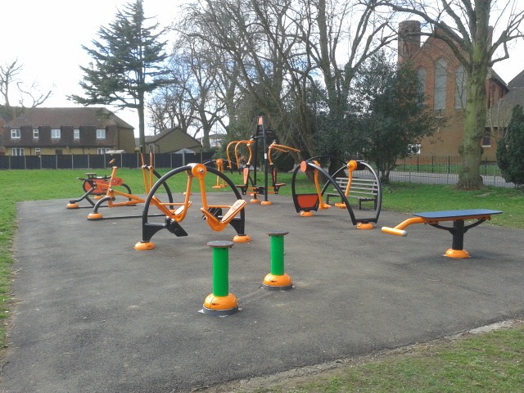
Photo: Rockingham Road Pleasure Park.

Palm Sunday with procession through Rockingham Rd Pleasure Park

 | 

During the second and third months of the project Kettering Borough Council with Alex Jelley (Economic Regeneration Manager) organised The Kettering Teenage Market which took place on Saturday, December 5th, in the town centre, offering free stalls and insurance for traders aged 16-21. This event celebrated the talent and creativity of young people in Kettering, with participants selling their own handmade and individually designed products, such as printed mugs, jewellery, gifts, home ware, textiles, and homemade cakes and confectionery. Interested young traders were able to book a stall by visiting www.kettering.gov.uk/markets. The market provided a platform for youth to showcase their skills and unique offerings.
While the Kettering Teenage Market may not directly address the issue of high crime in teenagers in Kettering, it can have a positive impact on the overall well-being and
opportunities for young people in the area. By providing a platform for young traders to showcase their skills and creativity, the market promotes a sense of purpose and achievement among teenagers. This can help divert their attention and energy towards productive pursuits, reducing the likelihood of engaging in criminal activities.
Additionally, the market fosters entrepreneurship and provides young people with valuable experience in running their own businesses. This can enhance their employability and offer alternative pathways to success, reducing the appeal of criminal activities as a means of income.
Moreover, the market encourages community engagement and collaboration among young people. By connecting with like-minded individuals and forming partnerships, teenagers can build a supportive network that promotes positive behaviour and discourages involvement in criminal activities.
While the impact of the Kettering Teenage Market on reducing high crime in teenagers may be indirect, it contributes to creating a positive and supportive environment that nurtures the potential of young people and offers them alternative paths towards a brighter future.
The Research and Development Committee established a partnership known as the Youth Engagement Task and Finish Group in April 2016. This collaborative effort was initiated following a successful motion at the Council and aimed to explore effective strategies for the Council to engage with, listen to, and inform young people in the Borough.
The Borough Council's project-based initiatives have had a significant impact on reducing the high crime rate among teenagers in Kettering. By directly involving young people in the design and delivery of projects that affect them, these initiatives have provided constructive outlets and opportunities for positive engagement.
One example is the development of new play areas and outdoor gyms at Rockingham Road Pleasure Park and Grafton Street Park, which engaged St Andrew's School
and pupils. This involvement fostered a sense of ownership and pride in these spaces, helping to deter young people from engaging in criminal activities. During the Council meeting in 2015, the Deputy Head of St Andrew's School advocated for the Council's support in implementing the Little Ambassadors program in other schools within the town. The Deputy Head emphasised the positive impact of the program and suggested that extending this initiative to other schools would empower their communities and facilitate similar positive outcomes.Similarly, the extension of opening times and improved facilities at the Ise Skate Park and the development of new skate facilities at Rothwell followed a similar approach. By consulting with local users and involving young people in the decision-making process, these projects created a sense of ownership and belonging. This, in turn, reduced the likelihood of young people turning to crime.
Overall, these project-based initiatives have empowered young people, fostered a stronger connection to the community, and provided constructive alternatives to criminal behaviour. As a result, they have played a key role in reducing the high crime rate among teenagers in Kettering.

In the months four and five it is more about implementing awareness campaigns and workshops, engage teenagers in peer discussions. Youth Works is an organisation dedicated to supporting young people and contributing to their development. It plays a crucial role in reducing crime rates and improving youth education. To ensure that they can provide the necessary support, they have specific eligibility criteria that teenagers need to met. To qualify for their services, individuals must be aged between 16 and 25 (from the 16th birthday to the 26th birthday), reside in Northamptonshire, not be in Local Authority Care (LAC) or currently working with the Leaving Care Team, require support in navigating mental health services, accessing adult mental health services, or in other life areas made more challenging by a mental health diagnosis, have a history of mental health issues. Their aim is to provide support to as many young people as possible, ultimately contributing to their growth and well-being.

In month six and nine the project aimed to mobilise the resources, to provide mentoring for adolescences. The Youth Employment Initiative (YEI) is a funding program that was implemented in collaboration between the government and the EU during months six and nine. Its primary objective is to address the issue of youth unemployment and provide support to teenagers who are not in education, employment, or training (NEETs) in regions with high youth unemployment rates exceeding 25%.
Over the course of three years, the YEI has demonstrated positive outcomes and received favourable initial evaluations. By offering financial resources and assistance, the initiative has effectively contributed to reducing youth unemployment rates and addressing the specific challenges faced by NEETs.
Furthermore, one of the significant benefits of the YEI is its impact on mitigating the high crime rate among teenagers. Through the provision of employment and training opportunities, the initiative offers constructive alternatives, empowering young individuals and redirecting them away from engaging in criminal activities. This not only benefits the individuals themselves but also contributes to creating safer communities as a whole.
Dr. Anna Carlile from Goldsmiths University of London explains that the Youth Friendly Employer framework provides organisations with the necessary tools and support to effectively harness the potential of young people they engage with, whether as employees, customers, or other stakeholders. This framework assists organisations in positioning themselves to create an environment conducive to the growth and development of young individuals, enabling them to thrive and contribute positively to the organisation and wider society.
In conclusion, the project aimed to address the issue of high crime rates involving teenagers in Kettering. Through extensive research and analysis of the situation, it was evident that proactive measures needed to be taken to tackle this pressing issue. The project focused on implementing a comprehensive approach that involved community engagement, youth empowerment, and targeted interventions.
By engaging with various stakeholders, including local authorities, law enforcement agencies, community organisations, and schools, the project aimed to create a collaborative network to address the root causes of teenage crime. Through targeted interventions such as educational programs, mentorship initiatives, and employment opportunities, the project aimed to provide teenagers with alternatives to criminal activities and empower them to make positive choices.
Additionally, the project recognised the importance of addressing underlying social issues such as poverty, lack of educational opportunities, and limited access to recreational facilities. Efforts were made to advocate for policy changes and allocate resources towards creating safe spaces, recreational areas, and educational programs specifically tailored for teenagers in Kettering.
Overall, the project aimed to create a safer and more inclusive community for teenagers in Kettering by addressing the factors contributing to high crime rates. Through collaborative efforts, targeted interventions, and long-term sustainable solutions, it is expected that the project will have a positive impact on reducing teenage crime and creating a brighter future for the youth in the area.

- Kettering Borough Council. (n.d.). 11 Outdoor Gyms and Play Areas. Retrieved from https://www.kettering.gov.uk/download/meetings/id/11285/11_outdoor_gyms_and_play_areas
- Kettering Borough Council. (n.d.). Delivering Our Town Centres. Retrieved from https://www.kettering.gov.uk/download/meetings/id/11798/10_delivering_our_town_centres
- Kettering Borough Council. (2016). Report and Conclusions of the Youth Engagement Task and Finish Group Autumn 2016. Retrieved from https://www.kettering.gov.uk/download/meetings/id/12350/13_appendix_a
- Youth Employment UK. (2023). About Us. Retrieved from https://www.youthemployment.org.uk/about-us/
- European Parliament. (2017). Briefing: How the EU budget is spent September 2017 Youth Employment Initiative. Retrieved from https://www.europarl.europa.eu/RegData/etudes/BRIE/2017/608688/EPRS_BRI(2017)608688_EN.pdf
- Youth Works Northamptonshire. (n.d.). History. Retrieved from https://www.youthworksnorthamptonshire.org.uk/about-us/history
- Youth Works Northamptonshire. (n.d.). Eligibility Criteria. Retrieved from https://www.youthworksnorthamptonshire.org.uk/restart/eligibility-criteria/

