

DATA CENTRE
VIRTUALIZATION

Tutor: Koushik Modak
Student: Silvia Diana Iagar
ID: 1805743
Abstract

Today's business networks and data centres are extremely diverse, having fully merged themselves into every aspect of the entity they serve. Internet-facing systems and software must be accessible at all times of the day and night for businesses to function. These businesses have discovered that unified computing and highly accessible components will vastly improve their technical position with consumers. To perform optimally, an architecture enabling such high availability necessitates the use of multiple components and services. When a company decides to build a data centre, they depend on tools to help them figure out which materials to use. Most of this detail is dependent on third-party vendor advice or minimal prior knowledge.

Table of Contents
Introduction 4
Scenario 1: Implementing a Data Centre for UWTSD…………………………………………………………5
1.1 EDGE Data Centers 5
1.2 EDGE Data Centre Virtualization …………………………………………………………………….….……….6
1.3 EDGE Data Centre Architecture and Design …………………………………………………………….….7
1.4 Implications and Outcomes of the EDGE Data Centre ..……..……….……………………………...8
1.5 Considerations of the EDGE Data Centre …………………………………………………………………….8

Scenario 2: ABC Data Ltd. 12
2.1 Business Adoption of Virtualization technologies 12
2.2 Data Centre Infrastructure Management ……………………………………………………………………………… 13
2.3 The importance of Security Policy…………………………………………………………………………………………. 13
2.4 Storage Area Networks (SAN) importance for security …………………………………………………….…… 14
2.5 The Disaster Recovery (DR) System’s Importance ………………………………………………………………… 15
Conclusion ……………………………………………………………………………………………………………….…………………17
References ……………………………………………………………………………………….……………………….……………... 18

Introduction

Organisational networks have grown in size and complexity. Many businesses worldwide have data centres that have grown from single rooms inside larger organisation service centres to massive, isolated structures housing thousands upon thousands of servers. There is no longer a belief that data centres are strictly for big enterprises worldwide, as smaller, and smaller firms continue to focus on the centralisation and advantages of operating a data centre that can help with their overall performance. A data centre contains a variety of separate components that must work in unison for optimum efficiency. Heavy preparation is required for an enterprise to implement and construct a data centre to identify the organisation’s needs and assess the full scope of the result. Some organisations may pay special attention to the financial side of the data centre, while others may pay special attention to the actual space that can accomplish. This specific requirement can differ from one company to the next, but some primary areas must tackle to design a functioning data centre. [7]
This research will present two scenarios regarding data centres. In the first scenario, UWTSD has chosen to virtualise its core information technology operations and build a virtualised data centre to consolidate its servers and services. The research’s goals are to develop a plan for how the facilities will be organised and make a case for whether it is easier for the university to build its data centre or use an outsourced solution.
In the second scenario, the research objective is to write a report on the critical nature of security policy and its effect on the organisational architecture at ABC Data Ltd. Additionally, the study will discuss how SAN will assist ABC Data Ltd in protecting their data from corruption and detail the disaster management processes critical to ABC Data Ltd.’s virtualised data centre.

Scenario 1: Implementing a Data Centre for UWTSD

  - EDGE Data Centres

Our way of life is constantly changing in reaction to the pandemic, and we are more reliant on technology than at any point in human history. Education programmes, in particular, are being compelled to adapt on a massive scale to remote learning. As a result of the extra bandwidth needed to accommodate this level of operation, customer-hosted equipment is being stressed. To address this problem, school districts, colleges, and universities are abandoning on-premises equipment favouring collocating servers and network equipment in a data centre.
Along with assisting universities in addressing particular problems, edge data centres (EDC) will benefit from all facets of data and compute use in higher education. However, there are specific uses that edge data centres are well-suited.
The University of Wales Trinity Saint David is a multi-campus institution with three main campuses in South West Wales, Carmarthen, Lampeter, and Swansea, a fourth campus in London, England, and study centres in Cardiff, Wales, and Birmingham, England. The university enrols about 10,001–15,000 students.
UWTSD ensures it has the best possible learning environment. The university’s information technology architecture must accommodate high bandwidth, low latency, and, most importantly, fast, and secure access to digital services. The term “edge data centres” (EDC) refers to small data centres located at a network’s edge. They offer similar equipment as conventional data centres but with a reduced footprint that puts them closer to end customers and devices. Edge data centres may contribute to network infrastructure simplification by simplifying distribution, servicing, and access control.
Additionally, the solution facilitates high-bandwidth applications by minimising the need for data transmission across networks. Due to the compact design of the small cabinets used for edge applications, their positioning and application are highly flexible. This enables IT teams, to respond more rapidly and cost-effectively to evolving requirements.[1][6]
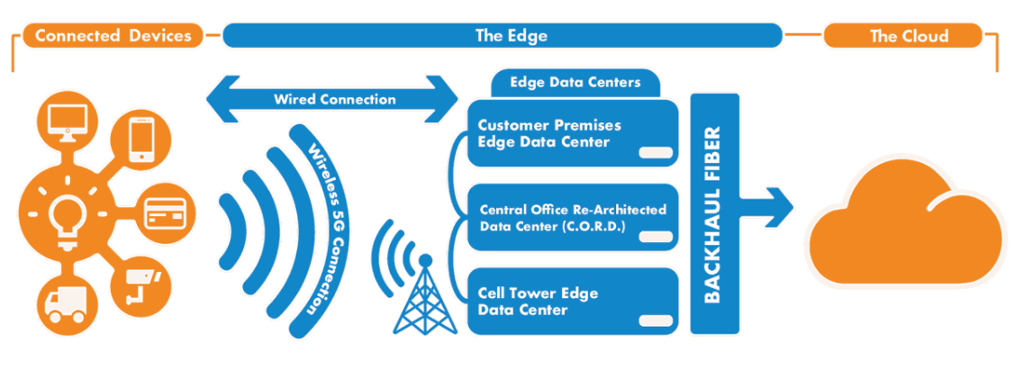
Figure 1. EDGE Data Centre
A decentralised mobile network comprised of edge data centres will contribute to 5G's low latency. If data provided by devices requires additional processing and is too time-sensitive to send to a centralised server, an edge data centre would be used. Some medical equipment, such as those used for robotic surgeries, would require extremely low latency.
Attributes of edge data centres:
- Location: Edge data centres are located near the end devices on which they are networked.
- Dimensions: Edge data centres can have a significantly smaller footprint than conventional data centres though retaining the same components.
- Data type: Usually, edge data centres can host mission-critical data that requires low latency.
- Despatch: A more comprehensive core data centre or even part of a network of other edge data centres could be annexed to an edge data centre.
Micro-data centres can also be used by some edge data centres (MDC). A micro-data centre is a compact, scalable infrastructure that supports smaller enterprises or augments an enterprise’s capital.[2]

  - EDGE Data Centre Virtualization

Edge virtualisation is the process of utilising software-based representations of physical computing properties at the network’s edge, nearest to the data-generating machines. Virtualisation isolates the entire computing stack from the physical infrastructure, including operating systems (OSes) and everything that runs on them. After that, instances can be copied and spread through a variety of various types of hardware.
Edge virtualisation is critical because it universally expands the software-defined cloud concept. This software-defined approach enables remote provisioning, control, and monitoring of edge devices across vast geographic areas, making it a more reliable and cost-effective option.
By definition, edge virtualisation is a combination of software-defined computing, storage, and networking – similar to what you will find in the cloud but with remote and, in most cases, small-scale resources.
Whereas cloud computing utilises vast processing, storage, and networking resources closely coupled geographically, typically in one or two immense data centres, edge virtualisation utilises a large number of locations, each with a modest complement of resources.
Edge virtualisation differs conceptually from core data centre virtualisation in the following ways. Specific “cases” of virtualisation at the edge:
- are on a significantly smaller level.
- Without local assistance, they are located far from the edge’s control point.
- May have restricted bandwidth for communications, which may also experience substantial latency, and
- are needed to maintain a diverse set of workloads that communicate with real-world peripherals through various technologies; most of these may be legacy or nonstandard.[3]

  - EDGE Data Centre Architecture and Design

One of the most often used methods is to use a complex architecture with various stages ranging from main to geographic to aggregated edge, or even farther out to approach edge stages. The provider network's size would determine the precise number of categories. Usually, core positions are well-equipped to accommodate massive amounts of centralised signalling and are optimised for network-control activities.
For edge architectures, the Base Band Unit (BBU) factor must be revamped. This component is often placed near a broadcast tower equipped with power and memory. In a 5G structure centred on the edge domain, a Cloud RAN (C-RAN) solution will be used to disaggregate the BBU into a Central Unit (CU), a Distributed Unit (DU), and a Remote Radio Unit (RRU) (RRU). The diagram below illustrates how the CU factor can be situated in a regional or aggregated edge field, whilst the VDU component is housed in edge data centres. This architecture enables greater management flexibility for the CU and DU while maintaining optimal bandwidth use and meeting growing industry demands.

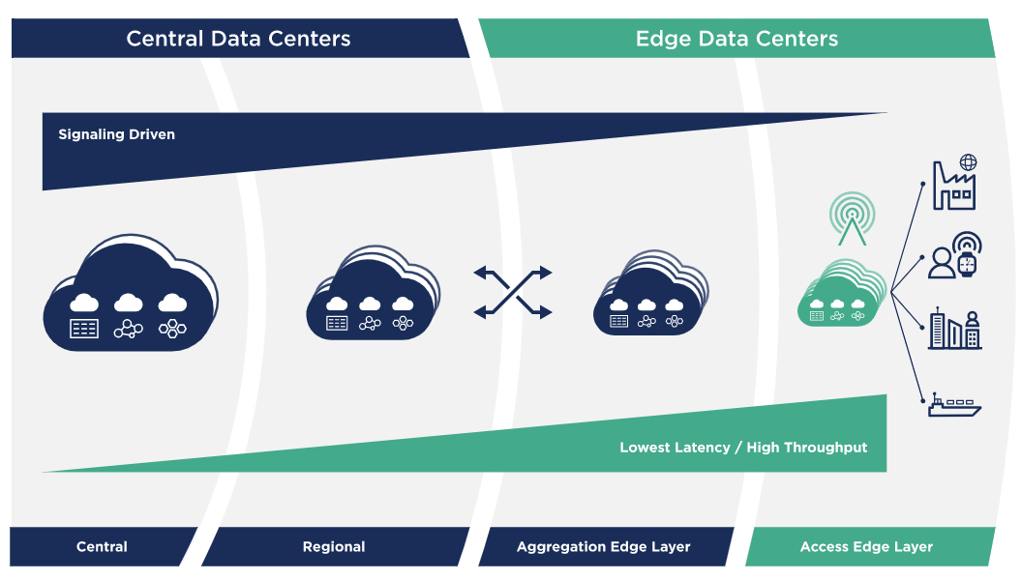
Figure 2. EDGE Architecture

EDC are still in progress, and as additional needs and specifications in particular areas are gathered, the following potential architectural considerations should be regarded:
- Consider local storage to maximum resistance, low-latency data processing, as well as connectivity to remote storage solutions. Many distributions have variants, from basic lightweight software RAID or LVM to intricate and well-balanced programmes like Ceph.
- Bare metals management: The technique can be used in several layers: the organisation that runs and manages the infrastructure, which has access to manage zero-touch provisioning methods, also has permission to scale up if required, and the organisation that can scale their edge site on demand. [6]

  - Implications and Outcomes of the EDGE Data Centre

As shown, computer technology at the edge opens up vast new creative possibilities while also necessitating the addition of critical networking services (such as those provided by Edge Data Centres) to serve edge applications. The development of the cutting-edge infrastructure networks must satisfy three essential requirements:

- Distributed Scalability - The and need for more mass applications and services and services requires the rising use of more highly dispersed data centres. This would undoubtedly necessitate the relocation of a considerable number of computer and data resources from many locations. It will be governed by the application’s latency and available bandwidth.
- Enhanced Data Flow - From being primarily a download (delivering data) to a bi-directional (tending to internal and user) flow (DTX). New computing and storage architecture must be built into the network. There will be a considerable volume of bi-directional data generated at the edge of the web and spread around the rest of the network, allowing two-way information flow.
- Criticality Increased - Due to the spatial dispersion of processing and data resources, significant physical and logical protection concerns must be addressed. In today's architecture criteria, topographic scale and reduced form factors were not properly recognised. For example, critical edge technology can directly affect life-safety and require end-to-end "dial tone" resilience and deterrent performance. The deployment and management of these basic utilities may be required to cover higher costs, but for other edge implementations this could be prohibitively costly. In current EDC codes, the concept of affordability is difficult to answer. [4]

  - Considerations of the EDGE Data Centre

A data centre, which is particularly suitable pro the implementation of any concept, must have the proper facilities for networking. Centralised data centres can grow to be larger than 100,000 square feet. By comparison, EDCs enable a diverse range of distributed resources while maintaining an acceptable level of availability and investment costs. Structures and processes must be designed to deal with new EDCs.
This segment gets into the depth of issues at the edge and the EDC versus non-EDC architecture differences.

  - Location

Geographically, energy availability and cost, as well as environmental and value are commonly accepted as the traditional criteria for selecting a data centre site. However, the position of the edge data centre would be governed by the time delay and proximity to the network requirements.
Then, as a result, the site selection requirements of the EDC will need to include less-than-ideal climate data, population density (city), and other considerations, such as macro-o-scalability, which are present in regions, would need to be changed, such as proximity to fault lines and airports. In addition, facilities and networks must be architected in an innovative manner to satisfy EDC requirements.
  - Safety on a Physical and Logical Level

The impact of potential threats to electronic hardware and data is far greater than what most people realise since many of them originate in the world of the physical rather than the digital. A proliferation of access points increases data vulnerability, as well as risk. in order to mitigate potential risk, one must have adequate protection in place. And since these data centres are assumed to have strong and independent roles servicing the size, it is essential that they be able to accept data in these environments use identity and authorization as the controls over access into their architecture are completely automated.

  - Factors and Considerations Affecting Operational Risk

EDCs are like conventional data centres, but an extra factor must be considered to guarantee operation and maintain their uptime.
However, several other critical considerations are involved:
- Using Edge data centres and complementary software at each location can yield monetary and procedural cost savings while still maintaining system uptime and durability.
- Additional risk-reduction needs to meet space availability issues is mandatory in housings.

Considerations for Critical Infrastructure

The vital data centre facilities equipment is generally including cabling, power, and the building itself is the container in which the cooling system and other system must be situated. Willingness to have extra capacity allows the EDC to retain access to a portion of the network infrastructure until a hand-off is made.

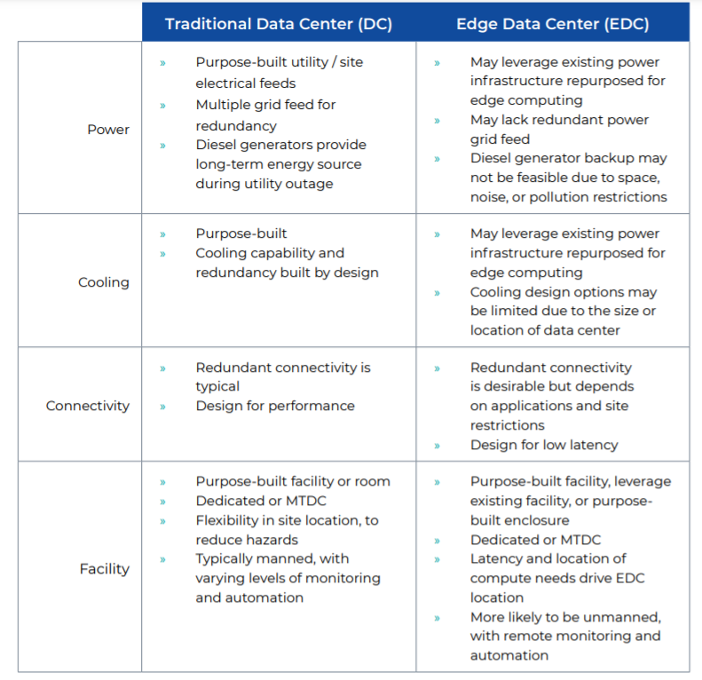
Figure 3. Comparison of Traditional and Edge Data Centres
  - Operating Environmental Considerations

An EDC may be micro, unregulated, and situated in the desert amid oil pipelines – clearly incapable of providing the conventional data centre’s highly regulated, tracked, and restricted operating environment. Historically, DCs often operated with excessively stringent environmental A1 restrictions. Relaxing operating area constraints decreases the need for mechanical ventilation, resulting in lower PUE and cooling capacity needs. Wherever possible, alternative “free” cooling systems should be considered. Considering the expected high number of EDCs, minimising the burden on these facilities is a critical design priority.

  - Support, automation, and monitoring

Investing in automated control can be crucial in mitigating operational risk as the edge grows in size and complexity. Most organisations have traditionally considered facility monitoring to be separate from device and computing monitoring.
With the overall objective of making software easily and reliably available at the edge, ER/disaster/overlapping the infrastructure perimeters will go hand in hand to better comprehend and handle the associated service level of service levels.
The fibre and copper cabling system, which has traditionally been unmanaged, is one expected pressure point for EDC management. In the EDC, standards-based Automated Infrastructure Management (AIM) programmes extend physical network coverage. The ISO/IEC 18598 standard specifies Target. AIM is described as a “integrated hardware and software device that automatically detects the insertion or removal of cables, logs the cabling (connectivity) infrastructure including connected devices, and enables infrastructure management and data sharing with other systems,” according to the standard.

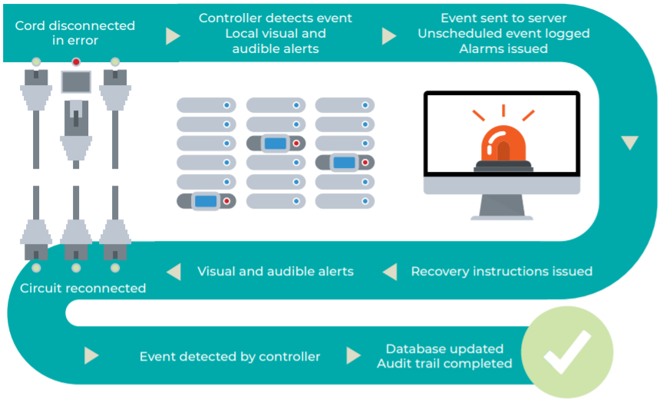
Figure 4. AIM Overall System

In the diagram above, AIM helps EDC workers keep tabs on the connected universe, granting them better access, navigation, and refinement abilities:
- Develop and incorporate connectivity enhancements.
- Resolve connection issues in real time.
- Identify and register connected devices.

The intrinsic advantages of the AIM scheme on the connectivity infrastructure include the following:
- Accurate and automatic reporting to eliminate the risk of human error associated with traditional testing.
- Minimise the monetary expenditures for the motion, augmentation, and adjustment.
- Risk mitigation minimises loss and expedites the arbitration process.
- Capacity management that optimises port usage and preparation.

While edge computing is still in its infancy, the following three observations have been made:
- Increased size and reduced latency are linked.
- Automation, parallel design, and standardisation are mandatory to meet the requirement set.
- Energy-efficient construction and service must be a priority, all the more so given the impending size of EDC deployments.

EDCs would dramatically increase in the Information and Communications Technology (IT) industry. To increase competition around the margins, information and communications technology (ICT) providers will have to bridge wireless and wired networks in a fragmented, consolidated manner. [4][5]

Scenario 2: ABC Data Ltd.

ABC Data Ltd. is a company with three physical data centres that offer a single stable data centre through virtualisation technology. The data centre charges users for cloud computing and virtualised services. Fibre-optic high-bandwidth internet connections connect ABC’s physical locations, and their data storage is mirrored for redundancy. The organisation charges a premium for convenient, safe storage and facilities. This is possible due to the careful nature of the security, hardware facilities, and storage systems.
This scenario will highlight the critical nature of security policy and its effect on the organisational architecture at ABC Data Ltd and how SAN will assist ABC Data Ltd in protecting their data from corruption and detailing the disaster management processes critical to ABC Data Ltd.’s virtualised data centre.

2.1 Business Adoption of Virtualization technologies

Virtualisation has served as a game-changer with many of the issues confronting today’s IT organisations. However, it is also a kind of infrastructure that IT administrators must be able to navigate and handle – in addition to current servers.

Virtualisation technology has had a significant effect on the information technology industry, especially in data centres, where it helps reduce costs and improve efficiency. Virtualisation technology is evolving exponentially, and an increasing number of developers are pursuing cloud-based application development. All of these advancements should be investigated further to simplify data concealment methods and data leakage.
Server virtualisation is pervasive, with 92% of companies using it. Some ways of virtualisation, on the other hand, have some catching up to do. Storage virtualisation (also known as software-defined storage) is the most widely used modern virtualisation technology, accounting for 40% of all new virtualisation technologies, followed by system virtualisation at 39% and virtual desktop infrastructure (VDI) at 32%. Moreover, network virtualisation (a.k.a. software-defined networking) and data virtualisation have a 30% approval score. [8]

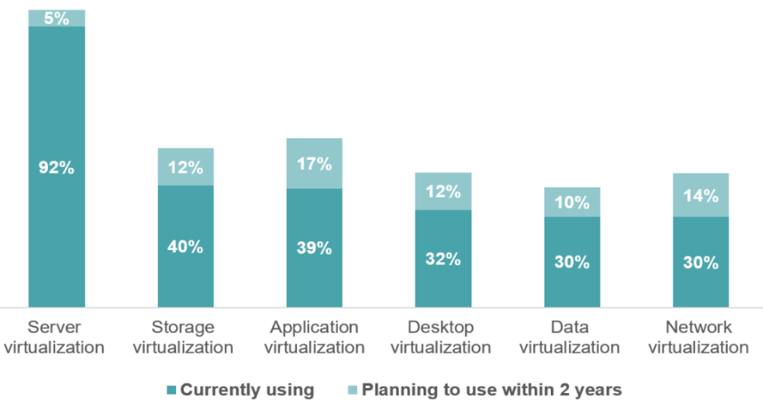
Figure 5. Business Adoption of Virtualization technologies

2.2 Data Centre Infrastructure Management (DCIM)

DCIM is a standardised, all-inclusive approach to tracking and handling data centre services and processes. Put, without monitoring and measuring the data centre’s vital structures and processes, controlling, and optimising them is difficult. DCIM’s primary objective is to provide management with a centralised vision of how a data centre works, allowing for the most optimal utilisation of facilities, floor space, and resources and the least amount of downtime available. DCIM software collects data from thousands of sensors located in a data centre.
A decent DCIM programme package can help answer the following concerns.
- Is my equipment running correctly at the moment? Is there any cause for alarm?
- What improvements would I make to improve the efficiency of my systems?
- What power gaps would I encounter in the future?
- Are my devices in need of some diligent repair practises, and are there any potential issues on the horizon?
ABC Data Ltd., with a correctly deployed DCIM, would be able to immediately simulate the whole data centre and drill down to any necessary degree of granularity to answer these and several other questions with a few mouse clicks.

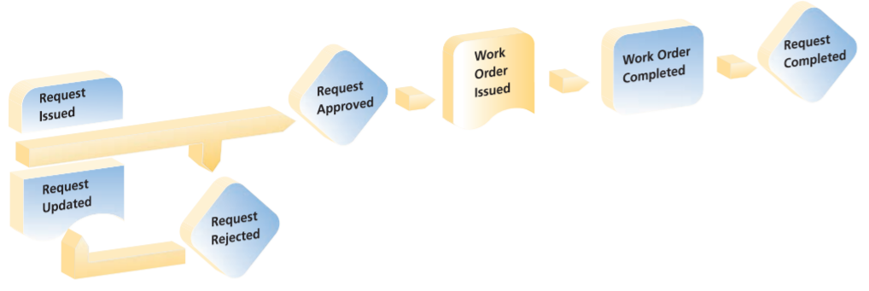
Figure 6. DCIM

Additionally, DCIM will provide the business with automatic resources and what-if scenarios that simplify system moves or new system provisioning while maximising the use of available space, electricity, and cooling energy.[9]

2.3 The importance of Security Policy

To ensure the effectiveness of their cyber-security initiatives and efforts, organisations need well-designed information technology security policies. Lack of an IT security strategy can be attributed to various factors. Still, the more common include a lack of personnel to assist in policy development, poor management implementation, or a lack of knowledge of the critical nature of getting a successful IT security programme in place.
Adequate information technology protection safeguards an organisation’s information infrastructure from unwanted exposure, damage, destruction, entry, use, or alteration. Without proper information storage, ABC Data Ltd.’s information properties, including intellectual property, are vulnerable to compromise or theft. When designing enterprise information management policy, it is essential to keep the values of secrecy, transparency, and availability in mind.
Information technology protection policies aim to identify security risks and enforce techniques to resolve information technology security vulnerabilities and define how to recover from a network attack. Additionally, the rules outline what workers can and should not do. The below are some of the primary reasons your organisation should have information technology compliance measures in place:

- IT compliance policies identify the security requirements for an organisation’s employees.
- Information technology protection policies should represent an organization's risk perception and management attitude toward security.
- Information technology management strategies provide a framework for protecting the organisation from external and internal threats.
- IT protection regulations serve as a framework for an organisation’s legal and ethical obligations.
- IT security protocols are used to assign accountability for adhering to planned information security behaviours.[10][11]

2.4 Storage Area Network (SAN) importance for security

According to Starkman, “storing data has become an increasingly important and complex issue thanks to concerns about capacity, accessibility, security, and of course, cost.” [12]
Because of the advantages, an increasing number of companies migrate to a SAN solution for storage and backup.
ABC Data Ltd. must first recognise the essential importance of SAN protection before it can adequately protect the storage area network.
The company must consider all potential points of failure to ensure that the highest levels of availability, integrity, and fairness are included in the design of SAN solutions. The ability to find vulnerabilities and execute a secure solution is critical for securing a SAN fabric infrastructure.[13]

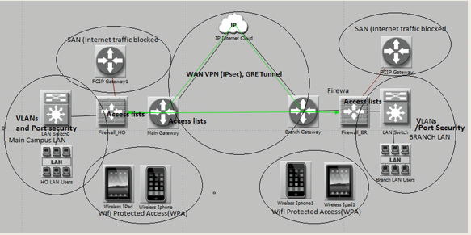
Figure 7. SAN Security
Except for the above reasons, the laws under the Sarbanes-Oxley Act of 2002 and the Health Insurance Portability and Accountability Act (HIPAA) provide principles, conditions for ensuring the confidentiality and integrity of all forms of personal information. Not only is storage area network security critical for an enterprise watching out for its own needs, but it is still a legal requirement for specific organisations.
When businesses deal with overburdened with the issue of handling huge amounts of data, they are forced to deal with the issues associated with unmanaged distributed LANS. Ignoring potential issues with the SAN would mean putting mission-critical networks and data at risk. You cannot just set a machine or system to be safe, you have to pay attention to it every day before it is successful. the weakest link in the chain is just as strong as its weakest storage Risk mitigation has to be done when you are setting up the SAN, but continuous risk monitoring is needed afterwards. Administration is needed over the life cycle and dealt with often. Anything is going into the database. There are no discernible threats to the network and organisations should be optimistic. [13][14]

2.5 The Disaster Recovery (DR) Systems’ importance

A data centre disaster recovery project is deemed successful if ADC Data Ltd. can quickly restore and restart activities without causing any business interruption.
ABC Data Ltd. must determine which data centre disaster management solutions are the most effective for their specific data centre facility. ABC Data Ltd can address future threats and challenges, prepare for potential disasters, and minimise their effect on company reliability and competitiveness by implementing a comprehensive data centre Disaster Recovery Plan. [15]

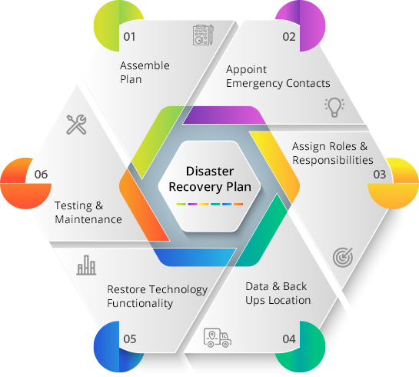
Figure 8. Disaster Recovery Plan

Establishing a data centre disaster recovery plan is important because it will have a direct effect on the recovery's outcome. To develop a comprehensive disaster response approach for ABC Data Lt., an organisational risk assessment and industry effect review must first be conducted. As a result, management will be able to identify the risks to which their data centre is most vulnerable, measure their possible impact on market competitiveness, and evaluate the infrastructure's readiness for data centre catastrophe recovery.
A disaster response strategy for a data centre should include the steps and protocols necessary to avoid a DR incident. The operations team would conduct annual tests of the data centre’s Disaster Recovery Plan. This way, it would recognise schedule anomalies and enhance their IT infrastructure's disaster recovery readiness. [16][17]

Conclusion

Data is an organisation’s most valuable commodity, and companies face immediate difficulties handling and regulating data while maintaining data enforcement. Data processing is essential for any enterprise that wishes to increase its agility by making current knowledge accessible anywhere, at any moment, to the workers who need it most.
Businesses, recognising the potential of their records, are migrating away from their current infrastructure and into well-equipped Data Centres to facilitate improved data storage. Data centres have risen to prominence as a top priority for companies worldwide as they assess their IT technology needs. Through this change in how information is addressed, Data Centres have evolved into being just another storage facility. Indeed, they have developed into a critical market metric. Here are five reasons why enterprise companies need data centres.[7]

In conclusion, regarding the first scenario from this research, a campus data centre for UWTSD should showcase the school’s commitment to science and technology. However, please make no mistake; it is a significant commitment for a university to entrust vital technology components that support its academic activities. UWTSD will minimise the physical distance that data would travel to access a data facility using an edge data centre, resulting in decreased latency. Additionally, because of its redundant nature, if an edge data centre goes offline due to a power outage or for some other purpose, nearby facilities will take over its services, ensuring a higher percentage of uptime.

Concluding for the second scenario, the object of implementing IT protection policies is not to fill empty spaces on the ABC Data Ltd. bookshelf. If IT protection protocols are not actively maintained, they may get out of date over time. Security strategies are just as effective as the organisation’s ability to track their implementation. Ascertain that the ABC Data Ltd. IT team or a third-party provider has the necessary resources to track the network environment correctly. Consider monitoring Internet/email content, installed software, and unauthorised devices with tools. Having the appropriate resources to track security settings effectively is critical to the performance of an IT security programme.

References

[1] M. Trifiro and J. Smith, "Data at the Edge. Managing and Activating Information in a Distributed World", Seagate, 2019. Available: https://www.seagate.com/www-content/enterprise-storage/it-4-0/images/Data-At-The-Edge-UP1.pdf. [Accessed 24 April 2021].
[2] H. Chang, A. Hari, S. Mukherjee, and T. Lakshman, "Bringing the cloud to the edge", IEEE Conference on Computer Communications Workshops (INFOCOM WKSHPS), 2014. Available: https://ieeexplore.ieee.org/abstract/document/6849256. [Accessed 24 April 2021].
[3] Roberto Morabito, "Virtualization on Internet of Things Edge Devices with Container Technologies: A Performance Evaluation", Access IEEE, vol. 5, pp. 8835-8850, 2017. [Accessed 24 April 2021].
[4] M. Satyanarayanan, "The Emergence of Edge Computing," in Computer, vol. 50, no. 1, pp. 30-39, Jan. 2017, doi: 10.1109/MC.2017.9. [Accessed 24 April 2021].
[5] Qiucheng Miao, Weipeng Jing, Houbing Song, "Differential privacy–based location privacy enhancing in edge computing", Concurrency and Computation: Practice and Experience, vol. 31, pp. e4735, 2019. [Accessed 25 April 2021].
[6] R. Brannvall, M, Siltala, J. Gustafsson, J. Sarkinen, M. Vesterlund, J. Summers, "EDGE: Microgrid Data Centre with Mixed Energy Storage Share on", Association for Computing Machinery, pp. 466–473, 2020. Available: https://dl.acm.org/doi/abs/10.1145/3396851.3402656. [Accessed 25 April 2021].
[7] B. Ayomaya, Data Center for Beginners: A beginner's guide towards understanding. Independently published, 2020, pp. 5-50.
[8] Rabi Prasad Padhy, Manas Ranjan Patra, Suresh Chandra Satapathy, "VIRTUALIZATION TECHNIQUES & TECHNOLOGIES: STATE-OF-THE-ART", Journal of Global Research in Computer Science, vol. 2, no. 12, pp. 29-41, 2011. Available: https://www.researchgate.net/profile/Rabi-Padhy/publication/264884756_VIRTUALIZATION_TECHNIQUES_TECHNOLOGIES_STATE-OF-THE-ART/links/5476b2940cf245eb43727c2f/VIRTUALIZATION-TECHNIQUES-TECHNOLOGIES-STATE-OF-THE-ART.pdf. [Accessed 25 April 2021].
[9] D. Cole, "Data Center Infrastructure Management", Data Center Knowledge, pp. 3-16, 2012. Available: https://www.jsfleming.com/wp-content/uploads/white-papers/Data-Center-Knowlede-DCIM-Guide.pdf. [Accessed 25 April 2021].
[10] J. Paliszkiewicz, "Information Security Policy Compliance: Leadership and Trust", pp. 211-217, 2019. Available: https://www.tandfonline.com/doi/10.1080/08874417.2019.1571459. [Accessed 25 April 2021].
[11] B. Bulgurcu, H. Cavusoglu and I. Benbasat, "Information Security Policy Compliance: An Empirical Study of Rationality-Based Beliefs and Information Security Awareness", MIS Quarterly, pp. 523-548, 2010. Available: https://www.jstor.org/stable/25750690. [Accessed 26 April 2021].
[12] N. Starkman, "Go Ahead and Back Up", T.H.E. Journal Online, 2021. Available: Nhttp://www.thejournal.com/thefocus/featureprintversion.cfm?newsid=51. [Accessed 26 April 2021].
[13] J. Tate, P. Beck, H. Ibarra, S. Kumaravel and L. Miklas, Introduction to Storage Area Networks, 9th ed. IBM Redbooks, 2017.
[14] M. Haron, "Is Your Storage Area Network Secure? An Overview of Storage Area Network from Security Perspective", SANS Institute, 2021. Available: https://www.sans.org/reading-room/whitepapers/storage/storage-area-network-secure-overview-storage-area-network-security-perspective-516. [Accessed 16 April 2021].
[15] J. Mendonça, E. Andrade, P. Takako Endo, and R. Lima, "Disaster recovery solutions for IT systems: A Systematic mapping study", Journal of Systems and Software, vol. 149, pp. 511-530, 2019. Available: https://www.sciencedirect.com/science/article/abs/pii/S0164121218302814#! [Accessed 26 April 2021].
[16] "Disaster Recovery", VMware, 2021. [Online]. Available: https://www.vmware.com/topics/glossary/content/disaster-recovery. [Accessed: 26- Apr- 2021].
[17] "Disaster-Recovery-Introduction", Ibm.com, 2021. [Online]. Available: https://www.ibm.com/cloud/learn/disaster-recovery-introduction. [Accessed: 27- Apr- 2021].

