Shay, Pippa
2417658
Design of Shaped Charges
Advanced Physics for OME ACDB5015
Ordnance Munitions and Explosives BEng

Table of Contents
List of Figures 1
List of Equations 2
List of Tables 3
Executive summary 4
Section 1: Introduction 4
1.1 Shape Charge Overview 4
1.2 Abaqus 4
Section 2: Shaped Charges 4
Section 3: Forces 5
3.1 Stress and Strain 5
3.2 Velocity 5
3.3 Pressure 6
3.4 JWL Equation 6
Section 4: Simulations 6
4.1 2D Models 6
4.1.1 Simulation 1 6
4.1.2 Simulation 2 16
4.2 3D Model 24
Section 5: Conclusion 29
References 30

List of Figures
Figure 1 - Casing Geometry 7
Figure 2 - Liner Geometries 7
Figure 3 - Steel Case Material Properties [11] 8
Figure 4 - Steel Case Material Properties [11] 8
Figure 5 - Steel Case Material Properties [12] 8
Figure 6 - Copper Liner Material Properties [13] 8
Figure 7 - Copper Liner Material Properties [14] 8
Figure 8 - Copper Liner Material Properties [15] 8
Figure 9 - Copper Liner Material Properties [15] 8
Figure 10 - PETN HE Material Properties [9] 8
Figure 11 - PETN HE Material Properties [9] 8
Figure 12 - Simulation 1's First Mesh 9
Figure 13 - Pressure Results Simulation1 9
Figure 14 - Pressure Results Simulation 1 10
Figure 15 - Revolved Liner Velocity Results Simulation 1 10
Figure 16 - Simulation 1 with Finer Mesh 11
Figure 17 - Pressure Results of Finer Mesh Simulation 1 11
Figure 18 - Pressure Results of Finer Mesh Simulation 1 11
Figure 19 - Pressure Results of Finer Mesh Simulation 1 12
Figure 20 - Velocity Results of Finer Mesh Simulation 1 12
Figure 21 - Velocity Results of Finer Mesh Simulation 1 13
Figure 22 - Velocity Results of Finer Mesh Simulation 1 13
Figure 23 - Revolved Liner Velocity Results of Finer Mesh Simulation 1 14
Figure 24 - Revolved Liner Velocity Results of Finer Mesh Simulation 1 14
Figure 25 - Velocity Graph of Nodes at the tip of the Jet 15
Figure 26 - Pressure Graph of Nodes at the tip of the Jet 15
Figure 27 - Stress Graph of Nodes at the tip of the Jet 16
Figure 28 - TNT Property Values Compared to PETN [9] 17
Figure 29 – Pressure Results of Simulation 2 17
Figure 30 – Pressure Results of Simulation 2 18
Figure 31 – Pressure Results of Simulation 2 18
Figure 32 – Pressure Results of Simulation 2 19
Figure 33 – Velocity Results of Simulation 2 19
Figure 34 – Velocity Results of Simulation 2 20
Figure 35 – Velocity Results of Simulation 2 20
Figure 36 – Velocity Results of Simulation 2 21
Figure 37 - Revolved Velocity Results of Simulation 2 21
Figure 38 - Revolved Velocity Results of Simulation 2 22
Figure 39 - Revolved Velocity Results of Simulation 2 22
Figure 40 - Velocity Graph of Nodes from the end of the Jet of Simulation 2 23
Figure 41 - Strain Graph of Nodes from the end of the Jet of Simulation 2 23
Figure 42 - First mesh of 3D Simulation 24
Figure 43 - Velocity Results for First 3D Simulation 24
Figure 44 - Pressure Results for First 3D Simulation 25
Figure 45 - 3D Simulation Finer Improved Mesh 25
Figure 46 - Velocity Results Finer Mesh 3D Simulation 26
Figure 47 - Velocity Results from Finer Mesh 3D Simulation 26
Figure 48 - Velocity Results from the Finer Mesh 3D Simulation 27
Figure 49 - Pressure Results from Finer mesh 3D Simulation 27
Figure 50 - Pressure Results from Finer Mesh 3D Simulation 28
Figure 51 - Velocity Results Finer Mesh 3D Simulation Liner Only 28
Figure 52 - Velocity Results Finer Mesh 3D Simulation Liner Only 29

List of Equations
Equation 1 - Stress Equation [4] 5
Equation 2 - Strain Formula [5] 5
Equation 3 - Hooke's Law [6] 5
Equation 4 - Pressure Equation [8] 6
Equation 5 - JWL EOS [9] 6

List of Tables
Table 1 - Geometries of Shaped Charge 7
Table 2 - Material Properties used for Simulation 1 8

Executive summary
A student undertook modelling and simulating a shaped charged detonation in Abaqus. Using steel as the case, copper as the liner and for the high explosive PETN was used for the first simulation and TNT for the second simulation. The PETN simulation was then turned from a 2D simulation into a 3D simulation. It was shown that mesh sizing and shape is of upmost importance when wanting an accurate and successful simulation in Abaqus. When running the two different 2D simulations the student found that PETN detonates at a higher velocity than TNT and therefore the metal jet created by the PETN shaped charge also travelled at a higher velocity.

Section 1: Introduction

1.1 Shape Charge Overview
Shape charges are a very useful explosive device, used to create metal jets that can penetrate through thick armour. This is highly useful when needing to pierce armour to allow larger explosives to be able to affect the underneath area. Although the average person may believe this type of device may only be useful in the Ministry of Defence (MoD) they are also used frequently in other sectors such as the oil and gas industry, the mining industry and in the fire fighting industry.

1.2 Abaqus
Abaqus is a computer aided engineering (CAE) software that is used widely amongst physicists and engineers, predominantly in the automotive and aerospace industries. The software can be used to model and predict the size and extent of forces a design will experiences during different situations dependant on the simulations the user builds. In the above industries this is highly important as they both push to the limits of the known and proven so software such as Abaqus is a great tool to help speed up calculations and help the user visualise what will happen to their designs and materials in situations never tested before.

Section 2: Shaped Charges
A shape charge is an explosive device [1] which is composed of high explosives filling [2], a hollow cavity [3] with a metal liner on the end. The explosives inside a shape charge are in an initiation train [3], once this detonates the detonation wave travels through the device until reaching the metal liner, with the force of the detonation wave this transforms to a thin high velocity metal jet [2] [1] which are useful for target damage [2] and to penetrate thick targets [1]. A great example of where this would be useful in the MoD would be using them to efficiently damage tanks which possess thick armour, also bunkers, aircrafts, ships and submarines [2]. They are the first weapon that was based on technology and was trialled and used successfully in the second world war [1].

Section 3: Forces

3.1 Stress and Strain
Stress is the internal force that materials undergo when external forces are acted upon it, dependant on how elastic the material is different amount of stress and strain will cause the material to either stretch, deform or break. The amount of stress a material is under also changes by how large the area of the force is that is acting upon it. The relationship between them can be seen in the equation below:
$$σ= \frac{F}{A}$$
Equation 1 - Stress Equation [4]
Where σ is stress, F representing force and A for area. Strain is linked more to the change in length of a material, this relationship can be shown by the below equation:
$$ε= \frac{change in length}{original length}$$
Equation 2 - Strain Formula [5]
Where Ɛ is strain. The higher the strain in a material is the longer the material becomes until it reaches a point of elasticity where deformation starts, this means that the material will no longer return back to its original length. If more stress and strain is applied after this point the material eventually fails. Each material has a number that describes its ‘amount’ of elasticity, this is the modulus of elasticity also known as Young’s modulus, it is decided by Hooke’s Law that can be explained in the below equation:
$$F= -kx$$
Equation 3 - Hooke's Law [6]
Where F is the applied force, x is the deformation and k is the constant for that particular material.

3.2 Velocity
Velocity is the measure of how far something goes in a space of time; it is generally measured in meters per second. What differentiates velocity from speed is velocity is a vector and speed is a scalar. Scalars are a simple measurement with only magnitude and no direction whilst vectors are a measurement of both magnitude and direction [7]. Another example of vectors and scalars would be weight and mass; the mass of a person is a scalar and is simply just ‘how much of them their is’ and never changes, this is measured in kilograms usually. Whilst a person’s weight is specific to where they are. On earth a person’s weight may be 800N at a 90-degree angle however on a different planet with a different gravitational pull this may change to 600N at a 90-degree angle, this does not mean their mass has changed, just the gravitational pull so only their weight has changed, this is a common conception. This means that velocities can be both negative and positive. This is important to note as this is relevant in the work the student later carries out in the report as both positive and negative velocities may be seen in the scale of the results of the simulations.

3.3 Pressure
Pressure is measured the same as stress, it is the measurement of force, applied at a right angle to a surface, per unit area. This can be seen by the below equation:
$$P= \frac{F}{A}$$
Equation 4 - Pressure Equation [8]
Where P is pressure, F is the force applied perpendicular to the surface and A is the area of the force. Although this looks identical to the stress equation there is one slight difference. Pressure is the force exerted on the surface of a material whilst stress in the force the material is experiencing internally.

3.4 JWL Equation
The Jones-Wilkins-Lee (JWL) equation of state is used when describing the expansion of detonation products [9]. Using the equation of state JWL equation the shock wave propagation and energy release process during an ideal detonation can be simulated.
$$p=A\exp\left(-R_{1}v\right)+B\exp{(-R_{2})}+ \frac{C}{v^{ω+1}}$$
Equation 5 - JWL EOS [9]
Where p is the pressure and v is the relative volume.

Section 4: Simulations

4.1 2D Models
The aim of these simulations was to model different two different shaped charges in abaqus to then allow the student to compare the results of both of the simulations and eventually turn one of the simulations into a successful 3D simulation.

4.1.1 Simulation 1
For the students first simulation they began by drawing half of the shape charge, this is a great time saving skill when working with CAE packages as it reduces the computers work by half and does not decrease the accuracy of the result as long as by halves are identical. The student drew the outside casing of the explosive, the liner and the high explosive itself.

Table 1 - Geometries of Shaped Charge
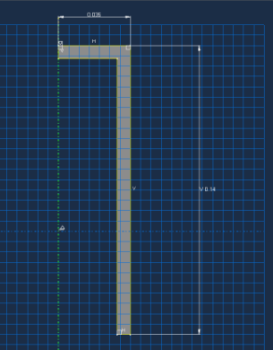  Figure 1 - Casing Geometry | 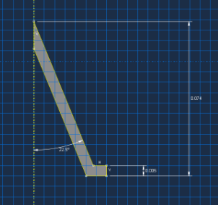  Figure 2 - Liner Geometries

The student had decided on these geometries due to them being very realistic to shape charges used in industry [10]. The high explosive (HE) geometries are not shown in the above table as the liner and case were lined up and the HE was just made to fill the gap so the geometries can be inferred from the above images and their geometries. The next step in abaqus is to assign material properties to all the parts created. Due to the research the student had already carried out on shaped charges the case was decided to be steel, the liner copper and the HE for the first simulation would be PETN.
Table 2 - Material Properties used for Simulation 1
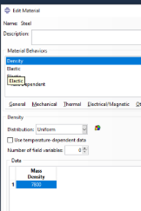  Figure 3 - Steel Case Material Properties [11] | 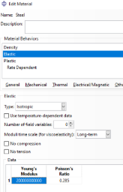  Figure 4 - Steel Case Material Properties [11] | 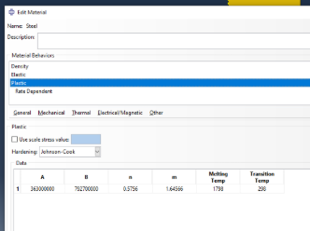  Figure 5 - Steel Case Material Properties [12]
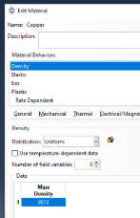  Figure 6 - Copper Liner Material Properties [13] | 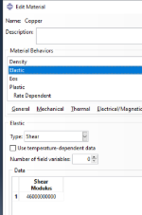  Figure 7 - Copper Liner Material Properties [14] | 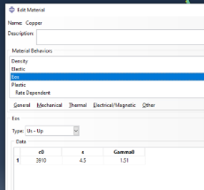  Figure 8 - Copper Liner Material Properties [15]
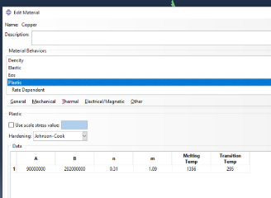  Figure 9 - Copper Liner Material Properties [15] | 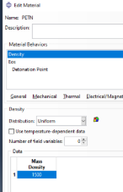  Figure 10 - PETN HE Material Properties [9] | 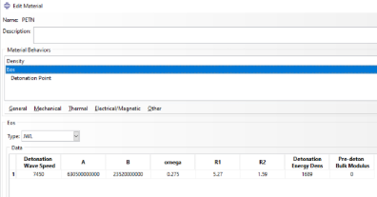  Figure 11 - PETN HE Material Properties [9]

It should be noted that in the above no damage parameters were put in for either of the metals meaning they could have gone past their limits of elasticity but the software would not know as the parameters have not been put in for it so if the metals reach amounts of stress and strain that in real life would cause them to break the simulation will continue to model them, giving somewhat incorrect results but will show the jet formation better.
Upon assigning all the correct material properties to the right parts of the design, the next and potentially longest step is to mesh the whole design, this is easiest done part by part. Starting with the casing the student set the mesh size to relatively coarse making sure to select tri shaped elements as this allows for better flowing of elements around corners. Moving onto the liner the student decided on a graduated mesh along the top edge of the liner. This decision was made as the tip of the liner is where the shaped charge will see the highest change in pressures and velocities as that is where the pressure wave travels to first and where the metal jet begins to form from. The liner starts with a fine mesh at the tip moving to a coarser mesh at the base to match the case at the end of the liner. The graduated mesh allows the student to have a closer analysis of where the majority of the action is happening in the simulation but does not massively increase the run time of the simulation. This then leaves the HE to mesh, as this is the part that joins both the case and liner it is imperative to ensure all mesh sizes along each edge of each part that sit next to each other are the same as without them lining up it will prevent shock waves from travelling smoothly throughout the design. The HE was given a global seed of rather coarse mesh to allow it to flow seamlessly into the case. There was then two graduated meshes assigned to the HE. One along the base to match the liners mesh sizing while the other graduated mesh was along the centre line of the HE. This graduated mesh was exactly where the front of the pressure wave would travel first so it was very important it was a well lined up graduated mesh to not make the simulation give any errors. The mesh created can be seen below if fig. 12.
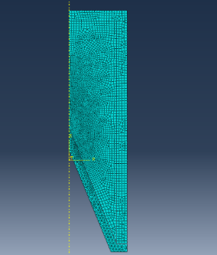
Figure 12 - Simulation 1's First Mesh
Upon running thus simulation the student gathered these results which were a promising start.
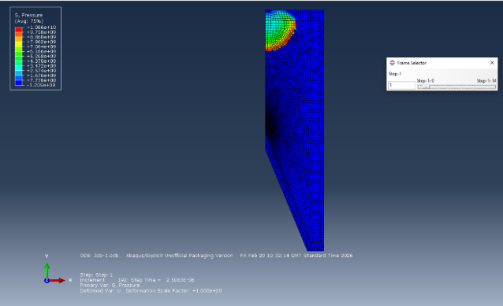
Figure 13 - Pressure Results Simulation1

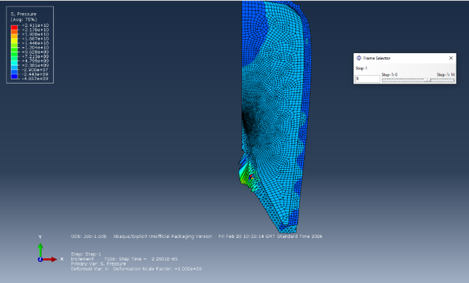
Figure 14 - Pressure Results Simulation 1
With a keen eye it could be noted that the way the nodes in the liner are distorting this simulation will likely fail as they are stretching beyond their limit and not quite in the directions expected for a simulation like this. Luckily, abaqus does in fact tell the user what the error is if a simulation fails which is what happened in the above simulation. As could be predicted the nodes in the liner excessively distorted causing the simulation to abort. The best way to fix such an error is usually the reduce the size of the mesh down even more. As the errors were in the liner it was only the liner and the bottom of the HE that the student decided on reducing the mesh size as they did not want to reduced the size of unnecessary things such as the case as this would only add time to the run time and not actually improve the quality of the results. Upon running this simulation again, the same error came back but at a different point, the results however looked more accurate this time than they did the fires time the simulation was run as the beginning of a jet formation could be seen in the liner, the results ca be seen in fig. 15.
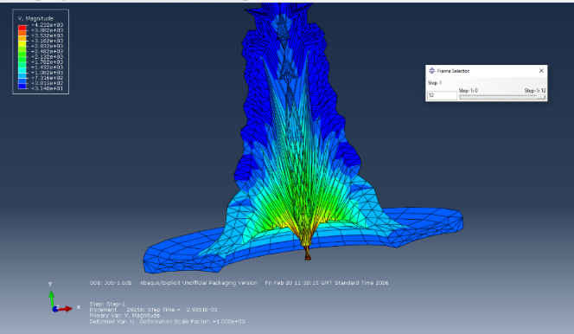
Figure 15 - Revolved Liner Velocity Results Simulation 1
As reducing the mesh size a bit had already taken the student in the correct direction so the next logical step was to continue reducing the mesh size until a full jet formation could be seen. Instead of a slowly graduated mesh on the liner the student decided on making the whole of the sloped section of the liner a very fine mesh and then only graduating the very end section to help it line up correctly with the cases’ mesh size.
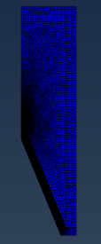
Figure 16 - Simulation 1 with Finer Mesh
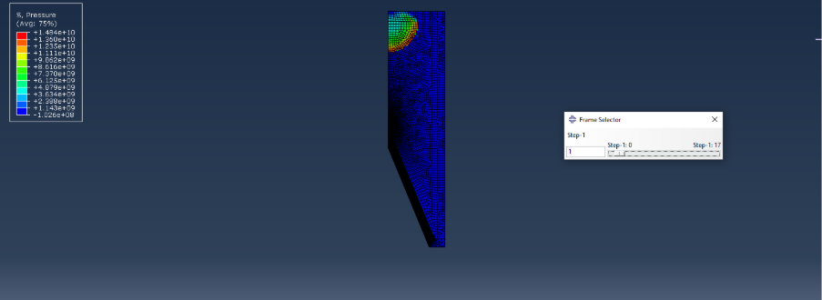
Figure 17 - Pressure Results of Finer Mesh Simulation 1
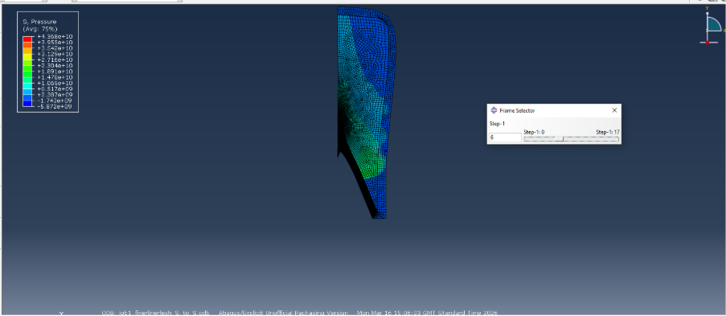
Figure 18 - Pressure Results of Finer Mesh Simulation 1

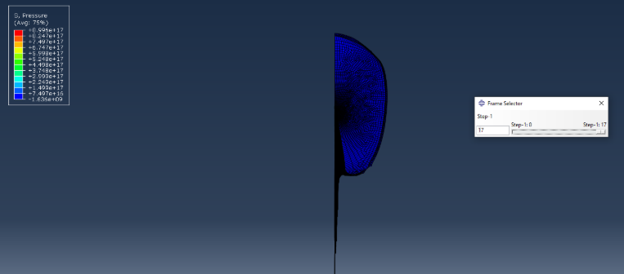
Figure 19 - Pressure Results of Finer Mesh Simulation 1
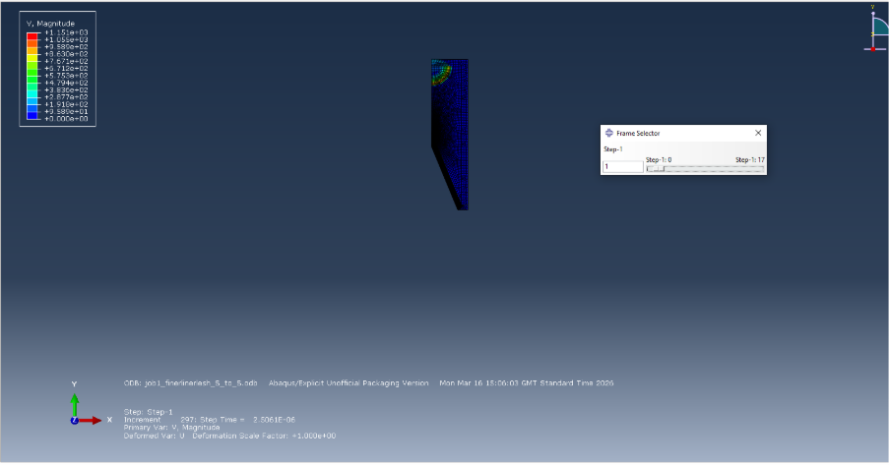
Figure 20 - Velocity Results of Finer Mesh Simulation 1
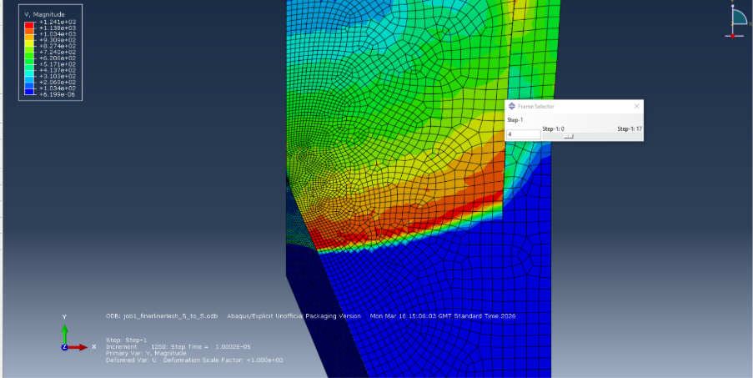
Figure 21 - Velocity Results of Finer Mesh Simulation 1
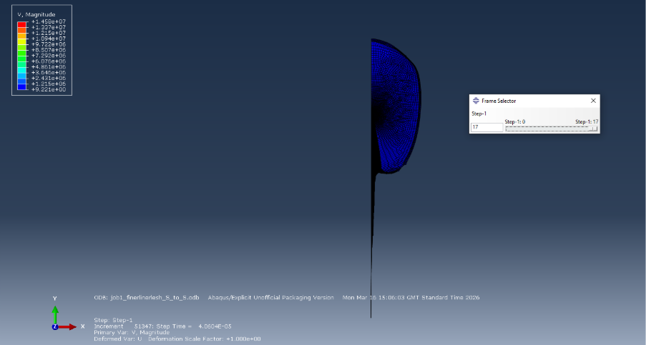
Figure 22 - Velocity Results of Finer Mesh Simulation 1

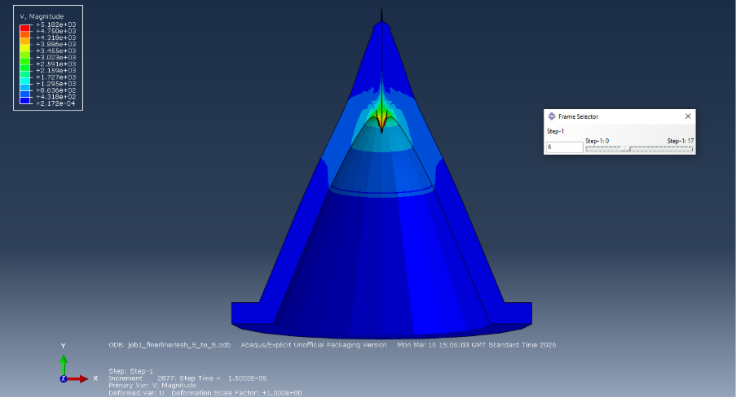
Figure 23 - Revolved Liner Velocity Results of Finer Mesh Simulation 1
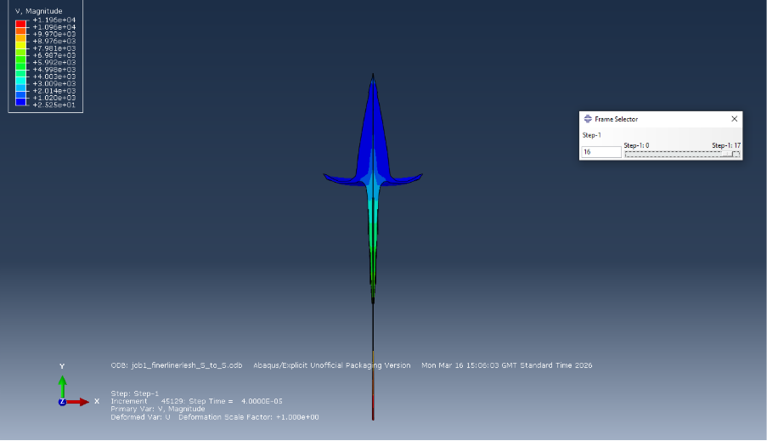
Figure 24 - Revolved Liner Velocity Results of Finer Mesh Simulation 1
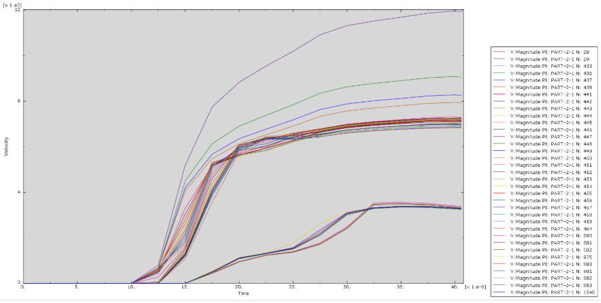
Figure 25 - Velocity Graph of Nodes at the tip of the Jet
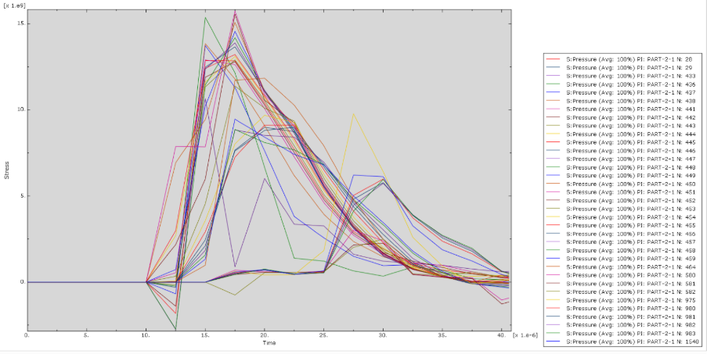
Figure 26 - Pressure Graph of Nodes at the tip of the Jet
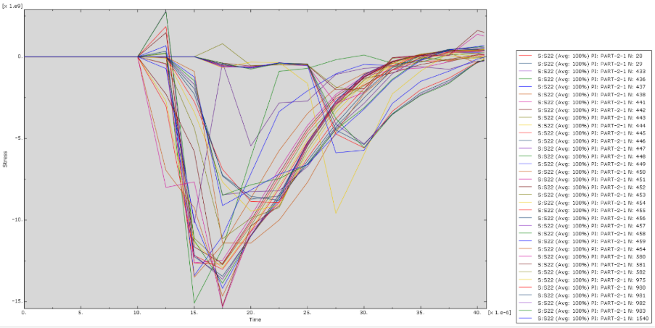
Figure 27 - Stress Graph of Nodes at the tip of the Jet
As can be seen in the above the average fastest velocites that the nodes in the liner experienced were around 8m/s, this is equivalent to just less than 18,000mph to put that into perspective. That sort of velocity was putting the copper liner under a stress of -15e9 Pa. This is so large that likely in practice the jet formation would not be one long line but instead be breaking off in chunks, this is not witnessed in the simulation as no damage parameters have been included so the software behaves as if the materials are endlessly elastic.

4.1.2 Simulation 2
Originally, the student had planned on their second simulation being one of the other angles of the liner stated in their research conducted previously. The angle of the first liner was 45°, the other angle used in the literature read was 75°. Upon attempting to run the same above simulation with the only change being the angle abaqus gave many errors and aborted the simulation, this was due to the angle being too steep for the software to be able to smoothly transition the pressure wave through it. The recommended technique of how to get around this is to round the tip of the liner, so it is a nice circle to transition to rather than a sharp point. However, even with the rounded tip of the liner abaqus still aborted the simulation every time it was run, these errors were show:
‘The ratio of deformation speed to wave speed in the elements in element set WarnElemDeformRateExceedsRatio-Step1 exceed the warning ratio. Refer to the status file for further details. This message is printed during the first applicable increment, but will not be printed during subsequent increments for the remainder of the step’
‘Some nodes involved in general contact have penetrated their tracked faces by more than 50.000 percent of the typical element dimension in the general contact domain, 1.16300E-03. Please check the node set "InfoNodeDeepPenetFirst". Please make sure that these nodes and their contacting faces have sufficient mass to allow the code to calculate realistic contact penalties for enforcing the contact constraint.’
‘All nodes involved in general contact that have undergone deep penetration of their tracked faces during this step have been listed in node set "InfoNodeDeepPenetAll". Please make sure that these nodes and their contacting faces have sufficient mass to allow the code to calculate realistic contact penalties for enforcing the contact constraint.’
Even with changing mesh sizes, rounding the sharp edge of the liner and adding interacting between the surfaces so they would behave as if they were welded together this simulation would not work. Due to the limited time frame given to work in the student moved on and decided the second simulation would be a change of explosive. The second explosive chosen was TNT.
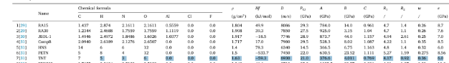
Figure 28 - TNT Property Values Compared to PETN [9]
The rest of the TNT values [16] were filled in the material properties section. As the previous simulation had work well with a good jet formation and for ease of comparison the student used the same model that was used in simulation 1. However, surface to surface interactions had been added between the HE and the copper liner as the student had learned their usefulness whilst trying to make the steeper liner angle design work.
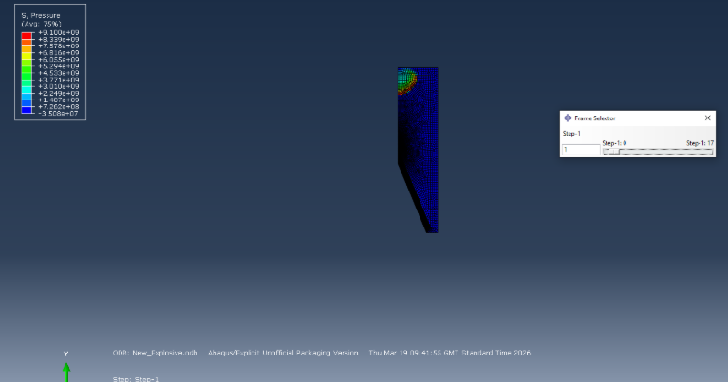
Figure 29 – Pressure Results of Simulation 2
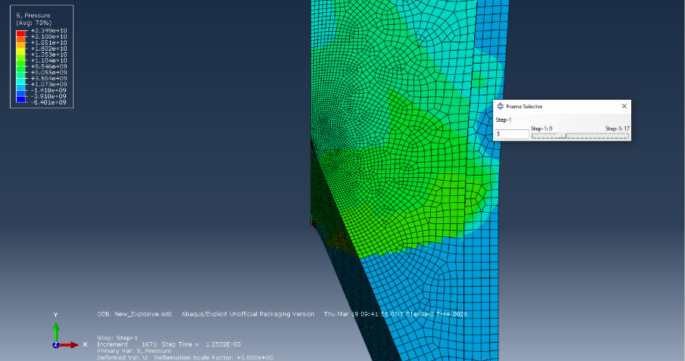
Figure 30 – Pressure Results of Simulation 2
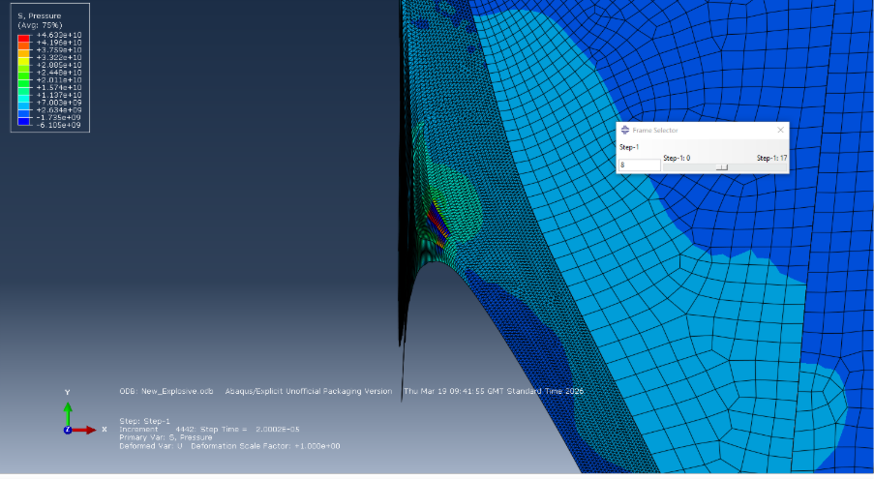
Figure 31 – Pressure Results of Simulation 2

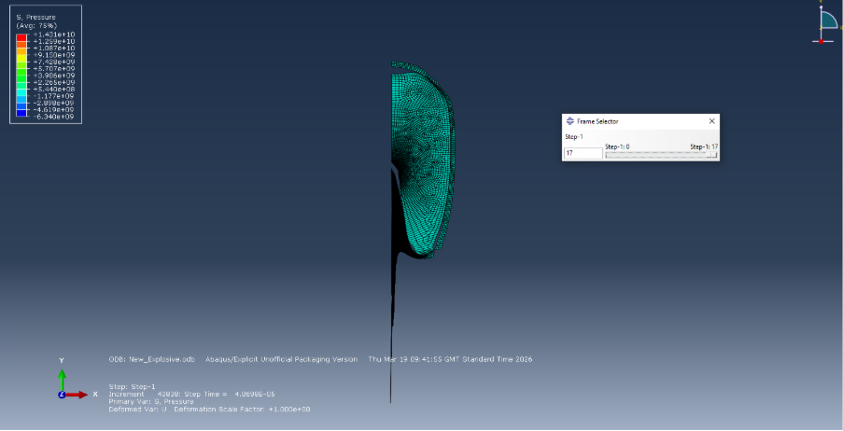
Figure 32 – Pressure Results of Simulation 2
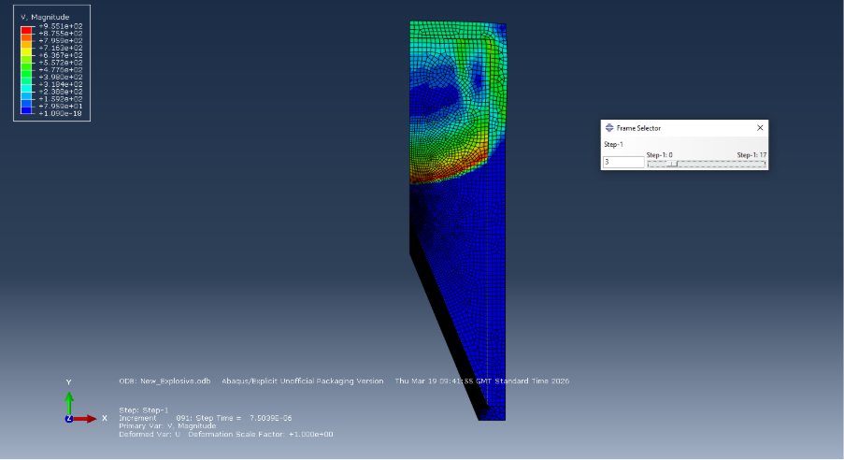
Figure 33 – Velocity Results of Simulation 2
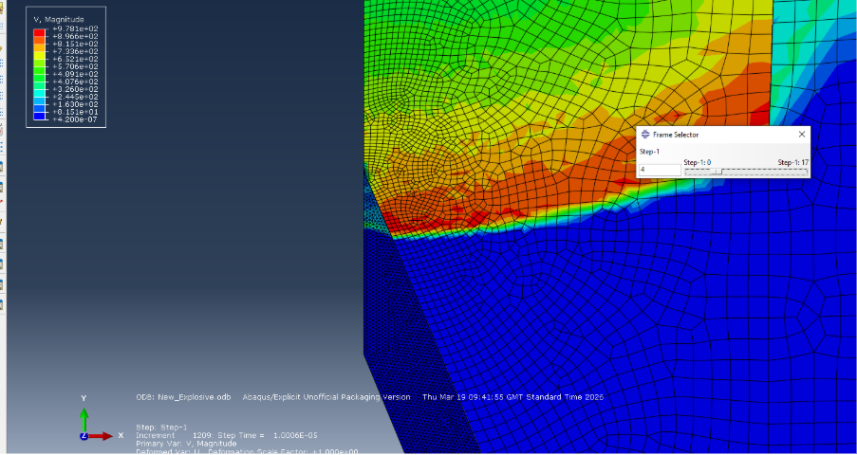
Figure 34 – Velocity Results of Simulation 2
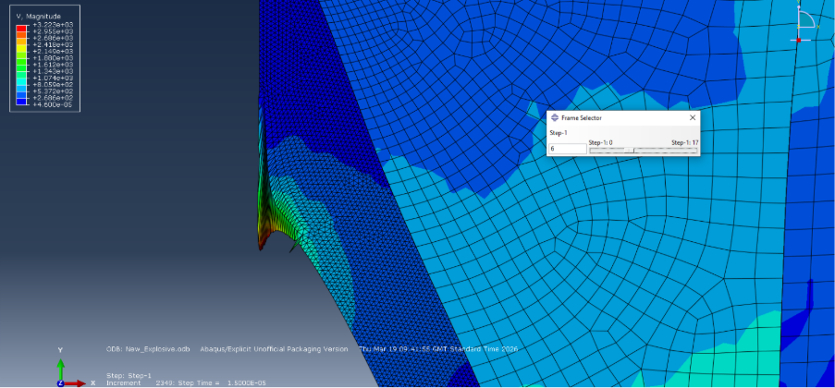
Figure 35 – Velocity Results of Simulation 2
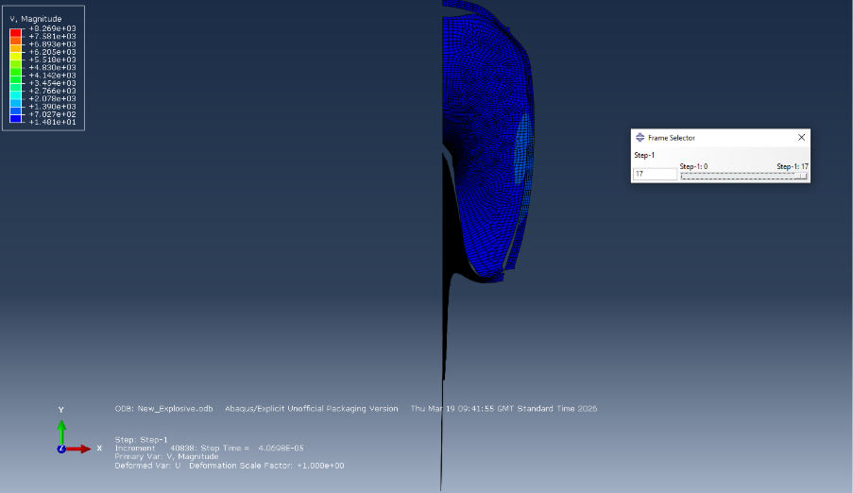
Figure 36 – Velocity Results of Simulation 2
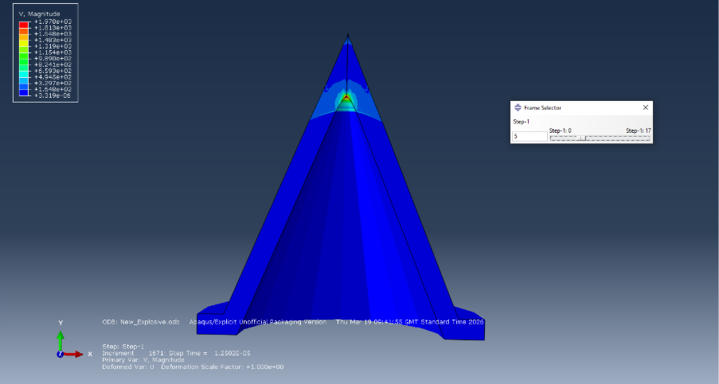
Figure 37 - Revolved Velocity Results of Simulation 2
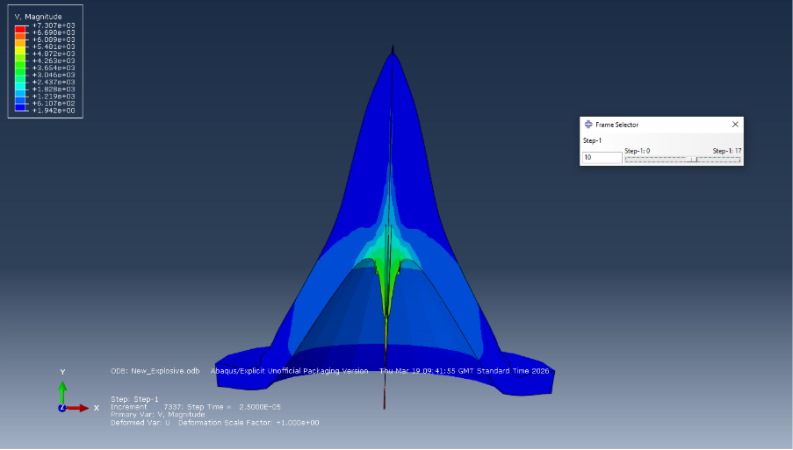
Figure 38 - Revolved Velocity Results of Simulation 2
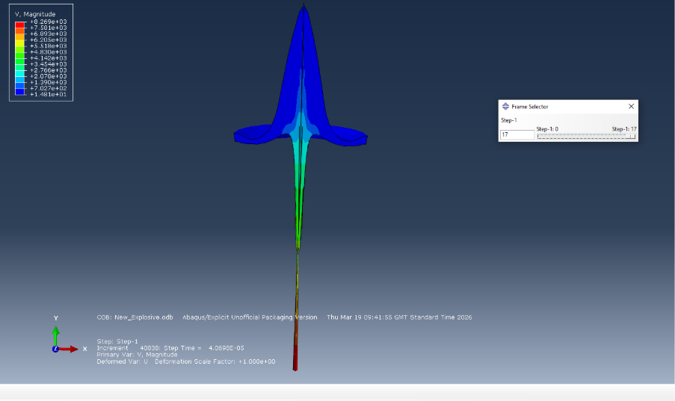
Figure 39 - Revolved Velocity Results of Simulation 2
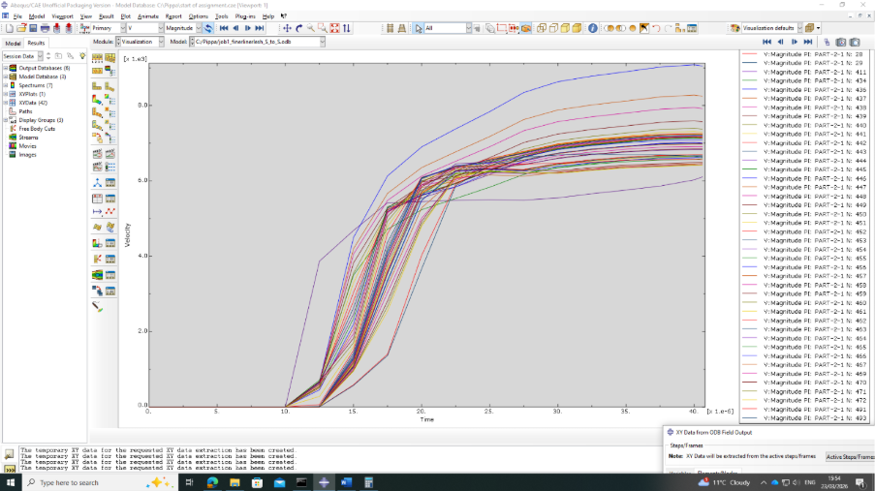
Figure 40 - Velocity Graph of Nodes from the end of the Jet of Simulation 2
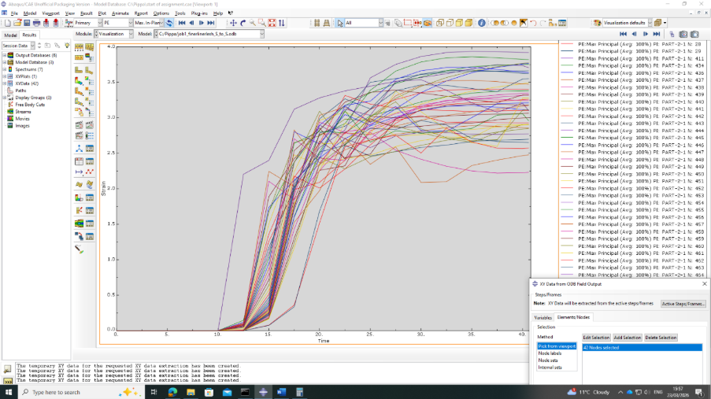
Figure 41 - Strain Graph of Nodes from the end of the Jet of Simulation 2
In the strain graph above the strain levels go above 0.6 which is the failure point for copper. This again means that this simulation was not fully accurate as a lot of the nodes reach a strain of around 3 or even 3.5 meaning the material would have failed and would not have formed a smooth jet it would broken into pieces. The maximum velocities experienced by the nodes in the end of the jet were approximately 6e3m/s which is around 13,400 mph. This is approximately 2 x10³m/s slower than simulation 1’s metal jet. This aligns with the velocity of detonation throughout the explosives. In simulation 1 the velocity of the detonation wave in the PETN was approximately 1.2 x10³ m/s while the detonative wave velocity throughout the TNT was approximately 9.5 x10²m/s.

4.2 3D Model
For the 3D model the student decided to use the PETN model as this had produced the least number of difficulties in the 2D stages. As this was now a 3D design rather than 2D the mesh was required to be fully restarted. The student began by creating a global seed on the cone of 0.003 with graduations similar to the 2D designs towards the point of the liner. The graduated mesh went from 0.0007 at the tip of the liner to 0.003 at the base. The HE had a global seed of 0.004 which had a few graduated meshes, one along the bottom where it touches the cone and the oner down the middle travelling in the same direction the front of the detonation wave would. The case was left until last and was given just a simple coarse global seed of 0.01, although this meant that the meshes would not line up perfectly the student hoped this would still work as they were very aware of not wanting to go over the node limit which they were warned was a lot easier in the 3D models.
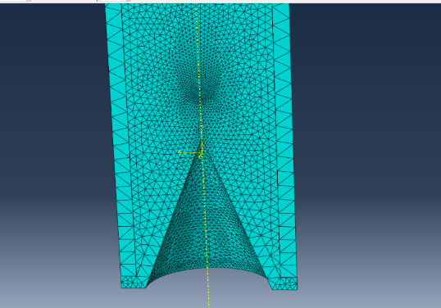
Figure 42 - First mesh of 3D Simulation
Although this mesh ensured small nodes in the HE it did not give a small enough mesh in the casing, an important thing to try and remember is to always ensure each height and width has at least two nodes, as can be seen the sides of the casing is only one node wide which is a red flag for the simulation to likely abort itself due to excessive distortion.
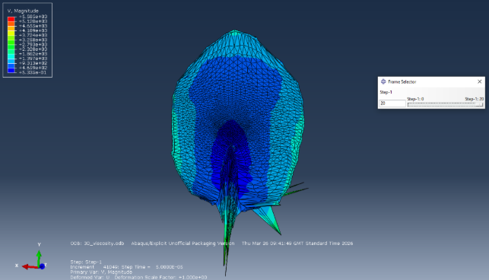
Figure 43 - Velocity Results for First 3D Simulation
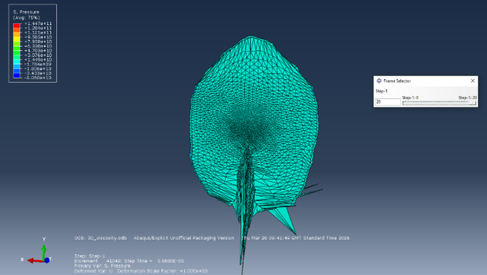
Figure 44 - Pressure Results for First 3D Simulation
As can be seen in the above figures the case elements are excessively distorting and no clear jet formation can be seen. The first few things to combat this are the create a much finer mesh, a clear conical shape throughout the HE will allow the detonation wave to travel very smoothly throughout the explosive and a finer mesh in the case that will allow a smooth transition between the parts will massively help the simulation. Another useful option is to add in surface to surface interactions between the HE and liner. The graduated mesh on the liner was kept instead of just reducing the whole liners mesh to help ensure the node number stayed below the software’s licensing limits. The student also increased the run time as the above figures are showing the full extent of the results of the previous run time if that simulation and as there is not a fully formed jet it is clear the run time needed to be increased.
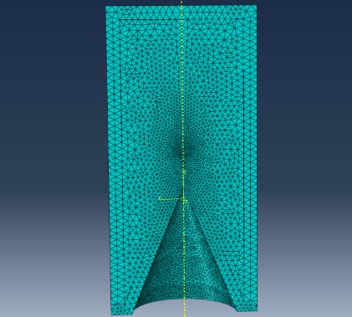
Figure 45 - 3D Simulation Finer Improved Mesh
As can be seen in fig. 45 there is now a conical shape to the mesh in the HE for the detonation wave to travel down and every node lines up perfectly with another even if they belong to separate parts.
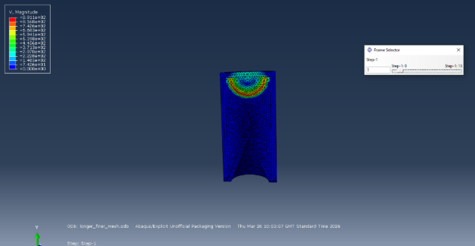
Figure 46 - Velocity Results Finer Mesh 3D Simulation
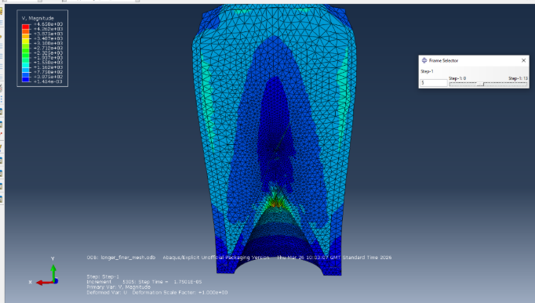
Figure 47 - Velocity Results from Finer Mesh 3D Simulation
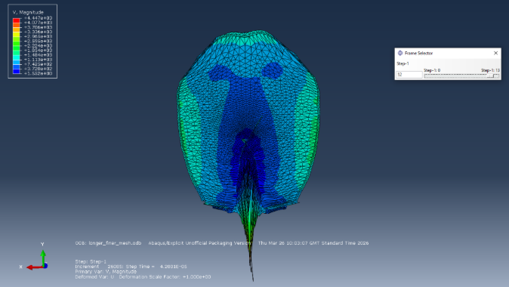
Figure 48 - Velocity Results from the Finer Mesh 3D Simulation
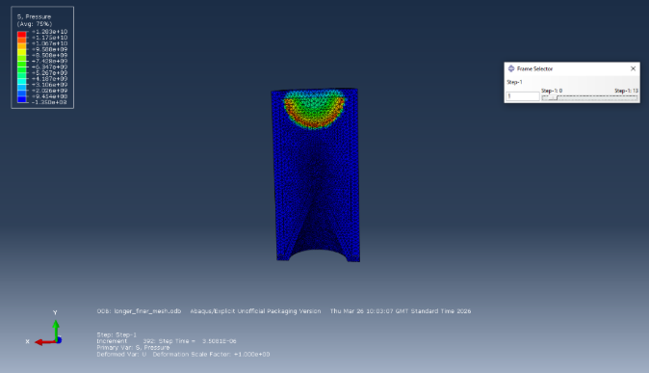
Figure 49 - Pressure Results from Finer mesh 3D Simulation

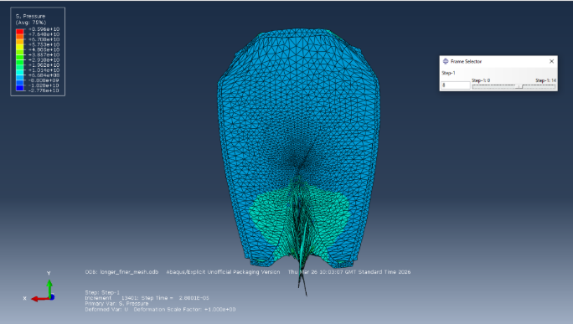
Figure 50 - Pressure Results from Finer Mesh 3D Simulation
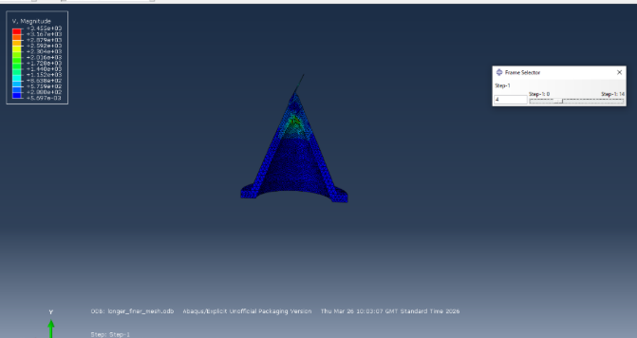
Figure 51 - Velocity Results Finer Mesh 3D Simulation Liner Only
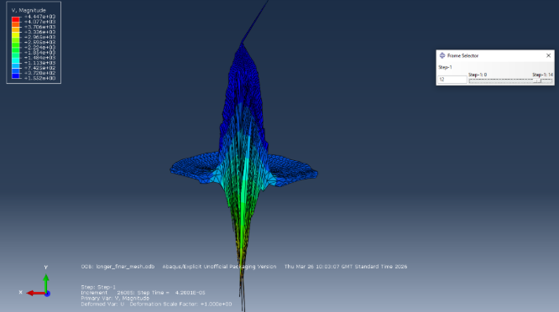
Figure 52 - Velocity Results Finer Mesh 3D Simulation Liner Only
As can be seen in figure 52 the maximum velocity of the jet is around 4.4 x10³m/s which is smaller than the velocity seen in the 2D simulation which was approximately 8 x10³m/s, this difference could be due to the number of nodes included, the lack of surface to surface interaction in the 2D PETN simulation.

Section 5: Conclusion
The student completed all simulations, whilst with more nodes, interactions and material properties added they could be made more realistic and correct they give a very good base point for what an engineer should expect from a shaped charge. As shaped charges are usually operating at such high velocities there is no easy way to prove any of the above however high explosive are known to detonate between 8,000 mph and 17,000 mph, all of the results given in the above report have been within this boundary so that is a very good starting point of producing some good reliable data. However, with the knowledge of the stress and strain copper can undertake before failure the student was able to identify a perfect metal jet would not be formed in real life as the copper would have already started breaking into pieces under the stress and strain.

References

[1] | C. Poole, “Penetration of a Shaped Charge,” University of Oxford, Oxford, 2005.
[2] | A. Q. malik, “A Review of Works on Sharped Charges,” Engineering Technology & Applied Science Research, vol. 7, no. 5, pp. 2098-2103, 2017.
[3] | W. Walters, “A Brief History of Shaped Charges,” Interational Symposium on Ballistics, vol. 1, no. 1, pp. 3-10, 2008.
[4] | W. C. Young and R. G. Budynas, Roark's Formulas fro Stress and Strain, New York: McGraw-Hill, 2002.
[5] | Z. Engineer, “Strain: Meaning, Definition, Formula, Typres, Symbols and Calculation,” Mech Forged, 30 July 2025. [Online]. Available: https://mechforged.com/strain-meaning-definition-formula-types-symbol/. [Accessed 15 May 2026].
[6] | M. J. Giuliodori, H. L. Lujan and W. S. Briggs, “Hooke's Law: applications of a recurring principle,” Advances in Physiology Education, vol. 33, no. 4, pp. 193-296, 2009.
[7] | H. J. Keighley, “Motion, Scalars and Vectors,” in Work Out Physics 'O' Level and GCSE, London, Palgrave, 1986, pp. 22-38.
[8] | R. Kadariya, “Pressure: Principe, Formula, Types, Factors, Devices, Examples,” Science Info, 30 July 2025. [Online]. Available: https://scienceinfo.com/pressure/. [Accessed 16 May 2026].
[9] | R. Liu, “JWL equation of state parameters for ideal detonation: A comparative study of literature reports, theoretical derivation, and artificial neural network prediction,” FirePhysChem, vol. 6, no. 1, pp. 51-60, 2026.
[10] | C. K. Patel, “Conical Shaped Charges,” ProQuest, Ann Arbor, 2018.
[11] | MatWeb, “Material Property Data,” MatWeb, [Online]. Available: https://www.matweb.com/errorUser.aspx?msgid=2&ckck=nocheck. [Accessed 15 March 2026].
[12] | S. Yadav and S. Singhal, “Determination of Johnson-Cook material model for weldment of mild steel,” Materials Today: Proceedings, vol. 28, no. 3, pp. 1801-1808, 2020.
[13] | D. M. Iordache and E. R. Oprescu, “Determination of Johnson-Cook material constants for Copper using traction tests and inverse identification,” IOP Conference Series: Materials Science and Engineering, vol. 1182, no. 1, pp. 12-32, 2021.
[14] | MatWeb, “Material Property Data,” MatWeb, [Online]. Available: https://www.matweb.com/search/DataSheet.aspx?MatGUID=9aebe83845c04c1db5126fada6f76f7e&ckck=1. [Accessed 15 March 2026].
[15] | F. Wang, J. Wang and Z. Qi, “Evaluation of copper spall response using Mie-Grüneisen equation-of-state parameters determined from molecular dynamics,” Computational Material Science, vol. 216, 2023.
[16] | United States Environmental Protection Agency, “Technical Fact Sheet – 2,4,6 - Trinitrotoluene (TNT),” EPA, January 2014. [Online]. Available: https://19january2017snapshot.epa.gov/sites/production/files/2014-03/documents/ffrrofactsheet_contaminant_tnt_january2014_final.pdf. [Accessed 15 March 2026].

