LCBB4009 Understanding Organisational Structure and Culture

Communication Dynamics in Business: Methods, Challenges, and Strategic Recommendations: A Case Study of Marks & Spencer plc

Student Name: Cornelia Ioan
Student ID: 2515711

Module Leader/ Lecturer: Dr Said Usman

Word Count: 1520

Table of Contents
1. Introduction 3
2. Communication and Methods 3
2.1 Defining Business Communication 3
2.2 Key Communication Methods in Business 3
3. Common Issues 5
3.1 Miscommunication and Structural Complexity 5
3.2 Information Overload 5
3.3 Cross-Cultural and Linguistic Barriers 6
4. Recommendations 7
5. Conclusion 8
References 9

List of Figures
Figure 1: Multi-Directional Communication Flow Framework at Marks & Spencer plc. 4
Figure 2: Interconnected Communication Challenge Framework in Large Retail Organisations. 7
List of Tables
Table 1: Key Communication Methods in Business. 4
Table 2: Cross-Cultural and Linguistic Barriers. 6

1. Introduction
Organisational communication is a cornerstone of organisational performance, influencing decision-making, employee interaction, and strategic goal achievement (Musheke & Phiri, 2021). The report discusses communication in the business context as an analytical focus on the case of Marks and Spencer plc (M&S), which is a large multinational retailer employing more than 64,000 staff members in more than 1,058 outlets around the world (Marks & Spencer plc, 2024). Continuing the discussion on the functional, divisional, and matrix structures' development by Component 1, this report examines important ways of communication, common organisational problems, and strategic solutions that can be implemented to ensure the effective use of communication in a multidivisional and complex retail scenario at M&S.

2. Communication and Methods

2.1 Defining Business Communication
In business communication, communication is not merely a process of an exchange of information; it is a systematic, well-organised process that involves the integration of verbal, non-verbal, written and technology-mediated forms of communication to attain organisational effectiveness (Diasamidze, 2025). Kalogiannidis (2020) verifies that effective horizontal, downward, or upward communication in the business directly and positively affects the performance of the employees and organisational profitability.
Valiyeva and Thomas (2022) also say that leadership style, top management support, information technology implementation and frequency and diversity of interaction are important factors that influence the effectiveness of communication. Importantly, communication is not a passive medium but a strategic action: Taruchaín-Pozo et al. (2025) show, with a narrative review of 52 peer-reviewed articles, that the organisations which employ open and adaptive communication strategies have better outcomes in decision-making and stakeholder alignment and better retention of talent. This is a vital strategic aspect of communication in competitive retail markets like the one that M&S is in in the UK.

2.2 Key Communication Methods in Business
Table 1 below lists the main communication tools that are used in big organisations, and this will act as a systematic guide in further analysis.
Communication Method | Type | Direction | Example Application
Leadership briefings and town halls | Formal | Downward | Strategic direction from the co-CEO to the divisional heads
Digital internal platforms (intranets, AI tools) | Technology-mediated | Multi-directional | CommerceHub, store-level AI communication systems
Face-to-face/team meetings | Informal / Formal | Upward / Lateral | "Straight to Stuart" employee idea collection initiative
Written reports and policy communications | Formal | Downward | Annual strategy documentation, policy circulars
Surveys and feedback mechanisms | Formal | Upward | "Voice of the Partner" franchise partner survey
Table 1: Key Communication Methods in Business.
Formal downward communication in M&S is provided through its co-CEO system – Stuart Machin and Katie Bickerstaffe – through divisional and functional hierarchies. Valiyeva and Thomas (2022) prove that leadership communication style is one of the most significant predictors of the effectiveness of organisational communication, which proves the structural significance of the dual-leadership approach of M&S. Digital internal communication (DIC) is the most centralised one. According to Wuersch, Neher and Peter (2022), DIC is a socio-technical phenomenon that is not only limited to the implementation of digital tools but also meaning-making, trust-building, and interaction at different organisational levels.
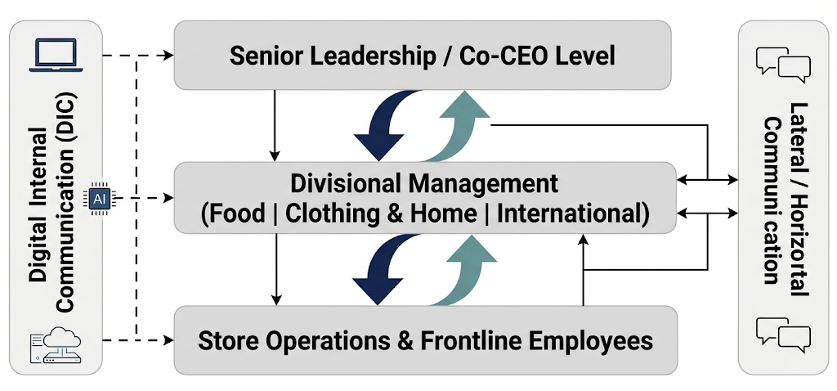
Figure 1: Multi-Directional Communication Flow Framework at Marks & Spencer plc.
Increasing strategic primacy of DIC is reflected by the investment that M&S just announced in 2024 (Marks & Spencer plc, 2024): the technology infrastructure will be deployed in 2025-26, with £200-250 million of AI implemented in more than 500 stores and in the CommerceHub Commerce Suite. The example of face-to-face and participative upward communication is the so-called 'Straight to Stuart' programme, where more than 10,000 ideas of employees were collected by 2023 (Ledingham, 2024). Empirically, Battiston et al. (2020) affirm that information transfer is faster with face-to-face communication, and team productivity is increased. Moreover, Mbhele and De Beer (2022) determine that two-way internal communication, which is participative, is directly associated with employee engagement, which is an important performance driver in large and geographically dispersed retail organisations, like M&S.

3. Common Issues

3.1 Miscommunication and Structural Complexity
As Component 1 defined, M&S has a hybrid-divisional-matrix organisation with Food, Clothing and Home and International divisions. Cooper (2024) points out that it is the nature of matrix organisations to experience confusion of roles, blind spots in decision-making processes, and fragmentation of accountability, which in turn directly result in communication failures. In a qualitative multiple-case study, Ghaleb and Piaralal (2025) discovered that a lack of formal communication guidelines, role ambiguity, and overuse of informal or asynchronous communication have led to communication breakdown in complex organisations. In 1,058 stores of M&S, the distortion of messages across the hierarchical layers is a serious threat to the operation of the company. Campbell, Phillips and Phillips (2020) affirm that the lack of effective communication between employees and management has a negative impact on organisational productivity and destroys institutional trust, which is especially critical in frontline retail settings where clarity of operations is a prerequisite.

3.2 Information Overload
The fast digitalisation of the processes of M&S, including the introduction of AI, e-commerce platforms and automated supply chain systems, provides systemic preconditions of information overload. In a systematic review of 87 studies, Arnold, Goldschmitt, and Rigotti (2023) found that continuous digitisation is an important driver of information overload, which negatively affects the ability of employees to focus, make better decisions, and experience better well-being. Barrett, Ford and Zhu (2022) showed that, indirectly, job satisfaction and organisational identification are decreased by the overload of communication due to poor participation in the decision-making process. Supriyadi et al. (2025) additionally discovered that overuse of digital activities causes cognitive overload, increased stress, and poor job performance at the workplace in any professional environment, which is especially relevant to the high number of frontline employees at M&S.

3.3 Cross-Cultural and Linguistic Barriers
Table 2 shows the main communication issues that arise in multinational retail organisations and frames these in the context of the operations of M&S.
Communication Challenge | Root Cause | Organisational Impact
Miscommunication and role ambiguity | Matrix structural complexity; absent formal protocols | Reduced accountability; operational delays
Information overload | Rapid digitalisation; multi-channel proliferation | Burnout; impaired decision-making
Cross-cultural communication barriers | Diverse workforce; international franchise network | Conflict: misaligned stakeholder expectations
Digital fatigue and technostress | Excessive technology-mediated communication | Decreased engagement; staff turnover risk
Table 2: Cross-Cultural and Linguistic Barriers.
The varied workforce and global franchise operations in various European markets and India that M&S has subjected itself to present acute intercultural communication dilemmas. According to Gašpar, Podrug and Aleksic (2023), the key factors that lead to communication failure in multicultural organisations are language differences, non-verbal misinterpretations, and cultural stereotyping. Rajhans and Hiray (2022) discovered that cross-cultural barriers to communication are a major deterrent to team performance when unattended to.
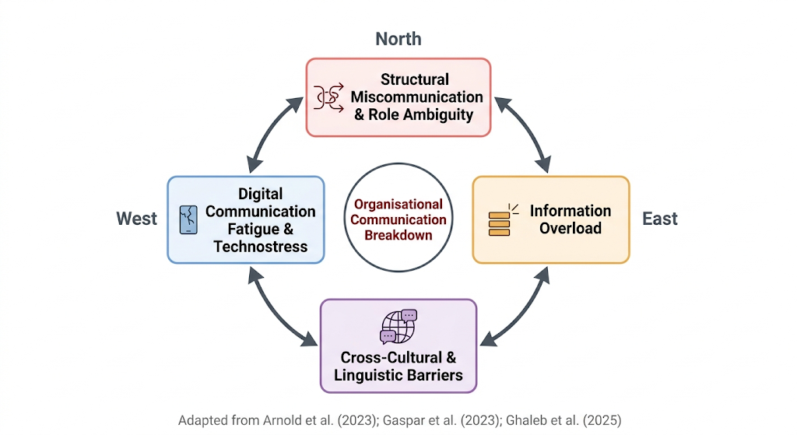
Figure 2: Interconnected Communication Challenge Framework in Large Retail Organisations.
The fact that M&S introduced the voice of the partner-independent survey and invited the franchise partners to the International Business Board meetings (Marks & Spencer plc, 2024) admits the extent of cross-cultural alignment issues that are inherent in its international communication infrastructure. Fiset, Bhave and Jha (2023) also confirm that there are quantifiable adverse effects of language-related misunderstanding in the workplace on the performance of employees and attitudinal outcomes, which, in turn, require strategic intercultural communication.

4. Recommendations
In order to deal with the specified communication issues, M&S may implement the following evidence-based practices. First, formal communication protocols must be laid down at all divisional and matrix levels and responsibilities and reporting channels must be made clear. Chirwa and Boikanyo (2022) discovered that the strongest predictors of successful strategy implementation are credibility and flexibility in formal communication.
Second, the deployment of AI-based information filtering systems must be done to prioritise essential messages, which would minimise the risk of overload. Arnold, Goldschmitt and Rigotti (2023) suggest that structural redesign of the digital communication workflows should be used as the main preventive intervention.
Third, a systemic intercultural communication training programme, based on the cultural dimensions of Hofstede, will have to be introduced on both the management and frontline levels. In his research, Mushaathoni (2025) suggests three stages of the intercultural communication management framework, which include recognition, planning, and integration to minimise cross-cultural barriers in a systematic way.
Lastly, a hybrid model of communication between physical presence and online technologies needs to be embraced to reduce the effects of digital exhaustion but still enjoy the benefits of technology-mediated communication in terms of productivity (Supriyadi et al., 2025).

5. Conclusion
This report has critically analysed communication practices, issues and strategic suggestions in the multifaceted organisational context of M&S. M&S utilises a broad assortment of channels of communication such as formal briefings by the leadership and online digital communication platforms, as well as participative upward communication, but it is still struggling with several challenges such as structural miscommunication caused by the matrix structure, information overload due to the increasing pace of digitalisation, some cross-cultural barriers integrated into its global business, and digital communication burnout. Communication is not a transactional role but a strategic requirement that supports the performance of the M&S divisions, engagement of its employees, and sustainability in the competitive arena. It will be necessary to tackle these issues by implementing culturally sensitive, structured and technologically smart communication approaches to ensure that M&S can continue its growth path in the UK retail market, which is becoming more complex.

References
Arnold, M., Goldschmitt, M. and Rigotti, T. (2023). Dealing with Information overload: a Comprehensive Review. Dealing with Information Overload: a Comprehensive Review, [online] 14(1122200). doi:https://doi.org/10.3389/fpsyg.2023.1122200.
Barrett, A.K., Ford, J. & Zhu, Y. (2022). Communication Overload in Hospitals: Exploring Organisational Safety Communication, Worker Job Attitudes, and Communication Efficacy. Health Communication, 38(13), pp.1–15. doi:https://doi.org/10.1080/10410236.2022.2129313.
Battiston, D., Blanes i Vidal, J. and Kirchmaier, T. (2017). Face-to-Face Communication in Organisations. SSRN Electronic Journal, [online] 131(636). doi:https://doi.org/10.2139/ssrn.2934290.
Campbell, S., Phillips, S.C. and Phillips, D. (2020). Lack of Communication between Management and Employees. SIASAT, [online] 4(3), pp.32–39. doi:https://doi.org/10.33258/siasat.v4i3.67.
Chirwa, M. and Boikanyo, D.H. (2022). The Role of Effective Communication in Successful Strategy Implementation. Acta Commercii, 22(1), pp.1–13. doi:https://doi.org/10.4102/ac.v22i1.1020.
Cooper, A.C.M. (2024). Overcoming Leadership Challenges in Highly Matrixed Organisations. Leader to Leader, 2025(115). doi:https://doi.org/10.1002/ltl.20860.
Diasamidze, T. (2025). Business Communication as a Formula for Effective Communication, Innovative Economics and Management. Innovative economics and management, [online] 12(2), pp.111–116. doi:https://doi.org/10.46361/2449-2604.12.2.2025.111-116.
Fiset, J., Bhave, D.P. & Jha, N. (2023). The Effects of Language-Related Misunderstanding at Work. Journal of Management, 50(1). doi:https://doi.org/10.1177/01492063231181651.
Gašpar, M., Podrug, N. and Aleksić, A. (2023). The Significance of cross-cultural Barriers in Organisational communication. Zbornik Veleučilišta u Rijeci, [online] 11(1), pp.235–246. doi:https://doi.org/10.31784/zvr.11.1.13.
Ghaleb, M.M.S., & Piaralal, S.K. (2025). Information and Communication with Business or Organisation: a Thematic Case Study Analysis of Two Communication Challenges. El Profesional de la Informacion, [online] 34(1). doi:https://doi.org/10.3145/epi.2025.ene.34110.
Kalogiannidis, S. (2020). Impact of Effective Business Communication on Employee Performance. European Journal of Business and Management Research, 5(6), pp.1–6.
Ledingham, D. (2024). Marks and Spencer: Reshaping a Strategy. [online] Substack.com. Available at: https://dledingham.substack.com/p/marks-and-spencer-reshaping-a-strategy [Accessed 21 Apr. 2026].
Marks & Spencer plc (2024). Marks and Spencer Plc Financial Statements 2024. [online] Available at: https://corporate.marksandspencer.com/sites/marksandspencer/files/09-2025/SIGNED%20Financial%20Statements%20-%20Marks%20and%20Spencer%20plc%20FY24_DTT%20signed%20opinion.pdf [Accessed 21 Apr. 2026].
Mbhele, S. and De Beer, E. (2022). Achieving Employee Engagement through Effective Internal Communication. Communicare: Journal for Communication Sciences in Southern Africa, 40(2), pp.153–182. doi:https://doi.org/10.36615/jcssa.v40i2.1315.
Mushaathoni, M. (2025). An Intercultural Communication Management Framework For Culturally Diverse Organisations. Journal of Intercultural Communication, [online] 25(1), pp.23–33. doi:https://doi.org/10.36923/jicc.vi.1227.
Musheke, M.M. and Phiri, J. (2021). The Effects of Effective Communication on Organisational Performance Based on the Systems Theory. Open Journal of Business and Management, [online] 9(2), pp.659–671. doi:https://doi.org/10.4236/ojbm.2021.92034.
Rajhans, K. and Hiray, A. (2022). Cross-cultural Communication Barriers to Managing Workforce Diversity in Multicultural Organisations. International Journal of Management Development, [online] 2(2), p.81. Available at: https://www.inderscienceonline.com/doi/abs/10.1504/IJMD.2022.122822.
Supriyadi, T., Sulistiasih, S., Rahmi, K.H., Fahrudin, A. and Pramono, B. (2025). The Impact of Digital Fatigue on Employee Productivity and well-being: a Scoping Literature Review. Environment and Social Psychology, [online] 10(2). doi:https://doi.org/10.59429/esp.v10i2.3420.
Taruchaín-Pozo, F., Avilés-Castillo, F., Cuesta-Andaluz, E. and Buele, J. (2025). Organisational Communication in Change management: a Narrative Review. Multidisciplinary Reviews, 9(1), pp.2026033–2026033. doi:https://doi.org/10.31893/multirev.2026033.
Valiyeva, A. & Thomas, B.J. (2022). Successful Organisational Business Communication and Its Impact on Business Performance: an Intra- and Inter-Organisational Perspective. Journal of Accounting, Business and Finance Research, 15(2), pp.83–91. doi:https://doi.org/10.55217/102.v15i2.586.
Wuersch, L., Neher, A. and Peter, M.K. (2022). Digital Internal communication: an Interplay of Socio‐technical Elements. International Journal of Management Reviews, 25(3). doi:https://doi.org/10.1111/ijmr.12323.

