Emergent Leadership Skills In The Workplace

Name: Sara Al Hashidi
Student ID: 1919947
Name of university: University Of Wales Trinity Saint David
Name of lecturer: Sujeewa Herath
Module code: BMSW6101
Module name: Emergent leadership skills in the workplace
Assignment title: Portfolio

Table of content
Introduction……………………………………………………………….1
Part 1,
Difference between leadership and management…..…2
The effective leadership styles………………………………..…3
The effective leadership skills…………………………………...4
Challenges to leadership in uncertain times……………...5
Ethical leadership………………………………………………………6
Part 2,
Reflective essay ………………………………………………….……7
Conclusion………………………………………………………..………8
Reference list………………………………………………….……..…9

Introduction
Leadership is an important aspect of business process. It is the way management functions which helps maximizing the efficiency in the workplace and a different way to achieve organisational goals. Leadership is the ability of an executive to manage, guide, and influence the behaviour and work of others in order to achieve certain objectives in a given circumstance. A manager's capacity to instil confidence and zeal in his or her colleagues is referred to as leadership. Leadership is focused much more on the individual capability of the leader: “Leadership is a function of knowing yourself, having a vision that is well communicated, building trust among colleagues, and taking effective action to realize your own leadership potential. However, this report will focus on the many challenges for leadership that NHS face. It will discuss the difference between leadership and management, the effective leadership styles, and the effective leadership skills. In addition to the challenges of leadership in uncertain times such as COVID-19 era and other emergencies within the NHS department. Part two includes a reflection of my own learning of emergent skills and leadership, and the different leadership traits and leadership styles will be discussed.



The difference between Leadership and Management

Definition of leadership,
Leadership is the ability to lead a group of people and inspire them to follow a specific path. It’s an interpersonal procedure that entails persuading someone or a group to do something willingly and passionately in order to attain a goal (Leadership, 2005). Leadership is not a lesson to be taught, but a quality or a trait that the individual can be born with which only a few people possess. Leadership is the process of guiding and directing others to work together to achieve a common goal (Gosling, J, 1994). It requires a clear understanding of how to think across borders. There are a lot of leaders in an organisation who are responsible for the work of their team members (Leadership, 2018). The employees of an organisation are divided into teams for the purpose of achieving a common goal, and each team is given a task to fulfil within the allocated time. Each team is led by a leader who is selected based on merit and seniority. In the business, leadership is not restricted to individuals, an organisation can also achieve market leadership by defeating its competitors. However, product, market share, brand, cost and other metrics can all be used to determine leadership (Leadership, 2005).
Definition of management,
Management is the process of planning, controlling , organising, leading, motivating, and decision-making. Management is when the manager is taking care of employees needs whether they are big or small, taking decisions regarding investments and finance, maintaining the budget of the overall company, organising schedules, guiding and motivating employees to achieve their goals, making plans for future development and creativity, taking the necessary procedures for the organisation (Alqahtani, A, 2014).
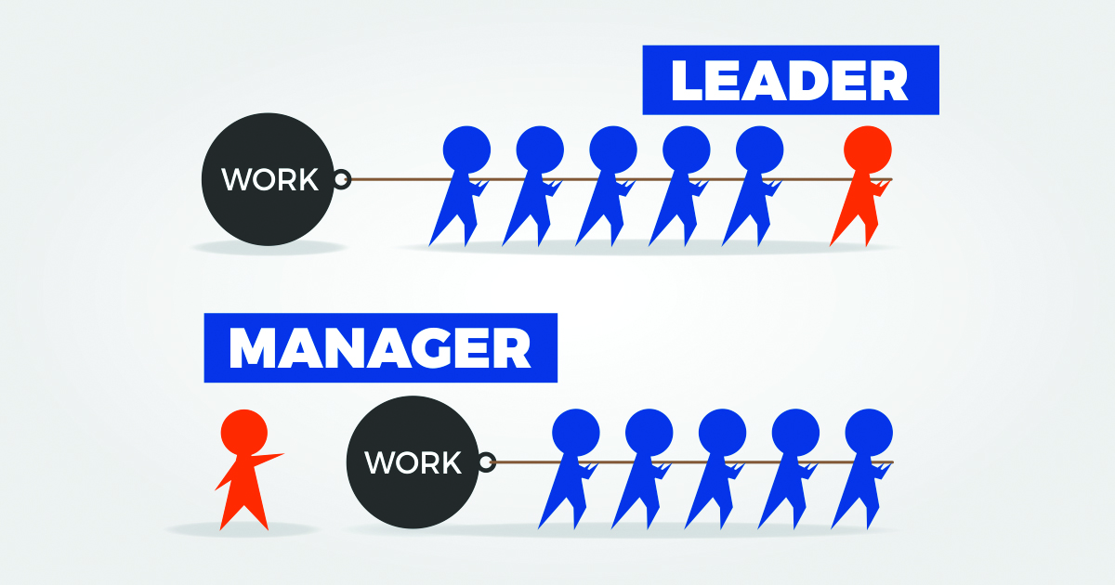

Comparison chart
Basis for comparison | Management | Leadership
Meaning | Management is an art of systematically organizing and coordinating thing in an efficient way.— | Leadership is a skill of leading others by encouraging and inspiring them.
Basis | Control | Trust
Emphasis on | Managing activities | Inspiring people
Power | Rule | Influence
Focus on | Bringing stability | Encouraging change
Strategy | Reactive | Proactive
Formulation of | Policies and procedures | Principles and guidelines
Perspective | Management has a short range perspective | Leaders requires good foresightedness
Source: ( Alqahtani, A, 2014)

Leadership is the ability to influence others, in a certain way so that the objectives are attained voluntarily and enthusiastically. It is not the same as management, despite the fact that the leadership is a key component of management. Management is a discipline that focuses on making the best decisions possible. It is the art or talent of completing tasks with and through others. It can be found in a variety of settings including, education, hospitality, sports and offices (Gosling, J, 1994).
However, one of the most significant distinctions between management and leadership is that management is reserved for official and organised groups of individuals, whereas leadership is applicable to both formal and informal groupings (Leadership, 2018).

Effective leadership styles
A persons leadership styles is a combination of principles and strategies for managing, guiding and motivating people. It can include things like a persons personality, qualities, management tools, and procedures and tactics. It can also refer to how a leader addresses big picture tactics such as organisational goals, as well as how attentive the leader is to them (Dogru, C, 2020). The leadership style that a person naturally gravitates towards is usually determined by their personality. Leadership styles are comparable to personality types, but they include more hard and soft talents as well as philosophical considerations (Kippenberger, T, 2002). There are a variety of leadership styles. In diverse context and scenarios, a variety of leadership styles can be effective. A list of some of the most effective leadership styles is provided is provided below. Different types of leadership styles have a significant impact on staff motivation and engagement as well as business success (Mughal, Y.H. and Kamal, S ,2019).
Agile leadership style: Agile leaders pay attention to other people’s needs. They respect other people’s viewpoints, take the time necessary to help them achieve their professional and personal goals, include them in decision making when it makes sense, and foster a sense of community within their teams. As a result, relationships between team members and other stakeholders are strengthened and engagement is increased (Dogru, 2020).
Autocratic leadership style: The control of an individual over decisions that affects a group, with little or no participation from group members, is known as autocratic or authoritarian leadership. Autocratic leadership style shares three major characteristics in common (Kippenberger, T, 2002).
Limited input from stakeholders, where nobody around the leader has their say and is more followed by the leader (Mughal, Y. H. and Kamal, S, 2019).
Highly structured environment, the autocratic leader has more control here over the work as a whole and tends to create more rigid environment.
Clearly defined rules and processes, autocratic leaders ensure work is done somehow and rules and regulations is followed. It also excludes stakeholders to perform any sort of suggestions or discussion in regards to working conditions (Dogru, 2020).
Democratic leadership style: A democratic leader seeks feedback and recommendations from all team members, ensuring that everyone has an equal say and opportunities in decision making and initiatives. Democratic leader isn’t the same as majority rule, the leader still makes the final choice and is held accountable for it (Kippenberger, T, 2002). A democratic leader, on the other hand, cultivates a workplace culture in which all employees are encouraged to contribute their views. This type of leadership can be really effective. A brilliant idea can originate from anybody, so fostering an environment where the employees feel comfortable sharing and being respected can broaden and diversify the pool of accessible ideas. It can also start nurturing and coaching potential future leaders by giving them constructive feedback on their ideas (Dogru, 2020).

Laissez faire leadership style: This leadership style is the most unobtrusive type which allow employees to have as much autonomy as possible. This leadership style can be effective when used correctly and in the right situations. It has the potential to enable strong people to operate freely and achieve their own best results (Kippenberger, T, 2002). However, there are certain drawbacks to this strategy. Communication can be harmed when a leader is too detached. Employees who are new or inexperienced may feel as if they don’t know what to do and what needs to be and how. As well as the employees who want to advance in their careers may feel left out if they don’t receive the critical criticism they require (Lee, 2022). This leadership style is best suited to small, talented and highly driven teams, such as those seen in start-ups. As the organisation develops larger and more complex, this strategy becomes less effective (Dogru, 2020).
Transformational leadership style: A visionary, a transformative leader is always focused on the major initiatives as well as what they see is missing from the firm. There is always an effort to transform the firm forward from where it is to where it needs to be (Dogru, 2020). Individuals are pushed to develop by transformational leader and their teams. This can be beneficial, but it can also become exhausting for members of the team If it gets out of control. Transformational leadership is critical during growth phases but, it must be handled with caution (Kippenberger, T, 2002).
Transactional leadership style: All choices, rewards and incentives are framed in terms of work objectives and concrete achievements in this leadership paradigm. Because everything is about performance and the individual doesn’t seem to matter much, this leadership style has a hard time forming relationships (Kippenberger, T, 2002).
According to the case study, Amanda Pritchard is facing many challenges throughout the pandemic of COVID-19 which made her get out of control to resolve this. However, Amanda Pritchard should work effectively with transformational leadership style which enable her to overcome the key challenges in such situations where she need to, create a vision for what’s ahead and identifying steps that is needed to achieve an outcome of a well functioning, equitable and resilient health system to the wellbeing of individuals and communities NHS needs to progress. Working towards a long term and renewed vision (Dogru,2020). However, in order for Pritchard to attain her potentials, using agile leadership and being capable to execute complex change within the health system will effectively help her to transform and make a positive change to inspire others (Mughal, Y.H. and Kamal, S, 2019).
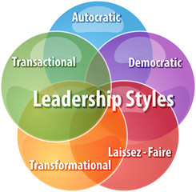
Effective leadership skills
Leadership skills are the individuals’ characteristics and abilities that enable them to monitor procedures, drive initiatives, and guide the people towards achieving their objectives. Leadership skills are an essential component in positioning executives to make judgments about their organisation’s mission and goals, as well as correctly allocating resources to meet those objectives (Shiel, M, 2004). The capacity to delegate, motivate, and communicate effectively are all valuable leadership characteristics. Honesty, confidence, devotion and innovation are some of the other leadership traits. There are lots of valuable and effective leadership skills which is applied by leaders and even for advance skills learned for future. Administrative skill, interpersonal skill and conceptual skill are three effective leadership skills used to influence others successfully (Lee, G , 2003).
Administrative: The abilities a leader requires to manage an organisation and achieve its objectives are referred to as administrative talents. They are fundamental to effective leadership. Administrative skills assist a leader in carrying out the routine but, vitally necessary tasks associated with exercising leadership (Lee ,G, 2003). A leader must possess administrative skills, which include planning, organising work, allocating assignments to the appropriate individuals and coordinating work operations. Administrative abilities is divided into three different categories, managing resources, managing people and demonstrating technical competence (Shiel, M, 2004).
Interpersonal: The abilities needed to engage, communicate, and collaborate with others in both small and large groups are known as interpersonal skills. These skills are crucial for success in both the professional and personal lives. However, interpersonal skills is divides into three skill sets, showing emotional intelligence, being socially perspective and managing interpersonal conflicts (Shiel, M, 2004).
Conceptual: Developing ideas, concepts, thoughts or notions is the definition of conceptual skills. Conceptual leadership abilities are concerned with the cognitive components of leadership and are essential for tasks like developing an organisation’s vision or strategic plan. This skill is divided into three main skill sets, strategic planning, problem solving and creating vision (Lee, G, 2003). According to Amanda Pritchard, decision making and communication skill would be an effective leadership skill that she could have used to motivate patients and make a change and decide to resolve the challenges and barriers she faced within the NHS effectively (Shiel, M, 2004).
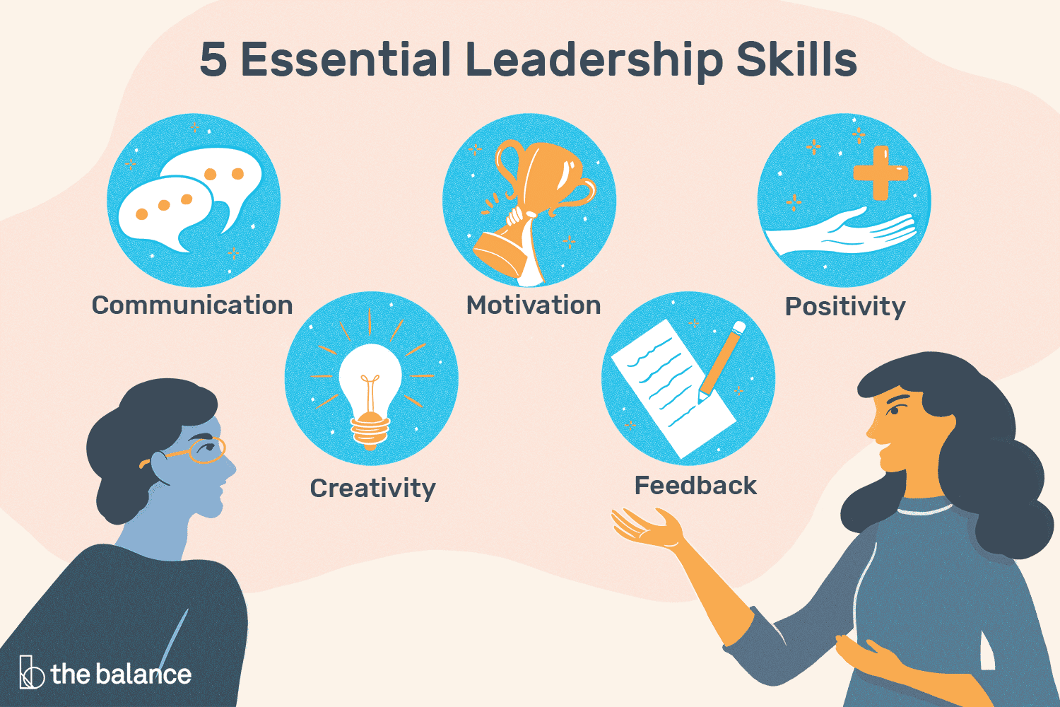
Challenges to leadership in uncertain times such as in COVID-19 era and other emergencies
There are many challenges to leadership that occurred within the NHS which is dealt with in different ways but not resolves yet. Multiple obstacles and fears confront leaders. These, of course are primarily concerned with how they serve patients and the general public. Patients suffering from Covid-19 are the most evident. Many others, however, who do not have Covid-19 but, have other diseases are facing physical and social isolation are having their health and care services disrupted as a result of the emergency reaction (Scanlan, L, 2005).
The Covid-19 pandemic is putting a strain on the NHS’s ability to provide safe, high quality care. This means that leaders must focus more on satisfying the core needs of their employees, as well as assuring their well-being and long term motivation, in order to assist them deal with the quickly changing scenario. The ideas of command, control and coordination, as well as the requirement for clear frameworks and instructions, are fundamental to managing emergency response and recovery in a crisis (Bennis, W, 2007). However, this might lead to an understandable fallback to a leadership style that goes beyond what is required, instead guiding people excessively. This has the potential to alienate the employees who need to be engaged and motivated (Bennis, W, 2007). There are lots of uncertainties in the Covid-19 situation and any other emergency that occur within the NHS that leaders face. As the context changes almost hourly, leaders such as Amanda Pritchard will need to try to identify the proper solutions. Leaders need to rely on all available resources, notably their people to draw on the collective wisdom of experience and expertise while adjusting and refining solutions as the crisis develops (Scanlan, L, 2005).
Uncertain challenges to leadership is not just a crisis to resolve effectively, its important to have a leadership strategy to implement any obstacles that may arise in the future. However, it does not matter how complicated and unclear the circumstances are, strategic leaders must be able to recognise them and make sense of them (Bennis, W, 2007). This is particularly important especially when there are uncertainties such as Covid-19 epidemic, growing racial tensions, international trade disputes, industry change and more. Pressure is put on the organisation as a whole and leaders in particular who are in charge of leading the organisation through change and innovation, by this turbulence (Scanlan, L, 2005).
Envisioning, future strategy, aligning, delivered strategy by an organisation and embodying, implementing change is key roles of top management in leading strategic change. A strategy of leadership styles affect the outcomes of any unexpected crisis that may occur. Leaders should be able to provide a rapid change and quick response in order to overcome these challenges effectively. Strategies includes, three main elements to follow (Scanlan, L, 2005).
Transformational, emphasis is placed on creating a vision, an organisational identity based on shared values, and motivating employees to realise that vision.
Transactional, put more emphasis on hard levers of change like system, design and activity management within the organisation, structural alternations, establishing goals, financial rewards, supervision and cautious management of initiatives (Bennis, W, 2007).
Situational, modifying leadership style to fit the situation they are in. Since different situations call for different leadership approaches, there is no best way to lead (Scanlan, L, 2005).

Ethical leadership
Ethical leadership is when the individual demonstrate conduct in a way that is appropriate and acceptable in every aspects of their life and serves the greater good. Leadership that adheres to a set of moral standards and ideals to uphold the rights of others and advance the common good is referred to as ethical leadership. An ethical leader prioritises relationships with others and behaves honourably (Connock, S, and Johns, T, 1995). There are six key components of ethical leadership.
Fairness: this entails providing equal opportunity to everyone and shielding workers from potential harm (Lashway, L, 1996).
Transparency: this entails open communication with all team members and other relevant stakeholders in order to disclose significant information.
Respect: a moral leader shows respect for others by talking with them, hearing from them and involving them (Connock, S , and Johns, T, 1995).
Honesty: moral leaders conduct themselves honestly and base their decision on knowledge that is supported by facts.
Integrity: this calls on moral leaders to keep their word and to be consistent in their goals and their capacity to achieve them, and follow through on commitments (Lashway, L, 1996).
Responsibility: ethics driven leaders accept their responsibilities, face difficulties head on, and find effective solutions.
Being able to serve and provide the most effective way to lead is to manage the actions of the leader and the way leaders apply to accomplish goals. There are principles that guides leaders’ actions to perform in an appropriate way. Leaders can take many various steps to reach their objectives, each of these actions has moral implications (Lashway, L, 1996).
Showing respect: being able to show respect as a leader by treating others as unique human beings and trying to understand their perspective.
Serving others: being able to promote and produce information to other individuals effectively throughout the different effective styles leaders indicate to attract followers (Connock, S, and Johns, T, 1995).
Showing justice: treating each individual equally is a primary goal for ethical leaders. A leader must put fairness at the forefront of all decisions in order to uphold justice (Lashway, L, 1996).
Performing ethically as a leader is important because it assist the leader to implement the most effective styles and skills that the individual have which could contribute in influencing others and achieving organisational goals. However, ethical leader could maintain the ways in which Amanda Pritchard produce to overcome the challenges efficiently (Lashway, L, 1996).

Reflective Essay
Description
The most effective leadership style in your business and the most effective style for the person are two separate concepts. The type of leader the individual become and how effective he or she is in that capacity will be influencing by who the person is. Experience, context, training, coaching, facilitation and reflection will assist the person in creating and accessing more of the various styles available, as well as sharpening and improving personal leadership styles and talents to become more effective and productive (Leadership, 2005).
However, being able to conduct in the best possible way as a leader depends on the individual. There are different ways to use personal skills, ethics and leadership styles to show the power of the most effective leader, although not everyone may agree on the same leadership style that they prefer, this is why I believe that its really important to engage and implement certain strategies in which a leader could follow to decrease the possibility of unmotivated individuals (Crosby, G, 2021).
Reflecting on my own personal and professional experiences from previous practices to the present, I have shaped the leadership approach I follow, democratic leadership style. Being a democratic leader provides each member of the team to consistently get involved and contribute, and accepts input from others in making decision making and providing ideas within the workplace. I have previously been working in a nursery with some colleagues, manager and children aged 3-5 years. This determined my leadership style and abilities where I was expected to deal with different age ranges and a variety of mindsets in which I have to cope with (Crosby, G, 2021). As a leader in such environment, I was expected to identify specific requirements and ideas to develop children’s creativity when learning and playing together. Taking such responsibility helped me to encourage my other colleagues in decision making and the different aspects that needs to be covered within my plan. As a democratic leader I took some activities and tasks shared with other employees and gave them the opportunity to discuss further what needs to be done next. There were lots of important aspects which I gained from them in which I appreciate they have added to my role of completing tasks successfully and make use of others input and take their perspectives into consideration to achieve common goal (Leadership, 2005).
According to my personality type and even professionally, while doing some class activities, I found that I am more relationship oriented were I focus more on satisfying, motivating others as well as prioritizing the general welfare of everyone in the group. I take the advantage of being a leader in which I can cooperate with people and make relationship while working towards a common goal (Tabernero, C, 2009). I believe that the most effective way leaders could become influential and inspire others is by promoting them, helping them, listening to them, providing them with the appropriate assistance they require. This drives motivation and encourage people to engage which simplifies the work for the leader to attain goals of the organisation. The more satisfied the employees are the more quality the organisation will obtain (Tabernero, C, 2009).
Democratic leadership style of mine plays a significant role in maintaining the satisfaction of each and everybody in the workplace. This is due to the ability that makes me create a sense of participation and control in which I can manage the process of decision making, and increase innovation and creative solutions to address obstacles hence serving organisation better (Crosby, G, 2021). Democratic leadership has several advantages which I can effectively perform when leading in any other environment with the key strategies that most show the intelligence of my leadership style such as emphasising more on values and morality, encouraging trust and respect throughout the team, and promoting a variety of ideas and solutions (Leadership 2005).
However, there are other disadvantages of being a democratic leader which I observed such as the different elements of uncertainty which can lead to the lack of time, confidence or unsuccessful solution suggested by a member of the team, or even inefficient control over the essential aspects that should be covered by the leader only. Leading dependently on certain features or suggestions can affect the overall work and reduced performance of the leader can also affect the effectiveness of the leadership style that the individual implement. I have learned to balance the various effective leadership styles and that different situations requires different actions and styles to cope with. Despite, the effectiveness of democratic leader, I need to manage and to be able to coordinate when to use what style and to implement a little of every effective style to become effective leader in the future (Shiel, M, 2004).
Evaluation
The qualities that describe not only my leadership style but also my personality involves, patience, integrity, trustworthy, attention to detail. There are lots of skills that I gained throughout my experiences where I worked as a nursery assistant, which helped me to develop my leadership style. Creativity, decision making, communication skills, organisational skills and team building and problem solving was some of the effective skills that I used to develop my leadership style (Shiel, M, 2004). However, in order for me to fully listen to others and for others to truly comprehend the solutions I strive to build given that they are also paying attention. I believe that effective leadership requires open communication. My vision serves as a general description of my intentions when I am leading in this way. I can evaluate my words and deeds from my vision and decide whether I need to change course or identify areas where I need to improve. I would like my concept of leadership to evolve over the coming years to be more collaborative and transformational. I must continuously go back on the fundamental traits, ideals, competences, and guiding principles that characterise my style in order to accomplish it. As a democratic leader targeting to become transformative leader, it requires to implement and promote significant positive change. I would like to develop my long term vision and recognise potential challenges and resources to mitigate them effectively to attain common goal (Leadership, 2018).


Conclusion
Effective leaders are critical to the success of any organisation. They can assist in the formation of strong teams within a company and the successful completion of projects, initiatives and other job responsibilities. Good leaders have excellent interpersonal and communication skills and anyone can learn to exercise and enhance their leadership qualities, employee engagement, foster a great work atmosphere and assist the team in overcoming hurdles (Leadership, 2018).

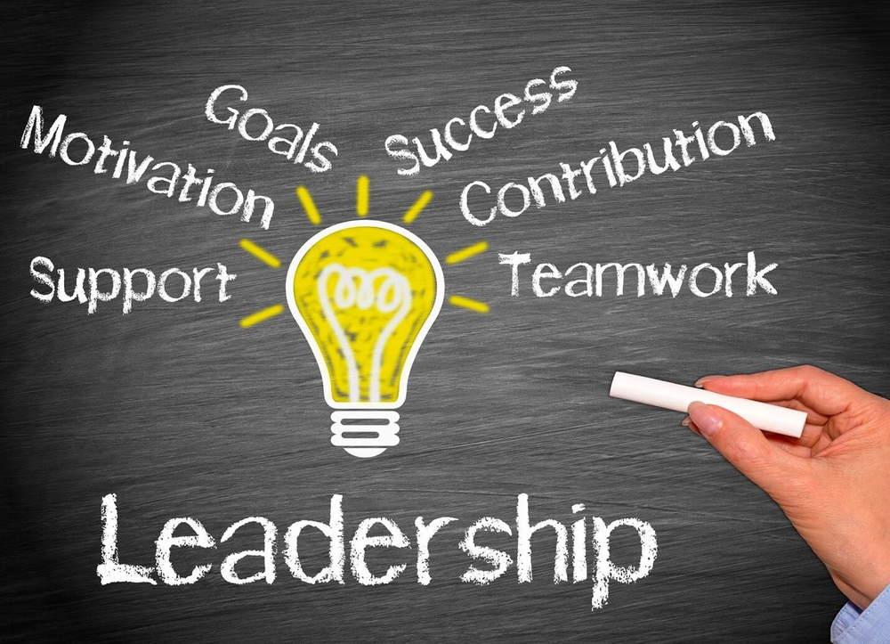

Reference list
- Al-Aali, E. and Masmoudi, M. (2021) ‘Responding to the Challenge of Employee Engagement During Uncertain Times: Adaptive Leadership is the Answer’, in Global Perspectives on Change Management and Leadership in the Post-COVID-19 Era. IGI Global, pp. 188–198. doi:10.4018/978-1-7998-6948-1.ch012.

- Algahtani, A., (2014). Are leadership and management different? A review. Journal of management policies and practices, 2(3), pp.71-82.

- Aronson, E., (2001). Integrating leadership styles and ethical perspectives. Canadian Journal of Administrative Sciences/Revue Canadienne des Sciences de l'Administration, 18(4), pp.244-256.

- Bennis, W., 2007. The challenges of leadership in the modern world: Introduction to the special issue. American psychologist, 62(1), p.2.

- Cacioppe, R., (1998). An integrated model and approach for the design of effective leadership development programs. Leadership & organization development journal.
- Clark, W.K. and Christ, J. (2012) General Wesley Clark on ethical leadership. Ripon, WI: Video Age Productions.

- Connock, S. and Johns, T. (1995) Ethical leadership. London: Institute of Personnel & Development.

- Crosby, G. (2021) ‘Lewin’s Democratic Style of Situational Leadership: A Fresh Look at a Powerful OD Model’, The Journal of applied behavioral science, 57(3), pp. 398–401. doi:10.1177/0021886320979810.

- Dogru, C. (2020) Leadership styles, innovation, and social entrepreneurship in the era of digitalization. Hershey, Pennsylvania: IGI Global.

- Ewing, J.C., Bruce, J.A. and Ricketts, K.G., (2009). Effective leadership development for undergraduates: How important is active participation in collegiate organizations. Journal of Leadership Education, 7(3), pp.118-132.

- Foels, R., Driskell, J.E., Mullen, B. and Salas, E., 2000. The effects of democratic leadership on group member satisfaction: An integration. Small Group Research, 31(6), pp.676-701.

- Gastil, J., 1994. A definition and illustration of democratic leadership. Human relations, 47(8), pp.953-975.

- Gosling, J. et al. (2012) Key concepts in leadership. Los Angeles, [Calif.] ;: SAGE.

- Kippenberger, T. (2002) Leadership styles. Oxford: Capstone Pub.

- Lashway, L., 1996. Ethical leadership.

- Leadership (2018). IntechOpen.

- Leadership. (2005). London: Sage Publications.

- Learning Instructors, L. (2020) Leading in Uncertain Times. Carpenteria, CA: linkedin.com.

- Lee, G. (2003) Leadership coaching : from personal insight to organisational performance. London: Chartered Institute of Personnel and Development.

- Mendonca, M. and Kanungo, R., 2006. Ethical leadership. McGraw-Hill Education (UK).

- Mughal, Y.H. and Kamāl, S. (2019) Servant leadership styles and strategic decision making. Hershey, PA: IGI Global.

- Mumford, M.D., Zaccaro, S.J., Harding, F.D., Jacobs, T.O. and Fleishman, E.A., (2000). Leadership skills for a changing world: Solving complex social problems. The Leadership Quarterly, 11(1), pp.11-35.

- Rüzgar, N., 2018. The effect of leaders’ adoption of task-oriented or relationship-oriented leadership style on leader-member exchange (LMX), in the organizations that are active in service sector: A research on tourism agencies. Journal of Business Administration Research, 7(1), pp.50-60.

- Scanlan, L. (2005) ‘Mergers: a critical test of leadership: challenge yourself to excel at leadership during uncertain times’, Healthcare financial management, 59(5), p. 110–.

- Sethuraman, K. and Suresh, J., (2014). Effective leadership styles. International Business Research, 7(9), p.165.

- Shiel, M. (2004) Leadership. Cork, Ireland: NuBooks.

- Tabernero, C. et al. (2009) ‘The Role of Task-Oriented Versus Relationship-Oriented Leadership on Normative Contract and Group Performance’, Social behavior and personality, 37(10), pp. 1391–1404. doi:10.2224/sbp.2009.37.10.1391.

- Toor, S.U.R. and Ofori, G., (2008). Leadership versus management: How they are different, and why. Leadership and Management in Engineering, 8(2), pp.61-71.

- van Wynen, S.E. and Niemandt, C.J.. (2020) ‘Leading in the certainty of uncertain times’, Hervormde teologiese studies, 76(2), pp. e1–e10. doi:10.4102/hts.v76i2.6114.

- Weathersby, G.B., (1999). Leadership vs. management. Management Review, 88(3), p.5.

