Application of Computer Aided Engineering Process

CONTENTS
1. Introduction
2. Background & Literature Review
3. Methodology
3.1 Case Study & 3D Design in SolidWorks
3.1.1. Case Study & Purpose
3.1.2. Assembly Lay-Out Operation & Kinematics Assessment
3.1.3. Operational Requirements Regarding Deformation
3.1.4. Part/Component for Analysis
3.1.5. Modelling in SolidWorks (Full Assembly)
3.2. Structural Analysis in Ansys (Full Assembly)
3.2.1. Engineering Data & Material Properties
3.2.2. Connections & Contact Settings
3.2.3. Mesh Settings
3.2.4. Static Structural Analysis
3.2.5. Results
3.3. Modelling & Analysis (Simple Assembly & Pin Only Model)
3.3.1. Modelling in SolidWorks
3.3.2. Ansys Settings & Structural Analysis
3.3.2. Validating Model
3.2.3. Changing Material Properties, Contact Types and Mesh Sizing
4. Fundamental Principles Calculations
5. Results and Discussion
5.1. Visual Results
5.2. Tabular Results
5.3. Qualitative Results & Discussion
5.3.1. Validity of ‘Pin Only’ Models/Simulations
5.3.2 Validity of ‘Simple Assembly’ Models/Simulations
5.3.2 Suitability of Selected Materials for the Assembly
5.3.3. Effect of Mesh Sizing
5.3.4. Effect of Contact Type
5.3.5. Limitations of Basic Isotropic Analysis (Young’s Modulus & Poisson’s Ratio)

1. Introduction
Finite-element analysis of 3D models/assemblies for designing and engineering products has become a highly useful and influential tool in recent years, with software packages such as Ansys, LS Dyna and Abaqus allowing for increasingly complex and specialised analyses. Iterative modelling and analysis in such packages forms an integral part of design processes, allowing for designs to be tested and refined prior to prototyping, and thus providing the possibility to significantly reduce costs. These analyses are bounded by limitations however, and cannot provide a completely realistic simulation of physical products. As such, understanding the limitations of the specific modelling and analysis being conducted is required in order to successfully utilise the generated results within the design process.
In this investigation, a physical product, an assembly of press tooling for pellet compaction of high explosives, is geometrically modelled in 3D using SolidWorks, and imported to Ansys Workbench for static structural finite element analysis. Critical isotropic elastic material properties, contact types, and meshes are generated for analysing the effect of the required physical forces on the assembly. Results of selected analysis iterations are discussed with respect to the limitations of type of analysis conducted, both in terms of suitability for modelling this assembly and the impact of general limitations of the static structural analysis technique within the software.
2. Background & Literature Review
- 3D Modelling for Analysis in Ansys
SolidWorks is a popular software package for creating 3D geometries, allowing limited finite element modelling and also exporting of geometries for modelling/analysing in other software packages such as Ansys Workbench.
Numerous studies across several fields have compared the results of finite element analysis with theoretical calculations in order to validate models and analysis techniques, with static structural analyses having attracted much attention. The field of literature has provided simulation results for several different problems based on geometric shape and material properties, with critical analysis of the results obtained pertaining to the limitations and computational methods utilised by Ansys and other software packages [1] [2] [3] [4]. This has included examples pertaining to punch and die process applications with some similarities to the present application [5].

3. Methodology
3.1 Case Study & 3D Design in SolidWorks
3.1.1. Case Study & Purpose
The product modelled in this investigation was an assembly of components forming a set of press tooling, in basic punch and die style, for the compaction of a high explosive powder into a dense pellet. The real/original assembly consisted of the following parts to the specified dimensions, as shown in Figures X-X below…
Please note that these drawings are property of Illusion Pyrotechnics Ltd and should be not be copied or distributed beyond this document.
Fig.1: Original Assembly
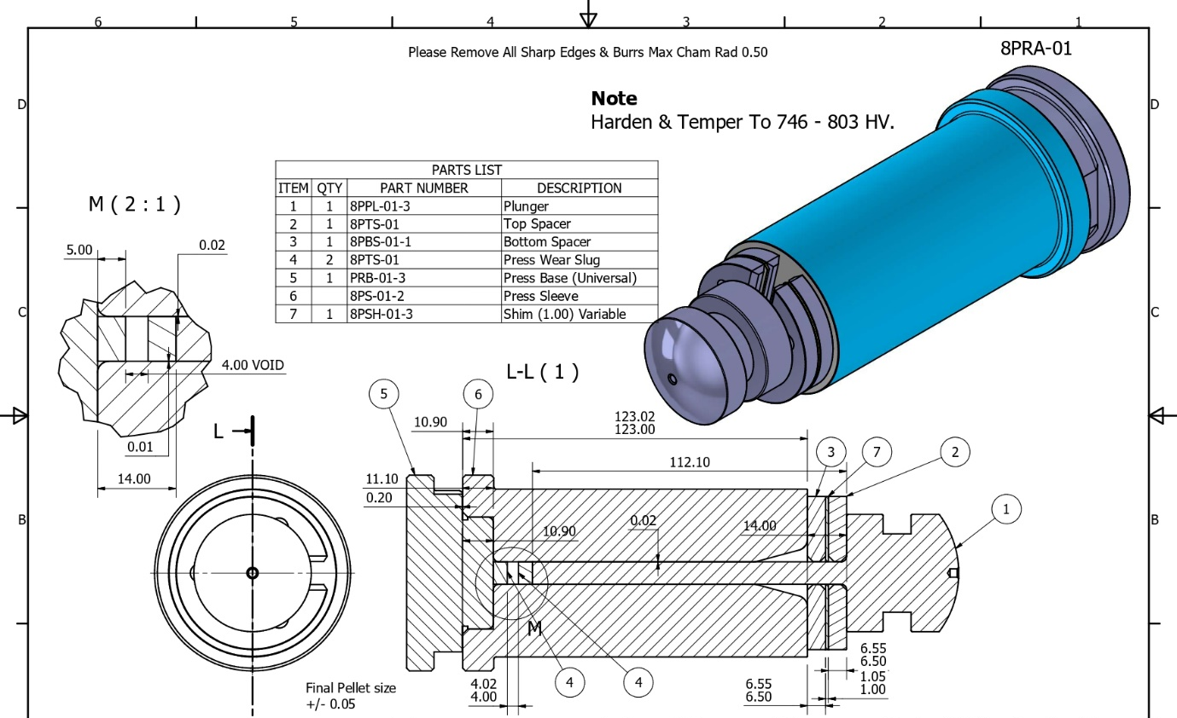

Fig.2: Press Sleeve (die)
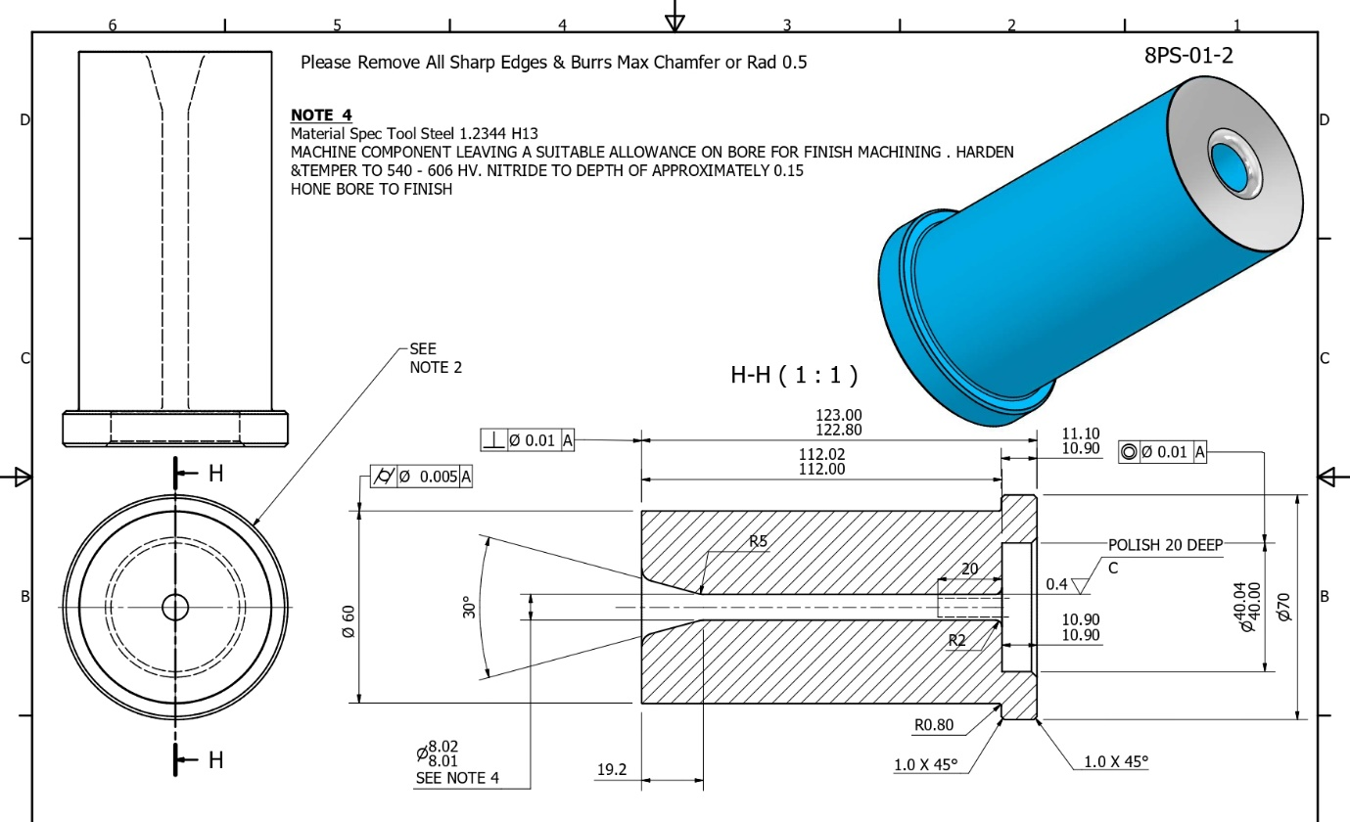

Fig.3: Bottom Spacer
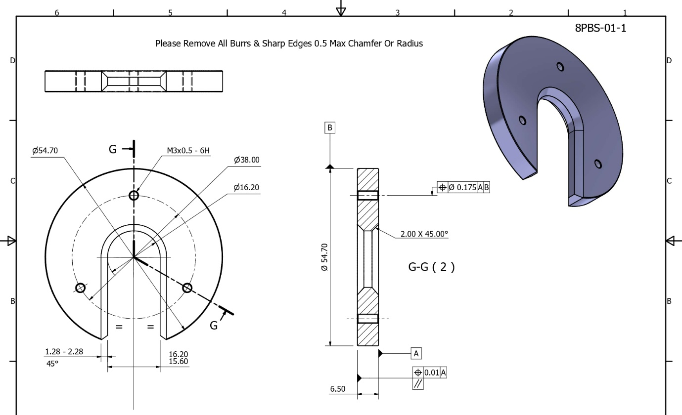

Fig.4: Press Shim Spacer
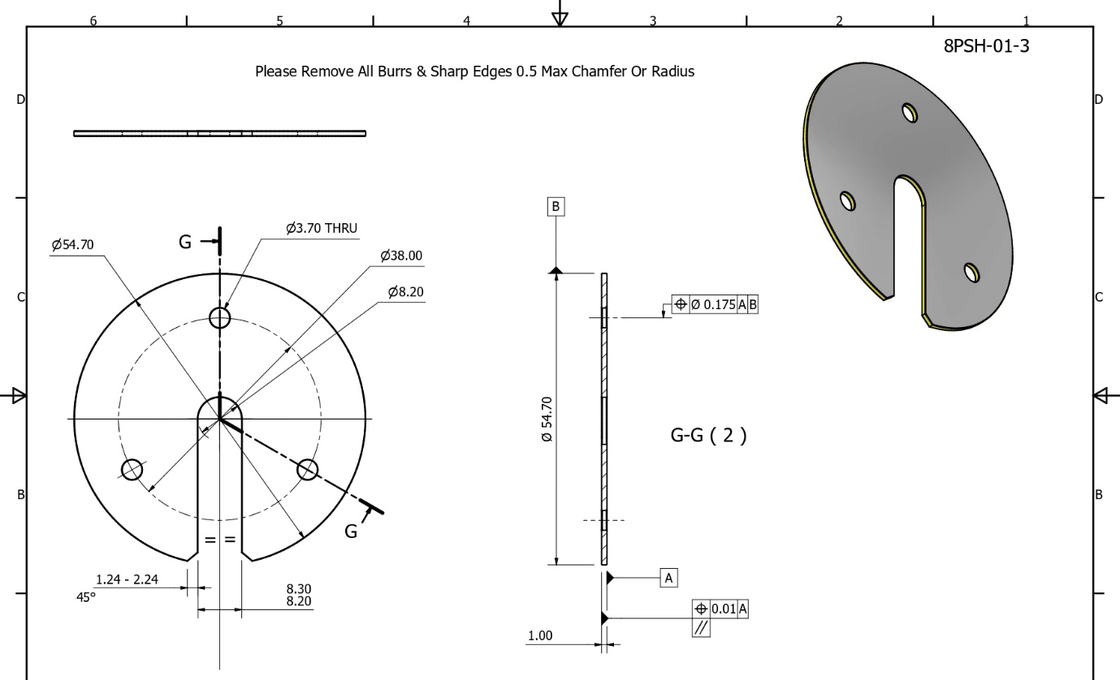

Fig.5: Top Spacer
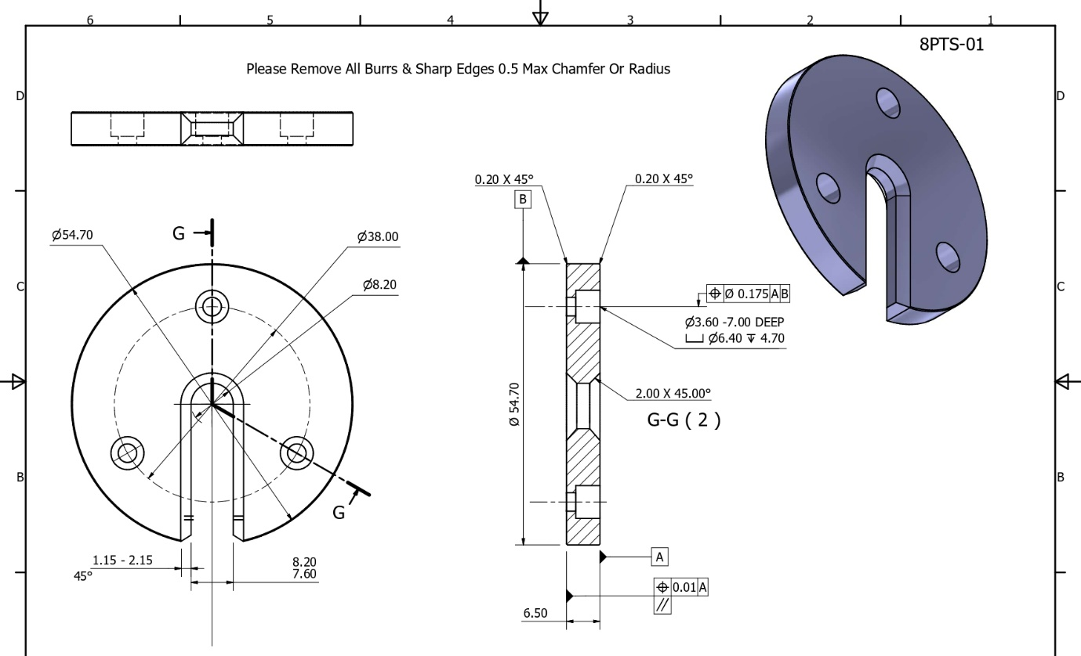

Fig.6: Press Plunger (punch)
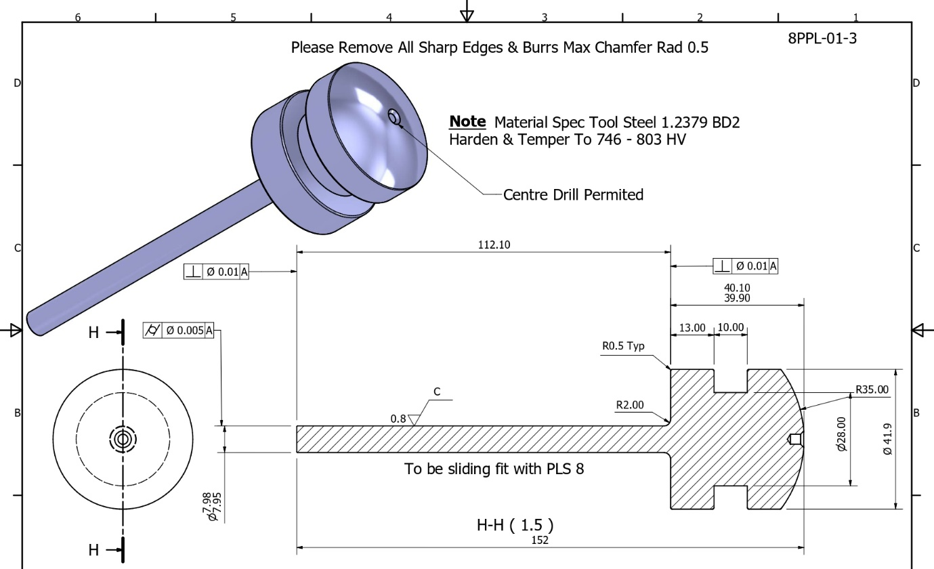

Fig.7: Press Pad x2 (x1 upper press pad + x1 lower press pad)
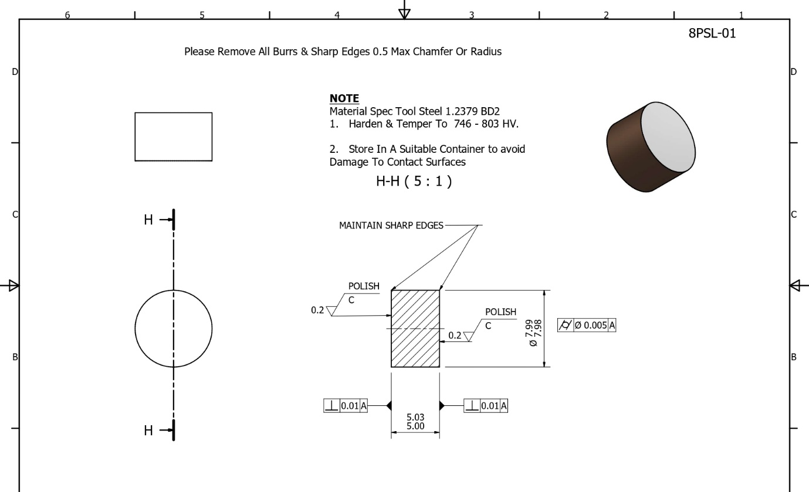

Fig.8: Base
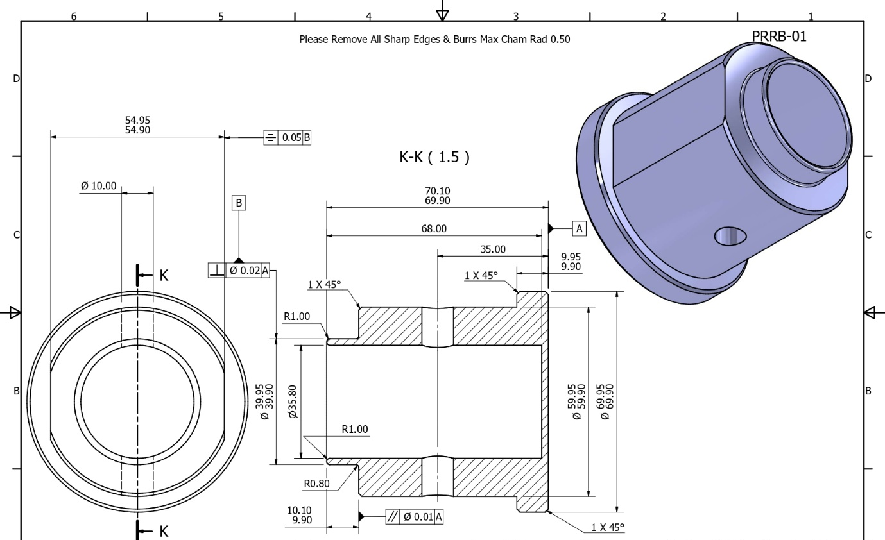

3.1.2. Assembly Lay-Out Operation & Kinematics Assessment
As can be seen in the diagrams in Figs.1-8, the assembly is laid out as follows…
The bore in the press sleeve (die), modelled to 8mm diameter allows space for the lower press pad, pellet body (as inserted as a loosely compressed powder), upper press pad, and pin stem to fit within, with their surfaces resting on each other in that order (from bottom to top). Essentially this forms the sealed pressing chamber during operation.
The bottom spacer, press shim spacer, and top spacer rest on the top surface of the press sleeve, in that order (from bottom to top). In real physical operation, these parts act as a stop for the press plunger (punch) travel/reach, such that the pressed pellet height can be finely adjusted by adding/removing additional press shim spacers as shim stock.
All the above components as assembled then rest upon the base part.
During the pressing operation a force is applied by a ram to the curved top surface of the press plunger (punch) of around 10054N (equivalent to roughly 200MPa on the flat surface of the press plunger based on its surface area of 50.27mm). This forces the press plunger and upper press pad downwards, compressing the pellet body in the longitudinal direction. Some lateral deformation does occur, however this is minimal and the lateral dimensions of the pressed pellet are constrained by the bore of the press sleeve.
3.1.3. Operational Requirements Regarding Deformation
Given the purpose of the assembly, to press multiple pellets of high explosive to a set height and diameter tolerance, all parts of the assembly need to be capable of withstanding the required pressing force from the ram multiple times without undergoing anything more than neglible deformation as compared to the tolerance values for the desired pellet dimension. In particular, this includes no deformation of the faces of the press pads, and the stem of the press plunger, given that this would lead to loss of concentricity of these parts when pressing and produce pellets outside a perfectly cylindrical shape, and potentially with rough rather than smooth surface finish.
3.1.4. Part/Component for Analysis
The press plunger was chosen as the part for detailed analysis given that its length and diameter were critical dimensions for operation of the assembly. As well as this the long length of the press plunger allowed for easier visualisation of longitudinal deformation.
3.1.5. Modelling in SolidWorks (Full Assembly)
The geometries of the parts forming the original assembly were roughly drawn in 3D in SolidWorks 2023. However for simplicity and to ease computational requirements some modifications were made (and the resulting assembly labelled ‘Full Assembly’), as follows…
Dimensions of the concentrically aligned original parts were rounded to the nearest whole millimetre, in order to allow for easier determination of contact surfaces within Ansys. This included the diameter of the press pads (upper and lower), the stem of press plunger (punch) which were all set to 8mm, rather than their respective and slightly differing original diameters.
The base part of the original assembly, which sits underneath all the other components, was excluded from the model, again for simplicity and easing computational requirements when analysis is carried out in Ansys, such that a fixed support could be applied directly on the bottom surface of the lower press pad and the bottom surfaces of the press sleeve (die) to prevent displacement.
Bolts holding together the top and bottom spacers and sandwiching the press shim spacer were also excluded, since these weren’t required in in the analysis, with these parts instead coincidentally mated in SolidWorks and set as bonded contact surfaces in Ansys.
Figs.9-12: Screenshots showing varying view aspects of the ‘Full Assembly’ of part geometries produced in SolidWorks
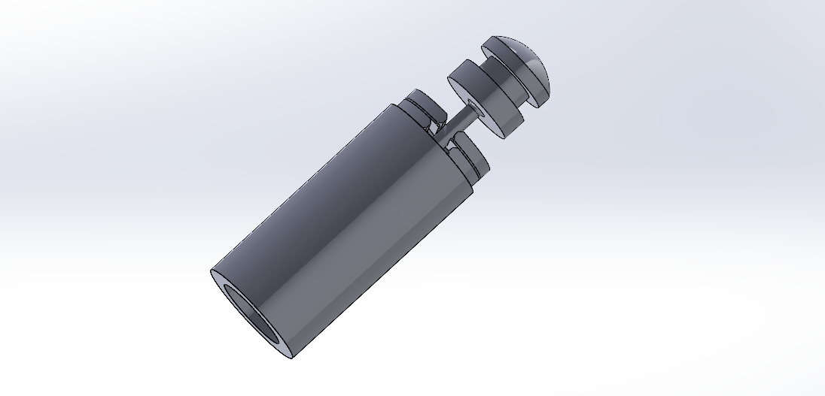
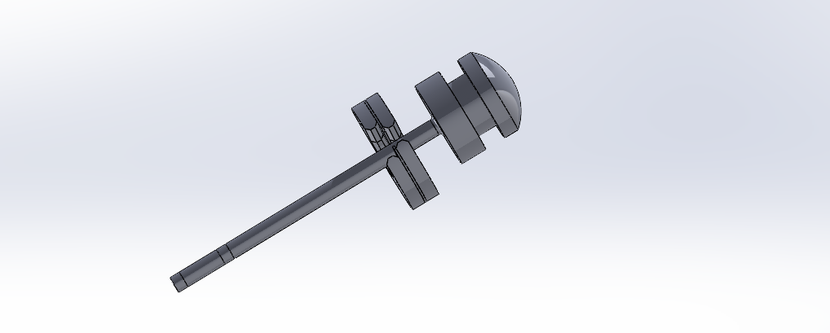
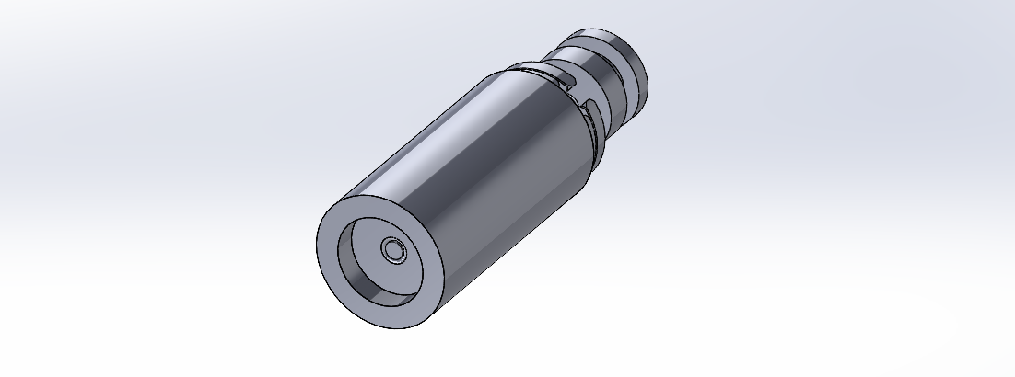
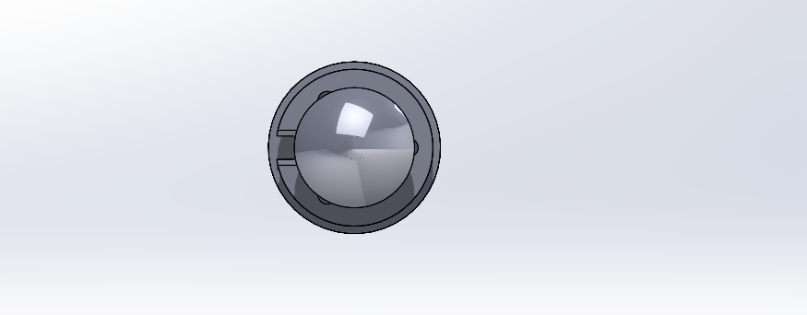
3.2. Structural Analysis in Ansys (Full Assembly)
The ‘Full Assembly’ was saved as a .STEP file and imported as the geometry into the static structural analysis in Ansys Workbench R2021.
3.2.1. Engineering Data & Material Properties
Custom materials were created in the engineering data segment of Ansys Workbench, by defining Young’s Modulus and Poisson’s Ratio values for isotropic elasticity, as follows…
Fig.13
MATERIAL NAME | YOUNG’S MODULUS | POISSON’S RATIO | SOURCE
Stainless Steel 316 Grade | 190GPa | 0.265 | [6]
Limestone Flour | 55GPa | 0.3875 | [7]

All parts of the assembly, excluding the pellet body, were assigned as Stainless Steel 316 Grade. The pellet body was assigned as ‘Limestone Flour’. Limestone flour and its material properties were chosen as a proxy to represent the high explosive pellet, based on its roughly similar physical properties, and since physical data for the high explosive used in the real world/original assembly was incomplete [8]
3.2.2. Connections & Contact Settings
Contact regions were successfully automatically detected by Ansys, and were set as follows…
Contact regions of the press sleeve, press shim spacer, and top and bottom spacers were set as ‘bonded’ where these interacted, as were the contacts between the flat faces of the press pads, pellet body and press plunger.
The contacts of the curved surfaces of the press plunger, press pads with the press sleeve were set as frictionless since the original assembly features a small gap between these. The contact between the curved surfaces of the pellet body and press sleeve were also set to frictionless for ease of modelling and since the real frictional forces at play are not known.
3.2.3. Mesh Settings
All parts were meshed using default/global settings with sizing set to 0.001
3.2.4. Static Structural Analysis
A force of 10054N was placed on the curved top surface of press plunger aligned with the length axis. The bottom surfaces of the press pad and the press sleeve were assigned as fixed supports to prevent displacement.
The following parameters of both the whole assembly and press plunger individually within the assembly were analysed…
- Total deformation
- Directional deformation (longitudinal with press plunger)
- Direction deformation (lateral with press plunger)
3.2.5. Results
The results of the static structural analysis for the ‘Full Assembly’ proved to be unsuitable for use in modelling the original assembly and validating the model. This was because the both the top and stem segments of the plunger unexpectedly bent, undergoing lateral displacement while only causing minimal longitudinal compression of the pellet body. Iterative modification of the contact type and variation in mesh sizing produced different but largely similarly unrealistic results, suggesting that neither were the cause of undesired result.
3.3. Modelling & Analysis (Simple Assembly & Pin Only Model)
3.3.1. Modelling in SolidWorks
Given the failure to achieve results which could be validated when modelling/analysing the ‘Full Assembly’, a ‘Simple Assembly’ was instead created, which modelled only the critical components for simplicity.
These components included the concentrically aligned components: the press plunger, the pellet body and the upper and lower press pads. The press plunger was modified and drawn as a simple cylinder labelled ‘Pin Stem’.
These components were mated coincidentally and concentrically into an assembly called ‘Simple Assembly’.
As well as this a .STEP file of just the Pin Stem was also imported to Ansys, and labelled ‘Pin Only’.
3.3.2. Ansys Settings & Structural Analysis
At first, the parts in the ‘Simple Assembly’ were assigned as Stainless Steel 316 Grade, with the Pellet Body assigned as limestone flour. The three contact surfaces, between the lower press pad, pellet body, upper press pad, and pin stem were set as bonded contacts. All four parts were meshed using global/default settings with sizing set to 0.01. A force of 10054N was applied to the top surface of the pin normal to the length axis. A fixed support was applied to the bottom surface of the lower press pad. Total deformation and longitudinal deformation of the whole assembly and directional (longitudinal and lateral) deformation of the pin only were analysed.
The ‘Pin Only’ model was set up similarly, except that the fixed support was placed on the bottom surface of the Pin Stem.
3.3.2. Validating Model
Once the analyses were conducted results were recorded and checked against manually calculated values derived from fundamental principles for longitudinal and lateral deformation in order to validate the model (see Section X; Fundamental Principles & Validating Model) and Section.X: Results – Validity of Model
3.2.3. Changing Material Properties, Contact Types and Mesh Sizing
Following the above analysis, the stainless steel 315 grade parts were instead assigned to Tool Steel 1.2379 to assess whether a stronger material would perform better and undergo less deformation and further iterations analysed. Material properties for Tool Steel 1.2379 are compared with the previously used material properties in Fig.13
Fig.14
MATERIAL NAME | YOUNG’S MODULUS | POISSON’S RATIO
Stainless Steel 316 Grade | 190GPa | 0.265
Tool Steel 1.2379 | 210GPa | 0.295
Limestone Flour | 55GPa | 0.3875

Contact types were also changed for the ‘Simple Assembly’ geometries, from ‘bonded’ to ‘rough’ to assess whether contact type had an impact on deformation.
Further iterations of the ‘Pin Only’ geometries were run with a differing mesh size, 0.01 instead of 0.001, to assess the impact of mesh sizing on the results.
The below table, Fig.15, shows the iterations of the ‘Simple Assembly’ and ‘Pin Only’ geometries simulated.
Fig.15: Table of iterative simulations run based on the above described settings
SIMULATION | MODEL/ GEOMETRY | MESH SIZING | METAL MATERIAL | CONTACT TYPE
SimAssBonSS | Simple Assembly | 0.001 | Stainless Steel 316 Grade | Bonded
SimAssBonTS | Simple Assembly | 0.001 | Tool Steel 1.2379 | Bonded
SimAssRouSS | Simple Assembly | 0.001 | Stainless Steel 316 Grade | Rough
SimASSRouTS | Simple Assembly | 0.001 | Tool Steel 1.2379 | Rough
PinOnlySS | Pin Only | 0.001 | Stainless Steel 316 Grade | N/A
PinOnlyTS | Pin Only | 0.001 | Tool Steel 1.2379 | N/A
PinCoarseSS | Pin Only | 0.01 | Stainless Steel 316 Grade | N/A
PinCoarseTS | Pin Only | 0.01 | Tool Steel 1.2379 | N/A

For simulation results see Section.5: Results & Discussion
4. Fundamental Principles Calculations
In order to provide data for validation of the models/simulations, calculations for longitudinal and lateral deformation of the parts/components in the ‘Simple Assembly’ were conducted. Calculations were completed for each part in isolation with the force kept constant. Initially calculations for longitudinal deformation were carried out manually using the formula: Pl/AE = longitudinal deformation. Calculations were then carried out using AmesWeb’s ‘Stress Strain Formulas Calculator’ [9] in order to check calculation of longitudinal deformation and also calculate lateral deformation. Formulae used by the calculator are shown in Fig.16.
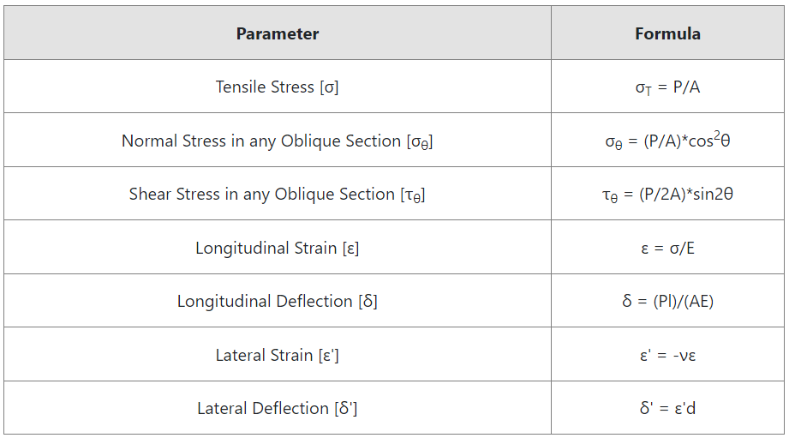
Fig.16: Table showing formulas applied in AmesWeb ‘Stress Strain Formulas Calculator’ [9]

Results of the calculations for each part in the ‘Simple Assembly’ are shown in Figs.17 & 18 below.
Fig.17: Table showing calculated values for deformation of Pellet Body and Pin Stem and Press Pad in Stainless Steel 316
PART | Pin Stem | Press Pad | Pellet Body
Material | Stainless Steel 316 Grade | Stainless Steel 316 Grade | Limestone Flour
Young’s Modulus - E (GPa) | 190 | 190 | 55
Poisson’s Ratio – v | 0.265 | 0.265 | 0.3847
Length - l (mm) | 112 | 4 | 20
Lateral Dimension – d (mm) | 8 | 8 | 8
Cross Sectional Area (mm^2) | 50.27 | 50.27 | 50.27
Applied Load – P (N) | 10054 | 10054 | 10054
Longitudinal Strain | 0.001053 | 0.001053 | 0.003636
Lateral Strain | 0.000279 | 0.000279 | 0.0072727
Longitudinal Deflection (mm) | 0.0117895 | 0.0004211 | 0.0072727
Lateral Deflection (mm) | 0.0002232 | 0.0002232 | 0.0011191
Fig.18: Table showing calculated values for deformation of Pin Stem and Press Pad in Tool Steel 1.2379
PART | Pin Stem | Press Pad
Material | Tool Steel 1.2379 | Tool Steel 1.2379
Young’s Modulus - E (GPa) | 210 | 210
Poisson’s Ratio – v | 0.295 | 0.295
Length - l (mm) | 112 | 4
Lateral Dimension – d (mm) | 8 | 8
Cross Sectional Area (mm^2) | 50.27 | 50.27
Applied Load – P (N) | 10054 | 10054
Longitudinal Strain | 0.000952 | 0.000952
Lateral Strain | 0.000281 | 0.000281
Longitudinal Deflection (mm) | 0.0106667 | 0.000381
Lateral Deflection (mm) | 0.0002248 | 0.0002248

5. Results and Discussion
5.1. Visual Results
Screenshots from Ansys Workbench, showing forces and fixed supports and selected time steps from the two of the simulation iterations run, are displayed overleaf.

Fig.19: Force and fixed support applied to the ‘pin only’ stainless-steel model/simulation
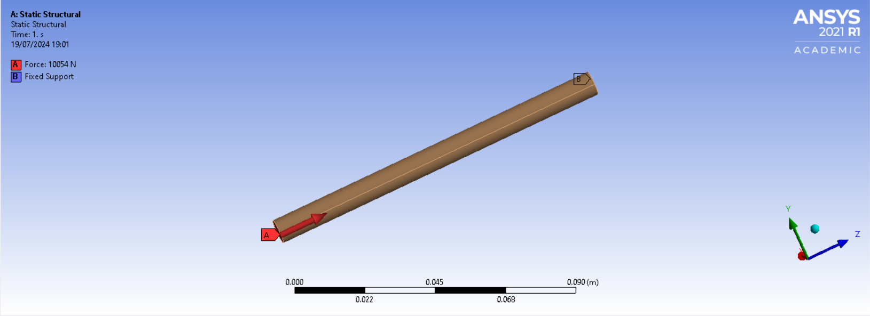
Figs.20-24: Selected time steps from the simulation of PinOnlySS, showing longitudinal deformation (along the z-axis)
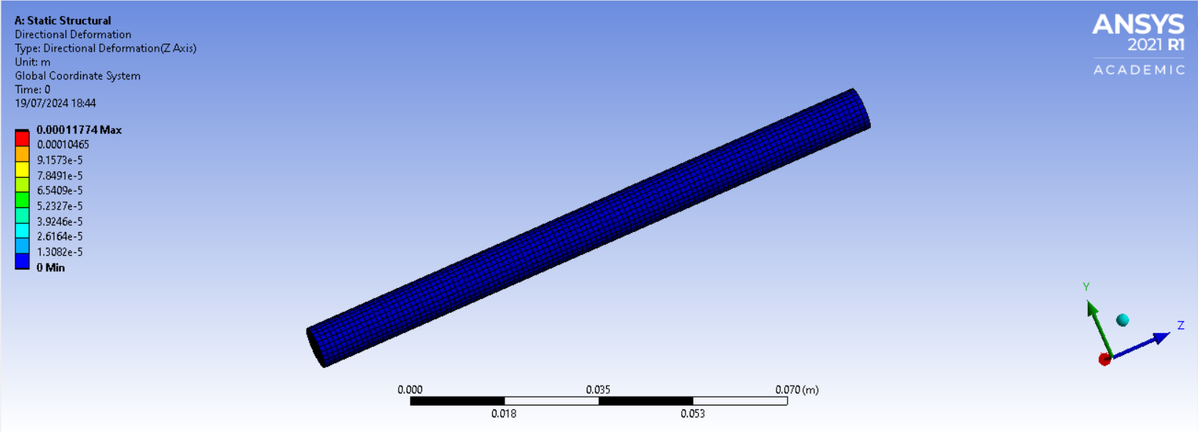
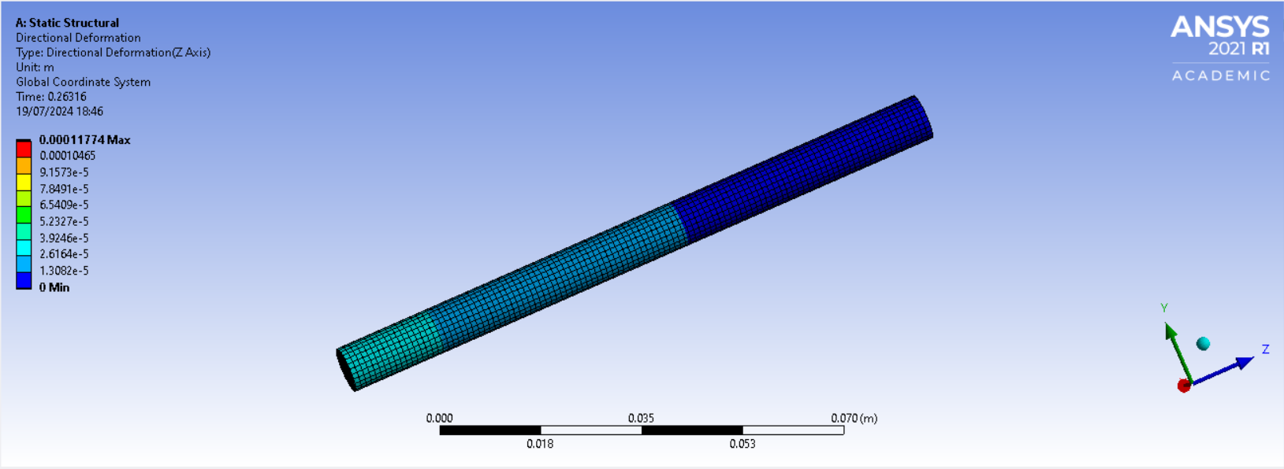

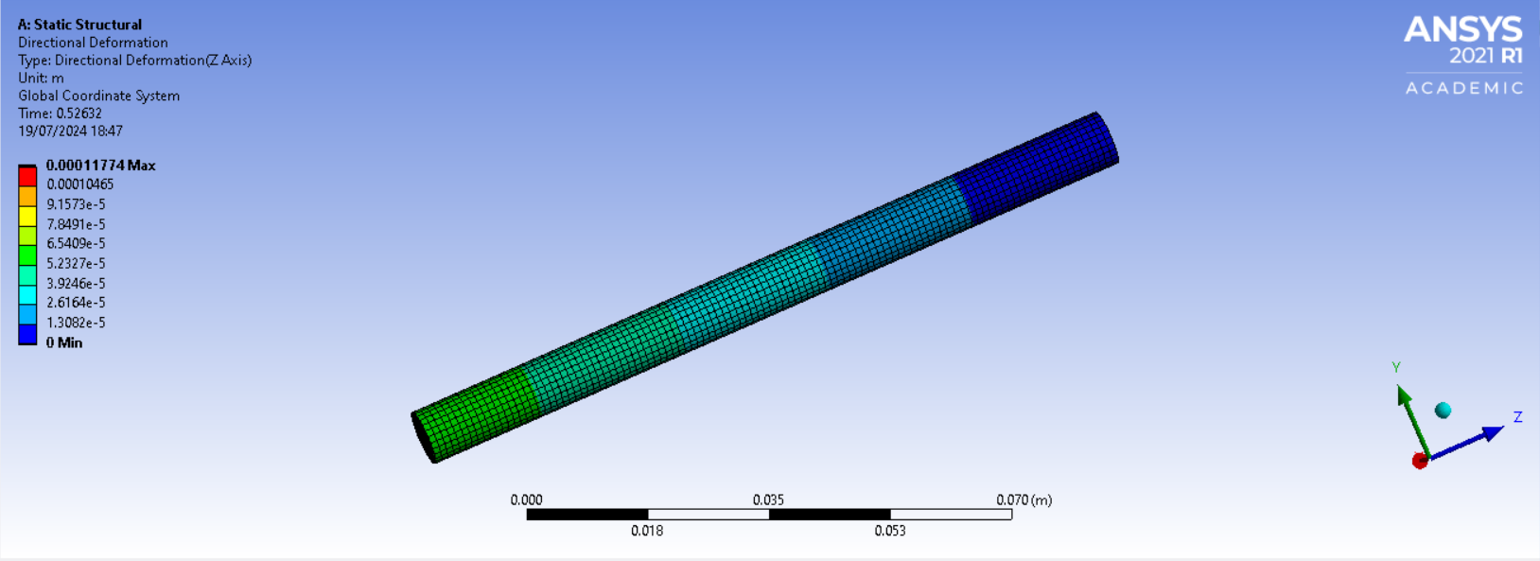
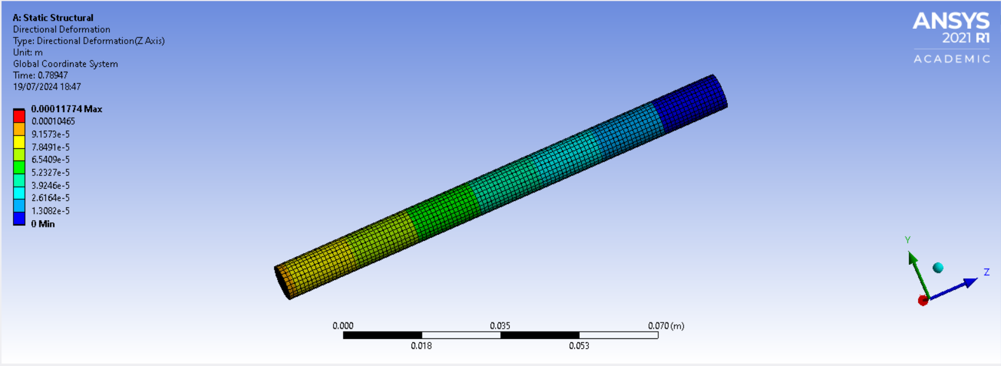
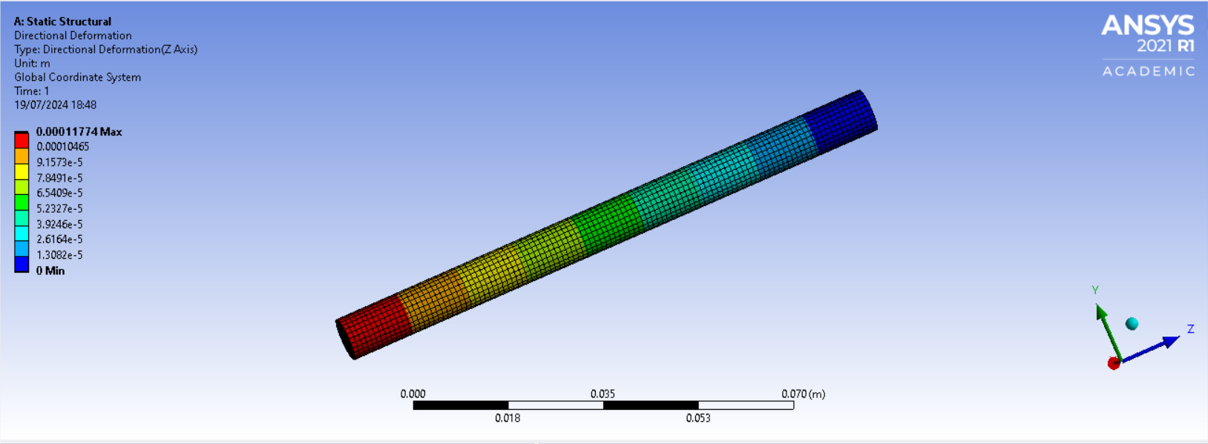
Fig.25-29: Selected time steps from the simulation of PinOnlySS, showing lateral deformation across the x-axis
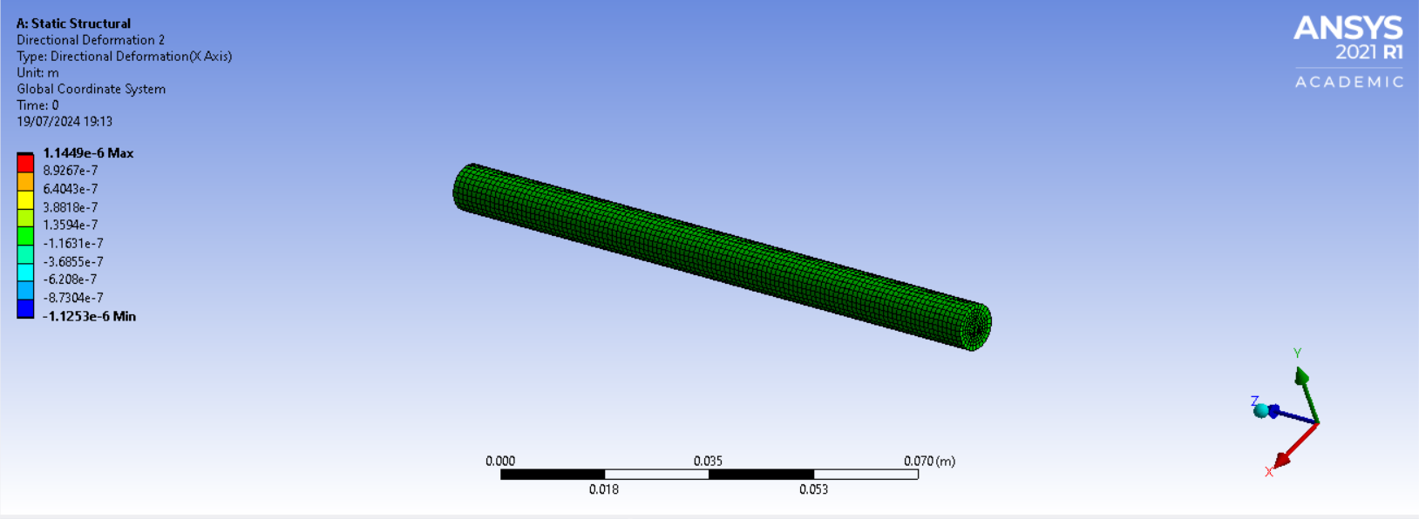
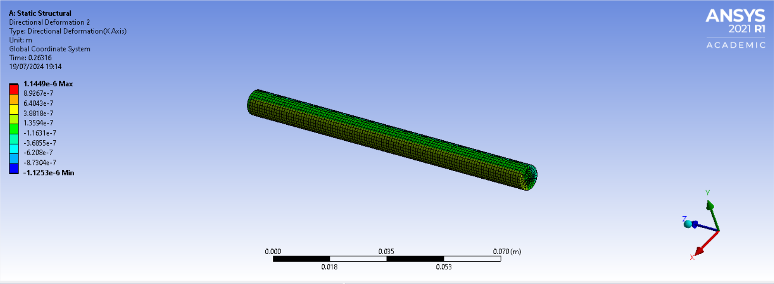
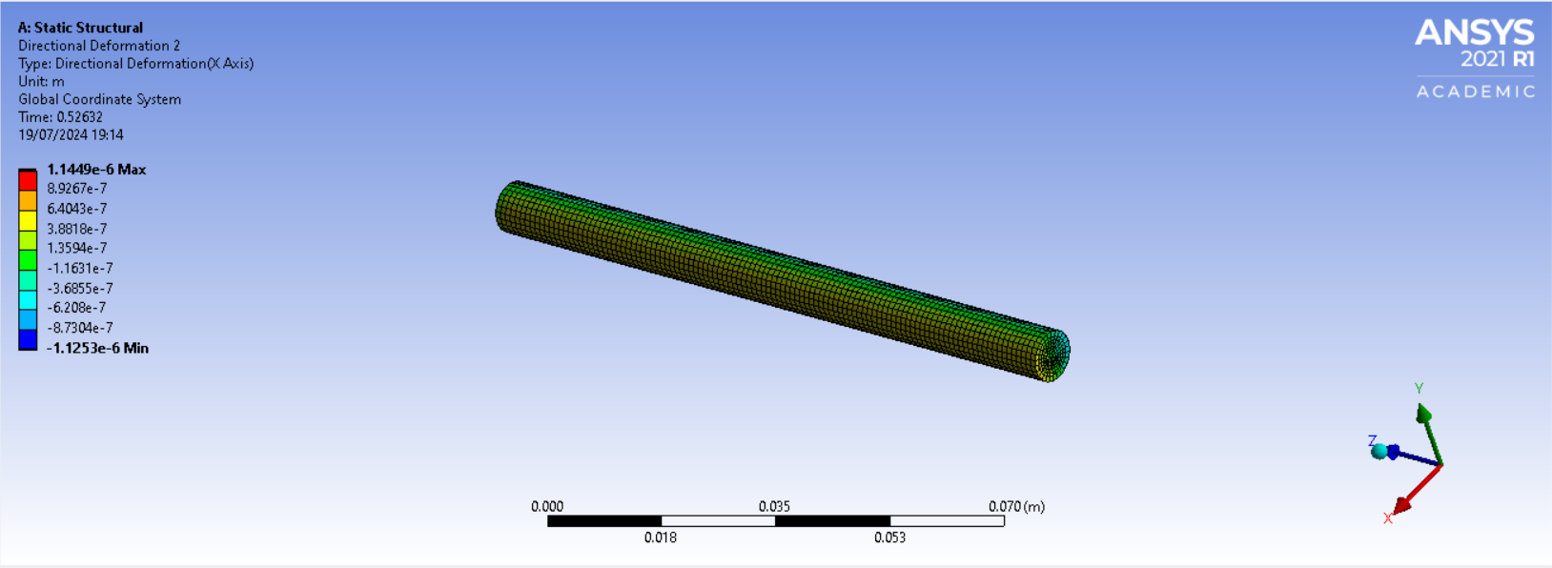
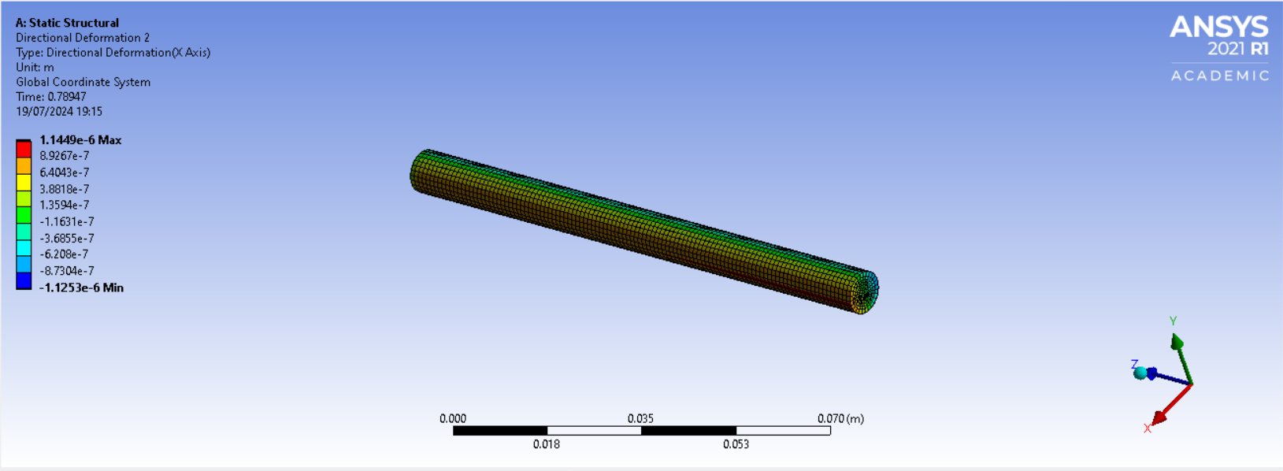
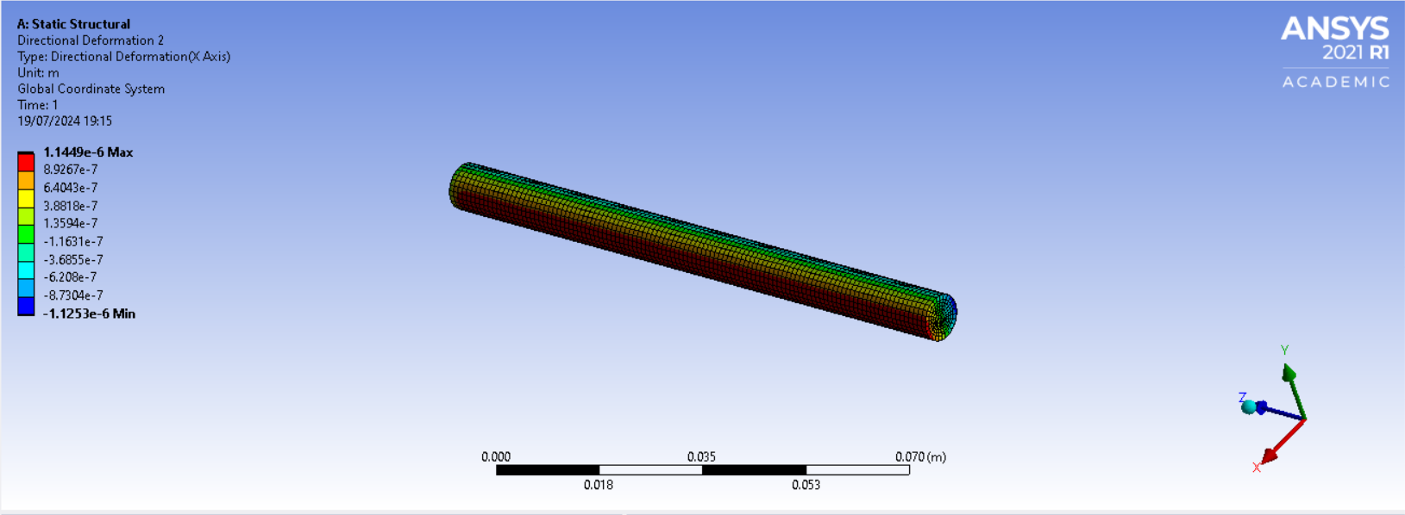
Fig.30: Force and fixed support applied to the model for simulation ‘SimAssBonSS’
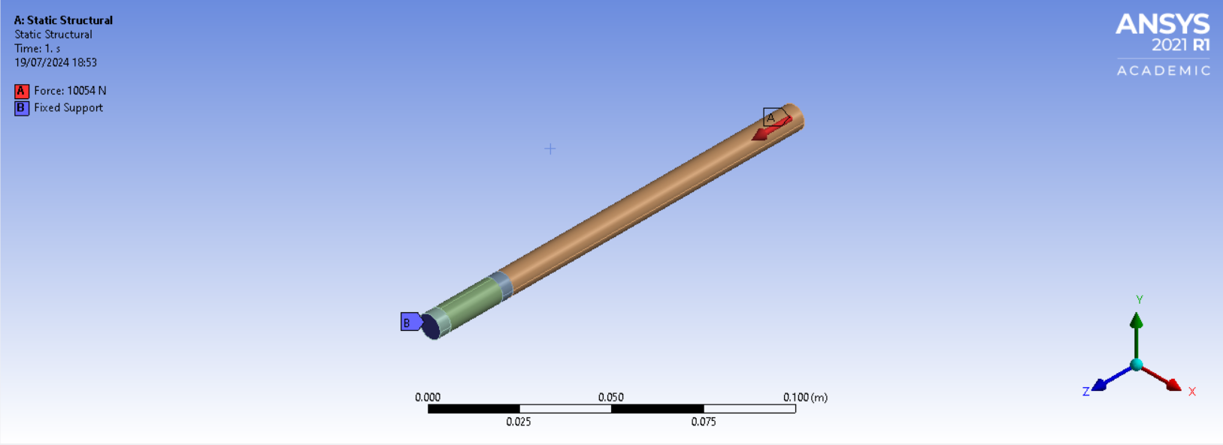
Fig.31-35: Selected time steps from the simulation of SimAssBonSS, showing longitudinal deformation (along the z-axis)
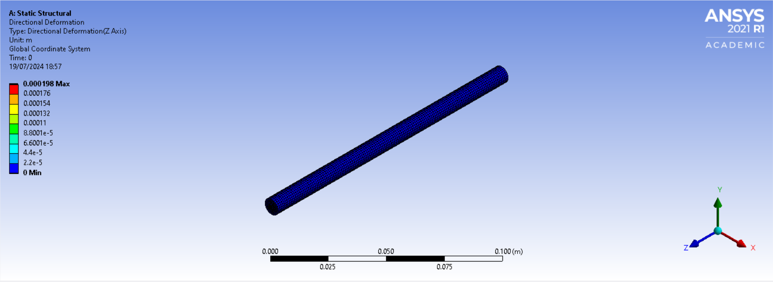
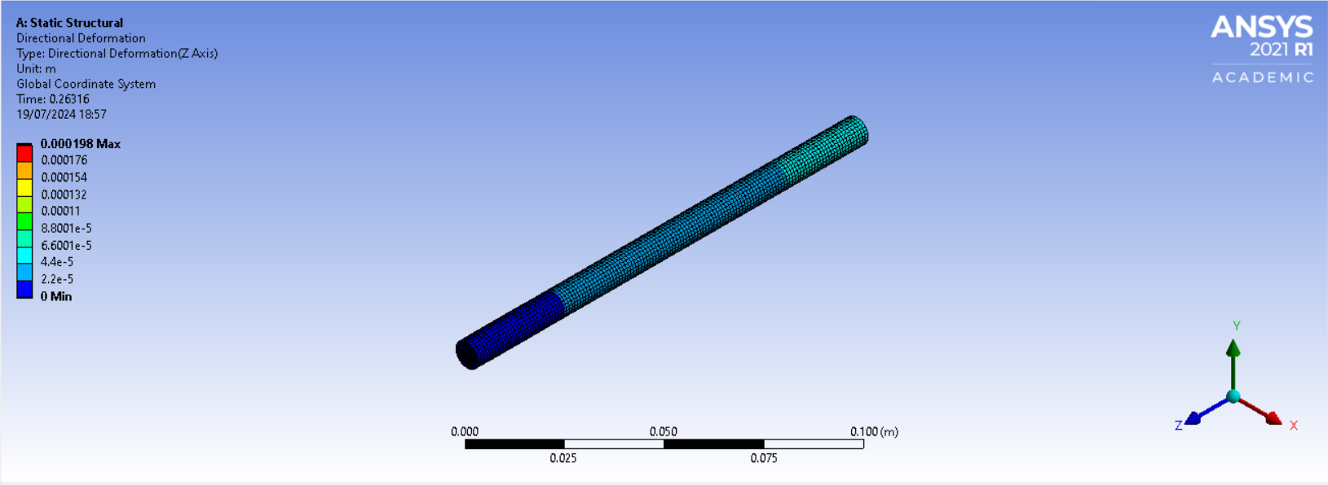
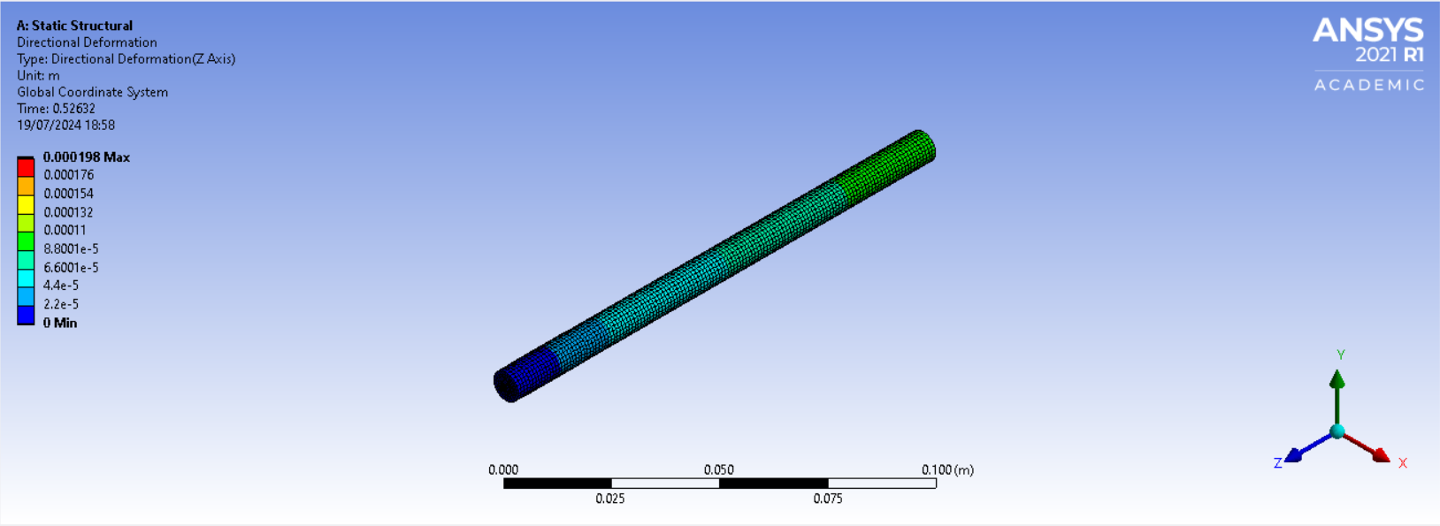
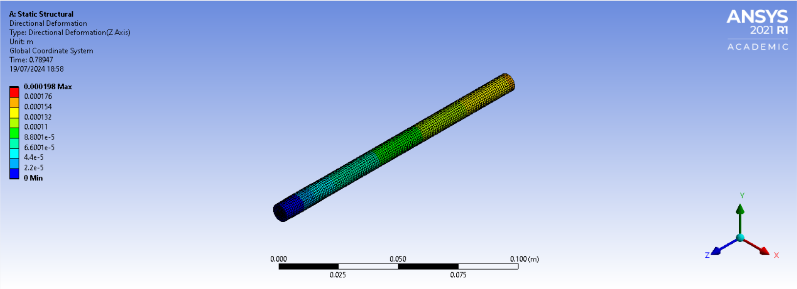
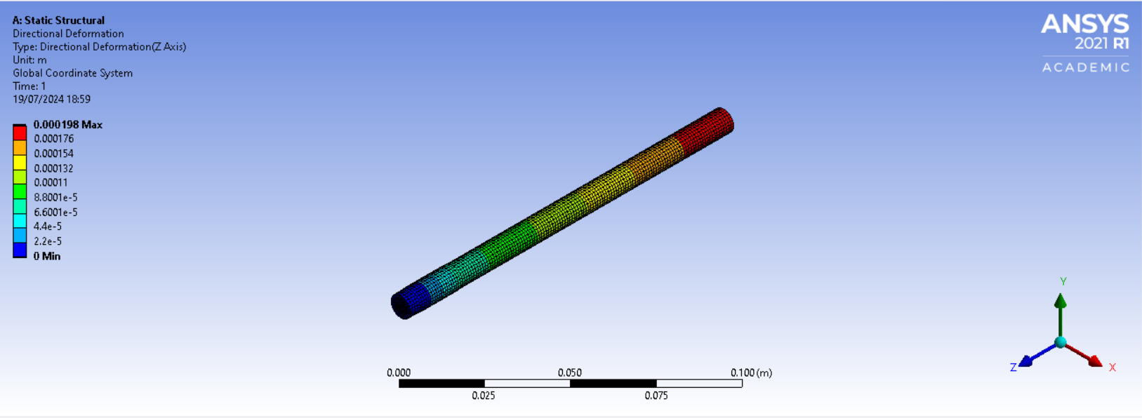
5.2. Tabular Results
Fig.36: Table showing the results for longitudinal and lateral and total deformation for all of the simulation iterations run using the ‘pin only’ and ‘simple assembly’ models, and providing the theoretically calculated values for comparison (see highlighted in orange)
*Sum of the values calculated for longitudinal deformation of each part of the assembly individually under 10054N force
**Value calculated for longitudinal or lateral deformation of the Pin Stem under 10054N force
5.3. Qualitative Results & Discussion
The results discussed focus on the values for longitudinal and lateral deformation of the Pin Stem in the ‘Simple Assembly’ and ‘Pin Only’ models/simulation iterations. See Section 5.1: Tabular Results for a table showing all values from simulations.
5.3.1. Validity of ‘Pin Only’ Models/Simulations
Following the basic principles for validating a model/simulation [10], validity of ‘Pin Only’ models/simulations can be assumed against the calculated values based on the following…
(1) The proximity of values (to within 2/10th of a micrometer) for longitudinal deformation in the ‘Pin Only’ models/simulations derived from using a coarse mesh (0.01) vs a finer mesh (0.001) suggests that all values obtained are not likely to have be significantly skewed by mesh sizing.
(2) Values for longitudinal deformation in the ‘Simple Assembly’ models/simulations derived from using bonded contacts vs rough contacts differ by around 1/100th of millimetre, also suggesting that the values obtained in ‘Pin Only’ model/simulation aren’t likely to have been significantly skewed by contact type applied.
(3) Finally, the proximity of the values derived for longitudinal deformation from all simulations to those manually calculated (mostly < 1/100th of a millimetre), based on fundamental principles, suggests that the ‘Pin Only’ models/simulations are valid.
Despite this, the ‘Pin Only’ model is not a realistic replica of what would happen in the real-world scenario, given that there isn’t a ‘fixed support’ directly at the end of the pin, and longitudinal deformation/compression of the powder material beneath would occur.
5.3.2 Validity of ‘Simple Assembly’ Models/Simulations
Validity of the ‘Simple Assembly’ models/simulations is not fully confirmed. This is because realistically the differing Young’s Modulus and Poisson’s Ratio values between concentric parts/components made up of steel and the pellet body should cause proportionally greater deformation of the pellet body and lesser deformation of the steel parts. This, with the same force and fixed support applied between the two models, would therefore be expected to cause somewhat less longitudinal deformation of the pin stem in the ‘Simple Assembly’ model as compared to the ‘Pin Only’ model. The results derived, however, show that the Pin Stem actually undergoes very slightly greater deformation in the ‘Simple Assembly’ simulation. This may be explained by the fact that in the ‘Simple Assembly’ model/simulation the force is being distributed evenly (per unit area) across the scoped geometry, meaning that the differential proportion of longitudinal deformation expected between the components of varying material is not occurring.
5.3.2 Suitability of Selected Materials for the Assembly
The materials selected for the press tooling application (316 Stainless Steel & Tool Steel 1.2379) both show only a minor deformation in all simulation iterations, suggesting that for single-use, or a small number of presses, they would likely be suitable for achieving an explosive pellet pressed to within 0.1mm height tolerance. However, based on the results of the simulations, it could be suggested that they would not consistently be able to achieve across multiple pressings, given the cumulative effect of each deformation.
It must be noted, however, that for the reasons mentioned in sections 5.3.1 & 5.3.2, none of the simulation iterations can be fully relied upon to provide a value for nominal deformation of the pin stem in the real world, given that neither have successfully modelled the powder material being compressed.
Of note, regarding the relative suitability of the two materials in that the Tool Steel 1.2379 performed better, as expected given its physical characteristics, than the 316 stainless steel.
5.3.3. Effect of Mesh Sizing
Mesh sizing has caused a very small difference (between 2/100th and 3/100th of a micron) in longitudinal deformation, with coarser (0.01) mesh seeing greater deformation compared to fine (0.01) mesh in the ‘pin only’ model in both the stainless steel and tool steel iterations.
Likewise, modelling with the coarser mesh also caused slightly greater lateral deformation (by around 1/100th of a micron) in both the stainless steel and tool steel iterations. This therefore total deformation is greater when using a coarse mesh.
Given the small magnitude in the difference between the deformations calculated with the two mesh sizes, it could be argued that the required level of mesh sensitivity has been attained [11], and that the finer mesh is more likely to have provided a more accurate result [12].
Of note however, is that results for lateral deformation when using the coarse mesh are the same for the maximum and minimum on the Y axis, suggesting lateral deformation is evenly radially distributed; but when using the fine mesh this is not the case. Lateral deformation with the fine mesh (0.01) differed by around 2.2/100ths of a micron around the radius for both the tool steel and stainless steel variants.
5.3.4. Effect of Contact Type
Contact type used in the ‘Simple Assembly’ simulations had some significant effect on the results obtained for longitudinal deformation of the full assembly; with the iterations using ‘rough’ contact types seeing almost half a micron more longitudinal deformation than the iterations using frictionless. However, when analysing the maximum longitudinal deformation of only the pin component within the assembly the results are almost identical. This means that longitudinal deformation of components other than the pin was proportionally greater when using the rough contact type. This suggests that the rough contact type may very marginally provide a more accurate result for this application, possibly due to the fact that the differing result for the frictionless model is simply an artefact of the ‘weak spring’ effect added to stabilise the model [13].
5.3.5. Limitations of Basic Isotropic Analysis (Young’s Modulus & Poisson’s Ratio)
Whilst the simulations carried out can be validated against the longitudinal deformation values calculated, since both utilise only Young’s Modulus and Poisson’s Ratio, the simulations here aren’t realistic because they don’t account for the thermal condition of the materials. In order to create a more realistic simulation thermal conductivity, specific heat capacity, coefficient of thermal expansion and density would also need to be considered [14]. This would aid in particular with creating a simulation that more realistically demonstrates the expected relative differences in the deformation of each component based on the assigned material. Applying density properties would also allow for the effect of gravity to be included within the simulated output.

[1] | M. I. Elso, “Finite Element Method studies on the stability behavior of cylindrical shells under axial and radial uniform and non-uniform loads,” Department of Mechanical and Process Engineering Hochschule Niederrhein, 2012.
[2] | A. Muhammad, M. A. H. Ali and I. H. Shanono, “Finite Element Analysis of a connecting rod in ANSYS: An overview,” Materials Science & Engineering, vol. 736, 2020.
[3] | B. Kaur, P. Kaur and A. K. Jian, “Analysis of deformation of RC beam with addition of fly ash: a Finite element based modeling,” International Research Journal of Engineering and Technology, vol. 07, no. 05, pp. 2395-0056, 2020.
[4] | Ansys Inc, “ANSYS, Inc. Known Issues and Limitations,” Canonsburg, PA, 2014.
[5] | S. M. Vali and A. S. Naga Raju, “Design and Analysis of Punch and Die Process by Using Ansys with Non Linear Materials,” International Journal of Research in Engineering, Science and Management, vol. 2, pp. 2581-5792, 2019.
[6] | Azo Materials, “Stainless Steel - Grade 316 (UNS S31600),” [Online]. Available: https://www.azom.com/properties.aspx?ArticleID=863. [Accessed 26 04 2024].
[7] | J. Tanijaya, S. Tappi and Jabair, “The mechanical properties of limestone as an aggregate on high strength concrete,” IOP Conf. Ser.: Mater. Sci. Eng., vol. 1088, no. 012098.
[8] | J. A. Crutchmer, “HNS Pressability Study,” Sandia Laboratories, Alberquerque, NM, USA, 1975.
[9] | AmesWeb, “Stress Strain Formulas Calculator,” [Online]. Available: https://amesweb.info/StructuralAnalysisBeams/Stress-Strain-Calculator-Formulas.aspx. [Accessed 03 05 2024].
[10] | Ansys, “Verification & Validation - Lesson 8,” [Online]. Available: https://courses.ansys.com/index.php/courses/a-non-slender-cantilever-beam-under-point-tip-loading/lessons/verification-validation-lesson-8-2/. [Accessed 03 05 2024].
[11] | Fidelis, “Element Size in FEA - Does it Matter?,” 2024. [Online]. Available: https://www.fidelisfea.com/post/element-size-in-fea-does-it-matter. [Accessed 15 07 2024].
[12] | A. Dutt, “Effect of Mesh Size on Finite Element Analysis of Beam,” SSRG International Journal of Mechanical Engineering, vol. 2, no. 12, 2015.
[13] | Ozgun, “Ansys Contact Types and Explanations,” Mechead, 07 03 2021. [Online]. Available: https://www.mechead.com/contact-types-and-behaviours-in-ansys/. [Accessed 15 07 2024].
[14] | J. Zhang, “Static Analysis of Manipulator Based on Solidworks and ANSYS Workbench,” J. Phys.: Conf. Ser., vol. 2477, 2023.

