Developing Innovation and Creativity for Business Advantage

BMSW6102_BIRM

Student Name – Mustafizur Rahman
Student Number – 1711957
Lecturer Name – Dr Md Nazmul Hasan
Group – One

Introduction
Product Innovation is an ability to create and introduce a new good or service for an enhanced version in goods and services. Product Innovation outlines techniques for delivering incremental enhancement in services. Hand-sanitizers are antiseptic agents which when applied to hand helps in removing bacterial pathogens present. In this study, a basic aim is to focus upon an innovative product by targeting the customer market and setting up an e-commerce market to set up on online service. It also aims to develop marketing to develop a product or service during a product or service development.

Task 1.

The innovative product OR unique service proposition.

Innovative Product

Figure 1: Hand-Sanitizer
(Source: which.co.uk, 2020)

Hand Sanitizer is a liquid gel, or foam used upon for reducing bacterial elements on hands. In hand washing elements, soap and water is mostly preferred. As a result of Covid-19 pandemic, restrictions have been imposed on sales of innovative products to be provided remotely. In developing a product like Hand Sanitizer, 3/4th cup of alcohol with 1/4 aloe vera is needed. As an antiseptic product, this product really aims to kill pathogens and works on skin where bacteria are a main pathogenic age (which.co.uk, 2020). Such a product is really innovative as it enables techniques for substantial development of incremental opportunities. The outbreak of Covid-19 pandemic has enhanced reliance on hand-sanitizers as a safety measure to cleanliness and fight against measures to pathogens.

Customers
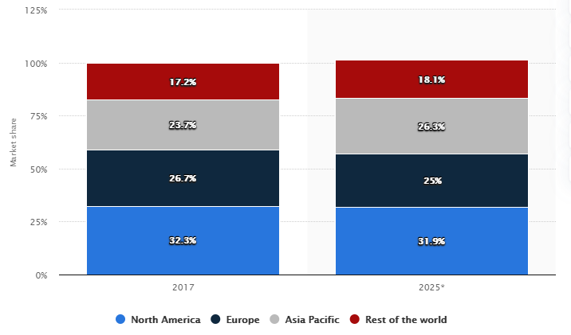
Figure 2: Customer Market for Hand-Sanitizer
(Source: statista.com, 2020)

Based on global statistics, it has been interpreted that estimated share of hand sanitizers is likely to grow significantly. In a year of 2025, market share for Europe is likely to come to 25% as compared to that of 2017 with 26.7% (statista.com, 2020). Considering the current situation of Covid-19, restrictions on sales of items has created a situation which makes it suitable for selling products remotely on an online basis. Customers for selling products of hand-sanitizers are restricted to online customers only including both men and women who are keen to acquire these products from the market. As such, both men and women who are health-conscious and willing to incorporate sanitation measures need to be prioritized first for sale of the product.

Place and method of selling product
Antibacterial sanitizers are created as a result of panic created from the spreading of Covid-19 Pandemic. Almost 97% of people do not make use of sanitizers for washing off their hands (businessinsider.in, 2020). Due to fear of viruses, most of the items are being sold rapidly and appearing at prices above market levels. As a result of scarcity of stock, this product would be selected on first-cum first service basis to online customers. The place for selling hand sanitizers would be restricted to place West Somerset only. An online website would be developed through which this product can be sold on an online basis by a retail market. CDCA had recommended hand washing to be one effective way of protecting oneself from spread of communicable diseases, by use of a hand-sanitizer containing at least 60% of alcohol.

Opinion regarding name for venture
Opportunities are a basic idea for construction of entrepreneurship. In developing literature about an issue, ideas regarding creativity and management need to be upheld, that needs to be developed for refining an idea into a marketplace through commercialization (Vogel, 2017). In development of a new venture, suitable understanding of process and outcomes can be arranged once individual opportunity is taken into consideration. Yes, there is a particular name for venture. As such, the name of the online website is therefore, “Digital Deals”. In delivering products of hand-sanitizer, this innovative product would be sold out through means of this online website.

How to sustain innovative business proposition
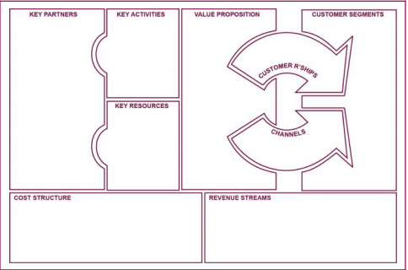
Figure 3: Business Model Canvas
(Source: Influenced by Wrigley and Straker, 2016)
Business Models are innovative forms of innovation. As such development of a business model, change is a sustainable form of innovation. In this respect, a leading firm needs to meet the glory and interest of a firm (Wrigley and Straker, 2016). Business Model Innovation can be a significant pathway for competitive advantage in case sufficient differentiation is developed for replicating on incumbents of business. In this aspect, the retail business of selling hand sanitizers through “Digital Deals” would involve incorporation of business canvas models. This would look into the aspect of initiating a business model canvas for sustaining innovative business propositions.

Implications of competitors in the area
The competitors at marketplace aim to deliver substantial relevant products through effective business sales. Competitor analysis is a crucial aspect for development of websites in e-commerce marketing. In audit of general digital spaces, looking into basic competition is of key significance. For instance, priority pixels know the significance of a website for developing any business, and therefore, encourage traffic to be driven by e-commerce websites (prioritypixels.co.uk, 2020). CK Creative is another competitor who can aim to create the best e-commerce website that is available in the Somerset region (ckcreativedesign.co.uk, 2020). Here, the team provides training and guidance in administering the site once it is running by putting on a lurch in items. Such competitors might affect business and shift attention to consumers at West Somerset who would divert their interest in a market.

Task 2.

E-commerce-propose to set up an online website and consider.

Using SaaS such as Shopify
Spotify is a SAAS tool that offers a web-browser version including pricing model, accessibility, and speedy implementation on a timely basis. SAAS products are generally followed upon a similar pricing model to be supporting business tools. In developing products, using SAAS as Shopify, would be made use of in developing hand sanitizer at online websites by retail stores.

Using a marketplace like Amazon or eBay
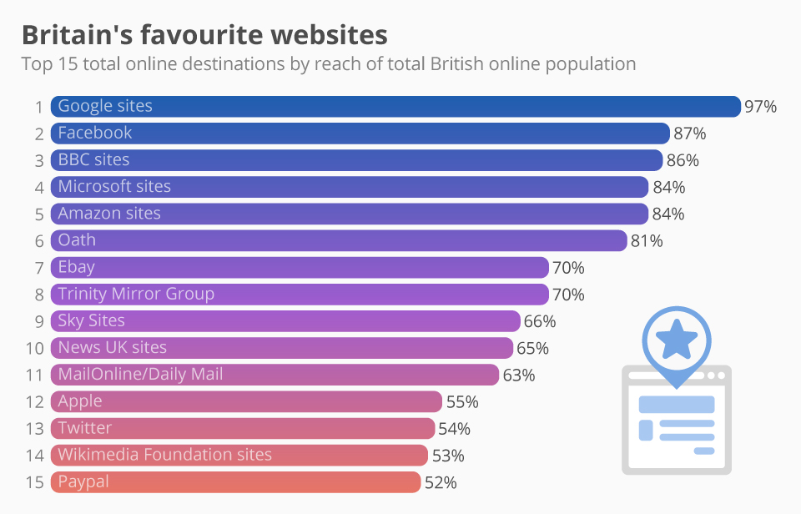
Figure 4: Britain’s Favourite Website
(Source: statista.com, 2020)

Consumers are keen on selling products in connection with online web pages. Since, Amazon is a suitable spot for delivering substantial output, development of such a website is a formidable measure for growth of business (statista.com, 2020). Using a marketplace of Amazon, product sales can be generated into a consumer market. Moreover, in a remote region of West Somerset, the need for creating business through this website needs to be initiated for sales of products to ultimate consumers.

Creating content
High quality content helps in establishment of effective sales in marketing. Creating a personalized experience is a possible measure by which consumers can be acquired. A need for focusing on strong headlines is a key to making content actionable in nature. Writing on short and to the point content provides understanding to consumers.

Using Payment Services, eg. card or PayPal
By consideration of PayPal, one can send or receive a message for goods and services to be picked upon. In going for PayPal, a manual payment is sent that provides options for goods and services to ultimate consumers. PayPal as a method needs to be used by consumers in making purchase of product, hand-sanitizer since it is sold in an online website. PayPal enables creation of protection for consumers to keep money safe.

Awareness about PCI-DSS compliance issues
The PCI-DSS is a series of requirements needed by businesses for ensuring that companies process, store and transmit information related to credit card information for maintenance of a secure environment. In case a business does not meet PCI requirements for compliance with security measures, it could result in payment of dollars as fines. Intellectual property rights enable a business to be well-aware of its product brand and are used to protect innovative ideas so that no loss is incurred upon by an innovator in business scenario. The “Intellectual Property Rights 2014 (c.14)” has been designed for delivering responsible rights to property (legislation.gov.uk, 2020). The “Copyrights, Designs and Patents Act 1988 (c.48)” provides right for controlling upon ways in which information would be used (legislation.gov.uk, 2020). In doing so, business needs to consider such aspects for compliance with issues on a relative basis.

Task 3

Marketing

How to promote product or service?
Covid-19 has witnessed a rising emergence of many products mainly hand-sanitizer where growth has been huge in this market. As such an alcohol based hand gel is regarded as a means of washing hands with warm water to put limits to transmission of Covid-19 disease. For instance, in the first month of vital medical equipment 12,000 were sold when this virus was at its peak. Each bottle contains 150 to 200 litres on a daily basis to begin the day with (nsmedicaldevices.com, 2020). In promoting the product, social media websites like Facebook would be used to deliver information about product price and usefulness to customers. Along with that application of customer support system, the website would ensure resolving customer queries by email or calling on support helpline numbers. The link to the website is in the reference list and the Image of the website is placed in the appendix.

Target customers and means of reaching them
Online social networking is a suitable way through which businesses perform on a key role in reach on a target audience on an effective basis. As such these platforms have turned into a suitable platform for daily lives of users over globe. The users are able to share photographs, web contents, audio visual tools that enables them for sharing or reacting against comments produced by own or other users of a service (Sarkar et al. 2019). In this aspect it can be stated that the target customers for selling products of hand-sanitizers would be online men and women who are health-conscious and purchase the stock on basis of its availability. In area of West Somerset region, this product would be supplied through means of online websites and social networking sites as well as email-marketing is a crucial way of reaching out to them.

Consideration of use of Social Media, Facebook

Figure 5: Usage of Facebook as social media website
(Source: statista.com, 2020)
Social Media is an effective tool through which online marketing is carried out. In UK for instance, the total number of users had been 39 million users for a month with an estimate reaching 42 million users. As such, the number of online adults reached 67% in 2016 (statista.com, 2020). In UK, total number of people who utilize Facebook on a daily basis is 44%. Therefore, a consideration for using Facebook as a social medium is a prime aspect in developing growth of a business. In this case it can be stated that promoting business by use of this medium can enable substantial growth of business.

Consideration of use of paid search engines, Google
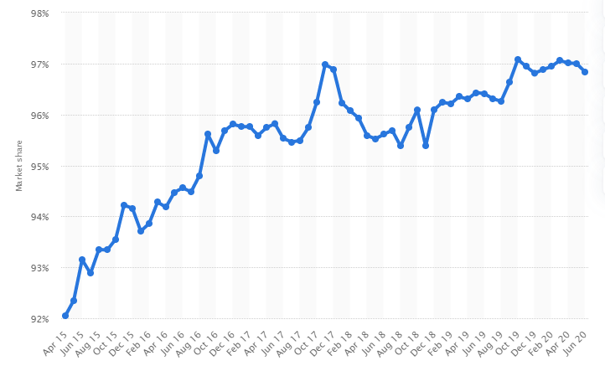
Figure 6: Consideration of google as paid service
(Source: statista.com, 2020)

Google is a popular search engine that enables consumers to gain knowledge on a particular product and prices offered. In country of UK, Google’s search regarding market share has reached millions at a significant rate. In a year of 2020, web traffic market tools reached significant heights at 96.8% (statista.com, 2020). The number of consumers has reached 50 billion hits on a monthly basis. Google can therefore be used as a paid online service for growth of its hand sanitizer product in online channels.

Understanding role of consumer journeys
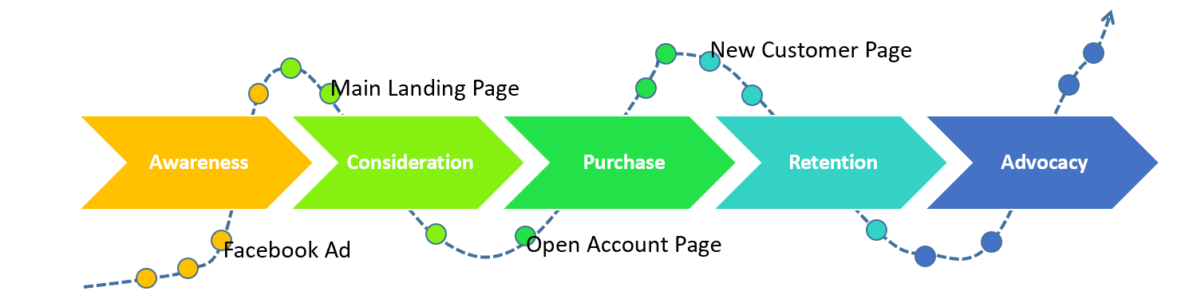
Figure 7: Consideration of consumer journeys
(Source: Influenced by Lemon and Verhoef, 2016)

Idea screening is an effective measure that fits on organization in terms of its capabilities, functions as well as structure and values. As such, they aim at providing significant value to consumers by solving a particular problem by being willing to satisfy their needs and interests. Understanding on consumer experience is a critical issue for a firm. In order to achieve a good experience for consumers, it is necessary for identification of needs and wants of consumers (Lemon and Verhoef, 2016). A consumer journey presents a complete sum of experiences that consumers go through starting from awareness, going through consideration, acquiring purchase, portraying retention and then going through advocacy. The entire journey of consumer purchase of hand-sanitizer needs to be well addressed for achieving widespread availability of options.

Consideration of use of email marketing
Email marketing is a crucial tool for spreading a commercial message to people by use of e-mail. In a survey conducted, it was viewed that 66% of consumers make online purchases by means of email-marketing. Therefore, effectiveness of email marketing promotions is crucial and a challenging aspect at both individual as well as aggregate levels. Hence effectiveness of such promotions can be found both at individual as well as response to purchase rate in individual-level analysis. Also discount coupons are available by means of effective campaigns on email-marketing (Wu et al. 2018). The retail store would also make use of email-marketing for selling hand-sanitizer products. In this manner, effective purchases can be made through discounts produced to ultimate consumers.

Consideration of pre-launch promotion to gain email-address
Advertising as well as marketing are effective tools in promotion of a business. They bring into notice how consumers' needs are satisfied by consumption of products. As a marketplace is hostile towards new incumbents, needs for conduction of radical business is quite efficient. A pre-launch promotion considers strategic fit; market needs have to be developed. The feasibility considering market credibility and technical requirements are to be upheld. A promotion of hand-sanitizer products before its launch would be done for gathering email addresses of consumers. In this manner, products can be sold out quickly among relevant people in a business website.

Conclusion
Innovation is a process as well as an outcome of creating a new product with greater value to consumers. Innovation is a process in which identification of an opportunity as well as entrepreneurship needs to be evaluated with involvement in the commercialization process. In this study, development of an innovative product named hand-sanitizer, has been taken into consideration for launching in an online website. Due to issues of covid-19 pandemic, the sales would be done remotely and delivered substantially to market. A consideration for development of e-commerce website and marketing means has been evaluated in this study.

References
- businessinsider.in, (2020). About the best hand sanitizers. Available at; https://www.businessinsider.in/science/news/a-designer-created-a-3300-temple-of-poop-a-composting-toilet-with-a-view-that-fertilizes-its-own-roof-garden/articleshow/74502342.cms [Accessed on 3 October 2020]
- ckcreativedesign.co.uk, (2020). About –commerce website design in Somerset. Available at: https://www.ckcreativedesign.co.uk/website-design-in-somerset/e-commerce-websites/ [Accessed on 5 October 2020]
- legislation.gov.uk, (2020). About Copyrights, Designs and Patents Act 1988. Available at: https://www.legislation.gov.uk/ukpga/1988/48/contents [Accessed on 10 October 2020]
- legislation.gov.uk, (2020). About Intellectual Property Act 2014. Available at: https://www.legislation.gov.uk/ukpga/2014/18/contents/enacted [Accessed on 9 October 2020]
- nsmedicaldevices.com, (2020). About Hand sanitizer, Covid-19 and the future market: Will the product become part of everyday life? Available at: https://www.nsmedicaldevices.com/analysis/hand-sanitiser-future-market/ [Accessed on 6 October 2020]
- prioritypixels.co.uk, (2020). About result-driven e-commerce solutions. Available at: https://prioritypixels.co.uk/e-commerce-somerset/ [Accessed on 4 October 2020]
- Rahman., M., (2020). Image of website page. (online) Available at: https://innovative-hand-sanitizer.myshopify.com/admin/products/5912459018394. Accessed on 5-10-2020.
- Sarkar, D., Debnath, S., Kole, D.K. and Jana, P., 2019. Influential Nodes Identification Based on Activity Behaviors and Network Structure With Personality Analysis in Egocentric Online Social Networks. International Journal of Ambient Computing and Intelligence (IJACI), 10(4), pp.1-24.
- statista.com, (2020). About Britain’s favourite websites. Available at: https://www.statista.com/chart/14885/online-reach-of-websites-in-britain/ [Accessed on 11 October 2020]
- statista.com, (2020). About estimated hand sanitizer worldwide in 2017 and 2025, by region. Available at: https://www.statista.com/statistics/888410/global-market-share-of-hand-sanitizer-by-region/ [Accessed on 2 October 2020]
- statista.com, (2020). About social media usage in the United Kingdom (UK)- Statistics and Facts. Available at: https://www.statista.com/topics/3236/social-media-usage-in-the-uk/ [Accessed on 7 October 2020]
- statista.com, (2020). https://www.statista.com/statistics/280275/market-share-held-by-google-search-engines-in-the-united-kingdom-uk/
Wu, J., Li, K.J. and Liu, J.S., (2018). Bayesian inference for assessing effects of email marketing campaigns. Journal of Business & Economic Statistics, 36(2), pp.253-266.
Lemon, K.N. and Verhoef, P.C., (2016). Understanding customer experience throughout the customer journey. Journal of marketing, 80(6), pp.69-96.
- Vogel, P., (2017). From venture idea to venture opportunity. Entrepreneurship Theory and Practice, 41(6), pp.943-971.
- which.co.uk, (2020). About hand hygiene, soap and sanitizer gel: whar you need to know. Available at: https://www.which.co.uk/news/2020/04/hand-hygiene-soap-and-sanitiser-gel-what-you-need-to-know/ [Accessed on 1 October 2020]
- Wrigley, C. and Straker, K., (2016). Designing innovative business models with a framework that promotes experimentation. Strategy & Leadership.

Appendix
Image of website page.


