

Course: BA (Hons) Business Management
Level 4 – Term 2 - Weekend
Community Engagement (LCBB4002)
Dr. Toyin Adisa
Assignment – A2

Sandra Iulia Ghinescu
2118454

Contents
Introduction 3
Building the community with art 3
The guide 3
Why Art Centred projects are important for a community? 4
The importance of art-based projects as a whole 4
Idea for VicHealth 5
Purpose of art-based projects 6
Advantages and disadvantages of art 6
Advantages of investing in the art 6
Disadvantages of investing in the art 7
Recommendation 8
Conclusion 10
References 11

Introduction
One of the community engagement projects which have been chosen in this case is the art-centred project. To begin with, arts-centred projects are the types of projects which are developed by any particular art organization or the artist who takes any existing work from the surrounding or an individual and start using it as the main centre piece for engaging a whole community after it. This is certainly named the Art Centred project which includes the open doors for engaging more people to work with self-esteem and proper mental health. One example of such an Art Centred project is the green thumb theatre's production of still falling.
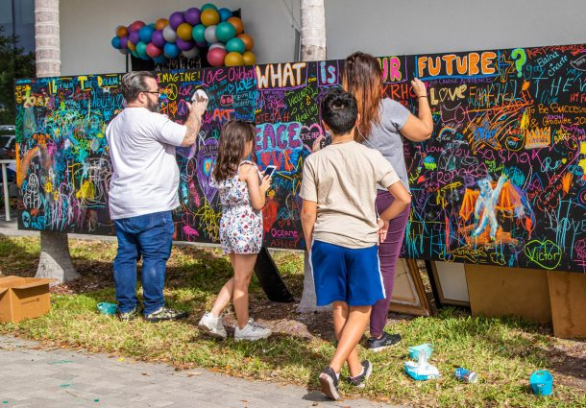
Figure 1: Community engagement through Art
(Source: Santos, 2018)

Building the community with art

The guide
The basic idea for building up a community and engaging more people using art is mainly work or a guide which has been brewing for over a few years or for some time in recent. This has been including more people who are aware of the various values which are present in the community based on the projects associated with the art and thereby have been increasing the demand for both the resources and the advisors which are related to it (Tartari et al., 2022). It can be said that the hope and the support which grows along with it brings together several people who can start accessing the advantages and features such as the arts themselves and the health policies which might be of great interest for some practical series off any particular Community Action. This brings about different artists together to build up a community and the members then brainstorm on creating new projects off the main topic or any topic which has been used earlier. The considerable research which goes on includes the discussion, the debate, writing, and essentially the support which is needed from the network of the different organizations, artists, and government agencies which means that in a later stage this will start emerging as a publication (Mishra, 2019). It can also be said that this work guide which is present is initially imagined before being involved in the process of the Art Centred project. It includes the breadth and the depth or deepness of a particular topic within the community that is sometimes extended beyond the normal outline or the sheets. However, there are different ways in which the Project can be taken and a community can be built up using art and the guide based on it.

Reasons behind the importance of Art Centred projects for a community
Speaking about the importance of the Art Centred project, it can invariably be mentioned that these projects are approached in different ways which means that there are different kinds of a particular project. It is important to know which model will be specific for guiding the whole community with the help of the art (Imran, 2021). The delivery of the practicalities and the snapshots include the philosophies, histories, and the different contexts and sub-context of any particular contemporary community-based topic. The models have been fitting into the project and the community which is being used to upgrade the surrounding. The guides include the artist, managers, stakeholders and even the leaders of a company or community who have been established for a long time or maybe new in the society too. The volume of all the ideas and information that is linked together to make a source or the possibility indicates how many projects our active and the guide is being used on which particular idea or research (Santos, 2018). This also highlights the different other aspects of what needs to be done before starting the art-based project and provides greater insight into every process.
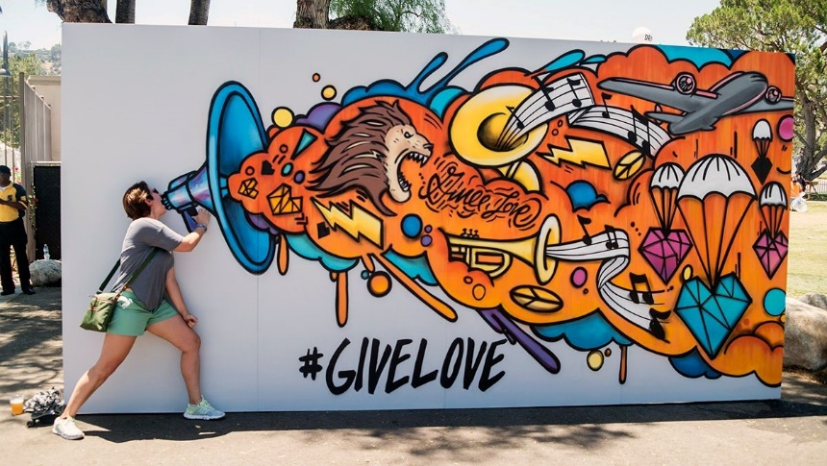
Figure 2: Art centred project
(Source: Zhou et al., 2020)

The importance of art-based projects as a whole
The artist's projects are of great importance to the community as discussed earlier. There are different creative activities and ideas which are even associated with the well-being of a group of people are the community which must not be underestimated at any cost. This might also include the experiences and understanding of the particular art which can be seen in the first-hand result and brings up the people together through the art activity. Over time, the different researchers and investments which have been made into different art-based programs have shown a sophisticated understanding of the different links which are present between health and art (Lim, 2020). This knowledge which is present between both of the separate departments is shared mutually with the different art organizations, artists, funding, and even the agencies who research community engagement and art-based projects. A much wider range of potential exploration takes place when the international bodies decide to communicate with these projects in a finer place.

Idea for VicHealth
There is a part of the idea associated with health as discussed earlier. For over 25 to 26 years, key acknowledgment took place for the potential units of participation related to the health and the energies which are being used for the promotion (Norbu et al., 2021). Effectively the art projects have helped to bring the different communities closer and together, to help in exploring and interpreting the unique stories and in turn, share the discoveries or any new perspective that has been found.
In short, it can be said that the work which is put into by different artists and organizations helps in building up such a community or stakeholders that stands on a very solid foundation of expertise. This particular expertise which is built on shared effort is further investigated by the investors and international bodies who are engaging in these projects. The dedication which is associated with the passion of these different artists lets the project get a new power and collaboration from many new other participants. One of these is the weekly health which is proud of being able to develop the making of a community with the help of art. In the future, this could also be termed as a favourable asset and working accordingly using the valuable resources and exploring the potential for the communities (Lam et al., 2018). In turn, this will start encouraging the other activities and community organizations for including more art-based projects in the future.

Purpose of art-based projects
The purpose of art can be described through a few of the mutual points first up these points are:
- Art is one of the most powerful ways or means in which a deep truth or fact can be expressed. This can be very useful for rethinking a particular concept or thing for society and allowing it to grow more (Oren et al., 2019). People need to understand this public art and its function the same. It was created in response to 911 which means that every tragic loss of life which occurred is being shown through the medium of art in the world.
- Art can also help in healing. This binds the community even more which means that there is the presence of a very sublime character in the art. The development of inclusion, collaboration and diversity are some of the major areas fulfilled in this purpose. This might include the members of the community or even the sense of closure is healing for any particular group of people is a person. It is very beneficial for the art and the artist both.
- Another thing that can be stated is the downside concept of the art-based projects or the art which is included in the project. This means that the community is bound up in a very pluralistic world, for this reason, the art which is used is being expressed and perceived in such a way that it provides a different point of view to each individual (Palumbo et al., 2022). This holds its meaning with different kinds of responses and ensures that everyone is happy at the end of the project.

Advantages and disadvantages of art

Advantages of investing in the art
It can be said that art is a great way of investing in different projects for several reasons. One includes the love and appreciation that the different artists and groups of people, communities, and even organizations hub for art. This helps in putting the different pieces together and investing in something which can bring joy and inclusion to the community. A number more people are engaged in working together and investing for monetary gains whereas art is one such medium that can be easily appreciated on some level (Lay, 2018). Other than this, there are some other advantages also. Investing in art-based projects is simply the art that is used must be appreciated. The appreciation which is provided helped in increasing the value and identifying if the artist can gain notoriety in society or not for a few of the cases, the benefits which come around with it include the pieces of work which are known for a long time and then sell those pieces of work for gaining the prophet. Therefore, art can be chosen as a medium of investment as a whole which can be used for obtaining a part of a fun and as well as gain from the same. The art pieces, the shows, hitting the estate sales, and the searching for the last pieces of the same art have different values which might be fulfilling the selling buying and attending the events might show this support which can turn into a very rewarding aspect for the investment choice for the project.
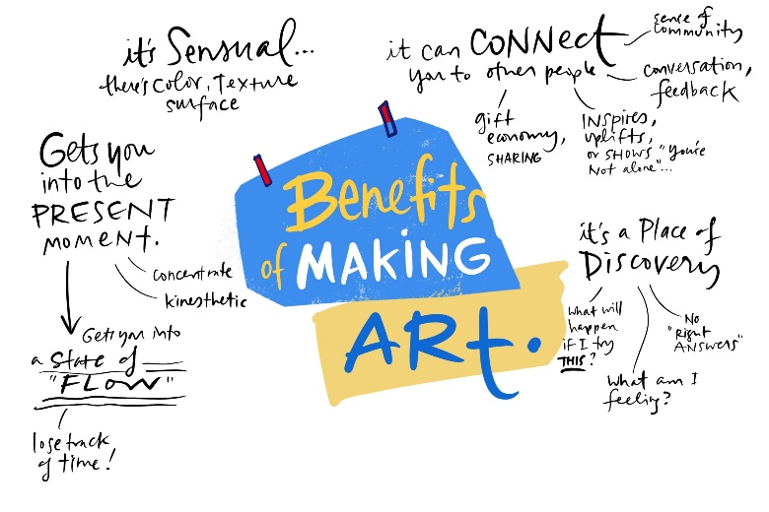
Figure 3: Benefits of Art in a community
(Source: Lim, 2020)

Disadvantages of investing in the art
Although there are different advantages of investing in art, several disadvantages are associated with art-based projects in community. The market for these projects often includes the cutthroat business. This is associated directly with famous artists and even organizations. Therefore, the buying and selling that takes place for the different pieces of projects are quite expensive most of the time (Gross et al., 2021). These individual pieces might indulge in a greater purchase which has a more appreciative value and opportunity for bringing up other pieces in the market which could have the same position.
One such disadvantage along with this is how new artists are being found. This takes a lot of time as well as that it becomes subjective which cannot be easily achieved. The investors start taking up other projects or organizations and the career of the artist is set at pause. Therefore, investing in an artist becomes a way in which the art loses its financial value or the monetary gain.

Recommendation
After the discussion that the art-based projects somewhat require a particular part of knowledge from the people who belong to a specific community. This helps in building up the contacts for buying cheap yet quality pieces which involves investment into it over a longer period. Therefore, it can also be said that there are benefits that are achieved through a slow process. This does not provide a direct result but helps in achieving the outcomes which were desired by the community and the engagement when the project was initiated (Zhou et al., 2020). The people then start thinking about the different strategies which might be useful in gaining a position in the market.
Therefore, it can be recommended that the art market being risky involves a lot of consequences. For this reason, it is important to look into how much money is being involved and invested into a particular art-based project for building up the community as well as keep in mind the different pieces associated with the betterment of society (Palumbo et al., 2022). These are even important for creating a place in the art market with the different unique ideas and antiques for bringing up the power on the earth that could stop dream.

Conclusion
Therefore, it can be concluded that the different art-based projects are even known as community-based art projects where it works within a particular community to facilitate a process that is very creative and enables the participants to express their needs, aspirations, identity, or even the sense of the place. They are not activities that are sometimes included within the community and these activities are at dared to the art, the young people engaging in two different art-based cultural projects and similar topics.

References
Gross, H., Schwarz, N., von Clausbruch, S.C. and Hary, K., (2021). Art projects as transformative services to integrate refugees. Journal of Business Research, 127, pp.373-381.
Imran, S.M., (2021). Art as a tool of empowerment: a case study of communal art projects with migrants.
Lam, B., Phillips, M., Kelemen, M., Zamenopoulos, T., Moffat, S. and de Sousa, S., (2018). Design and creative methods as a practice of liminality in community-academic research projects. The design journal, 21(4), pp.605-624.
Lay, R.P., (2018). Community, compassion and integrity: Consideration to ethics within art (s) therapy community projects. ANZJAT: Australian and New Zealand Journal of Arts.
Lim, S.J., (2020). Sinclair Wetlands: A case study of practice-led research in community projects. Junctures: The Journal for Thematic Dialogue, (21).
Mishra, A., (2019). ENONTEKIÖ ART PATH-ENONTEKIÖN TAIDEPOLKU: a practical framework for sustainable community art projects in Finnish Lapland using service design tools.
Norbu, S., Couraud, B., Robu, V., Andoni, M. and Flynn, D., (2021). Modeling economic sharing of joint assets in community energy projects under LV network constraints. IEEE Access, 9, pp.11(2019)-112042.
Oren, R., Orkibi, H., Elefant, C. and Salomon-Gimmon, M., (2019). Arts-based psychiatric rehabilitation programs in the community: Perceptions of healthcare professionals. Psychiatric Rehabilitation Journal, 42(1), p.41.
Palumbo, R., Manesh, M.F. and Sorrentino, M., (2022). Mapping the State of the Art to Envision the Future of Large-Scale Citizen Science Projects: An Interpretive Review. International Journal of Innovation and Technology Management, p.2230001.
Santos, L., (2018). Multidisciplinarity: Projects for Social Change in Art and Culture. Routledge.
Tartari, M., Trimarchi, M., Ghirardi, S. and Sacco, P.L., (2022). A monument to whom? Artist positionality in community art-based projects. Geoforum, 131, pp.173-184.
Zhou, Y., Wu, J., Long, C. and Ming, W., (2020). State-of-the-art analysis and perspectives for peer-to-peer energy trading. Engineering, 6(7), pp.739-753.

