University of Wales Trinity Saint David

Changemakers: Creativity and Value Creation
Sean Ramsey

Public Services

November 2022

Contents:

- Mind map on Identifying the Problem- Energy Saving Awareness
- Summary on my Energy Saving Awareness Campaign
- Pitch and Flyer video link
- Poster
  - References

Innovation: is what interests’ people in your project as new ideas are always intriguing because people want to try them. Finding new and unique methods to save energy and money this winter can be important to those struggling with money, especially during the current cost of living crisis. (Emeritus, 2022) Creativity is a skill used in my campaign as I want to offer advice and information to people that they have not seen before. (Stanford)
Database: The main database I used for my idea is the internet using Google Scholar to find reliable information. To find key words I would search pages using CRL + F and using Boolean search strategies with words such as 'and', 'or' and 'not'. (ScienceDirect) In my case, I was searching key words like 'saving energy' and 'energy reduction' to find relevant sources.

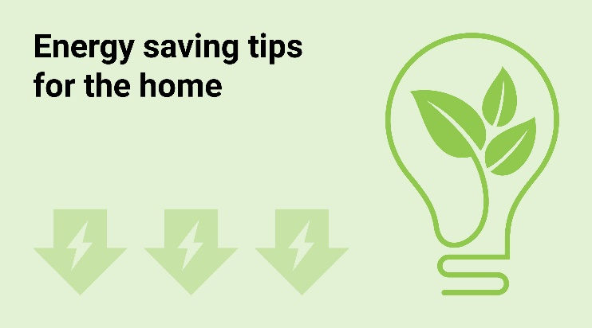

Energy Saving Awareness Campaign - Identifying the Problem

Creativity: was used in my project idea when I was brainstorming an idea that would be relevant in today's society that I believed I could help with. Creative work also makes you more motivated as it's your own idea which makes your more focused on accomplishing your goal. (ISTE, 2021) I used the positivism research philosophical approach as I am going to use factual knowledge and data to help express methods that can help save energy. (Positivism Research Philosophy)
What the problem is: I found out about the problem through different sources of media as the cost-of-living crisis has been on the news frequently in the recent months. I understand that feedback is very valuable, I am planning to improve my research and get a better understanding on the problem afterwards. (actiTime, 2021)


I used deductive reasoning to find already existing methods and evidence that actually have been proven to work to save energy and money. I believed that this would be the best type of reasoning to use as people will believe that the advice I am giving can help them if it has been proven to help others in the past. In my research I used quantitative and qualitative data to find out methods and advice that will allow people to save money. I had to use quantitative data when comparing numbers and measuring how much money/energy could be saved. I used qualitative data when reading resources and finding reliable information. When collecting qualitive and quantitative data, I got my information from using observations and secondary data. I used observations when thinking about past experiences where I have observed bills to be higher in the wintertime as heating and other bills are always higher. I used secondary data when using websites and looking at statistics on which methods save money. When using qualitative research data, I used typical case sampling as I looked at popular websites with information I could trust based off own experiences. Regarding my quantitative data, I used systematic sampling as I used current house bills and compared the prices and figures to previous bills a few months ago. (FullStory, 2021)
I believe I used convergent thinking when coming up with my project idea and when researching about it, this is because I based a lot of my research on facts I already know as opposed to divergent thinking where I did not come up with many ideas by brainstorming instead I believe for my project using factual information already out there would be the best way to approach it. I used the four W approach when testing if my project idea would be effective. The first W, who, is everyone who is affected by money problems or even people who just want to save more. The second W, what, the problem is saving energy and money which not only is relevant to a lot of people but saving energy is also good in general for the planet. The third W, where, the problem is everywhere that is energy is connected with therefore most places. Lastly, the last W, why, I believe giving relevant advice could help a lot of people and could be genuine use to some. (The 4W Analysis)
I believe my project idea and solution has value as it’s relevant to nearly everyone’s life, especially during the current cost of living crisis people want to save money where they can, and it could help people struggling. I believe my project would be valuable to mainly adults who work and have bills to pay, therefore a large population. Advice given could be helpful and hopefully new information people did not previously know will help and bring value to their lives. Entropy could be a problem relating to my project idea, as advice given might be already known by people and therefore they eventually will give up on the tips given as it might be more comfortable or easier living to not follow some advice or even not to try the advice at all as they have given it a go in the past and their past experience of entropy could dissuade them from trying again. (fs blogs)

Link to my pitch and flyer of my project:

https://www.youtube.com/watch?v=Ysd5GKPCXIU&ab_channel=SeanRamsey

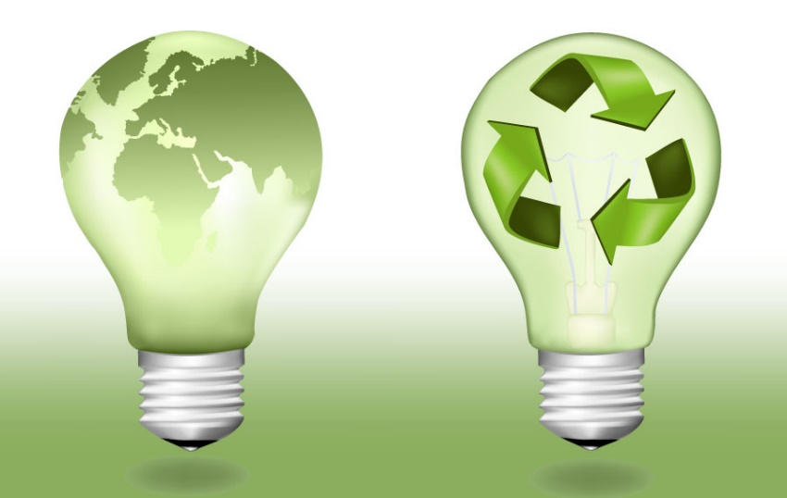
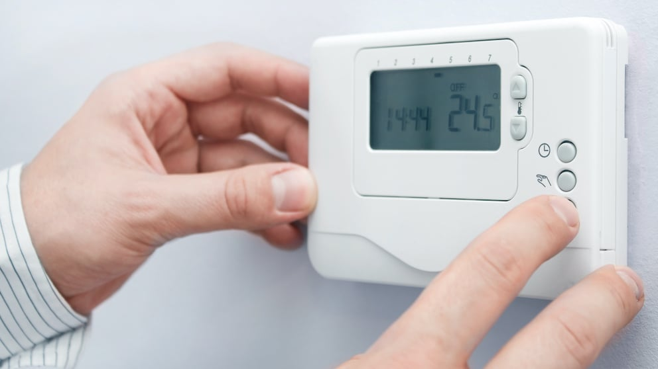
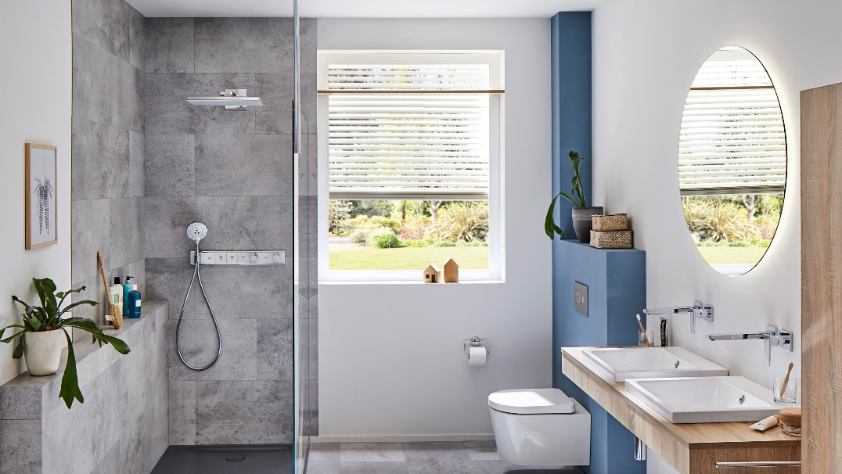


Kitchen:
If you use a washing up bowl instead of a running tap to clean the dishes, only fill the kettle to the amount you need and only use the washing machine once a week if possible you can save around £40 a year.

By checking dripping taps are properly turned off you can save around 5, 300 litres of water a year which is a decent amount of money and water being saved. (energysavingtrust, 2018)

Energy Saving Awareness Campaign
Appliances:
Leaving mobiles and laptops on charge for longer than needed wastes electricity and also damages the battery. Turning devices off standby mode can save about £30 a year. (Big Energy Saving Week)
Heating:
Having a room thermostat installed could save you around £75 a year.
Turning the thermostat down by 1 degree can save about 10% of your whole energy bill so if your house is too warm from the heating this can be useful.
To prevent draught, you can close curtains and install draught-proof windows and door which can save about £20 a year on energy bills.
Central heating systems with timers if you smartly can save a lot of money, setting the heating and hot water to come on only when needed will help reduce bills. (YouRepair website)

Lighting:
If you turn off the lights in the house when they are not being used you can save energy and money.
Around £14 on your annual energy bills. Also switching to energy efficient LEDs can save around £35 a year on bills. (HomeTips, 2021)

Bathroom:
If you reduce your time in the shower by 1 minute a family of four can save around £75 a year on energy and water bills.

Running taps waste 6 litres+ of water every minute so turning it off when it’s not being used like when brushing your teeth or shaving you can save a lot.
Using a water efficient shower head can save around £70 a year off gas bills and around £115 a year off water bills. (edfenergy website)

References:
Mind map sources:
Emeritus, 5 Important Benefits of Innovation in Business, July 21, 2022
Available here:
https://emeritus.org/in/learn/important-benefits-of-innovation-in-business/#:~:text=Innovation%20plays%20a%20key%20role,introduce%20modern%20technologies%20for%20automation.

Creativity and innovation management: How to inspire original ideas, Stanford Online
Available here:
https://online.stanford.edu/creativity-and-innovation-management#:~:text=Creativity%20is%20typically%20centered%20around,with%20into%20a%20viable%20solution.

International Society for Technology in Education, 5 Reasons Why It Is More Important Than Ever to Teach Creativity, Nicole Krueger October 5, 2021
Available here: https://www.iste.org/explore/5_Reasons_Why_It_Is_More_Important_Than_Ever%20_Teach_Creativity

Positivism Research Philosophy
Available here:
https://research-methodology.net/research-philosophy/positivism/

ScienceDirect, Boolean Search, Derek L. Hansen, in Analysing Social Media Networks with NodeXL (Second Edition), 2020
Available here:
https://www.sciencedirect.com/topics/computer-science/boolean-search#:~:text=A%20Boolean%20search%20is%20a,early%20computer%20pioneer%2C%20George%20Boole.

actiTime, The Importance of Feedback, 2021
Available here:
https://www.actitime.com/project-management/importance-of-feedback

Image sources:
Image 1:
https://img.uswitch.com/n36b8lzdmgnp/2039uHqBLQJfIl5hMZkVjz/3c3d8c53e96acc56a35d66fdd6c881c6/102energySavingTips_header_v3.jpg?

Image 2: https://www.thebalancemoney.com/thmb/l0KQr3CBNz85XPg3YXxRF2UIaiw=/1500x0/filters:no_upscale():max_bytes(150000):strip_icc()/cropped-image-of-hand-putting-coins-in-jars-with-plants-755740897-5ab88ee1875db9003759d390.jpg

Summary Resources:

Qualitative vs. quantitative data: what's the difference? THE FULLSTORY EDUCATION TEAM POSTED OCTOBER 06, 2021
Available here:
https://www.fullstory.com/blog/qualitative-vs-quantitative-data/#:~:text=Quantitative%20data%20is%20numbers%2Dbased,what%20happened%20behind%20certain%20behaviors.

The Four W's, Principles of Basic Analysis
Available here:
https://www.thevantagepoint.com/_Analyst_Guide_Online_/Getting%20Started/Analysis-Basic_4W_analysis.html#:~:text=The%20Four%20W's&text=These%20four%20questions%20(who%2C%20what,for%20thinking%20about%20our%20analyses.

Entropy: The Hidden Force That Complicates Life
Available here:
https://fs.blog/entropy/#:~:text=Entropy%20is%20simply%20a%20measure,and%20systems%20dissolve%20into%20chaos.

Poster references:
YourRepair, How to Save Money on Energy and Heating Bills
Available here:
https://www.yourrepair.co.uk/blog/how-to-save-money-on-energy-and-heating-bills

energy saving trust, Top five tips to save energy in the kitchen, 2018
Available here:
https://energysavingtrust.org.uk/top-five-tips-save-energy-kitchen/

HomeTips, 12 Ways to Save Energy Lighting Your Home, 2021
Available here:
https://www.hometips.com/diy-how-to/lighting-indoor-energy-efficient.html

Big Energy Saving Week, 20 Waves to Save,
Available here:
https://www.citizensadvice.org.uk/Global/CitizensAdvice/campaigns/BESW%202020/20%20ways%20to%20save%20(1).pdf

Energy saving ideas for your bathroom,
https://www.edfenergy.com/for-home/energywise/energy-saving-ideas-for-your-bathroom\

