Final Report

I. Introduction

In this major project, I was mainly responsible for the prop making, and the two characters' motorbikes were entirely made by me. I will be responding to the team producer. This includes but is not limited to prop design, prop modelling, prop mapping etc. Although I have previous experience in prop modelling, I have never worked on a motorbike model before, so I think this will be a good challenge for me to communicate with other members and get more ideas and become more diverse.
I was completely responsible for the motorbike content in this prop production, so I was responsible for the whole process, from the design drawings to the finished modeling and material mapping.
Firstly, I am confident in my prop design and will communicate with team members and team leaders during the design process to adjust the whole process and requirements.
Secondly, after the communication, I also design multiple versions for other members to discuss and choose from, to get a better design result and then proceed to the next step.
I think I can learn how to make props and designs faster in the whole process. I would love to learn these related just, which will be helpful for my future career path.
In terms of secondary roles, I choose to help with rendering where I think I can help other members do their jobs better and I can also help them quickly when they ask for it. Likewise, if I encounter problems and difficulties in my main job, I can gain more from learning and absorbing the strengths of other members.
The work I add not only reduces the processing time of the whole project, but also improves the quality of the work. This is a very important task for us now.
My understudy work is the scenario side of things and can help other members when they need help and take on their work. I also try to make time to help other team members during the project, and my colleagues make sure that my main job is done. Of course, this job also gives me more exposure to more work, which allows me to adapt to the project process faster in the future.

In my back up role I work in post (credits, sound, editing, credits), most of my roles are on the pre-production side so I chose post in my back up role, it gives me a different experience on the project, keeps me entertained and I can take over and replace other members of the team when they get stuck, this job content can all be done in pr and ae so I can also learn more than just 3d software.

II. Processes

2.1. Design part

In the early stages of the project I set some goals, there are many types of motorbikes, rally bikes, motorbikes, one-wheeled, two-wheeled, etc. I discussed with the team leader how the motorbikes should look like and communicated with the other team members to get their input, and after refining the model and decals, I again got input to improve them.
The first part I did was the design of the motorbike prop, wrapping some sketches and silhouettes.
At the beginning, I would look for pictures of motorbikes on the internet, from game models to real life photos of motorbikes, the shape of the motorbike was a very important part in my opinion, so I would look for some material to make a silhouette and then communicate with the team members to choose the most suitable shape of the motorbike for the two main characters, and then proceed to the next step of drawing.
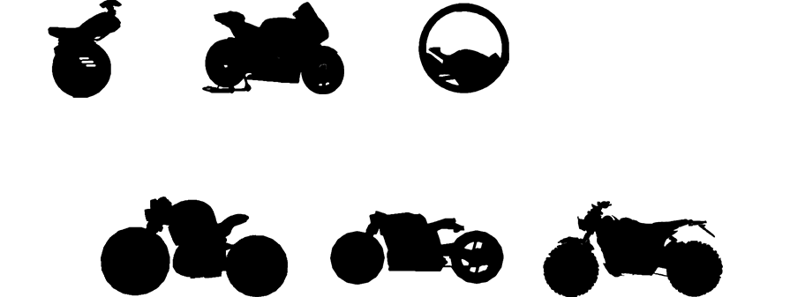
For this step I selected six motorbikes to make into silhouettes: street bikes, motocross bikes, cruisers, and the rather unusual one-wheeled motorbike. In discussion with the group we finally settled on the two bikes on the left below as prototypes, which are more stable and suitable for riding in the desert.
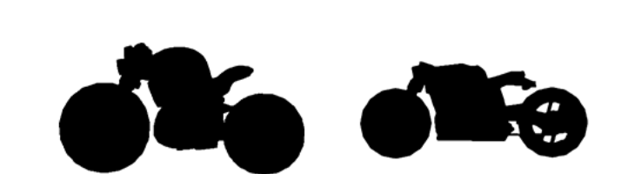
The silhouette was a very interesting part, it helped me to define a lot of the modelling content directly, all I needed was to add the details as the shape was already taken care of by the silhouette.
After defining the silhouette, I started working on the three views of the bike, which would help me with the modelling work later on.
The most important thing about the three views is that they are proportional, because they have to be put into the software as a reference for modelling, so when drawing the three views in PS you must determine the size of each canvas and finally the length, width and height of the customised length, so that the three views do not go wrong.
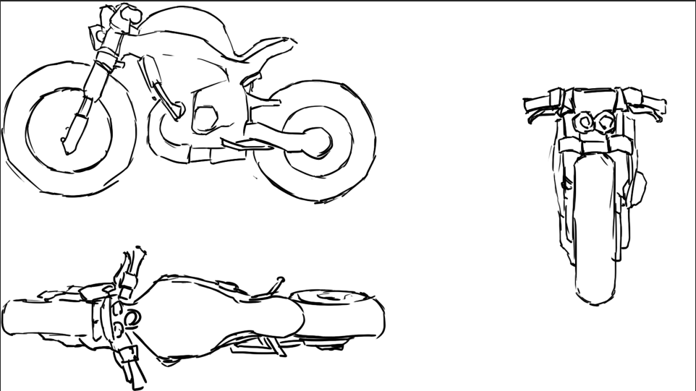
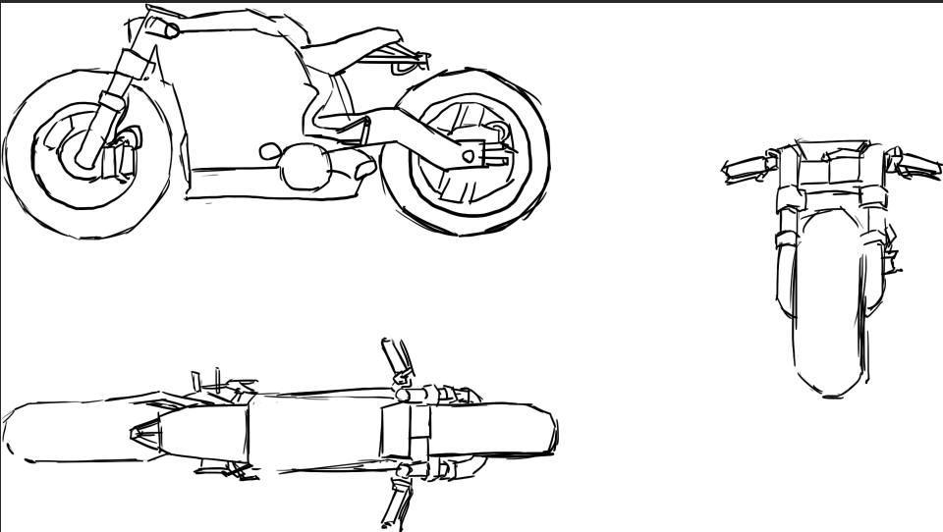

2.2. Modeling part

The software I chose for the modelling part was blender, as the team needed to import it into ue4 for rendering at a later stage, so as long as the model could be exported in obj format there was no problem, blender is the 3d software I use most and it is very convenient or open source.
The first thing I wanted to do was to model the rabbit motorbike, as the rabbit is the main character in the animation and takes up more of the space, and the animation takes place in the desert, so the model should look stable.

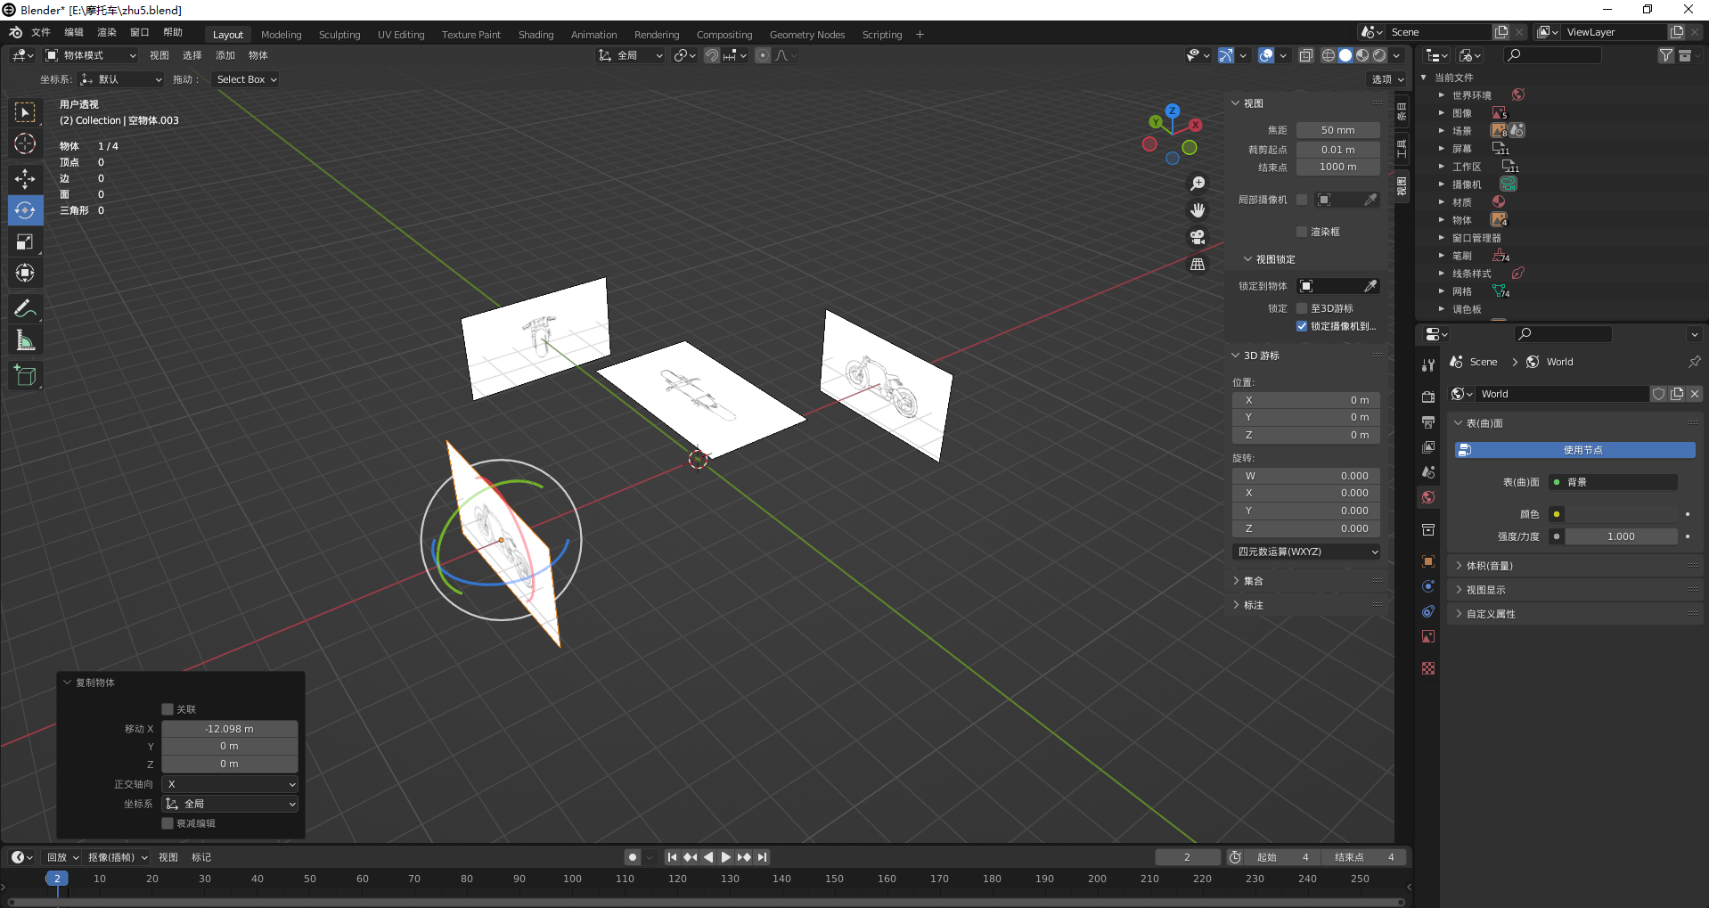
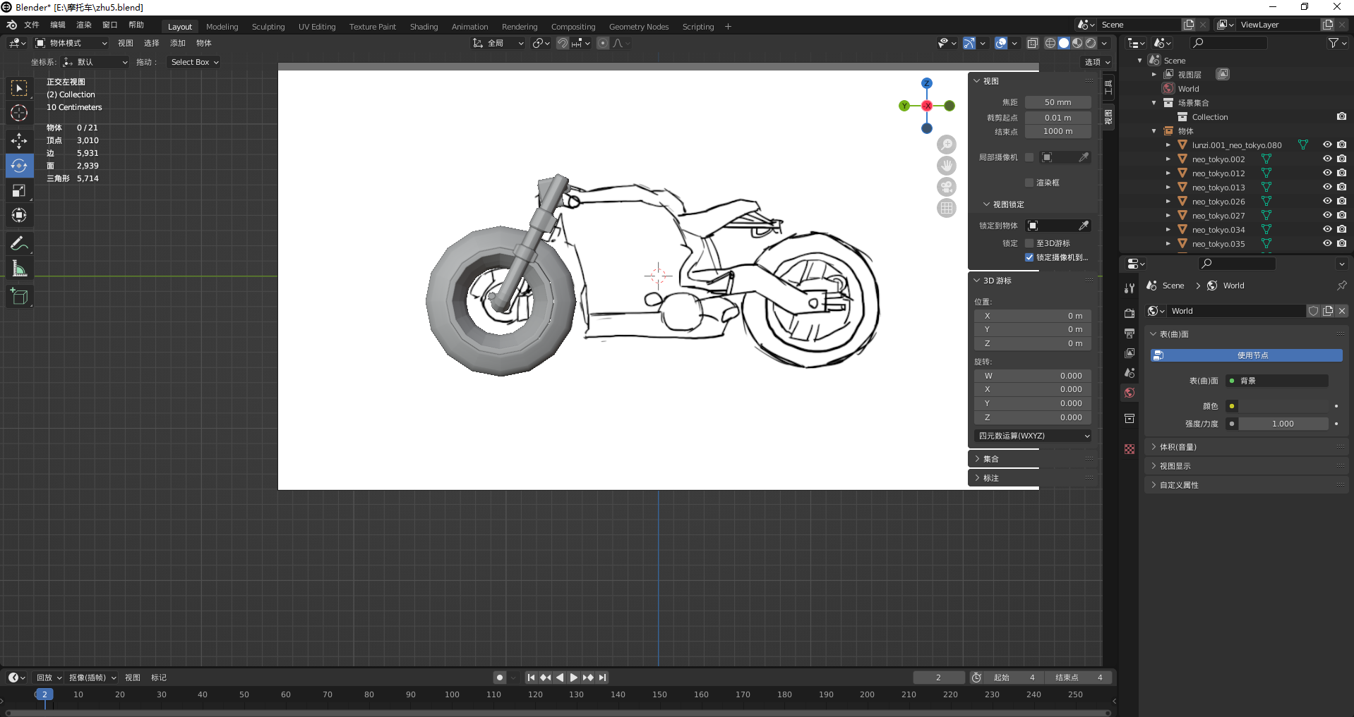

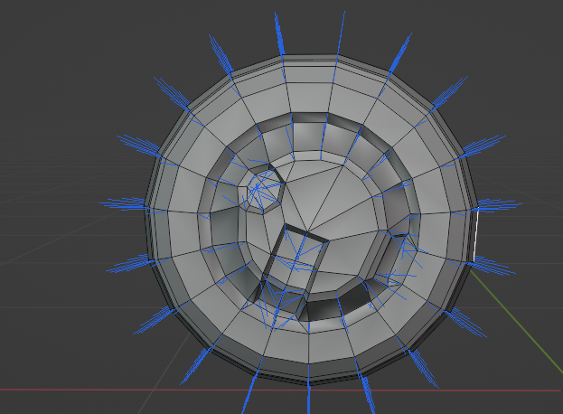
The priority in modelling is to build the overall shape out, so poly is good to use. After building the box and cylinder base shapes according to the shape in the three views, extrusion and stretching operations are carried out to make the model match the three views, whether the model needs to be modelled separately is a very important issue to prioritise, for example the rabbit's tyre.
I didn't want the rabbit's tyres to have a cut-out in the middle, so I chose to model them together to save the number of faces and the need for subsequent optimisation.
In the modelling of the motorbike the left and right sides are basically symmetrical and it is necessary to use the mirror function so that only half of the model needs to be built, which saves a lot of unnecessary trouble and time.
After the initial model is built, the model lines need to be modified. Quadrangles are the industry standard in modelling, as they allow for better calculations and save resources in rendering, and avoid stretching and distortion of the mapping, while triangles can cause many inexplicable and unsolvable problems. The initial modelling left a lot of triangles that I needed to change to quads.
The next thing to finish is the pirate pig motorbike, in order to make a distinction with the rabbit motorbike, the pirate pig is more massive, the motorbike is also more square shape, more reflective of the fierce pig, and the car's tyres also made a hollow design, so that the two motorbikes have their own characteristics.
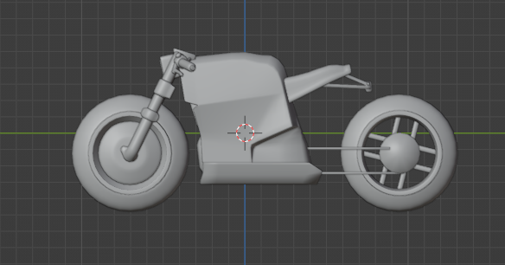
After the initial models of the two motorbikes were built, I would refine them. As I had no experience in building motorbikes, the details were a big challenge for me, and after discussing with my members, I chose to continue to look for some models and photos on the internet for reference, choosing useful parts or good looking parts as details to model based on the picture references, and it was important to understand how they worked.
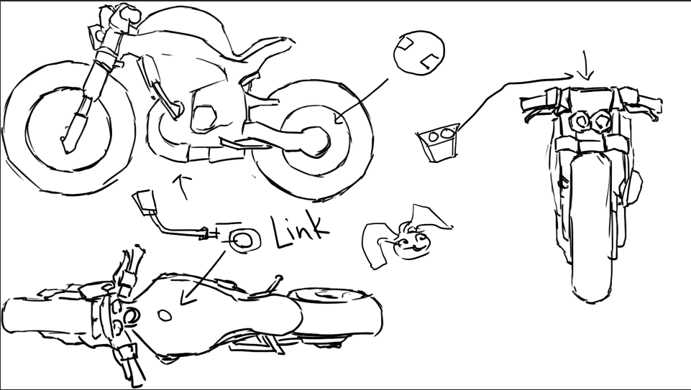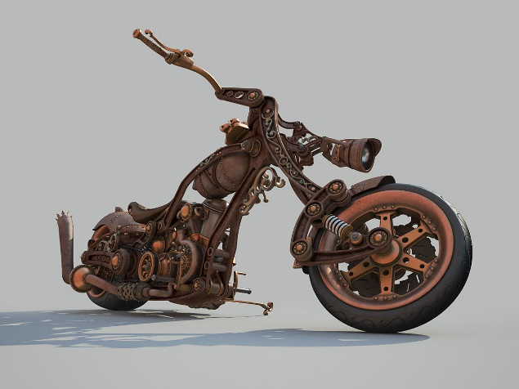
With the tailpipe, screws and other details added, the car modeling is complete, the next step is to refine the number of surfaces, because too many surfaces in the animation rendering will lead to crashes and slow progress, and may not even to rendering, in the import file into maya or ue4 may directly crash, and in the split uv will also be very difficult, it is necessary to manually go to reduce the surface, as long as the number of surfaces can support the shape, does not look very simple, then you can use, for example, the rabbit's motorbike I will reduce him from the beginning of 8000 surfaces to 6000 surfaces
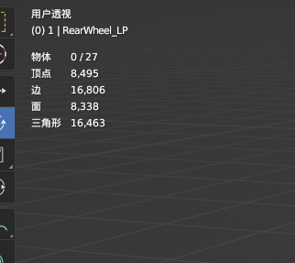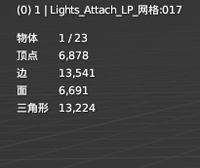

2.3. UV part

After completing the modelling, it was time to think about how to split the UV's. Splitting the UV's had a great impact on the mapping of the material behind it, and it was important to specify a good distribution of the split lines. In this team project, all the models in a motorbike needed to be unfolded in the same mapping, but the motorbike had different parts and their materials and mapping were different, so I chose a new approach, identifying the materials that needed to be sorted when unfolding the model, separating them all with uv lines, and then using Color ID to sort the parts that needed different materials into colours, so that they could be distinguished when making the materials later. Then use the Color ID to colour the parts that need different materials so that they can be separated when making the material, even if they are in the same UV map. The tool I chose is Rizom UV. This tool optimises many of the operations of expanding UV's and is very convenient, and the Color ID function of Rizom UV is very powerful.
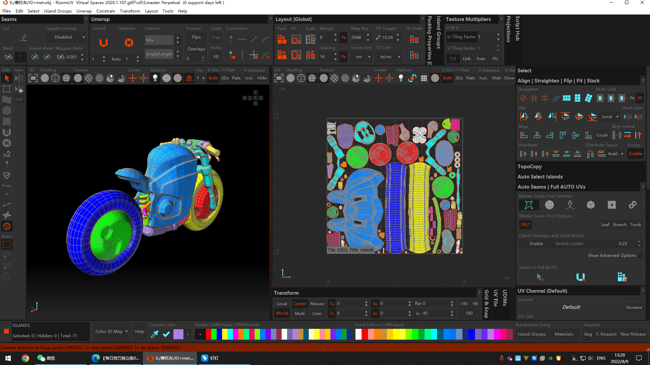

2.4. Texture part

For the texturing part I chose to use Substance 3d painter, this software is very convenient, firstly its huge library of intelligent textures helps me save a lot of time and makes it easier to produce results, and secondly the baked texture function of the software also helps me to produce PBR maps very quickly.
Before I start texturing I make a rough effect in blender's paint function for the group to see, and only after this effect has been modified with the group's input do I paint the texture in Substance 3d painter.
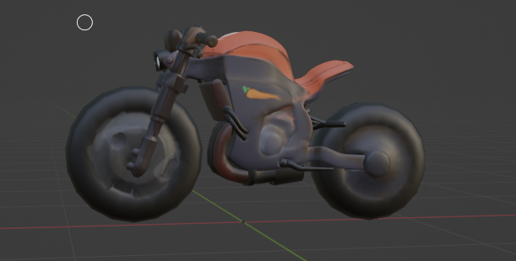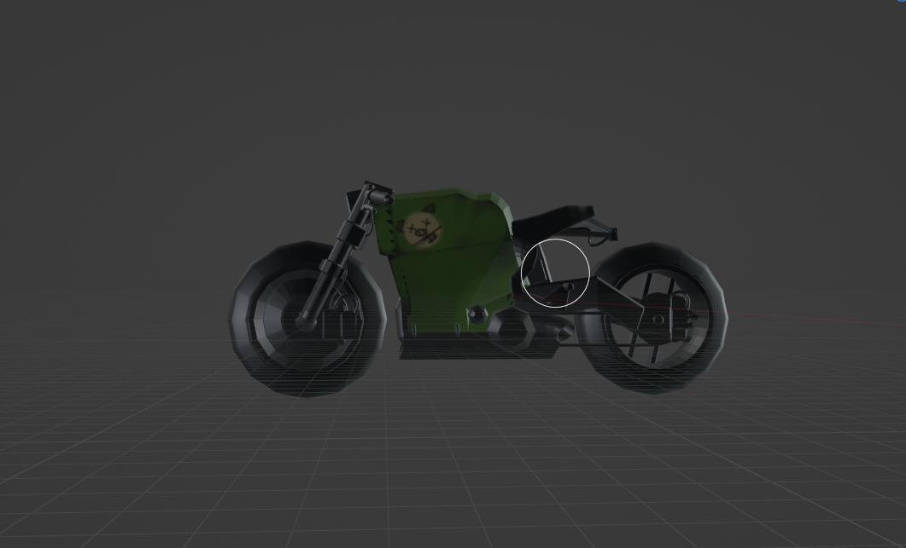
This version of the design I also put on the course presentation, followed by the process of refinement and reworking. Regarding the rabbit's motorbike, the initial version of the design I thought was not very characteristic of being a rabbit, so I carefully analysed the character model and finally discussed with the group and decided on red with black as the theme colour, but kept some hand-painted icons on the car with carrots and the rabbit's eyes to make the whole car more in line with the character's setting.
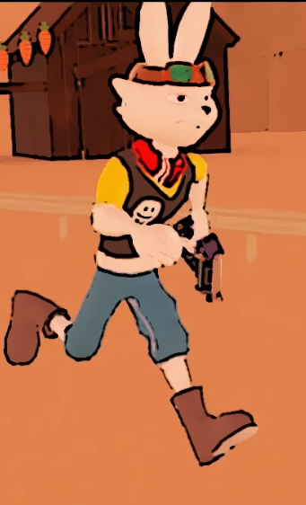
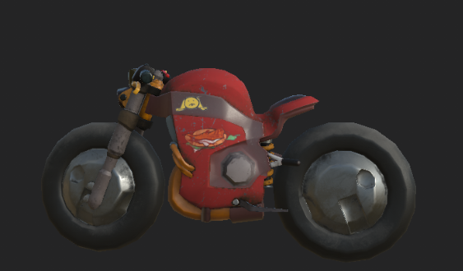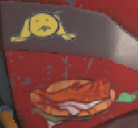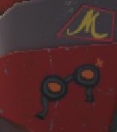
The group work is animated and will be added to ue4 for rendering in three renders, so I used solid colours for a lot of the model mapping, but pure colours would make the objects very monotonous.
I added some dirt to the parts of the car for realism and richness, the tyre part is the one I am most happy with.
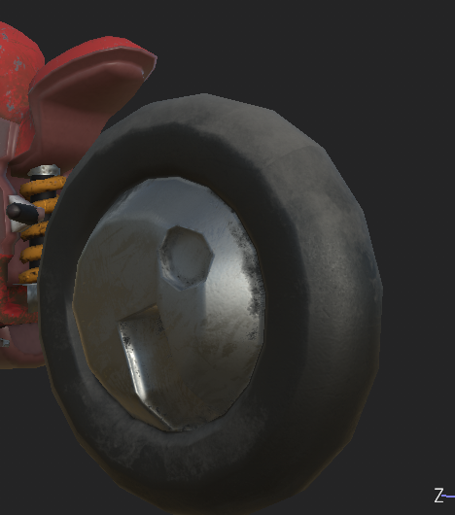
About the pirate pig motorbike after the group discussion basically did not use the design of the first version, in the first version of the vehicle is too cute, does not fit the pirate pig character setting, so I went back to find a reference, in many references I chose the game Road:96, one of the mob driving a car attracted me, this is a three-wheeled buggy, in the game appeared in a passing scene, but I was very keen to caught him, he had a very informative design with body graphics textures etc. The bodywork this was exactly what I needed, the pirate pig wanted to reflect the pirate character and the best way to do this was to add some skulls and such elements to remind you of pirates. For the colours I chose black and yellow, black to match the yellow and yellow as a complement to the purple, to complement the colours on the character, then I chose line scattering as a pattern to add richness, to differentiate it from the rabbit's motorbike, this time the pattern is vector graphics rather than hand drawn, and finally some dirt and scars to add realism, after all it is a ride in the desert After all, it is a vehicle that rides in the desert.
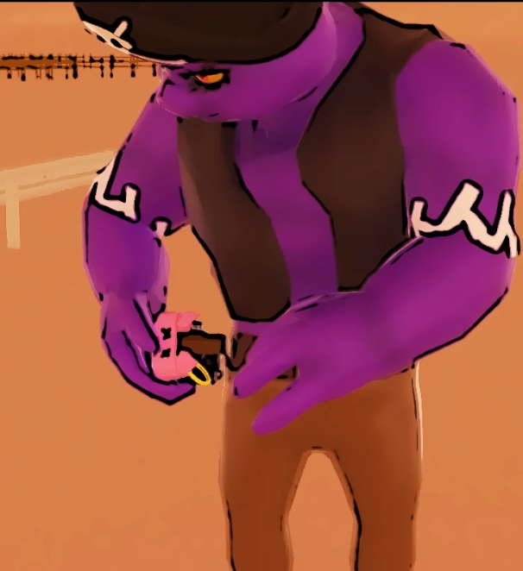
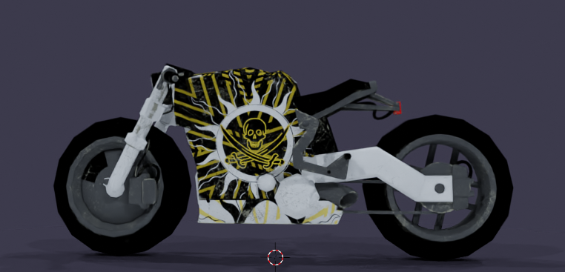

2.5. Rendering part

When I first took over the rendering job, I received one shot after another from ue4, and although the scenes and characters had been posed, they had no materials or textures, and many of the shots were incomplete, either missing characters or missing action. So I made a unified action, many of the materials were on in ue4 and could not be exported, so I selected external scene models in a separate guide, added materials to each of them that could be rendered out in maya, then saved the scenes in MB format for subsequent shots that needed scenes, completed the scheduling of the scenes and saved a lot of time, the scenes were rendered using the Arnold renderer. The lighting is very important, in the lighting select Skydome Light, this is a giant scene light that wraps around the whole scene and is used as natural light. Add HDR mapping to Skydome Light to give it an anime like weather.
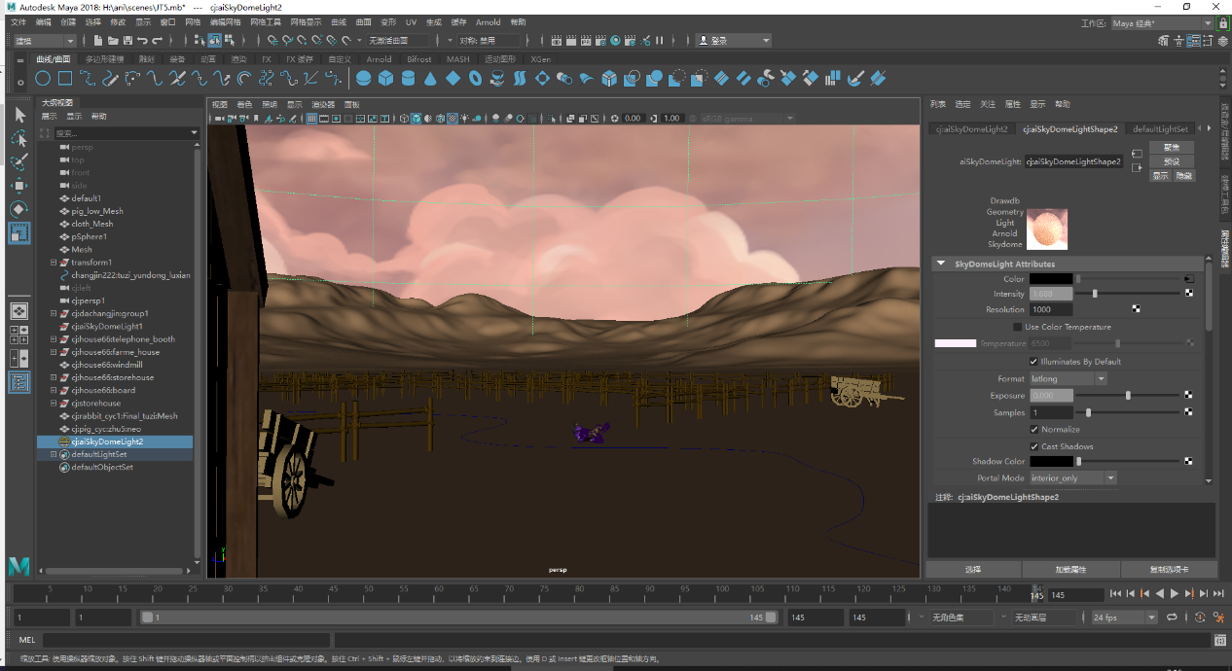
Once the HDR map has been added, the rendering takes place, but due to the specific nature of the Arnold renderer, rendering with the default settings will render a black colour, and the lights in Arnold use a secondary fade by default, unlike the default behaviour in Maya where the lights are set to no fade by default. In fact, setting the light fade under the Point Light Attributes section of the Light Attributes Editor will have no effect.
The problem of 'overdarkness' can also be solved by changing the intensity of the light or changing the Exposure attribute. The intensity (and scale of the model) can be selected and then fine-tuned using the Exposure setting.
If you increase the radius of the light (select the point light source, go to the properties editor, expand the "Arnold" tab and change the "Radius", you will get soft shadows. So I adjusted the shade colour, Exposure, Specular, Intensity, Diffuse and other parameters to finally render a passable scene without overexposure. Once the scene was resolved I shared the file with any group members who needed to use maya rendering and I selected the fifth shot in the shot file, the part where the pirate pig drops the bomb, as my work to help aid the rendering, which was rendered using 1280*720 format.

III. Methodology

I made these models and used the software by finding tutorials online and in books. It was important for me to have a good foundation for these props that are important in animation.

3.1. hard surface model

In order to show the texture of the prop, excessive smoothing can cause the outline of the model to change more than expected, so when making a high model you need to sand the sample lines of the low model first, after smoothing it becomes very difficult to modify.
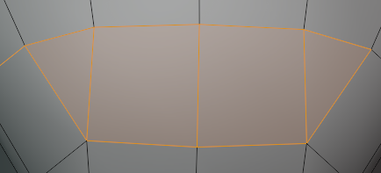
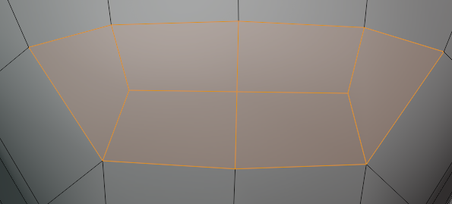

3.2. Texture and UV Part

The software I use to expand the UV is Riozm UV, in the UV split, not blindly choose the sample line for the split need to choose a good split line, so that the UV to keep the state of spreading, after the unfolding of the display is red or blue is the response of the map is stretched, so to expand each part, the more detailed part of the enlarged, so that the details do not need to shrink the place to save more space, to save more space, to facilitate the subsequent texture mapping. The different parts should also be split up clearly, to first classify which materials are available and give different colour ids to facilitate subsequent work in the substance 3d painter, work in the substance 3d painter, because this group work is animated style, so it needs a lot of stylised design, need The objects needed to reflect the materials as well as the stylisation of the animation, so instead of using a realistic effect like smart materials in Substance 3d painter, I broke down the metal, plastic and leather materials into various colours and added them to the model, wrapping the dirty stains so that my motorbike looked more stylised.

IV. Conclusion

I have gained a lot of experience and learnt a lot through this team project, both from the internet and from the team. Not only the technical aspects but also the teamwork.
On the technical side, I learnt how to make three views and how to use reference to make the shape I want. And I also learned how to make models better throughout the process, also how to expand uv and use Color ID to classify materials in UV, how to make dirty stains with solid colours in substance 3d painter, make stylised materials, manipulate Arnold's lights to light and finish the render when helping with the render, I also tried two different 3d software, blender and maya, all of which have benefited me immensely.
In terms of the team, I also took the tasks given to me by the team leader seriously and even helped other team members in other ways. I think I have completed all my individual tasks. At the same time, I learned a lot about team communication, and a team leader is very important when it comes to doing these things. The division of labour for each person also needs to be reasonably tailored, otherwise it will be a mess.
The team members played a big role in this teamwork, but of course there were also members who were not officers. Difficulties such as time difference, communication and file transfer did affect our production, but we did our best to overcome these difficulties and complete the animation. This task will also provide me with a lot of useful knowledge and experience in the future. I am very grateful for this opportunity. I will also use these experiences in my work and life to make better work.
This motorbike assignment I found very rewarding, from the design to the model mapping was done by me personally, so I put some effort into rendering it in bledner using studio level hdr and a separate video made to use as my personal portfolio. Here is my final video.

