Assignment 1:
Research and case scenario in Data Security and Compliance

COURSE: BSC Applied computing
Module NaMe: data security and compliance
Module Code: ACCA5034
Lecturer: DR ayman al hajjar
submission DATE: 30th april 2026
date submitted: 30th april 2026

Trinity saint david University of Wales (London Campus)

Meliha Redzhep (2416885)



Table of contents:
Abstract: 3
Introduction: 4
Task 1: Research in Data Security and Compliance 5
The Zero Trust Architecture: A Critical Analysis: 5
Core Principles of Zero Trust Architecture 6
Comparative Analysis: Traditional Security vs Zero Trust 7
Implementation Challenges and Limitations 8
Regulatory and Compliance Considerations 10
Critical Evaluation of Zero Trust Architecture 10
Conclusion 10
TASK 2: ZERO TRUST SECURITY DESIGN FOR MEDITRUST ANALYTICS LTD 12
Introduction 12
Zero Trust Architecture Design 12
Organisational Structure 14
Policies and Procedures 15
Governance and Strategy (NIST CSF 2.0 Alignment) 15
Risk Management 16
Compliance with DORA and NIS2 18
Contingency Planning 19
Protection Mechanisms 19
Conclusion 21
References: 22

Abstract:
The cybersecurity threat landscape that contemporary businesses confront, has been drastically altered by the quick development of digital technologies, such as cloud computing, artificial intelligence (AI), and hybrid working styles. Conventional perimeter-based security designs are becoming less effective against modern attacks that take advantage of trusted third-party connections, compromised identities, and incorrect setups. As a result, Zero Trust Architecture (ZTA), which is built on adaptive risk-based control, least-privilege access, and continuous verification, has become a well-known security paradigm.
This study does a critical analysis of Zero Trust Architecture, looking at its fundamental ideas, implementation difficulties, and efficacy in comparison to more conventional security methods. Additionally, the research uses these principles to develop a Zero Trust-aligned security program that covers governance, risk management, and regulatory compliance under GDPR, DORA, and NIS2 in a real-world case study involving MediTrust Analytics Ltd.
The results show that while Zero Trust greatly improves organisational resilience, visibility, and threat response capabilities [1].

Introduction:
Modern organisations function in increasingly complex digital environments which are factored by cloud computing, remote and hybrid work, integrated supply chains, and the quick uptake of artificial intelligence technologies. These advancements have reduced the effectiveness of traditional cybersecurity tactics by increasing organisational attack surfaces and weakening traditional network barriers.
In the past, companies relied on perimeter-based security models, which assume that once systems and people are validated, they can be trusted. Nevertheless, this strategy is no longer appropriate in settings where risks come from third-party access points, insider activities, and compromised credentials. Instead of breaking network perimeters, attackers increasingly concentrate on exploiting identities, allowing them to move laterally within systems unnoticed.
Zero Trust Architecture (ZTA) overcomes constraints by removing implicit trust and requiring constant verification of all access requests. In contrast to conventional security methods, the concepts and efficacy of Zero Trust are critically assessed in this research [2] .

Task 1: Research in Data Security and Compliance

The Zero Trust Architecture: A Critical Analysis:
The Evolving Cyber-Threat Landscape

The modern cybersecurity landscape has undergone a significant transformation, driven by rapid technical breakthroughs and the growing digitalisation of organisational processes. Traditional cyber threats, which mainly targeted network perimeters, have developed into complex, multi-layered attacks that take advantage of trusted connections, applications and identities. The necessity for Zero Trust Architecture, which uses identity-based security and ongoing verification to address these issues, is highlighted by the changing threat landscape [3] .
The emergence of identity-based attacks is one of the most significant developments in recent years. Attackers are increasingly taking advantage of flaws in authentication systems rather than trying to directly penetrate network defences. By using methods like phishing, credential stuffing, and brute-force assaults, attackers can successfully get around conventional security measures by obtaining legitimate user credentials. Attackers can function with legitimate user rights once they are inside the network, making identification much more challenging. This draws attention to a major flaw in conventional perimeter-based security models, which assume that users who have been verified may be trusted.
Supply chain attacks are becoming a serious concern in addition to identity-based threats [4]. Attacks aim at third-party vendors, service partners, or software providers to compromise many companies through a single point of entry. The complexity of supply chain interactions has expanded due to the rising dependence on cloud-based services and Software-as-a-Service (SaaS) platforms, which frequently reduces visibility and control over external security procedures.
The changing threat landscape has been further influenced by cloud computing. Although cloud systems provide flexibility and scalability, they also create new risks, especially when it comes to misconfigurations [5]. Sensitive information may be exposed to unauthorised individuals due to improperly designed storage systems, excessive permissions, and insufficient access controls. The complexity of managing hybrid and multi-cloud settings, where providers and consumers share security obligations, makes these problems worse.
Insider threats continue to be a major problem. Security may be purposefully or accidently compromised by workers, contractors, or partners who have authorised access to systems. One of the main causes of data breaches is still human error, such as misconfiguring systems or falling for phishing scams. This highlights the limitations of trust-based security approaches, which do not take into consideration the potential for compromised or malevolent insiders.
Furthermore, new threats like data poisoning and model manipulation are brought about by the growing use of Artificial intelligence (AI) systems. Attackers may take advantage of flaws in AI models to influence judgements such as decision-making or get sensitive data. Organisations must implement more sophisticated and flexible security procedures in response to these new threats.
In order to increase their attacks, modern threat actors are also using automation and Artificial Intelligence (AI). Attackers may target businesses more precisely and effectively thanks to automated phishing campaigns and AI-generated social engineering tactics. As a result, companies need to implement similar sophisticated defensive systems that can function at a large scale and react instantly. This emphasises the need for dynamic, intelligence-driven frameworks like Zero Trust Architecture and further demonstrates the shortcomings of conventional static security controls.
All things considered, the changing threat landscape is characterised by increased sophistication, complexity, and variability.
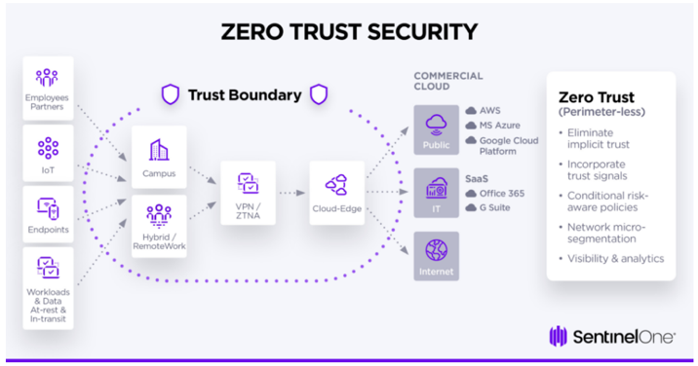
Modern Cyber-Threat diagram: [5]

Traditional Cyber-Threat diagram: (Self-made)
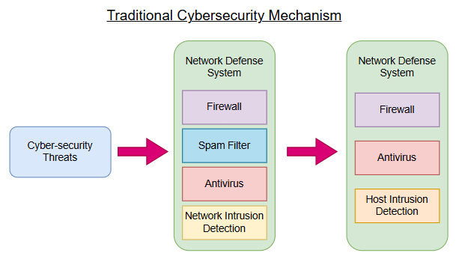

Core Principles of Zero Trust Architecture
A significant change in cybersecurity approaches is represented by Zero Trust Architecture (ZTA), which diverts from implicit trust and to continuous verification. The core philosophy of Zero Trust is "never trust, always verify," which mandates that all users, devices, and systems undergo authentication and authorisation before gaining access to resources [6].
One of the main principles of Zero Trust is continuous authentication and authorisation. Zero Trust requires continuous verification during the user session, in contrast to typical approaches that give access upon initial authentication This is accomplished through the use of mechanisms such as contextual access restrictions, behavioural analytics, and multi-factor authentication (MFA). Organisations may identify abnormalities and react to any dangers instantly by continually assessing user behaviour and environmental conditions.
The next important principle is least-privilege access. This method guarantees that users are only given the minimal amount of access required to complete their duties. Organisations may lower the possible effect of hacked accounts and stop hackers from accessing critical systems without restriction by restricting access permissions.
Another essential element of Zero Trust Architecture is micro-segmentation [7]. This entails breaking up the network into separated smaller sections, each with its own security measures. By limiting connectivity between sections and preventing lateral movement inside the network, organisations can minimise the spread of attacks.
A significant element that sets Zero Trust apart from conventional security methods is the "assume breach" principle. Organisations operate on the assumption that a breach has already happened, rather than presuming that systems are safe. This way of thinking promotes the deployment of strong detection and response systems, allowing businesses to rapidly recognise and contain threats.
Furthermore, a crucial component of Zero Trust is context-aware access control. A number of variables, such as user identification, device health, location, and risk level, are considered when making access choices.
The recognition of Zero Trust as an architectural solution is essential because it necessitates integration across several security domains rather than a single product or technology. Coordination of identity management, network security, endpoint protection, and data security measures are crucial for successful deployment. Zero Trust's interconnectedness makes it both strong and complicated since flaws in one area might compromise the architecture's entire efficacy [8] .
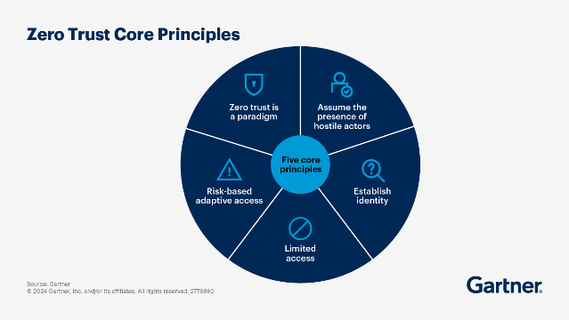

Comparative Analysis: Traditional Security vs Zero Trust
Zero Trust Architecture offers a more efficient and flexible alternative for traditional security approaches, which are becoming increasingly insufficient in modern settings. The foundation of traditional security models is derived from the idea that a trusted internal network is shielded by external defences [9]. This strategy, often known as the "castle-and-moat" concept, is based on the idea that internal users can be trusted and that risks come from outside the network.
In contrast, Zero Trust Architecture presents robust solutions to these limitations by removing the implicit trust and requiring continuous verification. Granular access management is a key advantage of Zero Trust Architecture which highlights a fundamental difference between ZTA and traditional security models [10]. Organisations may lower the risk of unauthorised access by ensuring that users only access the resources they require by assessing each access request separately.
Moreover, another Zero Trust benefit is its improved visibility. Organisations can identify abnormalities and possible dangers due to ongoing monitoring and recording. Since current cyber threats frequently operate in trusted environments, this degree of visibility is crucial for detecting and countering them.
Nevertheless, Zero Trust also exhibits a number of disadvantages [11]. Key challenges include continuous authentication and monitoring, which can over-complicate systems and require large infrastructure and technological investments. Additionally, the need for frequent authentication may negatively affect user experience and cause staff resistance.
Beyond the previously discusses factors, scalability represents another critical distinction between the two models. In dynamic situations, such as incorporating cloud infrastructure and remote workforces, traditional security methods find it difficult to adjust. On the other hand, Zero Trust is naturally scalable as it does not rely on set network boundaries but on identification and contextual data [16]. Consequently, it is especially appropriate for modern organisations that function in largely dispersed environments. However, maintaining system efficiency and handling high amounts of authentication requests are additional difficulties.
Zero Trust is a highly successful strategy for modern businesses because of its capacity to adjust to changing surroundings and handling identity-based risks.

Implementation Challenges and Limitations
The implementation of Zero Trust Architecture (ZTA) displays a number of organisational, technological, and strategic issues that can considerably affect its efficacy, if not dealt with correctly. Although Zero Trust provides a strong framework for modern cybersecurity, its implementation needs a thorough transformation of current organisational culture, procedures, and technology.
Whilst there are various limitations, integrating legacy systems is one of the biggest technological problems. Many businesses still use outdated technology that was not built to accommodate modern authentication procedures or ongoing monitoring features. Enforcing Zero Trust concepts like continuous verification and least-privilege access is challenging since these systems are frequently incompatible with sophisticated identity and access management (IAM) systems.
Moreover, the difficulty of managing identities at scale is another significant disadvantage. Accurate and thorough identity verification is crucial to Zero Trust; however, it gets harder as businesses expand and embrace remote work environments. Strong governance frameworks and advanced IAM solutions are necessary for managing identities across many platforms, including on-premises systems, cloud services, and third-party apps. Organisations risk the danger of problems like privilege creep, in which users gradually gain excessive access permissions, raising the possibility of misuse, if identity lifecycle management is not done correctly.
Another important factor to consider is the expense of implementing Zero Trust. Multi-factor authentication (MFA), Security Information and Event Management (SIEM) systems, Zero Trust Network Access (ZTNA), and Endpoint Detection and Response (EDR) solutions are just a few of the technologies that organisations need to invest in. Ongoing maintenance, monitoring, and update costs must be considered in addition to the original implementation costs. These expenses might be a major drawback to implementation for small and medium-sized businesses (SMEs).
Following on, resistance to change is another significant obstacle from an organisational standpoint. Zero Trust policies, such as frequent authentication requests and limited access, may be viewed by staff as inconvenient or affecting their productivity. If this issue is not effectively handled, it may compromise the implementation's efficacy. Organisations must give user education and awareness top priority in order to solve this problem, making sure that staff members are aware of the significance in security precautions and their part in safeguarding company property.
Additionally, a high degree of organisational maturity is necessary for the implementation of Zero Trust. Strong leadership support, well-defined policies, and transparent governance frameworks are necessary for effective implementation.
Furthermore, there is the difficulty of balancing usability and security. Strict access controls improve security, but if they are not applied carefully, they may also have a detrimental effect on user experience. Organisations need to use flexible, risk-based strategies that reduce conflict while preserving strong security.
The transition to Zero Trust presents strategic problems in addition to organisational and technological obstacles. To ensure that security measures do not negatively affect innovation or operational efficiency, organisations must reevaluate their security priorities and match them with business objectives.
Vendor dependency is another crucial factor to consider [12]. Third-party suppliers offer a large number of Zero Trust solutions, which raises concerns about supply chain security and vendor lock-in. Vendors must be thoroughly assessed by organisations to make sure their solutions are compatible and meet organisational needs.
Lastly, ongoing assessments and developments are necessary for Zero Trust implementation to be successful. Security tactics must change to keep up with the continuously evolving nature of cyber threats. To stay effective, organisations need to invest in new technology, update policies, and evaluate their security posture on a regular basis.

Regulatory and Compliance Considerations
Modern cybersecurity strategies must include regulatory compliance, especially for businesses that deal with sensitive data. A number of important regulatory frameworks, such as GDPR, DORA, and NIS2, are closely aligned with Zero Trust Architecture. However, attaining compliance requires more than just putting technological controls in place, it calls for a thorough strategy that incorporates organisational procedures, risk management, and governance.
The GDPR prioritises responsibility, privacy, and data protection. Organisations must put in place the proper organisational and technical safeguards, in order to guarantee the protection of personal data. Zero Trust supports these requirements by implementing tight access controls, ongoing monitoring, and data minimisation.
Operational resilience is the main emphasis of DORA, which mandates that businesses put strong incident response procedures in place and guarantee service continuity. Through constant observation and quick action, Zero Trust improves these capabilities.
NIS2 places a strong focus on incident reporting, supply chain security, and risk management [13]. Zero Trust helps meet these demands by offering improved visibility and control.
Additionally, in order to comply with regulations, companies are increasingly required to show that security procedures are both implemented and effective. Continuous monitoring, reporting, and improvement are given more weight in order to move towards smooth outcome-based regulation.
Integrating cybersecurity with more comprehensive organisational governance frameworks is another new trend. Frameworks like Zero Trust are crucial for illustrating appropriate governance and risk management techniques.

Critical Evaluation of Zero Trust Architecture
A major development in cybersecurity strategy is Zero Trust Architecture which provides a thorough framework for dealing with modern threats. Its focus on greater visibility, least-privilege access, and ongoing verification offers a robust protection against identity-based assaults. However, precise identification data, appropriate execution, and organisational maturity are necessary for its efficacy. Additionally, cost and complexity continue to be major obstacles, and ineffective execution can lower its efficacy. Maintaining Zero Trust requires ongoing effort and flexibility as companies change.
Ultimately, new threats brought about by developing technologies like AI and IoT may not be adequately addressed by existing Zero Trust models, meaning continuous improvement is required.

Conclusion
In the final analysis, Zero Trust Architecture signifies a significant change in cybersecurity by overcoming the shortcomings of traditional models through ongoing verification and adaptive security measures. It strengthens danger detection, promotes compliance, and increases resilience. However, successful implementation, governance, and ongoing development are necessary for its success.

TASK 2: ZERO TRUST SECURITY DESIGN FOR MEDITRUST ANALYTICS LTD

Introduction
MediTrust Analytics Ltd operates within a highly sensitive and data-intensive healthcare environment, where the protection of confidential patient information and proprietary AI models is critical to regulatory compliance and operational success. Large amounts of sensitive data are processed by the organisation, including real-time data streams from IoT-enabled patient monitoring devices, diagnostic imaging, and electronic health records. The exposure of such data would have serious legal and financial repercussions and could directly impact patient safety and clinical decision-making [14].
The operating structure of the organisation makes it far more vulnerable to cyberattacks. The traditional notion of a secure network perimeter is eliminated by its implementation of a hybrid workforce which includes remote developers, clinical analysts, and outside research colleagues. Furthermore, controlling access control, visibility, and configuration security becomes more difficult due to its reliance on several cloud service providers. Together, these elements provide a highly dispersed and dynamic environment.
MediTrust must abide by strict regulatory frameworks, such as GDPR, DORA, and NIS2, when it enters the European Union. In addition to requiring the security of personal data, these standards also call for operational resilience, efficient incident response, and safe supply chain management.
Adopting a Zero Trust Architecture (ZTA) is crucial in this context. In contrast to traditional security approaches, Zero Trust requires ongoing verification of all access requests since it believes that threats may come from both inside and outside the organisation. For MediTrust's new information security division, a thorough security approach that is in line with Zero Trust is required. In order to guarantee resilience, scalability, and regulatory compliance, the design is strategic and forward-thinking, incorporating organisational structure, governance, risk management, and contemporary security technology.

Zero Trust Architecture Design
Zero Trust principles, which remove implicit trust and impose strict identity-based access control, are the foundation of the proposed security architecture for MediTrust. In a highly dispersed environment where users and systems function across several locations and cloud platforms, identity becomes the main security barrier instead of the network perimeter.
A strong Identity and Access Management (IAM) system is a crucial part of this design. Phishing-resistant multi-factor authentication (MFA) is required for all users, including staff members, outside partners, and automated systems [18]. However, access choices must also consider contextual elements like device health, geolocation, user behaviour, and risk level because authentication alone is insufficient. Access requests from unmanaged devices or strange locations have to result in further verification procedures or be rejected completely. In order to lessen the possible consequences of security breaches, micro-segmentation is essential. Strict access restrictions should regulate communication between the smaller, separated sections of MediTrust's infrastructure. AI training environments, for example, must be totally segregated from patient data repositories and production systems. This guarantees that an attacker cannot simply migrate laterally across the network, even if they manage to get access to one section.
Traditional Virtual Private Networks (VPNs), which frequently allow excessive access to internal resources, should be replaced with Zero Trust Network Access (ZTNA). ZTNA offers application-level access, therefore users can only engage with certain services or systems that are necessary for their position.
Maintaining security in a Zero Trust environment requires constant monitoring and real-time analytics. For complete visibility throughout the company, Endpoint Detection and Response (EDR) solutions should be connected with Security Information and Event Management (SIEM) systems. These technologies can identify many anomalies, some examples include unusual login habits, data exfiltration attempts, and suspicious system activity. In order to swiftly control threats and shorten the time between discovery and cleanup, automated response mechanisms should also be put in place.
Protection of AI systems and training data is another crucial component of the design. Strict controls must be put in place to guarantee data integrity because of the possibility of data poisoning and model tampering. This includes verifying data sources, limiting access to training datasets, and consistently keeping an eye out for irregularities in model performance. These steps are crucial to preserving the dependability and credibility of therapeutic systems powered by AI.
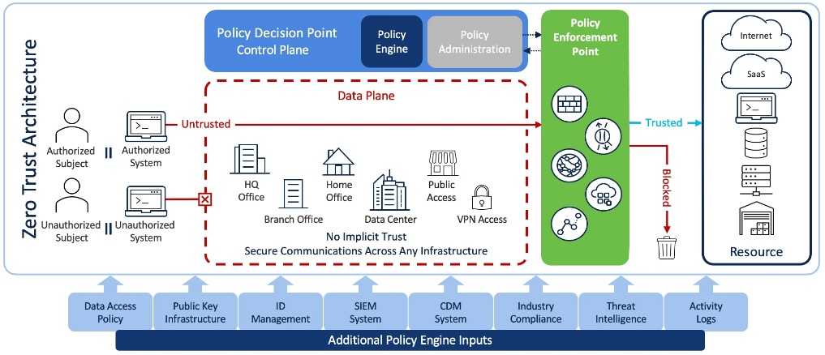
All things considered, the Zero Trust Architecture offers a strong and flexible security architecture that tackles the specific difficulties that MediTrust faces. The organisation may greatly lower its attack surface and enhance its capacity to identify and address threats by concentrating on identification, segmentation, and constant monitoring.

[17].

Organisational Structure
A clear organisational structure that facilitates cooperation between technical, operational, and compliance activities is necessary for the effective implementation of a Zero Trust security program. In accordance with its strategic goals and legal obligations, MediTrust must set up a specialised information security division.
The Cloud Security Architect, who is in charge of creating and safeguarding the company's multi-cloud architecture, is at the centre of this organisation. This role entails putting secure settings into place, enforcing micro-segmentation, and making sure cloud environments adhere to legal requirements. The Cloud Security Architect is essential to preserving both security and operational effectiveness because of the organisation's strong reliance on cloud services.
Another crucial position that is in charge of incorporating security into the software development lifecycle is the DevSecOps Lead. This includes controlling vulnerabilities, putting automated security testing into place, and making sure secure code guidelines are adhered to. The organisation may lower the risk of exploitation by identifying and resolving such problems early on.
A Security Operations Centre (SOC) should be set up to offer ongoing monitoring and incident response capabilities [19]. The SOC team is in charge of organising response activities, evaluating security warnings, and looking into possible threats. This minimises the effect of security issues by ensuring that they are identified and handled promptly.
A Compliance and Risk Officer should supervise regulatory alignment, making sure the company complies with GDPR, DORA, and NIS2 regulations. In order to maintain consistent application of Zero Trust concepts, an Identity and Access Management Specialist should oversee authentication systems and access restrictions.
This organisational structure guarantees that security is incorporated into every facet of the organisation's activities and that responsibilities are precisely defined.
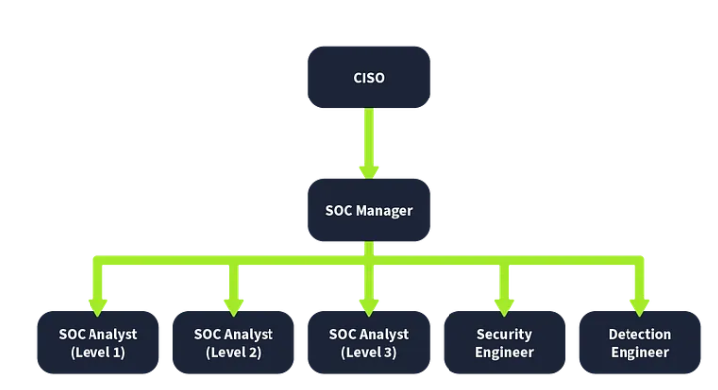

[19].

Policies and Procedures
For the organisation to implement Zero Trust principles, policies and processes are essential. They guarantee that security measures are implemented consistently across all systems and users and offer a framework for consistent decision-making.
The AI Usage Policy is very important in the context of MediTrust, where AI systems are essential to clinical decision-making [20]. This policy should cover risks including data poisoning, model modification, and unauthorised access to training datasets. Strict validation of data sources, restricted access to datasets, and frequent model integrity testing should be mandatory. These precautions guarantee that AI systems continue to be precise, dependable, and impervious to manipulation.
The hazards connected to cloud-based applications are addressed by the Secure SaaS Configuration Policy. Data breaches are often caused by misconfigurations, especially in multi-cloud systems. In order to guarantee that users are only given the rights required for their roles, this policy should enforce least-privilege access. Sensitive data encryption and ongoing configuration monitoring should also be mandated [15].
In order to manage the risks connected with a hybrid workforce, the BYOD Policy is required. Before being allowed access to company systems, personal devices must fulfil security standards. This covers secure access methods like ZTNA, endpoint protection tool installation, and device compliance checks. To avoid combining personal and business data, data separation strategies should also be used.
Together, these regulations uphold the Zero Trust principles.

Governance and Strategy (NIST CSF 2.0 Alignment)
A strong governance architecture that synchronises cybersecurity procedures with organisational goals is essential to a successful Zero Trust security program. The NIST Cybersecurity Framework (CSF) 2.0 offers MediTrust a thorough and adaptable framework for controlling cybersecurity risk while promoting legal compliance and corporate expansion [21].
The Identify function helps establish a thorough awareness of the organisation's assets including cloud infrastructure, IoT devices, AI systems, and sensitive patient data. This requires keeping an accurate asset inventory and doing frequent risk assessments in order to find vulnerabilities and prioritise mitigation actions. Accurate asset identification is crucial for monitoring activities and imposing access limits in a Zero Trust environment.
Implementing security measures to guarantee the safe operation of vital systems is the main goal of the Protect function. This involves implementing Zero Trust concepts including multi-factor authentication, least-privilege access, and micro-segmentation. Sensitive information should also be protected by data protection techniques like tokenisation and encryption.
The Detect function includes threat detection and ongoing monitoring. When SIEM systems are paired with behavioural analytics, the company can instantly see irregularities and possible security problems. In a Zero Trust architecture, where constant verification is necessary to preserve security, this is very crucial.
The organisation's ability to handle security events is guaranteed by the Respond function. This entails creating incident response plans, holding frequent training sessions, and setting up transparent channels of communication. In order to minimise the effects of security events and preserve operational continuity, quick response is needed.
After an incident, the Recover function's main goals are to restore systems and guarantee business continuity. This involves putting disaster recovery plans into action, keeping safe backups, and testing often to make sure everything is ready. Given the vital significance of MediTrust's services and the DORA regulations, this is especially vital.
Crucially, governance must guarantee that cybersecurity policy is in line with corporate goals. For MediTrust, this entails preserving patient data security, fostering safe innovation in AI-driven healthcare solutions, and upholding trust with healthcare providers. The company can make sure that security promotes rather than hindering growth by incorporating cybersecurity into its strategy.
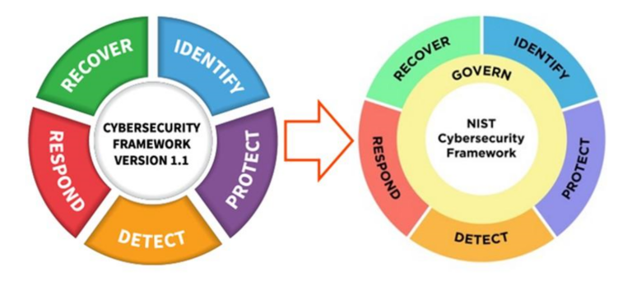 [21].

Risk Management
The proposed Zero Trust security program places a strong emphasis on risk management, especially in light of MediTrust's vulnerability to cloud-related vulnerabilities and software supply chain risks. Risk management is necessary to detect, evaluate, and reduce these risks, a proactive and organised approach [22].
MediTrust's software supply chain is one of the biggest dangers that the company faces. The organisation depends on third-party frameworks, libraries, and research partners, all of which might be vulnerable. Attackers may take advantage of these dependencies by exploiting update systems or inserting malicious code. Data poisoning attacks, in which harmful data is injected during the training process to influence results, may also be used to target AI models.
MediTrust should implement a Software Bill of Materials (SBOM) which offers insight into all software components and dependencies to reduce these risks. This makes it possible for the company to spot weak points and react fast to new threats. Vulnerabilities should be found early in the development process by using continuous integration pipelines and automated security testing.
Another significant danger is cloud misconfiguration, which continues to be one of the main reasons for data breaches. Sensitive information may be vulnerable to unwanted access due to improperly designed storage systems, overly broad permissions, and unreliable APIs.
MediTrust should use Cloud Security Posture Management (CSPM) solutions to continually monitor and enforce safe setups in order to address these problems. To guarantee that security rules are consistently implemented, regular audits and automated compliance checks should be carried out.
Each identified risk should have its likelihood and effect assessed using a systematic risk assessment approach. MediTrust can make sure that its security program stays focused on the most serious risks by using a risk-based approach.
As indicated in Table 1 the most serious concerns include supply chain vulnerabilities, cloud misconfiguration, and credential breach. These dangers emphasise how crucial it is to apply Zero Trust concepts like least-privilege access, continuous authentication, and real-time monitoring in order to lower the attack surface and boost resilience.
Table 1:
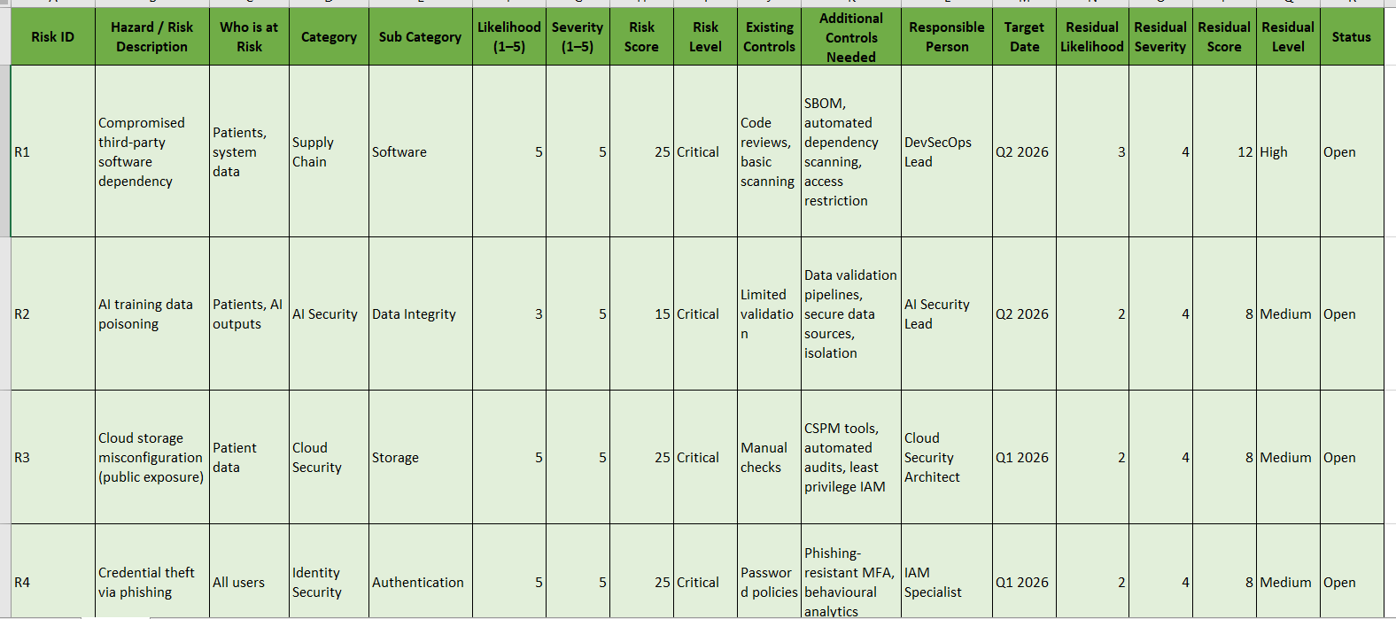
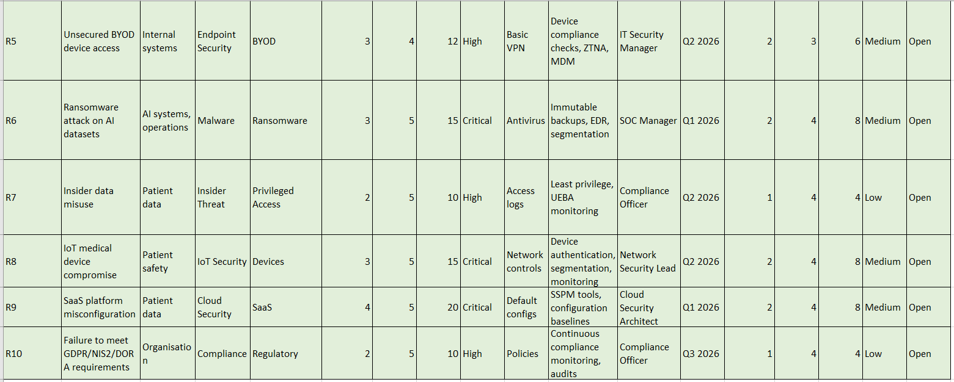
task 2 risk table.xlsx

Compliance with DORA and NIS2
Adherence to regulatory frameworks like DORA and NIS2 is crucial when MediTrust enters the European Union [23]. Organisations must comply with these laws in order to guarantee operational resilience, efficient risk management, and prompt incident reporting.
The Zero Trust security program benefits DORA by strengthening the organisation's capacity to endure and bounce back from disturbances. Potential dangers are promptly detected and dealt with thanks to automatic response systems, event detection, and continuous monitoring. Furthermore, frequent resilience testing and the execution of strong disaster recovery plans guarantee that vital services can continue even in the case of a significant occurrence.
Moreover, clear incident reporting processes and extensive risk management measures are part of the NIS2 program. Within predetermined timescales, the organisation must set up procedures for identifying, reporting, and handling cybersecurity issues. By offering improved visibility and control over system activities, Zero Trust facilitates the quick discovery and reporting of issues.
NIS2 prioritises supply chain security, which is consistent with the risk management strategies mentioned. MediTrust can lessen its exposure to supply chain risks and guarantee regulatory compliance by enforcing stringent controls over third-party access and regularly monitoring dependencies.
MediTrust may attain compliance and improve its overall security posture by incorporating regulatory standards into its Zero Trust architecture.

Contingency Planning
A ransomware assault that targets MediTrust's source code repositories and AI training data poses a serious risk of interfering with business operations and compromising private data. The organisation has to put in place, a thorough disaster recovery and contingency planning strategy in order to mitigate this risk.
The first line of protection is establishing frequent and secure backups. Moreover, to avoid being hacked during an attack, these backups should be kept in isolated settings apart from the main network. By using immutable storage, it guarantees that attackers cannot change or remove backup data, offering a dependable recovery point.
Additionally, incident response protocols need to be well-defined and routinely verified. These protocols have to include actions for locating and confining the attack, separating impacted systems, and stopping its spread. In order to lessen the effects of ransomware attacks and minimise downtime, quick action is crucial.
Critical services should be able to recover quickly thanks to system restoration procedures. In order to guarantee business continuity, it involves giving first priority to the restoration of crucial systems like AI models and healthcare platforms.
From a Zero Trust standpoint, contingency planning also entails using stringent access restrictions and micro-segmentation to stop assaults from spreading. The company can stop ransomware from spreading throughout the network by isolating systems and limiting access [24].
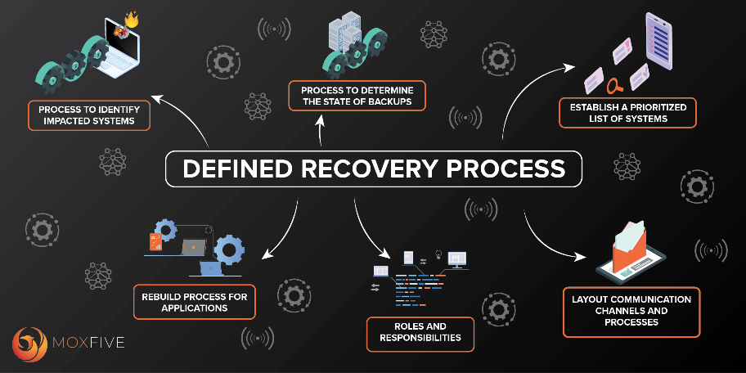 [25].

Protection Mechanisms
To ensure complete protection against cyber-attacks and to support the Zero Trust model, contemporary security procedures must be implemented. In order to provide ongoing monitoring, detection, and reaction, these measures must be included into a unified security architecture.
Tools for Cloud Security Posture Management (CSPM) are essential for locating and fixing setup errors in cloud settings. CSPM technologies assist in preventing human error-related data breaches by enforcing security regulations and continually monitoring setups.
Systems for Security Information and Event Management (SIEM) offer centralised insight into security incidents throughout the company. SIEM systems make it possible to identify complicated risks that might not be apparent through individual systems by evaluating logs and correlating data from many sources [26].
Advanced threat detection and automated response capabilities are offered at the endpoint level by Endpoint Detection and Response (EDR) solutions. These technologies can stop malware from spreading and spot unusual activity.
Finally, phishing-resistant Multi-Factor Authentication (MFA) is essential for preventing credential-based attacks. The organisation may drastically lower the danger of unauthorised access by demanding several types of verification, including hardware-based authentication techniques.
Together, these defences provide a layered security strategy that improves the organisation's overall security posture and is consistent with Zero Trust principles.
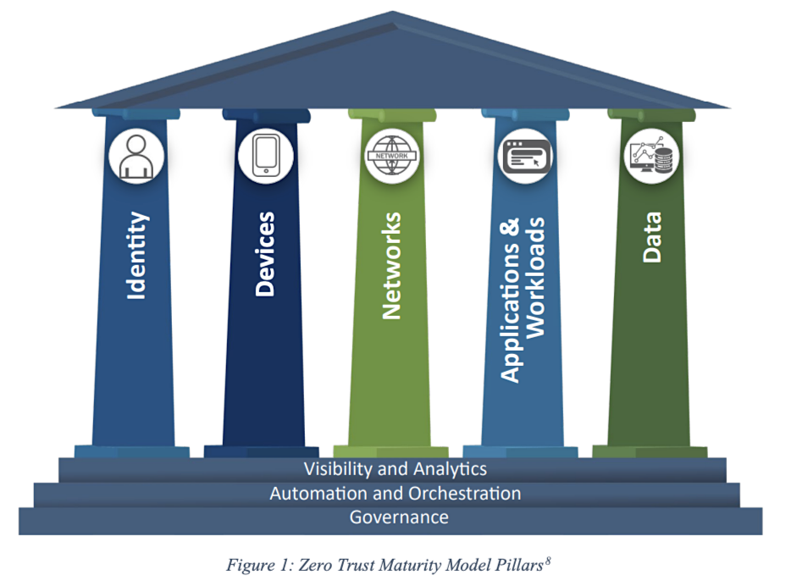
[27].

Conclusion
MediTrust Analytics Ltd. may take a thorough and forward-thinking approach to cybersecurity with the proposed Zero Trust-aligned security program. The organisation may successfully handle the difficulties brought on by hybrid work, multi-cloud settings, and complicated regulatory requirements by incorporating identity-based security, ongoing monitoring, and strong governance frameworks. The architecture guarantees compliance with important standards like DORA and NIS2 while also bolstering the organisation's capacity to safeguard sensitive healthcare data and AI technologies. MediTrust can improve its operational resilience and uphold stakeholder confidence by putting in place sophisticated security measures, organised risk management, and efficient backup plans.
The long-term advantages of switching to a Zero Trust model greatly exceeds the costs, even if it requires a large investment and organisational transformation. In the end, Zero Trust acts as a strategic facilitator, supporting MediTrust's entry into the EU market while guaranteeing the integrity and security of its vital systems and data.

References:

[1] | S. Rose, O. Borchert, S. Mitchell and S. Connelly, “Zero Trust Architecture,” NIST, August 2020. [Online]. Available: https://csrc.nist.gov/pubs/sp/800/207/final#pubs-documentation. [Accessed 20 April 2026].
[2] | Anonymous, “What is Zero Trust?,” Microsoft, 2024. [Online]. Available: https://learn.microsoft.com/en-us/security/zero-trust/zero-trust-overview. [Accessed 20 April 2026].
[3] | CrowdStrike and R. H. , “Cyber Threats 2026: AI, Identity, and Resilience in an Accelerated Threat Landscape,” CrowdStrike, 2026.
[4] | N. Goud, “Significant Cyber Threats of 2026: A Comprehensive Outlook,” Cybersecurity Insiders, 7 January 2026. [Online]. Available: https://www.cybersecurity-insiders.com/significant-cyber-threats-of-2026-a-comprehensive-outlook/?utm_source=copilot.com. [Accessed 20 April 2026].
[5] | Anonymous, “What is Zero Trust Architecture (ZTA)?,” SentinelOne, 11 November 2025. [Online]. Available: https://www.sentinelone.com/cybersecurity-101/identity-security/zero-trust-architecture/. [Accessed 20 April 2026].
[6] | F. Research, “The Zero Trust eXtended (ZTX) Ecosystem,” Forrester Research, Cambridge, MA, 2018.
[7] | Anonymous, “Zero Trust,” Palo Alto Networks, 2020. [Online]. Available: https://www.paloaltonetworks.com/zero-trust?utm_source=copilot.com. [Accessed 21 April 2026].
[8] | Anonymous, “Implement Zero-Trust Architecture to Adapt to a Shifting Threat Landscape,” Gartner, 2024. [Online]. Available: https://www.gartner.com/en/cybersecurity/topics/zero-trust-architecture. [Accessed 21 April 2026].
[9] | H. Shefrin, “Zero Trust vs Castle-And-Moat in Technology,” Dowidth.com, 25 March 2025. [Online]. Available: https://dowidth.com/technology/castle-and-moat-vs-zero-trust?utm_source=copilot.com. [Accessed 21 April 2026].
[10] | M. L. Gambo and A. Almulhem, “Zero Trust Architecture: A Systematic Literature Review,” arxiv, 2025. [Online]. Available: https://arxiv.org/html/2503.11659v1#S6. [Accessed 21 April 2026].
[11] | S. Mushtaq, M. Mohsin and M. M. Mushtaq, “A Systematic Literature Review on the Implementation and Challenges of Zero Trust Architecture Across Domains,” Sensors, vol. 25, no. 19, 2025.
[12] | ENISA, “ENISA (European Union Agency for Cybersecurity). Zero Trust Architecture: An ENISA Perspective, 2023.,” ENISA, Athens, 2023.
[13] | Anonymous, “NIS2 Directive: securing network and information systems,” Digital-Strategy, 2023. [Online]. Available: https://digital-strategy.ec.europa.eu/en/policies/nis2-directive. [Accessed 22 April 2026].
[14] | ENISA, “Cybersecurity in Healthcare: Sectoral Analysis,” European Union Agency for Cybersecurity, Athens, 2023.
[15] | AWS, “Understanding Zero Trust principles,” Amazon Web Services, 2024. [Online]. Available: https://docs.aws.amazon.com/prescriptive-guidance/latest/strategy-zero-trust-architecture/zero-trust-principles.html. [Accessed 22 April 2026].
[16] | M. L. Gambo and A. Almulhem, “Zero Trust Architecture: A Systematic Literature Review,” Journal of Network and Systems Management, vol. 34, no. 25, 2026.
[17] | CISCO, “Zero Trust Frameworks Architecture Guide,” CISCO, 18 May 2023. [Online]. Available: https://www.cisco.com/c/en/us/solutions/collateral/enterprise/design-zone-security/zt-frameworks.html. [Accessed 23 April 2026].
[18] | Microsoft, “Zero Trust identity and access management development best practices,” Microsoft, 2025. [Online]. Available: https://learn.microsoft.com/en-us/security/zero-trust/develop/identity-iam-development-best-practices?utm_source=copilot.com. [Accessed 22 April 2026].
[19] | T. Hussain, “Cyber Security and SOC Organizational Hierarchy,” Medium, 7 November 2025. [Online]. Available: https://medium.com/@tahirhussain8098/cyber-security-soc-organizational-hierarchy-and-event-id-mapping-b5930b68b175. [Accessed 22 April 2026].
[20] | M. Adams, “New tools and guidance: Announcing Zero Trust for AI,” Microsoft, 19 March 2025. [Online]. Available: https://www.microsoft.com/en-us/security/blog/2026/03/19/new-tools-and-guidance-announcing-zero-trust-for-ai/. [Accessed 22 April 2026].
[21] | NIST, “The NIST Cybersecurity Framework (CSF) 2.0,” National Institute of Standards and Technology, 2024.
[22] | NCSC, “Risk management,” National Cyber Security Centre, 2023. [Online]. Available: https://www.ncsc.gov.uk/collection/risk-management/cyber-security-risk-management-framework. [Accessed 23 April 2026].
[23] | Anonymous, “DORA and NIS2: strengthening digital resilience across the EU,” C-Risk, 2022. [Online]. Available: https://www.c-risk.com/cybersecurity-compliance/dora-and-nis2. [Accessed 23 April 2026].
[24] | CISA, “Ransomware Guide,” CISA, 2025. [Online]. Available: https://www.cisa.gov/stopransomware/ransomware-guide. [Accessed 23 April 2026].
[25] | J. Chan, “Ransomware Recovery Tales: Prepare for Battle,” MOXFIVE, [Online]. Available: https://www.moxfive.com/blog/ransomware-recovery-tales-prepare-for-battle. [Accessed 24 April 2026].
[26] | Microsoft, “Protect and modernize your organization with a Zero Trust strategy,” Microsoft, 2024. [Online]. Available: https://www.microsoft.com/en-us/security/business/zero-trust#:~:text=Zero%20Trust%20is%20a%20modern,originates%20from%20an%20open%20network.. [Accessed 23 April 2026].
[27] | Anonymous, “The CISA Zero Trust Maturity Model: A Definitive Guide,” Vistrada, 2023. [Online]. Available: https://vistrada.com/resources/insights/cisa-zero-trust-maturity-model. [Accessed 24 April 2026].

