Cover Page
Name: Prashant Thapa
Assignment: A presentation on team-working
Module Code: BMSK4002
Student Number: 1806502
Module: Effective Team-working and communication.

INTRODUCTION
For this assignment, my team was given a task and I was allocated to talk about effective conflict handling in a workplace to improve the performance of a team for new managers.
Dealing with conflict at workplace is an essential skill a new manager should have in their arsenal. In every workplace conflict can occur and can result to employees leaving their jobs due to disagreement with their managers. People encounter conflict everyday in their day to day life and try to solve them, same things happen in the workplace. On this assignment I am going to be talking about how new managers can improve the performance of the team by effectively handling conflict.
EFFECTIVE CONFLICT HANDLING
In an organisation where people are working together it is implausible everyone will agree to everything and a conflict will occur. A manager who has effective conflict handling skills will ensure that his team works around each other’s differences, work in harmony, build a good relationship with each other and make the team more productive.
According to Burton (2017) effective conflict management is an important skill that involves handling confrontation courteously and productively. In a workplace when a conflict occurs the manager must learn from his or hers experience and be prepared when a conflict takes place again. When resolving the conflict, the managers must see that they respect everyone’s wants and needs.
In a workplace conflicts can happen due to changes, personality clashes, misunderstanding, discrimination, poor communication, disagreement with co-workers, poor management, jealousy etc. Not all conflicts lead to disadvantageous situation as some conflict when handled appropriately can work in the managers favour. Myatt (2012) states that where there is disagreement there is an inherent potential for growth and development. Creative conflicts can lead to innovative ideas and make the teams more productive. Conflict can increase communication between work colleagues which results in greater mutual understanding between them. Conflict also brings up problems they are facing and when discussed can be solved and lead to positive outcomes.
According to Moodle (2018) Thomas-Kilmann conflict mode relies on two factors when dealing with conflicts assertiveness and cooperativeness.
Assertiveness is the extent to which the individual attempts to fulfil his or her interests and needs. They do this by expressing their feelings and beliefs without breaching the rights of others or by not being aggressive towards anyone. Cooperativeness is the extent to which the individual attempts to satisfy the other persons interests and concerns. These two dimensions of behaviour are used for five conflict handling modes. Please refer to figure 1 to see where all the modes lie in the chart.

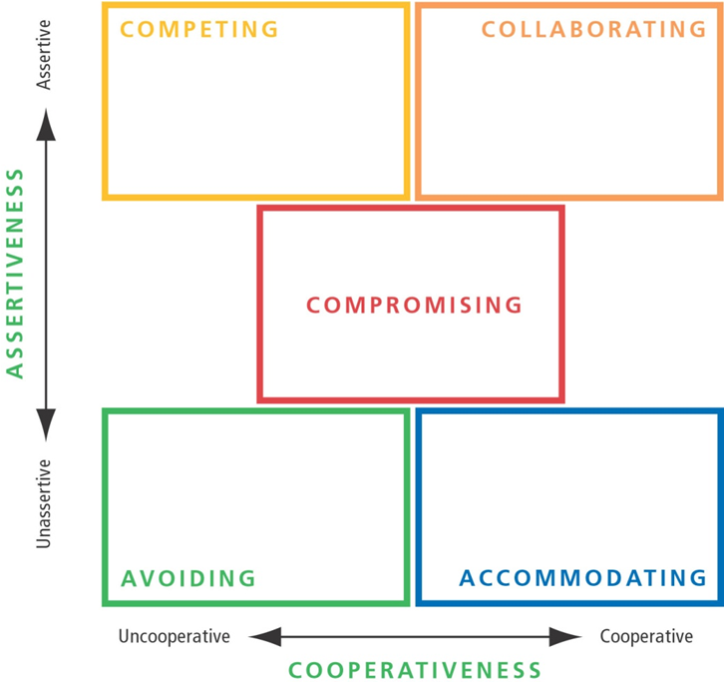
Figure 1: Five Conflict handling modes

- Competing: It is a win/lose style and is assertive and uncooperative. When competing the individual tends to pursue more of his or her goals at the expense of others. When handling conflict, the individual is selfish and power-orientated and has no concerns for others.
- Compromising: It is a lose/lose style and is intermediate at both assertiveness and cooperativeness. It is called a lose/lose style as both sides must lose something to gain what they want. The individual is interested in winning but does not want the other person to lose, compromising takes in consideration of both parties but produces mediocre results.
- Accommodating: This conflict style is a lose/win style and is very high in cooperativeness and unassertive. This individual will give up everything to see other people succeed in accommodating. When accommodating this person ignores his/her concerns to appease others concerns. The individual is generous and selfless and may also be deemed as a sycophant or a yes man.
- Avoiding: This is a lose/lose style and is unassertive and uncooperative. This individual completely ignores the conflict and does not address the issue in avoiding. This person does not assert their own goals and desires nor the other persons goals and desires. This conflict style is suitable when the tempers are hot and the individual needs time to decide and where it is not the right place and time to handle conflict. No parties gain anything avoiding and will create bitterness and resentment between both parties.
- Collaborating: This is a win/win style and is both assertive and cooperative. Collaborating allows both parties to reach their goals by working together, finding a solution and satisfying each of their concerns. Collaborating between two parties will help to learn from each other’s perceptions, solve the situation that would otherwise have them battling and disagreeing. Collaborating is used to find an integrative solution when both parties concerns are too important to be compromised. Collaborating style prioritizes both parties’ interests. Collaborating style is the best style when approaching conflict between two parties to achieve full success.

Each modes of conflict are useful and can all be used depending on the situation and scenarios. For new managers it would be best to use the collaborating mode of conflict as it will drive his/her team to success by prioritizing his/her team concerns and his/her team concerns. With this conflict mode the manager can get the insight from his/her team with different perspective and problem. This will result in both side contributing to solve the problem.
According to Whittaker (2016) there are 5 keys to conflict resolution for managers trying to solve a conflict effectively.
- Stay Neutral: When two parties have a conflict, the managers have to take in account both sides of the stories and cannot be biased or take sides.
- Acknowledge the problem: Whatever the issue is no matter how small it is the managers must recognize the issue and address them.
- Focus on the problem, not the people: Difficult employees may have conflict with their co-workers, instead of focusing on the difficult employees focus on what is causing the problem and address these issues to them by motivating them. Use “I” instead of “you” when confronting difficult employees and show them the big scope.
- Seek common ground: Managers should come to a mutual understanding and compromise so that the trust is built.
- Be patient, but decisive: When dealing with conflict, managers need to be patient when making decision. Once the decision is made the management needs to move decisively to execute whatever changes are called for.

REFERENCES
- Thomas, K.W., (2008). Thomas-Kilmann Conflict Mode.
- Burton, L. (2017) Managing Conflict in the Workplace: A Guide for Line Managers. Available at: https://www.highspeedtraining.co.uk/hub/conflict-management-in-the-workplace/ (Accessed :18 February 2019).
- Moodle. (2018) Effective team-working and communication. Available at: https://moodle.uwtsd.ac.uk/course/view.php?id=5703 (Accessed : 20 February 2019).
- Whittaker, R. (2016) 5 Keys to Conflict Resolution. Available at: https://aboutleaders.com/5-keys-to-conflict-resolution/#gs.FZcrWrH5 (Accessed : 22 February 2019).
- Strategy, I.F.A. and Skills, I.I.I., 1976. Conflict Management.
- Myatt, M. (2012) 5 Keys of Dealing with Workplace Conflict. Available at: https://www.forbes.com/sites/mikemyatt/2012/02/22/5-keys-to-dealing-with-workplace-conflict/#7892c9961e95 (Accessed: 21 February 2019).

