

Programmes: BA International Hotel Management

Module: Cultural Awareness (BMIH5003)

Student Name: Tuhel Miah
Student ID: 2126977
Lecturer Name: Luciana Suardi

Executive Summary
Travelodge provides its employees with a comprehensive employee policy to help them consistently and professionally greet guests. Travelodge employs individuals from numerous countries of origin. Due to the language barrier, it is much more difficult to communicate with individuals here. The management of Travelodge in the United Kingdom, the host country, takes extensive measures to ensure that all of its United Arab Emirates-based employees and visitors regard each other with respect and tolerance. The hotel's administration ensures a pleasant atmosphere and encourages open communication between the staff and guests to facilitate efficient service. Travelodge gave its employees more autonomy so that they could better serve consumers, particularly those from other nations.

Table of Contents
Executive Summary 2
Introduction 4
The United Kingdom (Travelodge) 5
UAE (Guests’ home country and culture) 6
Hofstede’s Cultural Dimensions 7
Travelodge Hotel’s handbook 9
Conclusion 10
Recommendations 11
References 12

Introduction
Travelodge, a UK hotel chain, hires interculturally competent and sensitive staff. Travelodge recruits from several nations because to cultural differences between the UAE and the UK. The Travelodge F&B crew must provide local specialties to visitors with kosher and food allergy restrictions in the UAE. Travelodge staff respect UAE guests' religion and culture. This document is meant to assist Travelodge personnel understand and respect UAE customers' cultural standards.

The United Kingdom (Travelodge)
Travelodge, a popular UK hotel brand, provides affordable, clean, modern rooms in handy locations. It opened in 1985. Over 500 US Travelodge hotels have opened. King-size beds, en suite bathrooms, and free Wi-Fi are available (Travelodge, 2022). Tourists and business travellers may find Travelodge hotels near major transit hubs in downtown and suburban areas. Because it values consumers, Travelodge trains its staff to be kind. The corporation expands and retains its assets (Lewis, 2008). UK holidaymakers like Travelodge because of its wide availability and inexpensive costs. The UK's varied population implies no greeting etiquette. "Hello," hug, nod, or salute. (Travelodge, 2022). Similar accents may help vernacular speakers. British individualism puts liberty first. Celebrations include Christmas, Easter, New Year's Eve, the Queen's birthday, and Good Friday (Lewis, 2008). Travelodge succeeds in this complex setting.

UAE (Guests’ home country and culture)
The UAE is intriguing. Its vibrant culture and customs are renowned. Emiratis and foreigners live in UAE. UAE citizens love their diversity. Islam influences Emirati culture. Tradition and openness underpin it (Mackay, 2011). Arabic has a rich history. UAE inhabitants love chatting to locals that respect their faith and culture. Hummus, falafel, and shawarma are popular Emirati dishes. Emiratis value Ramadan (Lewis, 2008). Emiratis value family, community, and festivals. Emirati guests who respect UAE norms may make true relationships and create a friendly atmosphere.

Hofstede’s Cultural Dimensions
Hofstede's cultural dimensions permit the comparison of cultural ideals and practise.

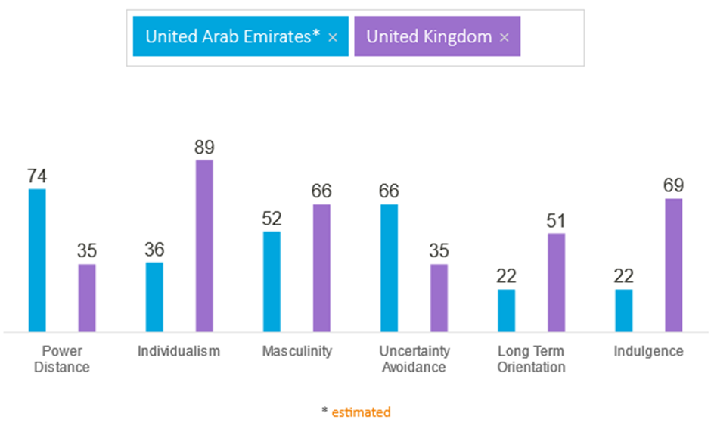

Figure: Cultural situation of the UK and the UAE (Huang and Crotts, 2019)
Power Distance
Power Distance gauges a community's acceptance of power inequality. The UK wants more transparent, egalitarian, and power-balanced organisations. Liberty, equality, and justice for everyone are cultural ideals (Hofstede et al., 2020). When necessary, people confront authority. The UAE prioritises respect for authority, formal institutions, and socioeconomic inequality. Emiratis revere authority and power.

Individualism Vs collectivism
Britain is known for its individuality. British culture values independence, liberty, and self-expression. People want autonomy, self-sufficiency, and prosperity. UAE is increasingly collectivist (Mackay, 2011). Emiratis value family, trust, and community. Because they value group participation and achievement, people often prioritise group aims above their own.

The Masculinity VS the Femininity
Masculinity vs. Femininity assesses how much a society values male traits like brashness, competition, and accomplishment over feminine traits like compassion, teamwork, and quality of life. UK masculinity values rivalry, ambition, and wealth (Hofstede et al., 2020). People respect their achievements and fame. The UAE, however, permits both genders. Emirati culture values conventional gender standards, self-confidence, communal welfare, and a good work-life balance.

Uncertainty Avoidance
Uncertainty How effectively society handles uncertainty, ambiguity, and danger affects avoidance. UK culture doesn't mind ambiguity. British culture is more open to change and new ideas. People are riskier and less obedient. The UAE avoids ambiguity. Emiratis appreciate security, organisation, and law and tradition (Adnan and Butt 2017). Unambiguous laws eliminate uncertainty and risk, thus people like them.

Long Term VS Short Term Orientation
Unlike short-term Orientation describes how much a culture emphasises long-term behaviours, perseverance, and frugality above instant enjoyment, tradition, and social conventions. The UK thinks faster. British people appreciate presence, adaptability, and change. Al-Mansoori et al. (2014) emphasise success, immediate benefits, and enjoyment. UAE is more long-term. Emiratis value traditions and social standards. Persistent, frugal, and future-oriented.

Restraint vs. Indulgence
Restraint vs Indulgence shows how much a community limits or indulges its needs and wants (Adnan and Butt 2017). Restrained societies manage emotions, conduct, and social standards. Indulgent civilizations provide greater freedom and authenticity. UKers are lazier. Brits value happiness, individuality, and self-expression. Those who are more tolerant of others and less conformist. The UAE controls more. Emiratis value self-control, self-discipline, and social standards (Al-Mansoori et al., 2014). Maintaining order and peace is the main objective.

Travelodge Hotel’s handbook
Do’s | Don’ts
Send a one-of-a-kind greeting:  As soon as they arrive, welcome them with a genuine smile and a pleasant demeanour to make them feel valued and appreciated (Travelodge, 2022).  Be mindful of what customers expect:  Keep an eye out for indicators left by visitors and guess what they need before they mention it.  Create a service-oriented culture:  Encourage employees to concentrate on the demands of the consumers.  Display cultural awareness  Recognise and appreciate the diversity of cultures among visitors (Travelodge, 2022).  Keep a professional demeanour:  Maintain the hotel's dress code and cleaning standards to project a professional, businesslike image. | Avoid generalisations and stereotypes:  Make no assumptions about your visitors based on their looks, ethnicity, or culture.  Don't dismiss your guests' requests or concerns:  Respond to visitors' queries and concerns as soon as possible.  Protect your visitors' personal space:  Keep in mind that your visitors may want some privacy (Travelodge, 2022).  Avoid arguing with your guests:  Maintain your cool in the face of adversity. It is preferable to avoid engaging in an argument or an aggressive confrontation with visitors since this will only exacerbate the problem..  Do not disregard comments or criticism:  Visitors' opinions and queries should be welcomed (Travelodge, 2022).

Conclusion
Travelodge, UK considers staff' and visitors' cultural backgrounds while creating hotel policies. This reduces errors and makes everyone happy. Travelodge staff treat UAE visitors like royalty. Emirati visitors may be impressed with respectful front desk employees. The hotel staff respects language, culture, ethnicity, and religion distinctions between the two nations. The hotel administration goes to considerable efforts to ensure that no one finds the rules and procedures irritating.

Recommendations
Create an Emphasis on Visitors
All staff members should be inculcated with the notion of providing exceptional service and creating unforgettable experiences.
Increase Coordination and Interaction through
Insist hotel personnel collaborates and communicates effectively. Encourage communication between teams, departments, and schedules.

References
Adnan, M., and Butt, S. (2017) Impact of Culture on Business Negotiations: A Comparative Study of the UAE and the UK. Journal of Business Studies Quarterly, 9(1), 1-22.
Al-Mansoori, M. H., El-Nawawy, M., and Erffmeyer, R. C. (2004) Hofstede's Dimensions of Culture in International Marketing Studies. Journal of Business Research, 57(12), 1396-1403.
Al-Seghayer, K. (2005) Cultural Dimensions of Learning: Addressing the Challenges of Multicultural Instruction. Language, Culture and Curriculum, 18(2), 143-155.
Bramwell, B. (2004) Coastal Mass Tourism, Clevedon: Channel View.
Brealey Publishing.
Brown, K. (2013) Contemporary China, Palgrave Macmillan.
Cooper, C. and Hall, C. M. (2005) Oceania: A Tourism Handbook, Clevedon: Channel View.
Cooper, C. and Wahab, S., (2007) Tourism in the Age of Globalisation. London: Routledge.
Drake, H. (2011) Contemporary France, Macmillan.
Globe, London, Nicholas Brealey Publishing.
Hofstede, G., Hofstede, G. J., and Minkov, M. (2010) Cultures and Organizations: Software of the Mind: Intercultural Cooperation and Its Importance for Survival. McGraw-Hill.
House, R. J., Hanges, P. J., Javidan, M., Dorfman, P. W., and Gupta, V. (2004) Culture, Leadership, and Organizations: The GLOBE Study of 62 Societies. Sage Publications.
Huang, S.S. and Crotts, J., 2019. Relationships between Hofstede's cultural dimensions and tourist satisfaction: A cross-country cross-sample examination. Tourism management, 72, pp.232-241.
Jandt, F (2016) An Introduction to Intercultural Communication, 8th edition, Sage: San Bernadino.
Lewis, R.D. (2005) When Cultures Collide: Leading, Teamworking and Managing Across the
Lewis, R.D. (2008) Cross-Cultural Communication: A Visual Approach, London, Nicholas
Mackay, H. (2011) Understanding Contemporary Wales, University of Wales Press Moran RT et al. Managing Cultural Differences, 2007, Elsevier, Oxford.
Methan, K. (2001) Tourism in a Global Society: Place, Culture, Consumption. London: Macmillan.
Moran, R. (2018) Managing Cultural Differences, 10th edition, Routledge: Abingdon.
Pearson.
Samovar, L. (2009) Communication Between Cultures, Wadsworth, London.
Timm, A. (2011) Intercultural Problems in the Tourism Industry, GRIN Verlag.
Travelodge. (2022). About Us. Retrieved from https://www.travelodge.co.uk/about-us
Travelodge. (2022). Our Values. Retrieved from https://www.travelodge.co.uk/about-us/our-values
Wall, G. and Mathieson, A. (2006) Tourism: Change, Impacts and Opportunities, Harlow:

