Danielle Evans 1900385 Lesson Reflection.

I feel that throughout the Welsh lesson that I did with the children I was able to improve their Welsh ability. I was able to complete a lesson plan on what I wanted the children to achieve and what activities the children were going to participate in, the children were able to get through most of the activities that I had planned for. I had planned for the children to sing songs to help them to pronounce the words, then to play ‘sawl un’ to help them with their counting in Welsh and their number recognition. I had then planned to play ‘pa liw’ on the white board and then to play ‘beth sydd ar goll’ I had then planned that after they had finished all of the activities that they would then go in to ‘talk partners’ to discuss what they had learnt and what they remembered from the lesson.
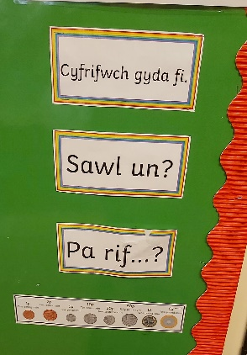
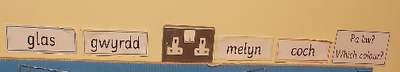
During the activity that I had planned the children were able to sing all of the songs that I had planned. One song that I had planned to do was longer than I had anticipated which then gave the children less time to complete all of the activities that were planned. We were unable to do the ‘beth sydd ar goll’ activity, but I made time to allow the children to do the paired activity so that they were able to communicate with one another and pronounce different colours and numbers so I could listen to their pronunciation to see if they needed any additional support. During the activity I was able to do ‘pa liw’ and ‘sawl un’ activities at 2 different difficulty levels. This then helped the children to develop on their knowledge of numbers and colours by adding additional colours and number at a higher level. During the activity a child said a number in English so I was able to correct the child straight away and ask the child what it was in Welsh, they then struggled to answer, so as a class we all went through the numbers again and the child was then able to tell me what the number was in Welsh.
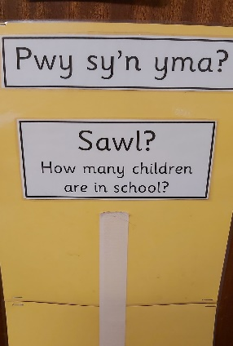
The things I could have done better throughout this activity was that I could have done it multiple times with a smaller number of children in groups so that they could all have had an opportunity to participate in every activity. I also could have gone through the resource to make sure of my timings so that I was able to plan more effectively and so that what I had planned for was able to be done in the lesson. I could also have made the lesson a little longer, so that if it was a full lesson the children would be able to do a wider range of activities so that I would be able to further their knowledge.
I was able to use Welsh all through the day, when the children came in I was able to tell them to sit down in Welsh. When they had settled down I was able to say good morning and start the day. I was able to do the days of the week in Welsh but the numbers in English. After the register the children would tell me in Welsh if they were having dinners or sandwiches. Throughout the day at the end of every lesson I would tell the children in Welsh that it was time to tidy up. After first session before they would go to assembly we would show how many children were in the class by putting their names on the board so that we could do the fire register effectively and so that the children were able to participate and count in Welsh how many children were present.
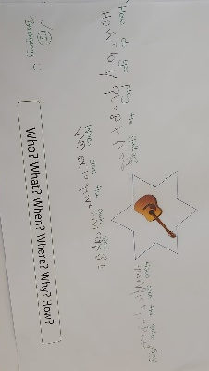
At dinner time I would tell them that it was dinner time using Welsh so that they knew what time of day it was. After lunch I would settle them back down into the classroom and say good afternoon in Welsh. Every afternoon we would do a Welsh activity on the board so that we were able to expand their knowledge and understanding of the language. At the end of the school day I would sing along with the children the goodbye song in Welsh before they went home. Throughout the day all of the teaching staff and I would praise the children in Welsh and would use stickers with Welsh praises on them. While I was in placement I was able to mark one piece of work, this I did in Welsh as we always praised the children in Welsh in the classroom.
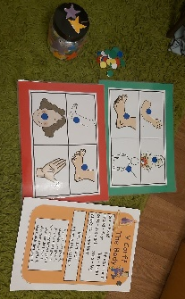
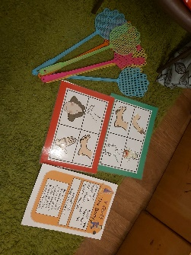
Other activities that I was able to do with the children in Welsh were, ‘Beth sy’n bod’, ‘Splat’, ‘Bingo’, and also ‘Teddy Twt’. While doing the Beth sy’n bod activity the children were able to expand on their knowledge of Welsh by being introduced to body parts and their names. The children would then act out a scene using phrases that they know but using their new knowledge of the body part in Welsh and what would help them with getting better in Welsh. An example of this is ‘Beth sy’n bod? Mae braich tost gyda fi. Plaster pinc i ti’. They were then able to do another activity after learning the parts of the body in Welsh. They would splat the body part which I would say in Welsh and they would show me what part of the body they thought it was. If the children would get it wrong I would then help the child within the group to see how they could remember what it was. Another activity using body parts was bingo. I would say a body part in Welsh and if they had that part on their sheet they would use a counter and they would tell me the colour of the counter that they were using in Welsh and would put the counter on the body part that I said. The first person to win would have a dojo point and the other children wpuld be rewarded with stickers. I was able to do ‘Teddy Twt’ with the children. I would choose a ‘Helpwr Y Dydd’ and they would get to choose a coloured jumper for the teddy to wear and would ask the class in Welsh what colour the jumper was and would choose a child to answer in Welsh.
I feel that I have helped to improve the children’s Welsh language development throughout my time in placement. I have been able to praise the children after they have done something well, I have also made sure that when I was saying something in Welsh I would ask the children if they understood what I was talking about and if they did not know or were getting it muddled up I would then give more help and support to the children and explain what I had said. If I said anything that I wanted the children to remember in Welsh I would always allow the children to repeat it back to me multiple times until they were able to remember it and pronounce it correctly.
The things that I feel I could have improved on in the setting to do with the Welsh language is that I feel that I could have used more Welsh throughout the day. An example of this is to introduce them to asking to go to the toilet and asking for various items in Welsh. This would have then improved their vocabulary and their speech of the language. I feel that I could have praised the children more so that they knew that they had done well and so that I could improve my Welsh and their Welsh at the same time. I can improve on my Welsh by using it more around the house with my family and using Duolingo to improve on my Welsh Language.

