Christopher Lewis
1909511
BA Graphic Design
“Paying close attention to the terms of ‘designer design, quiet design and the plenitude’, Critically discuss the work of TWO practitioners within your field and ascertain how their design work adheres to one or all of the terms”
Timi O’Neill
Word count: 2294

If you are anything like me, as a graphic designer I am always looking at the world around me, how it changes (socially, environmentally and economically) and the work of other designers. Looking at the way Design has changed over the years and the way in which visuals can be represented is always evolving. Keeping a close eye on these changes not just for inspiration but more so for me to try and understand how different designers see the world and the type of design they use. We can question if they are able to create certain designs because of signs they are familiar with from a young age or is it the ability to use what we know and push boundaries to create something new. “Barthes suggests that there are basically three types of signs – the iconic, the motivated and the arbitrary”. (Philip Thody, 2006, p.36). This theory goes on to conclude that the three types of signs belong on a sliding scale with the iconic (one function) at one end and the arbitrary (infinite in meanings) at the other. Around 300 BCE there was a debate between the Stoics and the Epicureans regarding sign systems with the Stoics believing “The crux of the matter concerned the difference between “natural signs” (freely occurring throughout nature) and “conventional” signs (those designed precisely for the purpose of communication). (Paul Cobley & Litza Jansz, 2012, p.8).
Design itself raises the question whether we really have much free will and ability to think for ourselves without influence. Considering when something has been created with the intention of swaying the view of its audience which sort of design category suits it best. I remember a few occasions growing up where I had believed something, I had drawn was unique and one of a kind to later discover that there were already almost identical designs available. These designs were in shops that I would visit regularly but never noticed before. “Without realising it, others have a huge influence on almost every aspect of life” (Jonah Berger, 2016, p.1). Carefully constructed designs can be successful in aiding or influencing decisions in several areas in life, such as political campaigns, sporting events, TV shows and more.
The terms: designer design, quiet design and the plenitude each describe different methods of design. When we think about quiet design, we get the idea that it is something that has been created visually to aid us in life without the tagline of it being designed. The focus is not on who it was designed by or how innovative the idea but most of the time it is about the product itself and how it can benefit us all. Opposite to what you would expect from Apple and other large companies that market a lot of their products as distinctive or ground-breaking. I would consider any sort of public notices, road layouts and signs to be quiet design as the importance is placed on what information is presented rather than how it looks. When you think about road signs dotted across the country, you are unlikely to know who has designed it but instead understand the importance of what it signifies and how it can potentially prevent accidents. The overall goal with designs such as this is the safety it provides for everyone.

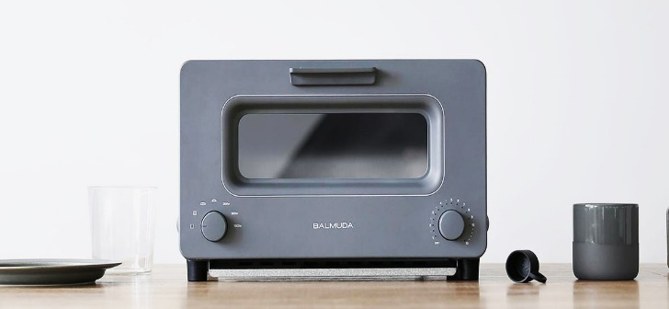
Fig 01 Balmuda Toaster.

Designer design can often be seen to be something that would have emphasis on the design itself, making it seem like it is exclusive or unique in some way. The words design, designer and designed by are usually used to add an extra element to a product to make it more appealing to the general public. I consider items such as the Balmuda Toaster (£238) to fit in this category, based on the price and description. The description used to make this product desirable explains how it will use a small amount of water in 3 stages to produce the perfect piece of toast without drying out the bread. Balmuda uses the description of their toaster to entice consumers to buy but to also justify its price tag. However, when we look at the service this product provides, the result will be the near enough the same as a toaster at a fraction of the cost. To attract buyers this product is marketed for its differences, by focusing on the design and uniqueness of the products rather than its overall usefulness.
Finally, the plenitude goes on to describe everything around us and how there is constant need for us to add it to it. “While there are various theories as to how the Plenitude started, we know it mostly grows because it creates desire for more of itself.” (Gold, 2007, p.27). If we all agree that everything around us has been created to satisfy our needs, over time these can change and there is a need for us to keep our creativity in line and up to date. When we fulfil one desire it opens other desires to be explored and that will then need satisfying, producing an endless cycle that we will likely never fulfil due to a constant need for new ideas and development. Within the design world this is very important to avoid work being replicated and allows for more freedom across all areas of design.
I will be comparing two of my favourite designers and analysing their work to see which of the following terms are most suited to describe them, designer design, quiet design and the plenitude. Exploring if their work is as close to complete as it can be (the plenitude), designed and marketed in a way to showcase the design (designer design) or simply designed for a specific purpose to aid us in our day to day lives (quiet design) that fits each style. With design around us all the time, there needs to be consideration for how the work may change behaviours, satisfies our needs or creates value. Analysing work from each of the designers and looking to see how they use signs, icons, symbols and sign systems to create a meaning.” Semiotics as a discipline is simply the analysis of signs or the study of the functioning of sign systems” (Paul Cobley & Litza Jansz, 2012, p.6).
Both designers use different styles of work which will hopefully provide different outcomes after deconstructing. Each piece represents presidency in the USA at different times. Whilst looking at the images in a few levels, looking at what the connotations and denotations are. “For Plekhanov, art was a recorder of social developments. By examining the art of a given period, we could pin down that period’s ideological character also” (Sim & Van Loon, 2012, p.29.). Also considering if the selected work would have any influence over its audience or simply be attractive to look at. Most importantly identifying which of the areas I believe the work to be most suited and my reasons for placing in that category of design.

Paul Pateman / Pateontoast
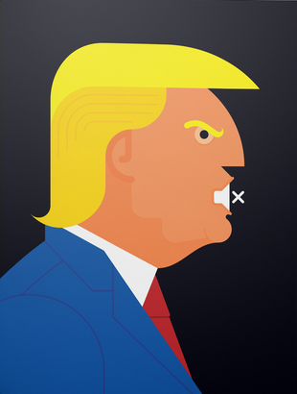

Fig 02 Trump on Mute. Fighting back against fake news
Paul Pateman / Pateontoast is one of my favourite designers due to his style and ability to deliver messages regarding real life topics, usually highlighting issues around the world. The designs he creates require very little detail and are usually made up of a combination of basic and complex shapes with bold colours
From analysing, I would conclude the work of Paul Pateman to be that of designer design. The work I have picked has a sole focus on representing Donald Trump in a unique way that Pateman is recognised for. I have found similar work through the internet but no other graphic designers with the same level of consistency in their approach and style in their work.
. Using the above example of Donald Trump, you can identify it is him from signs used like, yellow hair, shape of the nose, eyebrow, red tie and blue suit. I consider these elements to be common identifiers of the former president but do not consider them as neither positive nor negative. The mute icon for his mouth used to link to the story at that time surrounding Trump. “the notion of ‘sign’ in order to distinguish signs from non-signs and to translate the notion of ‘sign’ into the more flexible one of sign-function” (Eco, 1976, p.2.). Structurally this visual of Trump only works as all the features are there, if we took away some of the items that are used there might be confusion to who it portrays, all the items make up the whole image. The selected details even though they are minimal are recognised around the world as visual signs of Donald Trump. If you think about him, those are usually the main identifiers that we are familiar with. This image was used in the Positive News Magazine in an article surrounding truth and how people are starting to separate fact from fiction. With the popularity and accessibility of the internet this is a modern-day problem as the legitimacy of content available rarely gets checked.
Personally, whenever he is mentioned, I think of his hair, suit and red tie instantly. Therefore, the way that Pateontoast has created the above image makes it simple for the viewer to know who it is being illustrated. Unless you had never seen or heard of Donald Trump before you would easily make the connection with the image alone.

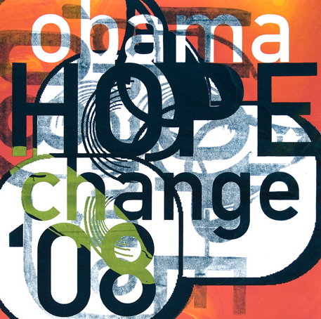
David Carson

Fig 03 Obama Campaign (2008)
The second artist I have selected is David Carson. Particularly his work for Obama’s campaign back in 2008. This image uses very few shapes and mainly focuses on the typography, words and colours. Asymmetrical in appearance and using both positive and negative space perfectly to create an appealing visual that would highlight the main policies that a change in leader would provide for the USA. The words selected play a key role in the overall message, Hope and Change give the readers a sense of a better life under a new leader. The two words chosen are very powerful words that a lot of people would relate to if they felt that the current leader was not doing what was best for everyone and recognised in all types of media as positive. The word Hope and the year 08 are the main areas of interest due to the size of characters, there is a clear emphasis on these in comparison to the other parts of the image. If we took away the other words and just left Hope and 08 the message would likely be less clear for the general public. This image from Carson, due to his fame and the political purpose of the image, falls in between Designer design and Quiet design depending on the viewer. For someone who is not Carson fan this work could be considered purely marketing material for Obama’s campaign, placing its purpose and campaign objective at the forefront. Whereas a Carson fan may, similarly to the Trump work by Paul Pateman, consider this work to be a showcase of Carson’s design skills with a political message attached.
Within Carson’s image you can clearly see several design principles. Including a hierarchy with the information presented as you would expect in a lot of design work. Generally, campaign images tend to be full of “facts” that are used to persuade a decision by highlighting the negatives of the opposition. However, this image employed a different approach and instead builds a picture of positivity from the use of words, shapes and colours, allowing Carson to communicate with the audience in a different way. The composition and use of imagery, lettering and space in Carson’s image demonstrates the fundamentals of graphic design, they are clear to see and used effectively. I believe this image is very well constructed would have served its purpose well during the campaign, mainly because it is simple in appearance yet very powerful and uses very few elements which a lot of viewers would find beneficial. In my opinion there is nothing less appealing than a poster that has too much information or that has not been constructed with thought as it usually reduces the impact of the overall message and you can end up feeling a bit overwhelmed. Design unity has been achieved in this image as I feel it meets all the necessary criteria, especially as none of the elements are competing against each other and seem to be complimenting one another instead.
To conclude, firstly focusing on the use of design principles in the images. Each image clearly communicates its core theme, and I would consider them both to be complete and successful in the messages they aim to deliver. There is very little room for wrong interpretations as both images have been thought about carefully and effectively use design thinking for its outcomes. In my opinion from looking at both images, there is strong use of the golden ratio, both have elements that are placed in proportions that result in them being visually pleasing.
Despite the differing visuals used in both images, they both fall within the designer design category to some degree. While both images relate to political concerns but is the way in which the work is used that means Carson’s work could also be considered quiet design. Pateman’s image conveys to me that it is a piece of work by the designer that has a political message. Whereas Carson’s work is a piece of work that has been created with a political message to aid a political campaign. This additional layer of purpose to Carson’s image means that is potential for the viewers perception of the image to shift away from viewing it as a designer design and towards societal purpose it serves.

Bibliography
Umberto Eco (1976), A Theory of Semiotics. Indiana University Press
Philip Thody (2006), Introducing Barthes. London. Icon Books
Stuart Sim and Borin Van Loon (2012), Introducing Critical Theory. London. Icon Books
Gold (2007), The plenitude: creativity, innovation, and making stuff. The MIT Press
Paul Cobley & Litza Jansz (2012), Introducing Semiotics. London. Icon Books
Jonah Berger (2016), Invisible Influence – The Hidden forces that shape behaviour. London. Simon and Schuster
Fig 01. Balmuda Toaster. Available at:
Review: Balmuda The Toaster | WIRED (accessed 20th November 2020)
Fig 02. Pateontoast. (2020) Trump on Mute. Available at: https://www.pateontoast.co.uk/#e-46 (accessed 9th November 2020).
Fig 03. Obama Campaign (2008)
http://www.davidcarsondesign.com/t/clients/obama/ (accessed 9th November 2020).

