Dissertation title: A Skyscape Archaeological Assessment of the Megalithic Tombs of Guernsey, Sark, Jersey and Herm in the Channel Islands

Sarah Bisby Student Number 2113745

Email: 2113745@student.uwtsd.ac.uk

Dissertation submitted in partial fulfilment
of a Master of Arts in Cultural Astronomy and Astrology
University of Wales Trinity Saint David

September 30th 2025


Master’s Degrees by Examination and Dissertation
Declaration Form
1. This work has not previously been accepted in substance for any degree and is not being concurrently submitted in candidature for any degree.
Name Sarah Bisby
Date 26th September 2025

2. This dissertation is being submitted in partial fulfilment of the requirements for the degree of MA in Cultural Astronomy and Astrology
Name Sarah Bisby
Date 26th September 2025

3. This dissertation is the result of my own independent work/investigation, except where otherwise stated.
Other sources are acknowledged by footnotes giving explicit references.
A bibliography is appended.
Name Sarah Bisby
Date: 26th September 2025

4. I hereby give consent for my dissertation, if accepted, to be available for photocopying, inter- library loan, and for deposit in the University’s digital repository
Name Sarah Bisby
Date 26th September 2025
Supervisor’s Declaration.
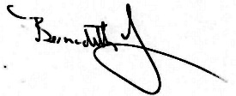
I am satisfied that this work is the result of the student’s own efforts.
Signed: …………………………………………………………………………...
Date: 26 Sep 2025…………………………..

Table of Contents

List of Figures and Tables p. 4
Acknowledgements p. 6
Abstract p. 7
Introduction p. 8
Methodology p. 10
The Mesolithic/Neolithic of the Channel Islands p. 12
The Neolithic Tombs of the Channel Islands p. 13
The Tombs of the Neolithic Atlantic Façade p. 20
Horizon Astronomy p. 22
Landscape p. 26
Cosmology/Mythology p. 28
Results and Discussion p. 33
Towards a Cosmology of the Channel Islands p. 50
Landscape Setting p. 50
Geology p. 53
Ritual Activity p. 57
Towards a Cosmology p. 58
Conclusion p. 61
Bibliography p.65

List of Figures and Tables

Figure 1: The Channel Islands today with sea level change since the Mesolithic, p.2.
Figure 2: Map of Jersey with numbered sites referred to in text, p.7.
Figure 3: Map of Guernsey with numbered sites referred to in text, p.9.
Figure 4: ‘Le Gardien du Tombeau’ at Déhus, p.11.
Figure 5: Neolithic sites on Herm, p. 12.
Figure 6: Distribution of megalithic structures and barrows on Sark, p. 13.
Figure 7: Megalithic tomb distribution across the Atlantic façade, p. 15.
Figure 8: The cross-quarter points of the solar year with solstices and equinoxes, p. 17.
Figure 9: The position of sunrise and full moonrise before (top) during (middle) and after (bottom) the spring full moon, p. 18.
Figure 10: The position of the sun and moon on the horizon at the major lunar standstill, p. 19
Figure 11: Simplified geological map of Guernsey, p. 25.
Figure 12: Simplified geological map of Jersey, p. 25.
Figure 13: Map to show stone provenance on Jersey, p. 26.
Figure 14: Map of sites in Jersey (left) and Guernsey (right) with number used in text, p. 28.
Figure 15: Passage tomb azimuths for the latitude of the Channel Islands at 4000 BCE with the summer and winter solstice axis, equinox and northern and southern major moonrise included, p. 31
Figure 16: Les Fouaillages and site plan, p. 32.
Figure 17: Figure 17a: Le Sergente, Jersey 17b: View from the back of Le Sergente showing visibility of Sark and Le Pinacle, p. 33.
Figure 18: Les Monts Grantez and Dolmen de Geonnais, Jersey, p. 34
Figure 19: La Varde, Guernsey from the entrance and inside back recess and side chamber, with site plan, p. 34
Figure 20: Le Pouquelaye de Faldouet, Jersey, p.35.
Figure 21: Monte Ubé (Guernsey) and reconstructed image p. 35.
Figure 22: Le Couperon gallery grave (Jersey), with ‘port hole’ feature, p. 36.
Figure 23: La Hogue Bie (Jersey) and site plan, p. 37.
Figure 24: Les Creux es Faies (Guernsey) and site plan, p. 37.
Figure 25: Le Trepied (Guernsey) and site plan, p. 38.
Figure 26: Le Déhus (Guernsey) and site plan, p. 38
Figure 27: Delancey (Guernsey) and site plan, p. 39
Figure 28: Roberts Cross (Herm) and site plan, p. 39
Figure 29: Clouet Bay dolmen, Little Sark, Google Earth image of headline between two dolmens and Vermandaye dolmen, pictured with local landowner Phil Perré, p. 40.
Figure 30: Sunset from the top/back of La Varde (Guernsey) at the beginning of August, p. 46
Figure 31: Ville-es-Nouaux gallery grave, Jersey, with striking pink granite and darker diorite stones, p. 48
Figure 32: Creux es Faies with wave worn stone on the right, p. 49
Figure 33: Plagioclase inclusions at Hogue Géonnais and quartz inclusions at Creux es Faies, p. 50
Figure 34: Large round back stones at Faldouet (Jersey) and le Déhus (Guernsey), p. 52
Figure 35: large round back stones at Roberts Cross (Herm) and La Varde (Guernsey), p. 51

Table 1: Astronomical site data, p. 28.
Table 2: Landscape setting, views, geology and material remains summary data for all sites, along with true azimuth for comparison, p. 44.

Acknowledgements

With thanks to Jackie Ward at the Société Guernesiaise for her help in locating papers, and to the librarians in the Priaulx Library for letting me look at the original copy of Lukis’ Collectanea Antiqua. Also to Philip de Jersey for his information on La Varde.
Thanks to all those at Société Sercquaise for letting me use the reading room, and filling me on Barry Cunliffe’s digs, especially Susan Synott, Jo Birch and Margaret Langlois.
To Hazel Fry, and Ray and Mara Smith for letting me stay on Sark and for Mara for accompanying me on dolmen hunting expeditions. To Stephan and Irene for having me to stay on Jersey.
Thanks also to Phil Perré for accompanying me past the bull one rainy January day, and for showing me the elusive Vermandaye Dolmen.
Thanks to Barry Cunliffe for undertaking all his incredible archaeological work on Sark, and for providing the evidence that Sark is indeed a Sacred Island. And to Andrew Prevel for filling me in on the recent digs on Little Sark and for showing me his precious collection.
Thanks to Fabio Silva for sharing information about the lunar standstill at Stonehenge, and to Frances Clynes for her support and encouragement.
Finally, with thanks to my supervisor Bernadette Brady for always sharing her knowledge, wisdom, expertise and guidance, and for inspiring me to undertake this project in the first place.

Abstract

The aim of this project was to undertake a skyscape archaeological assessment of the passage tombs of Jersey, Guernsey, Sark and Herm in the Channel Islands, and to place the results in the wider context of the Neolithic Atlantic tombs builders’ worldview. This was done using a ‘time-space action approach’ that included fieldwork to measure the orientations of the passage tombs; an astronomical analysis of their celestial alignments, with a focus on the sun and the moon; and an assessment of the landscape, geological and material remains left at the tombs. The results showed that all the tombs, regardless of age, island or type, except for the two oldest, were orientated towards the rising sun on the horizon between the winter and summer solstices. Within this range there was clustering at 90°, 95° and 115°, representing the equinox, potentially the equinox crossover of the sun and the moon, and the cross-quarter point we today call Samhain. On Guernsey there was also an alignment to summer solstice sunrise and the Beltane cross-quarter points, demonstrating the significance of the cross-quarter points in the worldview of the builders, and possible evidence for a precursor of what was to become the Celtic cross-quarter festivals. The orientation of the Hogue Bie to the equinoxes could indicate the prime importance accorded by this time of balance. Evidence from the landscape settings, tomb architecture and design, including the nature of the rocks selected, all indicated a cultural cosmology that saw an interplay between darkness and light, the seasonal cycles and the agricultural year with the life and death cycles of the communities that built them, symbolised and energised by the rising and setting of the sun, and possibly, moon, with a possible potential for rebirth at the equinox when the world was in balance. This cosmology could be based in a very ancient cultural astronomy indigenous to the people of the Atlantic façade.

A Skyscape Archaeological Assessment of the Megalithic Tombs of Guernsey, Sark, Jersey and Herm in the Channel Islands
The aim of this project is to contribute to the emerging academic inquiry into the unique importance of the Channel Islands within the broader context of the Neolithic Atlantic tomb builders' worldview, approached from a skyscape perspective, defined by Fabio Silva, as a ‘method to understand the importance of the sky in shaping the worldviews of the people who built them.’ The study will undertake fieldwork at the Neolithic passage tombs of Jersey, Guernsey, Herm and Sark in order to measure and analyse their celestial orientation, with a particular focus on the rising and setting positions of the sun and the moon. Passage tombs and gallery graves will be researched, as each features long entrance passages lined with parallel stones that enable measurement of orientation or direction. It will also assess the landscapes in which these monuments are situated by documenting topographical and environmental features, their positioning, the geological origins of the stones, and how they are employed. Finally, it will analyse material remains and ritual evidence, building on the work of academics such as Barry Cunliffe and Chris Scarre, to help reconstruct a potential Neolithic cosmology, defined by Nick Campion as ‘a worldview according to which cultures and societies locate themselves within the cosmos and engage with it.’
These objectives will be used to answer the research question, ‘How do the orientations of Neolithic passage tombs in the Channel Islands engage with solar and lunar phenomena, and in what ways might these orientations have mediated relationships between skyscape, landscape, and the cosmological worldview of their builders?’

Introduction
The Channel Islands are situated in the Bay of Mont St Michel, just off the coast of Normandy and Brittany, and have belonged to the French mainland, the landmass of Amorica, throughout most of their geological history. Historically they are remnants of the Duchy of Normandy, and therefore through the capacity of the British monarch as Duke of Normandy, they have become Crown dependencies of the UK. Today, the islands are governed by two separate Bailiwicks—Jersey and Guernsey—each with its own laws and political institutions. This unique political status is evident in the culture, geology, and archaeological history of the islands, which began separating from Amorica as sea levels rose following the last interstadial. Today there are five major islands, Jersey (116 km²), Guernsey (78 km²), Alderney (8 km²), Sark (5.5 km²) and Herm (2km²) as shown in Figure 1 below.
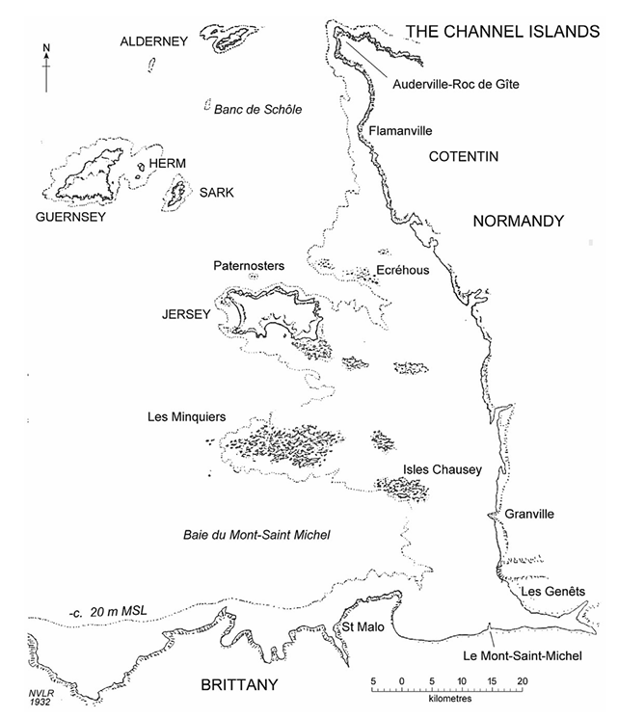
Figure 1: The Channel Islands today with sea level change since the Mesolithic, image after Rybot
The Neanderthals were the first attested inhabitants of the islands, and there is extensive evidence of Mesolithic occupation during the period when they split from the French mainland. According to Heather Sebire, by 5000 BCE Guernsey, Herm, Sark and Alderney were all islands though Jersey remained joined to the Cotentin peninsula and was accessible during exceptionally low tides. During the Middle Neolithic (4000 – 3250 BCE) the incoming farmers intermingled with the Mesolithic inhabitants and large megalithic structures in the form of passage tombs emerged. For around two thousand years vast amounts of resources, time and effort were put into these monuments, of which over twenty remain today, making the Channel Islands one of the most densely populated megalithic landscapes in the UK. James Hibbs suggested that there was once 68 more passage graves on Guernsey alone, and probably 40 – 50 that were destroyed on Jersey between 1682 – 1800. Today around 12 of those surviving are classed as passage tombs and three as gallery graves, consisting usually of a single passage and antechamber. Therefore, as noted by Sebire:
Two separate traditions of monument are still apparent, placing the islands in an interesting position, juxtaposed between the passage graves of the Atlantic coastal distribution and the long mounds of the North European plane.

Methodology
Naked-eye horizon-based methods will be used to examine how ancient sites relate to possible celestial targets, relying on techniques available to their builders but with support from modern analysis. In this project, I have followed Silva’s advice of using a ‘time-space action approach,’ using field techniques to take azimuth, altitude and GPS measurements, combined with an assessment of the landscape environment. Silva’s method uses a ‘window of visibility’ measured from the back of the tomb to the opening, taking a minimum and maximum compass bearing and an altitude measurement, that can then be combined to calculate a declination. Field work was conducted in Jersey, Guernsey, Sark and Herm during multiple visits between July 2024 – July 2025 and based on data collected over a period of 25 years through regular trips to these islands.
In the field, I used survey poles and string to mark a ‘window of visibility’ from the back of the tombs, and a Suunto KB-20 compass to take two horizon azimuths from their intersection at the tomb’s front. These values were then corrected for magnetic declination to measure true azimuth using the NOAA website. For example, according to NOAA, the difference in magnetic declination for the location of Le Hogue Bie on Jersey on the 20.2.2025 was 0.48 E (± 0.37 degrees), so this figure was added to get the true azimuth. I used a mobile phone to take latitude and longitude coordinates and site elevation, then verified these in Google Earth. Where relevant, I measured horizon altitude from the opening of the tomb using a Suunto PM-5/360 PC clinometer with a level of uncertainty of 0.5 ⁰. With the horizon being flat it was deemed most useful to work predominantly with true azimuth, which was then plotted on a compass ring for visual considerations. Stellarium version 24.1 was then used to ascertain whether, and when, the orientations of the passages coincided with the rising or setting positions of celestial objects, in particular the sun or moon, in 4000 BCE.
Using Vicki Cummings method of approaching a complex site, I combined scientific measurements that can be represented in a ‘coherent and reproducible format’ with elements of a phenomenological perspective, such as taking photographs, and placing myself in the site.I also used existing archaeological maps, noted key landscape features and their orientation; views and proximity to water; and the geology of the stones and how they were used. As a member of both the Société Sercquaise and Société Guernesiaise, I used the reading rooms to examine the archaeological record and to understand, as described by Silva, how ‘the skyscape was experienced and understood by the people who built them and embedded itself in their culture/society.’ This approach, one that combines a landscape, skyscape, cultural and cosmological perspective can be described as ‘cultural astronomy.’ The astronomical data, including azimuth, latitude, longitude, was summarised in Table 1 and the landscape, material remains and geological information in Table 2.

The Mesolithic/Neolithic of the Channel Islands
It is now widely recognised that what was once known as the Neolithic revolution across western Europe was a gradual process of mingling and integration between the indigenous Mesolithic inhabitants and incoming agricultural communities. These agriculturalists originated in Anatolia and came across the European mainland via the Danubian basin, possibly, as Barry Cunfliffe suggested, migrating because of changing climate. In any case, these incomers became known as the Linearbandkeramik (LBK) people, or those who took another route, the impressed ware/cardinal ware people of the Paris Basin and Brittany. There on the coast, probably through deep sea and coastal fishing, they interacted with each other and with the indigenous Mesolithic hunter-gatherers to develop what became known as Neolithic culture.
At the beginning of the Mesolithic, the islands that comprise the Channel Islands were linked to the mainland. According to research conducted by Sebire, as sea levels rose at the beginning of the last interstadial, land receded until by 5000 BCE Guernsey, Herm, Sark and Alderney were all islands. Recent studies have uncovered a wealth of remains to show that Guernsey, Jersey and Alderney were inhabited through the whole of the Mesolithic, but particularly from around 8500 cal. BC. The Middle Mesolithic was a time of rapid sea rise, creating, according to David Bukach, ‘a new focus on maritime lifeways, with more opportunities for maritime travel and access to a greater quantity of marine resources. It is also possible that islands held a deeper significance for the Mesolithic people, who went out of their way to colonise them even when difficulties were faced.
Meanwhile, as described by David Johnston, the Danubian people with their LBK pottery had arrived in the Paris Basin and merged with (or became) the Cerny culture. Around this time, during the 5th millennium BCE, one of the earliest forms of Neolithic architecture began to appear, the long mounds of northwest France. As Neolithic people progressively spread to Britain and Ireland, according to Chris Scarre, they drew on these structures, developing their own indigenous versions that became known as passage tombs. It is reasonable to place the passage tombs of the Channel Islands in this broader trajectory.
The earliest evidence for indigenous hunter gatherers adopting Neolithic elements in the Channel Islands comes from charcoal and pottery found at Camp Varouf on Guernsey, radiocarbon dated by Barry Cunliffe to 5200 BCE. Similar pottery was also found at Le Pinacle on Jersey, a multi-layered occupation site that included, according to Mark Patton, a Neolithic axe-making site, a Bronze Age sanctuary and a Celtic-Romano temple, showing how gradually the Neolithic people of the Atlantic façade brought their culture to the Channel Islands. Les Fouaillages on Guernsey offers the earliest known funerary structure on the Islands, radiocarbon dated by Patton to between 4600 and 4880 BCE at the Mesolithic-Neolithic transition.
To summarise, there is archaeological evidence for habitation in the Channel Islands starting with the Neanderthal, then the Mesolithic hunter-gatherers as sea levels rose. Incoming agriculturalists later intermingled with the indigenous population to develop a new way of life that included making pottery and building stone monuments in which to bury their dead.

The Neolithic Tombs of the Channel Islands
A chronological overview of passage tombs and gallery graves for each island will now be presented, and site plans and photographs provided in the Results section. The archaeological information is summarised in Table 2 for ease of reference.
- Jersey
Key
1. Les Monts Grantez 7. La Motte
2. La Pinacle 8. Mont Ube
3. Dolmen de Geonnaise 9. Villes-es-Nouaux
4. Le Couperon 10. La Table des Marthes
5. La Pouquelaye de Faldouet 11. La Sergente
6. La Hogue Bie 12. Menhirs

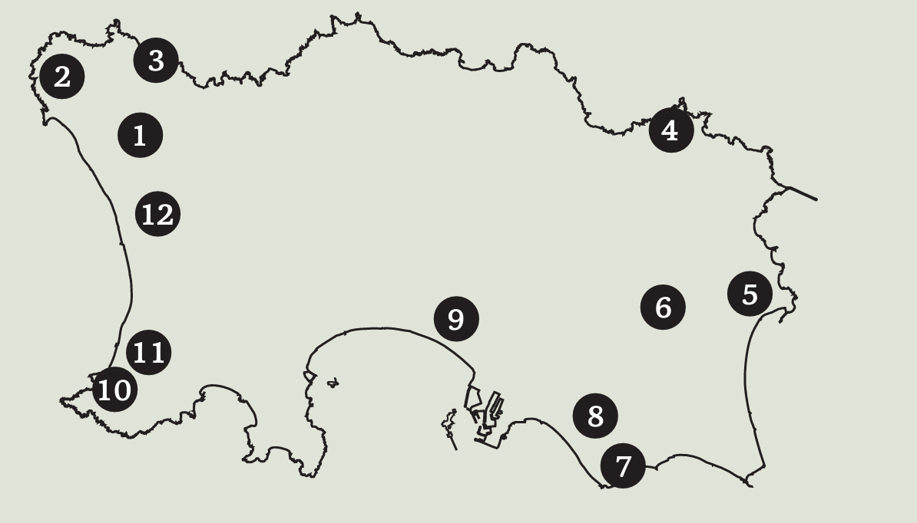
Figure 2: Map of Jersey with numbered sites referred to in the text, image after Jersey Heritage
La Sergenté (11) on Jersey was contemporary with the early phase of Les Fouaillages (around 4500 BCE) and the Neolithic occupation at La Pinacle (2) and could have been built during the final phase of Jersey’s separation with the mainland. It was unique in that it had a circular chamber with a corbelled, vaulted roof, placing the origin of the builders in Normandy where this type of tomb was more common.
Six monuments have been assigned a date of around 4000 BCE based on radio-carbon analysis of the earliest burial remains. La Pouquelaye de Faldouet (5) on the west of the island had a long entrance passage leading to a large chamber surrounded by cists and capped by a massage rhyolitic capstone. Pottery, stone pendants, polished axes and human remains were found within the chamber. Monte Ubé (8) in the south consisted of a large chamber and long passage that once had 19 stone pillars along its length. Shards of around 10 pots were found, as well as grave goods including a grape cup. Les Monts Grantez (1) on the west consisted of an oval chamber and side chamber, with a 4m long passage, once covered over by a mound. Seven burials were found in the chamber with grave goods, including animal bones and limpet shells. On the northeast coast was Dolmen de Géonnais (3) with a narrow passage with six uprights leading to a large rectangular D-shaped chamber covered with sea pebbles. Flint tools, pottery and human remains were found in the chamber, and it was also once covered by a rubble mound.
Though La Pinacle’s (2) east facing natural rock formation is the most dramatic of the Channel Islands sites, La Hogue Bie (6) is the most architecturally complex. Described by Patton as a ‘megalithic cathedral,’ it is situated on the second highest point of Jersey within site of the ocean and comprised a long passage leading to a ‘bottle shaped chamber’ with three side openings, making it a cruciform shape. It is still covered in a large mound around 12 m high and 54 m in diameter. Uprights divided the main chamber, forming an ‘inner sanctum’ at the back of the tomb, covered by huge cap stones with cup mark decorations. The original structure has been dated by Patton to around 4200 cal. BCE and was used until 3515 BCE when it was deliberately backfilled with rubble, and finally sealed around 2900 cal. BCE when the site was abandoned, a pattern that occurred across the Channel Island (and Brittany) with the arrival of the Beaker people. Bones of up to eight individuals, ceramic shards, two complete ‘vase supports’ and three betyls (30 cm high) were found at the site. It’s cruciform shape and evidence of ritual activity are reminiscent of Brú na Bóinne in Ireland, though it predates the Irish megalithic sites by nearly one thousand years. Patton places it within the context of the Armorican passage graves originally surveyed by Jean L’Helgouach in 1965, though he also notes that a cruciform plan is not usual in that region.
Jersey also had two remaining gallery graves dating back to the late Neolithic (3250 – 2850 BCE), described by Chris Scarre as originating from the allées couverte of northwest France and Brittany. Simpler in design, these structures comprised a single passage and antechamber, prompting Paul Driscoll to suggest they may have emerged during a period of societal decline, and ‘a greater access to ritual knowledge.’ Le Couperon (4) on the east is one example and consisted of a rectangular chamber with five capstones held in place by 11 uprights. The chamber was originally divided into two, probably by the porthole slab, now at the entrance of the passage. Twenty-two stones surrounded the chamber, which according to Frederick Lukis, would have originally been set into a long mound. The second is Ville-és-Nouaux (9) at dating from 3250 – 2850 BCE, consisting of a ‘parallel-sided chamber with a stone revetment on the north side.’ Finds date back to the early Neolithic and included a burial, and an archer’s wrist guard.
ii) Guernsey

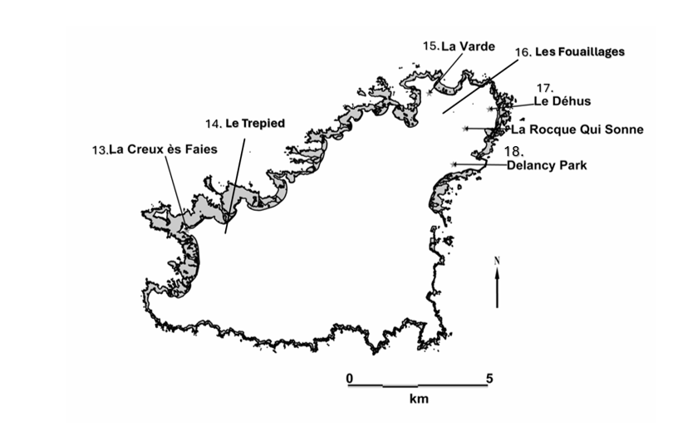
Figure 3: Map of Guernsey with numbered sites as referred to next, image after Driscolland amended by author
Les Fouaillages (16) is the oldest site on Guernsey, technically described as a long mound, and therefore with a potential origin in NW France. According to Ian Kinnes, the four original structure of the site were built along a NE-SW line, suggesting that orientations could have played a significant role in the layout and design at this early stage. Patton also reported that the first structure site was built on top of a previous Mesolithic settlement, emphasising the importance of continuity for the builders.
La Varde (15) is one of most intact of the passage tombs and consisted of a large chamber with upright slabs and a massive capstone. The entrance passage is 11 m long and around 2 m high. Pottery from some 150 vessels and human remains were found indicating a period of use from at least 3500 BCE. It was also originally covered by a mound, as was the Déhus (17) passage grave dating to the same period. In both cases, the tomb entrances are low and narrow, making it necessary to bow down, or crawl, before reaching a broad chamber. Le Déhus (17) also had four side chambers lined by stones and roofed with three large capstones, one of which was supported by a freestanding pillar. On the underside of the second capstone is a sculptured human figure, possibly holding a bow and arrow – see Figure 4 below. This is the only example of tomb art found in the Channel Islands. Material remains included bowls and, uniquely, the bodies of two adults placed in a kneeling position and surrounded by limpet shells and earth.
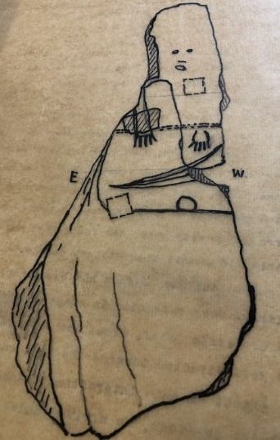
Figure 4: ‘Le Gardien du Tombeau’ at Déhus, image after Lukis
Le Creux ès Faies (13) and Le Trepied (14) are situated in the southwest, near to Lihou island which is the most westerly point in the Channel Islands. Though dateable material found in le Creux ès Faies (13) goes back to 2000 BCE, this may only represent the final phases of use and even an earlier tomb on the same site. The same is the case for Le Trepied (14) where flint remains, human bones and pottery date the final phases of its use to around 3000 – 2000 BCE.
On the northeast is Guernsey’s only gallery grave, situated on the northern slope of Delancey Park (18), overlooking the sea and the islands of Sark and Herm. The site today is in a poor state of repair but excavations by George Nash described the entrance passage as 9.5 m and comprising 16 granite stones. Material remains have been radiocarbon dated to around 2500 BCE though the site could have been in use well before this. Finally, also in the northeast, La Rocque qui Sonné was said by Lukis to have consisted of nine capstones was probably the largest in Guernsey before it was destroyed by a local landowner.
iii) Herm
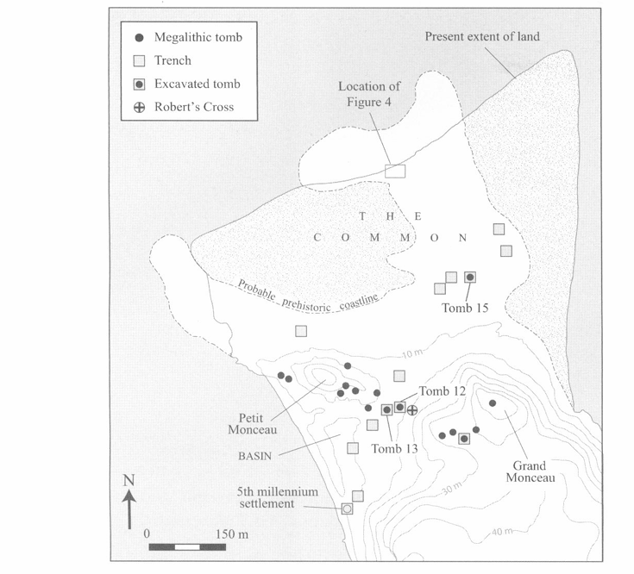
Figure 5: The Neolithic sites on Herm, image after Bailiff et al
On Herm there were assemblages dating back to 4700 – 4500 BCE attributed to the Cerny group, all of which are clustered on the flat common in the north of the island, dominated by the high grounds of the Grand and Petite Monceau (see Figure 5). Apart from tomb 12 at Robert’s Cross, poor states of repair did not allow for surveying, but Chris Scarre of Durham University reported all the tombs featured elongated chambers, orthostatic walls, and narrow east-facing entrances.
iv) Sark
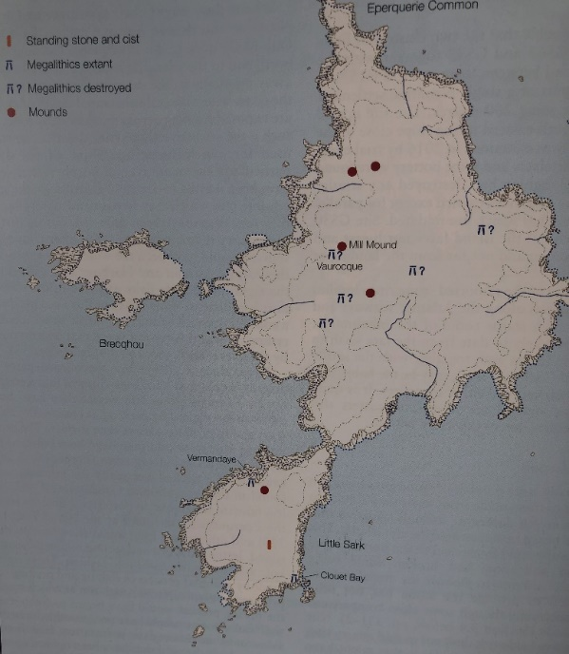
Figure 6: Distribution of megalithic structures and barrows on Sark, image after Cunliffe
The earliest evidence of farming is on little Sark where an excavation by Barry Cunliffe yielded hearth material with a radiocarbon date of 4800 – 4700 BCE. Cunliffe also found over 100 dolerite axes, hinting at a long-lived ‘axe producing factory’ and seven stone mounds, two of which have been excavated. At the Gaudinerie mound evidence of complex ritual activity dating back to 4300 BCE was found, making this site roughly contemporary with Les Fouaillages on Guernsey. There are also two dolmens on Little Sark (see Figure 6) that have not been dated, but they were surveyed in detail by David Johnson who believed they ‘must belong to the final states of the megalithic tradition.’
v) Alderney
According to F. C Lukis, there were once two passage graves on Alderney in the northeast of the island overlooking Longis Common, now named Les Pourciaux North and South. Both yielded human remains and limpet shells, but as they were used as gun-emplacements during the war, they do not survive in any recognisable form today and were not surveyed in this project.
To summarise, on Jersey there are six surviving passage tombs dating back to around 4000 BCE, and two gallery graves dating to around 2850 BCE. During this period, Guernsey had five passage tombs and a gallery grave. Of the 15 original tombs on Herm, one passage tomb remained at Robert Cross, and Sark had extensive evidence for ritual activity going back to 4800 BCE, including two cliff-side dolmens. The neolithic remains of Alderney no longer survive due to extensive war damage.

The Tombs of the Neolithic Atlantic façade
Some of the oldest megalithic structures in the world are found in what is known as the Atlantic façade, a geographical area encompassing a large part of the European Atlantic coast (see Figure 7).
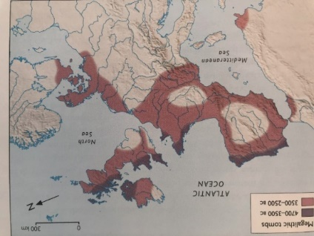
Figure 7: Megalithic tomb distribution across the Atlantic façade, image after Cunliffe
Over the past twenty years, tomb orientations across the region have been extensively studied, starting with Jean L’Helgouach in 1965. He recorded 140 gallery graves in Brittany alone and concluded that most of the Amorican tombs faced east, a practice he considered standard amongst the passage graves of Atlantic Europe. Scarre used plans of the Brittany passage tombs to establish a principle orientation and found that most, though not all, the azimuths were approximately 135° and therefore orientated towards the southeast. Michael Hoskins took a more systematic approach when undertaking field surveys of over 1,500 megalithic tombs of the Western Mediterranean using a strict methodology that defined an axes of symmetry using poles at each site, before applying statistical analysis to the results. His findings showed that in Sardina most tombs were orientated towards the southeast, as well as a statistically significant number across Iberia, NW and Western France. A different trend was reported in Menorca (southwest) and the French Mediterranean (sunset or declining sun). The orientations were the most striking in Atlentjo in Portugal where 177 tombs all faced within the range of the sun (and therefore moon) rise. In Ireland, Frank Prendergast surveyed 163 passage tombs that were intact enough for an axial azimuth of be measured and found a preference for the direction of winter solstice sunset, though a range of other directions were also seen, including summer solstice and equinox orientations. In the Boyne Valley, Brú na Bóinne has a demonstrated and well-observed orientation to the winter solstice sunrise, and Knowth’s east-west facing passages have been linked to equinox sunrise and sunset. An equinoctial alignment has also been observed by Martin Brennan at Loughcrew in Country Meath when the rising sun illuminates an embellished stone at the back recess. However, Prendergast discounts the Knowth true east-west orientation on the basis that a magnetic rather than true azimuth was used when constructing the plans, and conducted his own survey which concluded that ‘the full alignment at Knowth West does not occur until two weeks after the autumn equinox has passed.’ He therefore questioned whether the equinox had any significance to agrarian societies and dismisses the prevalence of the due east/west orientation for tombs across Europe. Taking a different view, Murphy and Moore argued that the aim of the builders at Knowth was actually much more complex: rather than attempting an exact east-west alignment, and failing, they were actually trying to work out a method of aligning the lunar and solar cycles. Kate Prendergast building on this work conducted detailed analysis of the alignments and tomb art at Knowth, and concluded that the builders were using ‘precise alignments and sophisticated calculations to both identify the equinoxes and facilitate the counting of the moon’s cycles in relation to the sun.’

Horizon Astronomy
It is therefore evident that Neolithic people over the Atlantic façade recognised the sun’s daily movement and were aware of the solstices. As described by Bernadette Brady, a solstice is when the sun reaches its northern or southern-most extent in relation to the celestial equator, and when observed on the horizon, it appears to standstill before then rising (and setting) in a different direction. In winter this is the point where the days begin to lengthen and nights shorten, and in the summer the reverse is true, seasonal turning points that would have been significant to both hunter-gatherers and agricultural people. Though marking the solstices is relatively straightforward as the sun stand still, it moves much faster at the equinox making it more difficult to define the timing precisely. However, as the equinox occurs halfway between the solstices, it would have technically been possible to count the days and mark out a halfway point. Furthermore, once these two points have been established it would theoretically be possible to sub-divide the year further using the same counting method, resulting in what is today known as the eight-fold wheel of the year. In ancient Ireland, according to Ronal Hicks, the cross- quarter points between the solstices and equinoxes were celebrated as festivals to mark agricultural and calendrical time (see Figure 8). Imbolc marked the beginning of the agricultural year, Beltane was when the flocks were driven to the summer pastures, Lughnasa the beginning of harvest, and Samhain when the flocks returned at the end of harvest.
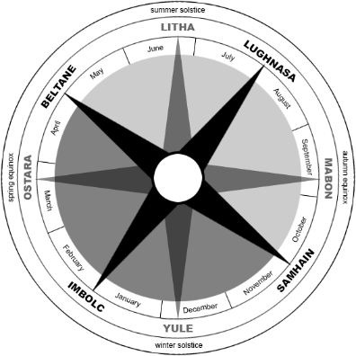
Figure 8: The four cross-quarter points of the solar year with solstices and equinoxes, after Wikipedia
It should also be noted that the movements of the sun and the moon are closely linked to each other. As the sun defines the ecliptic and the moon only varies by 5° degrees above or below the ecliptic, both will engage with the horizon in a similar arc and culminate in the south. In the winter, the sun rises in the southeast and sets in the southwest, whereas the moon rises from the northeast and sets in the northwest; in the summer the reverse is true. This leads to an astronomical phenomenon that occurs around the equinox, when the two appear to change positions, or crossover. According to Fabio Silva, this ‘crossover’ is empirically observed for the first time at the spring full moon when the sun and moon rise and set very close to each other, but twelve hours apart (Figure 9). Silva suggested that crossover events could have been used to define seasonal transitions, or as a way to harmonise a lunar/solar calendar, as also suggested by K. Prendergast above.
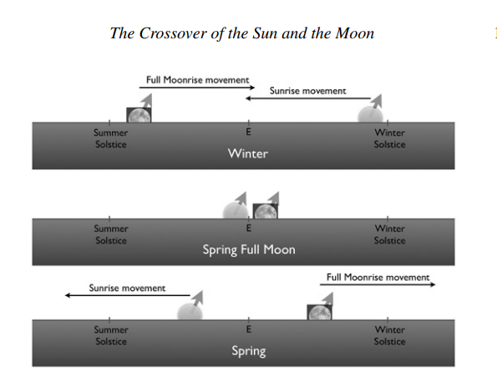
Figure 9: The position of sunrise and full moonrise before (top) during (middle) and after (bottom) the spring full moon, after Silva
According to Cândido Marciano da Silva, the average rising positions of the equinox sun and full moon is 97.3°, an orientation found by Pimenta and Silva to be statistically significant in the megalithic monuments of Alentjo. In the orientations of the megalithic cromlechs of Iberia, Pimenta and Tirapico found evidence for a ritual interest in the autumn equinox full moon cross-over of the hunter gatherer farmers who used the sites in a seasonable way. The authors suggest that the spring and autumn full moon cross overs were used to track the seasonality of wild animal migration who went in search of better pastures, rooting this phenomenon and associated worldview in the Mesolithic past. However, they also caution that as no megalithic structures remain from the Mesolithic, this can only be based on what Pimenta described as an ‘indirect, very long term transmission of general traits.’
There is another phenomenon of the moon that could have been of interest to ancient people that today we call the lunar standstills. Due to precession of the rotational axis of the sun and the moon, and the fact that the moon’s orbit around Earth is tilted, the moon appears to swing high and low throughout the month, reaching a peak every 18.6 years. The phase where the orbital tilts align to cause extreme lunar declinations is dubbed the major lunar standstill, whereas 9.3 years later, when the orbit tilts detract from each other, is the minor lunar standstill. As shown in Figure 10, the moon rises and sets outside of the solar range during a standstill.
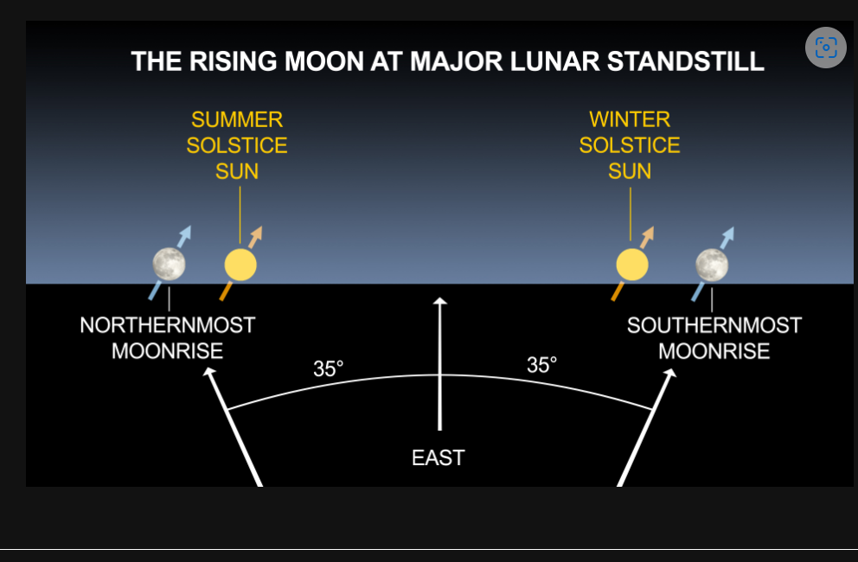
Figure 10: The position of the sun and moon on the horizon at the major lunar standstill, after the Griffith Observatory
Clive Ruggles has demonstrated that the Scottish recumbent rows have statistically significant alignments to both the major standstills, and Lionel Simms also proposed that minor lunar standstills could have been seen as significant because of ties with the winter solstice sunset at the time of the dark moonset. However, statistical analysis conducted by Prendergast on the middle to late Neolithic tombs found that solstice alignments were favoured over those of the lunar standstill, though this does not rule out standstill orientations altogether.
To summarise, extensive studies have shown that the orientations of the passage tombs of the Atlantic façade over large geographical areas and long periods of time show a marked correlation with the seasonal horizon movement of the sun, and potentially the moon, with a focus on the rising or setting sun at the solstices and equinox, and potentially the equinox crossovers and lunar standstills.

Landscape
In addition to examining the role of the sky in the placement of Neolithic monuments, it is important to consider both the choice of landscape and building materials used. According to Scarre, local topography not only supplied building materials for monuments, but also influenced their placement and design by offering striking settings and shaping ideas about form. As a result, these places gained significance and meaning to the builders, a concept known as ‘power of place.’
Scarre also noted that shorelines could have been considered special in that they comprised a boundary between land, sea and sky, a mutable zone where contact and communication between realms could take place, and therefore potentially of cosmological importance. He noted that the coast has ‘its own sounds, smell and qualities, making it a liminal zone where the dead were therefore placed.’ Animals that moved between the elements took on meaning, which could explain why limpets were used so often in a funerary context. Scarre found that most of the megalithic tombs in Brittany were placed on shorelines, usually with a sea-view backdrop, so to test this theory on Guernsey, Kevin Jelly conducted a ‘viewshed analysis study,’ reconstructing the ancient topography of L’Ancresse in the northwest, an area of dense megalithic tomb distribution. He concluded that all the passage tombs were built with a view of the sea, usually visible from behind the tomb when approached from the landward side. Therefore, if the passage entrance faced the rising sun, the setting sun could potentially be seen from behind or on top of the tomb, bringing the entire land and seascape into focus. This reminds us, as Brady pointed out, that a’ rhythm is embedded into any landscape, a rhythm which unites place and time with light and dark, sun and moon, all played out over the course of an exact year.’
Islands themselves, with their abundant shorelines and unique inter-island visibility could have had special status, as the work of both Cunliffe and Scarre have demonstrated. A distribution study of megalithic sites around the coast of Britain showed the highest proportion of tombs were found in the Scilly and Arran Isles – and the Channel Islands. There could also be social-economic reasons why islands in general have such a high density of funerary monuments, as fish and shellfish provided a good source of protein, and shells and unusual stones were classed as prestigious goods and used either in ritual or for trading.However, according to Scarre, isotopic analysis on human remains shows a shift away from fish at the beginning of the Neolithic, so there is no ‘overwhelming emphasis on the use of marine resources.’ Cosmological reasons could therefore have been just as, if not more important, than economic. Scarre, struck by the large tomb density on Herm, suggested that people were buried on the island who did not live there, bringing up questions of whether it was regarded as a sacred island reserved primarily for the dead. Cunliffe too believed that Sark might have been one of the many sacred islands along the Atlantic interface that Strabo wrote about at the end of the first century BCE.
To summarise, landscape was not only a backdrop and a source of materials to build the tombs but also had its own agency that informed the worldview involved in construction and use. Shorelines, and in particular islands, could have held special significance in that they are liminal zones, a mutable boundary between sea and sky, and as such were used in a funerary context. The proximity to the sea, and the view from the tombs, therefore played a key role in their placement.

Cosmology/Mythology
The sun's daily rise and set mark diurnal time, while its movement from solstice to solstice defines the seasons, and the rising of the full moon coinciding with the setting of the sun once a month amplifies it. As described by Brady, the movements of the sun enable a horizon calendar to be calculated with points along the horizon marking individual days of the year, something that could have particular relevance in an agrarian society for marking the time when crops should be sown, harvested, etc. In addition, as Prendergast noted, the deliberate orientations of the passage tombs could also embody ‘broader cultural and cosmological beliefs. He suggested that the sun, often viewed as the supreme cosmic entity, was believed to nourish the spirits of those buried in tombs.
Although early myths were not recorded, stone evidence and material remains show that ritualistic collective burials occurred widely during the Neolithic era, and ritual implies myth. Archaeological evidence reported by Cunliffe suggested that trade links existed throughout the Atlantic façade enabling a shared cosmology to develop that incorporated the movement of the sun and the interconnection with the agricultural seasons with religious festivals and ancestral worship. In addition, as suggested by Scarre, this cosmology could have had origins deep in the Mesolithic, in turn taken and shaped by the incoming farmers to create a shared cosmology and mythology. The oldest surviving written mythology of the Atlantic façade is that of the Irish and Welsh, and given the key role played by passage tombs, or mounds, in their mythology, it is feasible they contain relics of these earlier beliefs. O’Kelly, who excavated Brú na Bóinne, suggested that the Irish oral tradition, reflected in the connection between myths and monuments, could have begun with the Neolithic builders. John Waddell also suggests that common mytho-poetic themes were part of a common Indo-European inheritance that could be thousands of years old.
The Wooing of Etain is the one of the earliest known such myths. First recorded in the ninth century, it describes the conception of a hero by supernatural parents. The Dadga, originally an earth god, has intercourse with Boine, the river goddess, who then gives birth to the Mag Og, so named because ‘he was begotten at the beginning of a day, and born between then and evening.’ This event is a ‘cosmic’ event because he was conceived when magical spells stopped the passage of time, evoking the ‘standing still’ of the sun at the solstices. This union took place at Brú na Bóinne, a passage tomb covered in a mound in the Boyne Valley and linked to the rebirth of the sun at the winter solstice. It is also noteworthy that in Celtic mythology, islands had a special significance and were often also associated with the Otherworld (Annwyn), places of plenty and abundance where the ancestors dwelt, and where time stood still.
To summarise, the orientation of the passage tombs towards the rising sun could reflect long held beliefs across the Atlantic façade in the power of the sun to bring life, or rebirth, at magical and potent sites covered in mounds. Fragments of this ancient belief are still preserved in Celtic mythology as in, for example, the Wooing of Etain.

Geology
The Channel Islands are the last remaining phase of an ancient mountain building event knows as the Cadomian Orogeny and therefore have a unique range of igneous and metamorphic rocks, including rare dolerite and serpentine, visible along their extensive coastlines (see Figures 11 and 12). David Bukach carried out a survey of the geological provenance of stones used to build tombs on both Guernsey and Jersey and found that they were not selected for convenience. At La Varde (15) on Guernsey, despite the predominance of Bordeaux diorite bedrock, a L’Ancresse diorite capstone was also used. At Le Déhus (17), the capstone was of light coloured L’Ancresse diorite, and structural stones darker Bordeaux diorite and the ring of stones around the mound alternated between the two. At Le Trepied (14), the capstone is made from L’Ecrée granite, featuring large inclusions of alkali feldspar, though the site is on a bedrock of Perelle gneiss. At Le Creux ès Faies (13), he found that three of the large uprights were made from Perelle gneiss, though they were more distant than the L’Ecress granite bedrock.
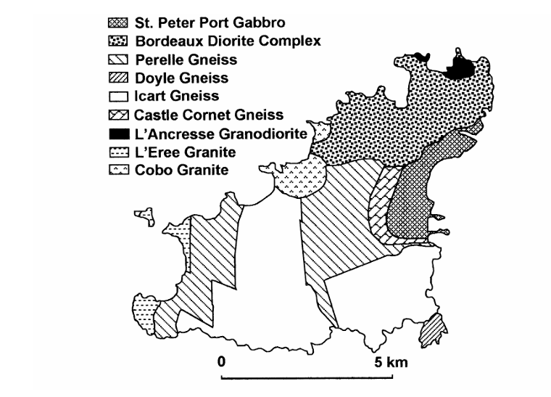
Figure 11: Simplified geological map of Guernsey, after Bukach
A similar theme was found on Jersey. Le Sergenté (11) and the Hogue Géonnais (3) were constructed from local granite, but Le Faldouet (5) had support stones made from Fort Regent granite and a rhyolitic capstone. Le Monts Grantez (1) was made up of local NW granite but also SW granite that came from longer distances; Le Mont Ubé (8) was made primarily from local Fort Regent granite but the four uprights at the entrance were made from diorite and could have once been capstones.
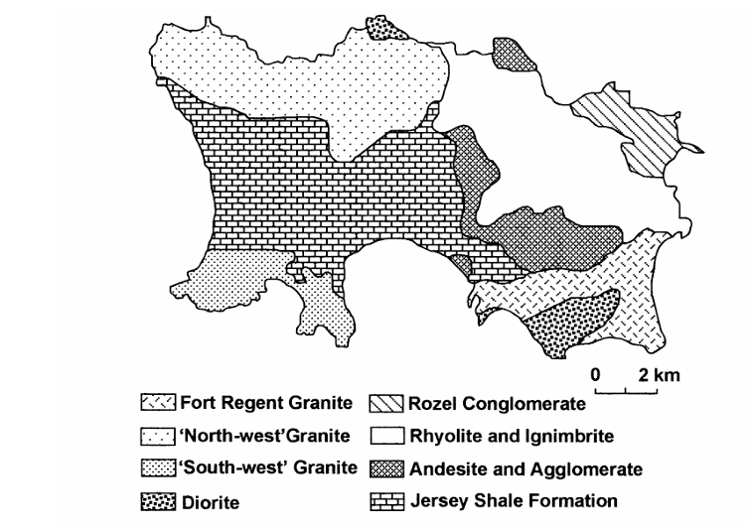
Figure 12: Simplified geological map of Jersey, from Bukach
At La Hogue Bie (6), the situation is more complex. According to Arthur Mourant, of the 64 stones that make up the monument, only three originated from local bedrock and as shown in Figure 12, the seventeen capstones contained a sample of all seven rock types found at the site. Patton calculated it would have needed 200 people working for 160 days just to transport the orthostats and capstones; taking the mound into account, this would increase to 600 days. He therefore concluded that the island was divided up into clans, with each clan having a fixed area and tomb building style. These clans, and their associated rocks, were then represented in La Hogue Bie in a sophisticated cruciform-shaped communal tomb, reflecting, according to Bukach, their individual identities. He criticises Patton’s analysis as for ‘regarding passage tombs as a passive rather than active reflection of the society that built them,’ though he himself does not link the builder’s choices with a potential worldview.
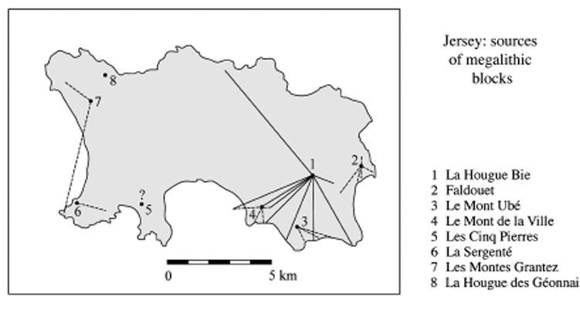
Figure 13: Map to show stone provenance on Jersey, after Patton
Bukach further suggested that choice and pattern of grave construction to express identity could be linked to the ideological significance attributed to prominent features in the landscape, which then could lead to stones being imbued with the same mystical or sacred qualities. This infers that stones could have also had symbolic as well as structural properties; at La Hougue Bie, 15 out of 65 blocks were ‘wave-worn’ and therefore representing elements of the sea, as were, according to de Guerin, the flagstones at le Dehus.’ Patricia Kenny also looked at the use of structural stones in megalithic monuments which contain geological inclusions (SWI’s) over the Atlantic façade and concluded that they were deliberately placed so as to be seen, implying they were invested with cultural or cosmological meaning.
Finally, studies by Nick and Philippe Aubin focussed on the size and shape of the orthostats used at the back of passage grave tombs in seven tombs across the Channel Islands, comparing them to the orthostats at the sides.Statistical analysis showed that for all sites bar one, the key orthostat at the back differed in size and shape to the others. They attributed a special significance to the choice and positioning of these stones and concluded that, given the astronomical orientation of the tombs the rising sun, the large roundish stones chosen to go at the back could be seen ‘as representing the sun on its hidden return from sunset back to sunrise.’
To summarise, the type of rock, colour, size and shape, and the patterns and inclusions on the surface, played a key role in the architecture of the passage tombs. Builders seem to have chosen and positioned rocks deliberately according to size and origins, potentially contributing to their significance within a larger cultural framework.

Results and Discussion
Field work findings are presented in two tables below. Table 1 displays the astronomical data, while Table 2 provides information on the landscape setting, geology, and material remains associated with each site.
Name and number of site | Description | Date BCE | Latitude (degrees) | Longitude (degrees) | Elevation (m) ± 1 m | Altitude (degrees) ± 0.5 degrees | True Azimuth (degrees) ± 2.0 degrees | Declination (degrees)
1.Les Monts Grantez (Jersey) | Passage grave | 4000- 3250 | 49.23111111 | -2.223055556 | 80 | 0.0 | 115.43 | -16.28452874
2.La Pinacle | Neolithic axe production,  Chalcolithic  Gallo-Roman temple | 4800  2850  AD 200 | 49.24753889 | -2.253750000 | 6 | 9.0 | 274.43
3.Dolmen de Geonnais (Jersey) | Passage grave | 4000 | 49.25027778 | -2.214166667 | 80 | 3.0 | 115.43 | -16.27803416
4.Le Couperon (Jersey) | Gallery grave | 2850 | 49.23416667 | -2.035000000 | 25 | 0.0 | 95.49 | -0.31995261
5.La Faldouet (Jersey) | Passage | 4000 | 49.20277778 | -2.026666667 | 72 | 0.0 | 95.49 | -2.931971411
6.La Hogue Bie (Jersey) | Cruciform passage grave | 4000 | 49.20027778 | -2.063611111 | 90 | 0.0 | 90.48 | -0.313638026
8.Mont Ube (Jersey) | Passage grave | 4000 | 49.17388889 | -2.072777778 | 38 | 4.0 | 95.48 | -0.544139013
9.Villes-es-Nouaux (Jersey) | Gallery grave | 2850 | 49.19638889 | -2.130555556 | 14 | 0 | 115.46 | -16.31473435
11.La Sergente (Jersey) | Corbelled passage grave | 4500 | 49.18583333 | -2.231666667 | 52 | 0 | 142.43 | -31.20190126
13.Les Creux es Faies (Guernsey) | Passage grave | 3000 | 49.45646389 | -2.655427778 | 17 | 3.0 | 90.25 | 2.116893657
14.Le Trepied (Guernsey) | Passage grave | 4000 | 49.46024167 | -3.392655556 | 13 | 0 | 55.00 | 21.88906265
15.La Varde (Guernsey) | Passage grave | 4000 | 49.50168056 | -2.536319444 | 15 | 1.0 | 115.28 | -15.30865478
16.Les Fouaillages (Guernsey) | Passage grave (long mound) | 4500 | 49.49744444 | -2.537622222 | 7 | 1.0 | 42.28 | 29.58583095
17.Dehus (Guernsey) | Passage grave | 3500 | 49.49717778 | -2.506427778 | 17 | 0 | 65.20 | 15.75363963
18. Delancey (Guernsey) | Gallery grave | 2500 | 49.47888889 | - 2.524188887 | 20 | 0 | 98.29 | - 5.375355129
19.Roberts Cross (Herm) | Passage grave | 4000 | 49.477132 | -2.45273800 | 11 | 8.0 | 90.32 | 5.865778863
20.Clouet Bay Dolmen (Sark) | Dolmen | n/a | 49.41097222 | -2.370483333 | 70 | 0 | 195.34 | -38.86215156
21.Vermandaye Dolmen (Sark) | Dolmen | n/a | 49.41638889 | - 2.373611111 | 52 | 0 | 340.34 | 37.77910022

Table 1 – Astronomical site data
Figure 14: Map of sites in Jersey (left) and Guernsey (right) with number used in text. (Images: Jersey, after Jersey Heritage), Guernsey: image after Driscolland amended by author)
Most of the Channel Islands passage tombs have been radiocarbon dated using material remains found in situ to around 4000 BCE, with the gallery graves being built later, usually around 3000 BCE. A representative date of 4000 BCE was therefore used to establish the solar range during time of building, and a comparison azimuth also obtained for 3000 BCE. It should be noted, however, that the century is not critical insofar as the azimuths of solar events are concerned; for example, according to Clive Ruggles, in 4500 BCE the azimuth of sunrise and sunset were within a quarter of a degree of those for 3500 BCE. Using Ruggles data, the obliquity of the ecliptic (ε) for the year 4000 BCE was 24.1, reducing to 24.0° in 3000 BCE. This gives a declination for the sun at the summer solstice as + 24.1° for this year, and a declination of – 24.1° at the winter solstice. Using Stellarium (version 24.1) and setting the solar declination (ε) at 24.1°, an azimuth of 52° (± 2°) for the summer solstice sunrise was obtained and an azimuth of 128° (± 2°) for winter solstice sunrise for a 0° horizon. Using a declination of 0° for the equinox sunrise resulted in an azimuth of 90° in the same timeframe. For comparison, the solar range for 3000 BCE was determined using an obliquity value (ε) of 24.0° and a 0° horizon. This calculation yields a summer solstice sunrise azimuth of 54° (± 2°) and a winter solstice sunrise azimuth of 131° (± 2°). As an average of both measurements was within the range of the measurement uncertainty, the solar range for the passage graves of 52° and 128° was used and plotted in red on Figure 12 below.
There are several reasons for the large measurement uncertainty. Firstly, the granite bedrock of the Channel Islands can affect the Sunto compass, giving different reading and resulting in a large azimuth uncertainty. Secondly, Le Conte defines sunrise as occurring when the upper limbs of the sun are above the horizon, but the human eye cannot necessarily perceive this accurately and in time. Finally, a 0° horizon altitude was assumed, though in a few cases the horizon altitude could be between 2 – 3°.
To test whether Neolithic people knew about major and minor lunar standstills (see Section 5), the maximum and minimum lunar declinations were also obtained. According to Ruggles, 5.15° is the maximum inclination of the lunar orbit to the celestial equator at a major lunar standstill. This needs to be corrected for parallax as we observe the moon from the earth’s surface rather than from the centre of the earth, which is 0.85° for the latitude of the British Isles. According to Le Conte, for around 4000 BCE this results in a range of lunar declinations from 28.4° to 19.8° at the major and minor lunar standstills, resulting in a declination of +28.3° for the northern major lunar moonrise and – 30° for the southern major moonrise, equating to an azimuth of around 42° and 139° respectively. For comparison with the solar range, this was also plotted on the compass ring below (blue lines on Figure 14) and the true azimuth of the passage tombs added in black.
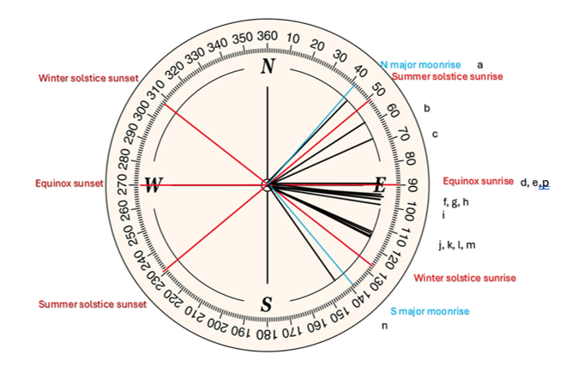
Key – capital letters denote islands G (Guernsey), J (Jersey), H (Herm)
a Les Fouillages (G) b Le Trepied (G) c Le Déhus (G) d Le Hogue Bie (J) e Le Creux es Faies (G)
f Le Couperon (J) g Le Faldouet (J) h Le Mont Ubé (J) i Delancey (J) j Le Monts Grantez (J)
k Le Géonnais (J) l Ville es Nouaux (J) m Le Varde (G) n Le Sergente (J) p Roberts Cross (H)

Figure 15: Passage tomb azimuths for the latitude of the Channel Islands at 4000 BCE with the summer and winter solstice axis, equinox and northern and southern major moonrise included (Image by author).
According to Figure 15, apart from Le Sergenté(n) and Les Fouaillages(a), all passage tombs in Guernsey and Jersey, and Roberts Cross(h) on Herm, had true azimuths within the rising sun's range on the horizon. Within this band there is clustering when two or more passage tombs had the same azimuth; at 90° La Hogue Bie(d), Les Creux es Faies(e), Roberts Cross(h); 95° (Le Couperon(f), Le Faldouet(g), Monte Ubé(h) and Delancey(i); 115° Les Monts Grantez(j), Le Géonnais(k), Ville-ès-Nouaux(l) and La Varde(m).
Starting with the outliers that were not within solar range, Les Fouaillages (Figure 16) and Le Sergenté (Figure 17a), the oldest surviving tombs on the Channel Islands, it is noteworthy that the azimuth of Les Fouaillages (42⁰) is the same as that of the northern major lunar sunrise azimuth (42⁰), as also noted by Le Conte. Furthermore, my results also show that the azimuth of Le Sergenté (142⁰) is also quite close to the southern major lunar sunrise azimuth (139⁰).
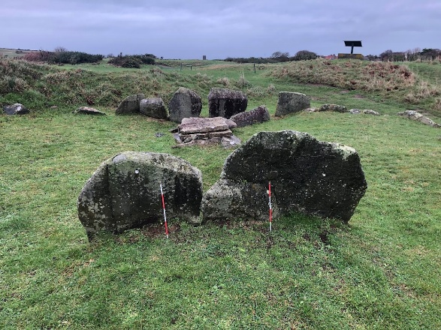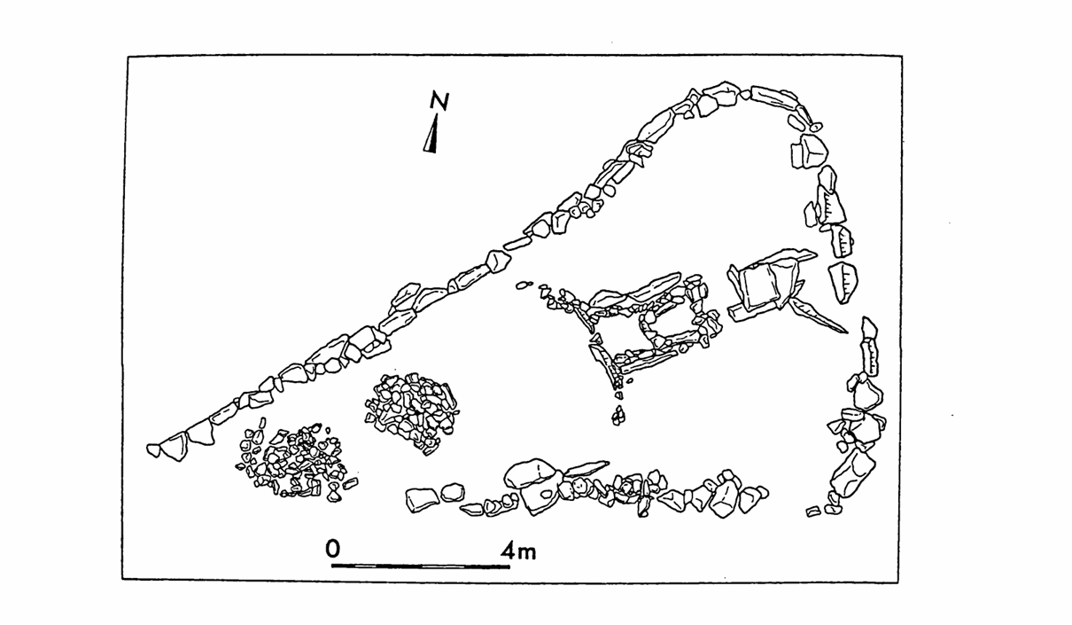
Figure 16: Les Fouaillages and site plan (photo: author, image after Patton)
As seen in Figures 16 and 17a, the design and layout of both tombs is completely different, as is their position: Les Fouaillages (16) is on a low-lying area in the north of Guernsey whereas Le Sergenté (11) is on a headland in the west of Jersey. From the back of Le Sergenté, I observed that there is also a clear view of Sark and Le Pinacle (2), the direction to which the axis of the tomb was roughly orientated, as seen in Figure 17b. This could have been purposeful, especially when bearing in mind that both Sark and Le Pinacle were already occupied and evidence for a significant amount of ritual has been found dating to the time Le Sergenté was built. The axis of orientation could therefore be deliberately focussing on two other ‘sacred sites’ in the Channel Islands, aligning the new tomb physically with that which had come before it, and also to an aspect of lunar cycle that was also of significance to the builders. This is speculation and Le Conte cautions against making firm conclusions about the moon's cultural importance, and indeed there is no clear evidence in the material remains that indicate a lunar cosmology. However, as noted by Kinnes, the earliest phase of Les Fouaillages dated back to the Mesolithic (6000 – 5000 BCE) and later phases were deliberately built on the same site, indicating continuity was important to the builders. The first tomb was ritually sealed around 4000 BCE at the time when construction began on the passage tombs. The change in tomb design and the ritual activity that accompanied it could indicate a significant change in worldview, and potentially a shift from a lunar to a more solar perspective, and could warrant further investigation.
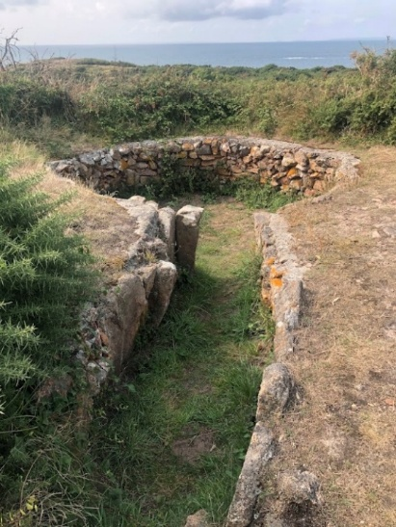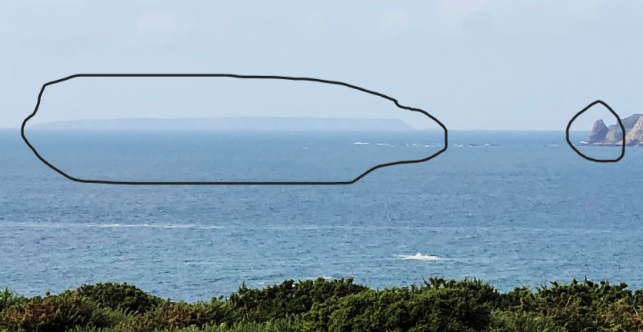
Figure 17a: Le Sergenté, (photo: author), Figure 17b: View from the back of Le Sergenté showing visibility of Sark and Le Pinacle (highlighted with black lines, (photo: author).
Les Monts Grantez (1), Dolmen de Géonnais (2) in Jersey (see Figure 18), La Varde (15) in Guernsey (Figure 19), and the gallery grave Villes-ès-Nouaux in Jersey (9) all have a true azimuth of 115° as demonstrated in Figure 15.
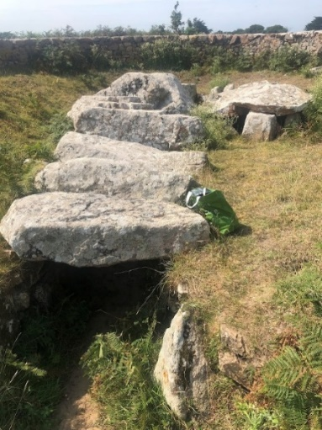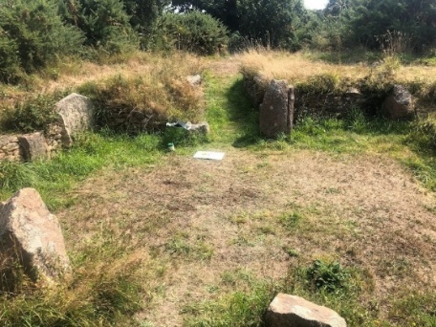
Figure 18: Les Monts Grantez and Dolmen de Géonnais, Jersey (photos: author)
Using Stellarium (version 24.1) and the azimuth of 115° for 4000 BCE at the latitude of St Helier, gave a (Gregorian) date of 30 November and a declination of the sun as -15°. In our modern calendar, this would equate to the cross-quarter date around the end of October we now call Samhain (see Figure 8), the beginning of the long dark nights and the onset of winter. As four sites across two islands were orientated to this azimuth, it is possible that this cross-quarter time was of significance to the builders.
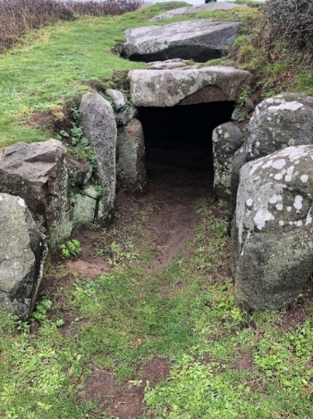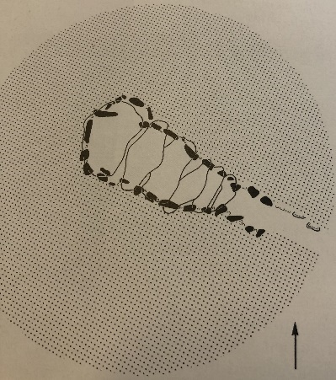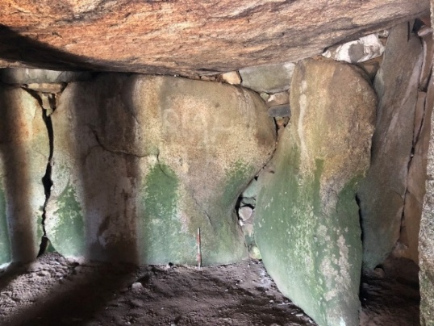

Figure 19: La Varde, Guernsey from the entrance and inside back recess and side chamber, with site plan (photos: author, image: after Kinnes)
Société Guernesiaise member Hazel Hill reported witnessing sunlight entering the back recess of the La Varde (15) dolmen at the winter solstice, reaching the stone at the side of the photograph in Figure 19, and illuminating two natural features that looked like breasts. Hill speculated this represented the ‘infusion of fertility into a mother goddess/menhir figure.’ As the winer solstice azimuth is 128° for this latitude at 4000 BCE, this was surprising as my measurements indicated a 115° azimuth for this tomb. However, according to Philip de Jersey, one of the entrance rocks had been damaged, allowing the light beam to enter through a gap. Further investigation is forthcoming, but it would be of interest to see if the ‘breast-like bulges’ are illuminated at Samhain.
During my field trip, I observed a natural rock formation from inside the tomb, that Andrew Fothergill describes as ‘shaped like a ‘sleeping giant.’ This feature is known as the ‘Rocque Balan’ and local folklore associates it with the Beltane fire festival when, according to Maris DeGaris, people go to the rock ‘carrying lighted brands in their hands.’ It is of note that Beltane is opposite to Samhain in the solar year according to Figure 8, marking the beginning of summer in the agricultural calendar. Therefore , preserved in folklore is potential evidence of a long- lived tradition linking this site to one of the solar cross-quarter dates.
The passage graves Le Faldouet (Figure 20) and Monte Ubé (Figure 21) on Jersey and the gallery graves Le Couperon on Jersey (Figure 22) share an azimuth of 95° and Delancey on Guernsey (Figure 27) quite close with a 98° degrees azimuth. This azimuth is ‘just off’ that of the equinox rising sun, over a sea horizon, for 4000 BCE, fitting da Silva’s description of an ‘equinox crossover.’
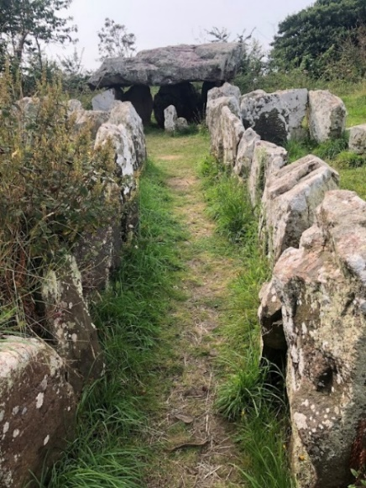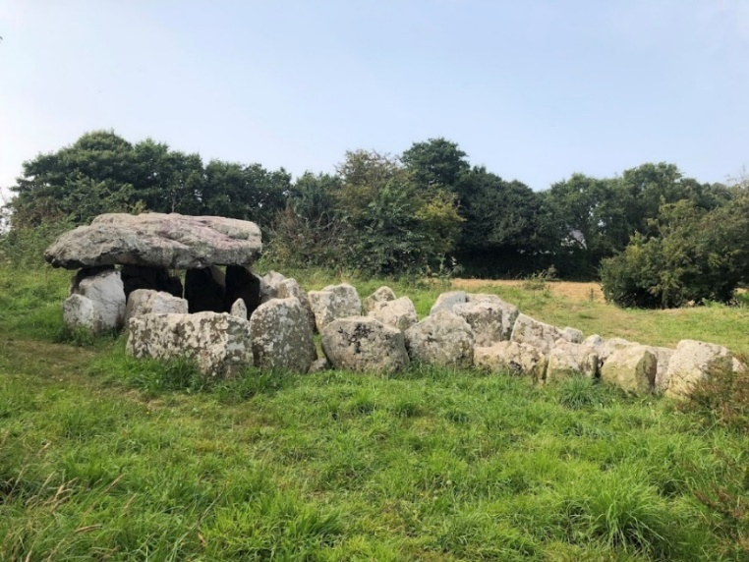
Figure 20: Le Pouquelaye de Faldouet, Jersey (photos: author)

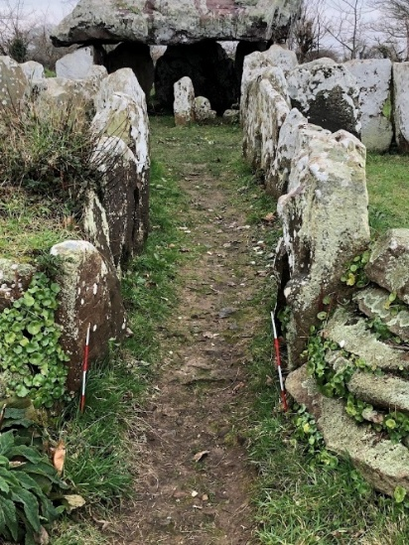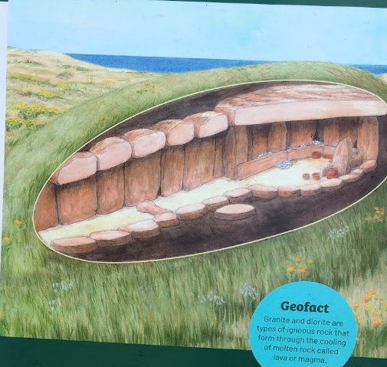
Figure 21: Monte Ubé (Guernsey) and reconstructed image (photo: author, image: after Jersey Heritage)

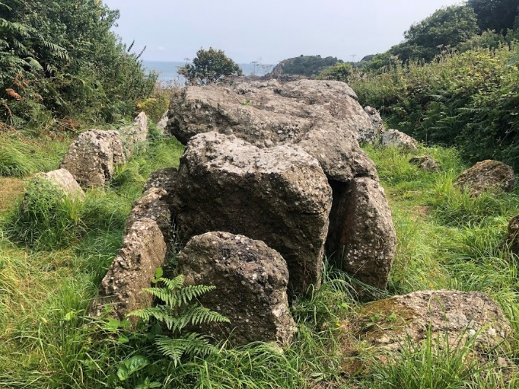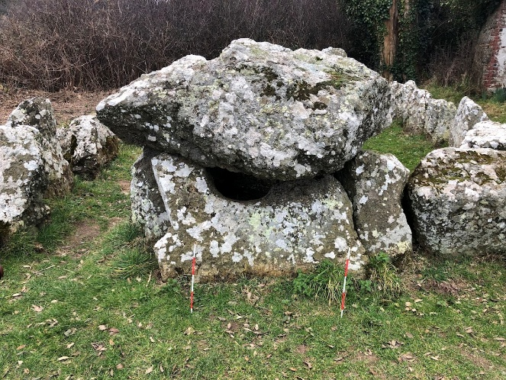
Figure 22: Le Couperon gallery grave (Jersey), with ‘port hole’ feature (photos: author)
The Hogue Bie (6) on Jersey (Figure 23) and les Creux és Faies (13) on Guernsey (Figure 24), as well as Roberts Cross (19) on Herm (Figure 28), each had a 90° orientation. This alignment corresponds to the direction of the equinoctial sunrise. In 1996, Patton and Finch observed firsthand the light of the rising sun entering the back recess of the tomb at La Hogue Bie:
The sun then leaves the terminal cell as it starts to light up the sanctuary floor and the eastern vertical face of the sanctuary threshold stone. It is here that the sun appears at its most intense, bringing the sanctuary floor alive in a glowing splendour of shimmering golden-orange light.

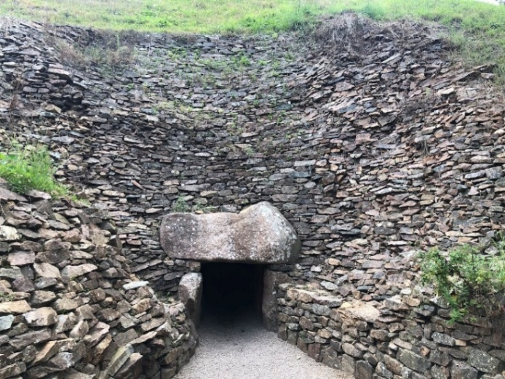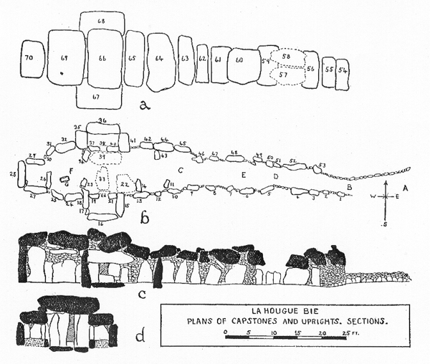
Figure 23: La Hogue Bie (Jersey) and site plan (photo: author, image: after Hawkes)
The equinoctial orientation of les Creux ès Faies (13) was also confirmed by David Le Conte on 20th March 2006, who saw the rising sun entering the tomb and ‘brilliantly illuminating the rear wall for the next half an hour.’ Therefore the stone architecture in the tombs at Hogue Bie (6) and Creux es Faies (13) were observed to produce varying patterns of light and shadow, causing certain rocks and their features to be illuminated while others remain shaded. Le Conte noted that there are several days round the equinox (both vernal and autumn) when the sun’s rays will penetrate the tomb, so orientation is not critical to within a few degrees. As he postulates, there is no reason, therefore, to assume that Neolithic people were working to high degrees of precision. This is confirmed by my results, where high measurement uncertainties could only realistically look for orientations, or even direction, and no assumption is being made for precise alignments in this project.
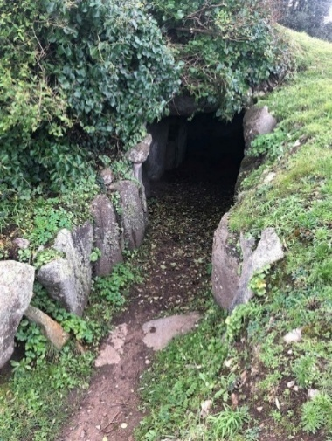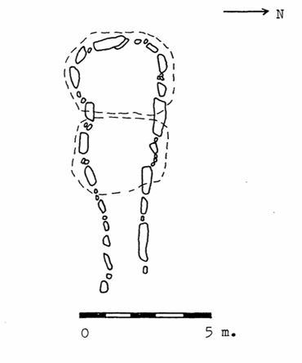
Figure 24: Les Creux es Faies and site plan (photo: author, Image: after Kendrick)
Uniquely, Le Trepied (14) on Guernsey had a 55° azimuth, almost identical to the summer solstice azimuth of 54°. Le Déhus(17) in the northeast had an azimuth of 65°, resulting in a declination of around +16° (see Table 2) and therefore corresponding to the cross-quarter point opposite Samhain, the beginning of the long summer days that we now call Beltane (see Figure 8). This provides more evidence for the potential significance for an eightfold division of the year.
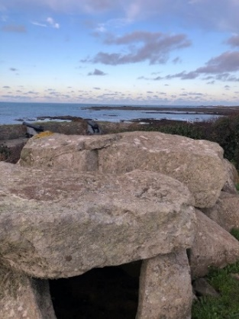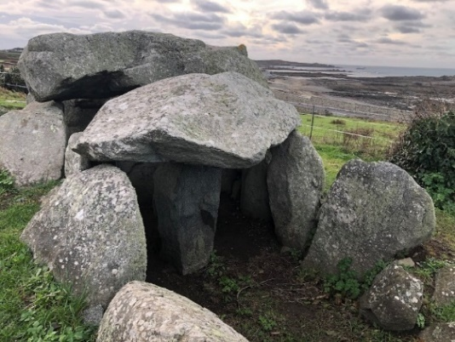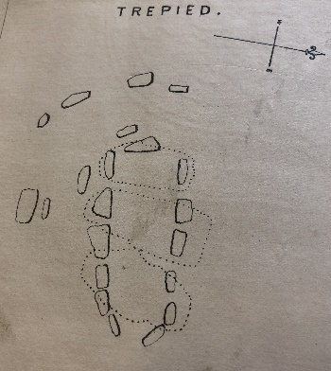
Figure 25: Le Trepied (Guernsey) and site plan (photos: author, image: after Lukis)
As already noted, one of the capstones inside Déhus feature a carved bearded figure (see Figure 4), and though I could see that light penetrating the chamber would not illuminate the figure, its presence seemed evocative nevertheless, deliberately incorporated from an older free-standing menhir and representing a presence in the tomb.

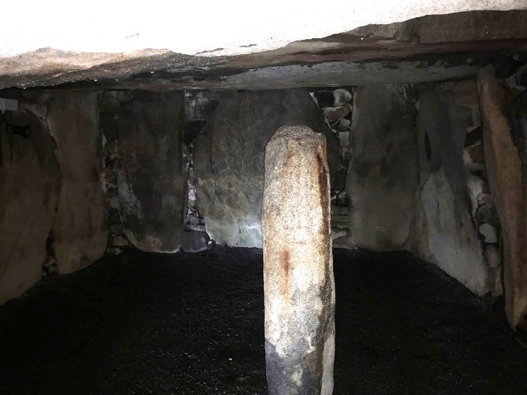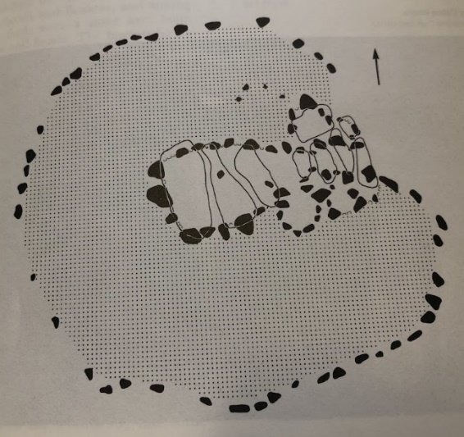
Figure 26: Le Déhus (Guernsey) and site plan, (photo: author, image after Kinnes)
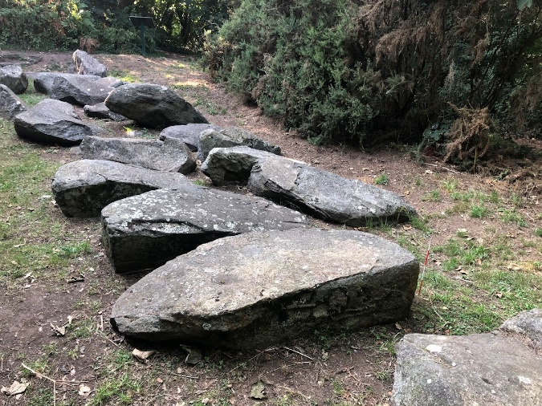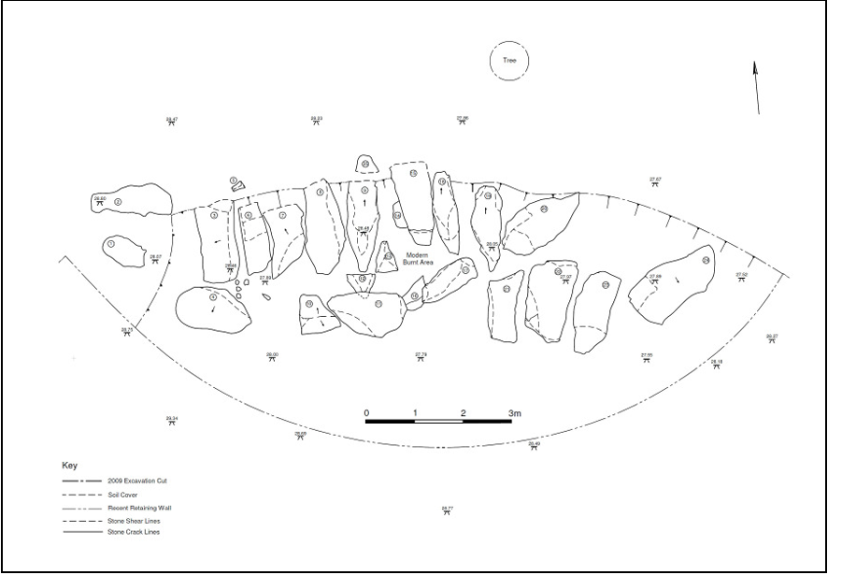
Figure 27: Delancey (Guernsey) and site plan (photo: author, image: after Nash)
Of the possible dozen or so Neolithic tombs built on Herm, only the tomb at Roberts Cross (Figure 28) has a discernible axis of orientation and this was found to be around 90⁰. I also observed that was oriented towards a small hill named le Grand Monceau, with the Petit Monceau framing the opposite horizon (see Figure 5). Due to the incline of the hills altering the azimuth relative to declination, the observed rising sun would appear nearer to the equinox cross-over point than the actual equinox (see Table 1), but it remains within the equinox range.
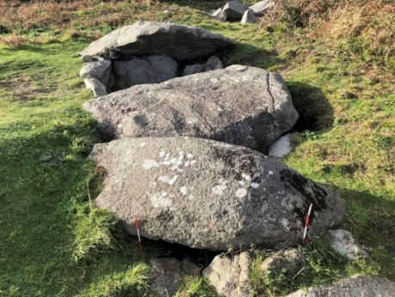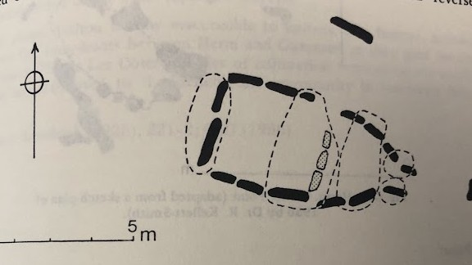
Figure 28: Roberts Cross, Herm and site plan (photo: author, image after Lukis)
Though the Alderney tombs have not survived and could not be surveyed, Le Conte reported a 98° azimuth for Les Pourciaux South and 110° for Les Pourciaux North, confirming to the pattern of sunrise orientation found elsewhere. Finally, the two dolmens on Sark were surveyed but did not have an azimuth that fell within the solar range. They did however have opposite declinations, as seen in Figure 29; the Clouet dolmen – 38.9⁰ and Vermandaye dolmen + 37.8⁰ as recorded in Table 1. Johnson noted their unique position cliff side position amongst the islands as an ‘insular tradition peculiar to Sark.’ Subsequent archaeological evidence is also pointing to Little Sark as a place of significant ritual activity, with the recent unearthing of Neolithic artefacts at the Vermandaye, as well as nearby flint scatters potentially dating back to the Neanderthal. The dolmens could be marking the north-south axis of a potentially larger sacred site, and though the azimuth of the dolmens are not within solar range, clear views of the horizon are visible from both sites. From le Clouet dolmen in the southwest, views of the setting sun can be seen for much of the year, again arguing for direction rather than alignment.
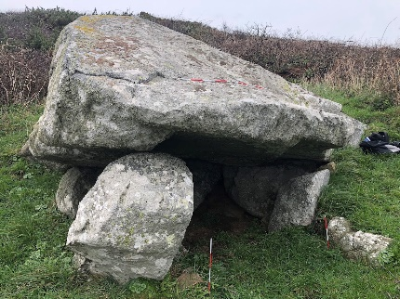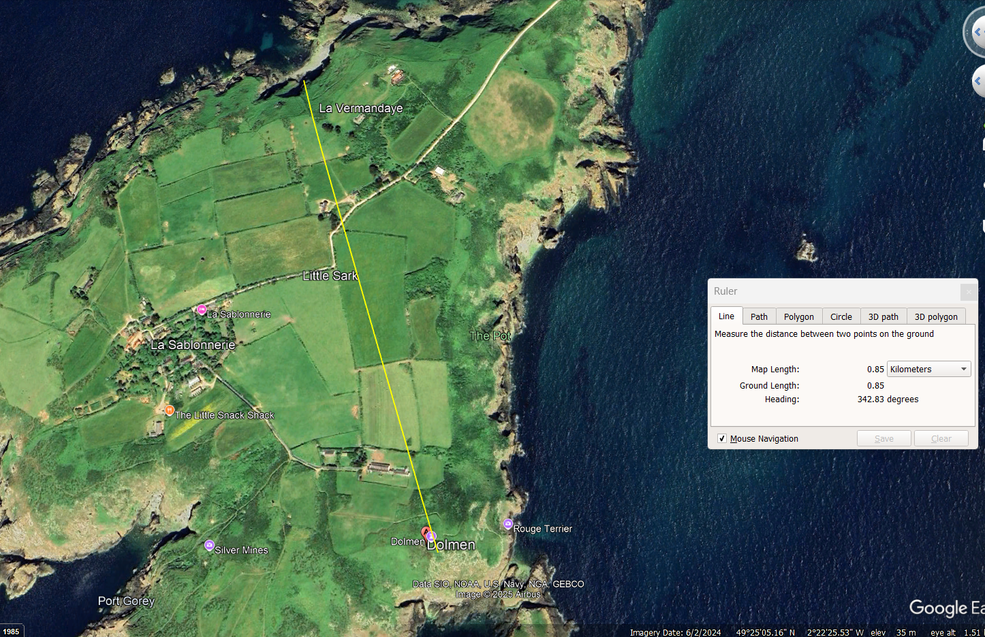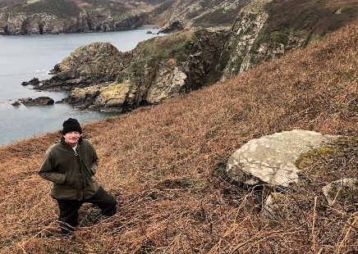
Figure 29: Clouet Bay dolmen (photo: author), Google Earth image of headline between two dolmens (image: Google Earth)and Vermandaye dolmen, pictured with local landowner Phil Perré (photo: author)
In summary, all tombs were unique in design and architecture, but regardless of age, island, or type, all but the two oldest were aligned with the rising sun, as demonstrated in Figure 15. The tombs in Jersey, Herm and Alderney all faced north of the winter solstice sunrise, but south of east, with all tombs on Jersey, regardless of age or type, having an azimuth of either 90⁰ (Hogue Bie), 95⁰ (Couperon, Faldouet, Mont Ubé) or 115⁰(Grantez, Géonnais, Ville ès Nouaux), all of which are significant crossover points of light and darkness in the solar year. On Guernsey there is a broader range with one tomb orientated to the summer solstice sunrise (Trepied, 55°), another the spring cross-over point we now call Beltane (Déhus, 65°), and one to the opposite point at the beginning of darkness (La Varde, 115°). One tomb was orientated to the equinoxes (Creux és Faies, 90°), and another possibly to the equinox crossover point (Delancey, 98°), though this is tenuous given this tomb’s poor state of repair. The results on Guernsey are therefore particularly significant as all the tombs, regardless of age or type, are orientated to sunrise at one of the key cross-quarter points of the year shown in Figure 8. It is of note that the recorded azimuths correspond to when the balance of daylight and night are changing in a noticeable way, rather than at Lammas or Imbolc when any changes in the length of the day are not particularly discernible. The change of seasons and availability of sunlight would affect the everyday life of the community, potentially pointing to a calendrical function for the tombs, used to mark key points in the journey of the sun on the horizon, possibly linked to the practicalities of the agricultural year. However, though the solstices, when the sun literally stands still, are easily observed, it is not so easy to determine the timing of the equinox or other cross-quarter dates, as cautioned by Ruggles. Le Conte there discounts these cross-quarter alignments as fortuitous rather significant, given the large number of tombs on the island designed to face sunrise.
Patton does not agree and uses his observations at the Hogue Bie to point out that that the sun’s rays penetrate the full length of the passage at the equinoxes, including the back recess, which cannot be coincidental.Furthermore, he suggested that an upturned, broken quern stone supporting a key orthostat was put in place to ensure that the sun’s rays did indeed reach the terminal cell. He also suggests that once the solstice points have been ascertained, the equinoxes can be by determined easily by halving the intervals between them, and then further again to get the cross-quarter days. It could also be measured in another way. My results show that the equinox crossover azimuth (around 95°) is represented across all the Islands (Figure 15), and as demonstrated by Silva above this relies just on the manageable observation of the time of the rising full moon when the sun and moon cross positions on the horizon. As previously indicated, this phenomenon may be integrated into both Knowth in Ireland and the Alentejo monuments of Portugal. As K. Prendergast argues, the cycles of the sun and moon can be reconciled in this way, resulting in a potentially potent calendrical device, though she does not mention the sun-moon crossover itself. Given the very early date of the Channel Islands tombs, it is possible that the spring full moon around the time of the horizon cross over was used to locate the equinox, usually around 2 weeks around the precise equinox point, which resulted in the 95° azimuth at the Le Couperon, Le Faldouet and Mont Ubé (Figure 15). The alignment would therefore not be precise, and there was no evidence that the cycles of the sun and moon were reconciled in the way they were at Knowth, but my results indicate that orientation as opposed to alignment was more significant at this early date, with the possible exception of La Hogue Bie. The potential use of the sun/moon cycles to ascertain the equinox gives more weight to a potential interest in the movement of the moon in the worldview of the builders, as discussed above at Les Fouaillages and le Sergenté. As suggested by Pimenta and Tirapico, the significance of this orientation could be rooted in earlier Mesolithic traditions relating to observable seasonal animal migrations, and could be indicative of a deep-rooted indigenous culture in the Channel Islands that actively participated in the solar/lunar cycle.
The link to the lunar standstill is weaker but may yield new insights. Fabio Silva’s recent research found that extreme lunar rises and sets align with Stonehenge’s station stones. He suggested that around 3000 BCE the alignments could have been round the Moon, becoming more solar around 2500 BCE. My data from Les Fouaillages (16) and Le Sergenté (11), if significant, would demonstrate an earlier interest in the movements of the moon going back to before 4000 BCE, possibly even to the late Mesolithic, as indicated above.
A shift in worldview has already been demonstrated between the building of Le Sergenté and les Fouaillages and the advent of the solar orientated passage tombs in around 4000 BCE. The next significant shift in Island history occurred around 2850 BCE with the move away from building large complex, mound-covered passage tombs to more simple gallery graves. Patton’s research demonstrated that the passage tombs where ‘ritually sealed’ around this time, as summarised in Table 2. Driscoll suggested that the passage graves emerged during a period of societal decline, bringing about ‘a greater access to ritual knowledge, and this dislocation could have resulted in a change in monument use from a ‘liminal holding place for the dead to permanent homes of the ancestors,’ as theorised by Patton. Though this change social change may have marked a significant hiatus in the worldview of the builders, my results show that the three gallery graves surveyed (Ville-és-Nouaux (9), Delancy (18) and Couperon (4) all had similar alignments to the older passage graves (115°, 98° and 95° respectively – see Figure 15). Therefore, my results demonstrate that specific solar orientations were consistently used in monument design from 4000 to 2850 BCE across all the Islands, indicating an indigenous astronomy that combined traditional and evolving beliefs.
Another key feature of my results was that all the tombs surveyed, including the dolmens on Sark, were either situated on cliffs overlooking the sea, in very close proximity to the sea, or on headlands next to it. Yet, in all cases, other than the monuments on the eastern side of the Islands, the passages were not orientated towards it. As Scarre noted, ‘The sea can provide an effective backdrop but it could be the direction of sunrise rather than landscape features that could be the most significant.’ I postulate, however, that both were equally important, that landscape placement was just as significant to the worldview of the builders as an orientation to the rising sun. The surrounding landscape not only provided building materials but may have shaped monument design, an idea known as ‘the power of place.’ This will be examined to propose a possible ‘worldview,’ using Table 2, which summarises landscape features, views, geology, material remains, and ritual evidence found in the tombs.
Name, number and date of site | Description | True azimuth (degrees) | Landscape setting | Visibility of other islands | Type of stone | Material remains | Comments | Evidence for ritual activity
1.Les Monts Grantez (Jersey)  4000 BCE | Passage grave, asymmetric chamber | 115.43 | Cliff top in west | Sark | NW granite, SW granite | Seven skeletons, animal bones. Vase supports. | Once covered in elongated mound | Limpet shells, pebbles. Large round stone at back.
3.Dolmen de Geonnais (Jersey)  4000 – 3250 BCE | Passage grave, rectangular chamber | 115.43 | Cliff top on NW of island. | Sark | Pink porphyritic local granite | Vase supports, pottery, human remains, arrowheads, flint tools | Once covered in a mound. Sealed in 2500 BCE. | Pebbles.
4.Le Couperon (Jersey)  3250 – 2850 BCE | Gallery grave | 95.49 | On cliff top in east, facing sea | France | Local conglomerate stone | None found | Surrounded by kerb stones. | Porthole stone
5.La Pouquelaye de Faldouet (Jersey)  4000 – 3250 BCE | Passage grave, chambers and cists | 95.49 | High ground in east, facing sea | France | Rhyolite capstone. Slickenslides. Grranites, but one diorite | Three adults, two children without skulls. Vase supports, stone axes and pendants. | Had a mound and dry stone walls | Large round stone at back of tomb
6.La Hogue Bie (Jersey)  4000 BCE | Cruciform passage grave | 90.48 | On high hill with view of sea | France | Fort Regent granite, NW granite, Mont Mado granite Diorite. | Vase supports, animal bones, human remains. 3 betyls found | Covered by 12 m high mound. | Pebbles used for ‘desantification’ during successive building phases.  Wave worn uprights.
8.Mont Ube (Jersey)  4000 – 3250 BCE | Passage grave with four internal cells | 95.48 | High ground in south | Green island visible | Fort Regent pink coarse granite. Diorite at entrance, | Vase supports, pottery, stone pendants, axes, burnt bones | Covered in a mound, surrounded by kerbstones. | Large round stone in back chamber
9.Villes-es-Nouaux (Jersey)  3250 – 2250 BCE | Gallery Grave | 115.46 | Sea level in south of island | None | Pink granite, Westmont diorite and porphyryr | None found |  | Cist in circle next door
11.La Sergente (Jersey)  4500 BCE | Corbelled passage grave | 146.43 | Headland on west of island | Sark | Local NW granite | Pottery, human remains | Le Pinacle is visible
13.Les Creux es Faies (Guernsey)  3000 BCE | Bottle-shaped passage grave | 90.25 | Headland near Lihou |  | Perelle gneiss, L’Ecree granite bedrock | Pottery, flint and human remains | Mound, surrounded by kerbstones | Wave worn uprights used, large round stone at back of tomb
14.Le Trepied (Guernsey)  4000 – 2000 BCE | Passage grave | 55.00 | High ground adjacent to sea in SW of island. |  | L'Ecree granite capstones, Perelle gneiss uprights. Phenocrysts inclusions. | Pottery, flint and human remains |  | Stone at back not particularly large or round
15.La Varde (Guernsey)  4000 – 2000 BCE | Passage grave, bottle necked chamber, side chamber | 115.28 | High ground in L’Ancresse Common | Alderney and Jersey | Bordeaux diorite, L’Ancresse granodiorite capstone. | Pottery, flint, human remains | Large round stone at back, facing Roque Balan | Limpet shells and pebbles
16.Les Fouaillages (Guernsey)  4500 BCE – 2000 BCE | Passage grave/long mound | 45.28 | L’Ancresse Common | None | Local granite | Pottery, flint, animal bones, schist rings from Paris Basin | Flint offering when tomb sealed | Three periods of use, deliberately sealed each time
17.Dehus (Guernsey)  3500 BCE | Passage grave | 65.20 | Facing sea on NE | None | L’Ancresse granodiorite capstone, Bordeaux diorite. | Carving of a man holding bow and arrow on capstone | Mound surrounded by alternating granodiorite and diorite kerb stones | limpet shells
18. Delancey Park (Guernsey)  2500 BCE | Gallery grave | 98.29 | Slope on NE, facing sea | Sark, Herm and Jethou | Local granite | Some limpet shells, ox bone, pottery, greenstone axe | Menhir nearby, could be marking larger site | Poor state of repair
19.Roberts Cross (Herm)  Approx. 4000 BCE | Passage grave | 90.32 | Between Grand and Petite Monceau | none | Local granite | Human bones and Bell Beakers. | Poor state of repair. Part of larger burial site. | limpet shells and animal bones.
20.Clouet Bay Dolmen (Little Sark) | Dolmen/cist | 195.34 | Cliff side setting | Jersey | Granite | None | Once covered in rubble mound
21.Vermandaye Dolmen (Little Sark) | Dolmen/cist | 340.34 | Cliff side setting | Beqhou and Guernsey | Granite | None |  | Next to Vermadaye fort, Neolithic remains found there

Table 2: Landscape setting, views, geology and material remains summary data for all sites, along with true azimuth for comparison

Towards a Cosmology of the Channel Islands

Landscape setting
My results show proximity to, or a view, of the sea was significant to the builders and could indicate, as suggested by Scarre, that the sea and shorelines held a special status in their worldview, as they evoked a liminal zone, or boundary. They also demonstrated that inter-island visibility could be significant, as summarised in Table 2. Le Couperon (4) for example is orientated towards France, from where the builders originated; Alderney is visible from La Varde (15); Sark from Le Sergenté (11), Dolmen de Géonnais (3) and Delancey Park (18), as is Herm and Jethou. From Herm's high ground, every island except Jersey is visible, and La Hogue Bie (6) would have been visible from as far away as the coast of the Cotentin in France. Sometimes my results show that the tombs are orientated towards the ‘ancestral’ home of the builders, or towards an island that may occupy a significant direction when seen from the tomb. For example, I observed that Sark is in the same part of the horizon as the summer solstice sunset when viewed from Le Sergenté (see Figure 17b). In some cases, my results show that inland topographical features appear also to be significant, for example, La Varde (15) points towards Le Rocque Balan and Roberts Cross (19) is located between two small hills. My results do not show any pattern linking inter-island views to azimuth, but they do show that all the tombs on the west side of the Islands are facing away from the sea and all the tombs on the east side are facing towards it as indicated above.
As shown in Table 2, most of the passage tombs were covered in a mound and this would have restricted the access of sunlight for most of the year, though it should be noted that sunlight can enter parts of tombs with shorter passages (e.g. Creux és Faies and La Varde). However, when standing on any of the surviving mounds (for example at Creux és Faies (13) or le Déhus17)) there was a clear view of the horizon affording good views of the sun when in that part of the sky, including sunsets. I observed, for example, the winter setting sun from the back of Le Trepied and the summer setting sun around the beginning of August (when Lammas is currently celebrated) from the top of La Varde (see Figure 30). Though the dead interred in the inner recess would only see the light of the rising sun (and moon) one a year, to the living the tombs would be part of the landscape, seascape and embedded in the diurnal movements of the sun throughout the year.
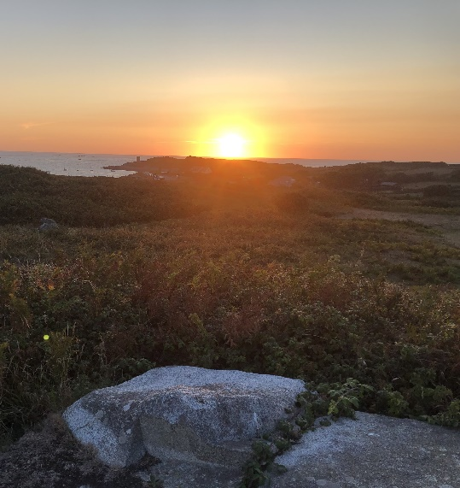
Figure 30: sunset from the top/back of La Varde at the beginning of August (photo: author)
In the Channel Islands, settlements were found in close proximity to tombs, leading Scarre to disregard the hypothesis that Herm was a sacred island reserved exclusively for the burial of the dead. However, on Guernsey most of the tombs are clustered on L’Ancresse Common, nestled in area called the Clos du Valle that was actually a separate island at high tide, until draining took place in 1806. Also on Herm, the tombs in the low lying Common would have been periodically inundated during the Neolithic, according to Scarre. The tomb density in both these areas suggests they were deliberately sort out for their association with water, which is a further indication that islands and places surrounded with water did have special status in the cultural worldview of the builders. In Celtic mythology, water is often used to symbolise a barrier between the world of the living and the Otherworld as suggested for example Ciaran Carson and according to Jelly, Les Fouaillages and Le Déhus were located east-west along the water course that once flowed through the Clos du Valle. My research also shows that all the tombs, with the exception of Robert’s Cross and Les Fouaillages were on high ground, in close proximity to, but also apart from the living. This implies that it was important to have a barrier between the two worlds, also visually enhanced by using mounds to enclose the tombs, and by deliberately placing kerbstones around their circumference, as for example at Le Déhus, Creux és Faies and Mont Ubé (see Table 2). Passage graves, therefore, should not be seen as a passive reflection of society but an active one, as maintained by Bukach.

Geology
My observations showed that both the sourcing and placement of the stones were deliberate and inherent in the design of the tombs, as suggested by Buckach (Figure 13). As demonstrated in Table 2, all passage tombs, apart from Hogue Géonnais (3) and Roberts Cross (19), were built from stones consisting of at least two different rock types, sourced from different places around the island on which they were situated. I observed that the passage tombs with an azimuth of 95⁰ - Faldouet (5) and Monte Ubé (8) - used a combination of lighter granite and darker diorite in their structure and Les Monts Grantez (1) and La Varde (15) with an azimuth of 115⁰ used two different types of granites and diorite, also varying in shades. Le Déhus (azimuth 65°) had a mixture of shades of diorite and at Trepied (55°) granite and gneiss was used. Capstones were often made from lighter coloured rock supported by darker stones, which Bukach suggests symbolizes the interplay between light and dark. My results therefore demonstrate that the use of shaded rocks was common to all passage tombs, regardless of their position or orientation. As my astronomical data showed that all passage tombs were orientated towards a cross-quarter or equinox point, azimuths that marked a seasonal time and therefore a transition between light and darkness, this theme appeared to be reflected in a deliberate choice of rocks that visually embodied this interplay. Except for Ville-és-Nouaux (9) with its striking pink granite and dark diorite rocks (see Figure 31), my observations showed that the gallery graves do not follow this pattern, indicating a changing cosmology at this later stage. Though the orientation towards solar cross-quarter features continued, a deeper understanding of the seasonal interplay of light and darkness mediated by the movement of the sun may have become lost, or less significant.
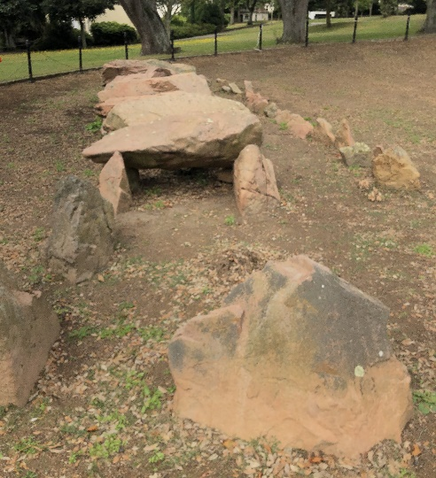
Figure 31: Ville-és-Nouaux gallery grave, Jersey, with striking pink granite and darker diorite stones (photo: author)
The two passage tombs orientated towards the equinox were the most complex in design. As outlined by Patton, all 16 capstones at the Hogue Bie (6) were sourced from different parts of the island, potentially brought by clans to be incorporated into a communal tomb. Scarre suggested that the tomb could have represented the island itself, with each rock type being imbued with the spirt of the place from where it came, so the choice of the stone creating ‘a bond between a monument and locale.’ This implies a worldview that gave ‘agency’ to a place, that place itself was deemed significant and used to represent the identity of each clan in the creating of a new structure of social cohesion and harmony. This in turn was bound up with, or energised, by the power of the equinox rising sun, potentially indicating that this time of year had a special significance to the builders.
At Creux ès Faies (13), both darker gneiss and lighter granite was used, and some stones were potentially chosen because of their natural pattern, for example the wave-worn upright shown in Figure 32. As the photo demonstrates, as light shines into the passage, it interacts with the features on the stone, bringing them to life.

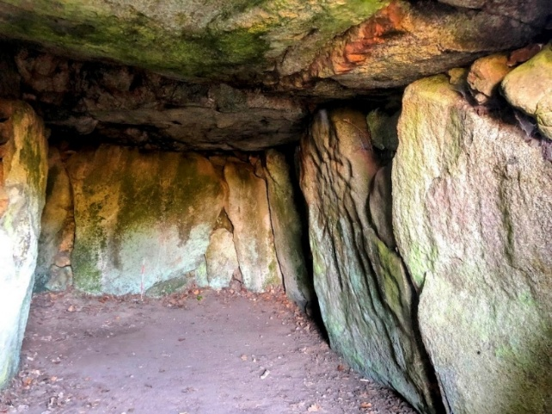
Figure 32: Creux ès Faies with wave worn stone on the right (photo: author)
I observed that in some cases, stones could have been chosen because of marks in the stone (inclusions) as suggested by Kenny, further emphasising the symbolic power associated with the stones’ features. For example, at Hogue Géonnais, I found large pink plagioclase inclusions on an entrance stone, and a large quartz vein on a prominent capstone le Creux és Faies (Figure 33). I observed slickensides on the rhyolitic capstone at Le Faldouet, caused by tectonic movement and friction, as well as cup marks on the capstone at Le Hogue Bie. Their incorporation into the architecture of the tombs, could, as Scarre suggested, made manifest properties that were assumed to be already present, ‘infusing the tombs with knowledge’ both literally and symbolically.
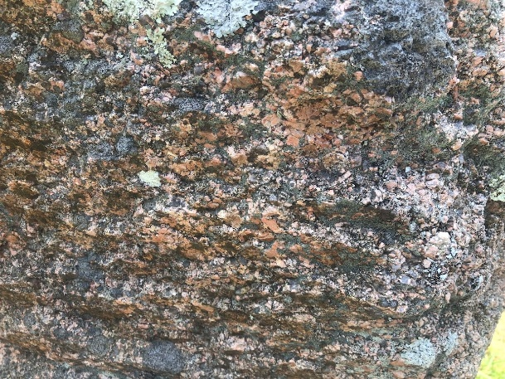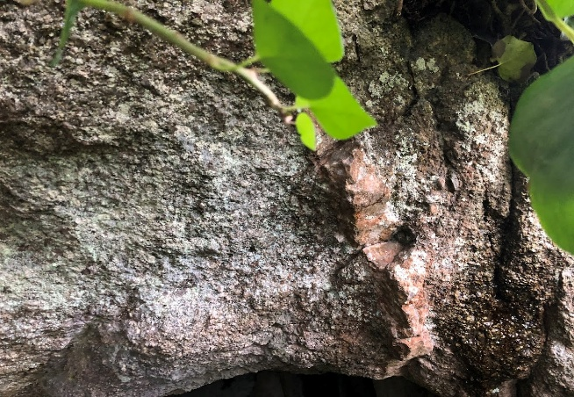
Figure 33: Plagioclase inclusions Geonnais and quartz inclusion Creux es Faies (photos: author)
Research by Aubin, along with my field work, indicated that at most passage tombs, large round stones were deliberately placed at the centre of the back chambers (see Table 2). I saw evidence of this at most of the passage tombs across the islands - Le Faldouet, Monts Grantez and Monte Ubé on Jersey; Le Déhus, La Varde and Creux es Faies on Guernsey and Robert’s Cross on Herm (Figures 32 and 33). However, I found that this was not the case at Le Trepied or Hogue Géonnais, though it should be noted that this tomb was severely looted for quarrying so the back stones were missing. None of the gallery graves followed this pattern, possibly once again indicating a changing worldview at this later date. It may be significant that all the passage tombs with azimuths towards the equinox or equinox cross over orientation did have large round stones in the middle of their back chambers, and two out of three of those orientated to the 115° Beltane cross-quarter point, potentially linking the significance of these times more strongly to the power of the sun.
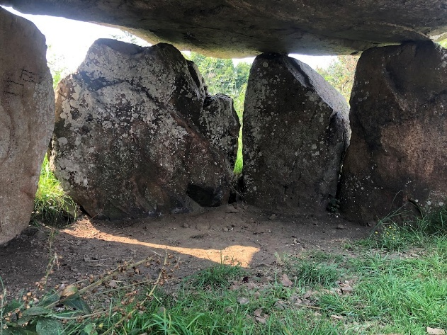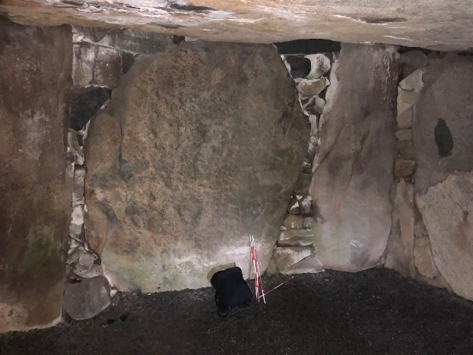
Figure 34: Large round back stones at Faldouet(Jersey) and le Déhus (Guernsey) (photos: author)
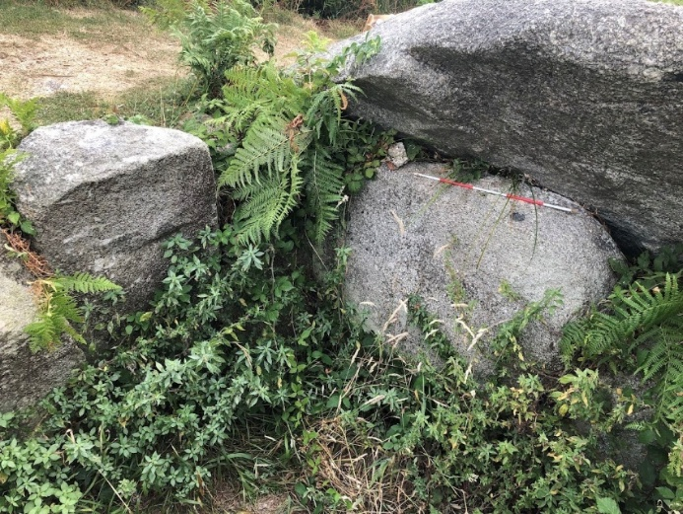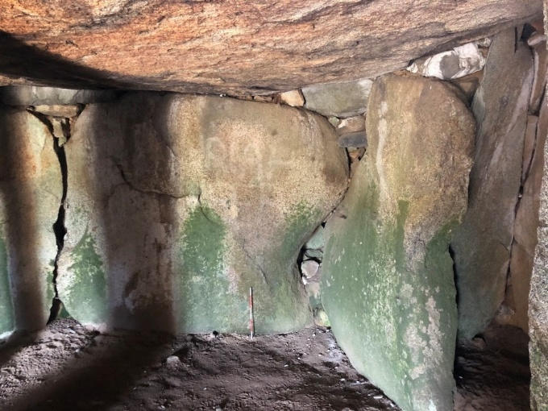
Figure 35: large round back stones at Roberts Cross (Herm) and La Varde (Guernsey) (photos: author)
Aubin suggests the large round back stone could represent ‘the sun on its hidden return from sunset back to sunrise.’ As all the passage tombs were covered with a mound the back chambers were in relative darkness for most of the year, the rays of the rising sun could only fully reach these stones for a few days, possibly bringing them to life once more. If this is the case, then this solar return could represent a rebirth, and this could have been of particular importance for the time of the equinox, potentially indicating that this is when the event physically took place in the cosmological world of the builders.

Ritual activity
A key feature of ritual activity for most tombs is the use of sea shells and limpets, which were often placed round the dead or in stragetic positions within the monument ( see Table 2.) A pile of beach pebbles was deliberately placed outside the Hogue Bie, and the floor of Hogue Géonnais was covered with pebbles.. Limpet shells were found near burials at Mont Grantez, La Varde and many sites on Herm, and at Le Déhus three skeletons were found ‘resting upon a rude pavement of flat sea-worn stones, and covered with a thick layer of limpet shells.’ Alkaline limpet shells could have been used to preserved human remains from the acidic soils of the Channel Islands, but they could have also had ritual or cosmological significance, emphasising the unique feature of islands as at a liminal junction between land and sea, as theorised by Scarre. Aubin suggested that limpets were symbolic of endurance as they would have been seen to ‘adhere with exceptional strength to the rocks used in construction of the passage graves.’ It could be significant that the three tombs with 90° azimuths and the four passage tombs orientated to the cross-quarter points of Beltane and Samhain all featured prominent sea symbolism such as pebbles, wave worn stones or limpets, but the tombs orientated to the equinox crossover did not. It could be that the Samhain point, as representing the beginning of the darker days, was particularly associated with the endurance of the ancestors, or their dwelling place in the watery realm of the dead. Once again, the gallery graves did not follow this pattern.
The shape and design of the passage tombs also evoked ritual activity. At Déhus, I had to bend low, even crawl to gain entry through the dark, long, narrow entrance, feeling like I was entering the body of the earth, or Otherworld, before reaching a larger end chamber suggestive of a womb. The younger gallery graves were not covered over, and therefore not in darkness, but their low and narrow chambers still necessitated crawling and a sense of humility, even disorientation. At La Hogue Bie, Patton found a unique indigenous form of pottery known as ‘vase-supports,’ that he suggested could have been used as lamps, or even ‘as braziers for infusing hallucinogenic drugs,’ further emphasizing a ritual environment in which some senses were enhanced. In all cases, I observed that tombs were departmentalised, often sub-divided with pillars to make side-chambers (e.g. Le Déhus), some also had burial cists (e.g. Le Couperon), maybe to further facilitate boundaries and separation that seemed to feature in the worldview of the builders as noted above when discussing mounds. Le Hogue Bie featured a platform and, notably, a terminal cell that may have served as the monument's most sacred and concealed area. The re-use of menhirs and carvings suggests funerary activity that seeks to incorporate the beliefs of the people who came before them, as for example, at Le Déhus where a guardian figure, or entity, could have born witness to the coming of the light. As Vicky Cummings suggested, ‘ethnography supports the suggestion that people understood landscapes as filled with mythical beings and symbolic places.

Towards a Cosmology
In mythology across all cultures and ages, the rising sun is often associated with rebirth and the setting sun therefore with death. With the clear views of the horizon afforded in the Channel Islands, it would seem like the setting sun disappeared into the ocean, the land of the dead, and conversely the rising sun in the east would bring a new dawn, life and the promise of rebirth. The predominance of passage tombs on the islands, their age and complexity, indicated that the islands were somehow considered special, a suitable place to bury their dead. This belief has been preserved in Celtic mythology, where islands, especially those in the west, were seen as ‘Otherworldly places’ where ancestral and mythical figures reside. In the Wooing of Etain, the cruciform passage tomb Brú na Bóinne, covered in a mound like the Channel Islands tombs, was the scene of a cosmogenic event when time stood still like the sun appears to at the solstice, allowing a hero to be conceived. This mythology is not only ancient but also potentially widespread across the Atlantic façade, possibly carrying relicts of much older Mesolithic beliefs. The incorporation of earlier fragments into monument design also indicates the importance of ancestral beliefs to the tomb builders. Mounds made the passage tombs prominent in the landscape, demarcating the world of the living from the world of the dead, and creating a barrier between darkness and light. But they were also deliberately made to be seen, potentially serving, as suggested by Sebire, as reminders of past achievements, possibly respect for the ancestors, and in this way marking continuity and a declared sense of time and space.
The orientations of both the passage tombs and gallery graves to the rising sun at key cross-quarters incorporated the seasonal rhythm of light and dark into the landscape and harmonised this natural cycle with the cosmological life death cycle of the Neolithic people. My evidence shows, as suggested by Richard Bradley, that the sun (and possibly moon) by continually passing over (and into) the monuments was the active agent in this rebirth process, giving life to the dead as the rising sun brings life to the living each day. The equinox sun as the choice of orientation at the Hogue Bie, marking the time when the light and dark were equal, could have been the ultimate symbol of cohesion and harmony. Furthermore, given the prominence of the equinox crossover azimuth in my results, it could have been that as the sun and moon were observed to cross over places on the horizon, they were symbolically seen to ‘energise’ each other, providing the mechanism, or potential, for rebirth.
The power of the sun, and potentially the moon, were ‘brought to earth’ through the architecture of the tombs and the choices of stones used in their construction. Through the interplay of light capstones and darker uprights, through using stones of different geological provenance, patterns or inclusion at strategic places throughout the site, incoming light made manifest these properties, potentially bringing them to life. The glow of the sunlight entering the tombs by would infuse them with golden light, and the moonlight of the night would be silver. This interplay was further enhanced by the compartmentalisation observed at the tombs, the narrowness and low nature of the entrances, and the use of platforms or cists ensured that when the light beams entered the tombs, only parts were illuminated, bringing some features to life and leaving others in darkness. Compelling evidence shows that larger, round stones were placed more frequently at the back of tombs, in darkness until touched once a year by the sun’s rays, possibly representing the sun on its hidden return from sunset back to sunrise.And in the case of Le Déhus, a guardian figure was deliberately incorporated into the tomb, potentially with the aim to ‘bear witness’ to this process, and at La Hogue Bie, betyls could have been used for the same purpose.
My results showed that all the tombs were located on cliffs or headlands with sea views, and though they rarely faced the ocean, the sea often provided a backdrop to the tombs, and a view of the setting sun could often be observed behind them. Their positioning in the landscape at this liminal juncture evoked both a diurnal and seasonal interplay between darkness and light, possibly enabling, as suggested by Scarre, communication between the realm of living and the dead. This claim is further supported by the choice of limpets as grave goods, creatures that inhabit both sea and land, as well as pebbles and wave-worn stones.
In summary, wide-ranging evidence suggested funerary practices across the Channel Islands involved complex symbolism and a sophisticated cosmology that incorporated stones, their features, architecture, landscape, the sea and the rising sun (and possibly moon) to reflect the transition from dark to light, from life to death, and a potential for rebirth at the equinox when the world was in balance.

Conclusion
The aim of this project was to contribute to the emerging academic inquiry into the unique importance of the Channel Islands within the broader context of the Neolithic Atlantic tomb builders' worldview, approached from a skyscape perspective. This led to the question: ‘How do the orientations of Neolithic passage tombs in the Channel Islands engage with solar and lunar phenomena, and in what ways might these alignments have mediated relationships between skyscapes, landscape, and the cosmological worldview of their builders?’ This was done through fieldwork to measure the orientations of the passage tombs and gallery graves on Jersey, Guernsey, Herm and the dolmens of Sark; an astronomical analysis of their celestial alignments; and an assessment of the landscape, geological and material remains left at the tombs.
Fieldwork revealed that, despite their distinct architectural designs, all tombs—except for the two oldest—were aligned toward the sunrise occurring between the winter (52°) and summer (128°) solstices. True azimuth as measured from a 0° horizon and with an uncertainty of ± 2° ranged between 55° and 115°, and clustering was found around 90°, 95° and 115°. These points correspond to the equinox rising sun (90°), and possibly the full moon equinox sun crossover (97°) and the cross-over time at the beginning of winter (115°) when the darkness takes (Samhain). This raised the possibility that these seasonal times were of significance, and that the tombs may have functioned as agricultural calendars, marking out time through the orientation of the passage to the diurnal movements of the sun. The data strongly suggests that orientation towards the rising sun (possibly moon) is the most significant feature in the placement, and possibly design of the tombs regardless of island, age or type of monument. It is also noteworthy in that the two oldest tombs on the islands could be orientated towards the major and minor moon rise.
Though the evidence is overwhelming that the rising sun was of central importance to the worldview of the builders, it is still debatable whether general orientation was more in line with this worldview than a precise orientation, and that any alignment to significant points in the solar year could be accidental. However, the observed impact of how at both Hogue Bie and Creux ès Faies the light of the equinoctial sun interacts with the architecture inside the tombs to produce a dramatic interplay of light and dark would indicate that, at least in these two cases, the positioning seemed to be intentional, though there is no evidence that it needed to be precise. Additional observations are needed to confirm this hypothesis, but for now, the evidence indicates that the tombs were deliberately orientated to key points in the sun’s cycle, to within a few degrees at least, and that this degree of working was enough to ensure the desired results.
An assessment of the landscape features found that position in the landscape could have been equally important to the builders. All the tombs were situated near the sea or on headlands with a sea view, and that the sun could be seen either from the tomb entrance or on top of or behind the tomb, strongly evoking the importance of the sea in the builder’s cultural worldview. In some cases, the opening was orientated towards an inland topographical feature such as a small hill or rock with key features. Sometimes other islands were clearly visible from the tombs, or they were orientated towards the French mainland, the origination point of the Neolithic inhabitants, deemed as ancestors. Geological analysis building on the work of Bukach revealed that the local landscape supplied building materials, influenced the site’s design, and served as its setting. In many cases, stones were deliberately sourced from different parts of the island, with rocks of certain colour or inclusions being placed in significant parts of the tomb, either as capstones, uprights or at the back of the main chamber, resulting in a deliberate interplay between the architecture of the tombs and the light of the sun (or moon). The large round stones often placed at the back of the tomb and could have been symbolic of the hidden journey of the sun between sunset and sunrise, as Aubin’s research suggested. The design of the tombs, with a low passageway opening into a large chamber and compartmentalization of the internal space, all covered over by a mound, further accentuated the dance between light and shadow, and evoked a ritual journey into an ‘otherworldly space.’ At le Déhus a ‘guardian entity’ was present, possibly bearing witness to this interplay; cup marks or wave-worn stones could also have served a similar function. The mounds that covered all the older passage tombs served to accentuate a separation between the world of the ancestors from the living, yet reminding of their past and separating the achievements, and creating a boundary between the light and the dark, as further emphasised by using shaded kerbstones.
An analysis of material remains revealed that limpet shells and sea pebbles were found at many sites suggesting ritual activity that evoked the symbolic connection between the sea and the land, and the living and the dead. Islands themselves, though not reserved exclusively for burial, could still have had special significance in the minds of the builders as liminal places, often positioned to the west and surrounded by sea, and associated in mythology with an Otherworldly realm, as the work of Scarre has demonstrated. By placing the tombs on the edge of islands, the builders seemed to be deliberately bringing the horizon, sea and dead together, with the light of the sun at seasonal points serving as an agent of rebirth in a ritual process.
These findings are consistent with other findings across the early Neolithic passage tombs of the Atlantic façade, as trade links facilitated not just the movement and exchange of goods, but also cosmological ideas as the work of Cunliffe has demonstrated. Insights into these beliefs are inherent not just in the stone architecture of the tombs, but also in the oldest surviving mythology of the region, relicts of which are preserved in an Irish mythological story that interlinks solar time, death and rebirth with a passage tomb covered in a mound. This perspective may also have origins in much earlier Mesolithic traditions, developed during the period when indigenous island inhabitants and incoming agriculturalists interacted as rising sea levels shaped the islands, as suggested by Scarre. As an indigenous form of astronomy, older fragments would have been incorporated and passed down in the cosmology and one of my key findings shows that this continuum is reflected in the consistent orientation of the monuments to the solstices, equinox and the cross-quarter points, even when a significant shift occurred from building communal style passage tombs to more simple gallery graves.
On Guernsey, the evidence showed that all passage tombs were orientated to key cross-quarter points marking a seasonal transition from darkness to light, or of a balance between the two, potentially indicating that at an early date, the cross-quarter times where significant and potentially a precursor to what later became the Celtic festivals. The orientation of the Hogue Bie on Jersey to the equinoxes, a monument described by Patton as a ‘megalithic ‘cathedral, indicates that this was the most important time of year in the cultural cosmology of the builders. This evidence is grounded in architectural data relating to the different shades of stone used predominantly at sites with equinox or equinox cross-over azimuths across the Islands, as well as the predominant use of large round stones at the back of their chamber at these sites, potentially represent the rising sun. It could therefore be the case that in the cultural astronomy of the builders, the sun and moon swapping relative positions on the horizon was seen ‘energising’ one another, bringing the world into balance through the equal length of light and dark, and enabling the ‘rebirth’ of the dead to take place.
There is therefore wide-ranging evidence that the monuments combined sky, sea, horizon and landscape to encapsulate in stone a worldview that promoted social cohesion, an honouring of those who came before, and an intricate connection between the seasonal cycles and the agricultural year with the life and death cycles of the communities that built them, symbolised and energised by the rising and setting of the sun, and possibly, moon, and that this could be based in a very ancient cultural astronomy indigenous to the people of the Atlantic façade. Further research could be undertaken on the skyscape archaeology of other islands in the geographical area to further substantiate this claim.

Bibliography
Aubin, Nick, ‘The Neolithic Passage Graves Of The Channel Islands: Stone Selection And The Sun,’ (Société Jersiaise, 2019).
Bailiff I.K., French, C.A., Scarre C.J., ‘Application Of Luminescence Dating And Geomorphological Analysis To Study Of Landscape Evolution, Settlement And Climate Change On The Channel Island Of Herm,’ Journal of Archaeological Science, vol. 41, (2014), pp. 890 – 903.
Brady, Bernadette, ‘Star-paths, Stones And Horizon Astronomy,’ in SEAC 2011 Stars And Stones: Voyages In Archaeoastronomy And Cultural Astronomy, Proceedings Of the SEAC 2011 Conference, (2015.)
Brady, Bernadette, "The Afon Cynfael- a River's Part in the Cosmology of the Mabinogi." In Rivers, Mountains, Sky and Sea - the Materiality of Spirit and Place edited by Luci Attala, (Ceredigion, Wales: Sophia Centre Press, 2023). pp. 117 – 130.
Brennan, Martin, The Stones Of Time: Calendars, Sundials, And Stone Chambers Of Ancient Ireland, (Inner Traditions, 1994).
Bukach ,David, ‘The Mesolithic-Neolithic Transition On The Channel Islands: Adopting Agriculture In An Emerging Island Landscape,’ in Environmental Archaeology, vol 9, (2004), pp. 155 – 162.

David Bukach, Exploring Identity And Place: An Analysis Of The Provenance Of Passage Grave Stones On Guernsey And Jersey In The Middle Neolithic, Oxford Journal of Archaeology, vol. 22 (1) (2003).

Campion, Nicholas ‘Cosmos And Cosmologies,’ in Vocabulary for the Study of Religion, Vol.1, (2015).
Conneller, Chantelle, Bates, Martin et al, ‘Rethinking Human Responses To Sea-level Rise: The Mesolithic Occupation Of The Channel Islands,’ Proceedings of the Prehistoric Society, vo. 82, (2016), pp. 27 – 71.

Cummings, Vicki, ‘Methodology,’ in Places Of Special Virtue: Megaliths In The Neolithic Landscape Of Wales, ed. Vicki Cummings and Alisdair Whittle, (Oxbow Books, 2016) pp. 17 – 23.

Cunliffe, Barry, Europe Between The Oceans, 9000 BC – AD 1000, (London: 2005).

Cunliffe, Barry, On The Ocean: The Mediterranean And The Atlantic From Prehistory To AD 1500, (Oxford: Oxford University Press, 2017).

Cunliffe, Barry and Durham, Durham ‘Sark: A Sacred Island? Volume 1: Fieldwork And Excavations 2004 – 2017,’ (Oxford, 2019).
Cunliffe, B., and De Jersey, P., ‘Rescue excavations on Guernsey and Herm, 1998, 1999.’ Transactions Société Guernesiaise 24(5), p. 867–944.

De Guerin, T.W.M., ‘Notes On The Recent Discovery Of A Human Figure Sculptured On A Capstone Of The Dolmen Of Dehus, Guernsey,’ Man, vol. 20, (1920), pp. 129 – 134.

Driscoll, Paul-David, ‘Ritual Competition In The Final Neolithic Of The Channel Islands,’ in Decoding the Neolithic Atlantic & Mediterranean Island Ritual, ed. G. H. Nash and A. Townsend, (Oxford: Oxbow Books, 2016), pp. 146 – 163.

Fothergill, Andrew, Megalithic Guernsey, (Channel Islands Publishing: Guernsey, 2006).
Garrow, Duncan and Sturt, Fraser, ‘The Mesolithic-Neolithic Transition In The Channel Islands: Maritime and Terrestrial Perspectives,’ Oxford Journal of Archaeology, vol. 35, issue 1, (2017), pp. 3 – 23.

Google Earth Pro version 7.3, available at https://google-earth-pro.

Hawkes, Jacquetta, The Archaeology of the Channel Islands, Vol. 2 The Bailiwick of Jersey (London, 1938).
Hibbs, J.L., ‘Post Depositional Transforms And The Megalithic Distributions Of The Channel Islands,’ in The Archaeology Of The Channel Islands, ed. Peter Johnston, (La Societe Guernesiaise, 1986), pp. 207 – 224.

Hoskins, Michael, ‘Patterns Of Orientation In The Megalithic Tombs Of The Western Mediterranean And Western Europe, in C.L.N. Ruggles (ed.), Handbook of Archaeoastronomy and Ethnoastronomy, (2015), pp. 1135 – 1147.
Hoskins, Michael, ‘Seven-Stone Antas,’ in C.L.N. Ruggles (ed.), Handbook of Archaeoastronomy and Ethnoastronomy, (2015), pp. 1149 – 1152.

Jelly, Kevin, ‘Re-Viewing the Megaliths of Northern Guernsey,’ in Decoding The Neolithic Atlantic & Mediterranean Island Ritual in G. H. Nash and A. Townsend (ed.), (Oxford: Oxbow Books, 2016) pp. 106–124.

Johnson, David, ‘The Investigation Of Two Dolmens On Little Sark, Summary Report, Le Société Sercquaise, (July 1980).

Johnston, Peter, The Channel Islands: An Archaeological Guide (Chichester, Sussex, 1981).

Kendrick, T. D. The Archaeology of the Channel Islands, Vol. 1 The Bailiwick of Guernsey, (London: Methuen, 1928).

Kenny, Patricia, ‘Secrets In The Stones: Examining The Presence Of Stones With Inclusions In The Passage Tombs Of Atlantic Europe,‘ in Megaliths of the World (ed.) Luc Laporte, Jean-Marc Large, Laurent Nespoulous, Chris Scarre, Tara Steimer-Herbert, (Archaeopress, 2022).
Kinnes, Ian & Grant, J.A., Les Fouaillages And The Megalithic Monuments Of Guernsey, (Guernsey: Ampersand Press, 1983).

Kinnes, Ian, ‘Megaliths in action: Some aspects of the Neolithic period in the Channel Islands,’ Archaeological Journal 145, (1998), p. 13–59.
Laporte, Luc & Bueno Ramirez,Primitiva, ‘On The Atlantic Shores:The Origin Of Megaliths In Europe,’ in Megaliths Of The World, ed. Luc Laporte, Jean-Marc Large, Laurent Nespoulous, Chris Scarre, Tara Steimer-Herbert, (Archaeopress, 2022), pp. 1173 – 1192.

L’Helgouach, Jean, Megalithic burials in Armorica (corridor dolmens and covered alleys), (Rennes: Travaux du Laboratoire d'anthropologie Préhistorique de la Faculté des Sciences, 1965).

Le Conte, D.‘The Orientation Of Megalithic Tombs In Guernsey: An Astronomical Connection?’ La Société Guernesiaise Report and Transactions 25 (5), (2005), pp. 899-906.

Le Conte, D., ‘Orientations Of Channel Islands Megalithic Tombs: An Addendum’ La Société Guernesiaise Report and Transactions 26 (2), (2007), pp.276-282.

Le Conte, D., ‘Orientations Of Channel Islands Megalithic Tombs’ Journal for the History of Astronomy vol. 39, (2008), pp.497-506.

Le Conte, D., ‘Orientations Of Channel Islands Megalithic Tombs: Further Observations’ La Société Guernesiaise Report and Transactions 26 (3) (2008), pp. 414-417.

Le Conte, D., ‘Orientations Of Channel Islands Megalithic Tombs: Addendum’ Journal for the History of Astronomy vol. 40 (2009), pp. 217-218.

Lukis, F.C., On The Antiquities Of Alderney, (reprinted by Toucan Press: Alderney, 2023).

Lukis, W. C. (n.d.), Collectanea Antiqua, Volume V: Records, Notes And Descriptions Of Stone Structures And Ancient Remains In Guernsey, Jersey, Alderney, Sark And Herm. Transcribed from the manuscript by S. C. Curtis.(Priaulx Library, Guernsey, 1917).

Mourant, Arthur, Dolmen At La Hogue Bie: Nature And Placement Of Materials, (Société Jersiaise, 1933), vol. 12.

Murphy, Anthony & Moore, Richard, Island Of The Setting Sun. In Search Of Ireland’s Ancient Astronomers, (The Liffey Press, Dublin, 2006)

Nash, George, Hawley, Donnavan, Waite, Laurie, ‘The Delancey Park Monument, St Sampson, Guernsey: A Reassessment Of A Late Neolithic Gallery Grave,’ La Société Guernesiaise, (2010).

NOAA, National Centres for Environmental Information, Magnetic Field Calculators available at https://www.ngdc.noaa.gov/geomag/calculators/magcalc.shtml.

O'Kelly, Michael J., Newgrange: Archaeology, Art and Legend (London: Thames
and Hudson, 1982).

Patton, Mark, Neolithic Communities of the Channel Islands (Oxford, 1995).
Patton, Mark, ‘Le Pinacle, Jersey: A Reassessment Of The Neolithic, Chalcolithic And Bronze Age Horizons,’ Archaeological Journal, 158, pp. 1 – 61.

Patton, Mark; Rodwell, Warwick, and Finch, Olga, La Hougue Bie Jersey, (Jersey: La Société Jersiaise, 1991).

Pimenta, Ferdinand and Tirapicos, Luis, ‘Megalithic Cromlechs Of Iberia, in C.L.N. Ruggles (ed.), Handbook of Archaeoastronomy and Ethnoastronomy, (2015), pp. 1153 – 1162.

Prendergast, Frank, ‘Irish Neolithic Tombs In Their Landscape,’ in Clive Ruggles (ed.) Handbook of Archaeoastronomy and Ethnoastronomy, (2015), pp. 1249 – 1261.

Prendergast, Frank, ‘Boyne Valley Tombs,’ in Clive Ruggles (ed.) Handbook of Archaeoastronomy and Ethnoastronomy, (2015), pp. 1263 – 1287.

Prendergast, Frank, ‘Techniques Of Field Survey’ in Clive Ruggles (ed.), Handbook of Archaeoastronomy and Ethnoastronomy, (2015).
Prendergast, Frank, ‘The Alignment Of Passage Tombs In Ireland – Horizons, Skyscape, And Domains Of Power,‘ in Zeit ist Macht. Wer macht Zeit? Ed. H. Meller, A Reichenberger and R. Risch, pp. 107–123, p. 107.
Prendergast, Frank & Ray, T., ‘Alignment Of The Western And Eastern Passage Tombs At Knowth Tomb 1’, Appendix 2. In: Excavations at Knowth 6: The Great Mound at Knowth (Tomb 1) and its passage tomb archaeology (Eogan, G., & Cleary, K., Eds.), (Royal Irish Academy, Dublin, 2015).

Prendergast, Kate, ‘Knowth Passage-grave In Ireland: An Instrument Of Precision Astronomy?’ Journal of Lithic Studies, vol. 4, no. 4, 2017, pp. 67 – 76.

Renouf, J., Urry, J., The First Farmers in the Channel Islands: The Neolithic in an Insular Environment (Jersey, 1976).
Ruggles, Clive, ‘Long-Term Changes In The Appearance Of The Sky,’ in C.L.N.Rugges (ed.), Handbook of Archaeoastronomy and Ethnoastronomy, (2015).
Ruggles, Clive, Astronomy In Prehistoric Britain And Ireland, (Yale: Ireland, 1999), p. 74 – 76
Ruggles, C.L.N. 1997, Whose Equinox? Journal of the History of Astronomy, 28: pp. 44-50, p. 50
Scarre, Chris and French, Charles ‘The palaeogeography and Neolithic archaeology of Herm in the Channel Islands,’ Journal of Field Archaeology, vol. 38, issue 1, (2013).

Scarre, Chris, ‘Megaliths From North-West France, Britain And Ireland,’ Megaliths of the World, ed. Luc Laporte, Jean-Marc Large, Laurent Nespoulous, Chris Scarre, Tara Steimer-Herbert, (Archaeopress, 2022), p. 1253.

Scarre, Chris, ‘Cosmos And Coast: The Neolithic Monuments Of Northern Britain,’ Monuments and Landscape in Atlantic Europe: Perception and Society during the Neolithic and Early Bronze Age,’ ed. Chris Scarre, (Routledge: London, 2002), pp. 84 – 103.

Scarre, Chris, ‘Stones In The Landscape: Megalithic Monuments In Their Wider Setting,’ in Megaliths of the World, ed. Luc Laporte, Jean-Marc Large, Laurent Nespoulous, Chris Scarre, Tara Steimer-Herbert, (Archaeopress, 2022). Scarre 9.
Scarre, Scarre, ‘Megaliths From North-West France, Britain And Ireland,’ in Megaliths of the World, ed. Luc Laporte, Jean-Marc Large, Laurent Nespoulous, Chris Scarre, Tara Steimer-Herbert, (Archaeopress, 2022). Scarre 4
Scarre, Chris, ’A Pattern Of Islands : The Neolithic Monuments Of North-west Brittan’, European Journal of Archaeology, 5 (1), (2002), pp. 24-41.

Sebire, Heather, The Archaeology And Early History Of The Channel Islands (Stroud, 2005).
Sebire, Heather, ‘Excavations At The Former Royal Hotel Site, Guernsey,’ (1998 – 2001).

Sebire, Heather and Renouf, John, ‘Sea Change: New Evidence For Mesolithic And Early Neolithic Presence In The Channel Islands With Particular Reference To Guernsey And The Rising Holocene Sea,’ Oxford Journal of Archaeology, (Blackwell Publishing Limited, 2010).
Silva, Fabio, ’The View From Within: A ‘Time-Space-Action’ Approach To Megalithism In Central Portugal,’ in Skyscapes: The Role And Importance Of The Sky in Archaeology, ed. Fabio Silva and Nicholas Campion, (Oxbow Books, 2015) pp. 120 – 138.
Silva, Fabio, ‘A Tomb With A View: New Methods For Bridging The Gap Between Land And Sky In Megalithic Archaeology,’ Advances In Archaeological Practice: A Journal Of The Society For American Archaeology, Vol. 2, issue 1, (2014), pp. 24 - 37, (p. 25).

Silva, Fabio and Ellingson, Ellision ‘The Major Lunar Standstill Season Is Here!’ Equinox Publishing Ltd, 2024.

Sims, Lionel, ‘The Solarization Of The Moon: Manipulated Knowledge At Stonehenge,’ Cambridge Archaeological Journal, vol. 16, no. 2, (2006), pp. 191 – 207.

Stellarium contributors, Stellarium version 24.1 Astronomy Software, 2025 available at https://stellarium.org/ last accessed [1.9.2025].

The Major Lunar Standstills of 2024 – 2025, the Griffiths Observatory, available at Extreme Moon: The Major Lunar Standstills of 2024 - 2025 - Griffith Observatory - Southern California’s gateway to the cosmos!

‘The Wooing of Etain,’ trans. John Carey, in The Celtic Heroic Age: Literary Sources For Ancient Celtic Europe And Early Ireland And Wales, 4th edition, ed. John Koch and John Carey, (Celtic Studies Publications, Aberystwyth, 2003), pp. 146 – 165, p. 146-7.

John Waddell, Archaeology and Celtic Myth: An Exploration (Dublin: Four Courts Press, 2014)

Fabio Silva, ’The View From Within: A ‘Time-Space-Action’ Approach To Megalithism In Central Portugal,’ in Skyscapes: The Role And Importance Of The Sky in Archaeology, ed. Fabio Silva and Nicholas Campion, (Oxbow Books, 2015) pp. 120 – 138, (p. 121)
Nicholas Campion, ‘Cosmos And Cosmologies,’ in Vocabulary for the Study of Religion, Vol.1, (2015), p. 1.
Kevin Jelly, ‘Re-Viewing The Megaliths Of Northern Guernsey,’ in Decoding the Neolithic Atlantic & Mediterranean Island Ritual, ed. G. H. Nash and A. Townsend, (Oxford: Oxbow Books, 2016) pp. 106–124, (p. 106).
In Heather Sebire and John Renouf, ‘Sea Change: New Evidence For Mesolithic And Early Neolithic Presence In The Channel Islands With Particular Reference To Guernsey And The Rising Holocene Sea,’ Oxford Journal of Archaeology, (Blackwell Publishing Limited, 2010), p. 363.
Heather Sebire, The Archaeology and Early History of the Channel Islands (The History Press: Stroud, 2005), p. 17.
David E Johnston, The Channel Islands: An Archaeological Guide, p. 21.
J. L. Hibbs, ‘Post Depositional Transforms And The Megalithic Distributions Of The Channel Islands,’ in The Archaeology Of The Channel Islands, ed. Peter Johnston, (La Societe Guernesiaise, 1986), pp. 207 – 224, p. 209.
Paul-David Driscoll, ‘Ritual Competition In The Final Neolithic Of The Channel Islands,’ in Decoding the Neolithic Atlantic & Mediterranean Island Ritual, ed. G. H. Nash and A. Townsend, (Oxford: Oxbow Books, 2016), pp. 146 – 163, p. 149.
Heather Sebire, p. 64
Silva, Fabio, ’The View From Within: A ‘Time-Space-Action’ Approach To Megalithism In Central Portugal,’ in Skyscapes: The Role And Importance Of The Sky in Archaeology, ed. Fabio Silva and Nicholas Campion, (Oxbow Books, 2015) pp. 120 – 138, p. 125.
Fabio Silva, ‘A Tomb With A View: New Methods For Bridging The Gap Between Land And Sky In Megalithic Archaeology,’ Advances In Archaeological Practice: A Journal Of The Society For American Archaeology, Vol. 2, issue 1, (2014), pp. 24 - 37, p. 27.
NOAA, National Centres for Environmental Information, Magnetic Field Calculators available at https://www.ngdc.noaa.gov/geomag/calculators/magcalc.shtml, last accessed [30.3.2025].
Google Earth Pro version 7.3, available at https://google-earth-pro, last accessed [10.8.2025].
Stellarium contributors, Stellarium version 24.1 Astronomy Software, 2025 available at https://stellarium.org/ last accessed [1.9.2025].
Vicki Cummings, ‘Methodology,’ in Places Of Special Virtue: Megaliths In The Neolithic Landscape Of Wales, ed. Vicki Cummings and Alisdair Whittle, (Oxbow Books, 2016) pp. 17 - 23, (p. 17).
Fabio Silva, ‘Making A Case For An Alignment,’ Sophia Centre Summer School, July 2024.
See for example, David Bukach, ‘The Mesolithic-Neolithic Transition On The Channel Islands: Adopting Agriculture In An Emerging Island Landscape,’ in Environmental Archaeology, vol 9, (2004), pp. 155 – 162, (p. 158).
Barry Cunliffe, Europe Between The Oceans, 9000 BC – AD 1000, (London: 2005), p. 137.
Duncan Garrow and Fraser Sturt, ‘The Mesolithic-Neolithic Transition In The Channel Islands: Maritime and Terrestrial Perspectives,’ Oxford Journal of Archaeology, vol. 35, issue 1, (2017), pp. 3 – 23, (p. 20).
Sebire p. 53.
Sebire, p. 17.
Chantelle Conneller, Martin Bates, et al, ‘Rethinking Human Responses To Sea-level Rise: The Mesolithic Occupation Of The Channel Islands,’ Proceedings of the Prehistoric Society, vo. 82, (2016), pp. 27 – 71, (p. 30).
Bukach, ‘Mesolithic-Neolithic Transition,’ p. 67.
David E Johnston, The Channel Islands: An Archaeolgical Guide, (London: Phillimore, 1981), p. 19.
Chris Scarre, ‘Megaliths From North-West France, Britain And Ireland,’ Megaliths of the World, ed. Luc Laporte, Jean-Marc Large, Laurent Nespoulous, Chris Scarre, Tara Steimer-Herbert, (Archaeopress, 2022), p. 1253.
Sebire, p. 55.
Mark Patton, ‘Le Pinacle, Jersey: A Reassessment Of The Neolithic, Chalcolithic And Bronze Age Horizons,’ Archaeological Journal, 158, pp. 1 – 61, (p.2).
‘The Dolmens of Jersey,’ available at Jersey Heritage: Discover Our Island Story, last accessed [28.9.2025]
Sebire, p. 65
Sebire, p. 69
Sebire, p. 71
Sebire, p. 71
Sebire, p. 172.
Mark Patton, Warwick Rodwell and Olga Finch, La Hougue Bie Jersey, (La Société Jersiaise, 1991), pp 88-89.
Patton, Rodwell, Finch, p.305.
Patton, Rodwell, Finch, p. 100.
Patton, Rodwell, Finch, p. 25.
Patton, Rodwell, Finch, p. 86.
Sebire, p.77
Sebire, p. 77
Paul Driscoll, ‘The Past In The Prehistoric Channel Islands,’ Shima: The International Journal of Research into Island Cultures, Vol. 4, Number 1, (2010), pp. 65 – 81, (p. 67).
Ian Kinnes & J A Grant, Les Fouaillages and the Megalithic Monuments of Guernsey, (Guernsey: Ampersand Press, 1983), p. 30.
Patton, Rodwell, Finch, p. 315.
Sebire, p. 72
T. W. M. de Guerin, ‘Notes On The Recent Discovery Of A Human Figure Sculptured On A Capstone Of The Dolmen Of Dehus, Guernsey,’ Man, vol. 20, (1920), pp. 129 – 134, (p. 132).
Lukis, W. C. (n.d.), Collectanea Antiqua, Volume V: Records, Notes And Descriptions Of Stone Structures And Ancient Remains In Guernsey, Jersey, Alderney, Sark And Herm, transcribed from the manuscript by S. C. Curtis, (Priaulx Library, Guernsey 1917).
Sebire, p. 75.
George Nash, Donavan Hawley & Laurie Waite, ‘The Delancey Park Monument, St Sampson, Guernsey: A Reassessment Of A Late Neolithic Gallery Grave,’ Société Guernesiaise (2010), p. 5.
Sebire, p. 74.
I.K. Bailiff, C.A. French, C.J. Scarre, ‘Application Of Luminescence Dating And Geomorphological Analysis To Study Of Landscape Evolution, Settlement And Climate Change On The Channel Island Of Herm,’ Journal of Archaeological Science, vol. 41, (2014), pp. 890 – 903, (p. 892).
Chris Scarre and Charles French, ‘The Palaeogeography And Neolithic Archaeology Of Herm In The Channel Islands,’ Journal of Field Archaeology, vol. 38, no. 1 (2013), pp. 4 – 20, (p. 5).
Scarre and French, p. 12.
Barry Cunfliffe and Emma Durham, Sark: A Sacred Island? Volume 1: Fieldwork And Excavations 2004 – 2017, (Oxford, 2019), p. 30.
Cunliffe and Durham, p. 29.
Cunliffe and Durham, p. 28 – 30.
David Johnson, ‘The Investigation Of Two Dolmens On Little Sark, Summary Report, Le Société Sercquaise, July 1980.
F.C. Lukis, On The Antiquities Of Alderney, (reprinted by Toucan Press: Alderney, 2023), pp. 4 – 6.
Luc Laporte & Primitiva Bueno Ramirez, ‘On The Atlantic Shores. The Origin Of Megaliths In Europe, in Megaliths Of The World, ed. Luc Laporte, Jean-Marc Large, Laurent Nespoulous, Chris Scarre, Tara Steimer-Herbert, (Archaeopress, 2022), pp. 1173 – 1192, p. 1173.
Barry Cunliffe, On The Ocean: The Mediterranean And The Atlantic From Prehistory To AD 1500, (Oxford: Oxford University Press, 2017), p. 121.
Jean L’Helgouach, Megalithic Burials In Armorica (Corridor Dolmens And Covered Alleys, (Rennes: Travaux du Laboratoire d'anthropologie Préhistorique de la Faculté des Sciences, 1965), p. 79.
Chris Scarre, ‘Cosmos and Coast: The Neolithic Monuments of Northern Britain,’ Monuments and Landscape in Atlantic Europe: Perception and Society during the Neolithic and Early Bronze Age,’ ed. Chris Scarre, (Routledge: London, 2002), pp. 84 – 103, (p. 86).
Silva, ‘A Tomb With A View,’ p. 25.
Michael Hoskins, ‘Patterns of Orientation In The Megalithic Tombs Of The Western Mediterranean And Western Europe,’ in C.L.N. Ruggles (ed.), Handbook of Archaeoastronomy and Ethnoastronomy, (2015), pp. 1135 – 1147, (p. 1137).
Hoskins, ‘Patterns Of Orientation,’ p. 1142.
Michael Hoskins, ‘Seven-Stone Antas’, in C.L.N. Ruggles (ed.), Handbook of Archaeoastronomy and Ethnoastronomy, (2015), pp. 1149 – 1152, (p. 1150).
Frank Prendergast, ‘Irish Neolithic Tombs In Their Landscape,’ in Clive Ruggles (ed.) Handbook of Archaeoastronomy and Ethnoastronomy, (2015), pp. 1249 - 1261, (p. 1259).
Frank Prendergast, ‘The Alignment Of Passage Tombs In Ireland – Horizons, Skyscape, And Domains Of Power,‘ in Zeit ist Macht. Wer macht Zeit? (ed.) H. Meller, A Reichenberger and R. Risch, pp. 107–123, p. (109).
Martin Brennan, The Stones Of Time: Calendars, Sundials, And Stone Chambers Of Ancient Ireland, (Inner Traditions, 1994), p. 90 – 100.
Frank Prendergast & T. Ray, ‘Alignment Of The Western And Eastern Passage Tombs At Knowth Tomb 1’, Appendix 2. In: Excavations at Knowth 6: The Great Mound at Knowth (Tomb 1) and its passage tomb archaeology (Eogan, G., & Cleary, K., Eds.), (Royal Irish Academy, Dublin, 2015) p. 1-17.
Frank Prendergast, Boyne Valley Tombs, in Clive Ruggles (ed.) Handbook of Archaeoastronomy and Ethnoastronomy, (2015), pp. 1263 – 1287, (p. 1263).
Anthony Murphy, & Richard Moore, Island Of The Setting Sun. In Search Of Ireland’s Ancient Astronomers, (The Liffey Press, Dublin, 2006) p. 340.
Kate Prendergast, ‘Knowth Passage-grave In Ireland: An Instrument Of Precision Astronomy?’ Journal of Lithic Studies, vol. 4, no. 4, (2017) pp. 67 – 76, (p. 75).
Brady, Bernadette. "The Afon Cynfael- a River's Part in the Cosmology of the Mabinogi." In Rivers, Mountains, Sky and Sea - the Materiality of Spirit and Place edited by Luci Attala. (Ceredigion, Wales: Sophia Centre Press, 2023), pp. 117 – 130, (p. 122).
Clive Ruggles, ‘Whose Equinox?’ Journal Of The History Of Astronomy, vol 28, (1997): pp. 44-50, p. 50.
Ronald Hicks, ‘The Sacred Landscape Of Ancient Ireland,’ Archaeology, (May/June 2011), pp. 40 – 45, (p. 42).
‘The Wheel Of The Year,’ available at Wheel of the Year - Wikipedia, last accessed [27.9.2025]
Brady, ‘The Afon Cynfael,’ p.123.
Fabio Silva & Fernando Pimenta, ‘The Crossover Of The Sun And The Moon,’ Science History Publications Ltd, pp. 191 – 208, (p. 192).
Silva and Pimenta, p. 193.
Cândido Marciano da Silva, ‘The spring full moon,’ Journal for the history of astronomy, xxxv (2004), pp. 475–8, p. 6.
Silva and Pimenta, p. 191.
Fernando Pimenta and Luis Tirapicos, Megalithic Cromlechs of Iberia, in (Handbook 3) C.L.N. Ruggles (ed.), Handbook of Archaeoastronomy and Ethnoastronomy, (2015), pp. 1153 – 1162, p. 1153.
Pimenta and Tirapicos, p. 1156
Pimenta and Tirapicos, p. 1178
Fabio Silva and Erica Ellingson, ‘The Major Lunar Standstill Season Is Here!’ Equinox Publishing Ltd, 2024, p. 281.
‘The Major Lunar Standstills of 2024 – 2025,’ available at Extreme Moon: The Major Lunar Standstills of 2024 - 2025 - Griffith Observatory - Southern California’s gateway to the cosmos! [last accessed 1.9.2025].
Clive Ruggles, Astronomy In Prehistoric Britain And Ireland, (Yale: Ireland, 1999), p. 74 – 76.
Lionel Sims, ‘The Solarization Of The Moon: Manipulated Knowledge At Stonehenge,’ Cambridge Archaeological Journal, vol. 16, no. 2, (2006), pp. 191 – 207, (p. 207).
Frank Prendergast, ‘Irish Neolithic Tombs In Their Landscape,’ in Handbook of Archaeoastronomy and Ethnoastronomy, (2015),(ed.) Clive Ruggles, pp. 1249 - 1261, (p. 1259).
Chris Scarre, ‘Stones In The Landscape: Megalithic Monuments In Their Wider Setting,’ in Megaliths of the World, ed. Luc Laporte, Jean-Marc Large, Laurent Nespoulous, Chris Scarre, Tara Steimer-Herbert, (Archaeopress, 2022), pp. 93 – 101, (p. 93).
Scarre, ‘Cosmos and Coast,’ p. 84.
Scarre, ‘Cosmos and Coast,’ p. 86
Chris Scarre, ‘A Pattern of Islands: Neolithic Monuments of NW Brittany,’ in Megaliths of the World ed. Luc Laporte, Jean-Marc Large, Laurent Nespoulous, Chris Scarre, Tara Steimer-Herbert, (Archaeopress, 2022), pp. 24 – 41, (p.24).
Jelly, Kevin, ‘Re-Viewing the Megaliths of Northern Guernsey,’ In Decoding the Neolithic Atlantic & Mediterranean Island Ritual in G. H. Nash and A. Townsend (ed.), (Oxford: Oxbow Books, 2016) pp. 106–124, (p. 110).
Brady, ‘The Afon Cynfael,’ p. 122.
Chris Scarre and Charles French, ‘The palaeogeography and Neolithic archaeology of Herm in the Channel Islands,’ Journal of Field Archaeology, vol. 38, issue 1, (2013), p. 5.
Bukach, ‘Mesolithic-Neolithic Transition,’ p. 161.
Scarre, ‘Cosmos and Coast,’ p. 85.
Scarre and French, ‘Herm,’ p. 15.
Ian Cartwright, ‘Sark: The Unexplored Isle – Investigating Millenia Of Isolation And Connectivity,’ Current Archaeology, Issue 361, (March 2019), p.1.
Brady, ‘The Afon Cyndael,’ p. 6.
Prendergast, ‘The Alignment Of Passage Tombs In Ireland,’ p. 107.
Prendergast, ‘The Alignment Of Passage Tombs In Irland,’ p. 107
Luc LaPorte and Primativa Bueno Ramirez, in Megaliths of the World, ed. Luc Laporte, Jean-Marc Large, Laurent Nespoulous, Chris Scarre, Tara Steimer-Herbert, (Archaeopress, 2022), pp. 1173 – 1192, (p. 1174).
Cunliffe, Europe between the Oceans, p. 159
Scarre, ‘Power of Place,’ p. 269
Michael J. O'Kelly, Newgrange: Archaeology, Art And Legend (London: Thames and Hudson, 1982), p.48.
John Waddell, Archaeology And Celtic Myth: An Exploration (Dublin: Four Courts Press, 2014), pp. 4 – 5.
‘The Wooing of Etain,’ trans. John Carey, in The Celtic Heroic Age: Literary Sources For Ancient Celtic Europe And Early Ireland And Wales, 4th edition, ed. John Koch and John Carey, (Celtic Studies Publications, Aberystwyth, 2003), pp. 146 – 165, (p. 146-7).
Scarre, ‘A Pattern Of Islands,’ p. 27.
David Bukach, ‘Exploring Identity And Place: An Analysis Of The Provenance Of Passage Grave Stones On Guernsey And Jersey In The Middle Neolithic,’ Oxford Journal of Archaeology, vol. 22 (1) (2003), p. 24 – 25.
Bukach, ‘Identity And Place,’ p. 25.
Buckach, ‘Identity And Place,’ p. 27 – 28.
Bukach, Identity And Place’, p. 26.
Arthur Mourant, Dolmen At La Hogue Bie: Nature And Placement Of Materials, (Société Jersiaise, 1933), vol. 12, pp. 217 – 220, (p. 220).
Patton, Rodwell, Finch, p. 109.
Patton, Rodwell, Finch, p. 304
Buckach, ‘Identity And Place,’ p. 29.
Mark Patton, Neolithic Communities Of The Channel Islands, (Oxford: 1995), p. 240.
Buckach, ‘Identity And Place,‘ p. 24.
Chris Scarre, ‘Power And Place: Connecting With The Land, in Landscapes of Neolithic Brittany,‘( Oxford, 2011), pp. 267 – 282, (p. 269).
Guerin, ‘Le Déhus,‘ p. 133.
Patricia Kenny, ‘Secrets In The Stones: Examining The Presence Of Stones With Inclusions In The Passage Tombs Of Atlantic Europe,‘ in Megaliths of the World ed. Luc Laporte, Jean-Marc Large, Laurent Nespoulous, Chris Scarre, Tara Steimer-Herbert, (Archaeopress, 2022), pp. 1270 – 1276, (p. 1270).
Nick and Philippe Aubin, ‘The Neolithic Passage Graves Of The Channel Islands: Stone Selection And The Sun,‘ (Société Jersiaise, 2019), p. 629.
Aubin, p. 638.
‘The Dolmens Of Jersey,’ available at Jersey Heritage: Discover Our Island Story, last accessed [28.9.2025]
Paul Driscoll, ‘The Past In The Prehistoric Channel Islands,’ Shima: The International Journal of Research into Island Cultures, Vol. 4, Number 1, (2010), pp. 65 – 81, (p. 67).
David Le Conte, ‘Orientations Of Megalithic Tombs In Guernsey: An Astronomical Connection?’ Volume XXV, part V, (2005), p. 891.
Clive Ruggles, ‘Long Term Changes In Appearance Of The Sky,’ in Clive Ruggles (ed.) Handbook of Archaeoastronomy and Ethnoastronomy, (2015) pp. 473 – 482, p. 499.
Stellarium contributors, Stellarium version 24.1 Astronomy Software, 2025 available at https://stellarium.org/ last accessed [1.9.2025].
Le Conte, Megalithic Tombs In Guernsey,f 2005, p. 89.
Clive Ruggles, ‘Long Term Changes in Appearance of Sky,‘ p. 499.
Clive Ruggles, ‘Calendars And Astronomy,‘ in Clive Ruggles (ed.), Handbook of Archaeoastronomy and Ethnoastronomy, (2015), p. 57
David Le Conte, ‘The Orientation Of Megalithic Tombs In Guernsey: An Astronomical Connection?’ La Société Guernesiaise Report and Transactions 25 (5), (2005), pp. 899-906, (p. 900).
Le Conte, ‘Orientation Of Megalithic Tombs In Guernsey,’ p. 900.
Mark Patton, Neolithic Communities of the Channel Islands, p. 86.
See Cunliffe and Durham, p. 55 and Patton, ‘Le Pinacle,’ p. 2.
Le Conte, p. 900
Kinnes, Les Fouailllages, p. 26.
Kinnes, ‘Megalithic Monuments of Guernsey,’ p. 140.
Hazel Hill, ‘La Varde Observations At The Winter Solstice, in ‘Archaeology Section Report for 2018, (La Société Guernesiaise, 2018), p. 368 – 374, (p.370).
Philip De Jersey, private correspondence, 31.7.2025.
Andrew Fothergill, Megalithic Guernsey, (Channel Islands Publishing: Guernsey, 2006), p. 49.
Maris DeGaris, Folklore of Guernsey, (The Guernsey Press Co. Ltd, 1986), p. 283
Cândido Marciano da Silva, p. 6.
‘Monte Ubé’ in The Dolmens Of Jersey, available at Jersey Heritage: Discover Our Island Story, last accessed [28.9.2025]
Patton, Rodwell and Finch, p. 120 – 121.
Jacquetta Hawkes, Archaeology of the Channel Islands, Volume II, 1937, p. 88.
Le Conte, ‘Orientation of Megalithic Tombs in Guernsey,’ p. 899.
Le Conte, p. 899.
T.D. Kendrick, The Archaeology of the Channel Islands, Vol. 1 The Bailiwick of Guernsey, (London: Methuen, 1928).
Lukis, W. C. (n.d.), ‘Collectanea Antiqua.’
Ian Kinnes & J A Grant, Les Fouaillages And The Megalithic Monuments Of Guernsey,’ (Guernsey: Ampersand Press, 1983), p. 115.
Kinnes and Grant, p. 134.
Nash, Hawley and Waite, p. 5.
W. C. Lukis, (n.d.), Collectanea Antiqua, Volume V
Barry Cunfliffe, ‘The French Fort At La Vermandaye, in La Société Sercquaise Summer News 2025, p.9.
Google Earth Pro version 7.3, available at https://google-earth-pro, last accessed [10.8.2025].
Ruggles, ‘Whose Equinox?’ p. 152.
Le Conte, ‘Orientation Of The Megalithic Tombs In Guernsey: An Astronomical Connection?’ Reports and Transactions of la Soc Guernesiaise, Vol XXV, Part V, (2005), pp. 889 – 906, (p. 903).
Patton, Rodwell and Finch, p. 310.
Patton, Rodwell and Finch, p. 121.
Patton, Rodwell and Finch, p. 311.
Silva and Pimenta, p. 78.
Hoskins, Seven-Stone Antas,’ p. 1150.
Kate Prendergast, p. 75
Pimenta and Tirapico, p. 1153.
‘Stonehenge And The Moon,’ available at Stonehenge Major Lunar Standstill | English Heritage, [last accessed 28.9.2025]
Patton, Rodwell, Finch, p. 324.
Driscoll, p. 9.
Patton, Rodwell and Finch, p. 325.
Scarre, ‘Cosmos and Coast’, p. 86.
Scarre, ‘Stones In Landscapes,’ p. 93.
Scarre, ‘Cosmos And Coast,’ p. 84.
Patton, Rodwell and Finch, p. 310
Scarre and French, p. 12.
http://www.megalithicguernsey.co.uk/lancresse-common
Bailiff, French, Scarre, ‘Herm,’ p.902.
Ciaran Carson, The Táin (Kindle Edition) (Penguin Books Limited, 2008), loc 99.
Jelly, p. 105.
Bukach, ‘Passage Grave Stones,’ p. 29.
Bukach, ‘Passage Grave Stones,’ p. 24.
Patton, Rodwell, Finch, p. 305.
Chris Scarre, ‘At The Edges Of The World: The Brittany Passage Graves’ in Landscapes of Neolithic Brittany, 2011, pp. 135 – 170, p. 161 – 162.
Kenny, p. 1270.
Scarre, ‘Power And Place, pp. 281-2.
Aubin, p. 638.
Guerin, p. 133
Guernsey Museum
Scarre,
Aubin, Stone Selection And The Sun, p. 638.
Patton, Rodwell and Finch, p. 125
Patton, Rodwell and Finch, p. 23.
Patton, ‘Cosmos And Coast,’ p. 86.
Vicki Cummings,’ All Cultural Things: Actual And Conceptual Monuments In The Neolithic Of Western Britain,’ in Monuments and Landscapes in Atlantic Europe, ed. Chris Scarre, (Routledge: London, 2002), pp. 107 – 121, p. 112
Scarre, ‘A Pattern Of Islands,’ p. 4.
Chris Scarre, ‘Introduction: Situating Monuments, The Dialogue Between Built Form And Landform In Atlantic Europe,’ in Monuments and Landscapes in Atlantic Europe, ed. Chris Scarre, (Routledge: London, 2002), pp. 1 – 15, (p. 12).
Sebire, p. 86.
Richard Bradley, ‘The Land, The Sky And The Scottish Stone Circle,’ in Monuments and Landscapes in Atlantic Europe, ed. Chris Scarre, (Routledge: London, 2002), pp. 122 – 138, (p. 136).
Aubin, ‘Stone Selection And The Sun,’ p. 638.
Scarre ‘Stones In The Landscape,’ p. 93,
Buckach, ‘Exploring Identity and Place,’ pp. 24 – 25.
Aubin, p. 638.
Scarre, A Pattern Of Islands, p. 2.
Cunliffe, Europe between the Oceans, p. 159
Scarre, ‘Power and Place,’ p. 269
Patton, Rodwell and Finch, p. 305.

