5OS01
Specialist employment law
Learner Assessment Brief
Assessment ID / CIPD_5OS01_26_01
Level 5 Associate Diploma in
- People Management
- Organisational Learning and Development

Please write clearly in block capitals.
Centre number: | 6 |  | 6 |  |  | 9
Centre name: | UWTSD
Learner number (1st 7 digits of CIPD Membership number): | 9 | 1 |  | 7 | 1 |  | 6 | 6
Learner surname: | Owen
Learner other names: | Victoria
Unit code: | 5OS01
Unit title: | Specialist employment law
Assessment ID: | CIPD_5OS01_26_01
Assessment start date:
Assessment submission date:
First resubmission date for centre marking – if applicable | 07/08/26
Second resubmission date for centre marking – if applicable
Declared word count
Declared word count resubmission 1 – if applicable: | 3969
Declared word count resubmission 2 – if applicable:


5OS01
Specialist employment law

This unit considers key areas of employment legislation and its legal framework, focusing on how people professionals are obliged to take account of legal requirements in different jurisdictions when carrying out the varied aspects of their role.

Relevant podcasts

For more information on this unit’s key issues, listen to CIPD’s podcast, HR People Pod.

Episode 10: Employment Rights Bill 2024
Episode 36: Employment Rights Bill 2025

Preparation for the task
You must:
- not use artificial intelligence to suggest ideas, generate content, or structure, edit or enhance your assessment in any way, and ensure that this is your own independent work;
- make sure you understand your Study Centre's instructions on how to complete and submit your assessment;
- read the CIPD’s word count policy which your Study Centre will provide for you. Remember that your work will be referred if you exceed the word count limit (+10%).

Case study
You work as a people management adviser for a large UK-based retail and e-commerce organisation employing around 4,000 staff across the country. The business operates high-street stores, a customer contact centre and a central distribution warehouse. The workforce includes full-time and part-time retail staff, warehouse operatives, customer service advisers, management teams and head-office employees who mainly have administrative roles.

Over the past week, you have received ten questions from colleagues seeking advice on a range of employment law issues. These are summarised below.

You are required to reply to each of the questions below, providing clear, accurate and practical responses and must be informed by wider reading of reliable sources and case law. You should ensure that the advice you give, where requested, is timely, full and accurate.

Each response should be approximately 390 words in length.

Task

- A newly appointed commercial director has questioned whether the UK’s employment law framework is ‘fit for purpose’ in a competitive retail market. He argues that regulation increases costs and makes it harder to respond quickly to changes in consumer demand. He asks you to evaluate the aims and objectives of employment regulation for the organisation and its staff. (AC 1.1)

- A store operations manager is preparing a response to a solicitor who has written to her on behalf of a recently dismissed colleague who is threatening legal action. She is unclear about the differences between employment tribunals and the ordinary courts. She also assumes that this unfair dismissal claim, if it is formally brought, will inevitably take many years to work its way through the courts because the employee will appeal any unfavourable outcome. Examine the role played by the tribunal and courts system in enforcing employment law in cases like this. (AC 1.2)

- Your company plans to introduce a new automated screening tool to shortlist candidates for customer service roles. Early testing suggests it disproportionately filters out older applicants and those with gaps in their employment history. The recruitment manager asks whether this could create legal risks, and if so, how significant they might be in practice. In relation to this, explain the main principles of discrimination law in recruitment and selection. (AC 2.1)

- To address high staff turnover in the distribution warehouse, managers propose introducing a temporary ‘retention payment’ for its predominantly male team of warehouse workers. There is some concern that this may create a legal risk because the bonus will not be paid to the predominantly female staff who work in the high-street stores. In this context, discuss the legal requirements of equal pay. (AC 2.2)

- Due to rising operating costs, the organisation is considering changing contractual sick pay arrangements for new and existing staff. Some employees have refused to agree to the change. A manager has asked whether the business can terminate contracts and offer re-engagement on new terms if agreement cannot be reached. To help the manager with this scenario, discuss the legal implications of varying contracts. (AC 3.1)

- The introduction of new stock-management technology is expected to reduce the need for certain roles in the distribution warehouse. The managers presenting the proposals consider that this is not a ‘true redundancy’ because the business is still growing overall and its total headcount will remain unchanged. In this context, explain to the managers the legal requirements relating to redundancy. (AC 3.2)

- The company currently employs an external contractor to run its training centre. Managers are considering bringing the service back in-house. The head of customer experience asks whether TUPE (the Transfer of Undertakings Protection of Employment Regulations) may apply in this situation and, if so, what legal obligations the company will have to comply with. Explain the legal requirements relating to transfers of undertakings to help the managers understand their obligations in this case. (AC 3.3)

- Several employees working variable shifts across the organisation have asked for clarification about their rights to annual leave and rest breaks. Some are unsure how much holiday they are entitled to, while others have questioned how their holiday pay is calculated when their working hours vary from week to week. A store manager has asked you to explain the company’s main legal obligations in relation to working time and annual leave for employees who do not work fixed hours. (AC 4.1)

- An employee and her partner both work for the company and are expecting a child. They are confused about eligibility, notice requirements and how shared parental leave would operate if both parents are employed by the same employer. Explain to them the main principles of maternity, paternity and shared parental rights to help them plan effectively. (AC 4.2)

- A full-time administrative employee based at head office has submitted a formal request to reduce her working hours from five days per week to four. She has stated that this change would help her manage caring responsibilities outside work. Her line manager is unsure how to respond and is concerned about the impact on team workload and service delivery. Explain the employee’s employment rights relating to flexible working in this case. (AC 4.3)

Your evidence must consist of:
- Q1 to Q10 should total approximately 3900 words. The acceptable word count range for this assessment is 3510 (-10%) to 4290 words (+10%). Any assessment that exceeds 4290 words will be automatically referred, in line with the CIPD word count policy.
- References should be included within each of your answers and full details presented in a reference list or bibliography at the end of your assessment.
Answer Checklist
You may find the following checklist helpful to make sure that you have answered all the questions. You don’t have to use it if you don’t want to.
Questions |  | Answered  Y/N
Q1. | A newly appointed commercial director has questioned whether the UK’s employment law framework is ‘fit for purpose’ in a competitive retail market. He argues that regulation increases costs and makes it harder to respond quickly to changes in consumer demand. He asks you to evaluate the aims and objectives of employment regulation for the organisation and its staff. (AC 1.1)
Q2. | A store operations manager is preparing a response to a solicitor who has written to her on behalf of a recently dismissed colleague who is threatening legal action. She is unclear about the differences between employment tribunals and the ordinary courts. She also assumes that this unfair dismissal claim, if it is formally brought, will inevitably take many years to work its way through the courts because the employee will appeal any unfavourable outcome. Examine the role played by the tribunal and courts system in enforcing employment law in cases like this. (AC 1.2)
Q3. | Your company plans to introduce a new automated screening tool to shortlist candidates for customer service roles. Early testing suggests it disproportionately filters out older applicants and those with gaps in their employment history. The recruitment manager asks whether this could create legal risks, and if so, how significant they might be in practice. In relation to this, explain the main principles of discrimination law in recruitment and selection. (AC 2.1)
Q4. | To address high staff turnover in the distribution warehouse, managers propose introducing a temporary ‘retention payment’ for its predominantly male team of warehouse workers. There is some concern that this may create a legal risk because the bonus will not be paid to the predominantly female staff who work in the high-street stores. In this context, discuss the legal requirements of equal pay. (AC 2.2)
Q5. | Due to rising operating costs, the organisation is considering changing contractual sick pay arrangements for new and existing staff. Some employees have refused to agree to the change. A manager has asked whether the business can terminate contracts and offer re-engagement on new terms if agreement cannot be reached. To help the manager with this scenario, discuss the legal implications of varying contracts. (AC 3.1)
Q6. | The introduction of new stock-management technology is expected to reduce the need for certain roles in the distribution warehouse. The managers presenting the proposals consider that this is not a ‘true redundancy’ because the business is still growing overall and its total headcount will remain unchanged. In this context, explain to the managers the legal requirements relating to redundancy. (AC 3.2)
Q7. | The company currently employs an external contractor to run its training centre. Managers are considering bringing the service back in-house. The head of customer experience asks whether TUPE (the Transfer of Undertakings Protection of Employment Regulations) may apply in this situation and, if so, what legal obligations the company will have to comply with. Explain the legal requirements relating to transfers of undertakings to help the managers understand their obligations in this case. (AC 3.3)
Q8. | Several employees working variable shifts across the organisation have asked for clarification about their rights to annual leave and rest breaks. Some are unsure how much holiday they are entitled to, while others have questioned how their holiday pay is calculated when their working hours vary from week to week. A store manager has asked you to explain the company’s main legal obligations in relation to working time and annual leave for employees who do not work fixed hours. (AC 4.1)
Q9. | An employee and her partner both work for the company and are expecting a child. They are confused about eligibility, notice requirements and how shared parental leave would operate if both parents are employed by the same employer. Explain to them the main principles of maternity, paternity and shared parental rights to help them plan effectively. (AC 4.2)
Q10. | A full-time administrative employee based at head office has submitted a formal request to reduce her working hours from five days per week to four. She has stated that this change would help her manage caring responsibilities outside work. Her line manager is unsure how to respond and is concerned about the impact on team workload and service delivery. Explain the employee’s employment rights relating to flexible working in this case. (AC 4.3)

Declaration of Authentication

Declaration by learner

I can confirm that:

- This assessment is entirely my own work and has been completed in accordance with the requirements set by my study centre and the awarding organisation.
- All sources used within this assessment have been clearly acknowledged and referenced, and that I have not copied from or colluded with any other individual.
- I have not used AI tools to suggest ideas, generate content, structure, edit or enhance my assessment.

I understand the consequences of malpractice and accept that any violation of this agreement may result in disciplinary action.

Learner name: Victoria Owen

Learner signature: 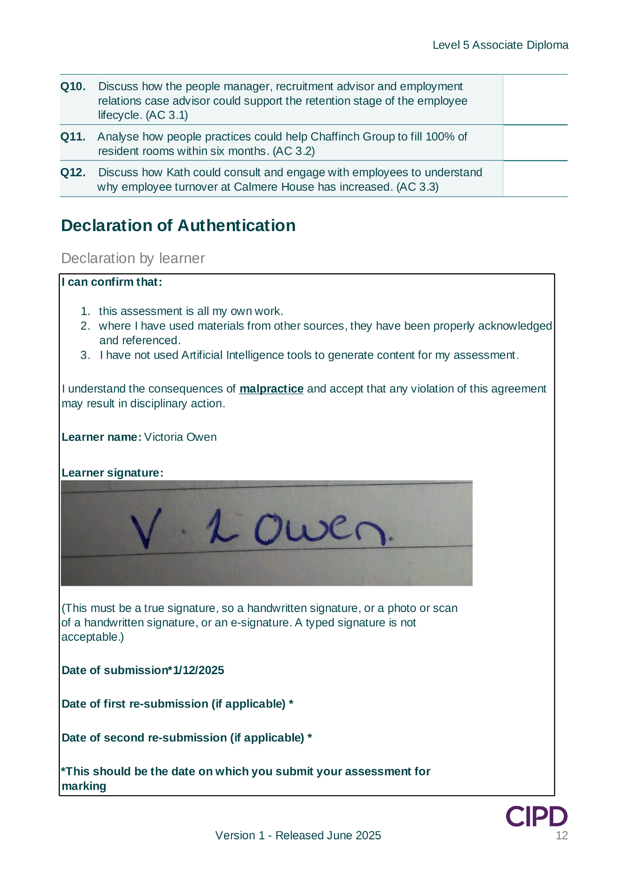
(This must be a true signature, so a handwritten signature, or a photo or scan of a handwritten signature, or an e-signature. A typed signature is not acceptable.)

Date of submission*07/08/26

Date of first re-submission (if applicable)*

Date of second re-submission (if applicable)*

*This should be the date on which you submit your assessment for marking.

5OS01
Specialist employment law

Marking Guidance for Assessors

You should mark in line with the marking descriptors set out on page 11 of this brief.
You must provide a mark from one to four for each question set. You must provide constructive, developmental feedback against each question where you award a mark of one, so refer/fail and rich summary feedback at the end of the feedback form, following the instructions provided there.
To pass the unit assessment learners must achieve a mark of two (Low Pass) or above for each of the questions. You must refer/fail them if you award a mark of one for any of the questions.
Please ensure that you use the correct terminology. Learners have three attempts at the assessment. They only ‘fail’ the assessment if they do not achieve a mark of one for any of the questions at their third attempt. Until then they are ‘referred’.
When you have marked each question, you should total the marks awarded and determine the unit outcome. The table below shows the marking bands for each outcome for this unit.

Overall mark | Unit result
0 to 19 | Fail
20 to 25 | Low Pass
26 to 32 | Pass
33 to 40 | High Pass

Please note that the unit outcome is provided:
- to help learners understand where they are performing well and where they may need to develop
- to help inform your teaching practice
- for moderation purposes

The qualification is not graded and unit outcomes do not appear on learners’ certificates or statements of unit credit.

Marking Descriptors
Mark | Range | Descriptor
1 | Refer/Fail | The response DOES NOT  - demonstrate the knowledge, understanding or skill required to meet the AC.  - include any, or appropriate examples, where these are required to support the answer.  - include evidence of the use of reading and research to inform the answer.  - include at least one appropriate reference for each assessment criteria (where this is required).*  - refer to the case study.  - respond clearly to the question/task and is not well expressed.  - have an appropriate format or structure which meets the requirements set out in the brief.
2 | Low Pass | The response DOES  - demonstrate the minimum level of knowledge, understanding or skill required to meet the AC.  - include an appropriate example where this is required to support the answer.  - include evidence of some reading and research to inform the answer.  - include a reference for each assessment criteria (where this is required).*  - refer to the case study.  - respond to the question or task although it could be clearer and/or better expressed.  - have an appropriate format or structure which meets the requirements set out in the brief.
3 | Pass | The response  - demonstrates a good level of the knowledge, understanding or skill required to meet the AC.  - includes use of a good example or examples where these are required to support the answer.  - includes evidence of a good level of reading and research to inform the answer.  - includes good use of at least one reference for each assessment criteria (where this is required).*  - makes good reference to the case study.  - directly addresses the question/task and is well expressed.  - has a good format or structure which meets the requirements set out in the brief.
4 | High Pass | The response  - demonstrates an excellent level of the knowledge, understanding or skill required to meet the AC.  - includes use of an excellent example or examples where these are required to support the answer.  - includes evidence of extensive reading and research to inform the answer.  - includes excellent use of at least one reference for each assessment criteria (where this is required).*  - makes excellent reference to the case study.  - responds very clearly to the question/task and is particularly well expressed.  - has an excellent format or structure which meets the requirements set out in the brief.
 |  | *Not all ACs in each unit need a reference. If they don’t, the brief will say so. All ACs in Unit 5OS01 require a reference. References should be presented using a recognised form of referencing. For example, if using Harvard referencing, this would include in-text citations and a list of references or bibliography at the end of the assessment.

Marking grid and feedback for learner
Unit 5OS01: Assessor Feedback to Learner
Centre number
Centre name
Learner number (1st 7 digits of CIPD Membership number)
Learner surname
Learner other names (e.g. first name and middle name(s))
Reported word count  Submission |  | Actual word count  Submission
Reported word count Resubmission 1 |  | Actual word count Resubmission 1
Reported word count Resubmission 2 |  | Actual word count Resubmission 2

Note to Assessor – Please enter a mark for each AC. You need only provide feedback where you have awarded a mark of 1. This feedback should be developmental.

TASK
Question  Number | Question | Mark  1-4
Q1. | A newly appointed commercial director has questioned whether the UK’s employment law framework is ‘fit for purpose’ in a competitive retail market. He argues that regulation increases costs and makes it harder to respond quickly to changes in consumer demand. He asks you to evaluate the aims and objectives of employment regulation for the organisation and its staff. (AC 1.1)
Q1. | Assessor feedback first submission (if applicable)
Q1. | Assessor feedback resubmission 1 (if applicable)
Q1. | Assessor feedback resubmission 2 (if applicable)
Q2. | A store operations manager is preparing a response to a solicitor who has written to her on behalf of a recently dismissed colleague who is threatening legal action. She is unclear about the differences between employment tribunals and the ordinary courts. She also assumes that this unfair dismissal claim, if it is formally brought, will inevitably take many years to work its way through the courts because the employee will appeal any unfavourable outcome. Examine the role played by the tribunal and courts system in enforcing employment law in cases like this. (AC 1.2)
Q2. | Assessor feedback first submission (if applicable)
Q2. | Assessor feedback resubmission 1 (if applicable)
Q2. | Assessor feedback resubmission 2 (if applicable)
Q3. | Your company plans to introduce a new automated screening tool to shortlist candidates for customer service roles. Early testing suggests it disproportionately filters out older applicants and those with gaps in their employment history. The recruitment manager asks whether this could create legal risks, and if so, how significant they might be in practice. In relation to this, explain the main principles of discrimination law in recruitment and selection. (AC 2.1)
Q3. | Assessor feedback first submission (if applicable)
Q3. | Assessor feedback resubmission 1 (if applicable)
Q3. | Assessor feedback resubmission 2 (if applicable)
Q4. | To address high staff turnover in the distribution warehouse, managers propose introducing a temporary ‘retention payment’ for its predominantly male team of warehouse workers. There is some concern that this may create a legal risk because the bonus will not be paid to the predominantly female staff who work in the high-street stores. In this context, discuss the legal requirements of equal pay. (AC 2.2)
Q4. | Assessor feedback first submission (if applicable)
Q4. | Assessor feedback resubmission 1 (if applicable)
Q4. | Assessor feedback resubmission 2 (if applicable)
Q5. | Due to rising operating costs, the organisation is considering changing contractual sick pay arrangements for new and existing staff. Some employees have refused to agree to the change. A manager has asked whether the business can terminate contracts and offer re-engagement on new terms if agreement cannot be reached. To help the manager with this scenario, discuss the legal implications of varying contracts. (AC 3.1)
Q5. | Assessor feedback first submission (if applicable)
Q5. | Assessor feedback resubmission 1 (if applicable)
Q5. | Assessor feedback resubmission 2 (if applicable)
Q6. | The introduction of new stock-management technology is expected to reduce the need for certain roles in the distribution warehouse. The managers presenting the proposals consider that this is not a ‘true redundancy’ because the business is still growing overall and its total headcount will remain unchanged. In this context, explain to the managers the legal requirements relating to redundancy. (AC 3.2)
Q6. | Assessor feedback first submission (if applicable)
Q6. | Assessor feedback resubmission 1 (if applicable)
Q6. | Assessor feedback resubmission 2 (if applicable)
Q7. | The company currently employs an external contractor to run its training centre. Managers are considering bringing the service back in-house. The head of customer experience asks whether TUPE (the Transfer of Undertakings Protection of Employment Regulations) may apply in this situation and, if so, what legal obligations the company will have to comply with. Explain the legal requirements relating to transfers of undertakings to help the managers understand their obligations in this case. (AC 3.3)
Q7. | Assessor feedback first submission (if applicable)
Q7. | Assessor feedback resubmission 1 (if applicable)
Q7. | Assessor feedback resubmission 2 (if applicable)
Q8. | Several employees working variable shifts across the organisation have asked for clarification about their rights to annual leave and rest breaks. Some are unsure how much holiday they are entitled to, while others have questioned how their holiday pay is calculated when their working hours vary from week to week. A store manager has asked you to explain the company’s main legal obligations in relation to working time and annual leave for employees who do not work fixed hours. (AC 4.1)
Q8. | Assessor feedback first submission (if applicable)
Q8. | Assessor feedback resubmission 1 (if applicable)
Q8. | Assessor feedback resubmission 2 (if applicable)
Q9. | An employee and her partner both work for the company and are expecting a child. They are confused about eligibility, notice requirements and how shared parental leave would operate if both parents are employed by the same employer. Explain to them the main principles of maternity, paternity and shared parental rights to help them plan effectively. (AC 4.2)
Q9. | Assessor feedback first submission (if applicable)
Q9. | Assessor feedback resubmission 1 (if applicable)
Q9. | Assessor feedback resubmission 2 (if applicable)
Q10. | A full-time administrative employee based at head office has submitted a formal request to reduce her working hours from five days per week to four. She has stated that this change would help her manage caring responsibilities outside work. Her line manager is unsure how to respond and is concerned about the impact on team workload and service delivery. Explain the employee’s employment rights relating to flexible working in this case. (AC 4.3)
Q10. | Assessor feedback first submission (if applicable)
Q10. | Assessor feedback resubmission 1 (if applicable)
Q10. | Assessor feedback resubmission 2 (if applicable)
Total marks for TASK
Total marks for TASK (resubmission 1 if applicable)
Total marks for TASK (resubmission 2 if applicable)

Total marks for UNIT |  | Grade
Total marks for UNIT (resubmission 1 if applicable) |  | Grade (resubmission 1 if applicable)
Total marks for UNIT (resubmission 2 if applicable) |  | Grade (resubmission 2 if applicable)
Assessor Feedback Summary
Please use this box to summarise your feedback on the assessment overall. This should highlight strengths and any areas for improvement, either referring to specific ACs or commenting more generally across the assessment. (Note: developmental feedback on any ACs awarded a mark of 1 should have already been provided in the relevant box of the assessment form above.
Please use a different font colour for any resubmission comments)
Assessor name | Submission |  | Resubmission 1 | Resubmission 2
Assessor signature*
I confirm that I am satisfied that to the best of my knowledge, the work produced is solely that of the learner.
Date

*This must be a true signature, so a handwritten signature, or a photo or scan of a handwritten signature, or an e-signature. A typed signature is not acceptable.

