Question 1:Using at least 3 examples, consider how image makers have utilised digital technology to explore at least one of the following: Conflict, Identity, the Surveillance State, the Technological World?

Student name: John Spalding

Programme of Study: Photography in the Arts

Tutor: Paul Duerinckx

Module:ADAD5003

Illustration list.
Fig1 www.petapixel.com Iphone DSLR Comparison
Fig2 www.petapixel.com iphone DSLR Comparison
Fig3 Recognition. (2016.) Sayyed Hassan Nasrallah. London. Tate
Fig4 Recognition. (1545). A Man in a Black Cap. London. Tate
Fig5 Recognition. (2016). File photo of farmers collecting corn for a cargo at a farm in Gaocheng. London. Tate
Fig6 Recognition. (1980). Portrait of V.I. Lenin with cap, in the style of Jackson Pollock III. London. Tate
Fig7 Metzger G. (1965). Liquid Crystal Environment. London. Tate
Fig8 Paik. N. J. (2002). Bakelite Robot. London. Tate
Fig9 Cortight. P. (2010) Vampire Masquerade. London
Fig10 Manning. M (2014) Full forever; Let Her Go. New York
Fig11 Molina. C. (2012) Crystal Radio. New Orleans. www.cristinamolina.com.
Fig12 Erickson. A. L. (2014) Data Shadows. www.annielauriee.com
Fig13 Erickson. A. L. (2014) Data Shadows. www.annielauriee.com
Fig14 (2019). Light L6 camera. www.format.com
Fig15 (2019). Iphone. www.format.com
Fig16 (2019). Lily Drone. www.format.com

Question 1:Using at least 3 examples, consider how image makers have utilised digital technology to explore at least one of the following: Conflict, Identity, the Surveillance State, the Technological World?
As technology relentlessly marches forward, how much has really changed? Being instantly able to see and show people their image and see if you have nailed that difficult shot are of benefit. Using film, people really had to know what they were doing. To get consistently good images you really must know your craft. Now with technology taking care of the technical details, anyone can get a halfway decent shop with absolutely no technical ability. In fact, you don’t even have to produce a decent image. With the power of processing the images in post you care fix any glaring issues with a few clicks of the mouse. Details like exposure and depth of field are no longer an issue. Disposing of negatives was never easy but erasing a file is much easier. It also doesn’t cost you money every time you fire off a shot.
Digital technology has changed the way we live. It is changing the way we see the world.
(A.I.), Artificial Intelligence, is the science of making machines capable of problem-solving by using learning and thought like processes, much as a human does. It was first coined by computer scientist John McCarthy in 1956.
Sentient machines with advanced artificial intelligence don't exist, but they will almost certainly in the future. In a recent survey, more than 72% of people expressed concerns about the future and machines performing human jobs.
AI is all around us. It is so commonplace that we barely notice. Every time we do an internet search, or an online recommendation is made there are powerful algorithms processing our data.
Google uses AI technology in its software, but specifically in Google Maps making travelling easier.
The search giant's AI-enabled mapping technology uses algorithms and road information to determine the optimal route.
Ref www.builtin.com
Now all mobile phones include a camera of a very high-quality, pictures can be taken by everyone. Everyone is a photographer.
The adage “the best camera is the one you have with you” is now redundant as now no one goes anywhere without their “Phone”.
The number of images taken and uploaded to social media is staggering and only on the rise.
The media is now far more ready to use images captured by the public instead of paying a professional photographer for an image.
Wedding photographers now must include time for the guests to take their own images with their phones. With guests jostling for position and try to get the couples to look in their direction, it would be impossible to compete.
Another concern with is a direct result of technology and social media is the very real chance of the day being ruined for the couple getting married.
Chances are you will want to share you photographs of the big day with friends and family. Particularly those who couldn’t attend. But imagine the disappointment of going on to social media and seeing there were already lots of images posted and some of them not too flattering.
Many wedding photographers are asking the couplesto make it a technology free day.
Wedding Photographer Shoots the Same Pics with Both the New iPhone 11 Pro and His Gear Compares the Results.
In this article direct comparison is made of the images taken with a pro dslr and the latest apple phone, a complete with pictures for direct comparison.
“The iPhone 11 Pro, the Apple flagship phone, is surely meant to be Apple’s photography counter to Android’s three-camera flagships.
Professional wedding photographers of 7 years Jamie and Lauren Eichar wanted to find out. They took the new device and their Canon 5d MK4 to an engagement shoot and then posted the results for a comparison
Ref www.petapixel.com

Fig1

Fig2
The evolution and subsequent price decrease have opened photography to practically everyone. It more accessible than it’s ever been. This isn’t an inherently bad thing but in the same way that giving someone a guitar does make them a musician, giving someone a camera doesn’t make them a photographer. The uninformed think any camera that is expensive is bound to take the best pictures. Photography is a lot like music you need to practice if you want to improve.
The thing about photography is that although digital technology is a revolution it's still the same medium that enthralled Louis Daguerre, Eugène Atget and André Kertés. It's become much easier to take photographs that are technically perfect (in terms of exposure and focus), but the difficulty still lies in capturing an aesthetically pleasing image. It appears that technology is a required, but not a sufficient, condition for creating art.
the technology is impressive. Almost every digital camera on the market today is packed with features, auto-focus that is fairly accurate, metering systems that assess light correctly(on evenly illuminated scenes) and reduce redeye from a direct flash. Some cameras go further than this, offering face detection and even smile detection. It is still possible to take terrible pictures, but they do their best to make it as difficult to get it wrong as possible
Ref theGuardian.com

The Tate
“Our mission is to increase the public’s enjoyment and understanding of British art from the 16th century to the present day and of international modern and contemporary art.”
The IK Prize is presented annually by Tate for an idea that uses digital technology to innovate the way we can discover, explore and enjoy British art and about the pairing of art and technology.
2016’s winner “Recognition” uses A.I. to compare up-to-the-minute photojournalism with British art from the Tate collection. Interestingly the prize is in partnership with Microsoft.
“Recognition was an artificial intelligence program that compared artworks with up-to-the-minute photojournalism.
It used powerful algorithms to search through Tate’s vast collection database, looking for visual and thematic similarities between artworks and the endless stream of online news images.
Winner of IK Prize 2016 for digital innovation, Recognition was active until 27 November 2016 as a website and installation at Tate Britain.”
Some of the similarities it found.


Fig3
Fig4
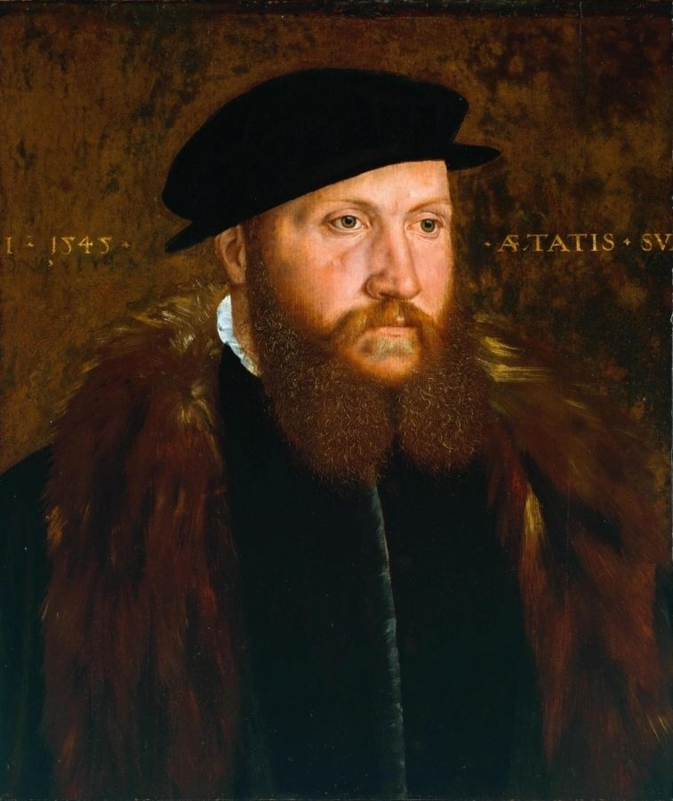
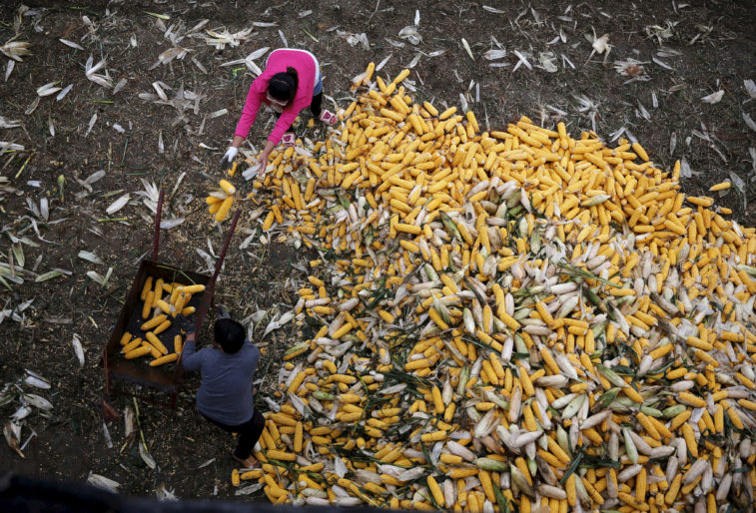
Fig5
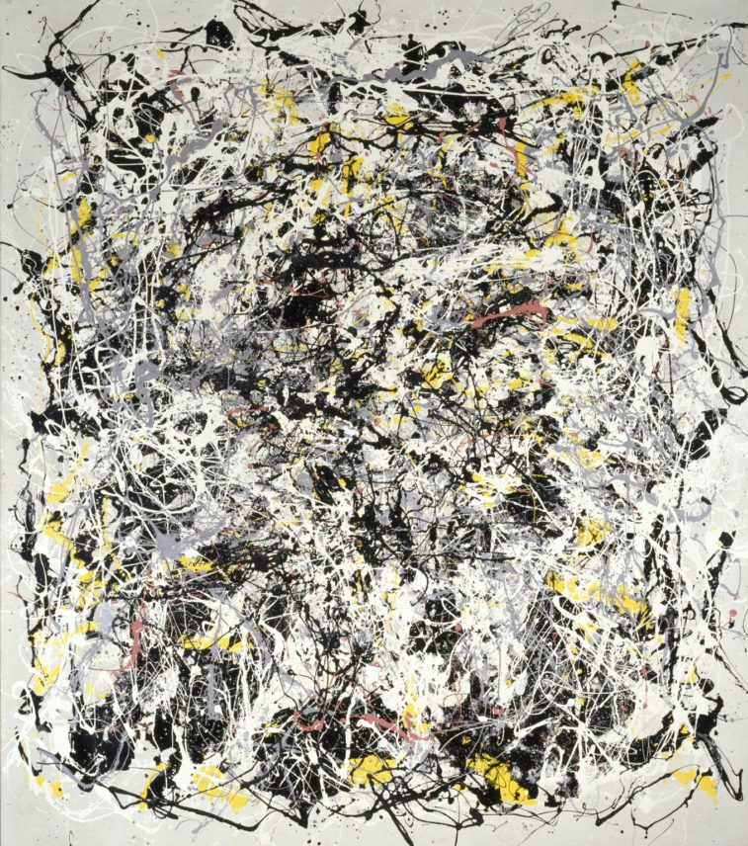
Fig6
Gustav Metzger
Liquid Crystal Environment 1965, remade 2005
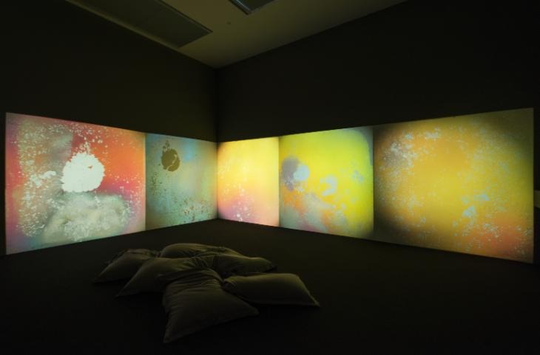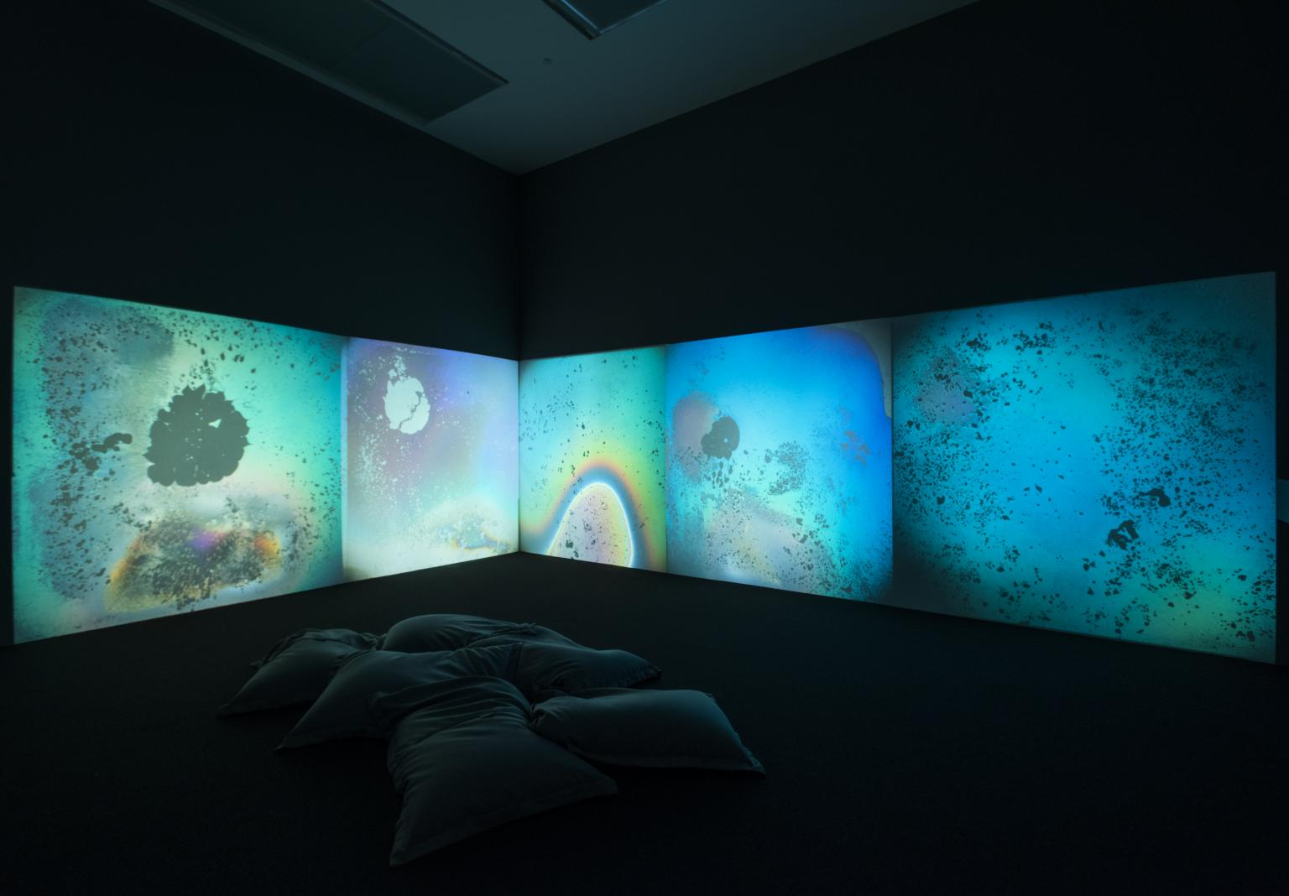
Fig7
Five modified slide projectors, liquid crystals, 35mm slides, Polaroid filter and computerised control duration: 22 min
Ref www.tate.org.uk
In 1961 German artist Gustav Metzger concentrated on a concept of “auto-destructive art”, using technology to construct a process of positive change.
The example above ‘auto creation’ is Liquid Crystal Environment, which became the backdrop for performances by Cream and The Who in London in 1966. Heat-sensitive liquid crystals were fitted into projectors. They were then heated and cooled to create patterns of alternating colours. These images were projected onto screens. The random psychedelic patterns projected created a total sensory experience, where art and technology coalesce.
The patterns produced by light displays such as Metzger’s became icons of London’s scene in the 1960s, as musicians sought to recreate the total sensory environments with their work.
— Gustav Metzger

Nam June Paik
Bakelite Robot 2002
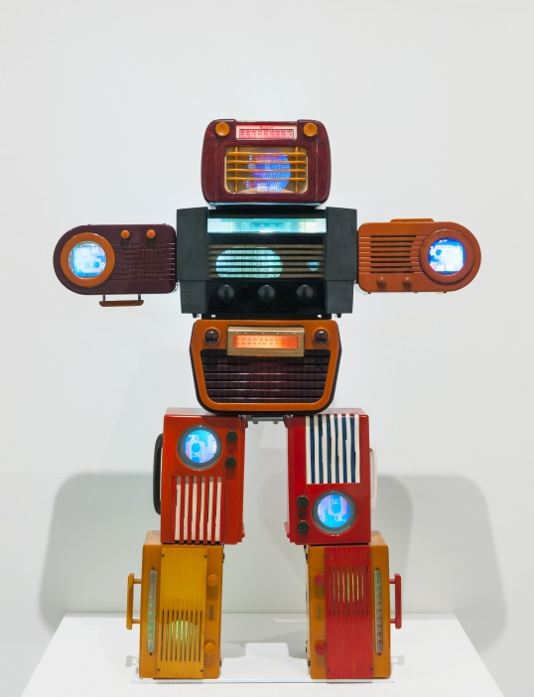
Fig8
One-channel video installation with 2 4" LCD monitors and 3 5.6" LCD monitors

Nam June Paik is best known for his works in video sculpture, robotic devices, performance and installation. He believes in a spiritual element of art that when combined with technology, could have the power to cleanse our mass-market, technology obsessed society.

Visiting Tokyo, he found inspiration and he uses media artefacts as part of his work. This piece constructed from nine vintage Bakelite radios in the form a miniature robot sculpture.
Paik placed tiny televisions inside the radios displaying footage from science fiction films. He is Interested in links between the human body and technology, this work attempts to ‘humanise the technology and the electronic medium’.

Petra Cortight
Vampire Masquerade
Fig9
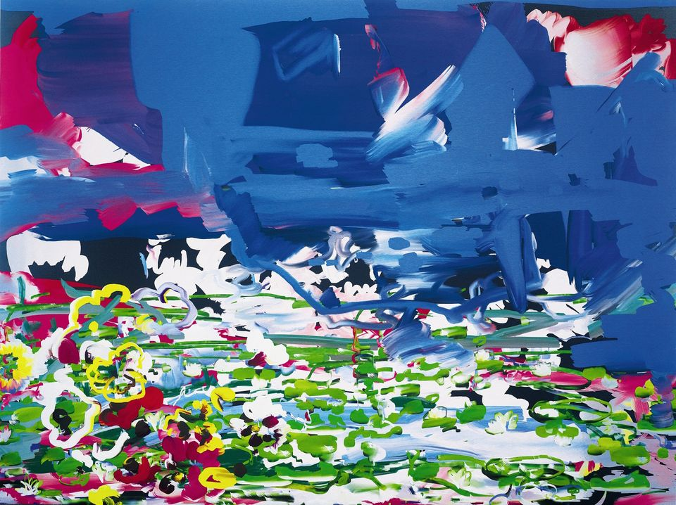
Petra Cortright uses a mix of analog and digital tools to create her works. This is to highlight and explore the issues of online consumption. The above painting, “Vampire Mascarade” uses aluminium, and was digitally created entirely on a computer.
"This process allows the artist to make endless modifications until the moment the digital file is translated into real space," Ref Artsy

MICHAEL MANNING
Full Forever; Let Her Go.

Fig10
Each of Michael’s works starts digitally. Working on a touch screen tablet or using specialist software like Photoshop. He acts out the experience of dabbling in oil paint. When complete he prints the image on a canvas, then applies layers of brushstrokes to simulate the appearance of physical painting. Through his work, Manning hopes to blur the lines between our online and material worlds
Cristina Molina
Fig11
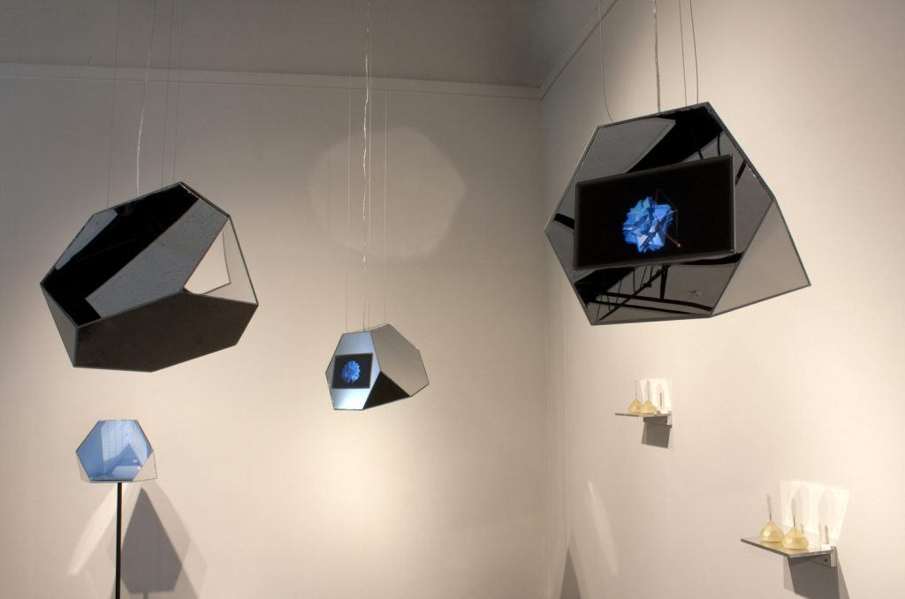
Cristina Molina is a video artist whose work Per her description, “Crystal Video is an interactive audio-visual installation that transmits sounds directly into participants heads. The video is shown in crystalline shapes hanging from the ceiling. However, the audio can only be heard when audience members bite down on a lollipop. The sound travels from the crystal base on the lollipop to the jaw and into the ear. The effect makes the transmission private, as if the figure in the video, inspired by Roland Barthes’ a Lover’s Discourse, is telepathically communicating.”

AnnieLaurie Erickson
Data Shadows
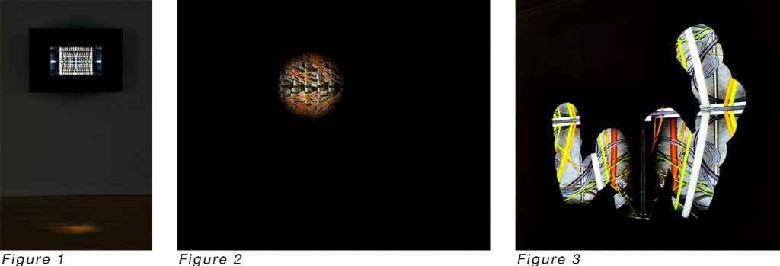
Fig12
AnnieLaurie Erickson is a lens-based artist whose work centres on what is invisible and visible. Her project Data Shadows examines “the physical apparatus of the Internet and digital surveillance,” through photographs and interactive media. The interactive component uses eye-tracking technology to illuminate small sections of a photograph visible on a screen as the viewer’s eye moves around. The path of their gaze is projected onto a wall behind the viewer for onlookers to see.
Ref www.thetempest.com

Fig13
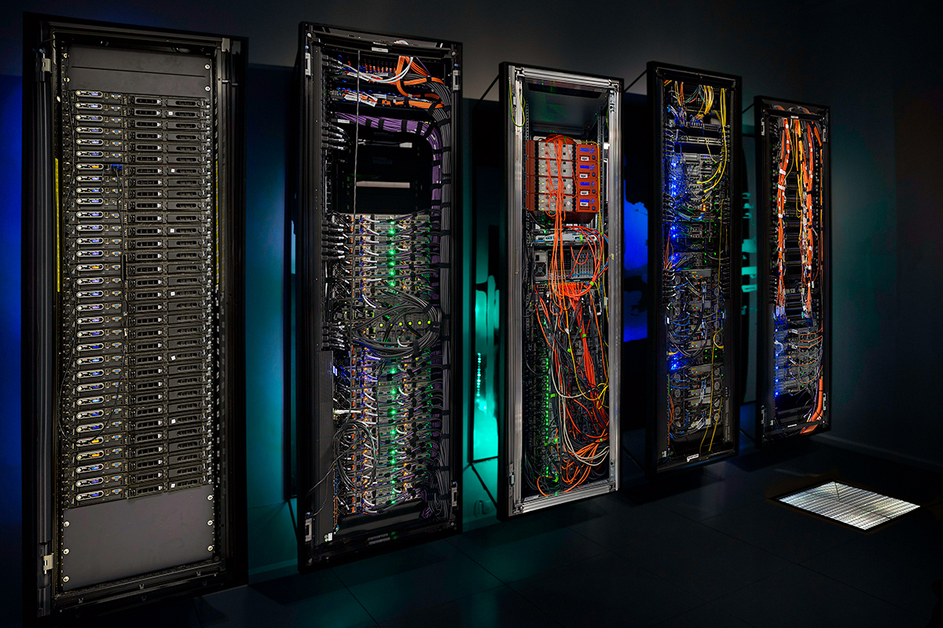

As our daily lives become increasingly monitored, connected and transparent, the data we leave in our wake as we crisscross the internet is seen as representing digital extensions of our identities. These digital identities, or “data shadows,” have significant and often unknown or unexpected effects on our relationships to large institutions, our social interactions, and our daily life.

Where next.
The technological onslaught continues unabated. Change seems to be happening at breakneck speed. By the time you have bought the latest device the new improved one is about to be released and the prices for flagship models is incredible.
“Get a glimpse of photography’s future at the Consumer Electronics Show in Las Vegas.”
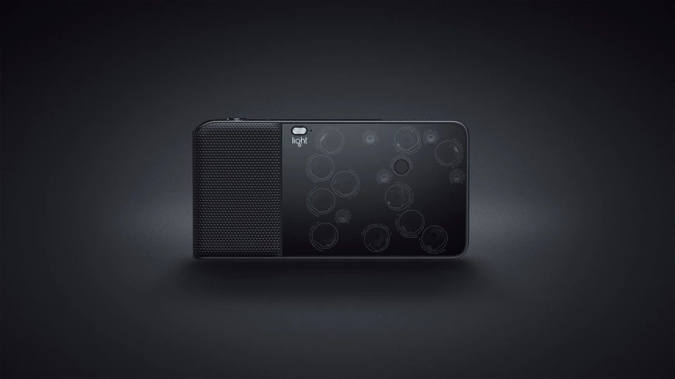
Fig14
Light L6 Camera
The Light L6 is definitely poised to be a real game changer. It uses a new folded optics design to put DSLR quality into a slim and streamlined camera body. A camera body, zoom, and prime lenses right in your pocket.

iPhoneography
The best camera is the one you have with you
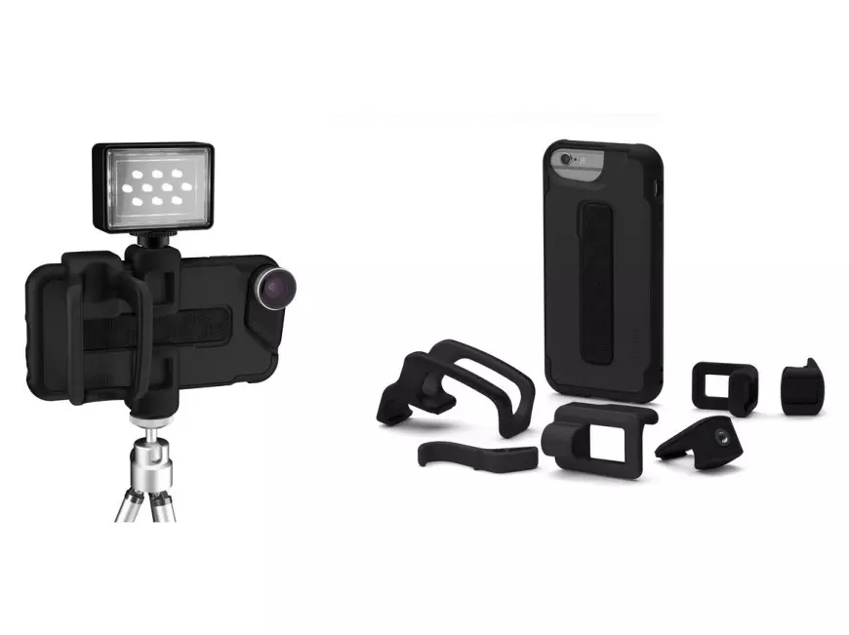
Fig15
Hi quality addons for you Iphone
For iPhone 6/6S series devices, this can take you to the next level whether you’re shooting professional photos and video for your portfolio.

Drones
Lily, a winner at 2016’s CES Innovation Awards.
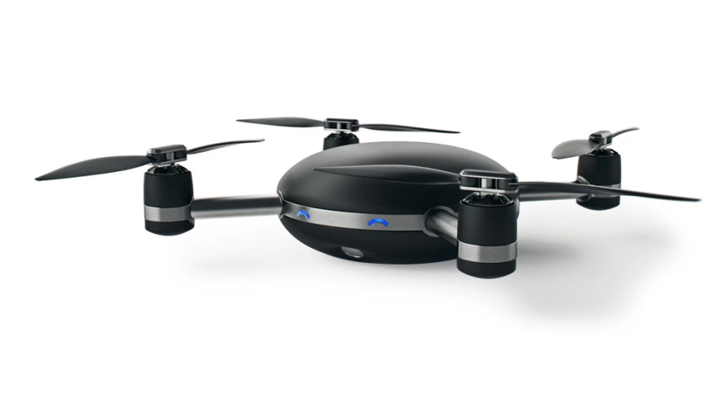
Fig16
Lily
Lily is a flagship camera-turned-drone. Its Fully equipped with all the usual tech and it can fly up to 50 feet, acting as your own personal robot videographer.
Ref Format.com

As expected, the pace of change hasn’t slowed, and innovation makes us more reliant on the new technology than ever before. The more advanced the tech the less advanced we need to be to successfully capture an image. Perhaps by relinquishing the control means we may eventually lose the skills that we need today.
Advanced cameras still can’t actually take the photographs themselves yet, so at least the human factor will be required for some time yet.

Word Count: 2213
References
Jeffrey. I. (2008). How to read a photograph. London. Thames and Hudson Ltd
Bull. S. (2010). Photography. Cornwall. TJ International.
Lister. M. (2013). The photographic image in Digital Culture. New York. Routledge
Burgin. V. (1994). Thinking Photography. London. Macmillan Press.
Mirzoeff. N. (2015). How to see the world. London. Penguin
Barthes. R. (2000). Camera Lucida. London. Penguin.
Benjamin. W.(2014). The work of art of Mechanical Reproduction. London. Penguin.
Baudrillard. J. (2005). The system of objects. London. Verso
Wells. L. (2015). Photography. A critical introduction. Oxon. Routledge

