Author: | Charles Gill | Student Number: | 0250767
Module: | Artificial Intelligence and Machine Learning | Programme: | BSc (Hons) Software Engineering
Reference: | ACCA6011 | Lecturer: | Seena Joseph
Date: | 12/12/24

Machine Learning Model

Telco Data Logistic Regression and Support Vector Machine

Contents
Section 1. Overview 4
1.1 Abstract 4
1.2 Objectives 4
1.3 Report Sections 4
1.4 Introduction 5
Introduction 5
1.5 Definitions 6
Section 2. Data Preparation 7
2.1 Initial data clean 7
2.1.1 Check column datatypes 7
2.2 Column encoding 10
2.2.1 Binary columns 10
2.2.2 3-4 Unique value columns 10
2.2.3 Grouping columns 12
2.2.4 Scaling columns 13
2.2.5 Dropping columns 15
Section 3. Machine Learning Models 15
3.1 Logistic regression 16
3.1.1 LR Code 16
3.1.2 LR results 17
3.1.3 LR Derived Metrics 18
3.2 Support Vector Machine 19
3.2.1 SVM Code 19
3.2.2 SVM results 20
3.2.3 SVM Derived Metrics 21
Section 4. Optimisation via Hyperparameters 21
4.1 Logistic Regression Optimisation 21
4.1.1 Hyperparameters 21
4.1.2 Confusion matrix 22
4.1.3 LR Optimisation Results 22
4.1.4 Observations 23
4.2 Support Vector Machine Optimisation 23
4.2.1 Hyperparameters 23
4.2.2 SVM Optimisation Results 24
4.2.3 Observations 25
Section 5. Conclusion 26
References 27
A video of this code being run can be seen at - 27

Overview

Abstract
This report explores the application of Machine Learning (ML) techniques to predict customer churn—a critical challenge for businesses aiming to retain customers in competitive markets. By analysing the Telco Customer Churn dataset, the study employs two ML models, Logistic Regression (LR) and Support Vector Machine (SVM), to identify at-risk customers. The analysis includes hyperparameter tuning and evaluation using metrics such as accuracy, precision, recall, F1 score, and AUC-ROC. The findings highlight the comparative performance of the models and provide insights into effective churn prediction strategies.

Objectives
- Develop and analyse the customer churn prediction model using LR and SVM Optimize each model performance through hyperparameter tuning.
- Compare the model performance and recommend the most effective model for customer churn prediction.

Report Sections
The report is in four main sections, which are listed below:
- Overview
- Data Preparation
- LR and SVM coding
- Optimisation
- Conclusion

Introduction

Introduction
Customer churn relates to customers decision to withdraw from a company’s products or services. It poses a significant challenge for businesses across many industries. Reports have been created that show retaining existing customers is not only more cost-effective but also critical for maintaining regular income and help with long-term growth. Machine Learning (ML) has become as a powerful tool for tackling the churn problem by enabling companies to predict customer behaviour with greater accuracy.
Churn prediction involves identifying customers who are at risk of leaving, allowing businesses to target those customers and retain them. Accurate churn prediction models can change how businesses approach customer relationship management by moving away from reacting to someone leaving to pre-empting the customer getting to the point of wanting to leave. This not only enhances customer loyalty but also helps maintain a steady customer base and their satisfaction.
The Telco Customer Churn dataset provides a fairly extensive source of data for examining churn patterns and testing predictive methodologies. This report investigates the effectiveness of two widely used ML models, Logistic Regression (LR) and Support Vector Machine (SVM), in predicting customer churn using this dataset. These models were chosen for their contrasting characteristics: Logistic Regression offers interpretability and simplicity, while Support Vector Machine excels in handling complex, non-linear relationships.
To evaluate the performance of these models, metrics such as accuracy, precision, recall, F1 score, and AUC-ROC were utilised. Additionally, hyperparameter tuning was performed to optimize the models and enhance their predictive capabilities. This report aims to provide a comparative analysis of the models, highlighting their strengths and limitations in addressing the churn prediction problem.
By exploring these approaches, this study seeks to offer insights into the application of ML for customer retention, ultimately assisting businesses in making decisions to improve their customer retention.

Definitions

ML | Machine Learning
LR | Logistic Regression
SVM | Support Vector Machine

Data Preparation
Effective data preparation is the first part of any Machine Learning exercise, as the quality of the input data significantly impacts model performance. The Telco Customer Churn dataset, sourced from a telecommunications company, comprises various customer attributes, including demographic details, service usage patterns, and account information. This section outlines the preprocessing steps undertaken to clean and prepare the dataset for analysis.
The data preparation involved several important tasks: inspecting the dataset for missing or inconsistent values, encoding categorical variables into numerical formats, and scaling features to ensure uniformity. Each of these steps is crucial for addressing potential biases and improving the predictive models.

Initial data clean
The Telco dataset contains 21 columns which can be considered as features. The last column is ‘Churn’ which can be considered as the target of the machine learning exercise. The following sections record how I checked through the data before performing the ML erxercise.

Check column datatypes
I used the command print(telcoData.info()) to provide information about the dataset. The following is the result gained:
RangeIndex: 7043 entries, 0 to 7042
Data columns (total 21 columns):
#ID | Column | Non-Null Count | Dtype
0 | customerID | 7043 non-null | object
1 | gender | 7043 non-null | object
2 | SeniorCitizen | 7043 non-null | int64
3 | Partner | 7043 non-null | object
4 | Dependents | 7043 non-null | object
5 | tenure | 7043 non-null | int64
6 | PhoneService | 7043 non-null | object
7 | MultipleLines | 7043 non-null | object
8 | InternetService | 7043 non-null | object
9 | OnlineSecurity | 7043 non-null | object
10 | OnlineBackup | 7043 non-null | object
11 | DeviceProtection | 7043 non-null | object
12 | TechSupport | 7043 non-null | object
13 | StreamingTV | 7043 non-null | object
14 | StreamingMovies | 7043 non-null | object
15 | Contract | 7043 non-null | object
16 | PaperlessBilling | 7043 non-null | object
17 | PaymentMethod | 7043 non-null | object
18 | MonthlyCharges | 7043 non-null | float64
19 | TotalCharges | 7043 non-null | object
20 | Churn | 7043 non-null | object
dtypes: float64(1), int64(2), object(18)
memory usage: 1.1+ MB
None
This displayed three features that are numerical and the remaining features are all objects. The object fields need to be converted into numerical values, so to determine this I used the following command to display the first five chromosomes in the dataset. print(telcoData.head()) (this can be seen in the video – link provided at the end of this document).
From this output it could be seen that many columns had Yes/No type content. For this reason I then ran another piece of code to find the number of unique values in each column.
unique_counts = telcoData.nunique()
print(unique_counts)
This provided the output below:
Column | Unique Value Count
customerID | 7043
gender | 2
SeniorCitizen | 2
Partner | 2
Dependents | 2
Tenure | 73
PhoneService | 2
MultipleLines | 3
InternetService | 3
OnlineSecurity | 3
OnlineBackup | 3
DeviceProtection | 3
TechSupport | 3
StreamingTV | 3
StreamingMovies | 3
Contract | 3
PaperlessBilling | 2
PaymentMethod | 4
MonthlyCharges | 1585
TotalCharges | 6531
Churn | 2
dtype: int64
From the above, I can determine immediately that customerID column has unique values for every entry and therefore does not provide any meaningful data to the ML. The majority of columns have 2 or 3 unique values and these will be converted to numerical values. This is discussed in the next section.
One last initial check concerns whether or not any of the columns contain missing values. I used print(telcoData.isnull().sum()) to determine this and the initial answer is that there are no null values in the dataset.

Column encoding
It can be seen that there are 7 binary columns where there are only two values, 10 columns where there are 3 or 4 values, and 2 with a large range of values. One column has 73 values which I expect to group. The methods to encode these columns are described in the sections below:

Binary columns
It was found that of the 7 columns with 2 unique values that 6 require conversion. ‘churn’ is the target and gets converted first to an integer datatype consisting of 0s & 1s. This is achieved with the command: telcoData['Churn'] = telcoData['Churn'].map({'Yes': 1, 'No': 0})
After that, it is realised that SeniorCitizen is already an int64 datatype that consists of 0s and 1s. So this column does not need to be altered.
This leaves the following code to convert the remaining columns:
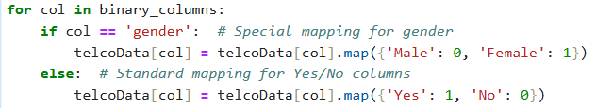
The code then continues to output the column heads to check that the conversion has worked.

3-4 Unique value columns
These columns get converted in a similar manner but rather than being mapped, we use one-hot encoding to distil the column’s contents into binary columns of true and false.
As Shivang Gupta states in his web article ‘One-Hot Encoding: A Comprehensive Guide with Python Code and Examples for Effective Categorical Data Representation’,
‘One-hot encoding addresses this issue by creating a binary vector representation of each category. Each category is assigned a unique index, and the corresponding index in the vector is set to 1 while the others are set to 0. This creates a sparse matrix where each row represents a unique instance, and the columns represent the presence or absence of a specific category.’ [1]
Therefore, for the 9 columns that have 3 or 4 unique entries these have been converted with the following code:
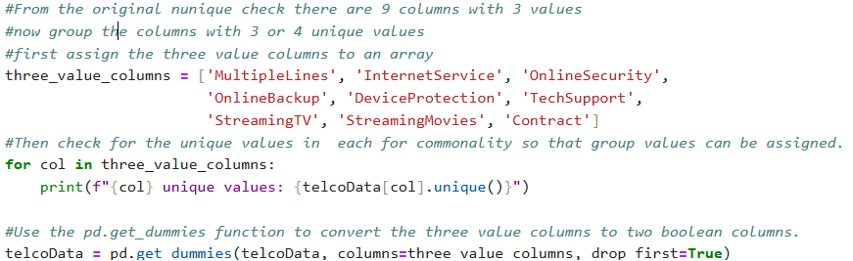
This code displays the contents of the unique values, as follows:
MultipleLines unique values | ['No phone service' 'No' 'Yes']
InternetService unique values | ['DSL' 'Fiber optic' 'No']
OnlineSecurity unique values | ['No' 'Yes' 'No internet service']
OnlineBackup unique values | ['Yes' 'No' 'No internet service']
DeviceProtection unique values | ['No' 'Yes' 'No internet service']
TechSupport unique values | ['No' 'Yes' 'No internet service']
StreamingTV unique values | ['No' 'Yes' 'No internet service']
StreamingMovies unique values | ['No' 'Yes' 'No internet service']
Contract unique values | ['Month-to-month' 'One year' 'Two year']
The column with the 4 unique values is encoded in the same fashion.
It is the command get_dummies that is a simple way to code one-hot encoding. If there are two unique values, a new column is created that is true if the one value is there but false if not. The command also drops the original column so that there is no duplication or confusion of the data.
It is of note that using the get_dummies command does create the newly created columns as Boolean, holding True and False as 1&0. It is recommended to convert these to integer values to make the machine learning model handle them easier, and in a more compatible fashion.
A diagram by Shivang Gupta demonstrates this column change as below:
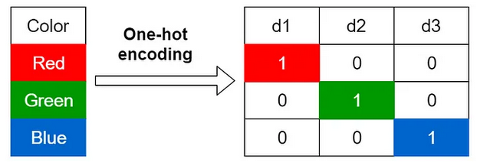 [1]
It can be thought of as; d1 – isRed, d2 – isGreen and d3 – isBlue.
However, it does increase the number of columns obviously. But the discreet nature of the values contained do lend themselves to ML.

Grouping columns
However, out of 7,000 entries there are 73 values for the tenure column, therefore I run some code to check the min and max values and the value counts.
It can easily be seen that this column will need encoding but whether to use numerical bin indices or one-hot encoding depends on whether there is a correlation between tenure and churn.
To determine this I compared the churn rate against the tenure, using a piece of code that plots the values against each other. The graph is below:
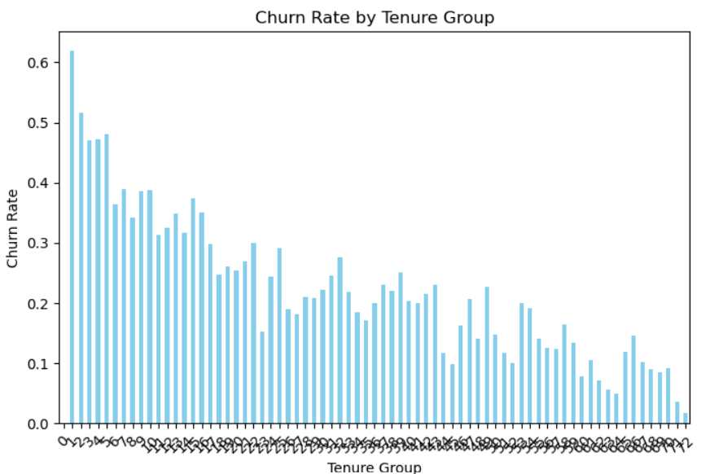
There is a strong correlation between the tenure group and the churn rate and so as Stéphanie Crêteur states on her webpage ‘Machine learning: one-hot encoding vs integer encoding’ that
‘… has as well the advantage of preserving an ordinal relationship, however, that is as well one of the reasons you shouldn’t be using it. Indeed, Integer encoding can introduce a bias into the data by implying a natural ordering between the categories.’ [2]
Although one-hot encoding is good at avoiding bias, in this case the bias is already present, and so, numerical bin indices were implemented for this column.

Scaling columns
There are now only two columns left to clean, one is ‘MonthlyCharges’ and the other is ‘TotalCharges’. Notice that TotalCharges is still an ‘object’ datatype and therefore needs to be converted.
·In checking the ‘TotalCharges’ column we find that there are several entries which are just “ “, these empty values must be filled to make sure that the model can work correctly.
This is dealt with in the following way:
First replace the “ “ with a Null value, then convert the column to a numeric column. The below code perfoms this:
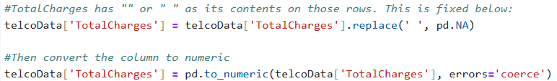
Secondly, the 0 values will skew the averages a within the numeric content. Therefore, these values need to be imputed with the median or mean values.
As Prerna Nichani states in her web article ‘Appropriate ways to Treat Missing Values’:
‘Mean imputation works better if the distribution is normally-distributed or has a Gaussian distribution, while median imputation is preferable for skewed distribution(be it right or left).’ [3]
Therefore, I created a small piece of code that plots the distribution of ‘TotalCharges’ which produced the following graph:
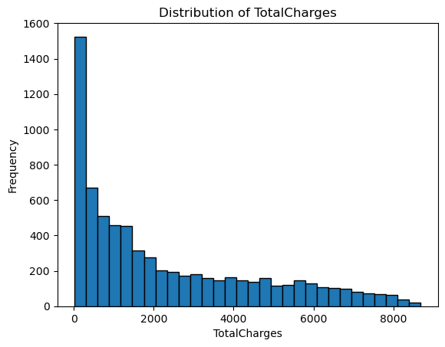
It can clearly be seen that there is a skew to the left side, and therefore imputing median values would least affect this dataset.
This is actioned with the following code:
At this point a final check is made of the columns and their contents to make sure that the dataset is fully cleaned and is ready for implementing into the ML models.
The last action is to scale the two columns with the following code:
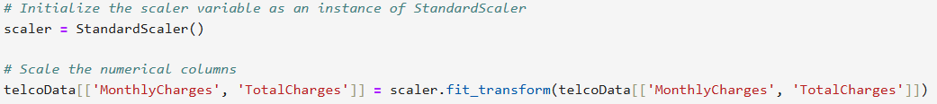
I then printed the columns ‘head’ to check the values are scaled.

Dropping columns
There are a number of columns to drop from the table and these are covered in the code below:
CustomerID has unique values for every chromosome, tenure is replaced by tenure_group and churn is the target.
This completes the data cleaning and preparation.

Machine Learning Models
There are a number of ML learning models, such as Decision Trees, Linear Regression, Logistic Regression, K Nearest Neighbours, Support Vector Machine, Random Forest and Naive Bayes. This report is only concerned with Logistic Regression (LR) and Support Vector Machine (SVM). These are the two models that have been implemented as part of this project and therefore the two sections below describe the models and then display the code that has implemented those models.

Logistic regression
Logistic Regression is defined by Patricia Bassey in her web article as the following:
‘Logistic regression is an algorithm that is used in solving classification problems. It is a predictive analysis that describes data and explains the relationship between variables. Logistic regression is applied to an input variable (X) where the output variable (y) is a discrete value which ranges between 1 (yes) and 0 (no).’ [4]
It uses the logistic sigmoid function to find the relationship between variables as seen in the diagram below:
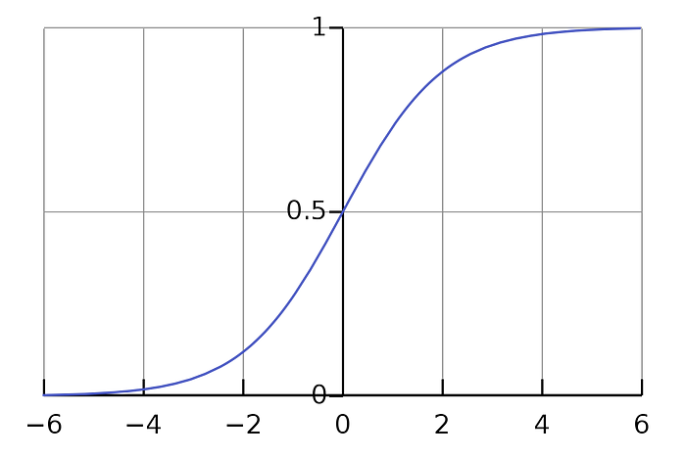 [4]
The sigmoid function is an S-shaped curve that can take any real-valued number and map it to a value between 0 and 1, but never exactly at those limits. [4]

LR Code
The code within python to implement this machine learning model is seen below:
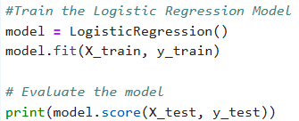

LR results
The above code produced the following results:
Accuracy: 0.82
Precision: 0.81
Recall: 0.82
F1 Score: 0.81
AUC-ROC: 0.86
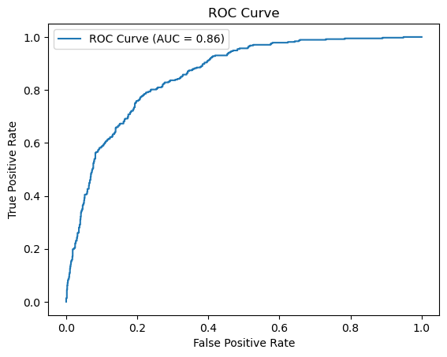
And a confusion matrix as below:
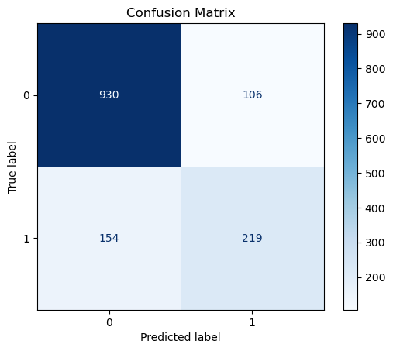

LR Derived Metrics
From these confusion matrix figures, you can calculate key metrics:

Accuracy
Accuracy is relatively high but can be misleading for imbalanced datasets.

Precision
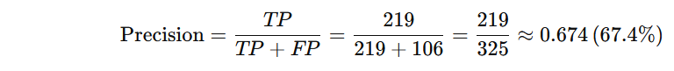
Precision is moderate, showing how well the model avoids false positives.

Recall (Sensitivity)
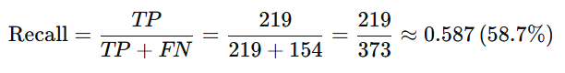
Recall is lower, suggesting the model is missing a fair number of positive cases.

F1 Score
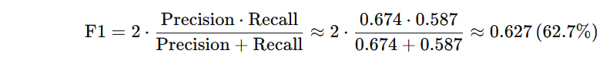
The F1 score balances precision and recall, indicating moderate performance in identifying positive cases.

Specificity
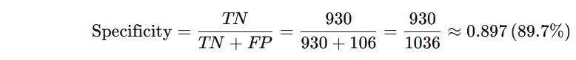
Specificity shows the model is excellent at identifying negatives.
Optimisation is shown in section 4.

Support Vector Machine
SVM is defined by Mariette Awad and Rahul Khanna in their book ‘Efficient Learning Machines’ as follows:
‘Support vector machines (SVMs) are supervised learning methods that analyze data and recognize patterns.’ [5, p. 11]
Going on to say that ‘Support vectors are the data points nearest to the hyperplane that divides the classes.’ [5, p. 11], followed by a diagram as below:
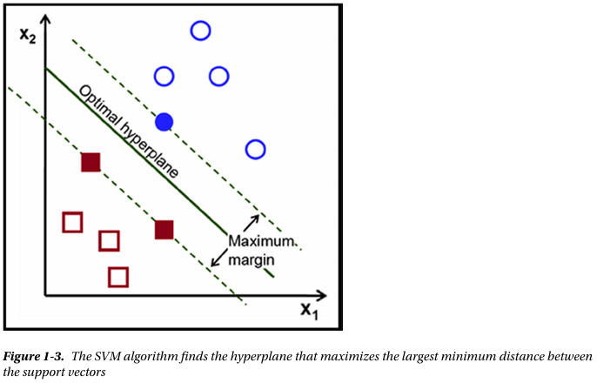 [5, p. 11]
The SVM model maps the nodes as points in Euclidean space and then observes the largest distance between the nodes or groups of nodes (ie the support vectors).

SVM Code
The python code to implement this model is found below:
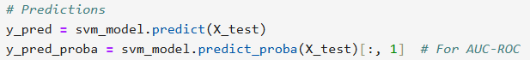

SVM results
Accuracy: 0.81
Precision: 0.80
Recall: 0.81
F1 Score: 0.80
AUC-ROC: 0.81
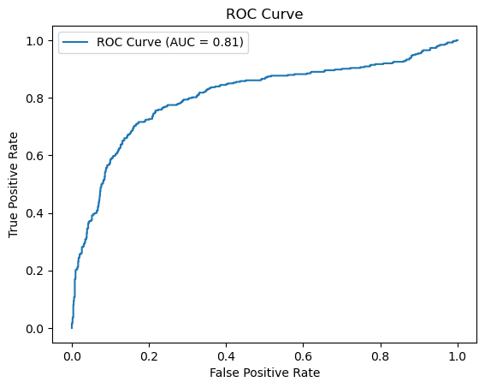
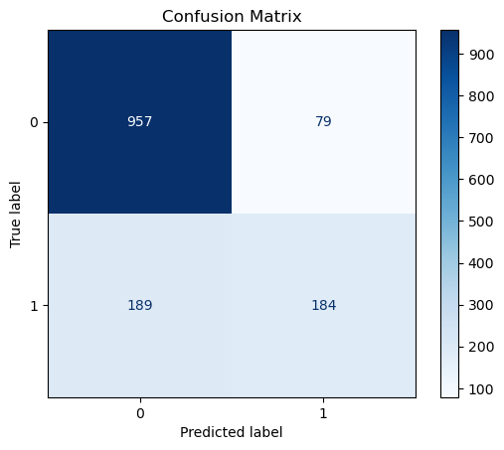

SVM Derived Metrics
Accuracy: 0.810 (81.0%)
The proportion of all correctly predicted instances (both positive and negative).
Precision: 0.700 (70.0%)
The proportion of true positive predictions out of all positive predictions.
Recall (Sensitivity): 0.493 (49.3%)
The proportion of actual positives correctly identified by the model.
F1 Score: 0.579 (57.9%)
The harmonic mean of precision and recall, balancing their trade-off.
Specificity: 0.924 (92.4%)
The proportion of actual negatives correctly identified.

Optimisation via Hyperparameters

Logistic Regression Optimisation
There are several hyperparameters that can be altered to optimise the machine learning within LR.

Hyperparameters
- C parameter relates to the regularisation strength
  - Initially used [0.01, 0.1, 1, 10, 100] but moved to [0.001, 0.01, 0.1, 1, 10] to check if improvements were made
- Penalty parameter is the regularisation type
  - Used [l1 and l2] except when this was removed and an attempt was made with a class weight of balanced.
- Solver is the algorithm that solves the optimisation problem.
  - Chose [Liblinear and saga], compatible with l1&l2.
Then the gridSearchCV function was called with:
- Max_iterations of 1000, moved to 5000 to complete
- Scoring is ‘f1 weighted’
- CV of 5 which is the cross validation

Confusion matrix
The confusion matrix also has a threshold and this can be optimised when displaying the results.
By using the following code, it was found that the optimal threshold for the confusion matrix could be found – at 0.52.
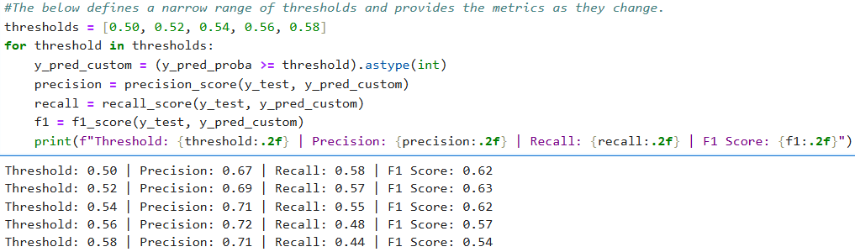
This can be run for other metrics as required.

LR Optimisation Results
The negative results were improved slightly but at the expense of the positive results.
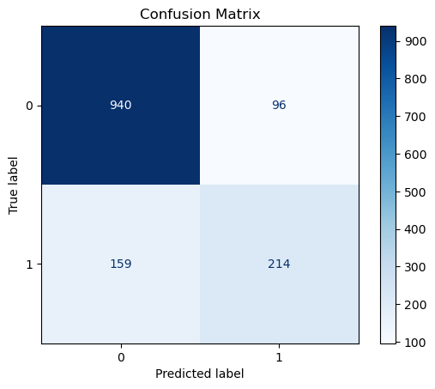
Derived Metrics
• Accuracy: 0.8190.8190.819 (81.9%)
The proportion of all correctly predicted instances (both positive and negative).
• Precision: 0.6900.6900.690 (69.0%)
The proportion of true positive predictions out of all positive predictions.
• Recall (Sensitivity): 0.5740.5740.574 (57.4%)
The proportion of actual positives correctly identified by the model.
• F1 Score: 0.6270.6270.627 (62.7%)
The harmonic mean of precision and recall, balancing their trade-off.
• Specificity: 0.9070.9070.907 (90.7%)
The proportion of actual negatives correctly identified.

Observations
High Specificity: The model is very effective at identifying true negatives.
Moderate Precision: Positive predictions are relatively reliable.
Low Recall: The model misses a significant portion of true positives, possibly due to the higher threshold.
Balanced F1: The F1 score is moderate, reflecting the trade-off between precision and recall.

Support Vector Machine Optimisation
There are several hyperparameters that can be altered to optimise the machine learning within SVM.

Hyperparameters
- C parameter relates to the regularisation small values for highly regularised models, larger values and vice versa.
  - Used [0.1, 1, 10, 100]
- Kernel parameter are the kernels to try
  - Used [linear, rbf, poly]
- Gamma is the kernel coefficient which determines the influence of a training example
  - Used [Scale and auto]
- Degree determines the degree of the polynomial function used to compute the decision boundary.
Then the ‘gridSearchCV’ function was called with:
- With SVC probability of true
- Scoring is ‘f1 weighted’
- CV of 5 which is the 5-fold cross validation

SVM Optimisation Results
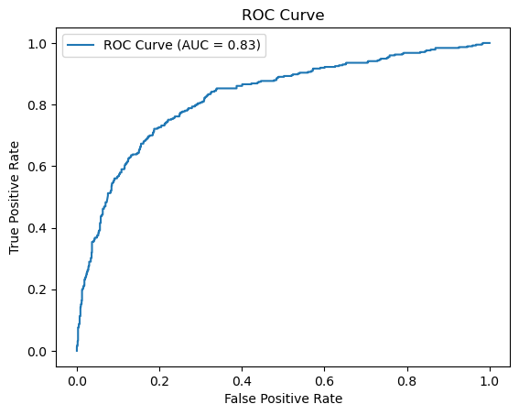

Accuracy: 0.82
Precision: 0.81
Recall: 0.82
F1 Score: 0.81
AUC-ROC: 0.83

Thresholds on SVM
The SVC model in SVM predicts class labels (y_pred) directly by default based on the decision boundary (threshold of 0). However, when using probability=True, the model provides class probabilities (y_pred_proba), allowing you to adjust the threshold for predictions. However, in this instance it was taking nearly half an hour to run the optimisation.
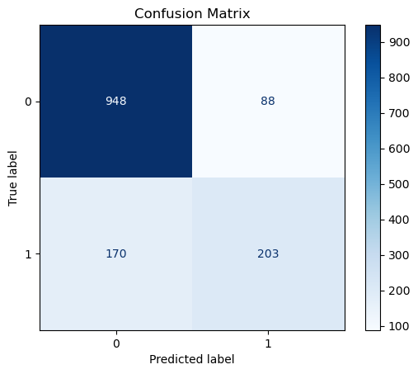
Derived Metrics
Accuracy: 0.817 (81.7%)
The proportion of all correctly predicted instances (both positive and negative).
Precision: 0.698 (69.8%)
The proportion of true positive predictions out of all positive predictions.
Recall (Sensitivity): 0.544 (54.4%)
The proportion of actual positives correctly identified by the model.
F1 Score: 0.611 (61.1%)
The harmonic mean of precision and recall, balancing their trade-off.
Specificity: 0.915 (91.5%)
The proportion of actual negatives correctly identified.

Observations
High Specificity: The model is effective at identifying true negatives, which aligns with a higher TN count.
Moderate Precision: Positive predictions are relatively reliable but could be improved.
Low Recall: A significant portion of actual positives are missed (FN is relatively high compared to TP).
Balanced F1 Score: The F1 score reflects a reasonable trade-off between precision and recall.

Conclusion

There was not a huge discrepancy between the two models ultimately, the optimisation took extra time and did not drastically improve the metrics. The tables below provide the figures for running the model direct and after optimisation and the associated confusion matrices.
Metrics
Model | Accuracy | Precision | Recall | F1-Score | AUC-ROC
LR standard | 0.82 | 0.81 | 0.82 | 0.81 | 0.86
LR optimised | 0.81 | 0.81 | 0.81 | 0.81 | 0.86
SVM standard | 0.81 | 0.80 | 0.81 | 0.80 | 0.81
SVM optimised | 0.82 | 0.81 | 0.82 | 0.81 | 0.83

Confusion matrices
Model | TP | TN | FP | FN
LR standard | 219 | 930 | 106 | 154
LR optimised | 214 | 940 | 96 | 159
SVM standard | 184 | 957 | 79 | 189
SVM optimised | 203 | 948 | 88 | 170

The figures are very similar but the optimisation of the SVM took around 20-25 minutes. This was not experienced on the other methods, so this method is very computationally heavy. Its results probably do not warrant the extra computational power needed. There is likely to be an element of over fitting within the models and the dataset as no tangible gains were made, and as gains were made in one area, there were equivalent losses in other results.
Unfortunately, there was a time constriction on this project which meant that ultimately, the author would have maybe attempted further combinations/models/parameter changes to increase the metrics. Closer analysis on the features may have yielded some further accuracy, precision or improved the F1 score.

References

[1] | S. Gupta, “One-Hot Encoding: A Comprehensive Guide with Python Code and Examples for Effective Categorical Data Representation,” Medium, 2 July 2023. [Online]. Available: https://medium.com/@creatorvision03/one-hot-encoding-a-comprehensive-guide-with-python-code-and-examples-for-effective-categorical-2fbbc111c320. [Accessed 10 12 2024].
[2] | S. Crêteur, “Machine learning: one-hot encoding vs integer encoding,” Medium, 16 12 2022. [Online]. Available: https://medium.com/geekculture/machine-learning-one-hot-encoding-vs-integer-encoding-f180eb831cf1. [Accessed 10 12 2024].
[3] | P. Nichani, “Appropriate ways to Treat Missing Values,” Medium, 02 05 2020. [Online]. Available: https://medium.com/analytics-vidhya/appropriate-ways-to-treat-missing-values-f82f00edd9be. [Accessed 10 12 2024].
[4] | P. Bassey, “Logistic Regression Vs Support Vector Machines (SVM),” Medium, 19 09 2019. [Online]. Available: https://medium.com/axum-labs/logistic-regression-vs-support-vector-machines-svm-c335610a3d16. [Accessed 11 12 2024].
[5] | M. A. a. R. Khanna, Efficient Learning Machines, New York: Apress Media, 2015.

A video of this code being run can be seen at - https://youtu.be/vD2K4OBNaIw

